ABSN-5778 WearerAccountabilityHist missing when marking route ready for transfer with Route Finalization
Environment | Prerequisites
Version:9.07.00  DBServerName= abs-SRV20.internal.abslbs.com  DBSID=CUST24  DBUser=UNFDEV  Environment=Test | - Module:  - System setting

Contents
Retest after fix 1
Expected behavior: 1
Test Steps: 1
Using process Cancel and regenerate US direct invoices for late delivery notes 9
Route Finalization through REST 14

Retest after fix
9.07.00.UNF20 hash: 0c2910d
Bu: 025 Portland

Expected behavior:
When mark ready for transfer is performed automatically for Route Finalization - either from scheduled process or web service - writing to this table is omitted. There should be recorded

Test Steps:
- RSC dlg: Open 'Route Status Control' DLG and add a new Route.
- Wearers: Load a customer that has wearers and keep that on the customer.
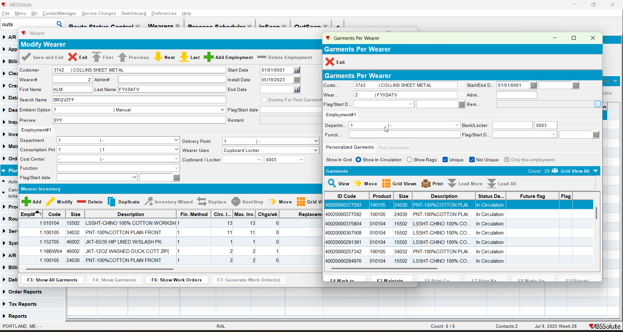
- RSC dlg: Generate put up docs, invoices and script the taxes for the route containing our customer.
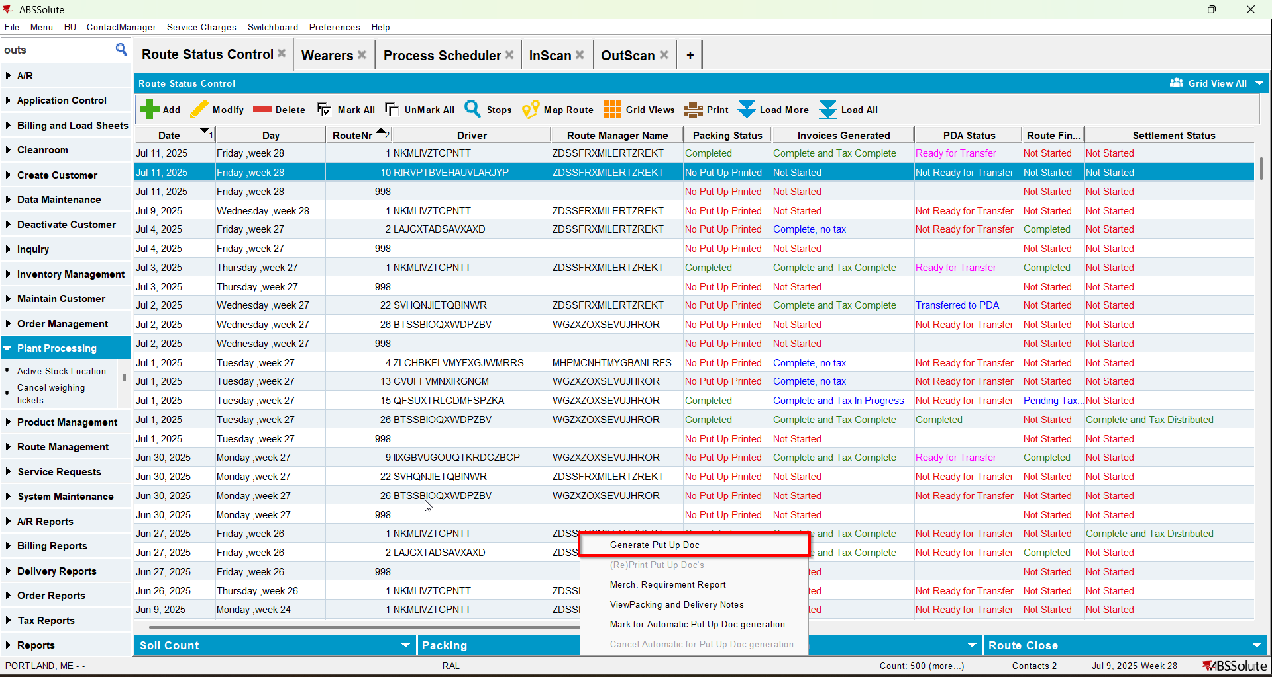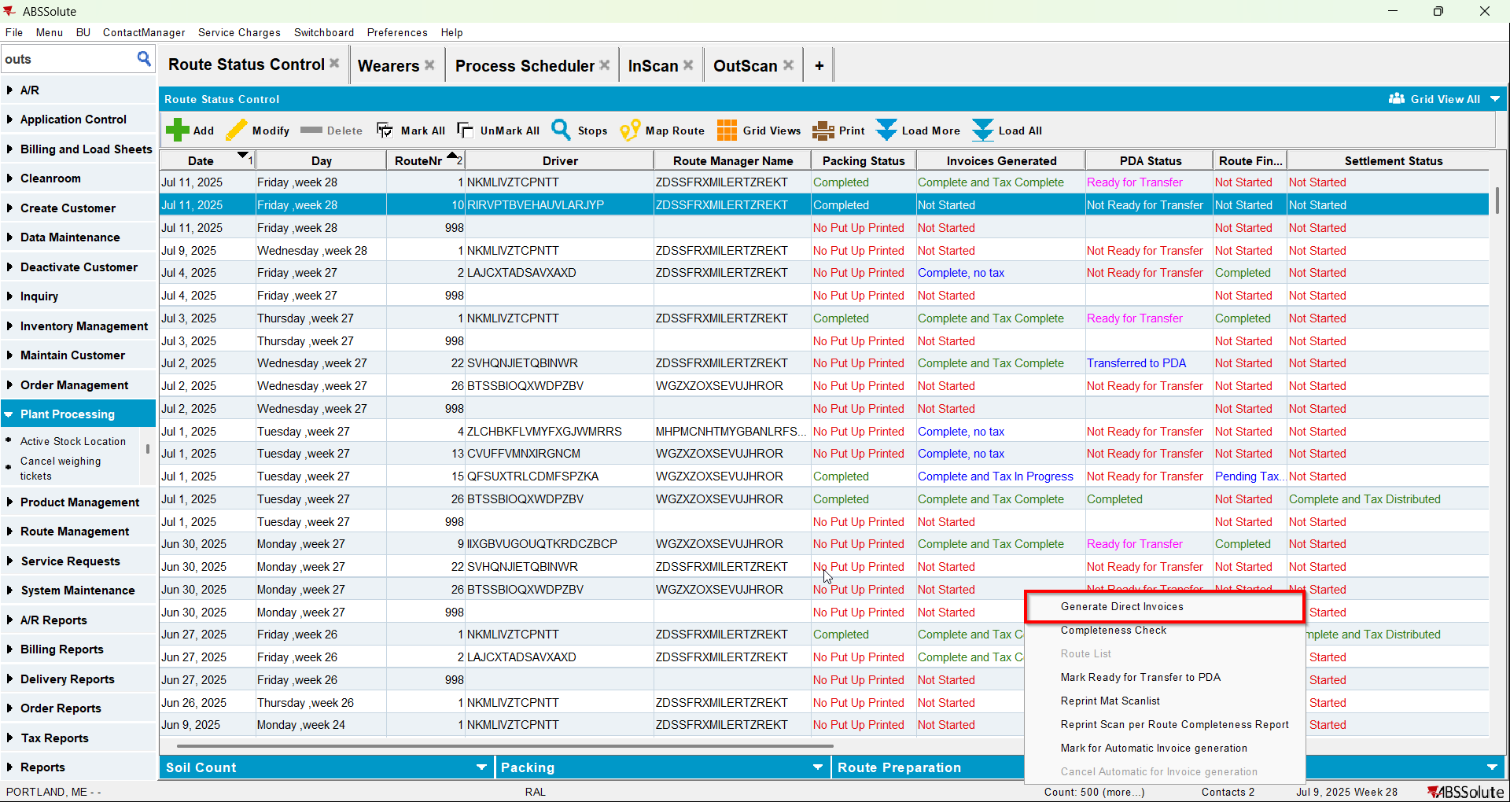
- Inscan dlg: From wearers copy a smartbarcode and scan it
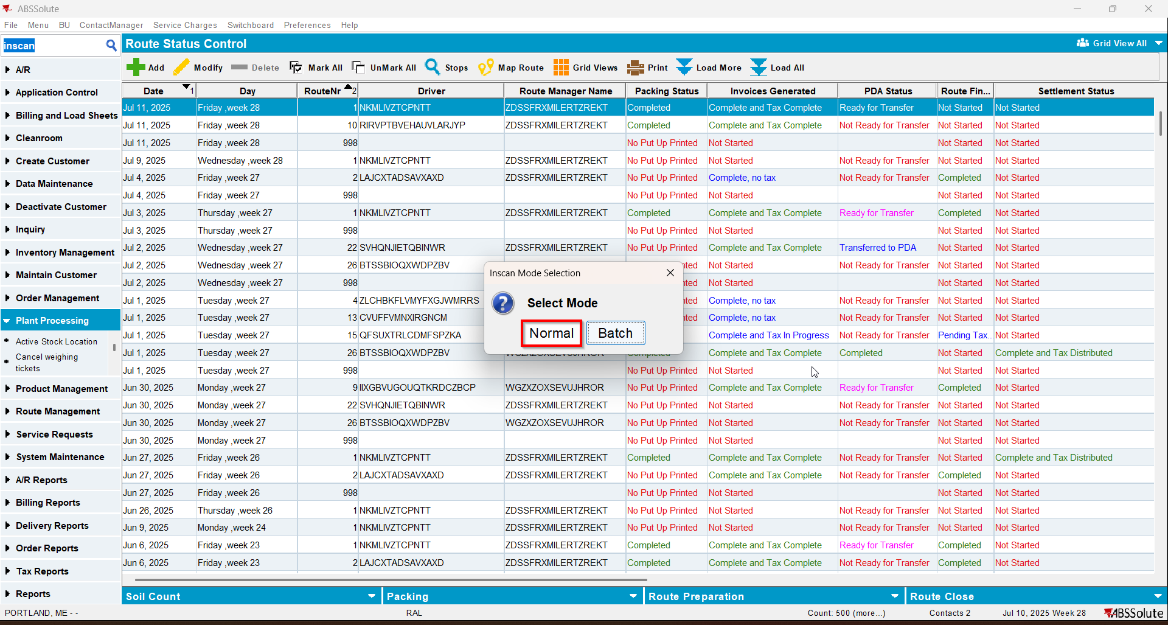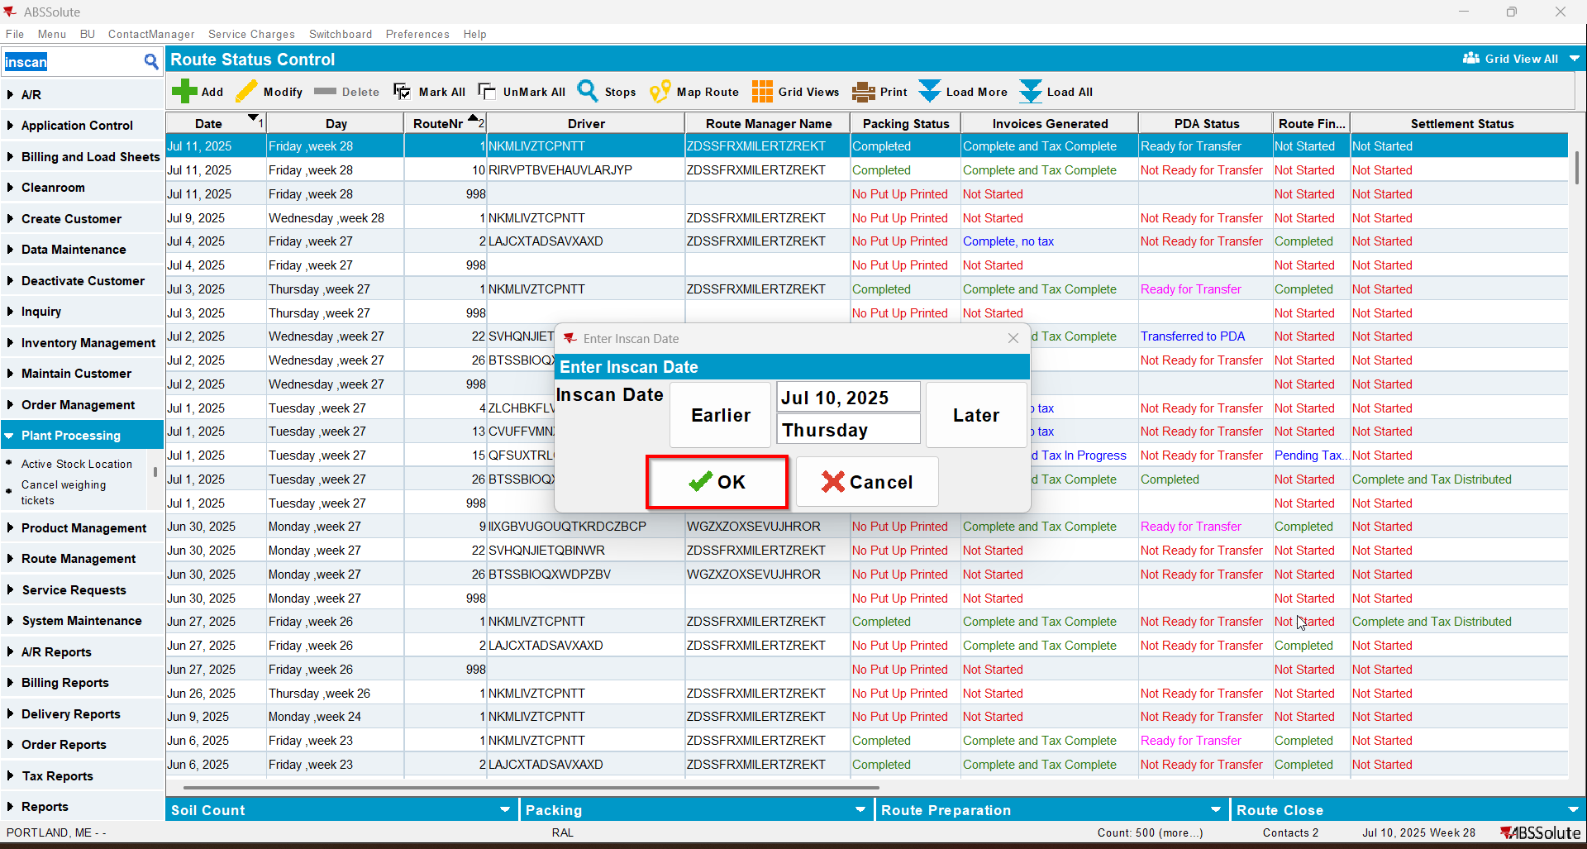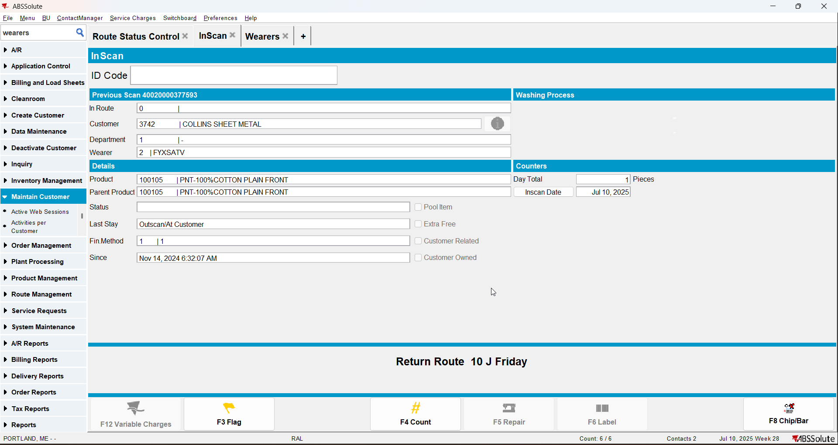

- Outscan dlg: Scan another unique code.
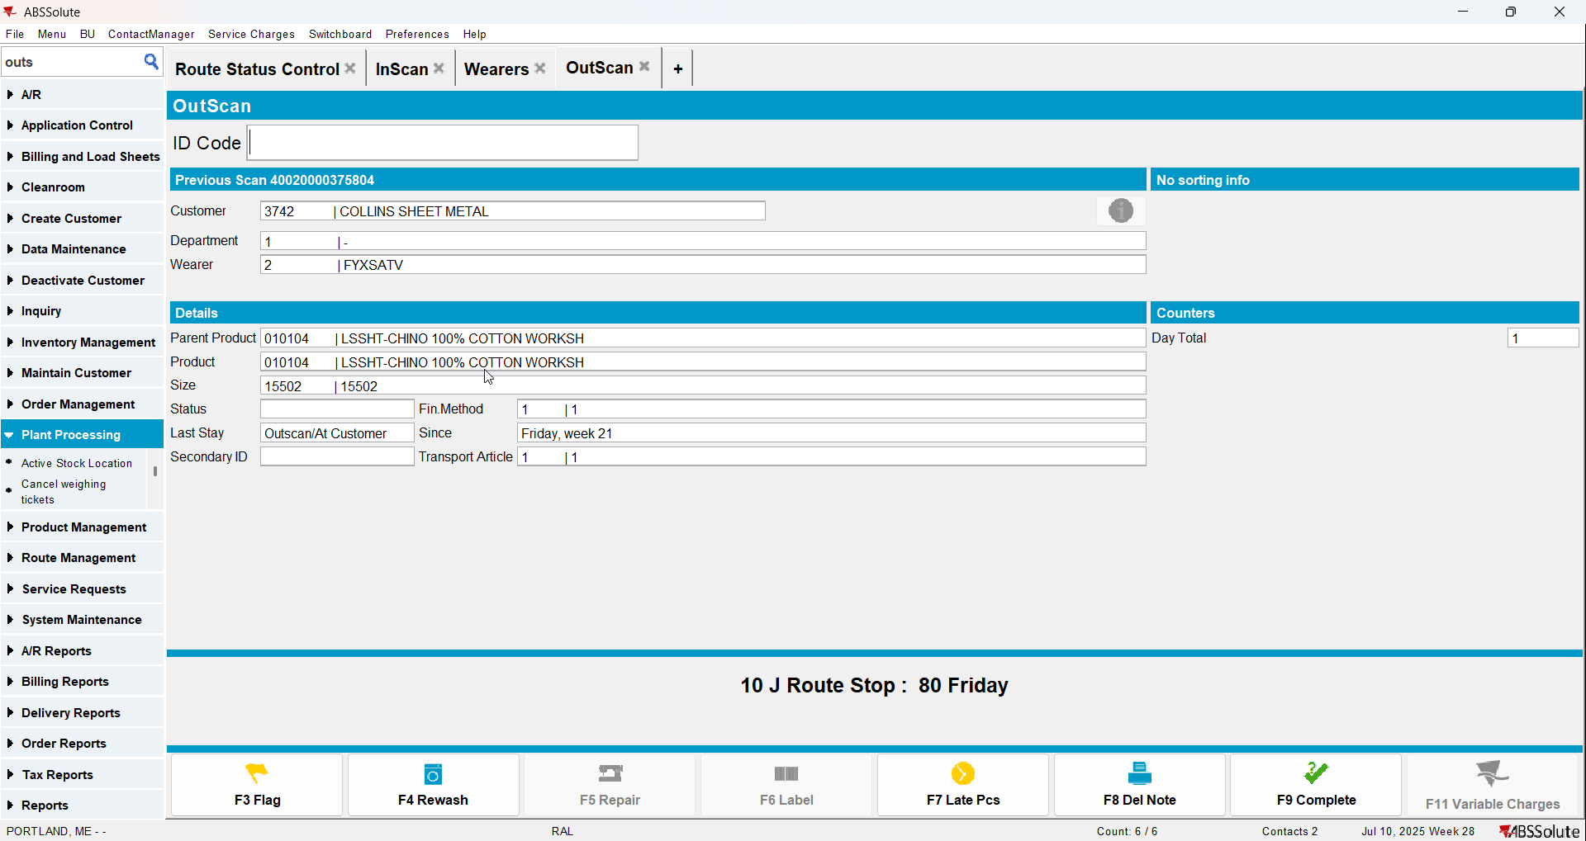
- Open bottom-bar pop-up 'Mark Ready for Transfer'
- Select action 'Mark Ready for Transfer' and press 'OK'
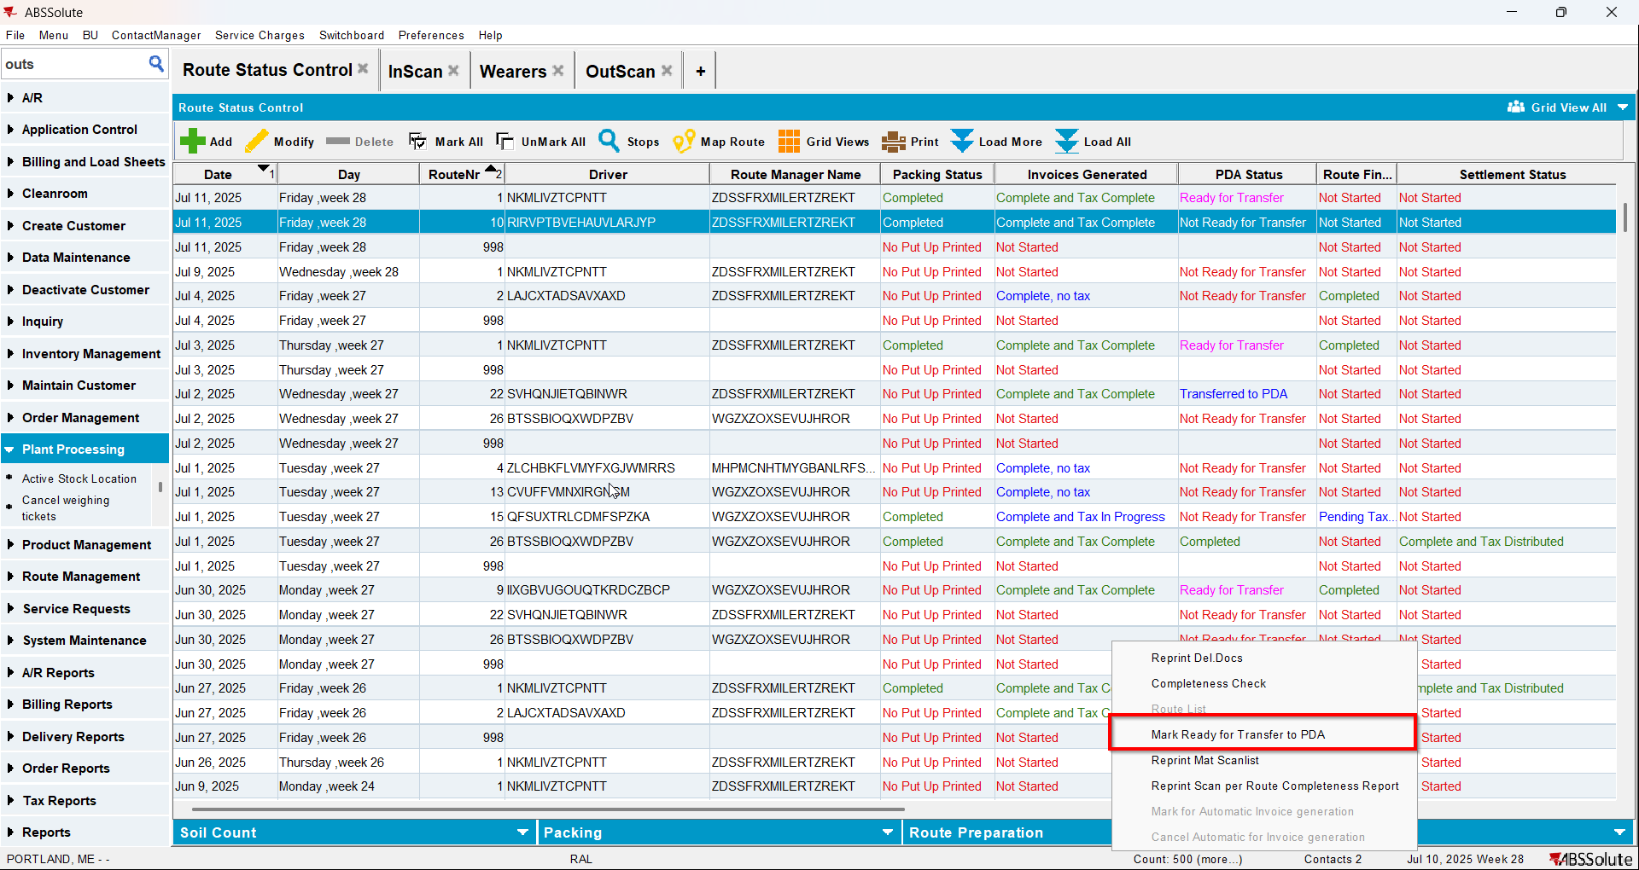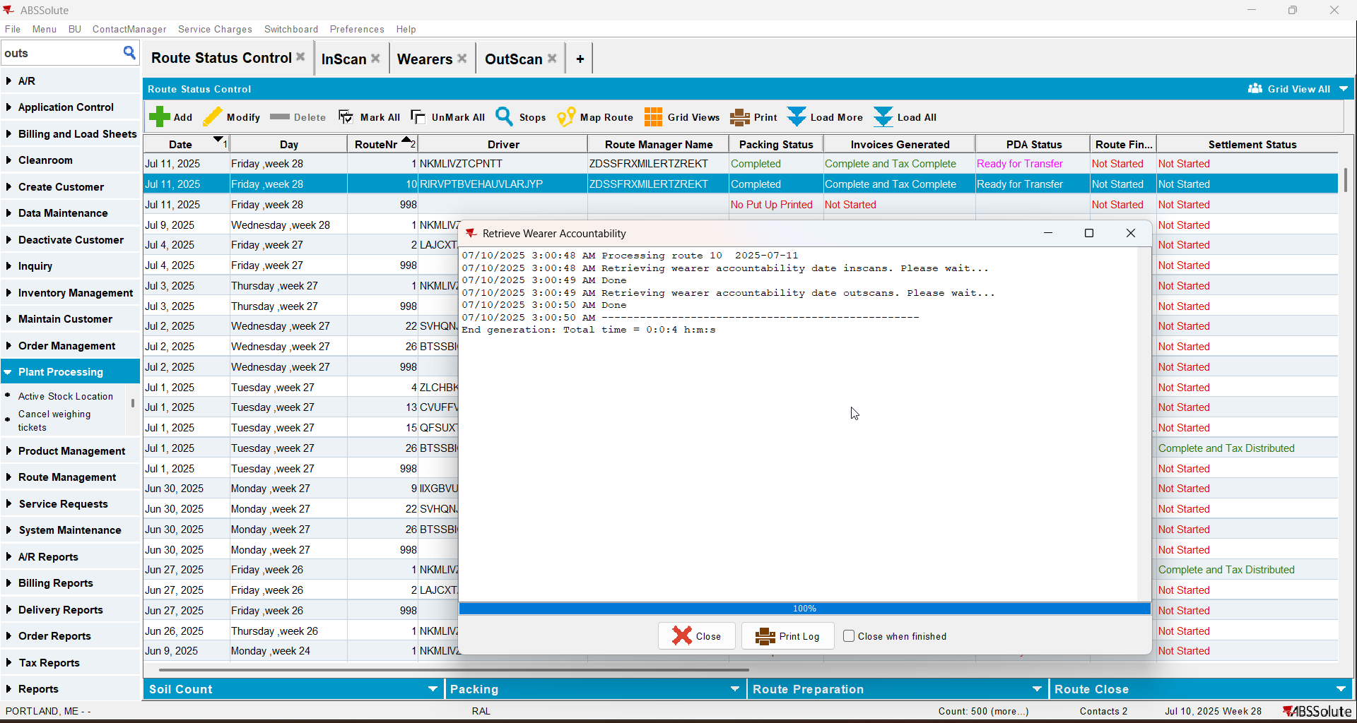
- After action finished check out there is recorded WearerActivity into dedicated table WEARERACCOUNTABILITYHIST for respective Customer WearerInventory on that Route DeliveryDate:
select c.customernumber, wah.* from WEARERACCOUNTABILITYHIST wah
join customer c on c.customer_id = wah.customer_id
where c.customernumber = 3742
and wah.deliverydate = to_date('11/07/2025', 'dd/mm/yyyy');

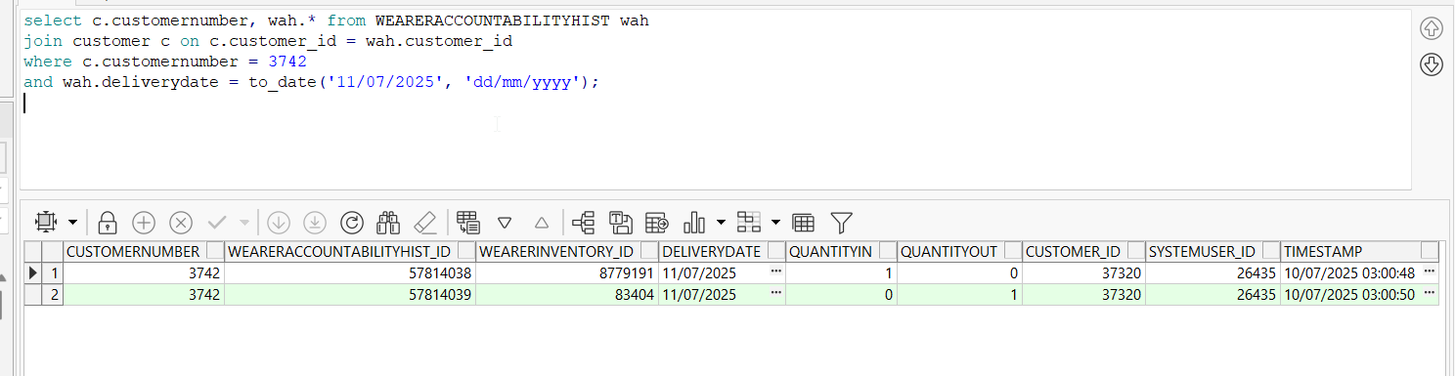
- RA: Download the route, arrive at the customer and enter Wearer / Customer Accountability
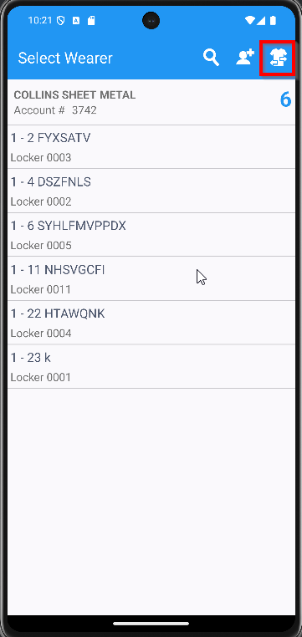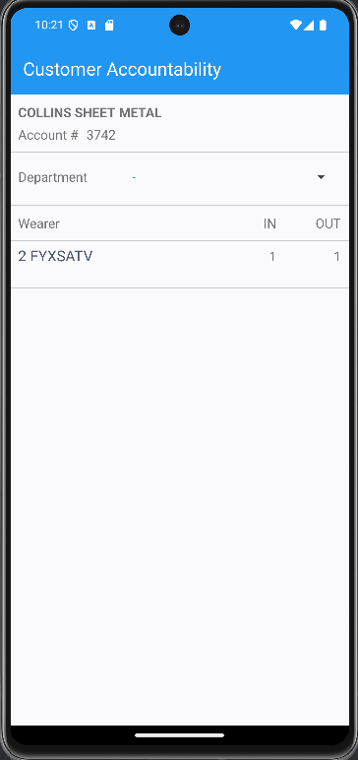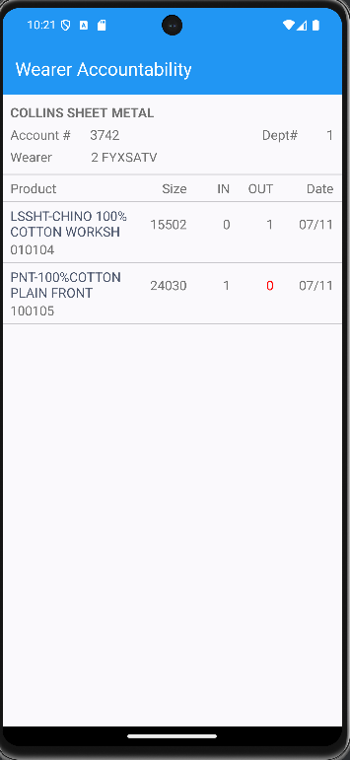

Using process Cancel and regenerate US direct invoices for late delivery notes
- RSC dlg: Mark ready for Re-Transfer. Remove the ready for Transfer Mark
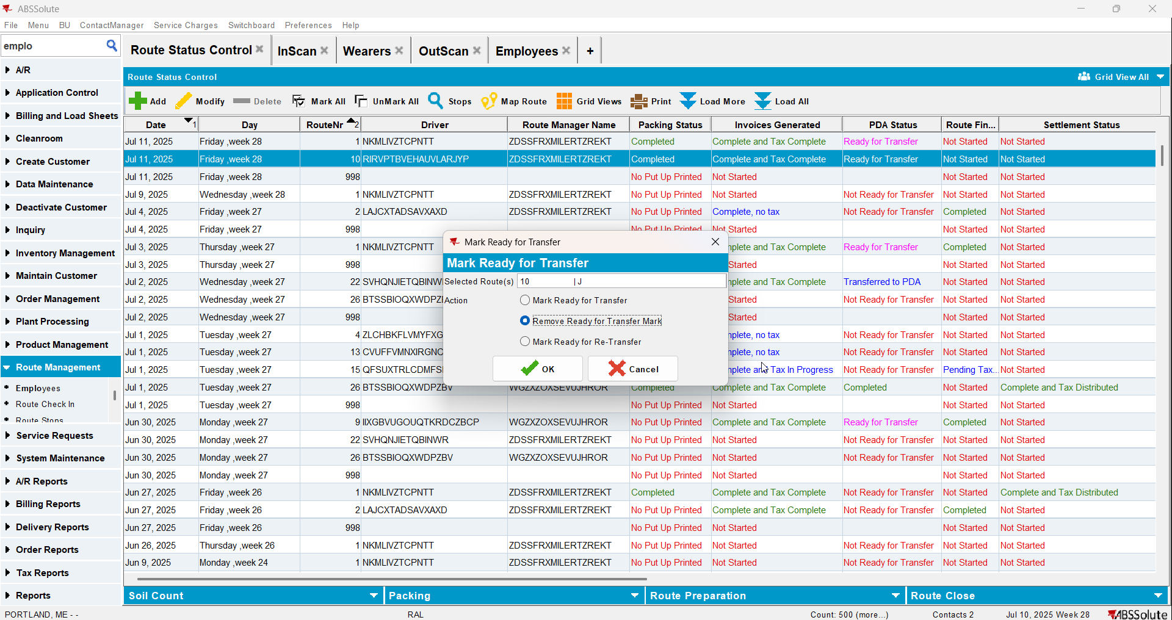
- Inscan dlg: scan another ticket
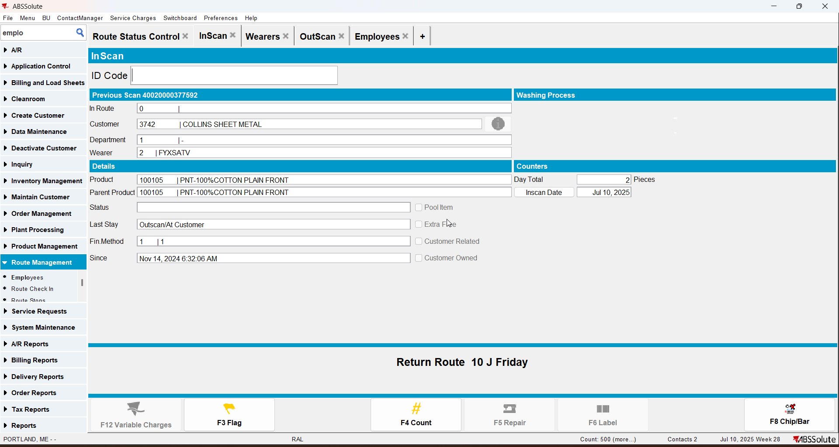
- Process Scheduler dlg: Run process Cancel and regenerate US direct invoices for late delivery notes
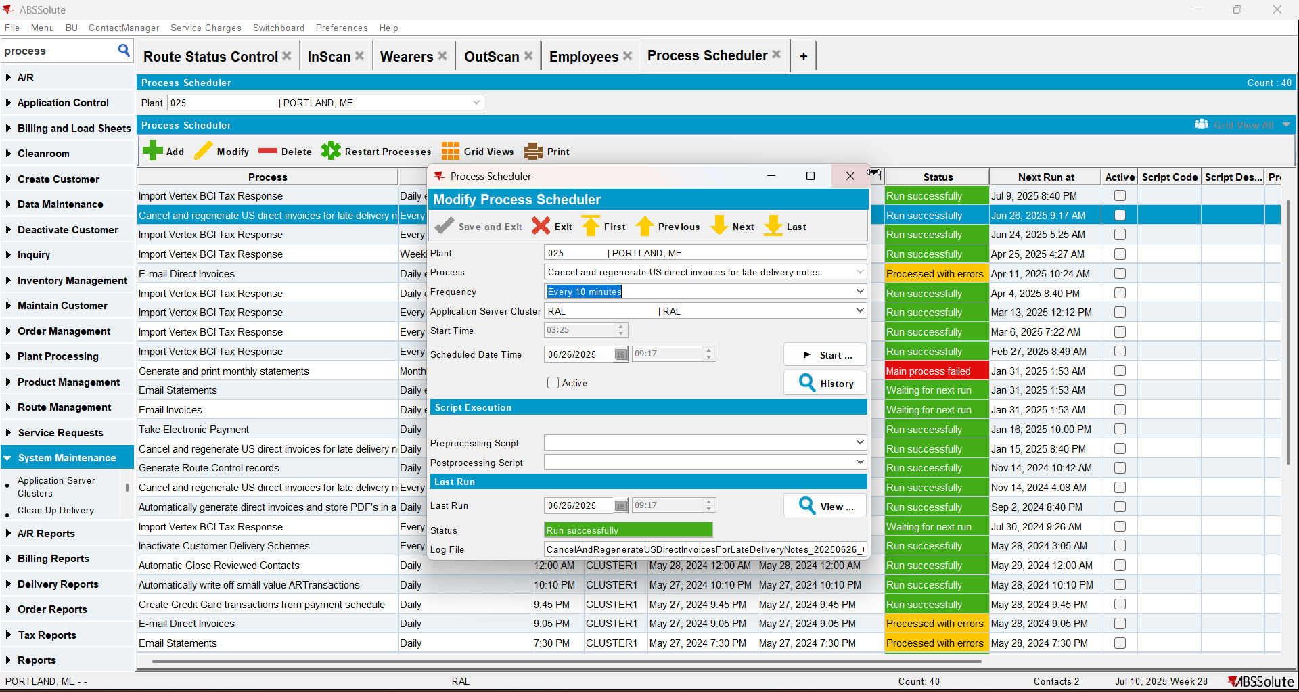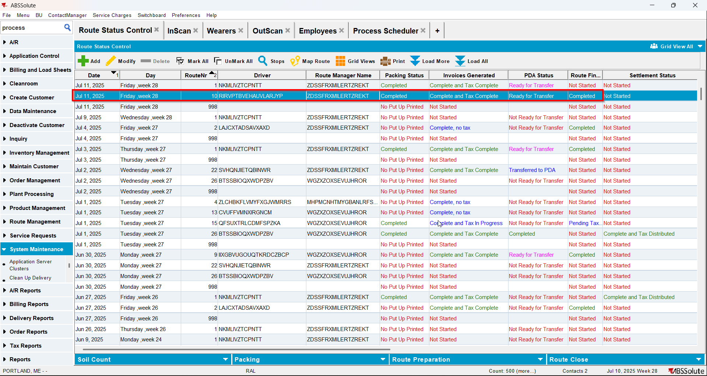

- After action finished check out there is recorded WearerActivity into dedicated table WEARERACCOUNTABILITYHIST for respective Customer WearerInventory on that Route DeliveryDate:
select c.customernumber, wah.* from WEARERACCOUNTABILITYHIST wah
join customer c on c.customer_id = wah.customer_id
where c.customernumber = 3742
and wah.deliverydate = to_date('11/07/2025', 'dd/mm/yyyy');
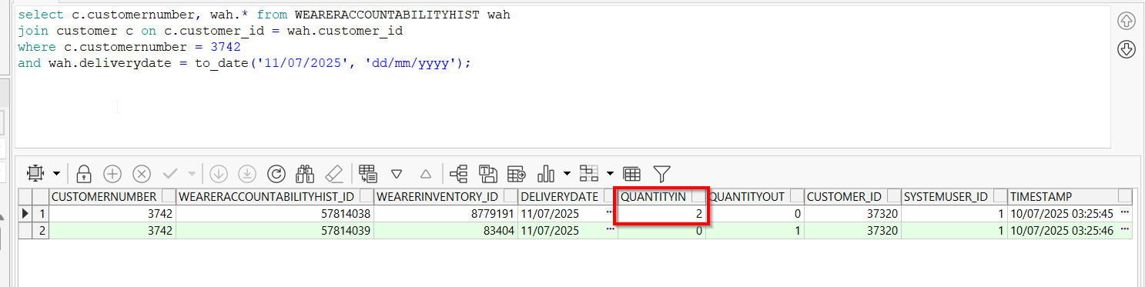
The extra garment scanned is present
- RA: Download the route, enter Wearers / Wearer accountability
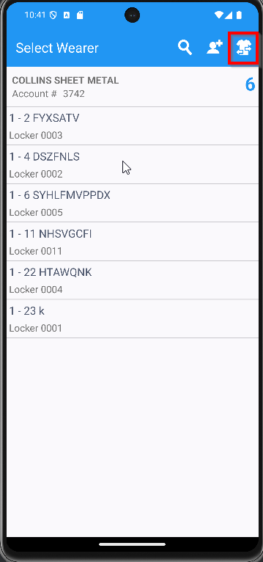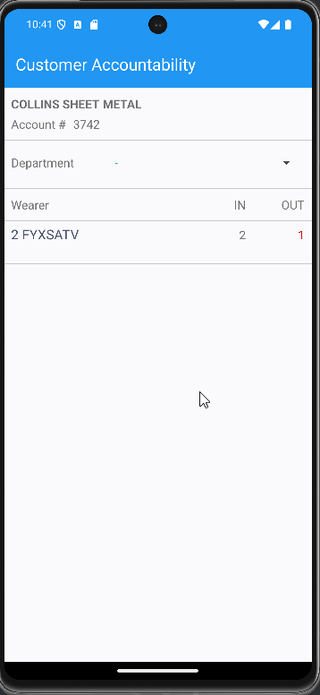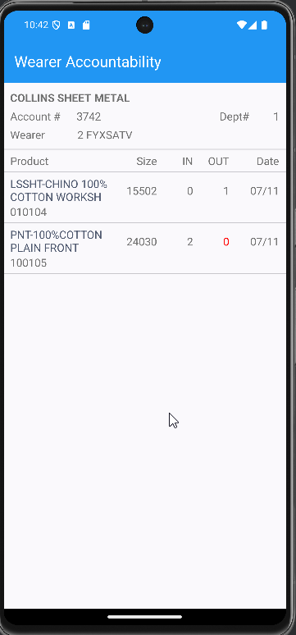
The extragarment is present

Route Finalization through REST

When the route finalization doesn’t find any late deliveries to attach to the route and regenerating the invoices are not necessary

- RSC dlg: Add a route. Keep at least 1 customer that has wearers.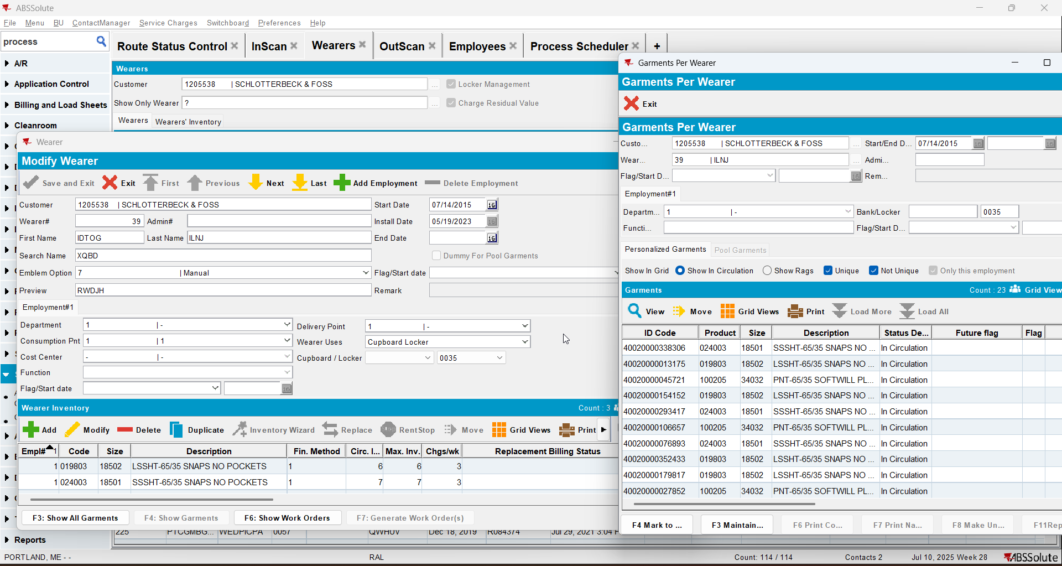
- RSC dlg: Generate put up documents, generate invoices, script the taxes.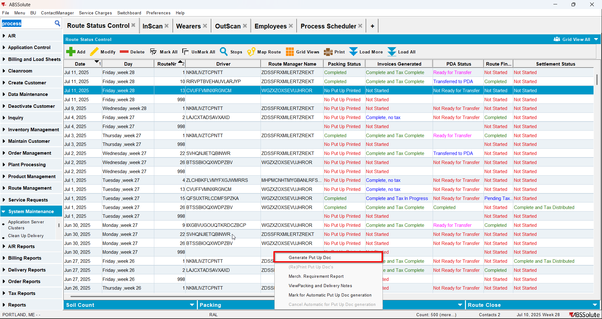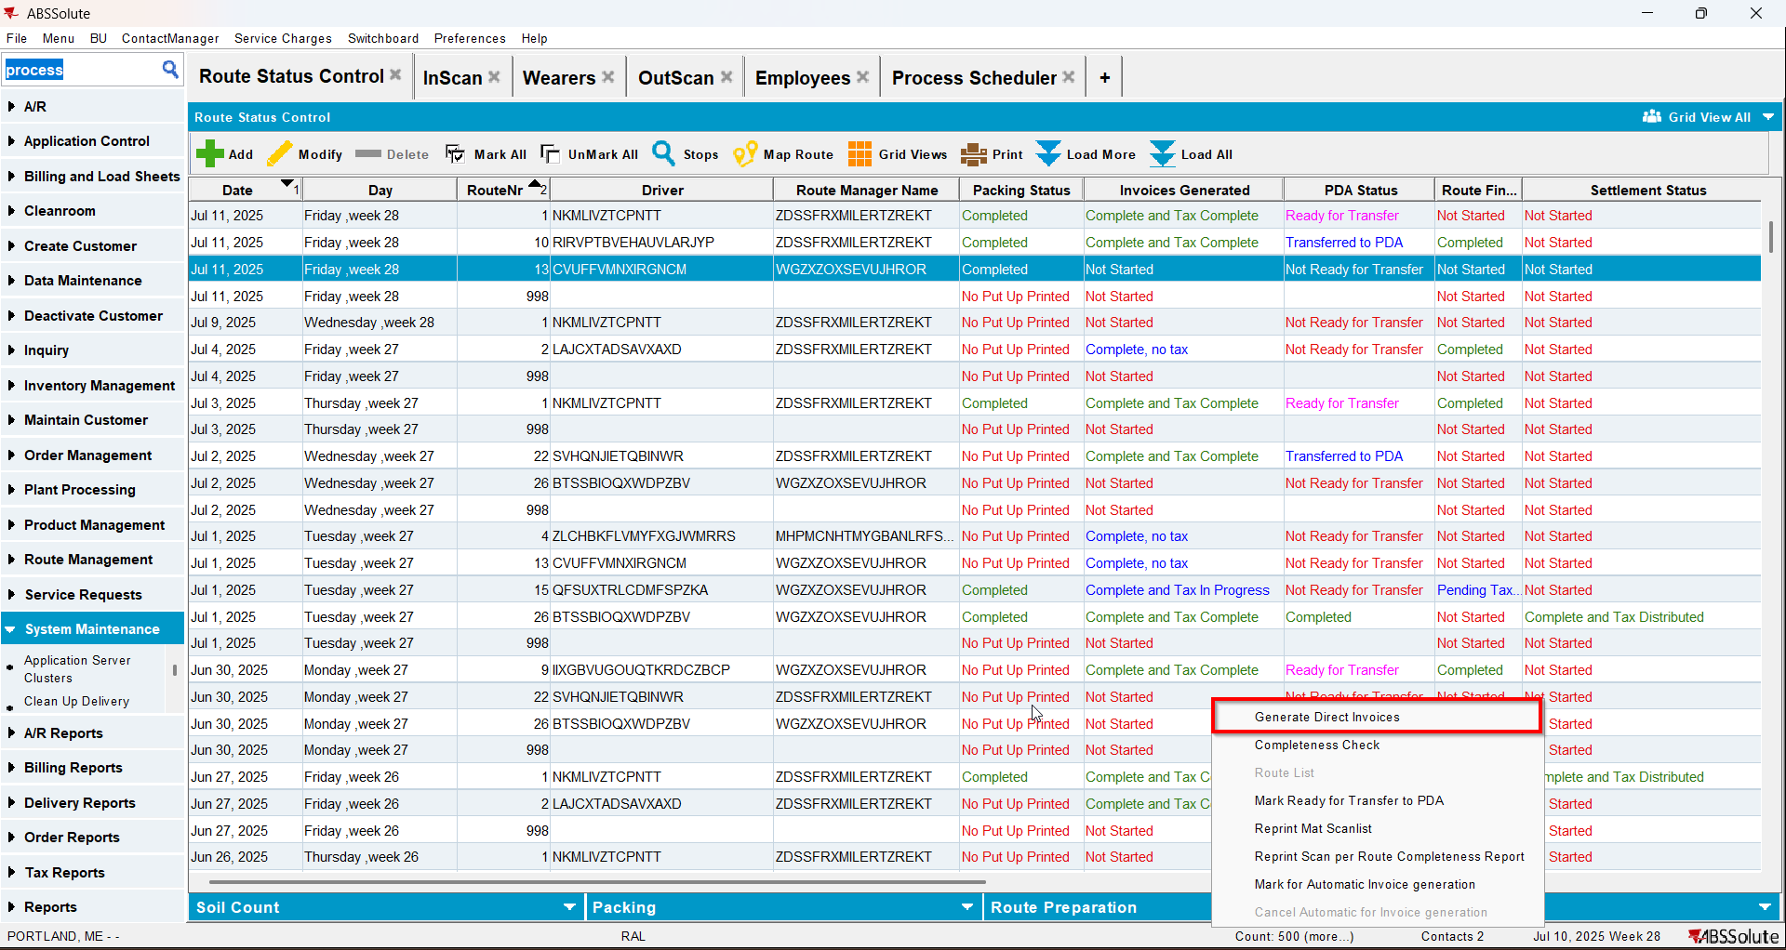
- Process Scheduler dlg: Run Import Vertex TAX BCI process.

- InScan dlg: Scan an unique garment from one of the customers wearer.
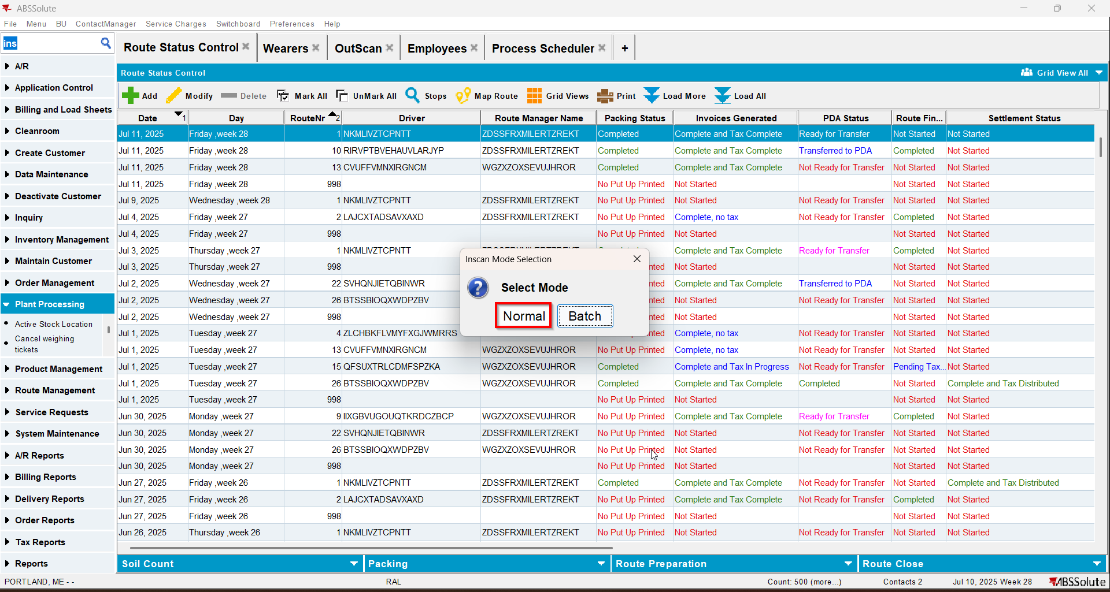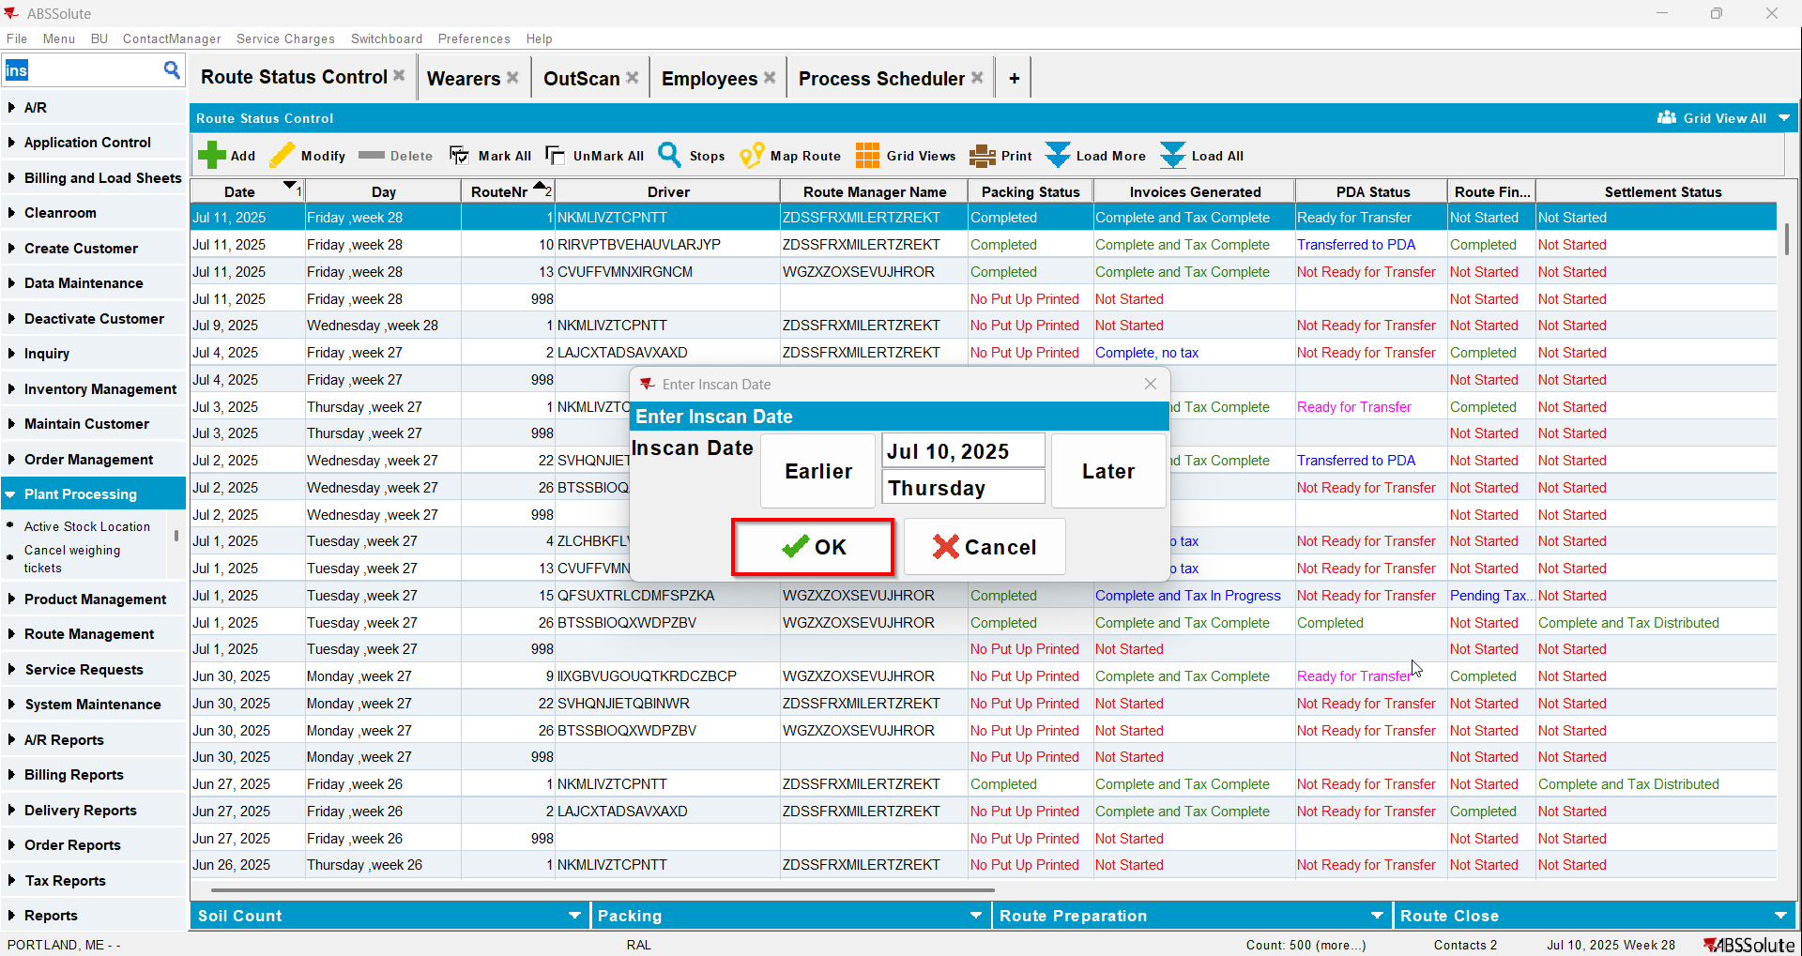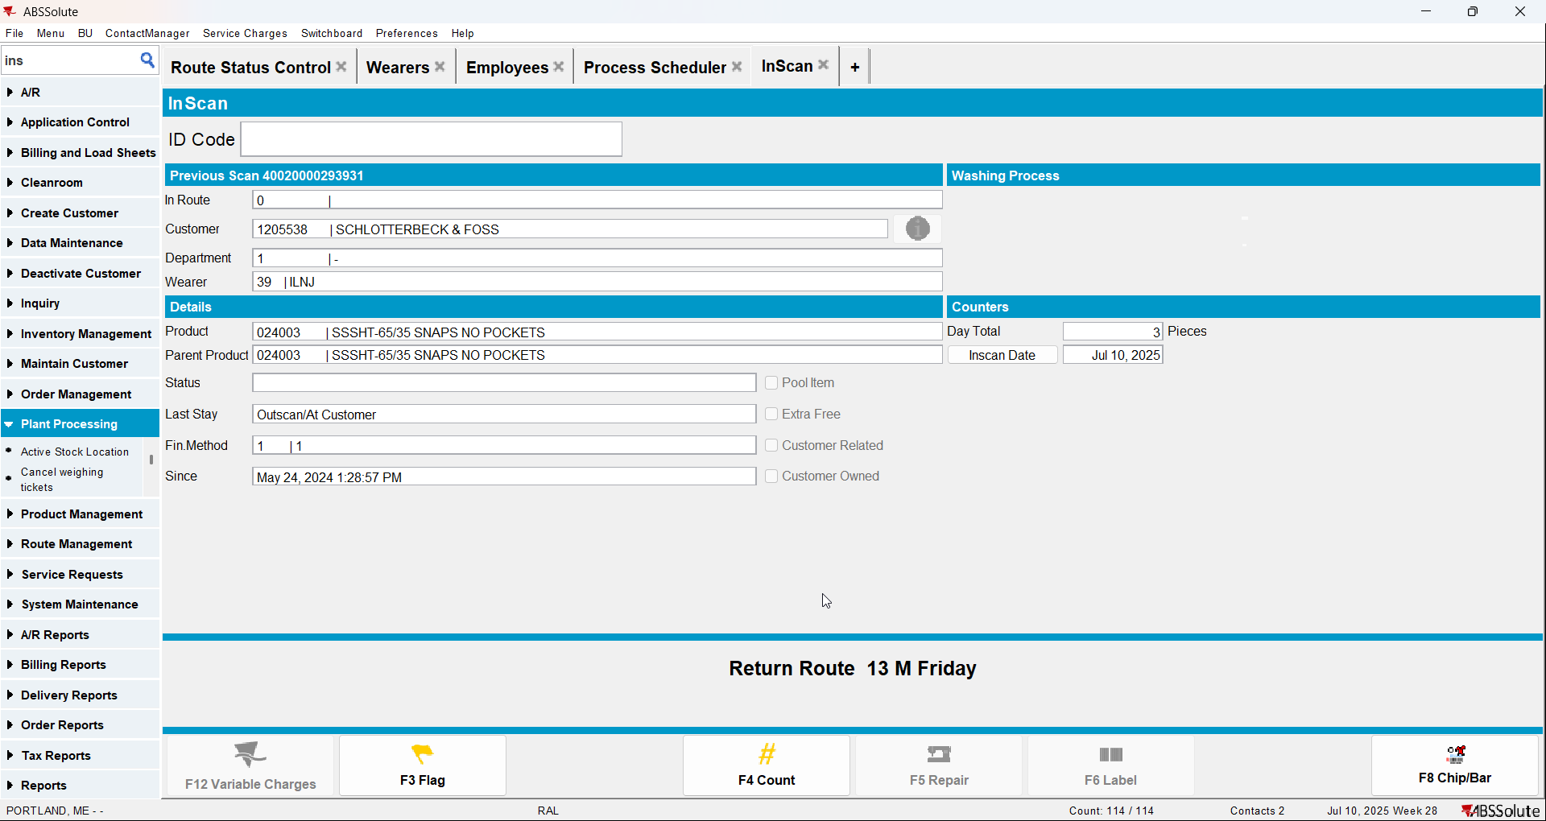

- OutScan dlg: Scan an unique garment from one of the customers wearer.

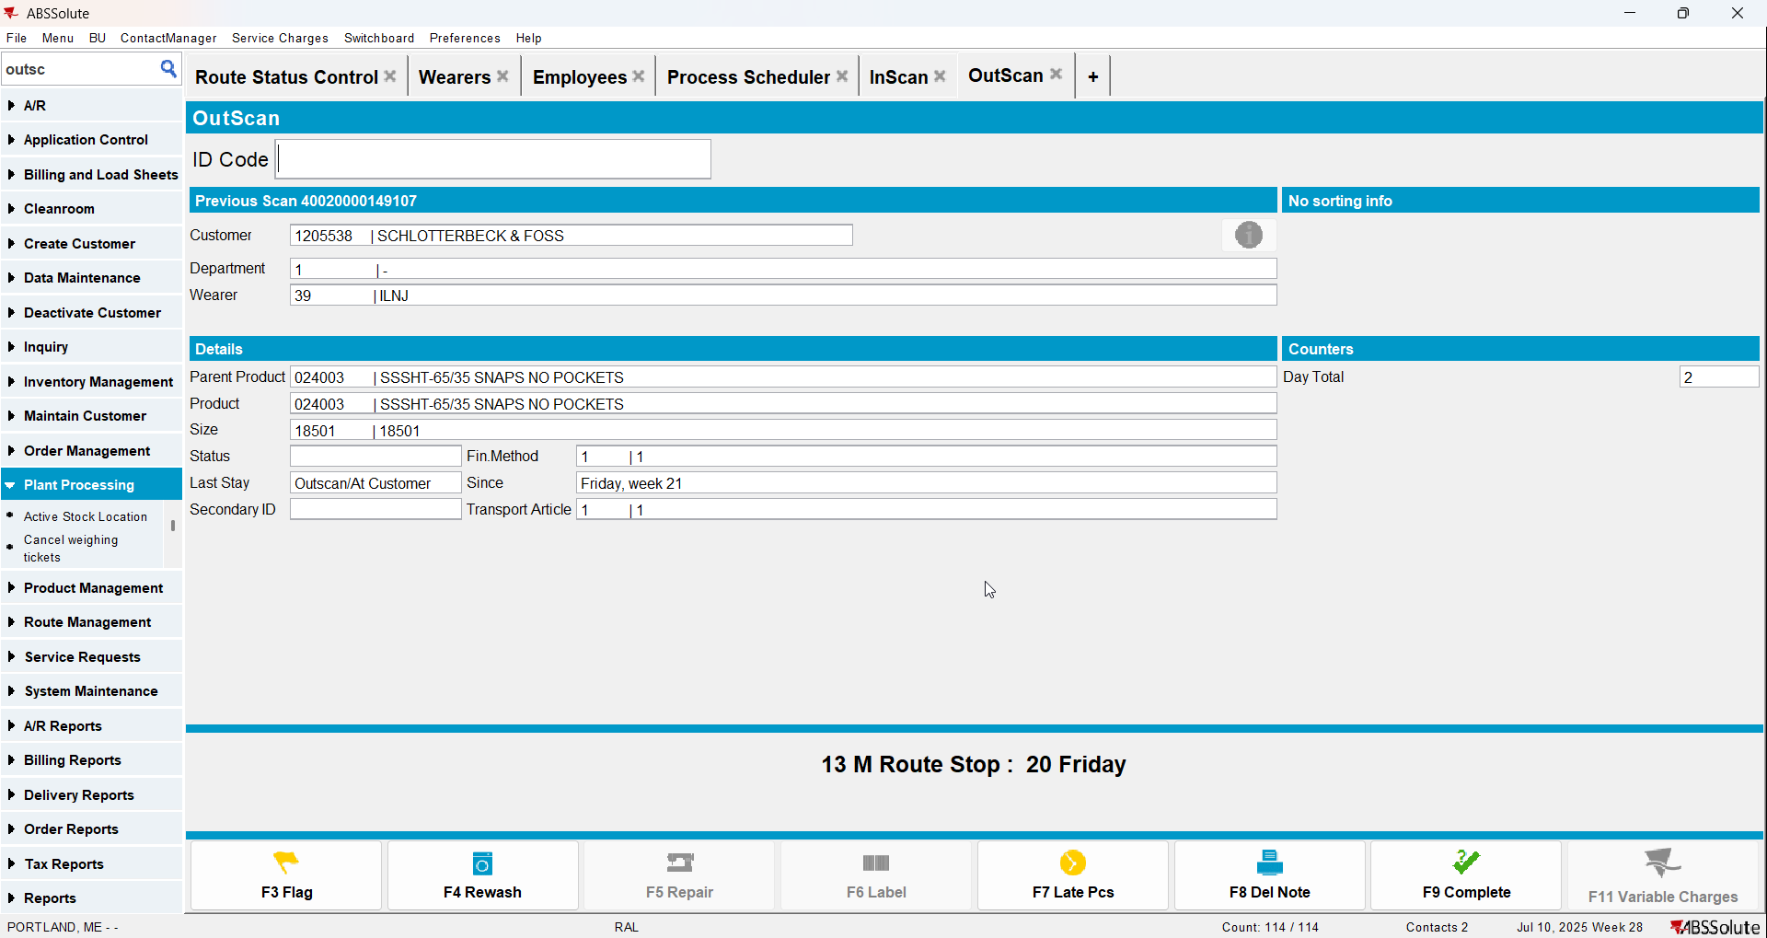
- Check the WearerActivity into dedicated table WEARERACCOUNTABILITYHIST for respective Customers
select c.customernumber, wah.* from WEARERACCOUNTABILITYHIST wah
join customer c on c.customer_id = wah.customer_id
where c.customernumber =1205538
and wah.deliverydate = to_date('11/07/2025', 'dd/mm/yyyy');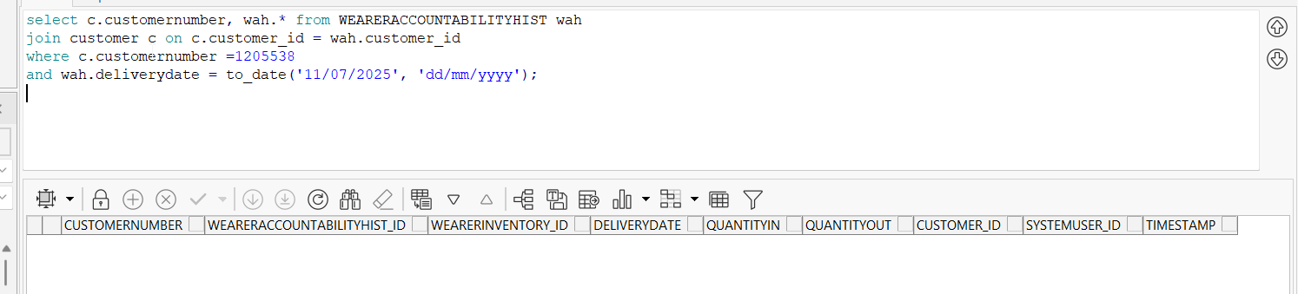
Is not recorded yet
- Postman: Run a rest call for route finalization for the route the customer is visited.

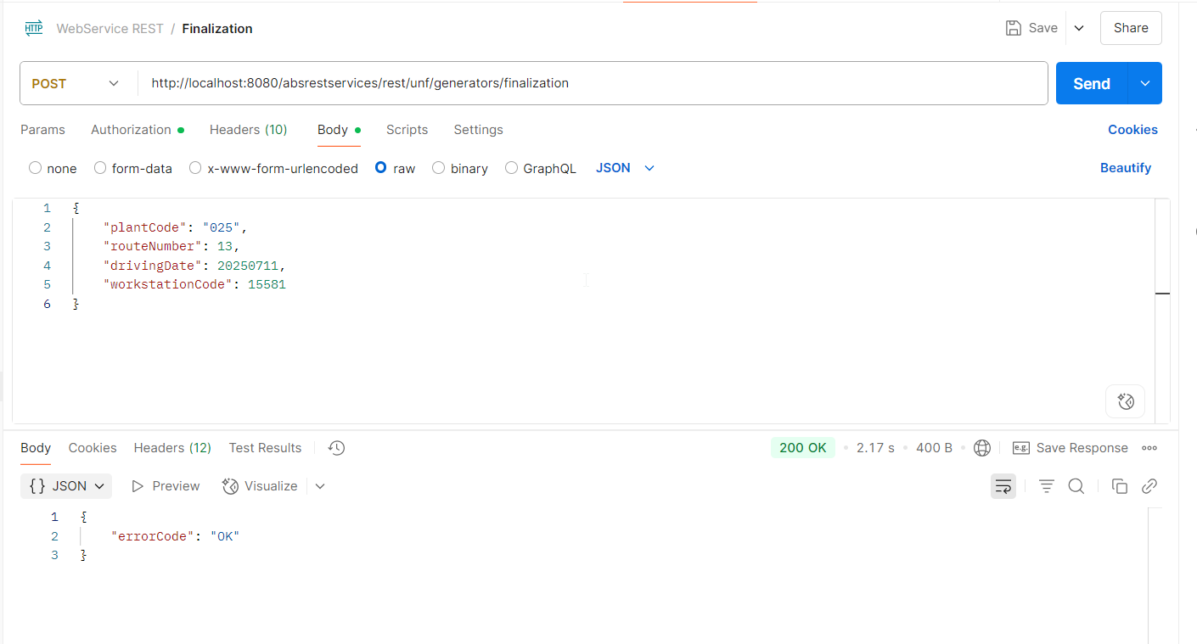
- RSC dlg: Recheck the statuses.
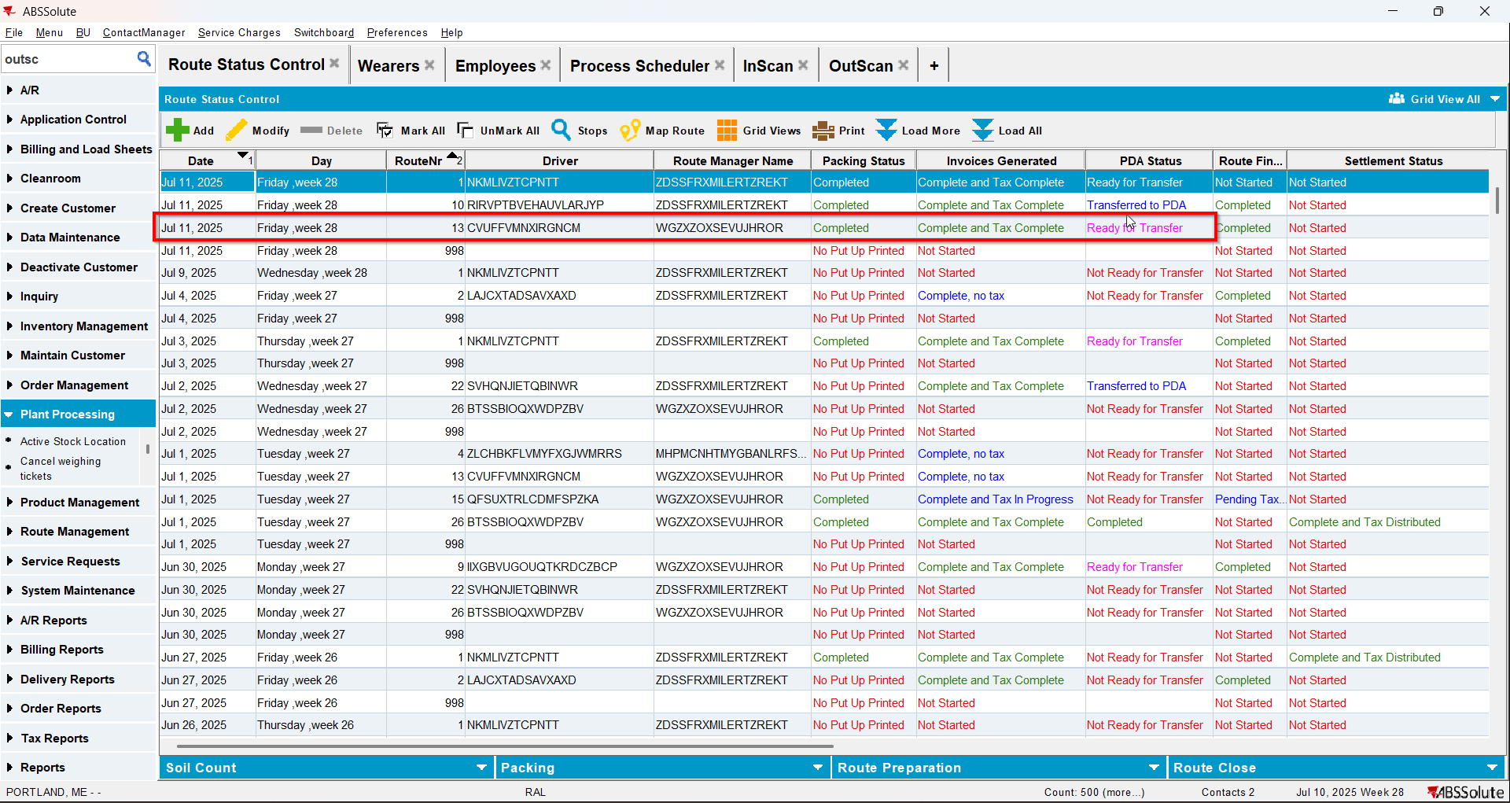
- After action finished check out the WearerActivity into dedicated table WEARERACCOUNTABILITYHIST for respective Customer WearerInventory on that Route DeliveryDate:
select c.customernumber, wah.* from WEARERACCOUNTABILITYHIST wah
join customer c on c.customer_id = wah.customer_id
where c.customernumber =1205538
and wah.deliverydate = to_date('11/07/2025', 'dd/mm/yyyy')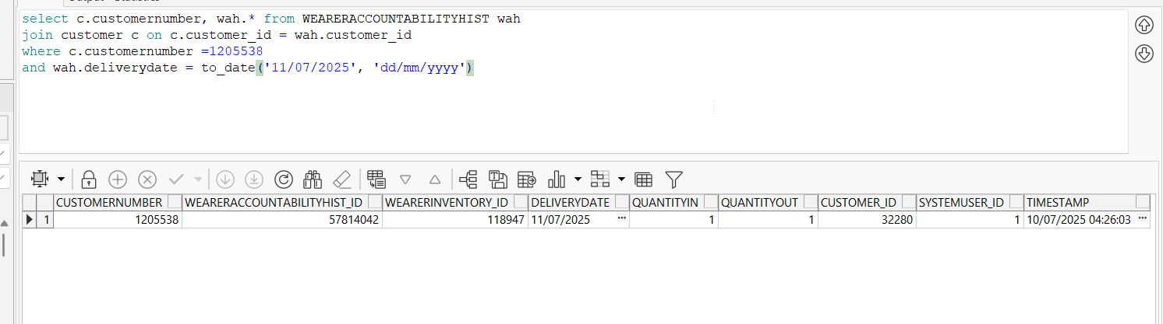
Scans appear and the PDA status was changed to Ready for Transfer and Route Finalization to Completed
- View Process log dlg: Check the Web Service section for Route Finalization.
The FillWearerAccountabilityHistRestService log was created after the web call
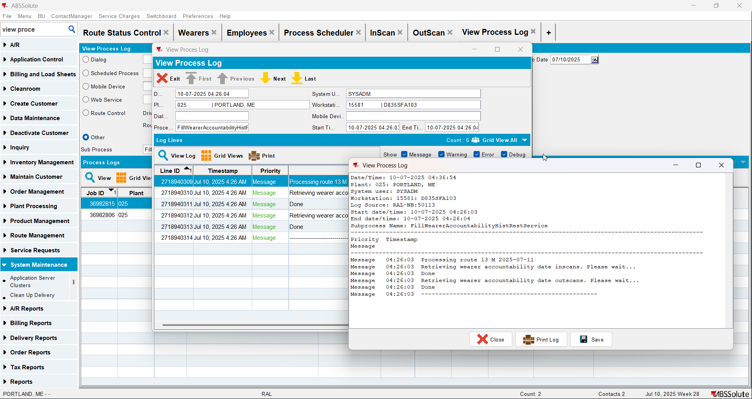
Generate Invoices log created but empty because no invoice regeneration was made because there were no late deliveries to attach to the route.
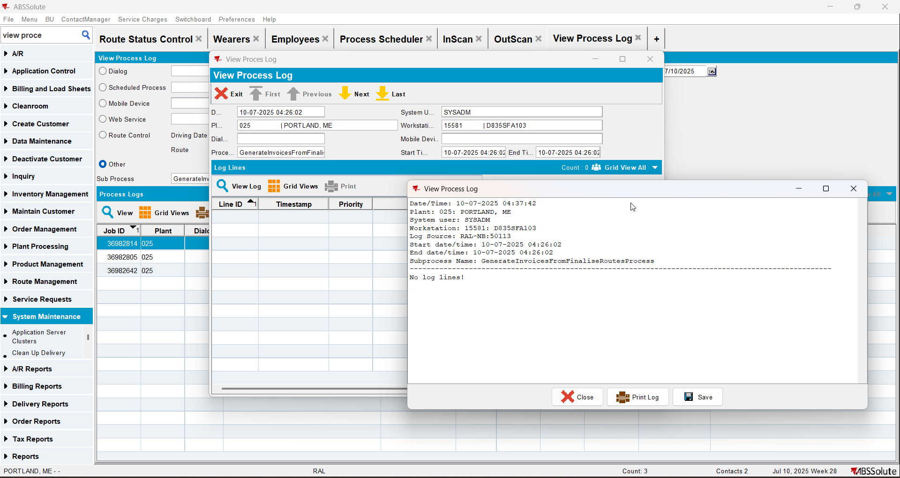
Route Finalization log created

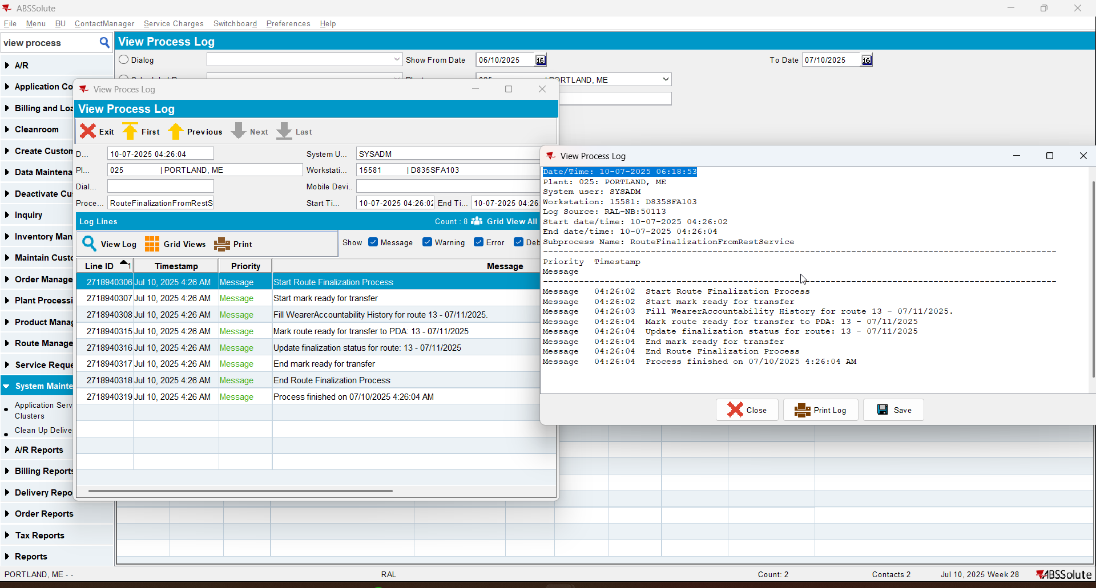

When the route finalization find any late deliveries to attach to the route and regenerating the invoices are necessary

- RSC dlg: Add another route. Keep at least 1 customer that has wearers
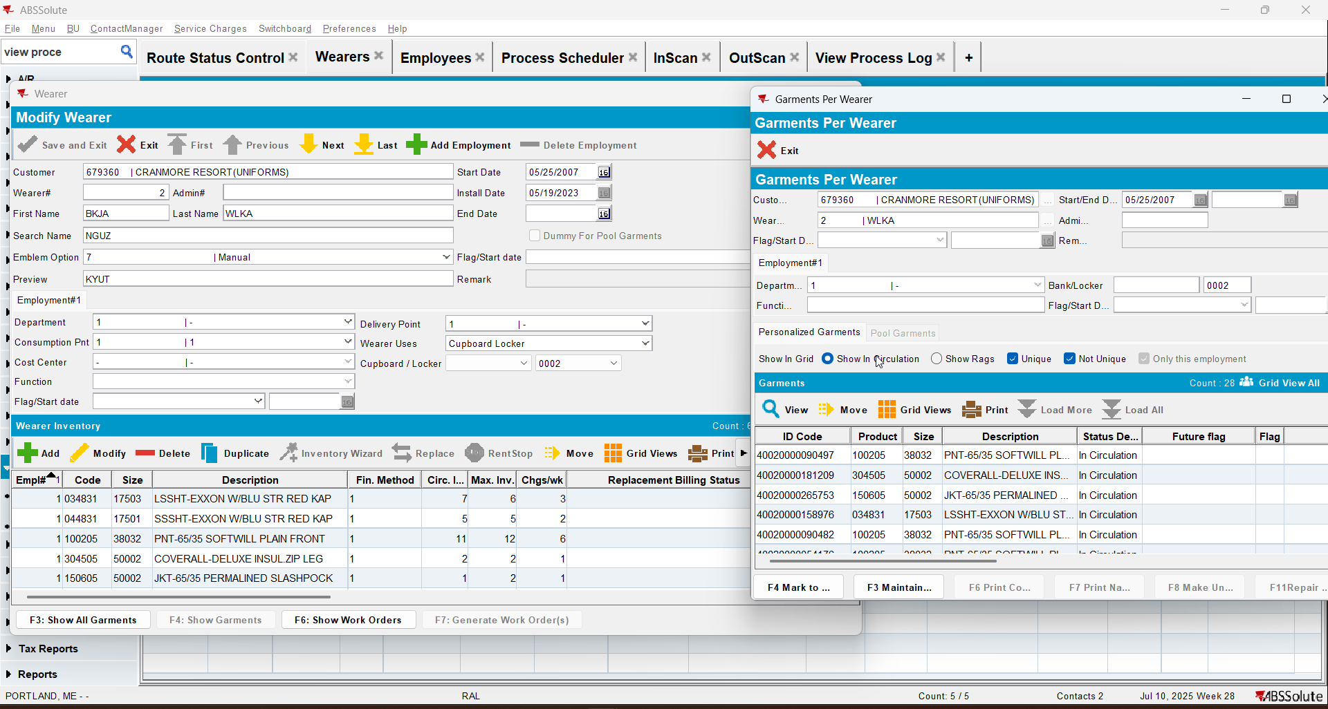
- InScan dlg: Scan one garment
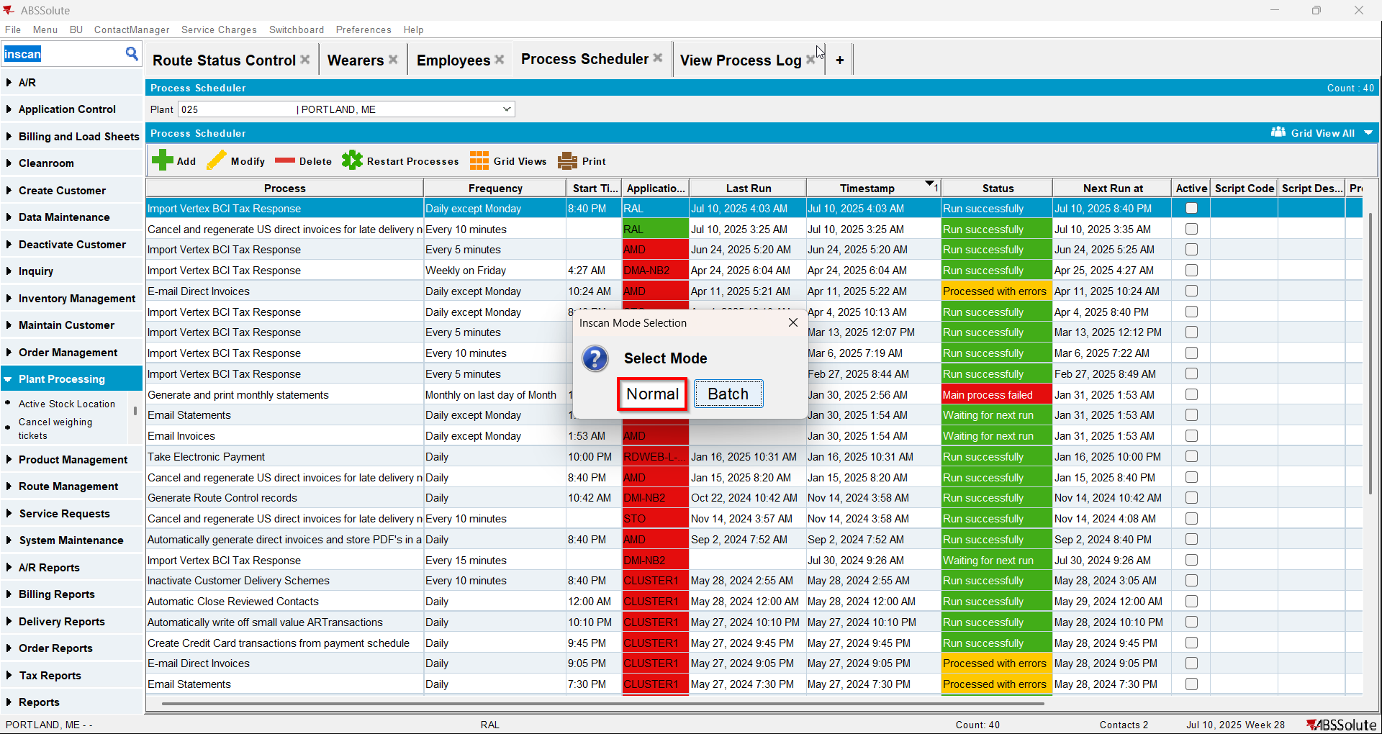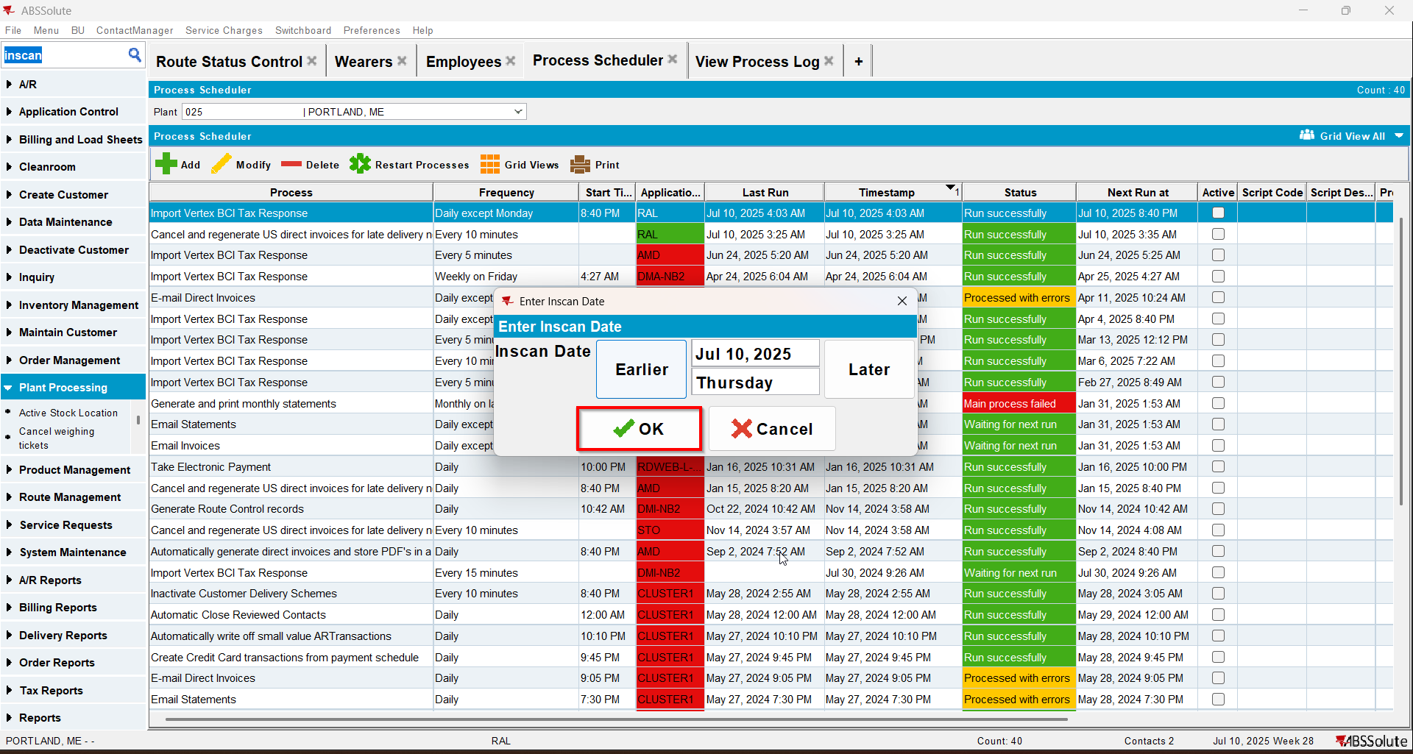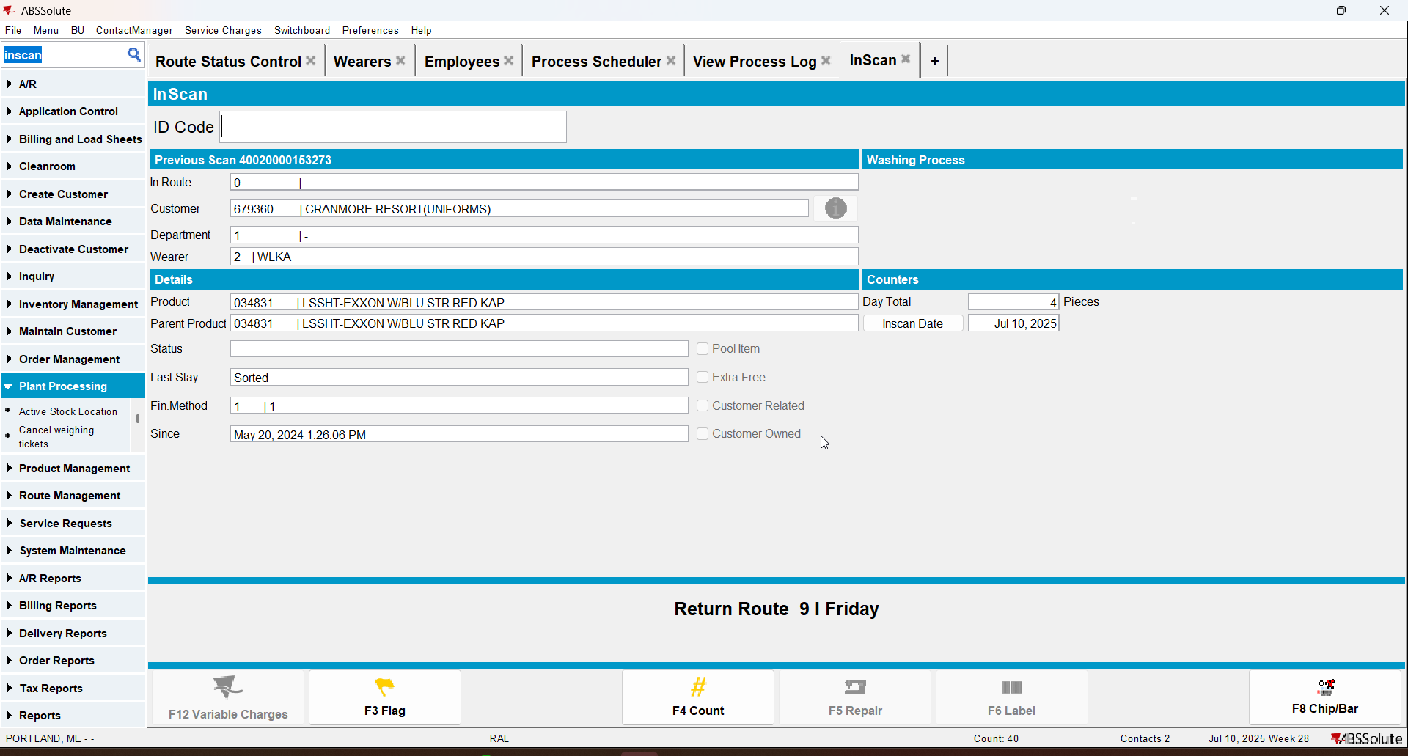

- OutScan dlg: Scan one garment.
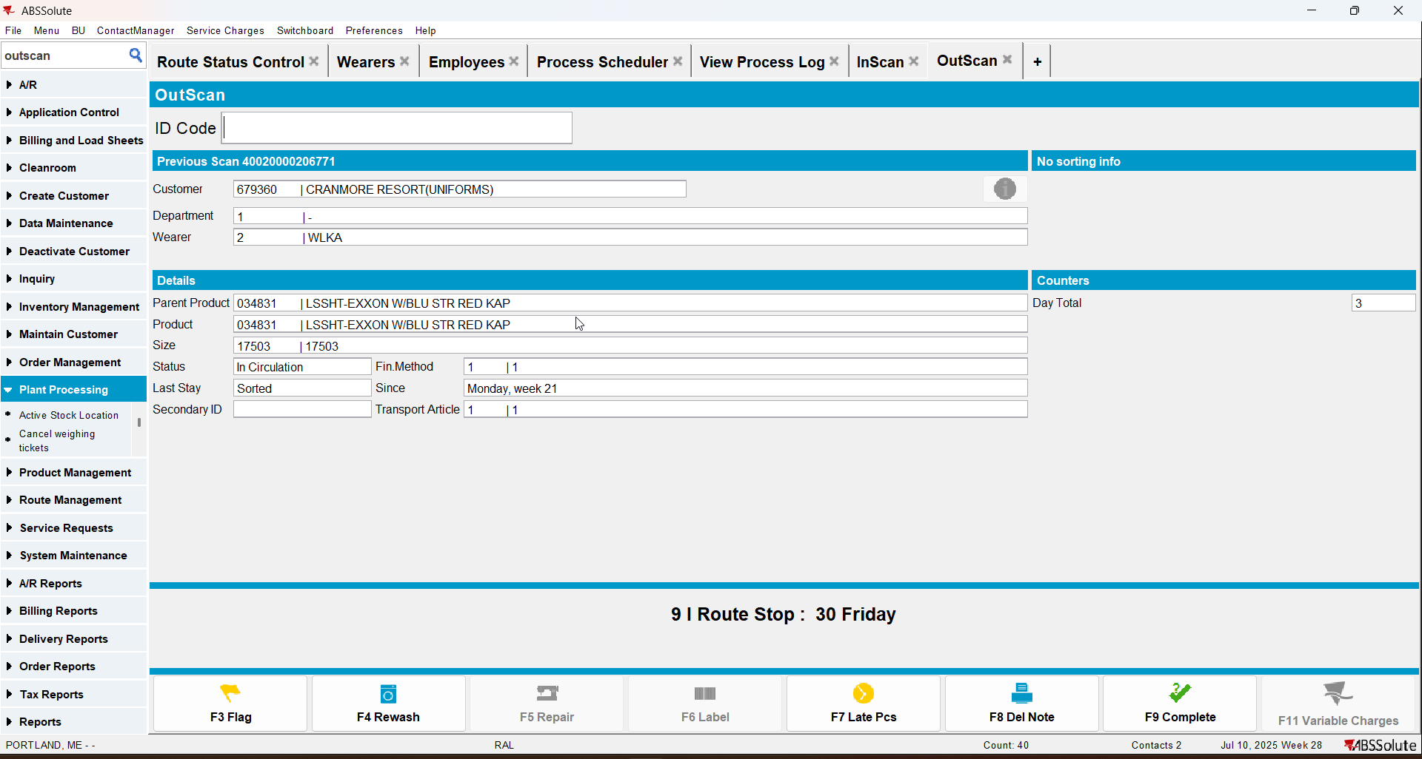
- RSC dlg: Generate packing note, invoices and script the taxes for the route.
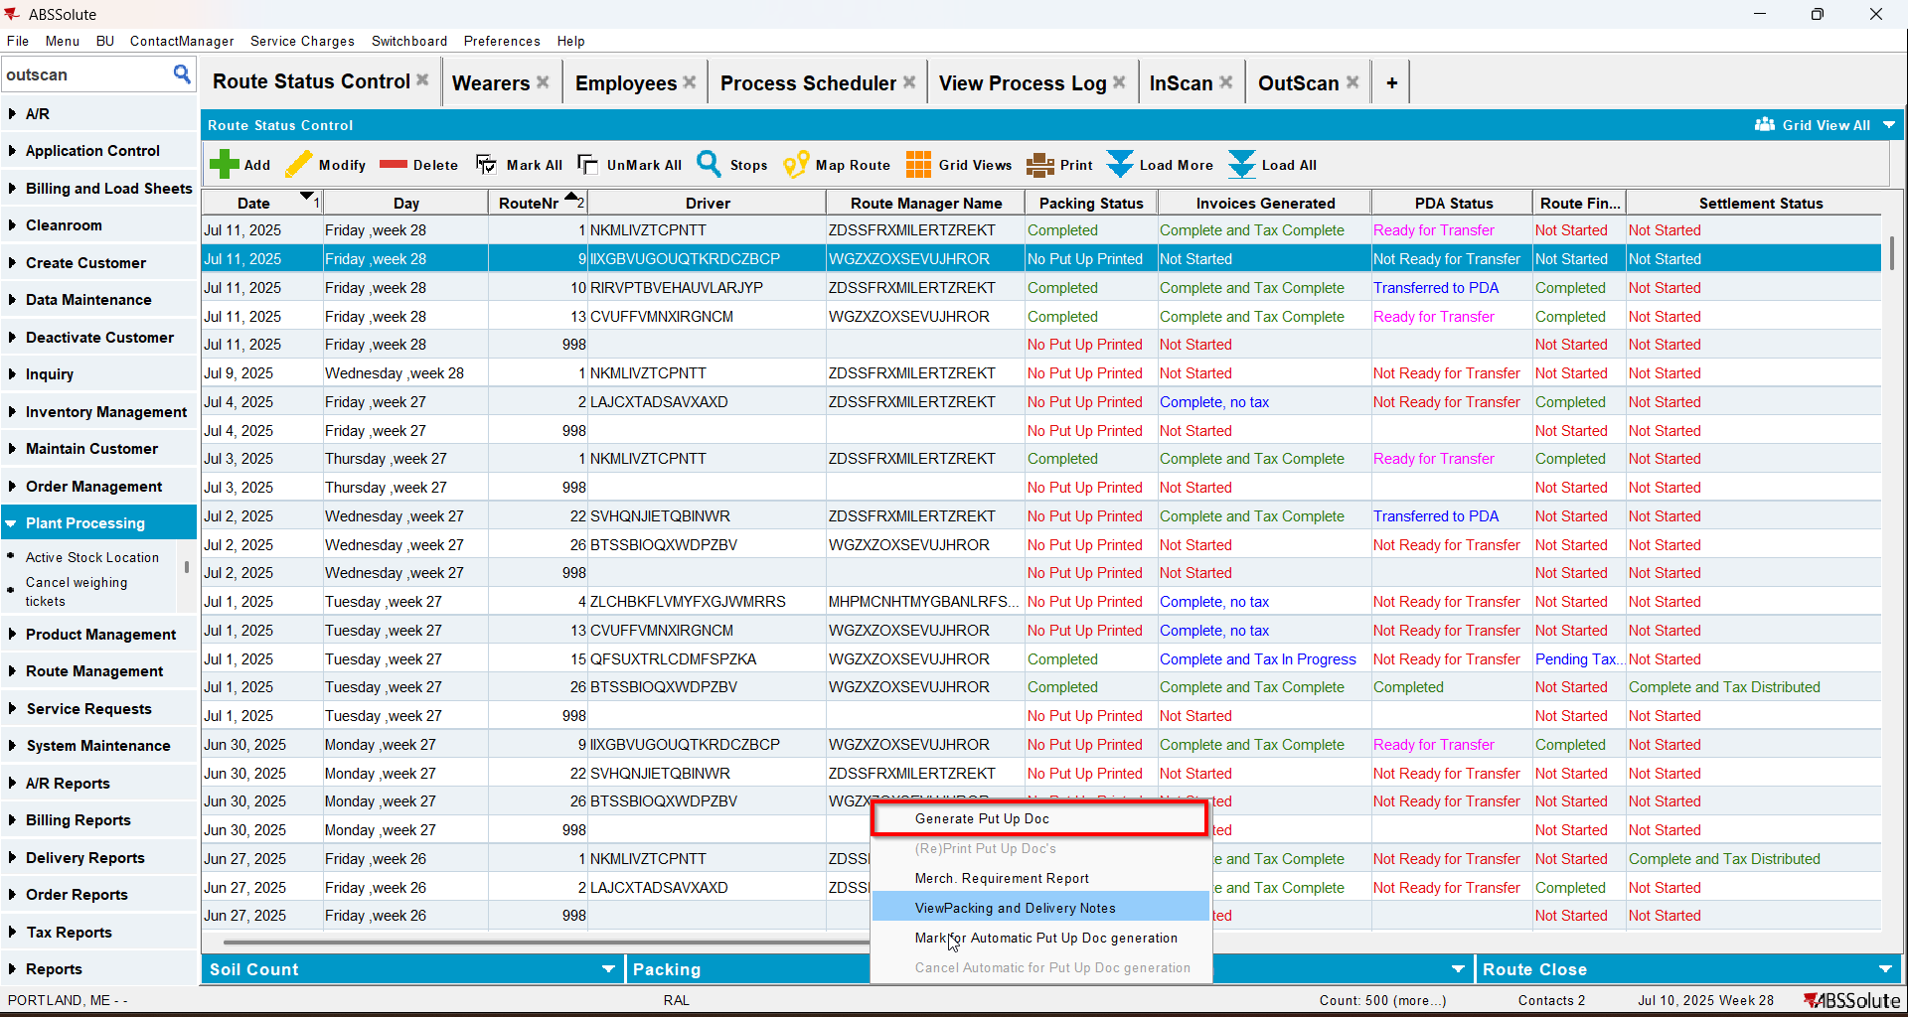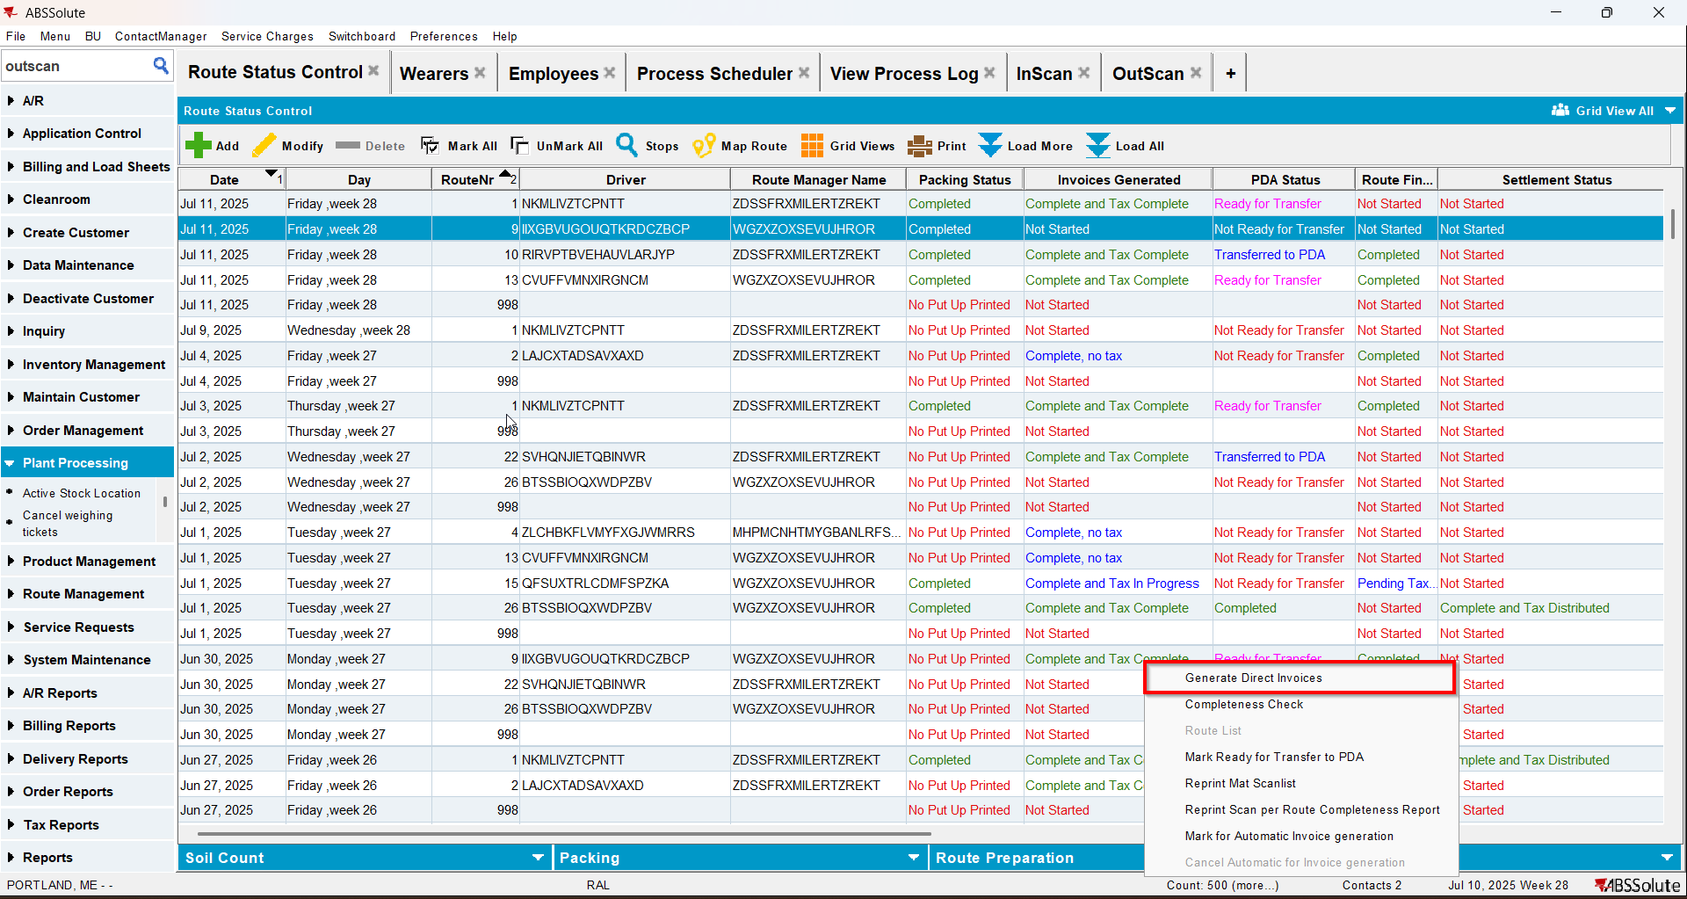
- Check the WearerActivity into dedicated table WEARERACCOUNTABILITYHIST for respective Customers
select c.customernumber, wah.* from WEARERACCOUNTABILITYHIST wah
join customer c on c.customer_id = wah.customer_id
where c.customernumber =679360
and wah.deliverydate = to_date('11/07/2025', 'dd/mm/yyyy');
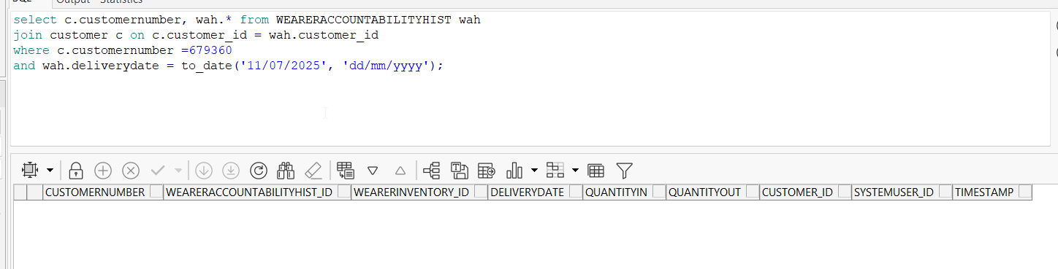
Is not recorded yet
- Maintain Sales Note dlg: Add a sales note for the customer.
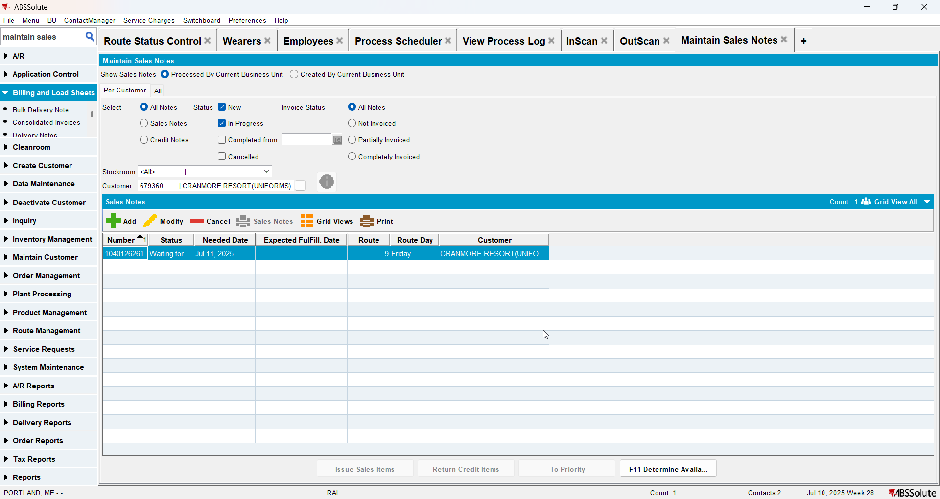
- Work Orders waiting for approval dlg: Approve the sale
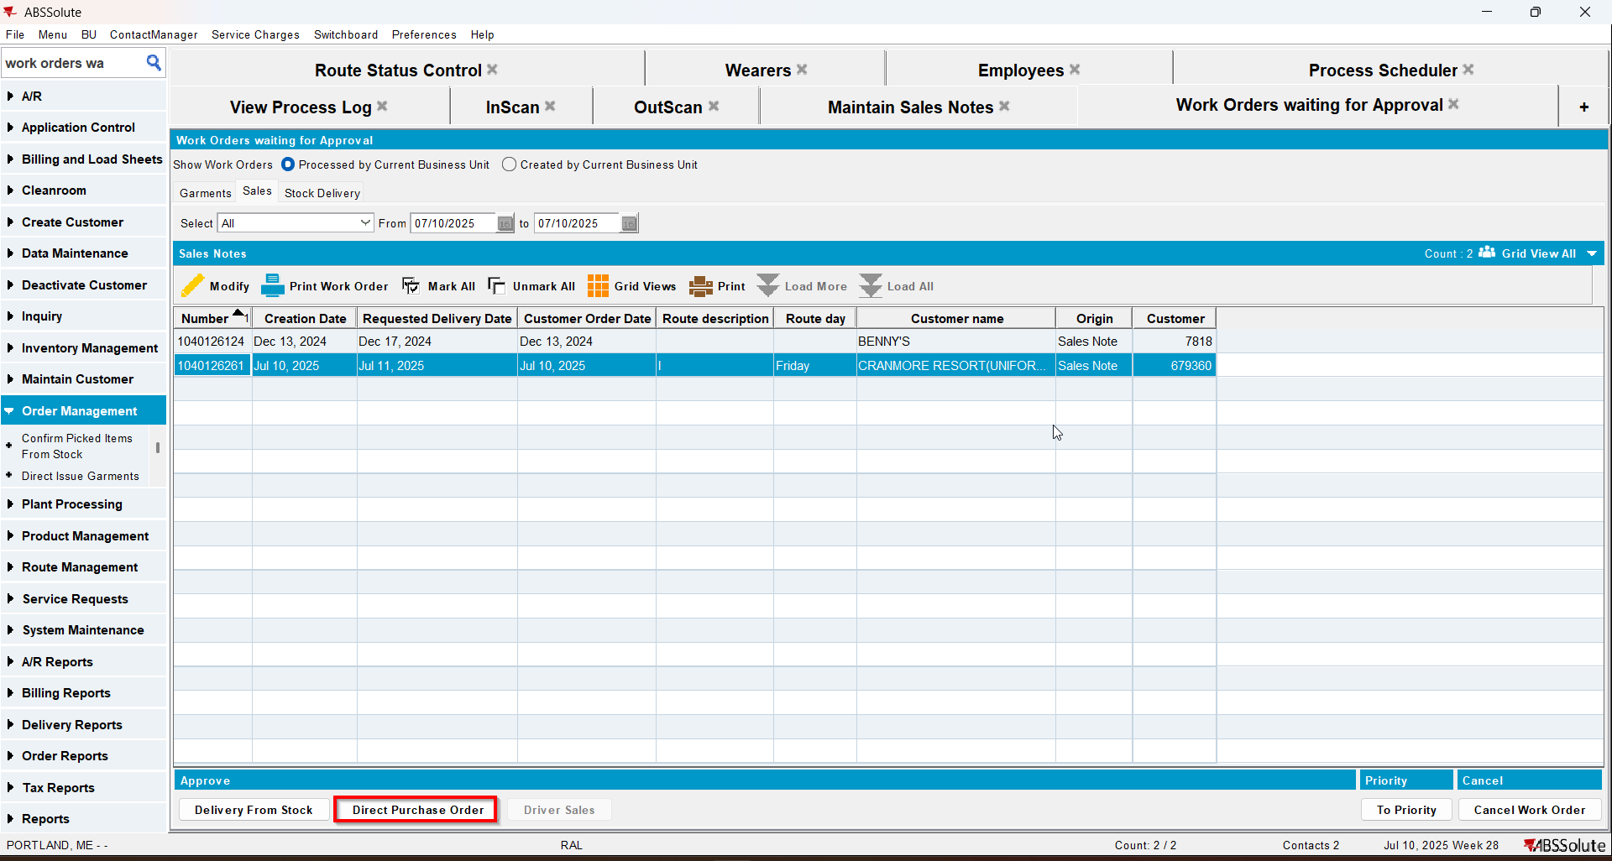
- Maintain Sales Note dlg: Issue the sales note with delivery date at least 1 day in the past from the route day.
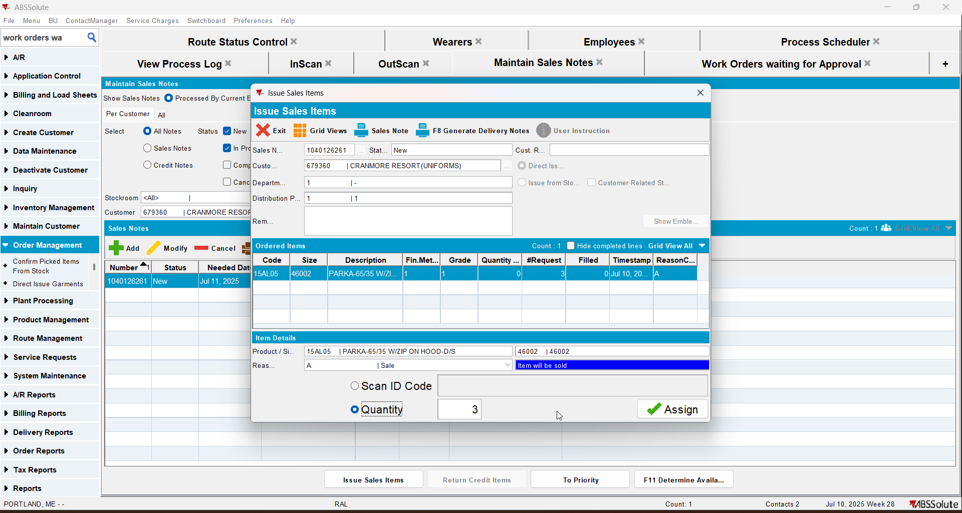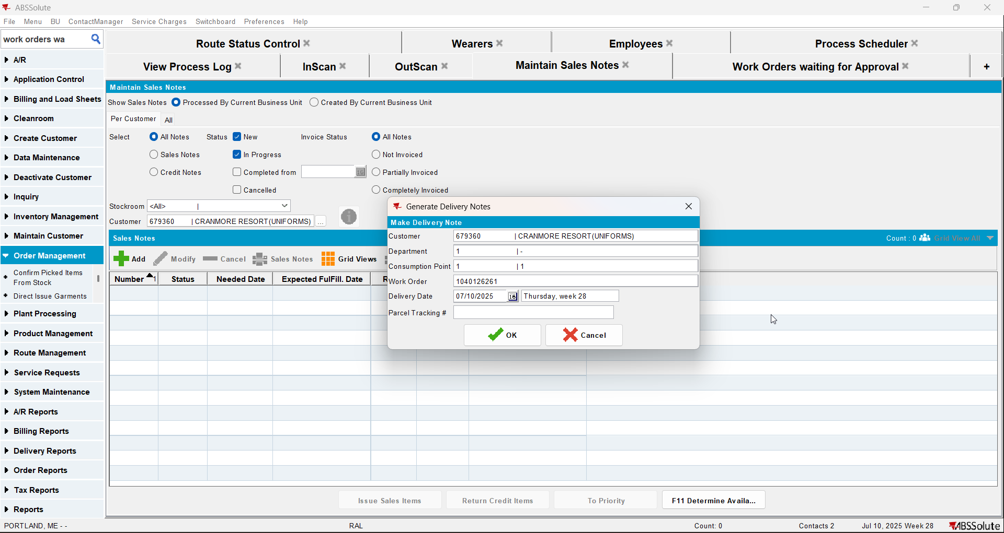

- Postman: Run a rest call for route finalization for the route the customer is visited.
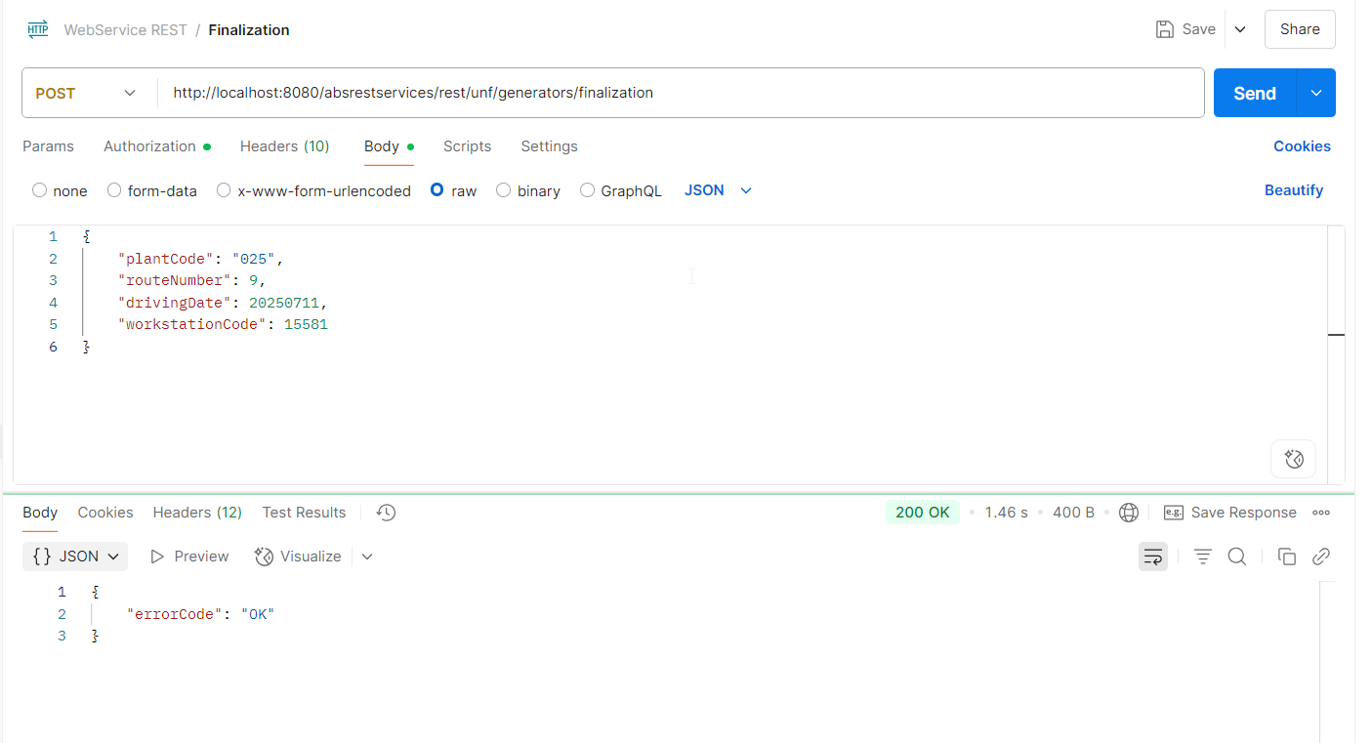
- RSC dlg: Recheck the statuses.
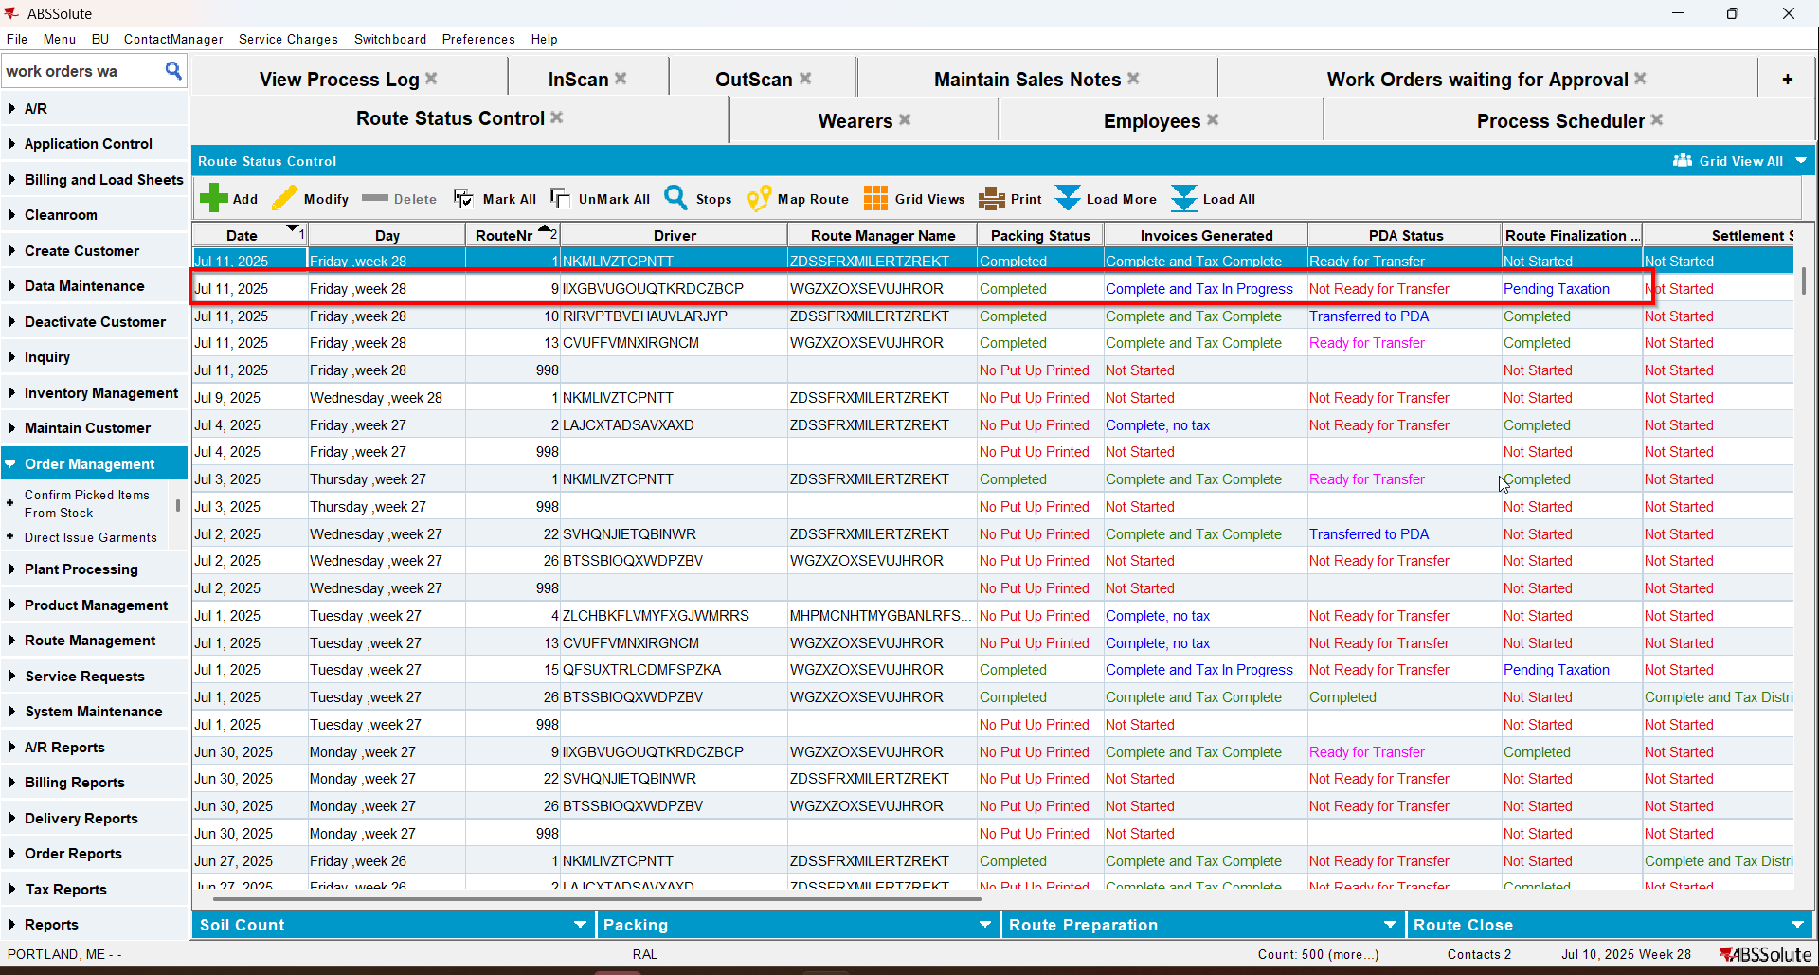
- After action finished check out the WearerActivity into dedicated table WEARERACCOUNTABILITYHIST for respective Customer WearerInventory on that Route DeliveryDate:

select c.customernumber, wah.* from WEARERACCOUNTABILITYHIST wah
join customer c on c.customer_id = wah.customer_id
where c.customernumber =679360
and wah.deliverydate = to_date('11/07/2025', 'dd/mm/yyyy');
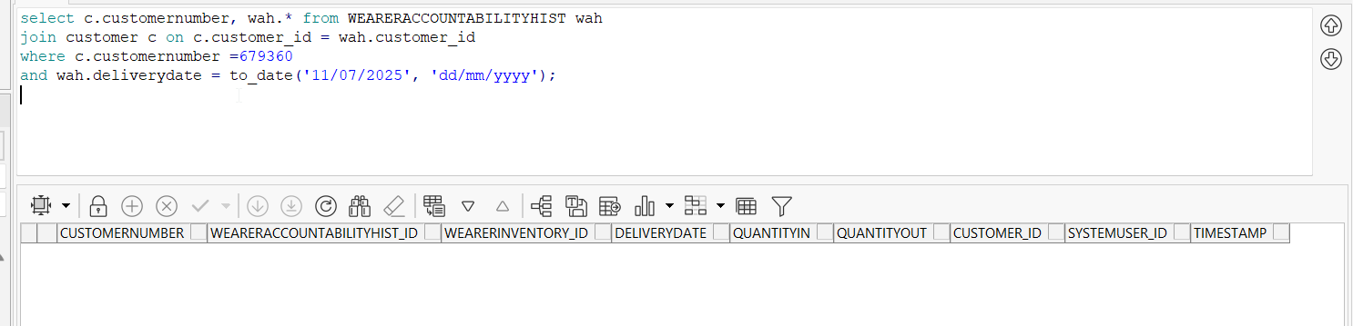
No scans appear just yet as the PDA status is not transferred until taxes are done
- View Process log dlg: Check the Web Service section for Route Finalization.
Check the Process Delivery Notes
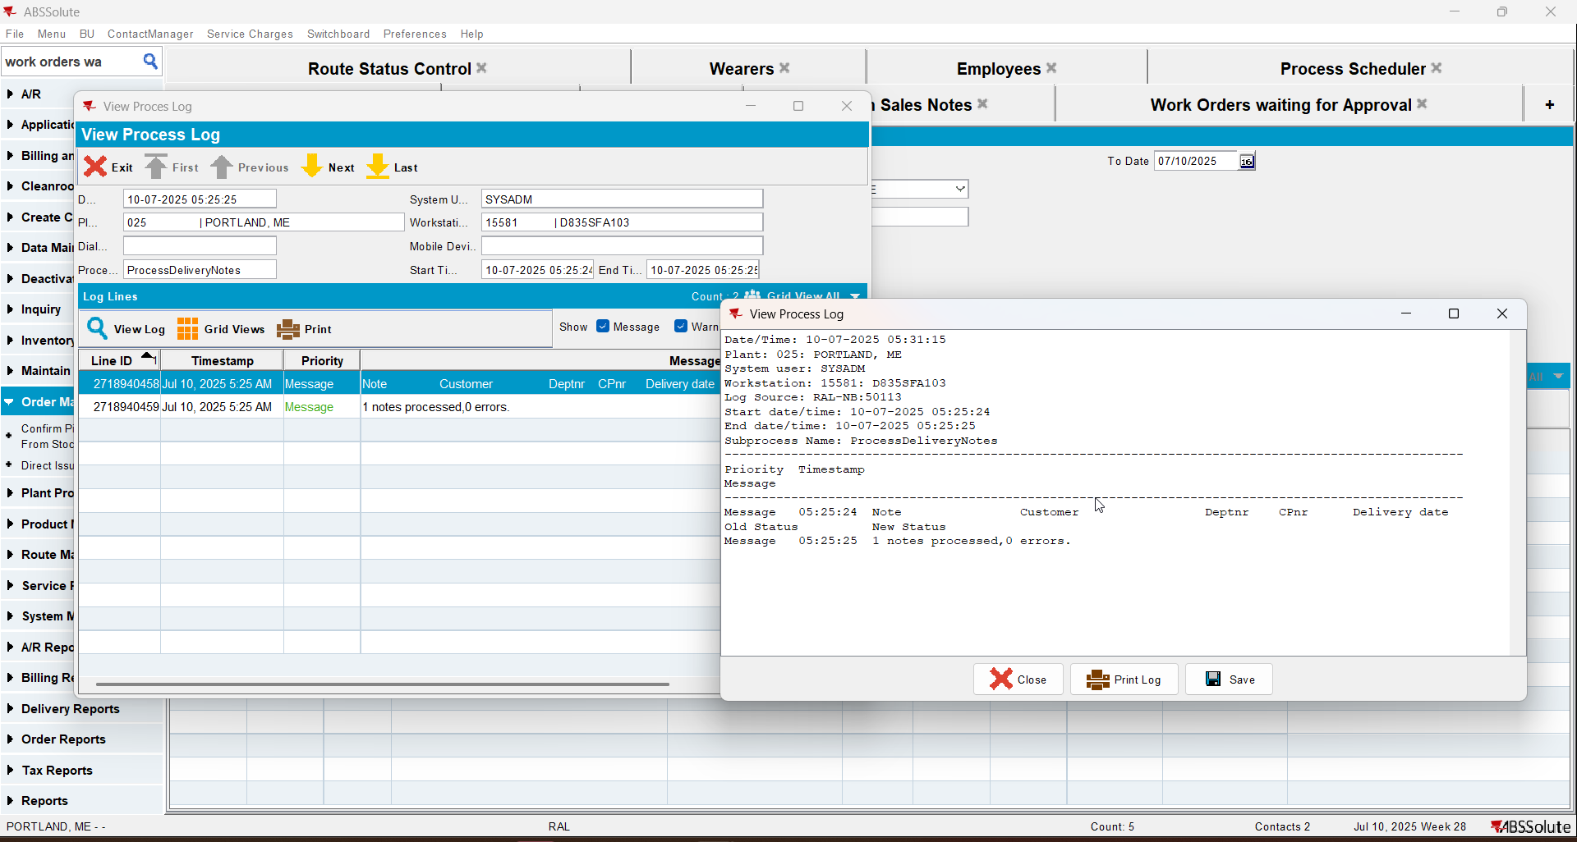
Generate invoices, grap the batch id to script the taxes.
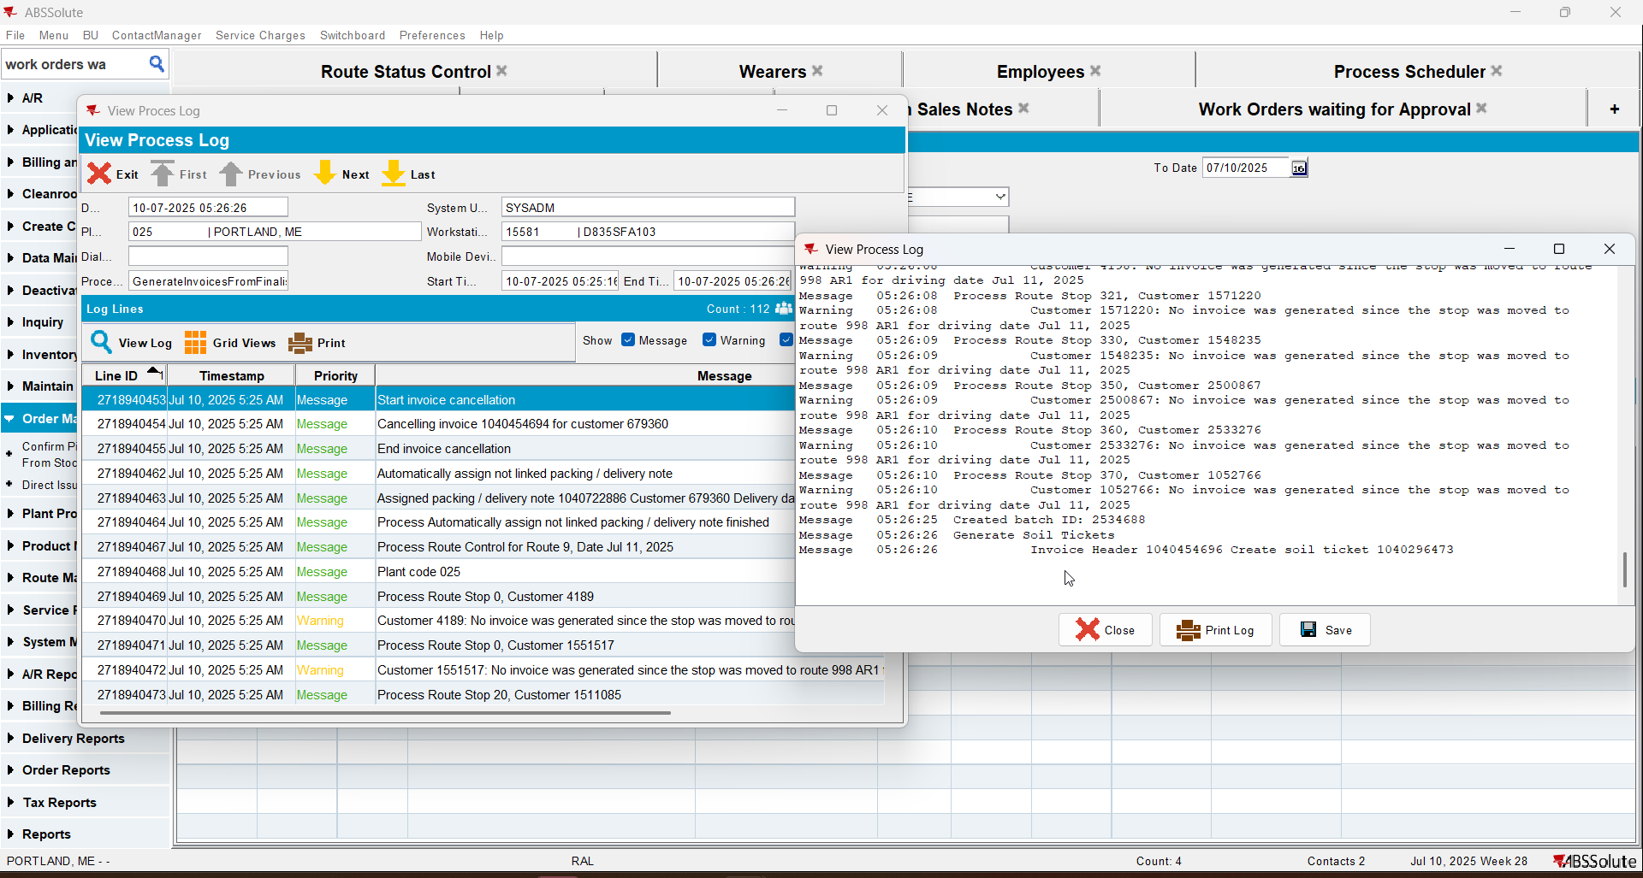
RouteFinalizationFromRestService
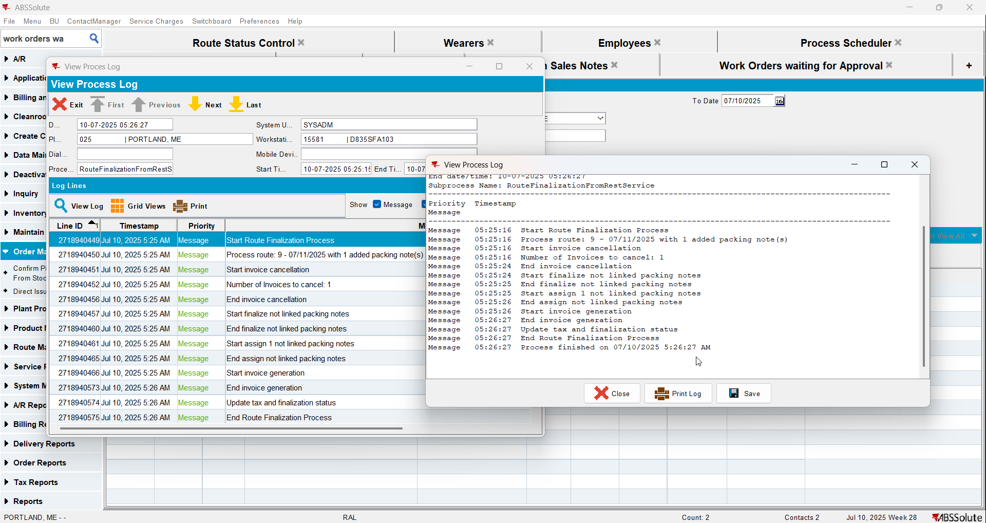
- Script the taxes and run Import Vertex Tax BCI process.
- RSC dlg: Recheck the statuses.
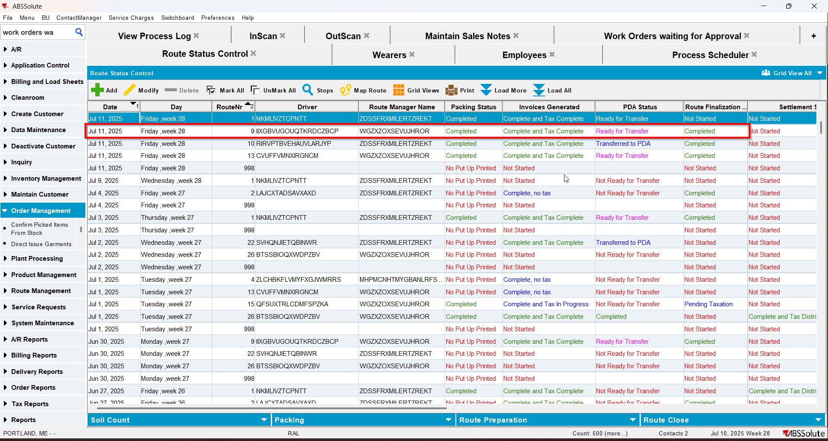
- After action finished check out the WearerActivity into dedicated table WEARERACCOUNTABILITYHIST for respective Customer WearerInventory on that Route DeliveryDate:
select c.customernumber, wah.* from WEARERACCOUNTABILITYHIST wah
join customer c on c.customer_id = wah.customer_id
where c.customernumber =679360
and wah.deliverydate = to_date('11/07/2025', 'dd/mm/yyyy');

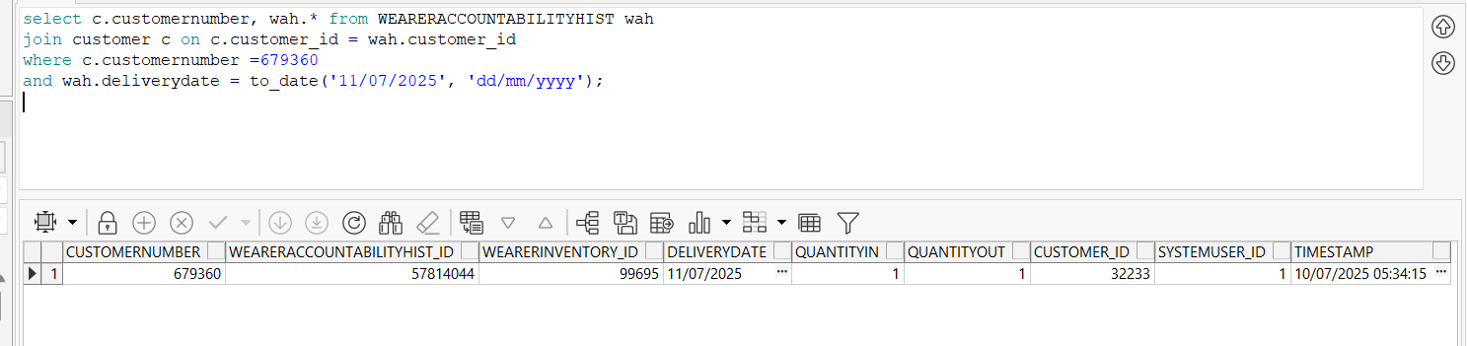
The garments scanned appear in the table
- View Process Log dlg: Check for a log regarding FillWearerAccountabilityHistRestService. In this case, the log will be found under Scheduled Process / Import Vertex BCI Tax Response, because the PDA transfer was made after the taxes were completed.
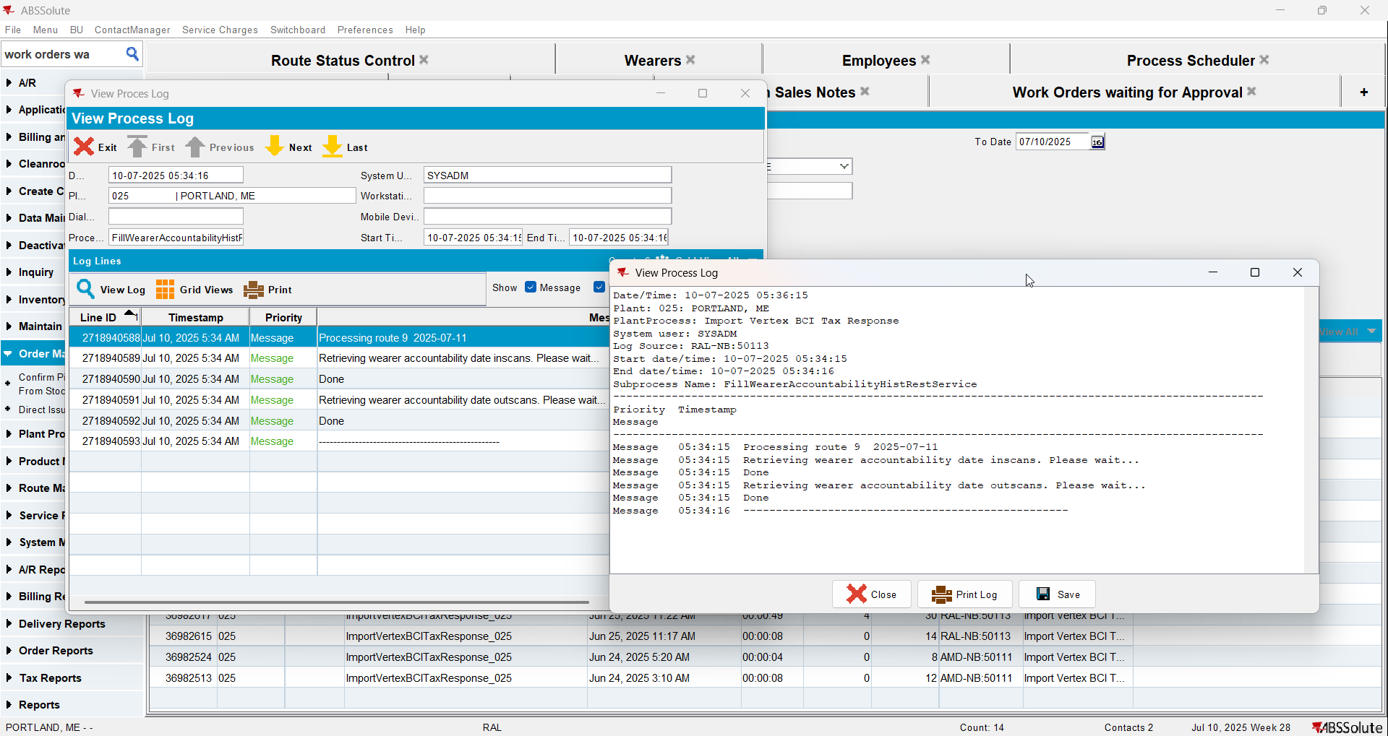
And the Vertex log for our route.
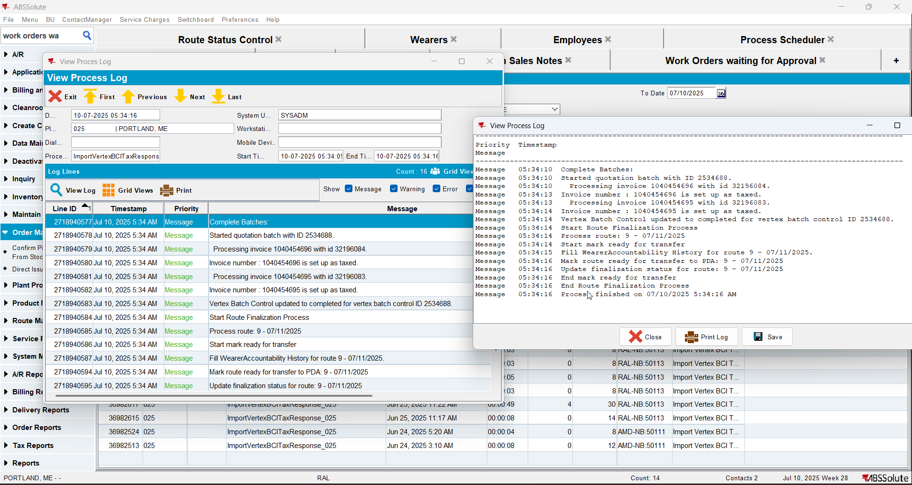

Tested OK

