ABSN-5766 D_UBS_2682 Price per Piece on Name Emblems showing as zero in Contract Emblem Template Screen
Environment | Prerequisites
Version:9.07.00  DBServerName=abs-SRV20.internal.abslbs.com  DBSID=CUST24  DBUser=UNFDEV  Environment=Test | - Module:  - System setting

Contents
Test after fix 1
Test Case 1 – Add an user defined emblem with Price/Piece – Tested OK 1

Test after fix

Test Case 1 – Add an user defined emblem with Price/Piece – Tested OK
Expected behavior: Price should appear in the grid on Contract Emblem Template window and should be included in the Total Amount Emblems
Hash: 2bc0680
- Go to a contract
- Add an emblem template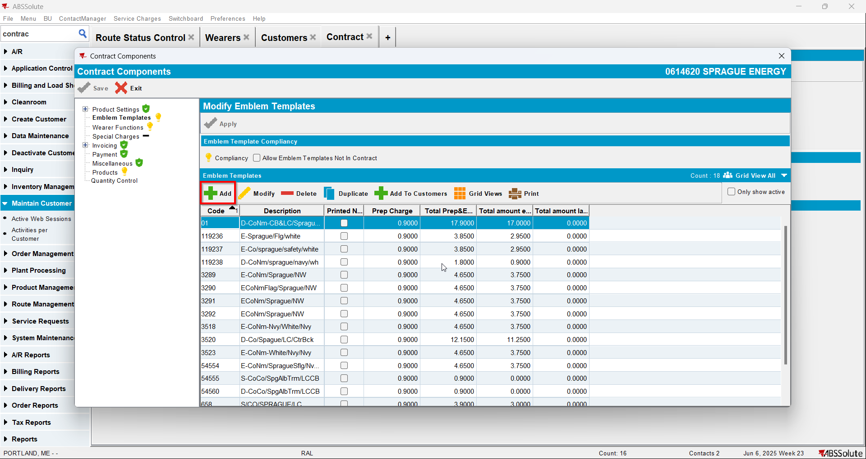
- Add a predefined emblem with Price/Piece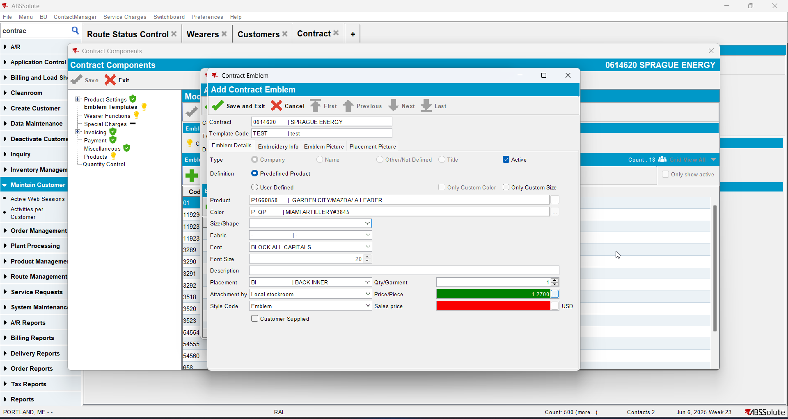
- Add an user defined emblem with Price/Piece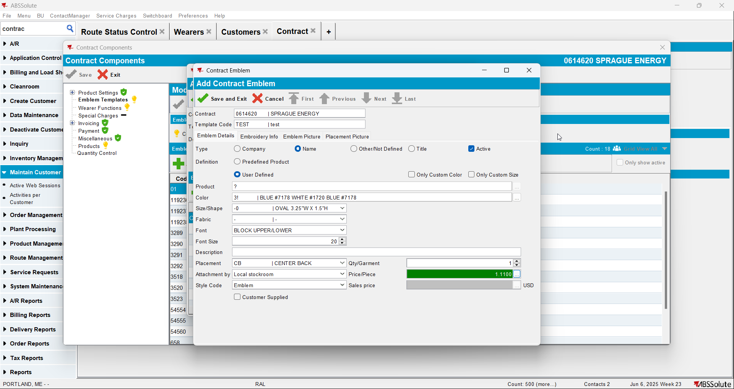
- Check that the price appears in the grid and is included in Total Amount Emblems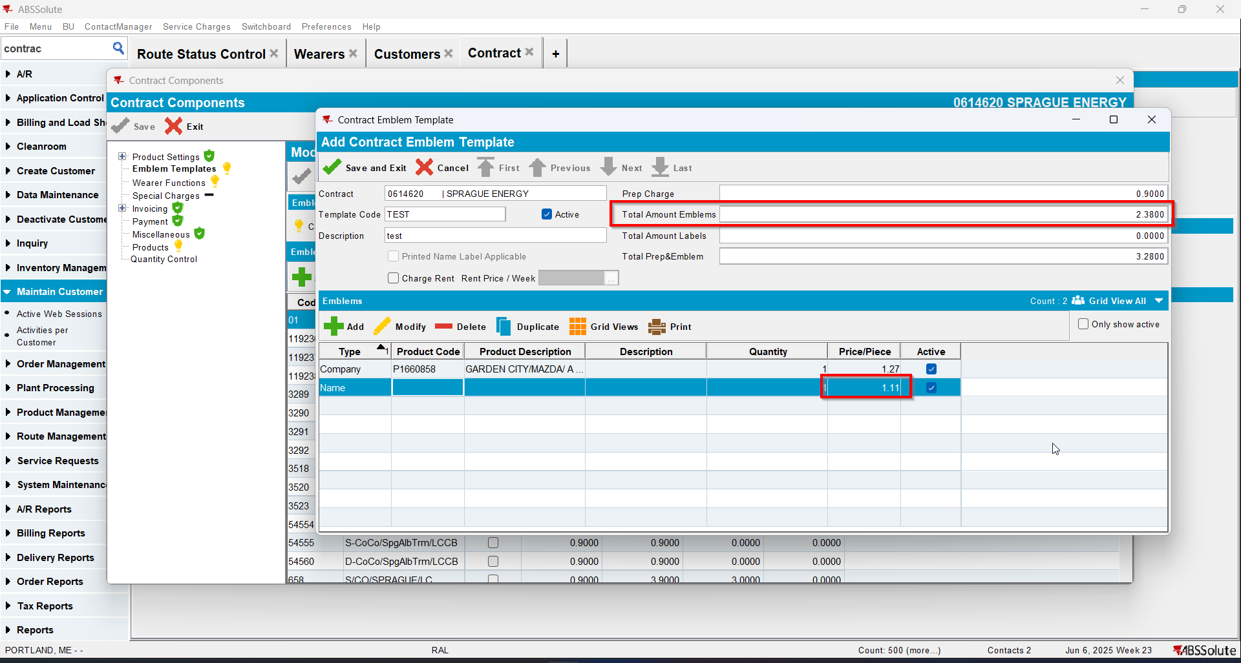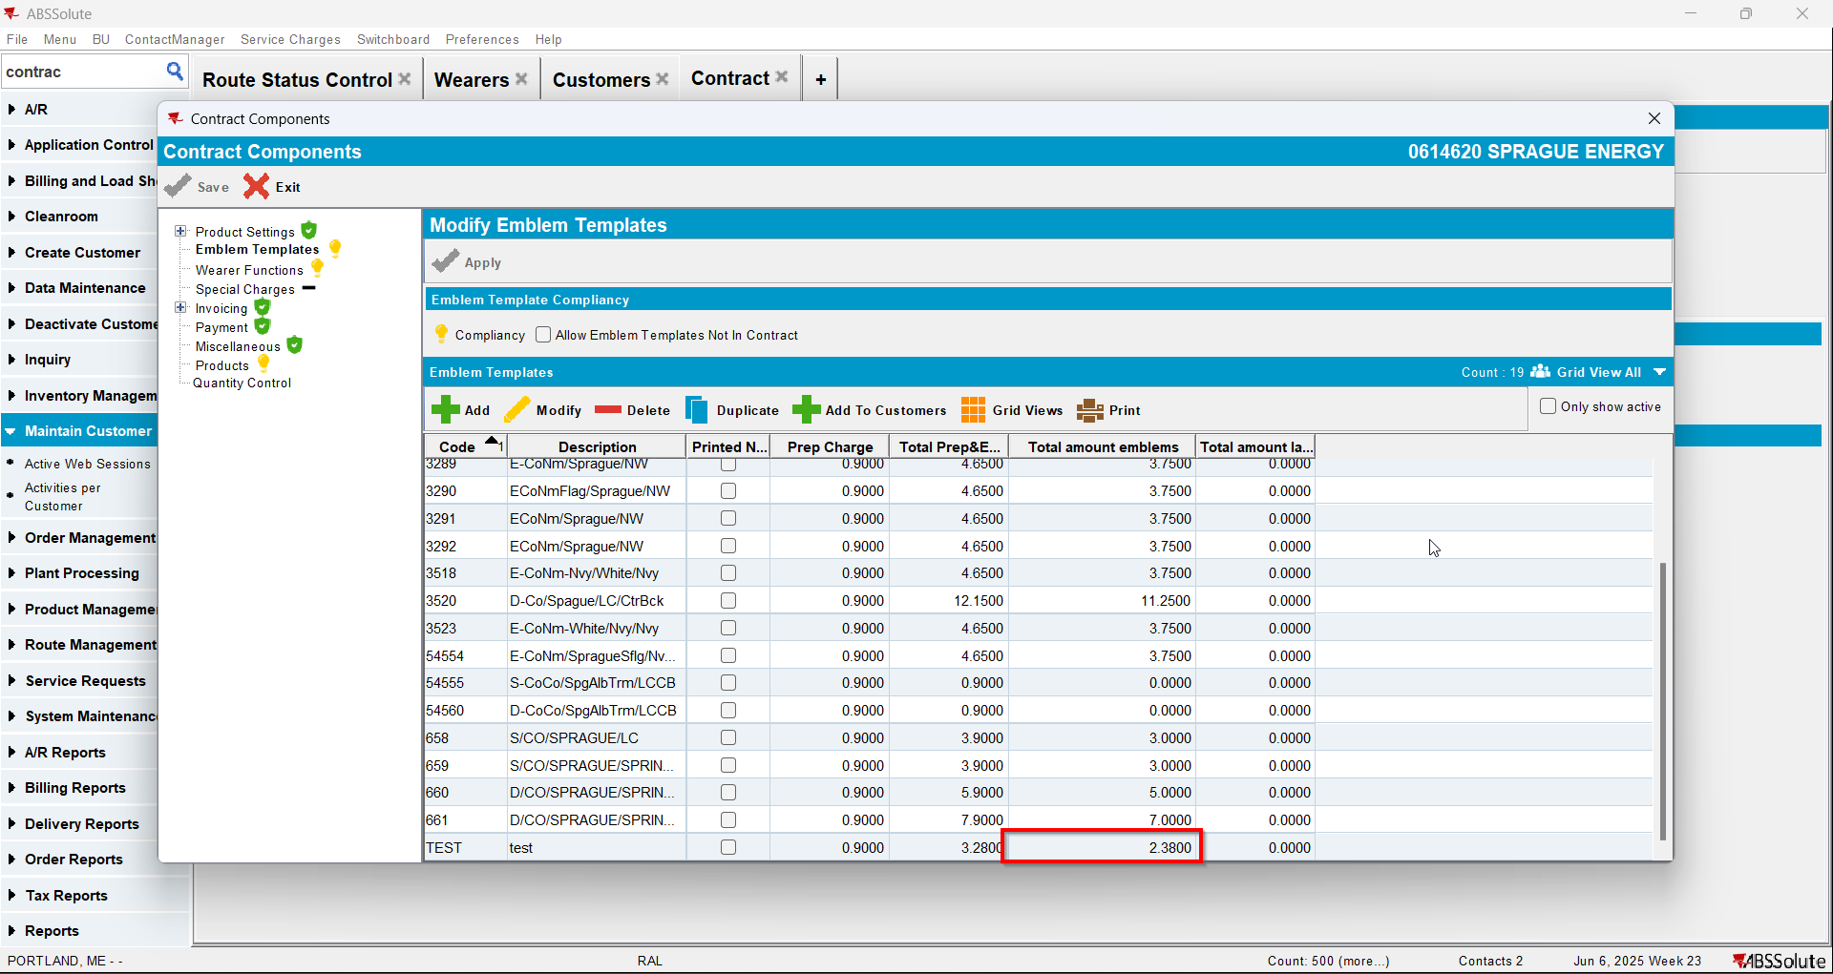
- Add the emblem template to the customer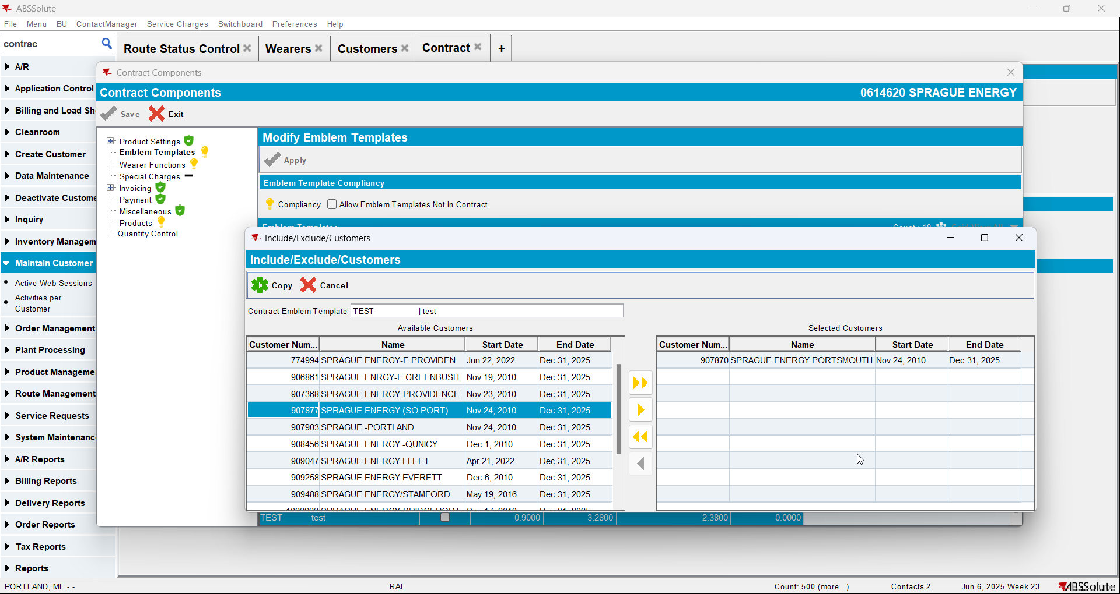
- Go to Customer dlg and check there too that the price appears in the grid and is included in Total Amount Emblems 