ABSN-5259 - D_UBS_2679 Web Client X - Missing French translations
Environment | Prerequisites
Version: 9.07.00.UNF20  DBServerName= abs-srv20.internal.abslbs.com  DBSID=CUST24  DBUser=UNFDEV  Environment=Test | - Module:  - System setting

Contents
Retest after fix 1
Data Preparation 1
Route Recording 2
Profile Menu 4
Start My Day 6
Overview 6
Invoice Adjustments 10
Invoice Details 11
Wearer Maintenance 13
Soil Counts 14
Cash IN 14
Contacts 14
Web Orders 14
Accounts Receivables 14

Retest after fix

Data Preparation
Hash: 2800e71e881e
- Languages DLG: Make sure you have francais (France) language added
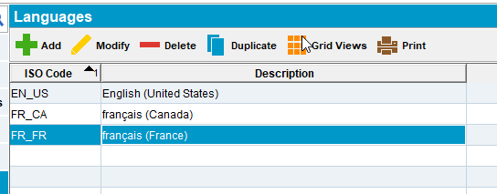
- WebX: Log in with your user and go to Settings
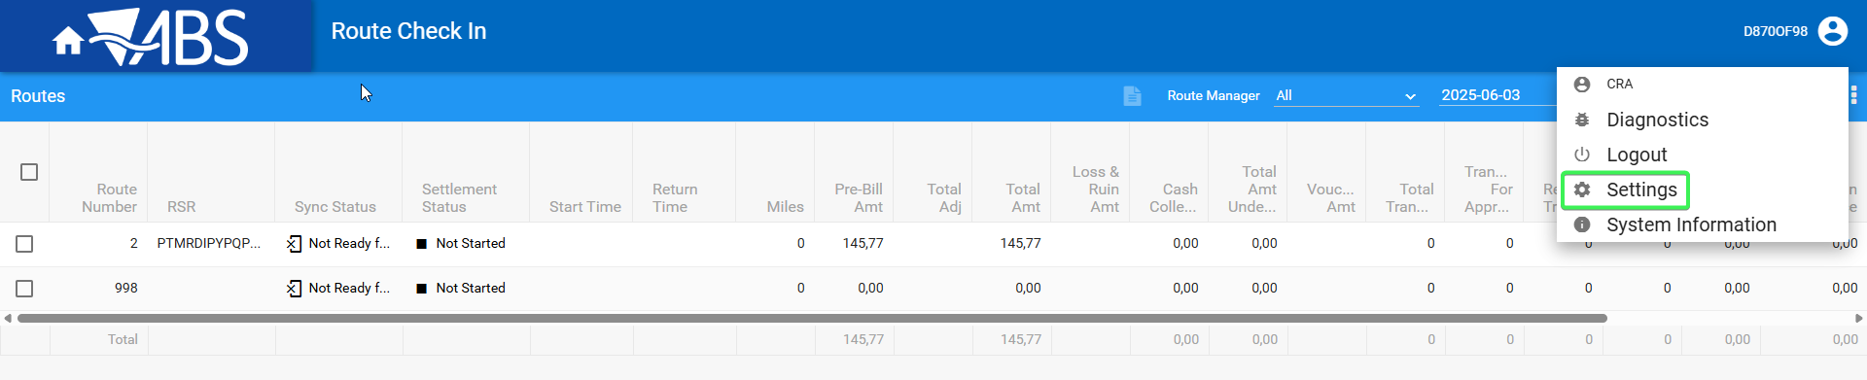
- From User section chose francais(France) from the drop down
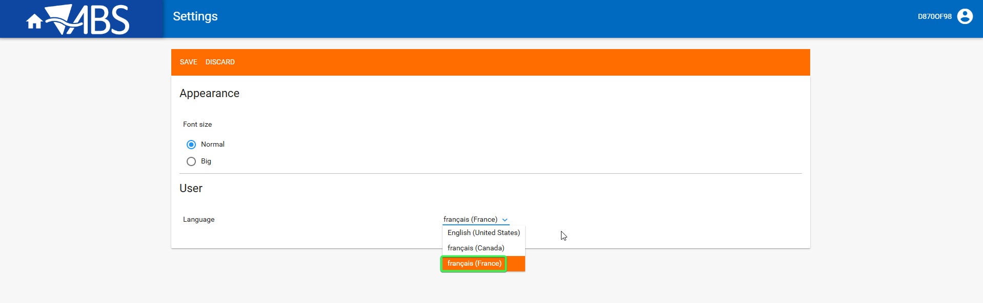
- Restart the server
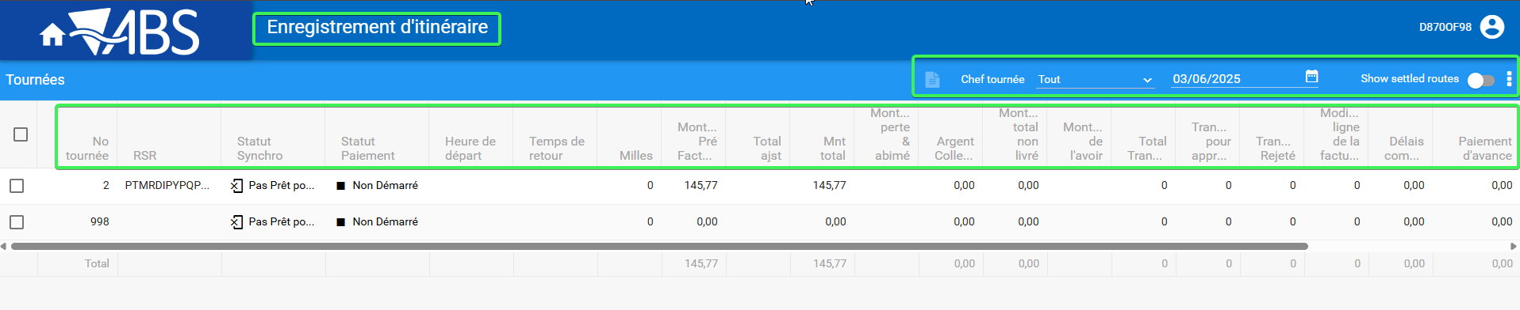

Create a route in FR localization
- Gestion Tournees: Add a new route with a few customers on it
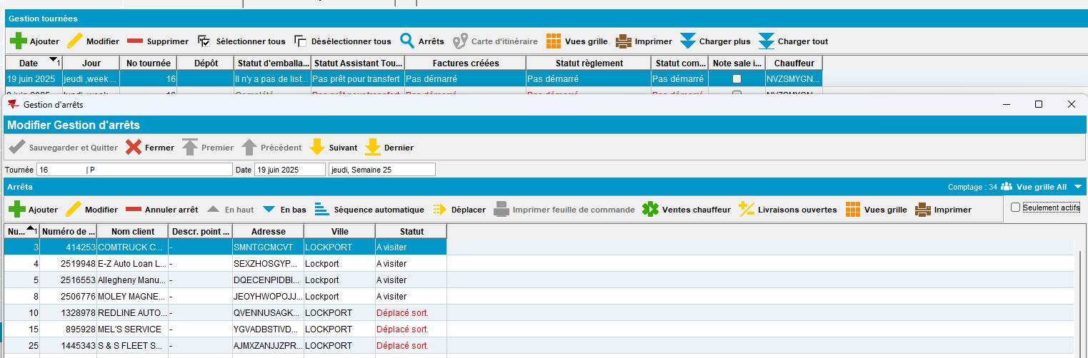
- Generate invoices and send the route to RA
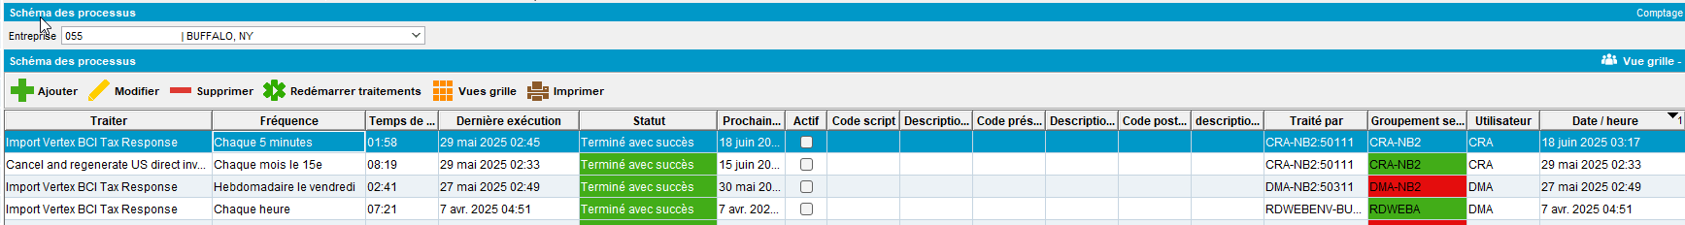
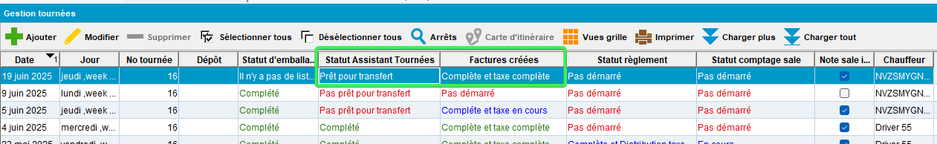
- RA: Arrive at the customers and create some invoice adjustments and quit a wearer, add a new WI, increase / decrease inventory
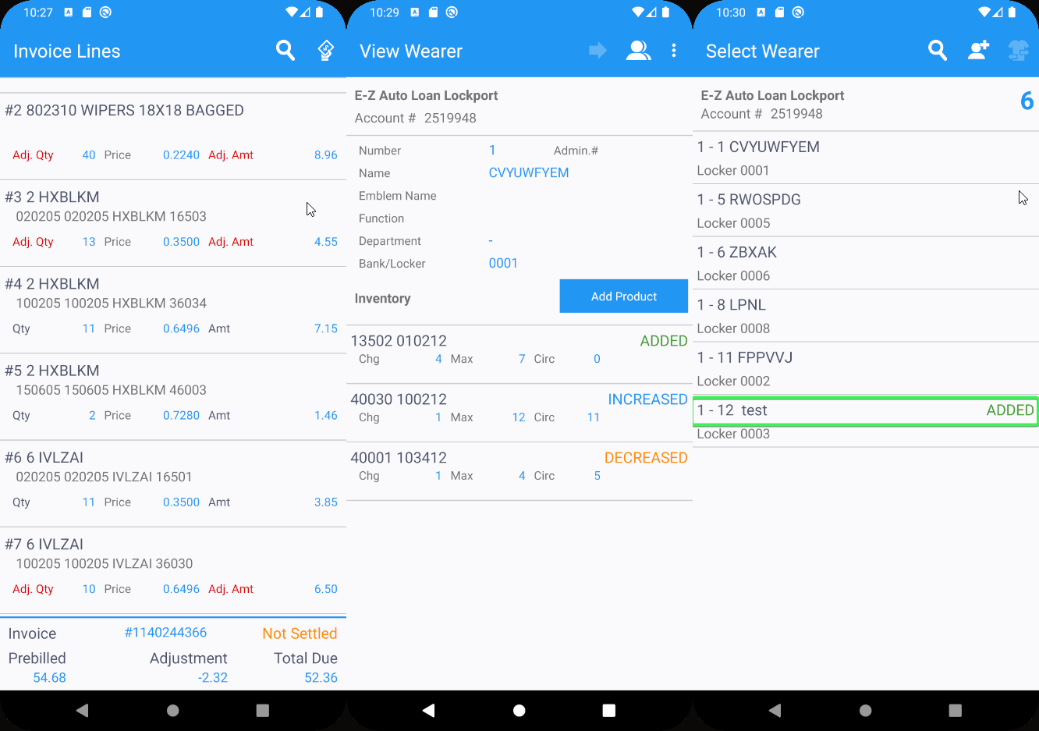
- Finish and upload the data
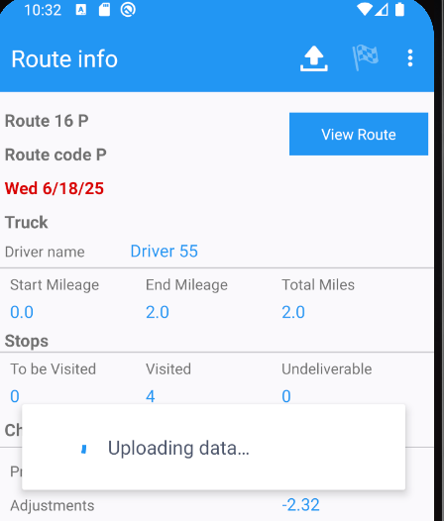

Route Check In
- Check all the elements in the header
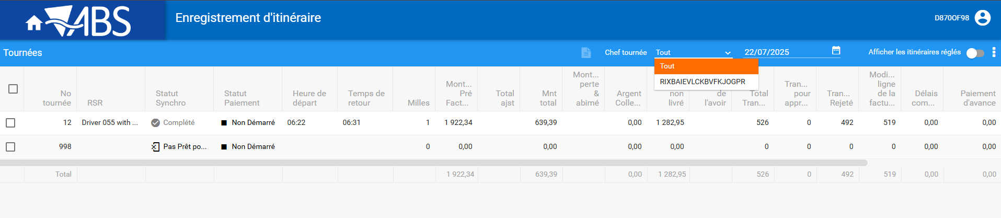
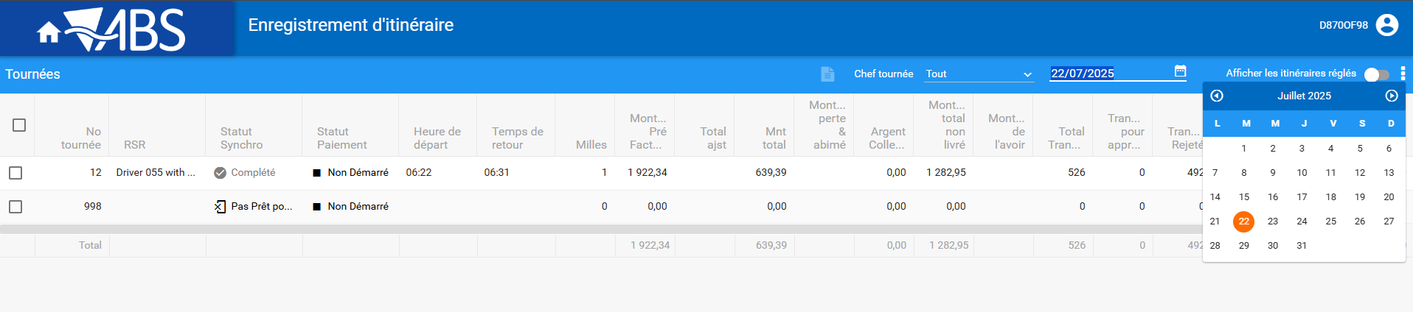
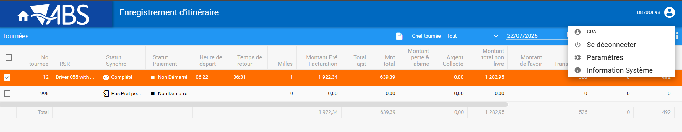
- Add all the columns in the grid
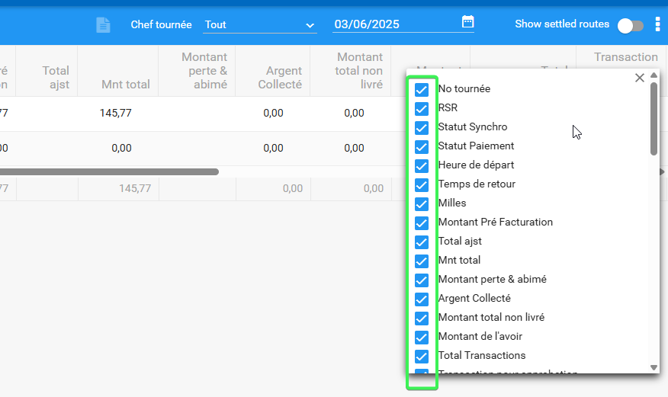
- Check all the header translations and column information
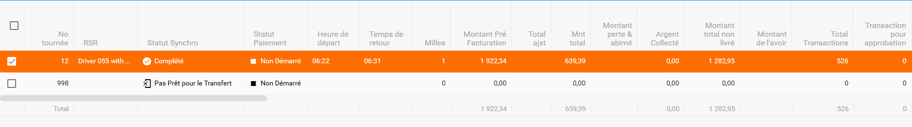
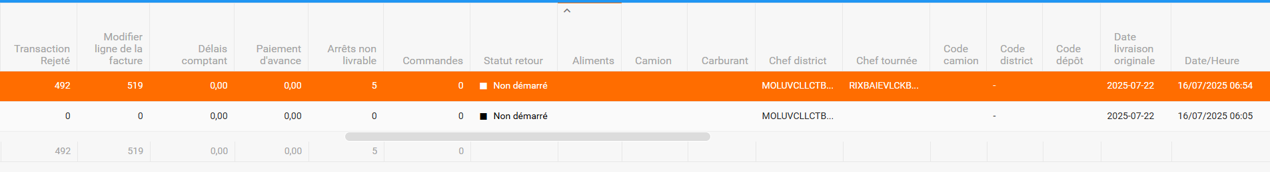
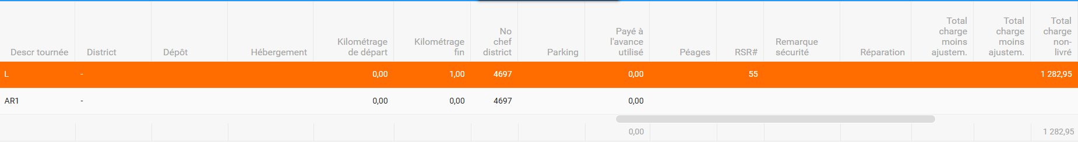
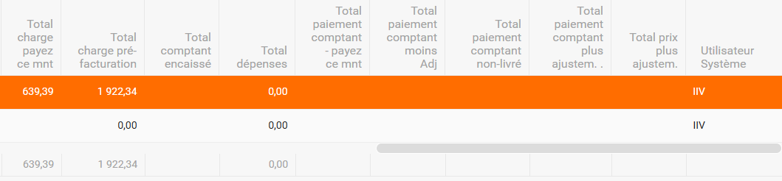
Tested OK

Profile Menu

- Select Profile menu
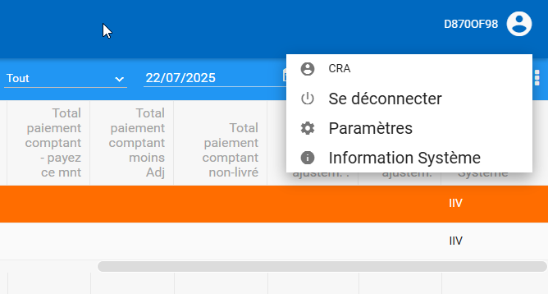
- Go to Settings tab
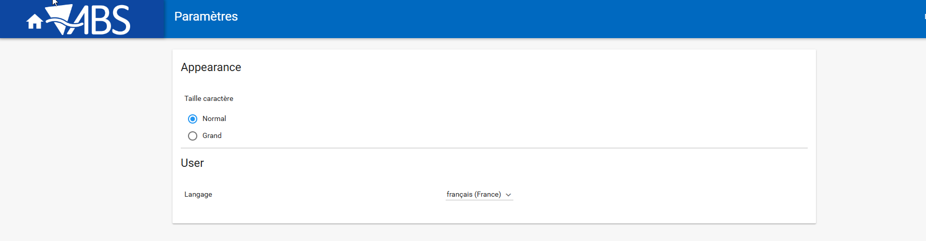
- Go to System Information

Tested OK

Start My Day
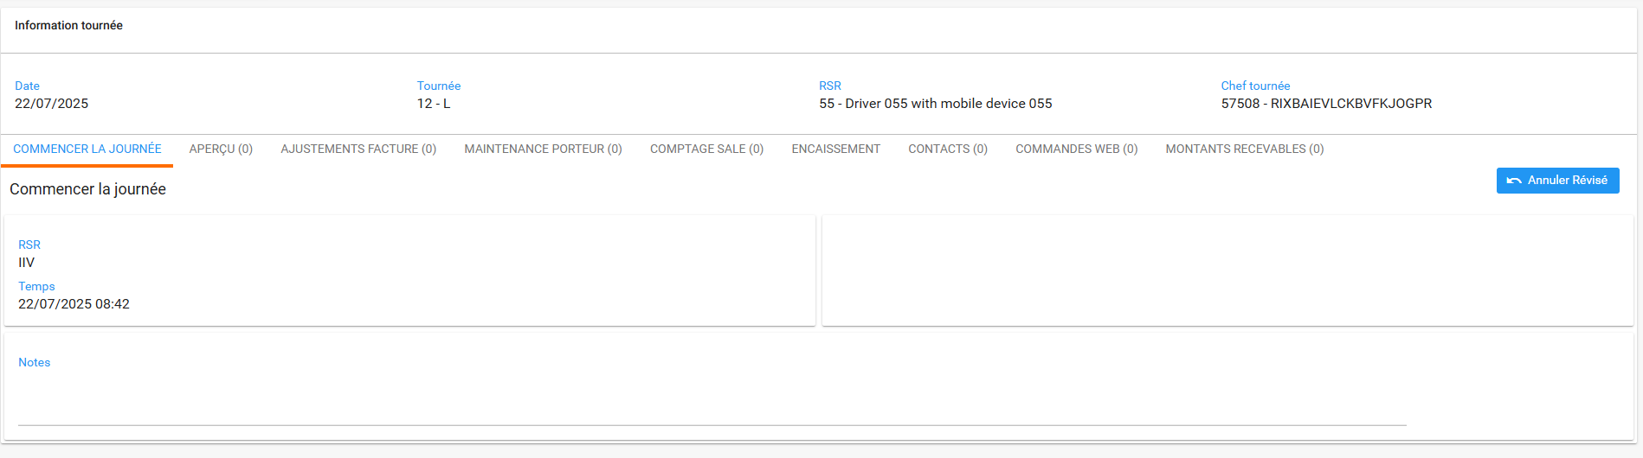

Overview
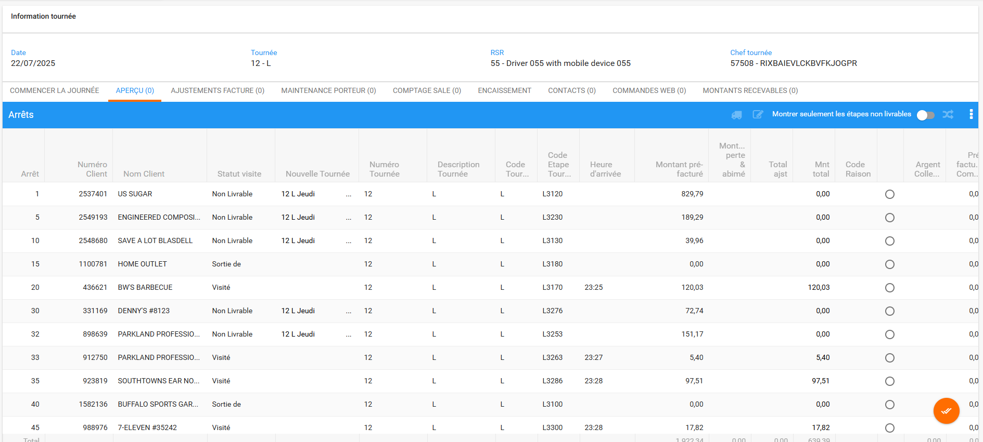
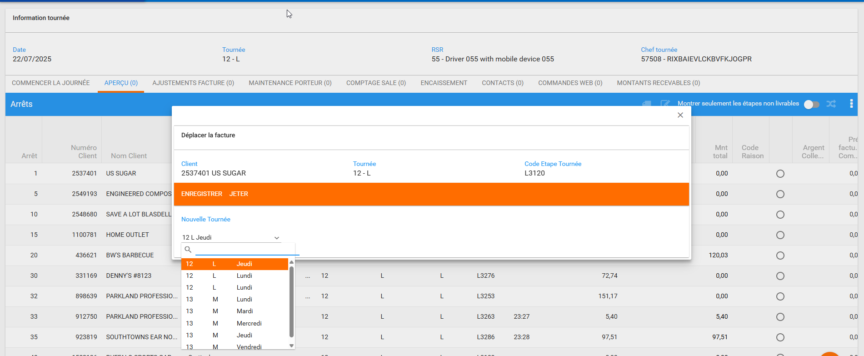
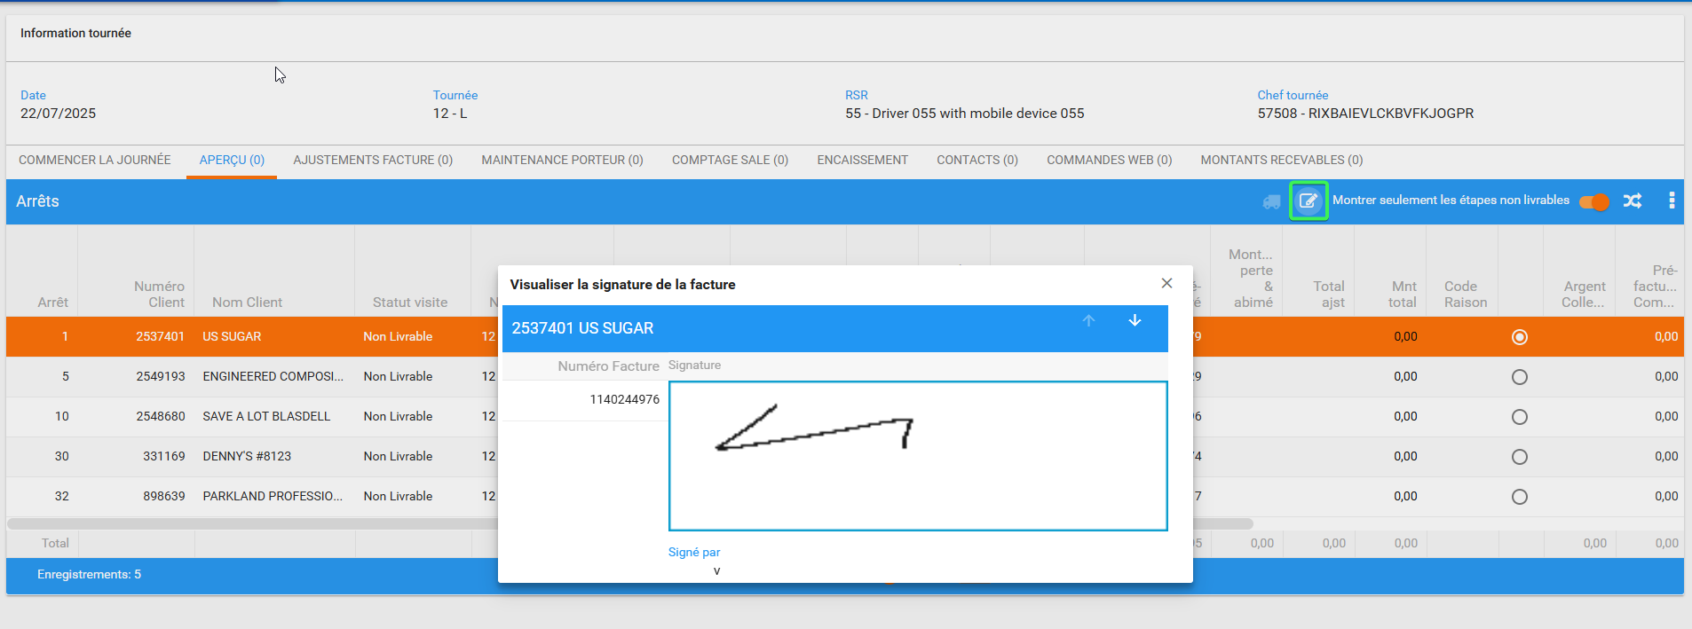
Grid translations
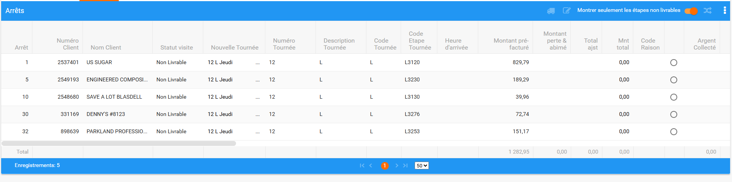
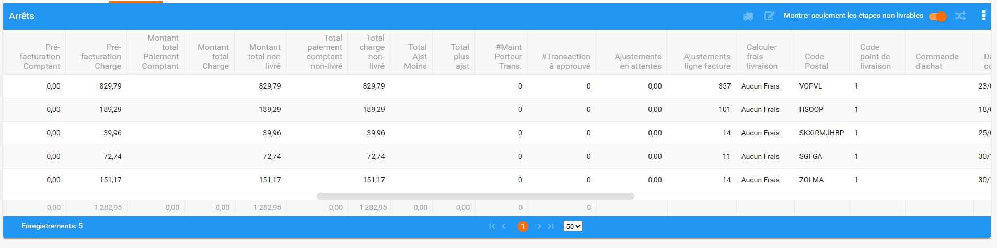
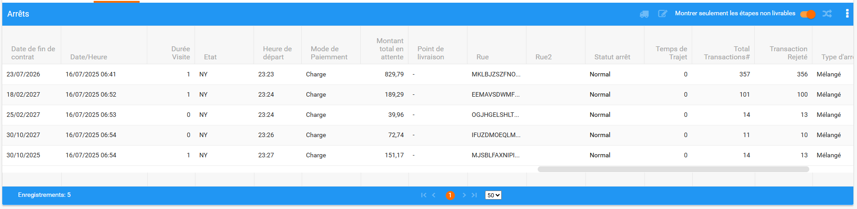
Error Messages
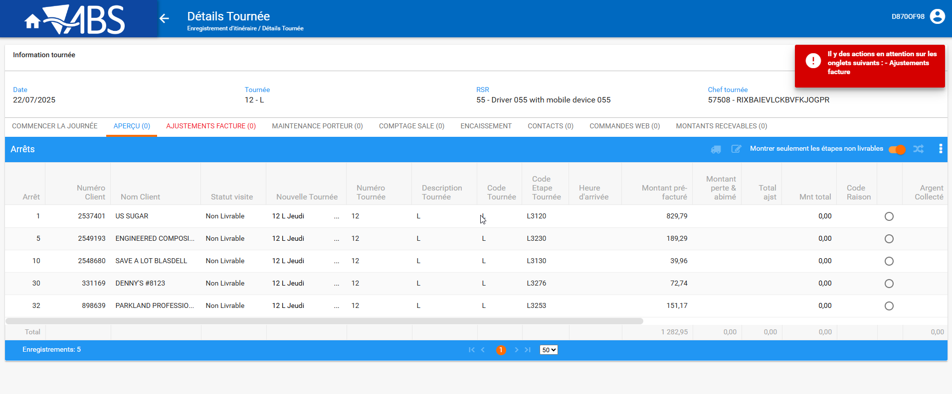
Tested OK

Invoice Adjustments
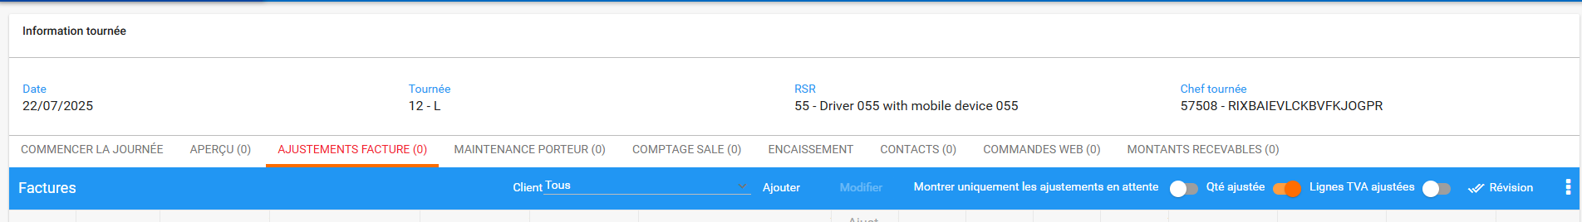
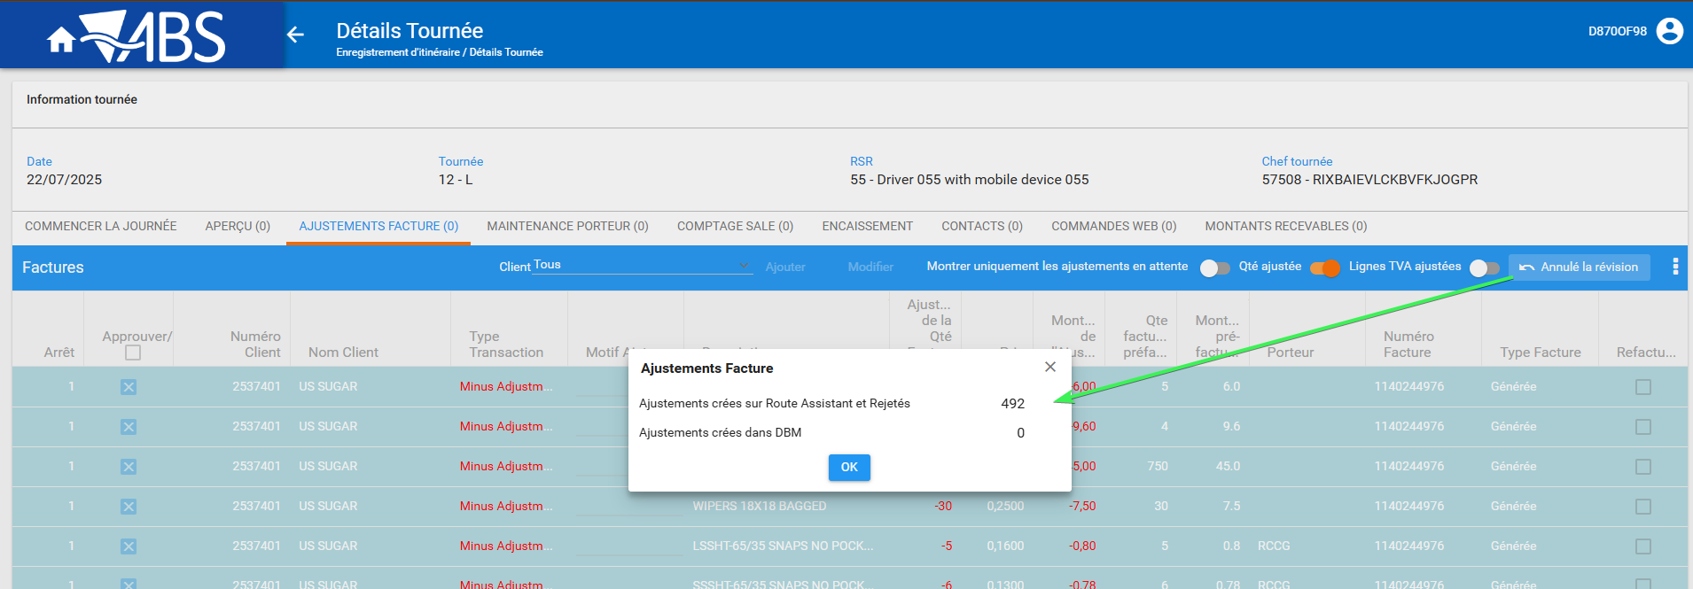
Header and table content
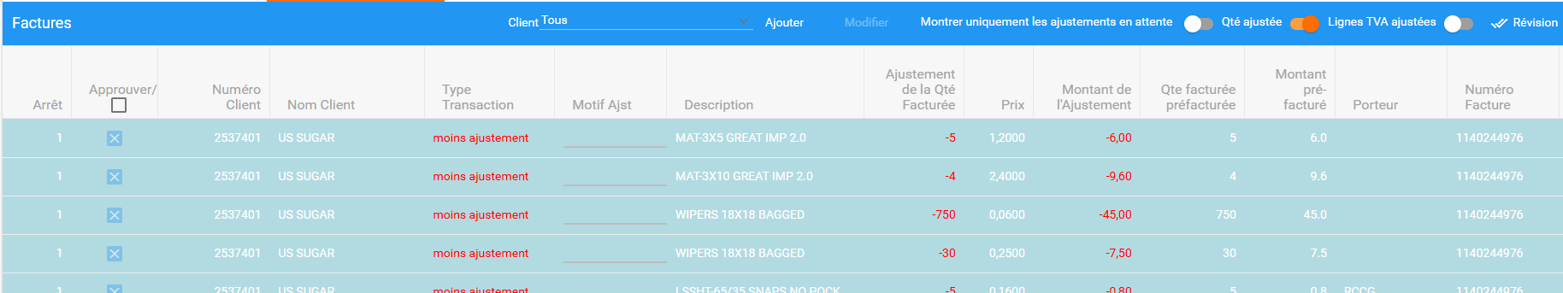
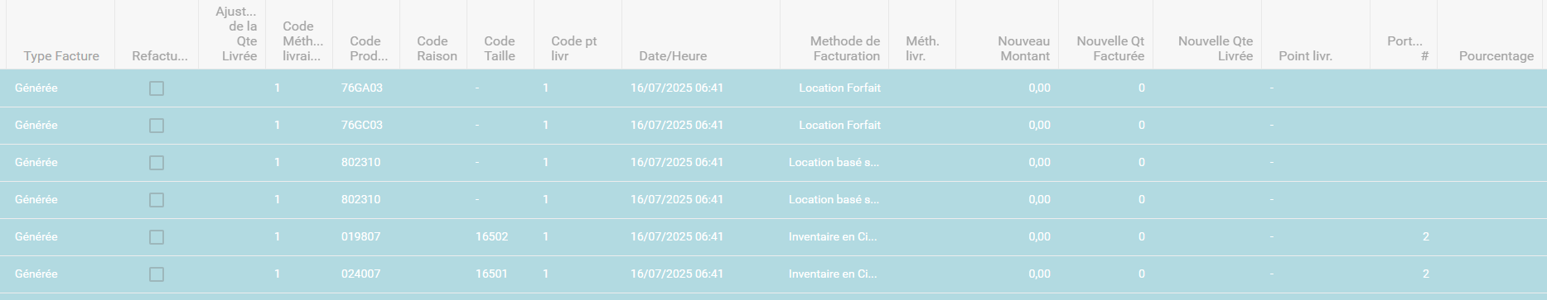
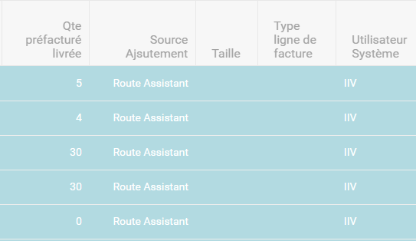
Tested OK

Invoice Details
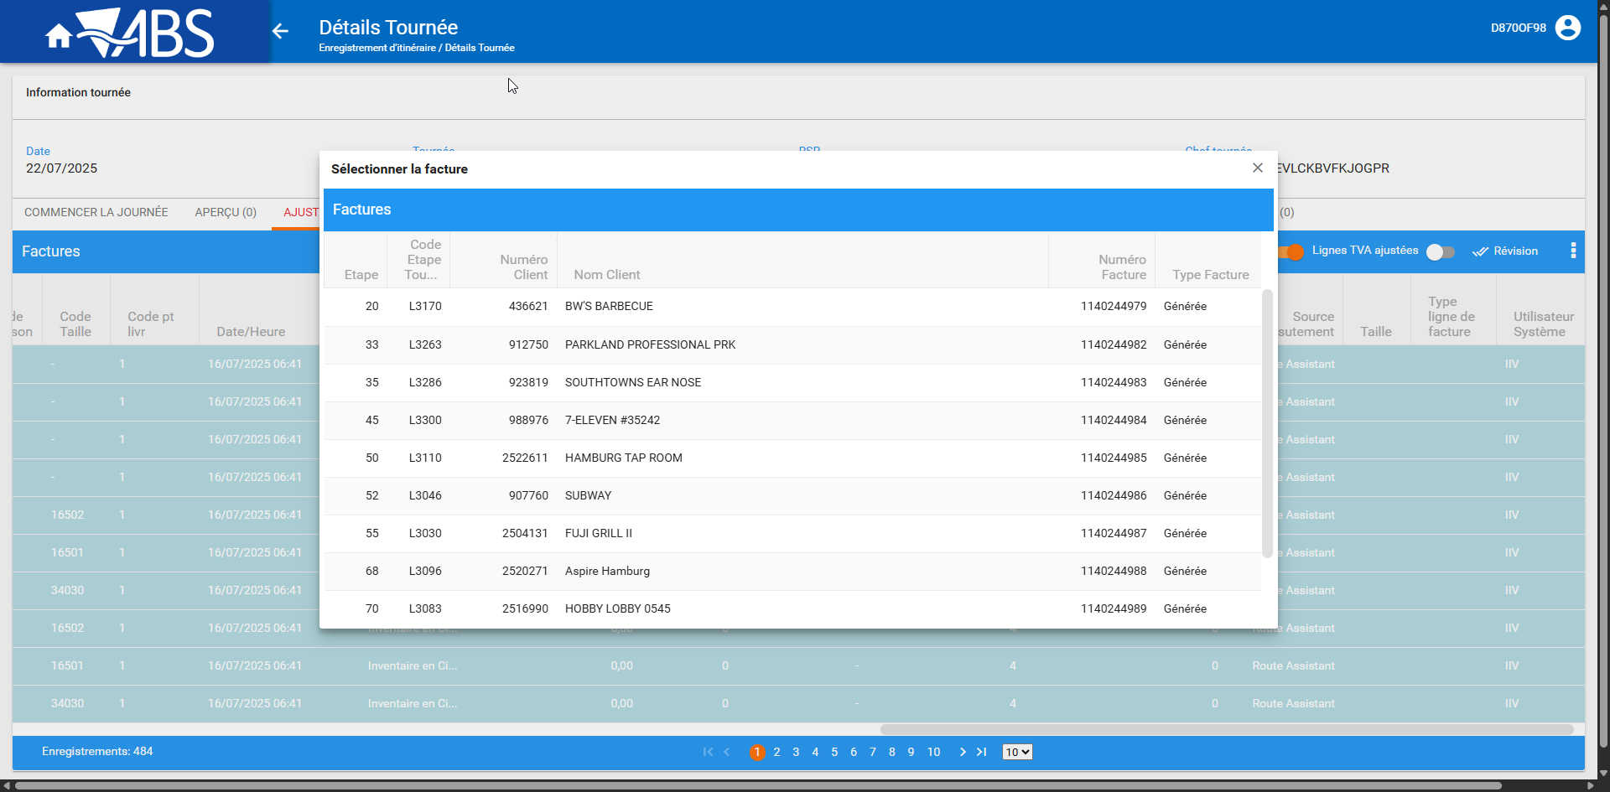
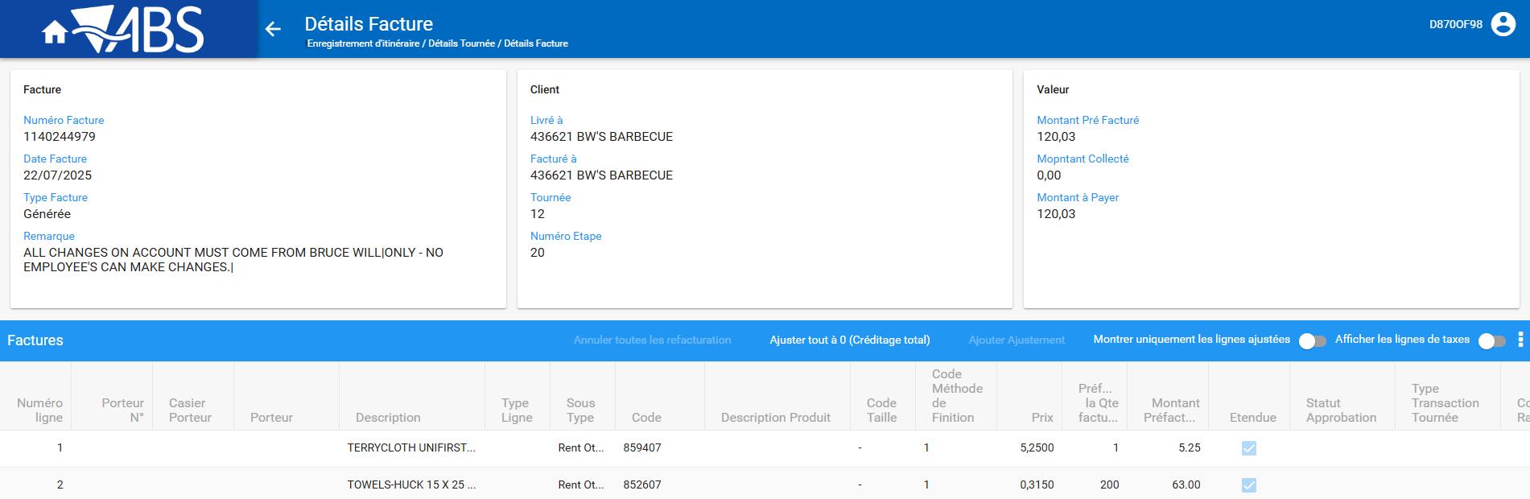

Header and table content
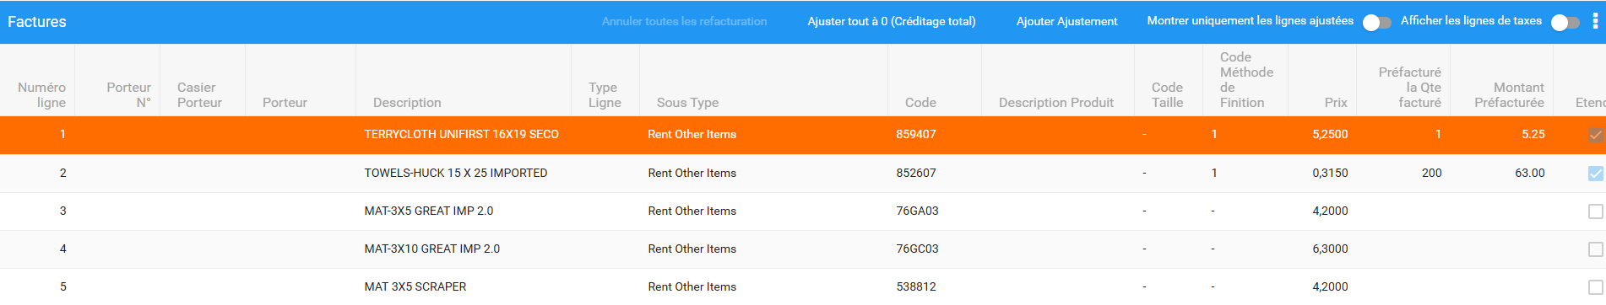
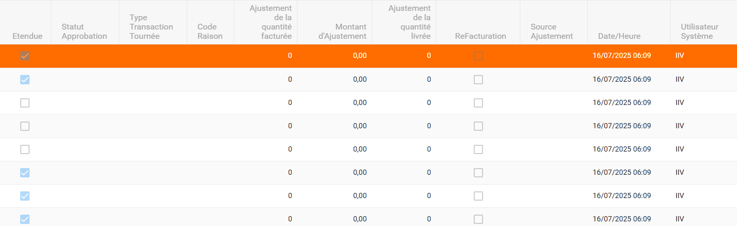
Full Credit / Adjust an invoice
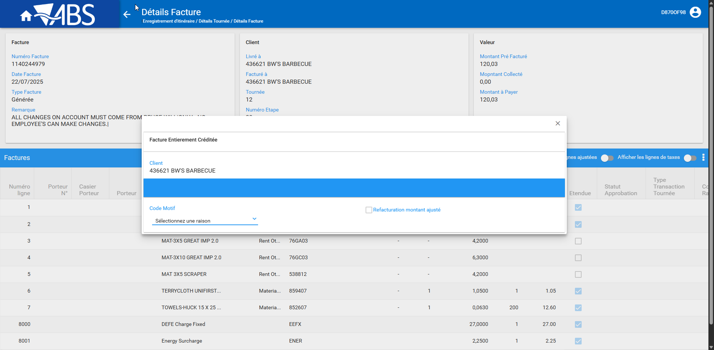
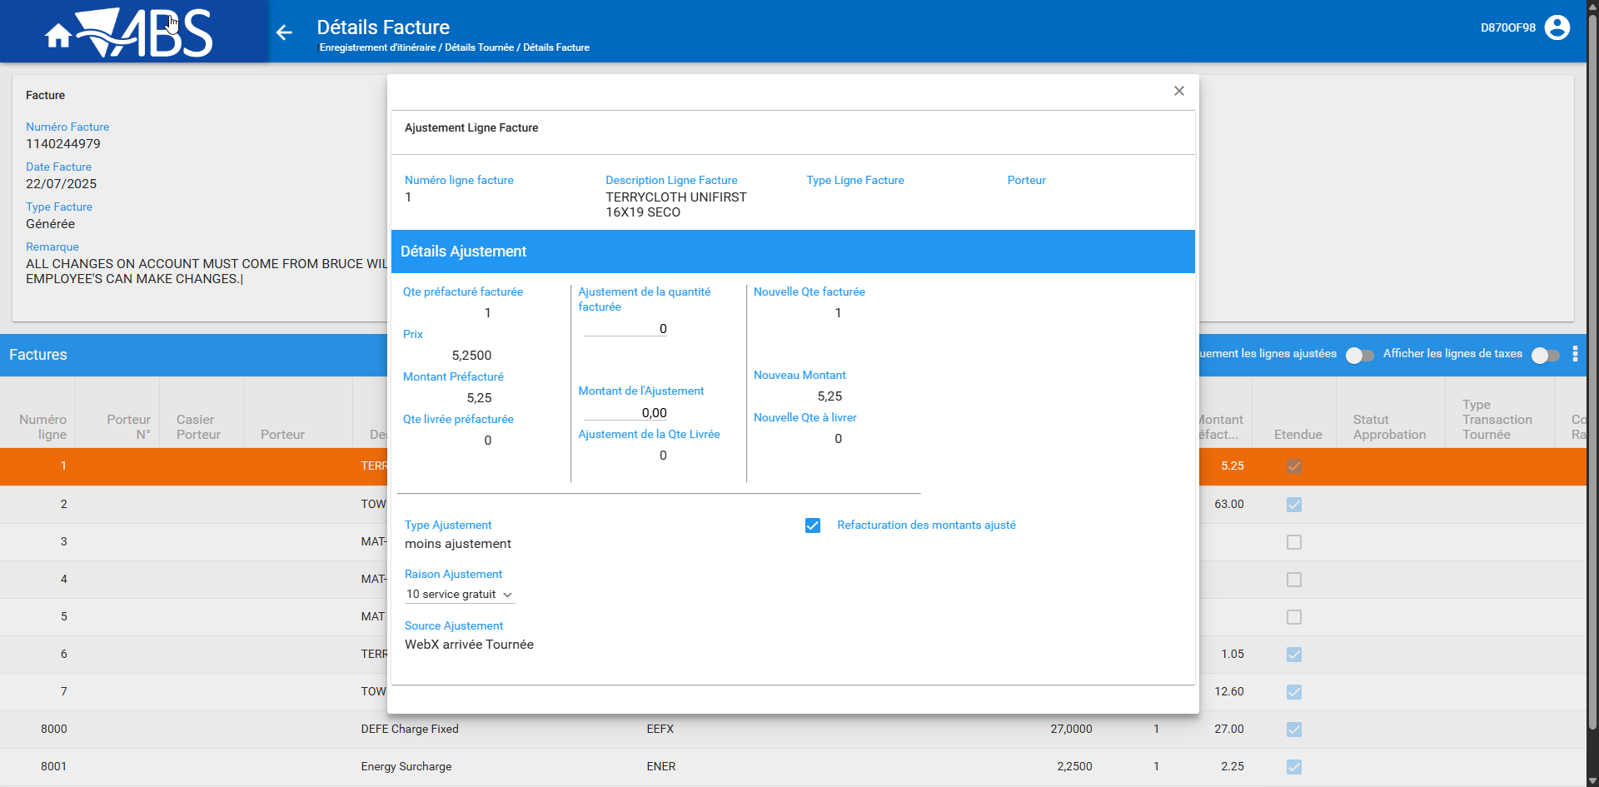
Tested OK

Wearer Maintenance

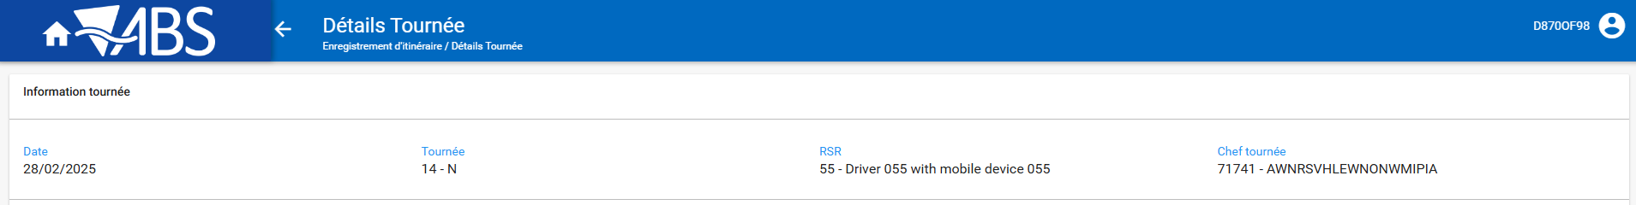
Header and table content
Type transaction and reason code need to be added from Route Transaction Category and Reason codes DLG
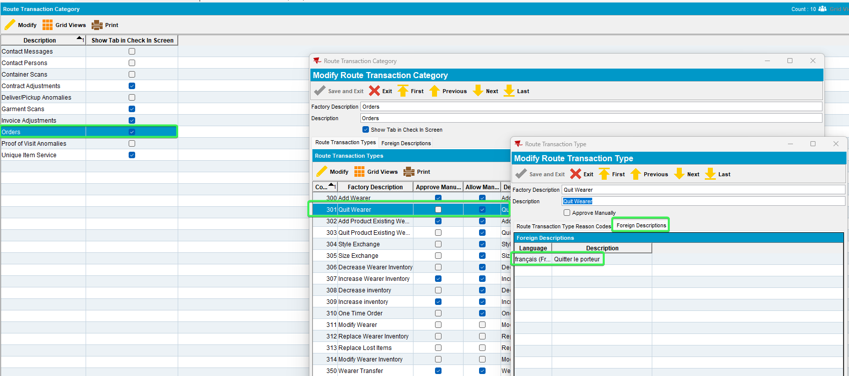
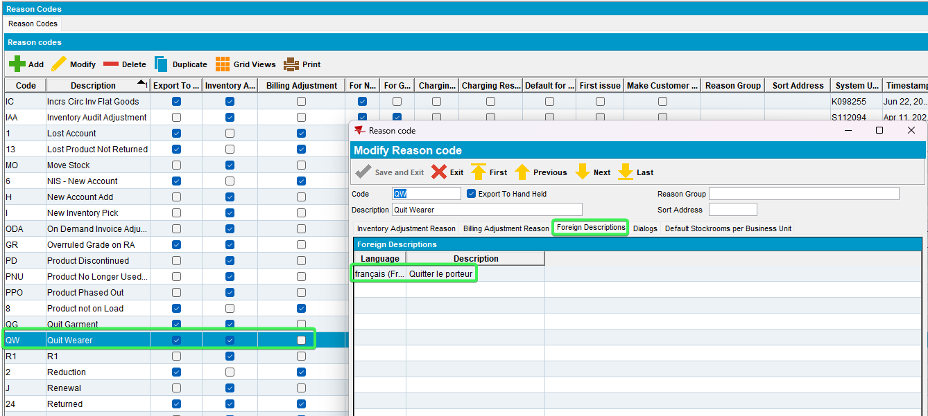
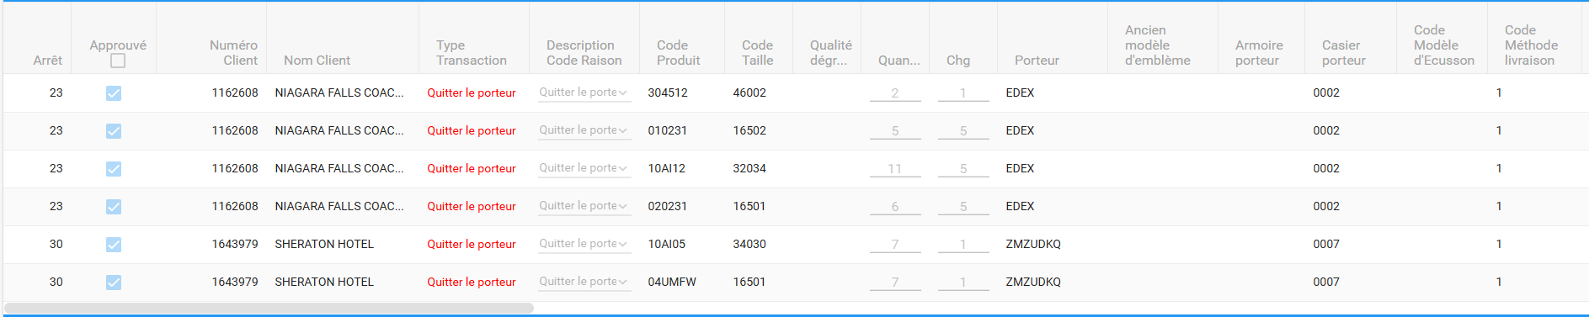
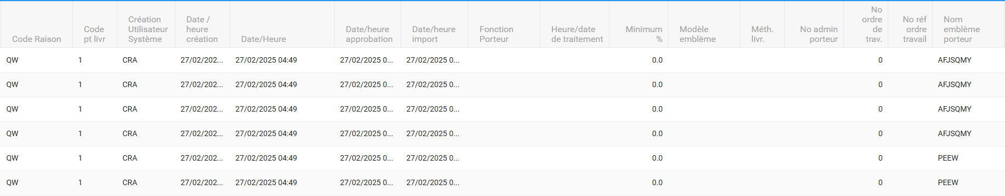
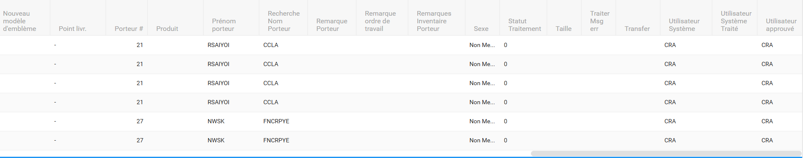
Tested OK

Soil Counts
The Product description in French needs to be added in order for data to appear in the grid – your cliend need to be in French in order to change the description of the product
English
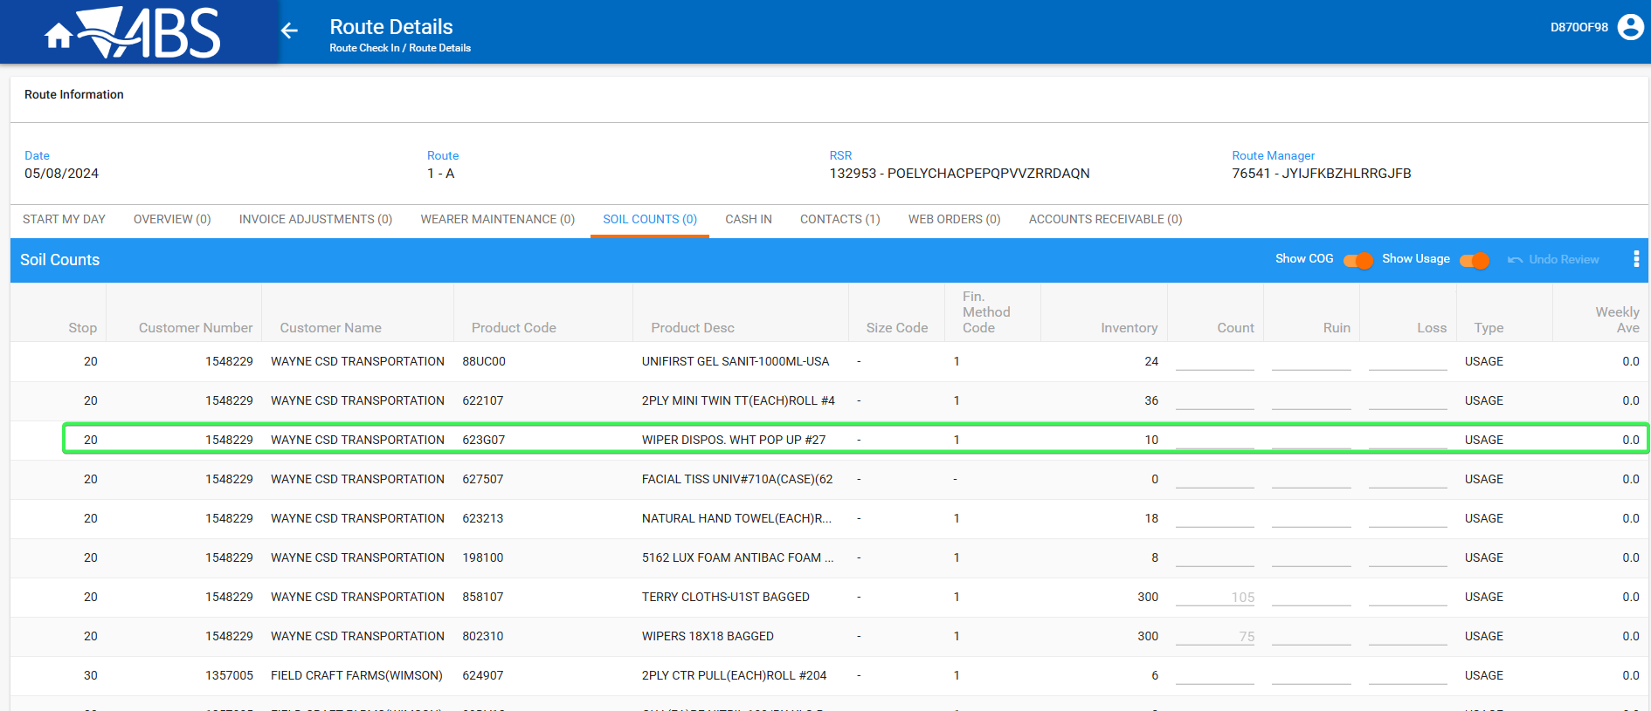
French
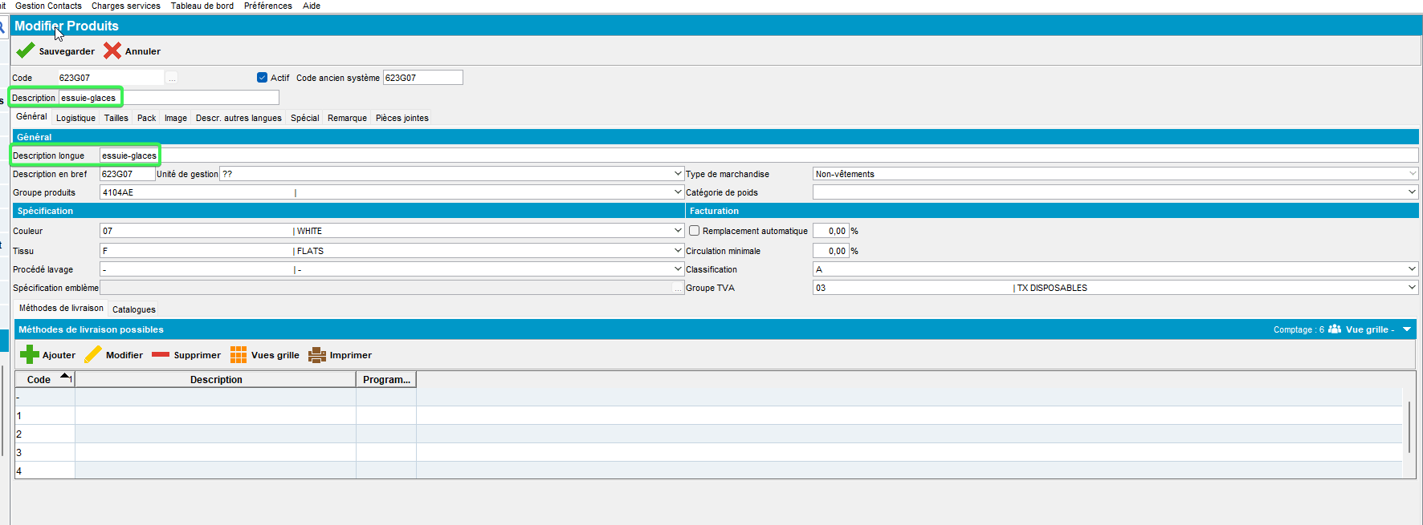
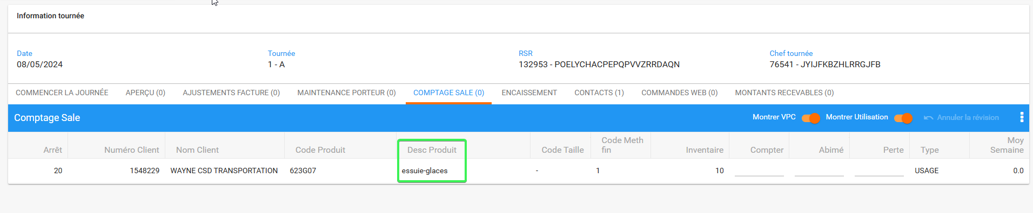
Tested OK

Cash IN
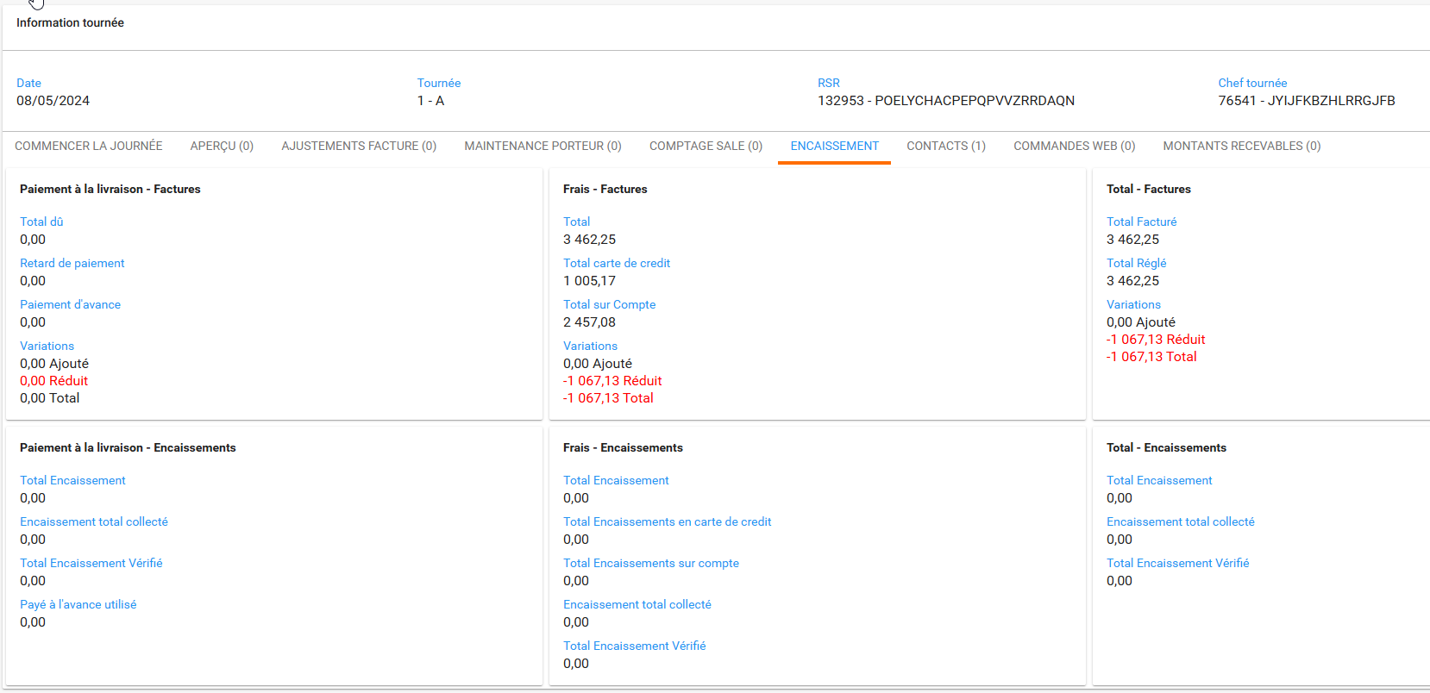

Tested OK

Contacts
Header and table content
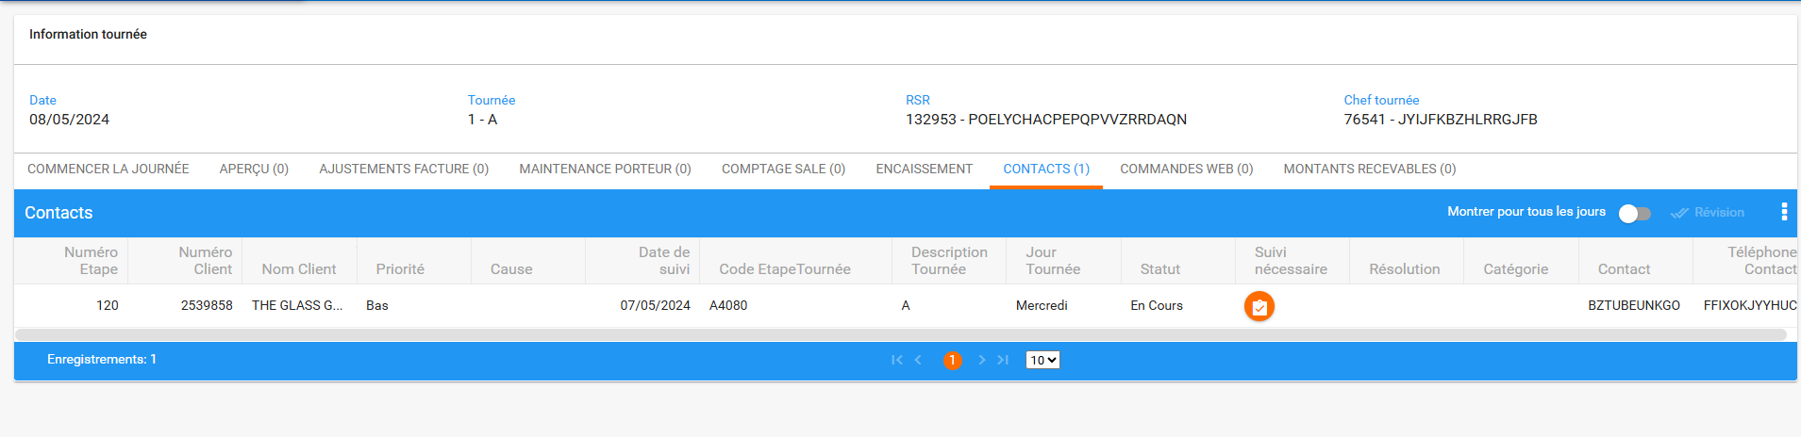
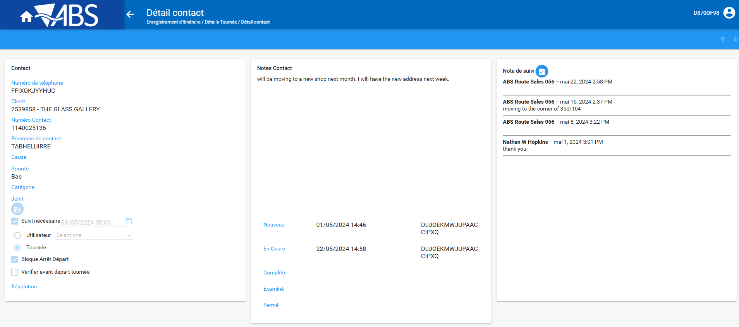
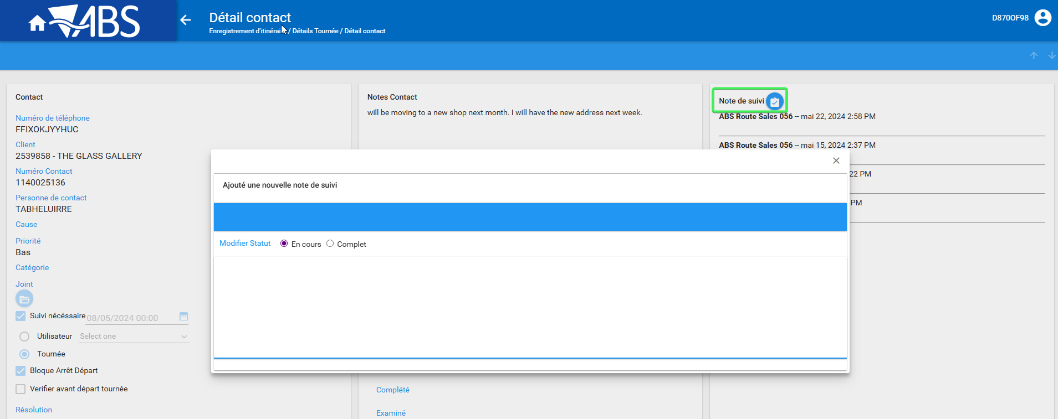
Tested OK

Web Orders
Header and table content
Tested OK

Accounts Receivables
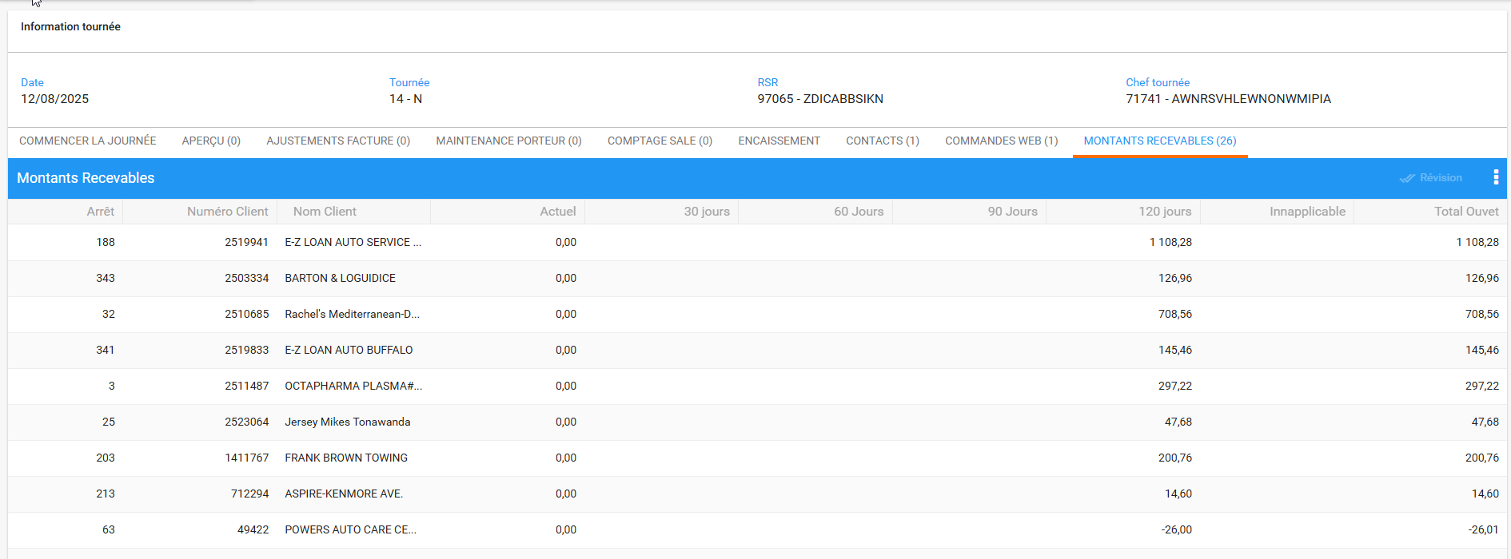
Tested OK

