ABSN-4918 Consecutive uploads generate two route transactions for undeliverable
Environment | Prerequisites
Version: 9.07.00.UNF20  DBServerName= abs-srv20.internal.abslbs.com  DBSID=CUST24  DBUser=UNFDEV  DBPassword=UNFDEV  Environment=Production | - Module:

Contents
Reproducing before fix 1
Retest after fix 4

Reproducing before fix
Hash: 421e5a8b6bb

- RSC: Add a new route
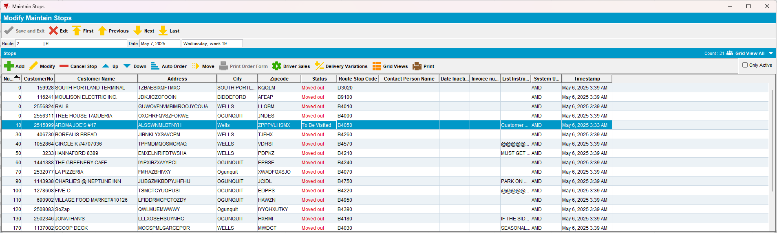

- RSC: Generate the invoices then transfer the route to PDA
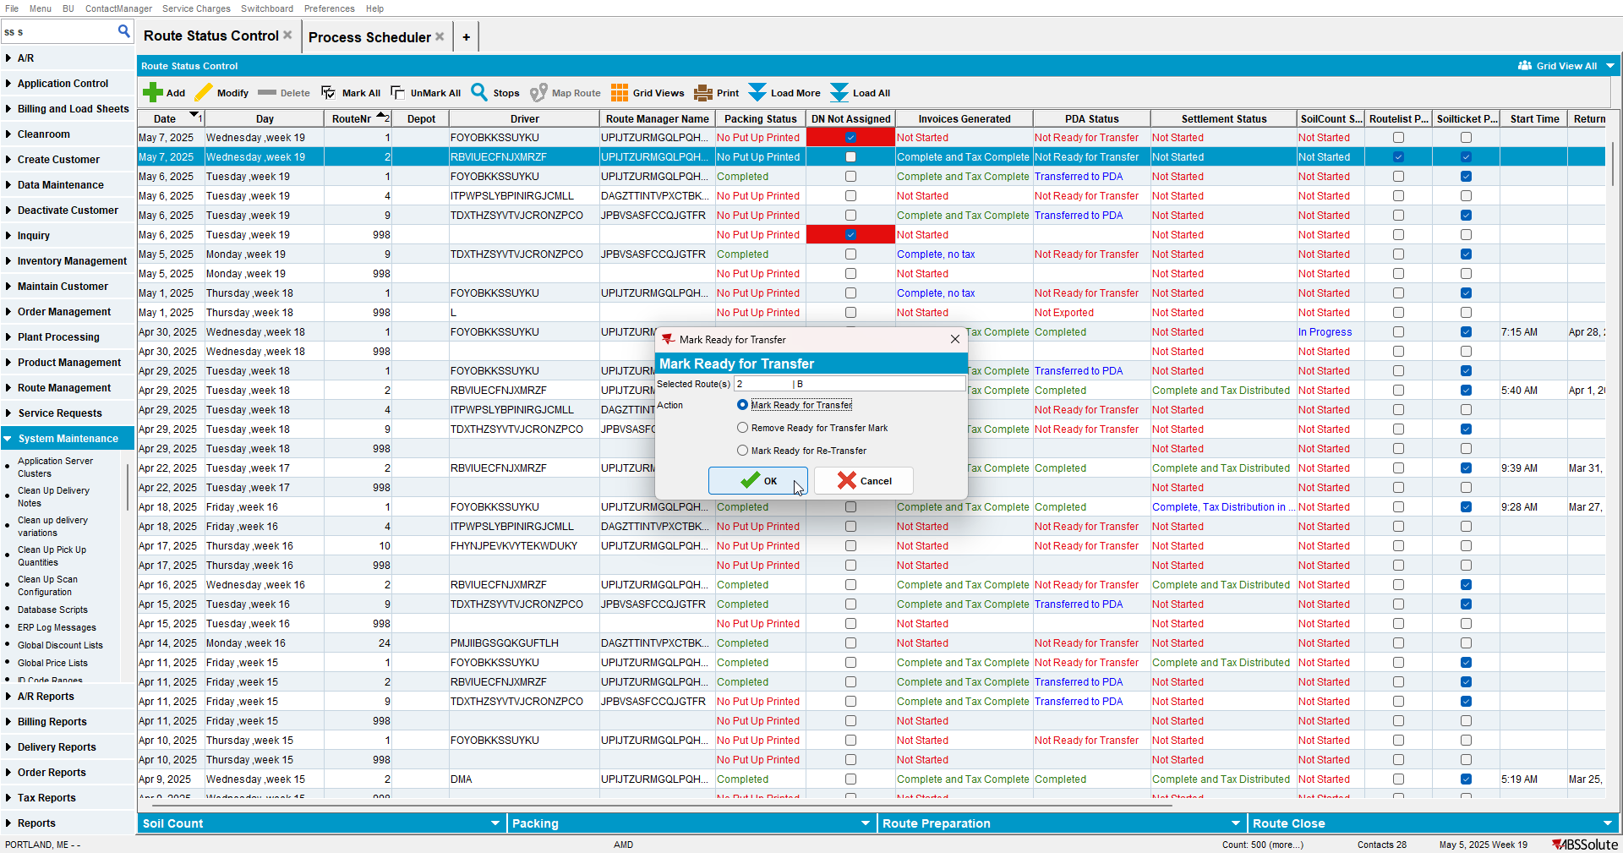

- RA: Make the stop undeliverable
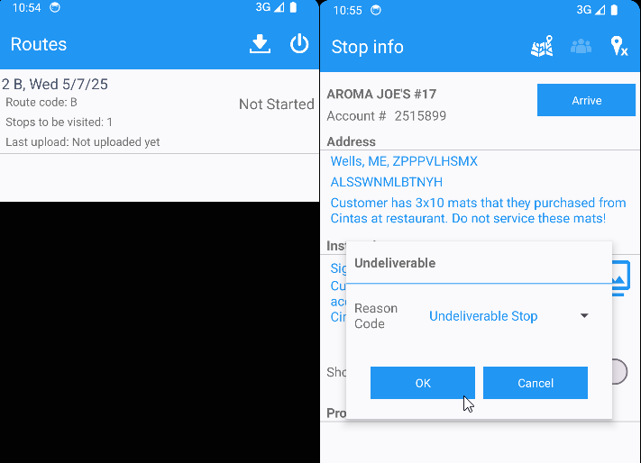
- Upload the route
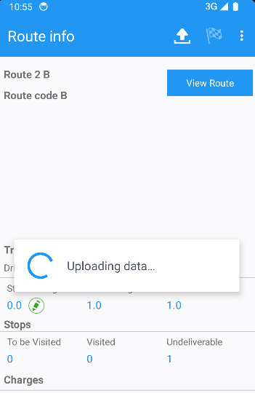

- Add a new record in reoutetransaction table
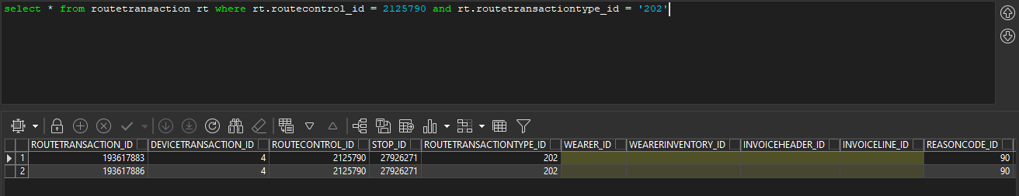

- WebX: Check Overview tab
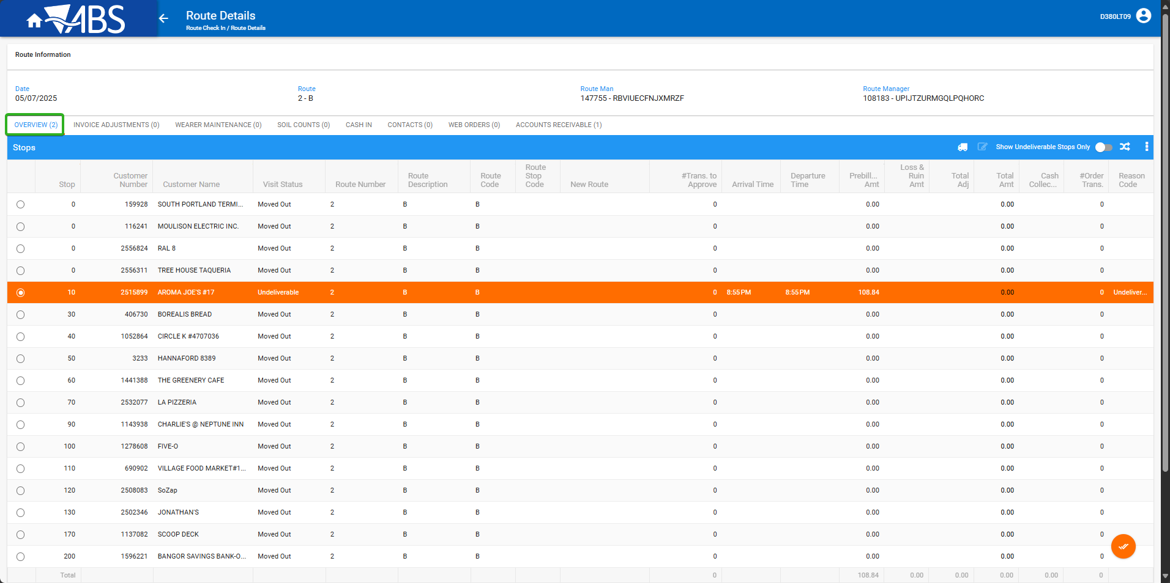

Expected behaviour: Tab should show count 1.
Actual behaviour: Tab show count 2 but there is just 1 undeliverable stop.

Retest after fix
Hash: d6ffcf1fe9f8

- RSC: Add a new route
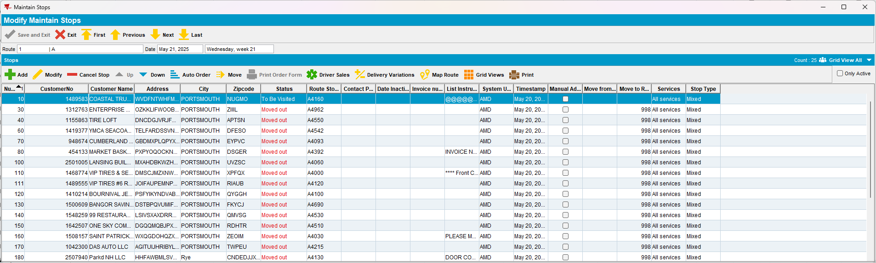

- RSC: Generate the invoices then transfer the route to PDA
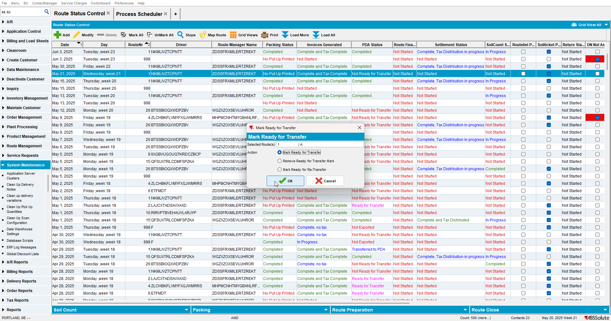

- RA: Make the stop undeliverable
- Upload the route
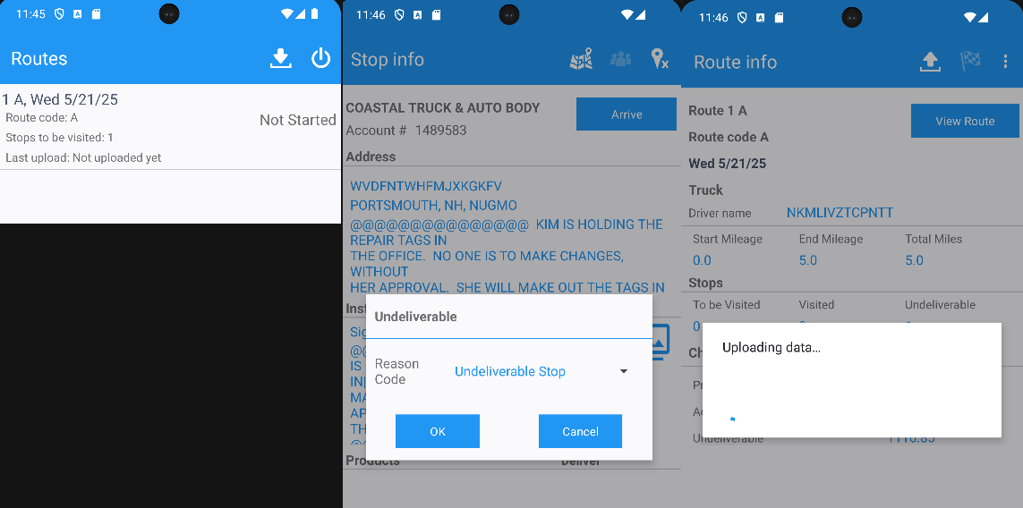

- Add a new record in reoutetransaction table
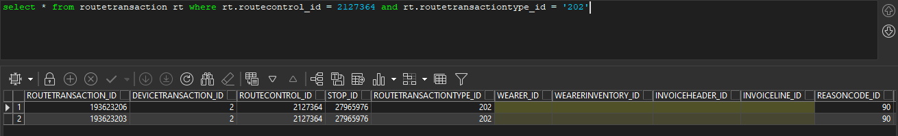

- WebX: Check Overview tab
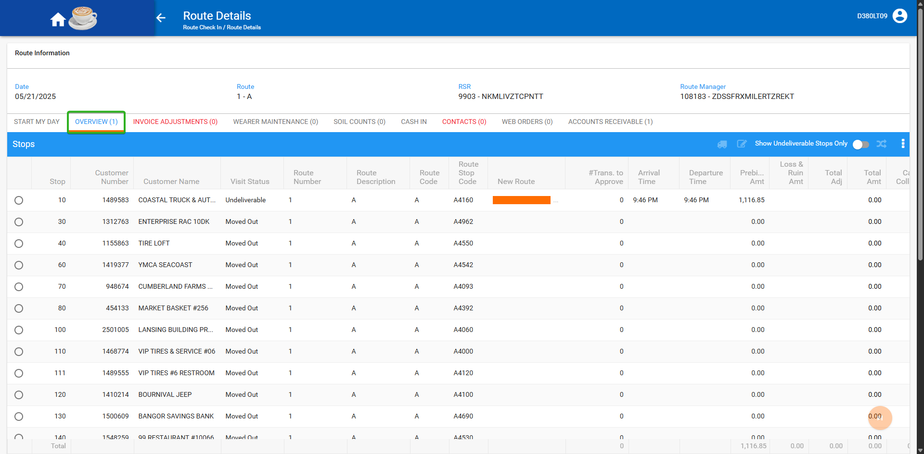
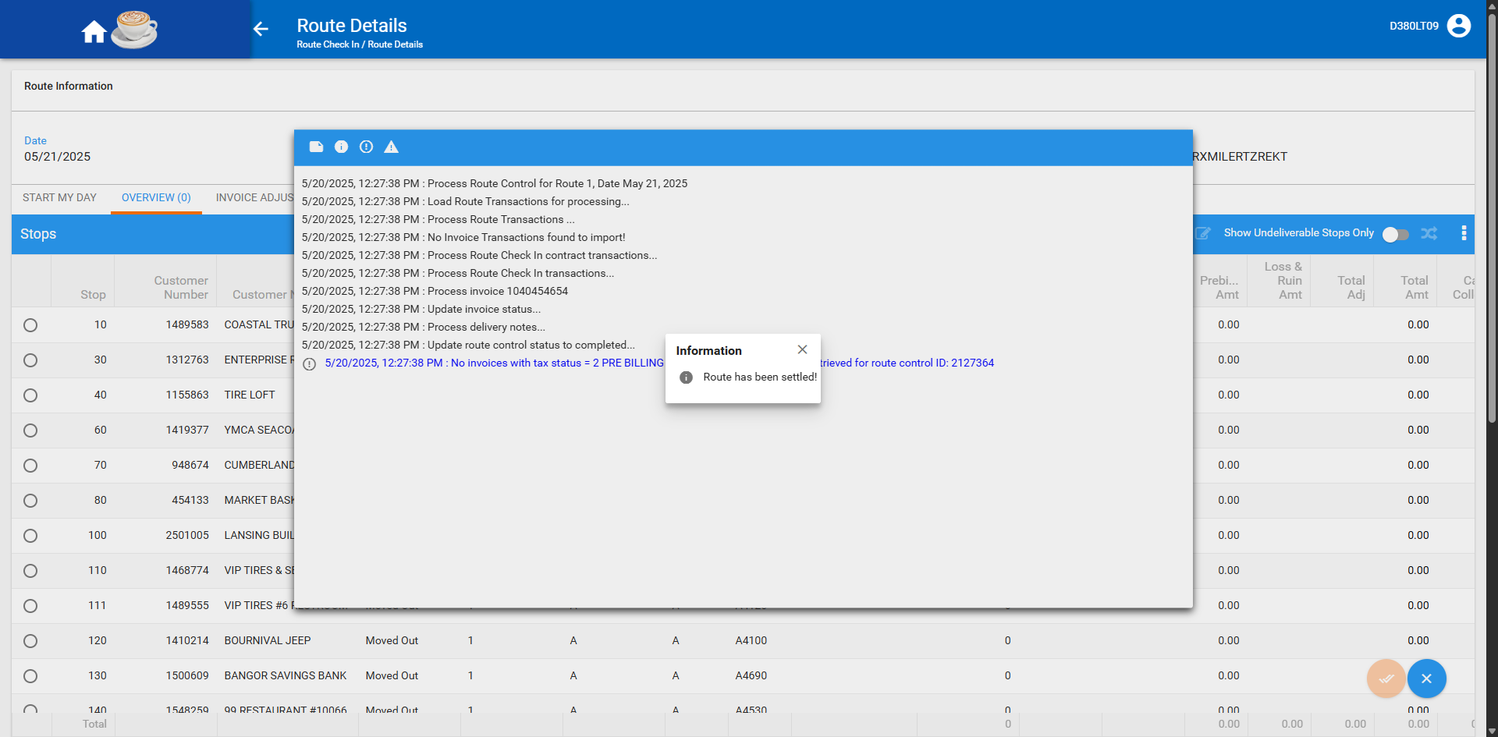

Expected behaviour: Tab should show count 1.
Actual behaviour: Tab show count 1.
TESTED OK

