ABSN-1656 - View Process Log - Redesign for performance
Environment | Prerequisites
Version: 9.07.00.UNF20  DBServerName= abs-srv20.internal.abslbs.com  DBSID=CUST24  DBUser=UNFDEV  Environment=Test | - Module:  - System setting

Contents
Retest after fix 1
Test Case 1 – Check loading times from Dialog tab 1
Test Case 2 – Check loading times from Scheduled Process tab 20

Retest after fix

Test Case 1 – Check loading times from Dialog tab
Hash: 0c2910d8eef7
Expected: Compare performances on a build without the fix to a build which contains the fix, the build with the fix should load faster
- View Process log DLG: Select a time frame of 1+ month
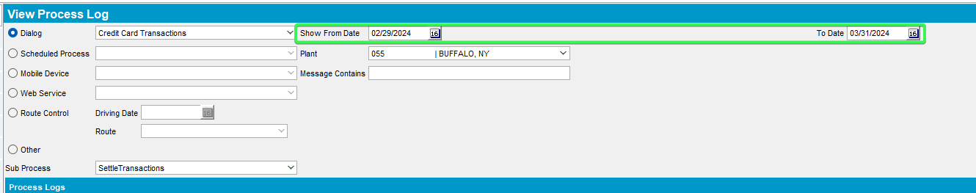

- Select Credit Card Transactions
Before
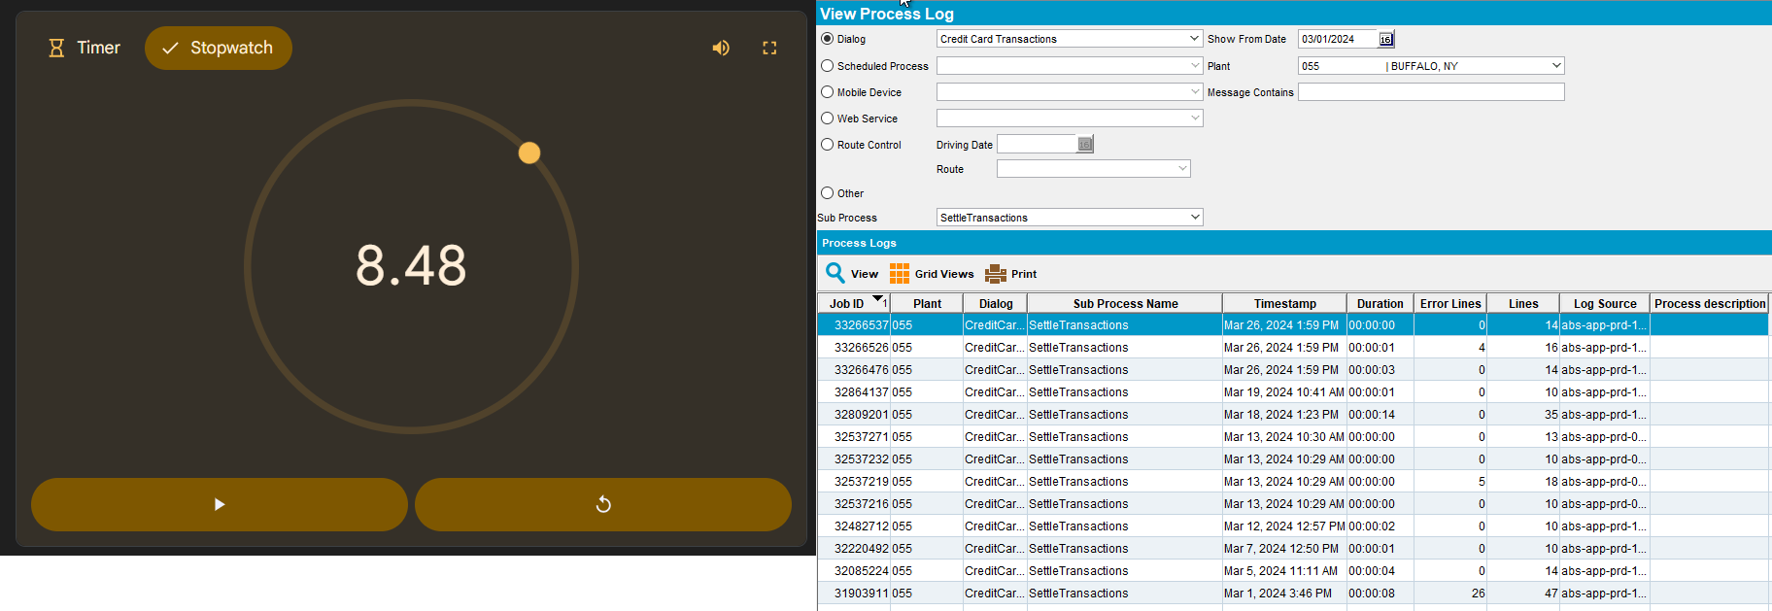
After
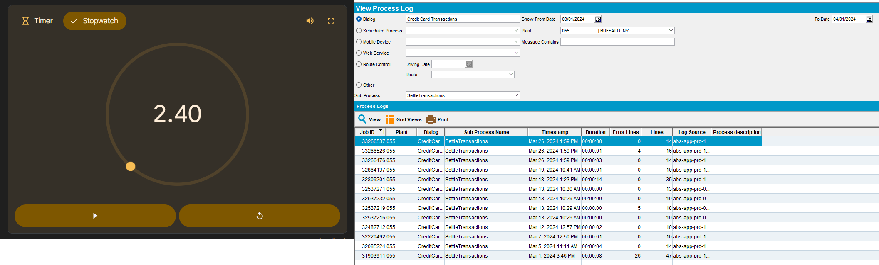

- Select Customers
Before
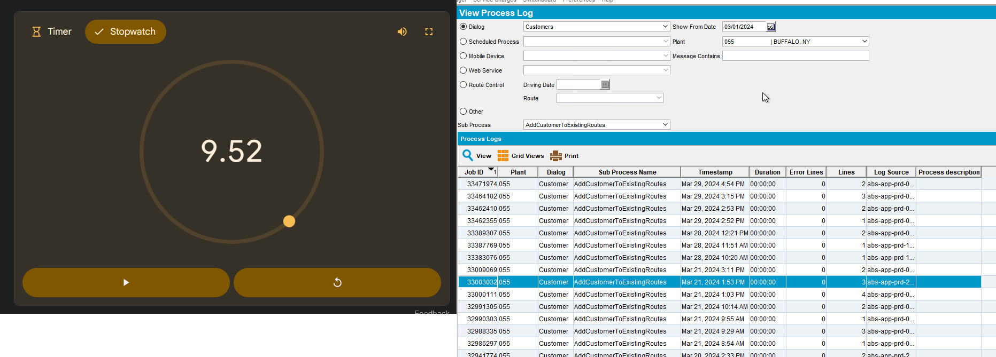
After
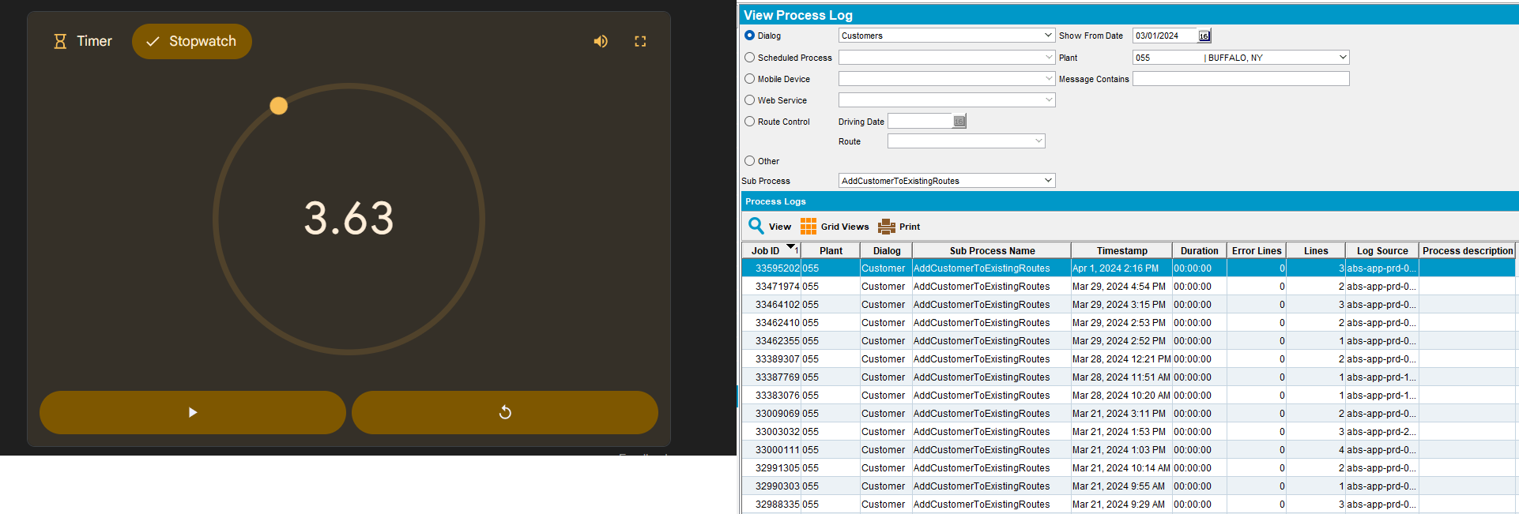

- Select Delivery Variations
Before
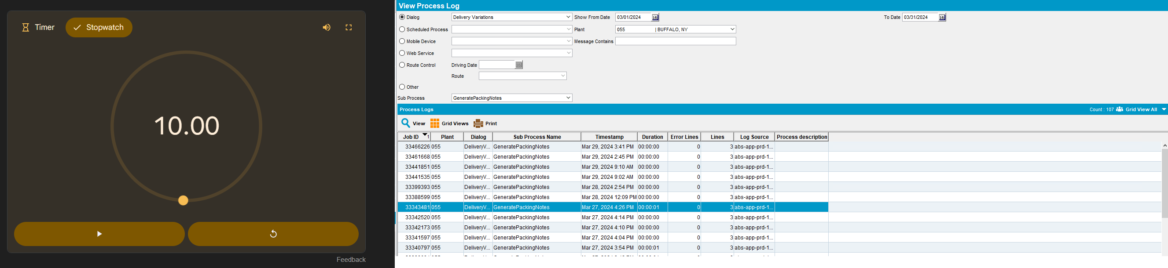
After
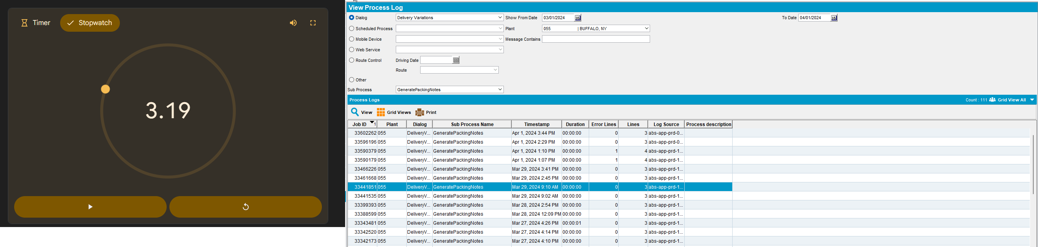
- Select Loss Charge Monitor
Before
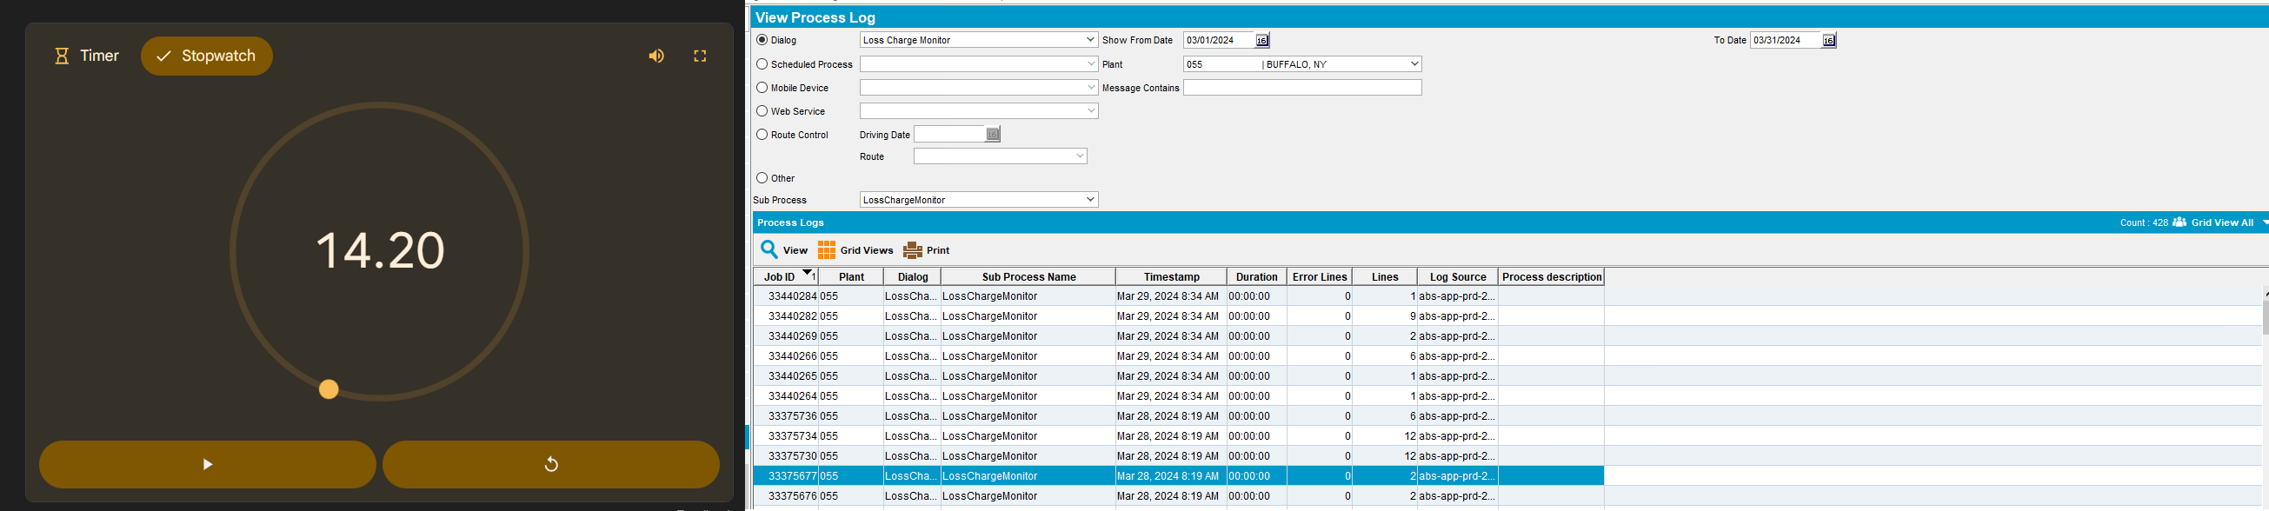
After
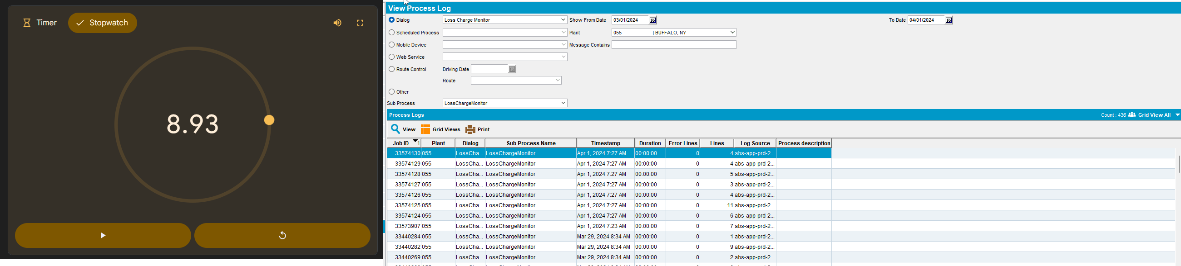

- Select Maintain Packing and Delivery Notes
Before
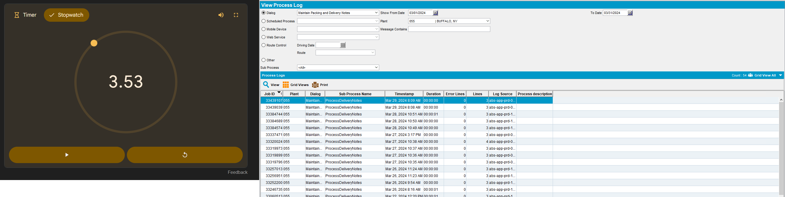
After
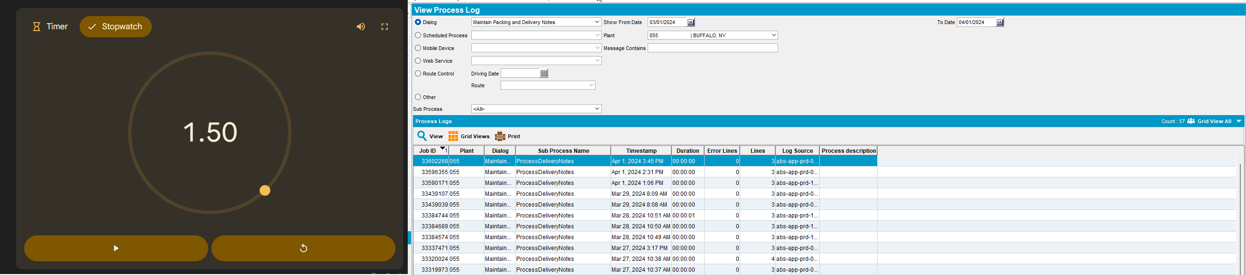

- Select Route Status Control
Before
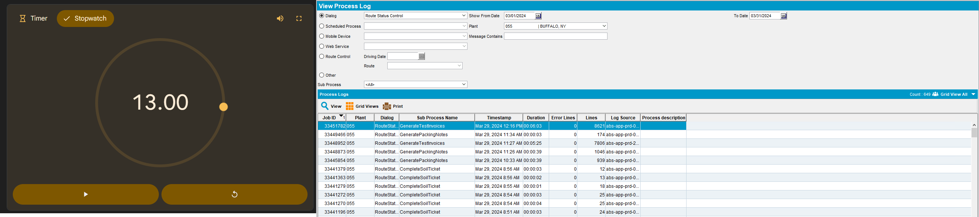
After
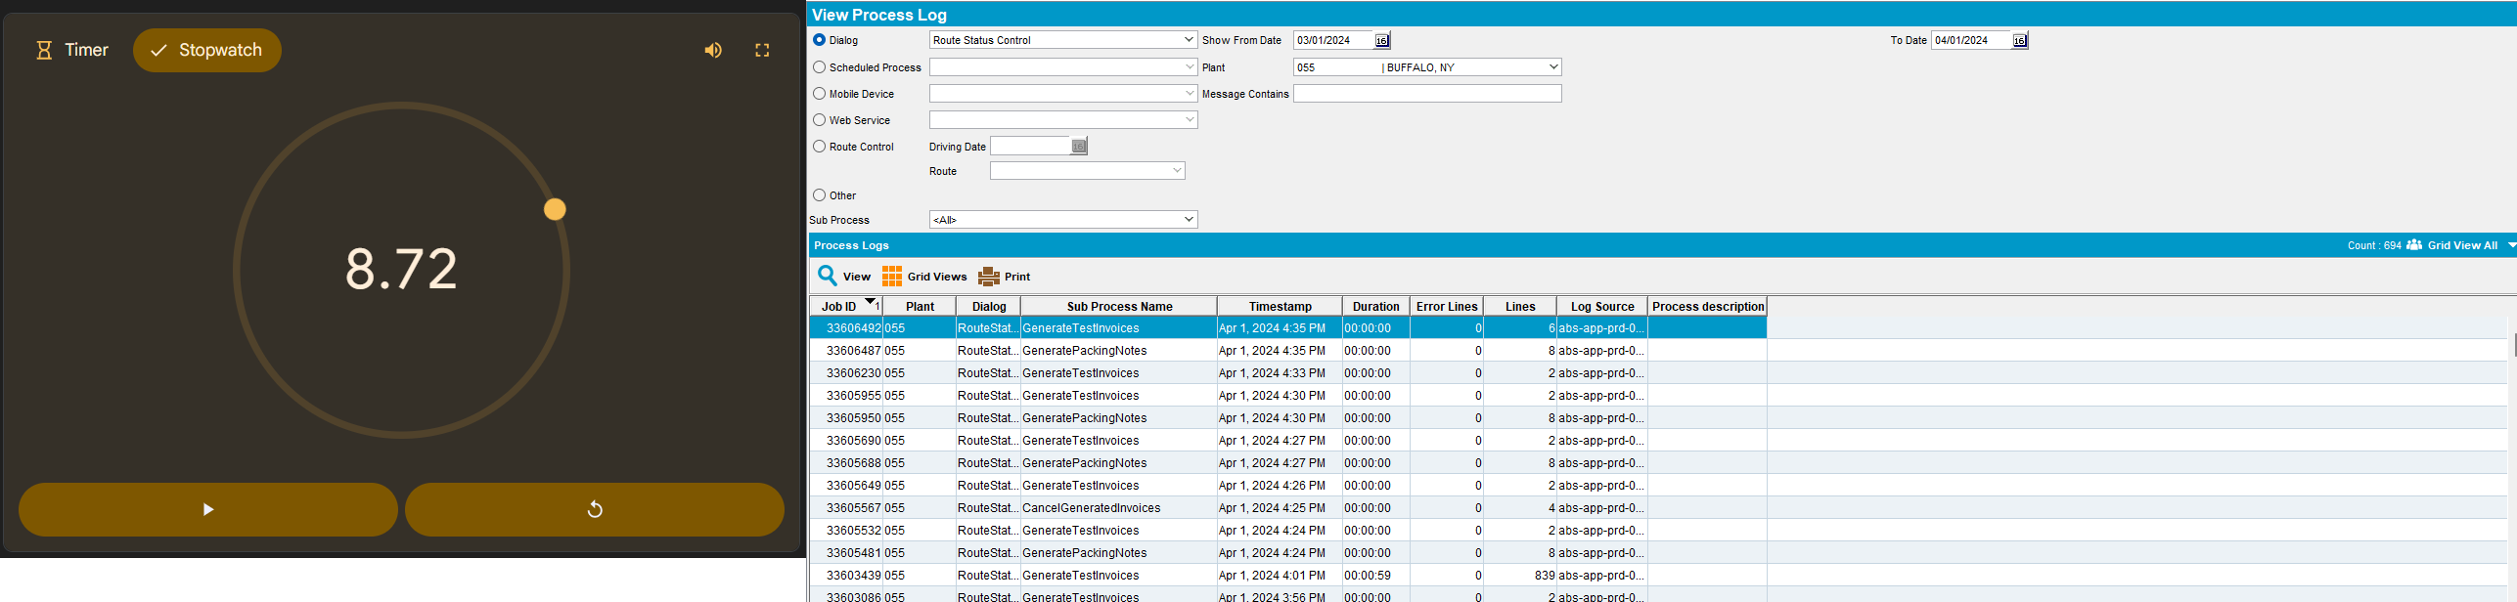
- Select Settlement
Before
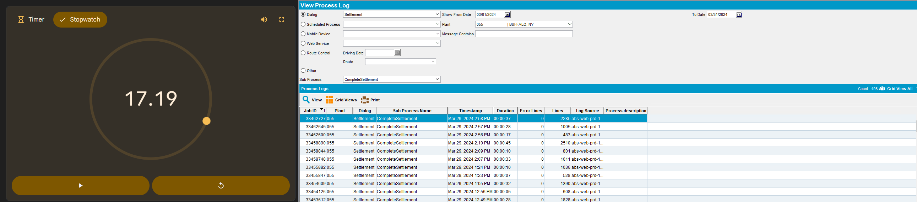
After
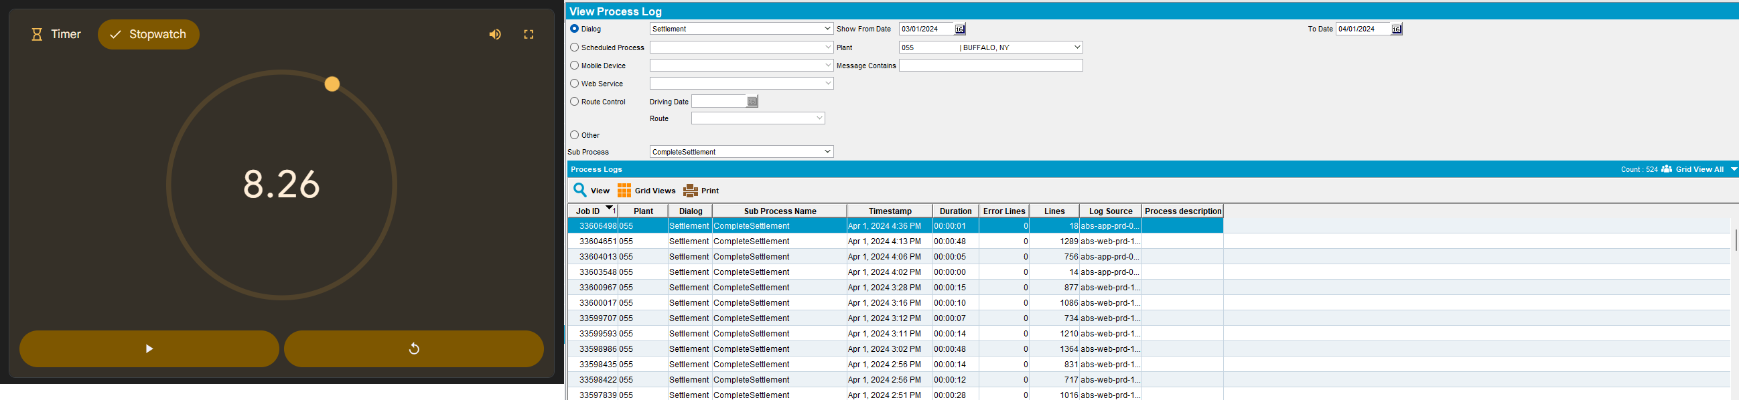
- Select Wearers
Before
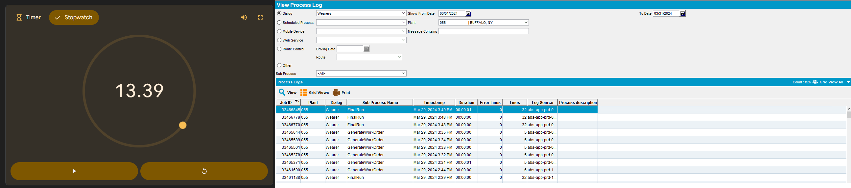
After
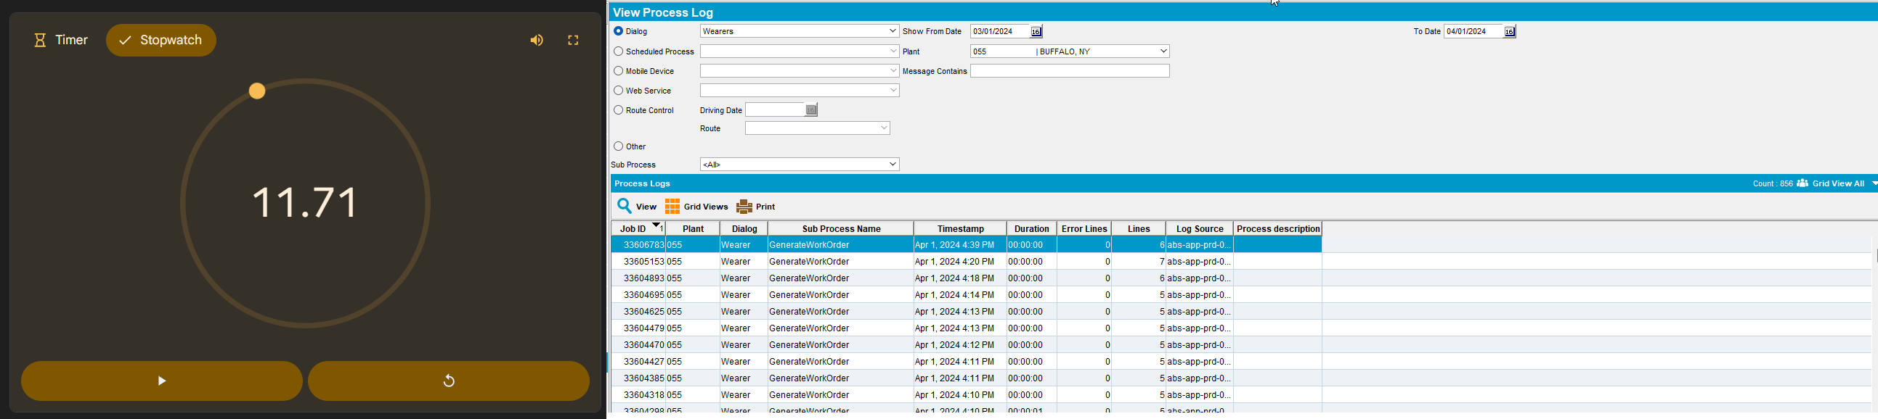

Tested OK

Test Case 2 – Check loading times from Scheduled Process tab
Hash: 0c2910d8eef7
Expected: Information in the grid should appear in under 10 seconds
- View Process log DLG: Select a time frame of 1 month
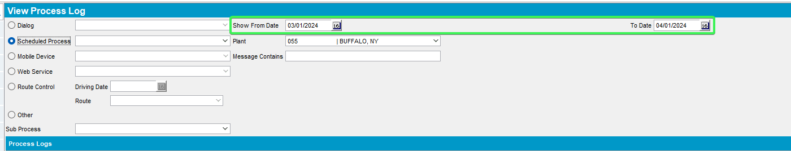
- Select Scheduled Process Option > press on the dropdown button and select the following
- Automatic write off small value ARTansactions
Before
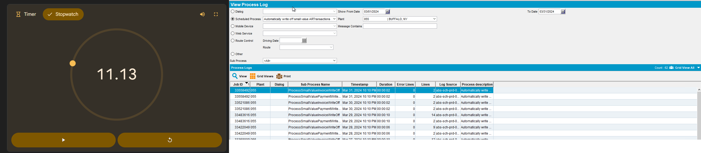
After
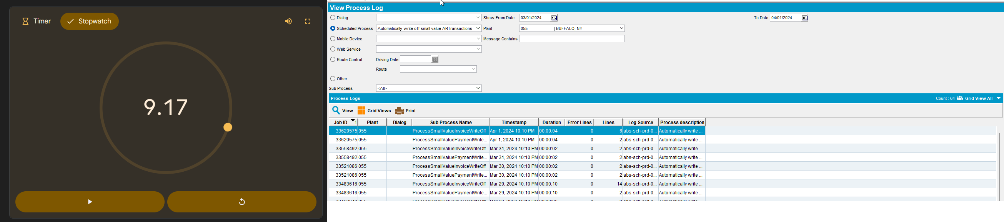
- Create credit card transactions from payment schedule
Before
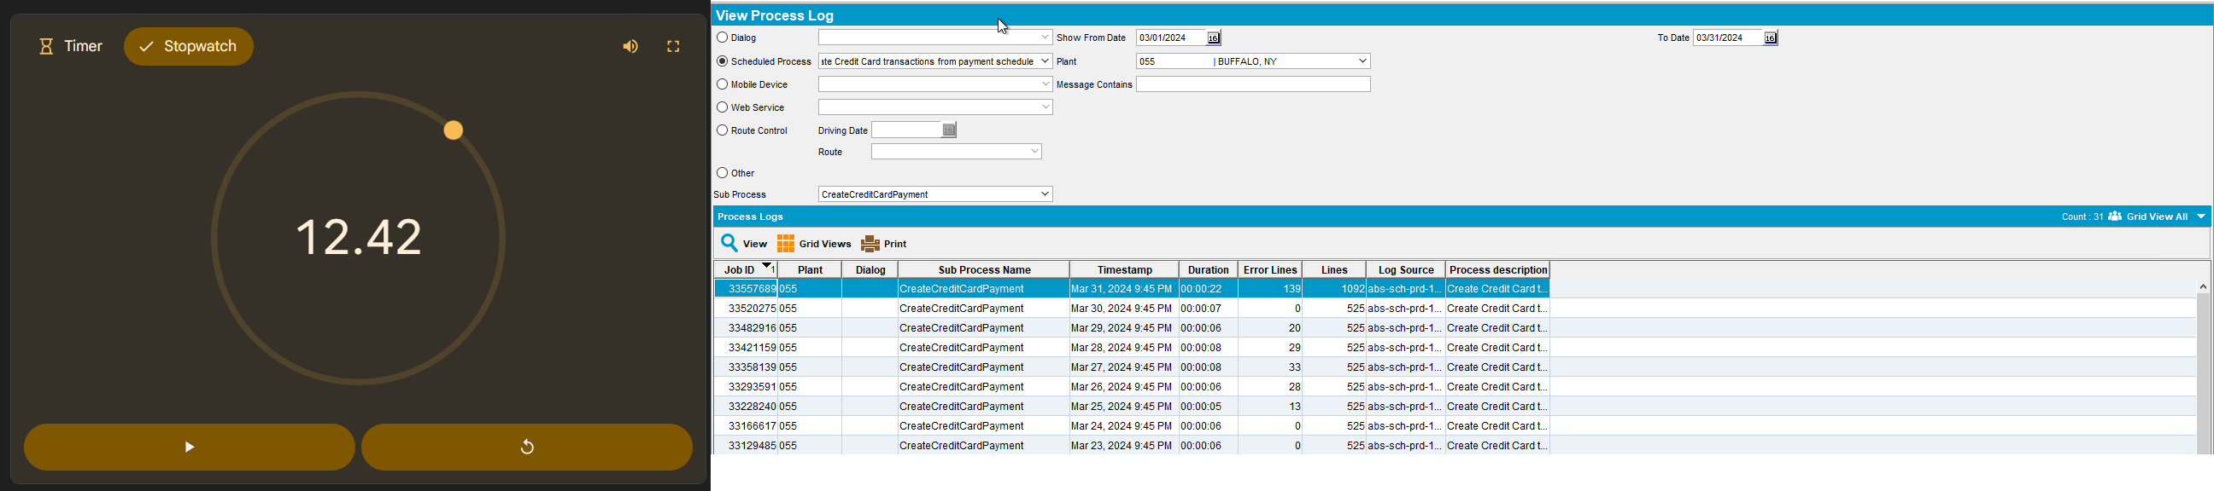
After
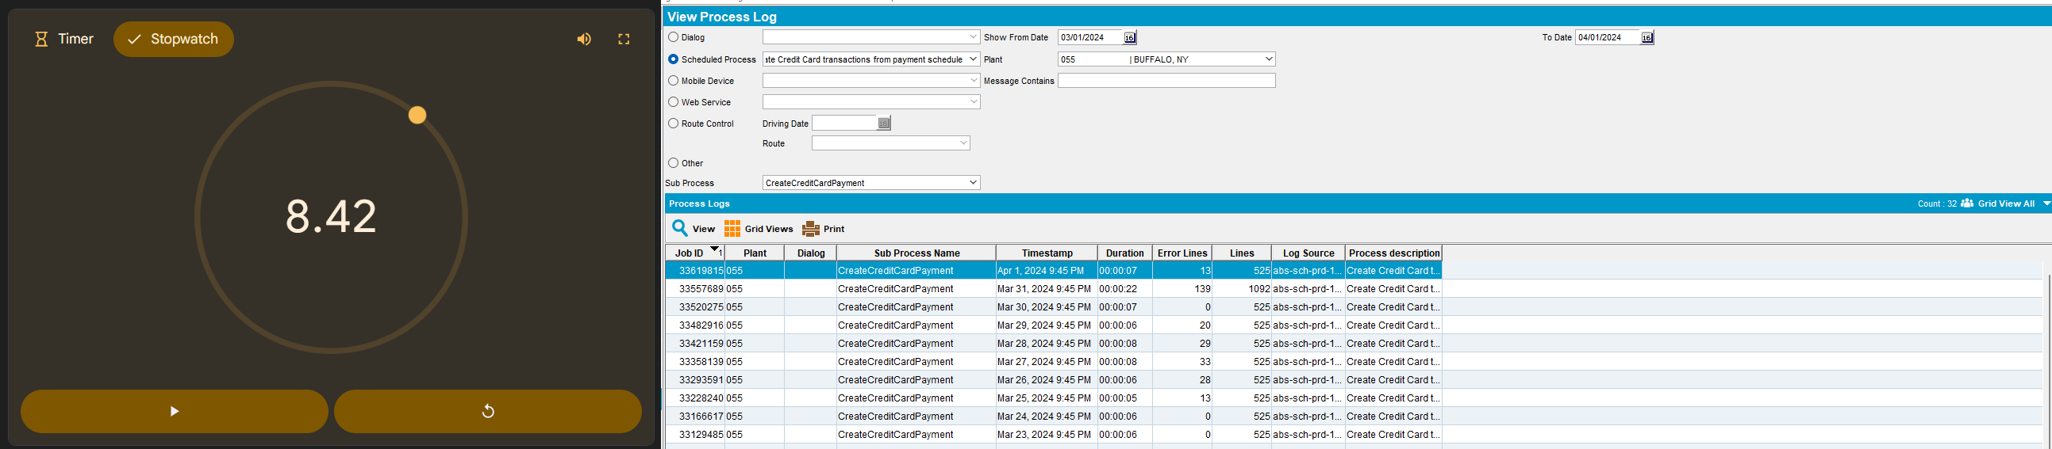
- Email direct invoices
Before
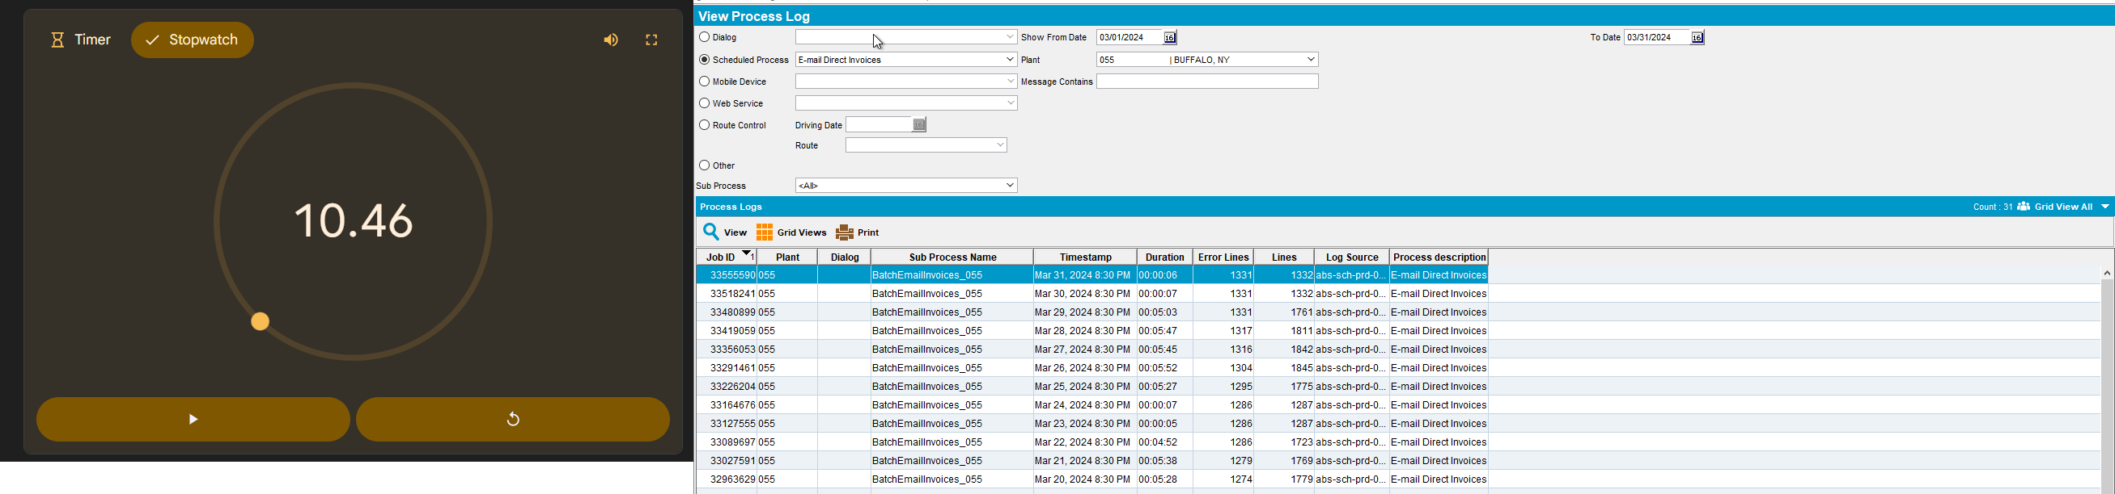
After
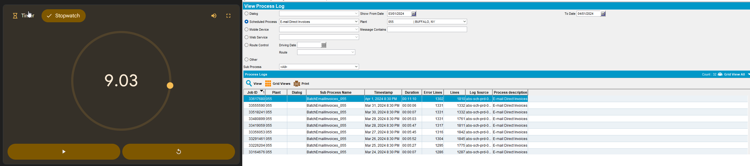
- Import Vertex BCI Tax Response
Before
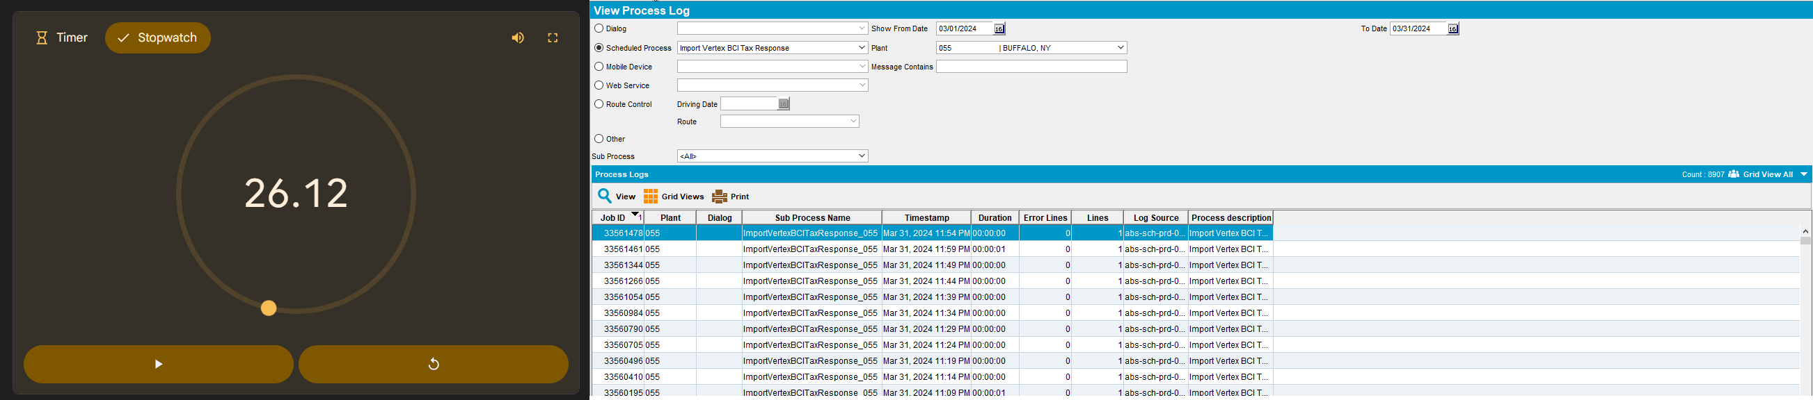
After
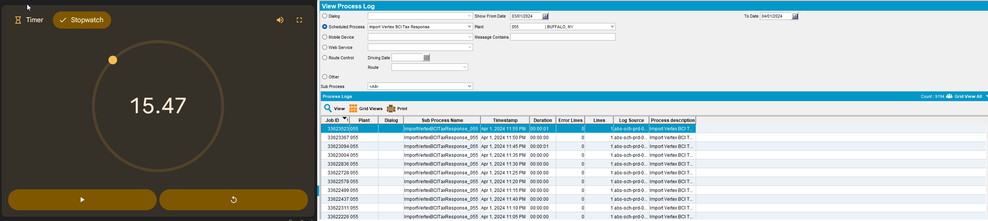
Tested OK

