ABSN-1527 ASD-64596 UNF: D_UBS_2547 Unable to scan returned items on the RA if the Loss Charges check box is unchecked in the Customers dialog
Environment | Prerequisites
Version:9.07.00  DBServerName=abs-SRV20.internal.abslbs.com  DBSID=CUST24  DBUser=UNFDEV  Environment=Test | - Module:  - System setting

Contents
Retest after fix 1
Test Case 1 – Return garments with Customer.ChargeLossCharge = 'N' with UNFCUSTOM– Tested OK 1
Test Case 2 – Generate Invoices for Customer.NonGarmentChargeLossCharge= 'N'with UNFCUSTOM– Tested OK 36
Test Case 3 – Return garments with Customer.ChargeLossCharge = 'N' without UNFCUSTOM– Tested OK 43
Test Case 4 – Generate Invoices for Customer.NonGarmentChargeLossCharge= 'N' without UNFCUSTOM – Tested OK 50

Retest after fix

Test Case 1 – Return garments with Customer.ChargeLossCharge = 'N' with UNFCUSTOM– Tested OK
Expected behavior: You should have a 0 price invoice line for loss charges for garments whenever you have a customer with Customer.ChargeLossCharge = 'N', this should allow the user to return garments on the RA.
Hash: 263bd3a
- Have UNFCUSTOM module in the license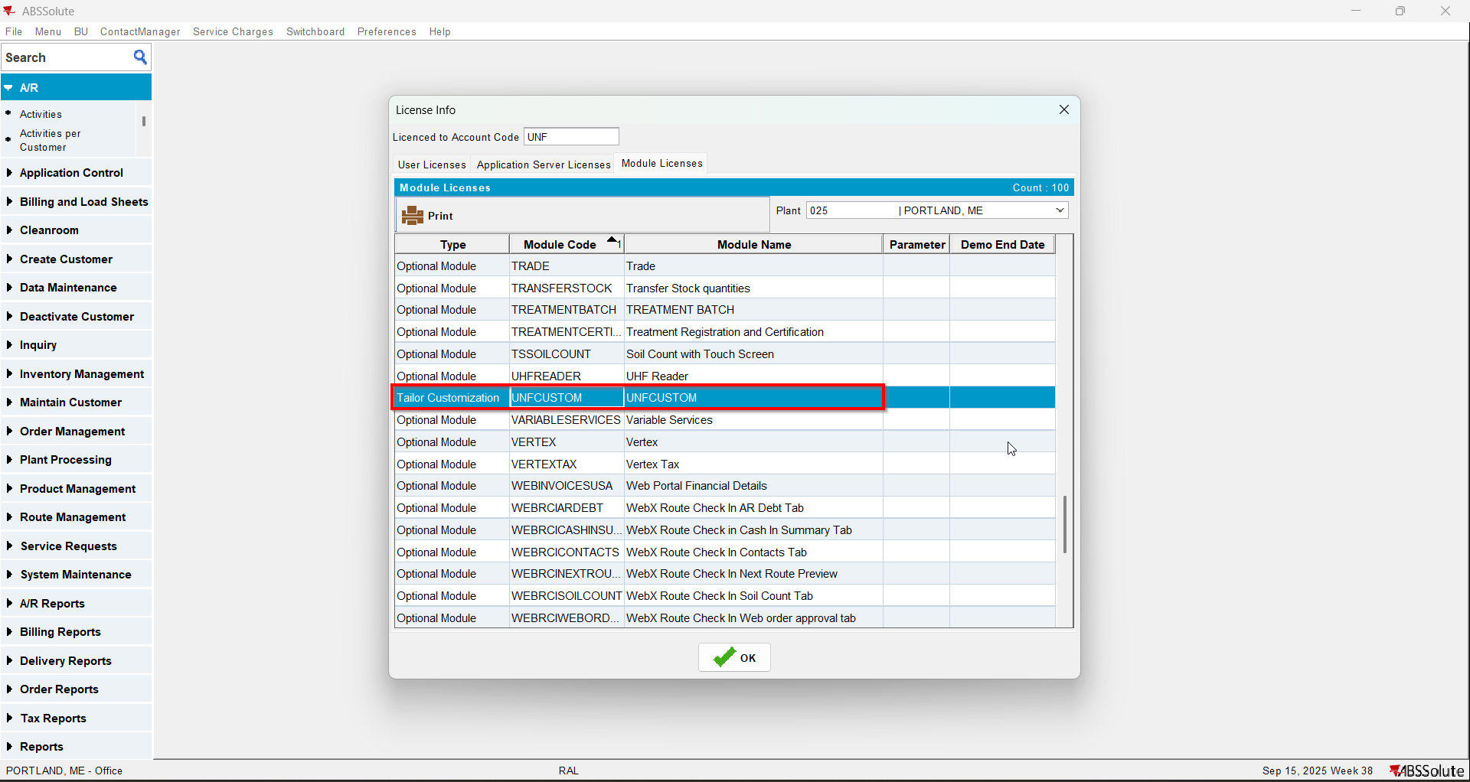
- Check that your customer has Charge Loss Charge unchecked for garments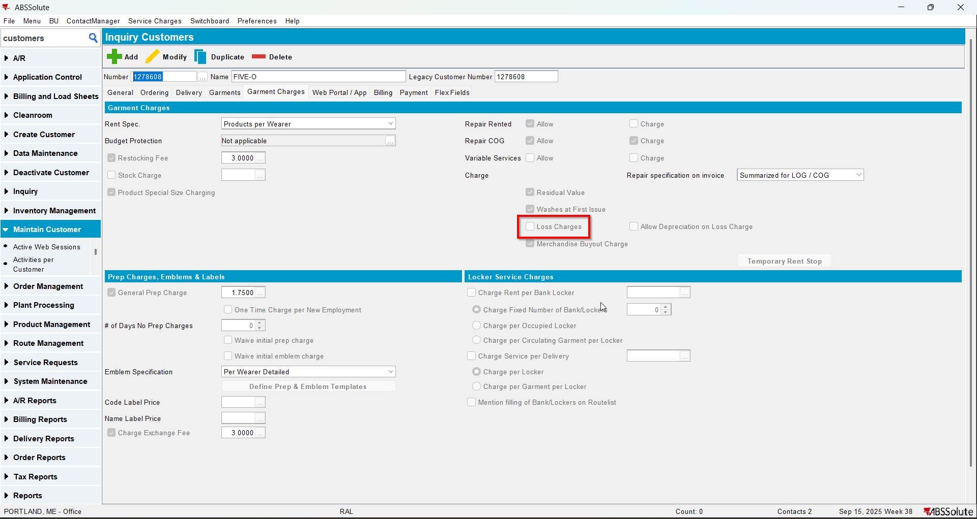
- Wearer inventory 1: Decrease Max inventory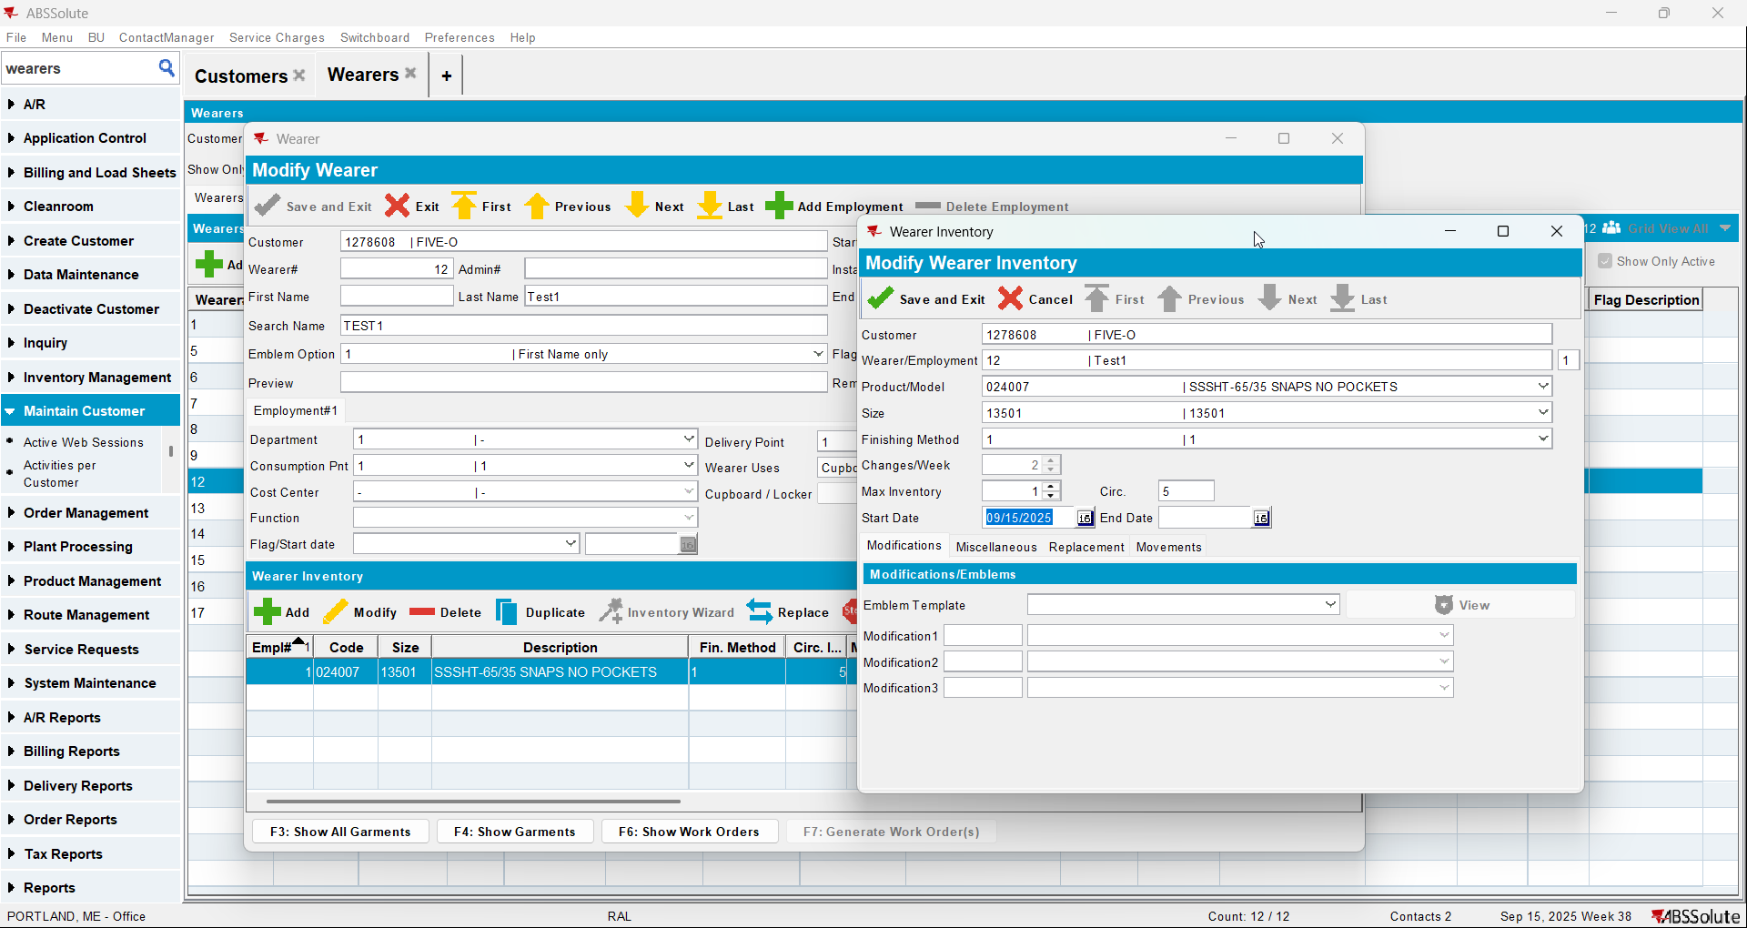
- Wearer inventory 2: Partial replacement of inventory (issue new garments)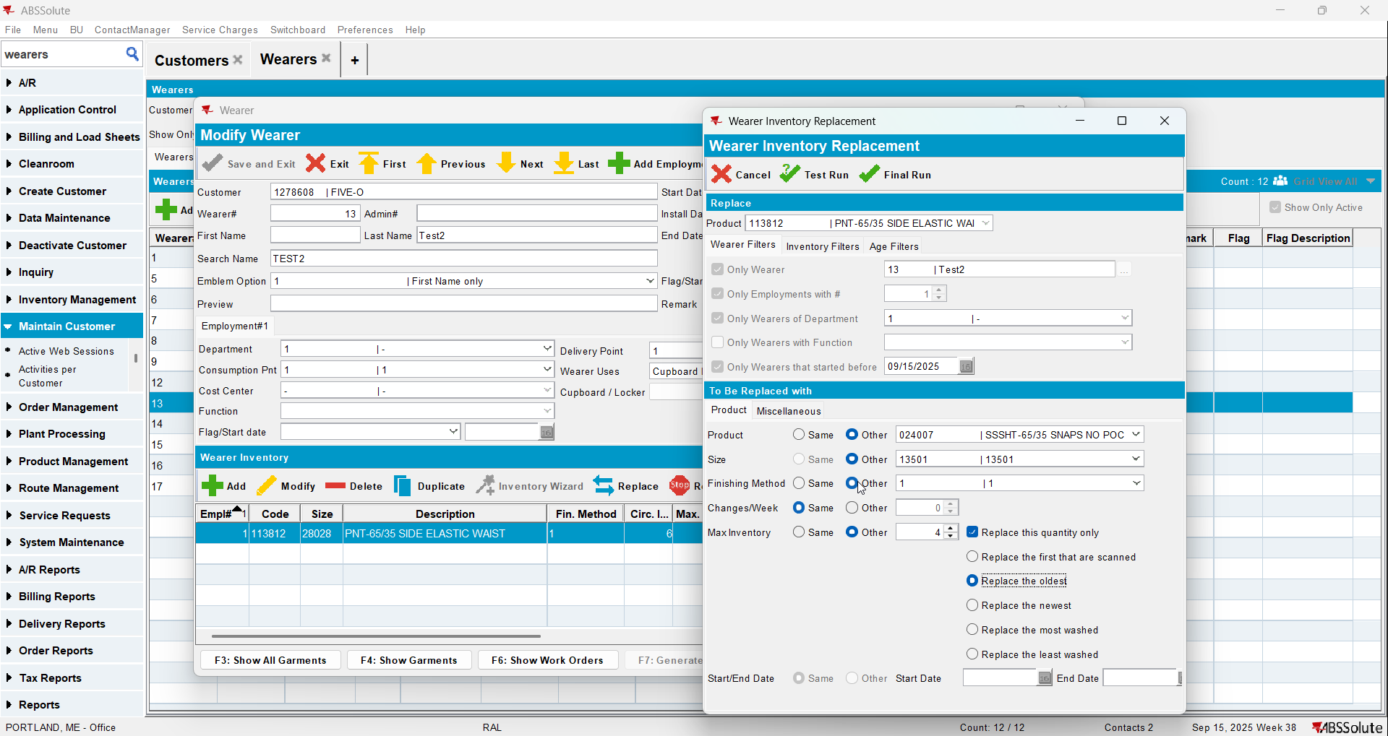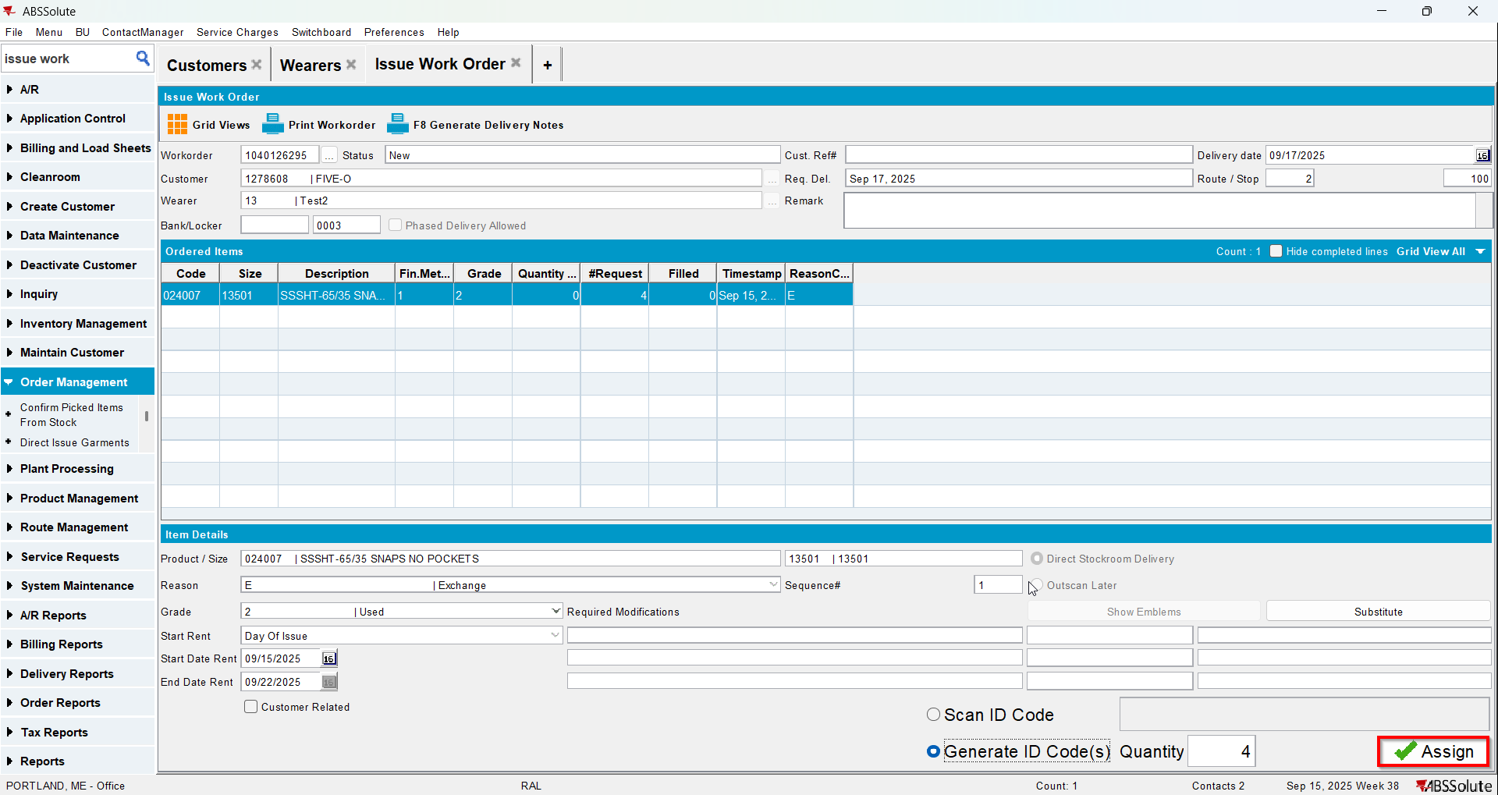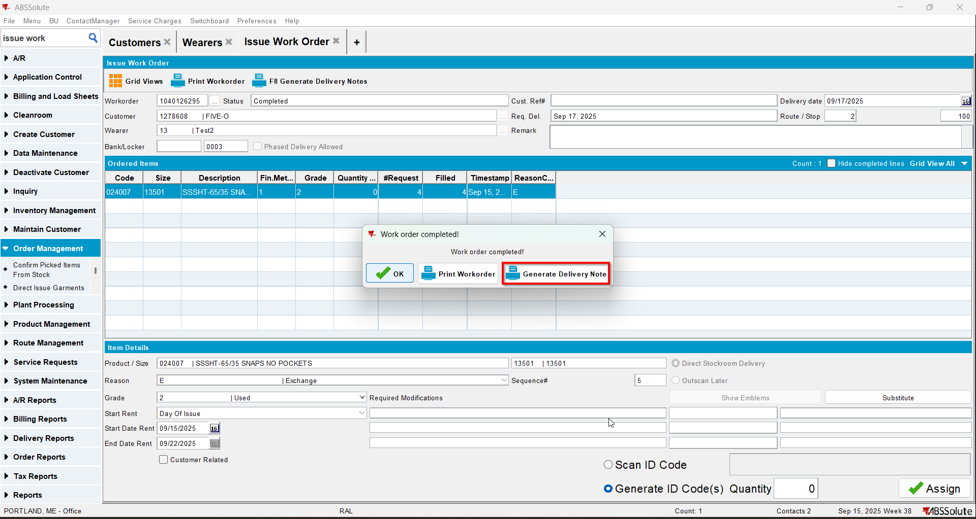
- Wearer inventory 3: Quit wearer inventory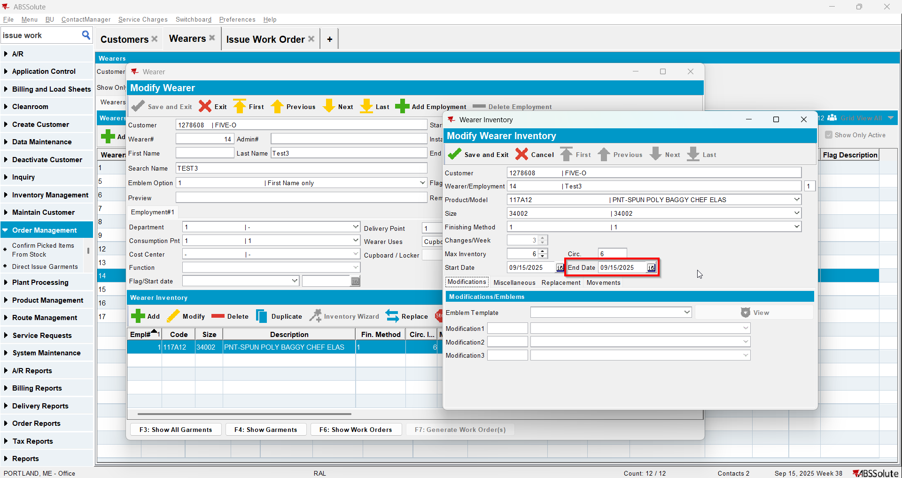
- Wearer inventory 4: Quit wearer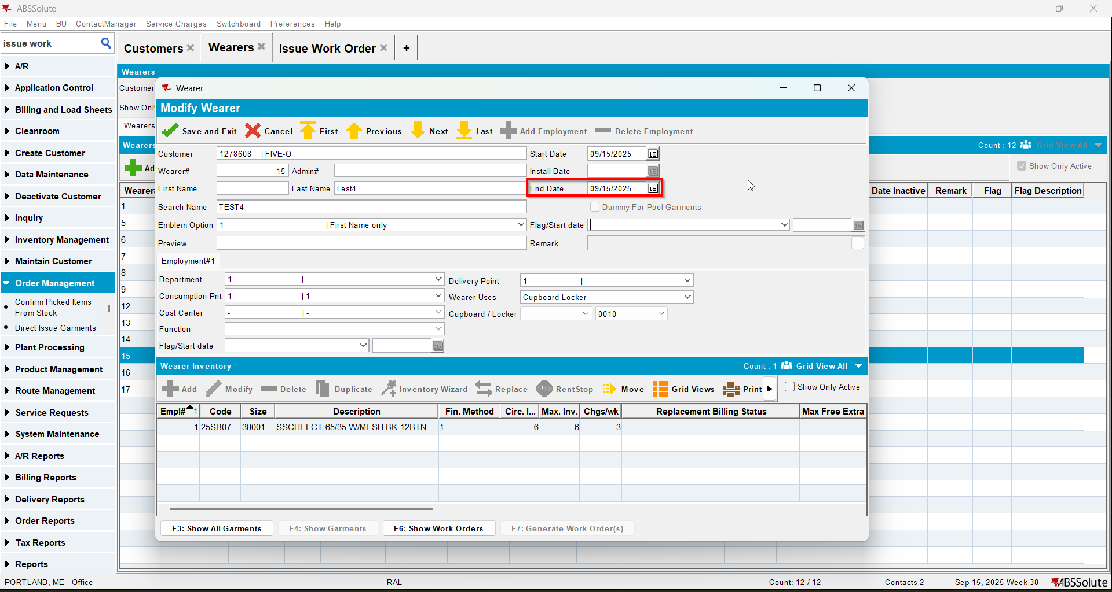
- Wearer Inventory 5: Quit PLPC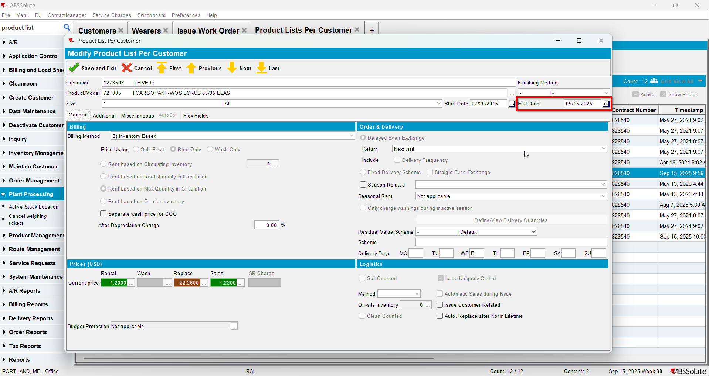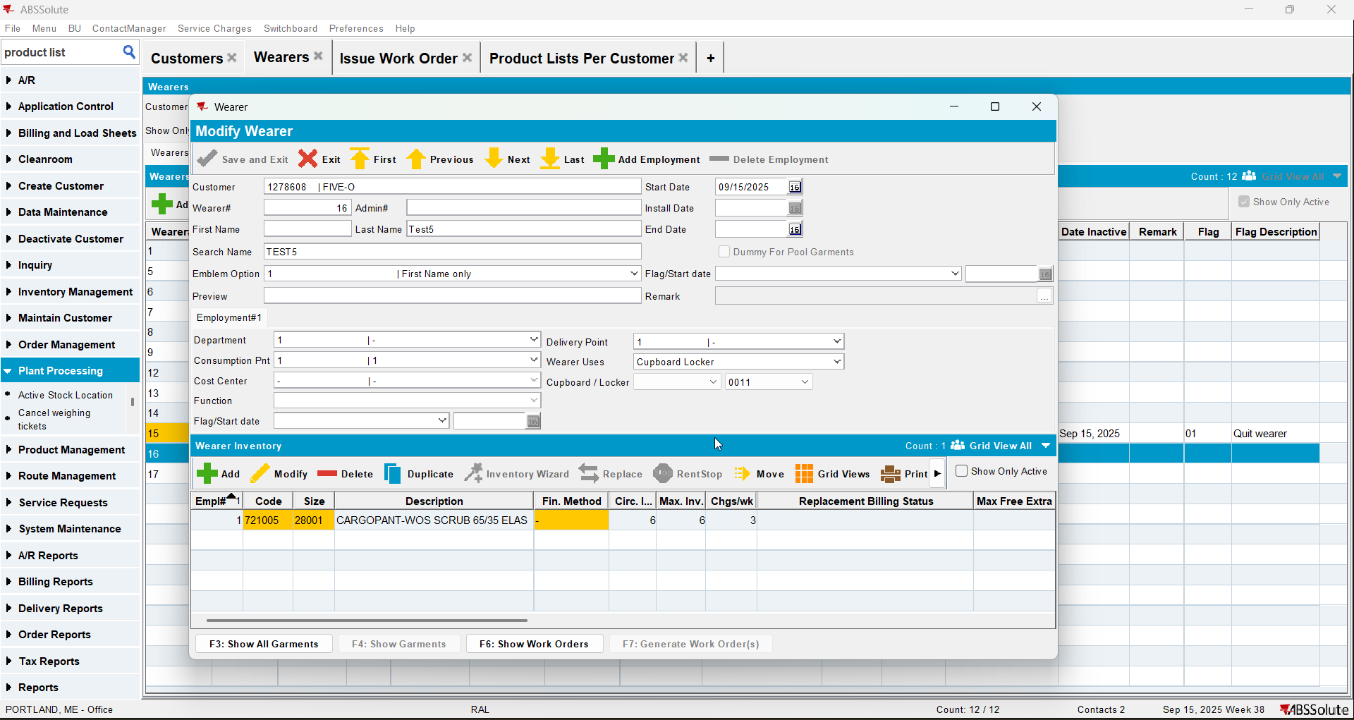
- Wearer Inventory 6: Quit wearer inventory MBYO(customer needs to have MBYO charge and the product Allow Return to Stock “No, Charge MBYO”)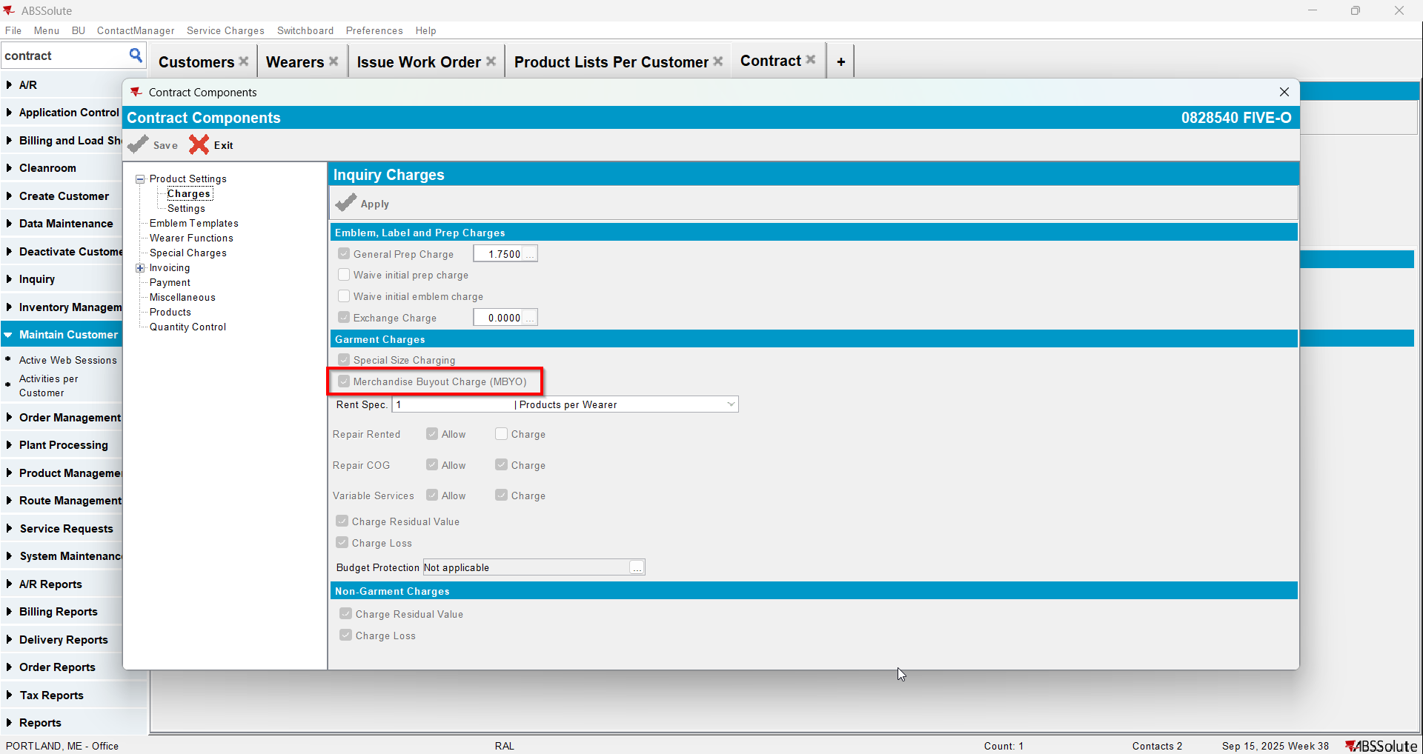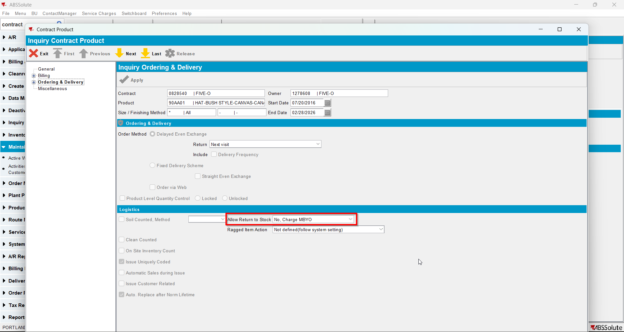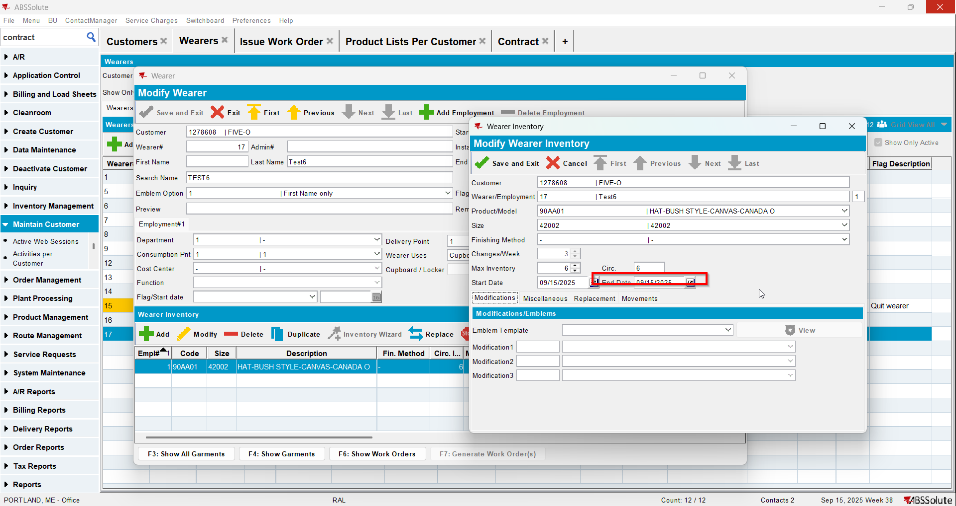
- Generate invoice in current week (all loss charges should be Extended = 'N' and price 0 instead of the MBYO) 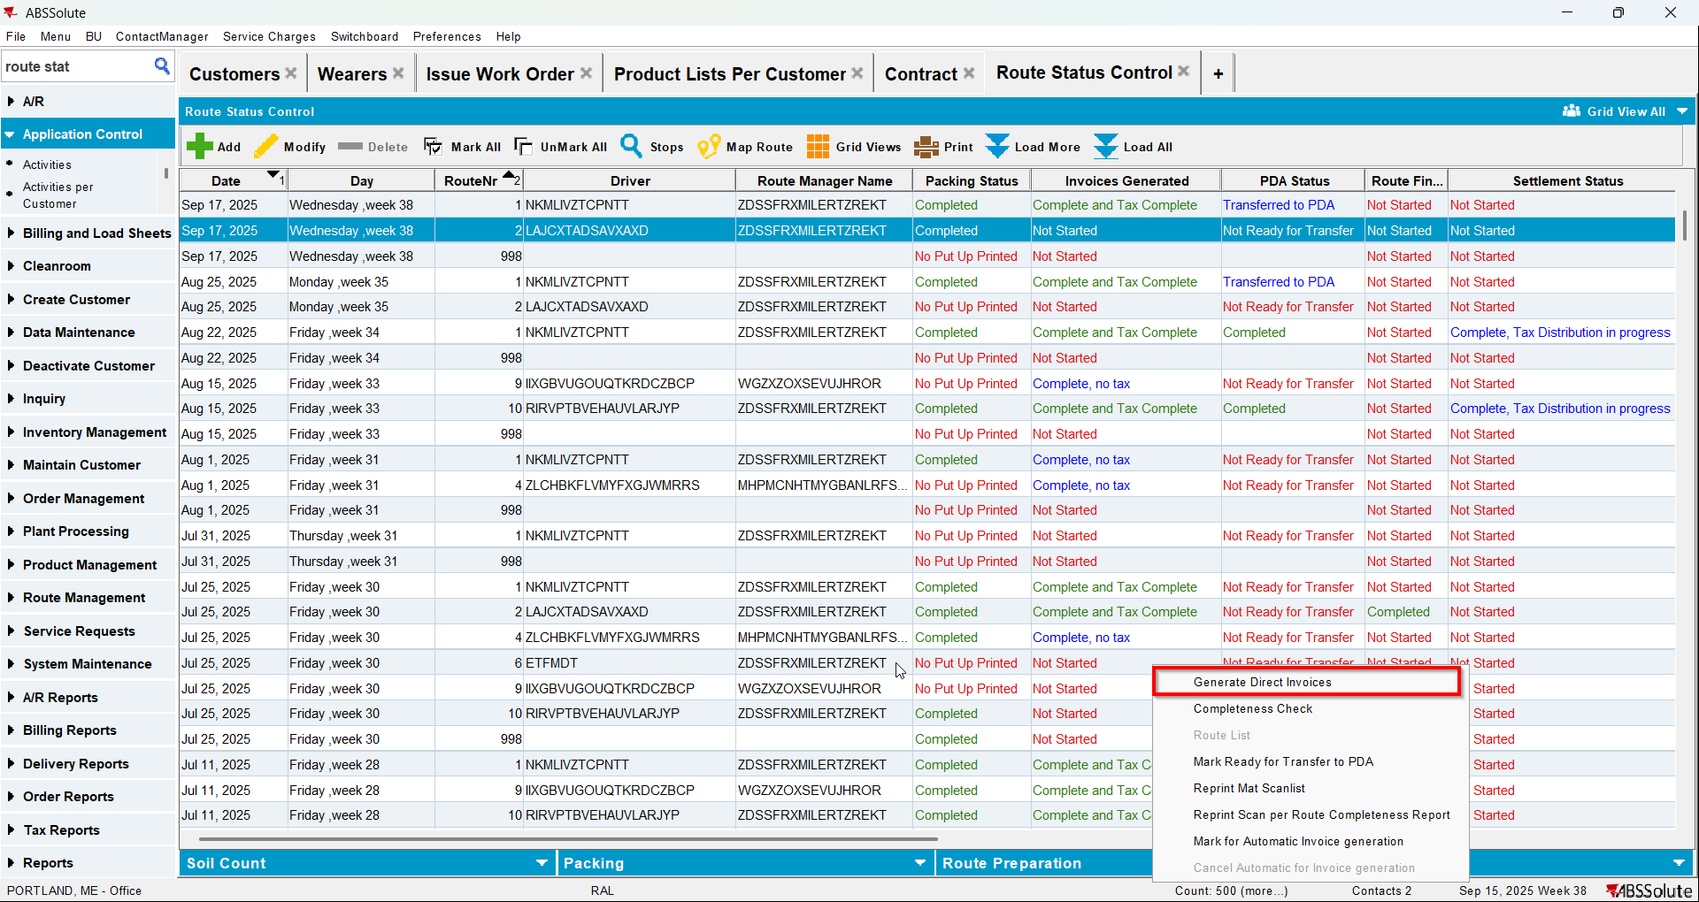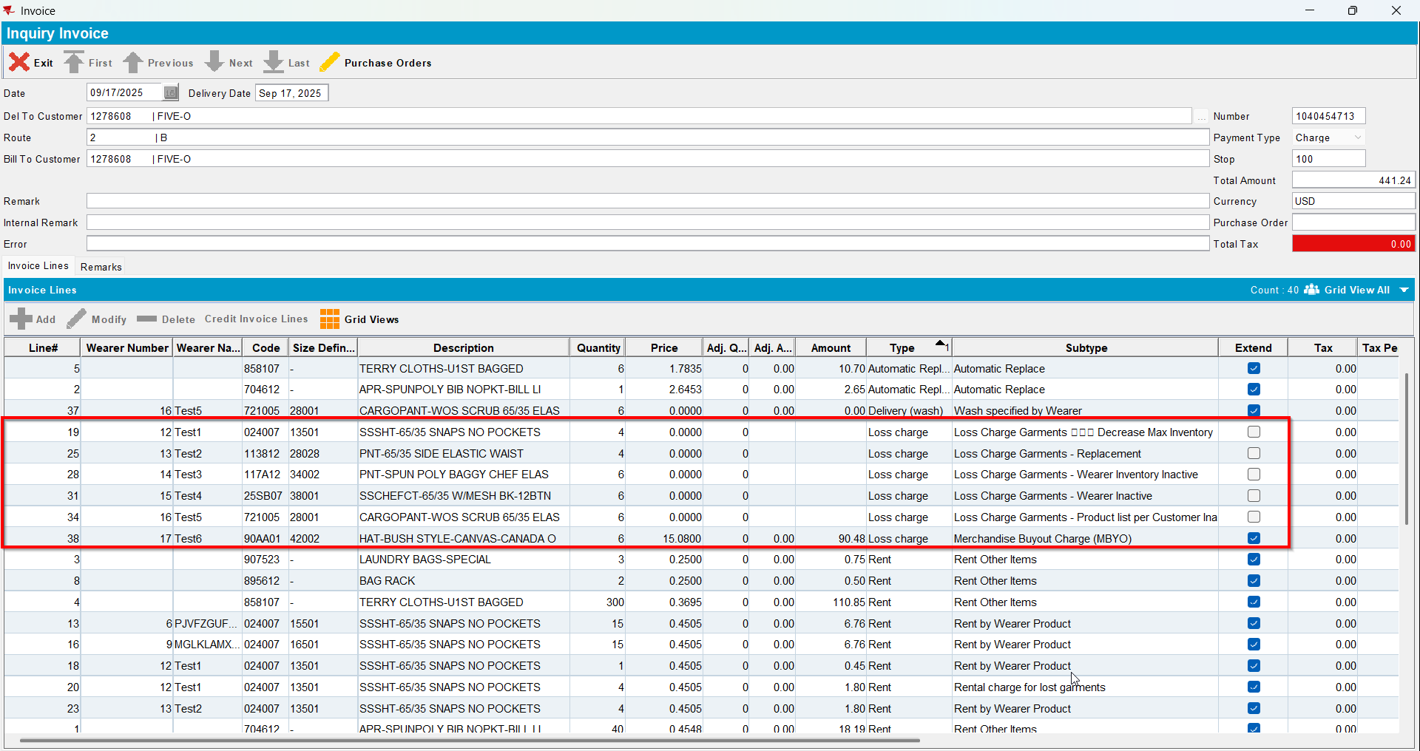
- Check the remarks for the loss charges with Extended=’N’. It should be “Loss charges will be billed in 2 weeks”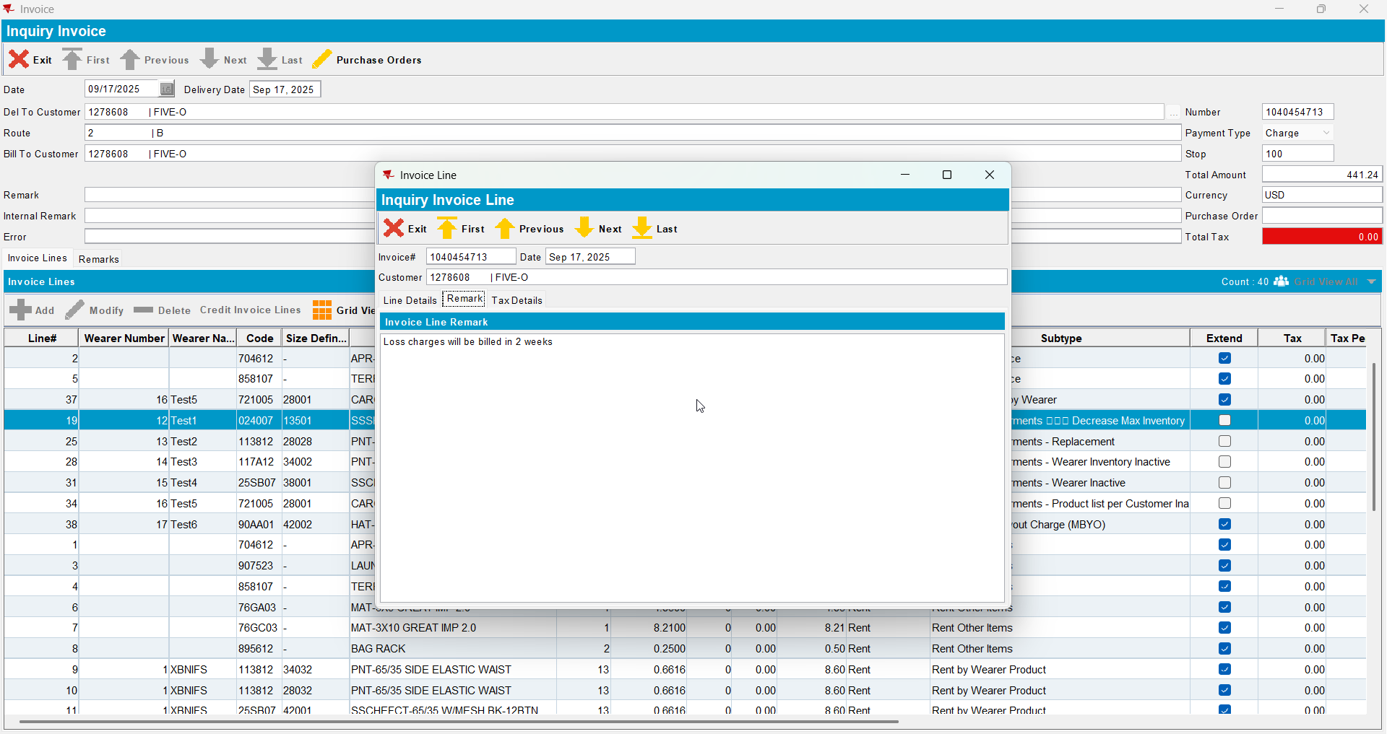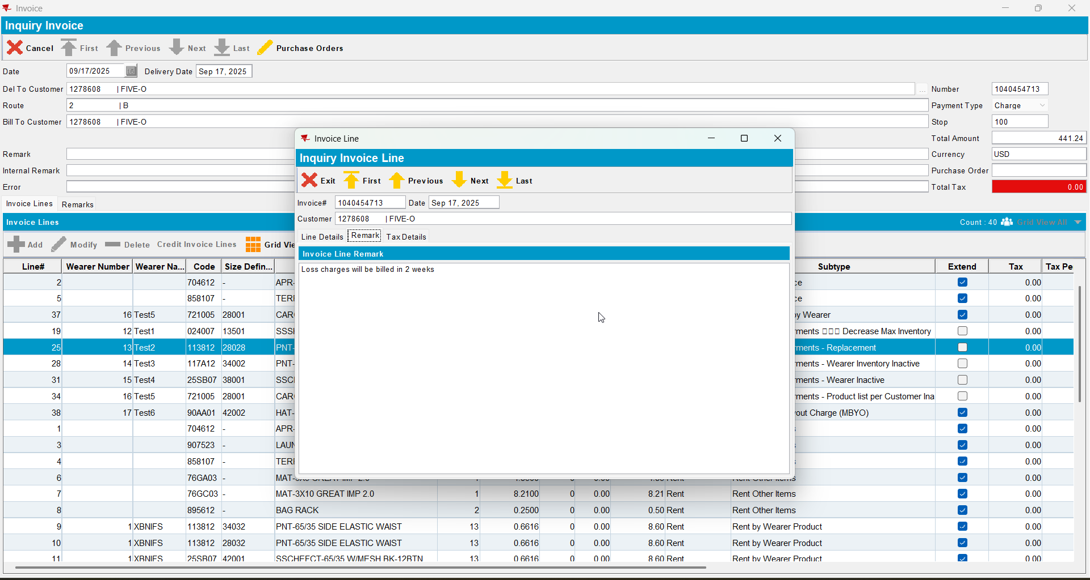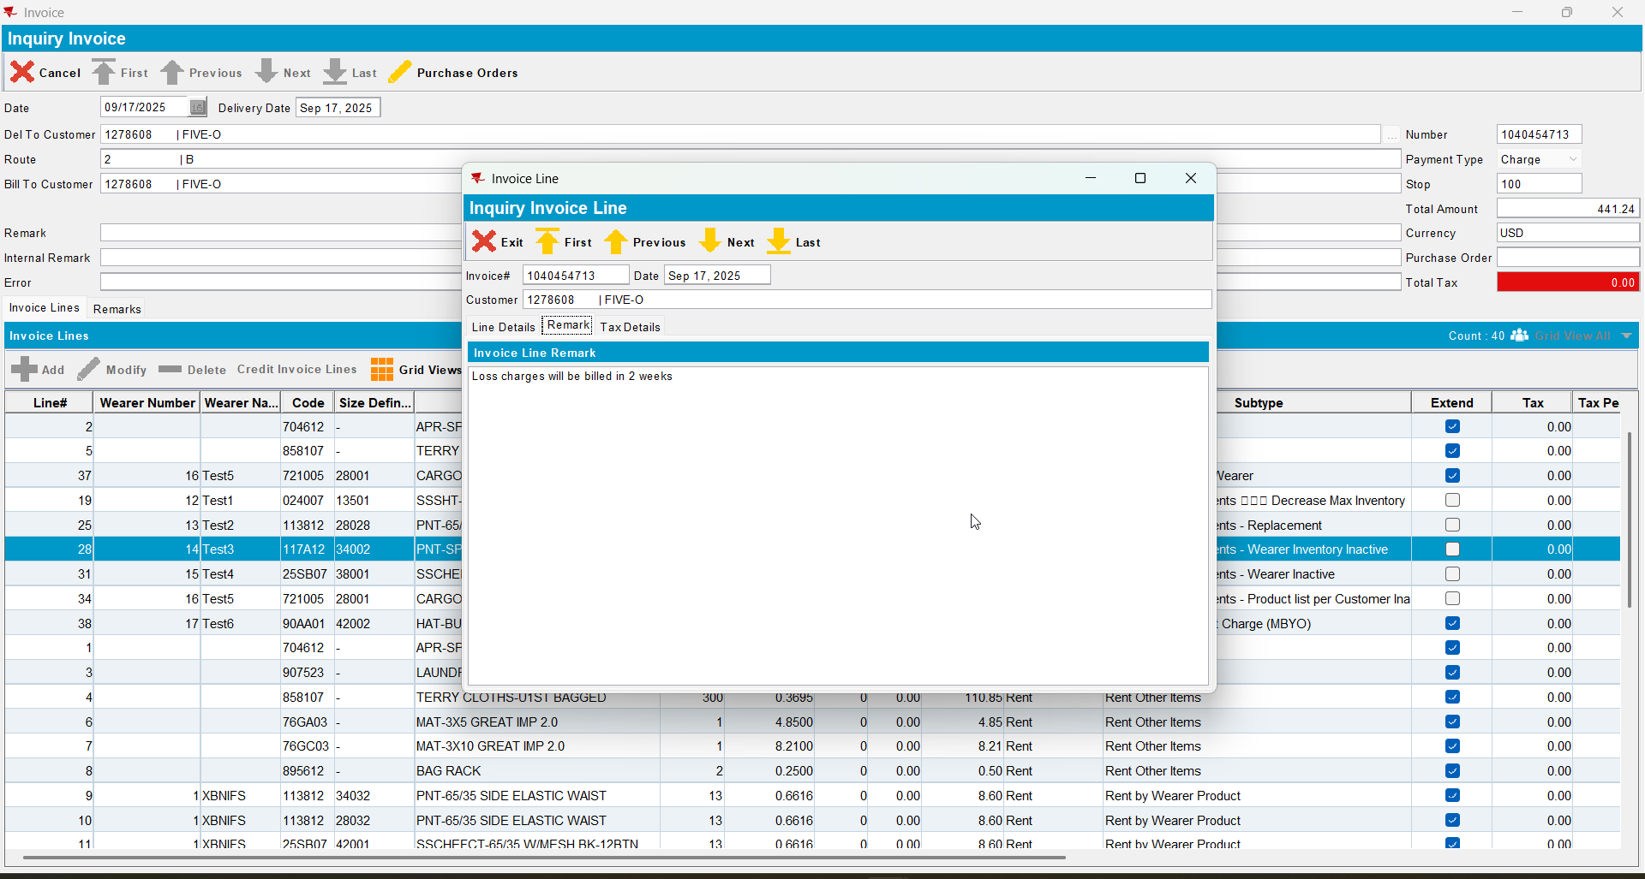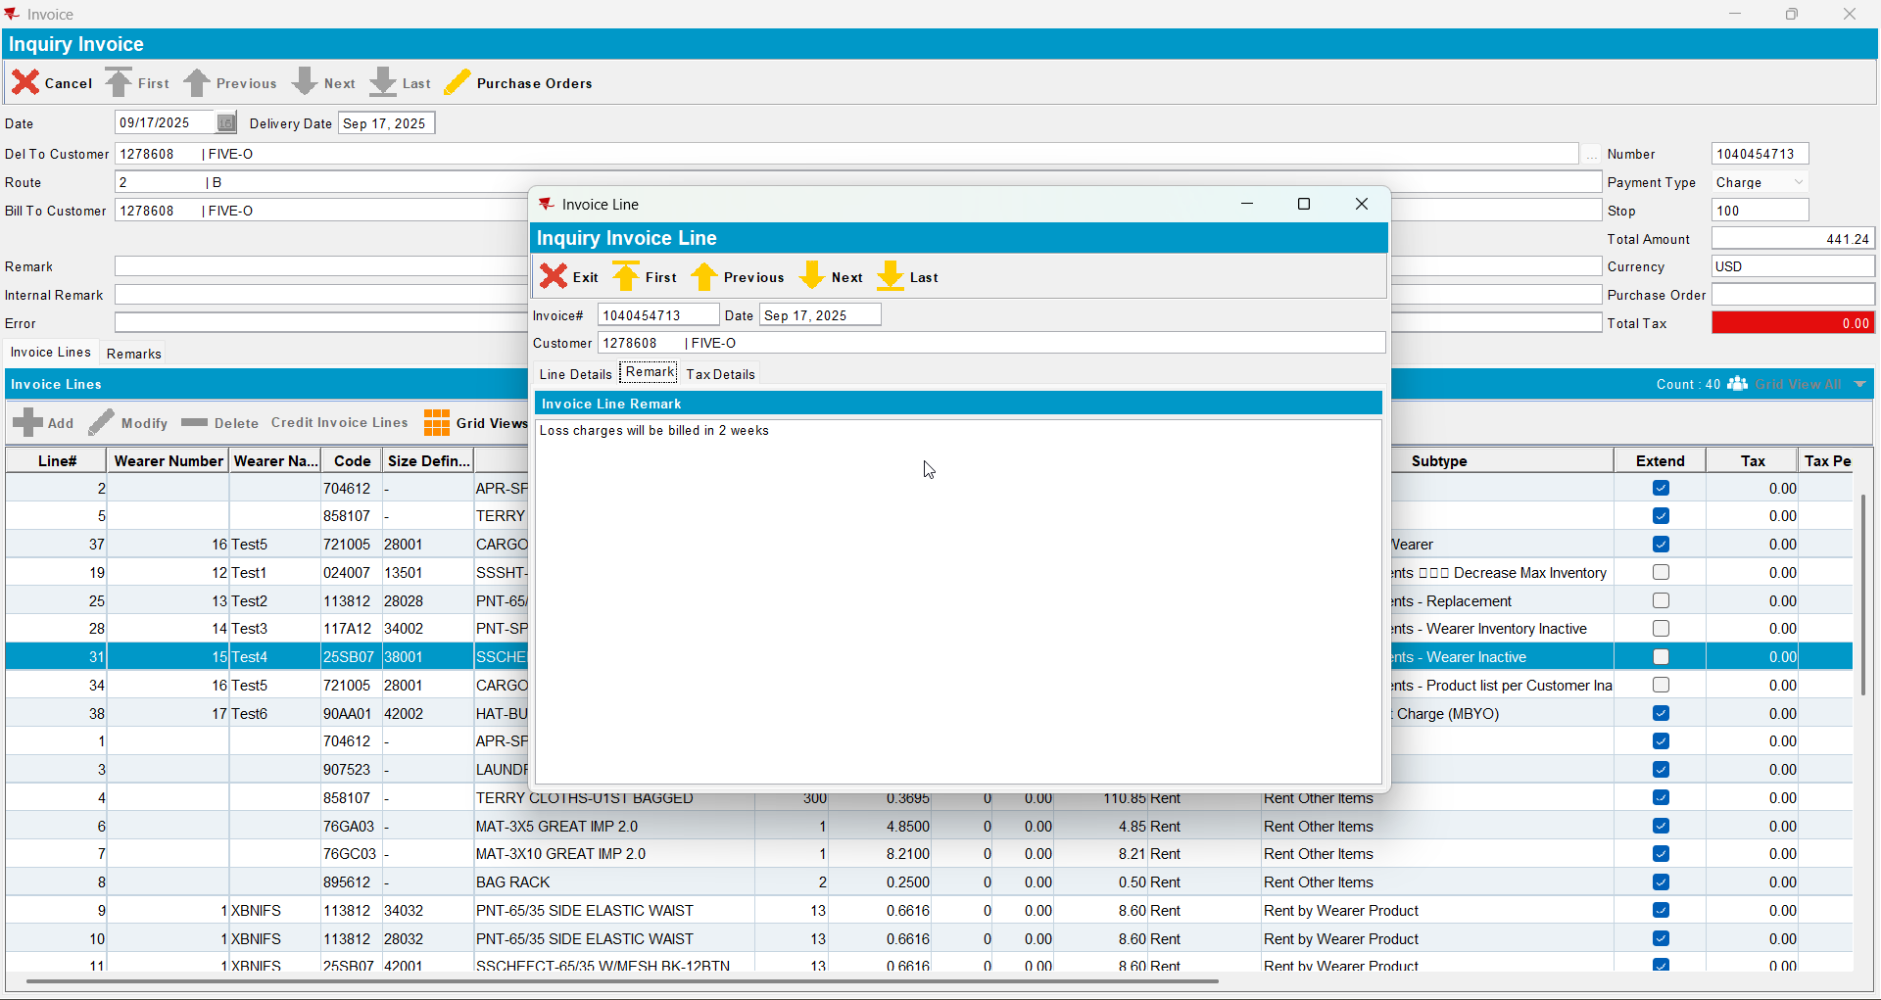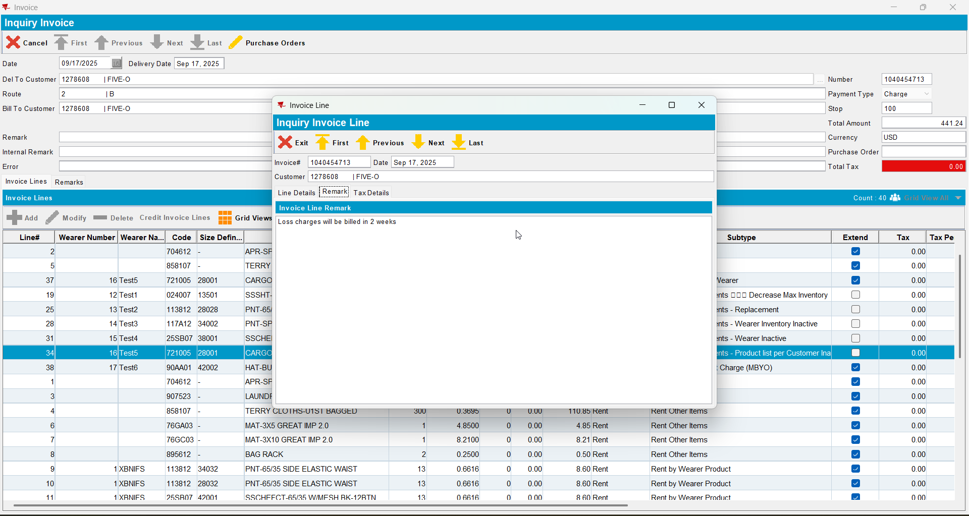
- Send the route to RA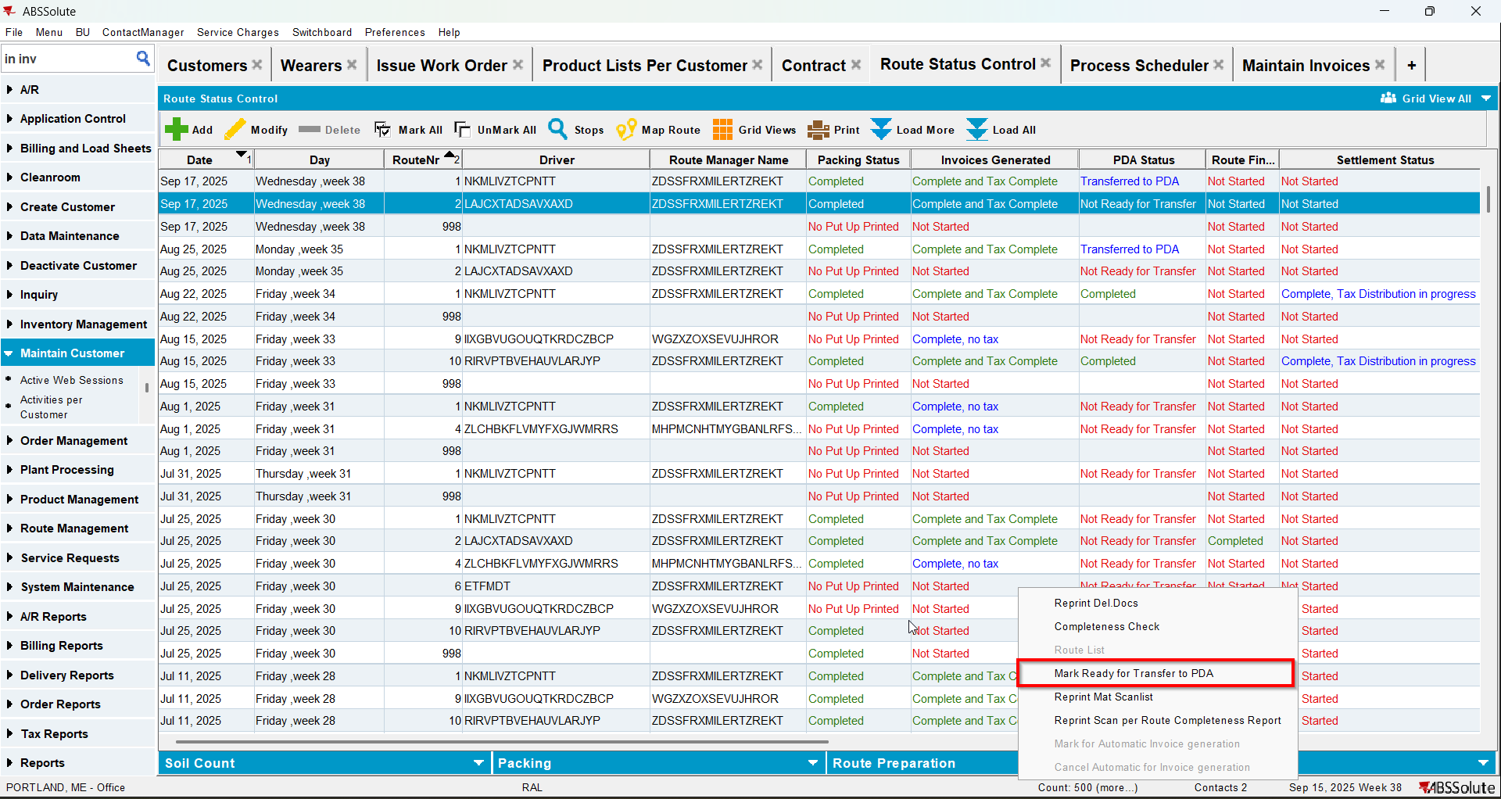
- Return at least one garment for each inventory instead of the MBYO
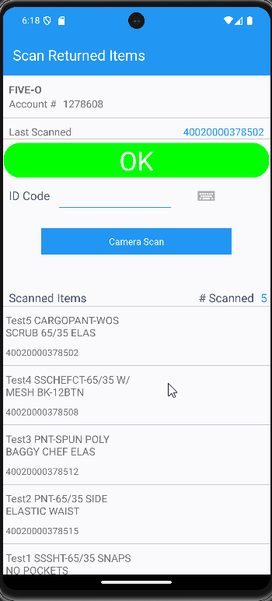
- WebX: Settle the route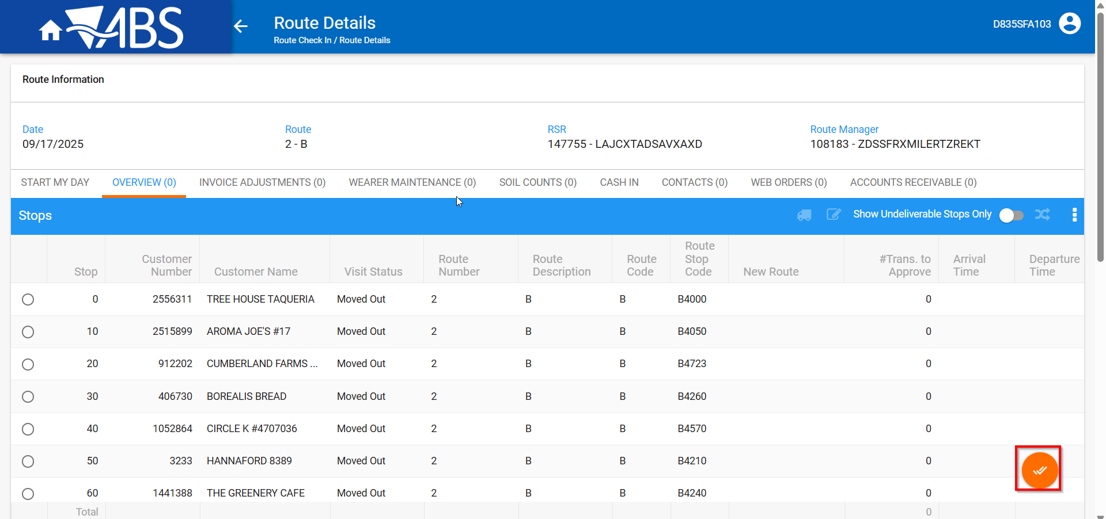
- Route Return all of the garments: Send to stock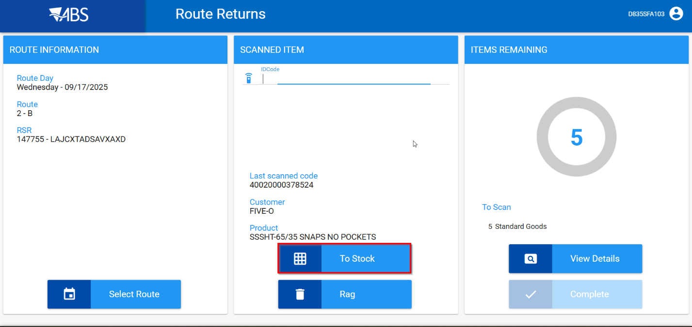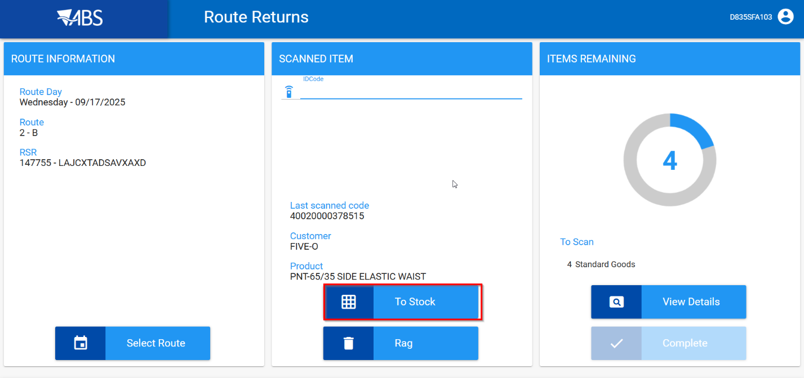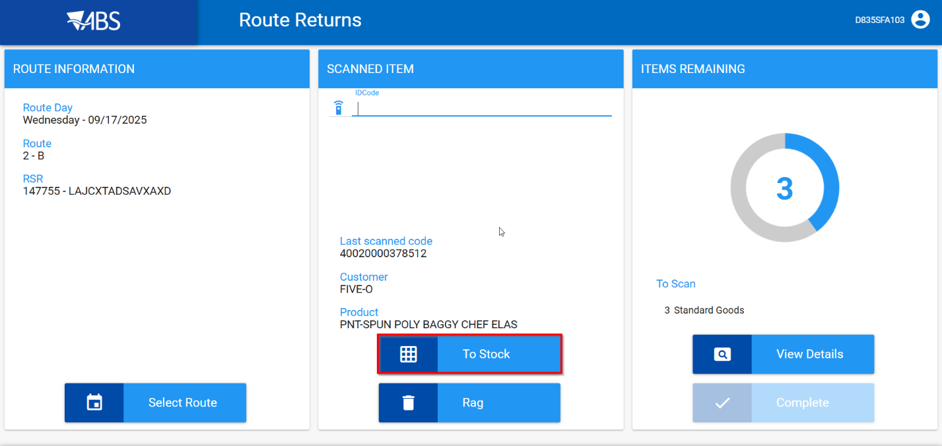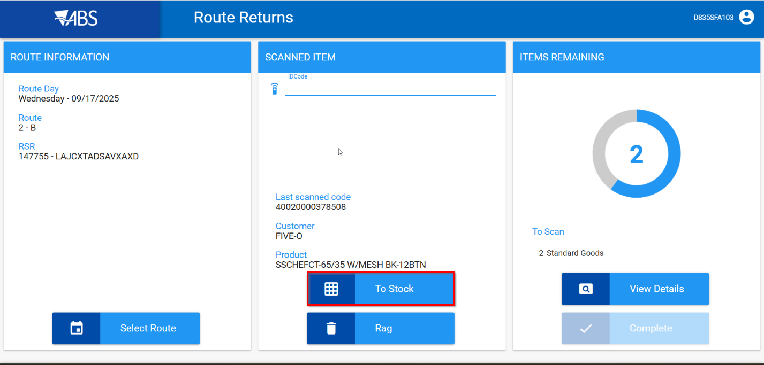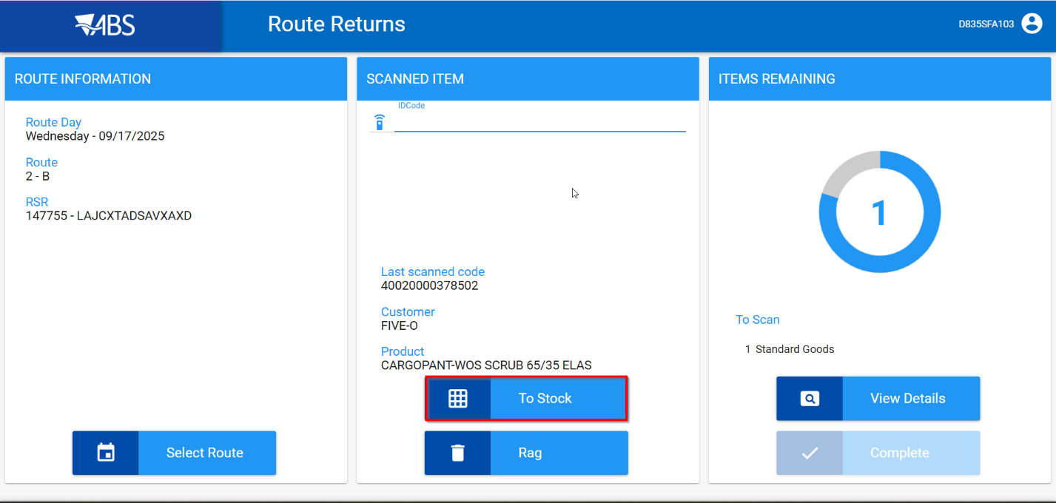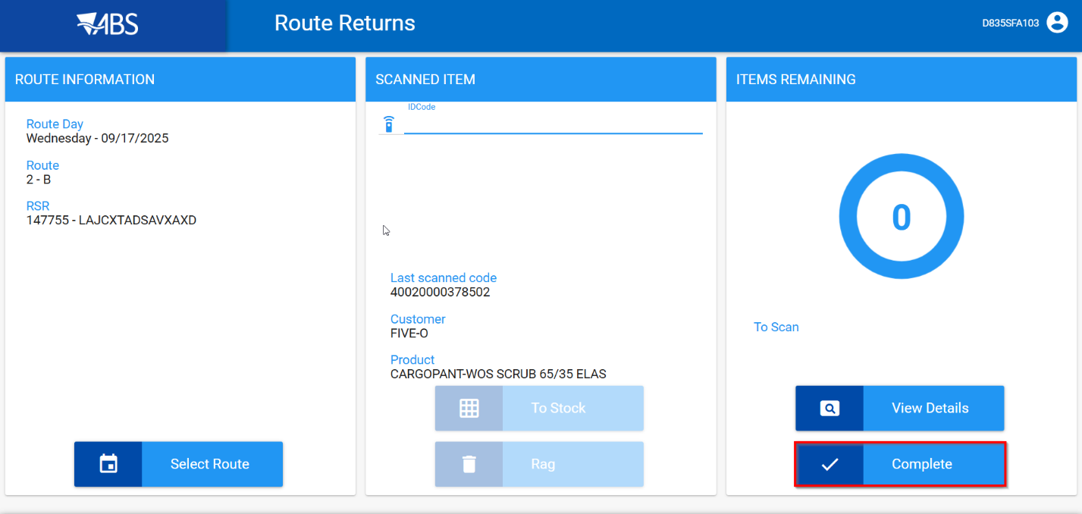
- Take items out of circulation: Send to Stock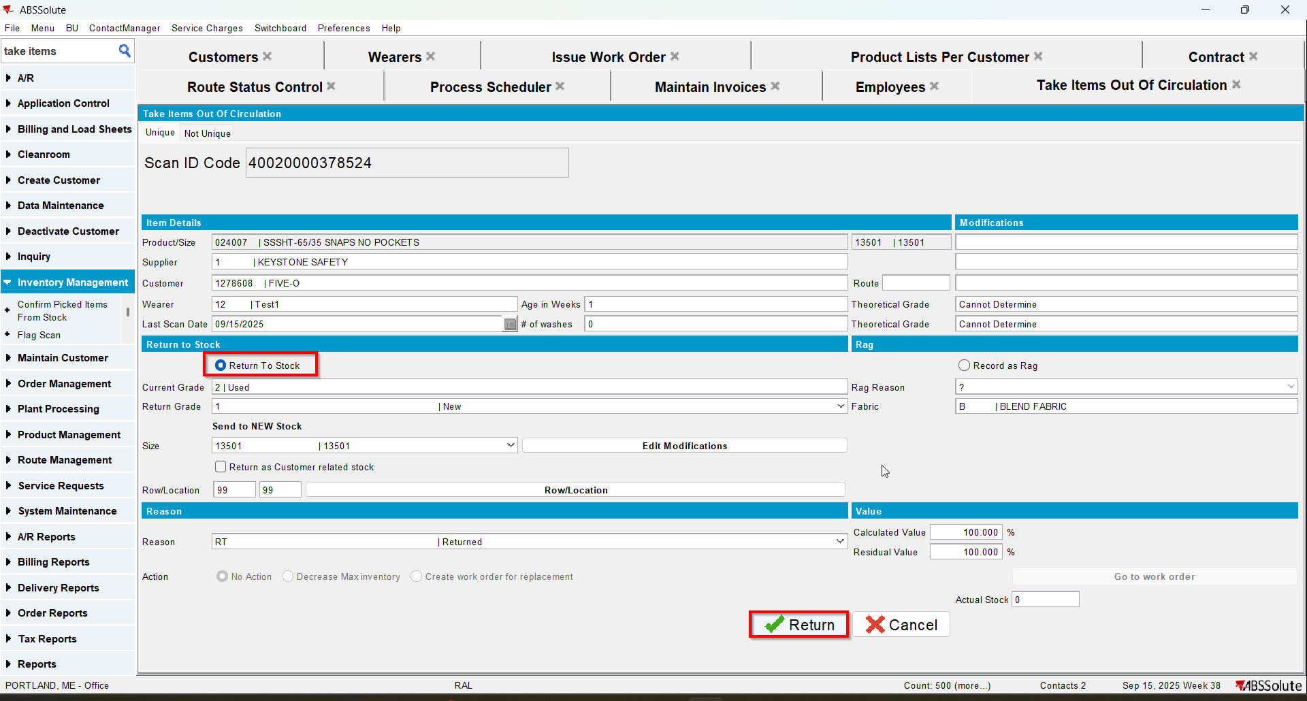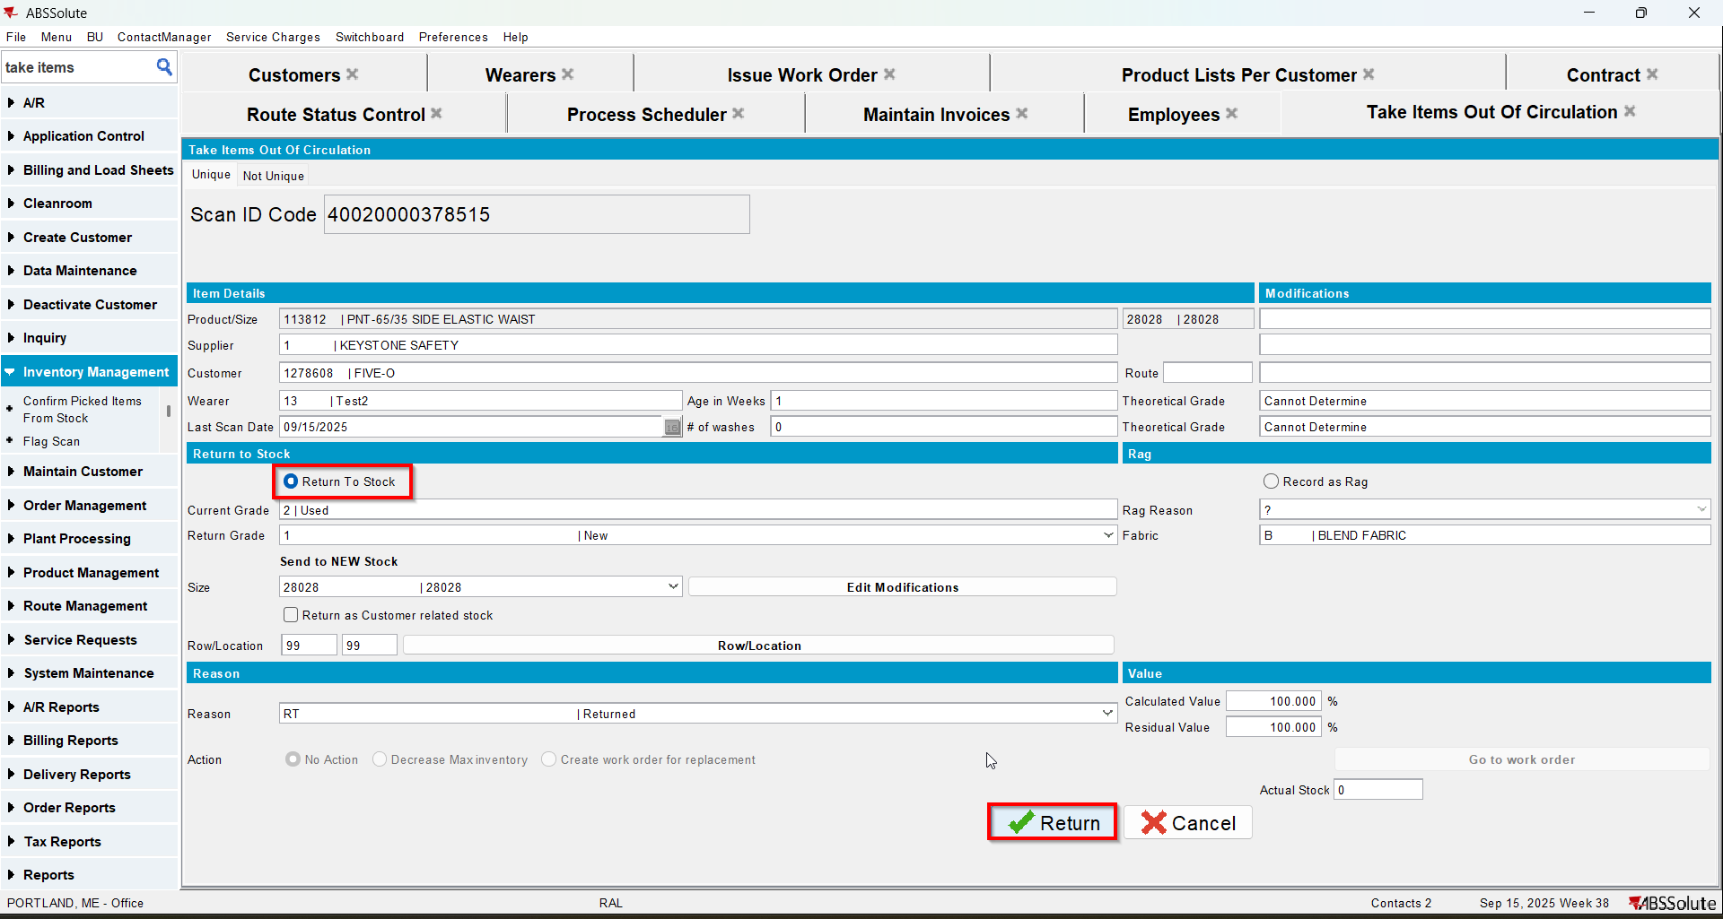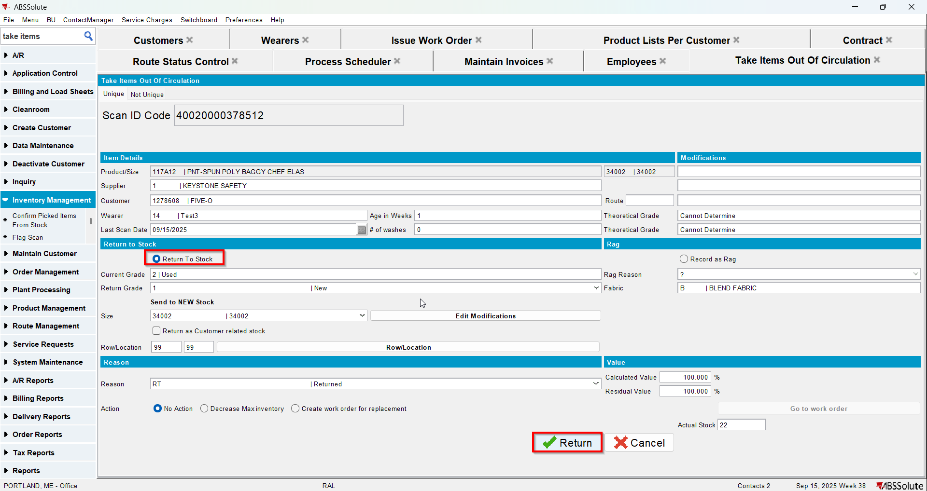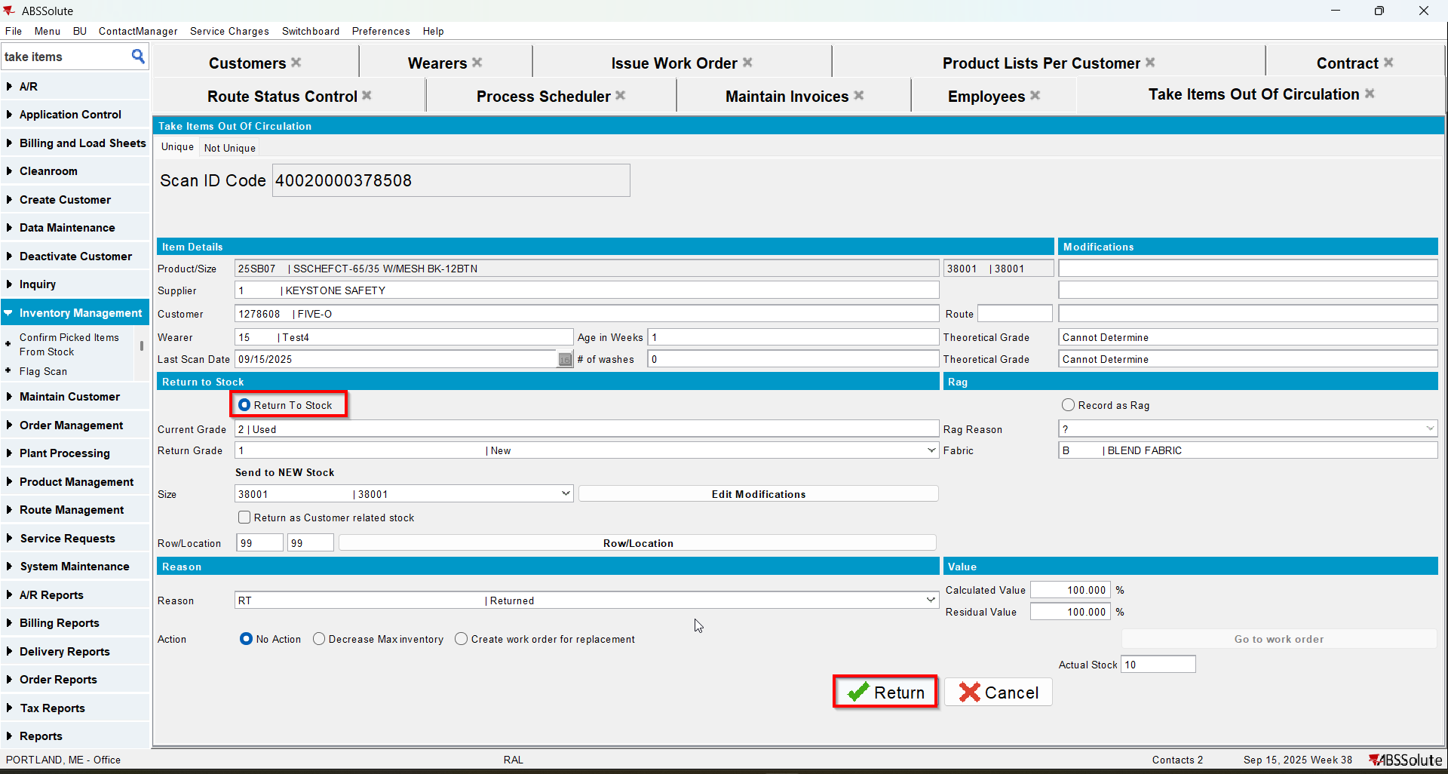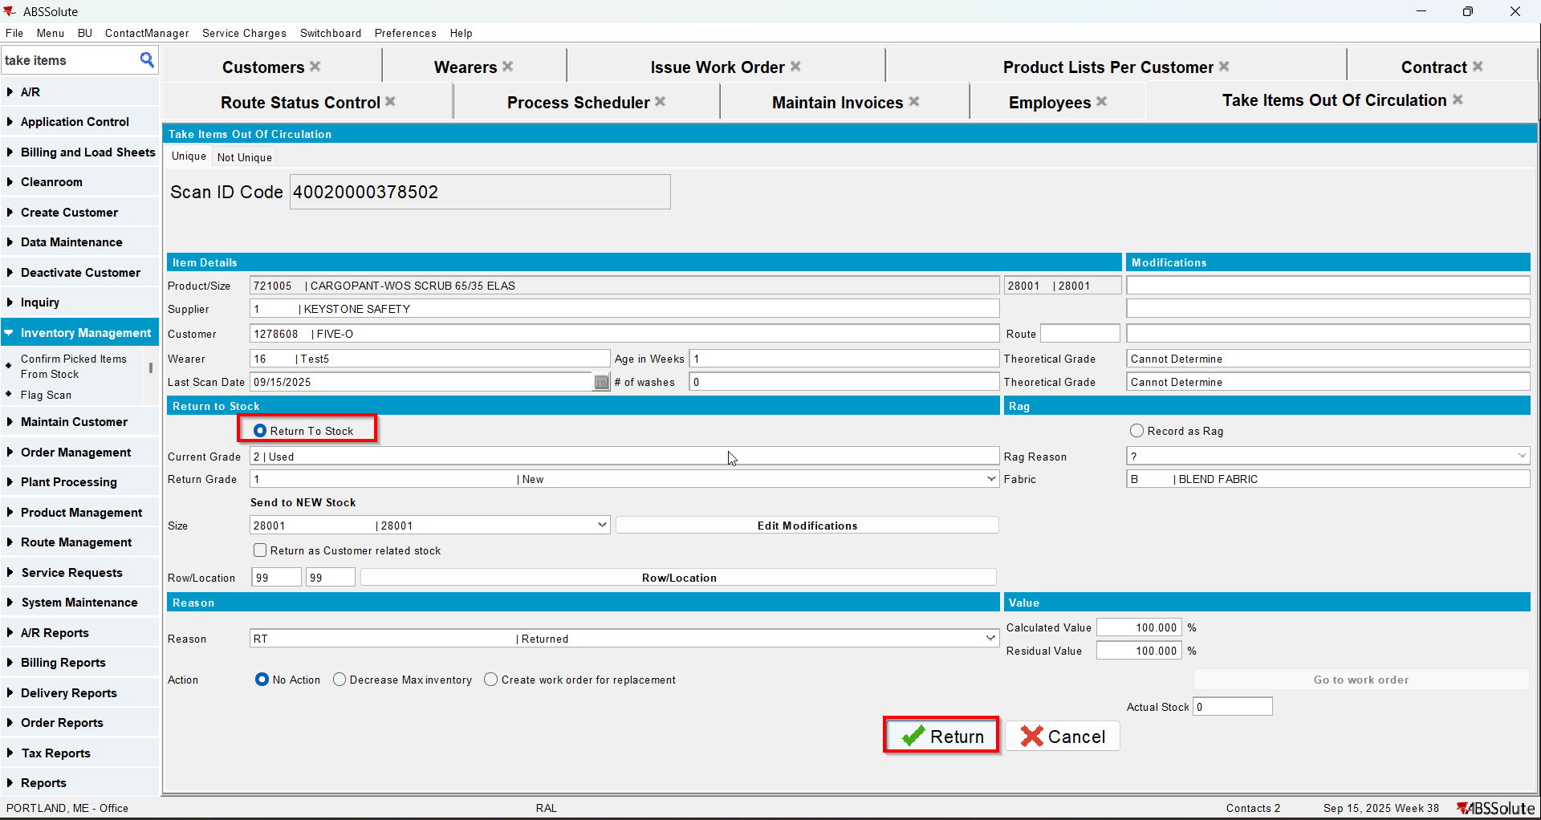
- In Maintain Unique Items dlg check that the returned items have the status Stock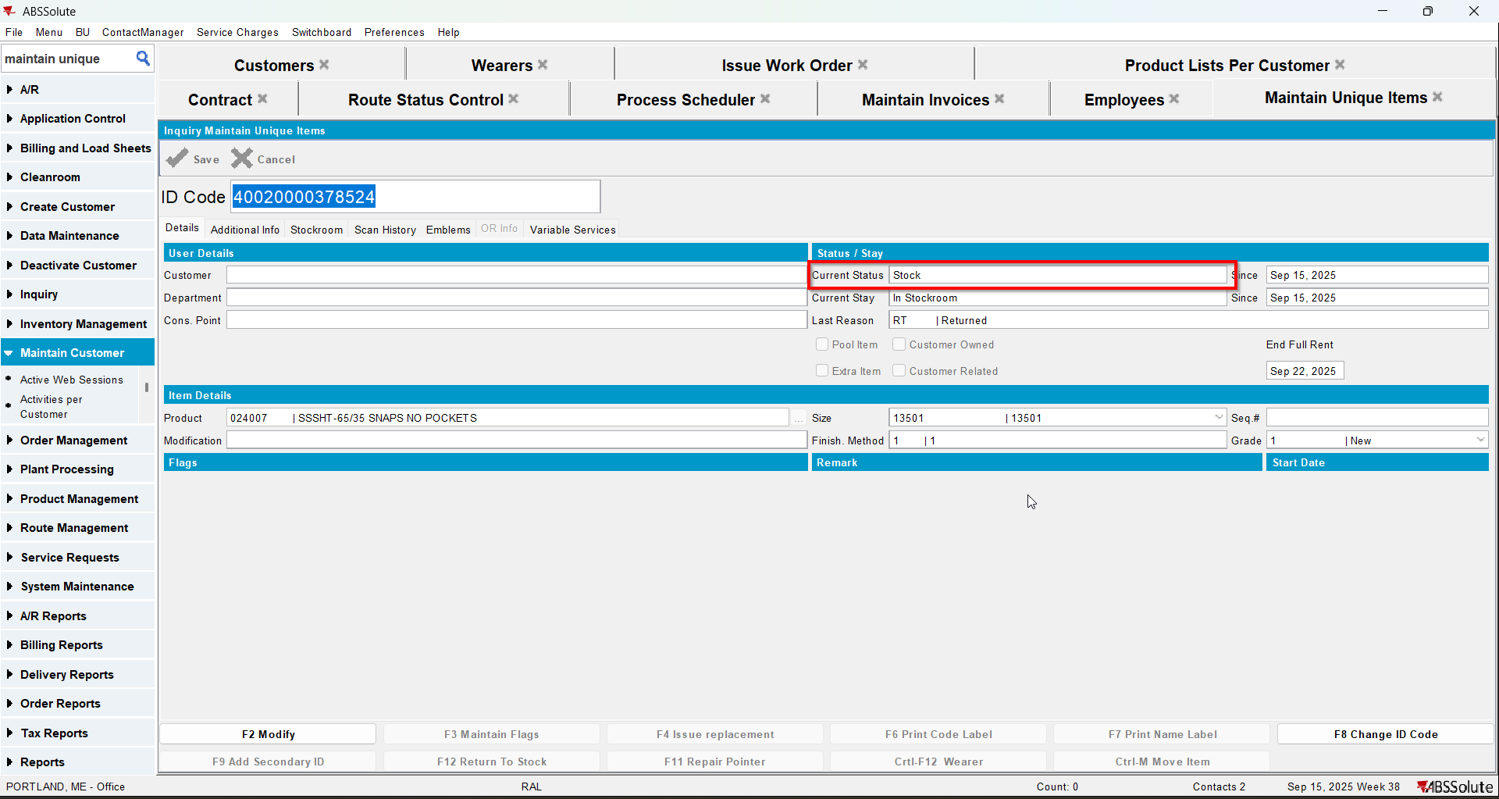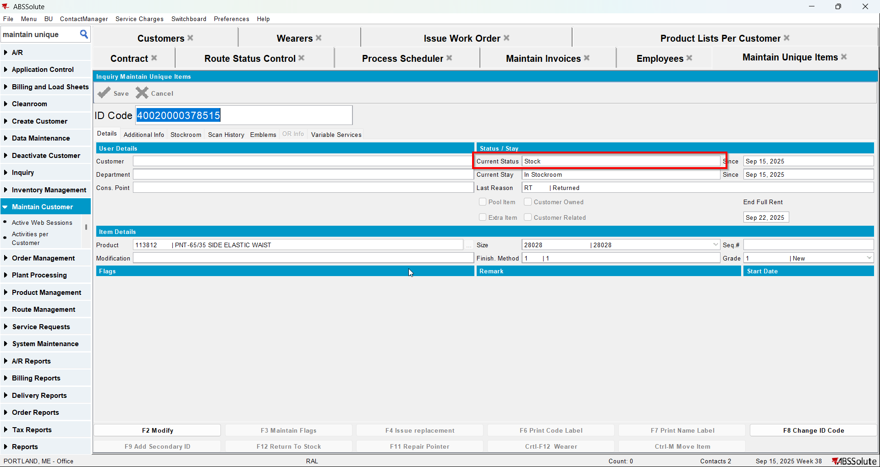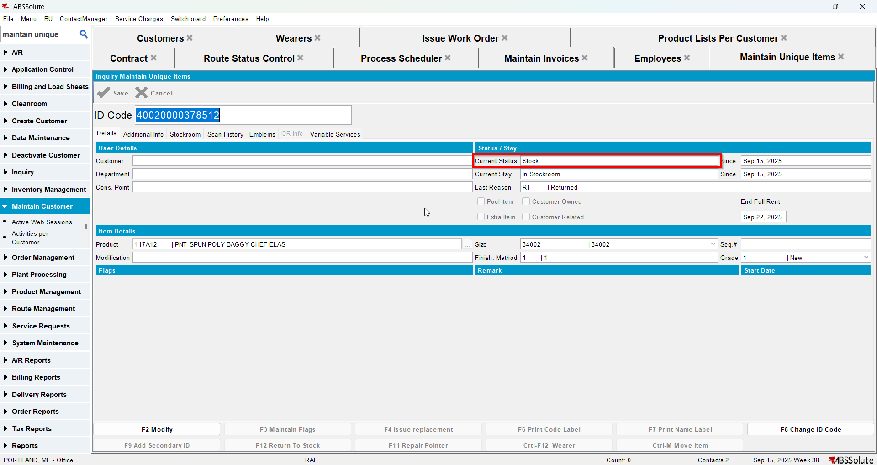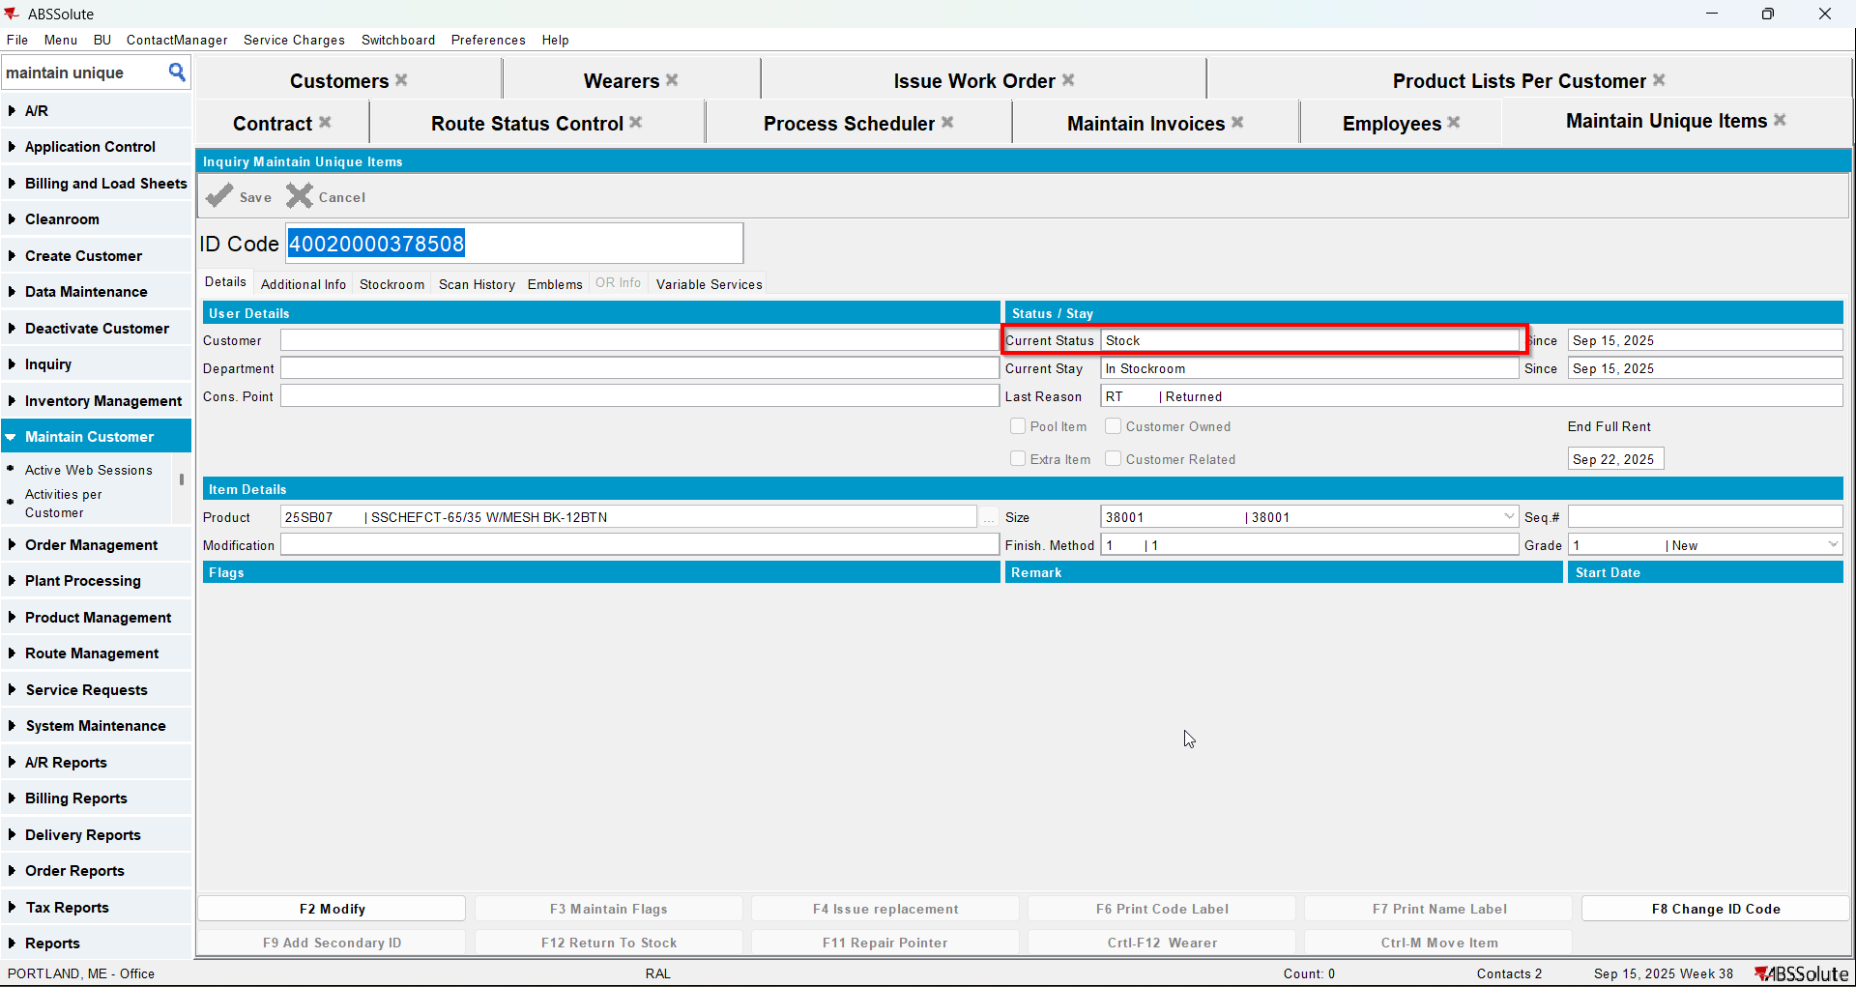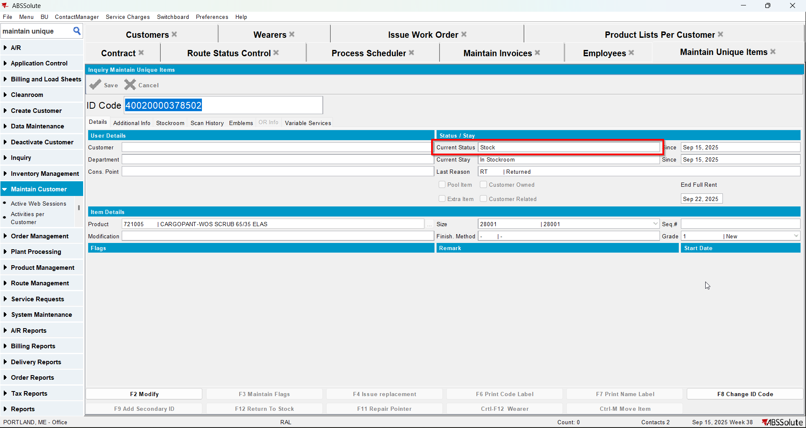
- Generate invoice for 3 weeks from sysdate (all loss charges should be Extended = 'Y' and price 0)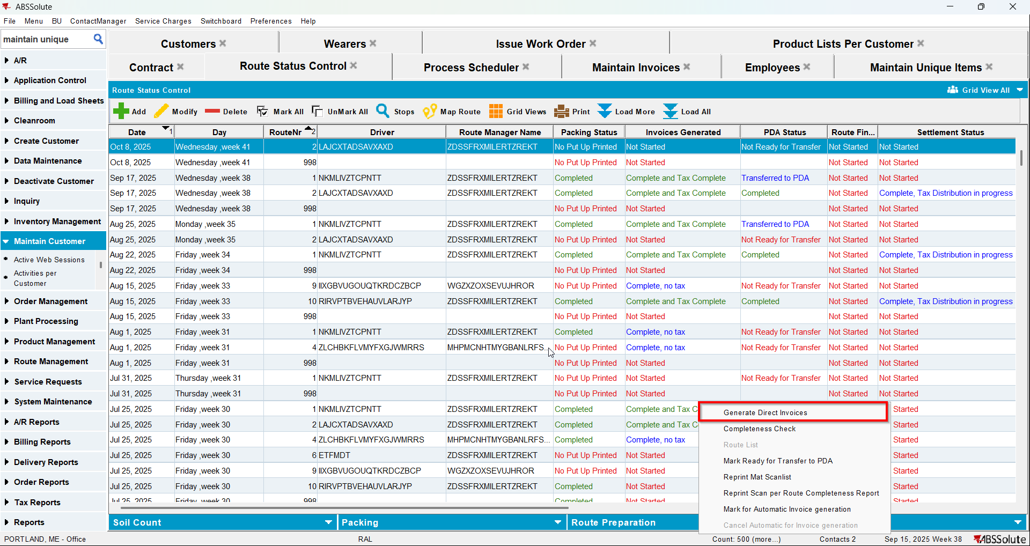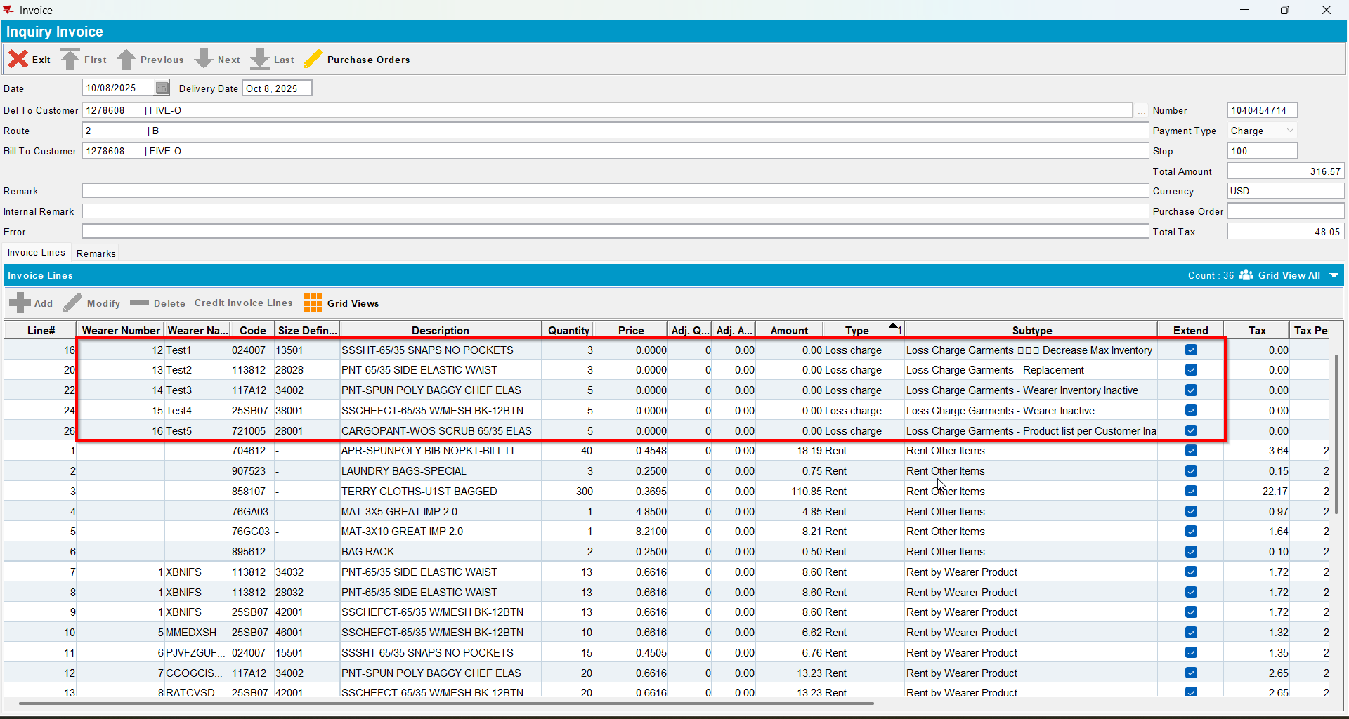
- Check the remarks for the loss charges. It should be “NoCharge for unreturned merchandise”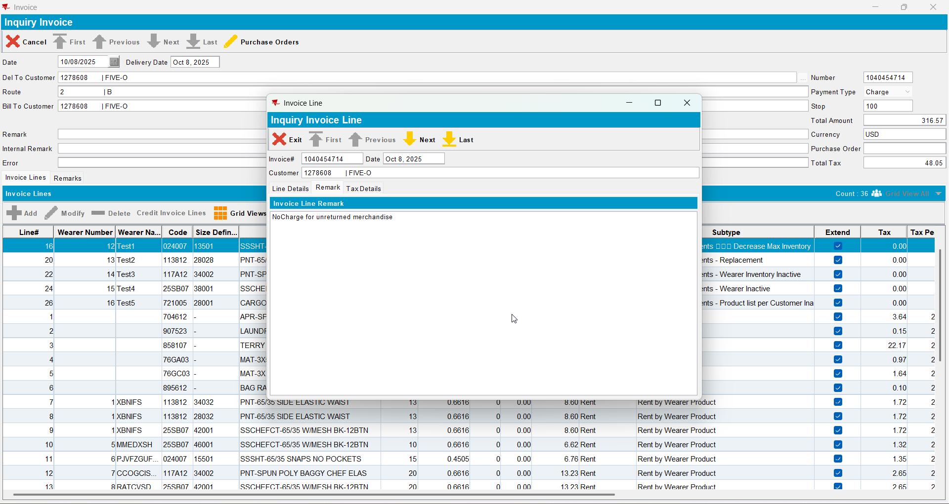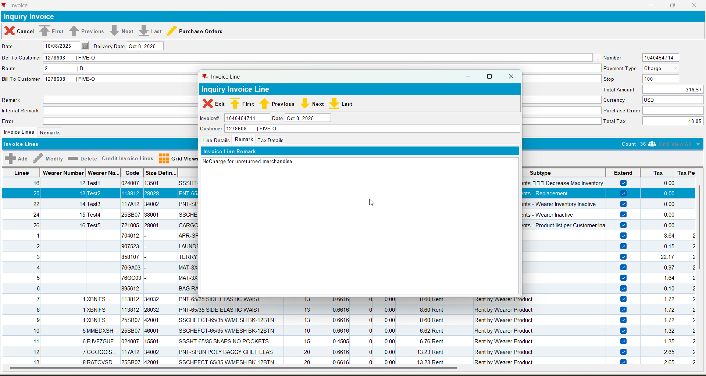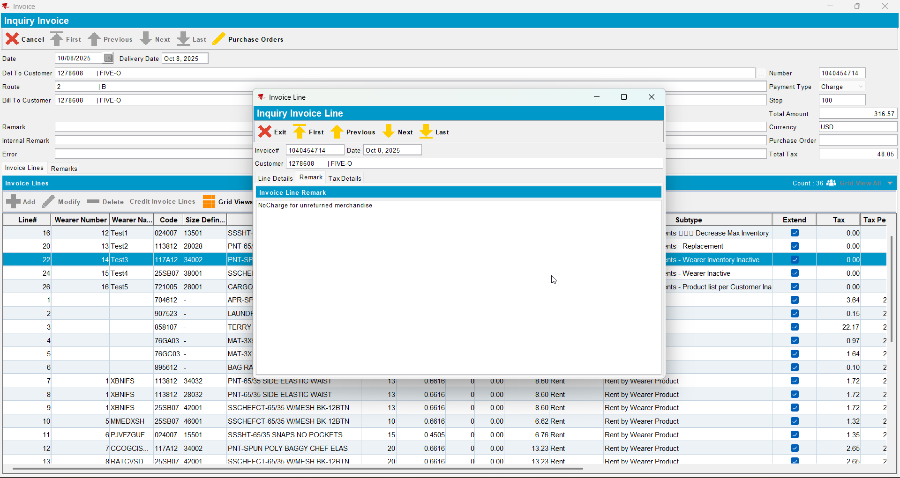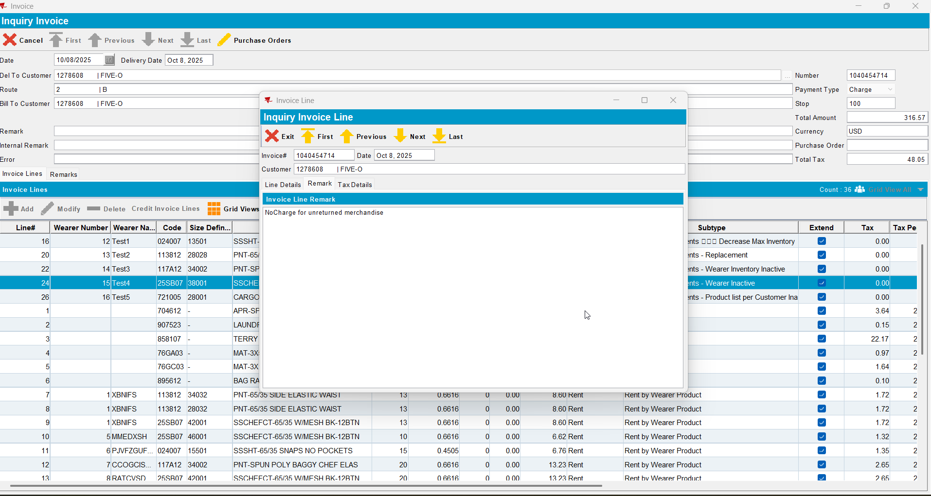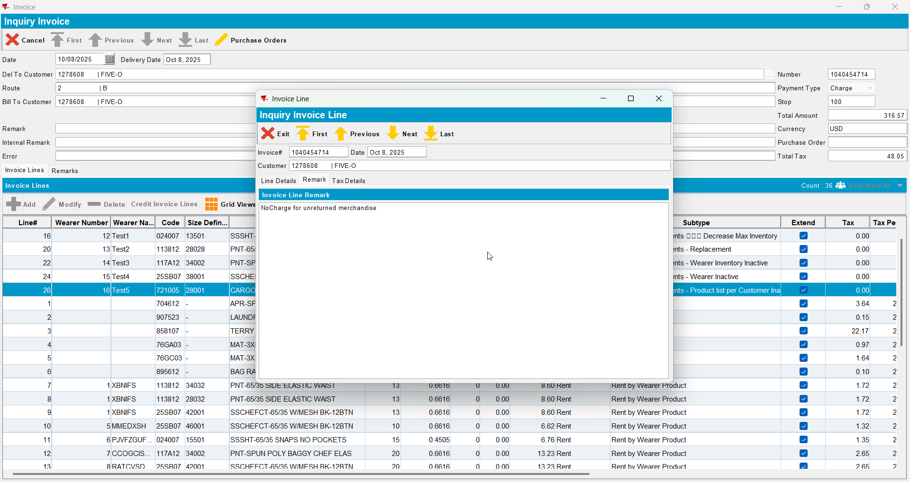
- Send the route to RA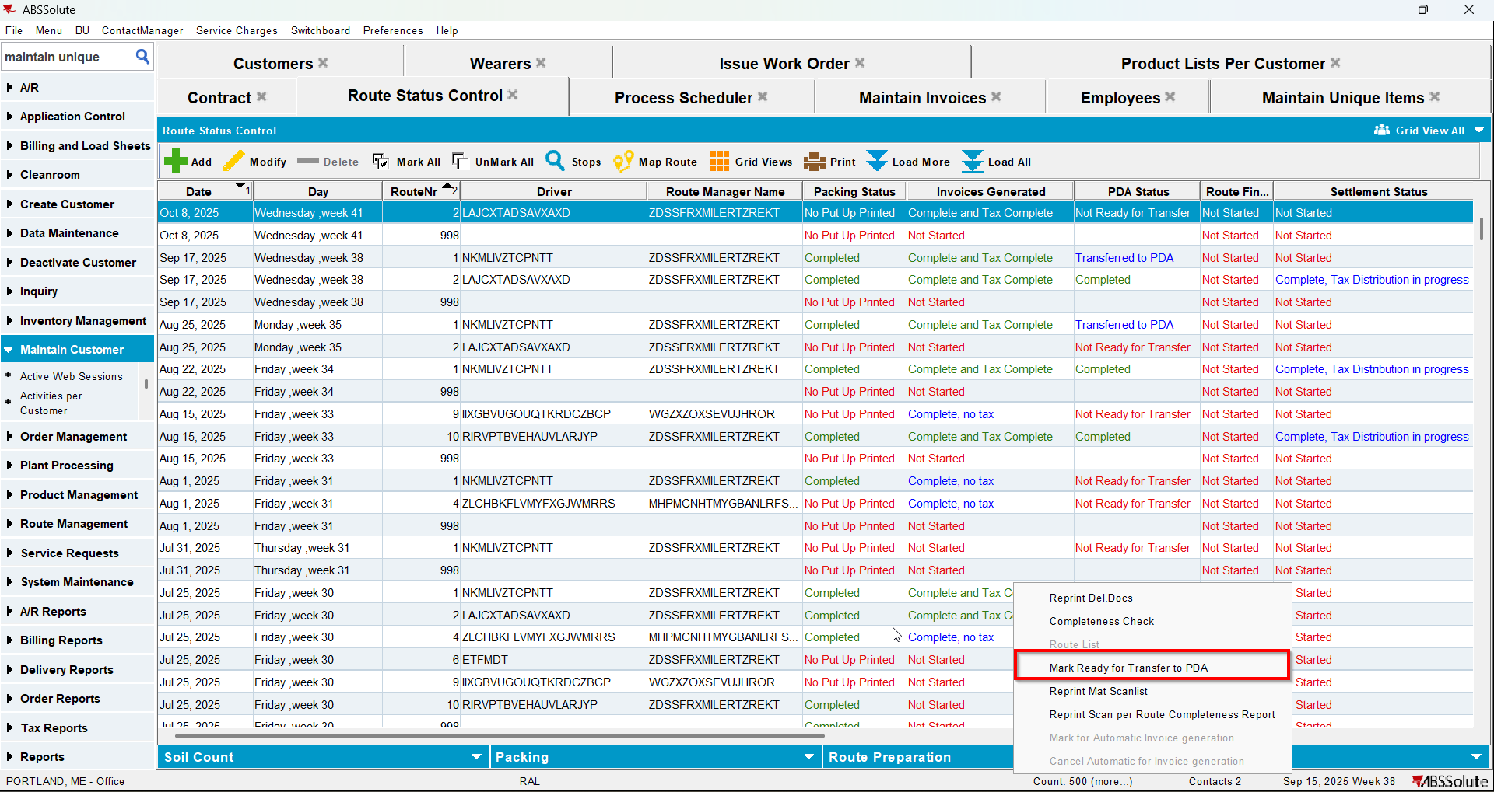
- Return at least one garment for each of the wearer inventories
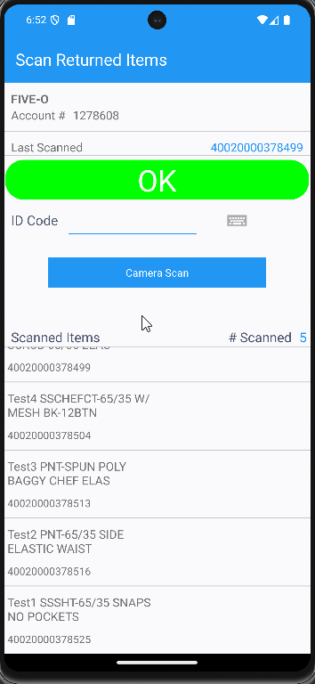
- WebX: Settle the route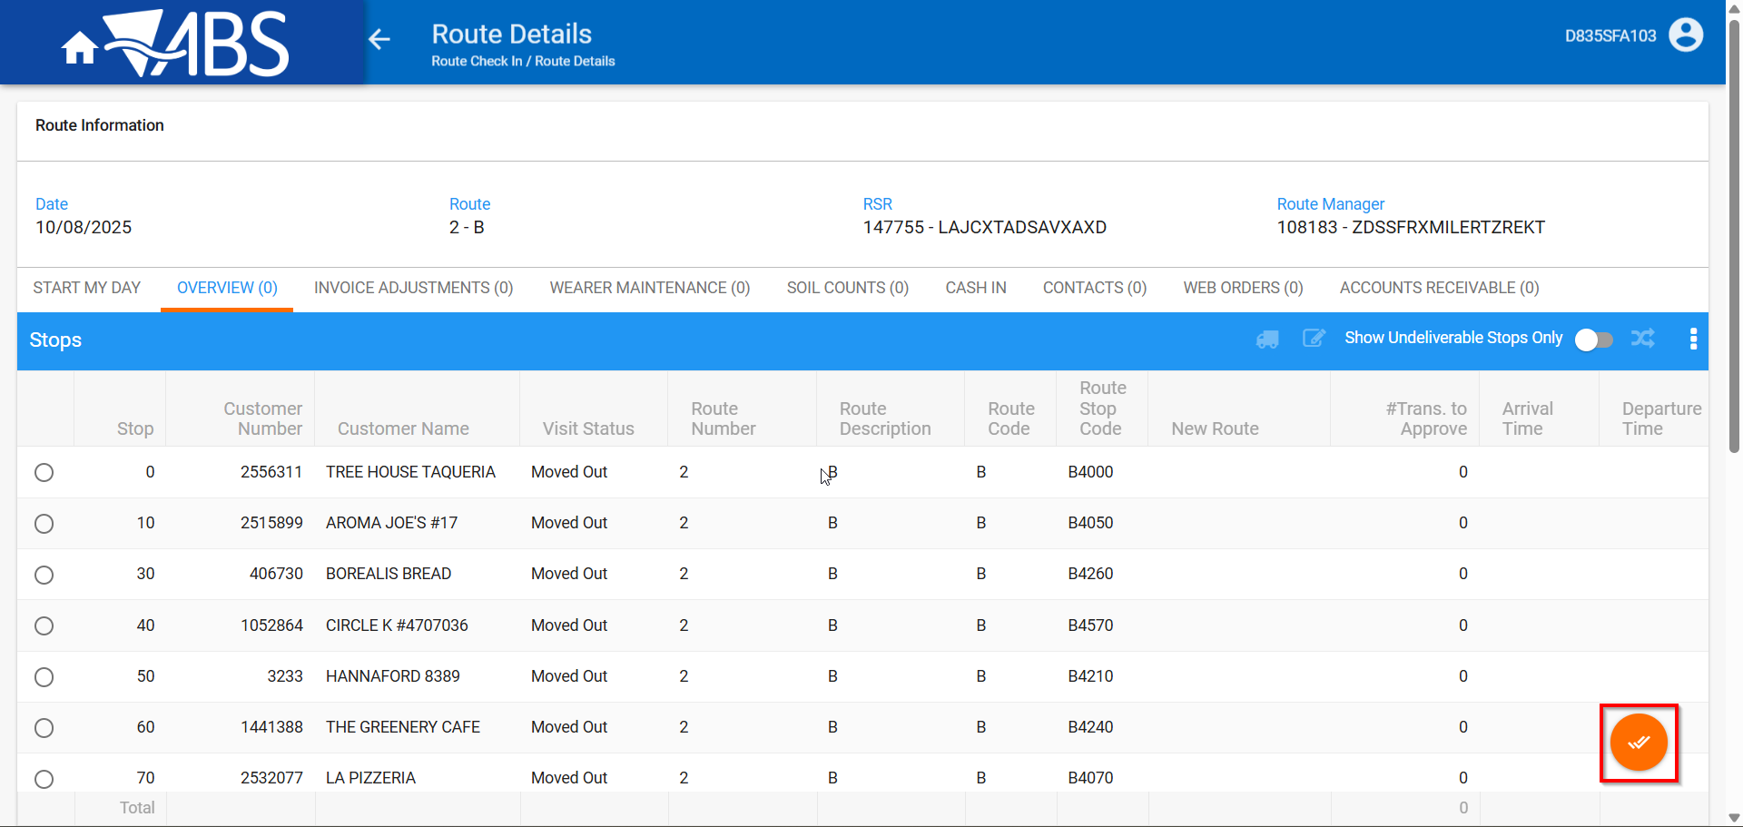
- Route Return all of the garments.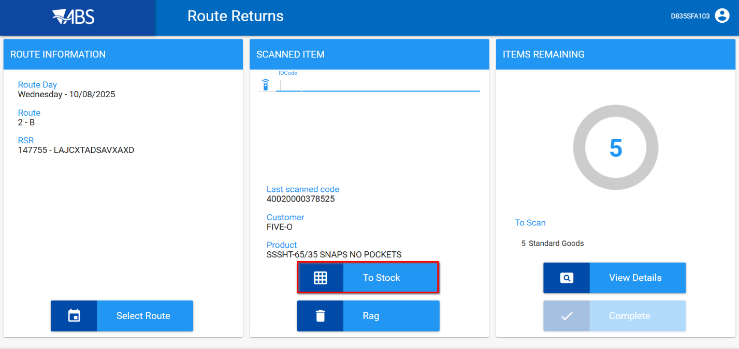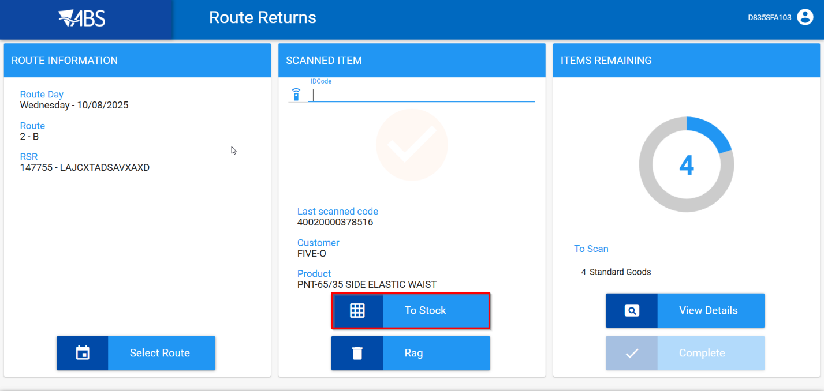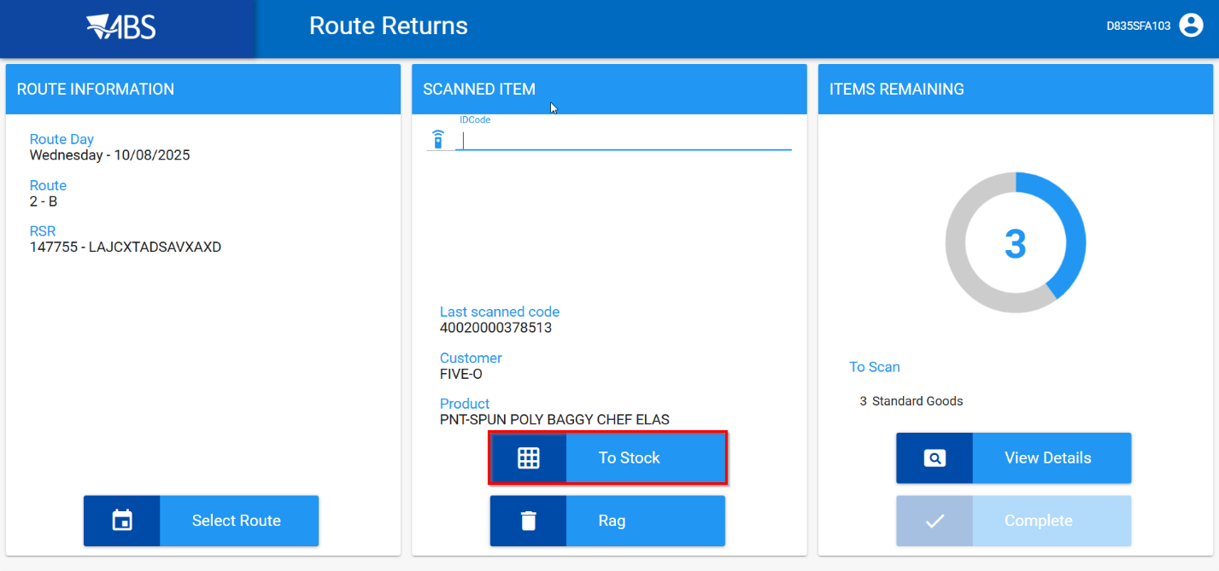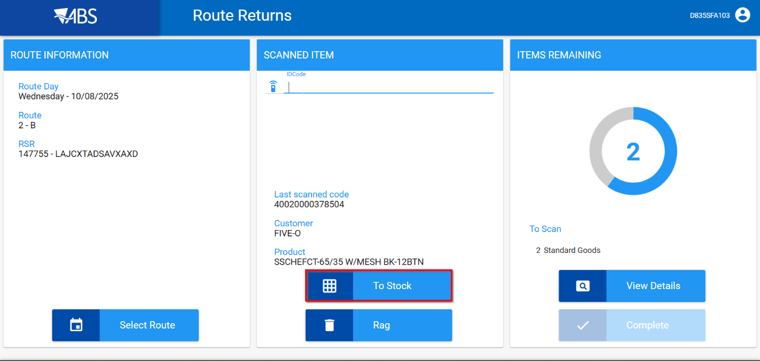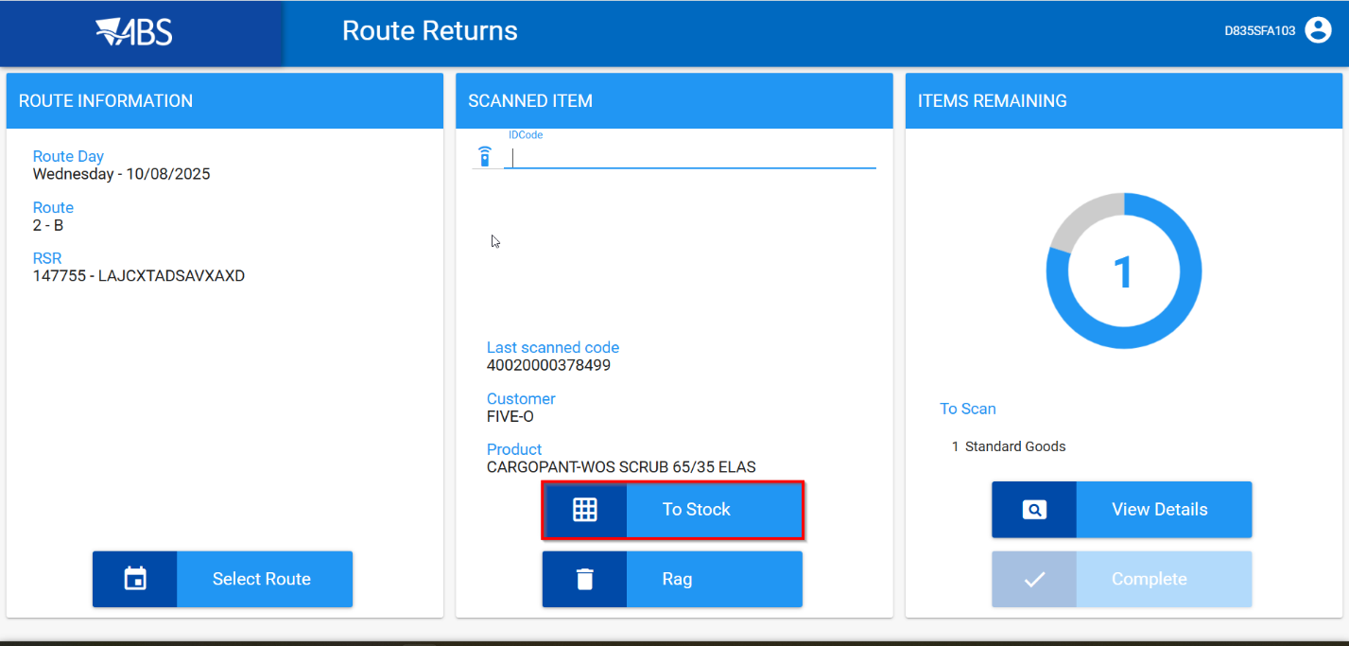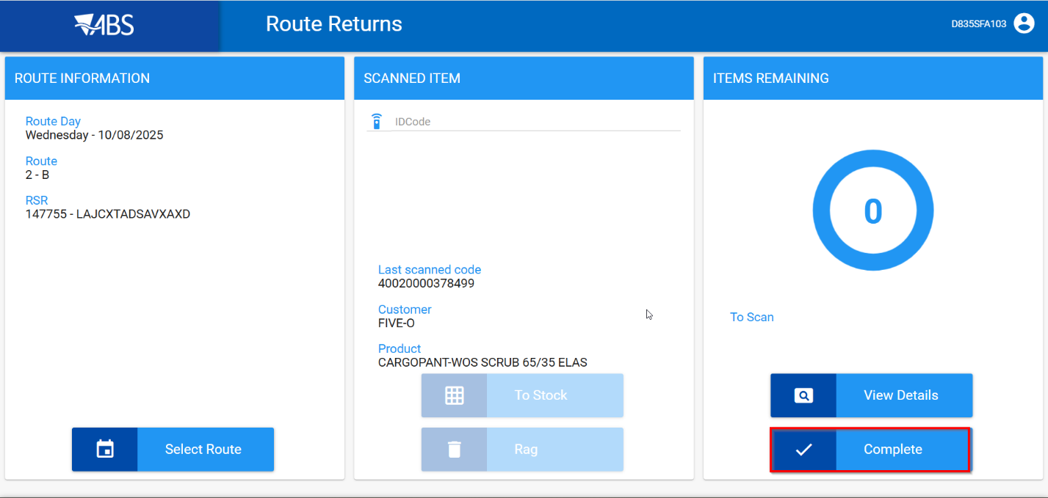
- Take items out of circulation: Send to Stock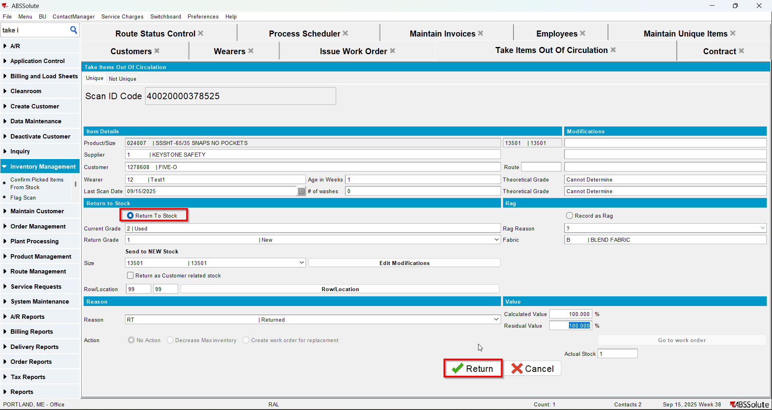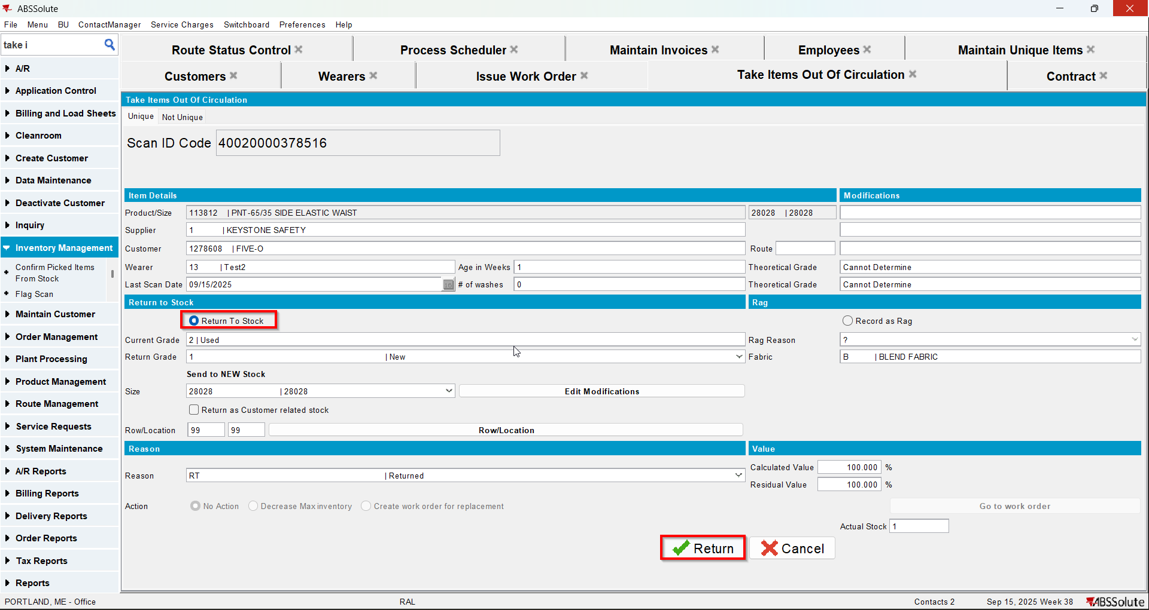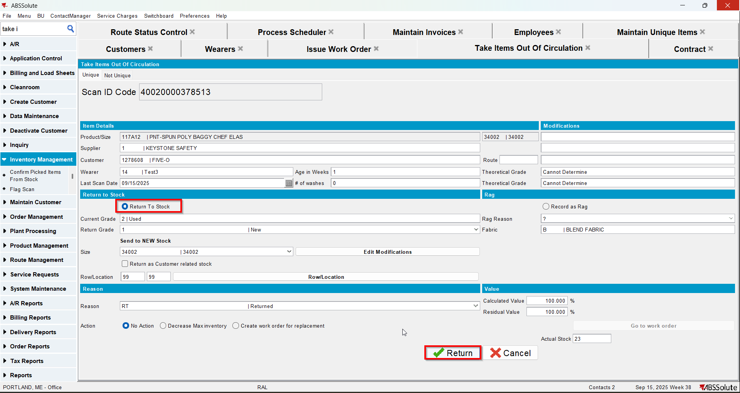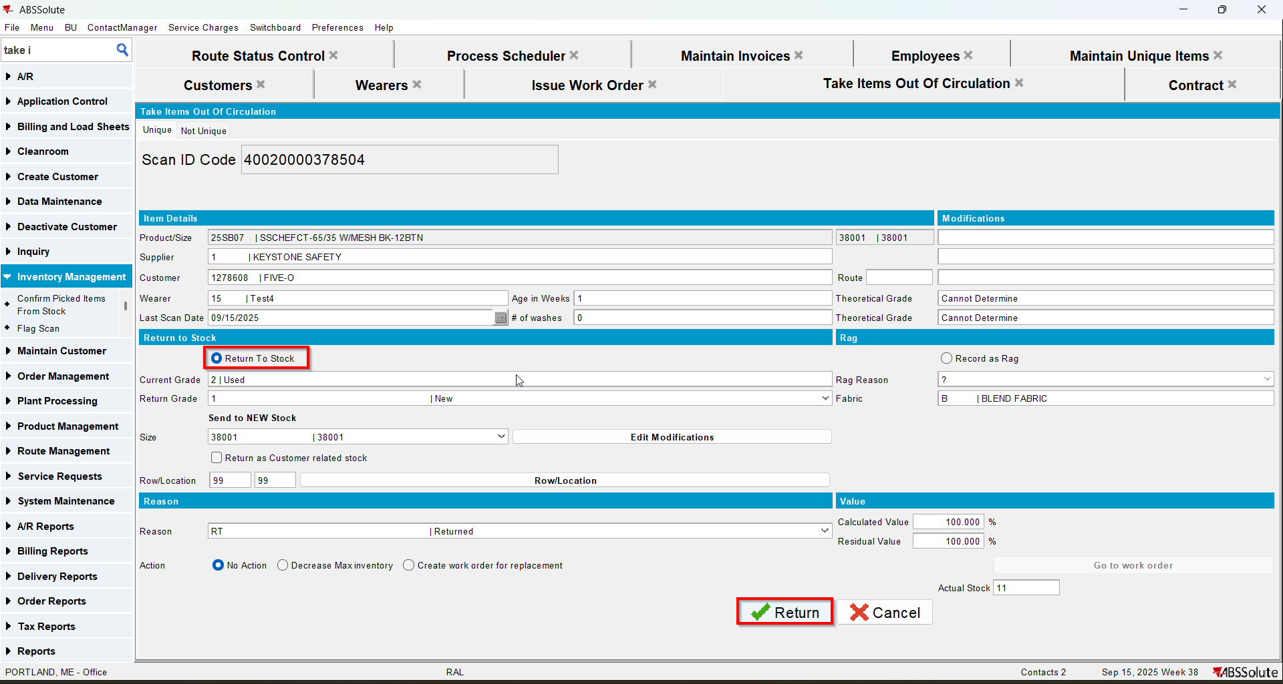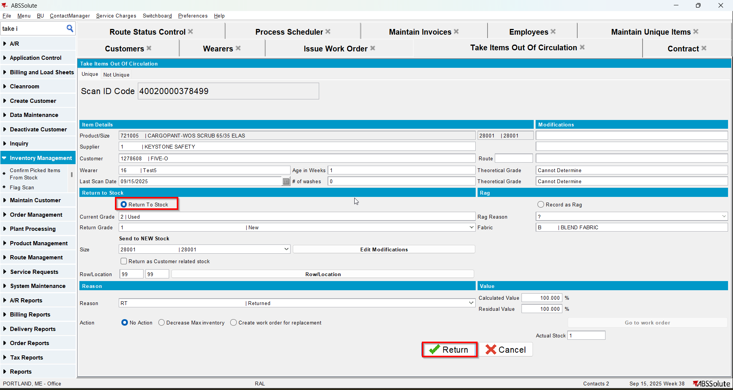
- In Maintain Unique Items dlg check that the returned items have the status Stock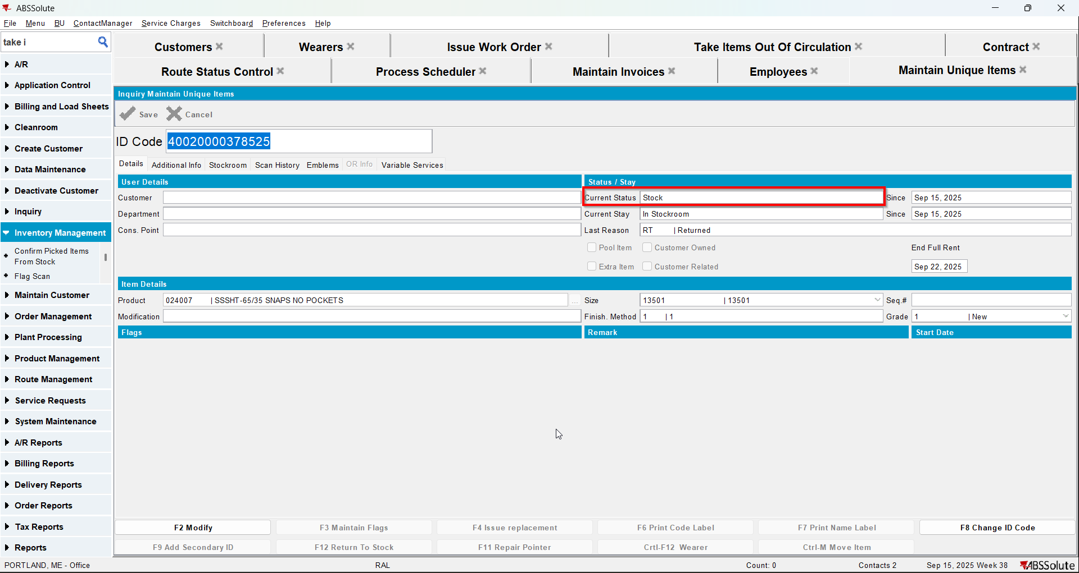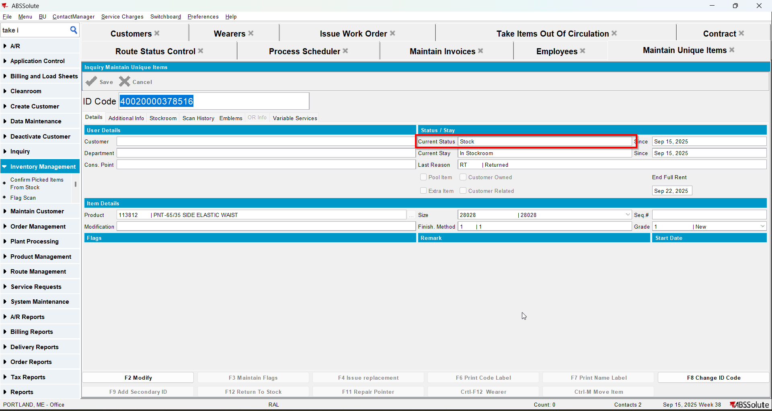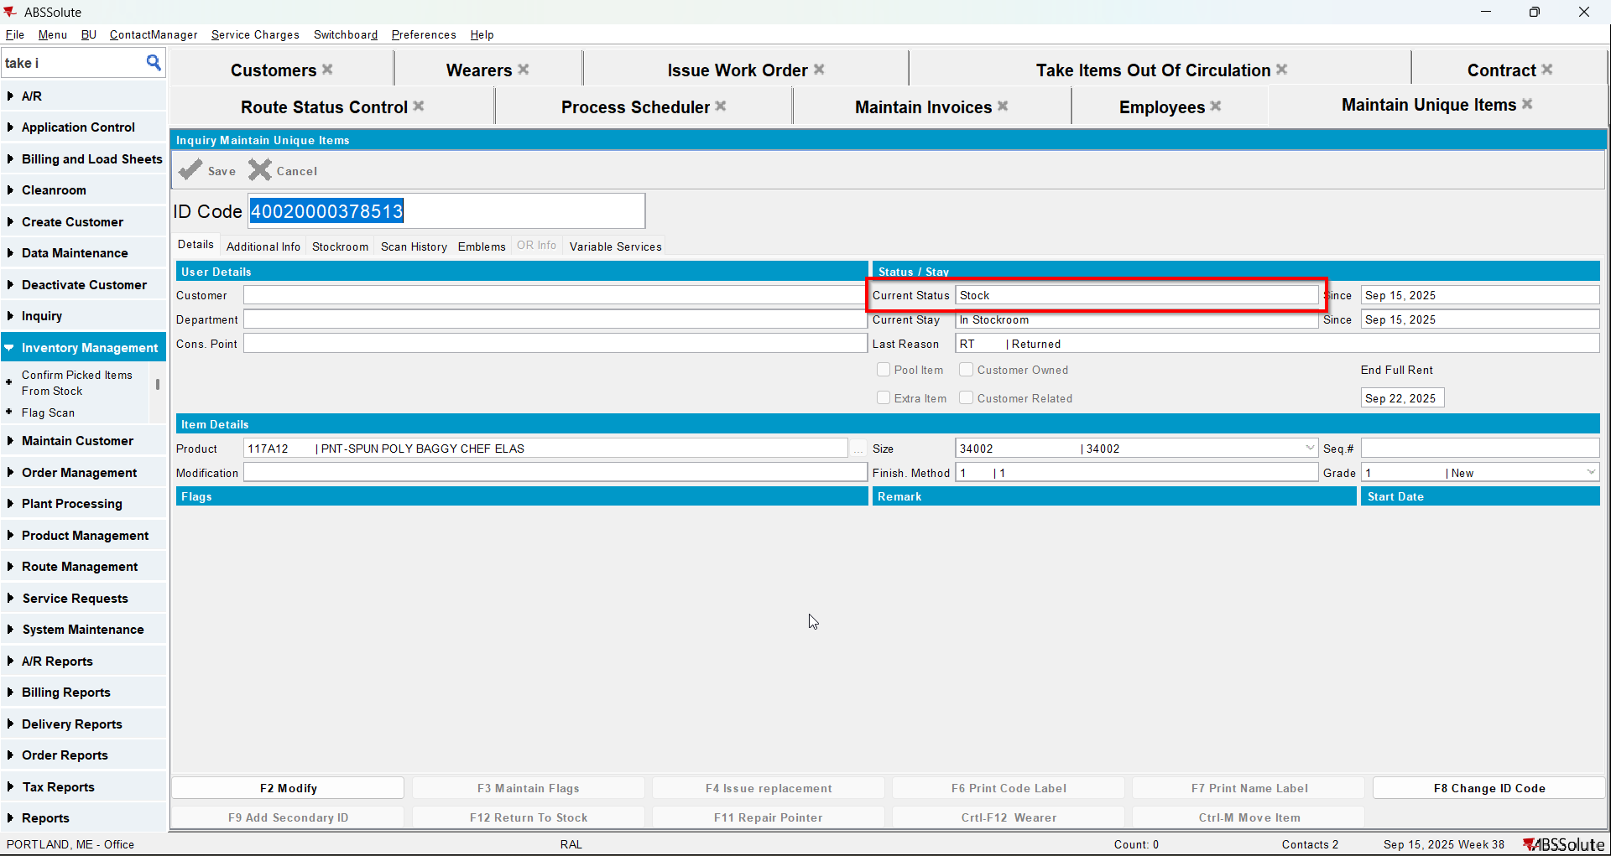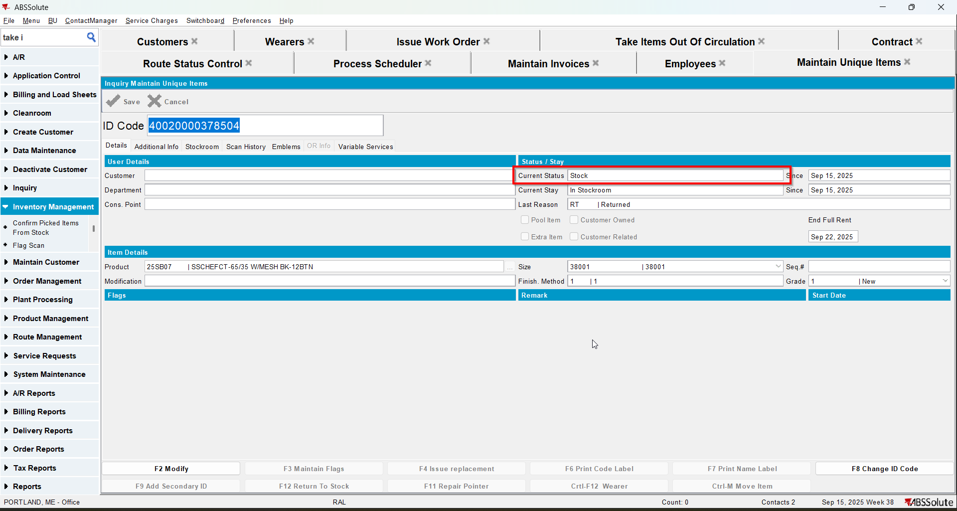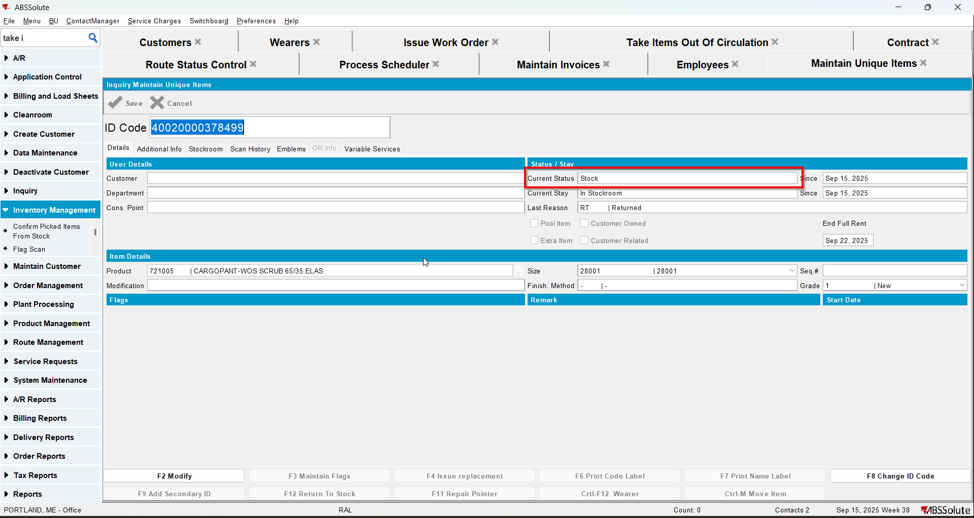

Test Case 2 – Generate Invoices for Customer.NonGarmentChargeLossCharge= 'N'with UNFCUSTOM– Tested OK
Expected behavior: there should be a 0 price Loss invoice line on the invoice for the non-garments when PLPC is quit
Hash: 263bd3a
- Have UNFCUSTOM module in the license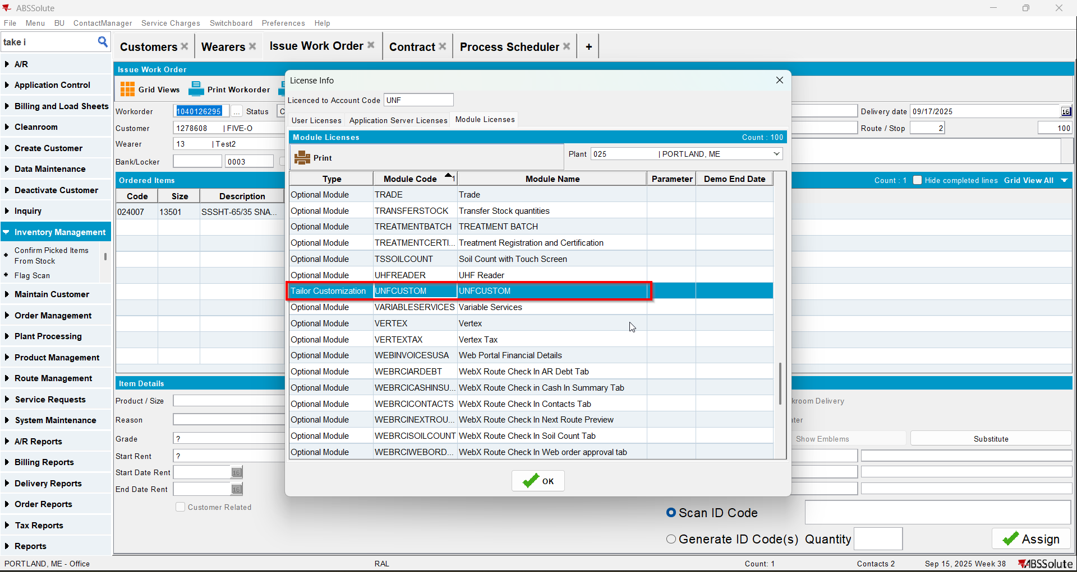
- Check that your customer has Charge Loss Charge unchecked for non garments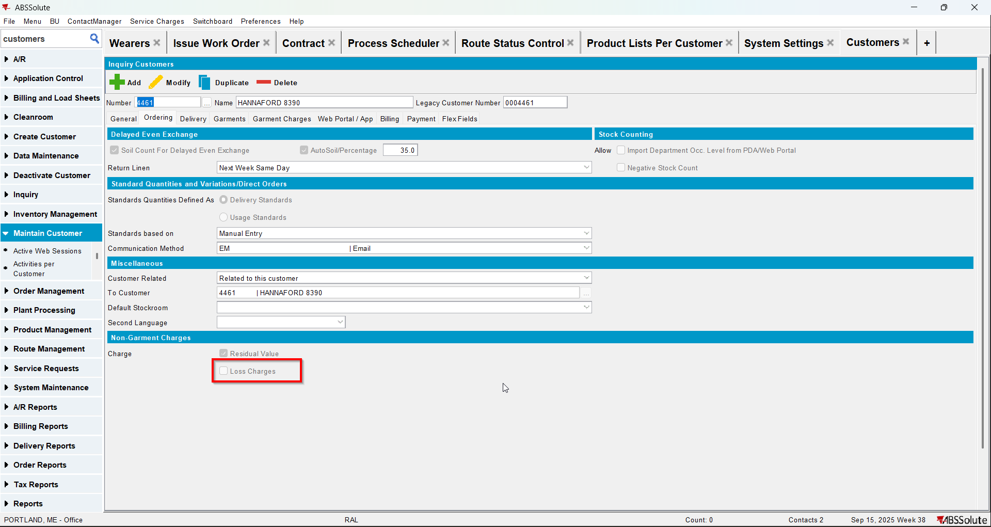
- Find a PLPC for a non-garment with items in circulation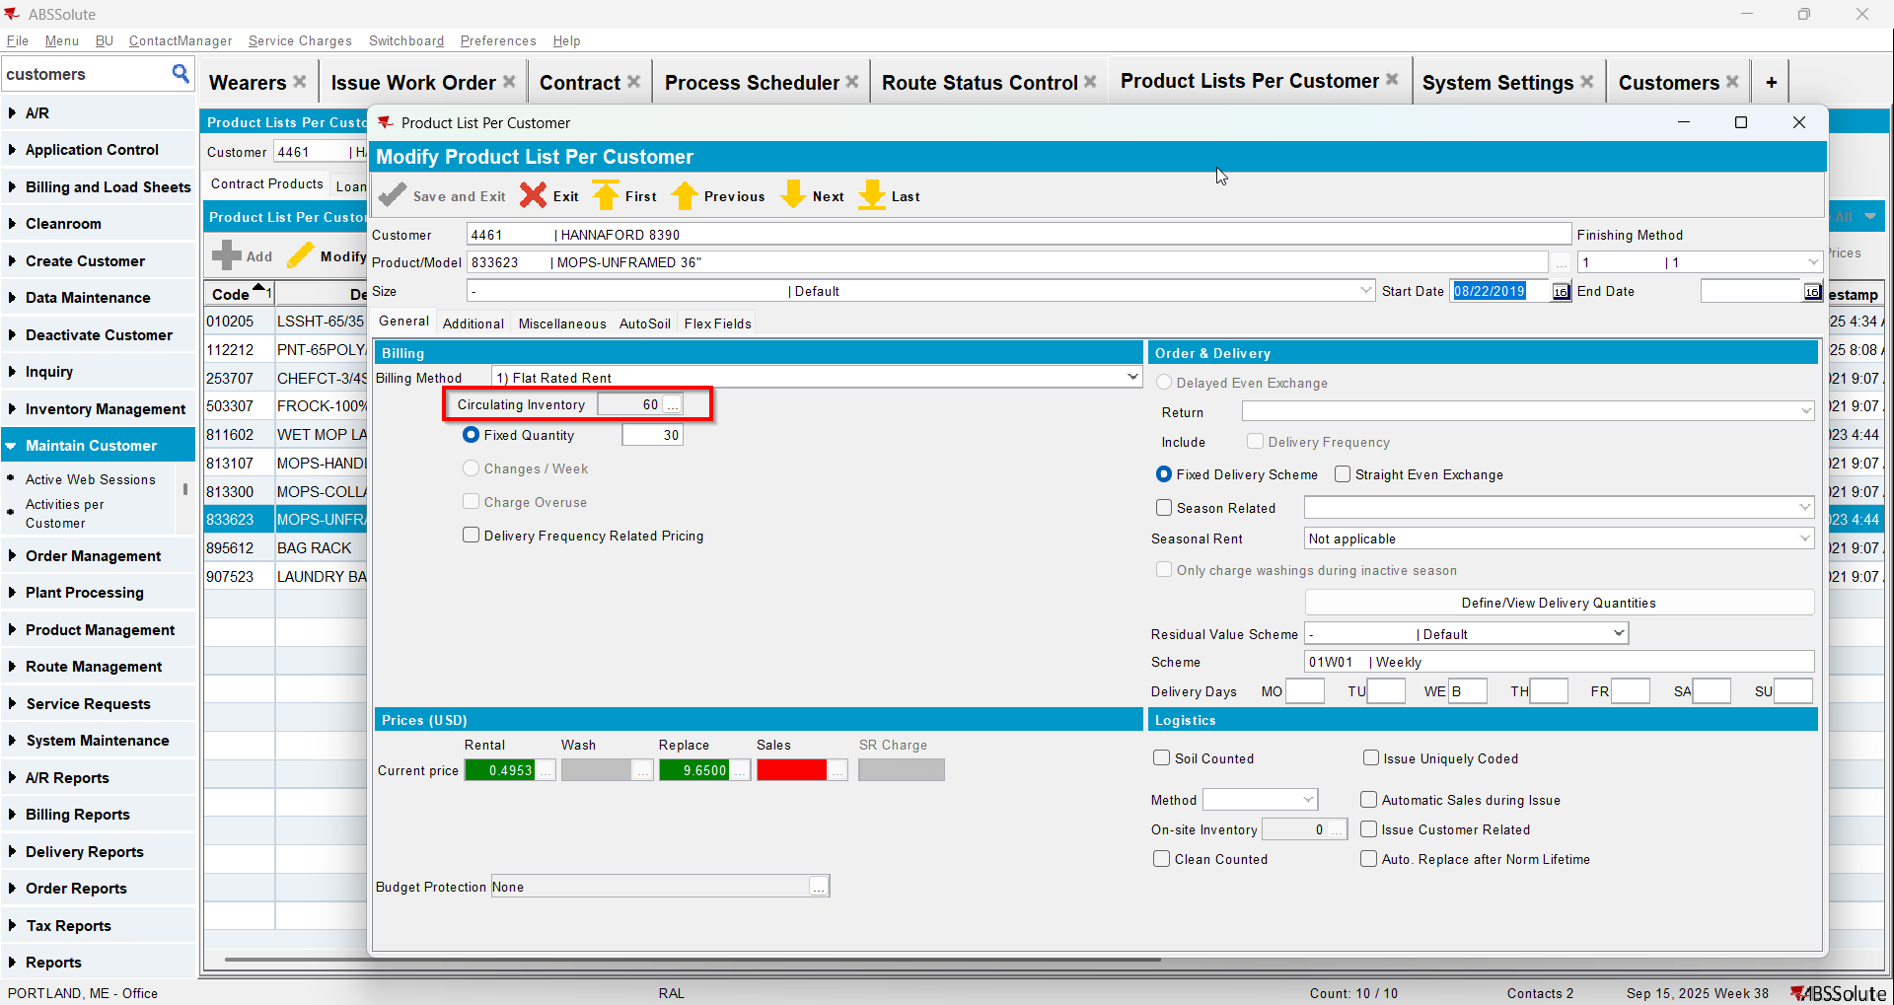
- Quit PLPC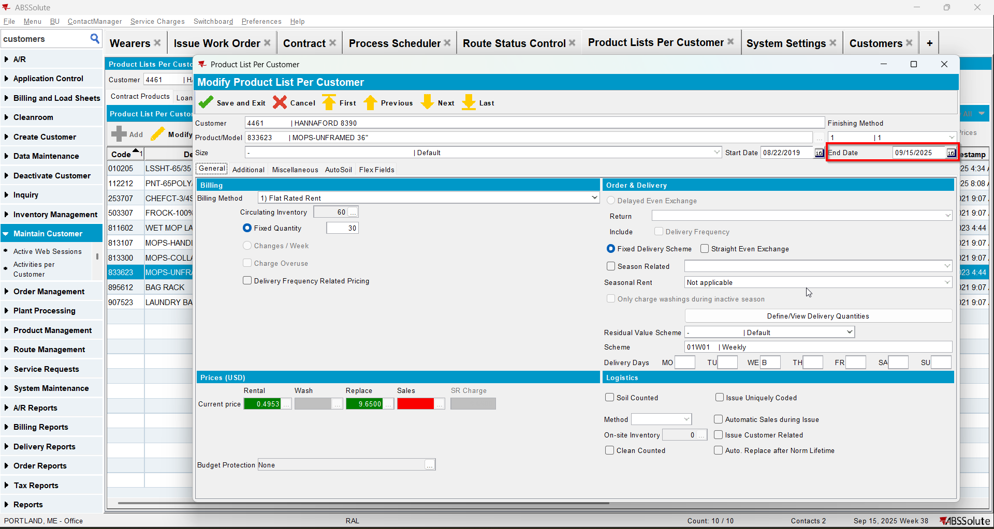
- Generate put up docs for current week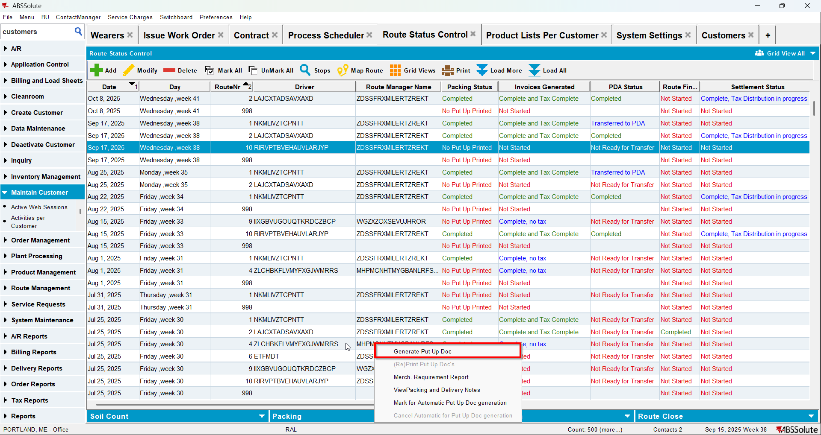
- Generate invoices for current week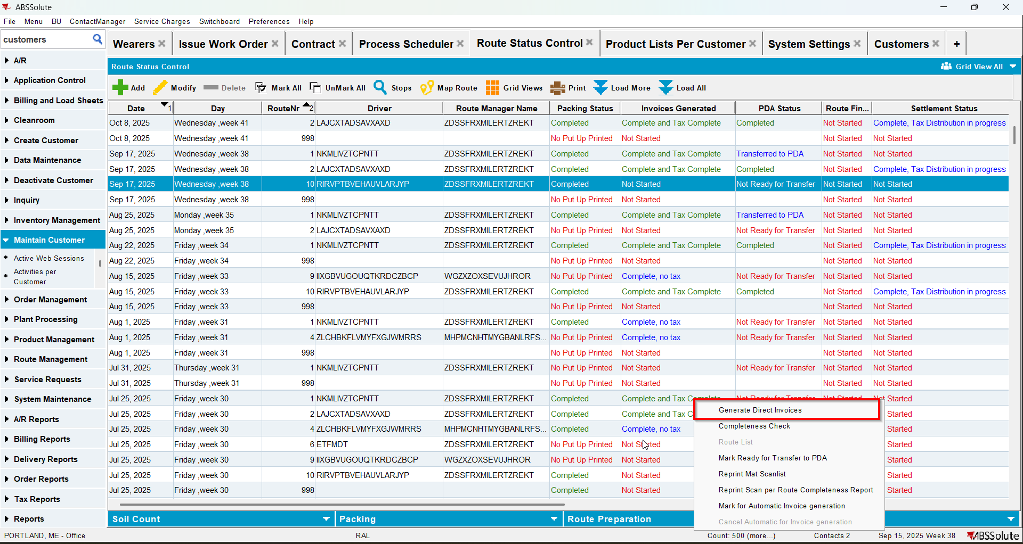
- Check that there is a loss line for the non-garment product with 0 price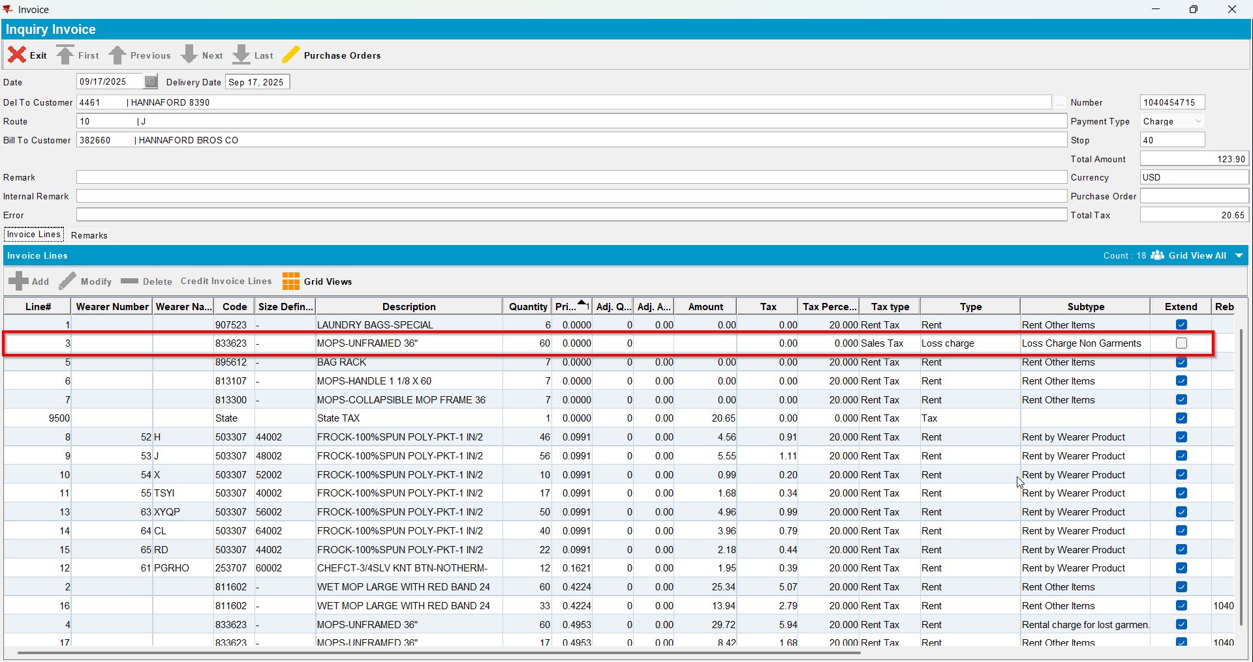
- Settle the route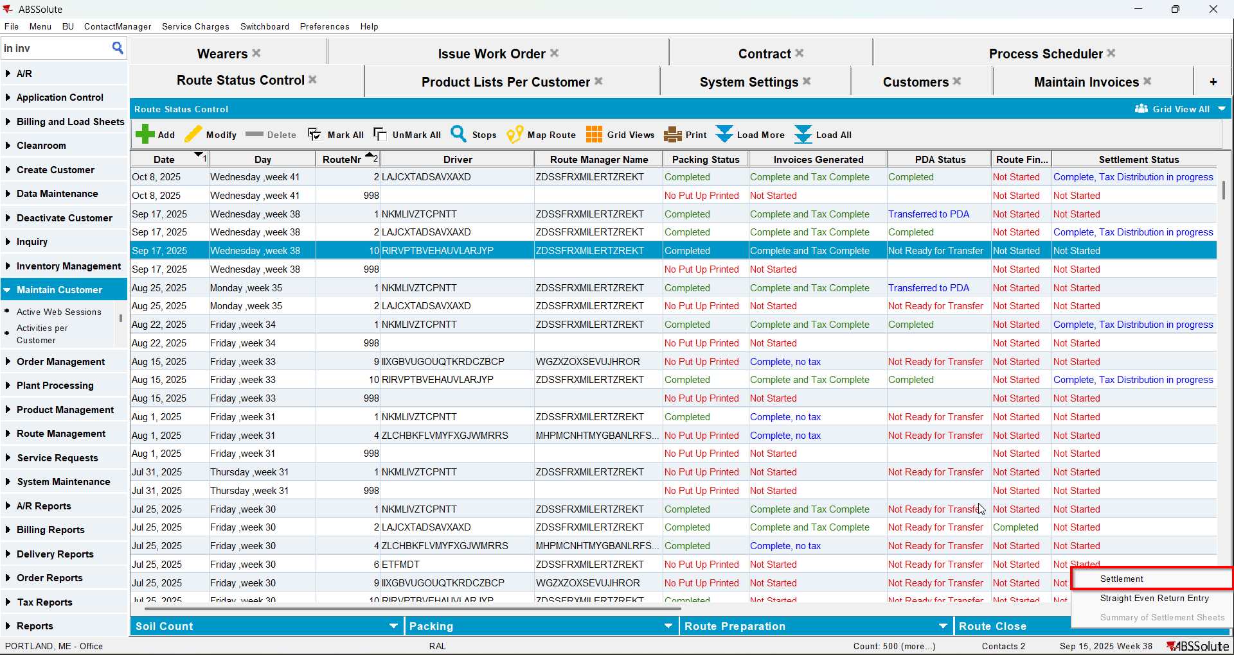
- Generate put up docs and invoices for a route 3 weeks from sysdate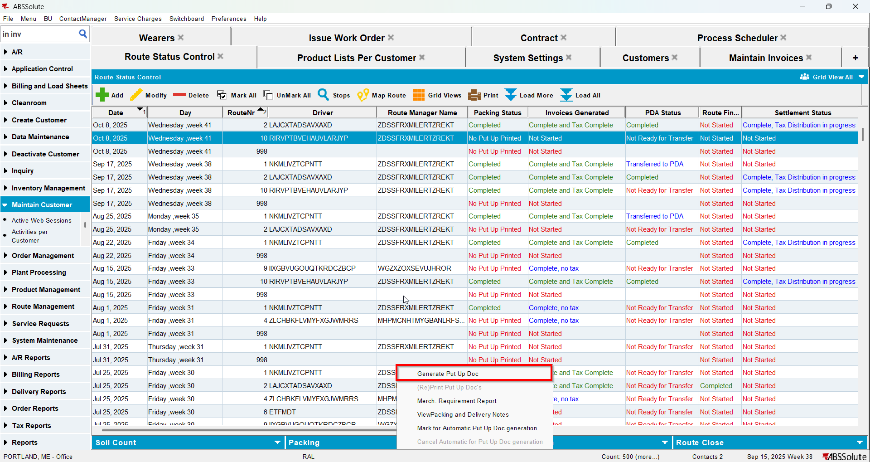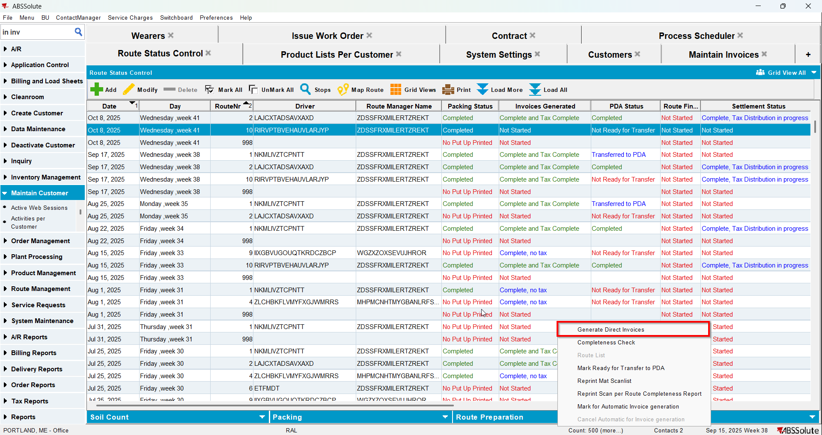
- Check that there is a loss line for the non-garment product with 0 price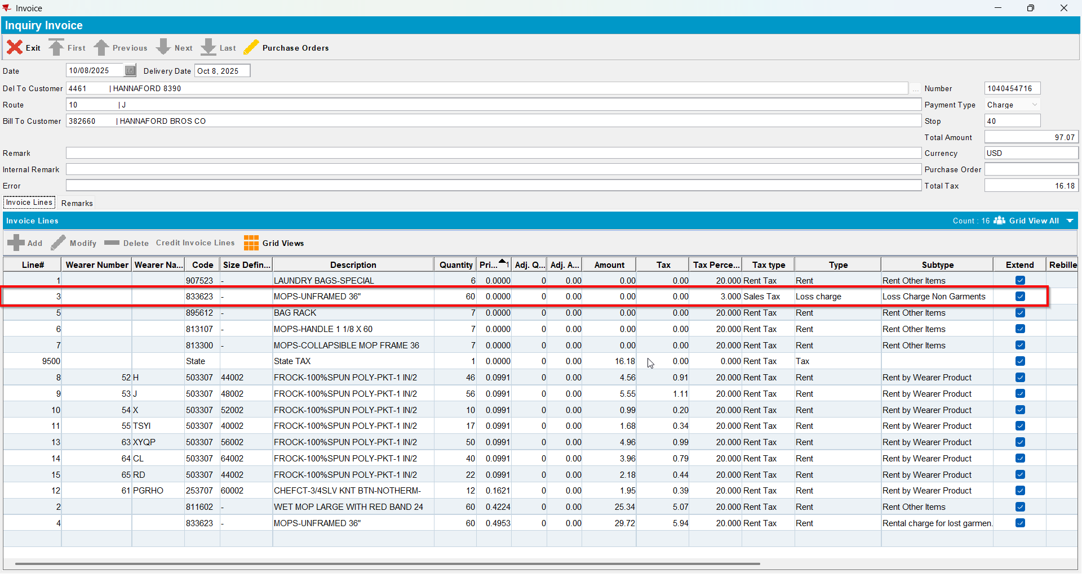
- Settle the route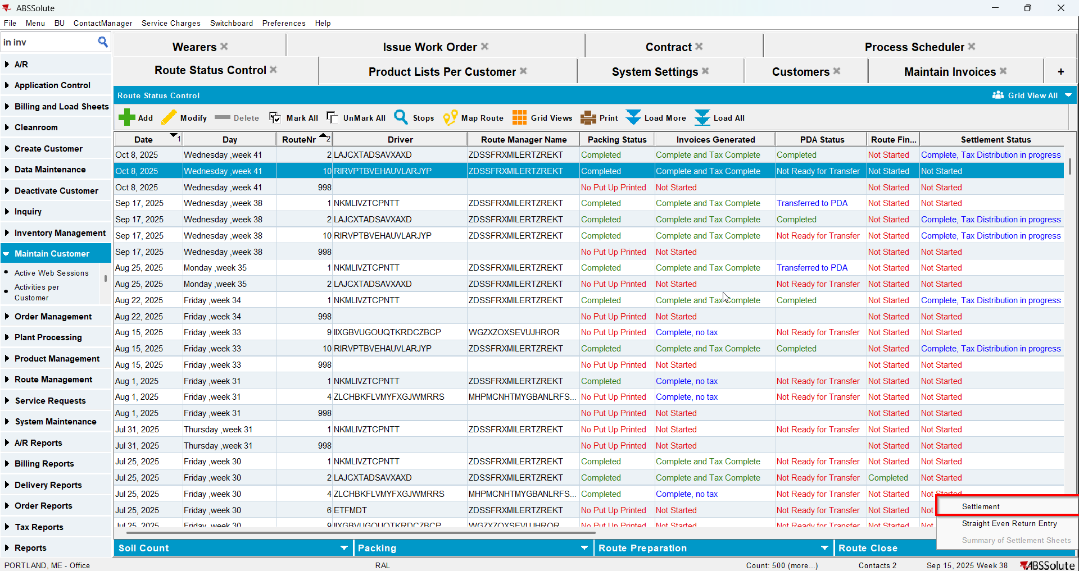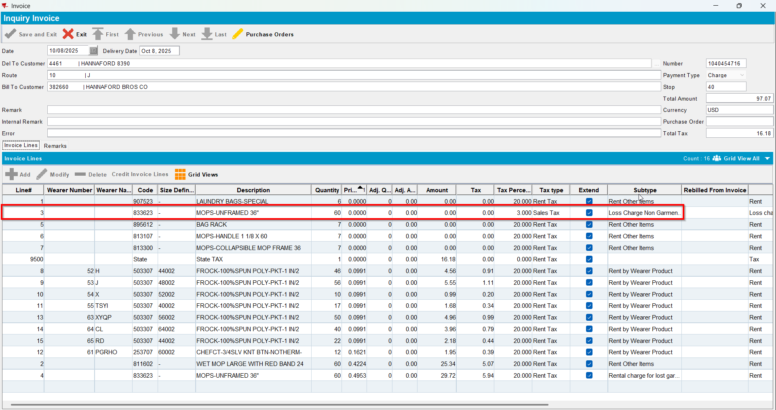

Test Case 3 – Return garments with Customer.ChargeLossCharge = 'N' without UNFCUSTOM– Tested OK
Expected behavior: Loss charge invoice line will not appear on the invoice. Just the MBYO will appear
Hash: 263bd3a
- Do not have UNFCUSTOM module in the license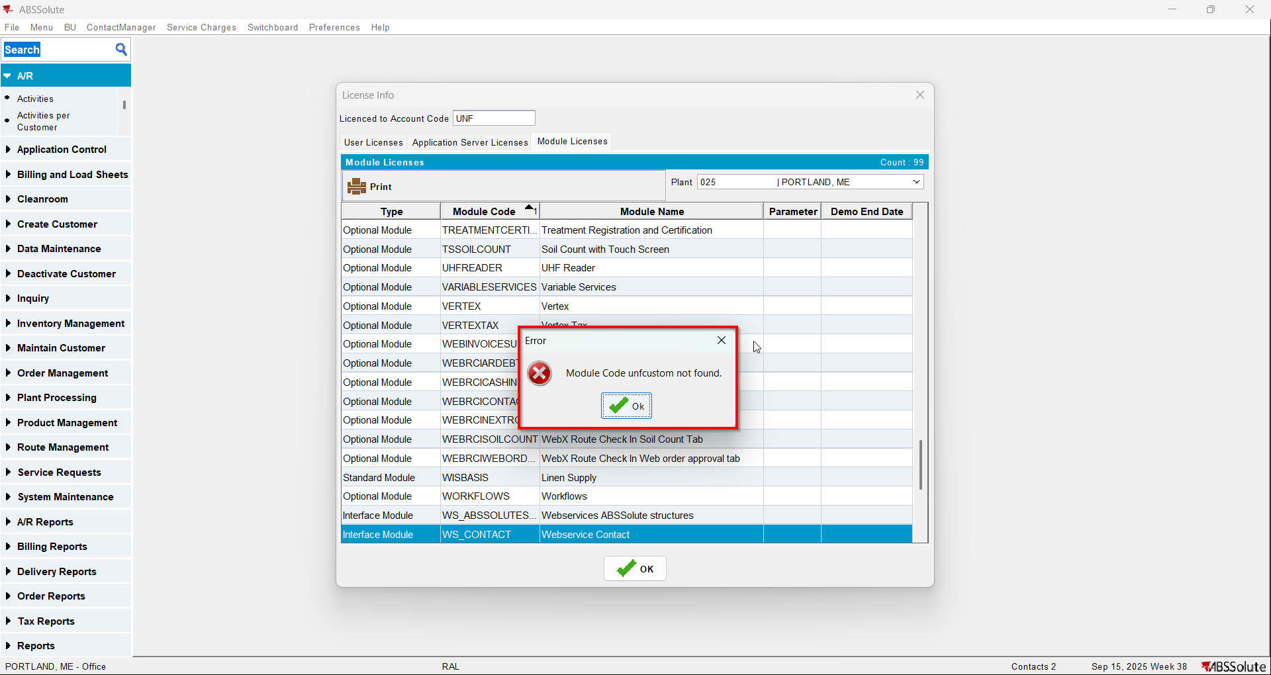
- Check that your customer has Charge Loss Charge unchecked for garments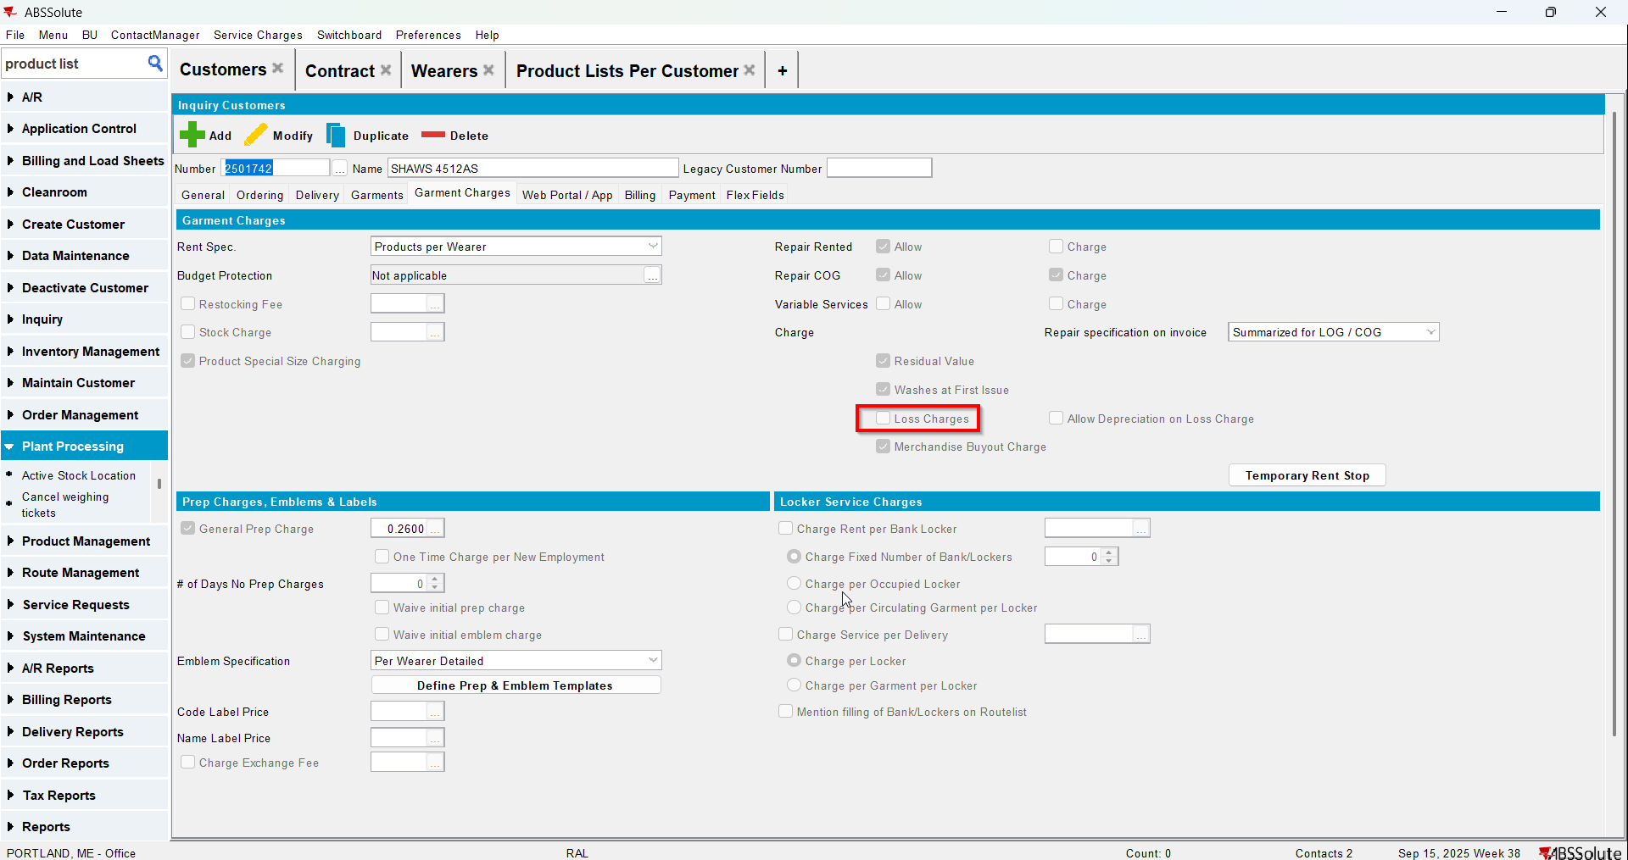
- Wearer inventory 1: Decrease Max inventory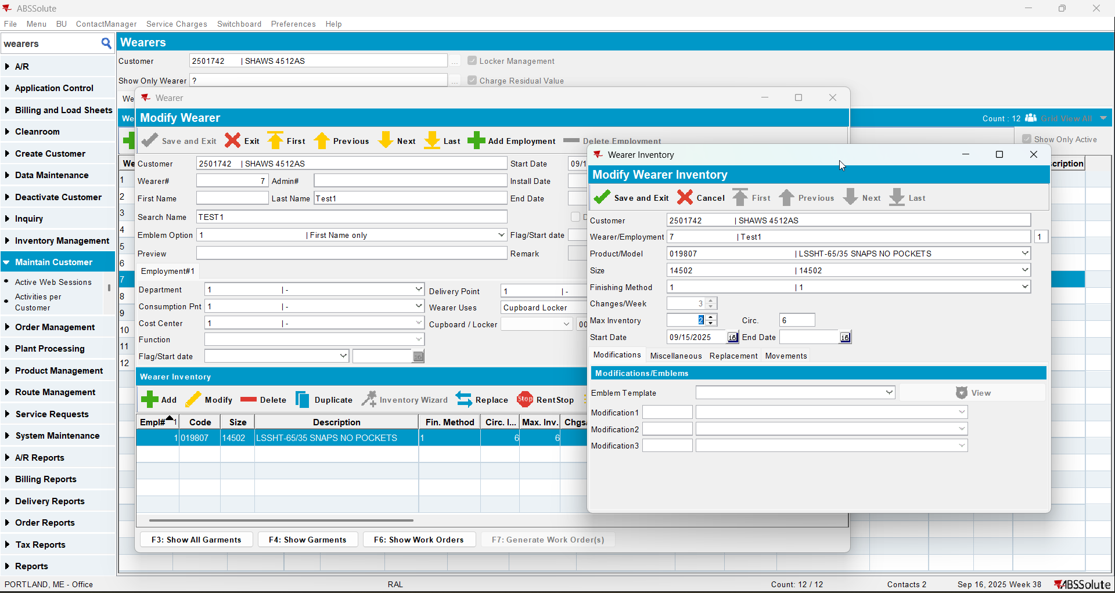
- Wearer inventory 2: Partial replacement of inventory (issue new garments)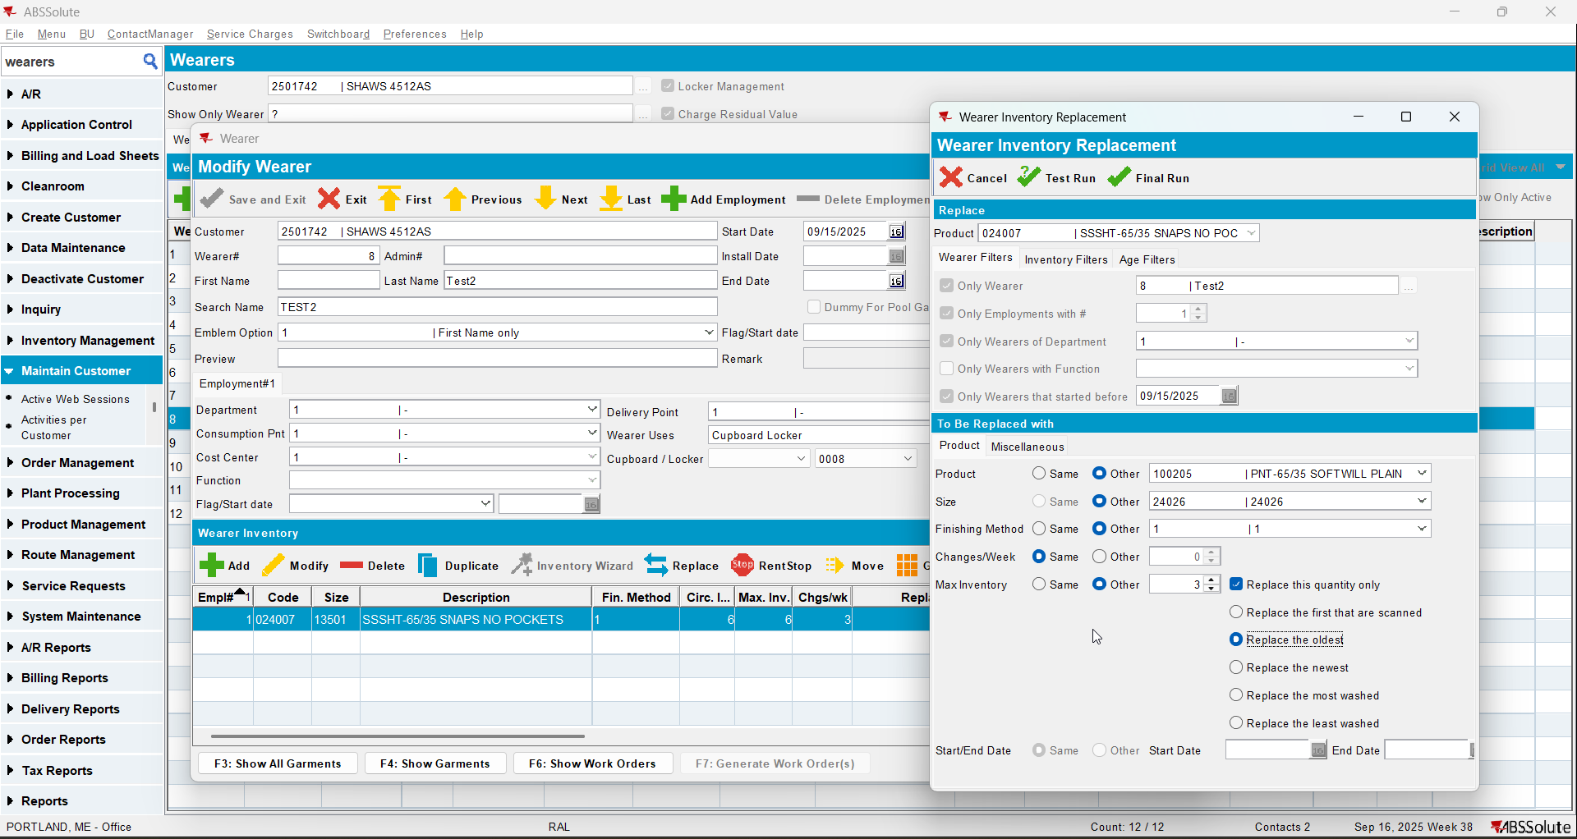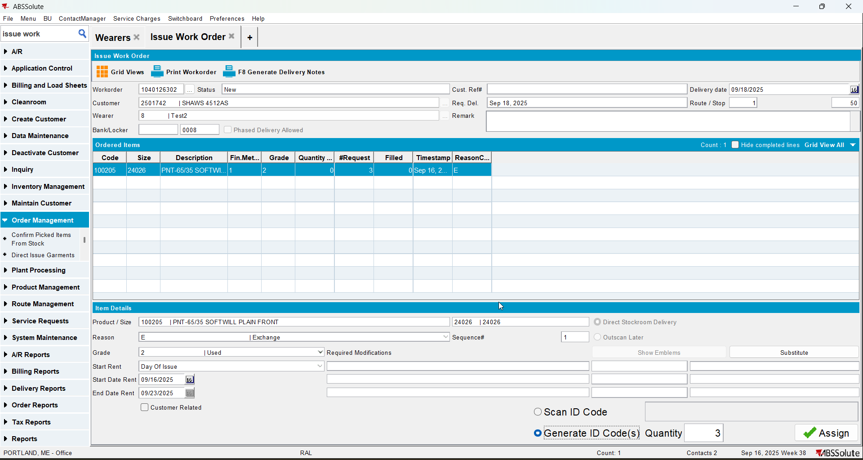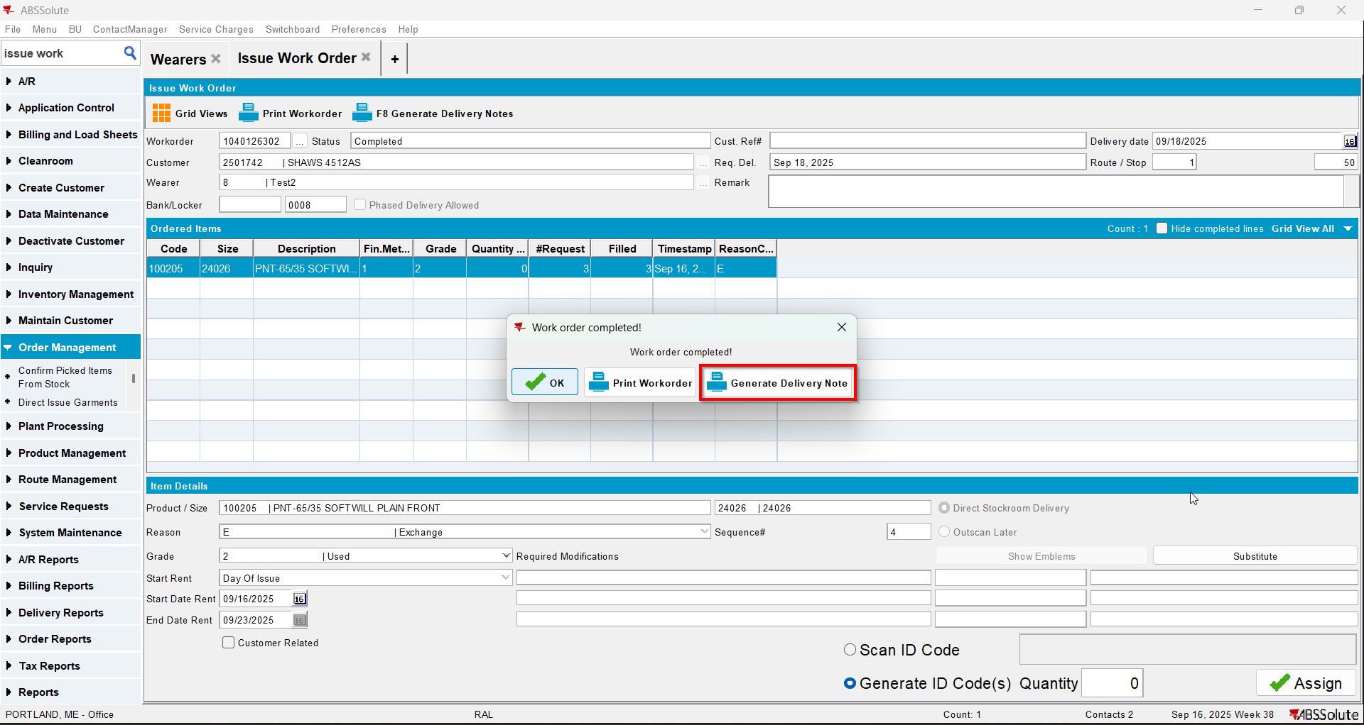
- Wearer inventory 3: Quit wearer inventory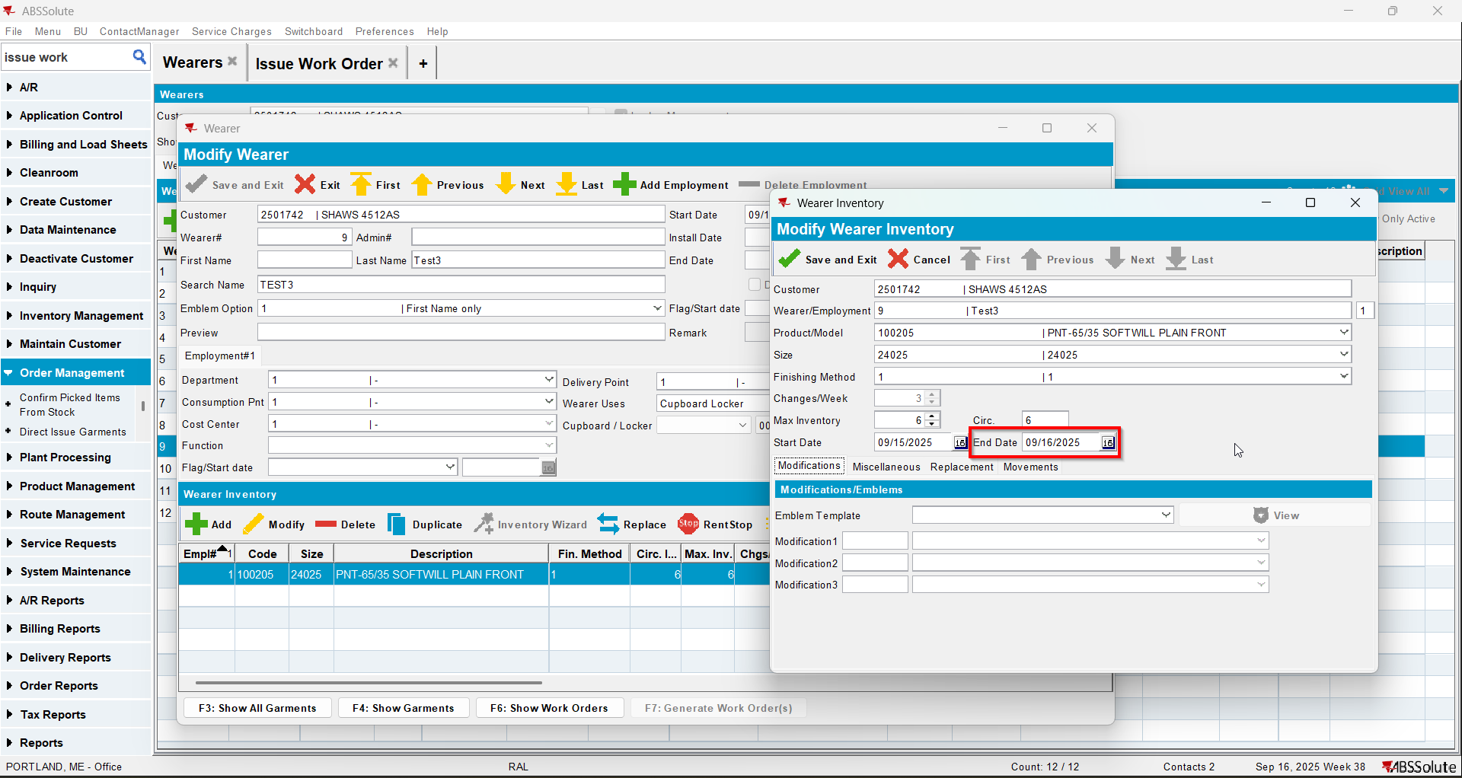
- Wearer inventory 4: Quit wearer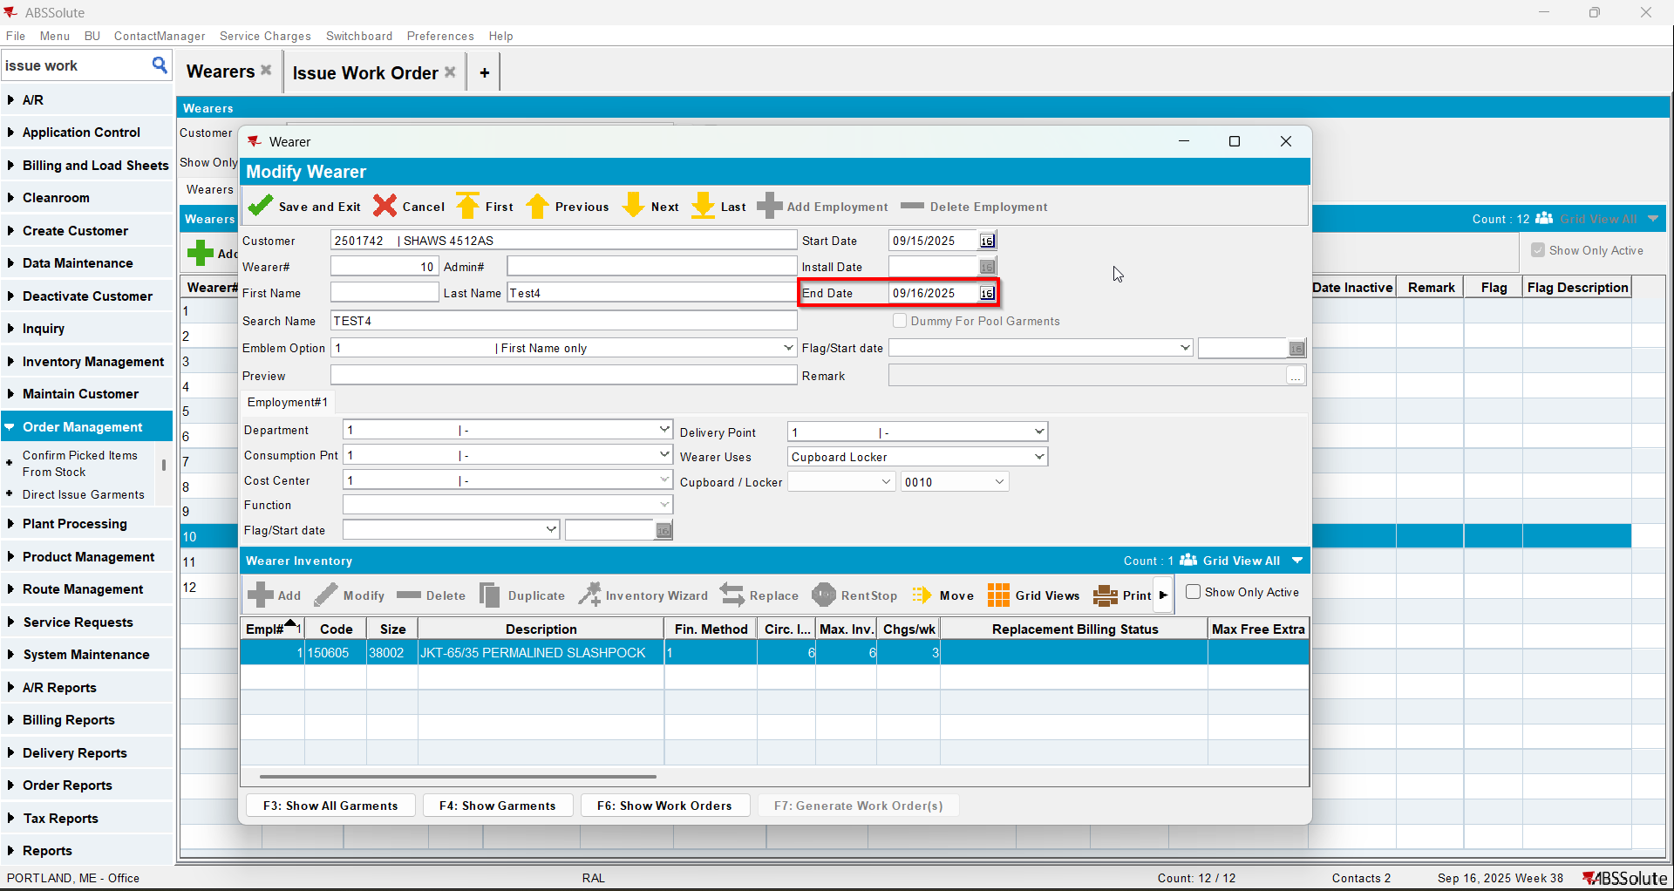
- Wearer Inventory 5: Quit PLPC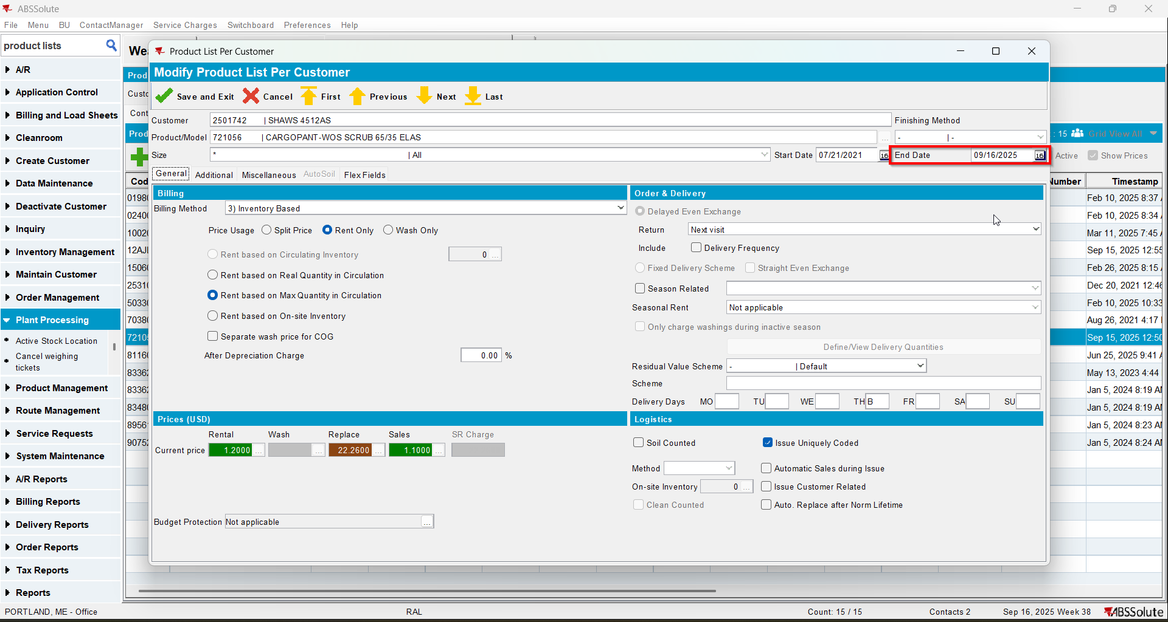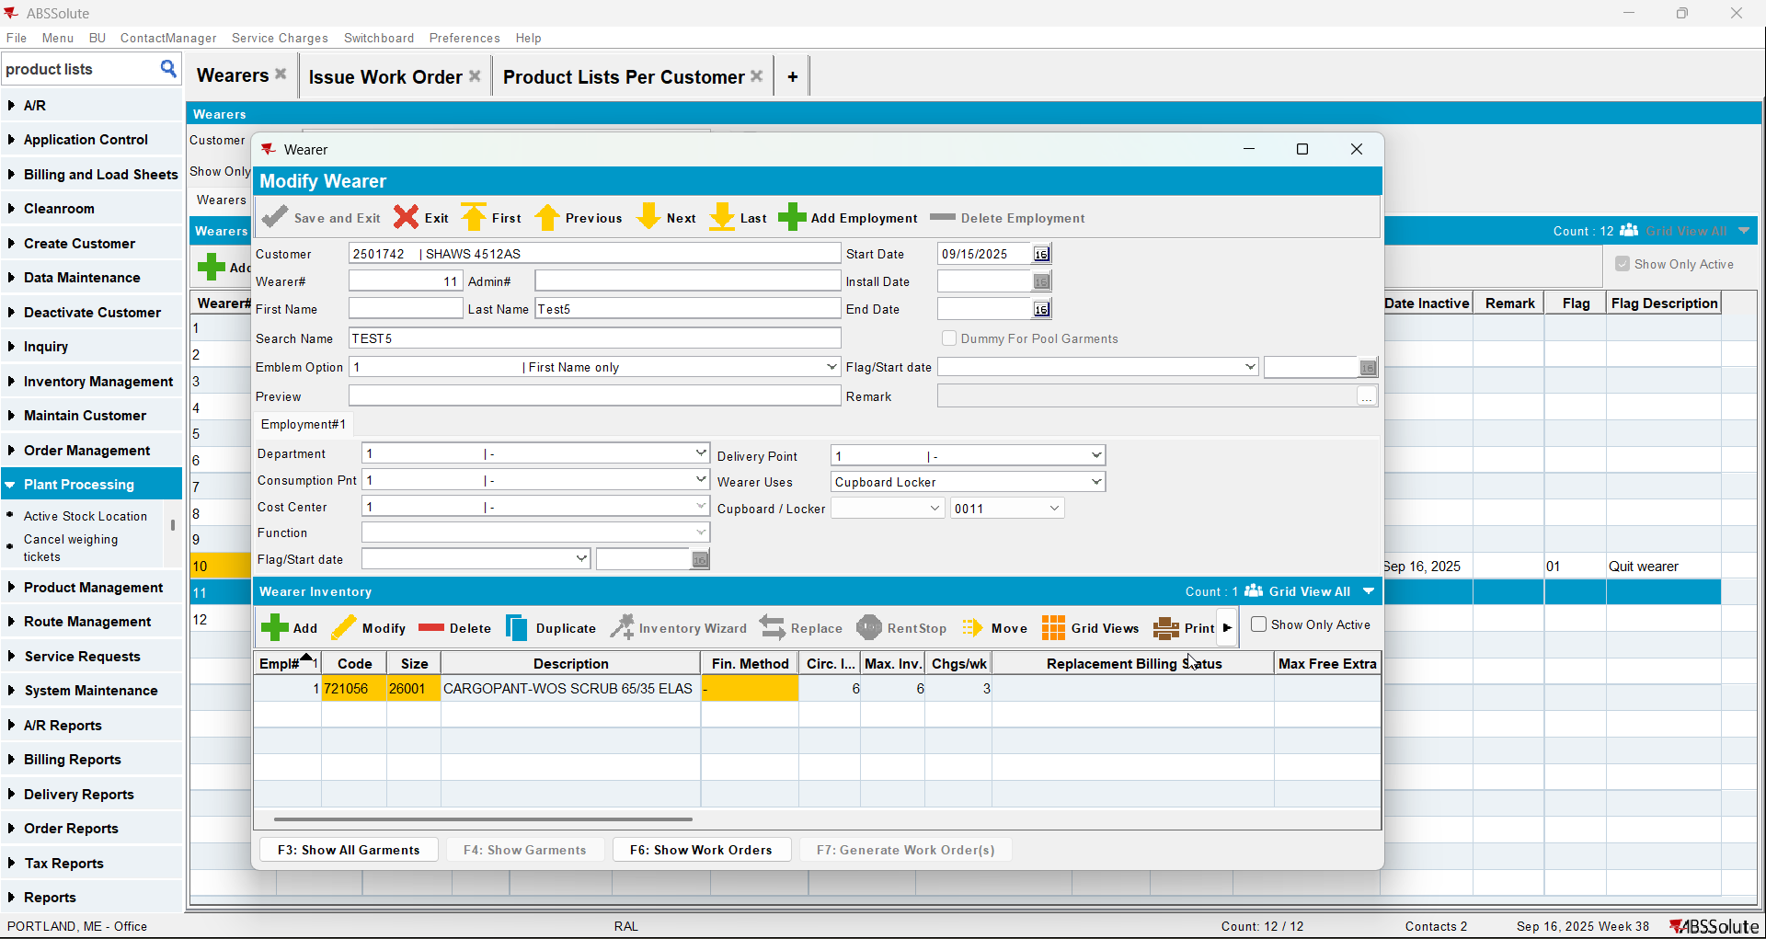
- Wearer Inventory 6: Quit wearer inventory MBYO(customer needs to have MBYO charge and the product Allow Return to Stock “No, Charge MBYO”)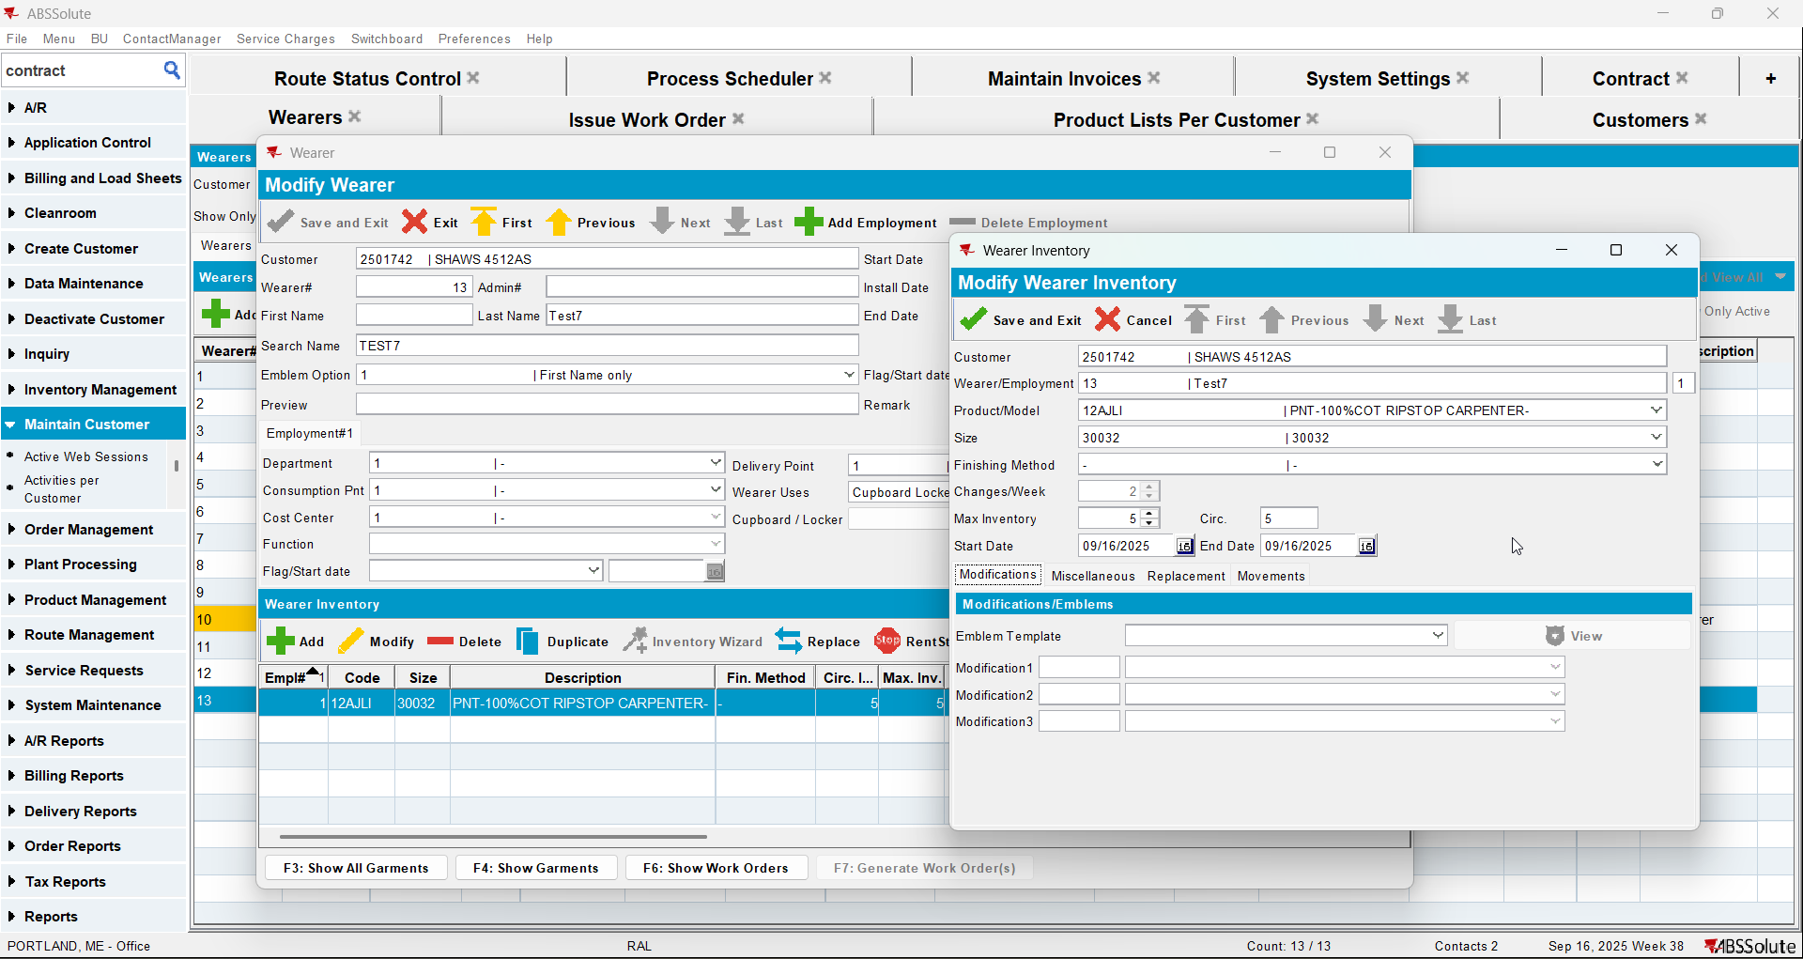
- Generate invoice in current week 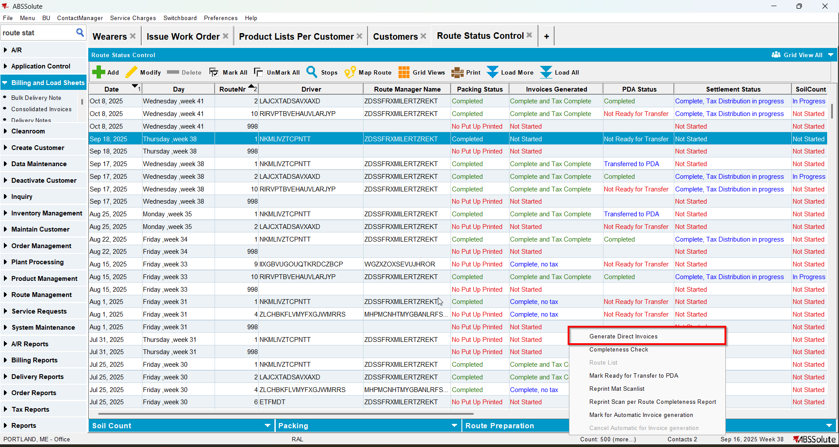
- There should be no loss charge invoice lines instead of the MBYO one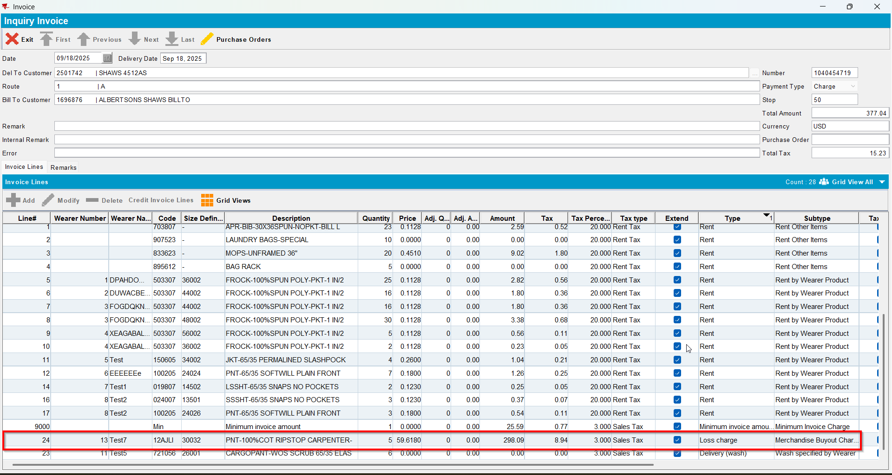

Test Case 4 – Generate Invoices for Customer.NonGarmentChargeLossCharge= 'N' without UNFCUSTOM – Tested OK
Expected behavior: there should be a 0 price Loss invoice line on the invoice for the non-garments when PLPC is quit
Hash: 263bd3a
- Do not have UNFCUSTOM module in the license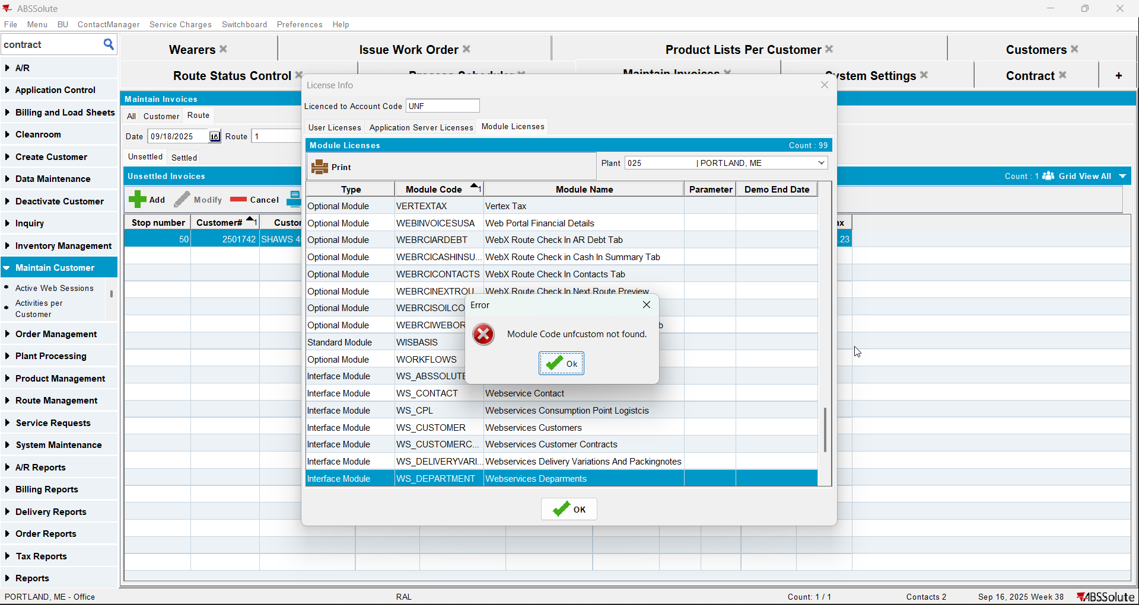
- Check that your customer has Charge Loss Charge unchecked for non garments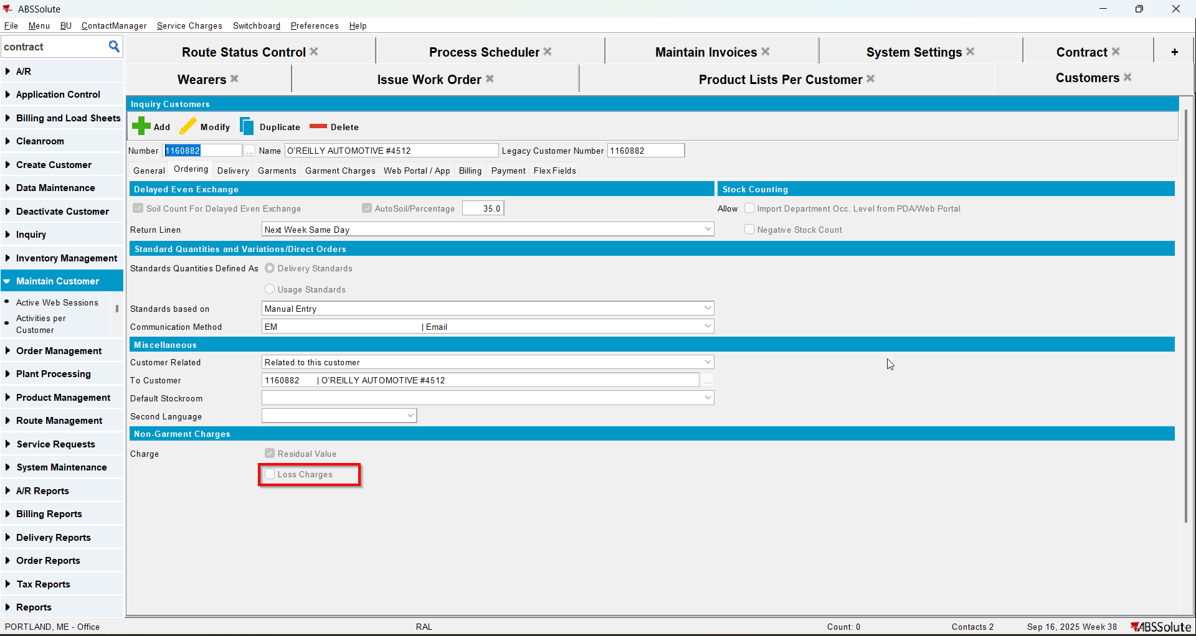
- Find a PLPC for a non-garment with items in circulation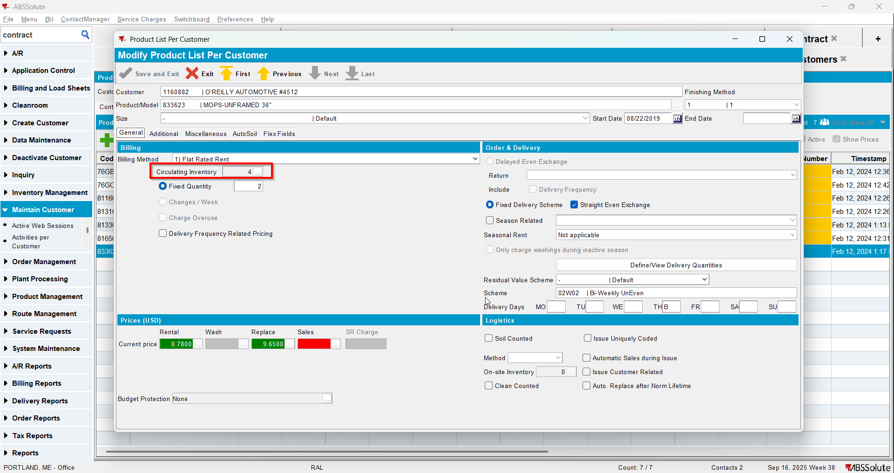
- Quit PLPC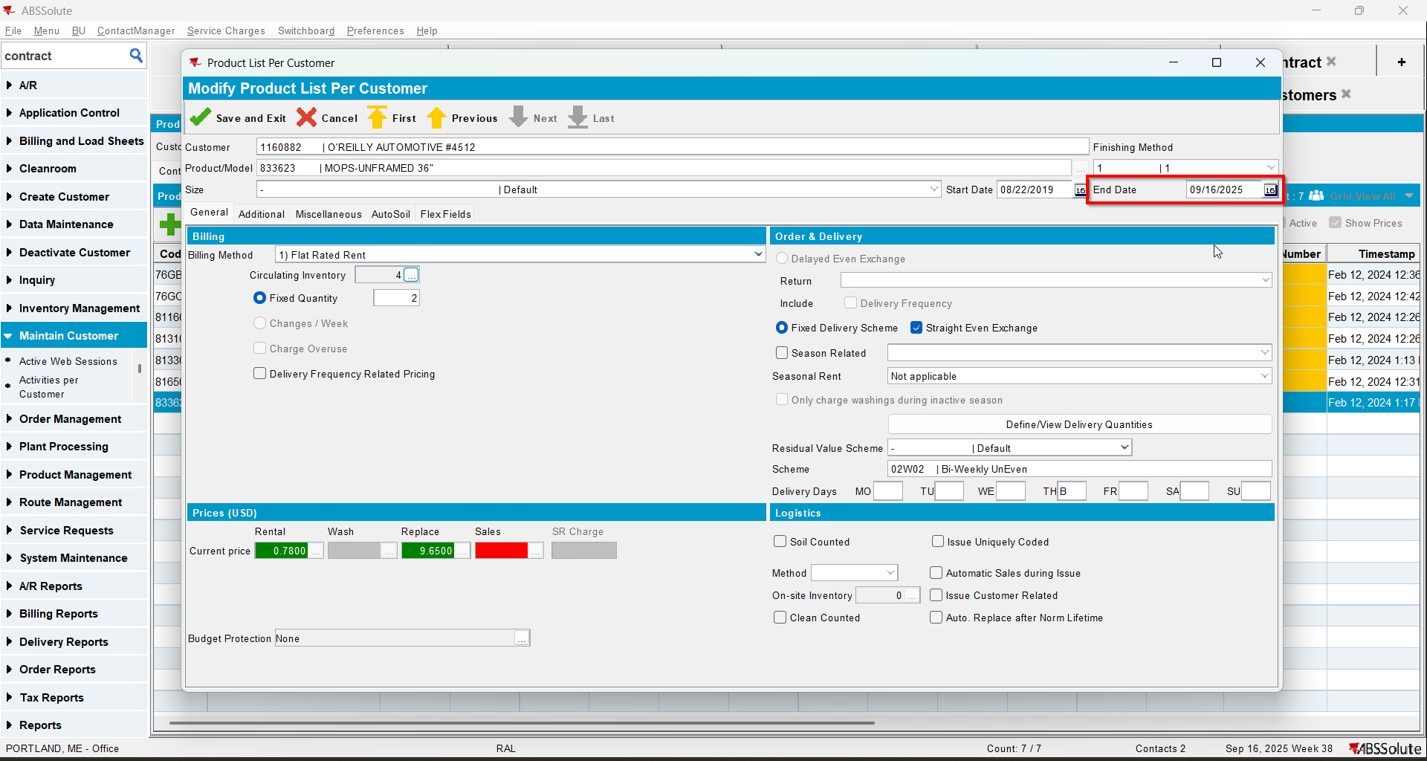
- Generate put up docs for current week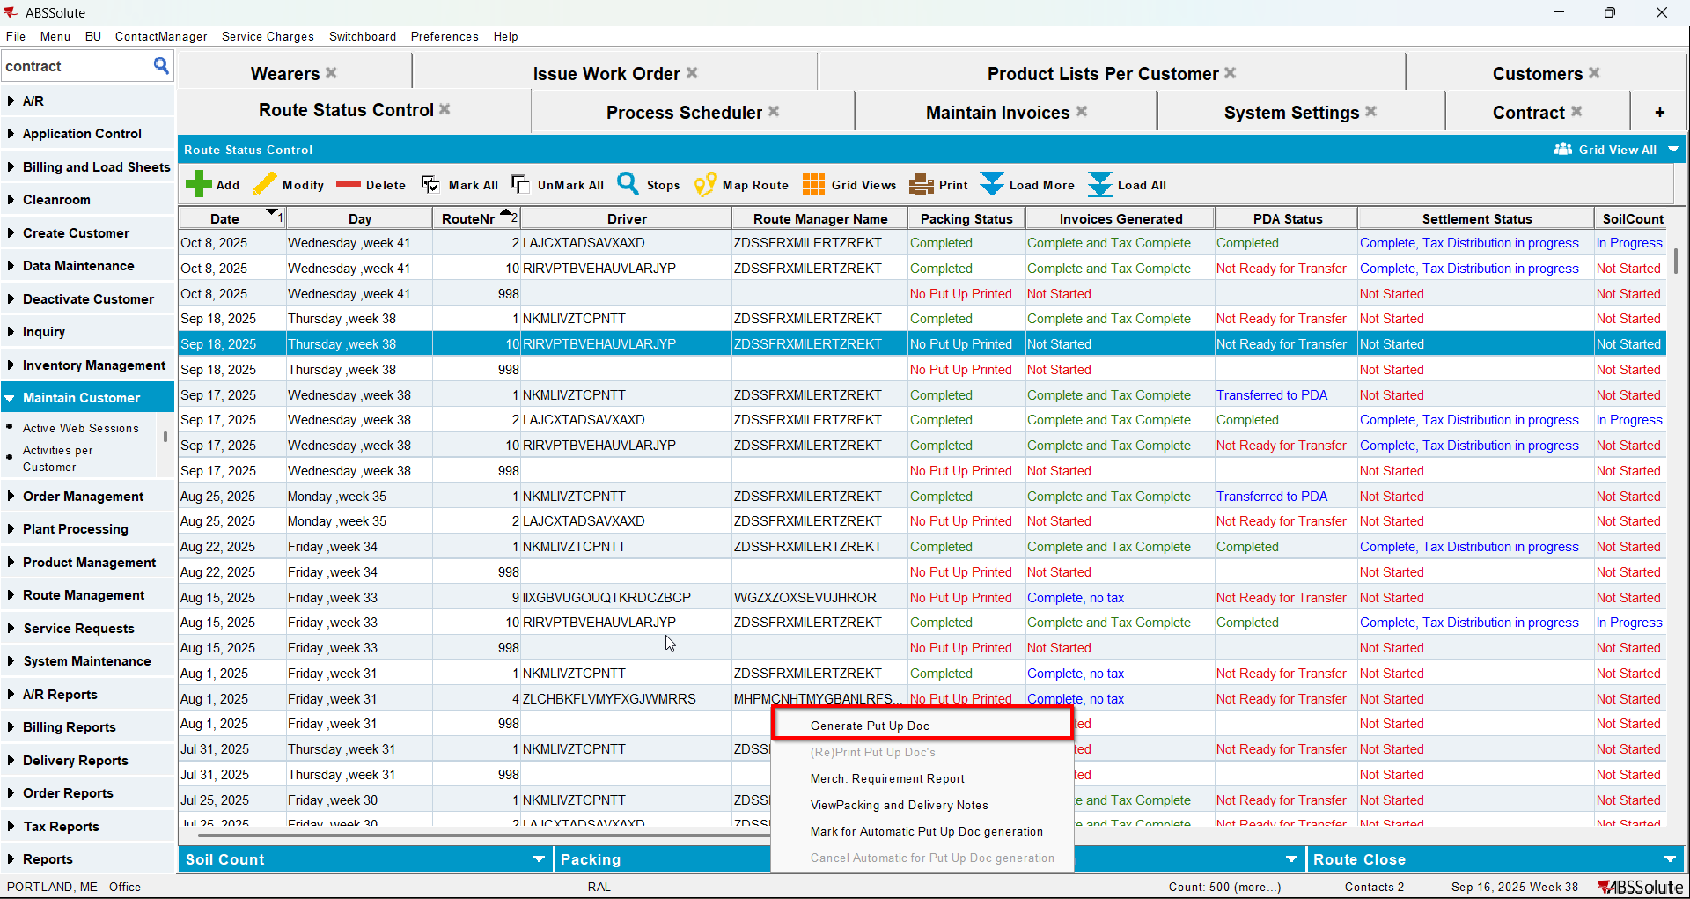
- Generate invoices for current week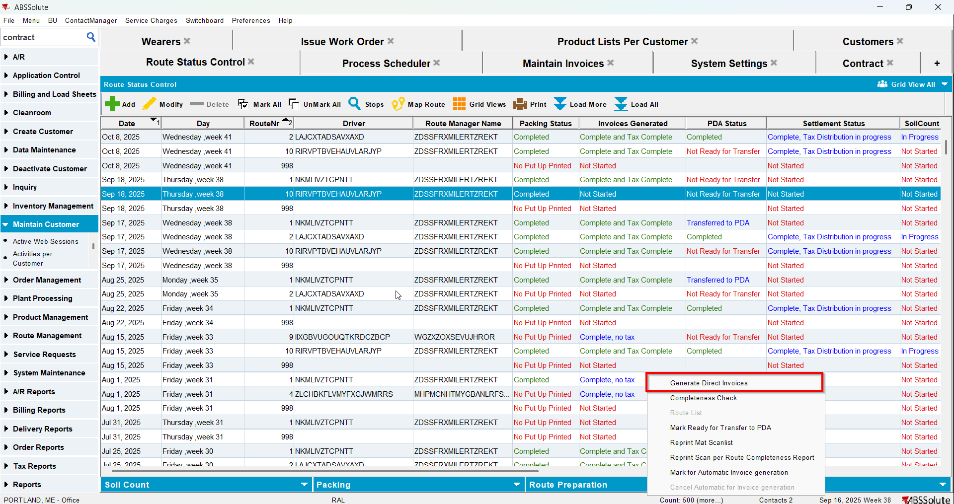
- Check that there is a loss line for the non-garment product with 0 price