ABSN-1520 Null error during Invoice Generation
Environment | Prerequisites
Version:9.07.00  DBServerName=abs-SRV20.internal.abslbs.com  DBSID=CUST24  DBUser=UNFDEV  Environment=Test | - Module:  - System setting

Contents
Test after fix 1
Test Case 1 – Cancel charge for emblems – Tested OK 1

Test after fix

Test Case 1 – Cancel charge for emblems – Tested OK
Expected behavior: The error should be visible in view process log and process file on disk
Hash: b72e077
- First we need to revert commit 82ec5d9 from ABS-157498
- Go to BU 044
- Go to Maintain Garment Charges and select customer 28826
- Go to emblems tab and cancel some emblem charges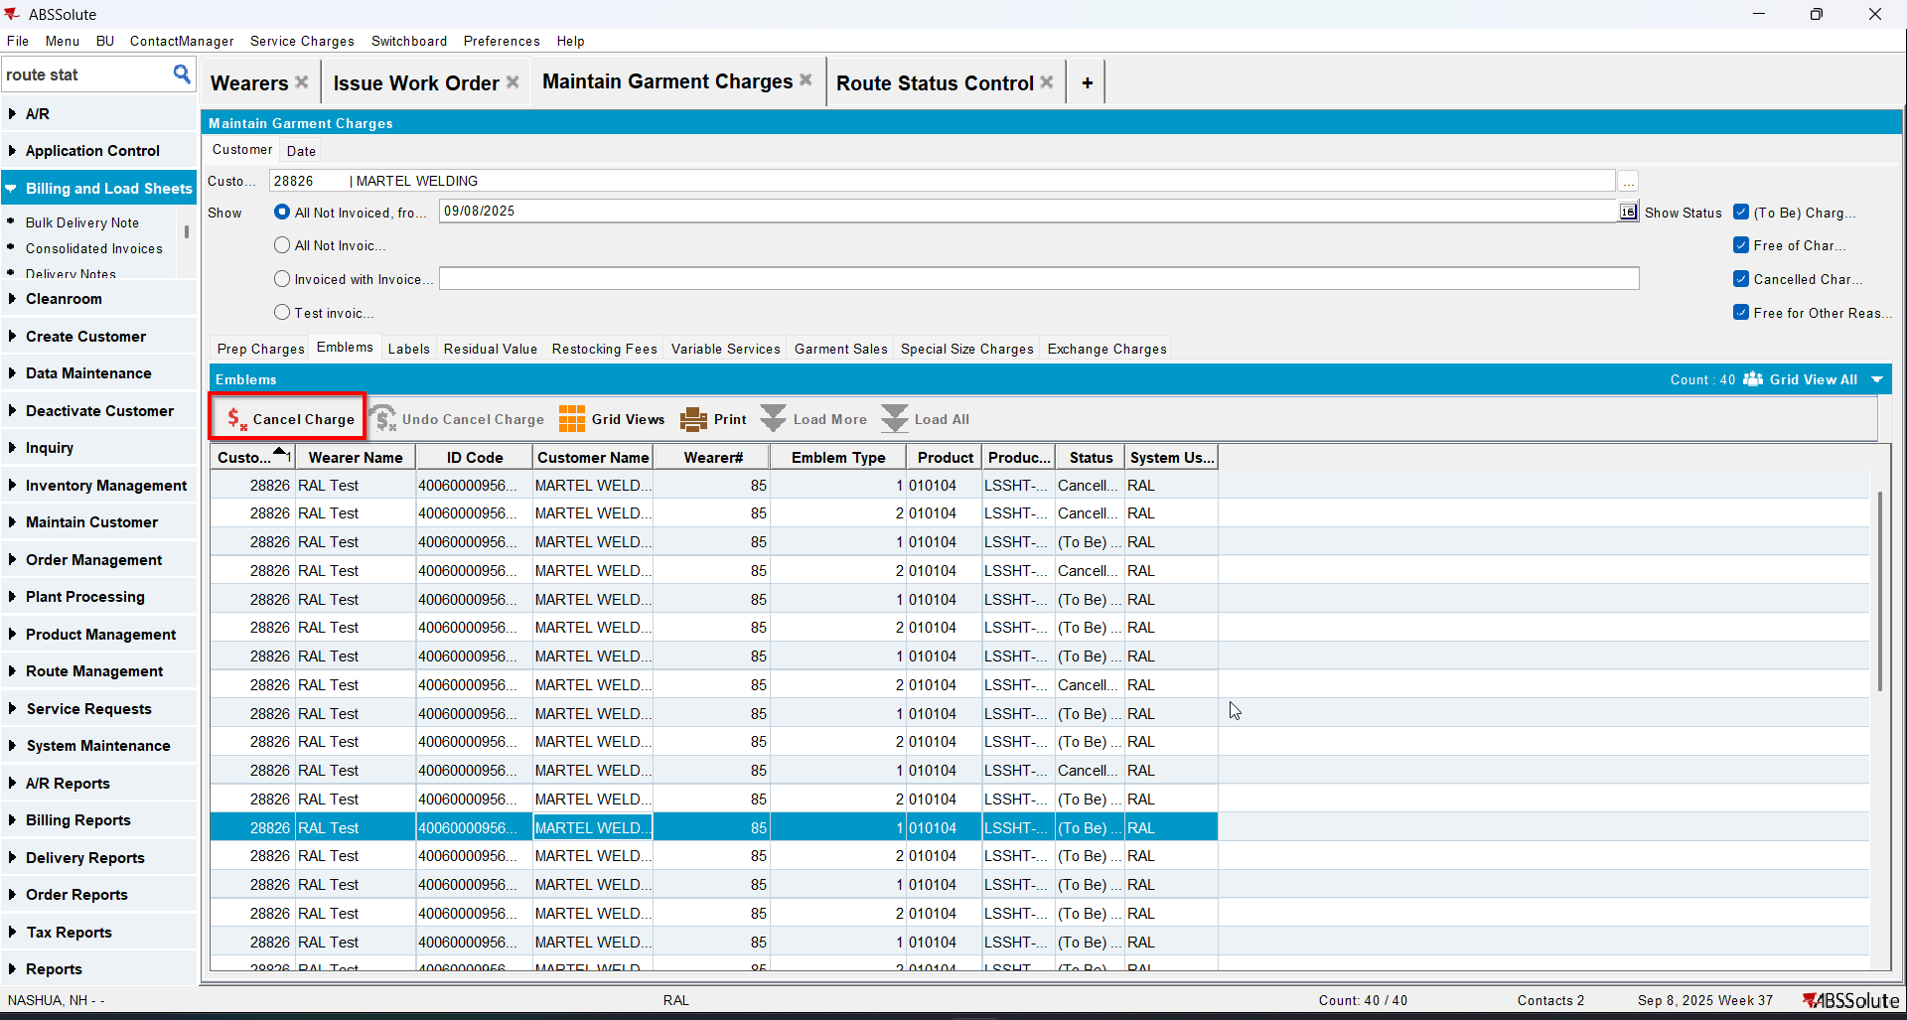
- Generate invoices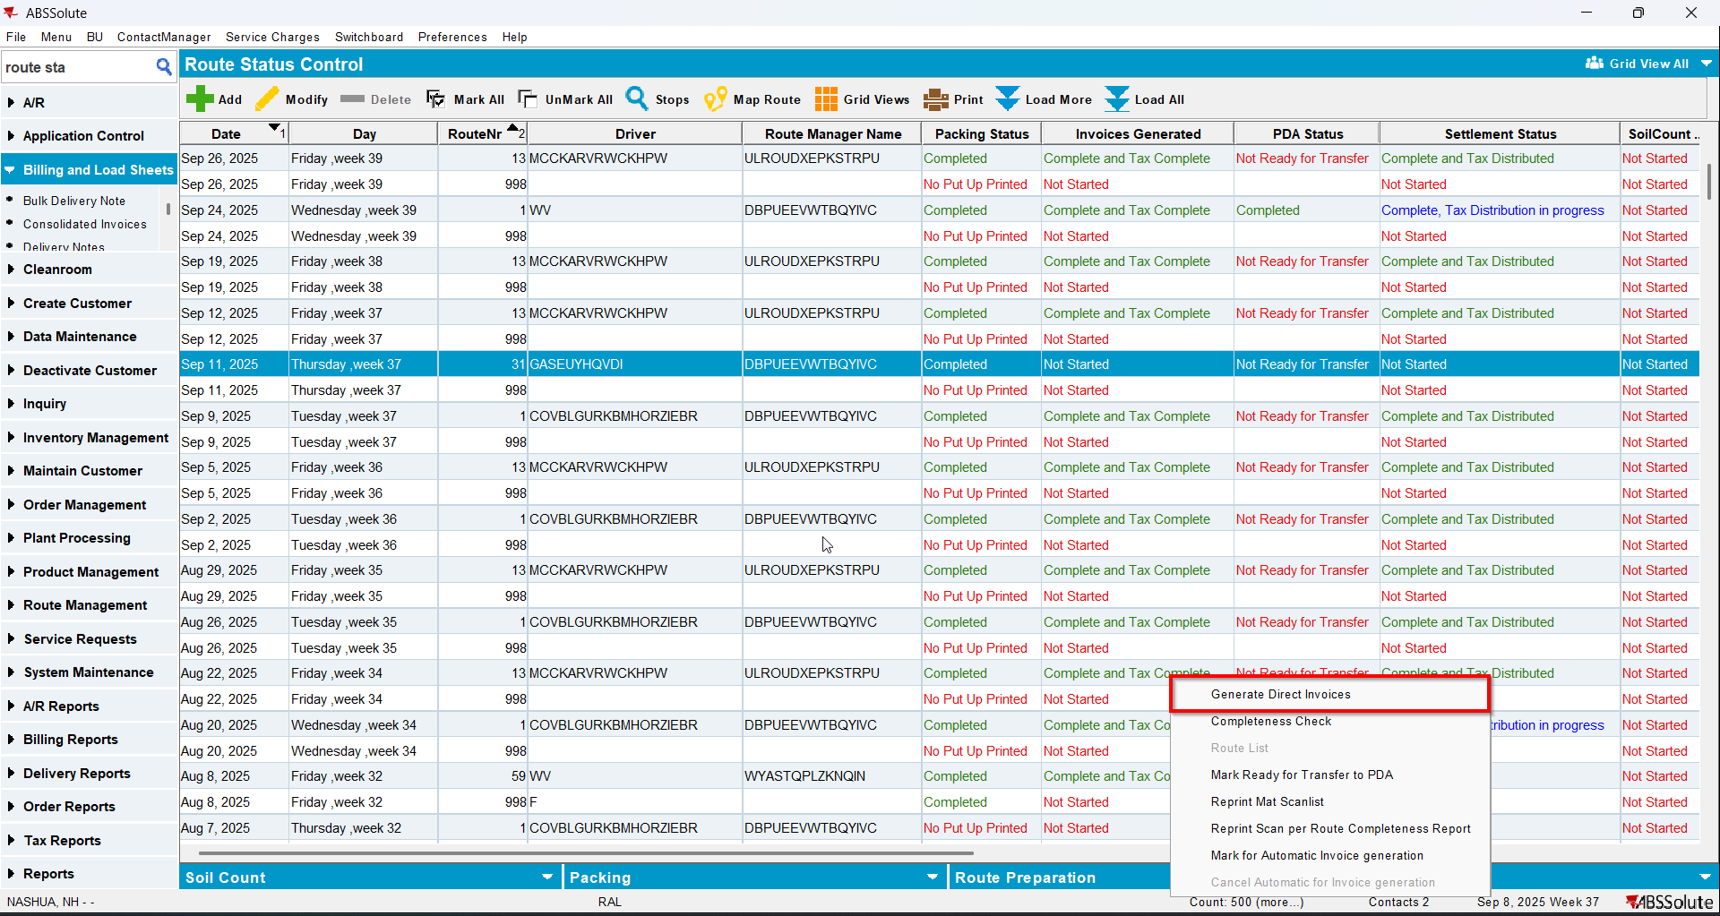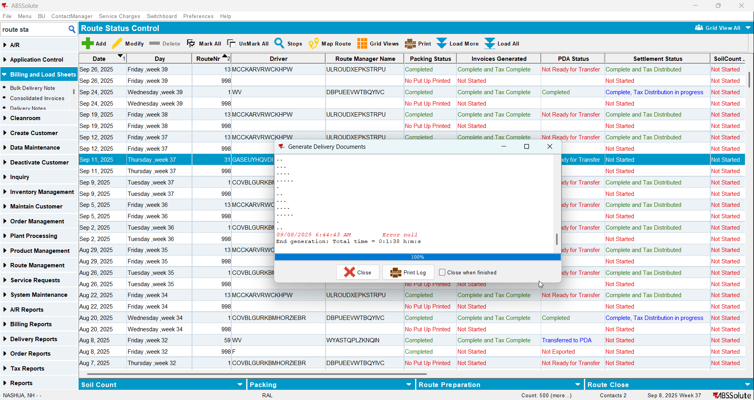
- Check that the error appears also in view process log and process file on disk