ABSN-1436 ABSSolute client Unexpected Exception with no further details
Environment | Prerequisites
DBServerName=abs-srv20.internal.abslbs.com  DBSID=CUST24  DBUser=UNFDEV  Environment=Test  Version: 9.07.00.UNF20 | - Module:  - System setting:  - Other applications versions (if is applicable)

Contents
Behavior after initial implementation 2
Preparation for test 2
Test for implementation 3
Test Set I: Out of Memory Error is displayed ok 3
Test Case 1: Work Order Status Control displays Out of Memory Error 3
Test Case 2: Route Status Control displays Out of Memory Error 5
Test Case 3: Work Order Status Control displays Out of Memory Error but memory is freed when the tab is closed 7
Test Case 4: Workstation Settings load all Workstations from all Business Unites 9
Test Set II: Out of Memory Error is not displayed 10
Test Case 1: Customer Switchboard Load All Customers 10

Behavior after initial implementation
When an Out of Memory Error is detected and the ABSSolute Client has no available memory to load records, an error pop-up is displayed with the following text
“There isn't enough available memory to load all the data!
Please consider closing some tabs or restarting the ABSSolute client.”
This means if there is a single tab opened and the error is thrown the Client has to be restarted. If the error is thrown in a tab if multiple are opened, each for a different dialog, the error pop-up can be closed and then the tab, the memory will be released and can be reallocated.
Another effect of this implementation is inside the user’s logs directory(user with which the ABSSolute Client is opened), heapdumps in the following format are generated “heapdump-OutOfMemoryWarning-yyyymmdd_HHhMM.hprof”(yyyy=year, mm=month number, dd=day of the month, HH = hour of the day in the continental time format[24 hours], MM=minutes, .hrpof = heap dump extension) with which further investestigations can be conducted. The files are usually big in size and only 5 such files are kept due to the size on disk issue, and then, one by one, in the order in which they were generated, are replaced by newer ones. These heap dumps are generated each time the error pop-up mentioned above is displayed.

Preparation for test
On the line 10 of client.bat add the -Xms90m -Xmx90m parameters which limit the memory with which the Client can operate and works on.

Test for implementation

Test Set I: Out of Memory Error is displayed ok

Test Case 1: Work Order Status Control displays Out of Memory Error
Step 1) Open Work Order Status Control
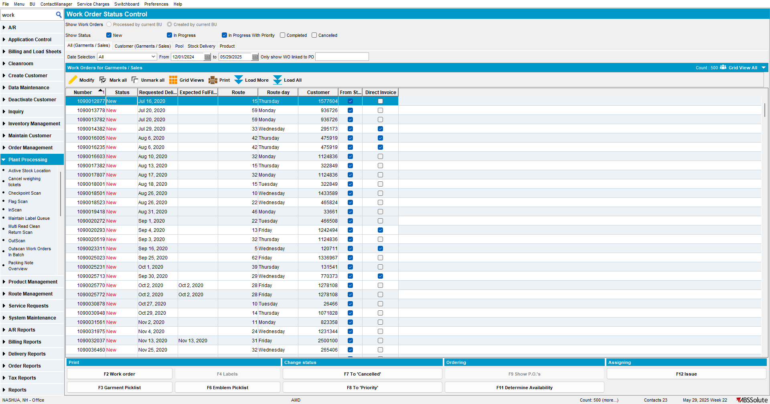

Step 2) On the All (Garments)/ Sales press the Load All button
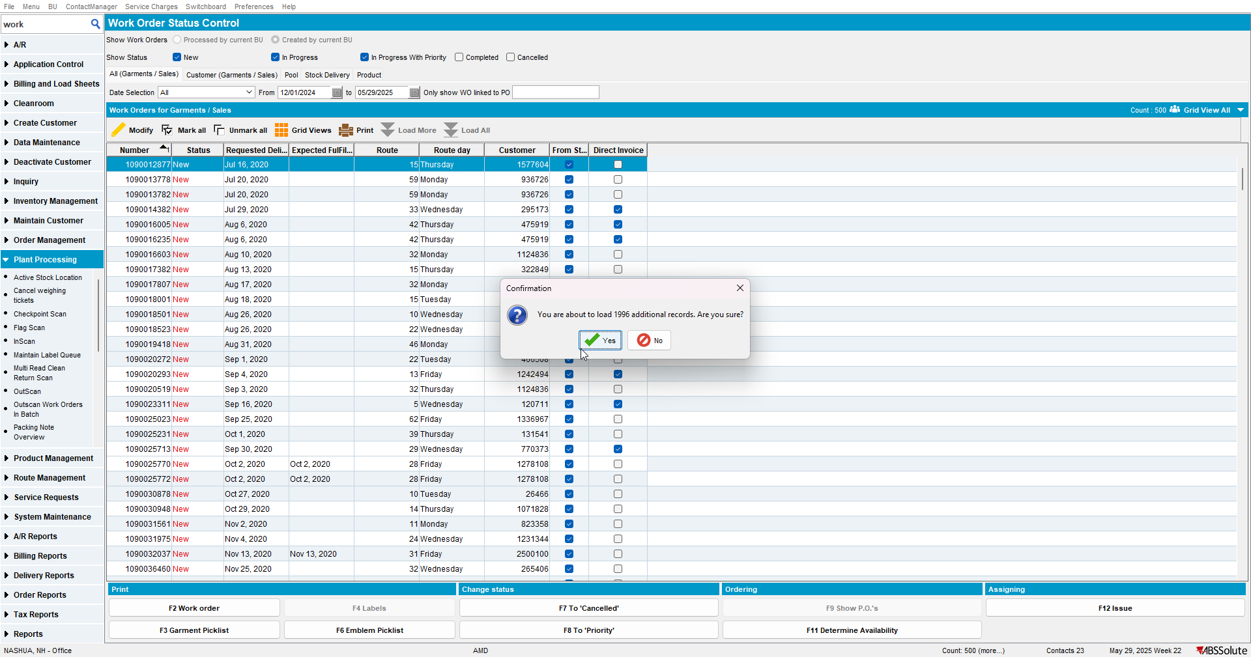
Step 3) Out of Memory is displayed when no more memory to load records is available
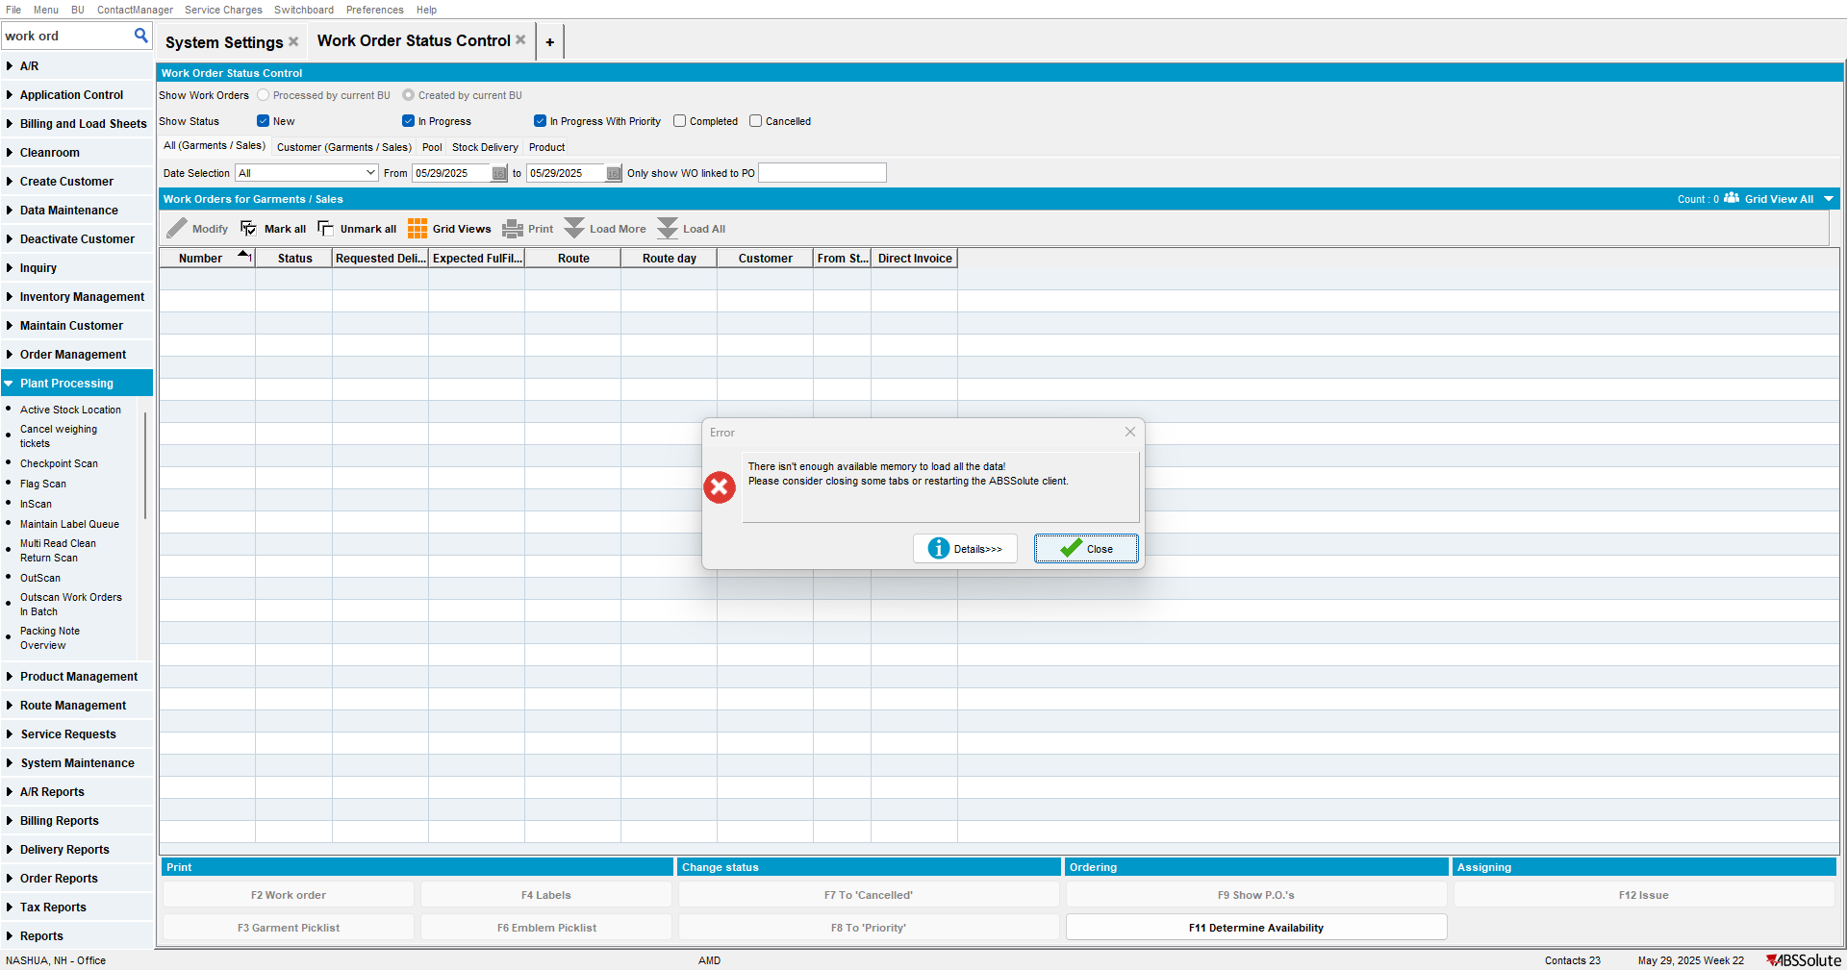
TEST OK

Test Case 2: Route Status Control displays Out of Memory Error
Step 1) Open Route Status Control
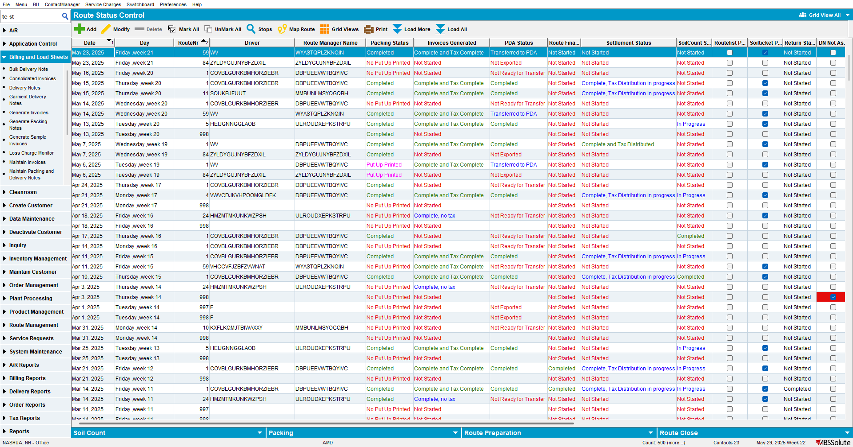
Step 2) Press the Load All button
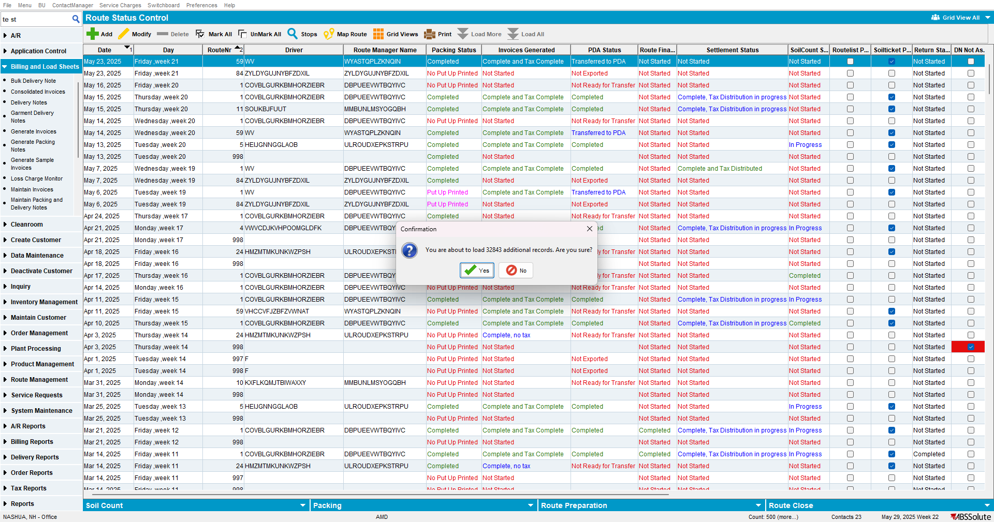

Step 3) Out of Memory is displayed when no more memory to load records is available
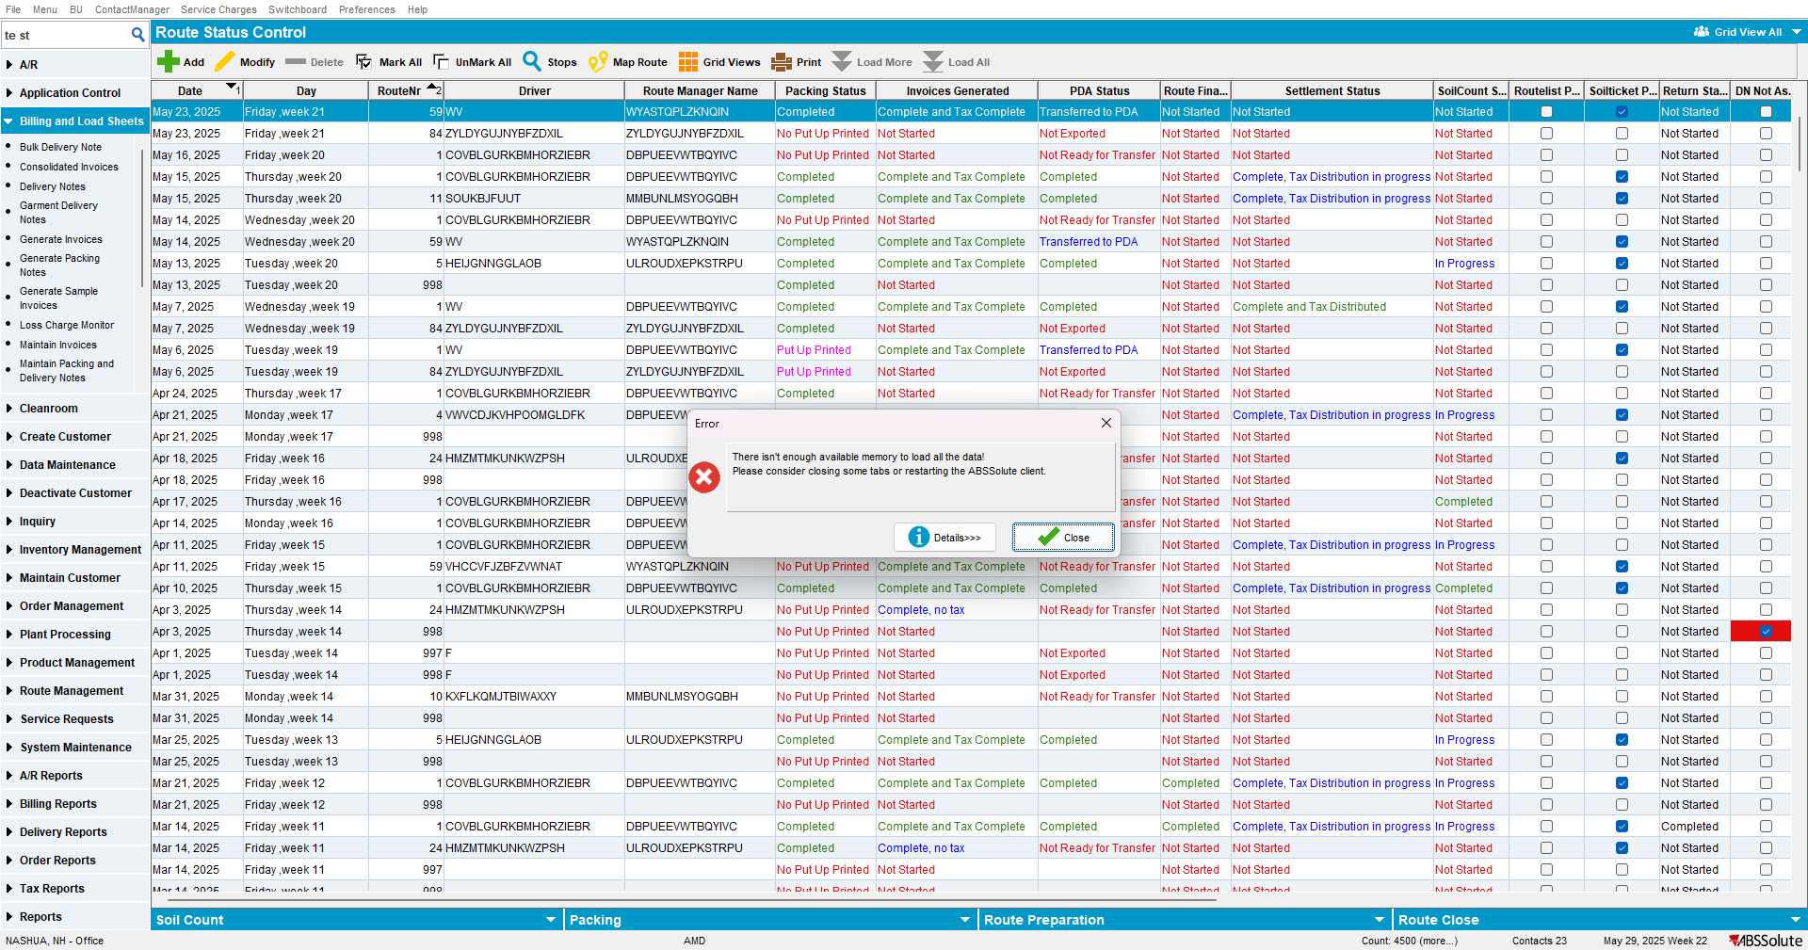
TEST OK

Test Case 3: Work Order Status Control displays Out of Memory Error but memory is freed when the tab is closed
Step 1) Open Activities per Customer dialog and load a customer
Step 2) Open the Work Order Status Control in the second tab and
Step 3) On the All (Garments)/ Sales press the Load All button
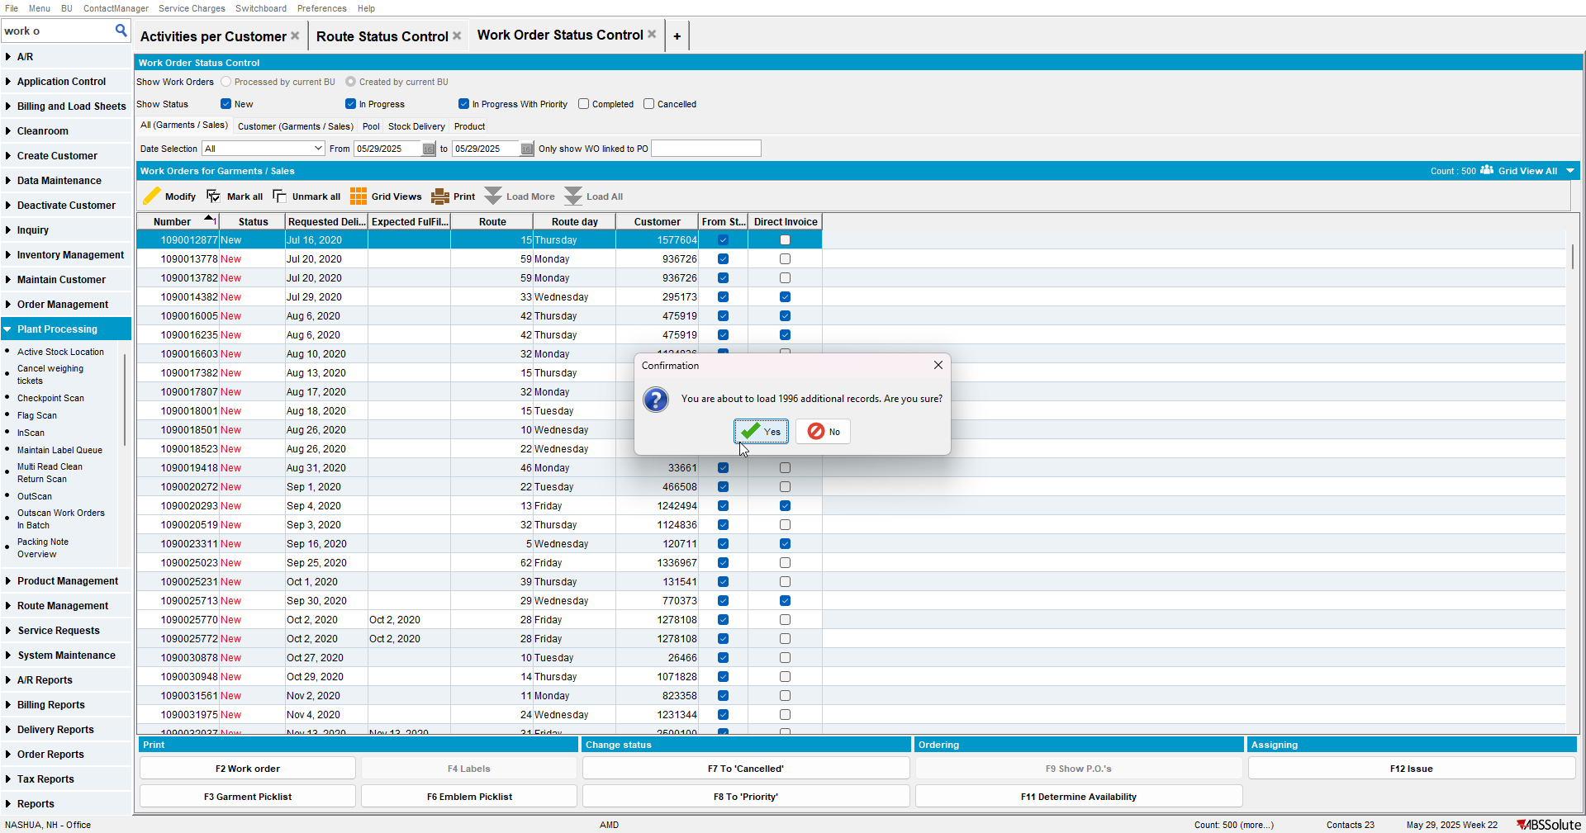
Step 4) Out of Memory is displayed when no more memory to load records is available
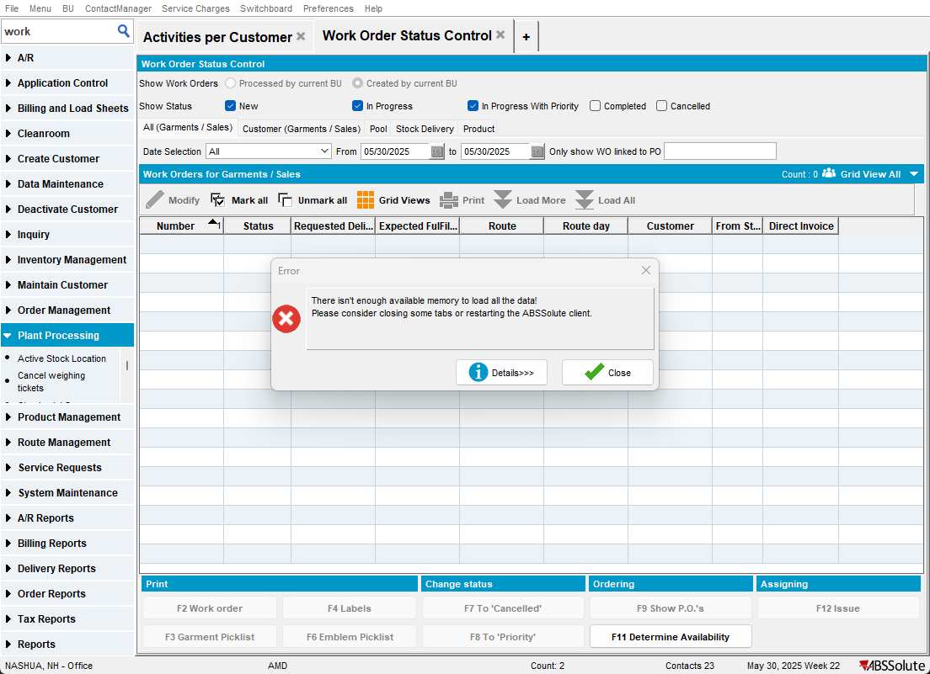
Step 5) Close the error by pressing Close and then the tab with the dialog
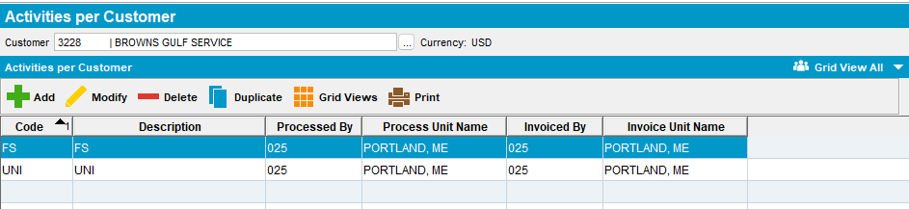
Step 6) The heap dumps which were already 5, removed the oldest and replaced it with the newest one
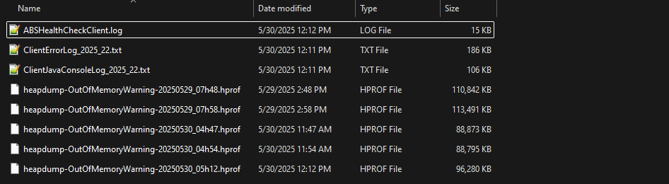

Step 7) Open Route Status Control in a second tab
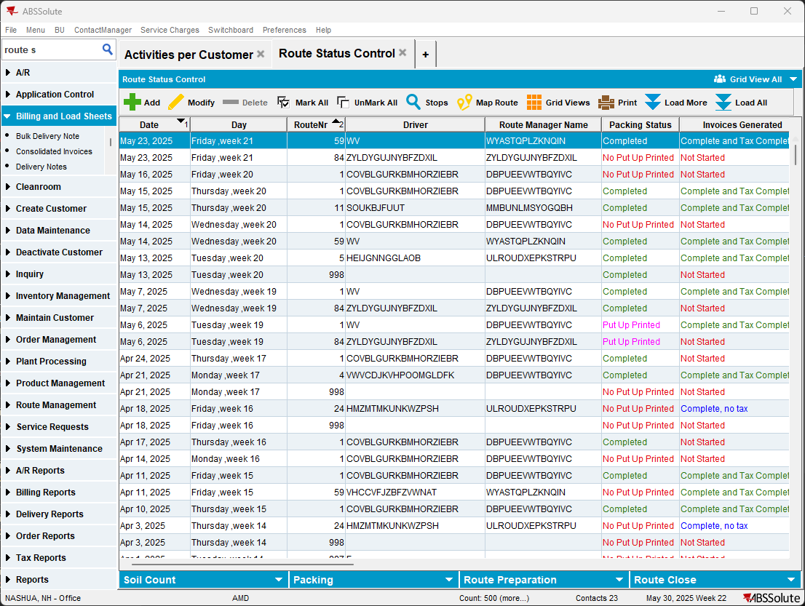
TEST OK

Test Case 4: Workstation Settings load all Workstations from all Business Unites
Step 1) Open the Workstation Settings dialog
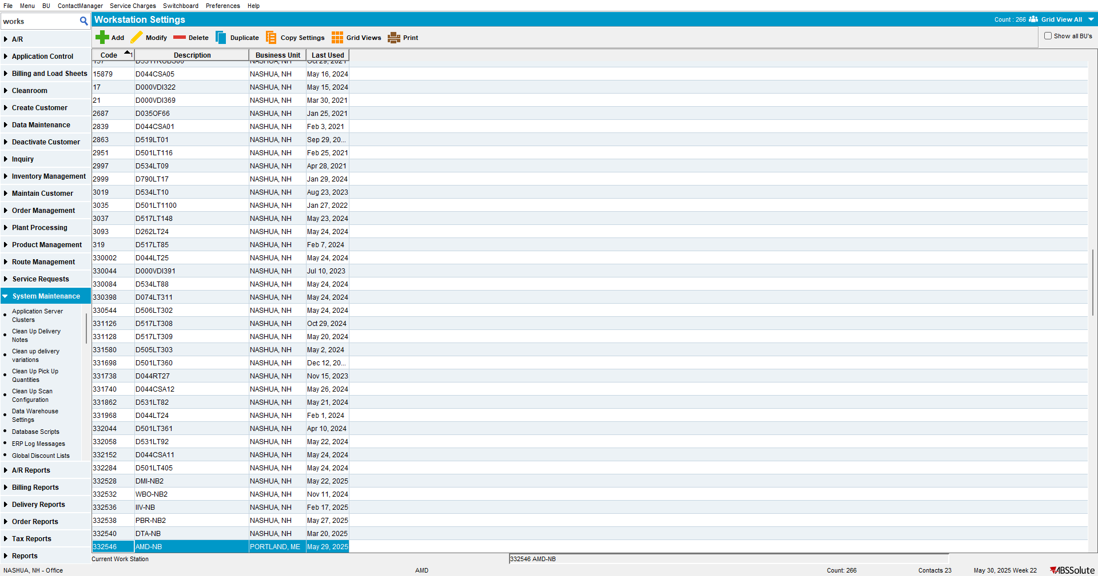
Step 2) Check the Show all BU’s checkbox
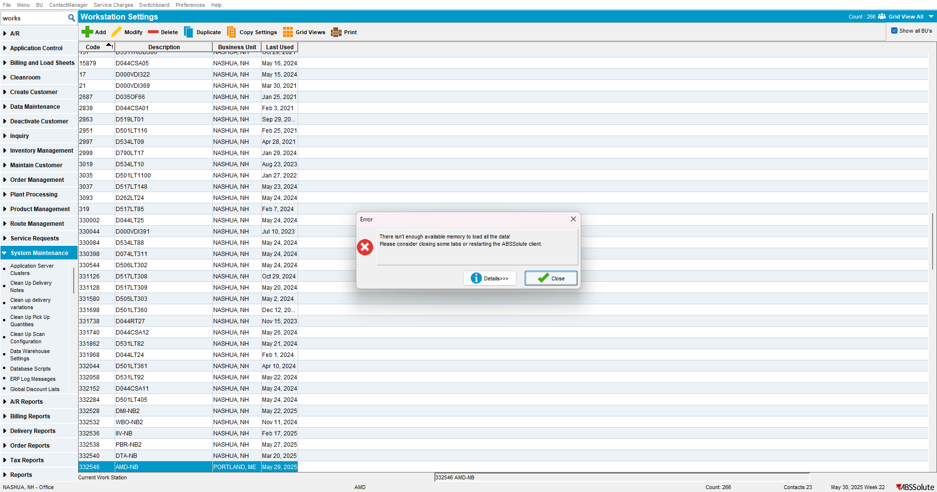
TEST OK

Test Set II: Out of Memory Error is not displayed

Test Case 1: Customer Switchboard Load All Customers
Step 1) Open the Switchboard
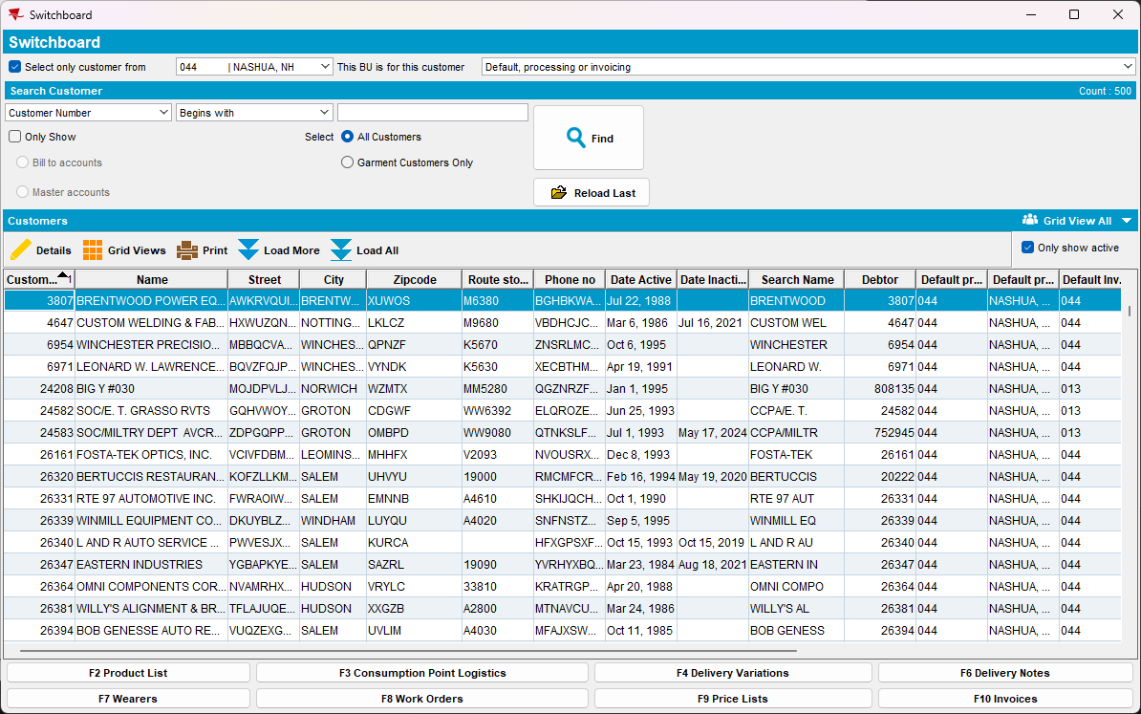
Step 2) Uncheck the only active customers to be shown checkbox and press Load All
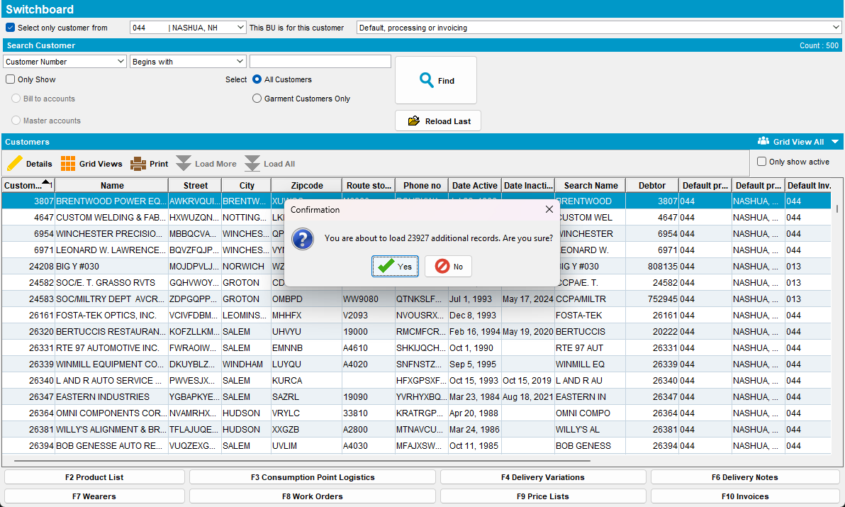
Step 3) All records are loaded and no error is displayed
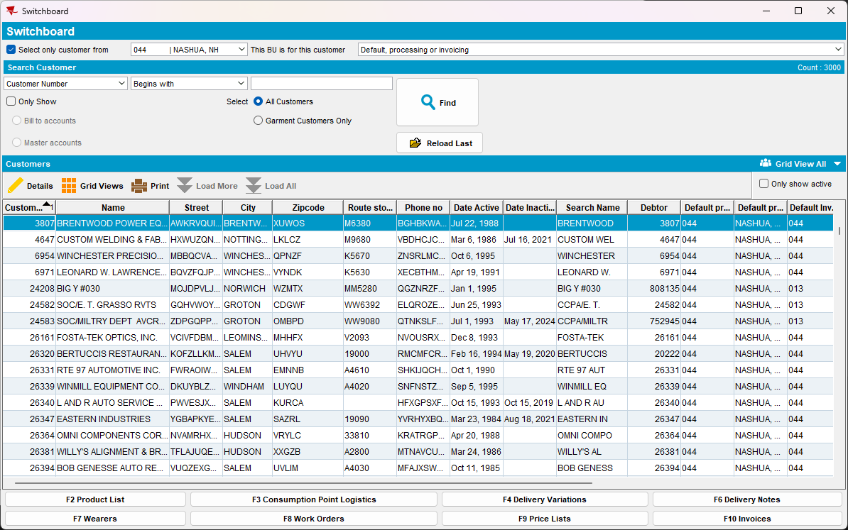
TEST OK

