ABSN-10409 D_UBS_2294 Unable to generate invoice - Null
Environment | Prerequisites
Version: 9.07.00.UNF20
DBServerName= abs-srv20.internal.abslbs.com
DBSID= CUST24
DBUser= UNFDEV
DBPassword= UNFDEV
Environment=Production

Contents
Retest after fix 1
Version: 9.07.00.UNF20 hash: 3700d8afc910 1
BU/Plant: 025 | PORTLAND, ME 1

Retest after fix

Version: 9.07.00.UNF20 hash: 3700d8afc910

BU/Plant: 025 | PORTLAND, ME

Step 1: Select a customer with sizedefinition NULL.
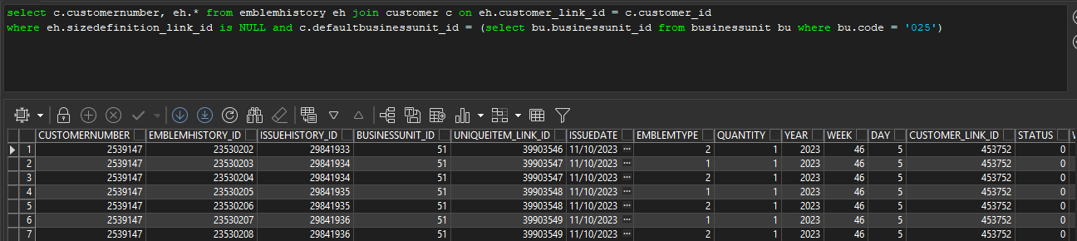

Step 2: Go to “Contracts” dialog, select the previously mentioned customer’s contract and go to “Components” tab then press “Modify” and “Load” button.
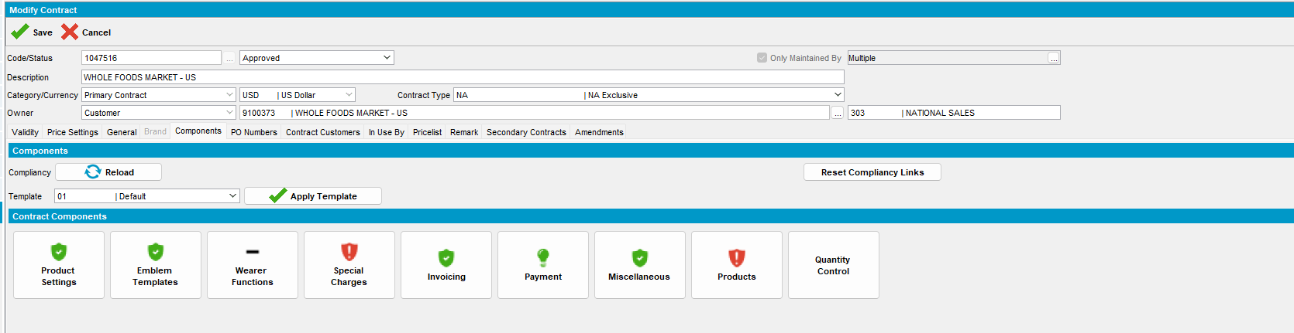

Step 3: Open “Products”, select a product and press “Modify” button then go to Billing -> Budget Protection and make sure that you have Garment Emblem Protection checked and an active price for it. 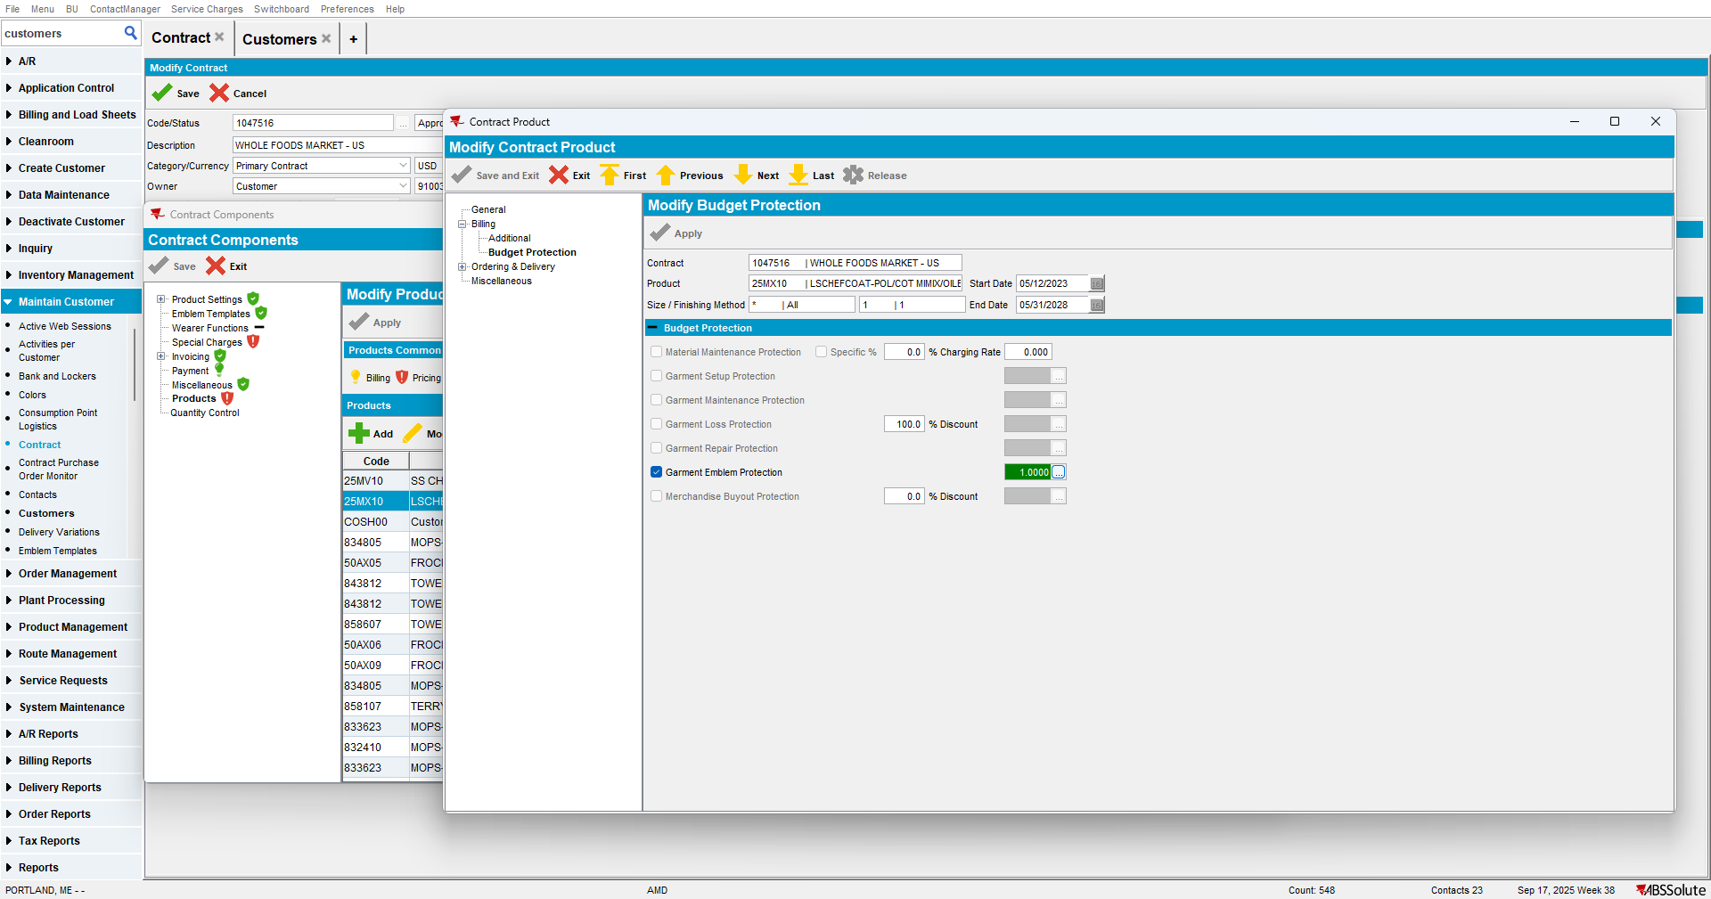

Step 4: Open “Route Status Control” dialog and generate invoices.
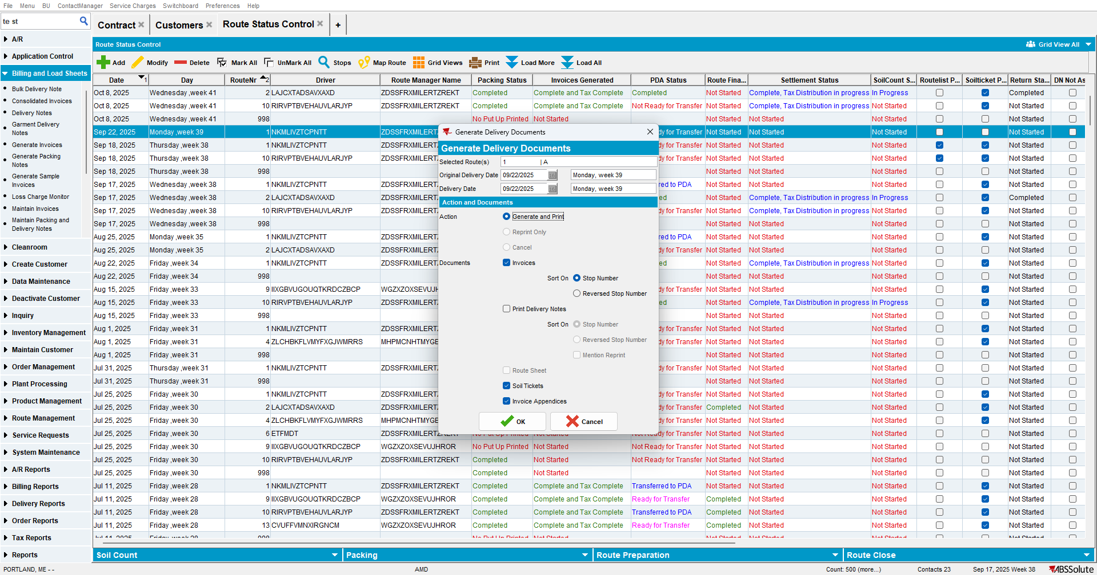

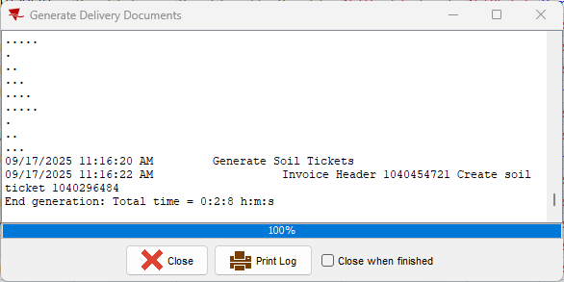
Expected behavior: The invoice should be created.
Actual behavior: The invoice was created.
TESTED OK.

