ABSN-10010 Customer billing tab - Invoice contact person not saved, direct invoicing
Environment | Prerequisites
Version:9.07.00  DBServerName=abs-SRV20.internal.abslbs.com  DBSID=CUST24  DBUser=UNFDEV  Environment=Test | - Module:  - System setting

Contents
Retest after fix 1
Test Case 1 – SS MULTIPLEINVANDSTMCONTACTS=0 and customer is its own bill to – Tested OK 1
Test Case 2 – SS MULTIPLEINVANDSTMCONTACTS=0 and customer has a different customer as its bill to – Tested OK 6
Test Case 3 – SS MULTIPLEINVANDSTMCONTACTS=1 and customer is its own bill to – Tested OK 14
Test Case 4 – SS MULTIPLEINVANDSTMCONTACTS=1 and customer has a different customer as its bill to – Tested OK 20

Retest after fix

Test Case 1 – SS MULTIPLEINVANDSTMCONTACTS=0 and customer is its own bill to – Tested OK
Expected behavior: The changes on contacts should save
Hash: ff9c238
- Check that SS MULTIPLEINVANDSTMCONTACTS=0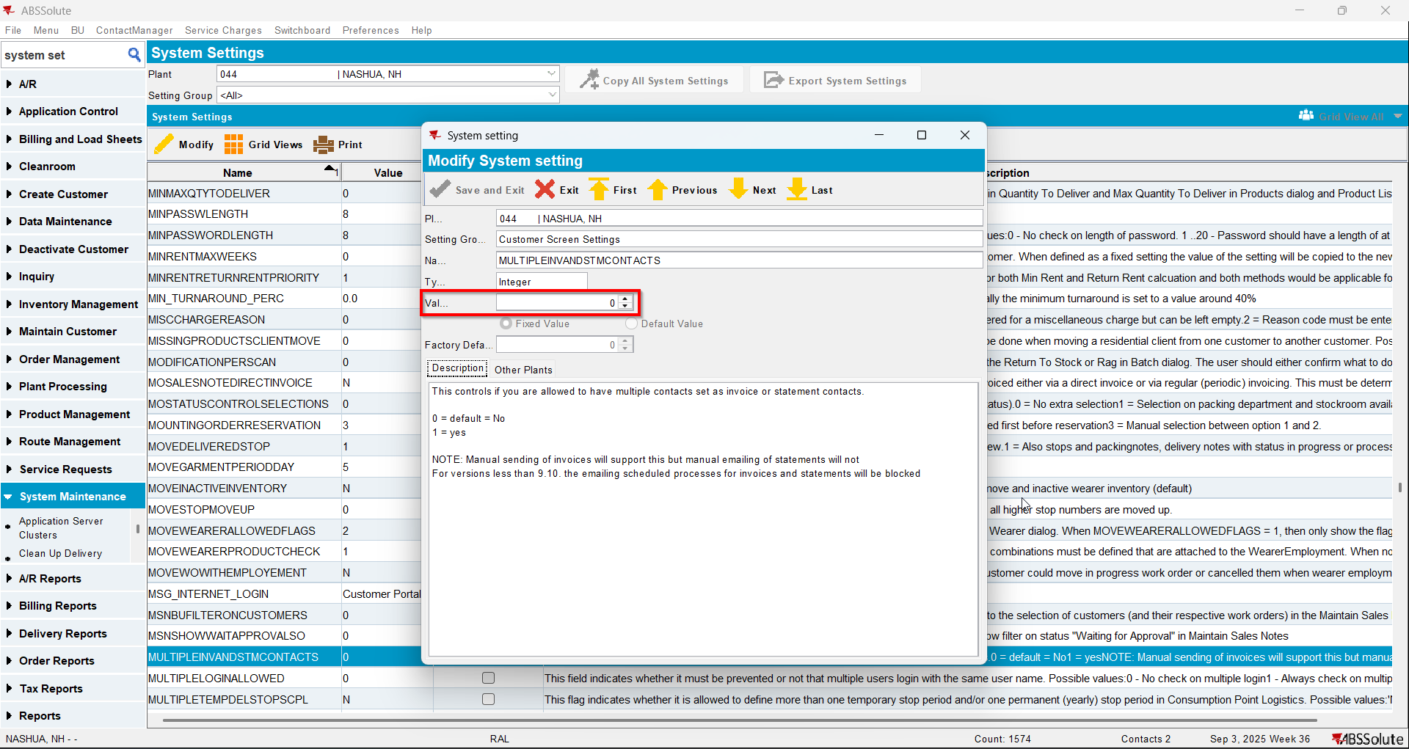
- Have a customer that is its own bill to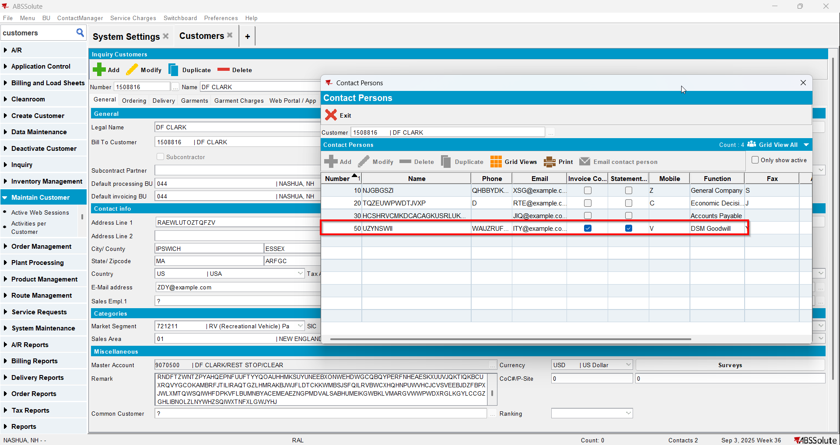
- Make another contact person to be to invoice contact and statement contact from general tab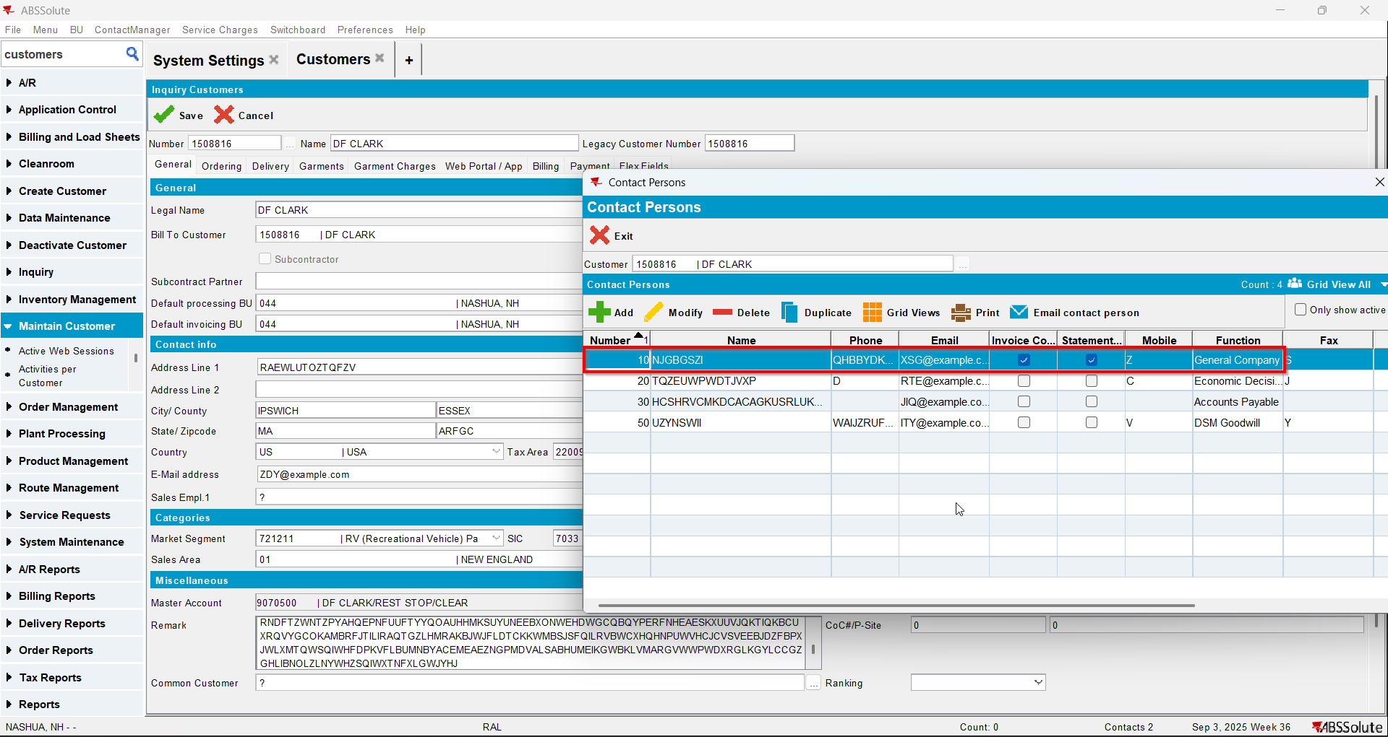
- Save and reload the customer
- Check that the change is saved on the general tab and on billing tab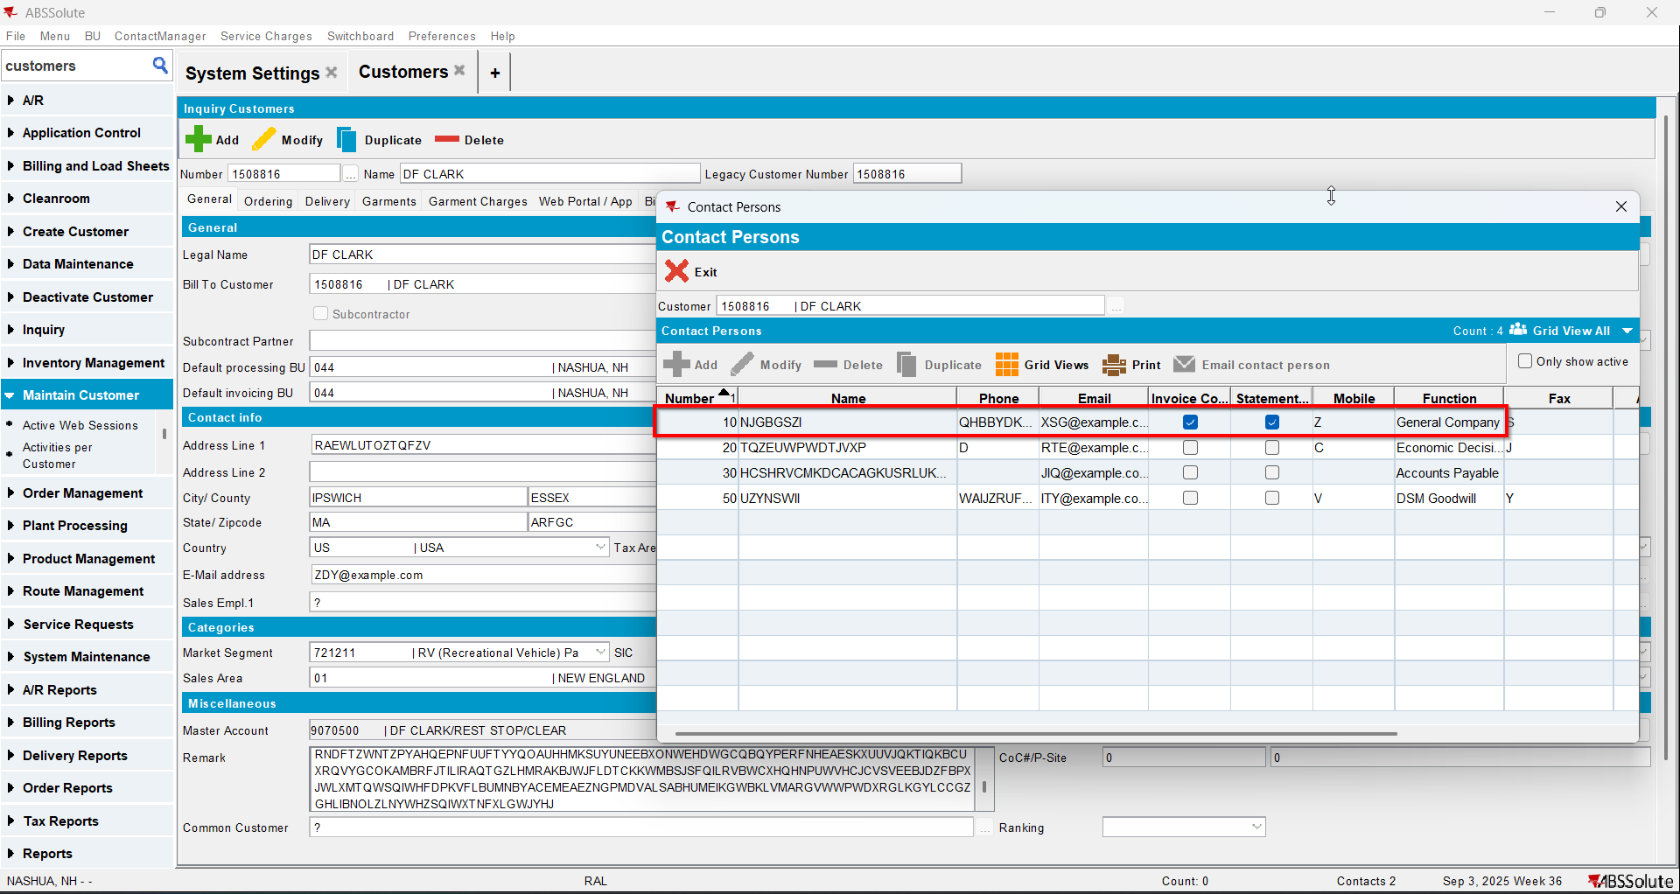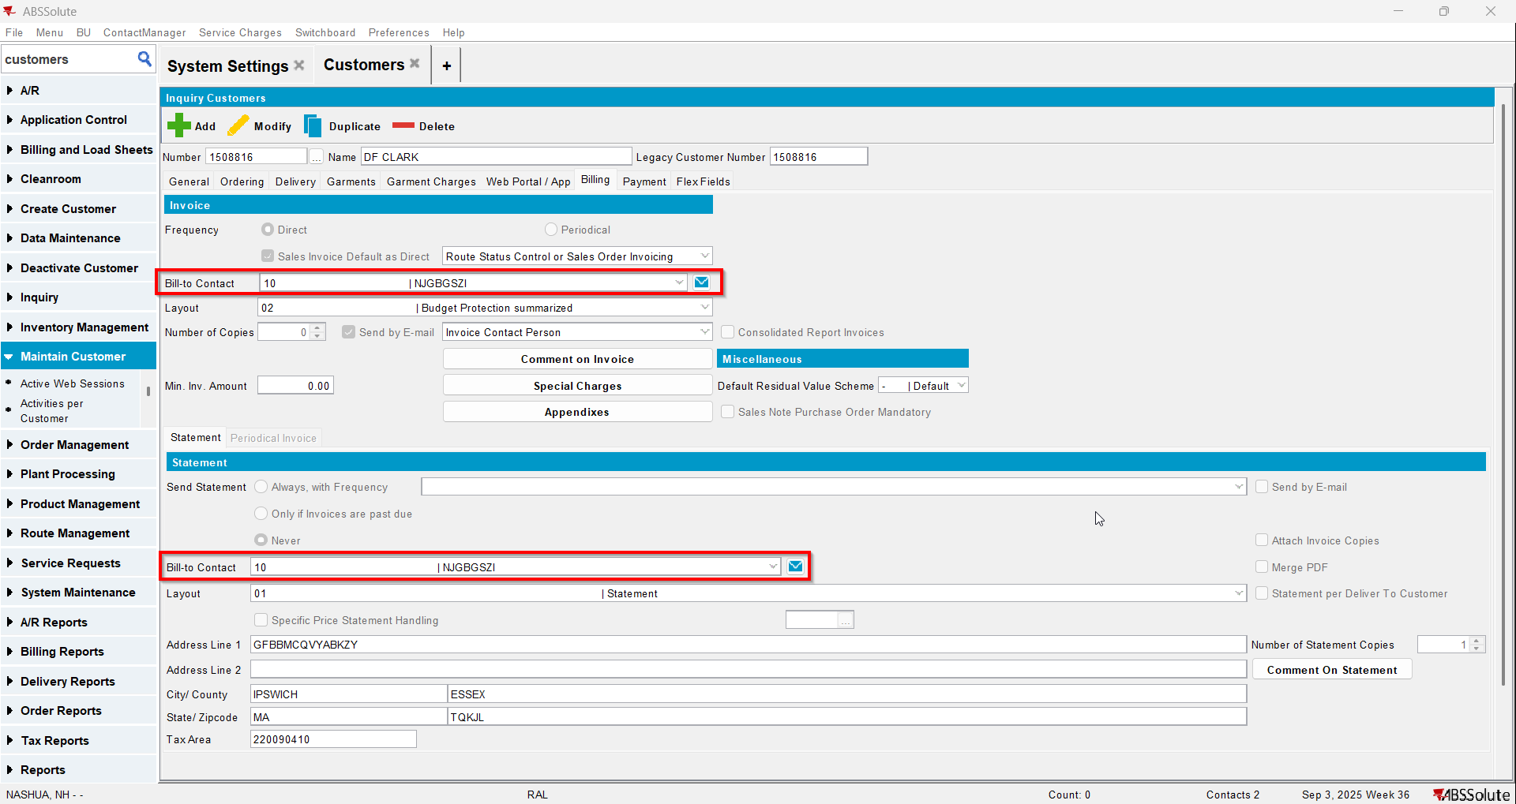
- Now make another contact person to be invoice contact and statement contact from billing tab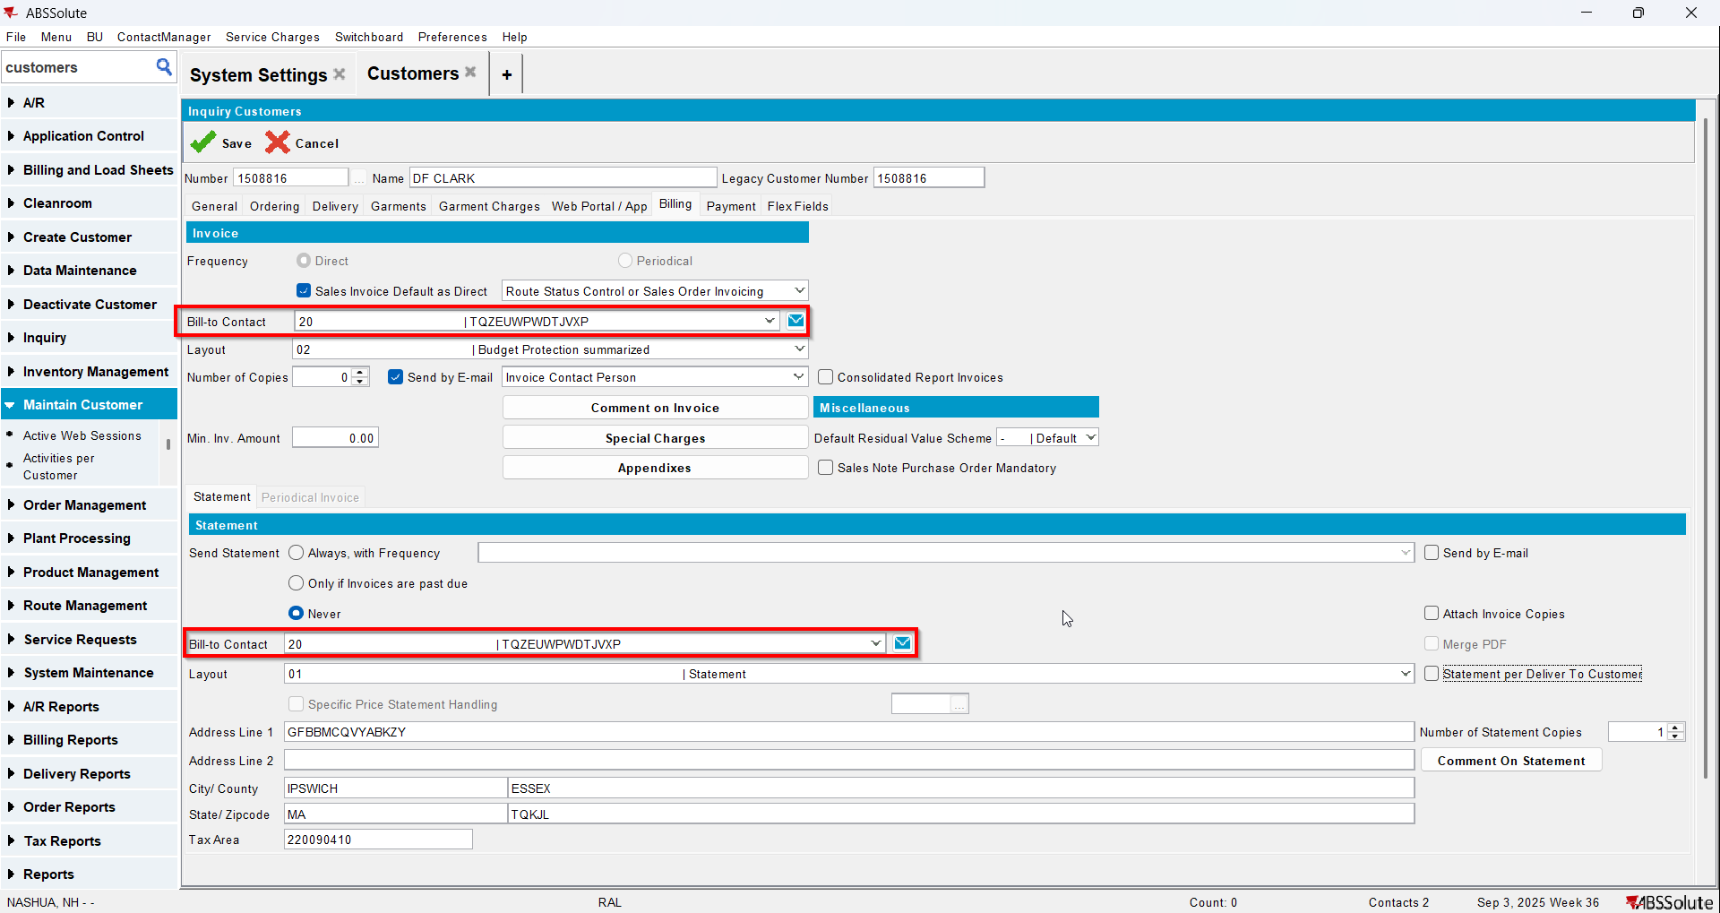
- Save and reload the customer
- Check that the change is saved on the general tab and on billing tab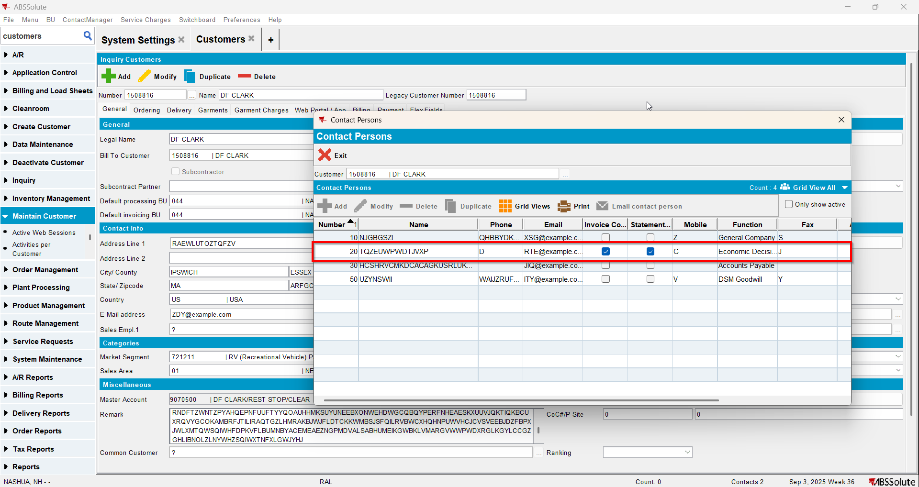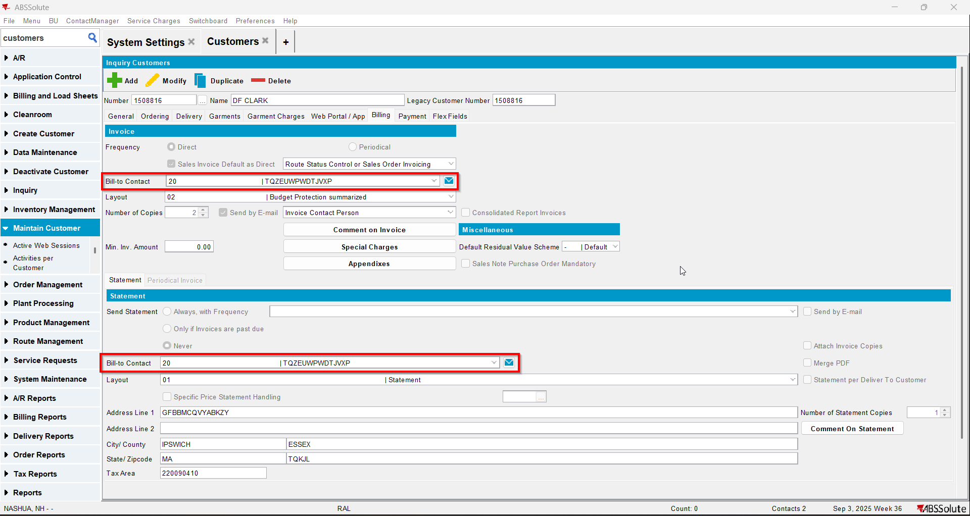

Test Case 2 – SS MULTIPLEINVANDSTMCONTACTS=0 and customer has a different customer as its bill to – Tested OK
Expected behavior: The changes on contacts should save
Hash: ff9c238
- Check that SS MULTIPLEINVANDSTMCONTACTS=0
- Have a customer that has a different customer as its bill to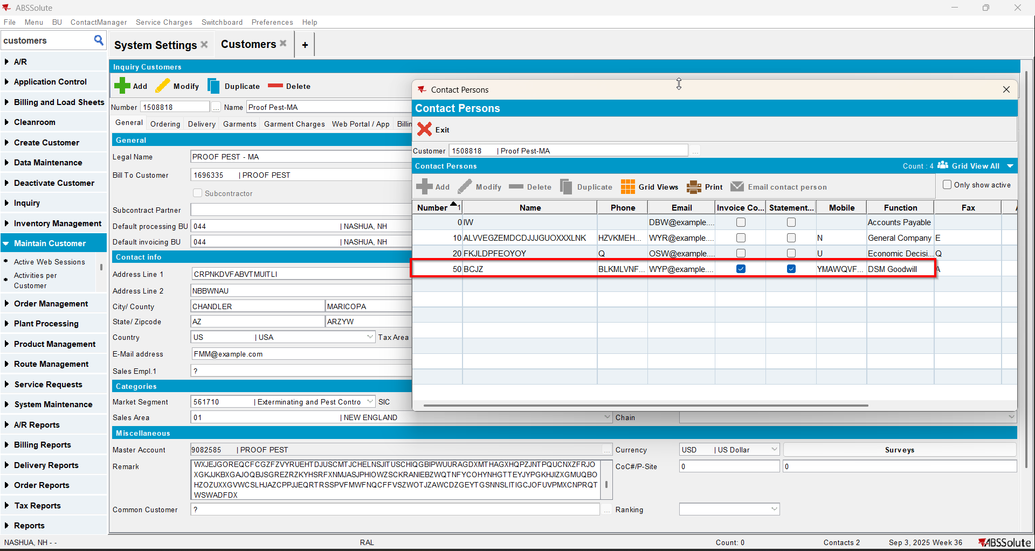
- Make another contact person to be to invoice contact and statement contact from general tab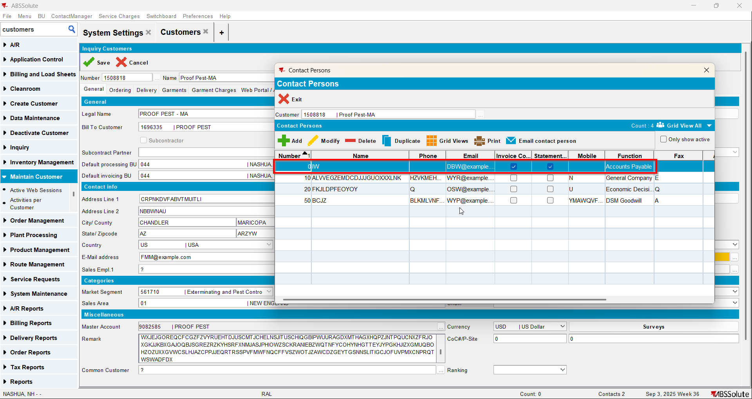
- Save and reload the customer
- Check that the change is saved on the general tab and on billing tab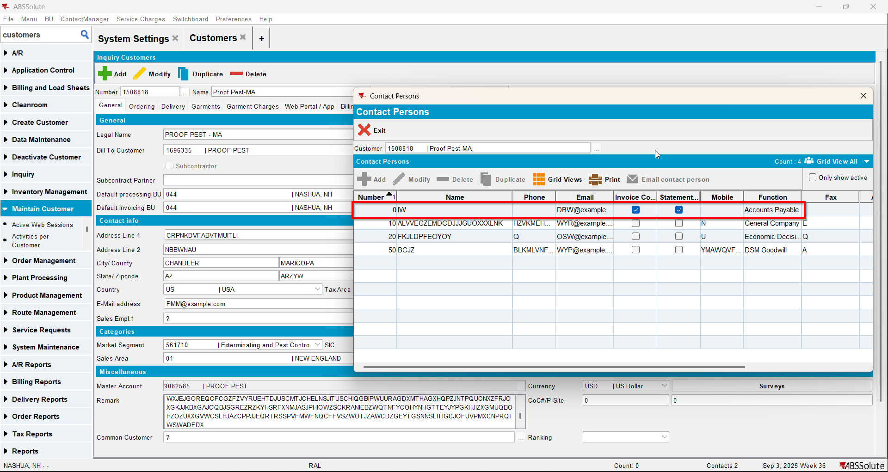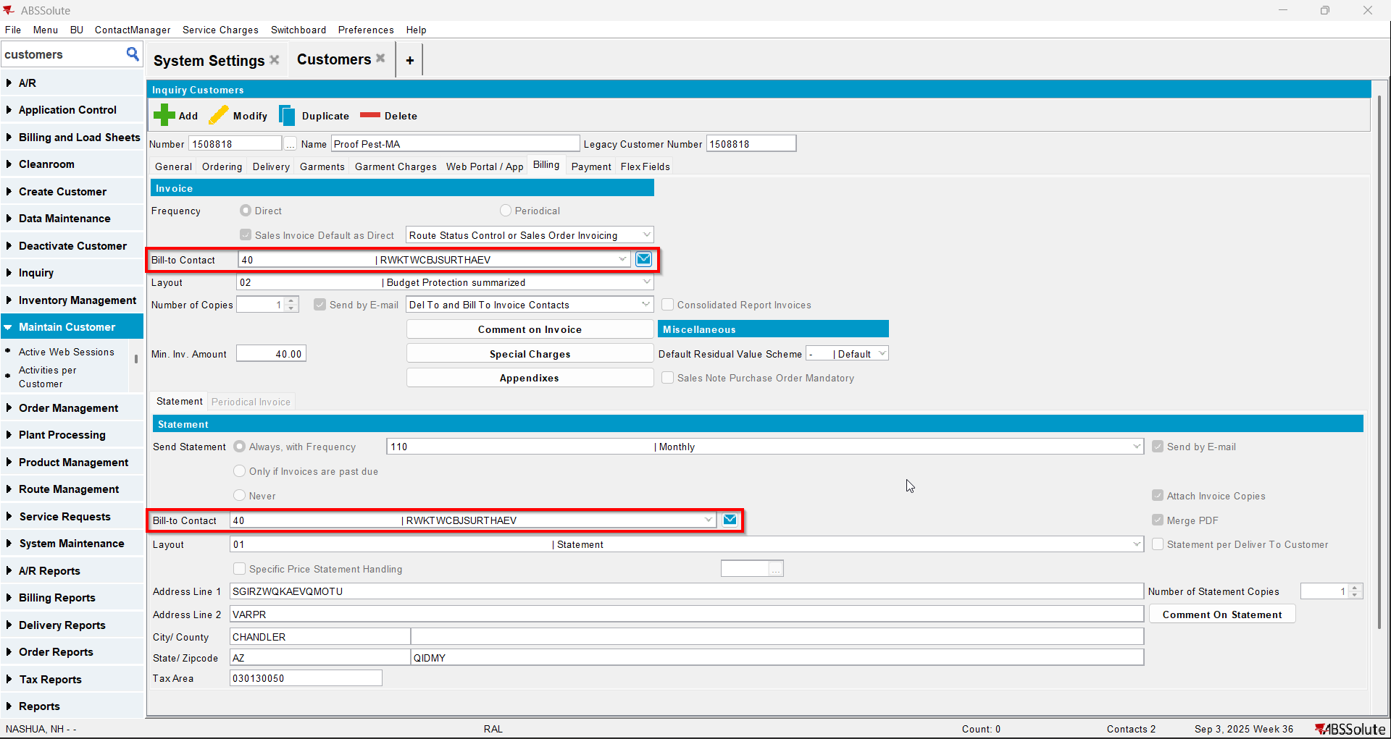
- Load your bill to customer
- Make another contact person to be to invoice contact and statement contact from general tab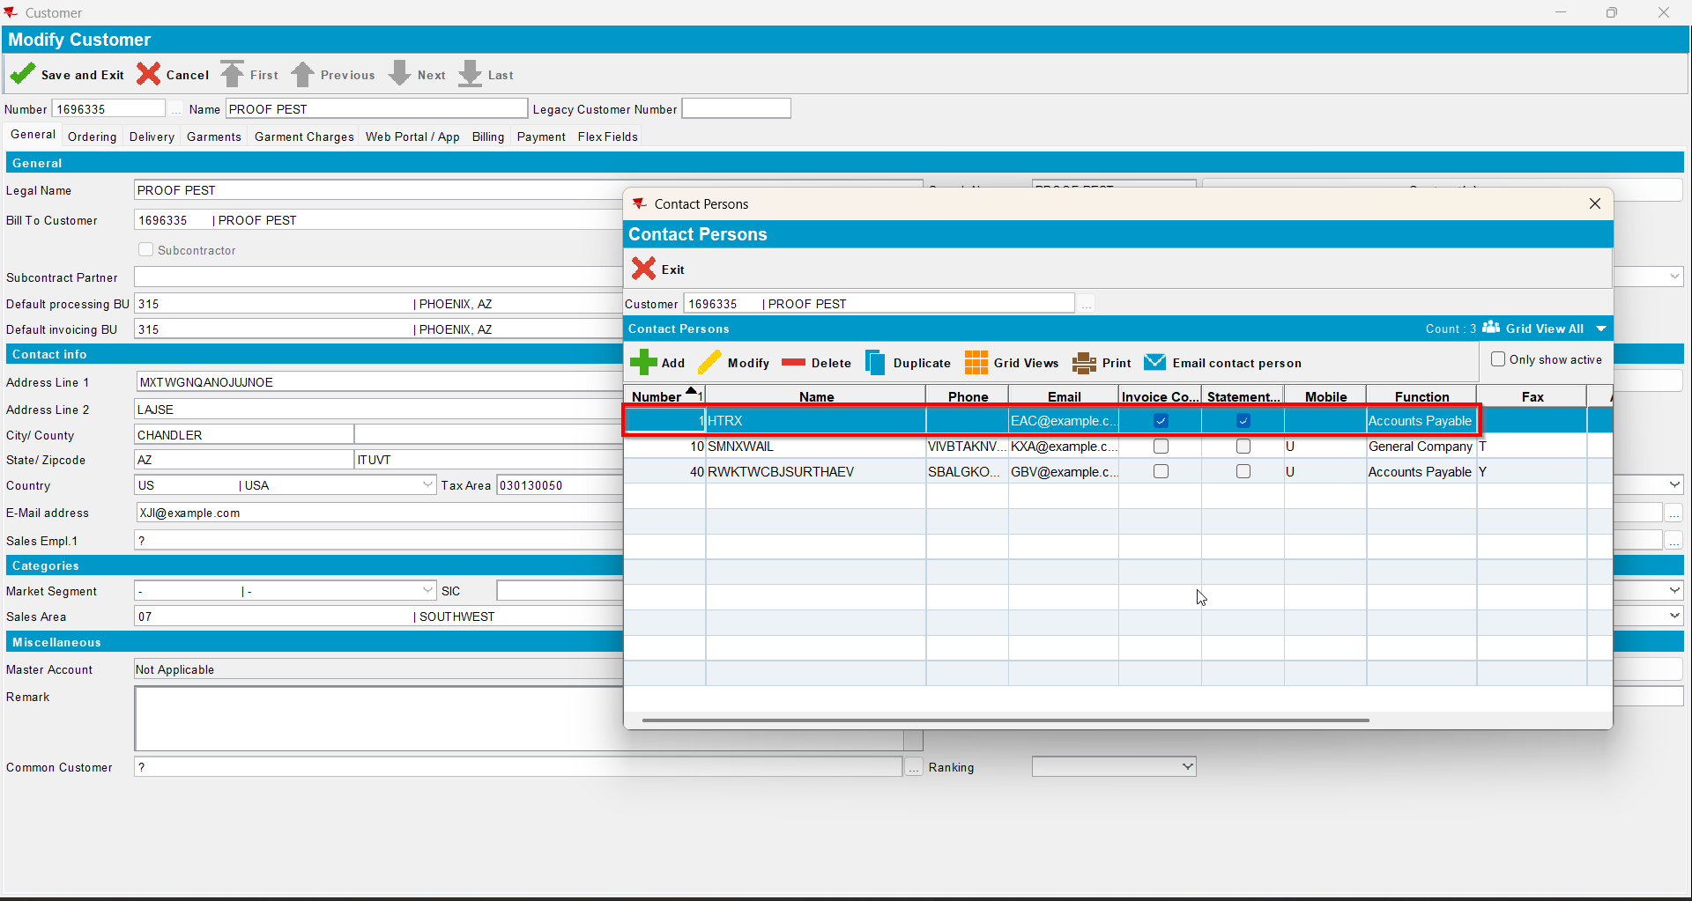
- Save and reload the customer
- Check that the change is saved on the general tab and on billing tab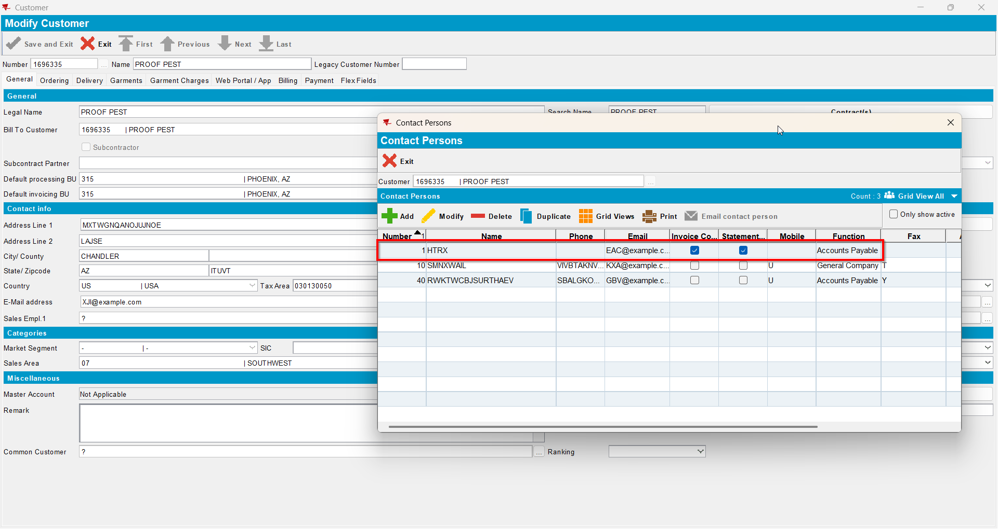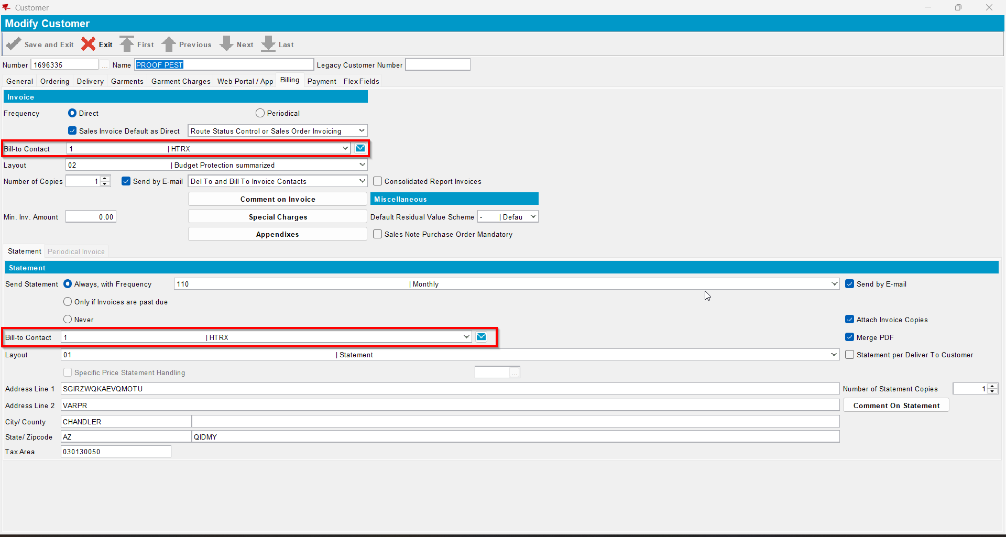
- Check it also saved on billing tab on the del to customer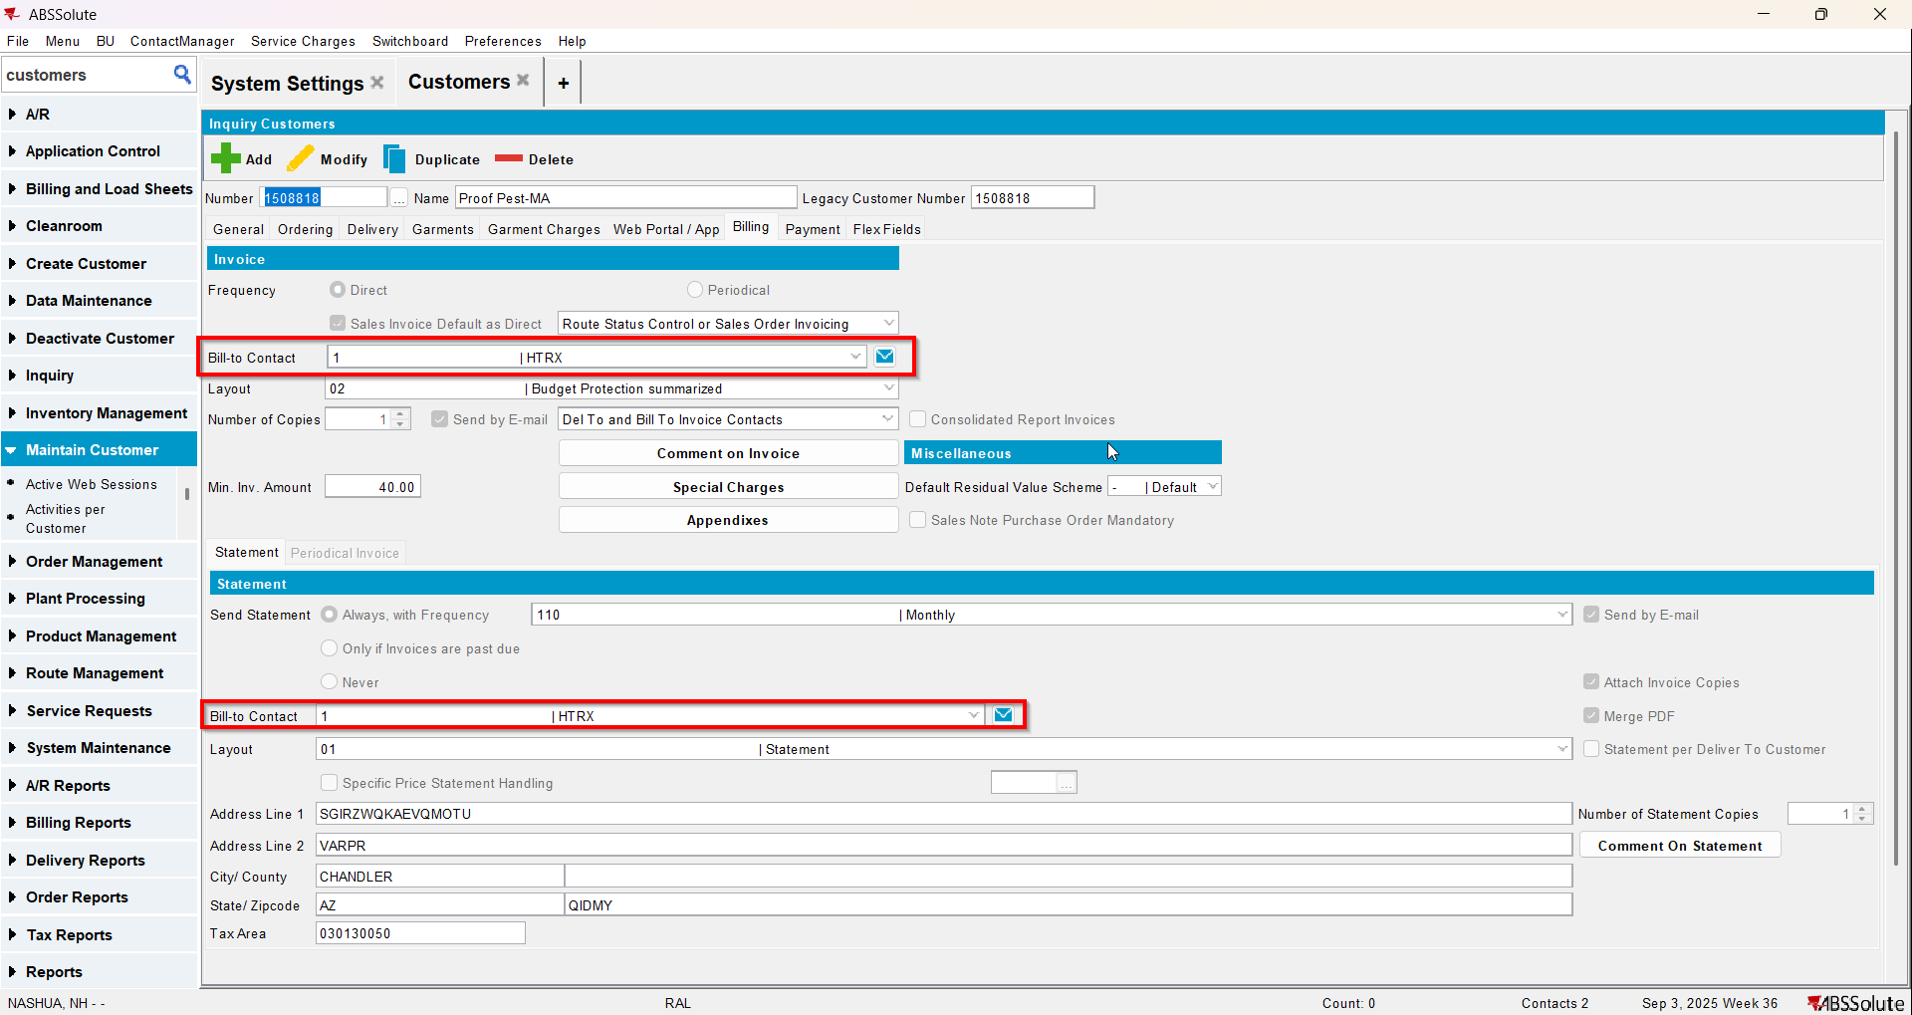
- Now make another contact person to be invoice contact and statement contact from billing tab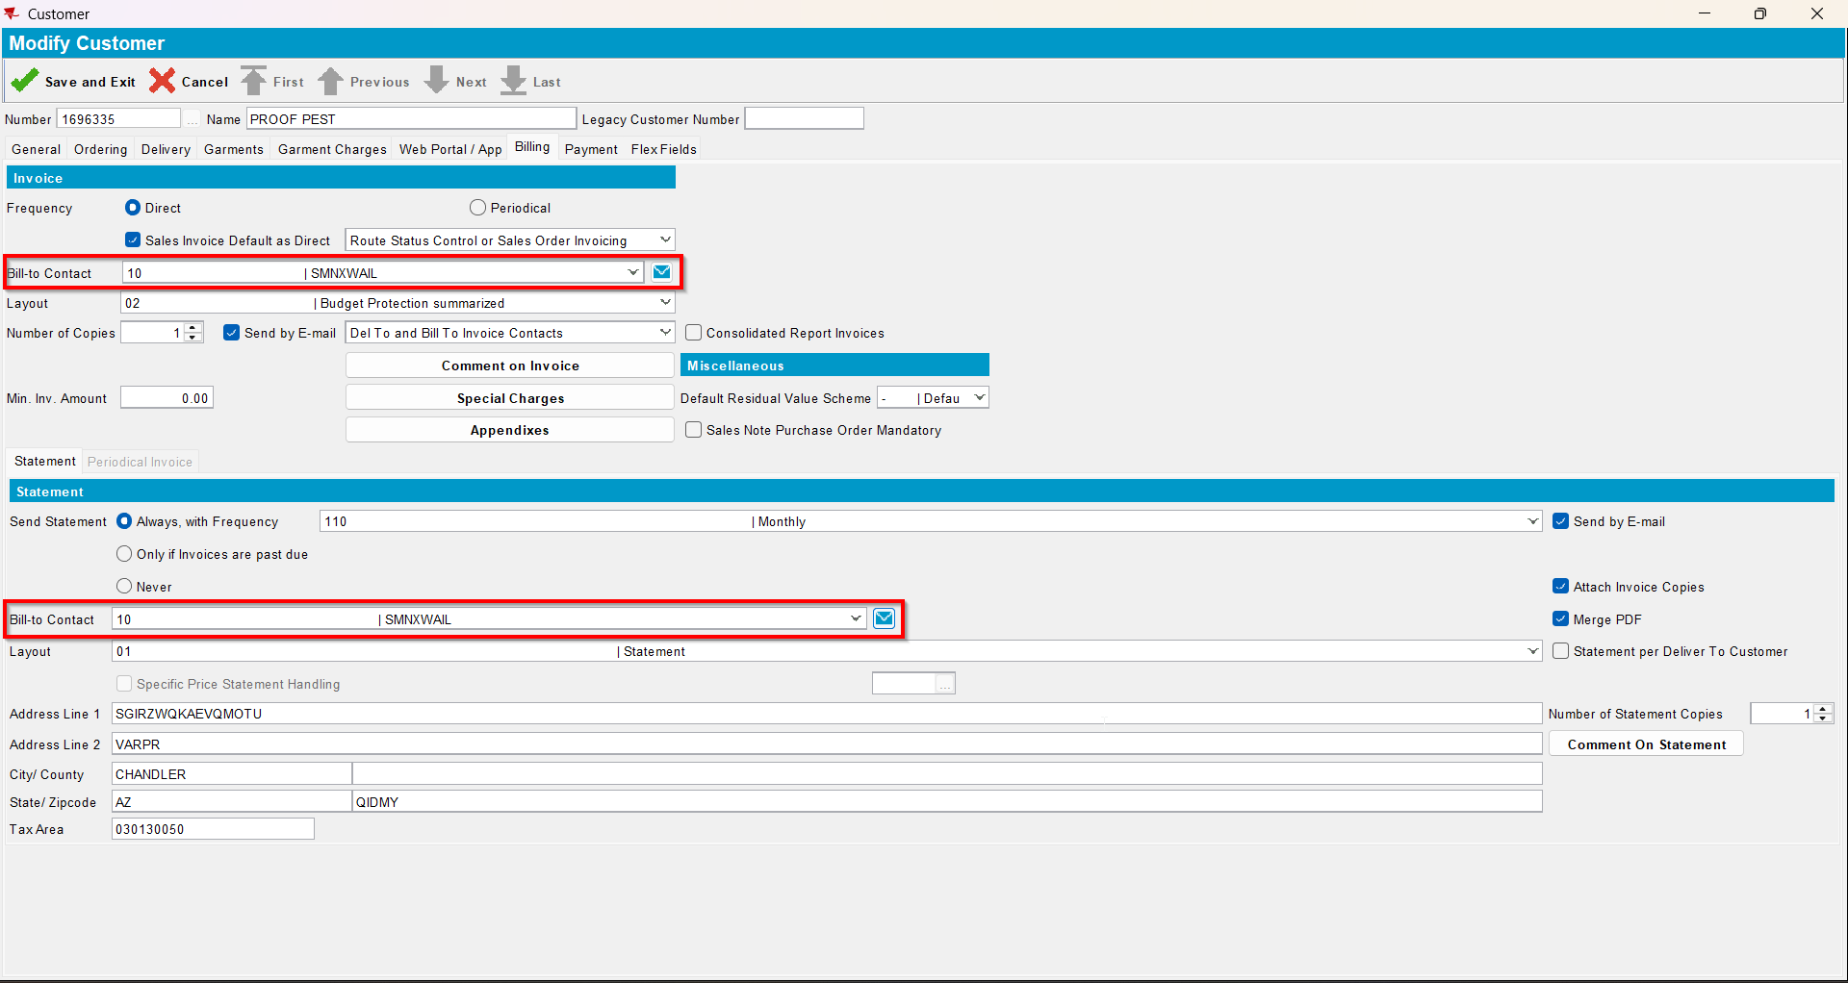
- Save and reload the customer
- Check that the change is saved on the general tab and on billing tab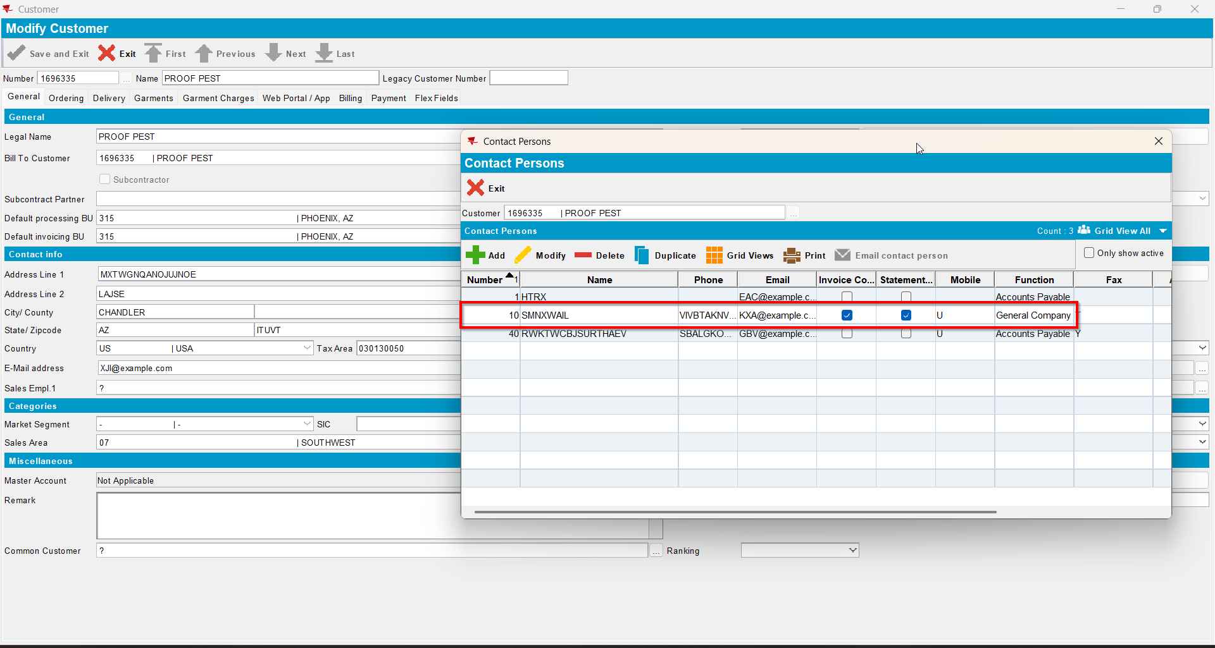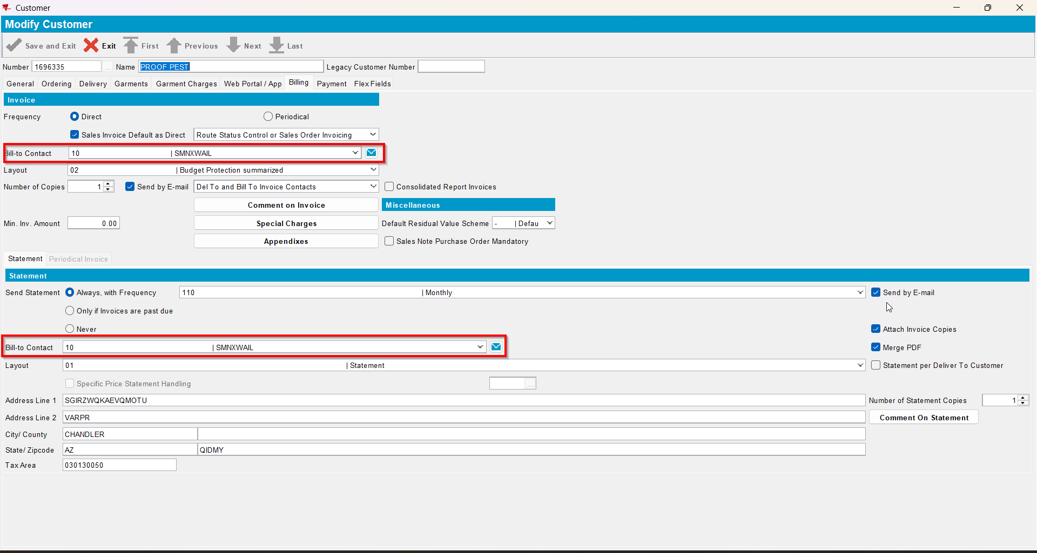
- Check it also saved on billing tab on the del to customer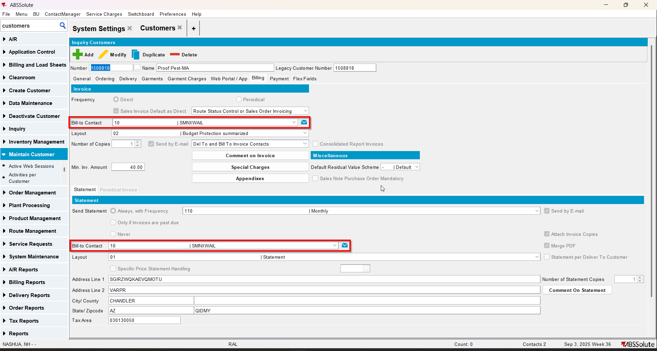

Test Case 3 – SS MULTIPLEINVANDSTMCONTACTS=1 and customer is its own bill to – Tested OK
Expected behavior: The changes on contacts should save
Hash: ff9c238
- Check that SS MULTIPLEINVANDSTMCONTACTS=1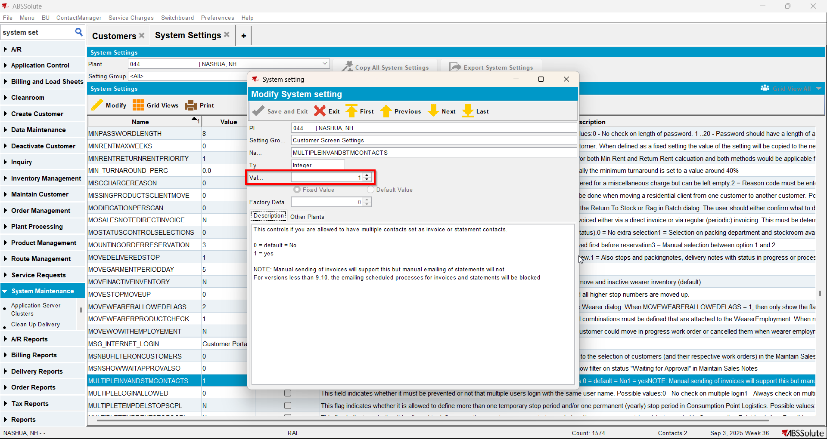
- Have a customer that is its own bill to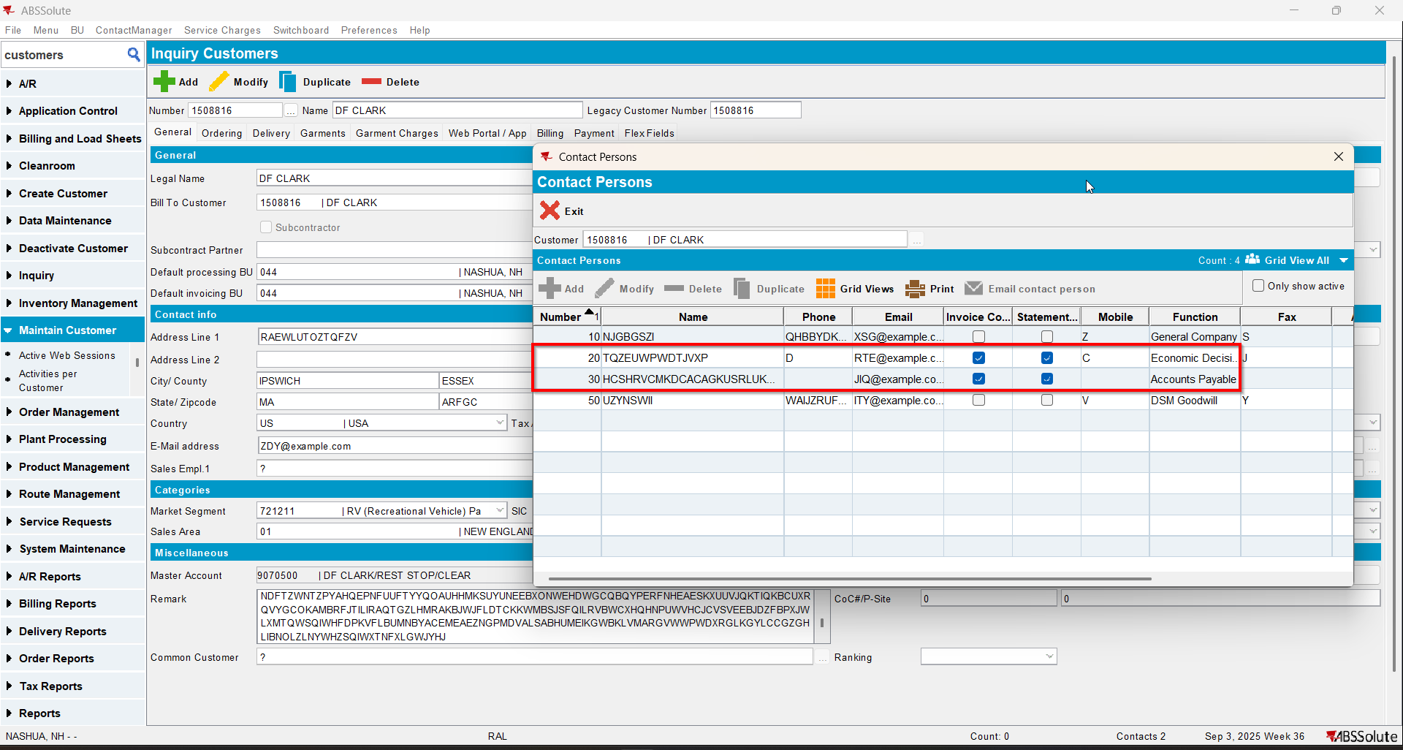
- Make another contact person to be to invoice contact and statement contact from general tab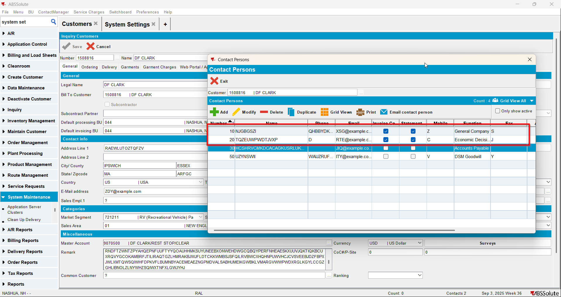
- Save and reload the customer
- Check that the change is saved on the general tab and on billing tab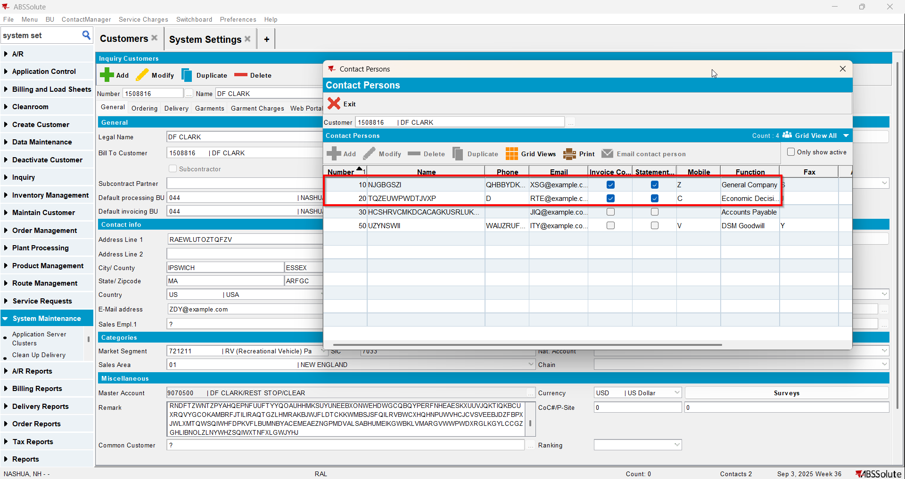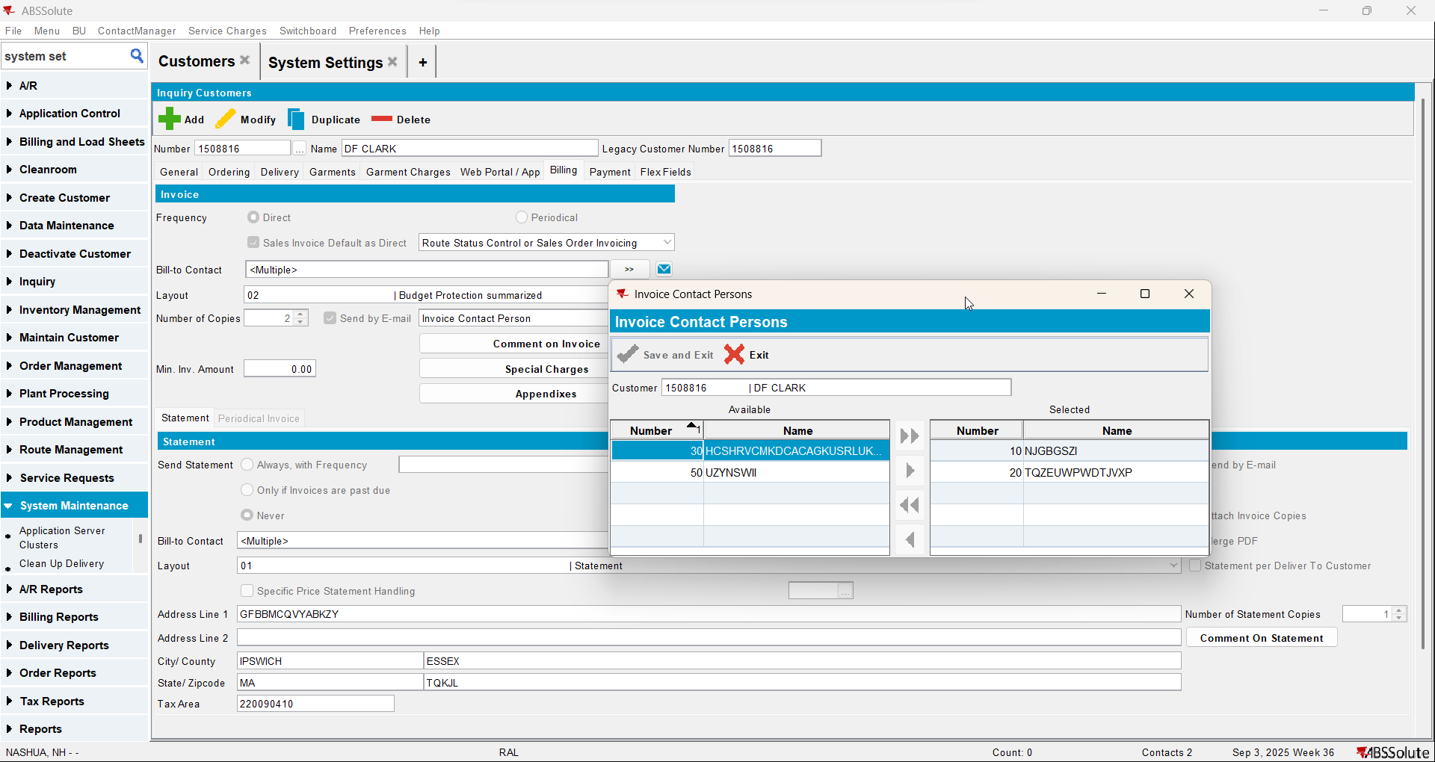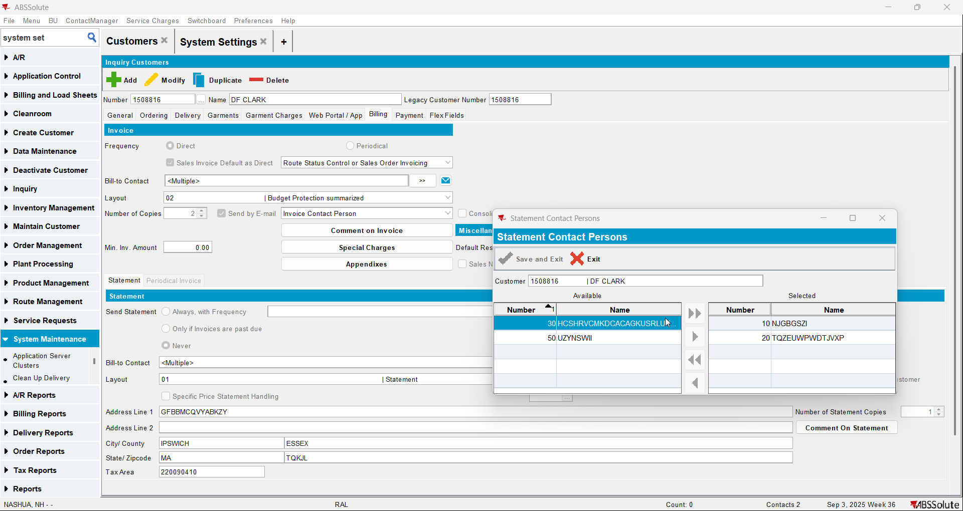
- Now make another contact person to be invoice contact and statement contact from billing tab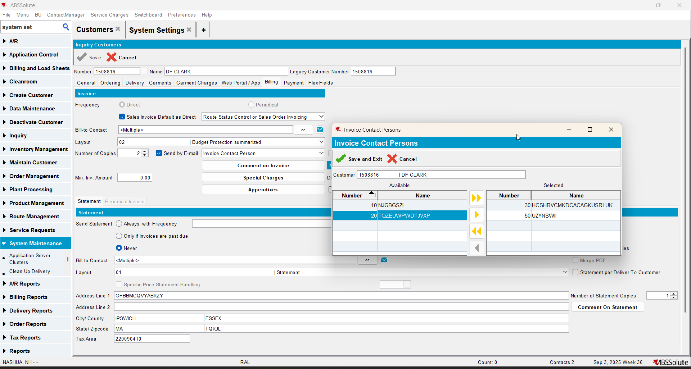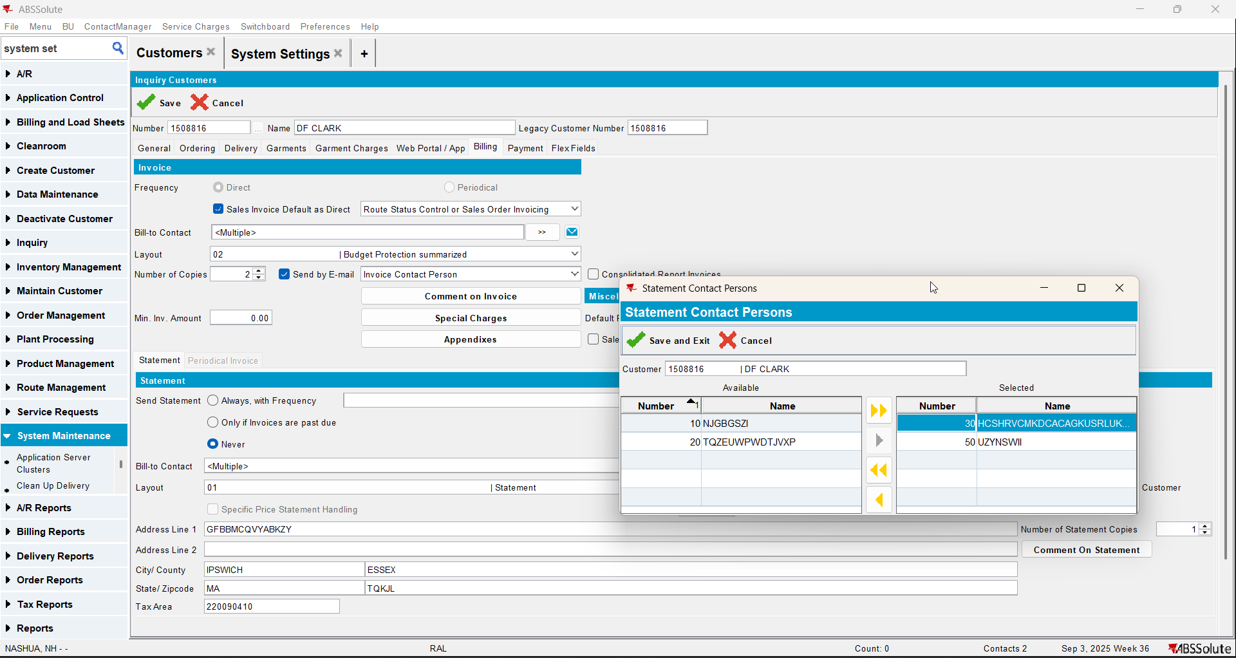
- Save and reload the customer
- Check that the change is saved on the general tab and on billing tab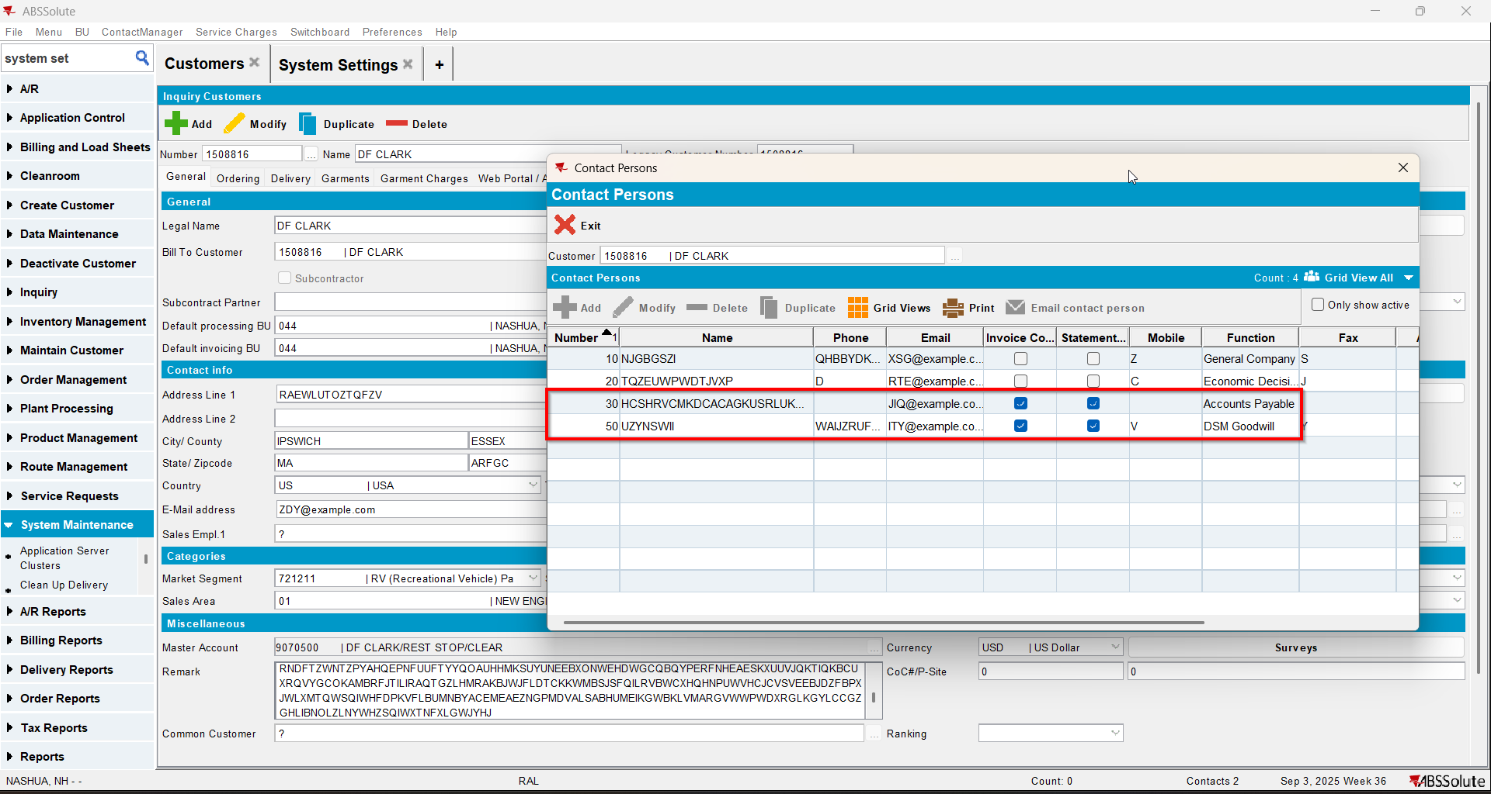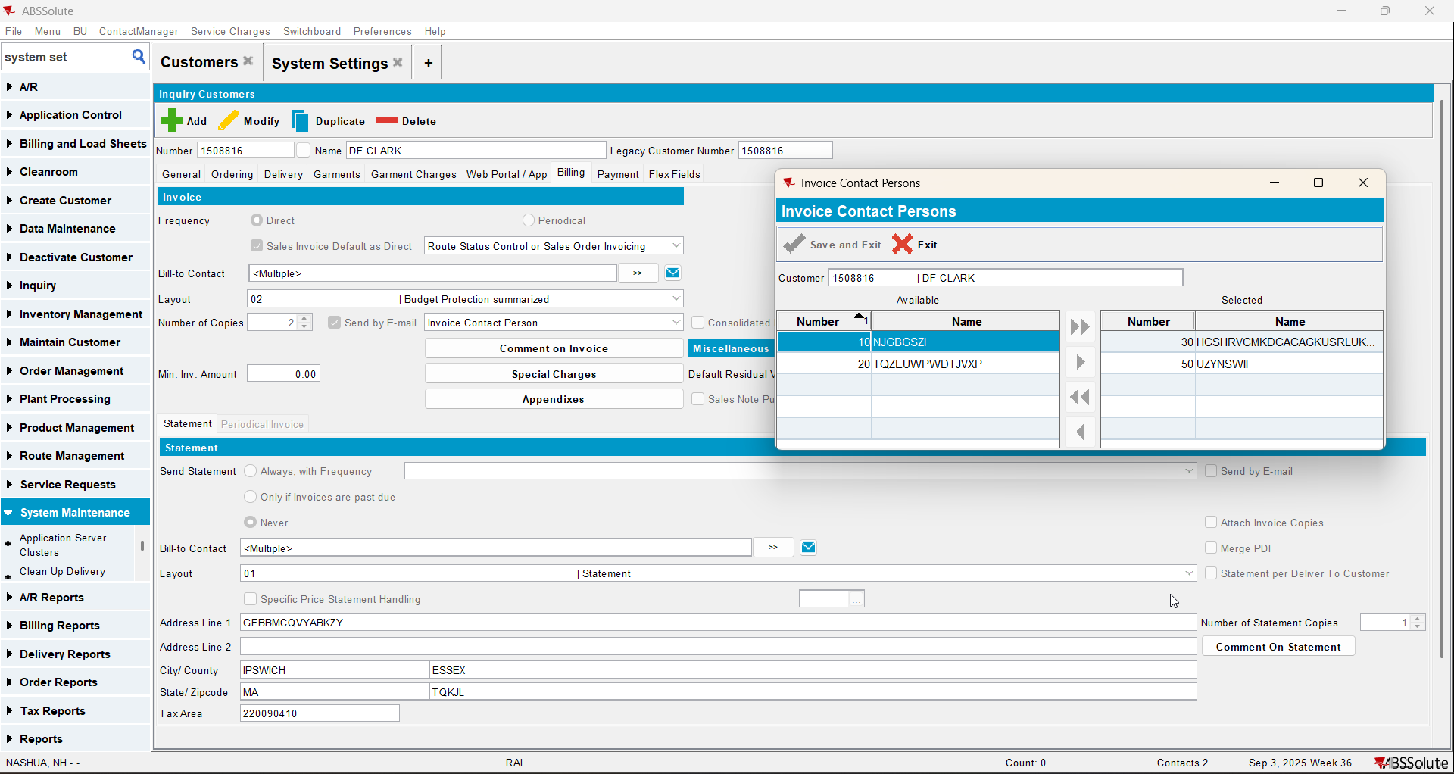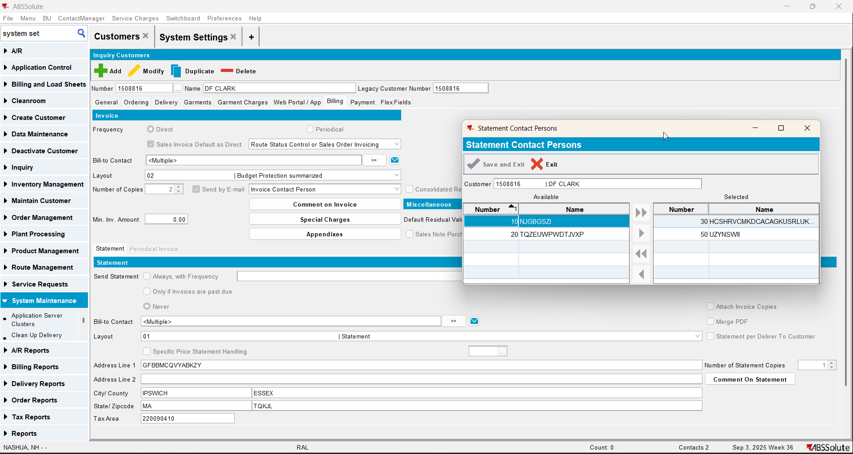

Test Case 4 – SS MULTIPLEINVANDSTMCONTACTS=1 and customer has a different customer as its bill to – Tested OK
Expected behavior: The changes on contacts should save
Hash: ff9c238
- Check that SS MULTIPLEINVANDSTMCONTACTS=1
- Have a customer that has a different customer as its bill to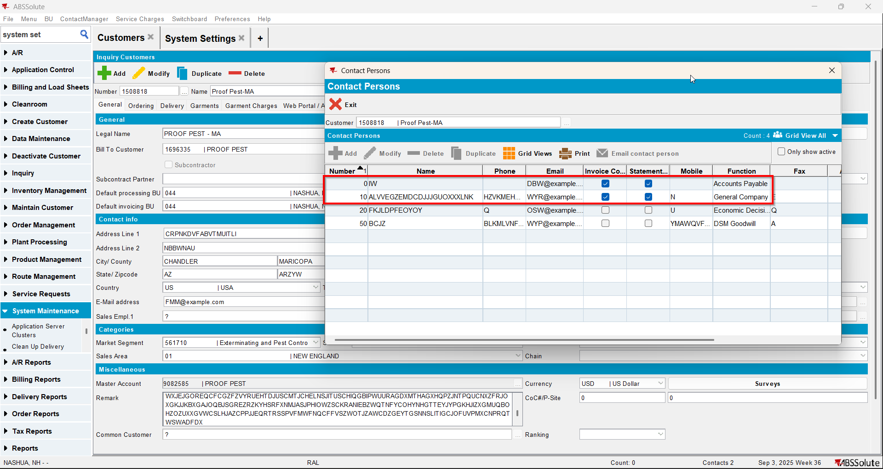
- Make another contact person to be to invoice contact and statement contact from general tab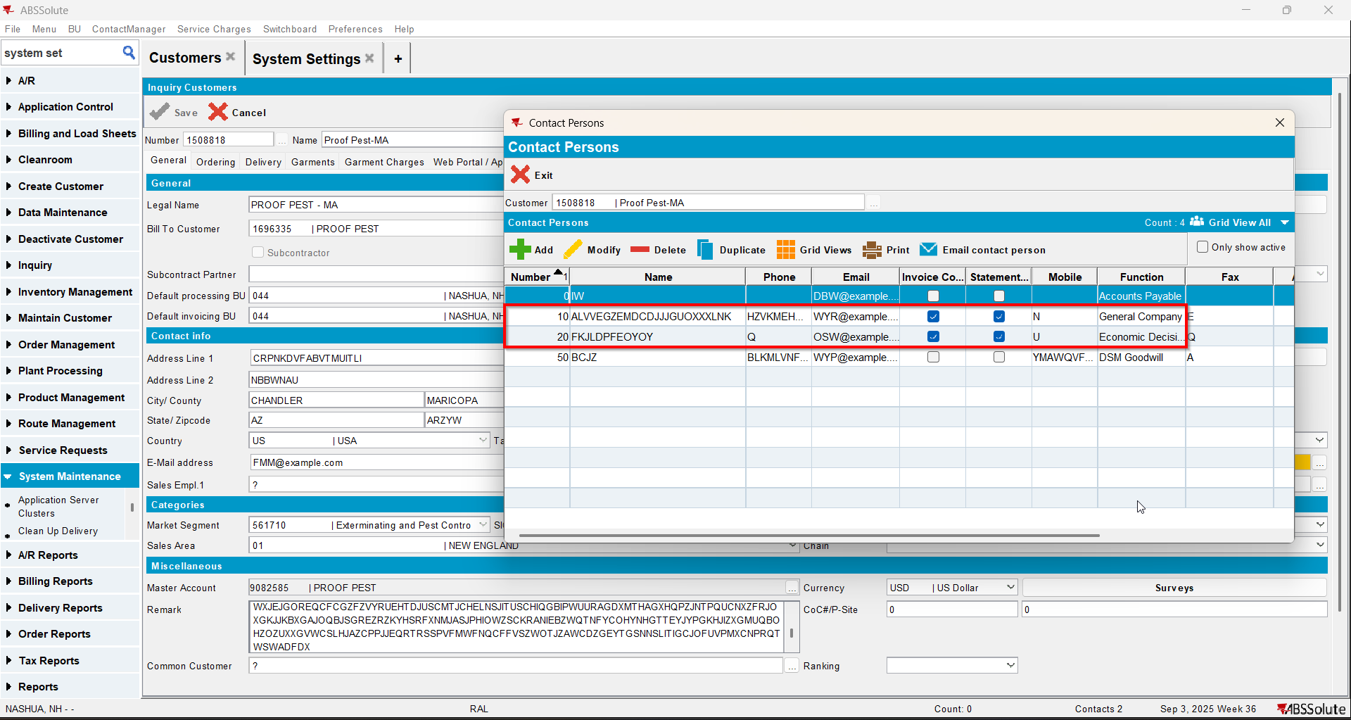
- Save and reload the customer
- Check that the change is saved on the general tab and on billing tab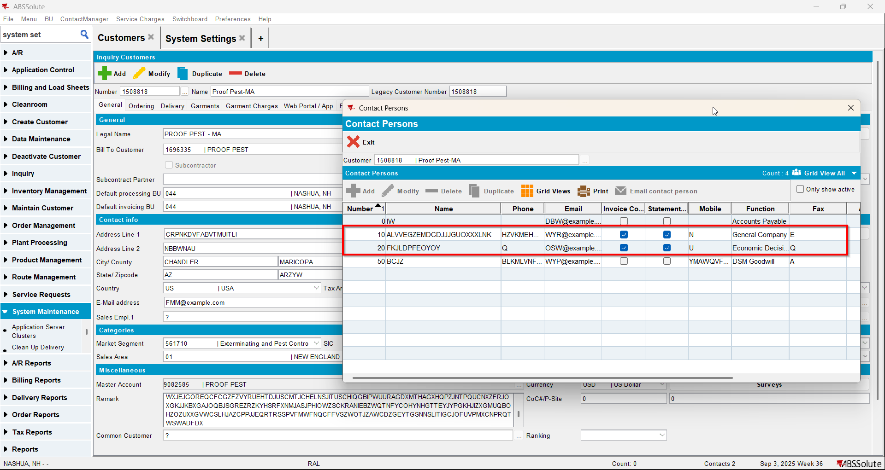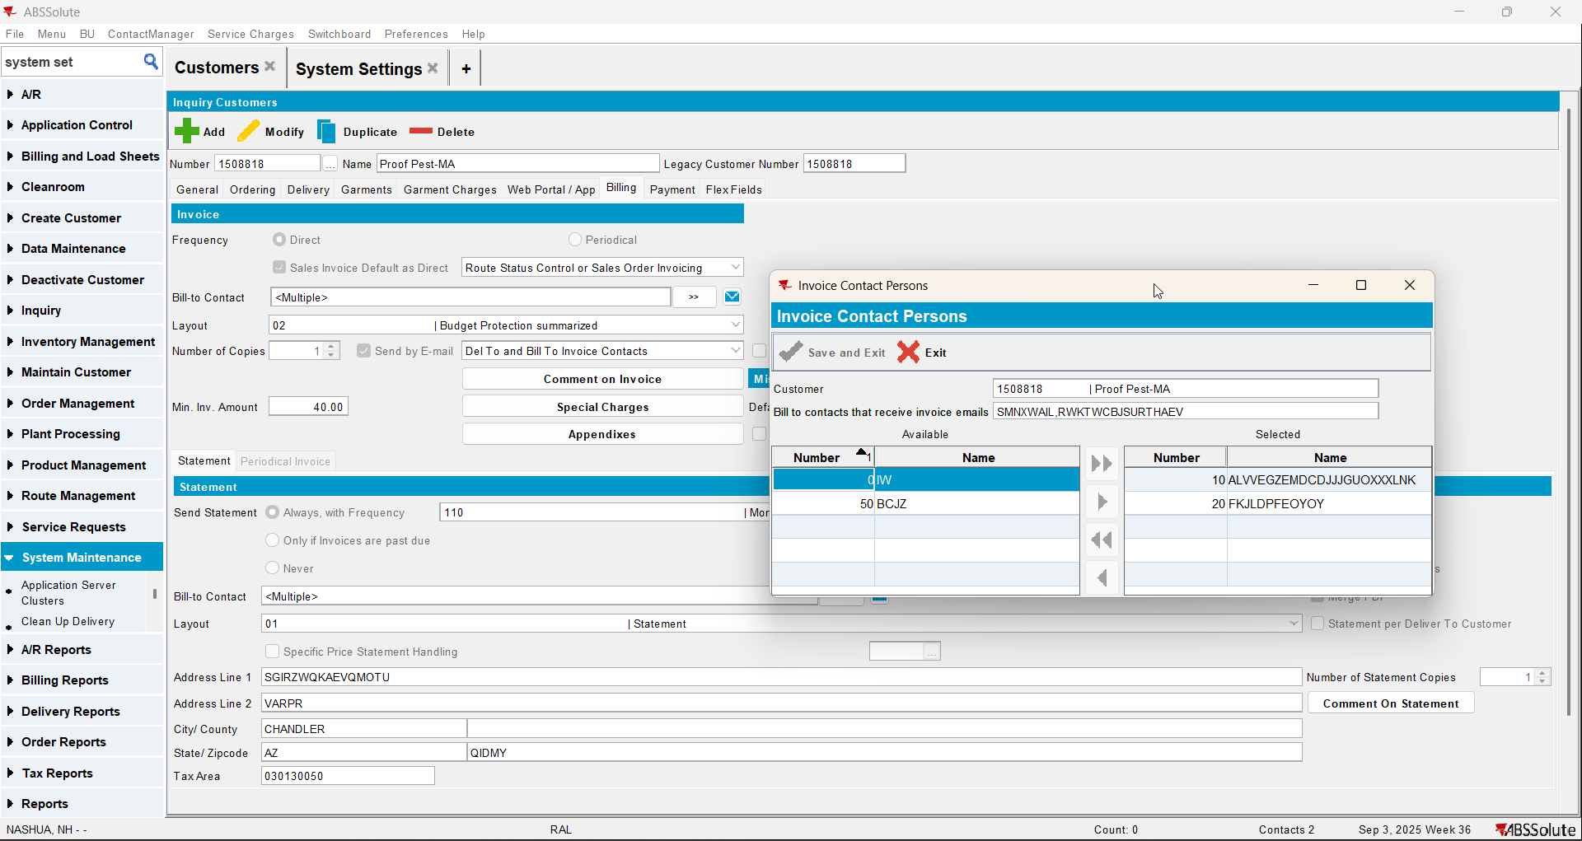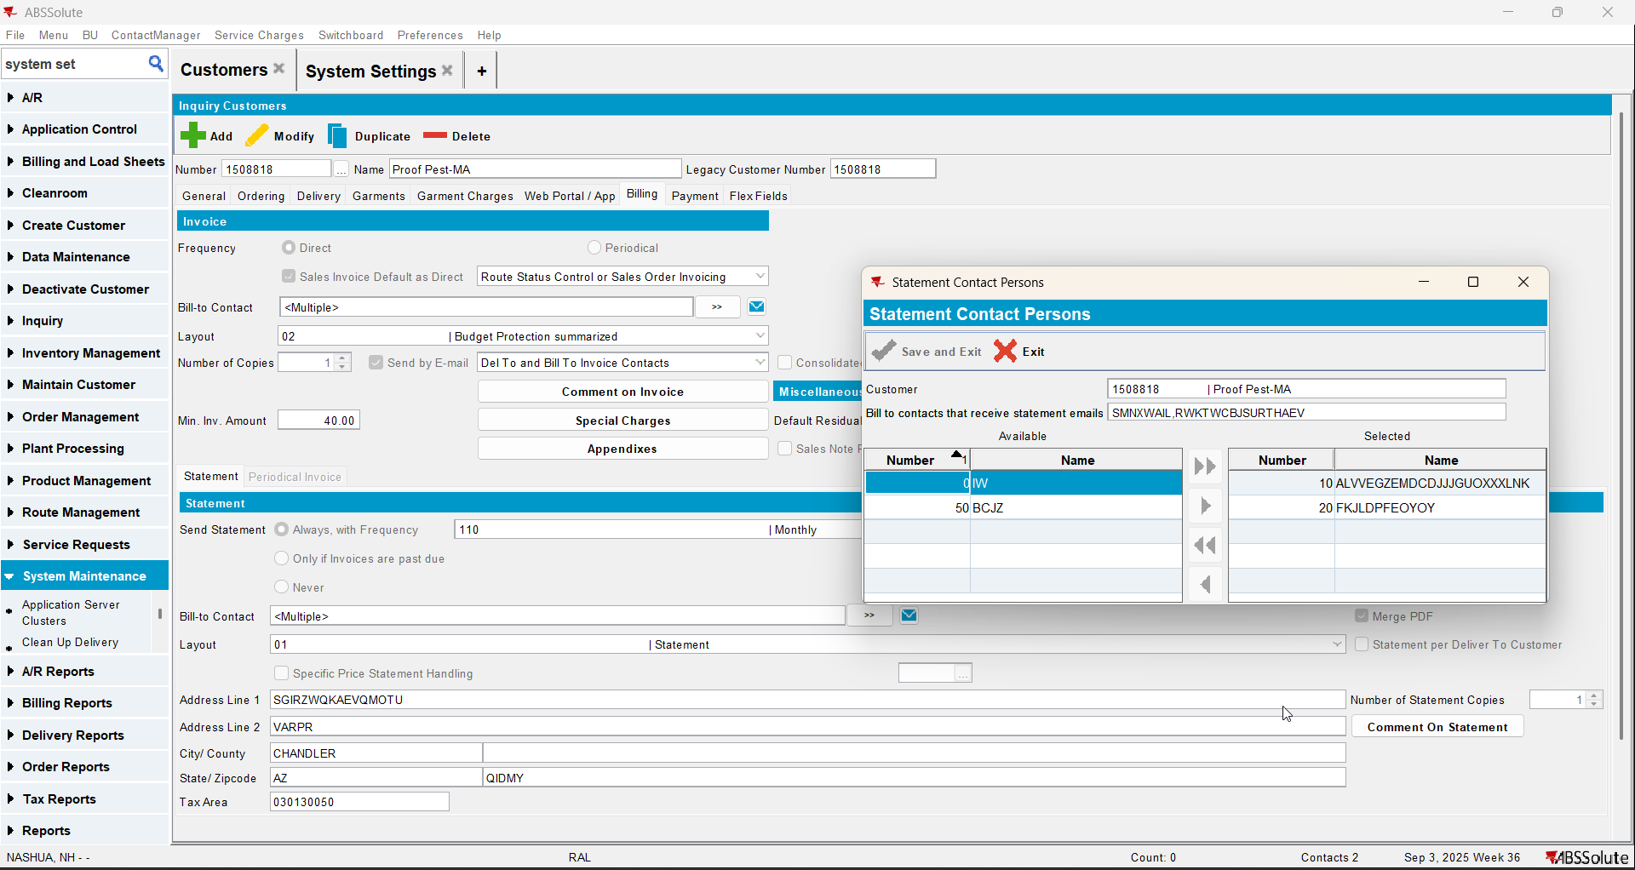
- Now make another contact person to be invoice contact and statement contact from billing tab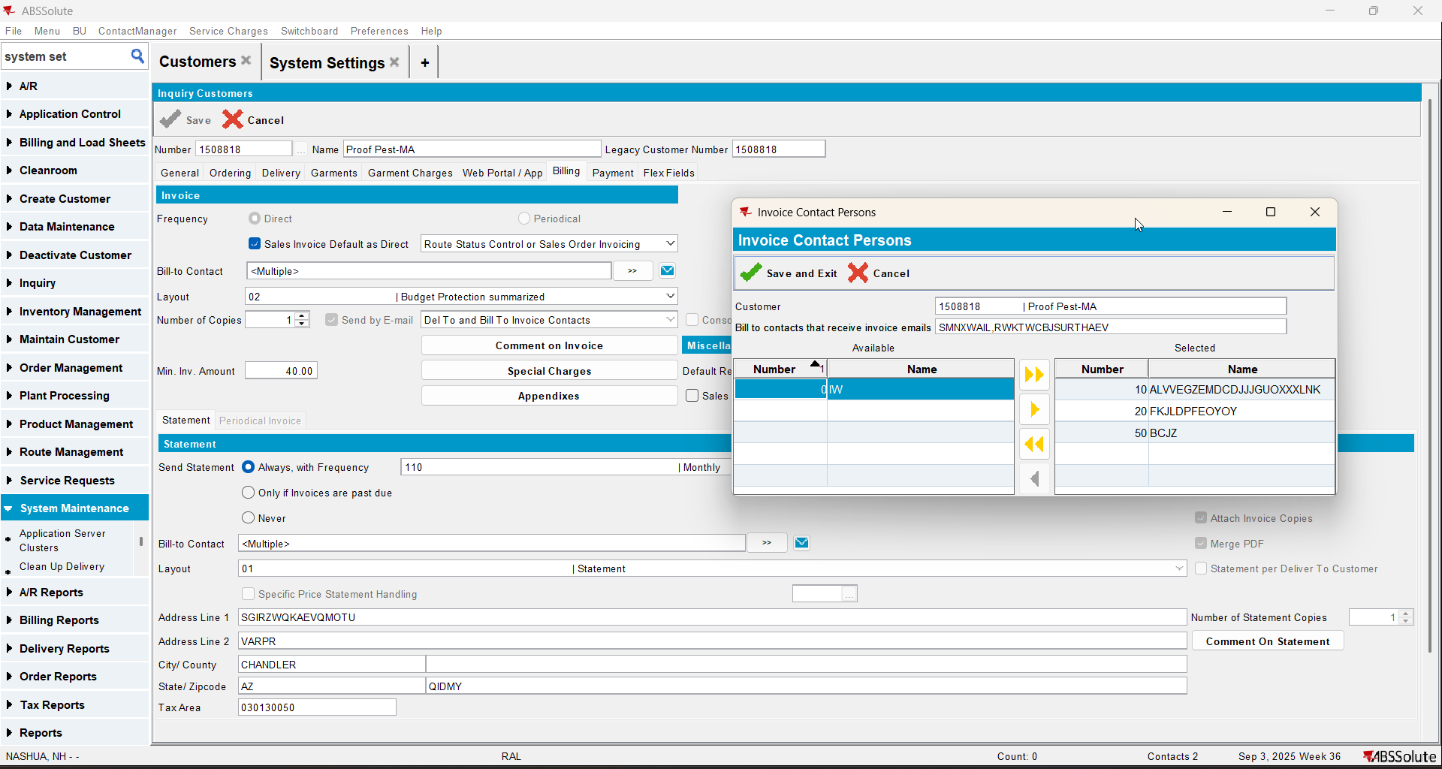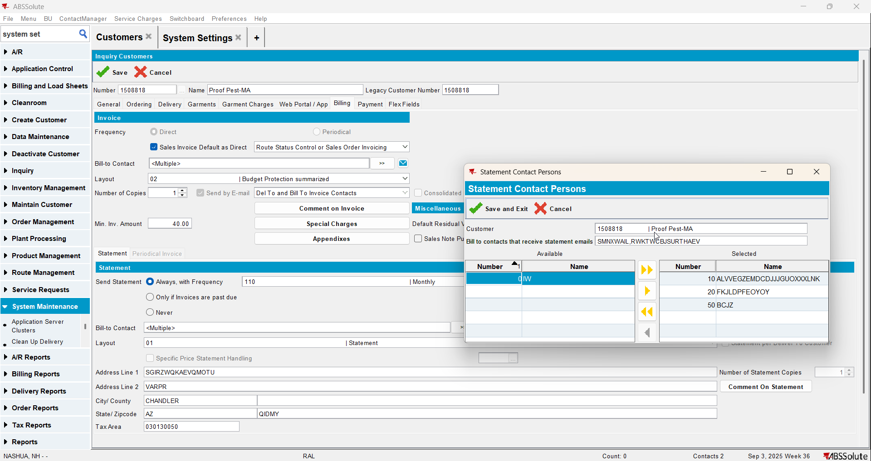
- Save and reload the customer
- Check that the change is saved on the general tab and on billing tab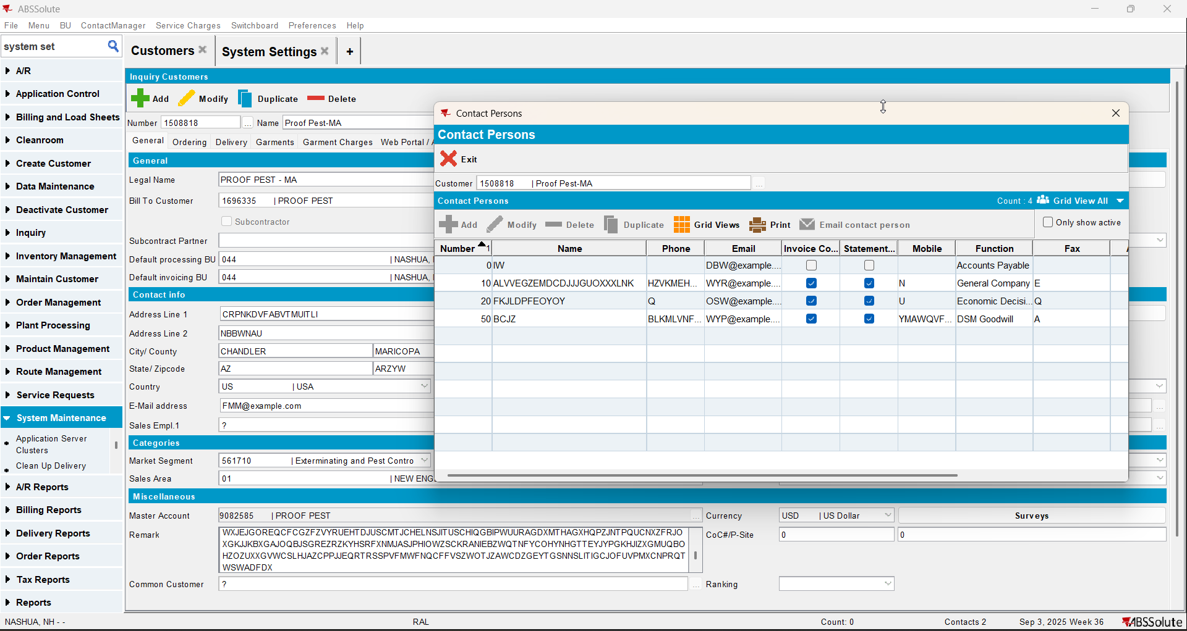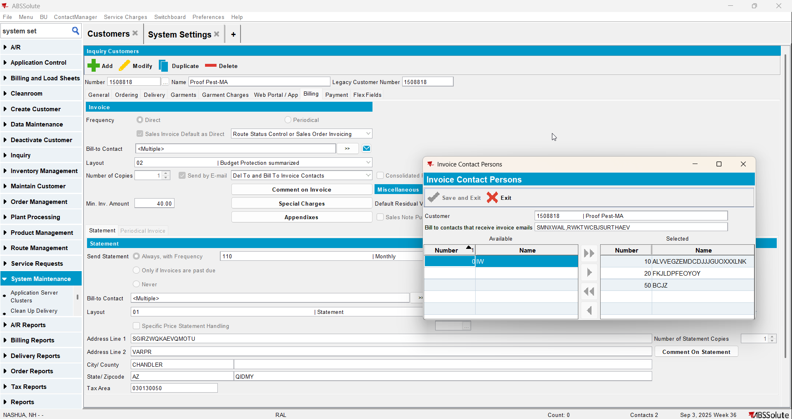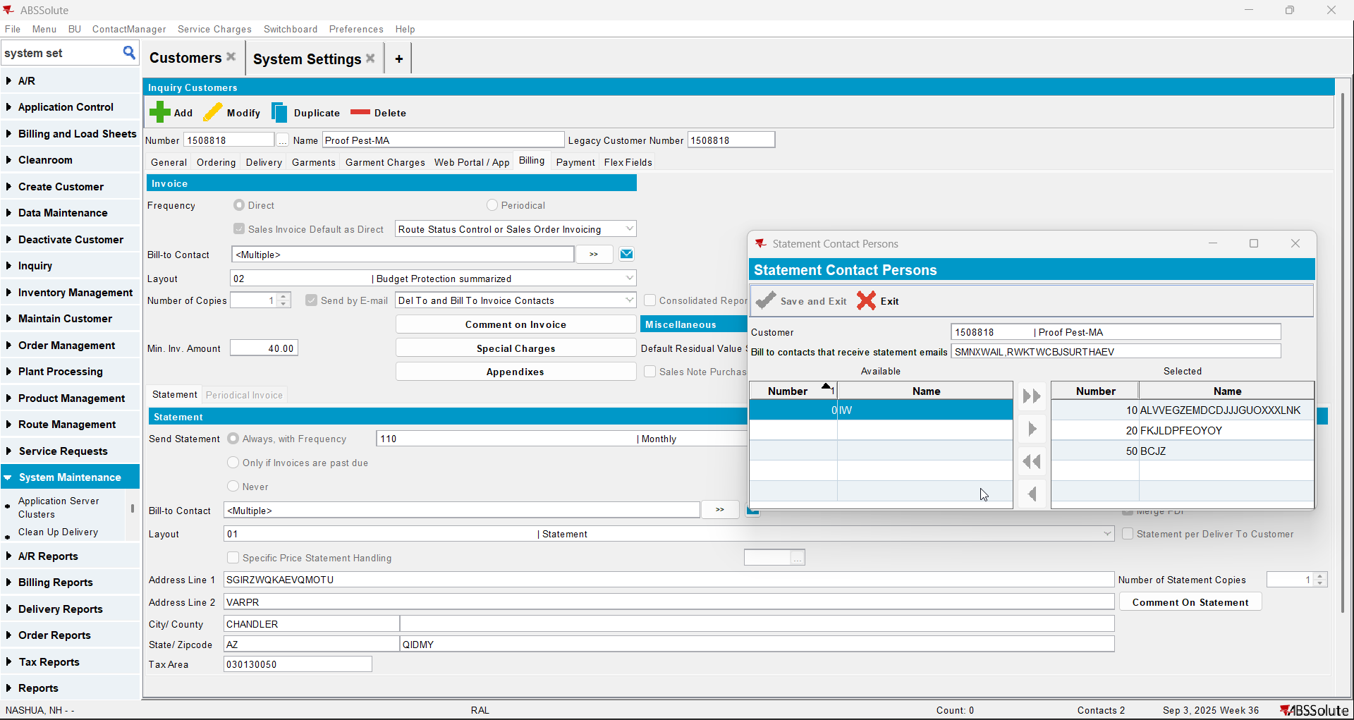
- Load your bill to customer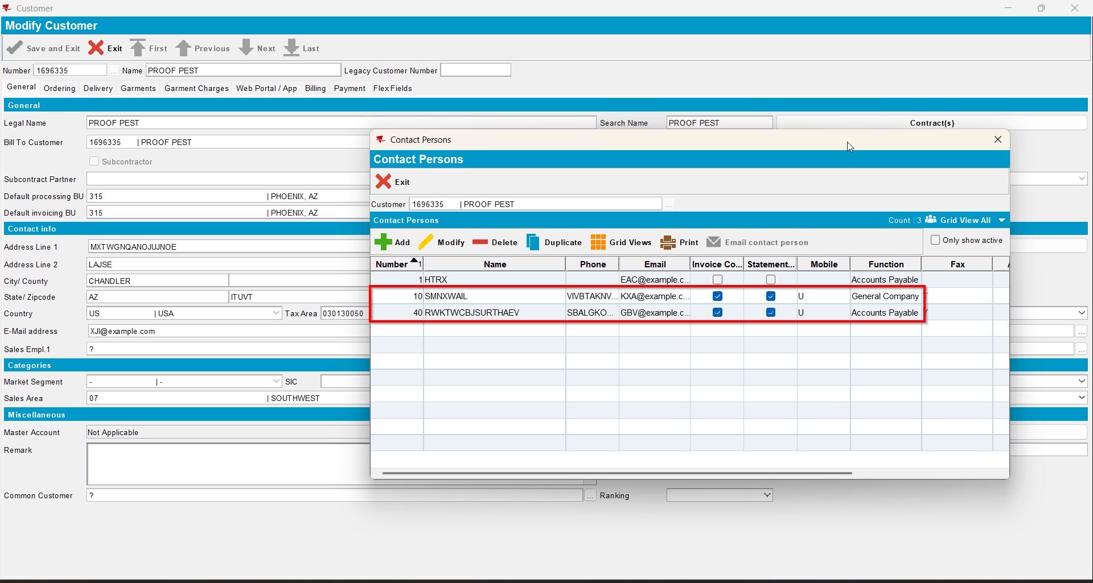
- Make another contact person to be to invoice contact and statement contact from general tab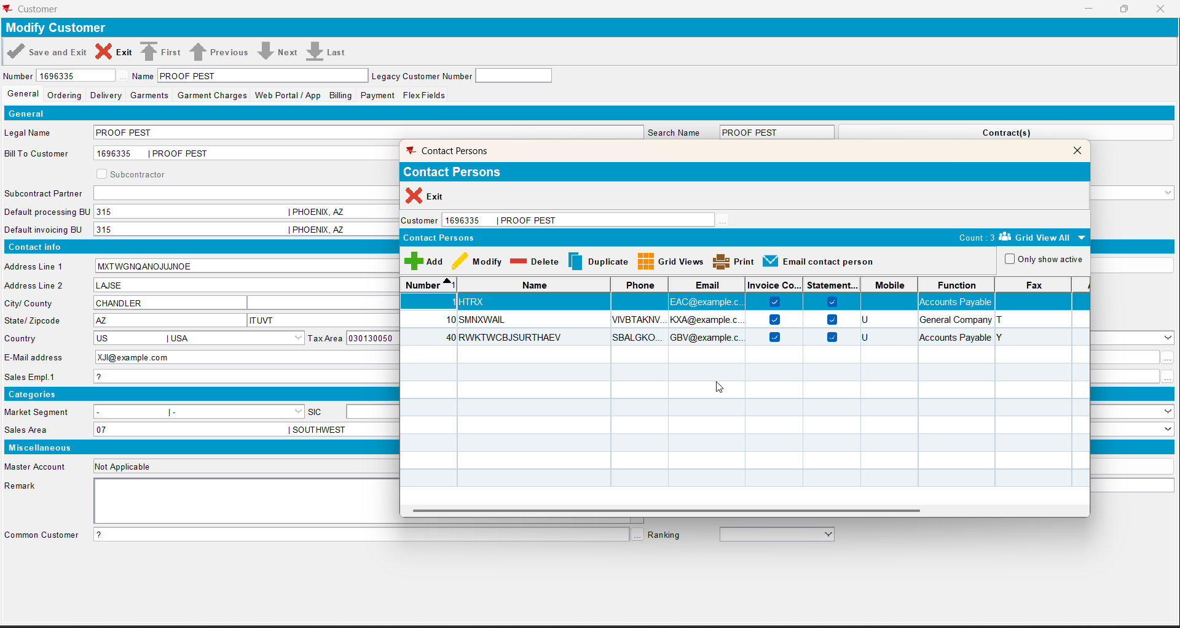
- Save and reload your customer
- Check that the change is saved on the general tab and on billing tab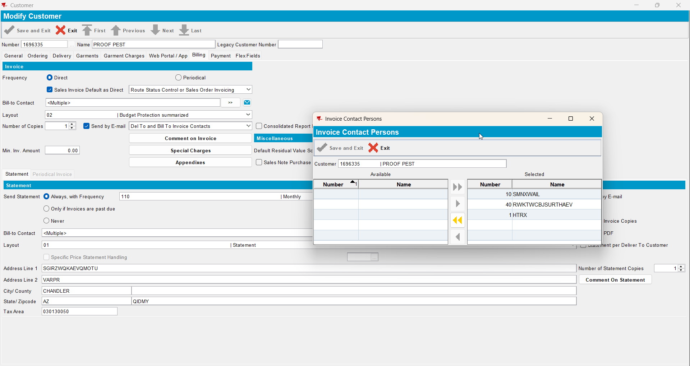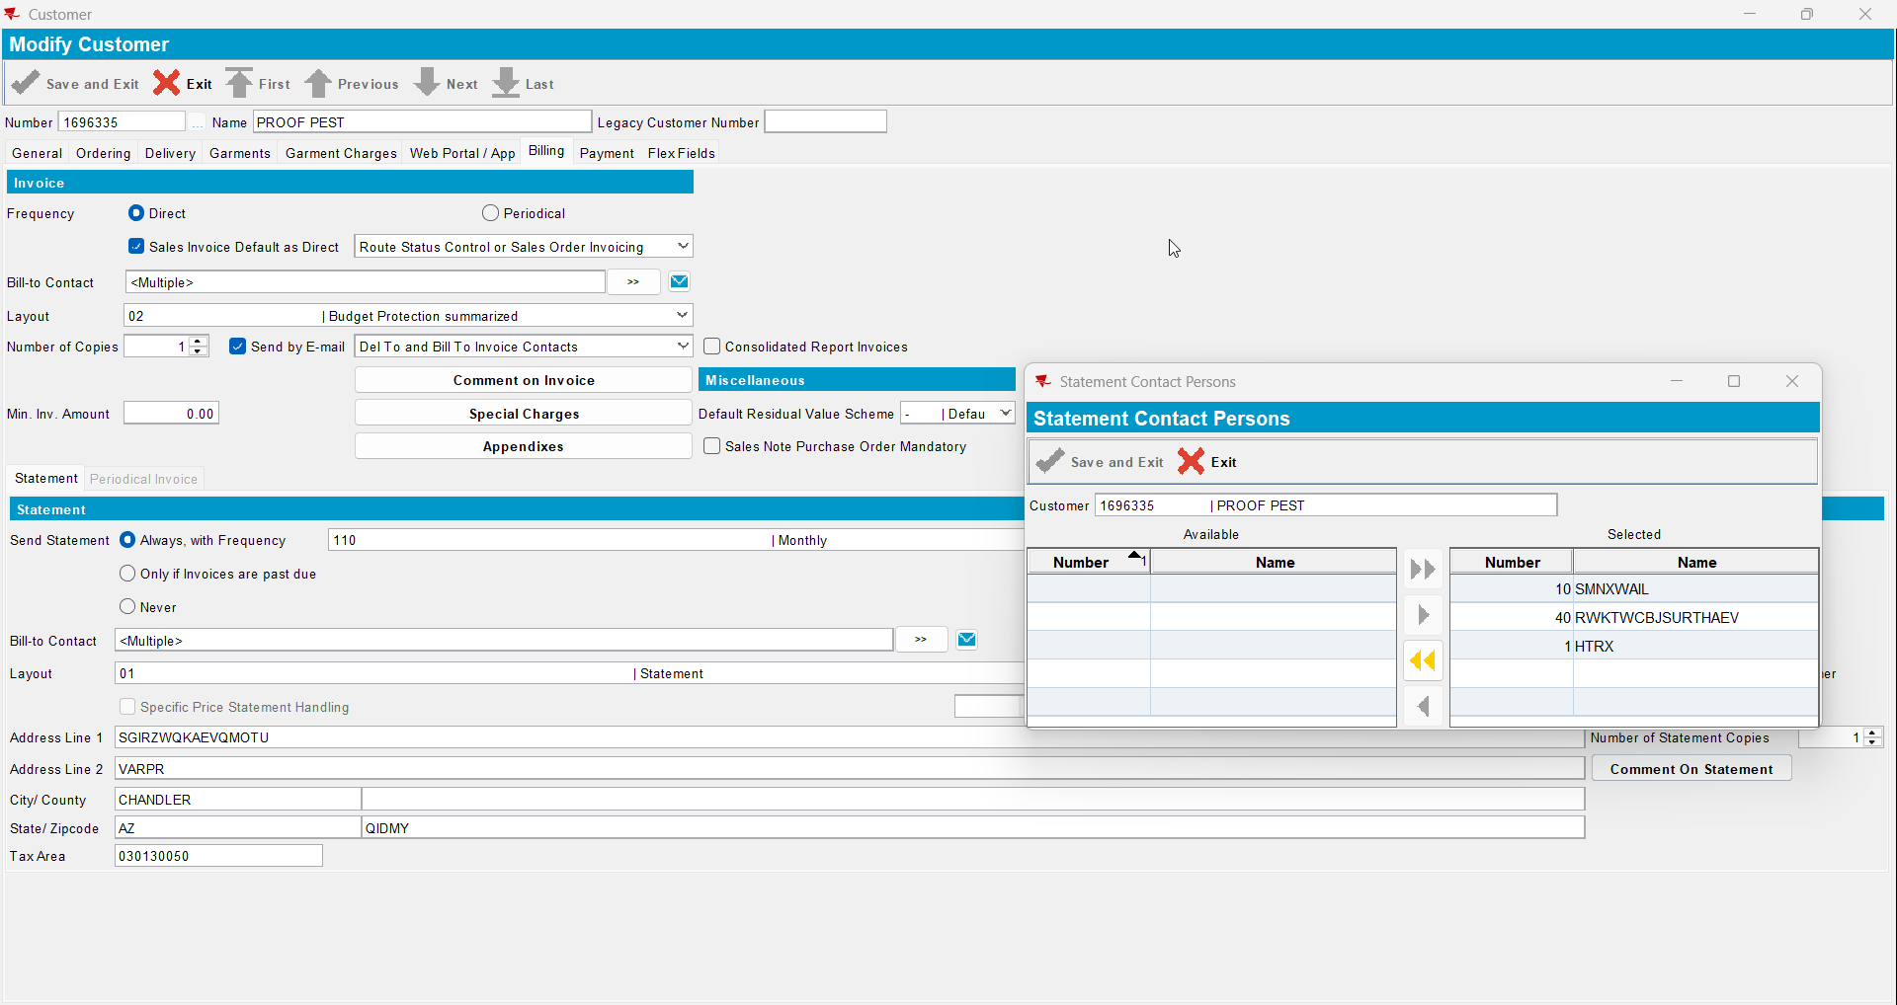
- Now load your del to customer and go to billing tab to check that is also changed the contacts person names for the ‘Bill to contacts that receive statement emails’ and ‘Bill to contacts that receive invoice emails’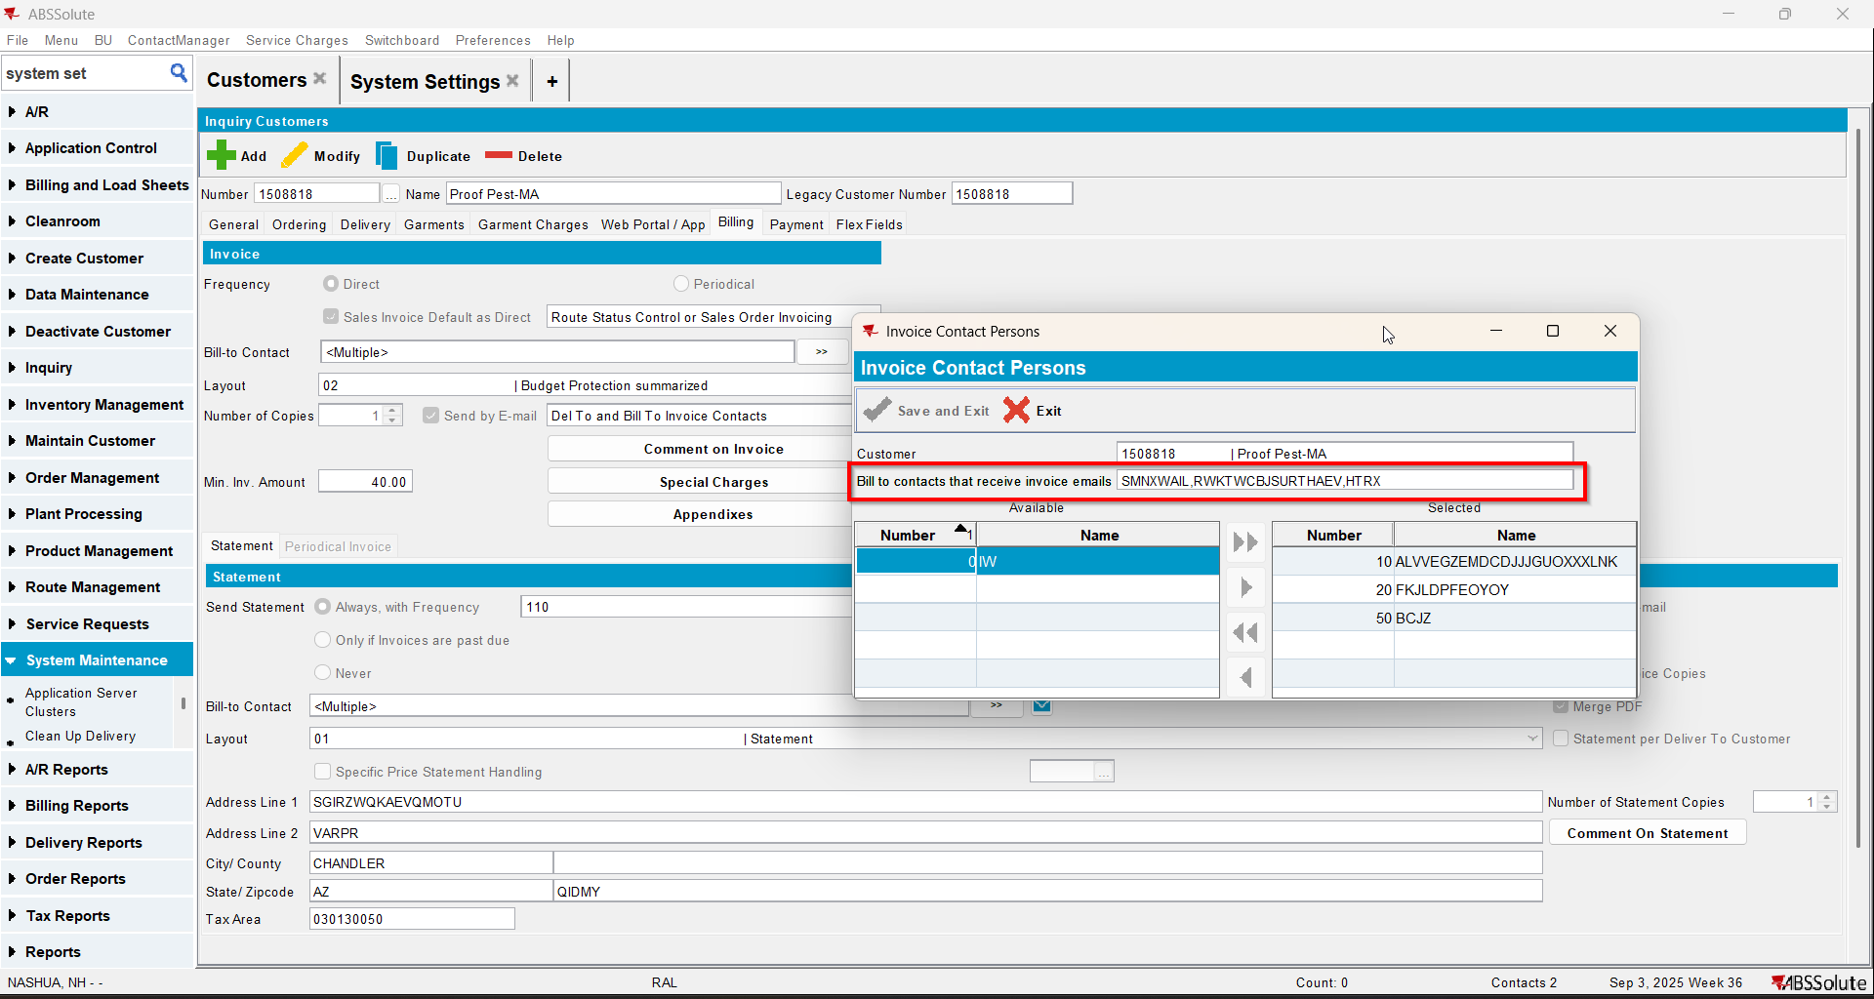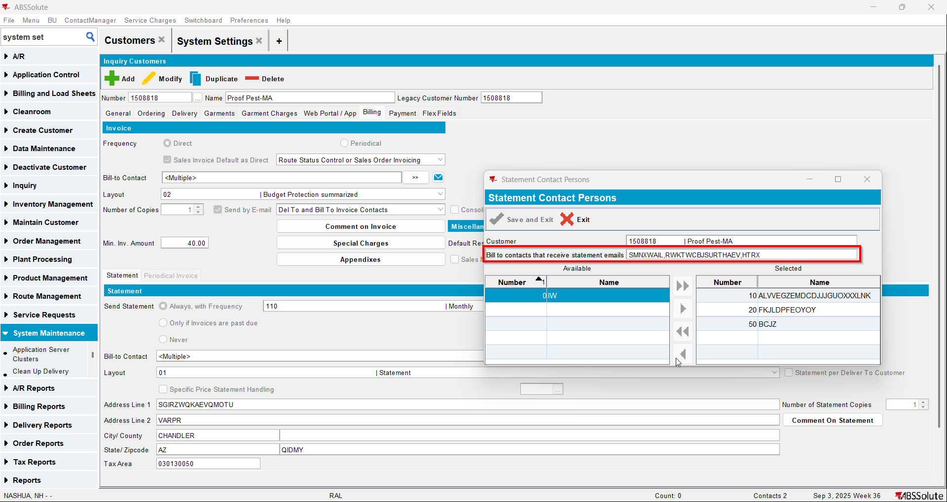
- Make another contact person to be to invoice contact and statement contact from billing tab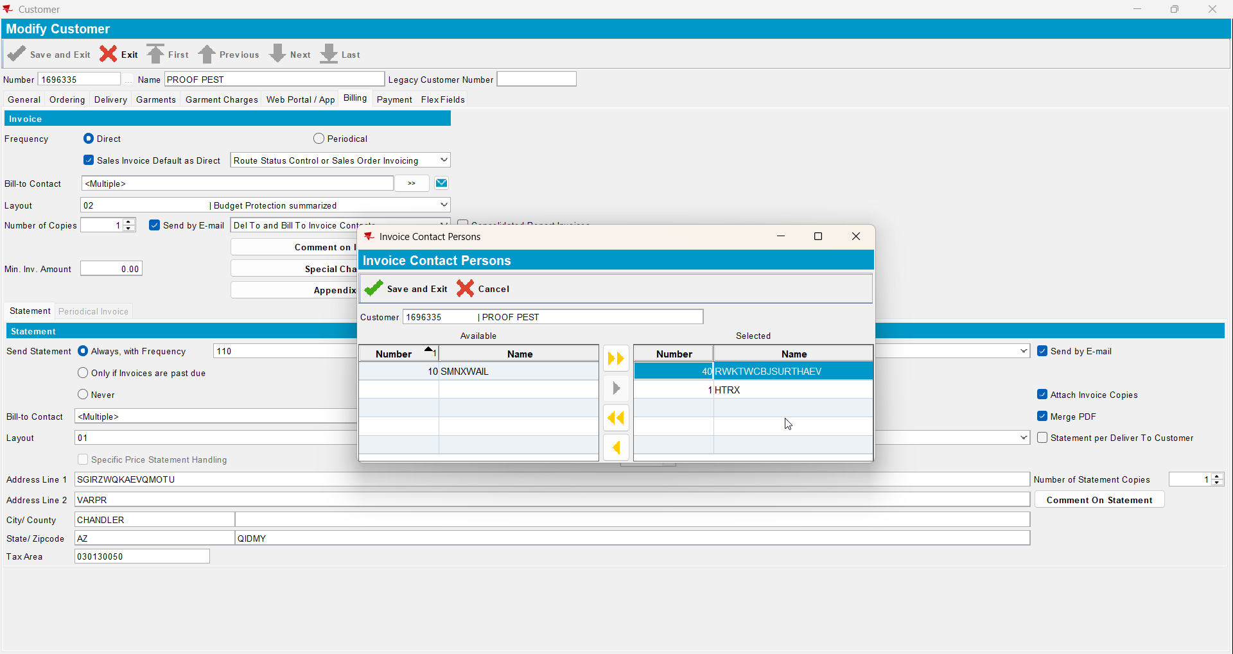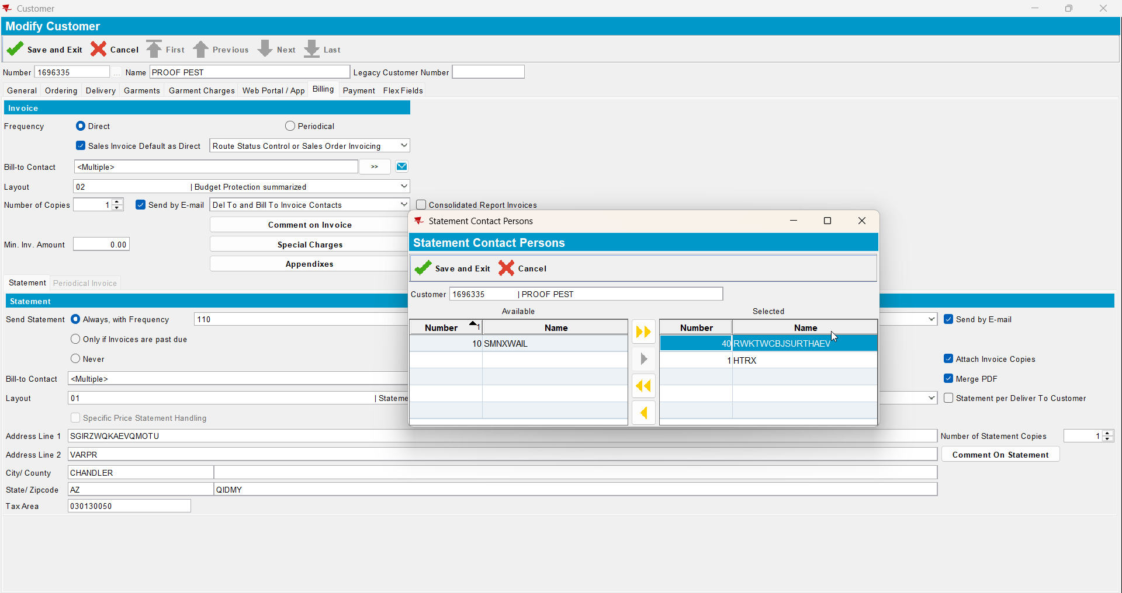
- Save and reload your customer
- Check that the change is saved on the general tab and on billing tab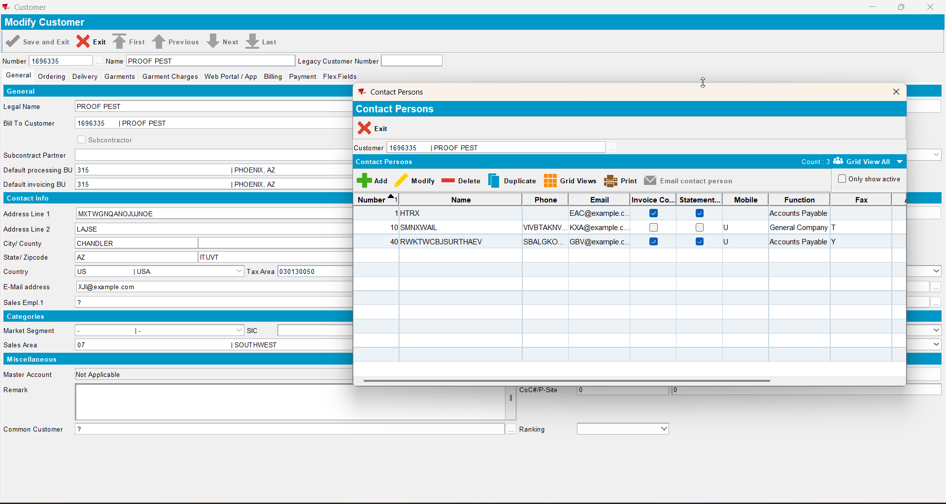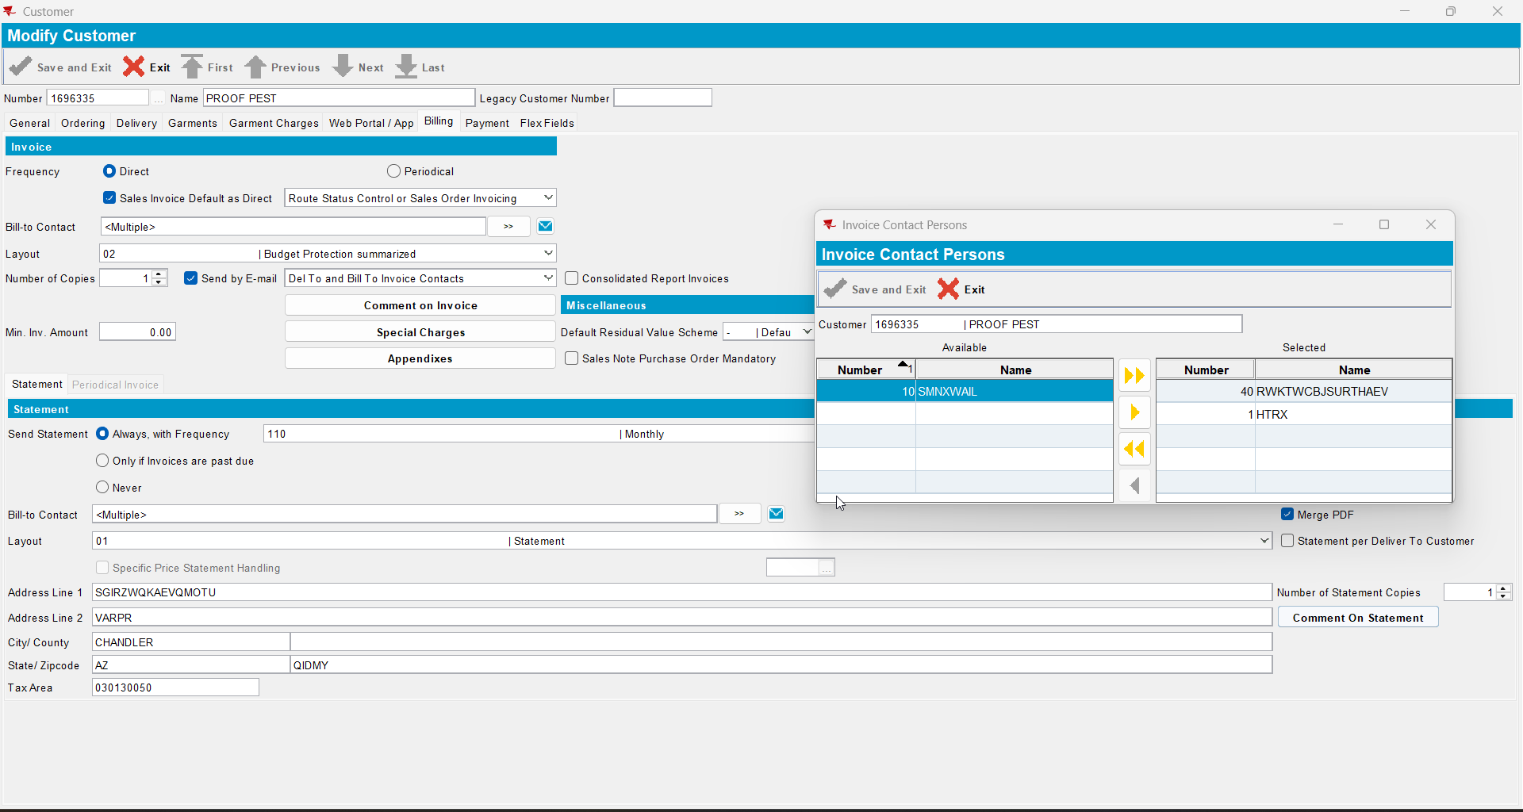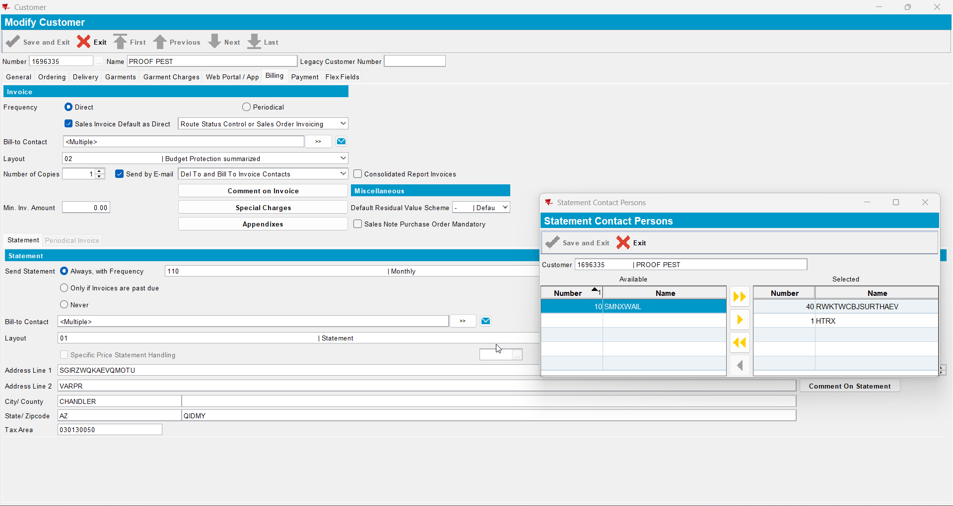
- Now load your del to customer and go to billing tab to check that is also changed the contacts person names for the ‘Bill to contacts that receive statement emails’ and ‘Bill to contacts that receive invoice emails’