BPA-285 - When scanning a mat to store, check for current shorts on the mat and tell the user
Environment | Prerequisites
Version: BulkPackingAssistant_v2.13+ 9.07.00.UNF18  DBServerName= abs-srv20.internal.abslbs.com  DBSID=CUST24  DBUser=UNFDEV  DBPassword= UNFDEV  Environment=Test | - Module:  - System setting

Contents
Retest after fix 1
Test Case 1 – BPAPACKBYSTOP = 0 Scan a code of a mat that was shorted and choose store 1
Test Case 2 – BPAPACKBYSTOP = 0 Scan a code of a mat that was shorted and choose pack 6
Test Case 3 – BPAPACKBYSTOP = 0 Have a customer with multiple B days (every weekday), have two routes in BPA PACK with the same customer and short the same mat on both then scan in store and pack it 11
Test Case 4 – BPAPACKBYSTOP = 1 Scan a code of a mat that was shorted and choose store 19
Test Case 5 – BPAPACKBYSTOP = 1 Scan a code of a mat that was shorted and choose pack 24
Test Case 6 – BPAPACKBYSTOP = 1 Have a customer with multiple B days (every weekday), have two routes in BPA PACK with the same customer and short the same mat on both then scan in store and pack it 30

Retest after fix

Test Case 1 – BPAPACKBYSTOP = 0 Scan a code of a mat that was shorted and choose store
Hash: 9.07.00.UNF18 hash: 1f0d60b2802d + BulkPackingAssistant_v2.13.INTERNAL_TEST_ONLY.9f42064
Expected behavior: The mat is stored, check in Active Stock Location
- System Settings: Have BPAPACKBYSTOP = 0
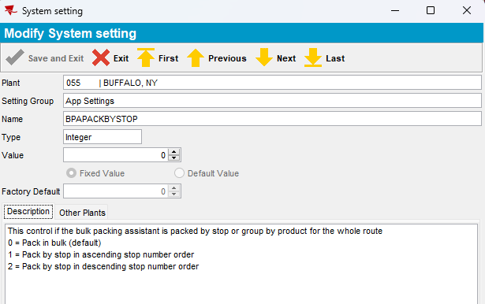
- Use the following select to find customers with Logo Mats
SELECT BU.CODE,
C.CUSTOMERNUMBER,
P.CODE AS PRODUCTCODE,
FM.CODE AS FMCODE,
UI.PRIMARYID,
(SELECT S.FACTORYDESCRIPTION FROM STAY S WHERE S.STAY_ID = UI.STAY_ID) AS STAY
FROM CUSTOMER C
JOIN PRODUCTLISTPERCUSTOMER PLPC
ON PLPC.CUSTOMER_ID = C.CUSTOMER_ID
JOIN PLPCEXTRAINFO PLPCE
ON PLPCE.PRODUCTLISTPERCUSTOMER_ID = PLPC.PRODUCTLISTPERCUSTOMER_ID
JOIN PRODUCT P
ON P.PRODUCT_ID = PLPC.PRODUCT_ID
JOIN FINISHINGMETHOD FM
ON FM.FINISHINGMETHOD_ID = PLPC.FINISHINGMETHOD_ID
JOIN UNIQUEITEM UI
ON UI.PRODUCT_ID = PLPC.PRODUCT_ID
AND UI.FINISHINGMETHOD_ID = PLPC.FINISHINGMETHOD_ID
AND UI.SIZEDEFINITION_ID = PLPC.SIZEDEFINITION_ID
AND PLPC.CUSTOMER_ID = UI.RELATEDCUSTOMER_ID
JOIN BUSINESSUNIT BU
ON BU.BUSINESSUNIT_ID = C.DEFAULTBUSINESSUNIT_ID
WHERE PLPC.DATEINACTIVE > SYSDATE
AND P.TYPEOFMERCHANDISE = 1
AND P.STOREACTIVESTOCKLOCATION = 'Y'
AND P.BULKPACKINGACTIVESTOCKTYPE = 1
AND BU.CODE = '055'
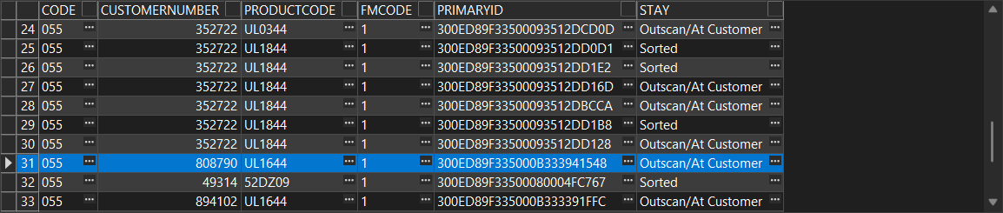
- Customers DLG: See the route and delivery day
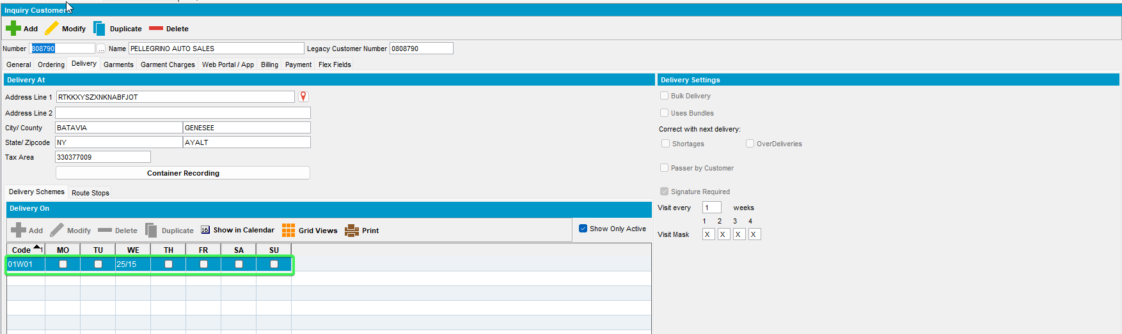
- Route Status Control DLG: Add a new routecontrol for that day and route
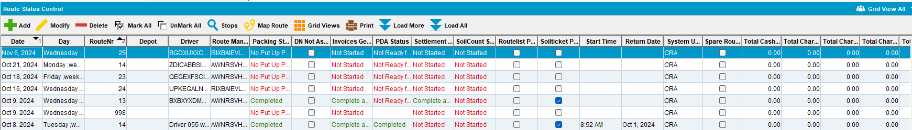
- Route Status Control DLG: Generate Put Up doc
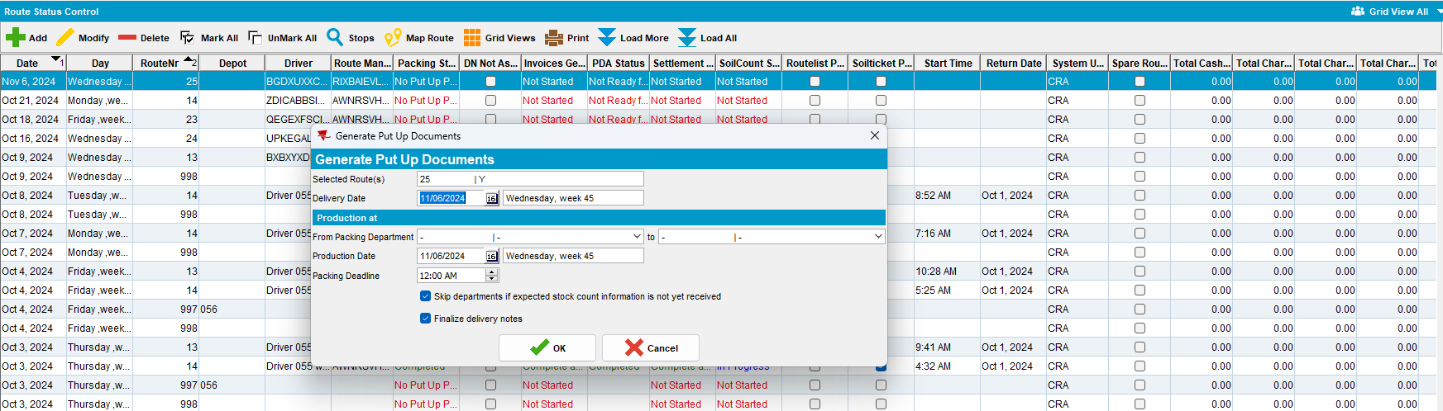
- Bulk Packing Assistant: Select Pack > Select the day on which you created the route > Select the Route
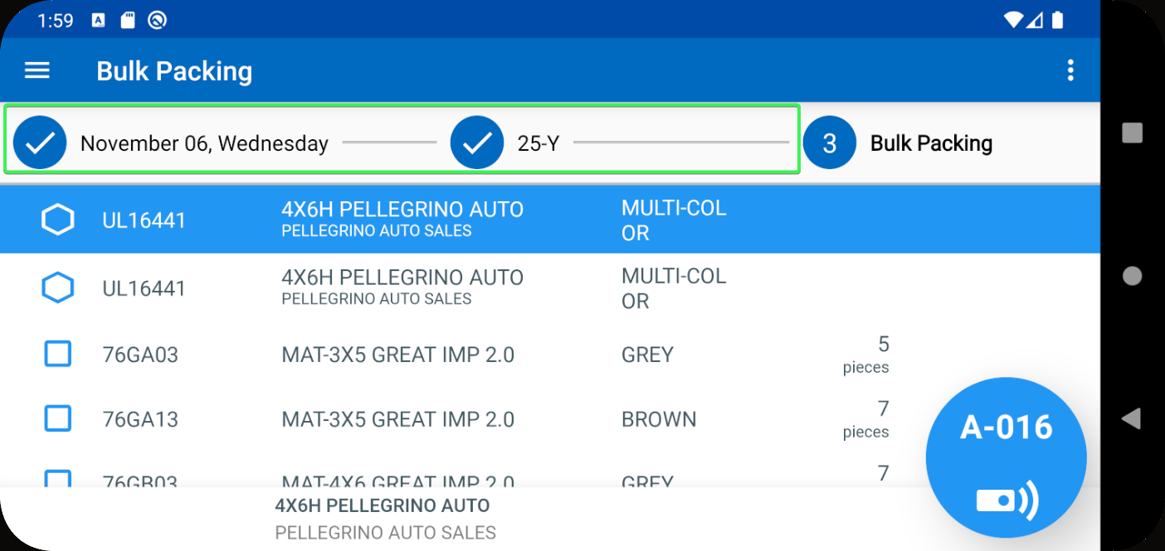
- BPA: Short the Logo mat from your customer
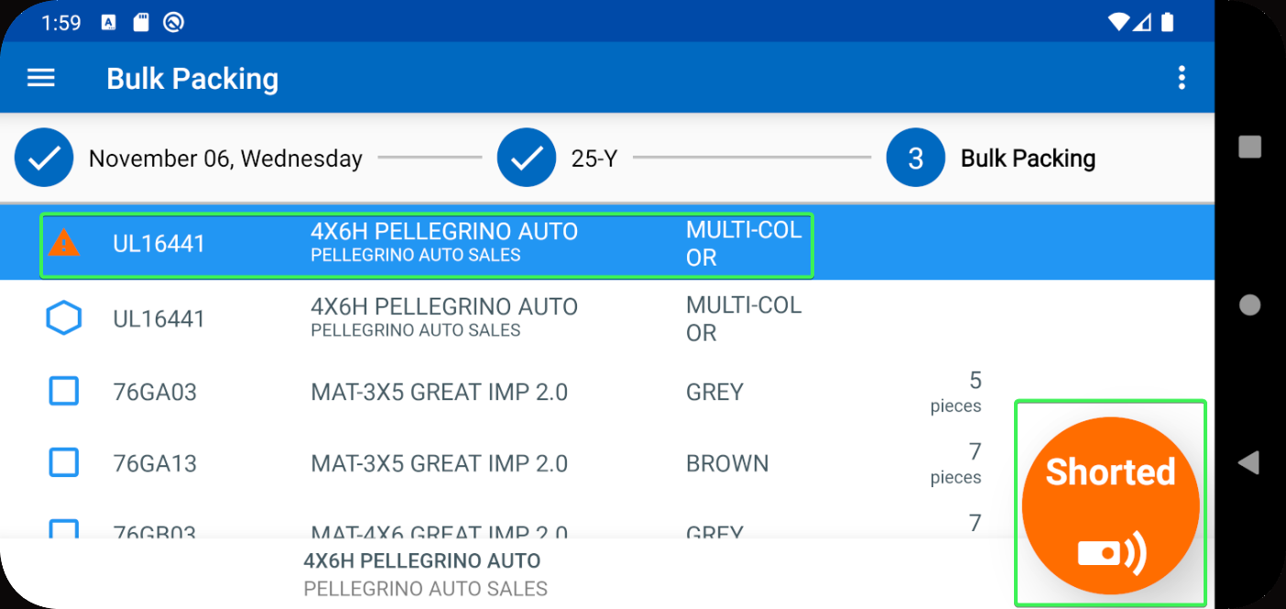

- Product List Per Customer DLG: Input your customer and press modify on your Product > Press View button in Logistics tab
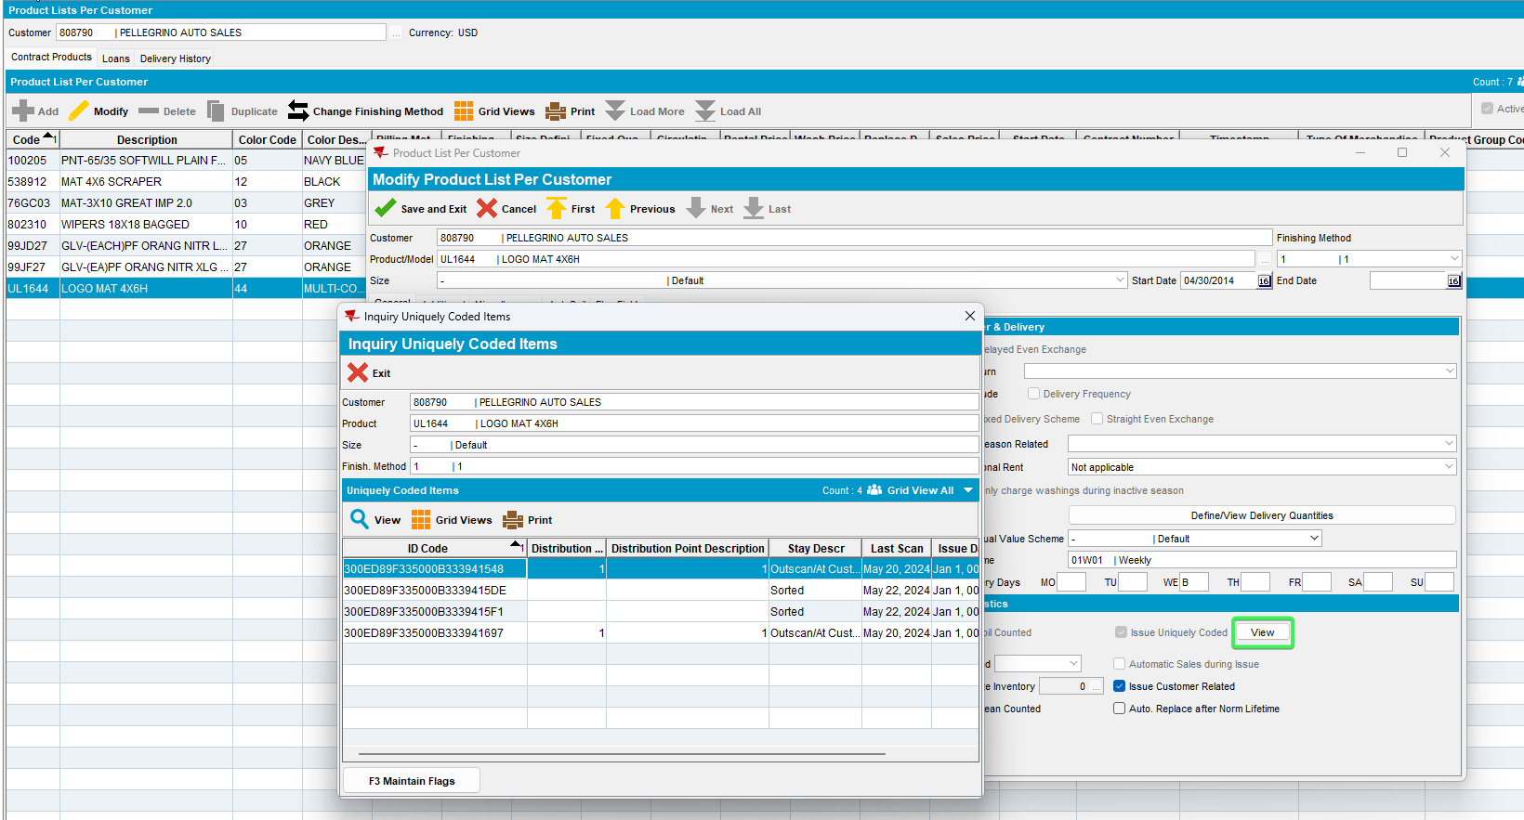
- Note one of the ID Codes
- BPA: Go to Store and scan the previous noted code
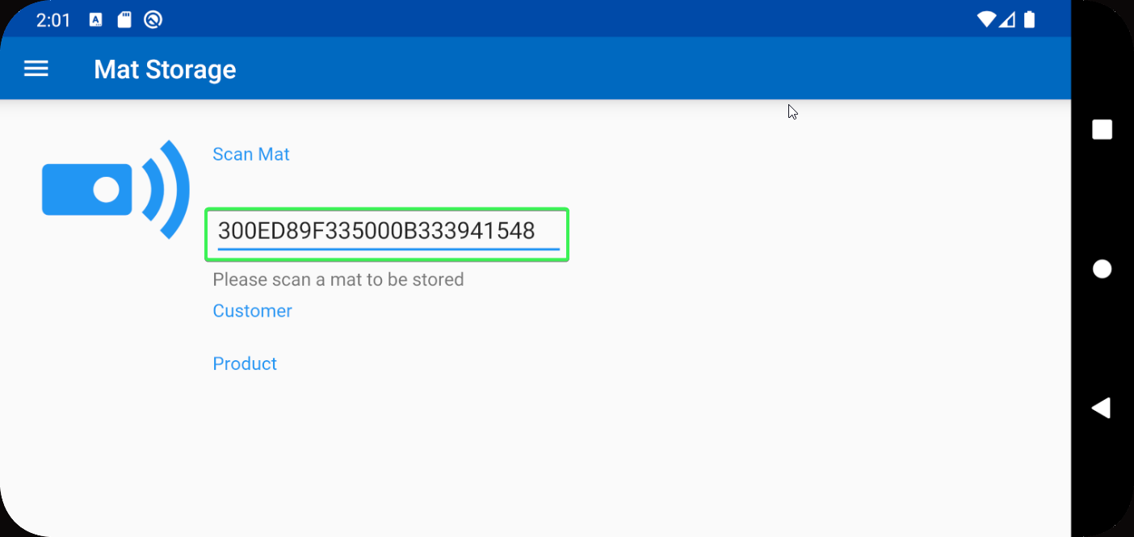
- Press Store when asked if you want to pack or store the shorted mat
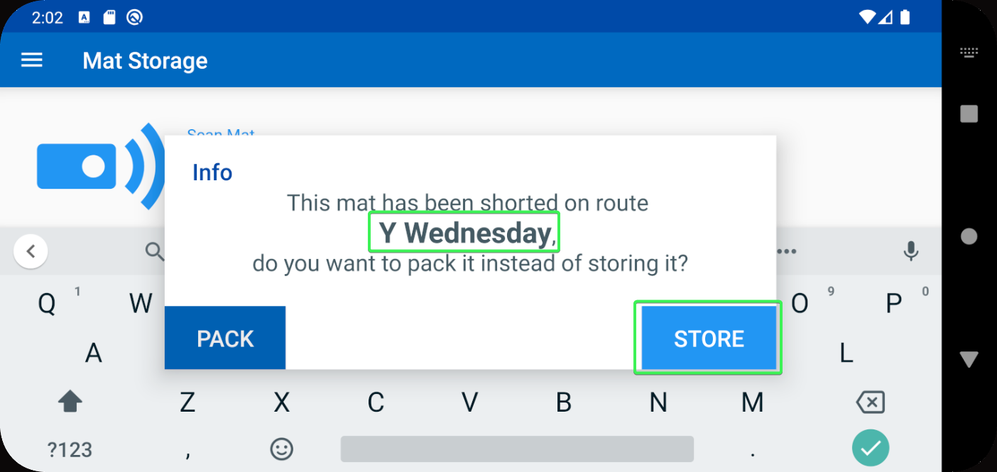
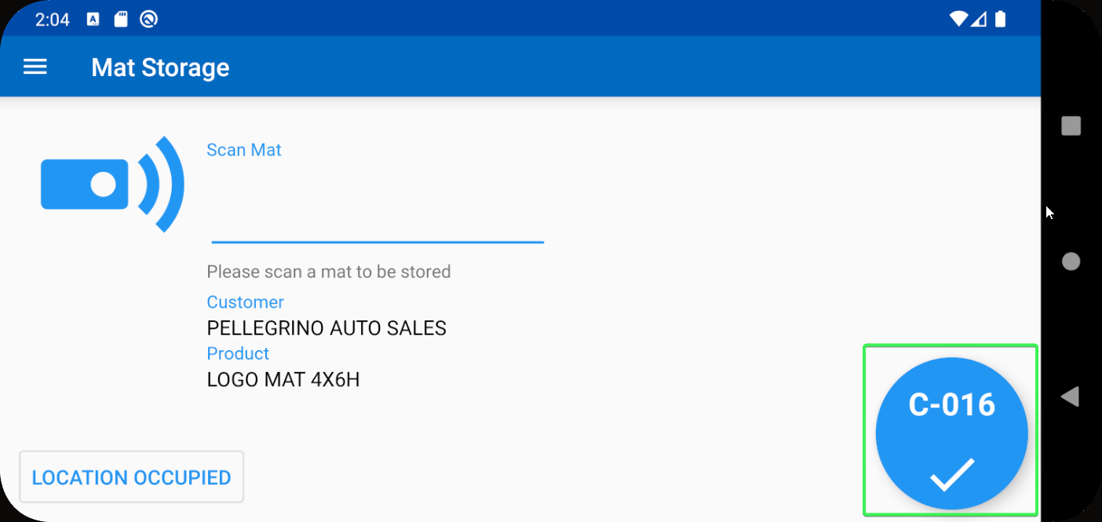
- Active Stock Location DLG: See if the Mat has been indeed stored in the indicated location
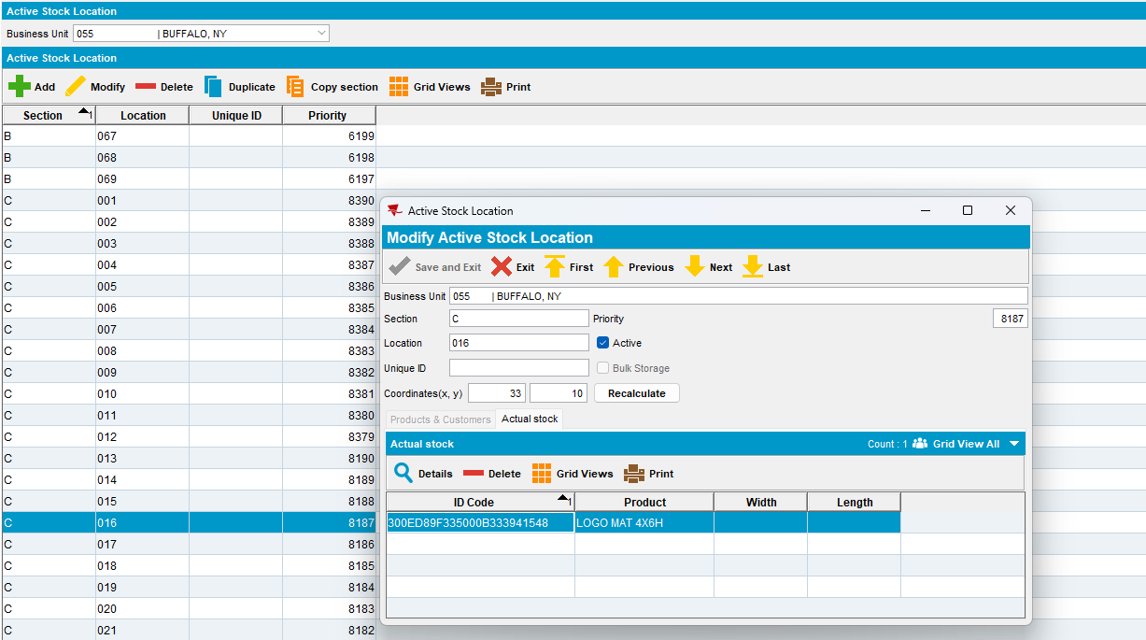
Tested OK

Test Case 2 – BPAPACKBYSTOP = 0 Scan a code of a mat that was shorted and choose pack
Hash: 9.07.00.UNF18 hash: 1f0d60b2802d + BulkPackingAssistant_v2.13.INTERNAL_TEST_ONLY.9f42064
Expected behavior: The mat is packed on the route, you can check the route in the pack menu and see that the mat is no longer shorted
- System Settings: Have BPAPACKBYSTOP = 0
- Use the following select to find customers with Logo Mats
SELECT BU.CODE,
C.CUSTOMERNUMBER,
P.CODE AS PRODUCTCODE,
FM.CODE AS FMCODE,
UI.PRIMARYID,
(SELECT S.FACTORYDESCRIPTION FROM STAY S WHERE S.STAY_ID = UI.STAY_ID) AS STAY
FROM CUSTOMER C
JOIN PRODUCTLISTPERCUSTOMER PLPC
ON PLPC.CUSTOMER_ID = C.CUSTOMER_ID
JOIN PLPCEXTRAINFO PLPCE
ON PLPCE.PRODUCTLISTPERCUSTOMER_ID = PLPC.PRODUCTLISTPERCUSTOMER_ID
JOIN PRODUCT P
ON P.PRODUCT_ID = PLPC.PRODUCT_ID
JOIN FINISHINGMETHOD FM
ON FM.FINISHINGMETHOD_ID = PLPC.FINISHINGMETHOD_ID
JOIN UNIQUEITEM UI
ON UI.PRODUCT_ID = PLPC.PRODUCT_ID
AND UI.FINISHINGMETHOD_ID = PLPC.FINISHINGMETHOD_ID
AND UI.SIZEDEFINITION_ID = PLPC.SIZEDEFINITION_ID
AND PLPC.CUSTOMER_ID = UI.RELATEDCUSTOMER_ID
JOIN BUSINESSUNIT BU
ON BU.BUSINESSUNIT_ID = C.DEFAULTBUSINESSUNIT_ID
WHERE PLPC.DATEINACTIVE > SYSDATE
AND P.TYPEOFMERCHANDISE = 1
AND P.STOREACTIVESTOCKLOCATION = 'Y'
AND P.BULKPACKINGACTIVESTOCKTYPE = 1
AND BU.CODE = '055'
- Customers DLG: See the route and delivery day
- Route Status Control DLG: Add a new routecontrol for that day and route
- Route Status Control DLG: Generate Put Up doc
- Bulk Packing Assistant: Select Pack > Select the day on which you created the route > Select the Route
- BPA: Short the Logo mat from your customer

- Product List Per Customer DLG: Input your customer and press modify on your Product > Press View button in Logistics tab
- Note one of the ID Codes
- BPA: Go to Store and scan the previous noted code

- Press Pack when asked if you want to pack or store the shorted mat
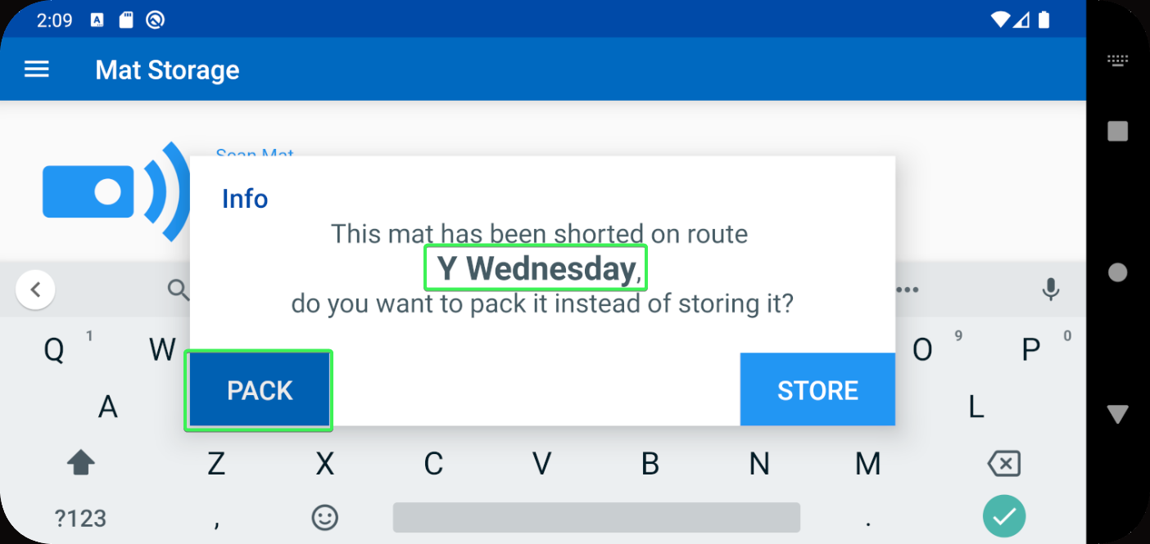
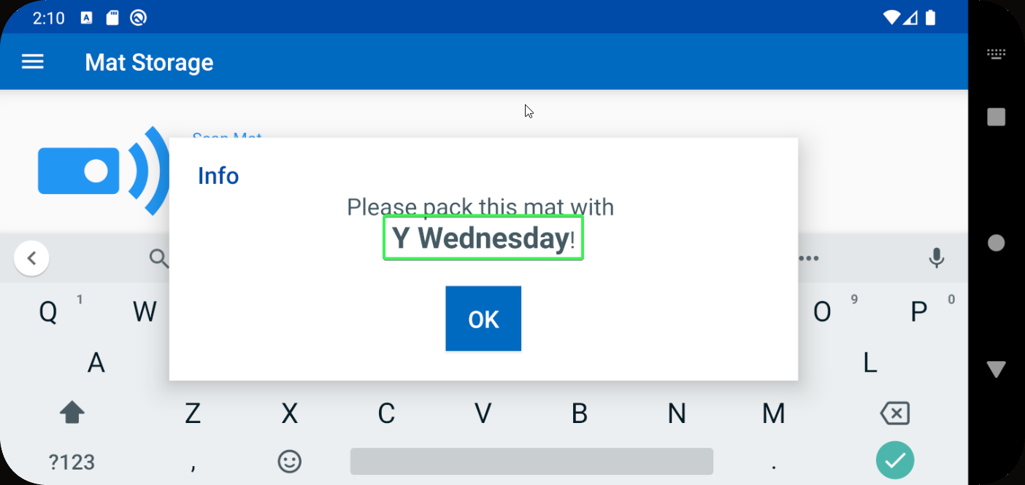
- BPA: Go back to Pack > your route and see that the Mat in no longer shorted
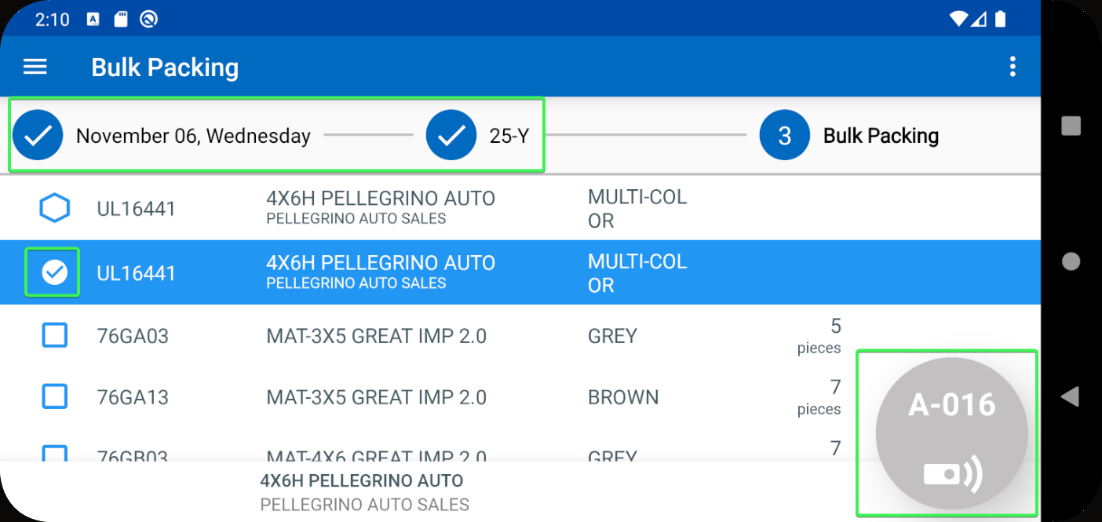
Tested OK

Test Case 3 – BPAPACKBYSTOP = 0 Have a customer with multiple B days (every weekday), have two routes in BPA PACK with the same customer and short the same mat on both then scan in store and pack it
Hash: 9.07.00.UNF18 hash: 1f0d60b2802d + BulkPackingAssistant_v2.13.INTERNAL_TEST_ONLY.9f42064
Expected behavior: The mat is packed on the route that was shown in the pop-up
- System Settings: Have BPAPACKBYSTOP = 0
- Use the following select to find customers with Logo Mats
SELECT BU.CODE,
C.CUSTOMERNUMBER,
P.CODE AS PRODUCTCODE,
FM.CODE AS FMCODE,
UI.PRIMARYID,
(SELECT S.FACTORYDESCRIPTION FROM STAY S WHERE S.STAY_ID = UI.STAY_ID) AS STAY
FROM CUSTOMER C
JOIN PRODUCTLISTPERCUSTOMER PLPC
ON PLPC.CUSTOMER_ID = C.CUSTOMER_ID
JOIN PLPCEXTRAINFO PLPCE
ON PLPCE.PRODUCTLISTPERCUSTOMER_ID = PLPC.PRODUCTLISTPERCUSTOMER_ID
JOIN PRODUCT P
ON P.PRODUCT_ID = PLPC.PRODUCT_ID
JOIN FINISHINGMETHOD FM
ON FM.FINISHINGMETHOD_ID = PLPC.FINISHINGMETHOD_ID
JOIN UNIQUEITEM UI
ON UI.PRODUCT_ID = PLPC.PRODUCT_ID
AND UI.FINISHINGMETHOD_ID = PLPC.FINISHINGMETHOD_ID
AND UI.SIZEDEFINITION_ID = PLPC.SIZEDEFINITION_ID
AND PLPC.CUSTOMER_ID = UI.RELATEDCUSTOMER_ID
JOIN BUSINESSUNIT BU
ON BU.BUSINESSUNIT_ID = C.DEFAULTBUSINESSUNIT_ID
WHERE PLPC.DATEINACTIVE > SYSDATE
AND P.TYPEOFMERCHANDISE = 1
AND P.STOREACTIVESTOCKLOCATION = 'Y'
AND P.BULKPACKINGACTIVESTOCKTYPE = 1
AND BU.CODE = '055'
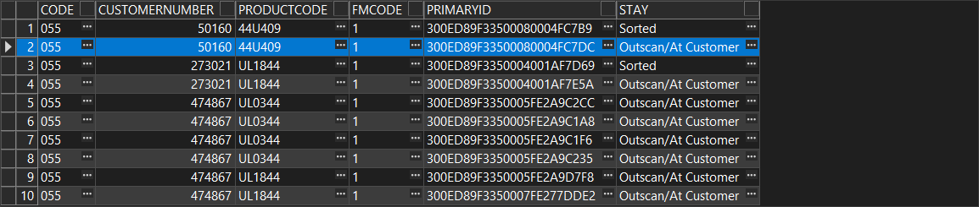
- PLPC DLG: See that the customer has multiple billing days for the Logo Mat
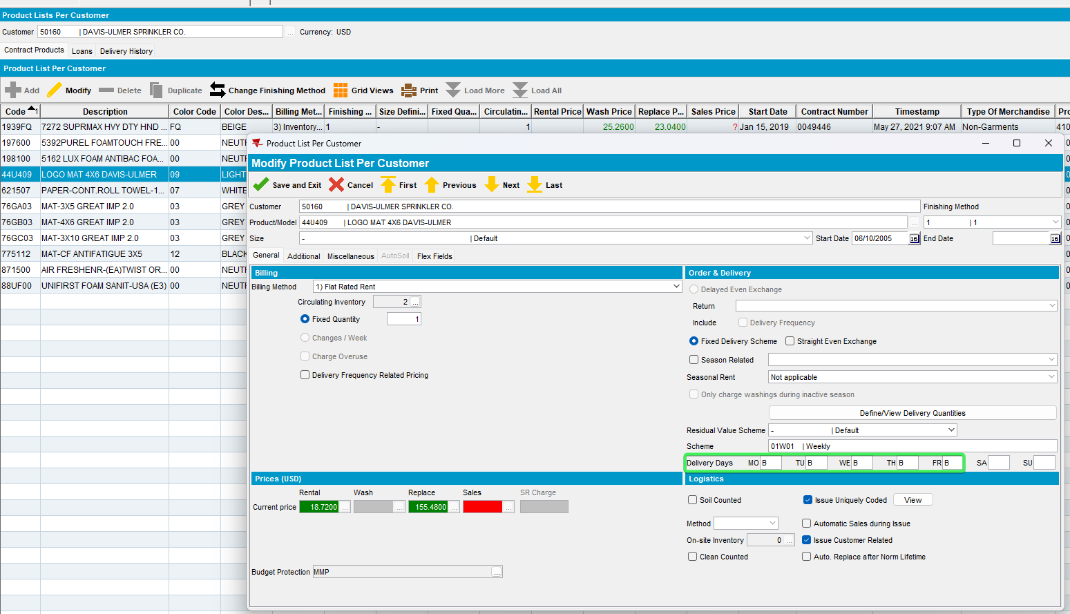
- Route Status Control DLG: Create 2 consecutive routecontrols for the same customer
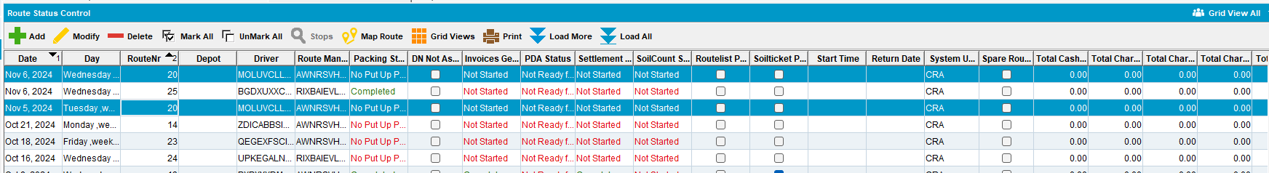
- RSC DLG: Generate Put up Docs for the 2 routes
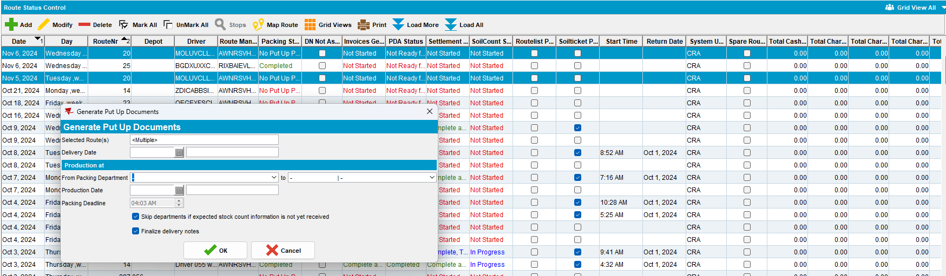
- Bulk Packing Assistant: Select Pack > Select the first day you created the route
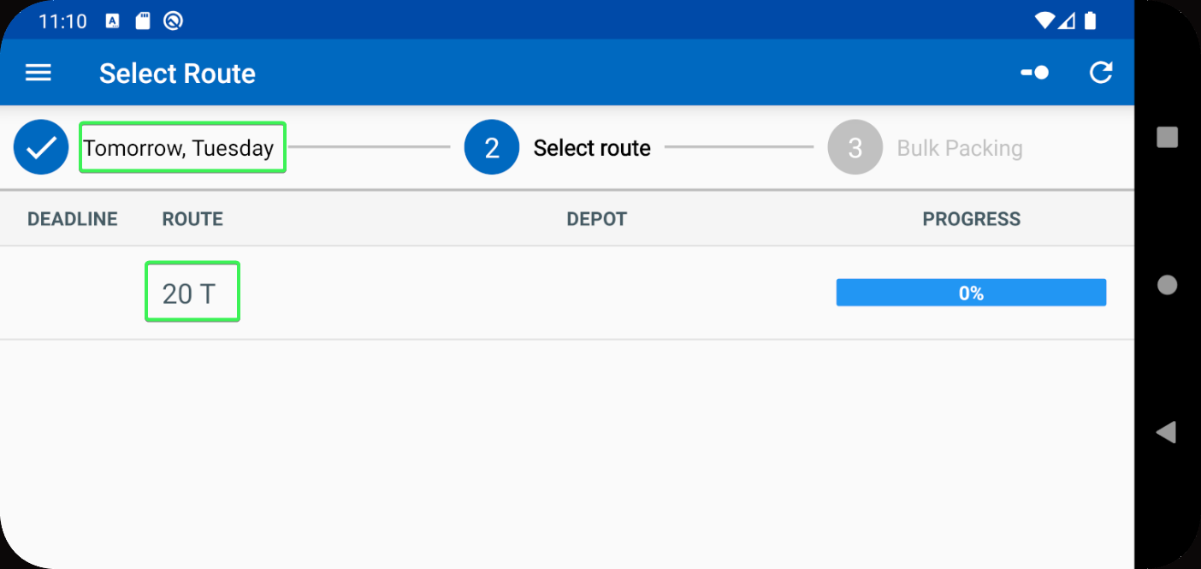
- BPA: Short the Logo mat from your customer
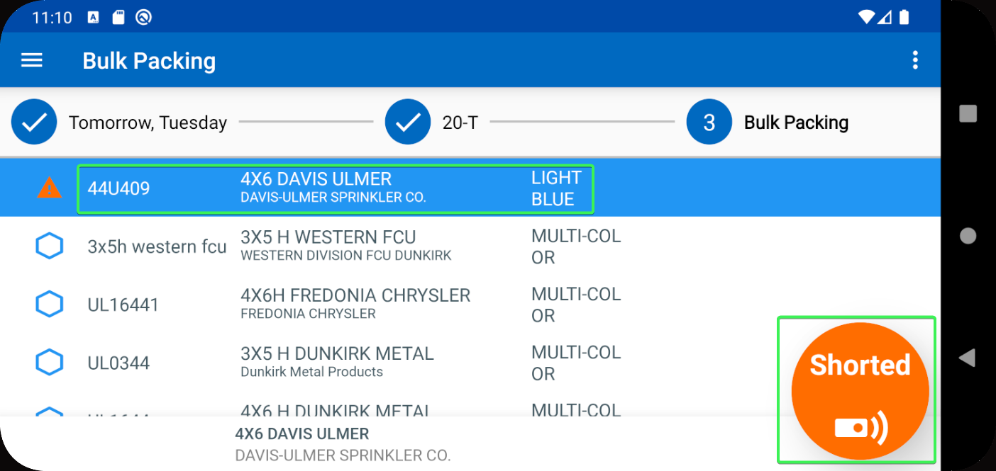
- BPA: Go on the route created the next day
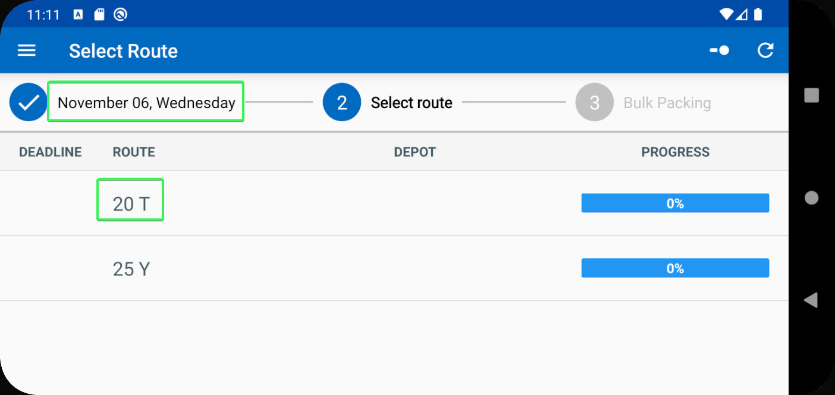
- BPA: Short the Logo mat from your customer
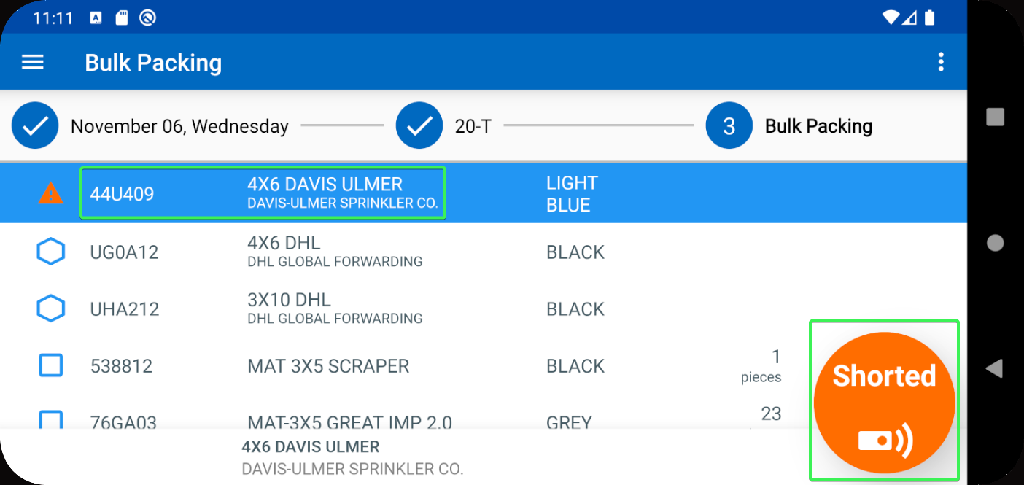
- PLPC DLG: Open your Logo Mat and note down on of the ID Codes
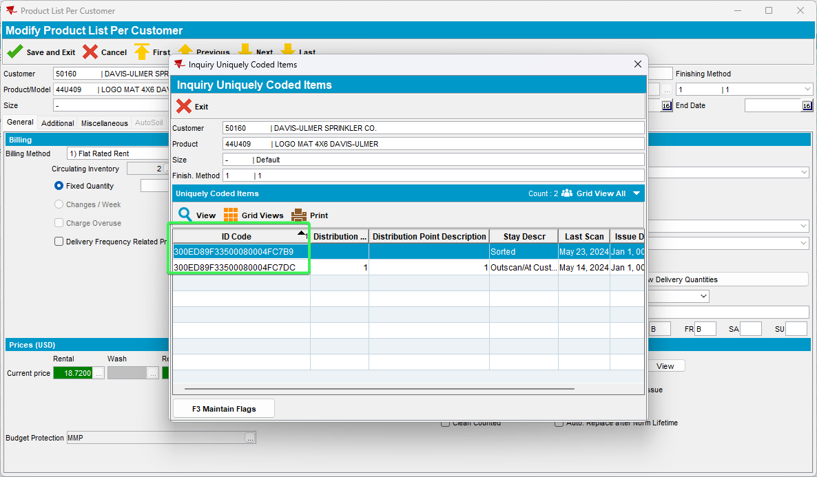
- BPA: Go to Store and scan the code from previous step
- See the mentioned day in the pop-up message and press “Pack”
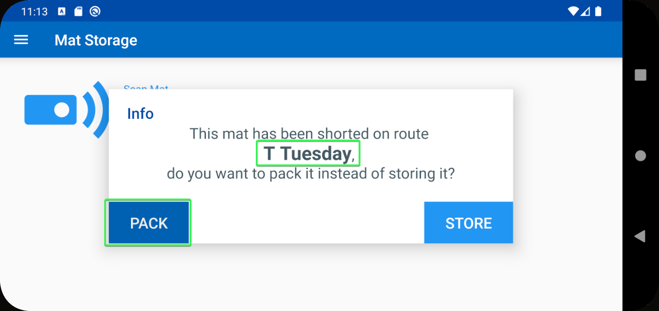
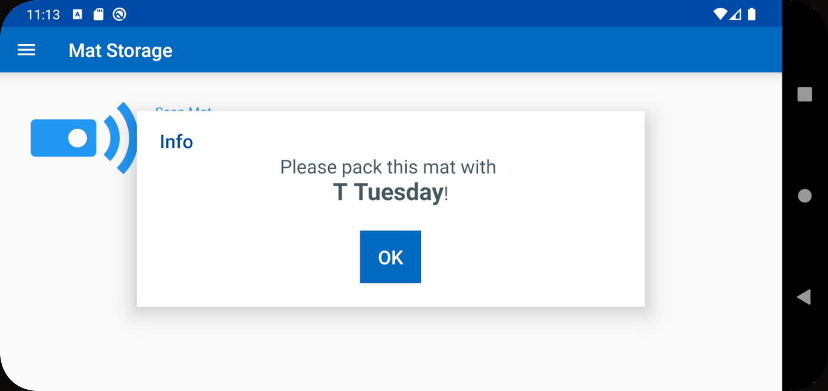
- BPA: Go back to Pack > Go to the route mentioned in the message (T Tuesday) and see that the Mat is no longer shorted
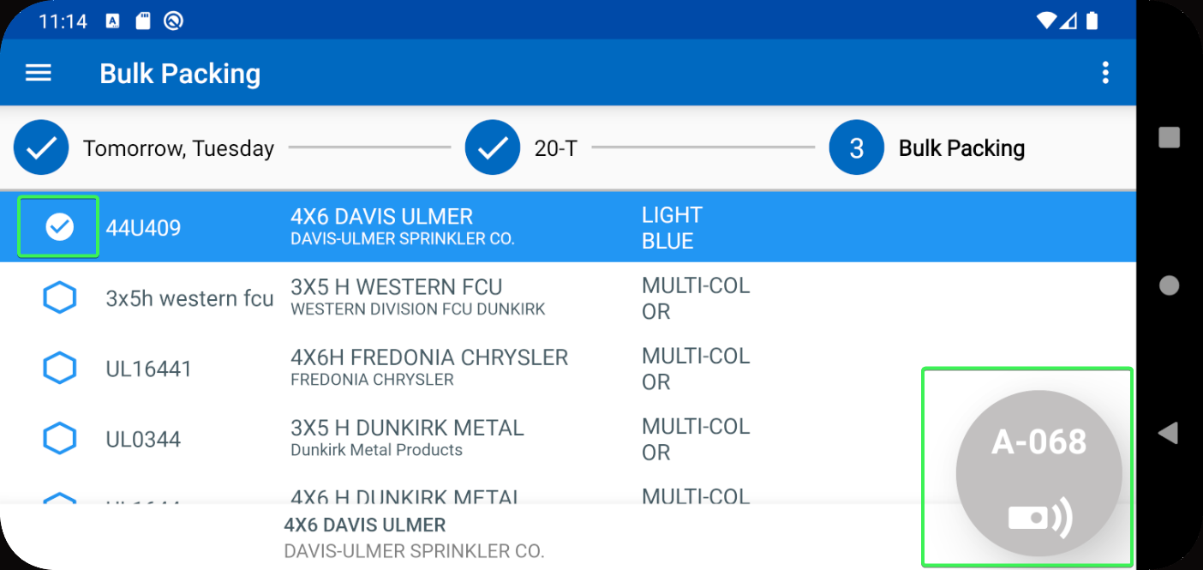
- BPA: Go to Store and scan the code
- See the mentioned day in the pop-up message and press “Pack”
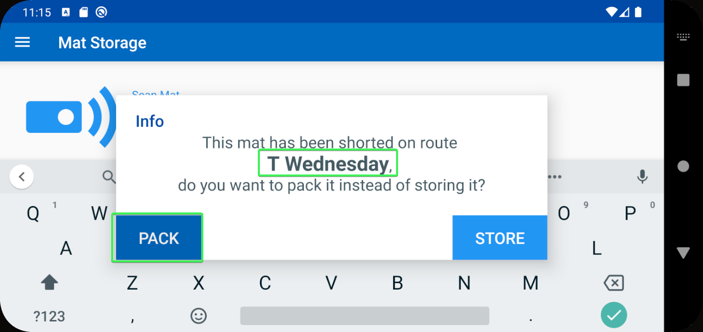
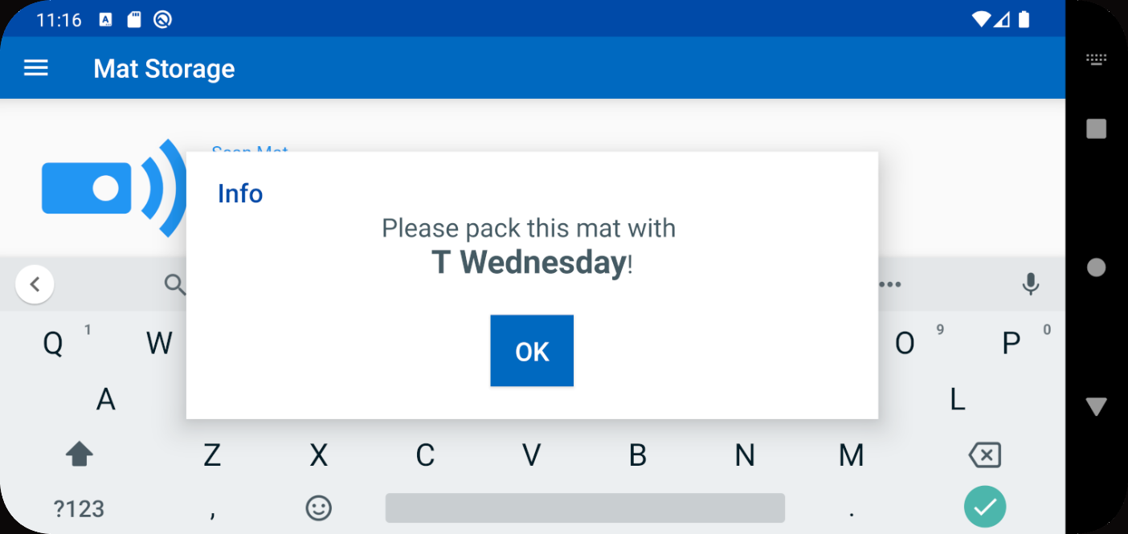
- BPA: Go back to Pack > Go to the route mentioned in the message (T Wednesday) and see that the Mat is no longer shorted
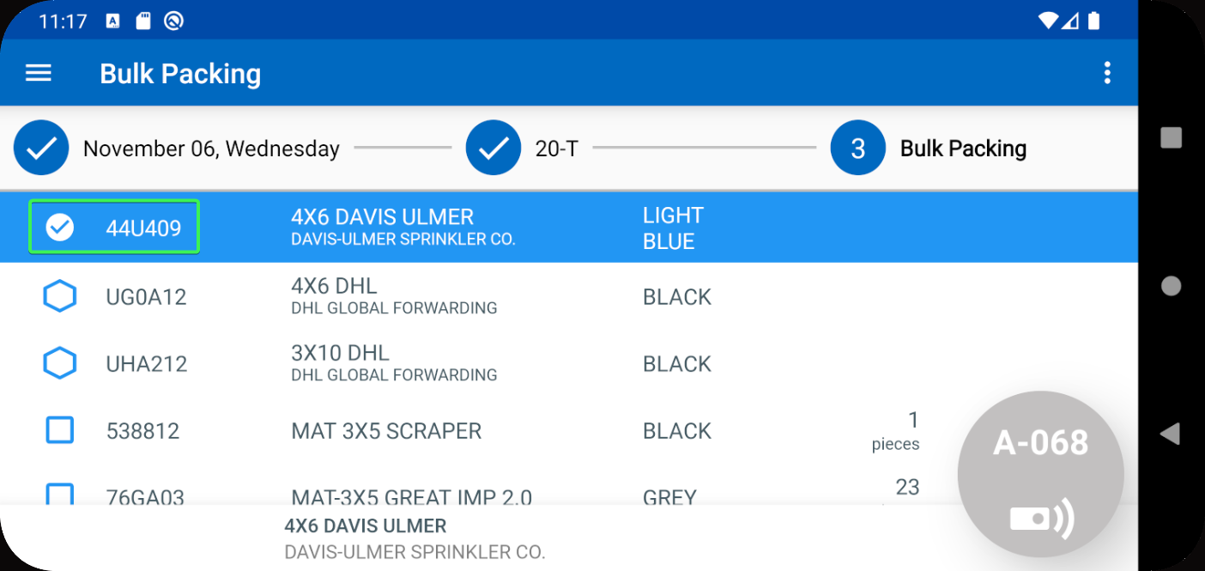
Tested OK

Test Case 4 – BPAPACKBYSTOP = 1 Scan a code of a mat that was shorted and choose store
Hash: 9.07.00.UNF18 hash: 1f0d60b2802d + BulkPackingAssistant_v2.13.INTERNAL_TEST_ONLY.9f42064
Expected behavior: The mat is stored, check in Active Stock Location
- System Settings: Have BPAPACKBYSTOP = 1
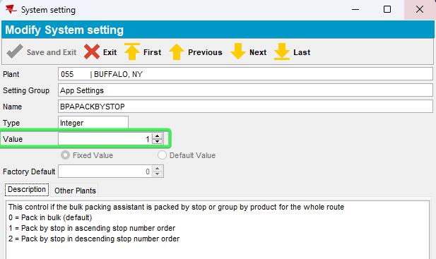
- Use the following select to find customers with Logo Mats
SELECT BU.CODE,
C.CUSTOMERNUMBER,
P.CODE AS PRODUCTCODE,
FM.CODE AS FMCODE,
UI.PRIMARYID,
(SELECT S.FACTORYDESCRIPTION FROM STAY S WHERE S.STAY_ID = UI.STAY_ID) AS STAY
FROM CUSTOMER C
JOIN PRODUCTLISTPERCUSTOMER PLPC
ON PLPC.CUSTOMER_ID = C.CUSTOMER_ID
JOIN PLPCEXTRAINFO PLPCE
ON PLPCE.PRODUCTLISTPERCUSTOMER_ID = PLPC.PRODUCTLISTPERCUSTOMER_ID
JOIN PRODUCT P
ON P.PRODUCT_ID = PLPC.PRODUCT_ID
JOIN FINISHINGMETHOD FM
ON FM.FINISHINGMETHOD_ID = PLPC.FINISHINGMETHOD_ID
JOIN UNIQUEITEM UI
ON UI.PRODUCT_ID = PLPC.PRODUCT_ID
AND UI.FINISHINGMETHOD_ID = PLPC.FINISHINGMETHOD_ID
AND UI.SIZEDEFINITION_ID = PLPC.SIZEDEFINITION_ID
AND PLPC.CUSTOMER_ID = UI.RELATEDCUSTOMER_ID
JOIN BUSINESSUNIT BU
ON BU.BUSINESSUNIT_ID = C.DEFAULTBUSINESSUNIT_ID
WHERE PLPC.DATEINACTIVE > SYSDATE
AND P.TYPEOFMERCHANDISE = 1
AND P.STOREACTIVESTOCKLOCATION = 'Y'
AND P.BULKPACKINGACTIVESTOCKTYPE = 1
AND BU.CODE = '055'
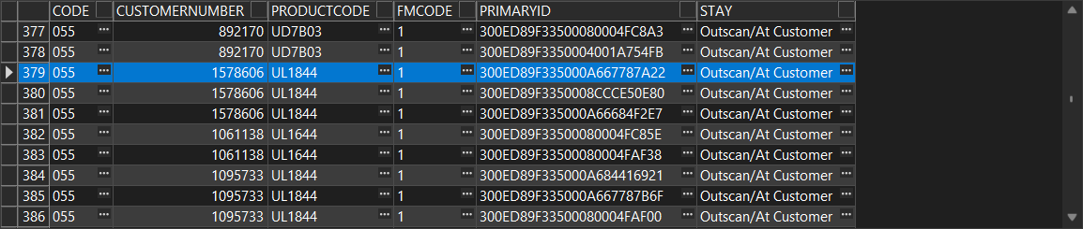
- Customers DLG: See the route and delivery day
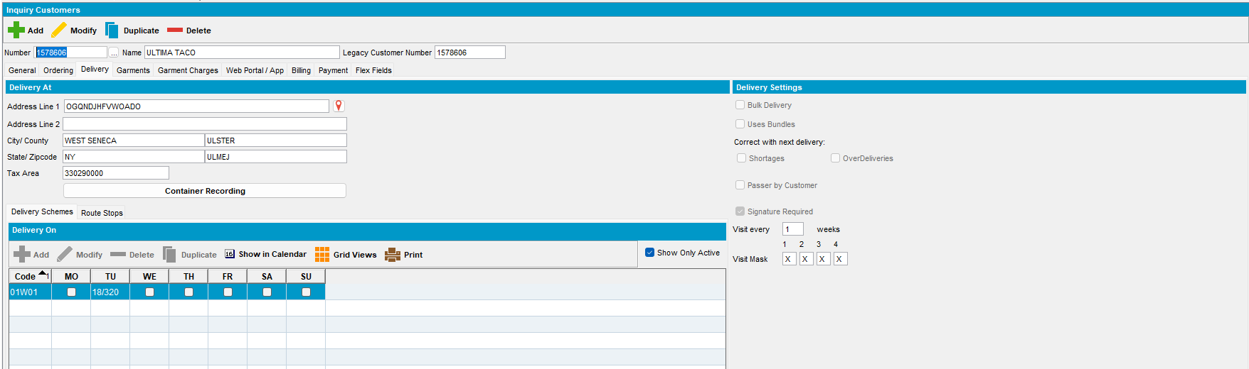
- Route Status Control DLG: Add a new routecontrol for that day and route
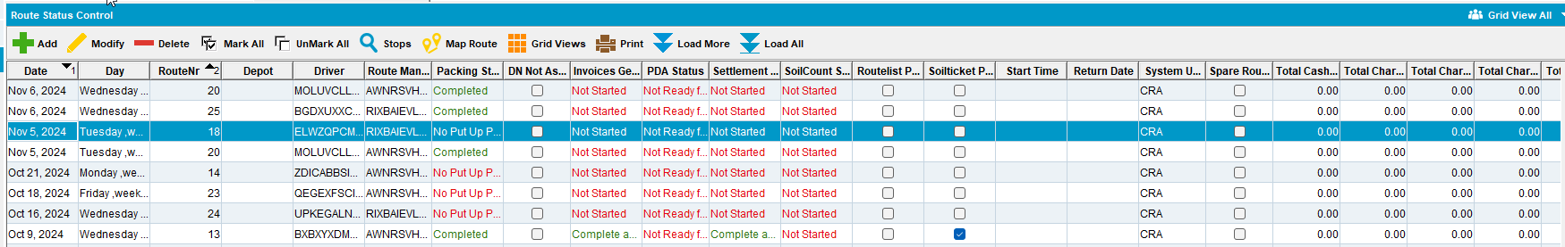
- Route Status Control DLG: Generate Put Up doc
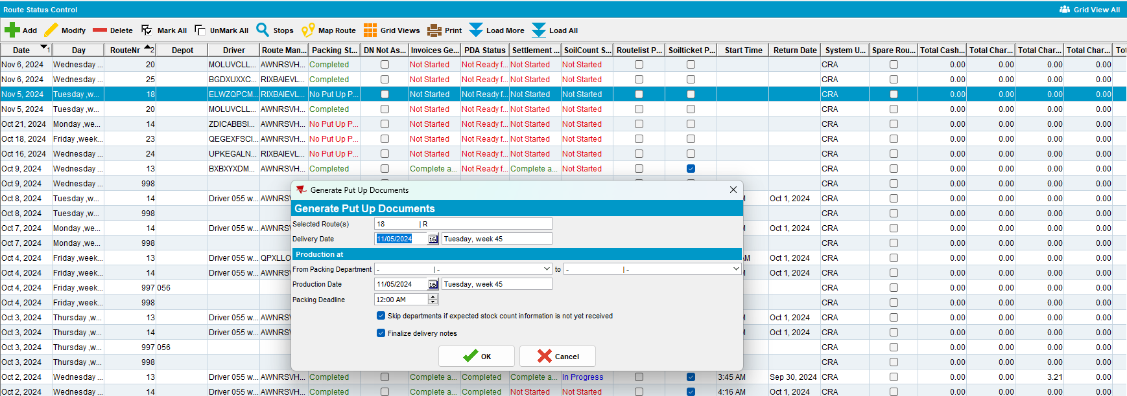
- Bulk Packing Assistant: Select Pack > Select the day on which you created the route > Select the Route
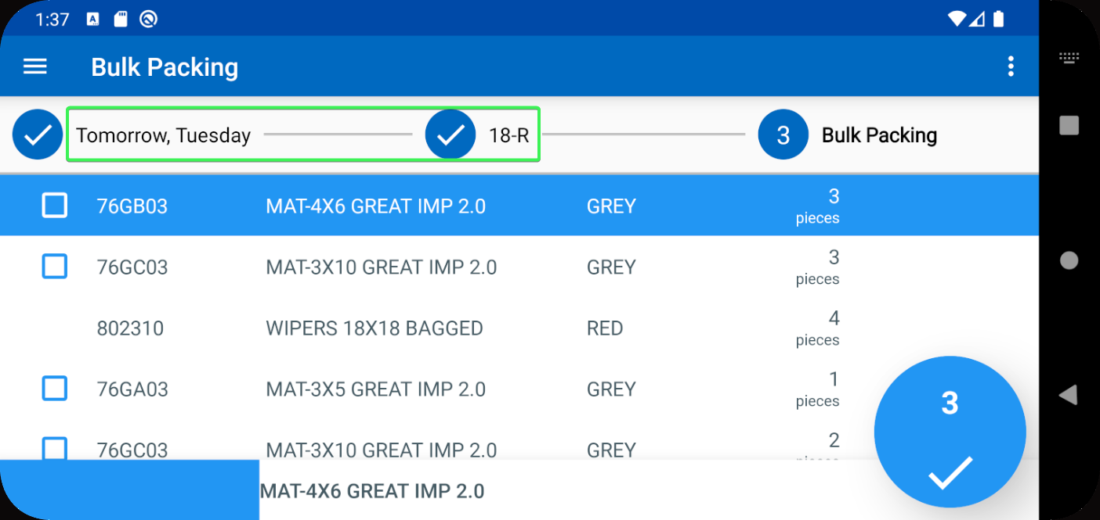
- BPA: Short the Logo mat from your customer
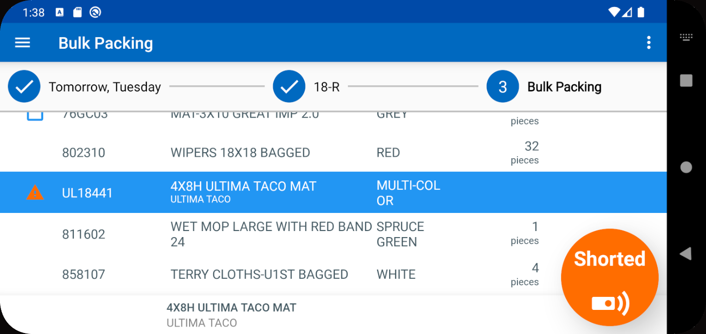
- Product List Per Customer DLG: Input your customer and press modify on your Product > Press View button in Logistics tab
- Note one of the ID Codes
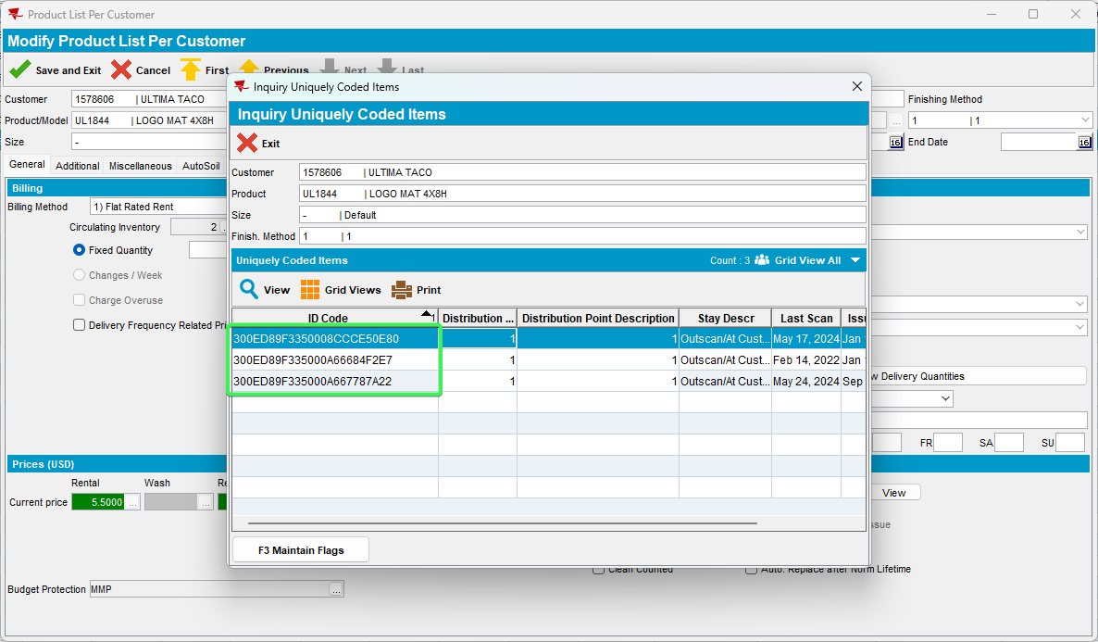
- BPA: Go to Store and scan the previous noted code
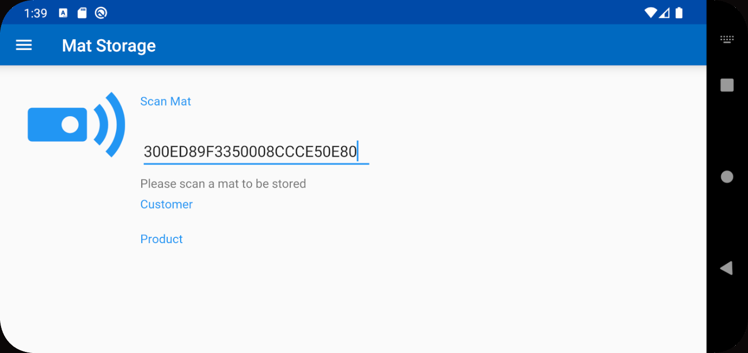
- Press Store when asked if you want to pack or store the shorted mat
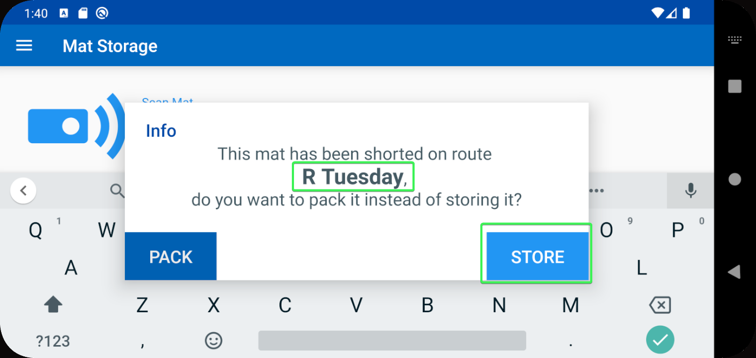
- Press the Locker button in the bottom right corner
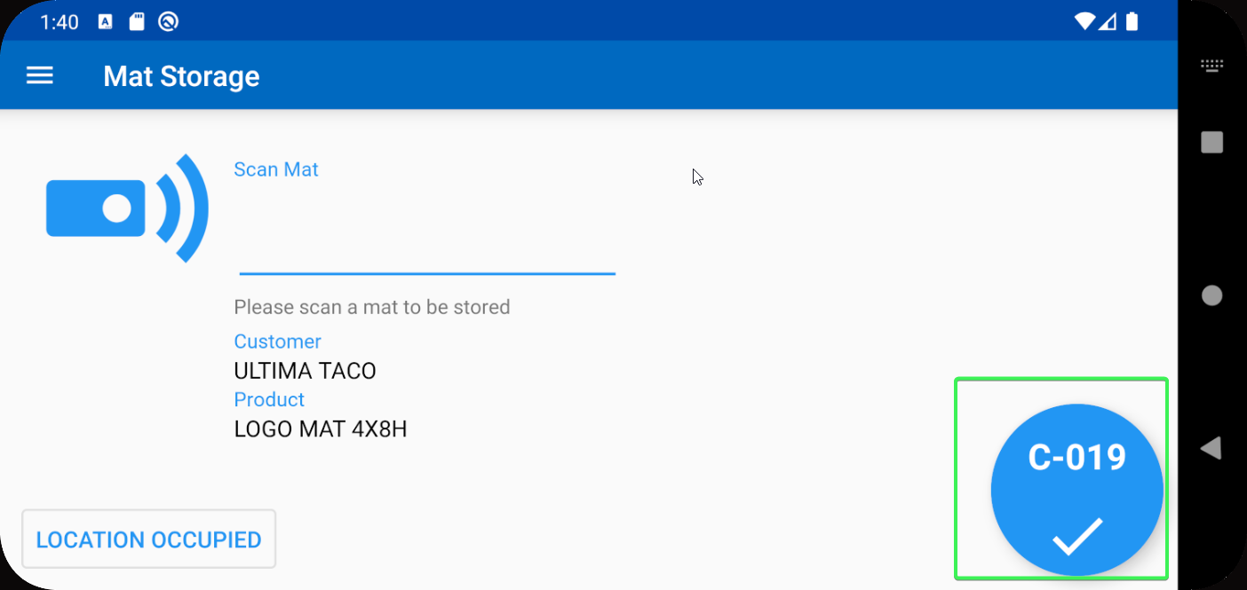
- Active Stock Location DLG: See if the Mat has been indeed stored in the indicated location
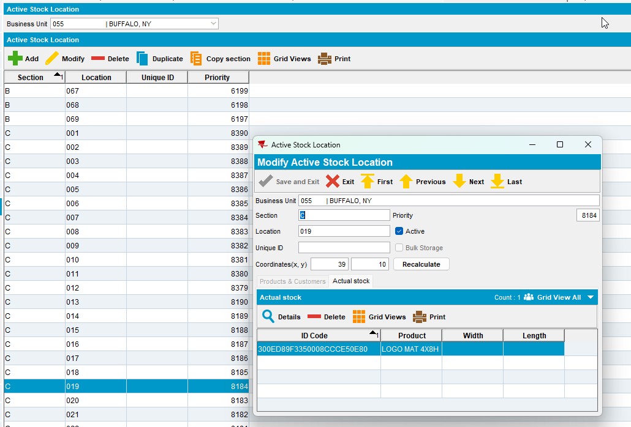
Tested OK

Test Case 5 – BPAPACKBYSTOP = 1 Scan a code of a mat that was shorted and choose pack
Hash: 9.07.00.UNF18 hash: 1f0d60b2802d + BulkPackingAssistant_v2.13.INTERNAL_TEST_ONLY.9f42064

Expected behavior: The mat is packed on the route, you can check the route in the pack menu and see that the mat is no longer shorted
- System Settings: Have BPAPACKBYSTOP = 1
- Use the following select to find customers with Logo Mats
SELECT BU.CODE,
C.CUSTOMERNUMBER,
P.CODE AS PRODUCTCODE,
FM.CODE AS FMCODE,
UI.PRIMARYID,
(SELECT S.FACTORYDESCRIPTION FROM STAY S WHERE S.STAY_ID = UI.STAY_ID) AS STAY
FROM CUSTOMER C
JOIN PRODUCTLISTPERCUSTOMER PLPC
ON PLPC.CUSTOMER_ID = C.CUSTOMER_ID
JOIN PLPCEXTRAINFO PLPCE
ON PLPCE.PRODUCTLISTPERCUSTOMER_ID = PLPC.PRODUCTLISTPERCUSTOMER_ID
JOIN PRODUCT P
ON P.PRODUCT_ID = PLPC.PRODUCT_ID
JOIN FINISHINGMETHOD FM
ON FM.FINISHINGMETHOD_ID = PLPC.FINISHINGMETHOD_ID
JOIN UNIQUEITEM UI
ON UI.PRODUCT_ID = PLPC.PRODUCT_ID
AND UI.FINISHINGMETHOD_ID = PLPC.FINISHINGMETHOD_ID
AND UI.SIZEDEFINITION_ID = PLPC.SIZEDEFINITION_ID
AND PLPC.CUSTOMER_ID = UI.RELATEDCUSTOMER_ID
JOIN BUSINESSUNIT BU
ON BU.BUSINESSUNIT_ID = C.DEFAULTBUSINESSUNIT_ID
WHERE PLPC.DATEINACTIVE > SYSDATE
AND P.TYPEOFMERCHANDISE = 1
AND P.STOREACTIVESTOCKLOCATION = 'Y'
AND P.BULKPACKINGACTIVESTOCKTYPE = 1
AND BU.CODE = '055'
- Customers DLG: See the route and delivery day
- Route Status Control DLG: Add a new routecontrol for that day and route
- Route Status Control DLG: Generate Put Up doc
- Bulk Packing Assistant: Select Pack > Select the day on which you created the route > Select the Route
- BPA: Short the Logo mat from your customer
- Product List Per Customer DLG: Input your customer and press modify on your Product > Press View button in Logistics tab
- Note one of the ID Codes
- BPA: Go to Store and scan the previous noted code

- Press Pack when asked if you want to pack or store the shorted mat
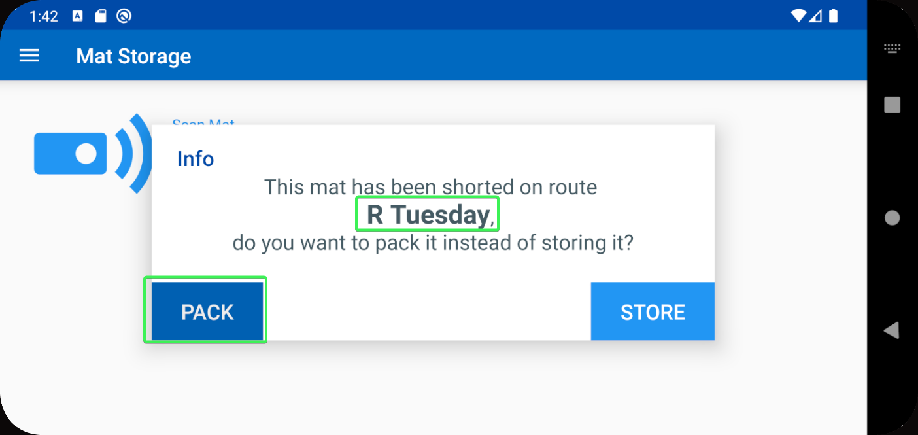
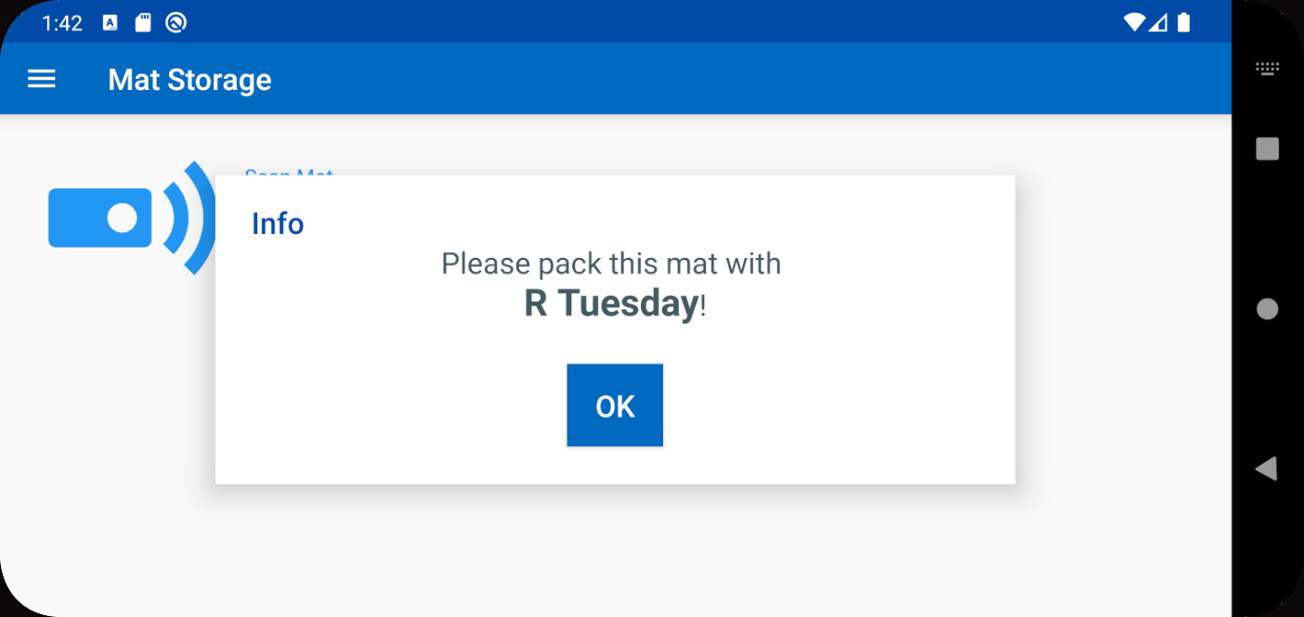
- BPA: Go back to Pack > your route and see that the Mat in no longer shorted
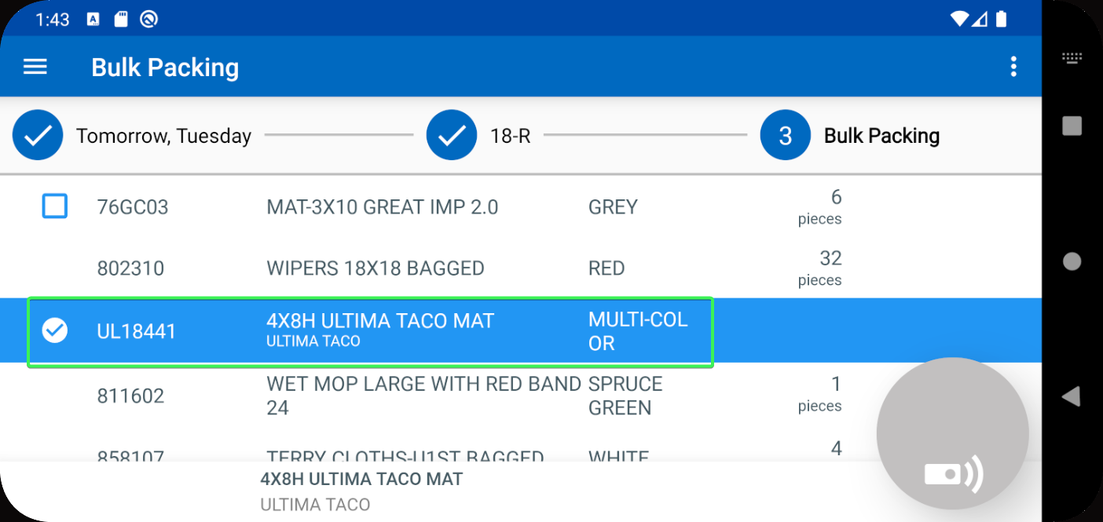
Tested OK

Test Case 6 – BPAPACKBYSTOP = 1 Have a customer with multiple B days (every weekday), have two routes in BPA PACK with the same customer and short the same mat on both then scan in store and pack it
Hash: 9.07.00.UNF18 hash: 1f0d60b2802d + BulkPackingAssistant_v2.13.INTERNAL_TEST_ONLY.9f42064
Expected behavior: The mat is packed on the route that was shown in the pop-up
- System Settings: Have BPAPACKBYSTOP = 1
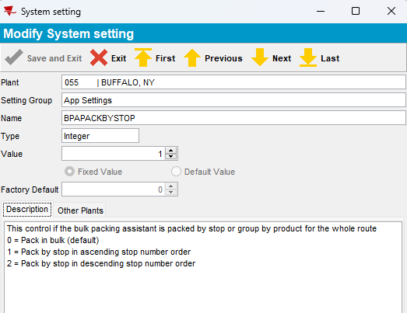
- Use the following select to find customers with Logo Mats
SELECT BU.CODE,
C.CUSTOMERNUMBER,
P.CODE AS PRODUCTCODE,
FM.CODE AS FMCODE,
UI.PRIMARYID,
(SELECT S.FACTORYDESCRIPTION FROM STAY S WHERE S.STAY_ID = UI.STAY_ID) AS STAY
FROM CUSTOMER C
JOIN PRODUCTLISTPERCUSTOMER PLPC
ON PLPC.CUSTOMER_ID = C.CUSTOMER_ID
JOIN PLPCEXTRAINFO PLPCE
ON PLPCE.PRODUCTLISTPERCUSTOMER_ID = PLPC.PRODUCTLISTPERCUSTOMER_ID
JOIN PRODUCT P
ON P.PRODUCT_ID = PLPC.PRODUCT_ID
JOIN FINISHINGMETHOD FM
ON FM.FINISHINGMETHOD_ID = PLPC.FINISHINGMETHOD_ID
JOIN UNIQUEITEM UI
ON UI.PRODUCT_ID = PLPC.PRODUCT_ID
AND UI.FINISHINGMETHOD_ID = PLPC.FINISHINGMETHOD_ID
AND UI.SIZEDEFINITION_ID = PLPC.SIZEDEFINITION_ID
AND PLPC.CUSTOMER_ID = UI.RELATEDCUSTOMER_ID
JOIN BUSINESSUNIT BU
ON BU.BUSINESSUNIT_ID = C.DEFAULTBUSINESSUNIT_ID
WHERE PLPC.DATEINACTIVE > SYSDATE
AND P.TYPEOFMERCHANDISE = 1
AND P.STOREACTIVESTOCKLOCATION = 'Y'
AND P.BULKPACKINGACTIVESTOCKTYPE = 1
AND BU.CODE = '055'
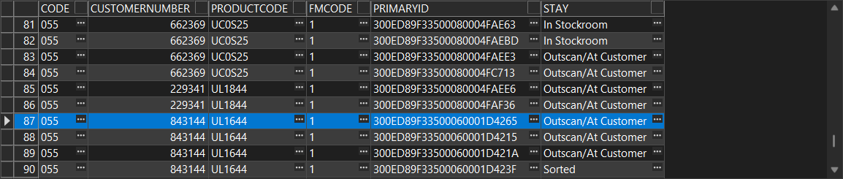
- PLPC DLG: See that the customer has multiple billing days for the Logo Mat
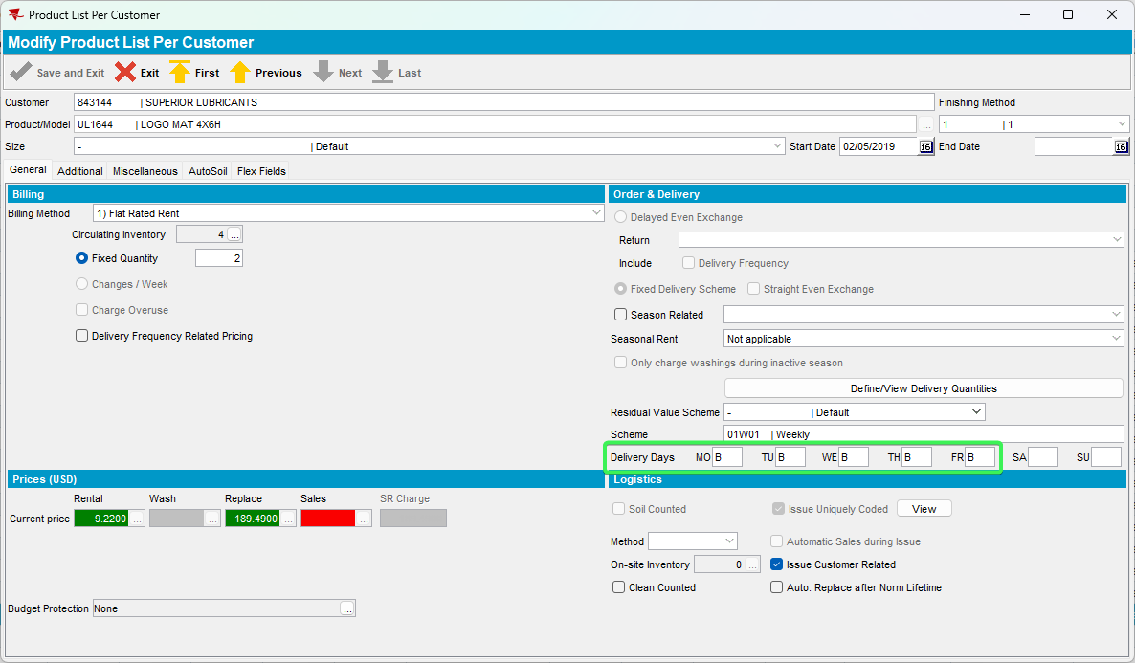
- Route Status Control DLG: Create 2 consecutive routecontrols for the same customer
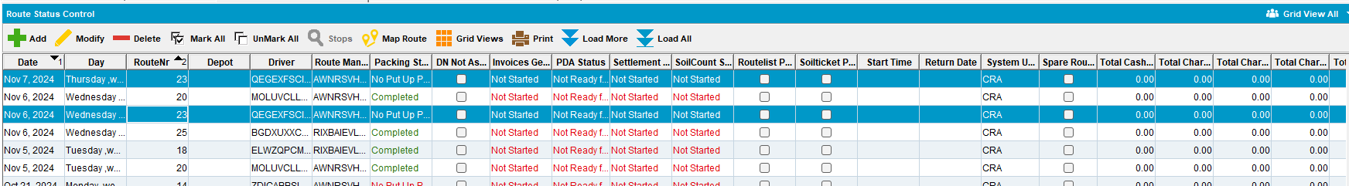
- RSC DLG: Generate Put up Docs for the 2 routes
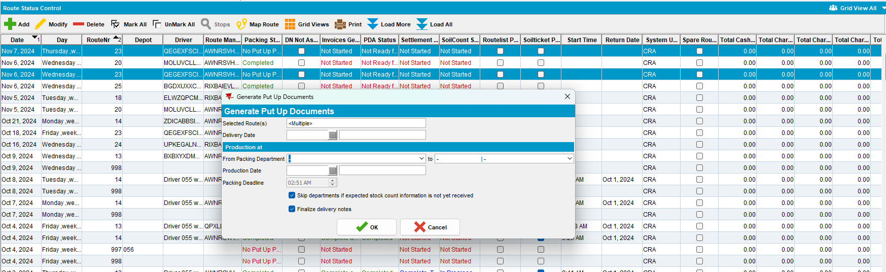
- Bulk Packing Assistant: Select Pack > Select the first day you created the route
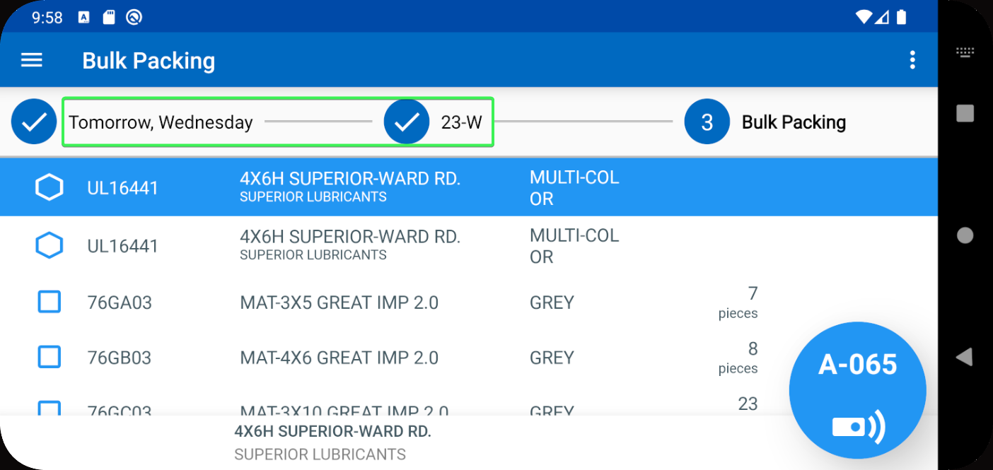
- BPA: Short the Logo mat from your customer
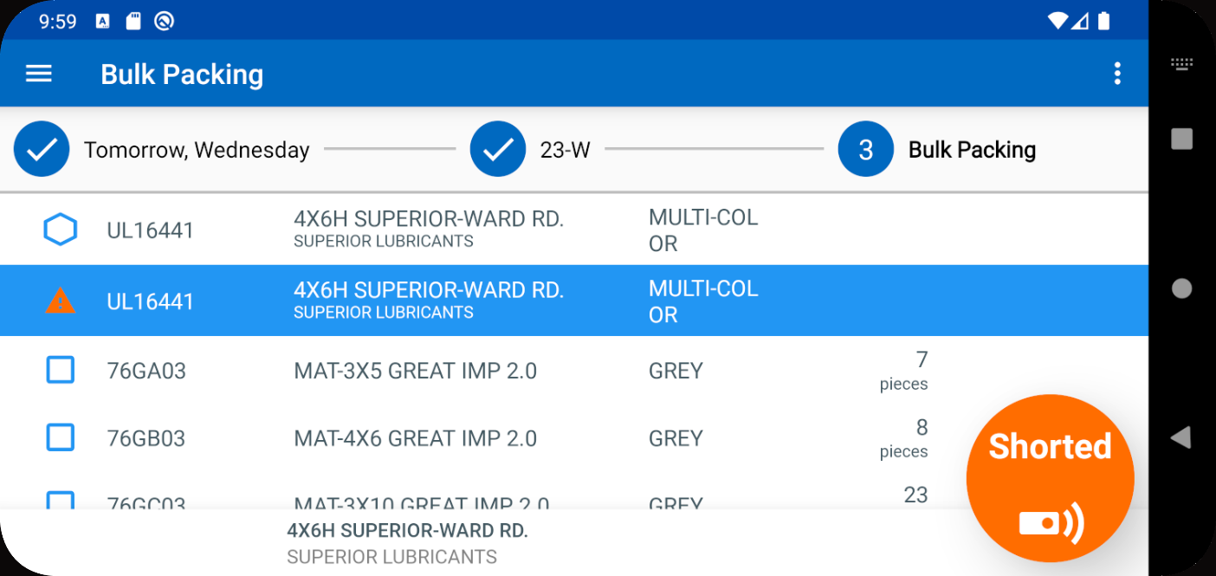
- BPA: Go on the route created the next day
- BPA: Short the Logo mat from your customer
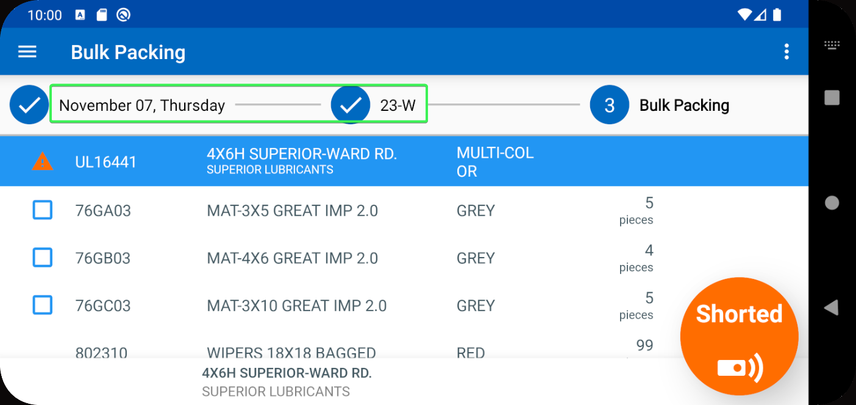
- PLPC DLG: Open your Logo Mat and note down on of the ID Codes
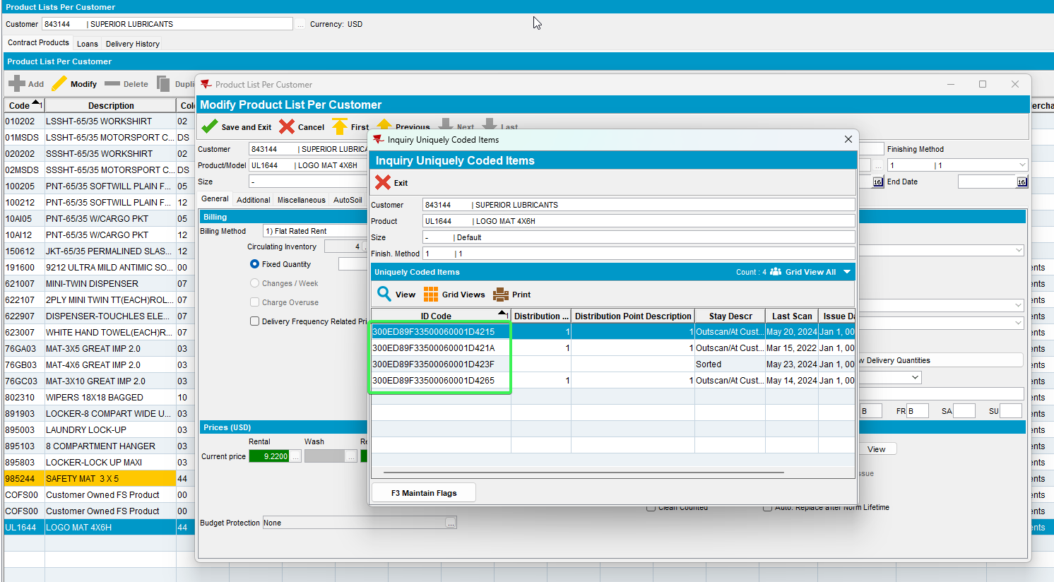
- BPA: Go to Store and scan the code from previous step
- See the mentioned day in the pop-up message and press “Pack”
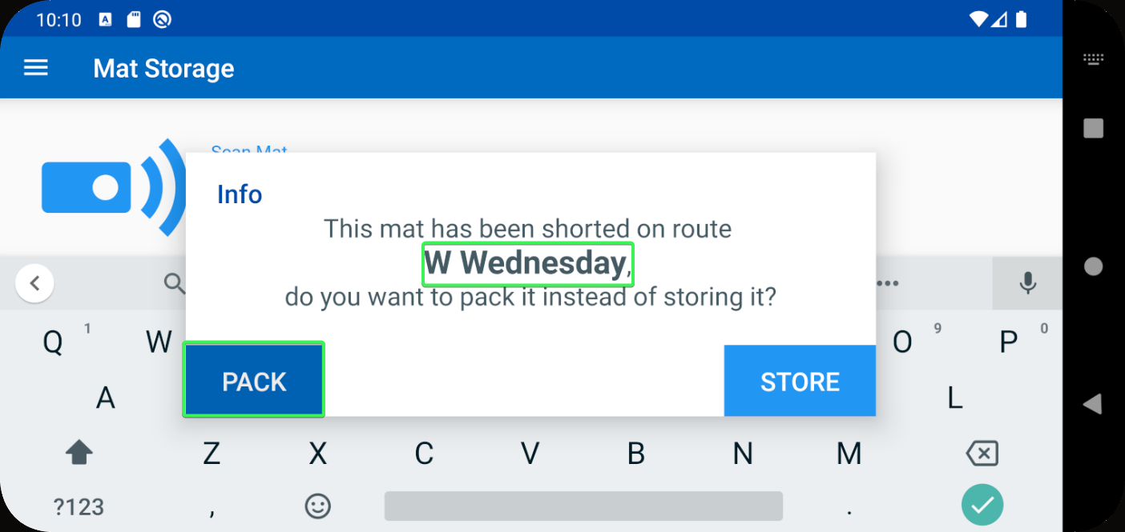
- BPA: Go back to Pack > Go to the route mentioned in the message (W Wednesday) and see that the Mat is no longer shorted
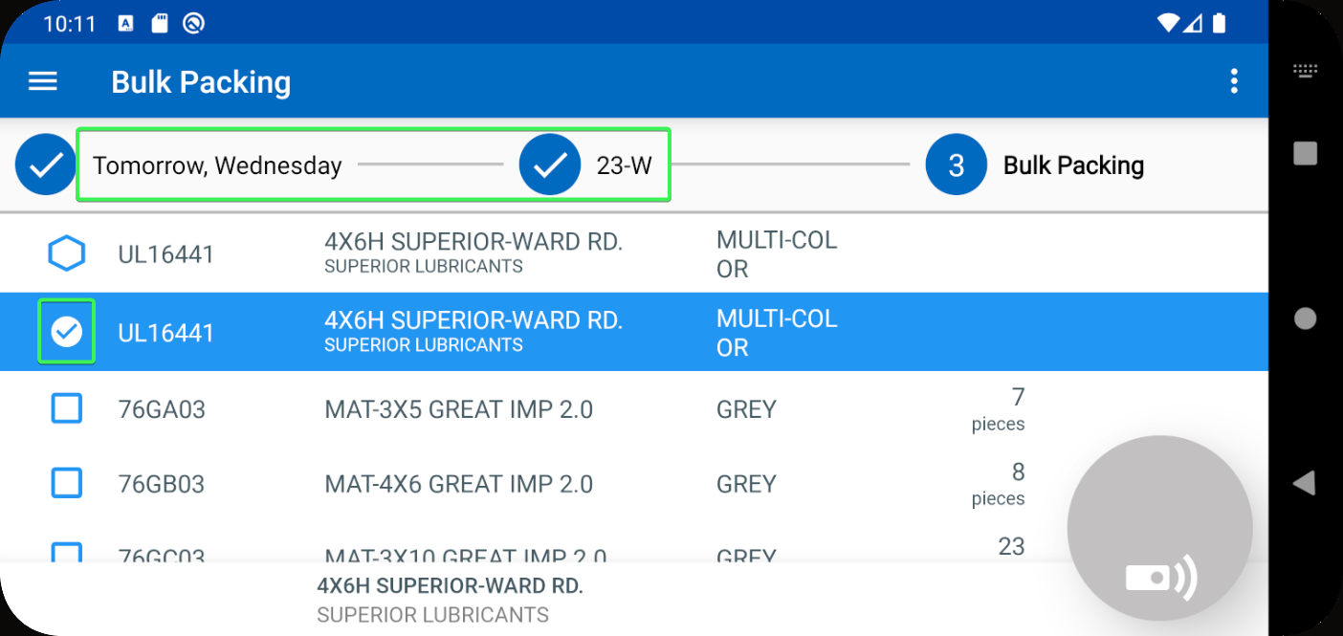
- BPA: Go to Store and scan a second code
- See the mentioned day in the pop-up message and press “Pack”
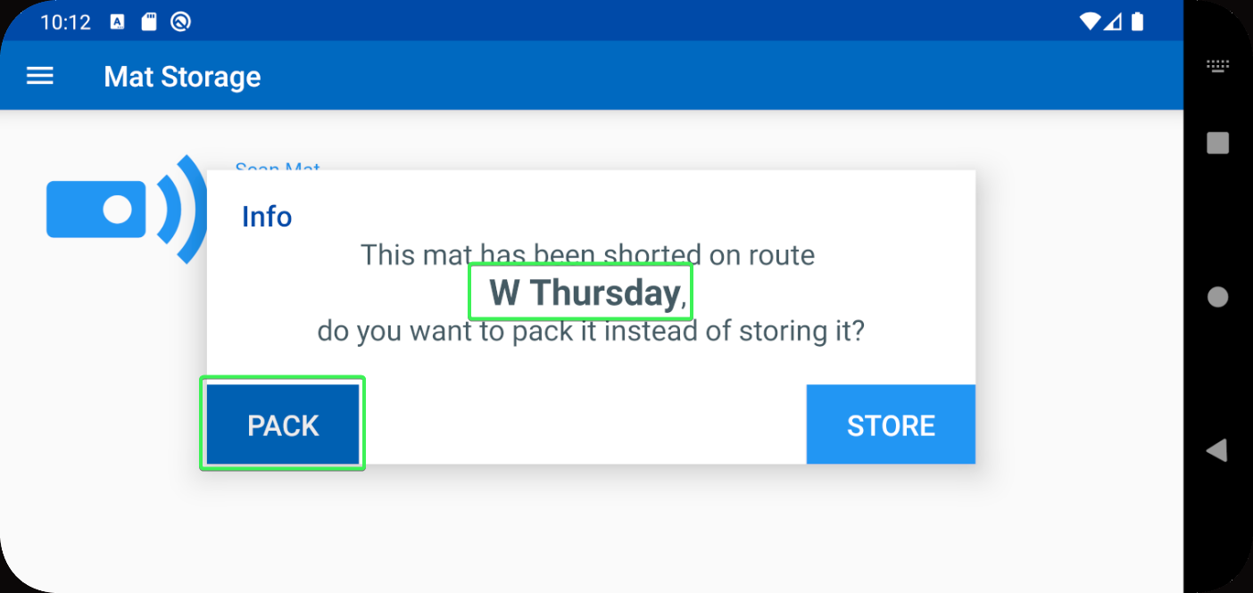
- BPA: Go back to Pack > Go to the route mentioned in the message (W Thursday) and see that the Mat is no longer shorted
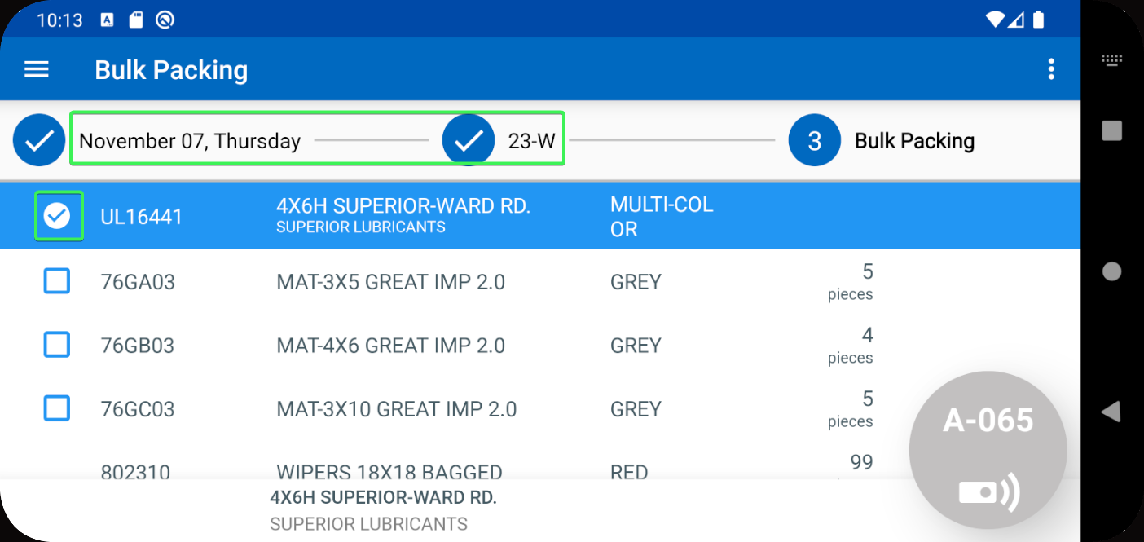
Tested OK

