ABSN-93 Do NOT update RCEI.FINALIZATIONSTATUS when invoices are canceled
Environment | Prerequisites
Version:9.07.00.UNF19  DBServerName=abs-SRV20.internal.abslbs.com  DBSID=CUST24  DBUser=UNFDEV  DBPassword=UNFDEV  Environment=Test | - Module:  - System setting

Contents
Test after fix 1
Test Case 1 – RCEI.FinalizationStatus = 2 and PDA Status= Ready to transfer then Cancel Invoices from RSC– Tested OK 1
Test Case 2 – RCEI.FinalizationStatus = 1 and PDA Status= Not Ready to transfer then Cancel Invoices from RSC– Tested OK 4
Test Case 3 – RCEI.FinalizationStatus = 2 and PDA Status= Ready to transfer then Cancel all Invoices from Maintain Invoices for that route– Tested OK 7
Test Case 4 – Route 1: RCEI.FinalizationStatus = 2 and PDA Status= Ready to transfer | route 2: RCEI.FinalizationStatus = 1 and PDA Status= Not Ready to transfer | route 3: RCEI.FinalizationStatus = 0 and PDA Status= Not Ready to transfer then Cancel Invoices from RSC for all routes by multiselecting them– Tested OK 10

Test after fix

Test Case 1 – RCEI.FinalizationStatus = 2 and PDA Status= Ready to transfer then Cancel Invoices from RSC– Tested OK
Expected behavior: When invoices are canceled and the finalization status is 2 we should not update it to 0
Hash: 79b1cfc154c5
- Route Status Control DLG: Add a new route control
- Route Status Control DLG: Generate Packing Notes and finalize them
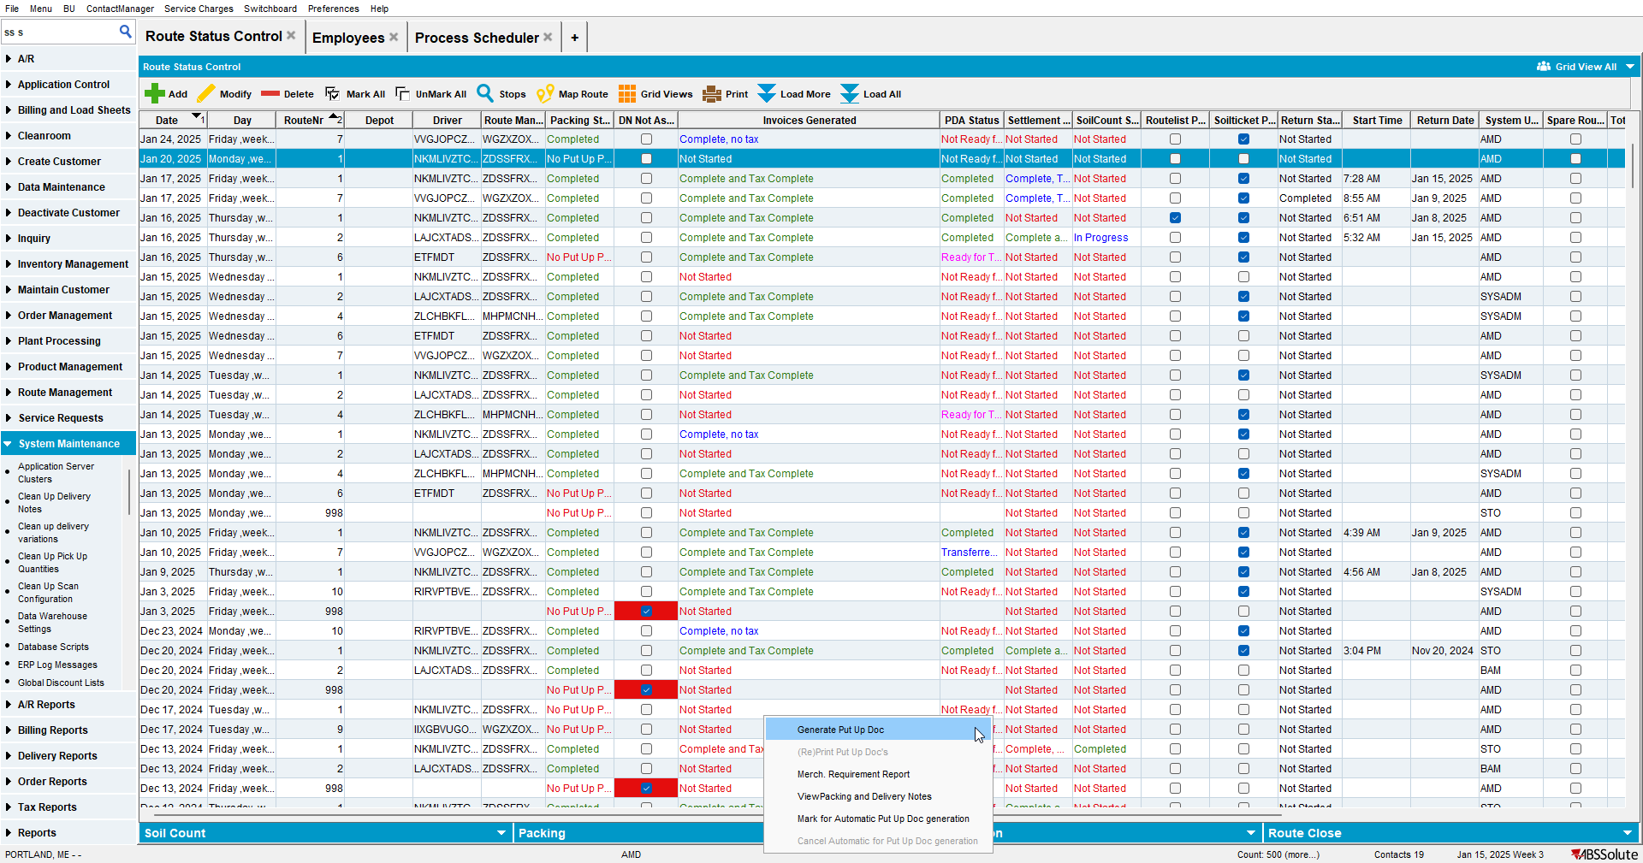

- Route Status Control DLG: Generate Invoices
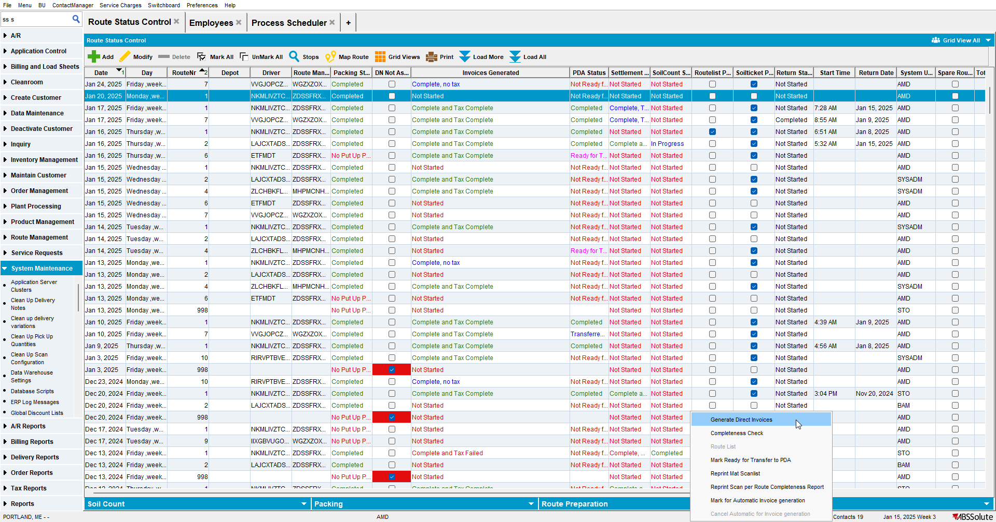

- Script in the BCI data and run the Vertex Tax Process Scheduler
- Process Scheduler DLG: Run the Cancel and regenerate US direct invoices for late delivery notes
- Check that the RCEI.FinalizationStatus = 2 for your routecontrol:
SELECT RCEI.FINALIZATIONSTATUS FROM ROUTECONTROLEXTRAINFO RCEI
WHERE RCEI.ROUTECONTROL_ID = (SELECT RC.ROUTECONTROL_ID
FROM ROUTECONTROL RC
JOIN ROUTE R
ON R.ROUTE_ID = RC.ROUTE_ID
JOIN PLANT P
ON P.PLANT_ID = R.PLANT_ID
WHERE RC.DRIVINGDATE = TO_DATE('20/01/2025', 'dd/mm/yyyy')
AND R.ROUTENUMBER = 1
AND P.CODE = '025')
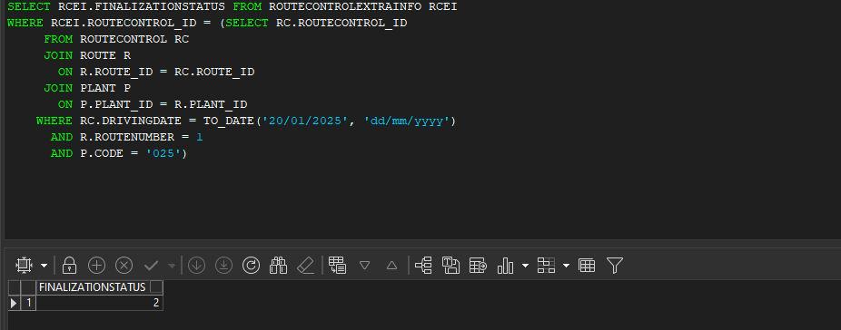

- Route Status Control DLG: Cancel invoices
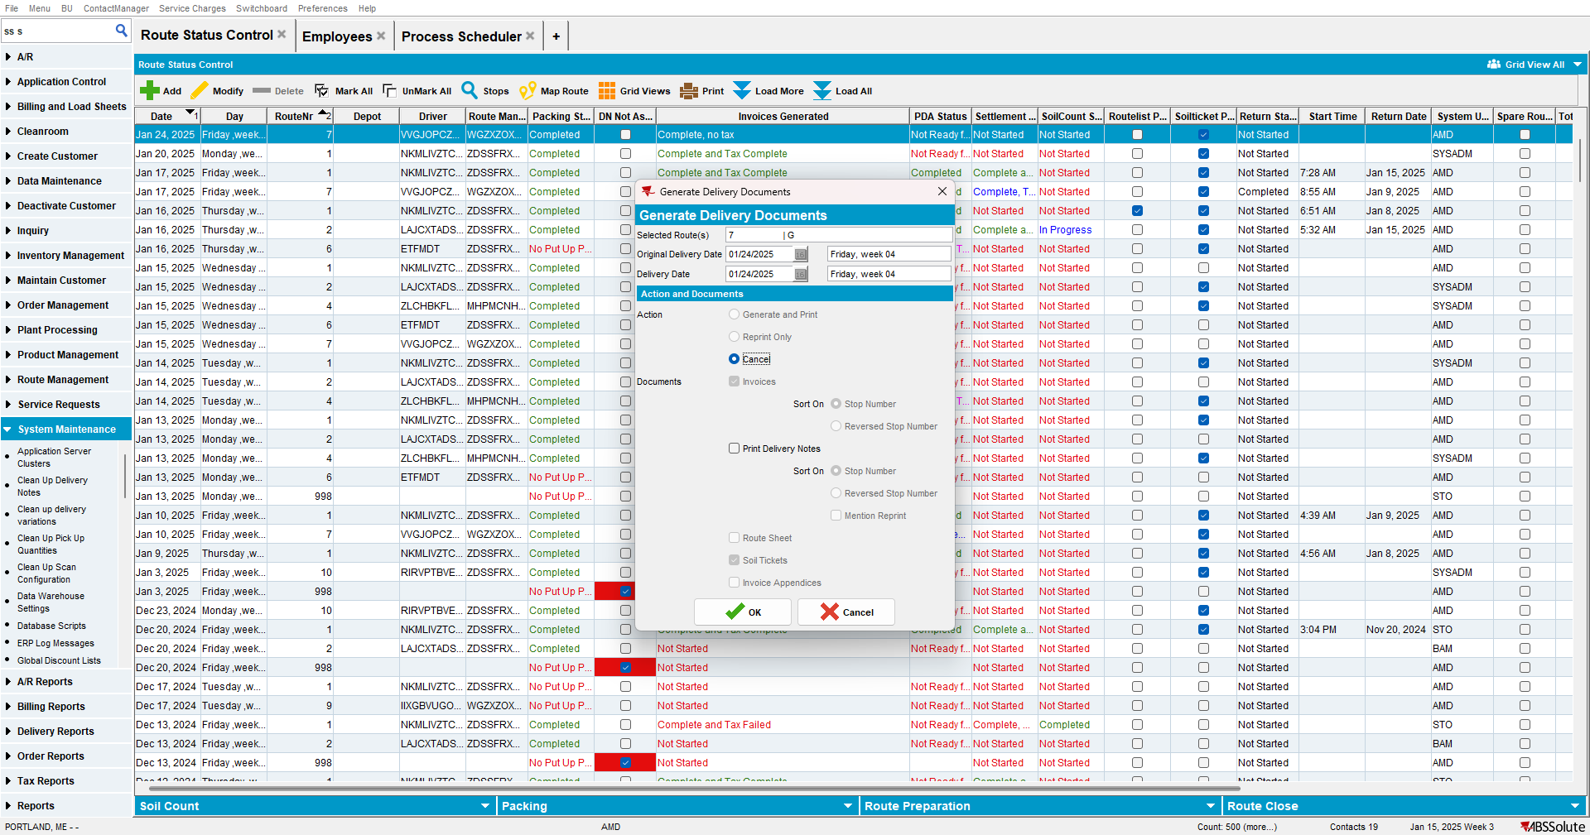
- Check that the RCEI.FinalizationStatus is still 2 for your routecontrol

Test Case 2 – RCEI.FinalizationStatus = 1 and PDA Status= Not Ready to transfer then Cancel Invoices from RSC– Tested OK
Expected behavior: When invoices are canceled and the finalization status is 1 we should not update it to 0.
Hash: 79b1cfc154c5
- Route Status Control DLG: Add a new route control
- Route Status Control DLG: Generate Packing Notes and finalize them
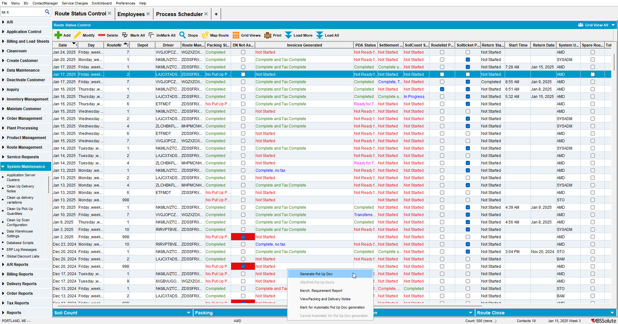

- Route Status Control DLG: Generate Invoices
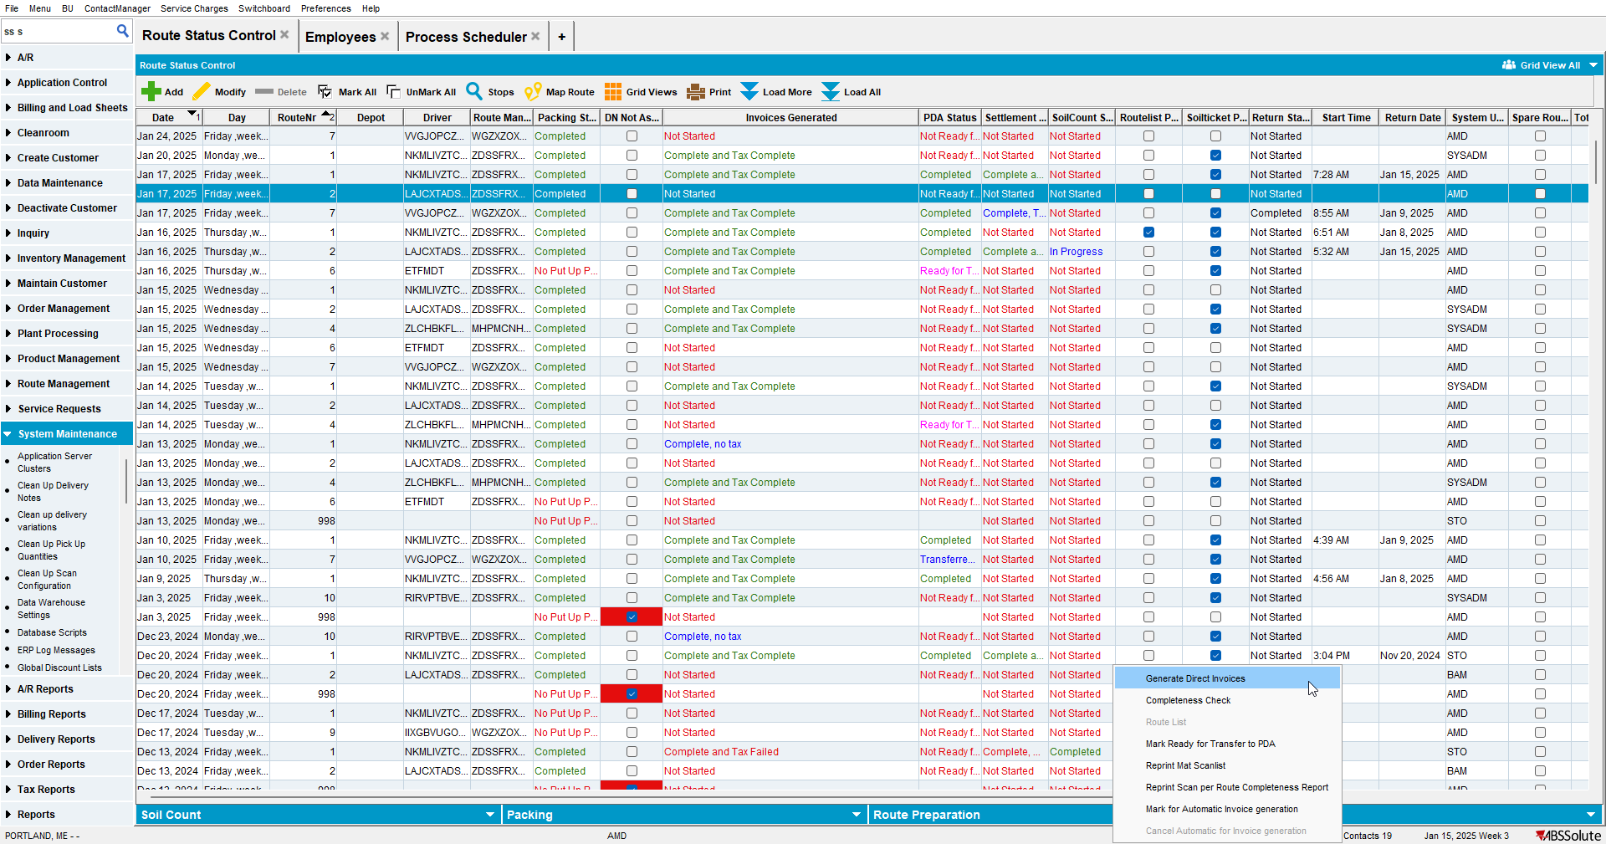
- Script in the BCI data and run the Vertex Tax Process Scheduler
- Set the RCEI.FinalizationStatus = 1 for your routecontrol:
SELECT RCEI.FINALIZATIONSTATUS FROM ROUTECONTROLEXTRAINFO RCEI
WHERE RCEI.ROUTECONTROL_ID = (SELECT RC.ROUTECONTROL_ID
FROM ROUTECONTROL RC
JOIN ROUTE R
ON R.ROUTE_ID = RC.ROUTE_ID
JOIN PLANT P
ON P.PLANT_ID = R.PLANT_ID
WHERE RC.DRIVINGDATE = TO_DATE('17/01/2025', 'dd/mm/yyyy')
AND R.ROUTENUMBER = 2
AND P.CODE = '025')
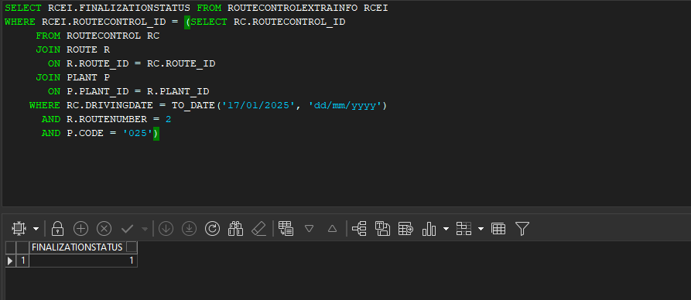

- Check that the route is NOT ready for transfer
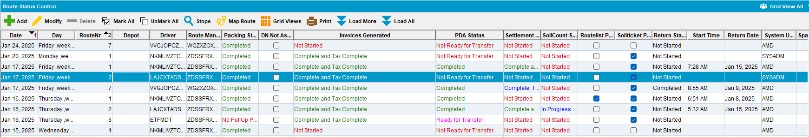

- Route Status Control DLG: Cancel invoices
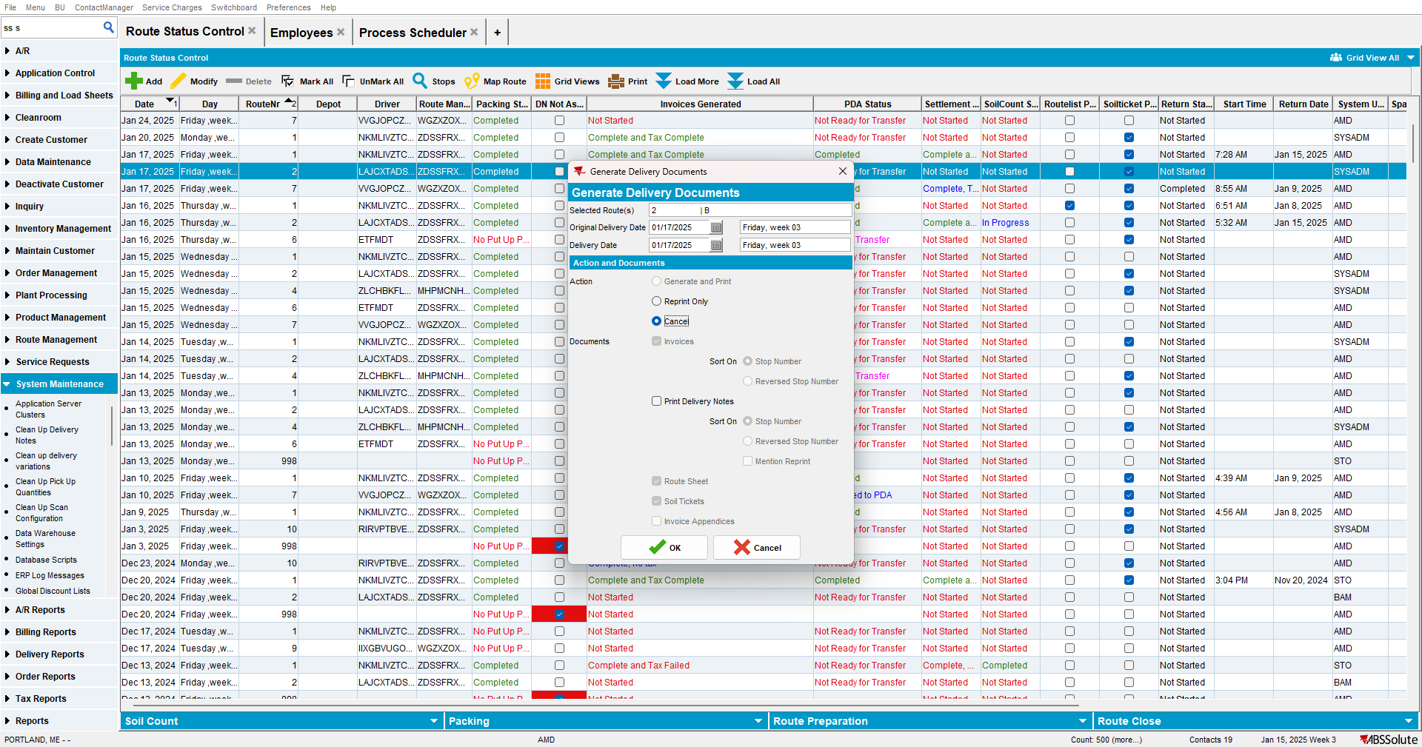
- Check that the RCEI.FinalizationStatus is still 1 for your routecontrol

Test Case 3 – RCEI.FinalizationStatus = 2 and PDA Status= Ready to transfer then Cancel all Invoices from Maintain Invoices for that route– Tested OK
Expected behavior: When invoices are canceled and the finalization status is 2 we should not update it to 0.
Hash: 79b1cfc154c5
- Route Status Control DLG: Add a new route control
- Route Status Control DLG: Generate Packing Notes and finalize them
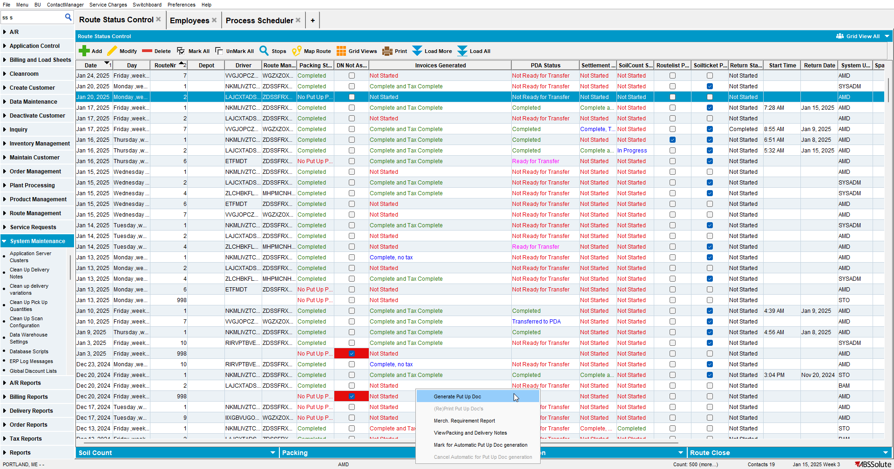
- Route Status Control DLG: Generate Invoices
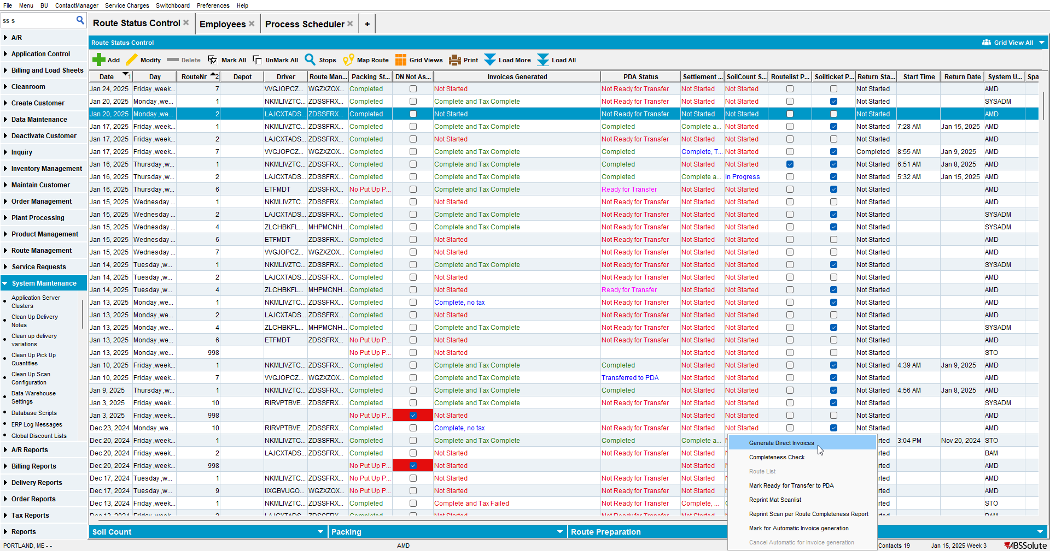
- Script in the BCI data and run the Vertex Tax Process Scheduler
- Process Scheduler DLG: Run the Cancel and regenerate US direct invoices for late delivery notes
- Check that the RCEI.FinalizationStatus = 2 for your routecontrol:
SELECT RCEI.FINALIZATIONSTATUS FROM ROUTECONTROLEXTRAINFO RCEI
WHERE RCEI.ROUTECONTROL_ID = (SELECT RC.ROUTECONTROL_ID
FROM ROUTECONTROL RC
JOIN ROUTE R
ON R.ROUTE_ID = RC.ROUTE_ID
JOIN PLANT P
ON P.PLANT_ID = R.PLANT_ID
WHERE RC.DRIVINGDATE = TO_DATE('20/01/2025', 'dd/mm/yyyy')
AND R.ROUTENUMBER = 2
AND P.CODE = '025')
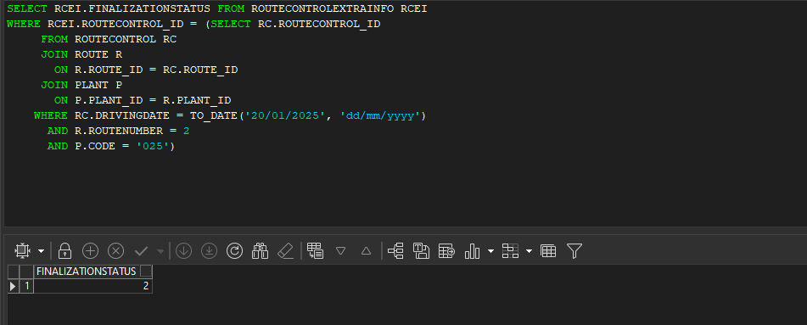
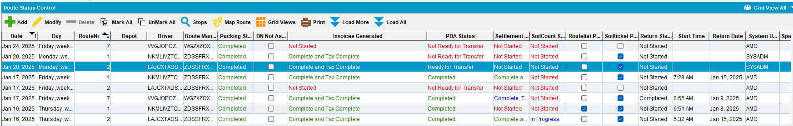

- Maintain invoices dlg: Cancel invoices
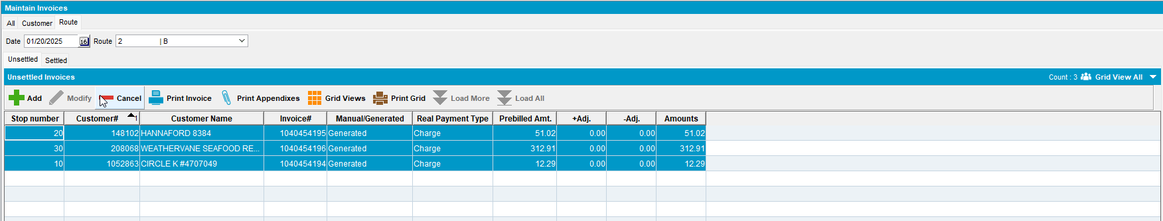

- Check that the RCEI.FinalizationStatus is still 2 for your routecontrol

Test Case 4 – Route 1: RCEI.FinalizationStatus = 2 and PDA Status= Ready to transfer | route 2: RCEI.FinalizationStatus = 1 and PDA Status= Not Ready to transfer | route 3: RCEI.FinalizationStatus = 0 and PDA Status= Not Ready to transfer then Cancel Invoices from RSC for all routes by multiselecting them– Tested OK
Expected behavior: When invoices are canceled and the finalization status is not updated
Hash: 79b1cfc154c5
- Route Status Control DLG: Add 3 route control
- Route Status Control DLG: Generate Packing Notes and finalize them and Generate Invoices for all 3
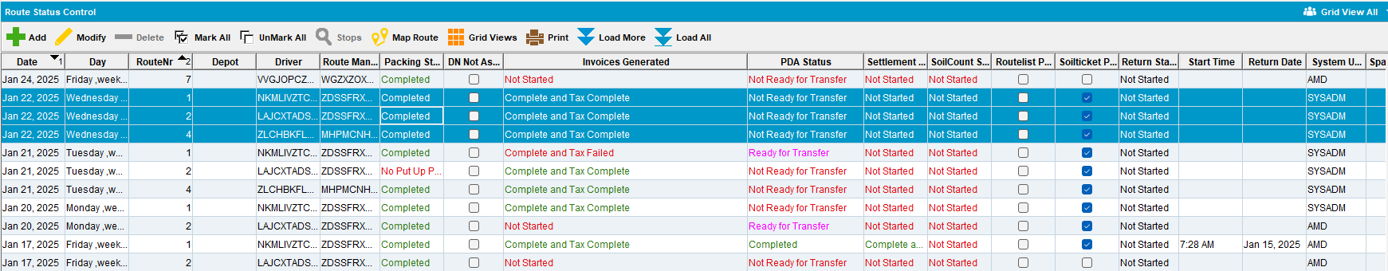
- Script in the BCI data and run the Vertex Tax Process Scheduler

- For 1st route have RCEI.FinalizationStatus = 2 and PDA Status= Ready to transfer
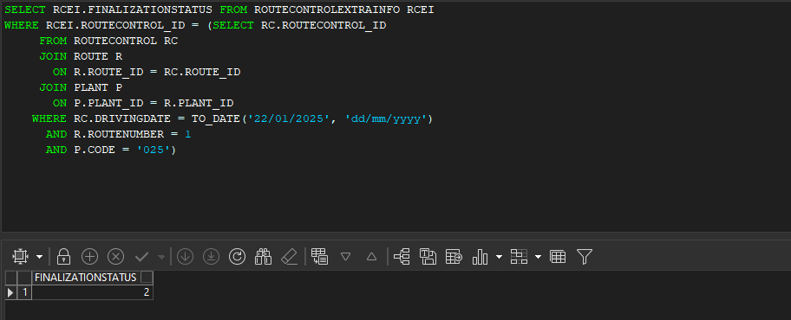
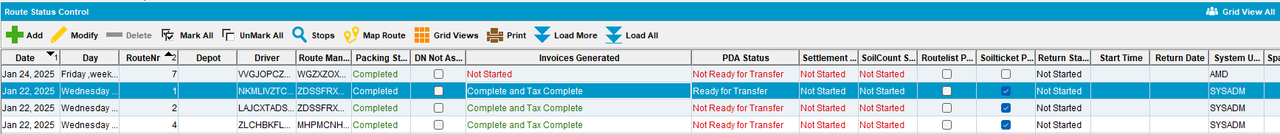

- For 2nd route have RCEI.FinalizationStatus = 1 and PDA Status= Not Ready to transfer
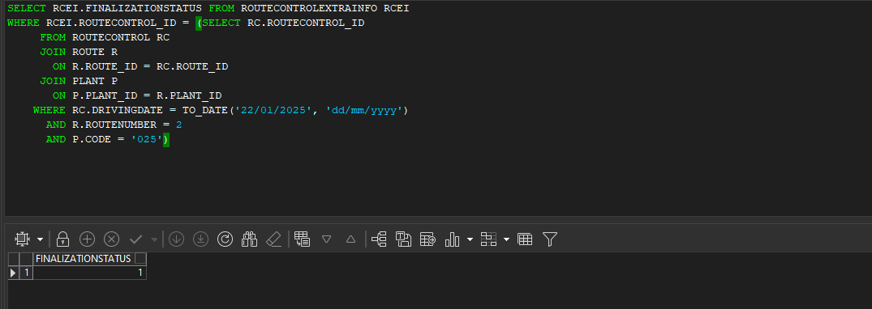
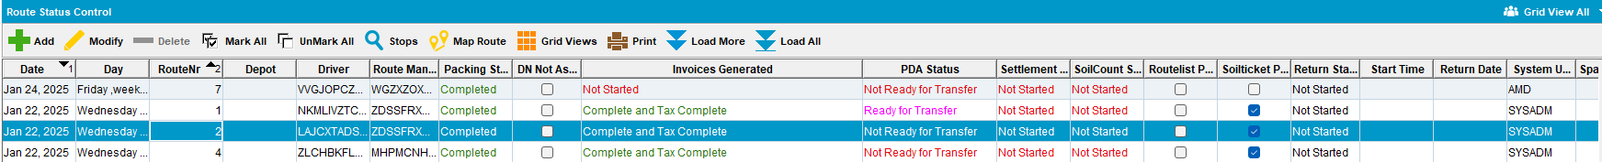

- For 3rd route have RCEI.FinalizationStatus = 0 and PDA Status= Not Ready to transfer
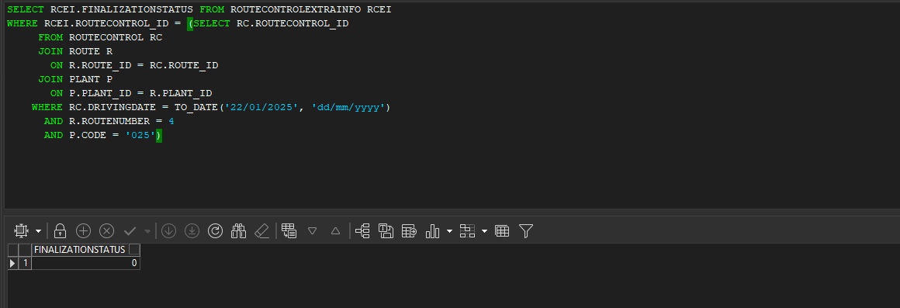
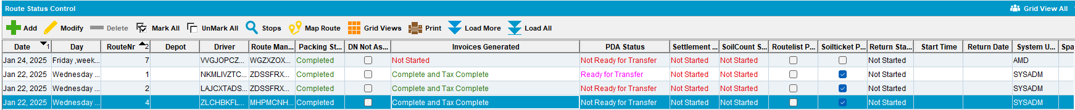

- From RSC cancel invoice for all 3 routes at the same by multiselecting them
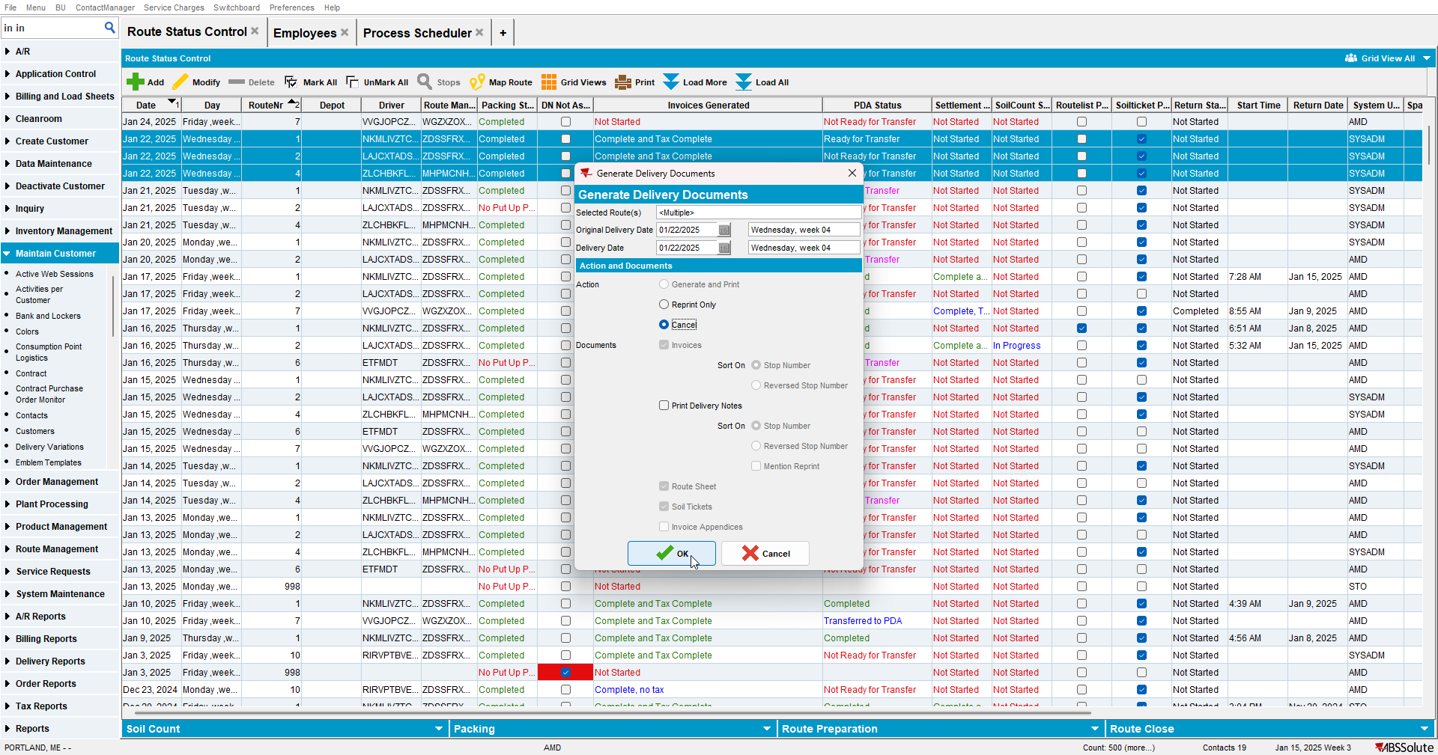

- Check that the finalization status has not changed

