ABSN-91 Price List Per Customer - OOM when loading non customer specific prices
Environment | Prerequisites
Version: 9.07.00.UNF19  DBServerName= abs-srv20.internal.abslbs.com  DBSID=CUST24  DBUser=UNFDEV  DBPassword=UNFDEV  Environment=Production | - Module:

Contents
Test Case #1 – UNFCUSTOM module is in the license 1
Test Case #2 – UNFCUSTOM module is not in the license 4

Test Case #1 – UNFCUSTOM module is in the license
Hash: f81b1d2ec2d9

- Price Lists per Customer DLG: Check all the tabs where we have “All” option.
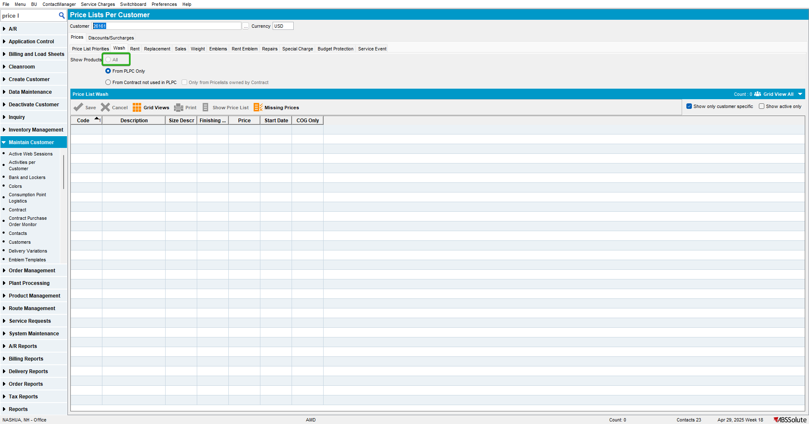
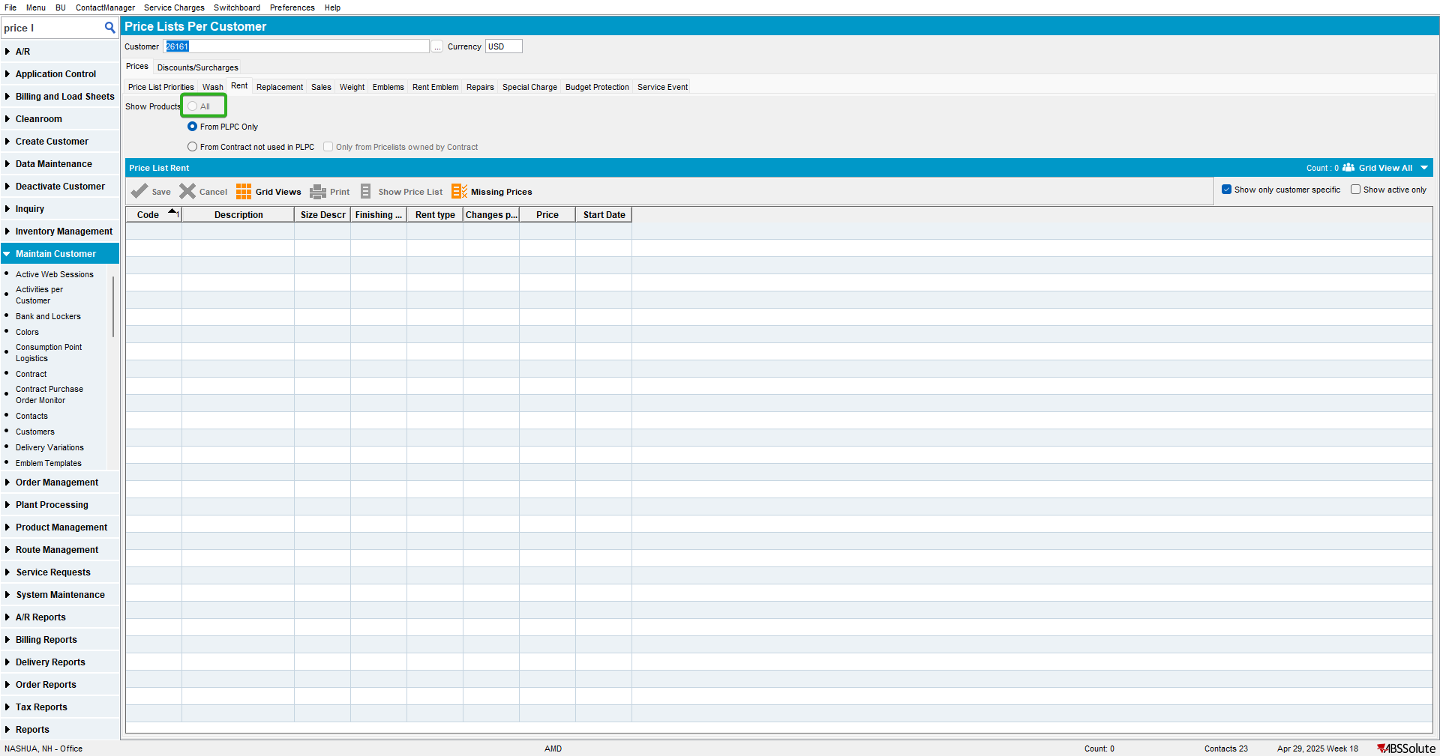
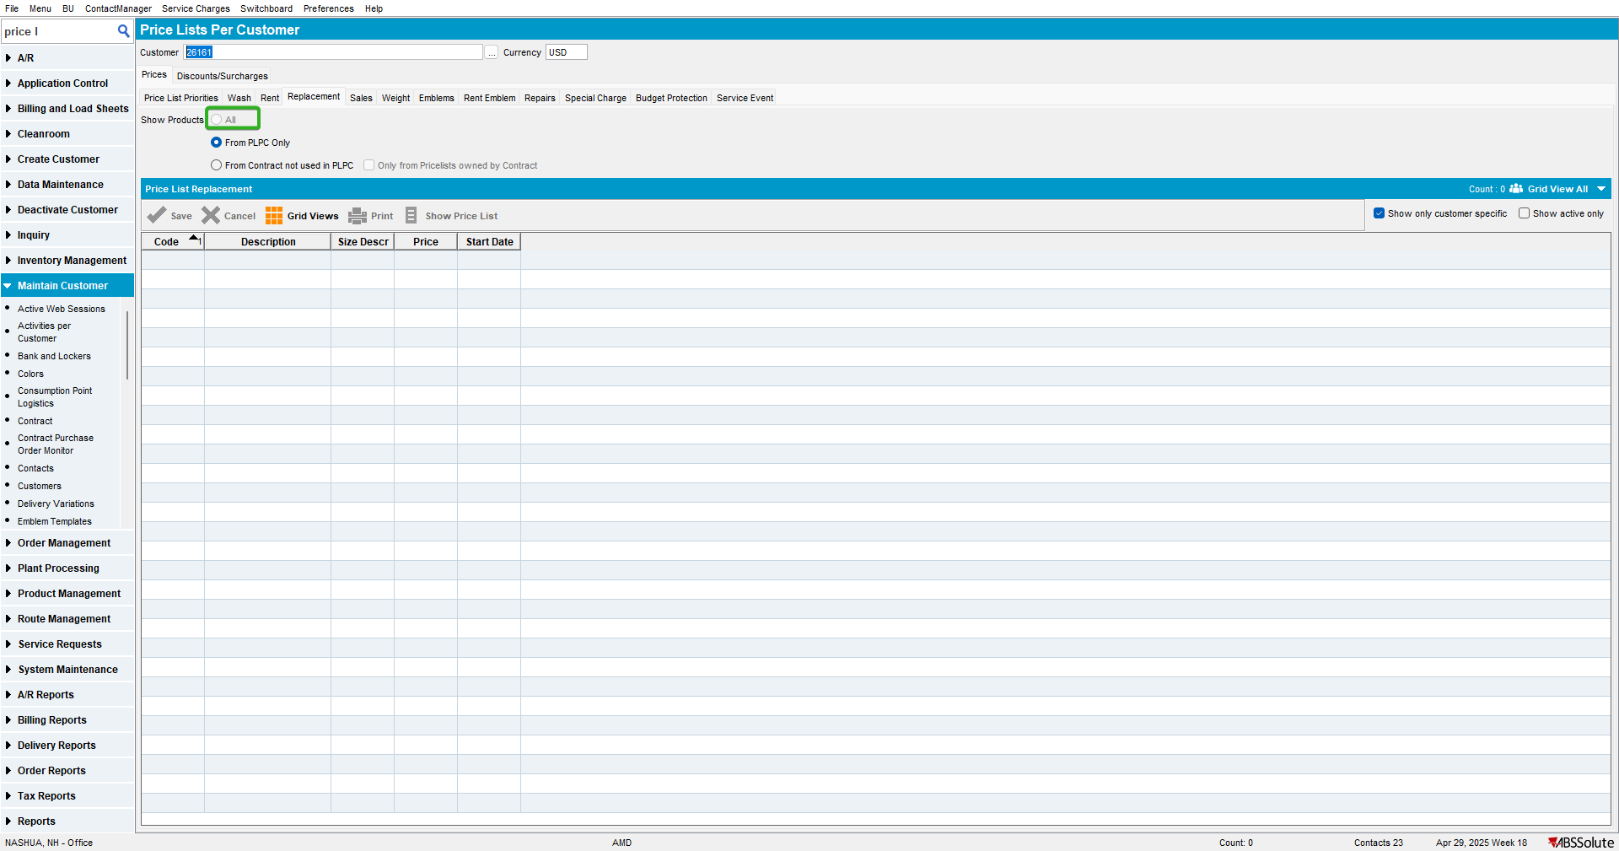
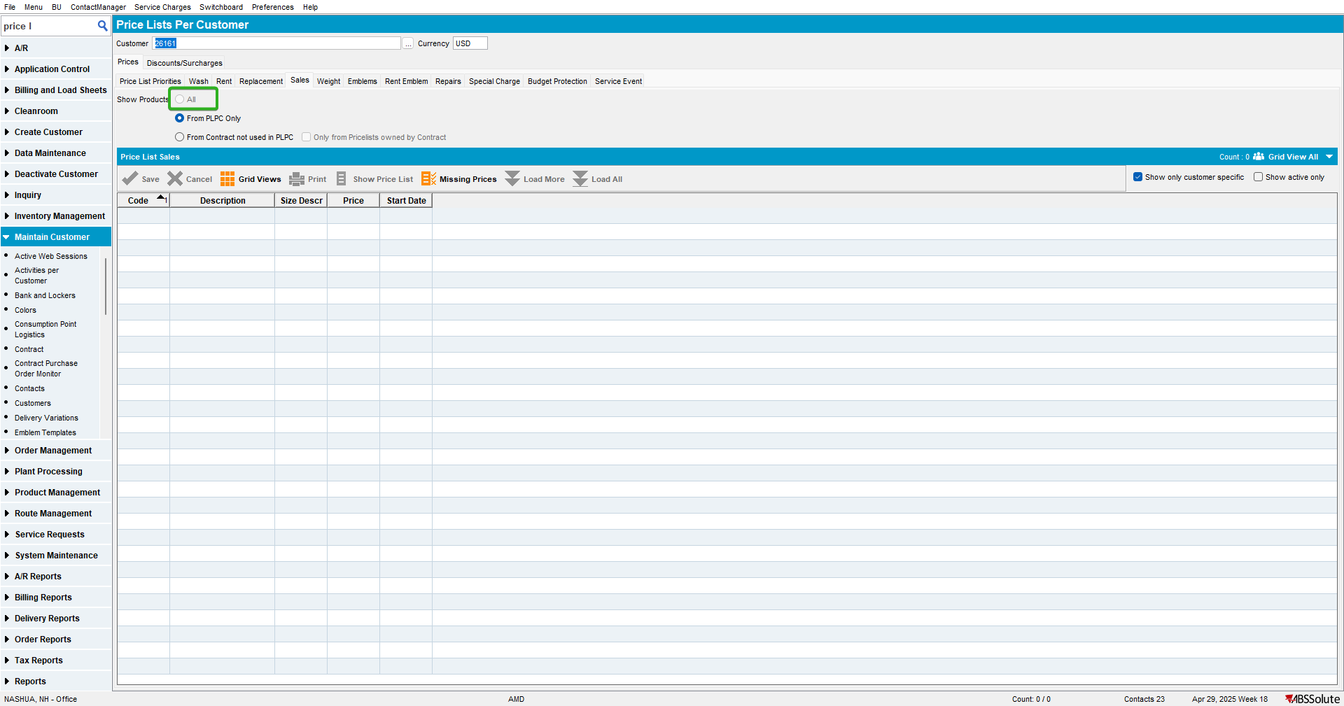
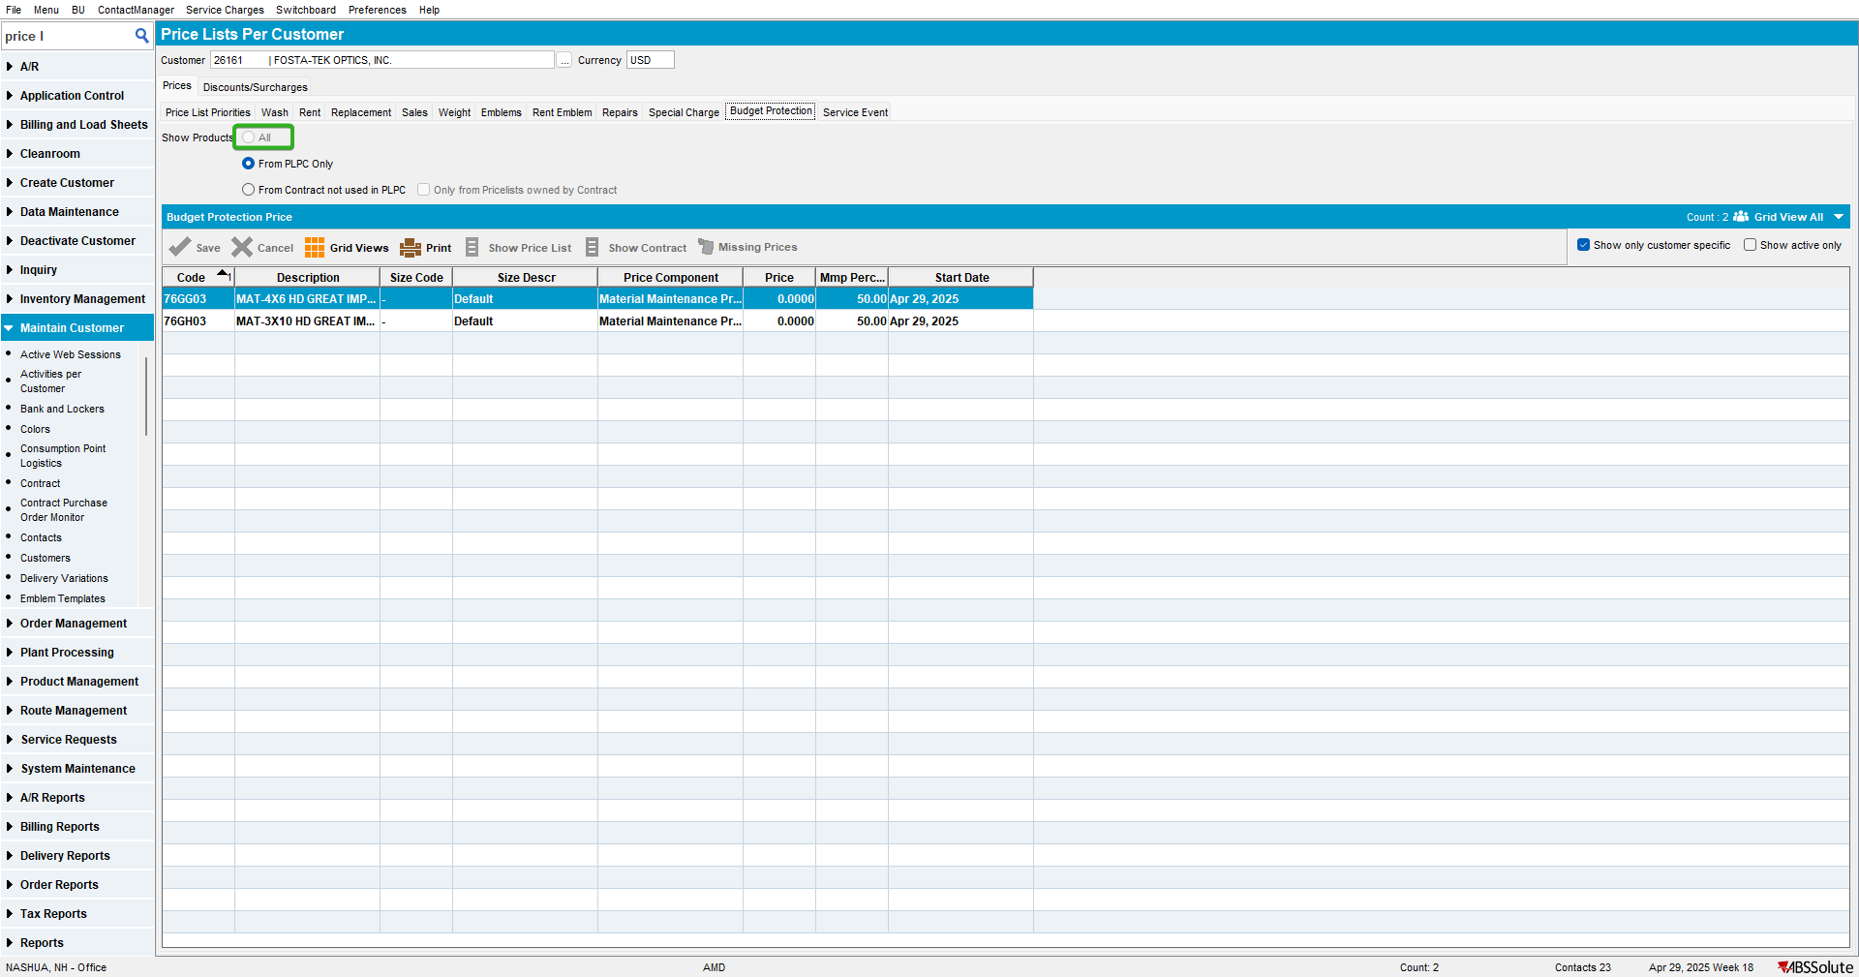

Current behavior:
“All” option is disabled and PLPC is the default option.
TESTED OK

Test Case #2 – UNFCUSTOM module is not in the license
Hash: f81b1d2ec2d9

- Price Lists per Customer DLG: Check all the tabs where we have “All” option.
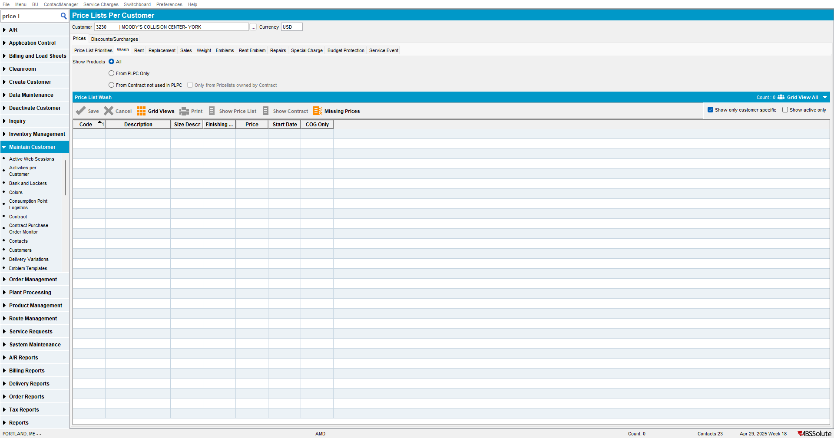
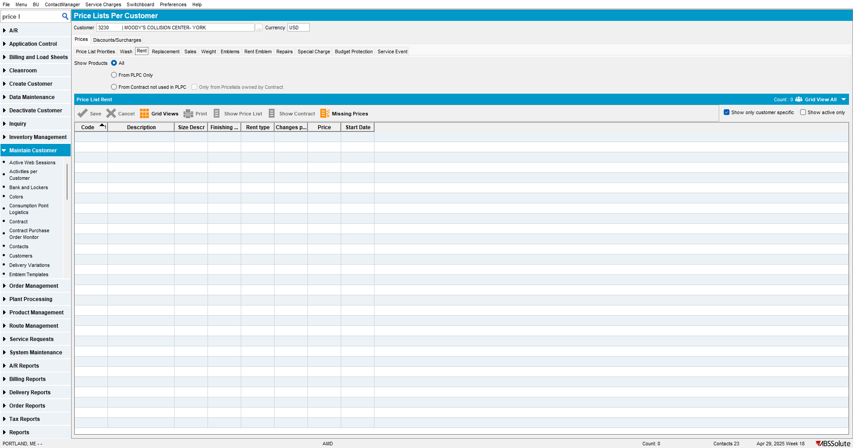
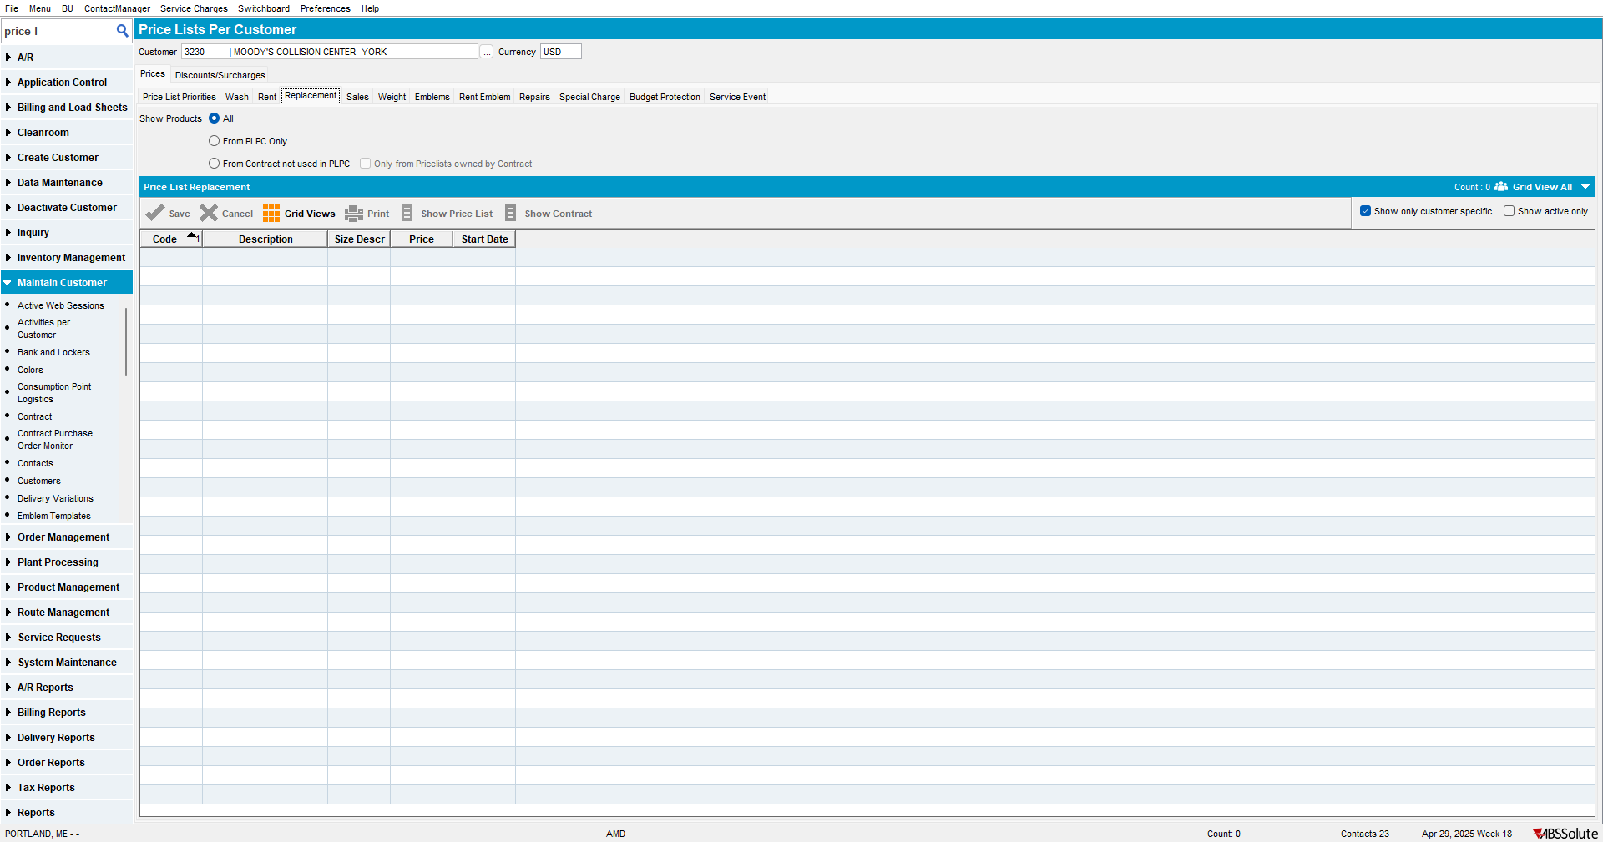
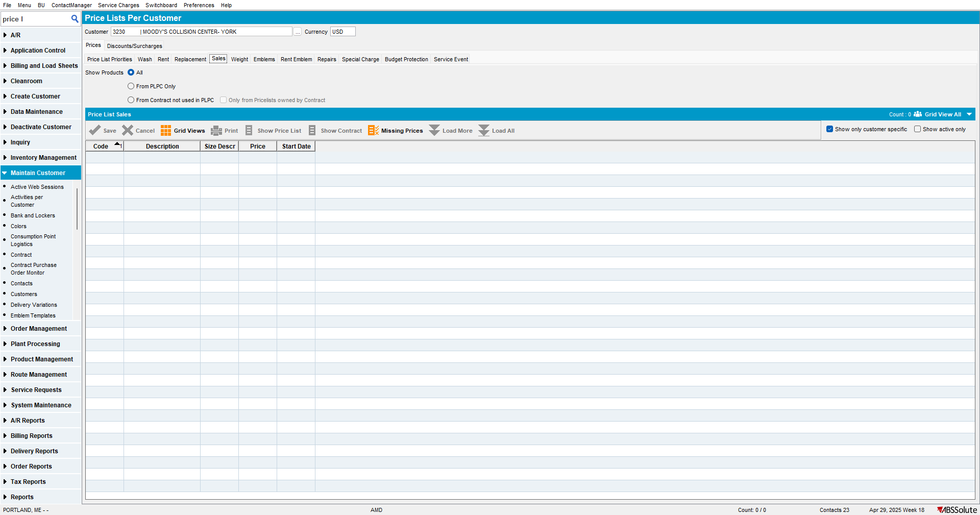
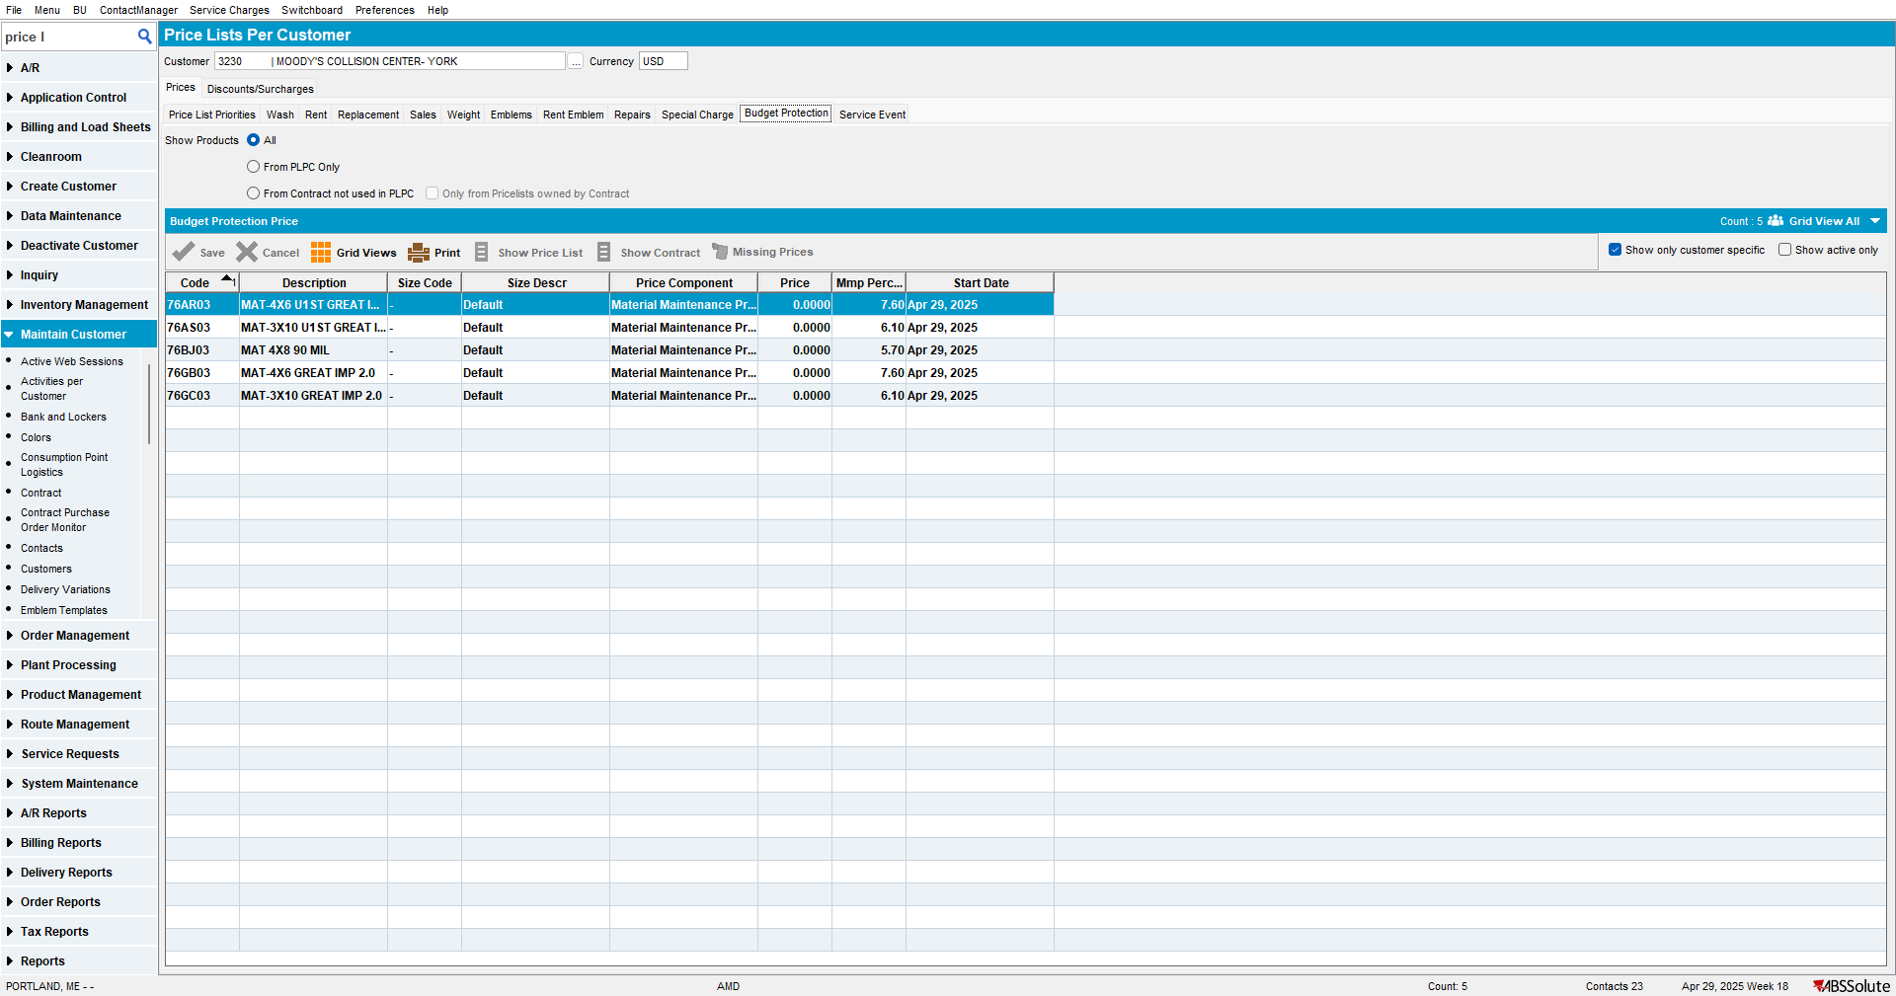

Current behavior:
“All” option is enabled and it’s the default.
TESTED OK

