ABSN-90 Pricing Compliancy appears as not compliant when it should appear as compliant
Environment | Prerequisites
Version:9.07.00  DBServerName=abs-SRV20.internal.abslbs.com  DBSID=CUST24  DBUser=UNFDEV  DBPassword=UNFDEV  Environment=Test | - Module:  - System setting

Contents
Retest after fix 1
Test Case 1 – CONTRACTPRICELIST does not exist CUSTOMERPRICELIST exists and CUSTOMER PRICE LIST has price for specific product– Tested OK 1
Test Case 2 – CONTRACTPRICELIST exists but there is no price for the specific product CUSTOMERPRICELIST exists and CUSTOMER PRICE LIST has price for specific product– Tested OK 5
Test Case 3 – CONTRACTPRICELIST exists and there is a price for the specific product CUSTOMERPRICELIST exists with a lower priority number and CUSTOMER PRICE LIST has price for specific product – Tested OK 9
Test Case 4 – CONTRACTPRICELIST exists and there is a price for the specific product CUSTOMERPRICELIST exists and CUSTOMER PRICE LIST has NO price for specific product– Tested OK 13
Test Case 5 – CONTRACTPRICELIST exists and there is a price for the specific product CUSTOMERPRICELIST does not exist – Tested OK 17
Test Case 6 – CONTRACTPRICELIST exists and there is a price for the specific product CUSTOMERPRICELIST exists and CUSTOMER PRICE LIST has price for specific product BUT the priority on the CUSTOMERSPECIFICPRICELIST is a higher number than the CONTRACTSPECIFICPRICELIST – Tested OK 21
Test Case 7 – CONTRACTPRICELIST exists and there is a price for the specific product CUSTOMERPRICELIST exists and CUSTOMER PRICE LIST has price for specific product BUT the CUSTOMERSPECIFICPRICELIST has an end date < SYSDATE– Tested OK 25

Retest after fix

Test Case 1 – CONTRACTPRICELIST does not exist CUSTOMERPRICELIST exists and CUSTOMER PRICE LIST has price for specific product– Tested OK
Expected behavior: Should be compliant
Hash: 8de3f55
- Add a new customer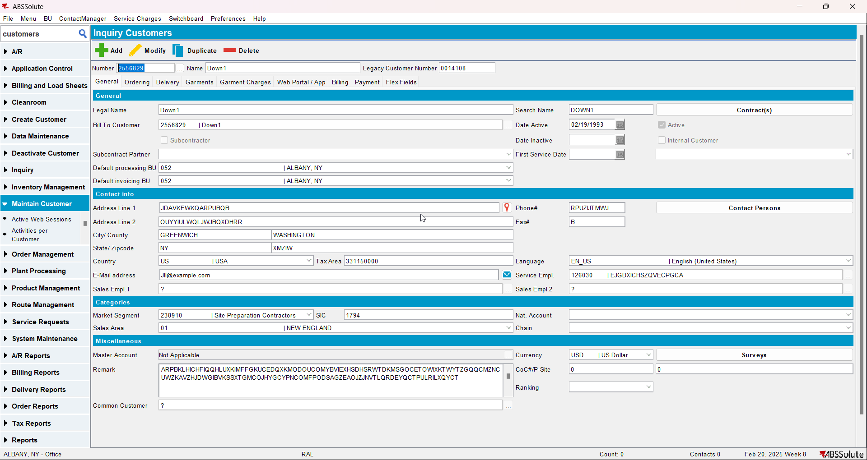
- Add a new contract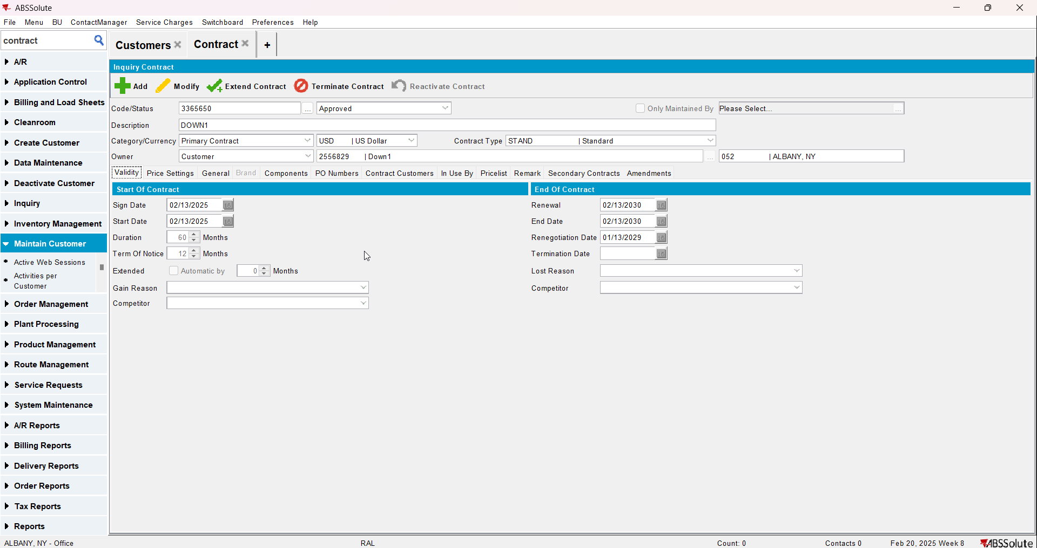
- Add a garment to the contract but don’t add a sales price to it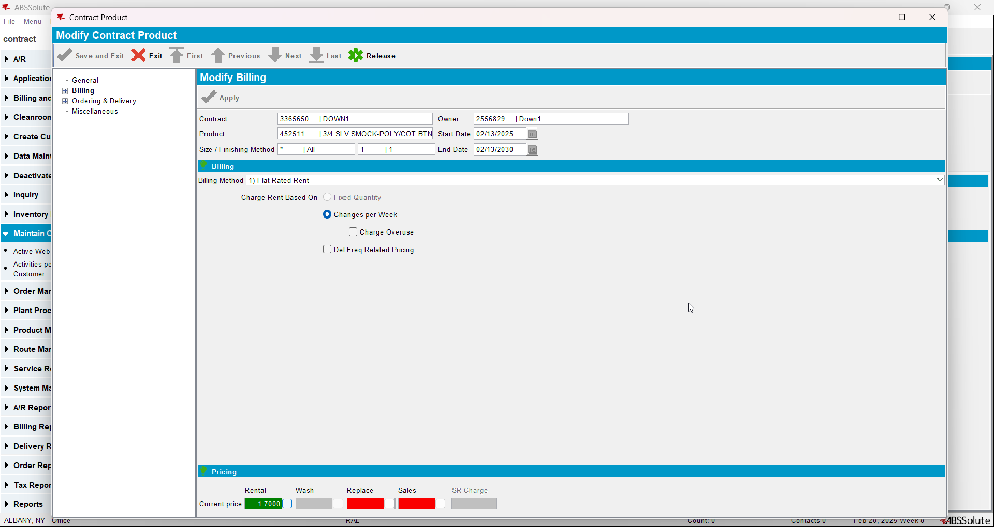
- Add the customer to the contract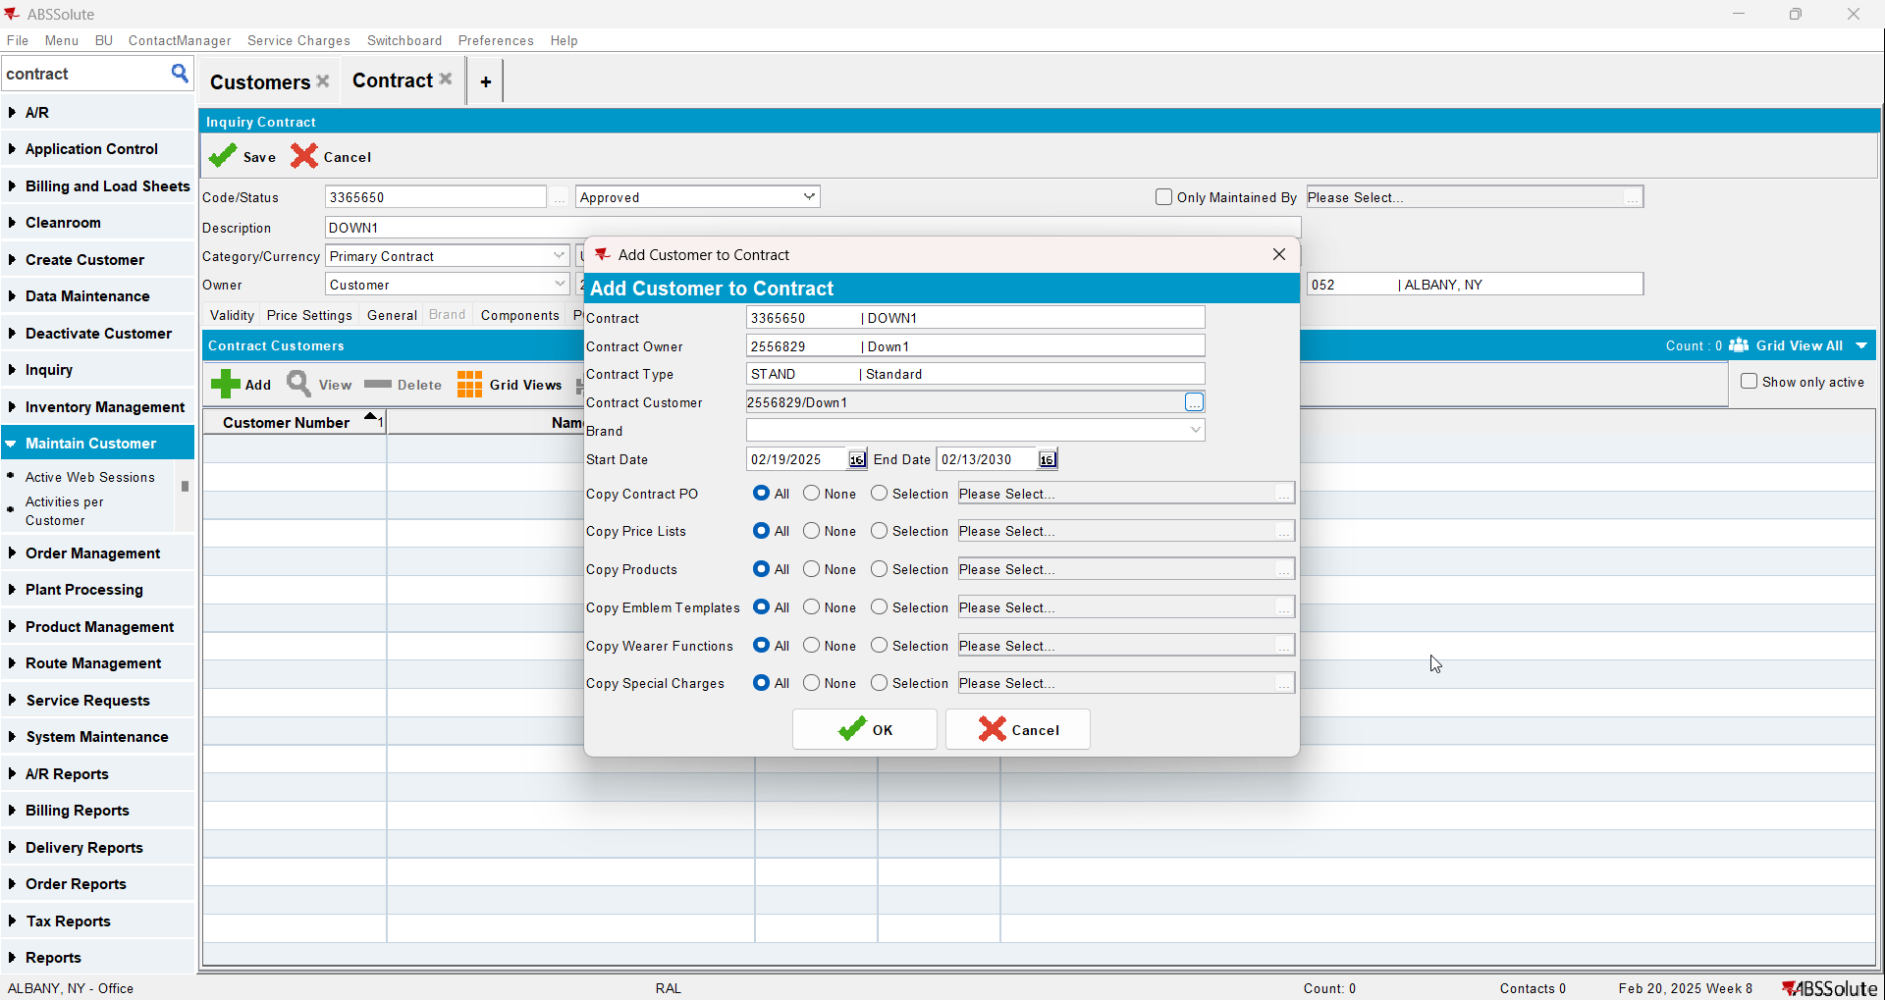
- Go to Price Lists Per Customer and add a customer specific sales price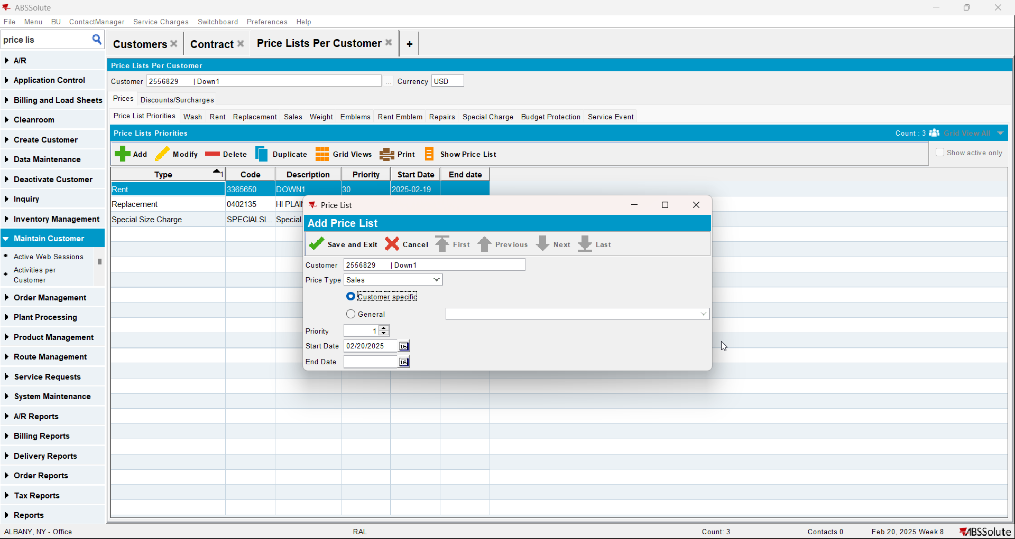
- Go to Product Lists Per Customer and add a sales price to the product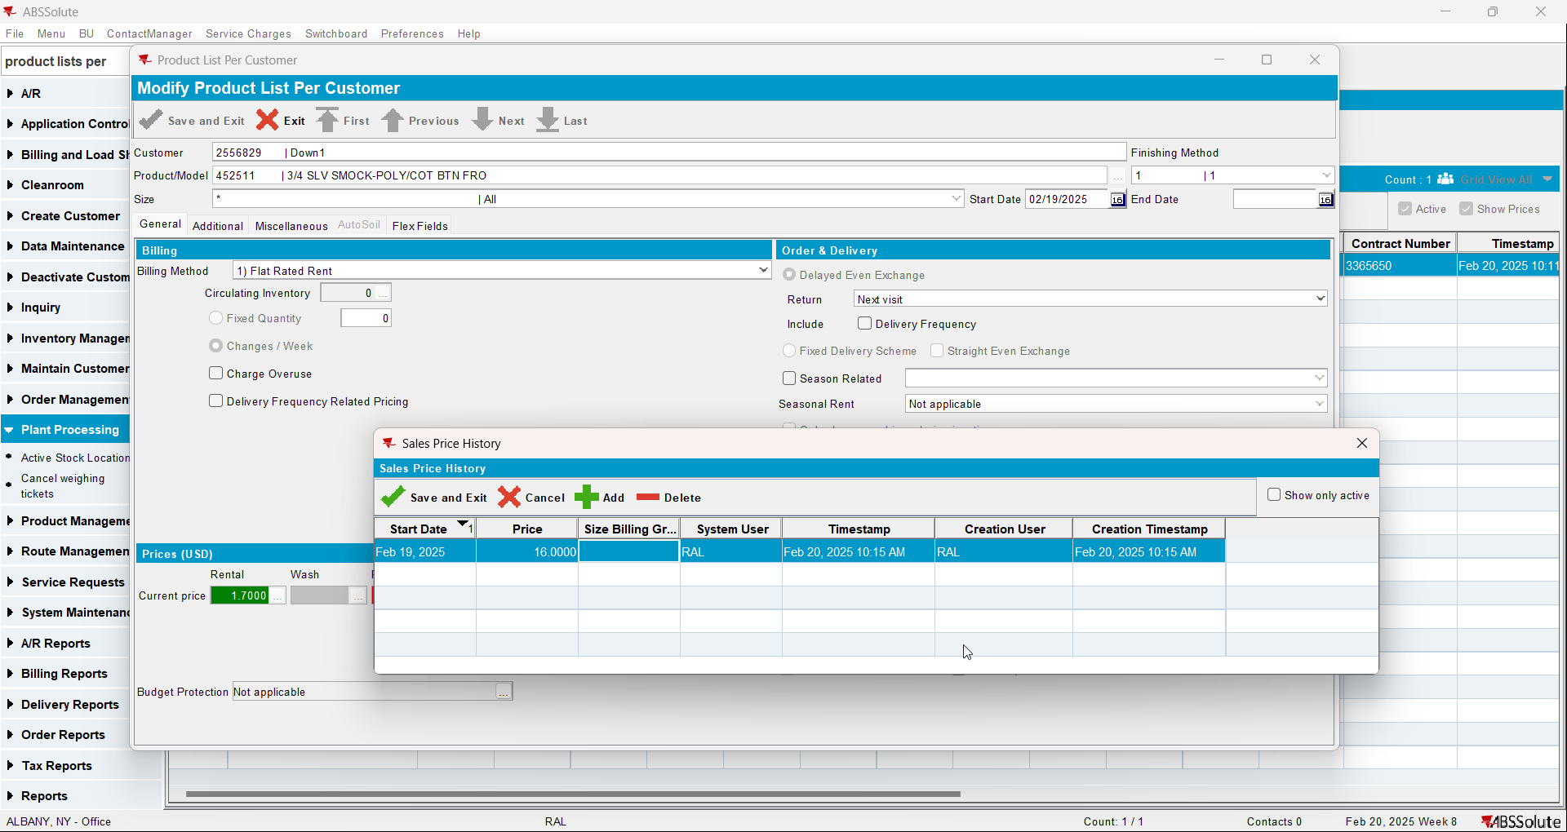
- Check there is no sales price list on the contract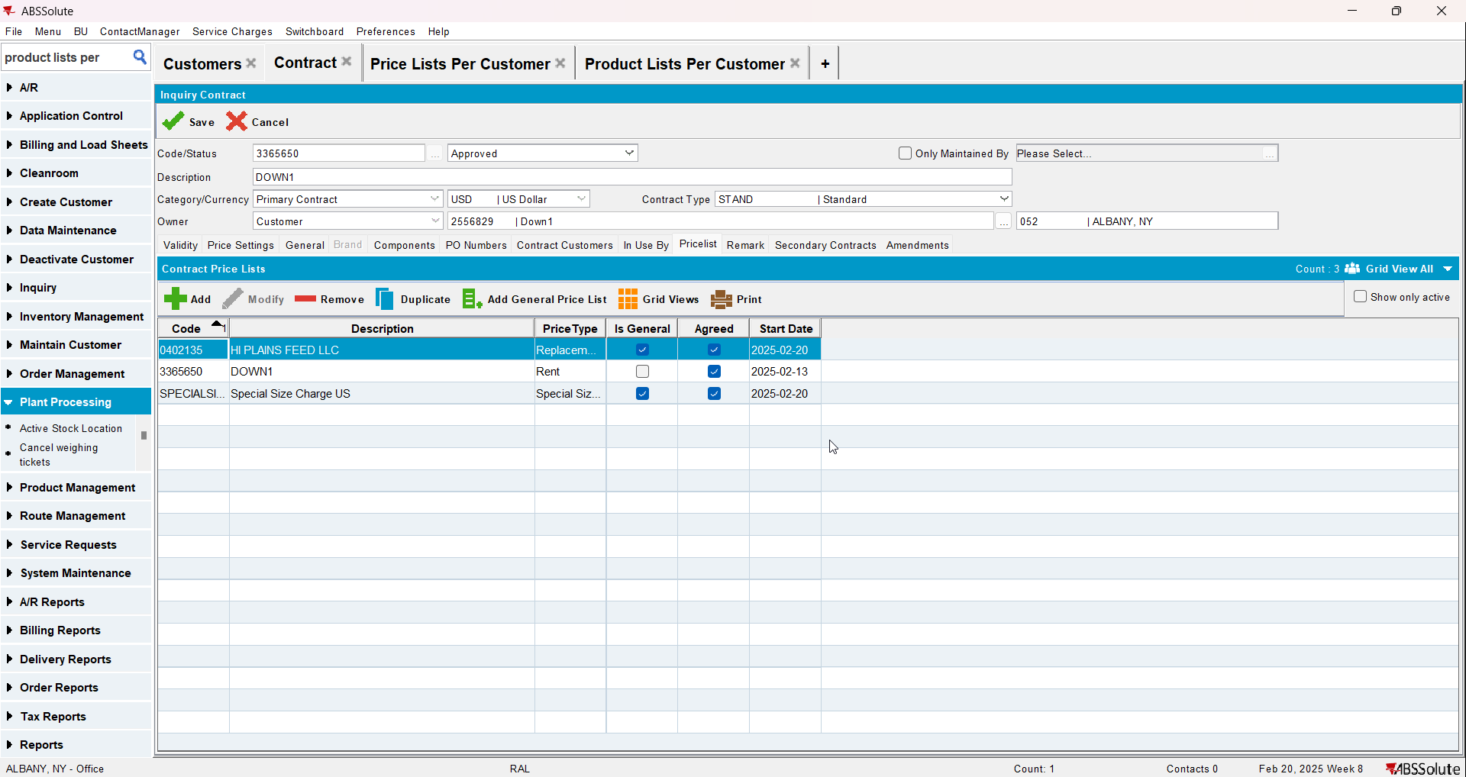
- Check the compliancy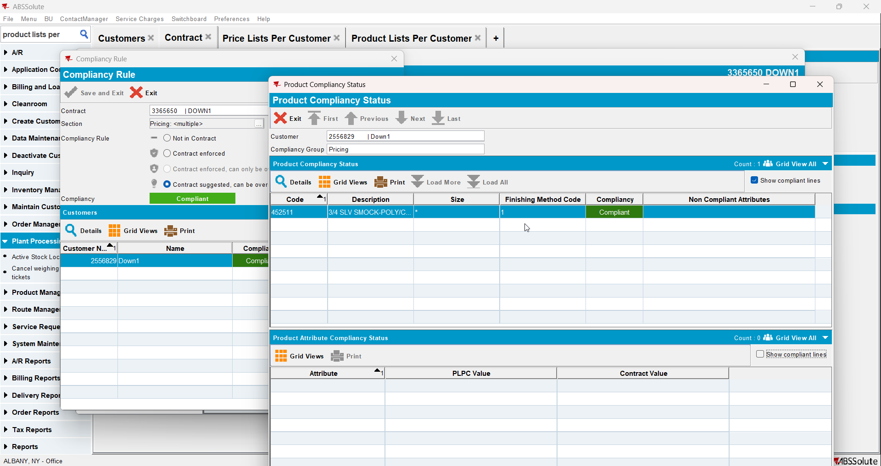

Test Case 2 – CONTRACTPRICELIST exists but there is no price for the specific product CUSTOMERPRICELIST exists and CUSTOMER PRICE LIST has price for specific product– Tested OK
Expected behavior: Should be compliant
Hash: 8de3f55
- Add a new customer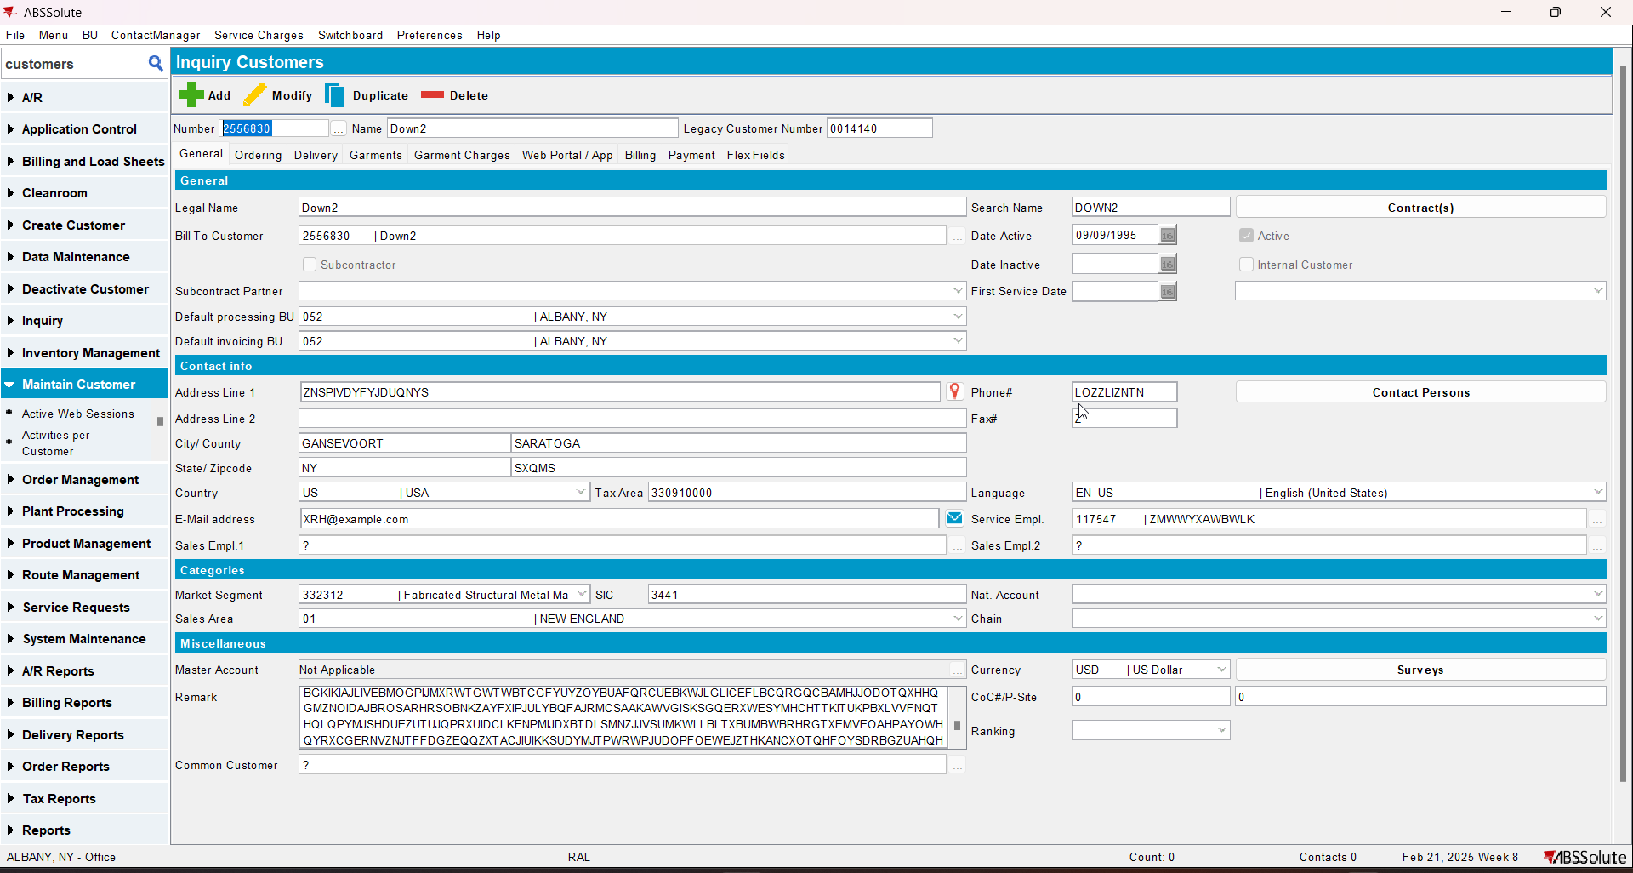
- Add a new contract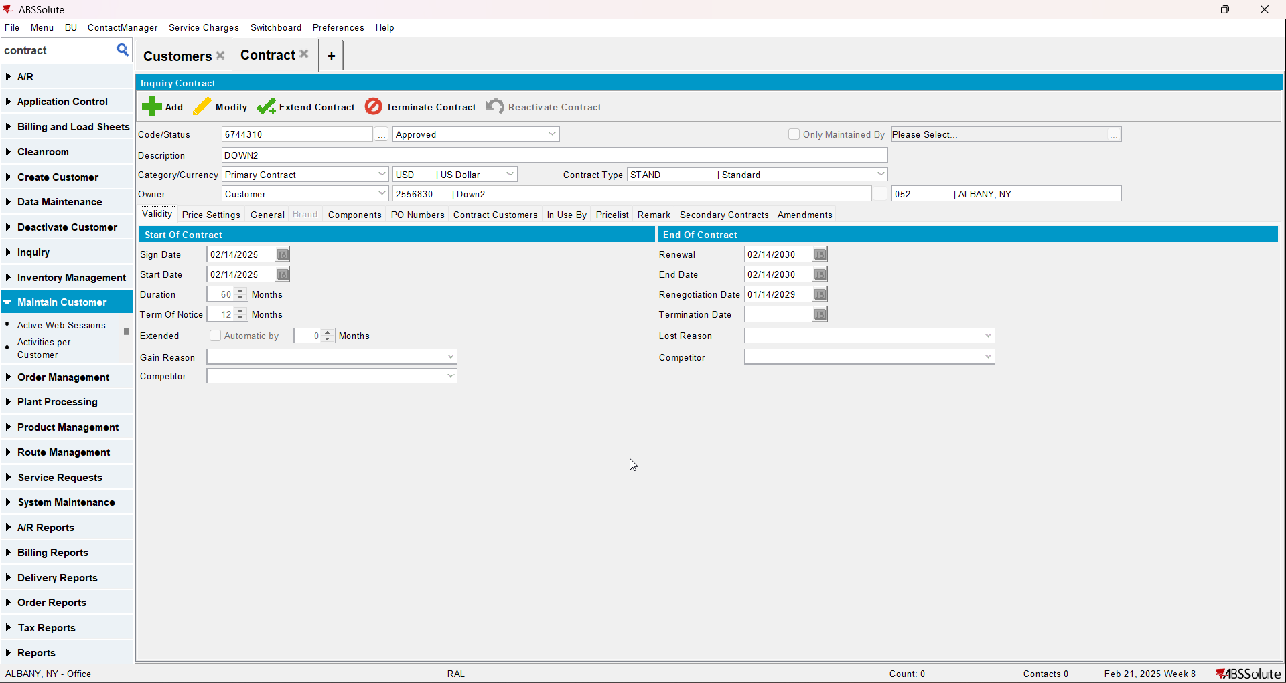
- Add a sales price list on the contract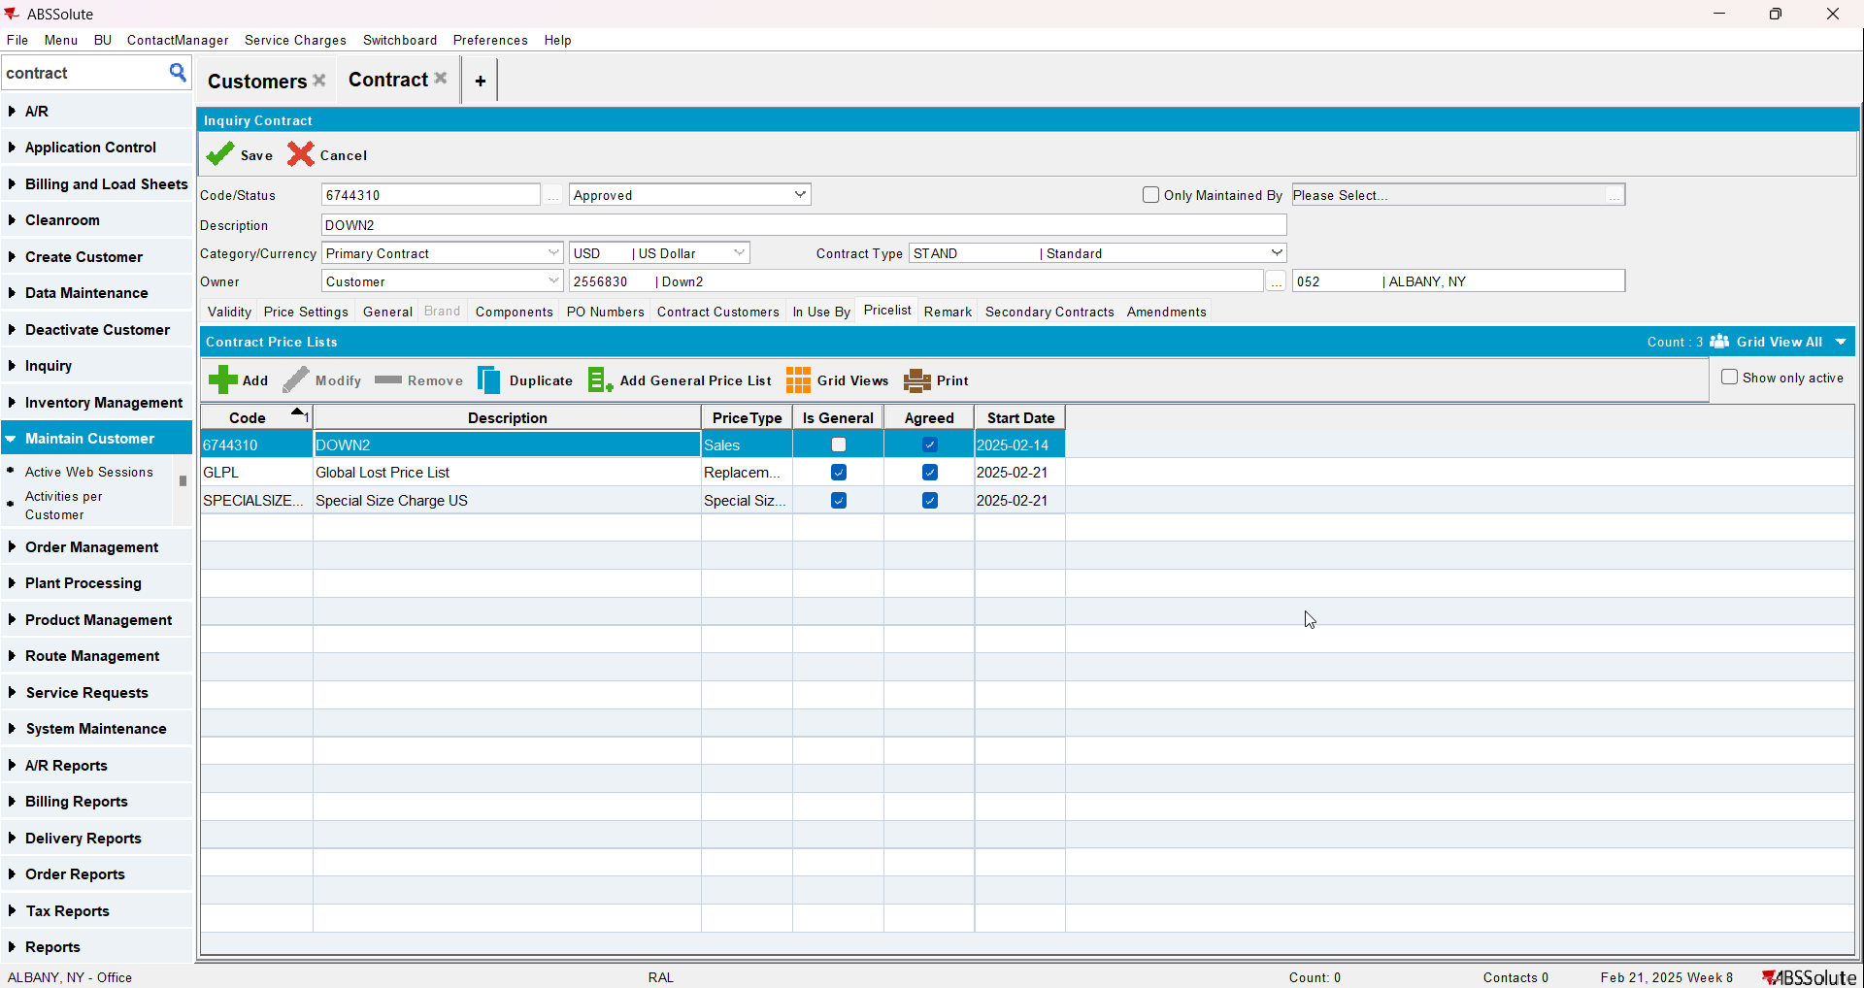
- Add a garment to the contract but don’t add a sales price to it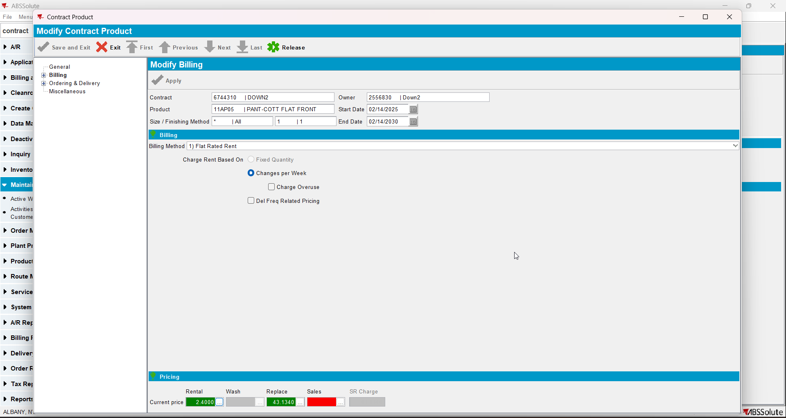
- Add the customer to the contract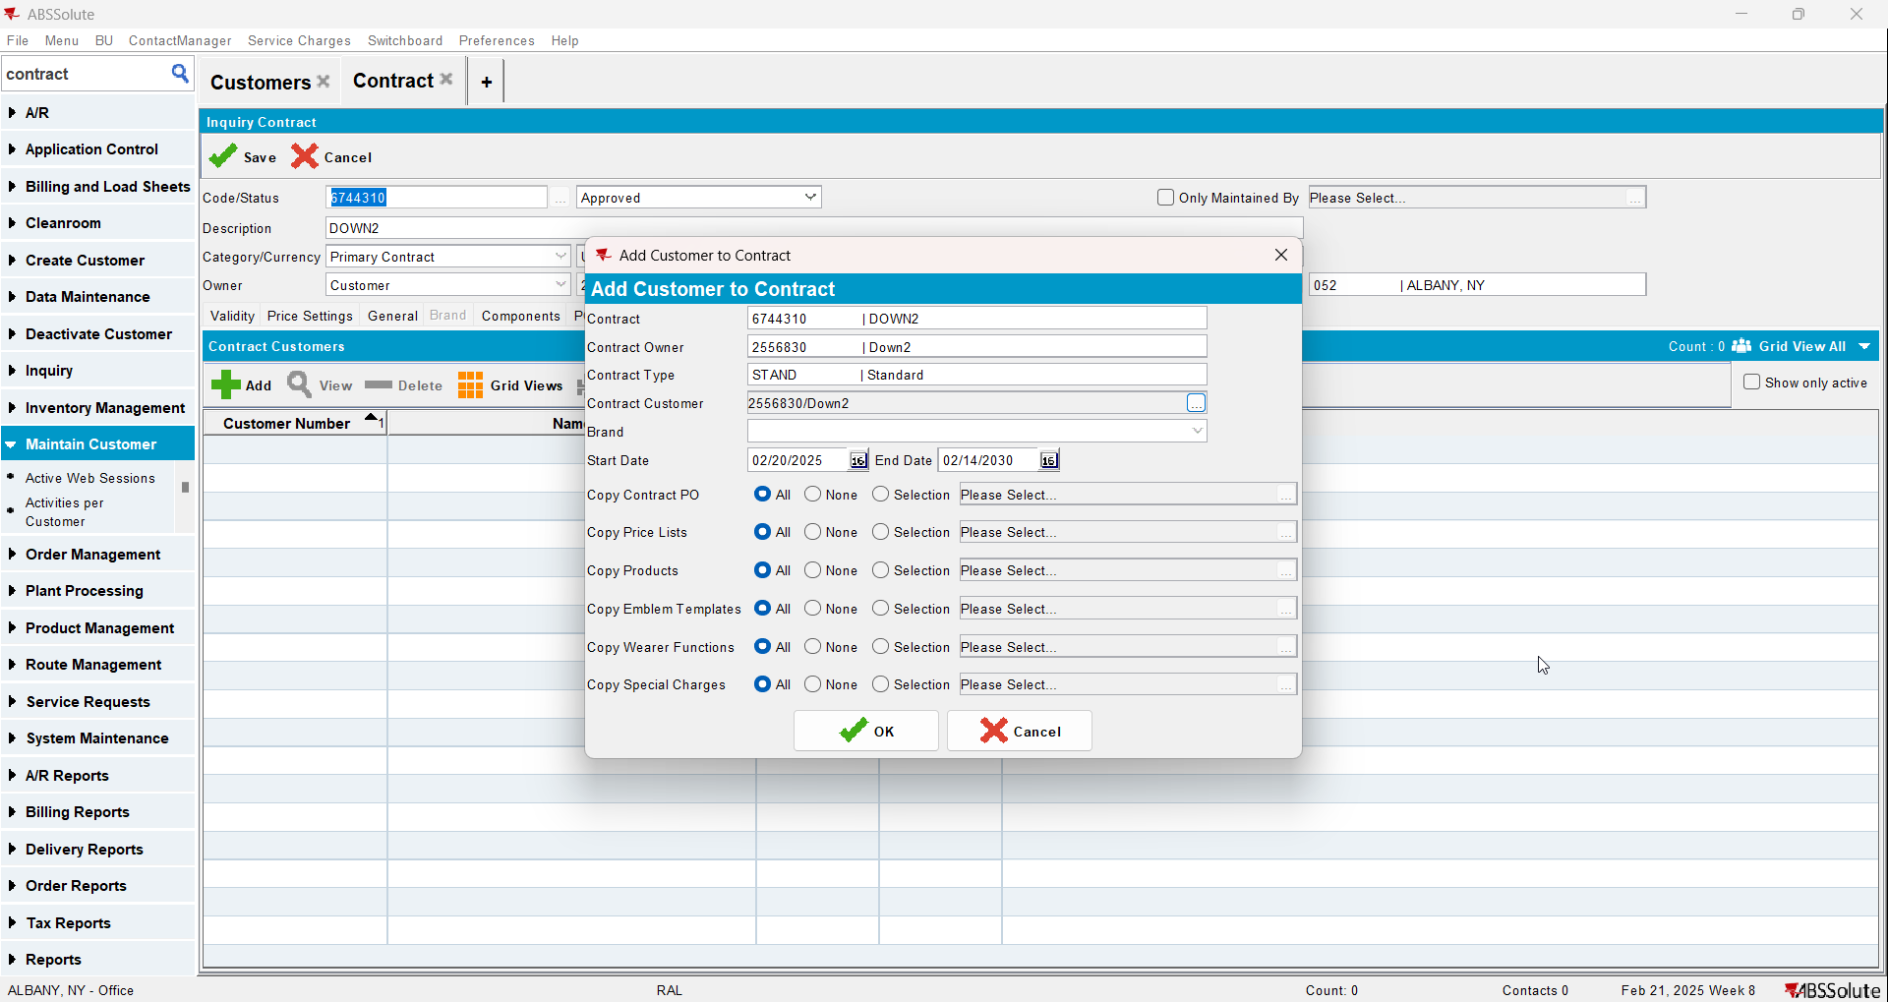
- Go to Price Lists Per Customer and add a customer specific sales price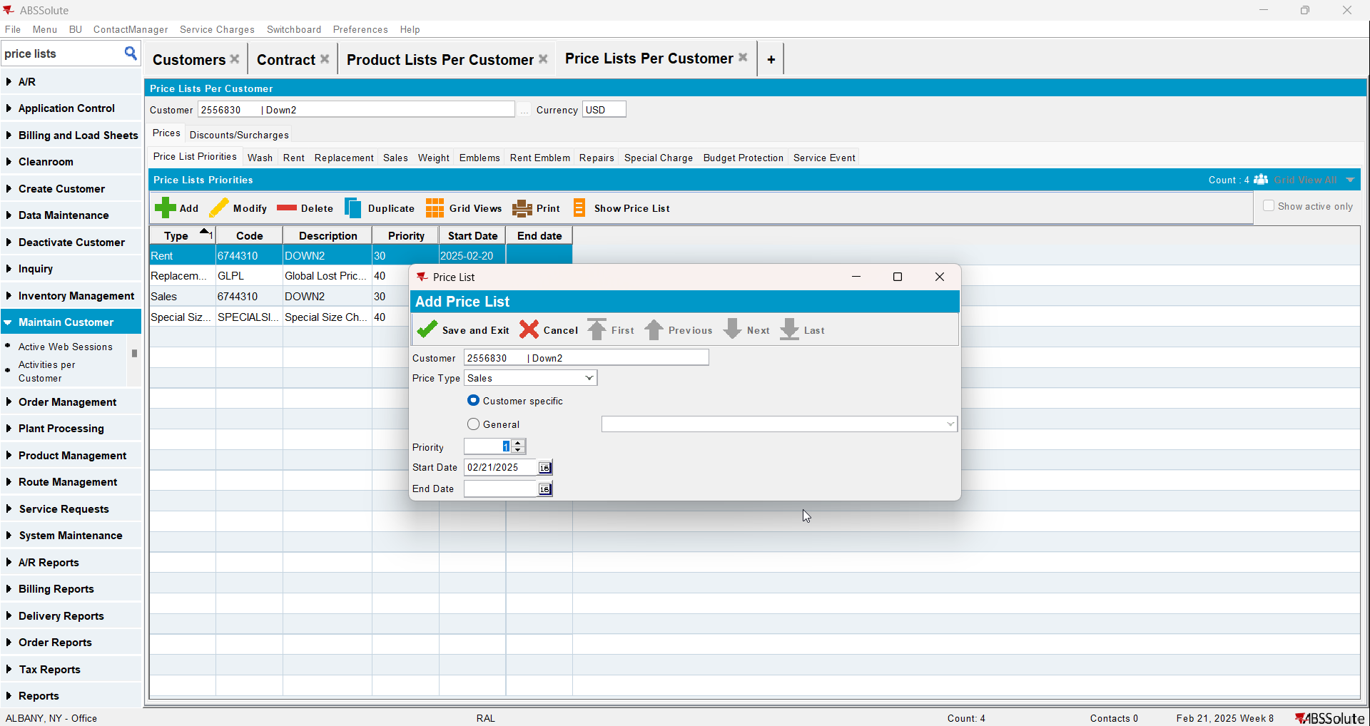
- Go to Product Lists Per Customer and add a sales price to the product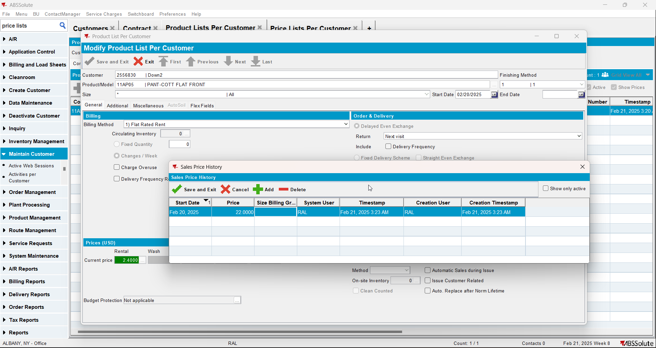
- Check the compliancy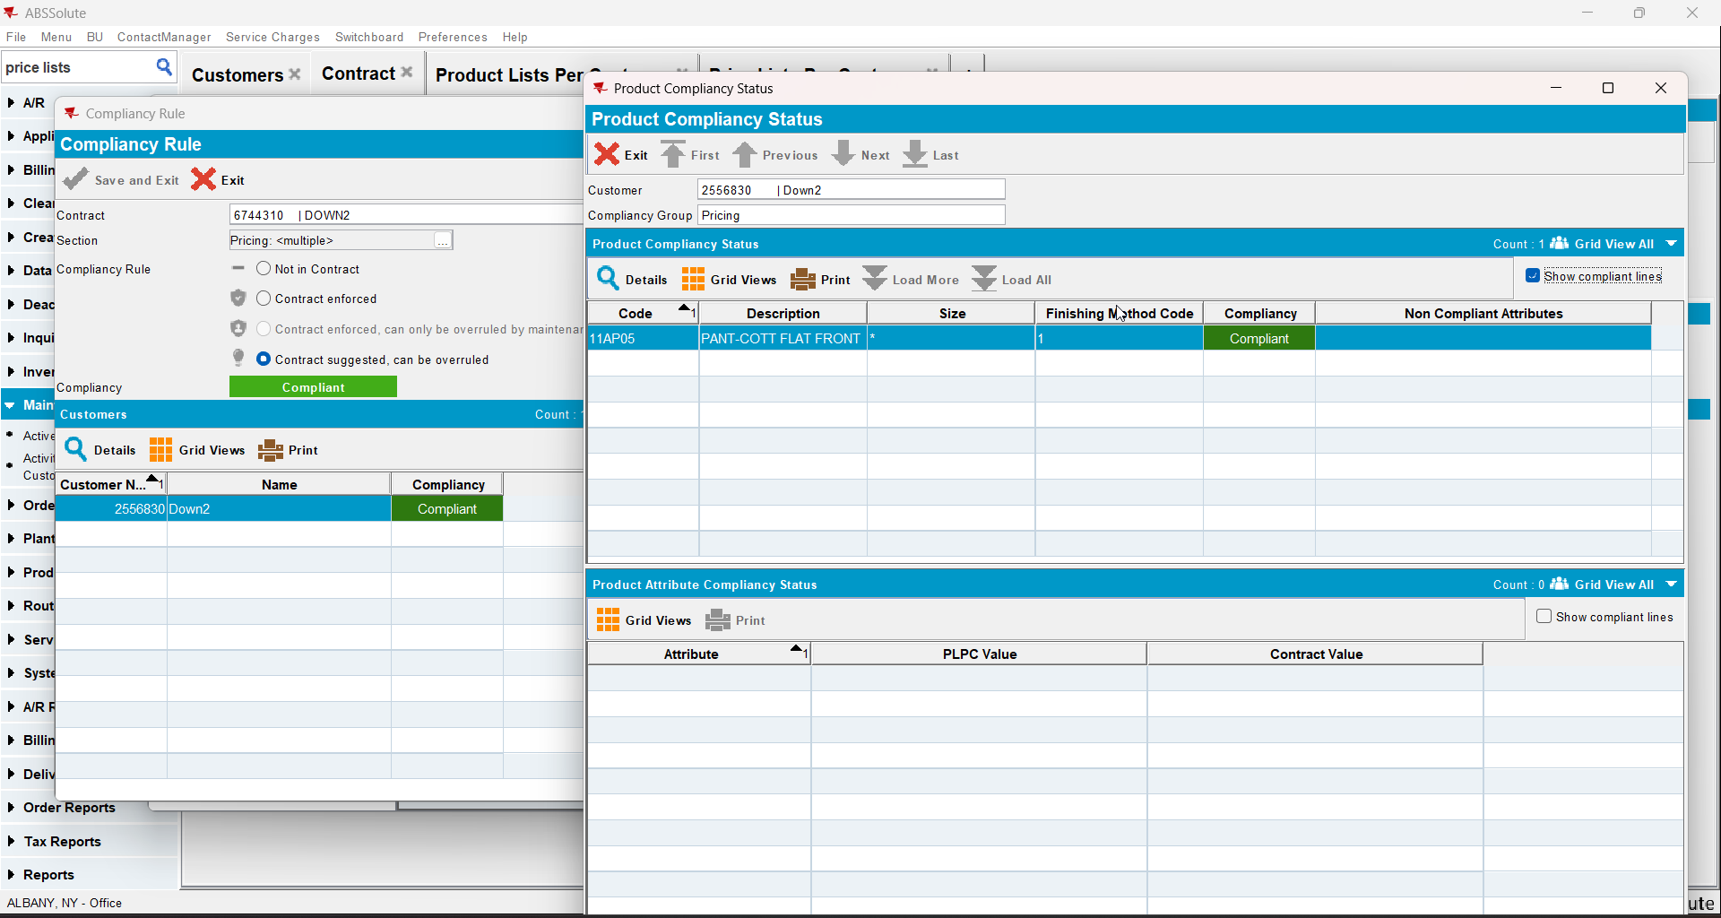

Test Case 3 – CONTRACTPRICELIST exists and there is a price for the specific product CUSTOMERPRICELIST exists with a lower priority number and CUSTOMER PRICE LIST has price for specific product – Tested OK
Expected behavior: Should be not compliant
Hash: 8de3f55
- Add a new customer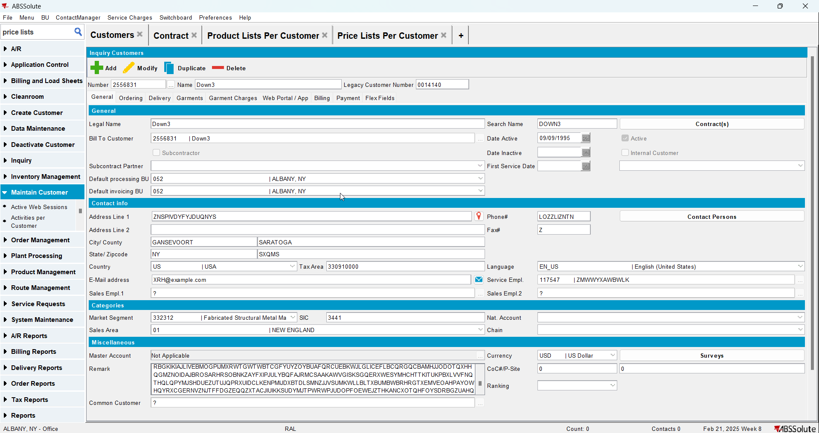
- Add a new contract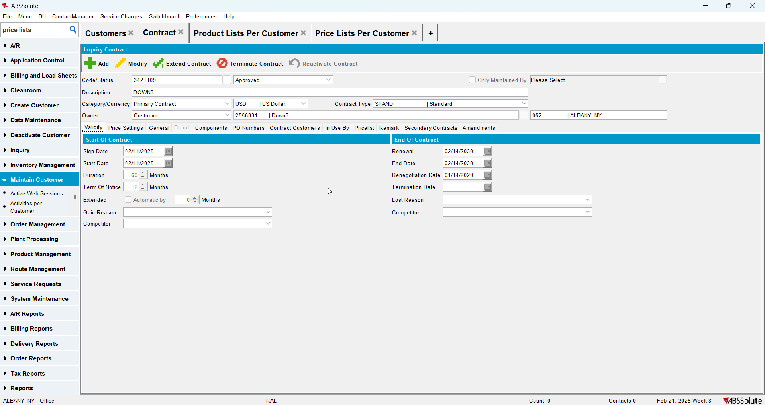
- Add a garment to the contract and add a sales price to it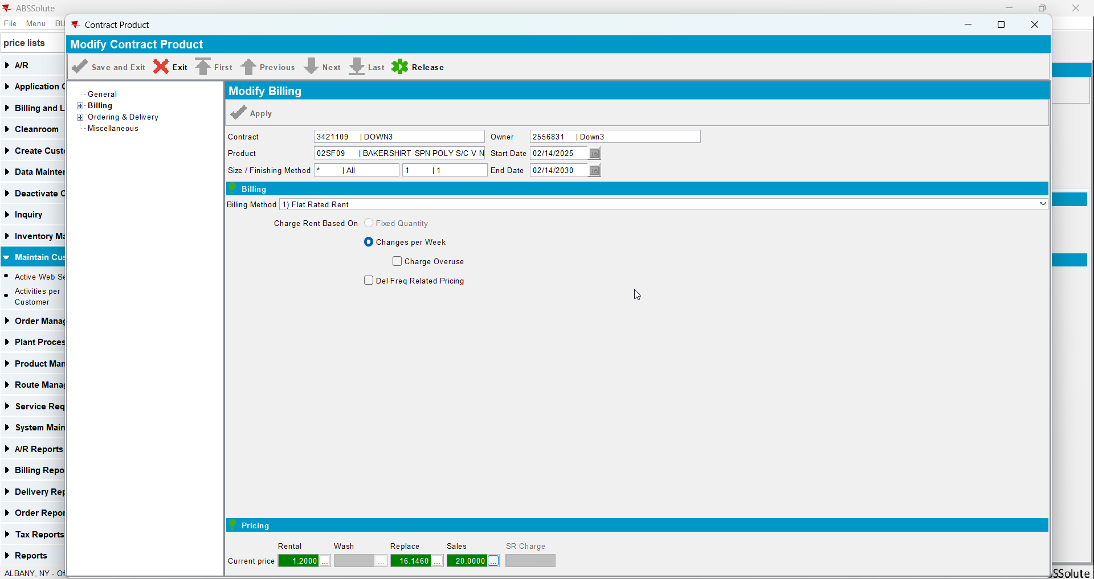
- Check that a sales price list was added on the contract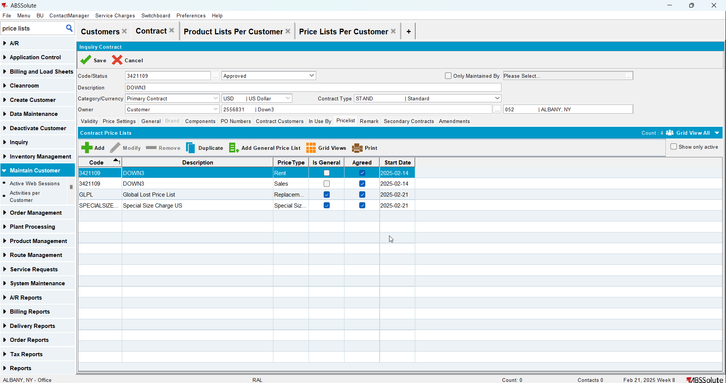
- Add the customer to the contract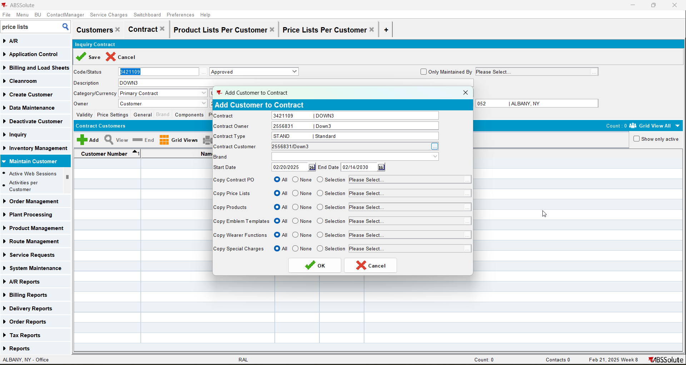
- Go to Price Lists Per Customer and add a customer specific sales price with a lower priority number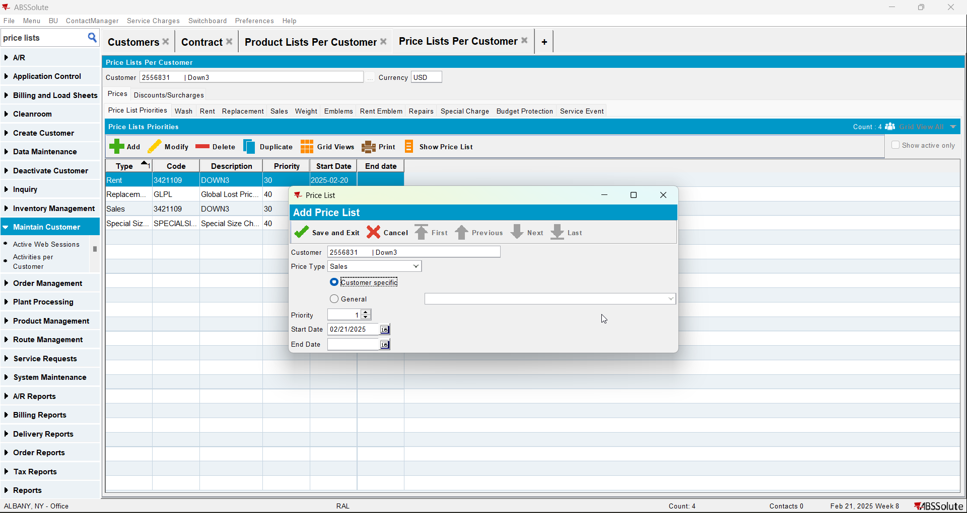
- Go to Product Lists Per Customer and add a sales price to the product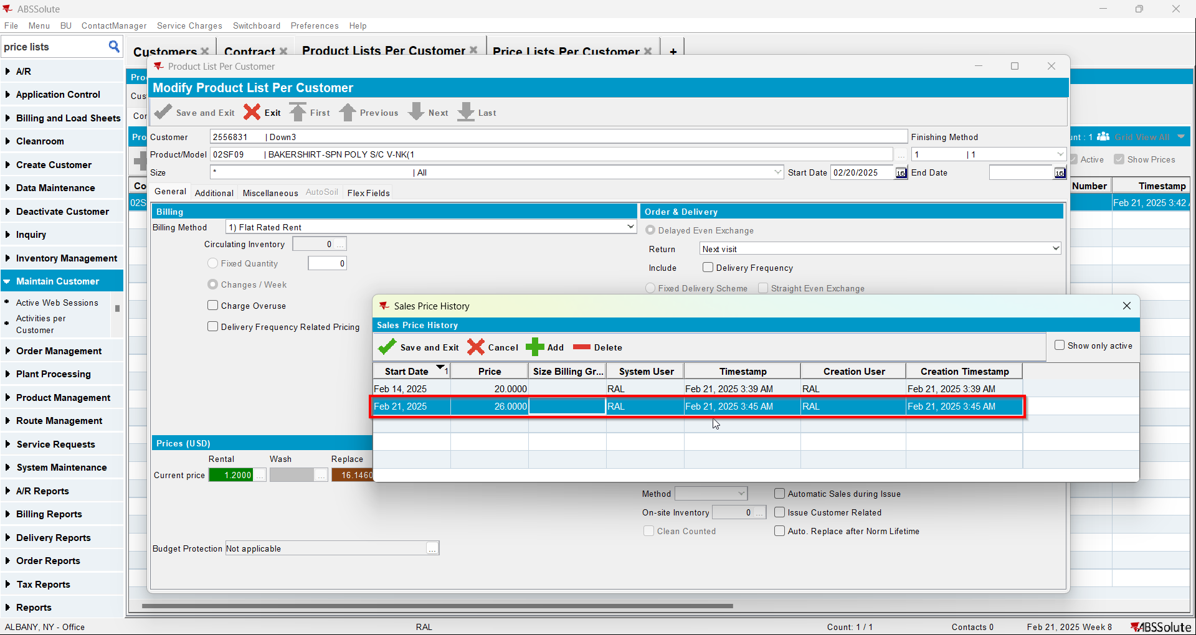
- Check the compliancy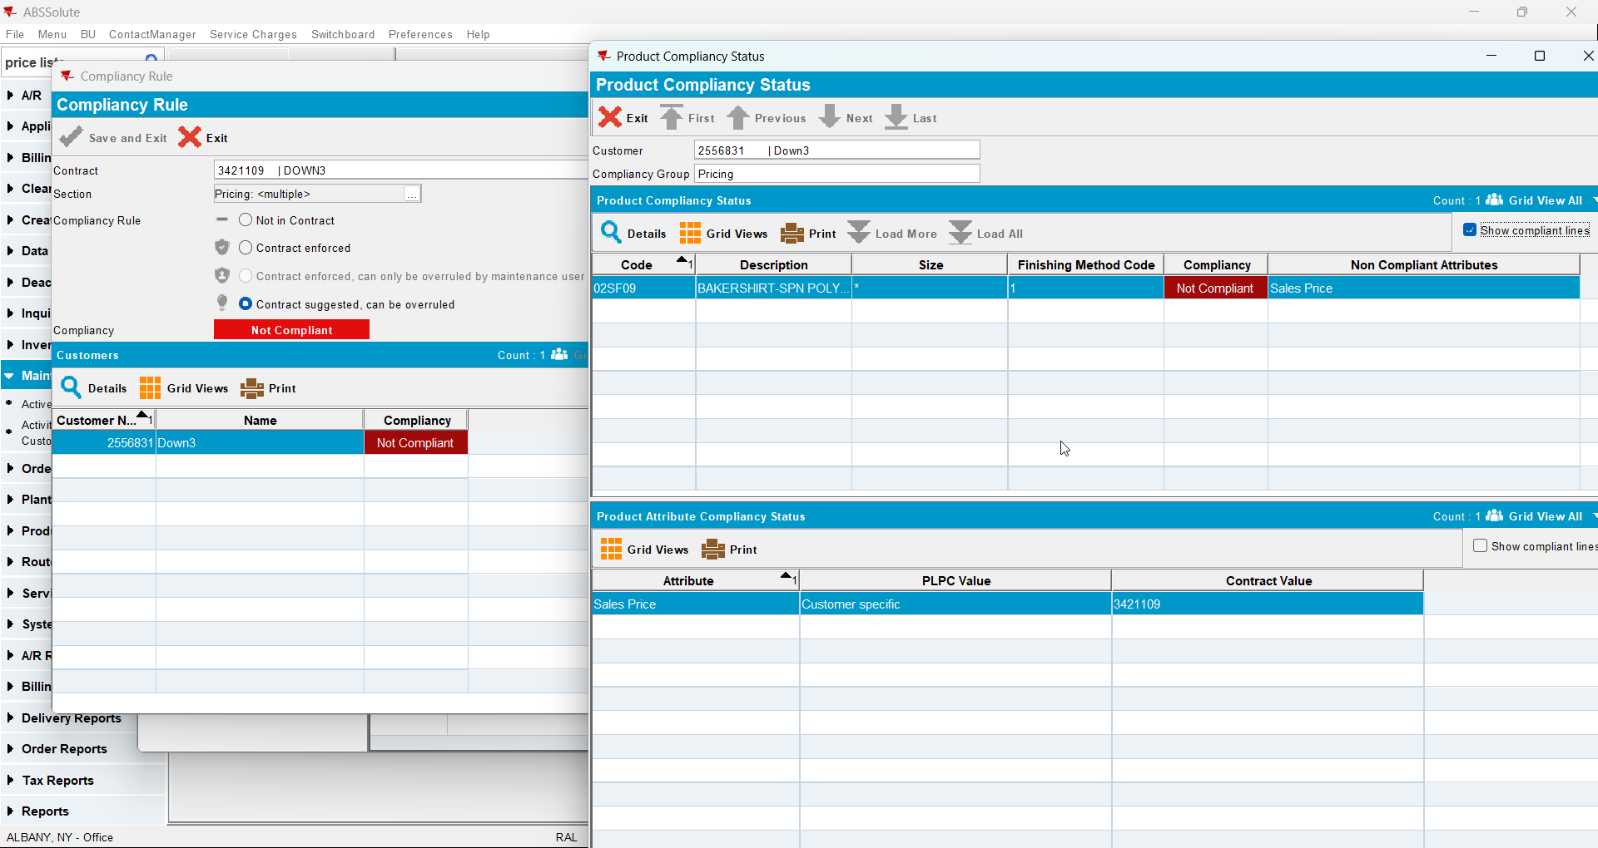

Test Case 4 – CONTRACTPRICELIST exists and there is a price for the specific product CUSTOMERPRICELIST exists and CUSTOMER PRICE LIST has NO price for specific product– Tested OK
Expected behavior: Should be compliant
Hash: 8de3f55
- Add a new customer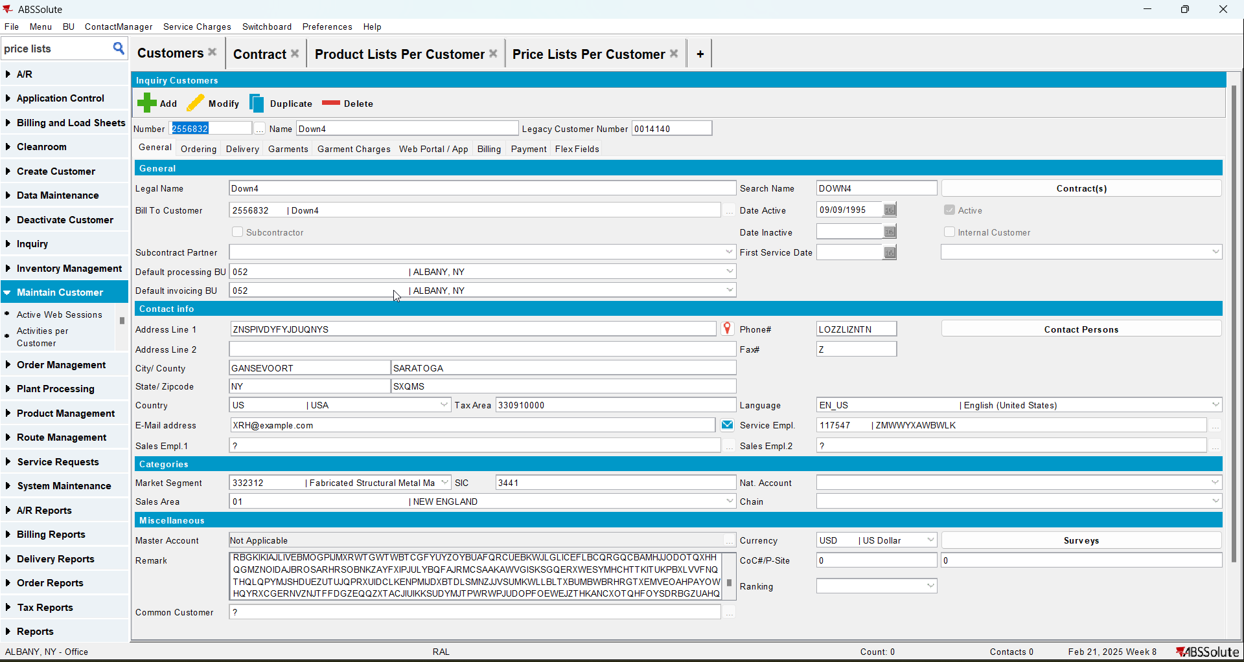
- Add a new contract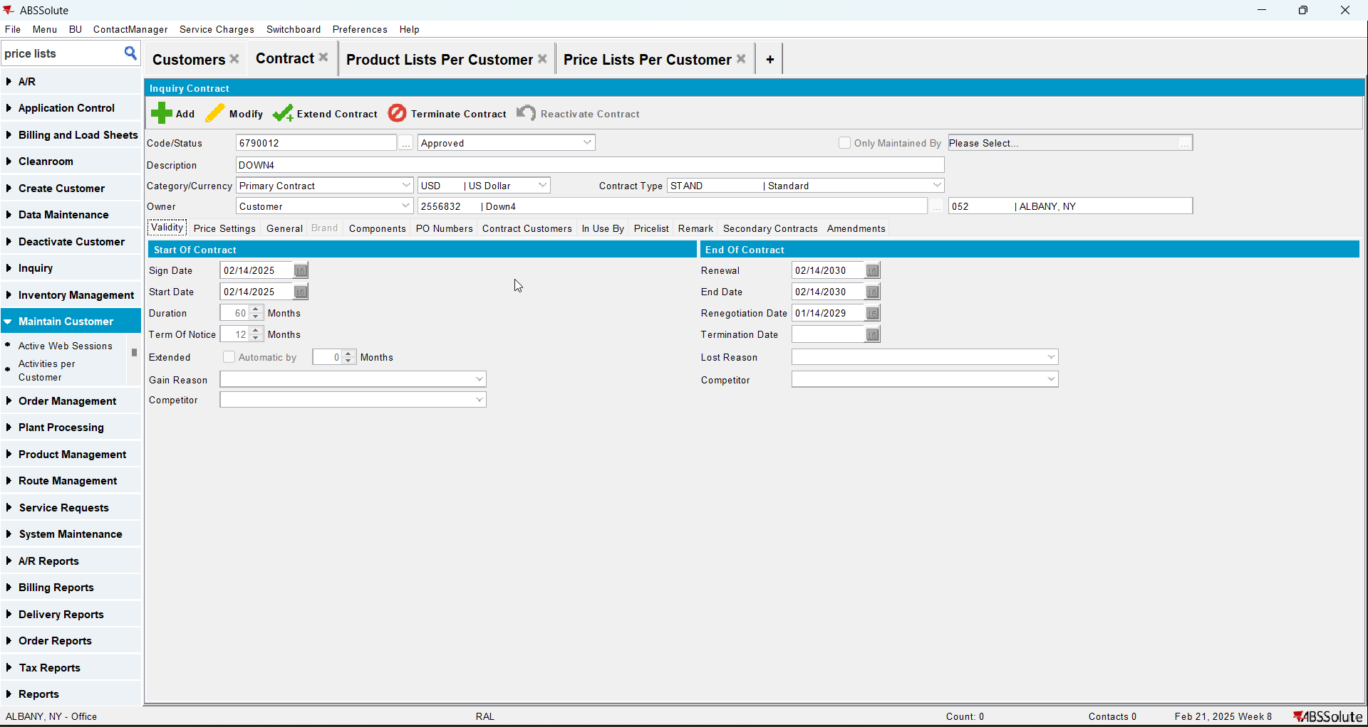
- Add a garment to the contract and add a sales price to it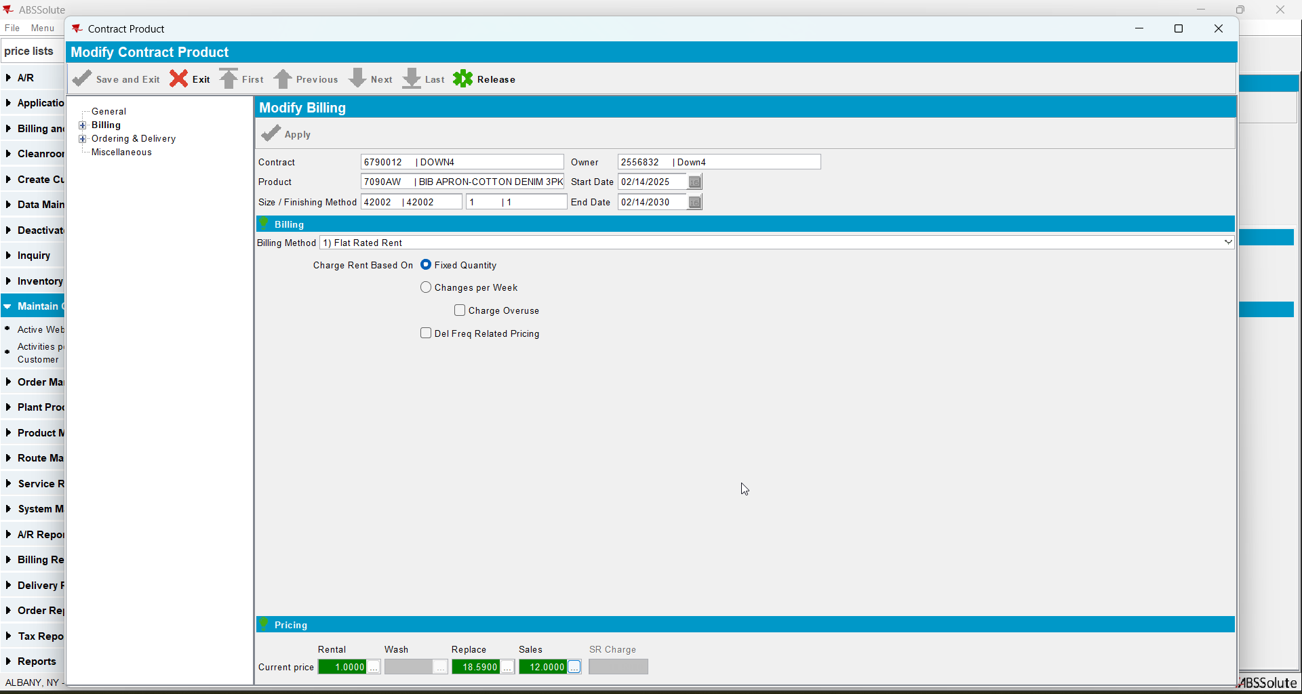
- Check that the sales price list was added on the contract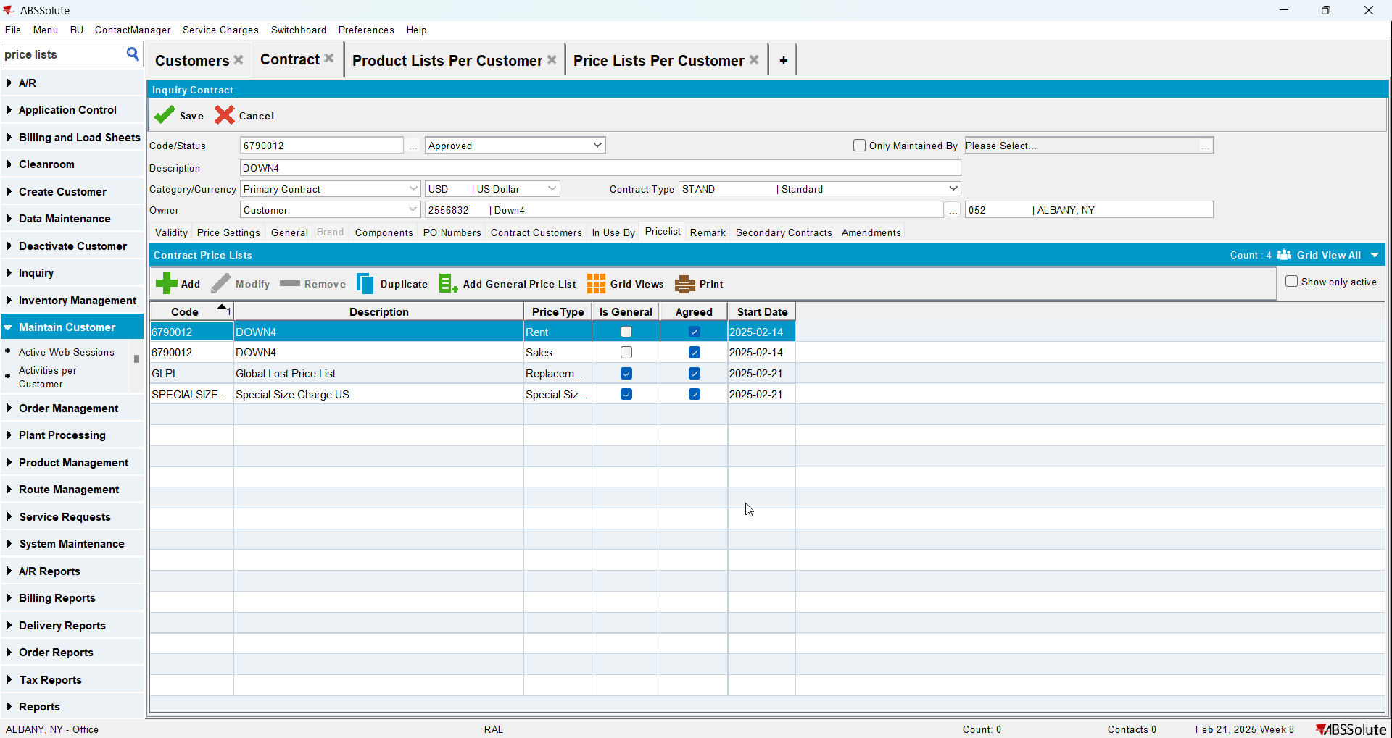
- Add the customer to the contract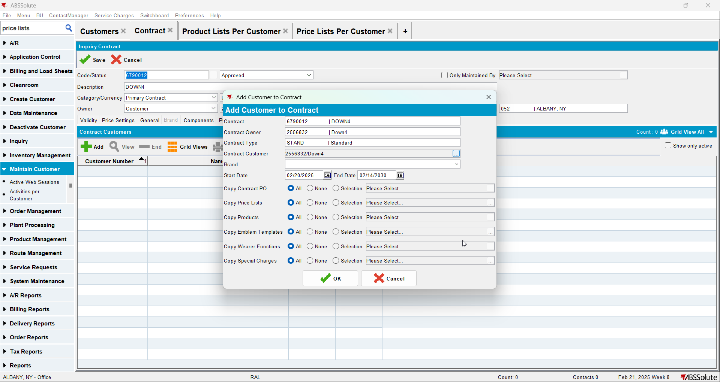
- Go to Price Lists Per Customer and add a customer specific sales price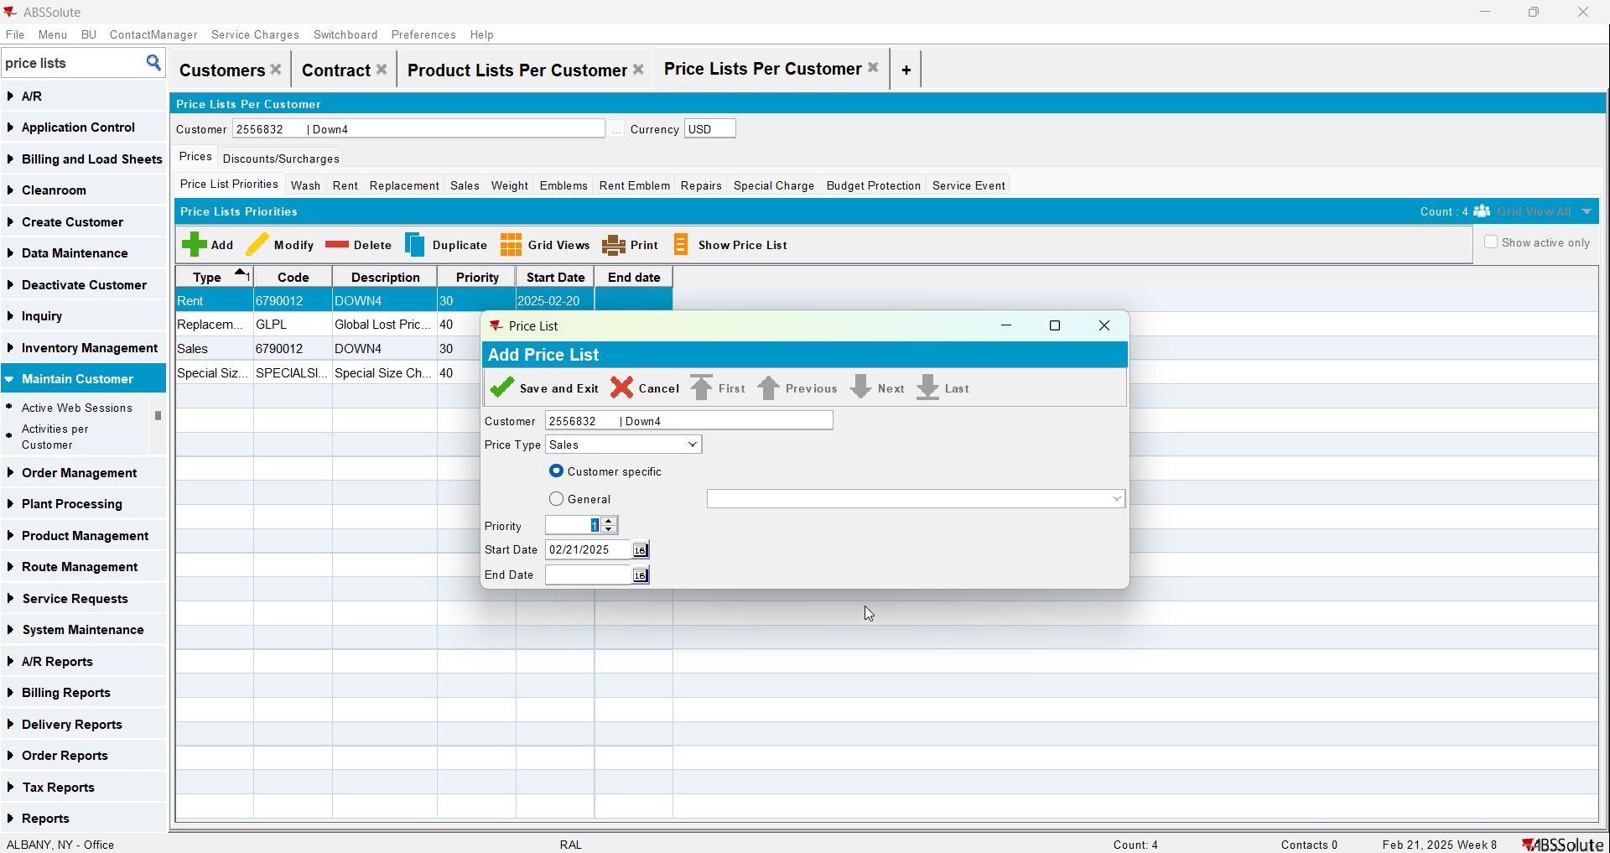
- Go to Product Lists Per Customer and check there is only the price from the contract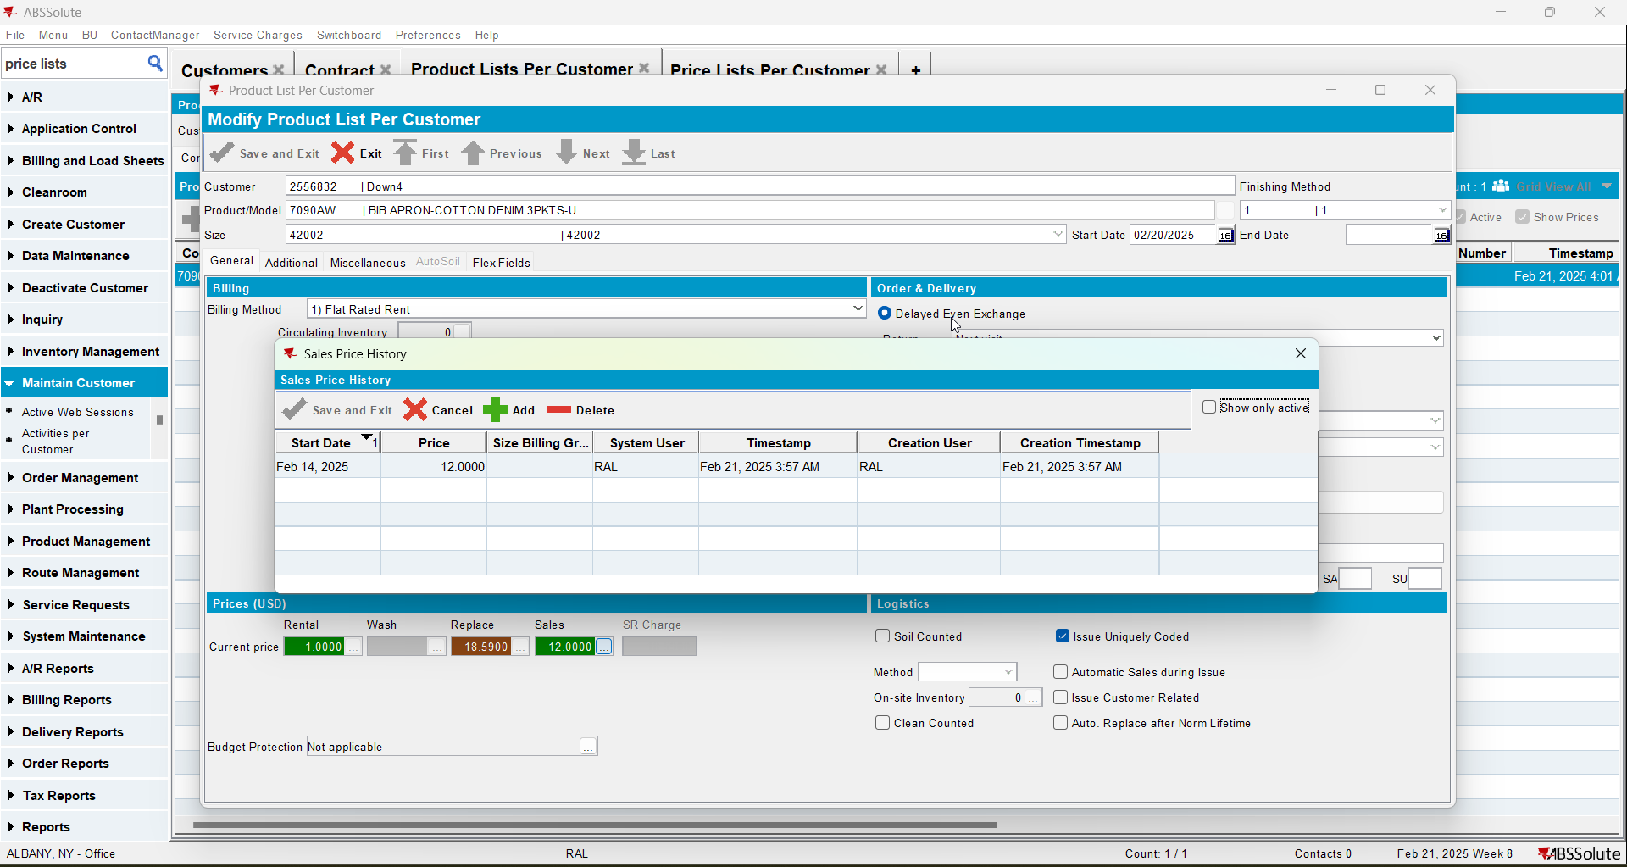
- Check the compliancy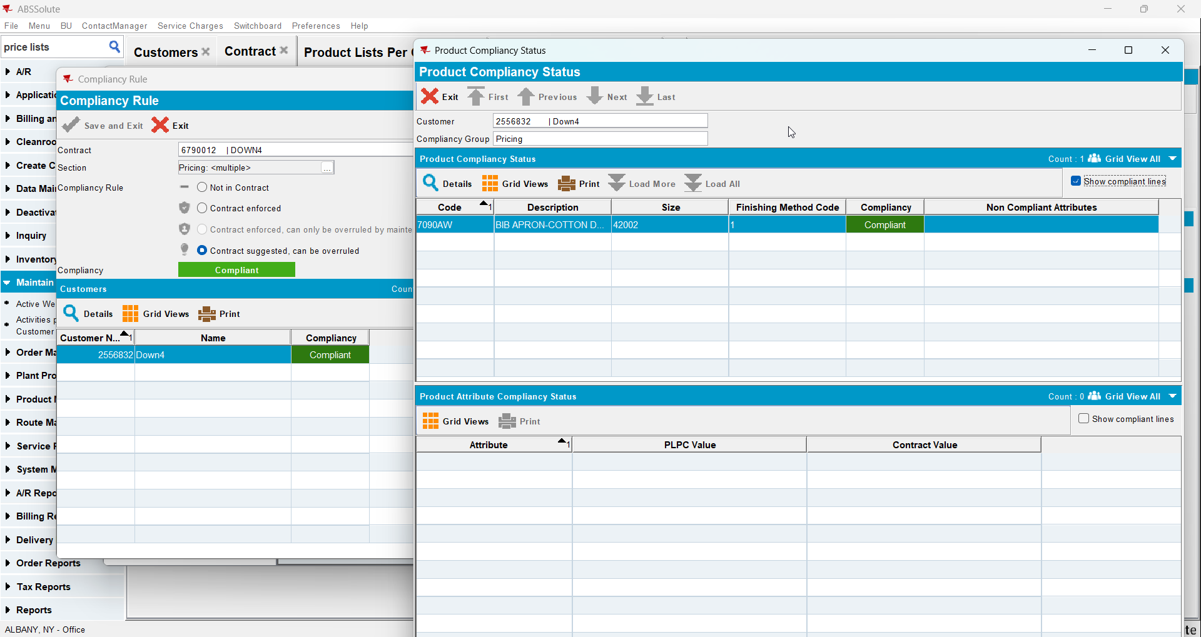

Test Case 5 – CONTRACTPRICELIST exists and there is a price for the specific product CUSTOMERPRICELIST does not exist – Tested OK
Expected behavior: Should be compliant
Hash: 8de3f55
- Add a new customer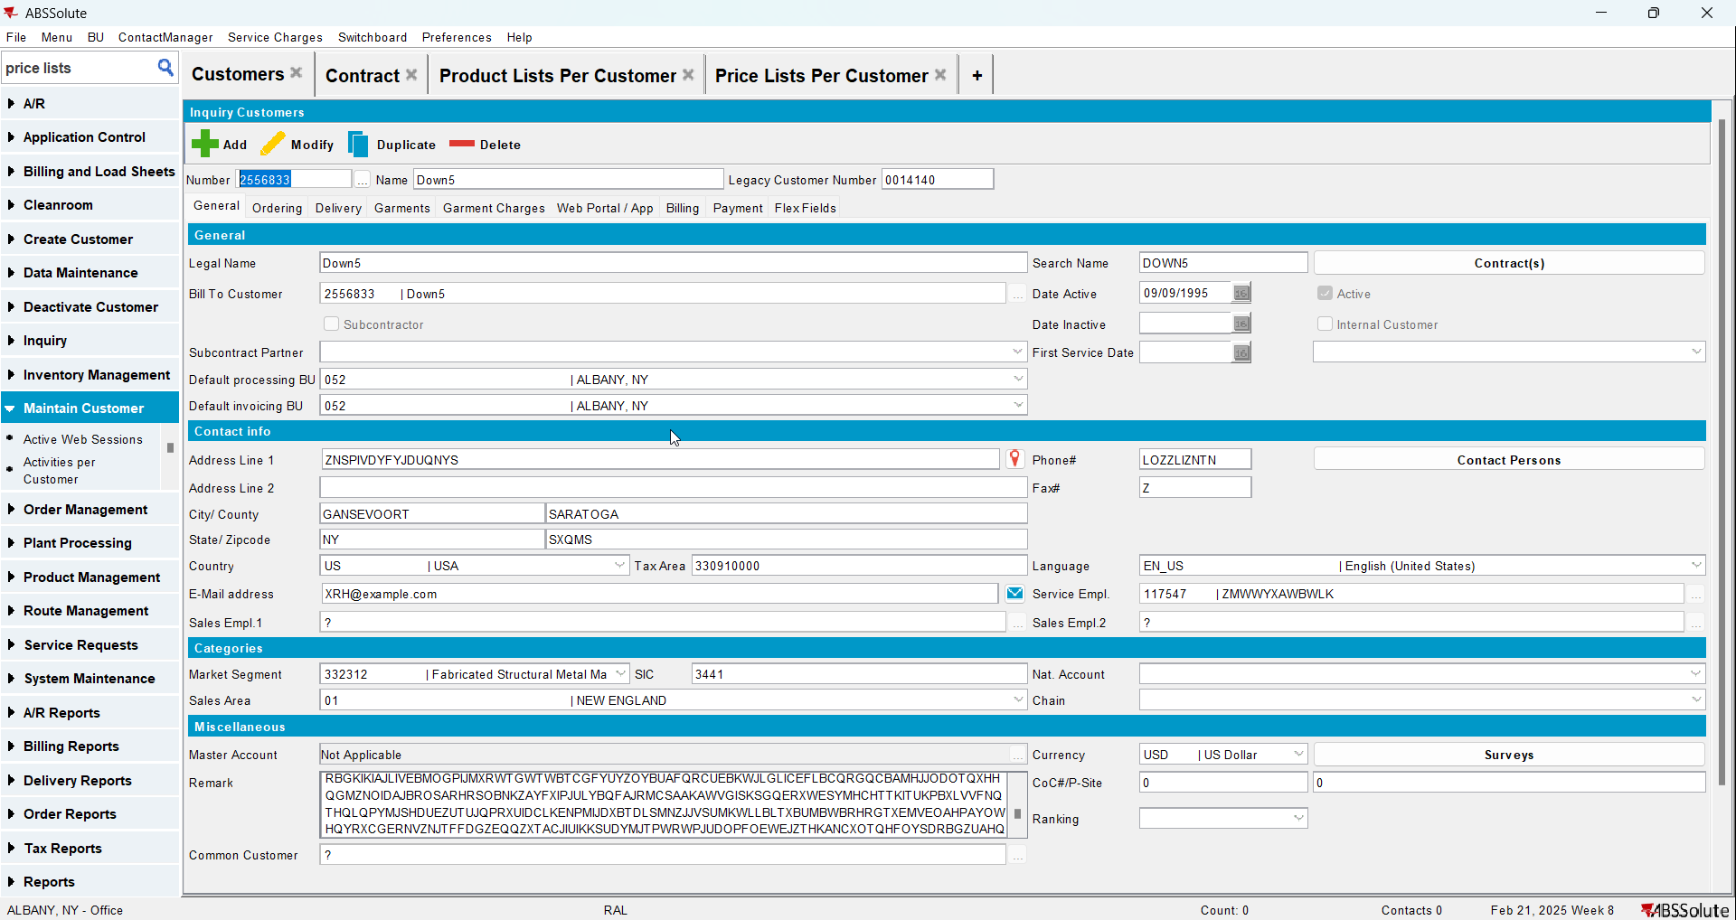
- Add a new contract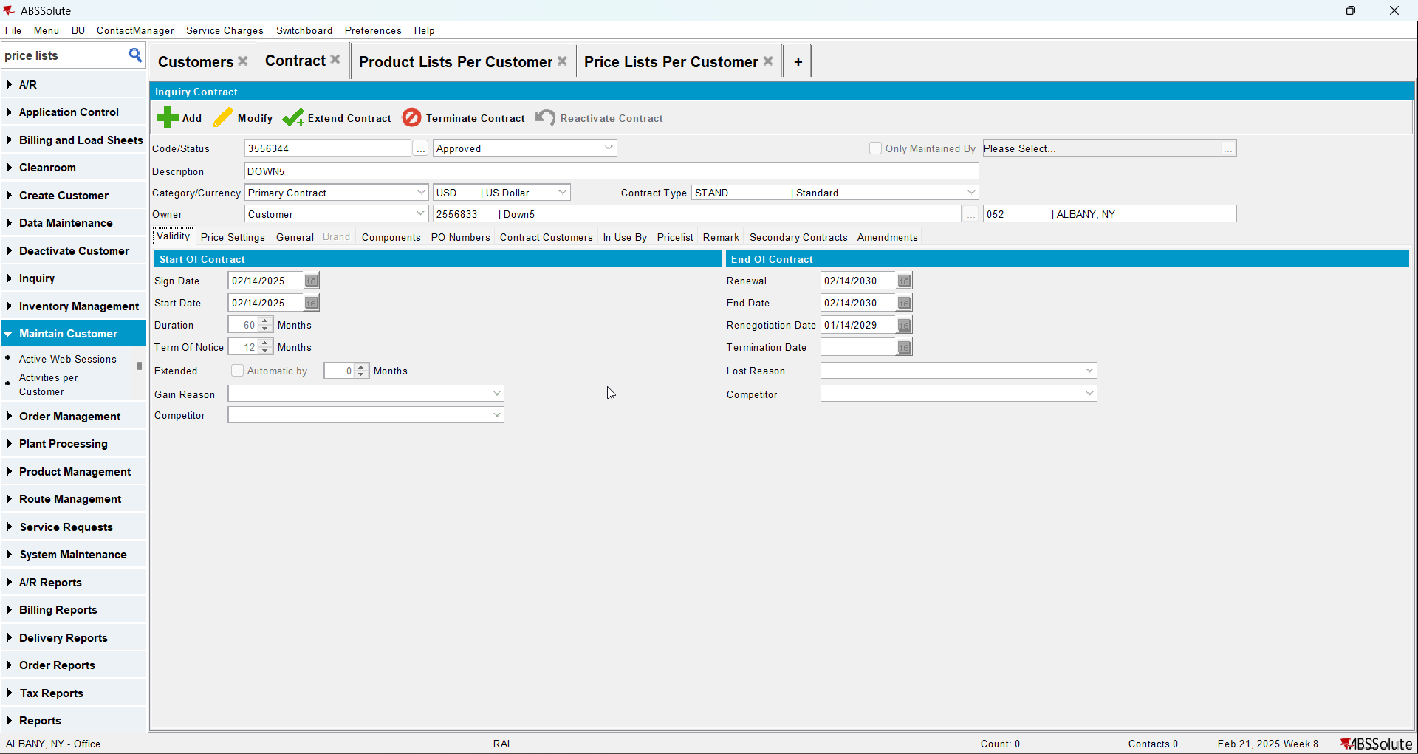
- Add a garment to the contract and add a sales price to it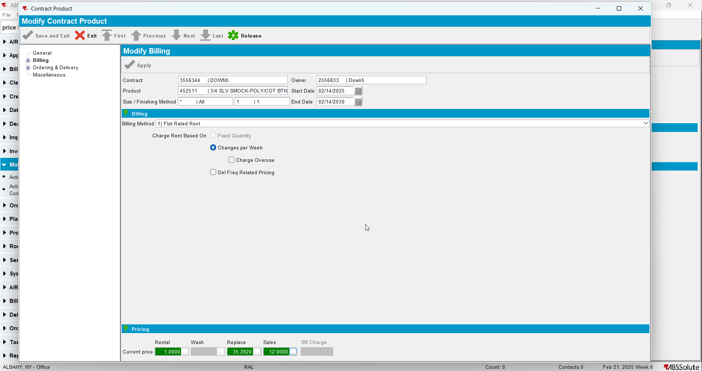
- Check that the sales price list was added on the contract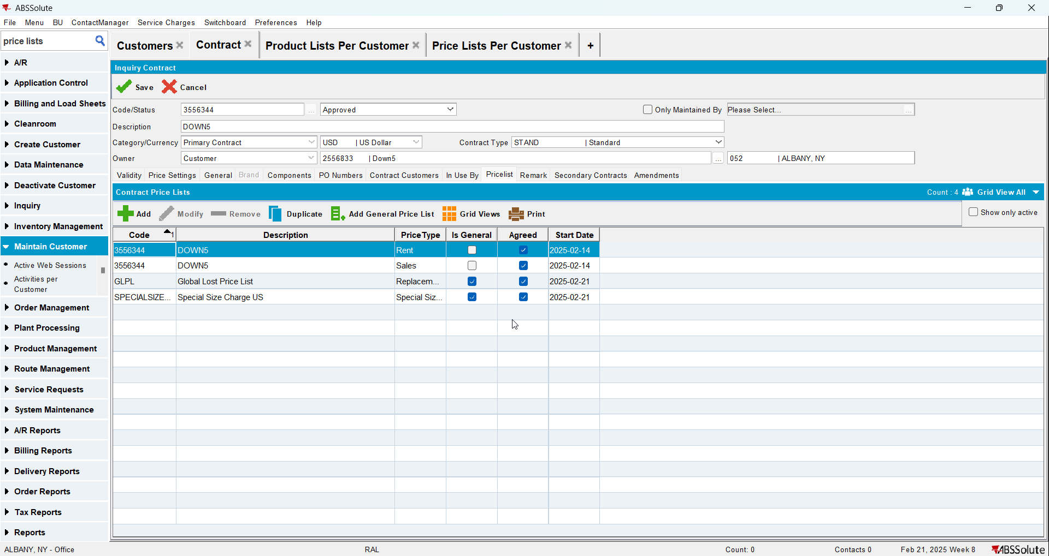
- Add the customer to the contract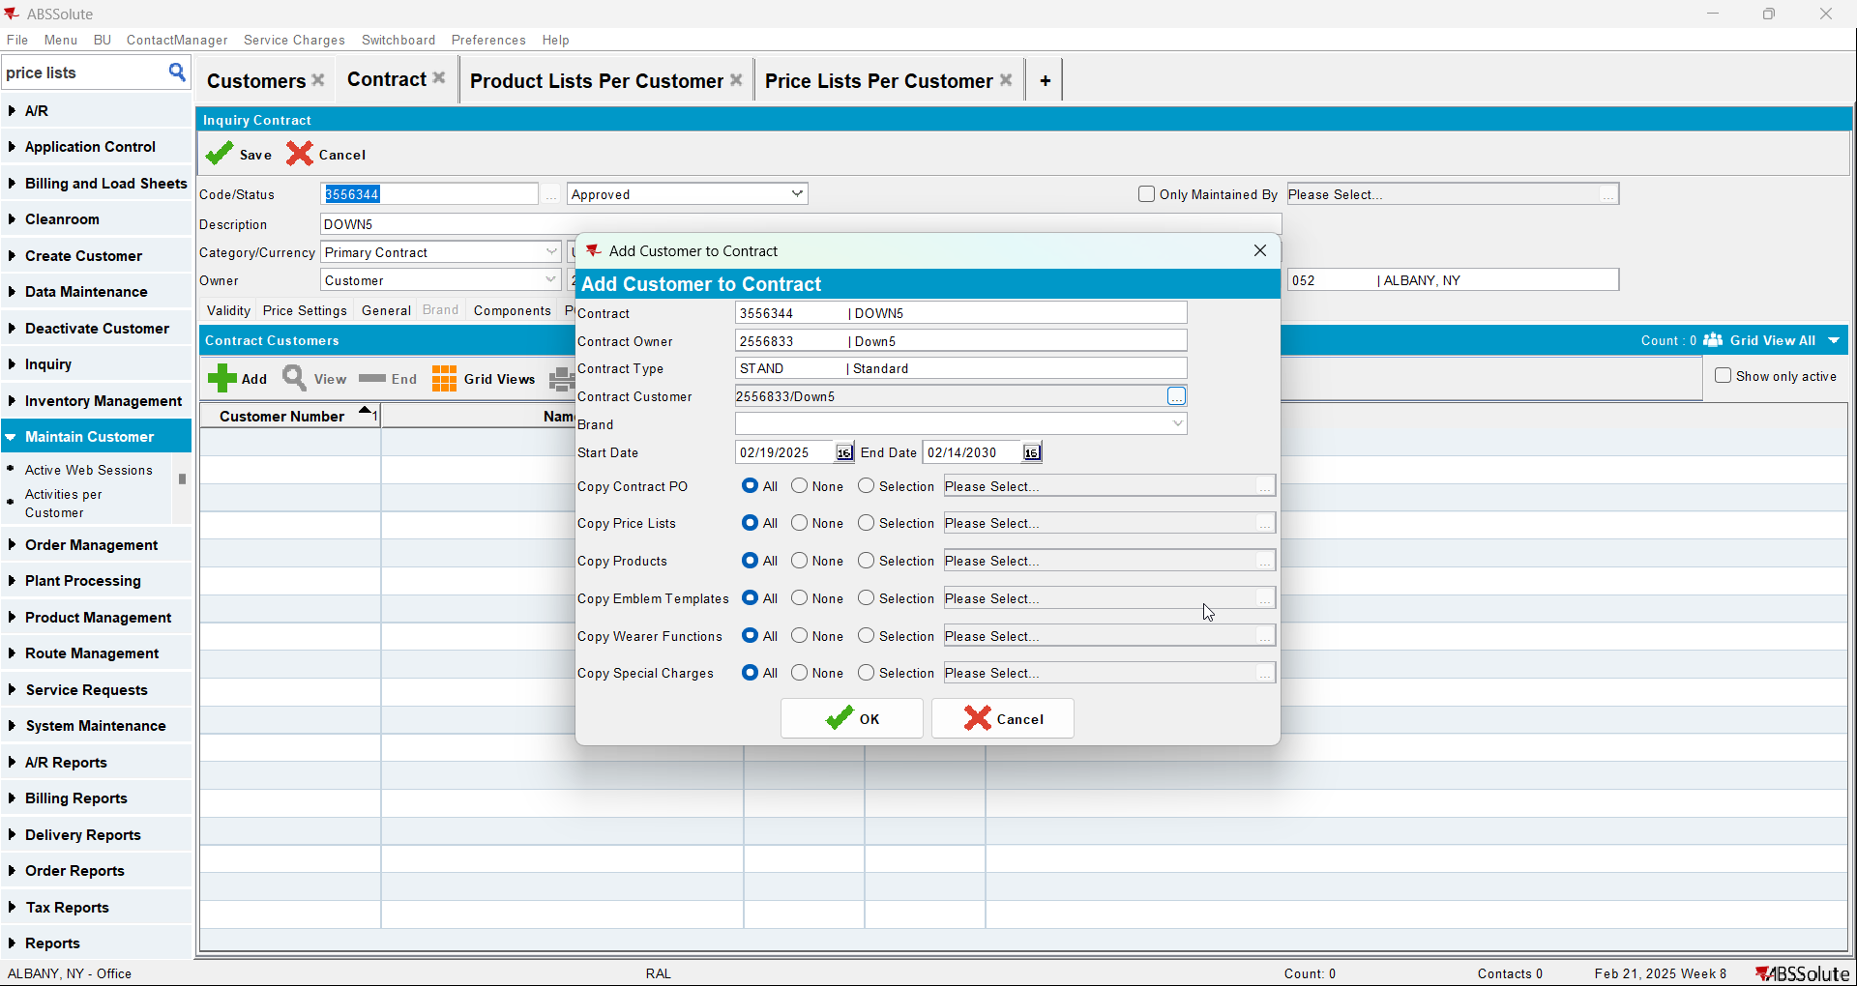
- Check there is no customer specific sales price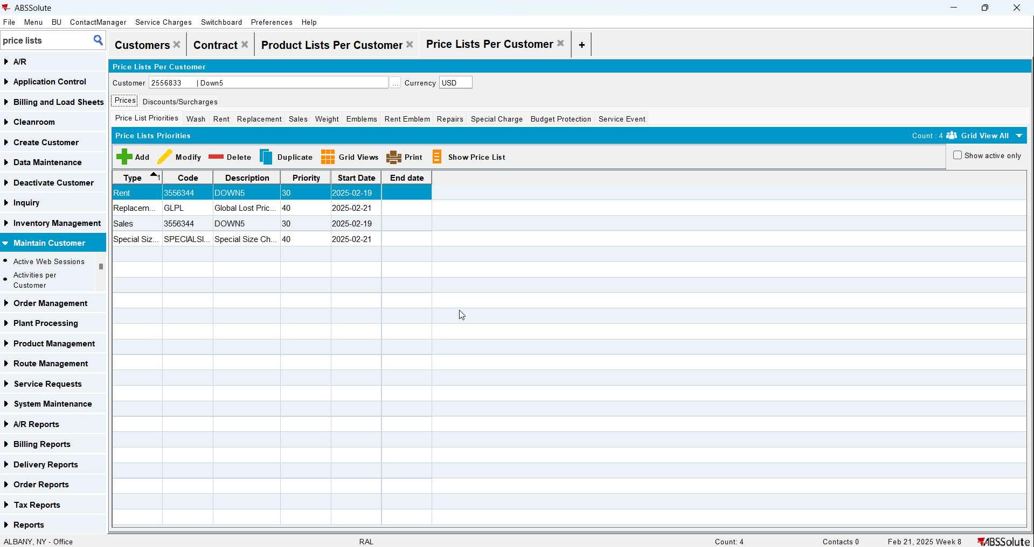
- Check the compliancy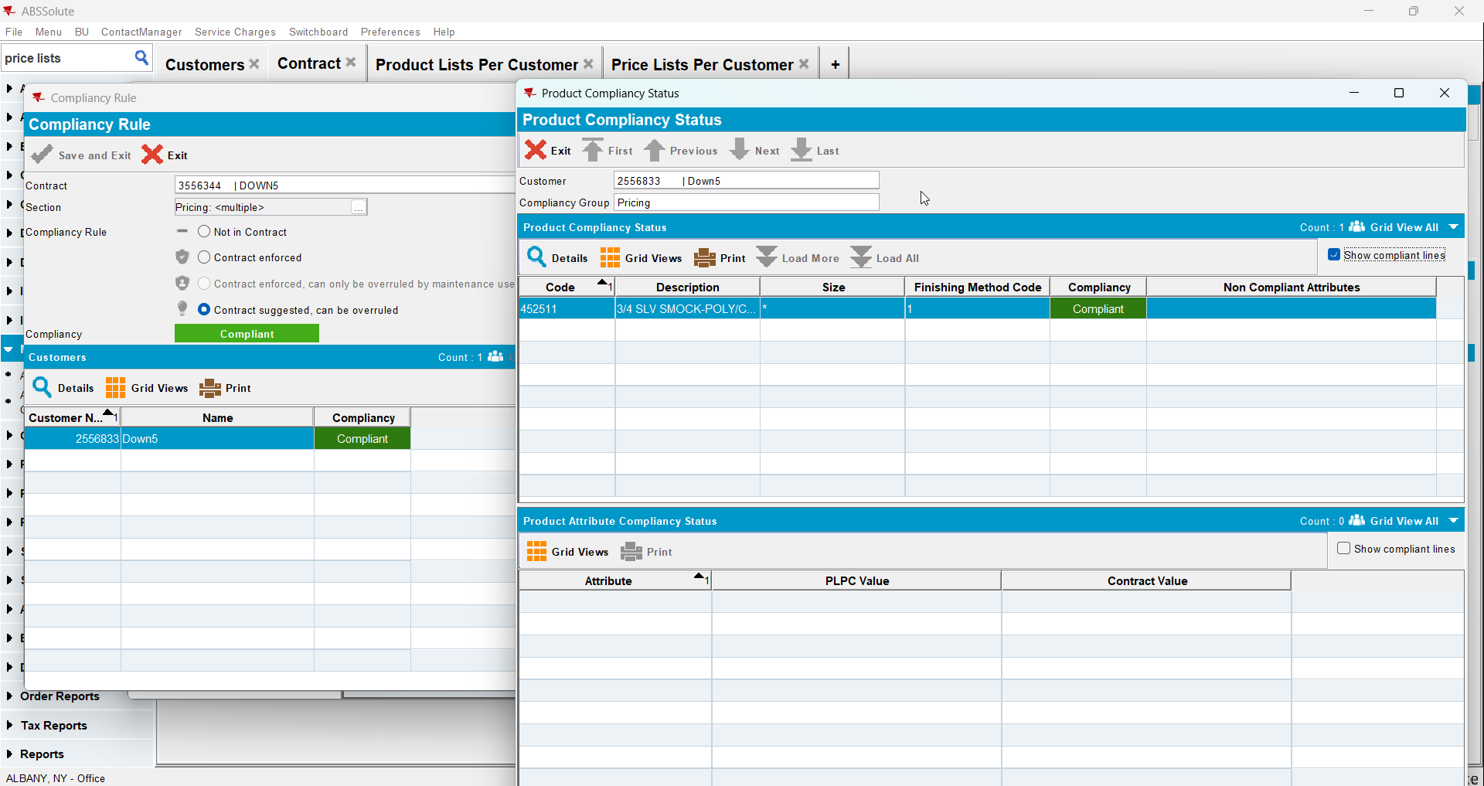

Test Case 6 – CONTRACTPRICELIST exists and there is a price for the specific product CUSTOMERPRICELIST exists and CUSTOMER PRICE LIST has price for specific product BUT the priority on the CUSTOMERSPECIFICPRICELIST is a higher number than the CONTRACTSPECIFICPRICELIST – Tested OK
Expected behavior: Should be compliant
Hash: 8de3f55
- Add a new customer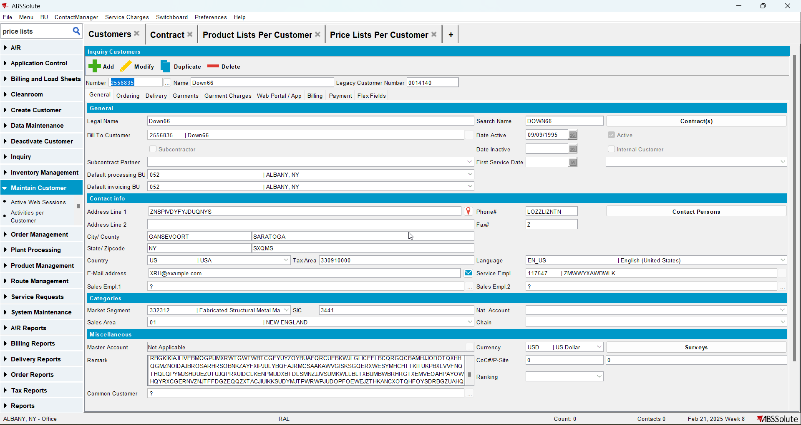
- Add a new contract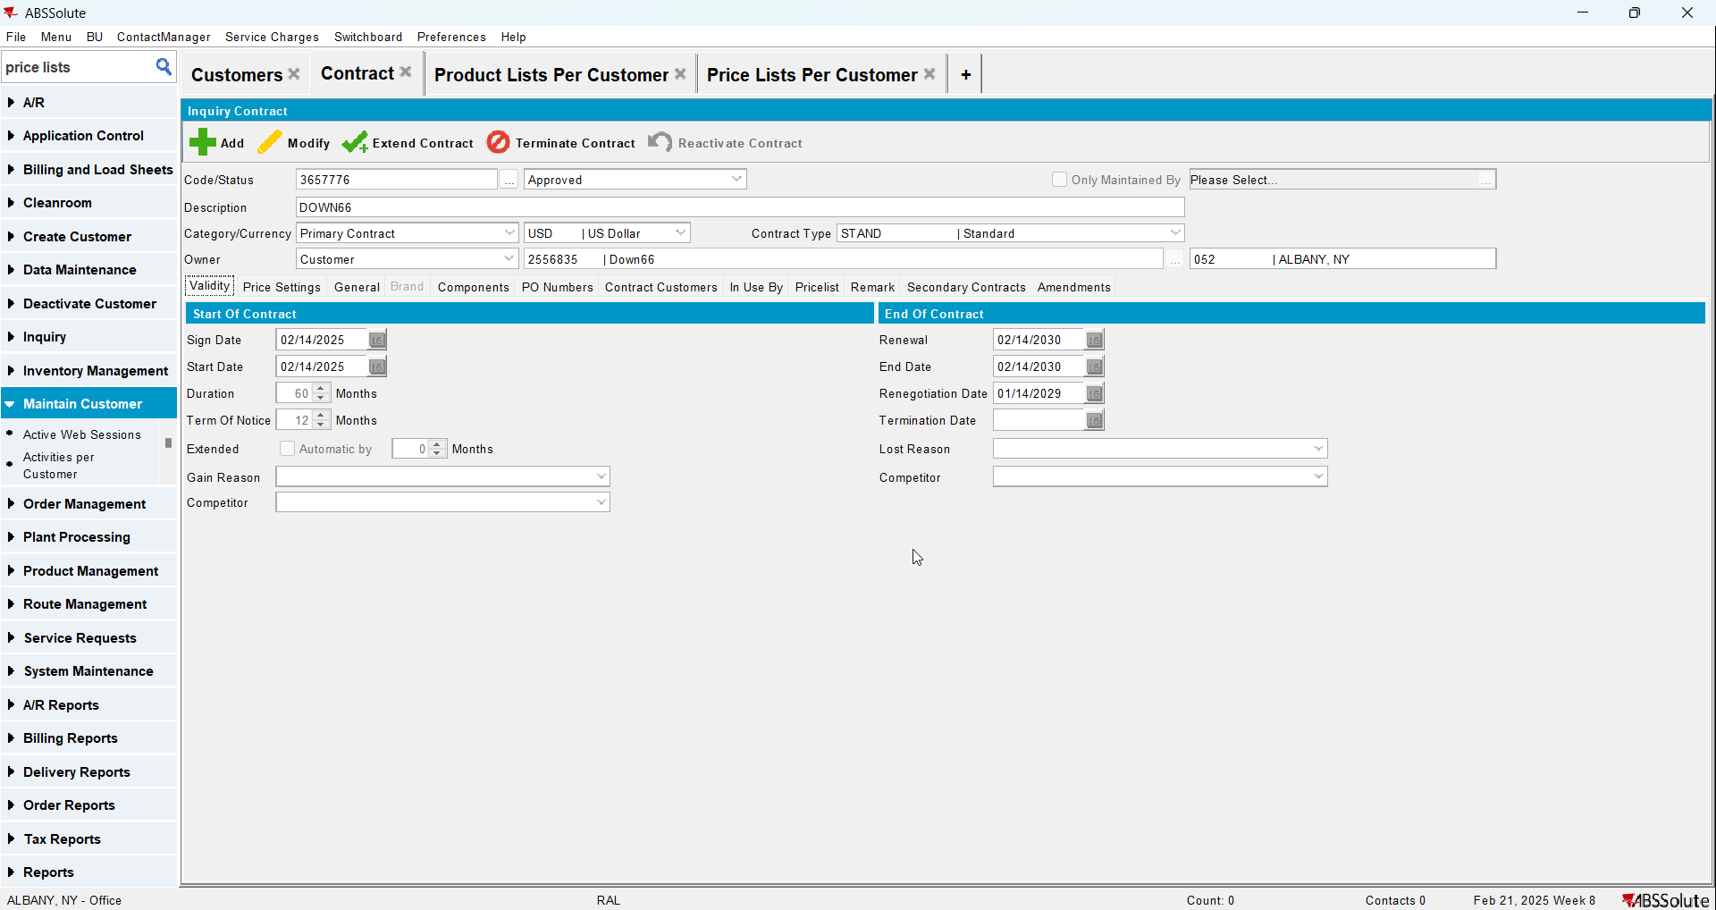
- Add a garment to the contract and add a sales price to it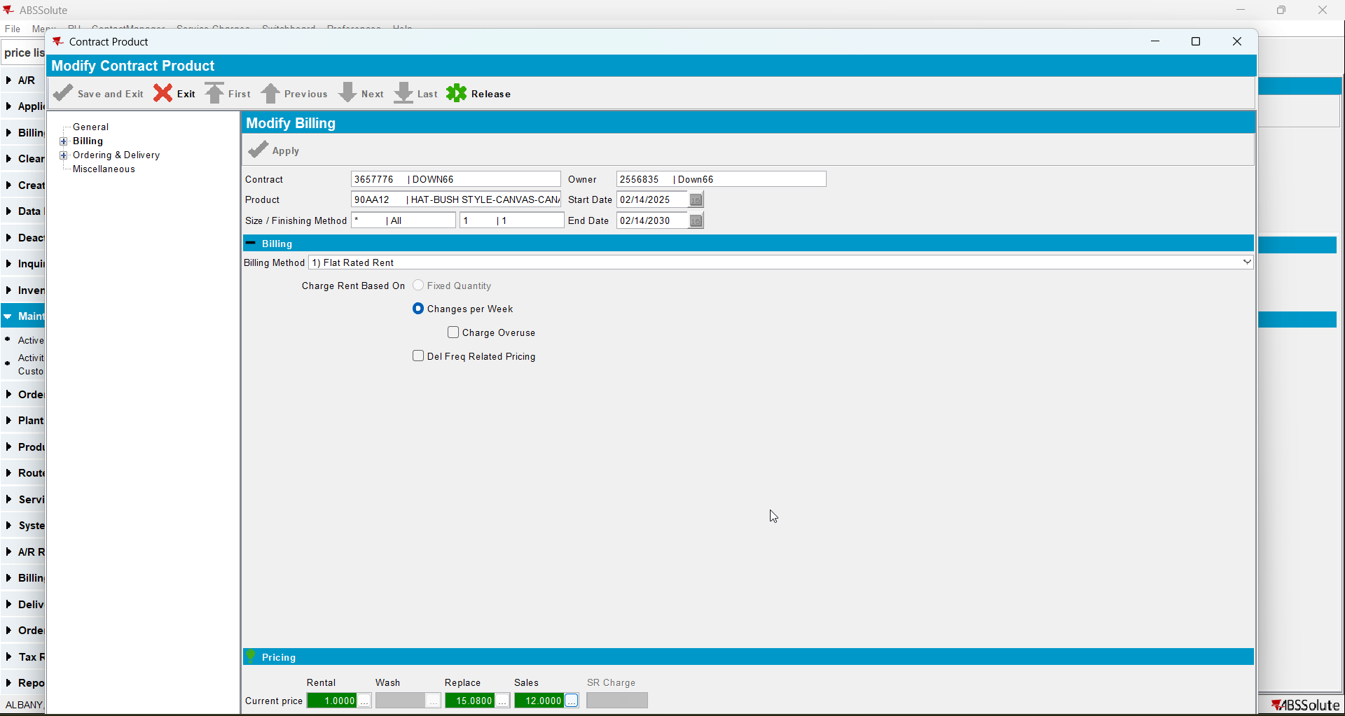
- Check that the sales price list was added on the contract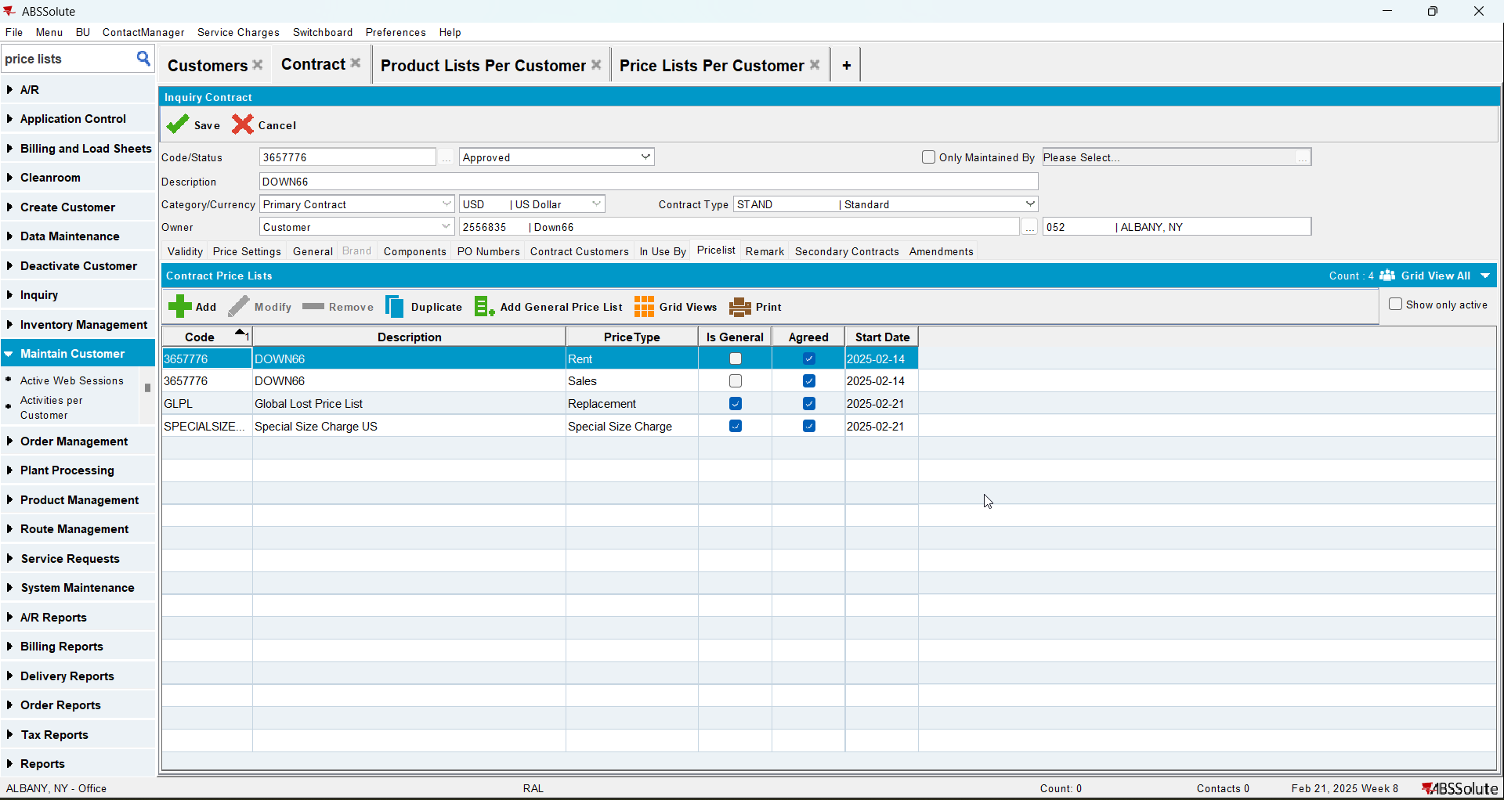
- Add the customer to the contract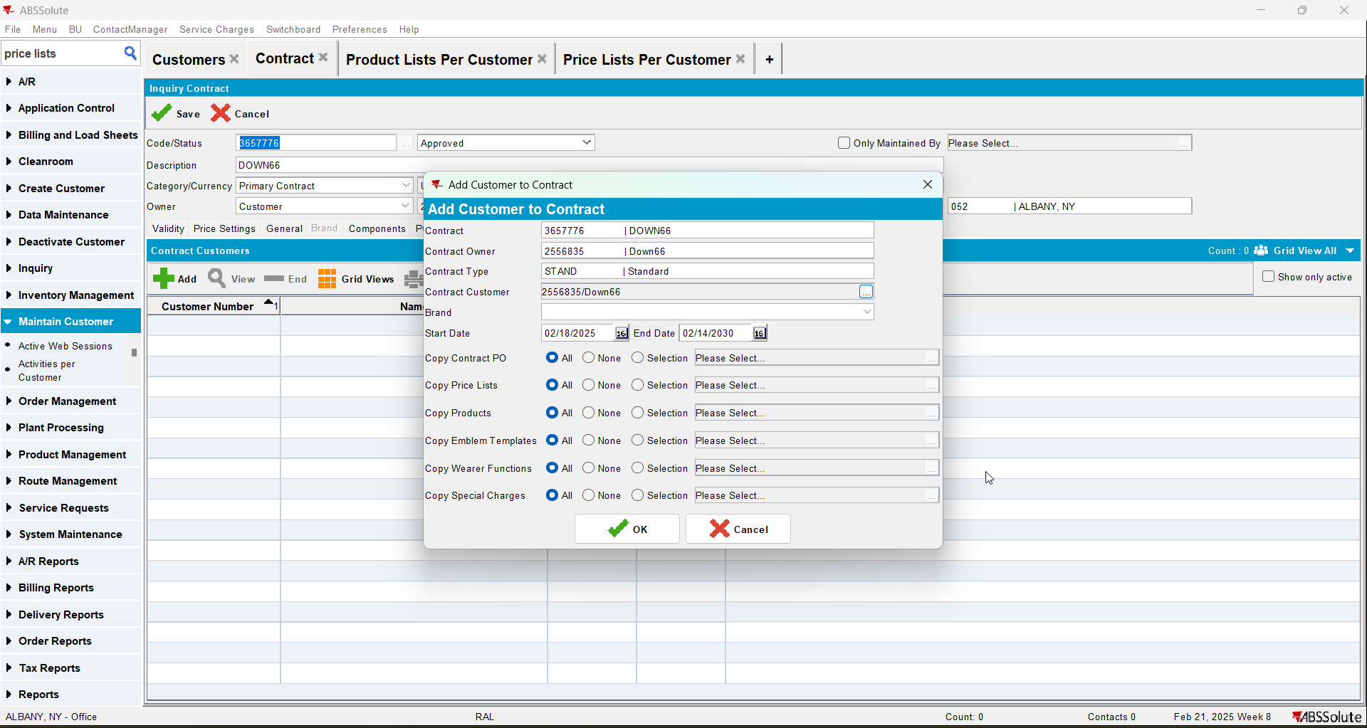
- Go to Price Lists Per Customer and add a customer specific sales price with a higher priority number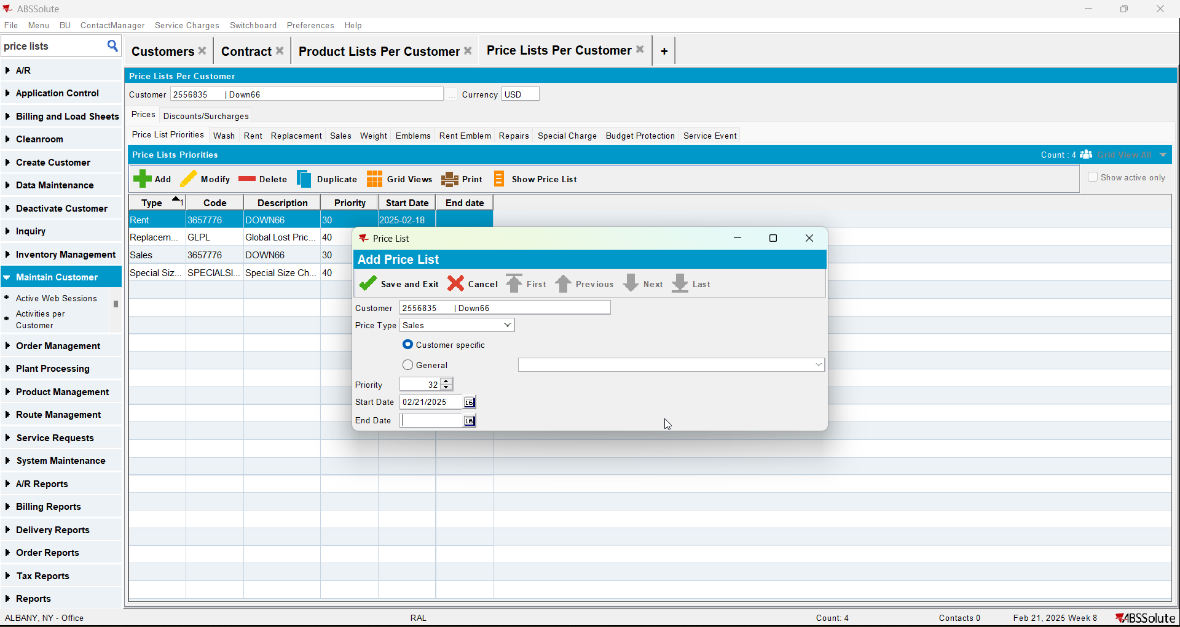
- Go to Product Lists Per Customer and add a sales price to the product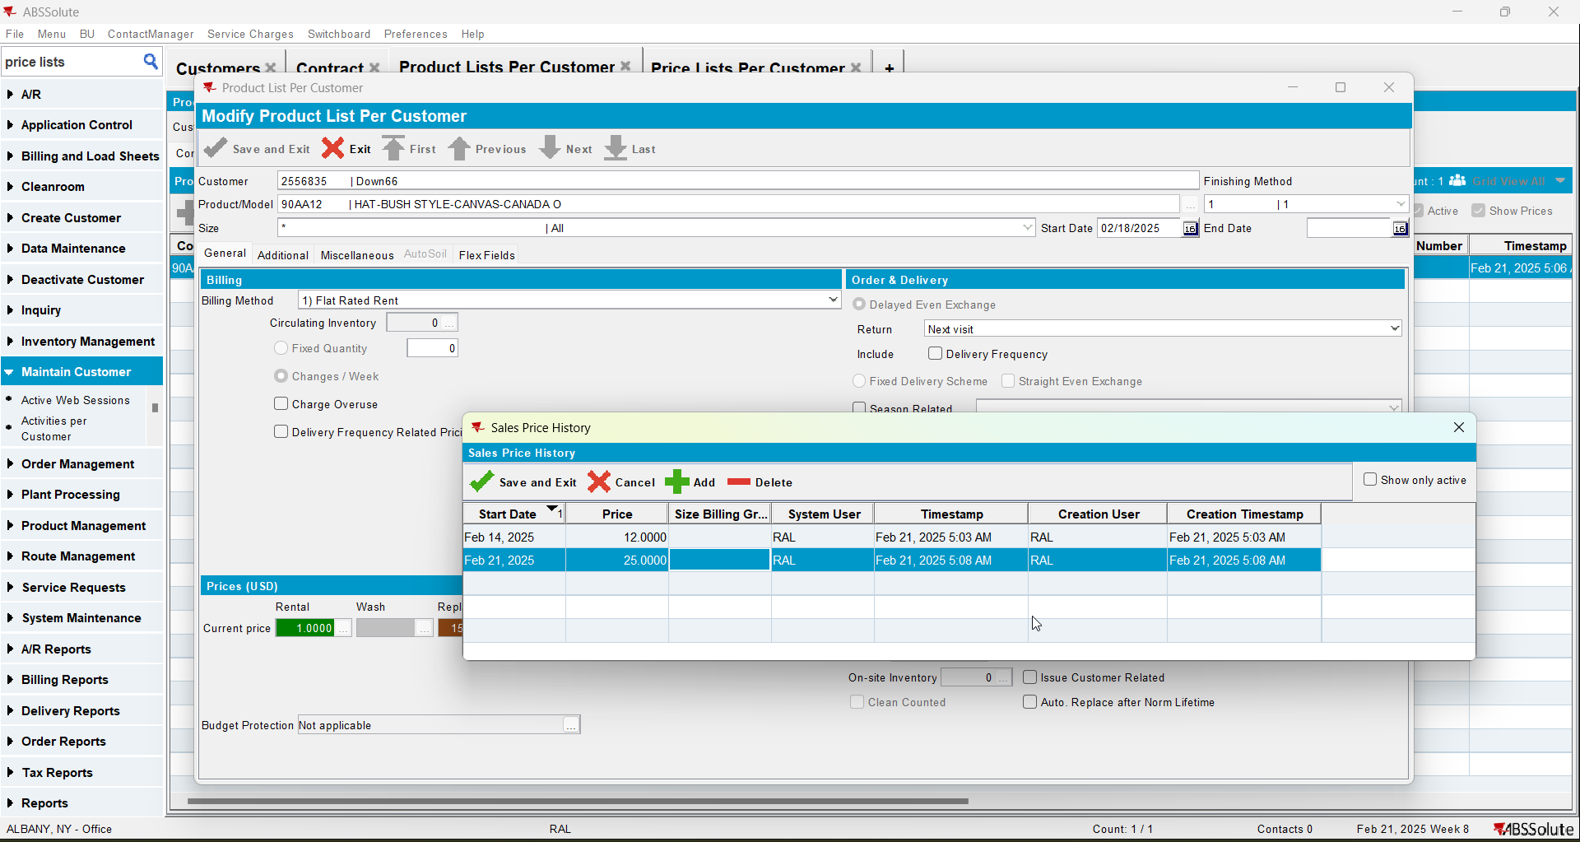
- Check the compliancy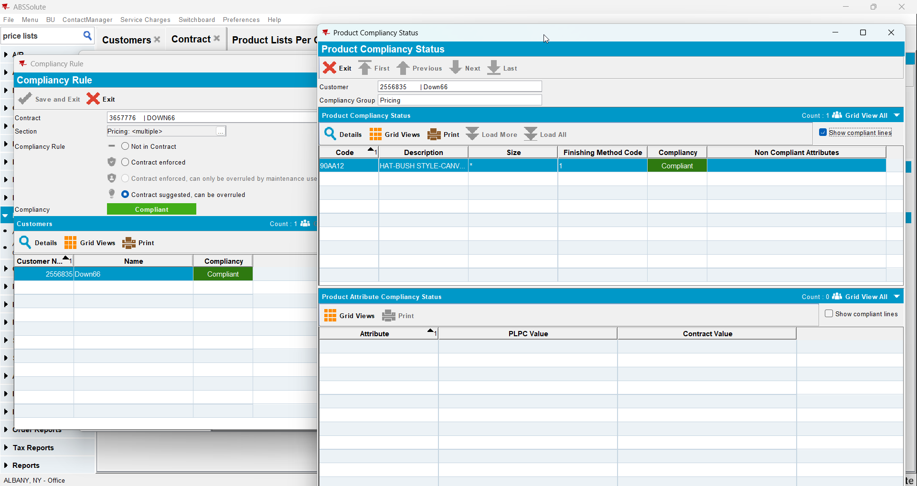

Test Case 7 – CONTRACTPRICELIST exists and there is a price for the specific product CUSTOMERPRICELIST exists and CUSTOMER PRICE LIST has price for specific product BUT the CUSTOMERSPECIFICPRICELIST has an end date < SYSDATE– Tested OK
Expected behavior: Should be compliant
Hash: 8de3f55
- Add a new customer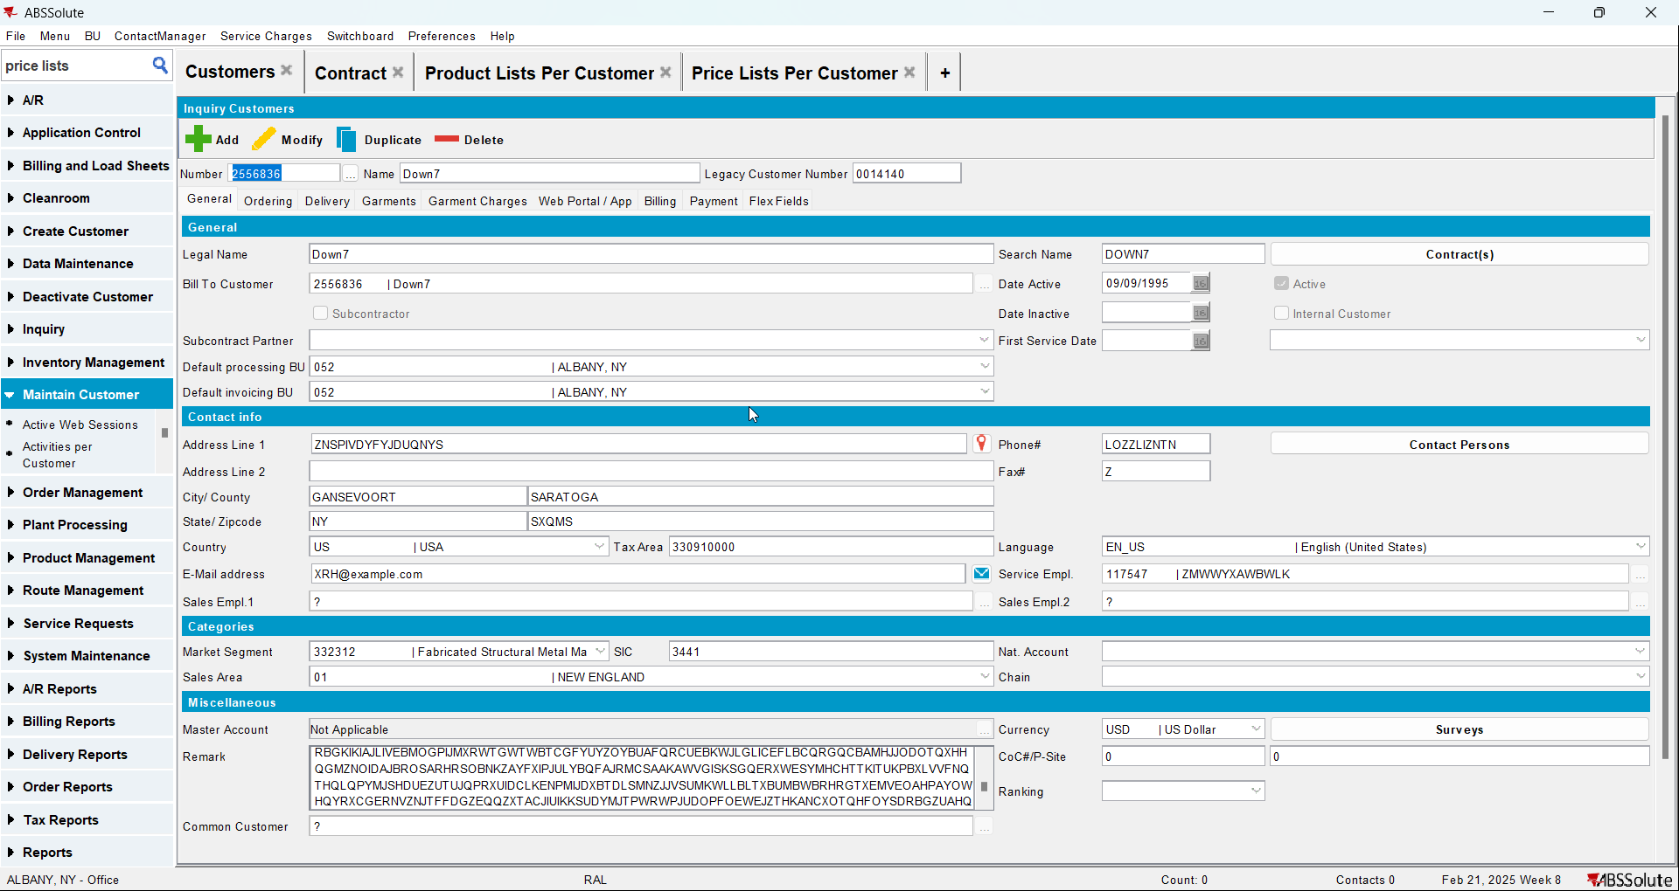
- Add a new contract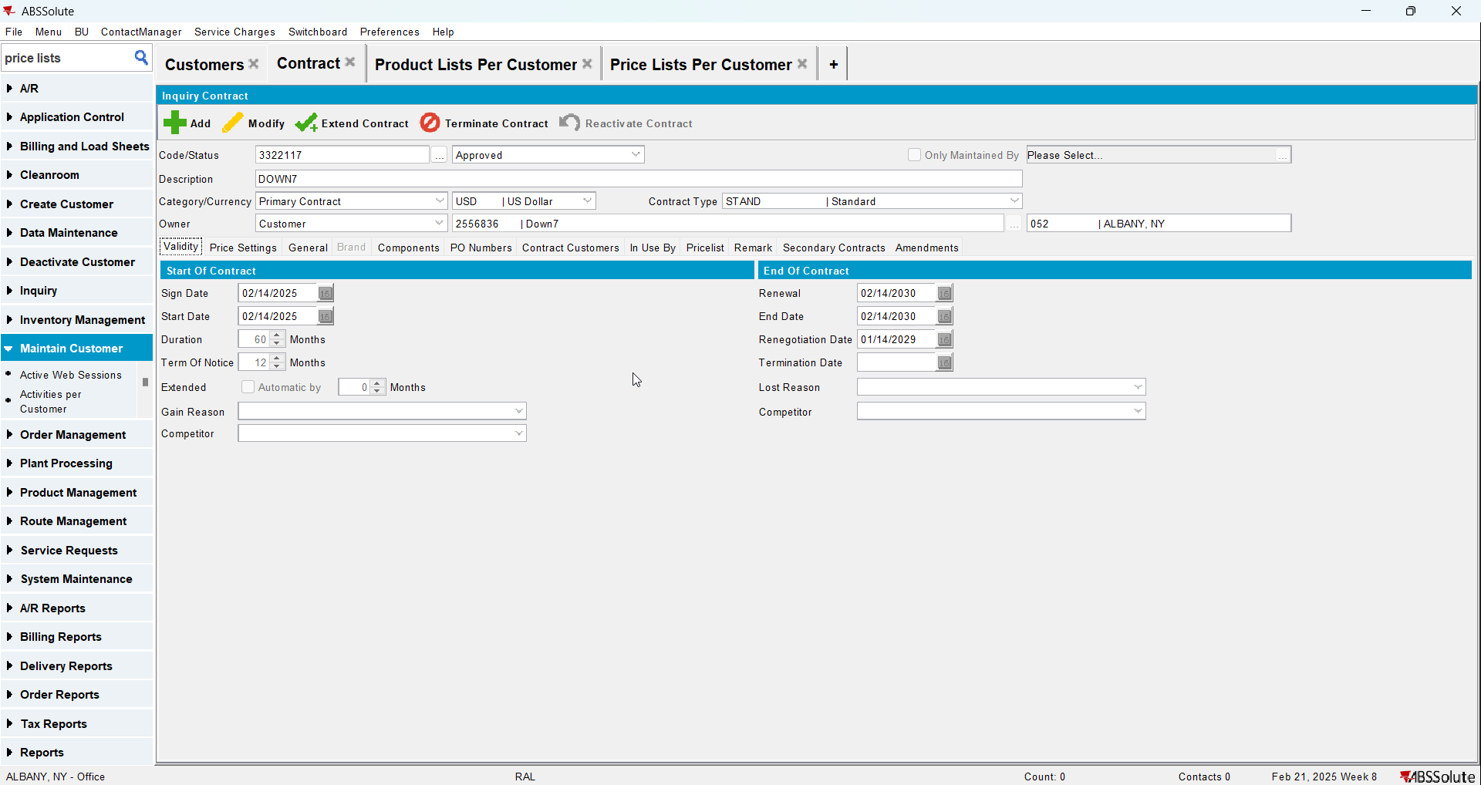
- Add a garment to the contract and add a sales price to it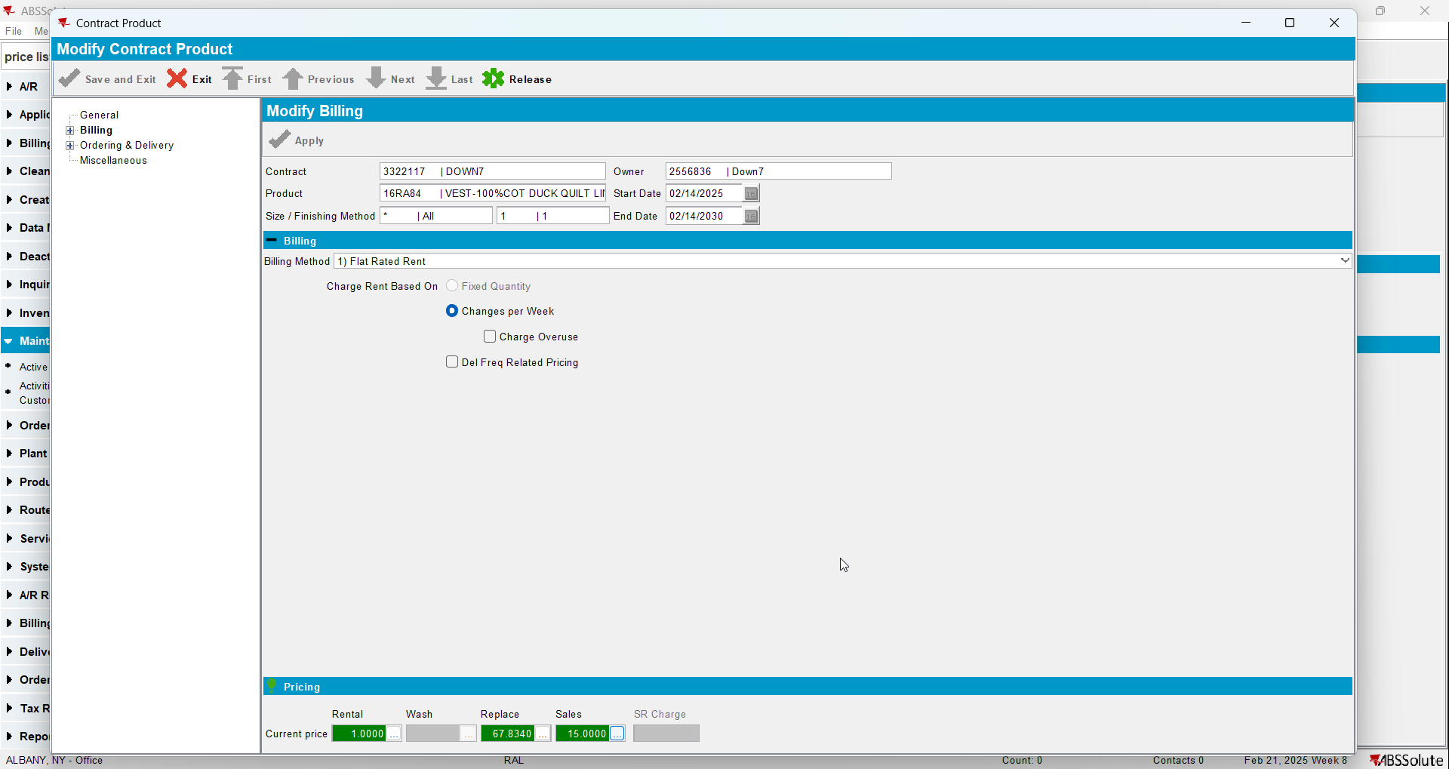
- Check that the sales price list was added on the contract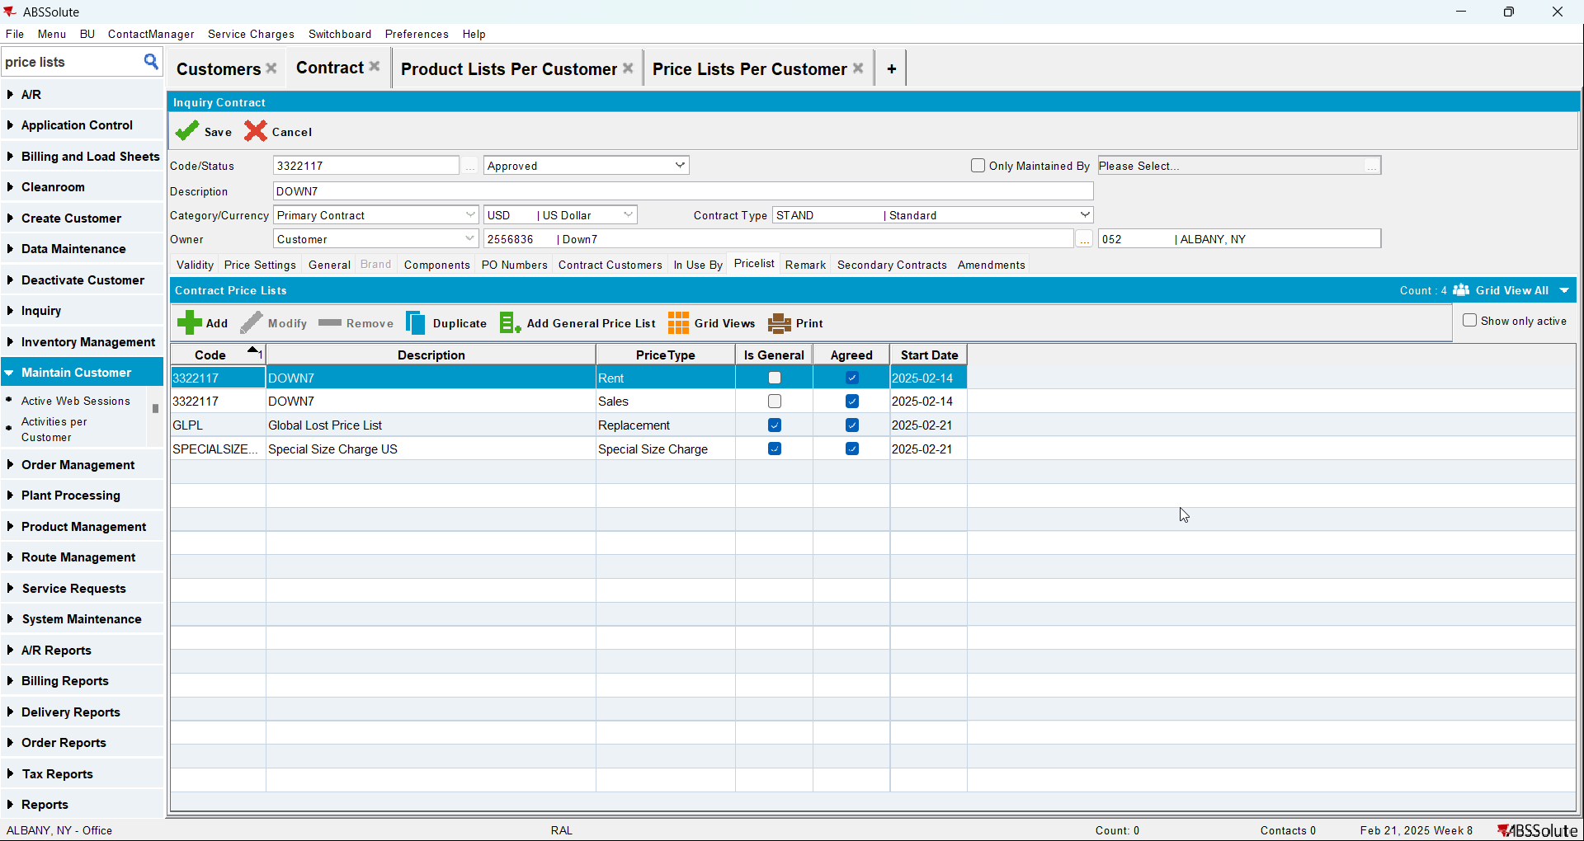
- Add the customer to the contract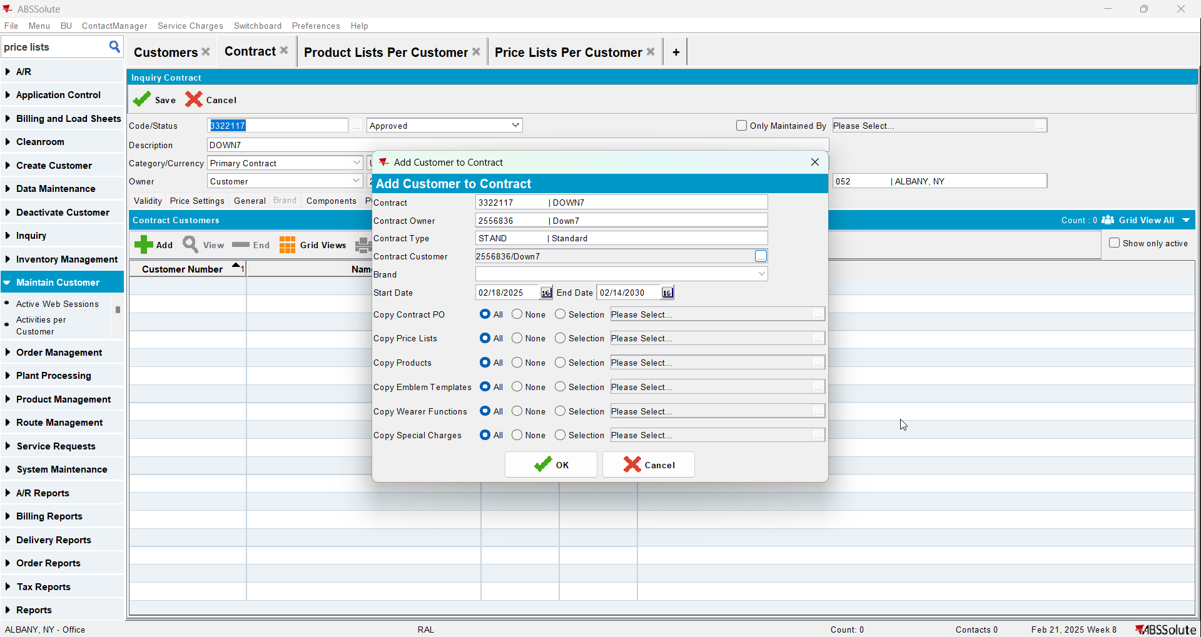
- Go to Price Lists Per Customer and add a customer specific sales price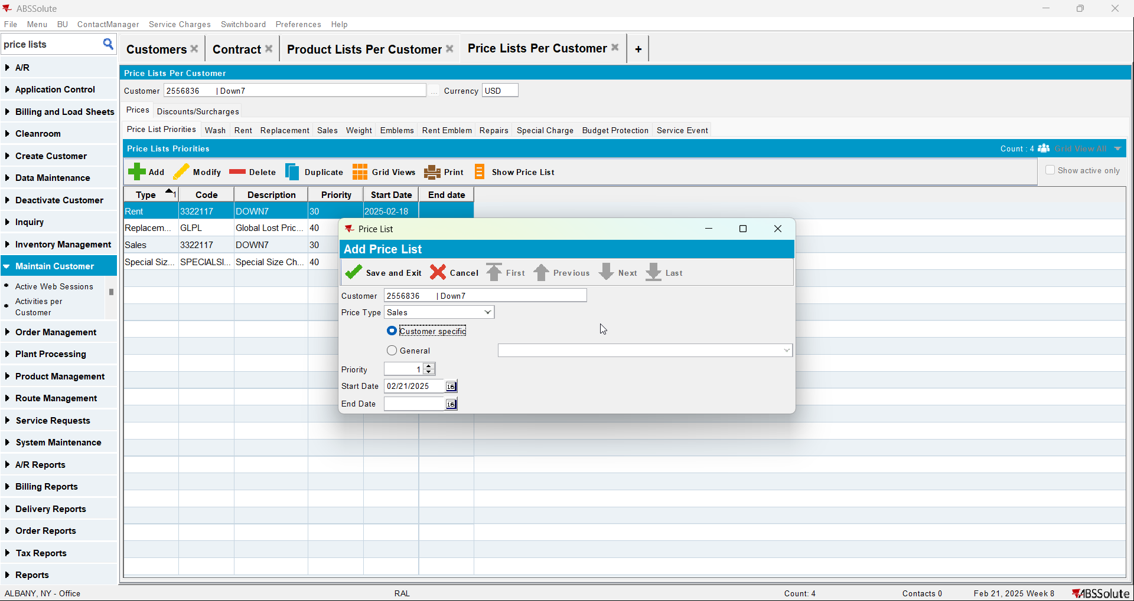
- Go to Product Lists Per Customer and add a sales price to the product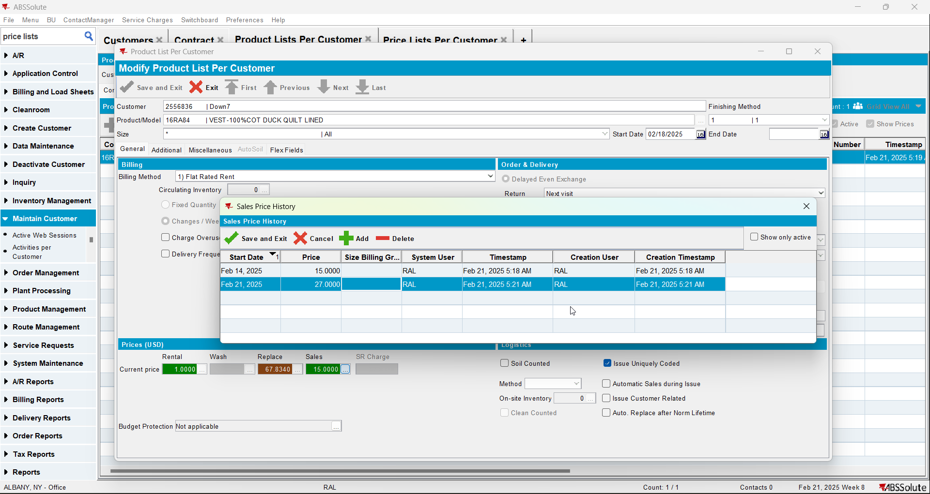
- Go to Price Lists Per Customer and inactivate the sales specific price list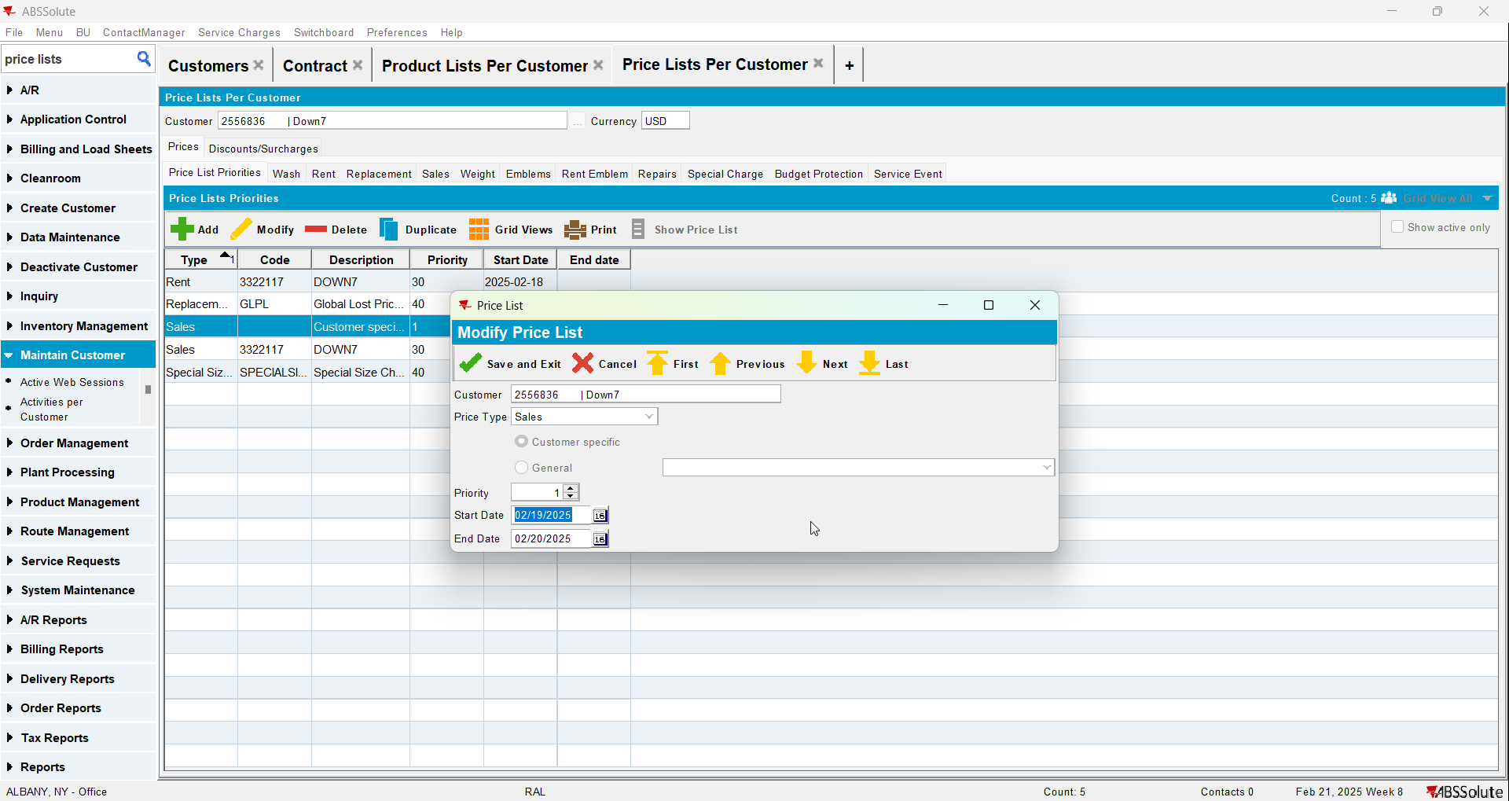
- Check the compliancy