ABSN-87 Hide gender field under HIDEGENDERFIELD system setting
Environment | Prerequisites
Version:9.07.00  DBServerName=abs-SRV20.internal.abslbs.com  DBSID=CUST24  DBUser=UNFDEV  DBPassword=UNFDEV  Environment=Test | - Module:  - System setting

Contents
Test after fix 1
Test Case 1 – SS HIDEGENDERFIELD=0– Tested OK 1
Test Case 2 – SS HIDEGENDERFIELD=1– Tested OK 6

Test after fix

Test Case 1 – SS HIDEGENDERFIELD=0– Tested OK
Expected behavior: Gender should be visible
Hash: a6826de
- Have SS HIDEGENDERFIELD=0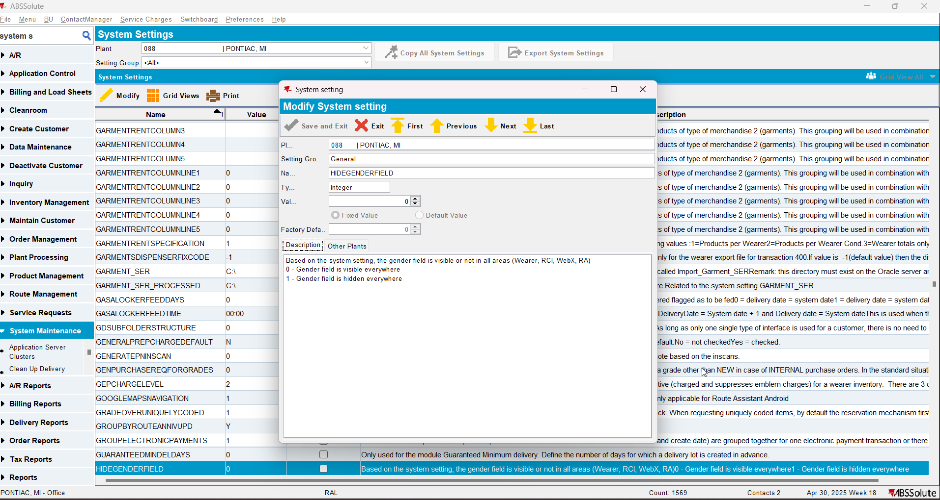
- Go to Wearers dlg and check that gender is visible by checking the grid, opening the wearer, adding a wearer.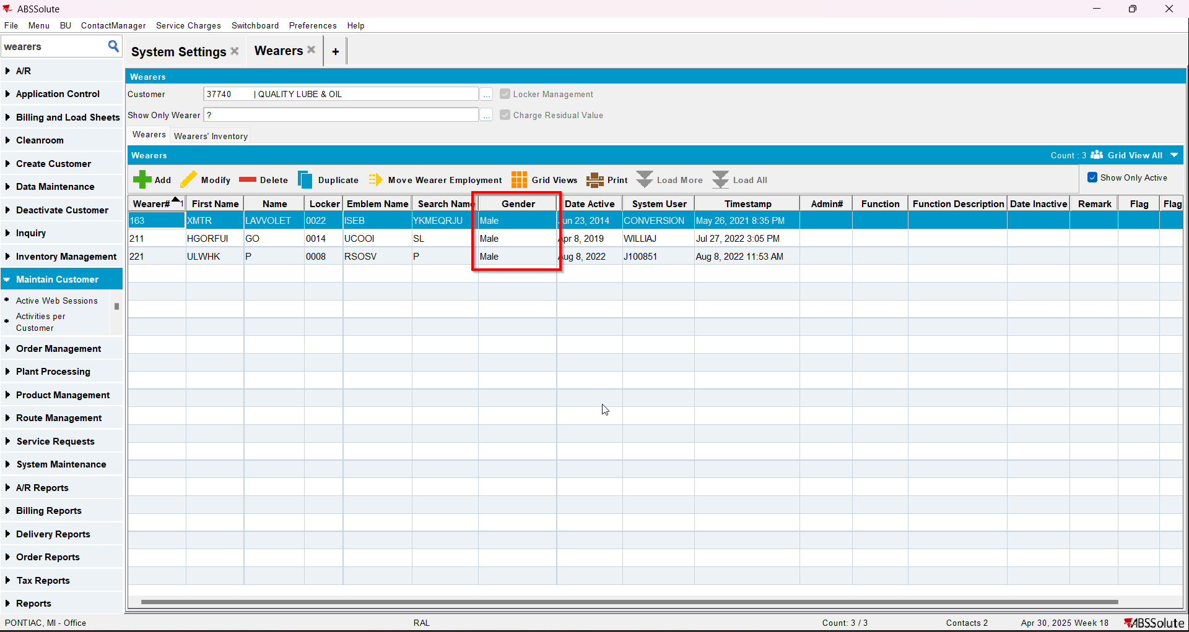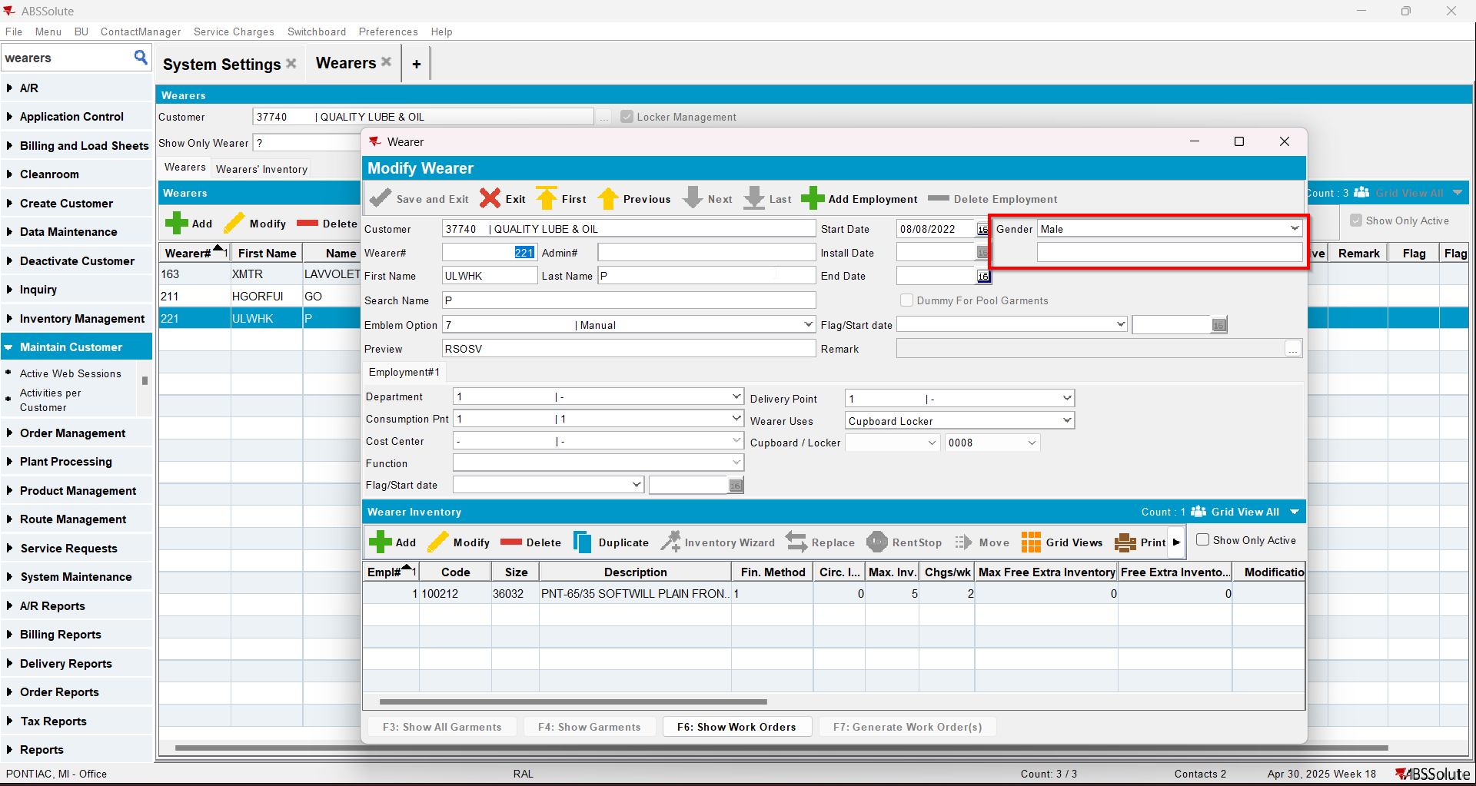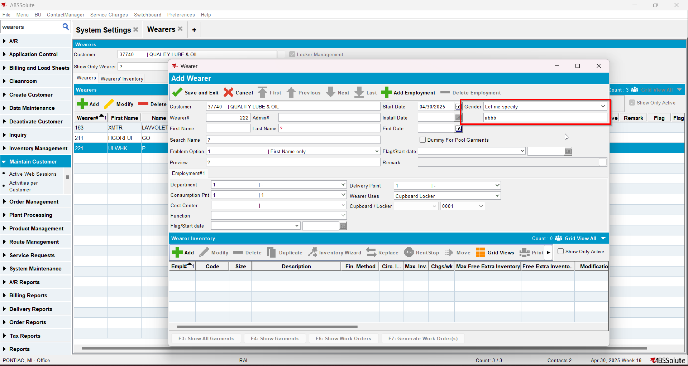
- Go to WebPortal. Make sure the SS is set to 0 for the Plant of the web user. I used BU 088
- Check that the gender is visible by checking the filters, checking the grid, adding a wearer, checking wearer details, adding an employment, editing wearer(only works for added wearers) 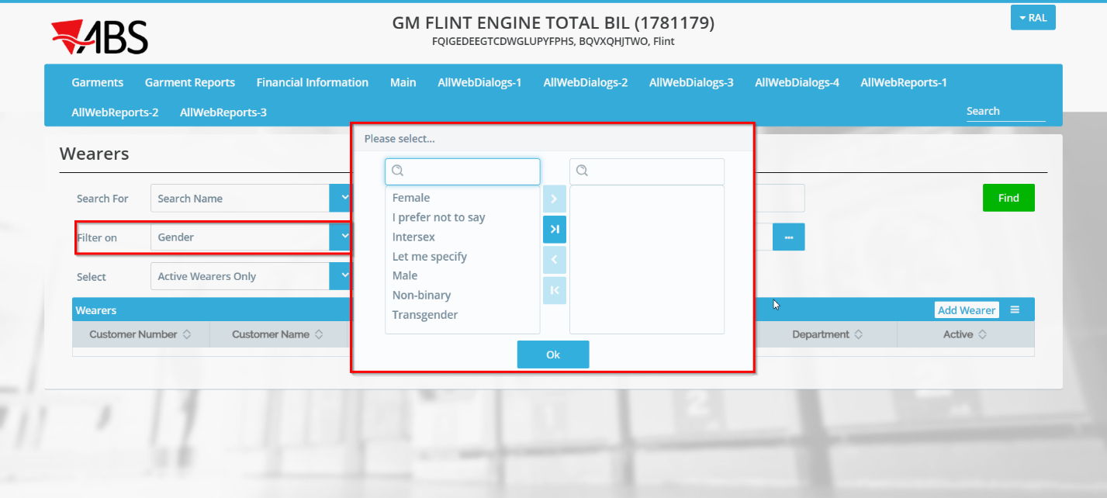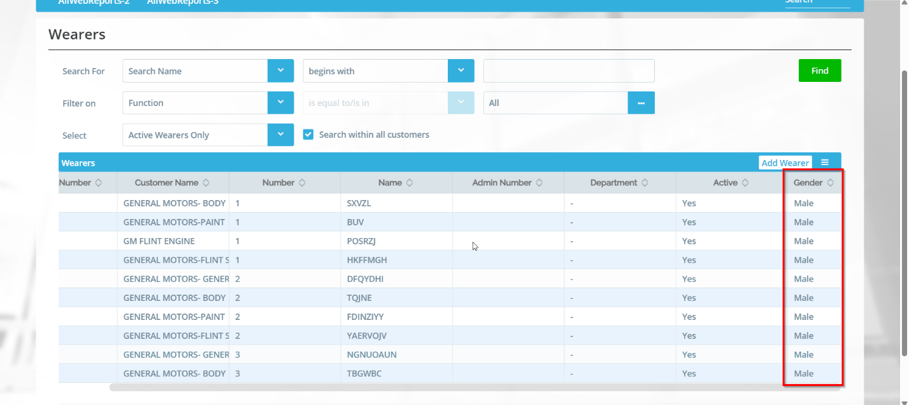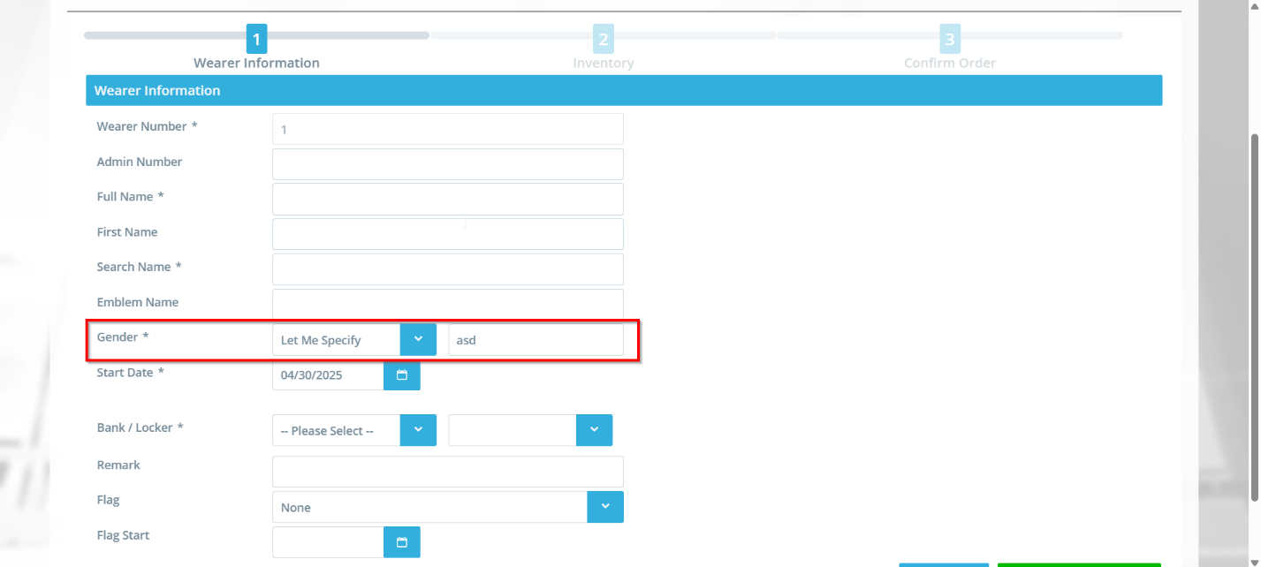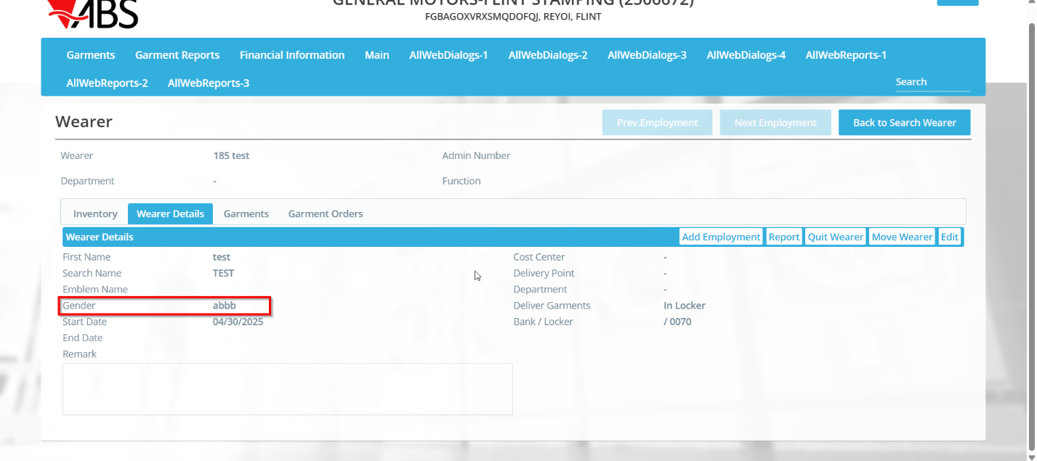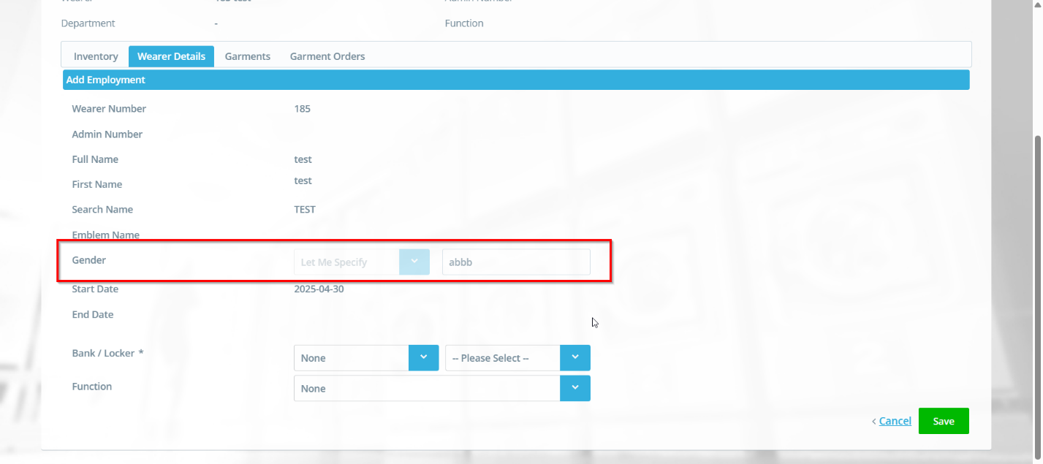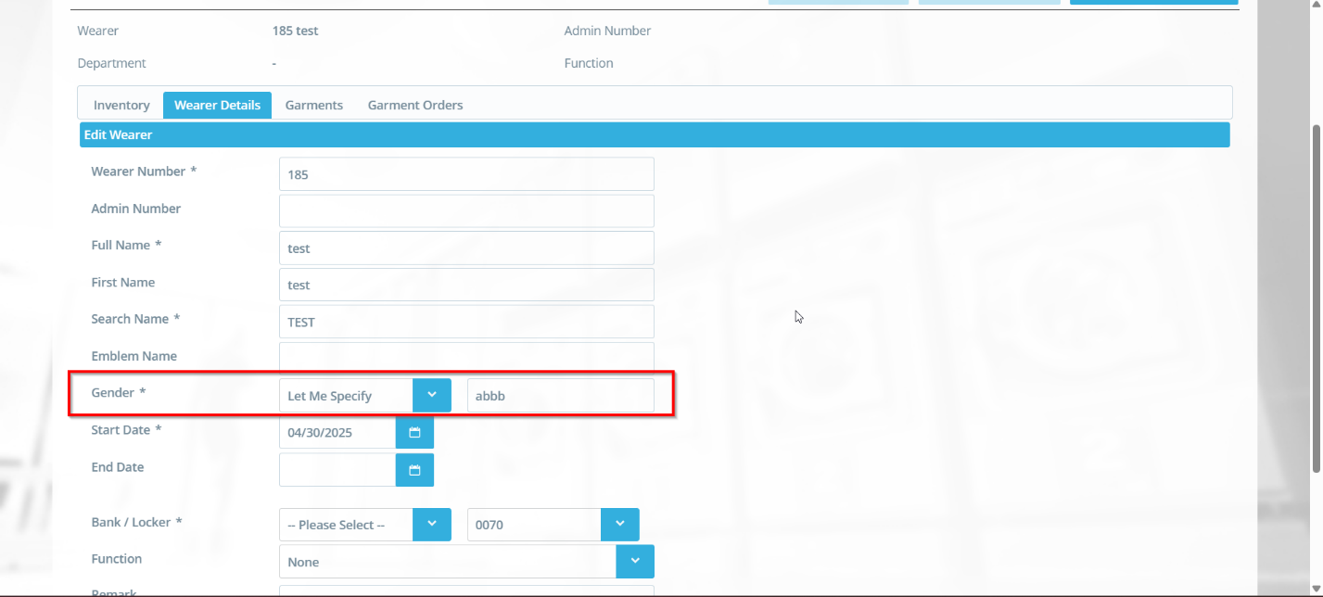
- Go to WebX to Wearer Maintenance tab and check that gender is visible (Make sure SS is set to 0 for the plant of the BU selected on WebX)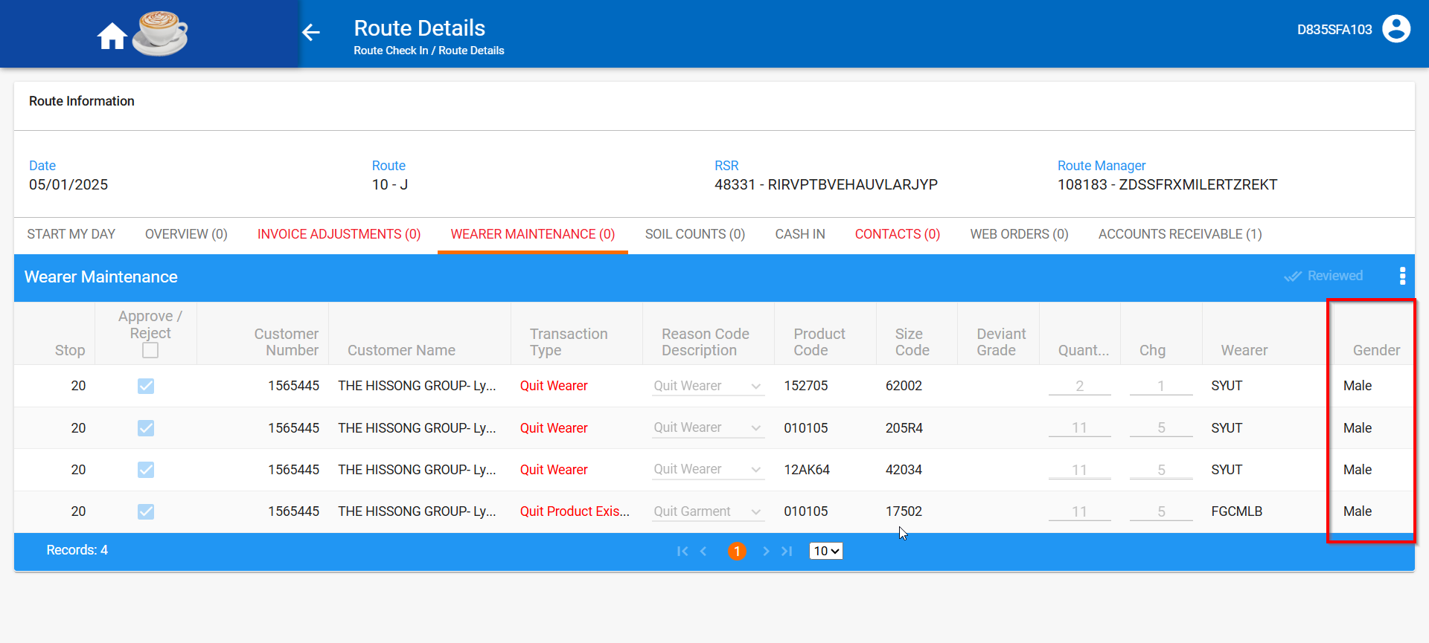

Test Case 2 – SS HIDEGENDERFIELD=1– Tested OK
Expected behavior: Gender should not be visible
Hash: a6826de
- Have SS HIDEGENDERFIELD=1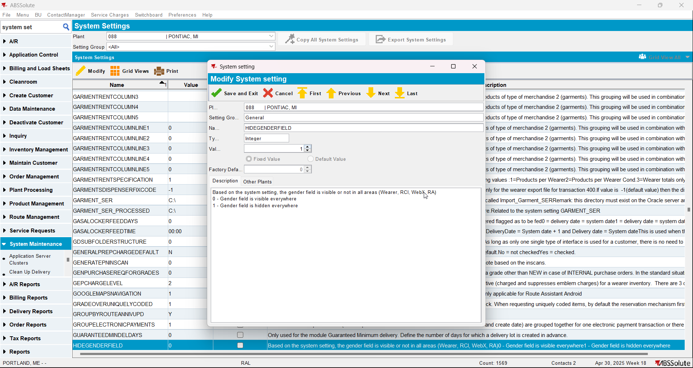
- Go to Wearers dlg and check that gender is not visible by checking the grid, opening the wearer, adding a wearer.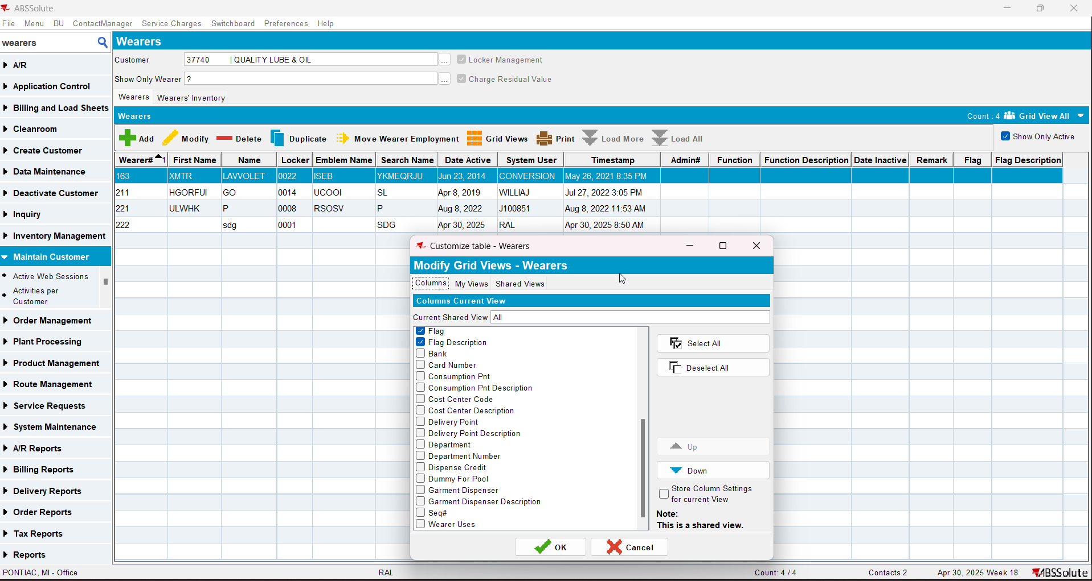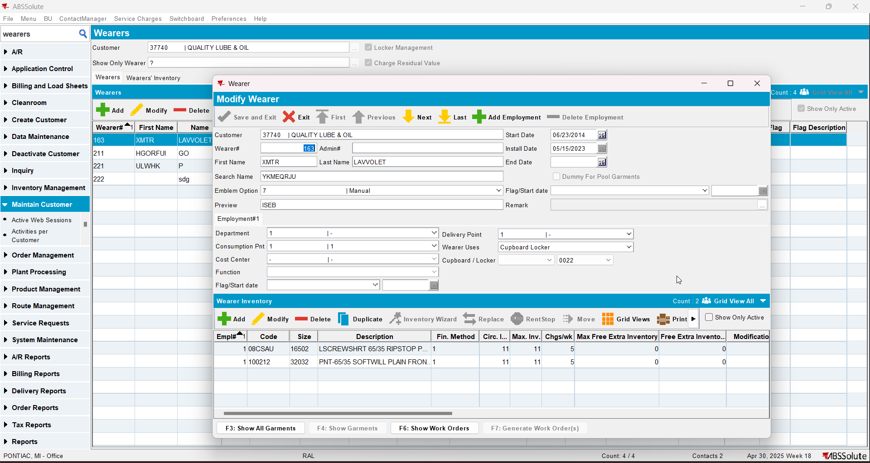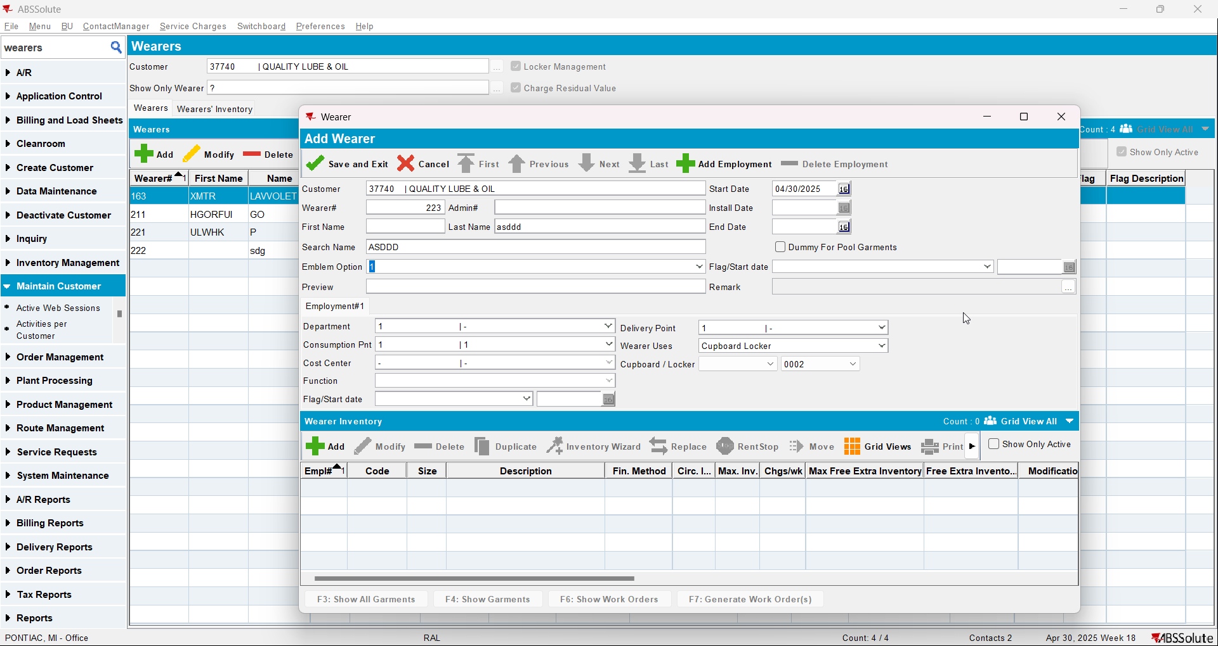
- Go to WebPortal. Make sure the SS is set to 1 for the Plant of the web user. I used BU 088
- Check that the gender is not visible by checking the filters, checking the grid, adding a wearer, checking wearer details, adding an employment, editing wearer(only works for added wearers) 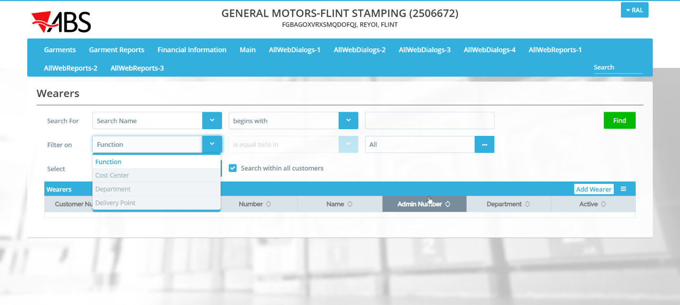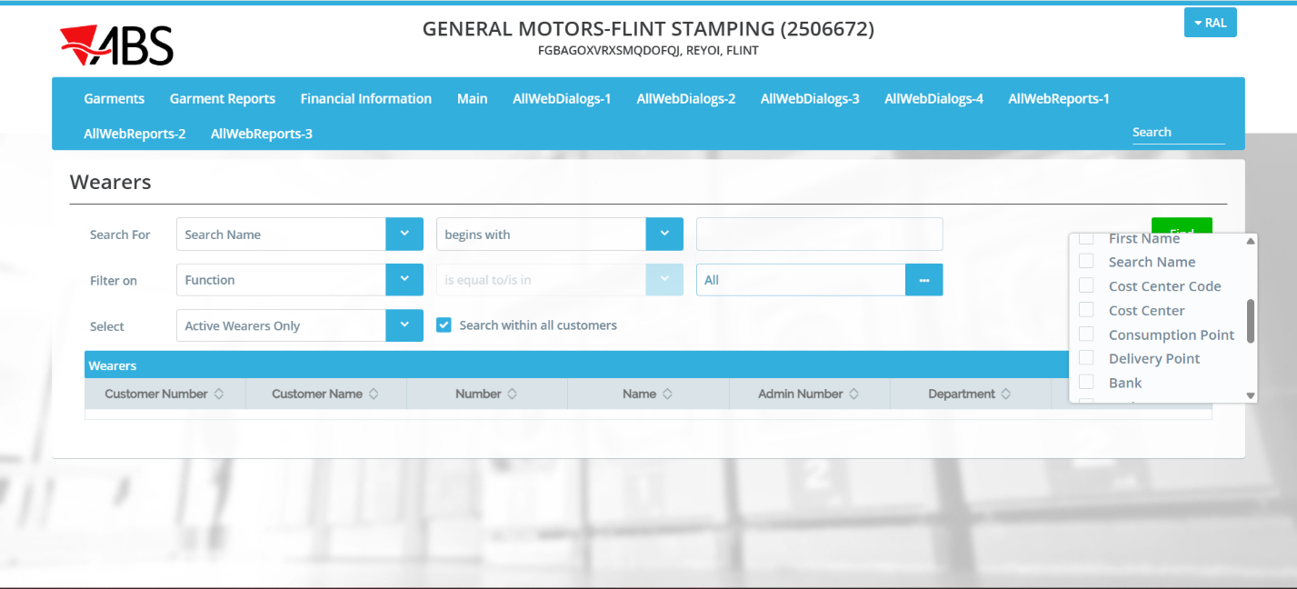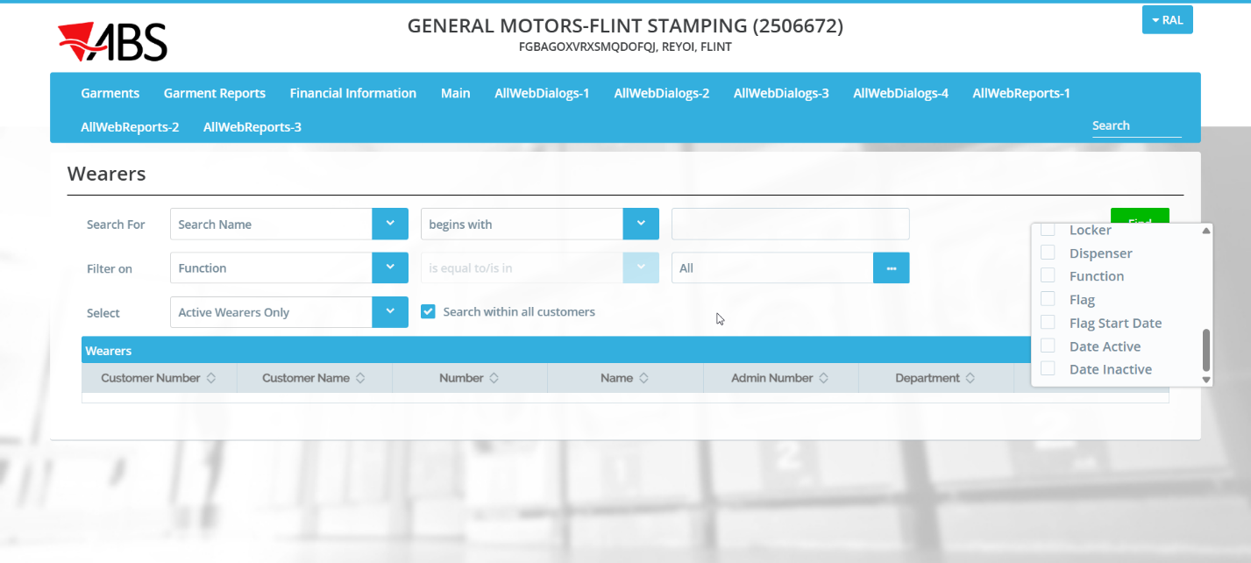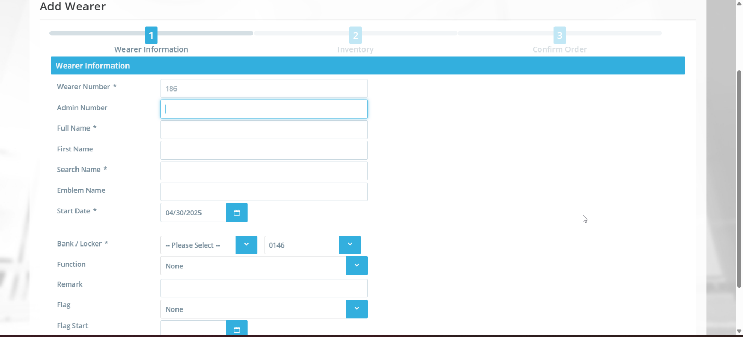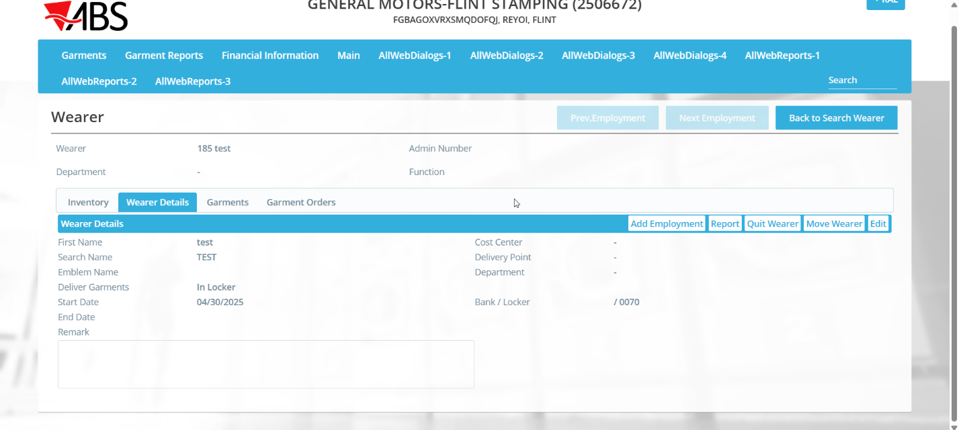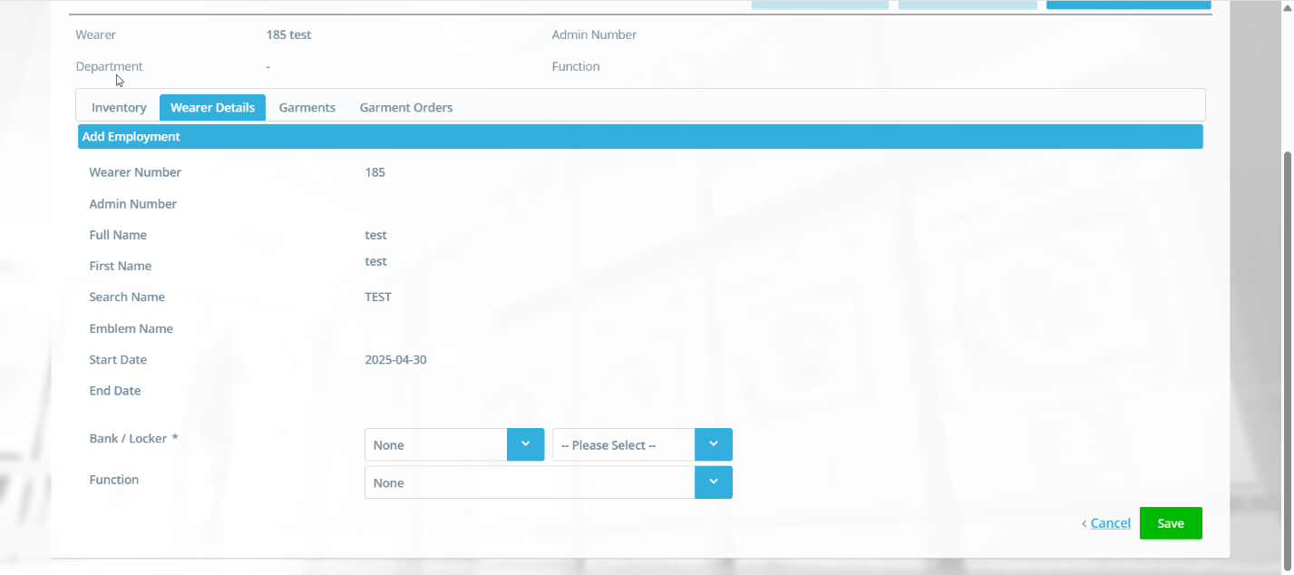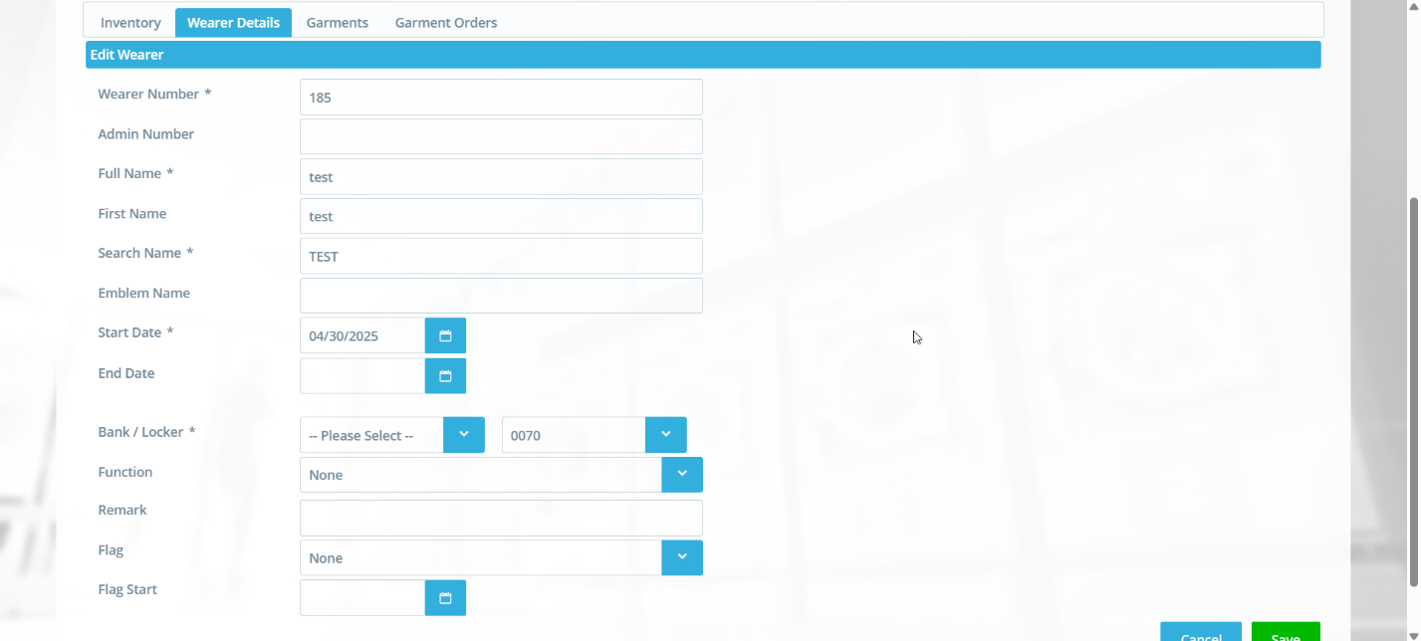
- Go to WebX to Wearer Maintenance tab and check that gender is not visible (Make sure SS is set to 1 for the plant of the BU selected on WebX)