ABS-171811 - D_UBS_2555 A direct sale invoice was generated after the invoices for the route were generated and uploaded to the RA
Environment | Prerequisites
Version: 9.07.00.UNF18  DBServerName= abs-srv20.internal.abslbs.com  DBSID=CUST24  DBUser=UNFDEV  DBPassword= UNFDEV  Environment=Test | - Module:  - System setting

Contents
Reproducing before fix 1
Data preparation 1
Steps to reproduce 1
Current Behavior 6
Retest after fix 6
Test Case 1 – SALESDNONINVOICEDROUTE = 3 target route has InvoiceGeneration = Complete and PocketPCStatus = Transfered 6
Test Case 2 – SALESDNONINVOICEDROUTE = 3 target route has InvoiceGeneration = Complete and PocketPCStatus = Ready to transfer but route download is in progress 11
Test Case 3 – SALESDNONINVOICEDROUTE = 3 target route has InvoiceGeneration = Complete and PocketPCStatus = Ready to transfer and was never downloaded to RA 17
Test Case 4 – SALESDNONINVOICEDROUTE = 3 target route has InvoiceGeneration = Complete and Route was downloaded once to RA and then set PocketPCStatus = Ready to transfer 22
Test Case 5 – SALESDNONINVOICEDROUTE = 3 target route has InvoiceGeneration = Complete and PocketPCStatus = Not Ready to Transfer 28
Test Case 6 – Add Sales Note with multiple wearers and garments – Partial Credit on WebX and Rebill 33

Reproducing before fix

Data preparation

Steps to reproduce
- RSC DLG: Create a route control
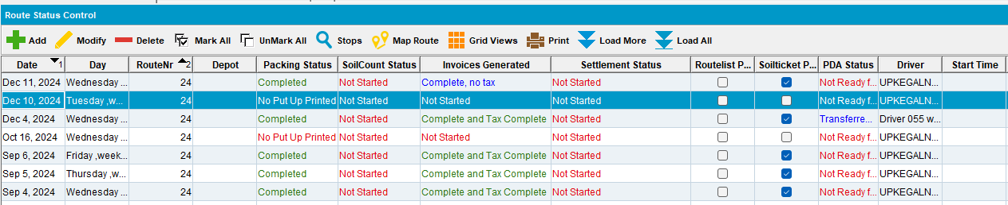
- Generate Packing Notes and Invoices for the route control
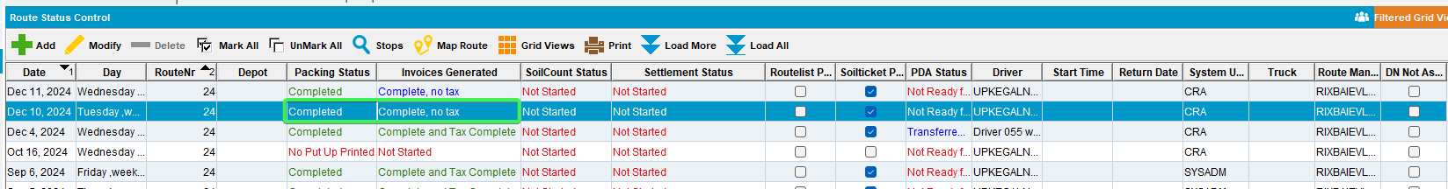
- Script in the BCI data and run the Import VertexTax process scheduler
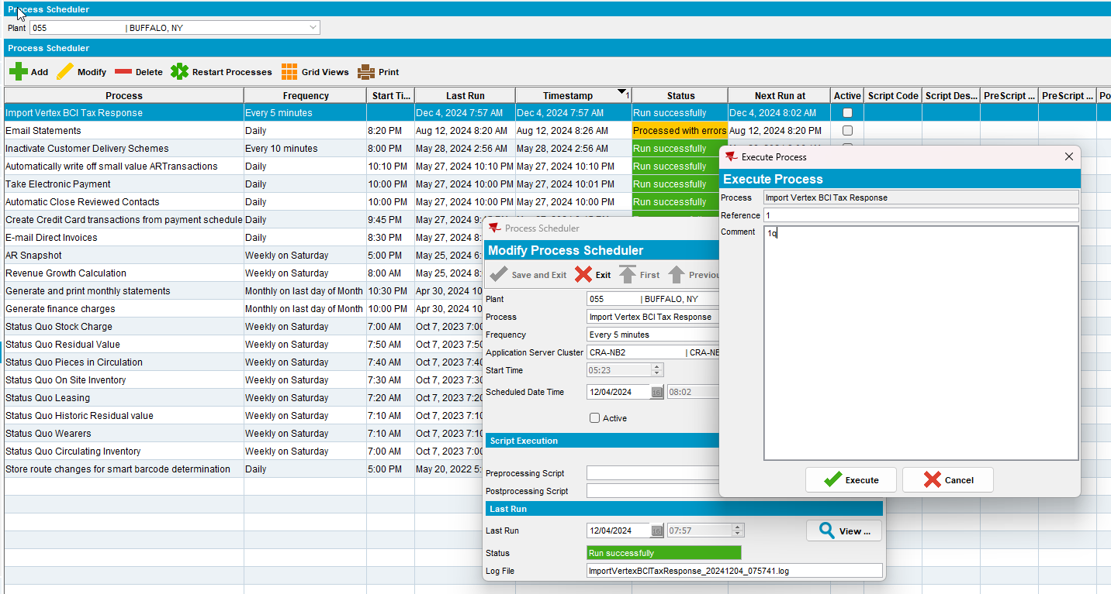
- Maintain Sales Notes DLG: Add a new sales note for one of the customers already on the route
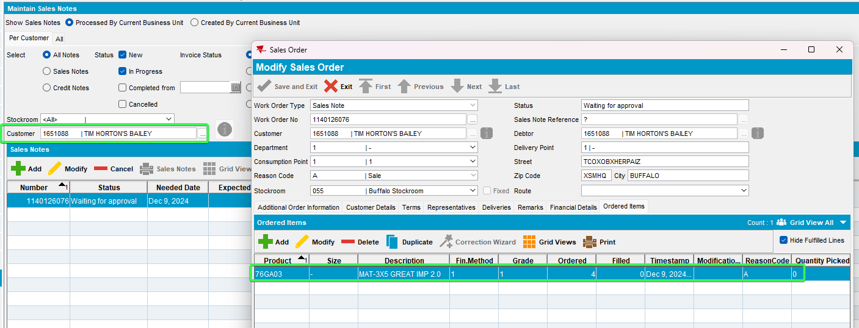
- Work Orders Waiting for Approval DLG: Approve the sales order
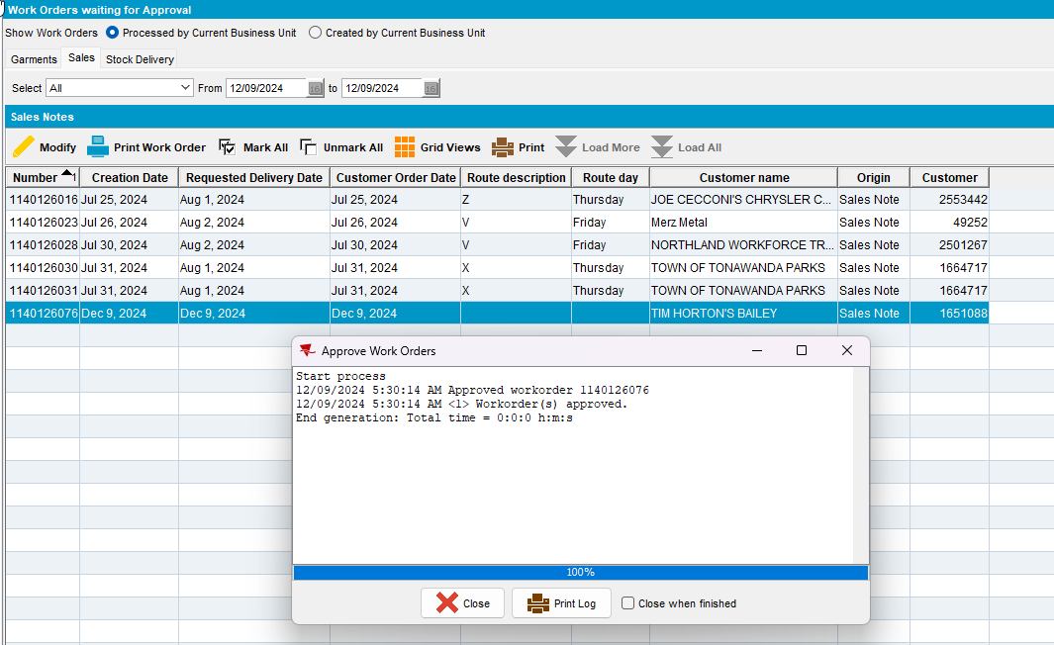
- Maintain Sales Notes DLG: Issue all garments and generate the delivery note for the day with the route from step 1
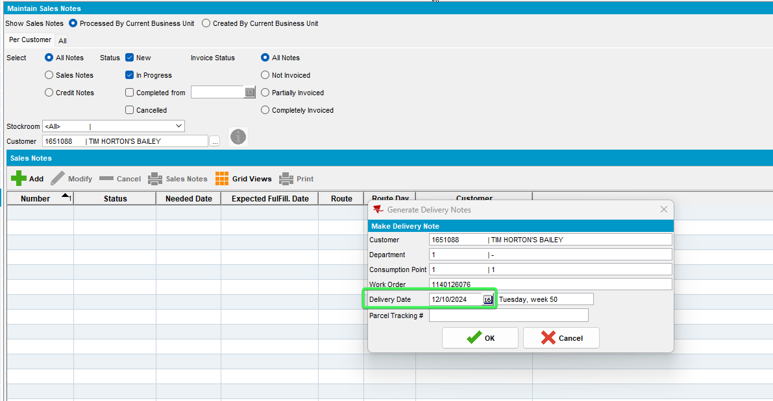

- RSC DLG: Go to View Delivery and Packing notes > Sales Notes>assign not linked: link the sales delivery note to the route
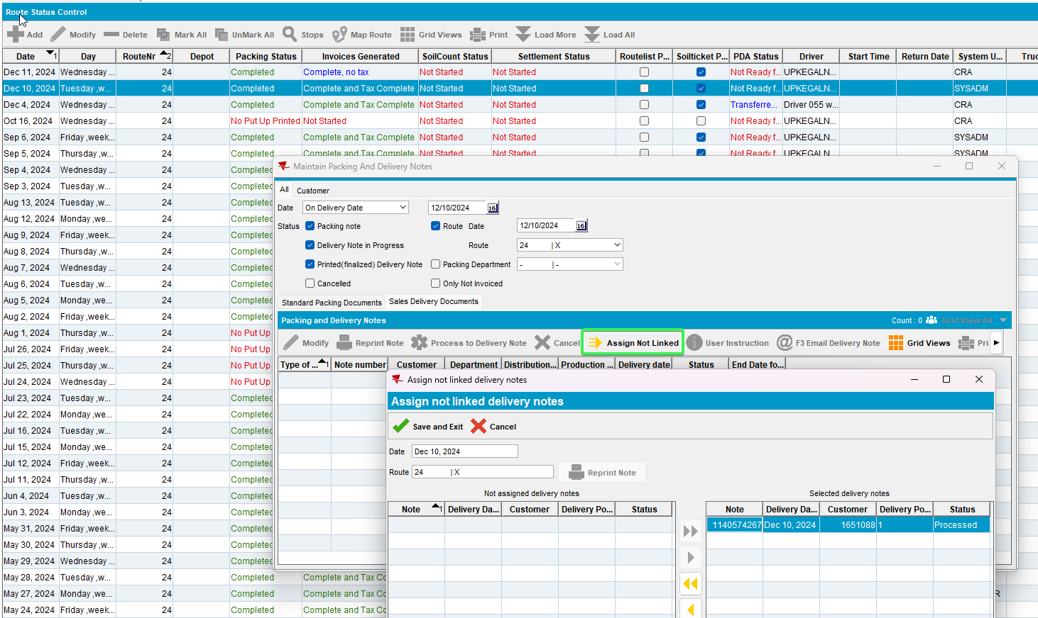
- RSC DLG: Mark the route ready for transfer
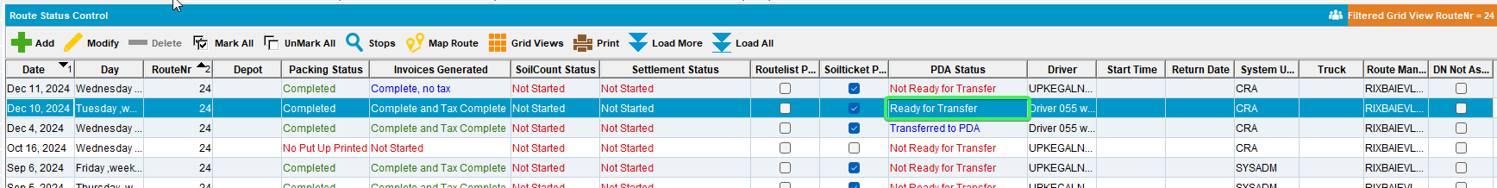
- Download the route to RA.
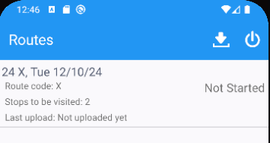
- Maintain Sales Notes DLG: Open the sales note and generate the invoice
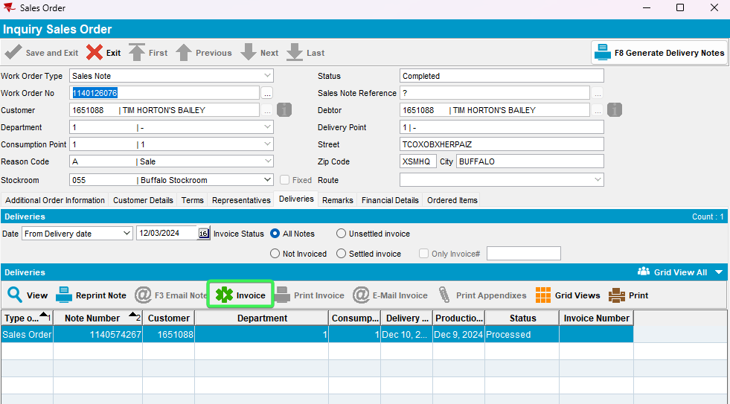
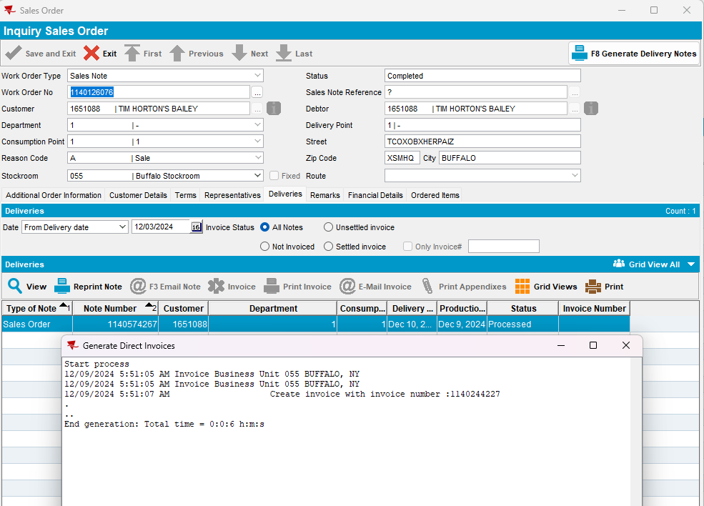
Sales Note(Generated Aditional) RouteControl_ID
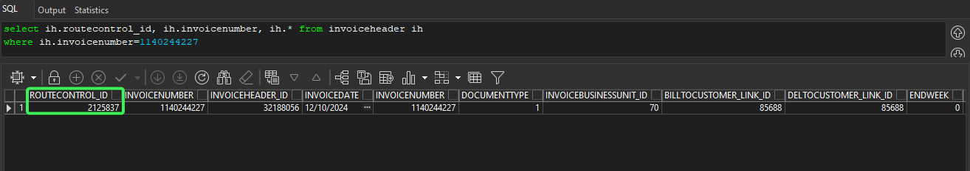
Generated Invoice RouteControl_ID
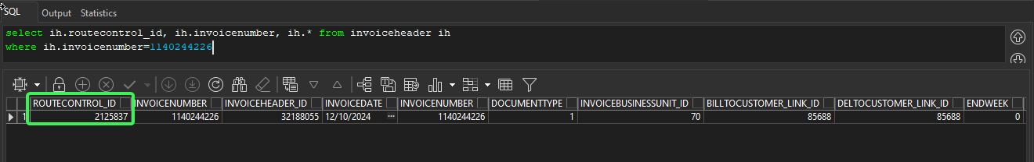
REPRODUCED OK.

Current Behavior
The invoice is generated and attached to the RouteControl_id of the route control record that was already sent to RA.

Retest after fix

Test Case 1 – SALESDNONINVOICEDROUTE = 3 target route has InvoiceGeneration = Complete and PocketPCStatus = Transfered
Hash: e081f84ac845
Expected Behavior:
When invoice is generated from Maintain Sales Notes DLG the following occurs:
- Delivery Note is disconnected from the route:
SELECT PN.ROUTECONTROL_ID, PN.ROUTE_ID, PN.STOPNUMBER, PN.STOP_ID FROM PACKINGNOTE PN WHERE PN.NOTENUMBER = ?
- Maintain Invoices DLG> Route: Load the date and route and check that the invoice is generated and NOT attached to the routecontrol

- RSC DLG: Create a route control
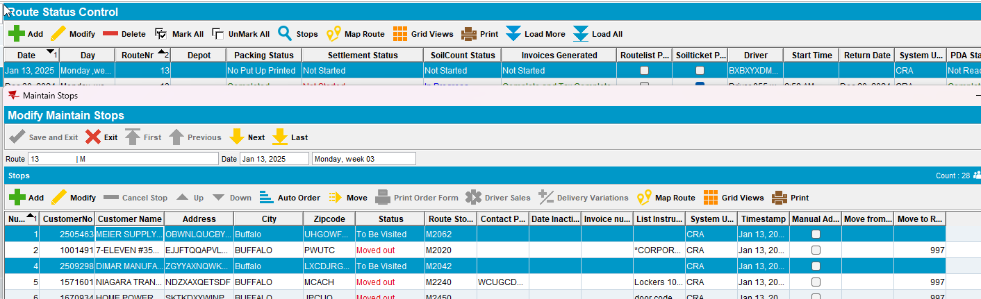
- Generate Packing Notes and Invoices for the route control
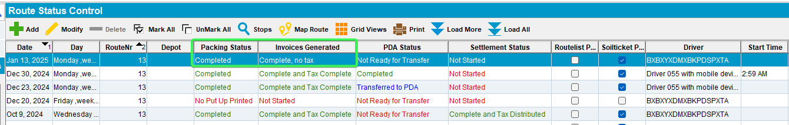
- Script in the BCI data and run the Import VertexTax process scheduler
- Maintain Sales Notes DLG: Add a new sales note for one of the customers already on the route
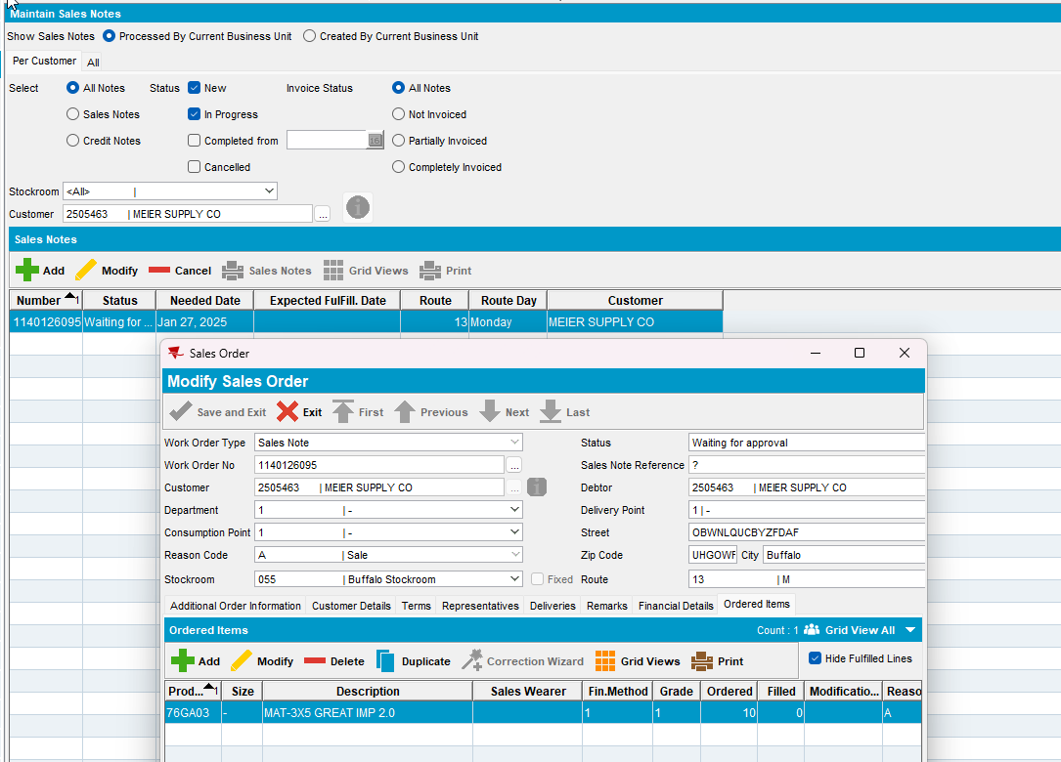
- Work Orders Waiting for Approval DLG: Approve the sales order
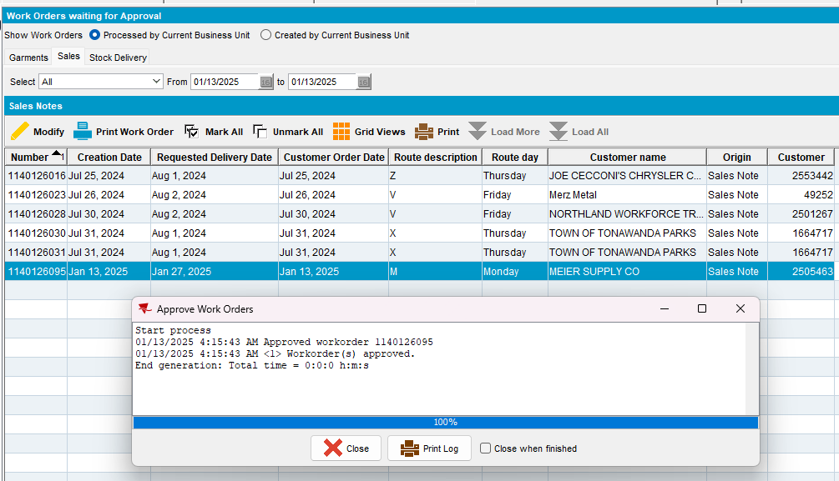
- Maintain Sales Notes DLG: Issue all garments and generate the delivery note for the day with the route from step 1
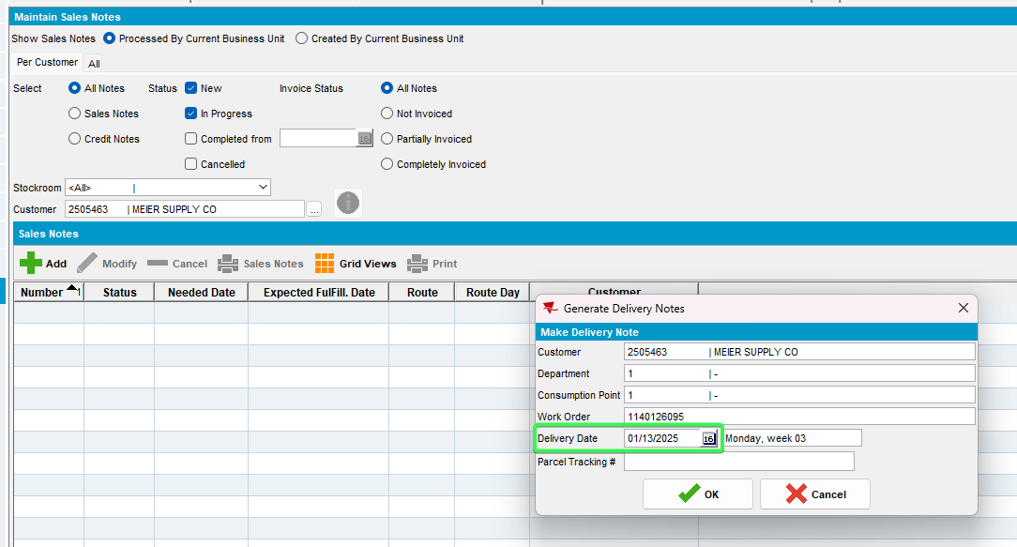
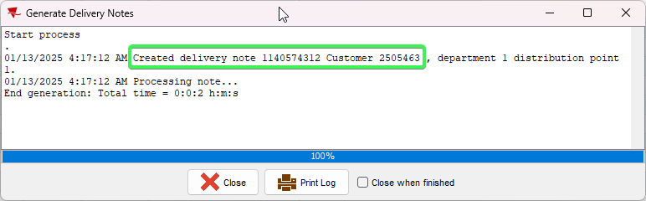
- RSC DLG: Go to View Delivery and Packing notes > Sales Notes>assign not linked: link the sales delivery note to the route
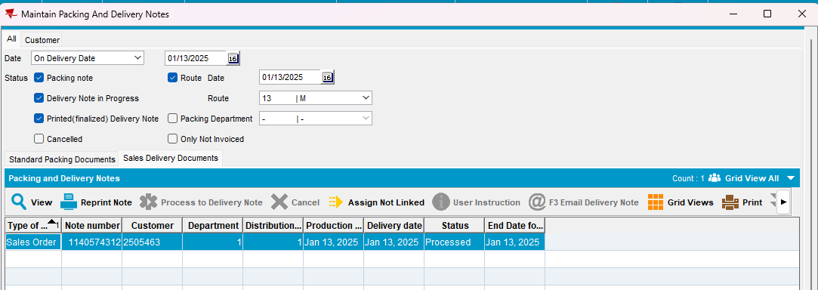
- RSC DLG: Mark the route ready for transfer
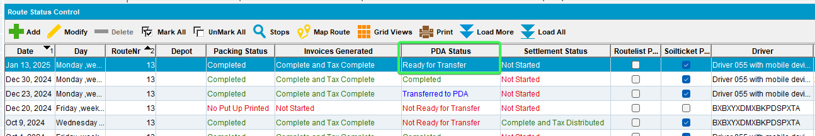
- Download the route to RA.
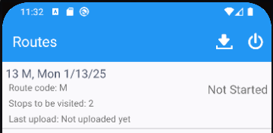

- Maintain Sales Notes DLG: Open the sales note and generate the invoice
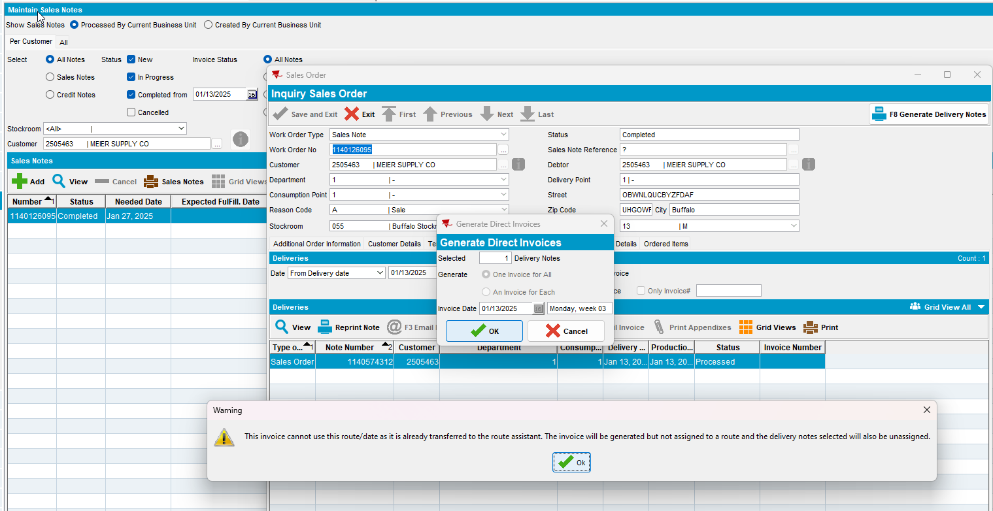
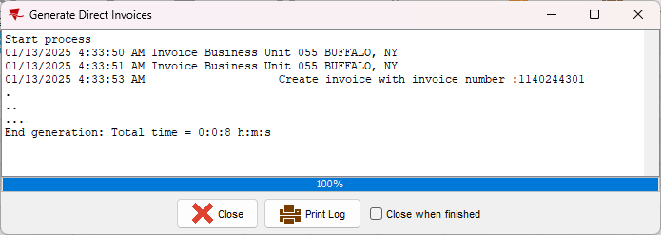

- Maintain Invoices DLG: Check that the Invoices were generated but not attached the route
The generated additional invoices are not present on the route
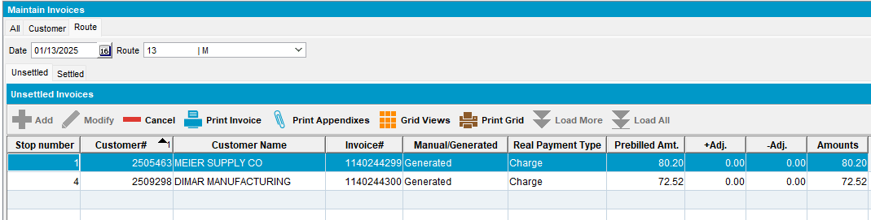
Delivery note is discontinued from the route
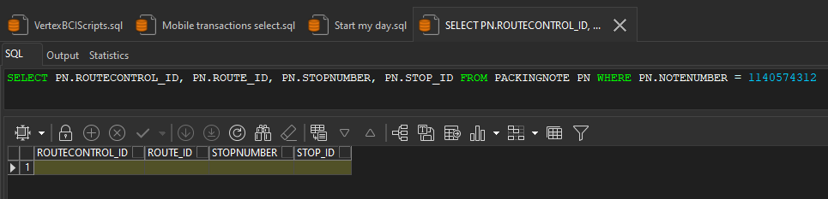

Tested OK

Test Case 2 – SALESDNONINVOICEDROUTE = 3 target route has InvoiceGeneration = Complete and PocketPCStatus = Ready to transfer but route download is in progress
Hash: e081f84ac845
Expected Behavior:
When invoice is generated from Maintain Sales Notes DLG the following occurs:
- Delivery Note is disconnected from the route:
SELECT PN.ROUTECONTROL_ID, PN.ROUTE_ID, PN.STOPNUMBER, PN.STOP_ID FROM PACKINGNOTE PN WHERE PN.NOTENUMBER = ?
- Maintain Invoices DLG> Route: Load the date and route and check that the invoice is generated and NOT attached to the routecontrol

- RSC DLG: Create a route control
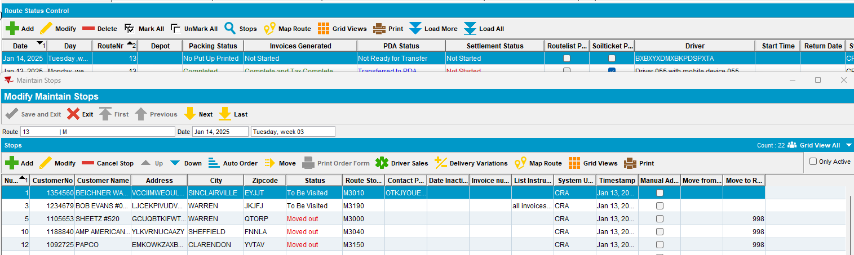
- Generate Packing Notes and Invoices for the route control
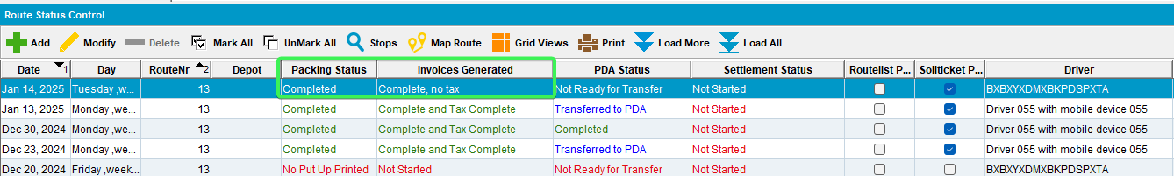
- Script in the BCI data and run the Import VertexTax process scheduler
- Maintain Sales Notes DLG: Add a new sales note for one of the customers already on the route
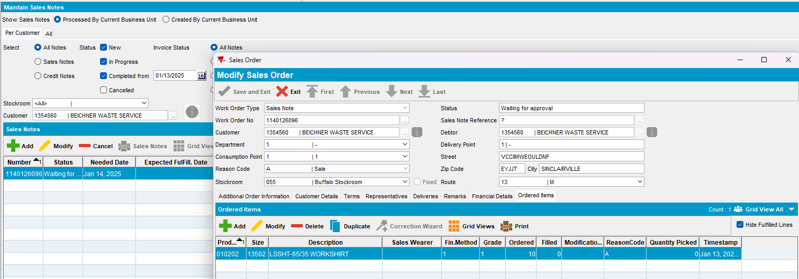
- Work Orders Waiting for Approval DLG: Approve the sales order
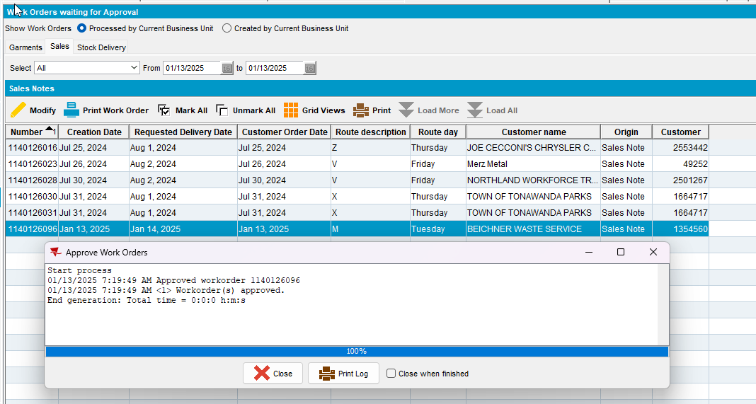
- Maintain Sales Notes DLG: Issue all garments and generate the delivery note for the day with the route from step 1
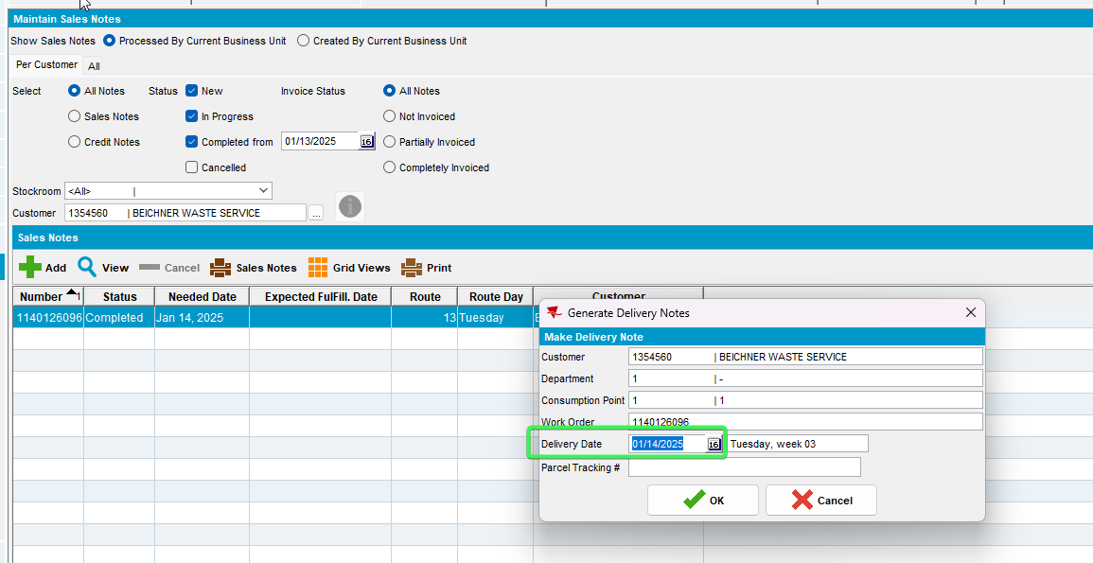
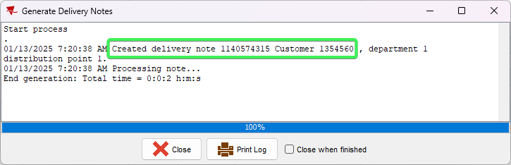
- RSC DLG: Go to View Delivery and Packing notes > Sales Notes>assign not linked: link the sales delivery note to the route
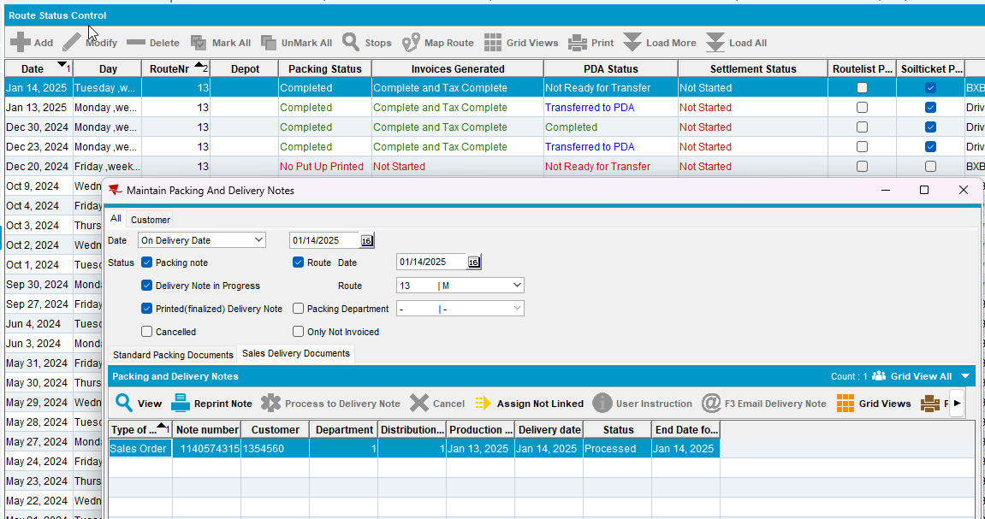
- RSC DLG: Mark the route ready for transfer
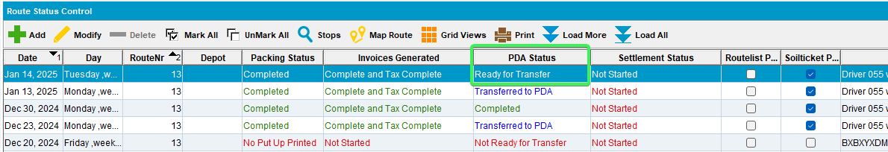
- Start to Download the route on RA.
- Maintain Sales Notes DLG: While the route is being downloaded on RA open the sales note and generate the invoice
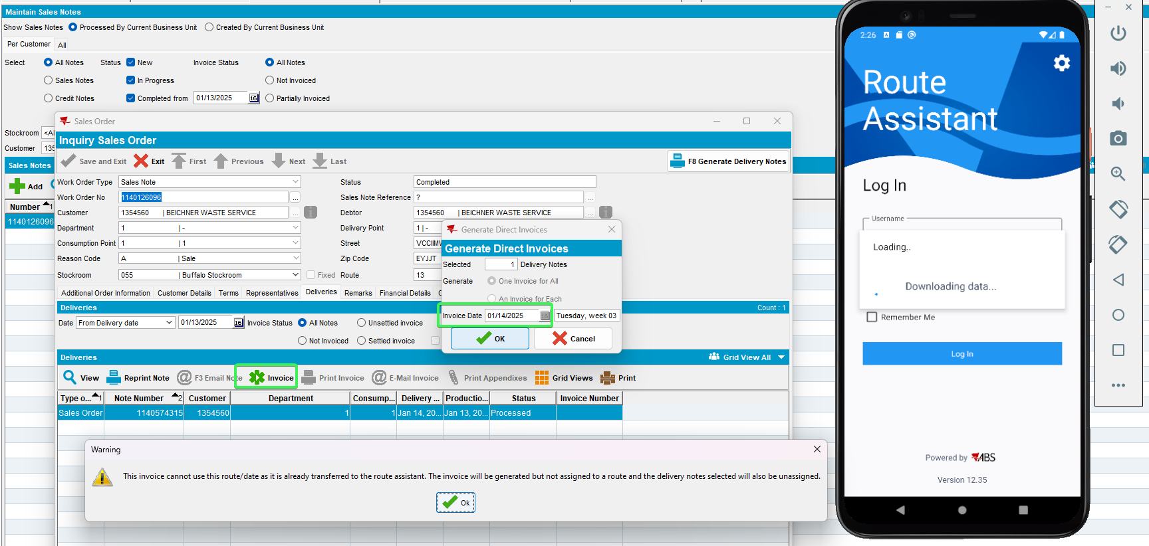
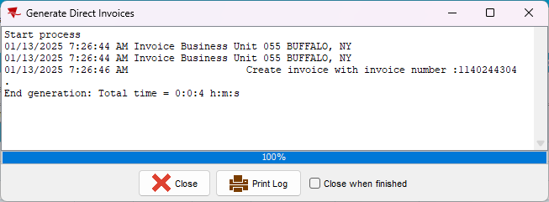

- Maintain Invoices DLG: Check that the Invoices were generated but not attached the route
The Invoices were created
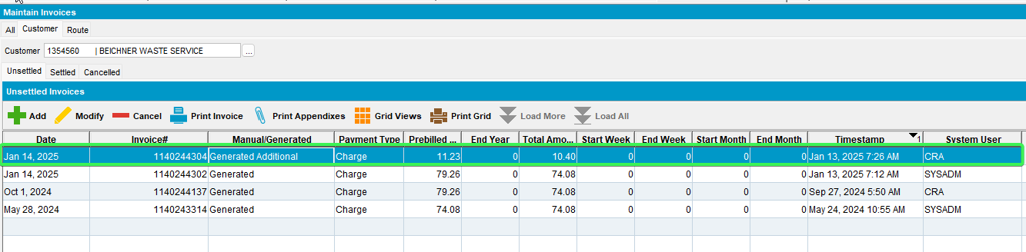
And were not attached to the route
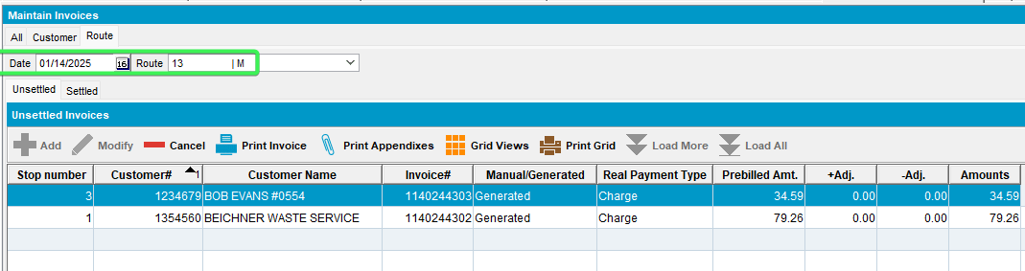
Delivery Note is also disconnected form the route
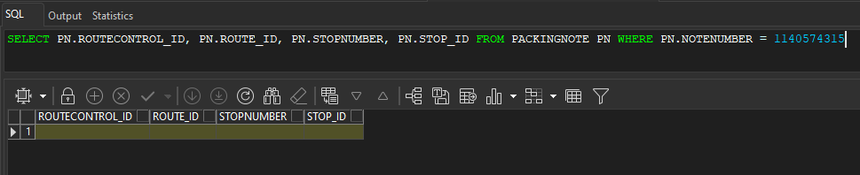
Tested OK

Test Case 3 – SALESDNONINVOICEDROUTE = 3 target route has InvoiceGeneration = Complete and PocketPCStatus = Ready to transfer and was never downloaded to RA
Hash: e081f84ac845
Expected Behavior:
When invoice is generated from Maintain Sales Notes DLG the following occurs:
- Delivery Note is NOT disconnected from the route: Route Status Control DLG > View Packing/Delivery notes and see that the sales note is still attached
- Maintain Invoices DLG> Route: Load the date and route and check that the invoice is generated and IS attached to the routecontrol

- RSC DLG: Create a route control
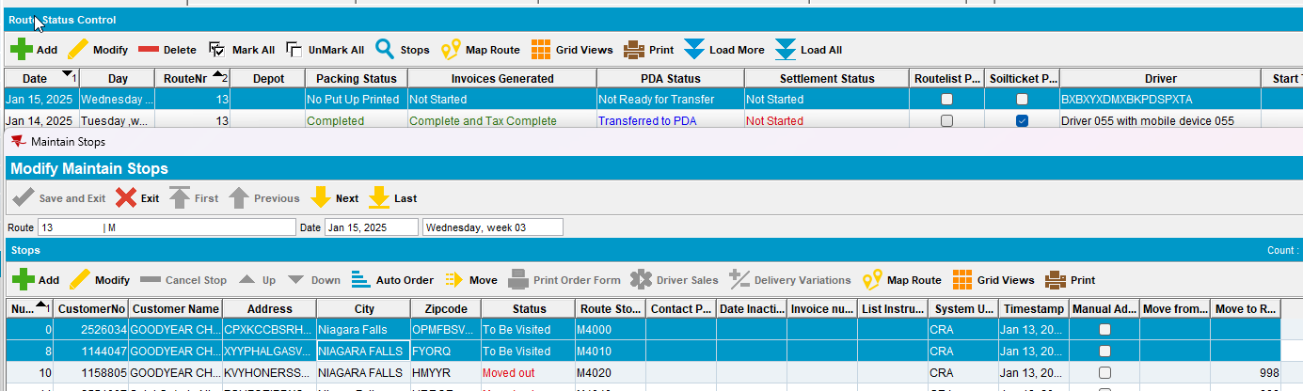
- Generate Packing Notes and Invoices for the route control
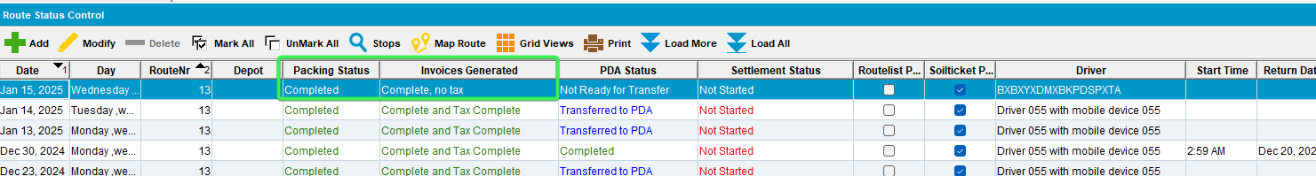
- Script in the BCI data and run the Import VertexTax process scheduler
- Maintain Sales Notes DLG: Add a new sales note for one of the customers already on the route
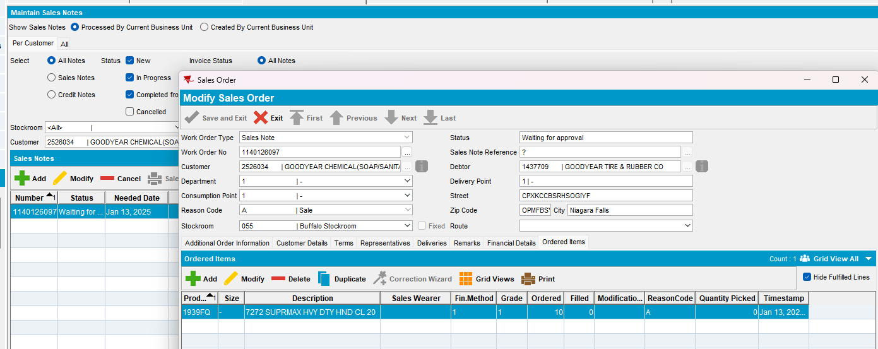
- Work Orders Waiting for Approval DLG: Approve the sales order
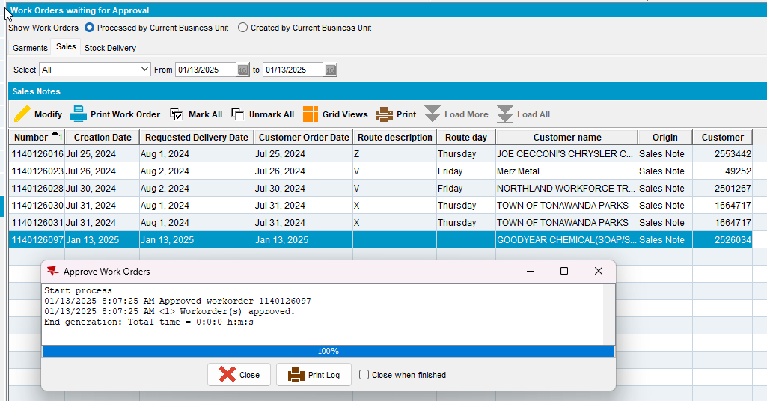
- Maintain Sales Notes DLG: Issue all garments and generate the delivery note for the day with the route from step 1
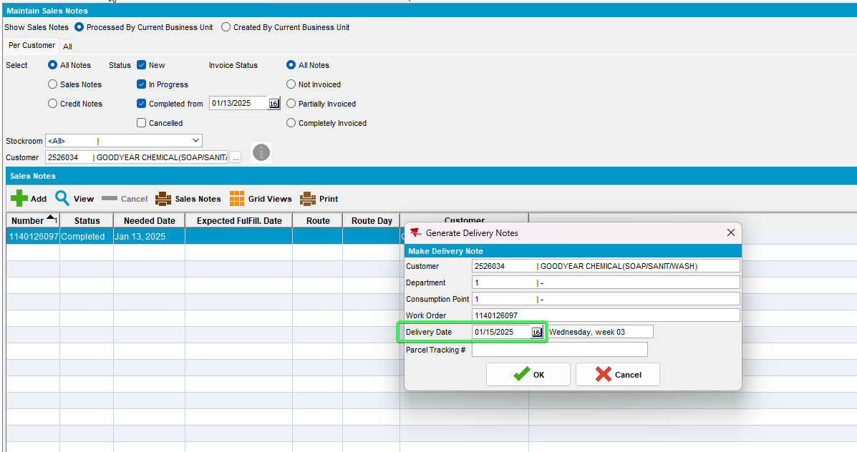
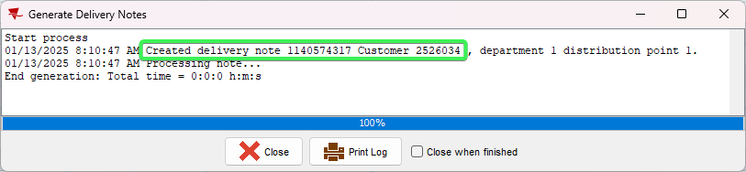
- RSC DLG: Go to View Delivery and Packing notes > Sales Notes>assign not linked: link the sales delivery note to the route
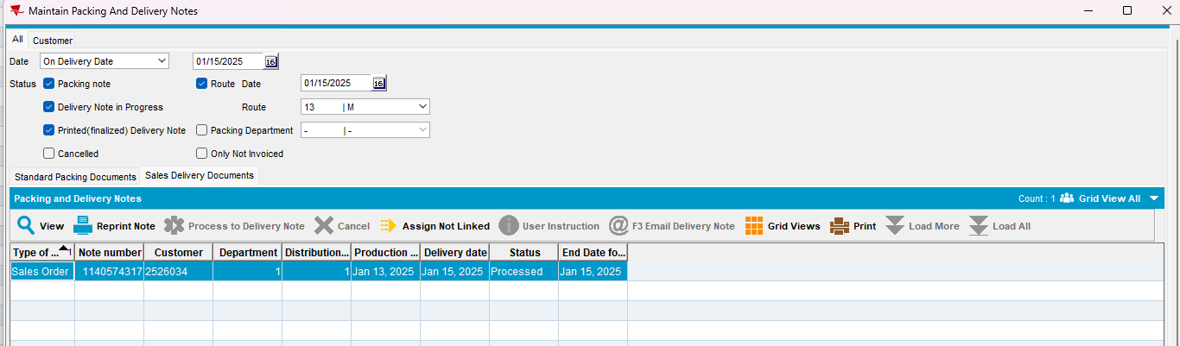
- RSC DLG: Mark the route ready for transfer but DO NOT start the download to RA
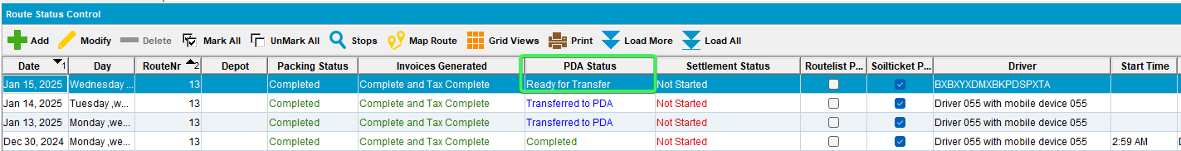
- Maintain Sales Notes DLG: Open the sales note and generate the invoice
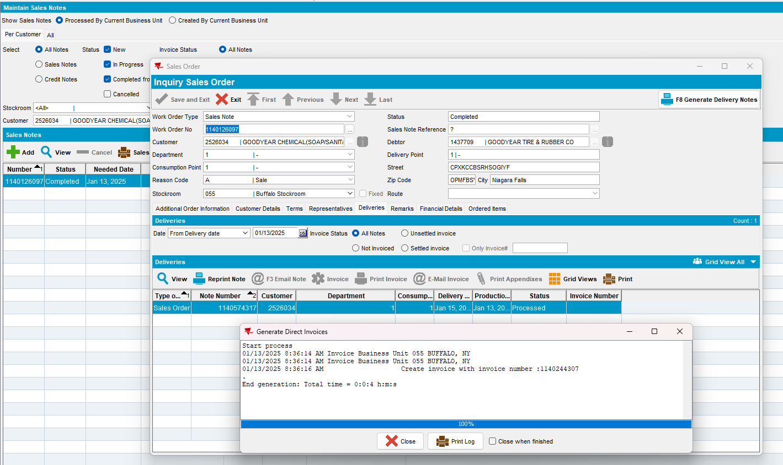

- Maintain Invoices DLG: Check that the Sales Order is attached to the route
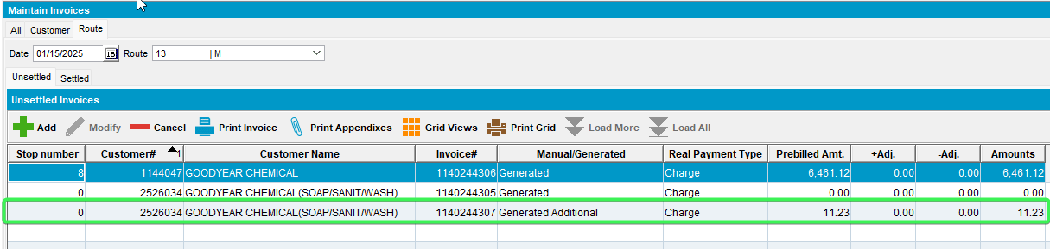
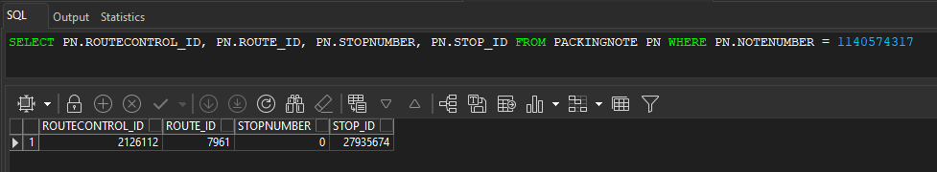
Tested OK

Test Case 4 – SALESDNONINVOICEDROUTE = 3 target route has InvoiceGeneration = Complete and Route was downloaded once to RA and then set PocketPCStatus = Ready to transfer
Hash: e081f84ac845
Expected Behavior:
When invoice is generated from Maintain Sales Notes DLG the following occurs:
- Delivery Note is NOT disconnected from the route: Route Status Control DLG > View Packing/Delivery notes and see that the sales note is still attached
- Maintain Invoices DLG> Route: Load the date and route and check that the invoice is generated and IS attached to the routecontrol

- RSC DLG: Create a route control
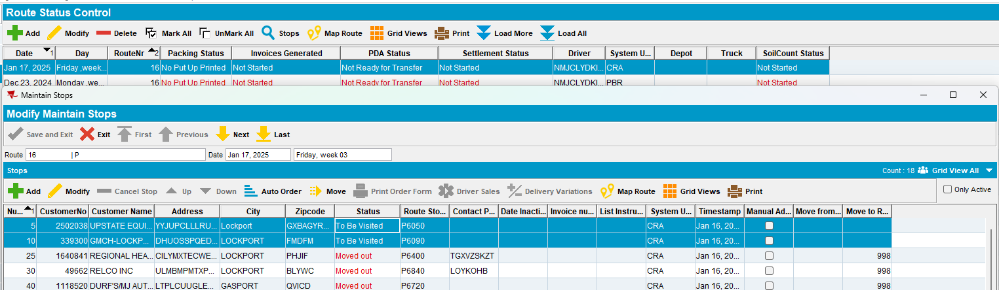
- Generate Packing Notes and Invoices for the route control
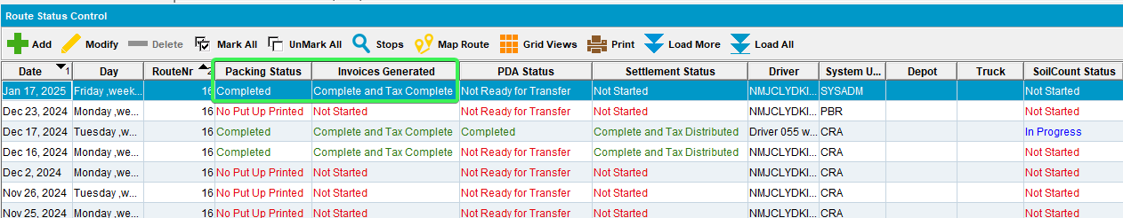
- Script in the BCI data and run the Import VertexTax process scheduler
- Maintain Sales Notes DLG: Add a new sales note for one of the customers already on the route
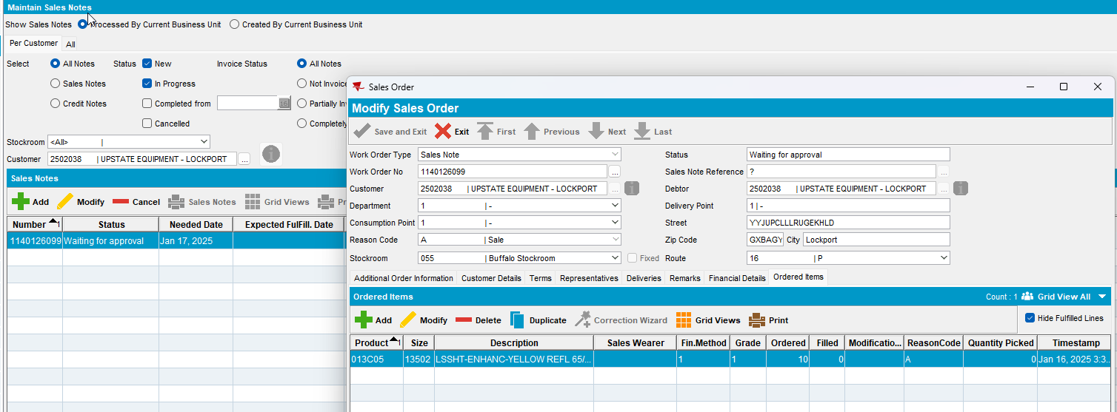
- Work Orders Waiting for Approval DLG: Approve the sales order
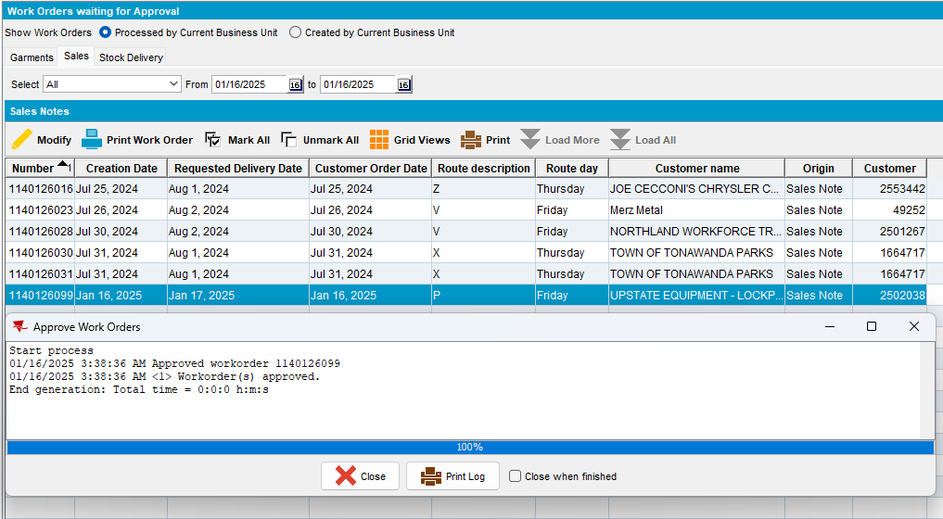
- Maintain Sales Notes DLG: Issue all garments and generate the delivery note for the day with the route from step 1
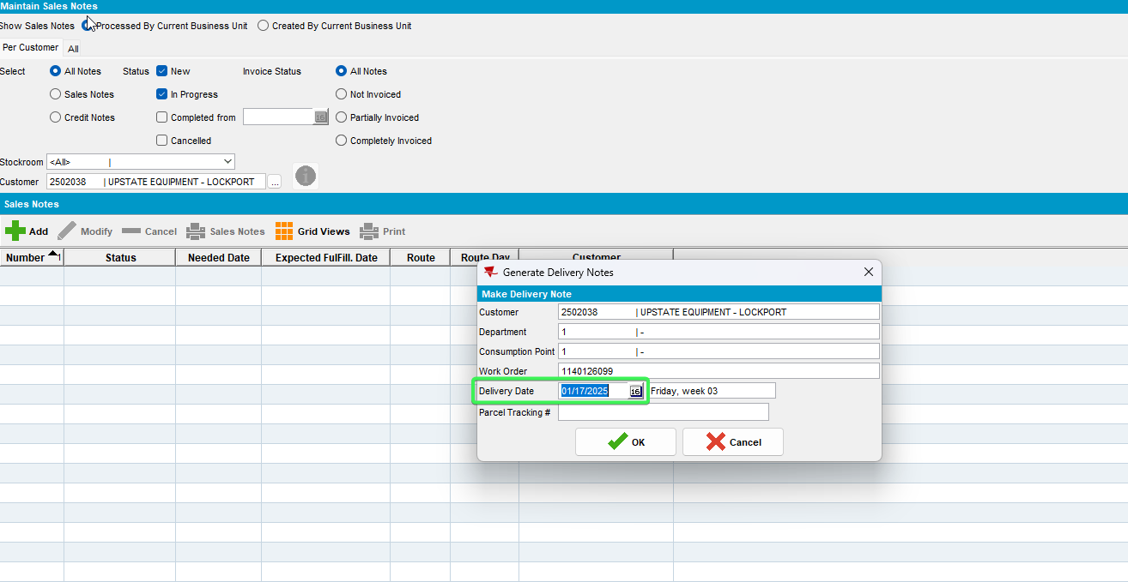
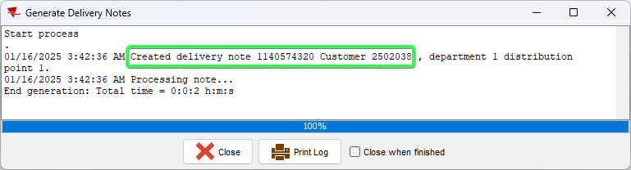
- RSC DLG: Go to View Delivery and Packing notes > Sales Notes>assign not linked: link the sales delivery note to the route
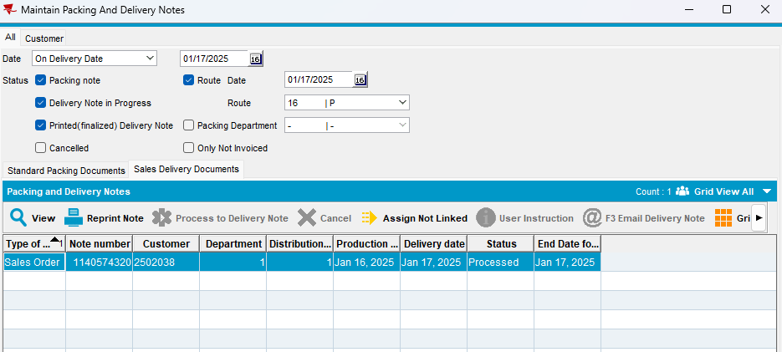
- RSC DLG: Mark the route ready for transfer
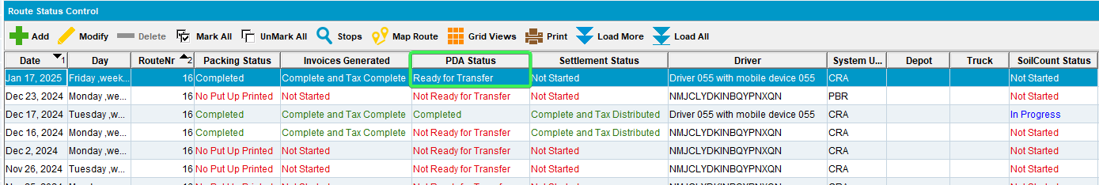
- Download the route on RA.
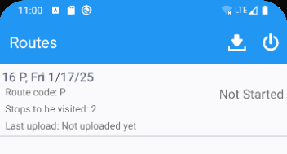
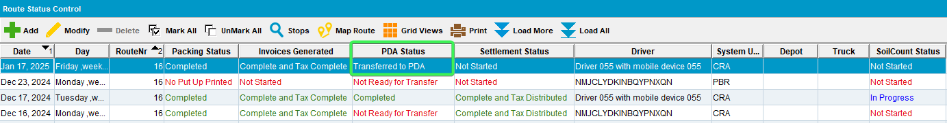
- Route Status Control DLG: Set the PocketPCStatus back to mark ready to re-transfer to PDA
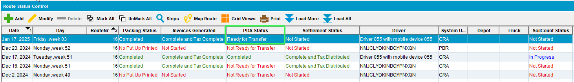
- Maintain Sales Notes DLG: Open the sales note and generate the invoice
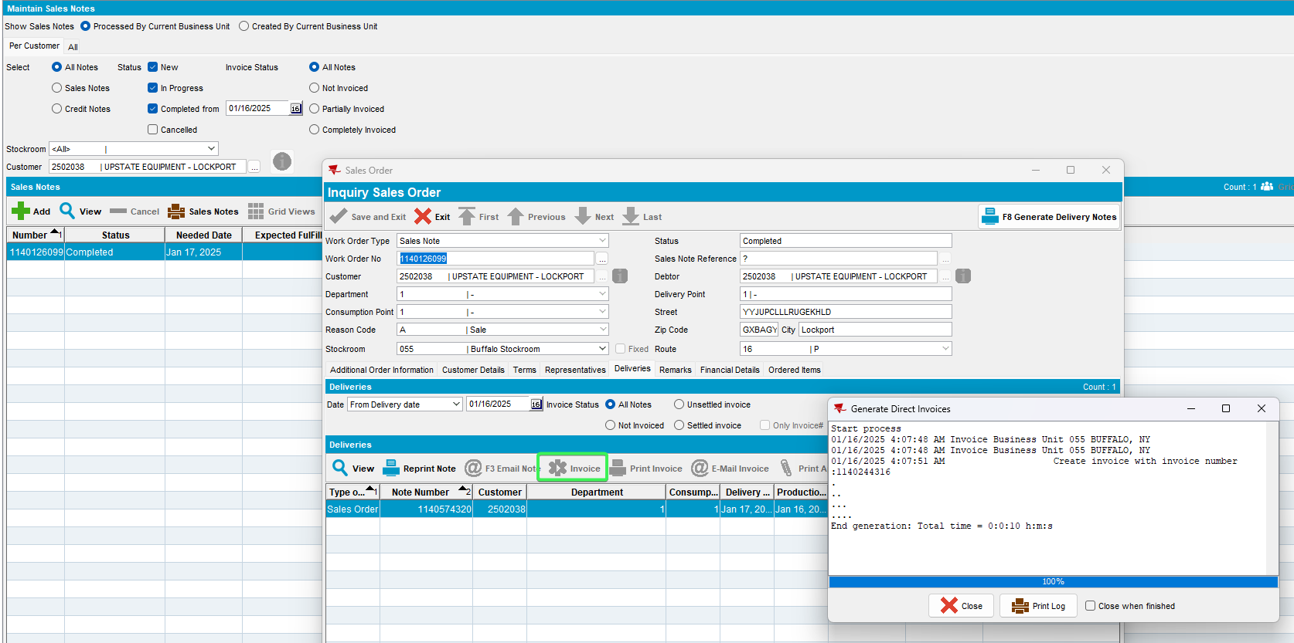
- Maintain Invoices DLG: Check that the Sales Order is attached to the route
The sales order is attached to the Route
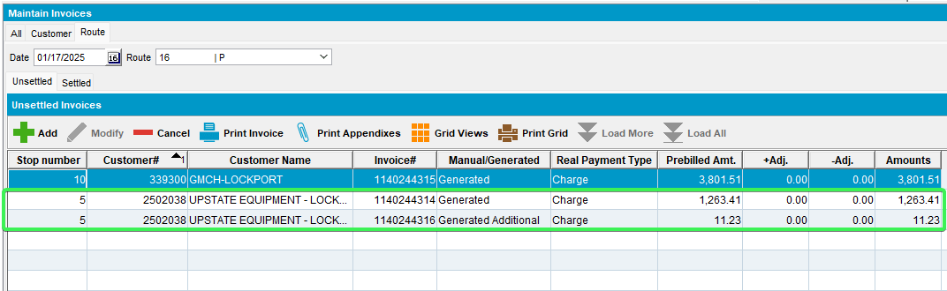
Delivery note is NOT discontinued from the route
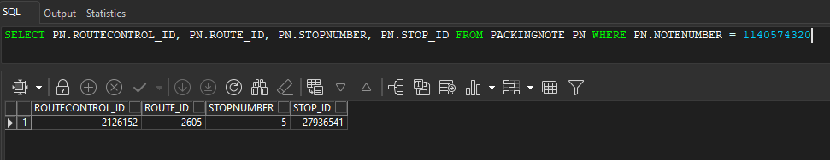

Tested OK

Test Case 5 – SALESDNONINVOICEDROUTE = 3 target route has InvoiceGeneration = Complete and PocketPCStatus = Not Ready to Transfer
Hash: e081f84ac845
Expected Behavior:
When invoice is generated from Maintain Sales Notes DLG the following occurs:
- Delivery Note is NOT disconnected from the route: Route Status Control DLG > View Packing/Delivery notes and see that the sales note is still attached
- Maintain Invoices DLG> Route: Load the date and route and check that the invoice is generated and IS attached to the routecontrol

- RSC DLG: Create a route control
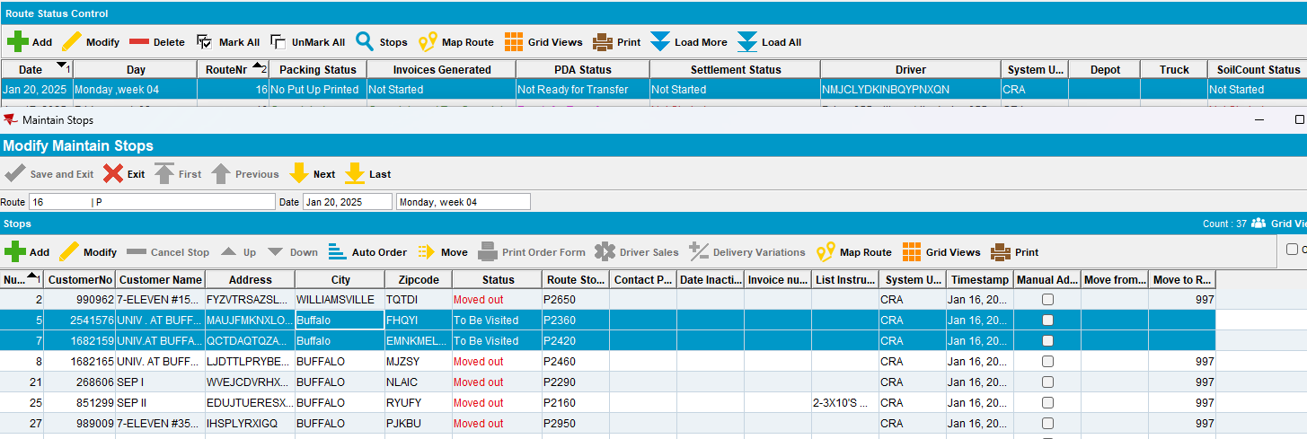
- Generate Packing Notes and Invoices for the route control
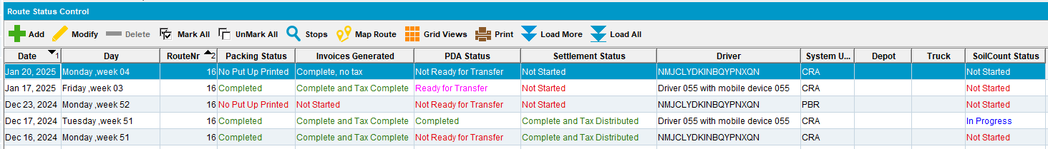
- Script in the BCI data and run the Import VertexTax process scheduler
- Maintain Sales Notes DLG: Add a new sales note for one of the customers already on the route
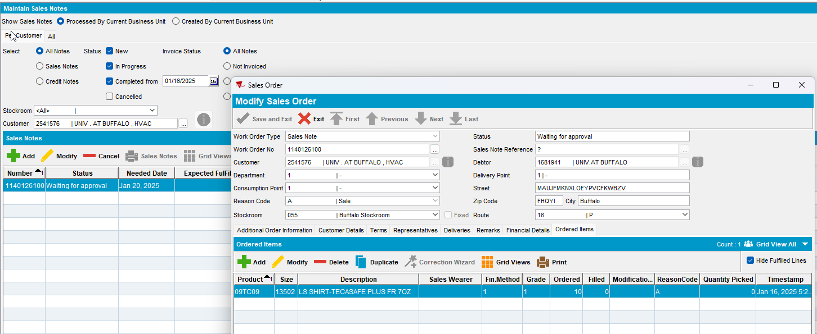
- Work Orders Waiting for Approval DLG: Approve the sales order
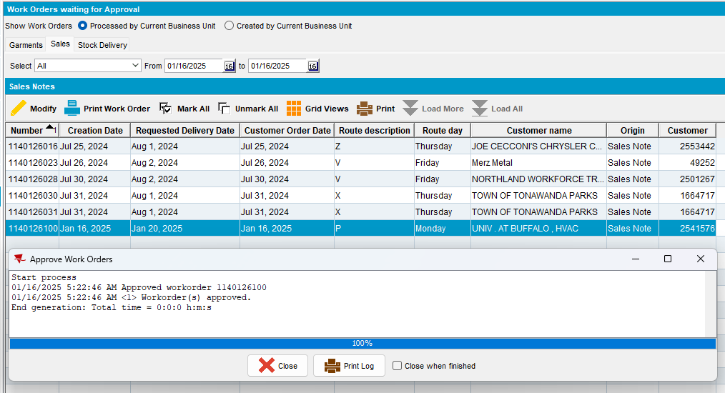
- Maintain Sales Notes DLG: Issue all garments and generate the delivery note for the day with the route from step 1
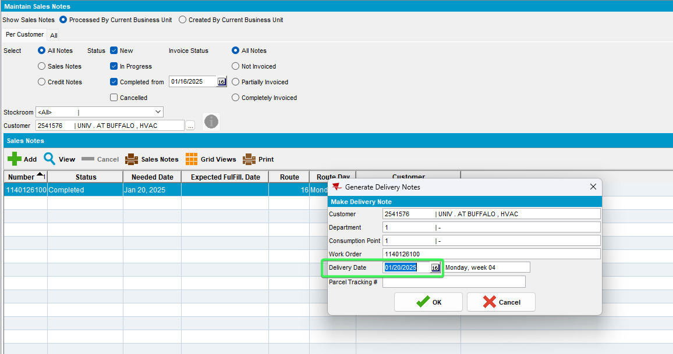
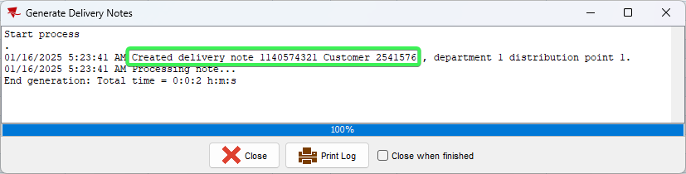
- RSC DLG: Go to View Delivery and Packing notes > Sales Notes>assign not linked: link the sales delivery note to the route
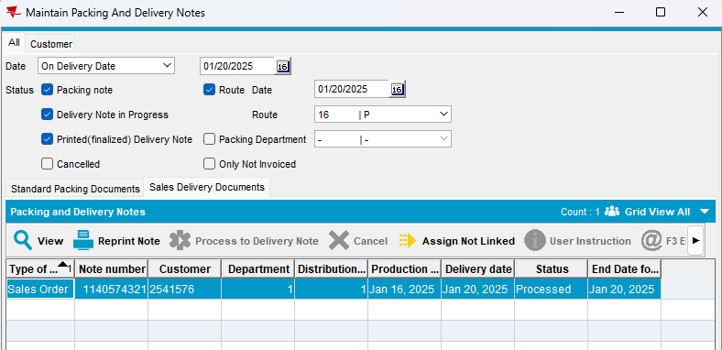
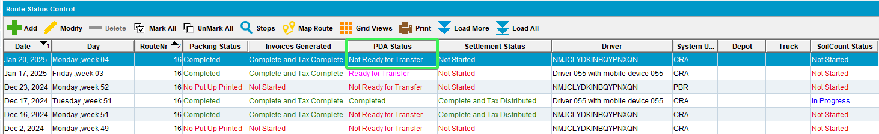
- Maintain Sales Notes DLG: Open the sales note and generate the invoice
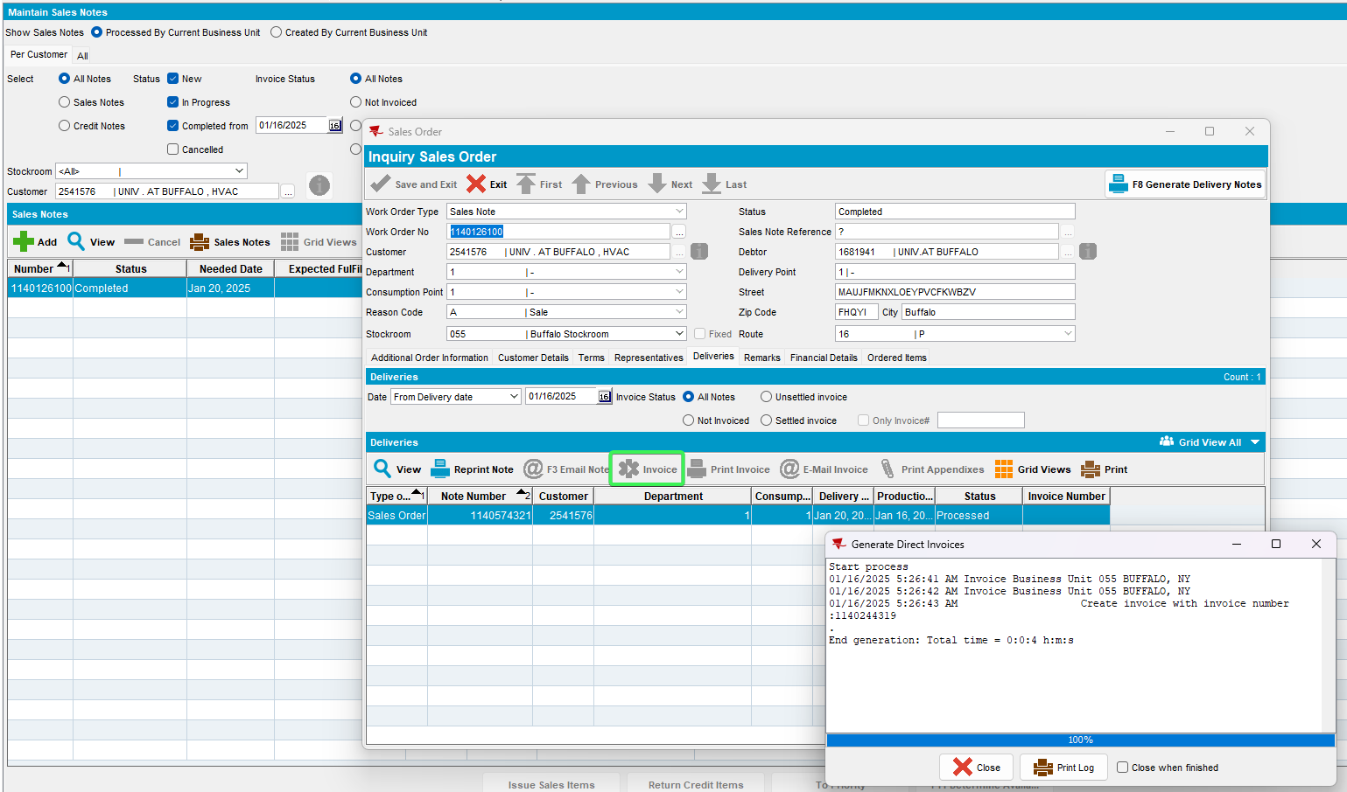

- Maintain Invoices DLG: Check that the Sales Order is attached to the route
The sales order is attached to the Route
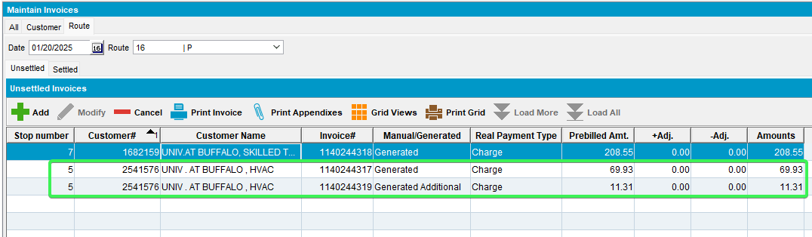
Delivery note is NOT discontinued from the route
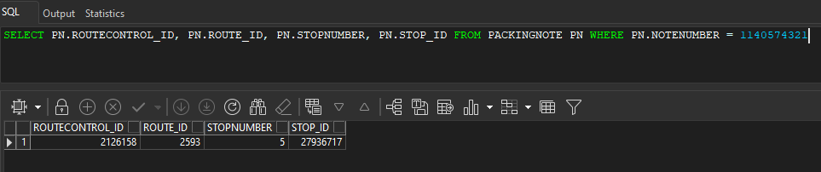
Tested OK

Test Case 6 – Add Sales Note with multiple wearers and garments – Partial Credit on WebX and Rebill
Hash: e081f84ac845
- Add new Sales Note
- Check the Sales Wearer Order
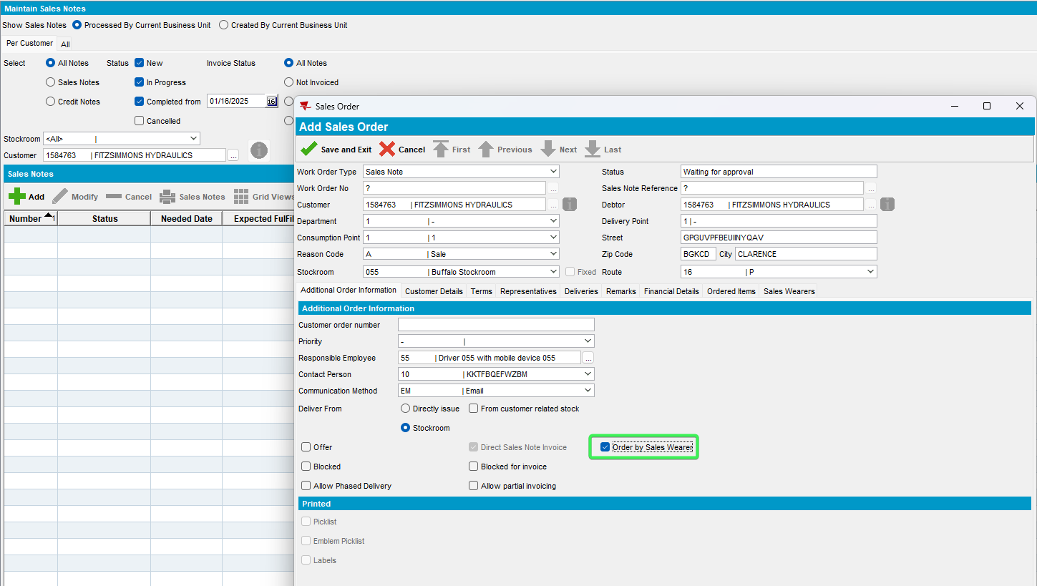
- Work Order Line 1 - Add Garment 1 from PLPC for Sales Wearer 1 – Set sales price > 0 – QTY = 10
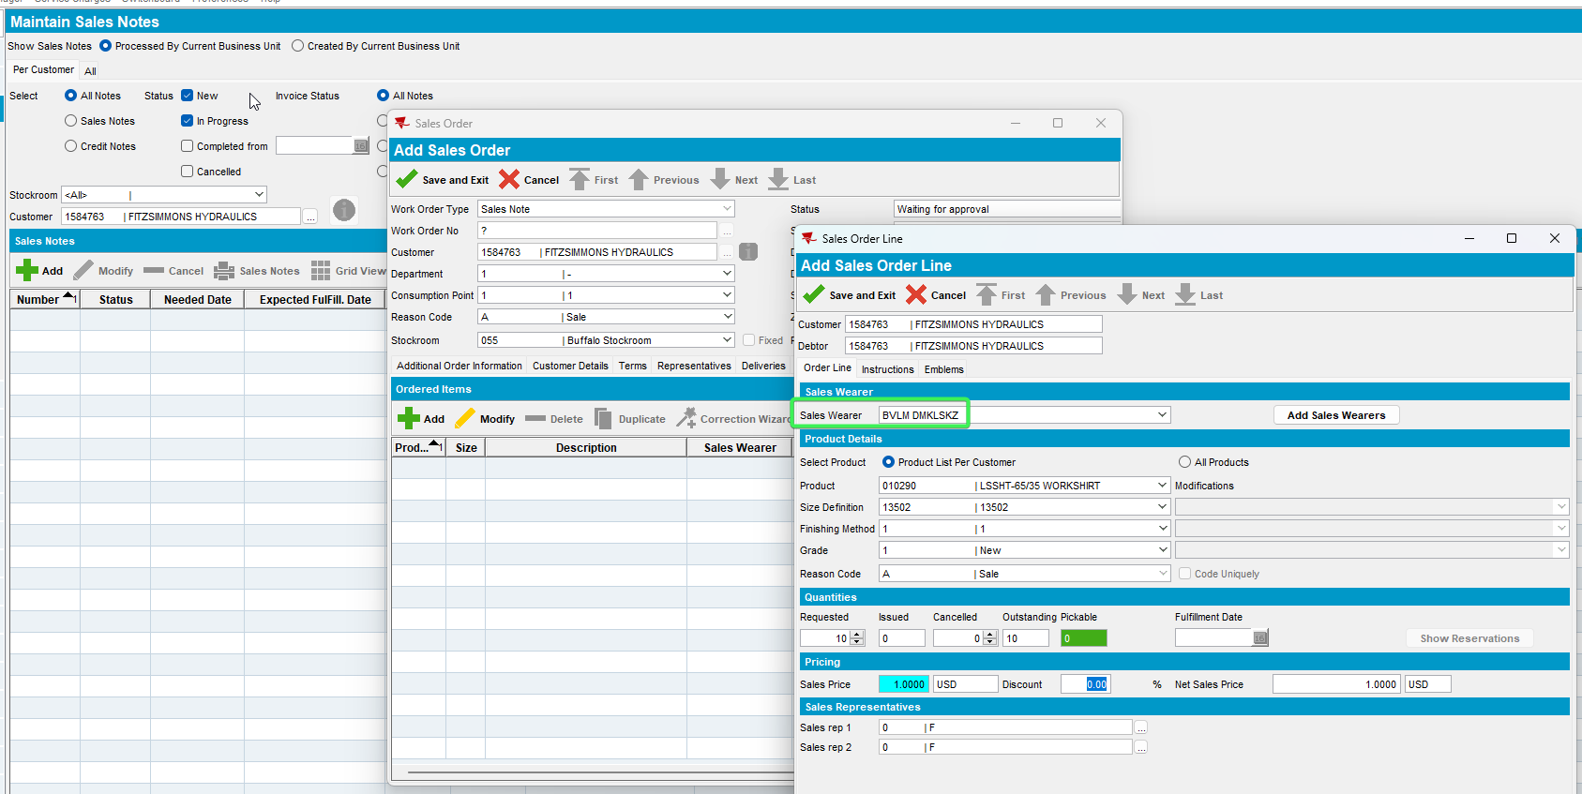
- Work Order Line 1 - Add Emblems from Template – 1 Product + 1 Non-Product – Set all sales prices > 0 – QTY = 10
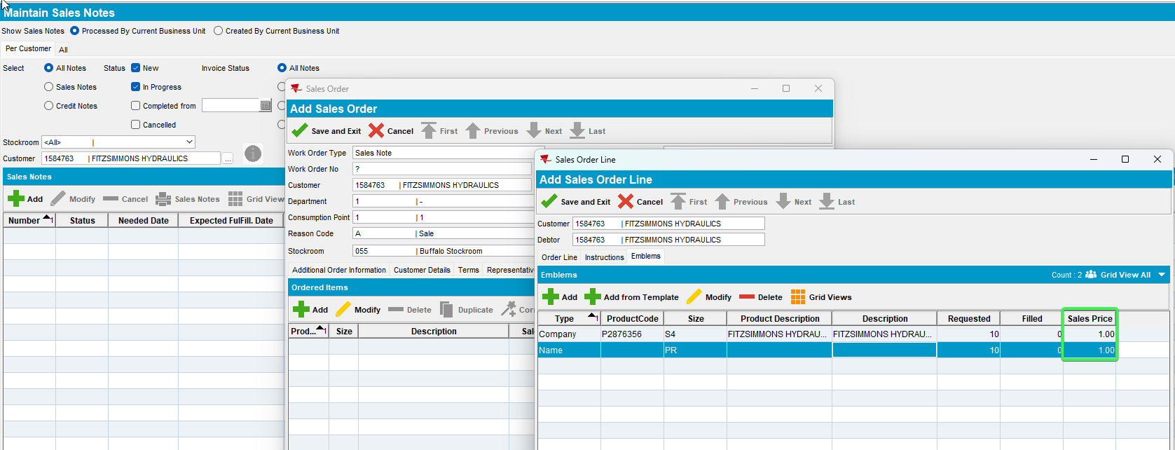

- Work Order Line 2 - Add Garment 2 from Product List for Sales Wearer 1 – Set sales price > 0
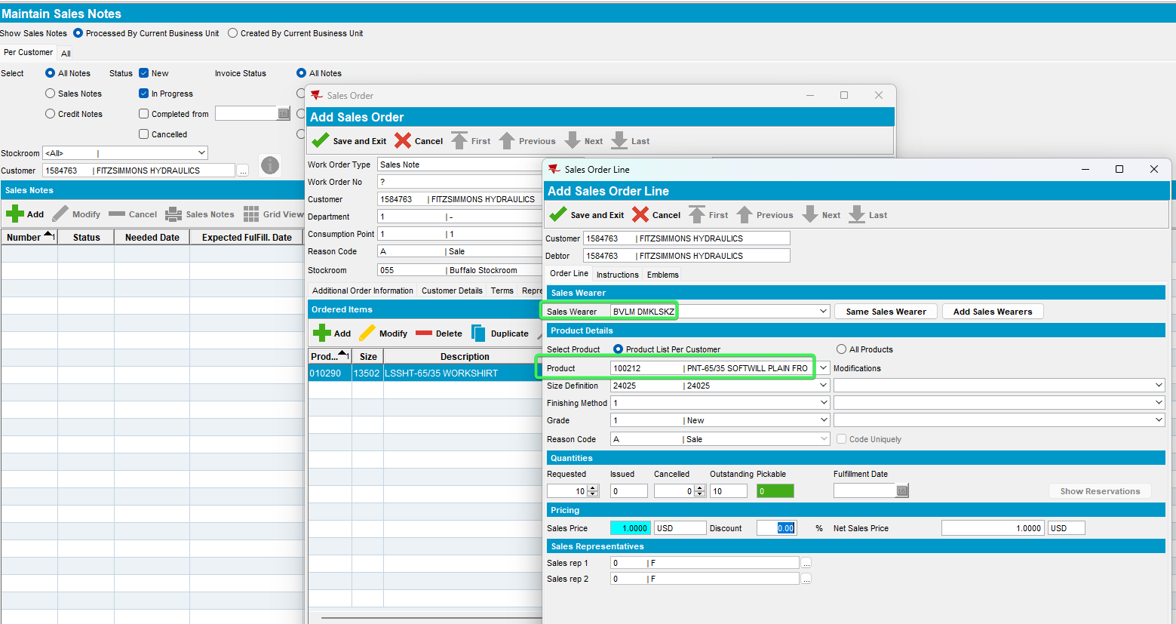
- Work Order Line 2 - Add emblem via Add button of type product – Set all sales prices > 0
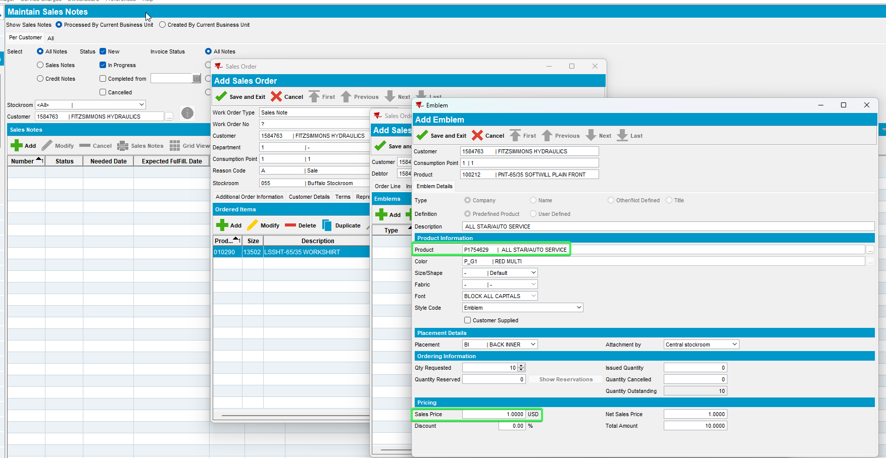
- Work Order Line 3 - Duplicate Line 1 but change it to Sales Wearer 2
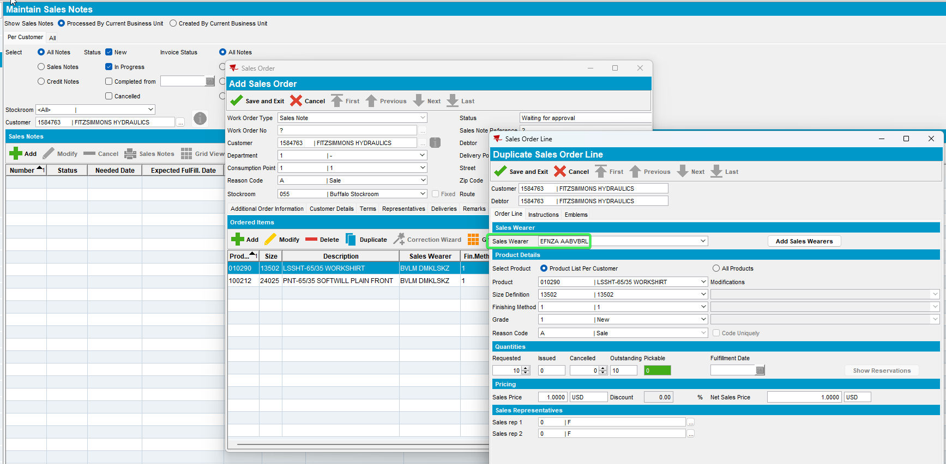
- Work Order Line 4 - Duplicate Line 2 but change it to Sales Wearer 2
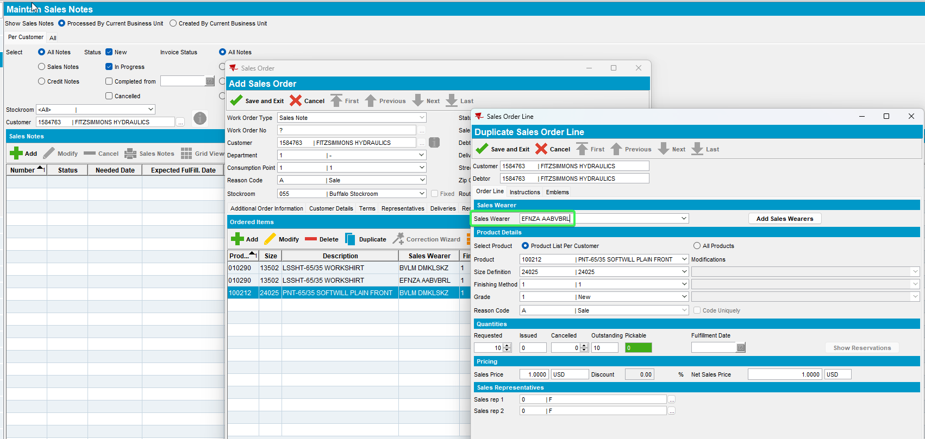
- Work Order Line 5 - Duplicate Line 3 but change it to Sales Wearer 3
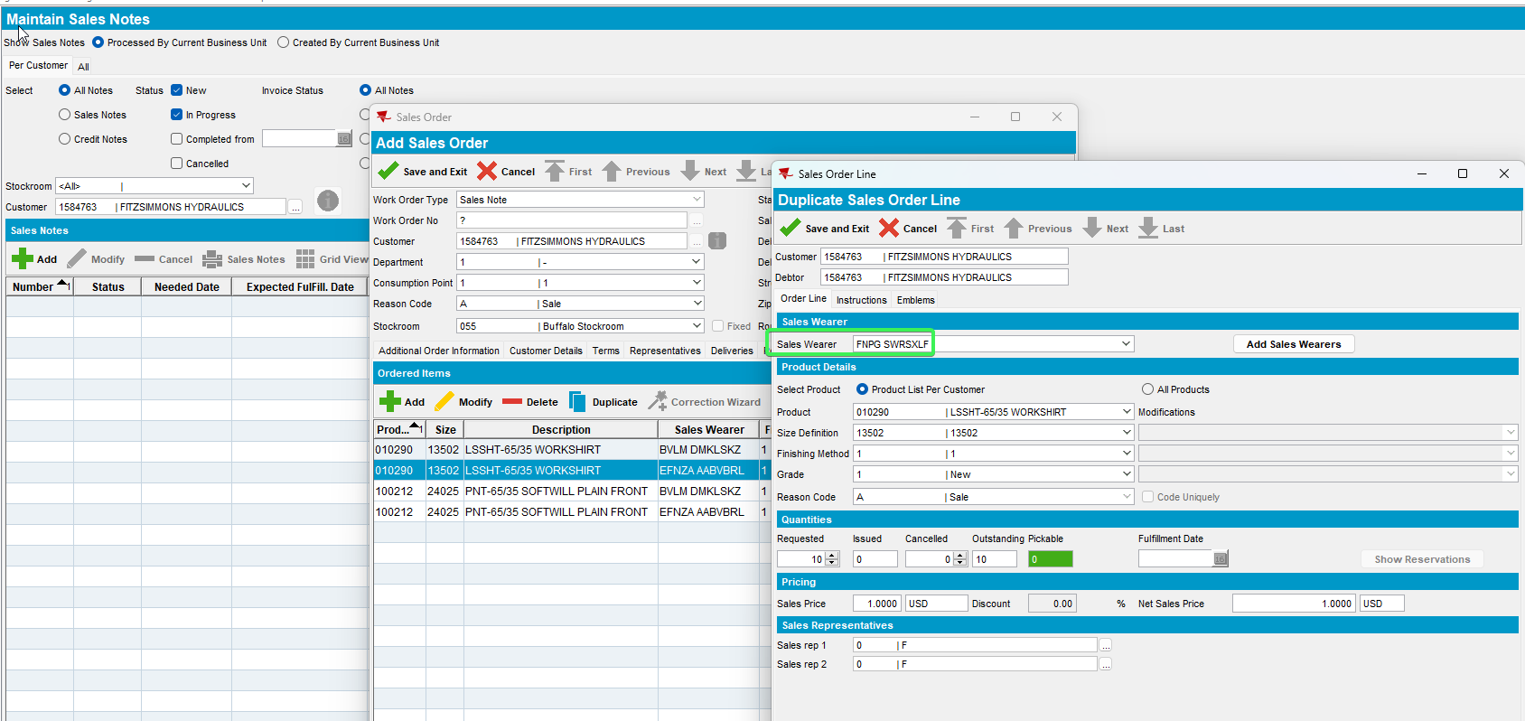
- Work Order Line 6 - Duplicate Line 4but change it to Sales Wearer 3
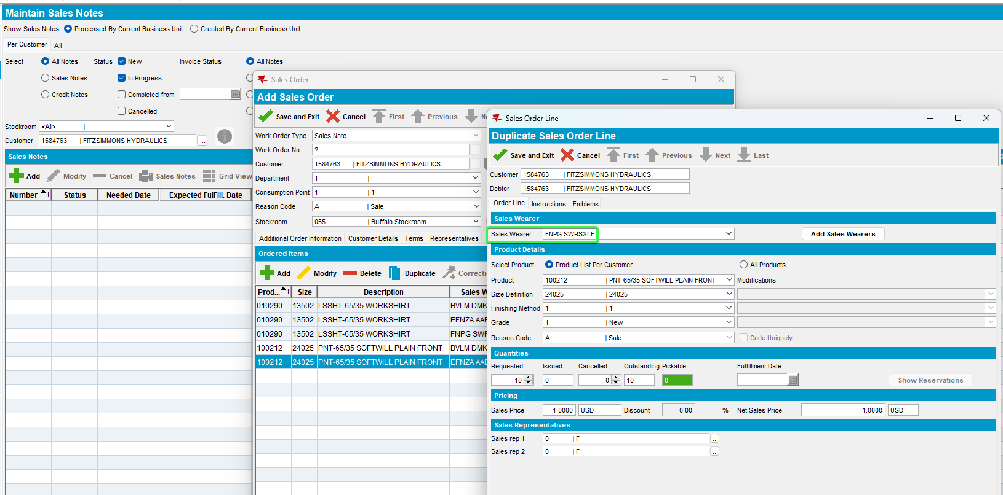
- Save & Exit
- Open the Sales Order again and go to the Financials tab
- Set the Handling Charge to 5% and the General discount to 10%
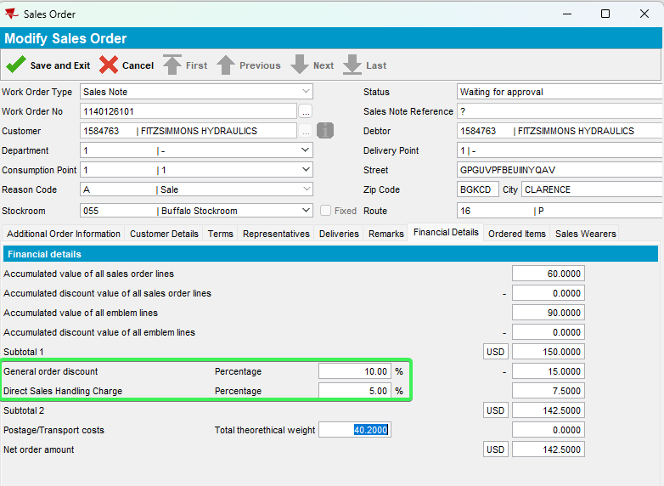
- Work Orders Waiting For Approval DLG: Approve the Sales Note
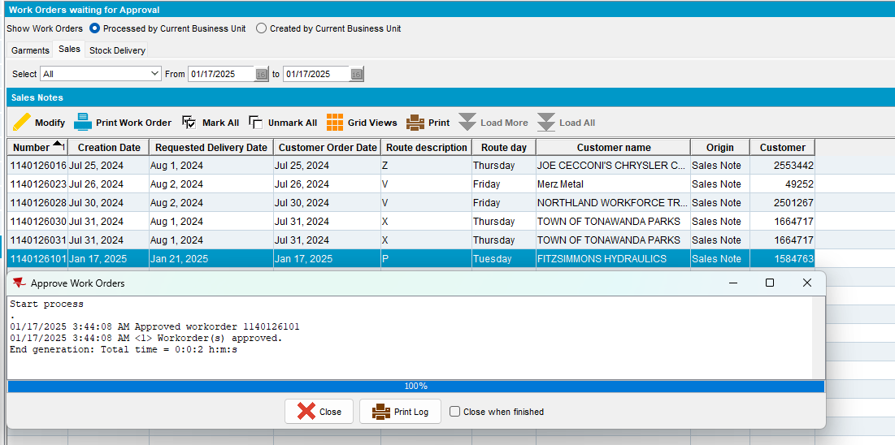

- RSC DLG: Generate invoices for the next available route

- Script in the BCI data and run the Vertex Tax process scheduler
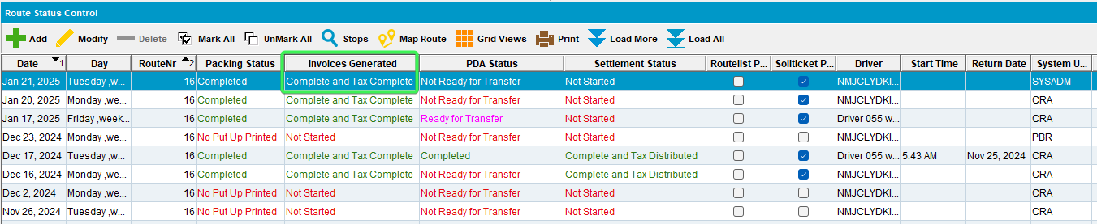
- Maintain Sales Notes DLG: Issue all work order lines
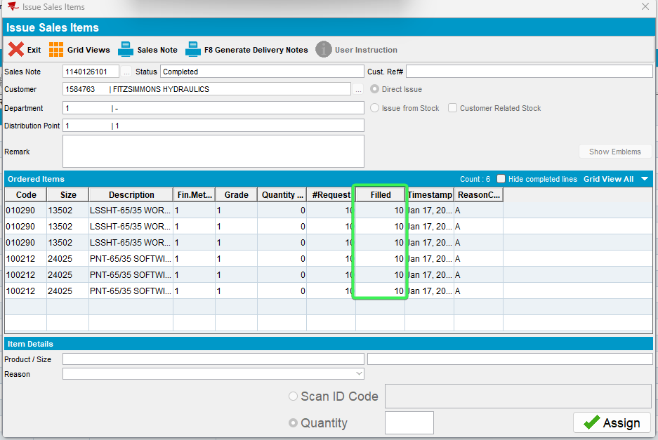
- Generate Delivery Note for the route where you just generated invoices

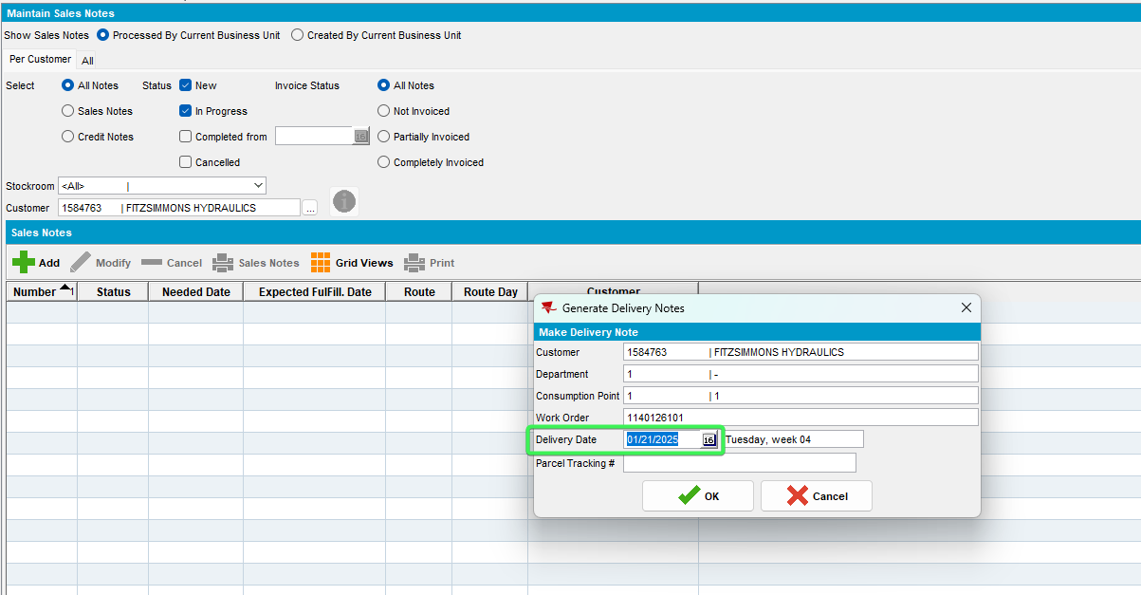
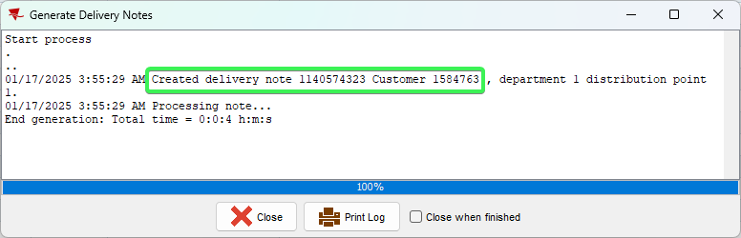
- Assign the delivery note to the route you just generated invoices on
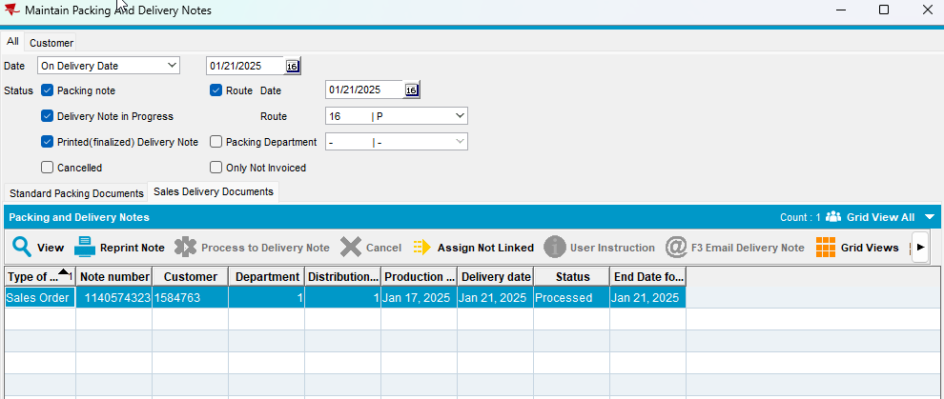
- Mark the route ready to transfer to PDA.
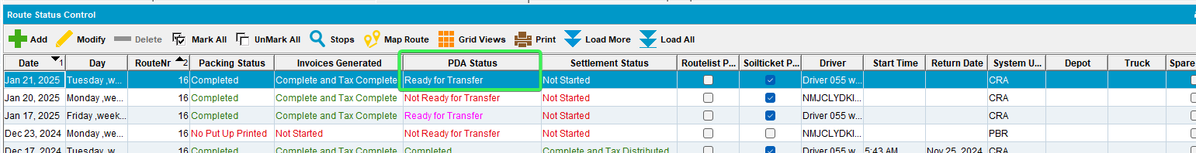
- Download the route to PDA.
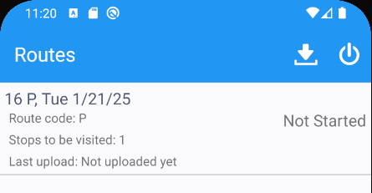
- Maintain Sales Notes DLG: Generate invoices for the same date. This will trigger the delivery note to be un-assigned from the route and the invoice to be generated without any route to which it is assigned.
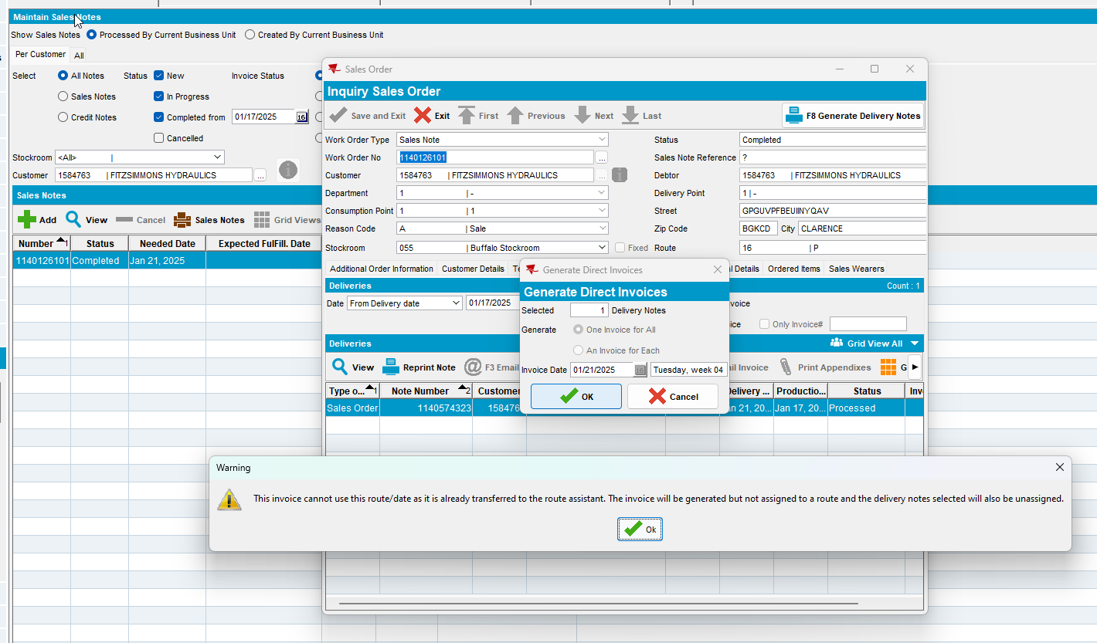
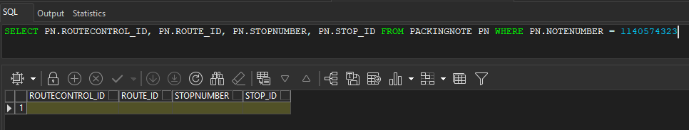
- Maintain Invoices DLG: Find your invoice and verify that you have separate invoice line per Product/Size/Sales Wearer and Work Order Emblem Line
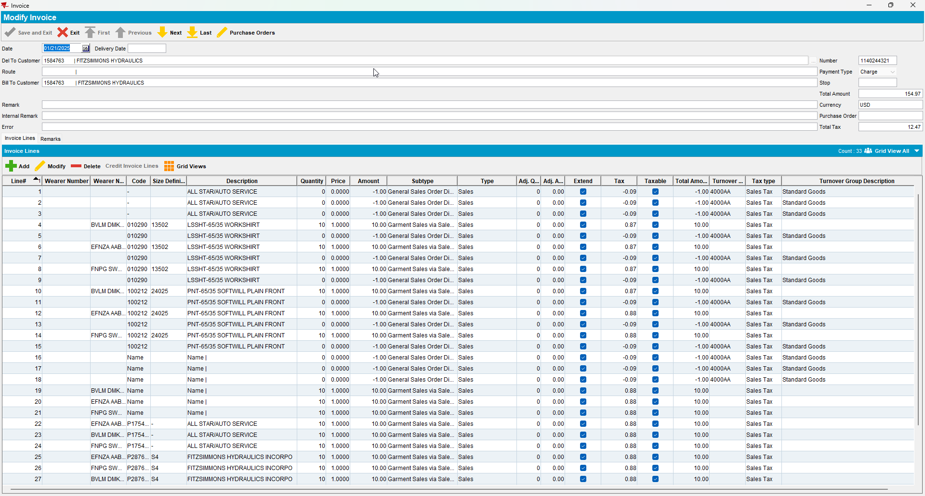
- RSC DLG: Add next week’s route for the same customer (Route #2)
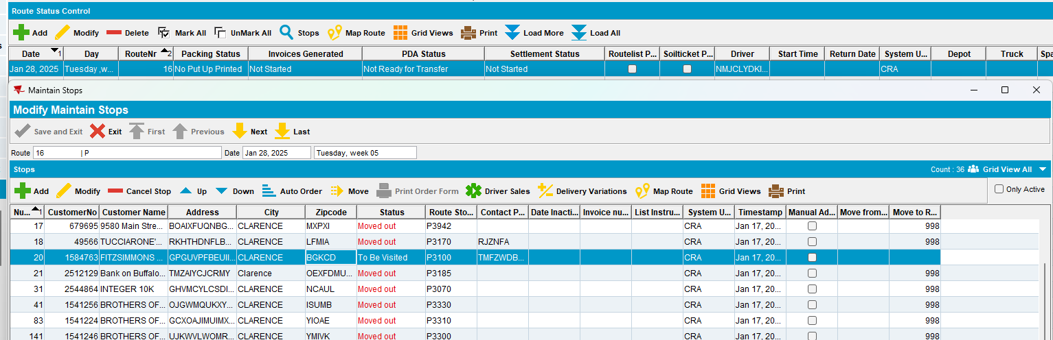
- RSC DLG: Generate packing notes and invoices for Route #2
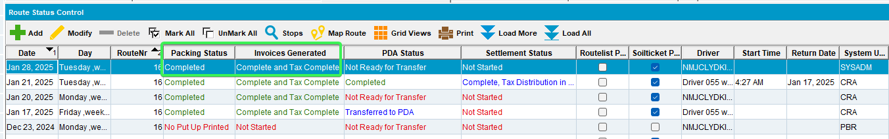
- Maintain Invoices DLG: Assign the invoice to Route #2
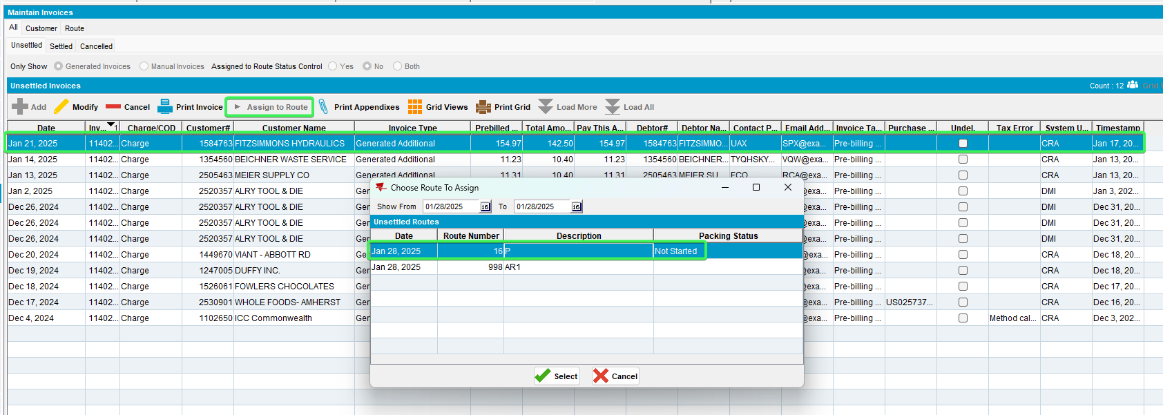

- RSC DLG: Mark the route ready to download to RA
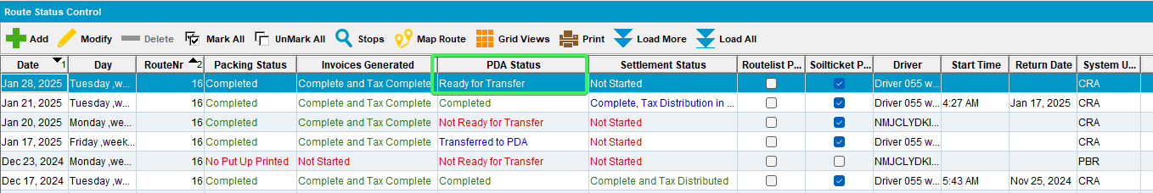
- RA: Download the route and arrive at the customer
- RA: Settle the stop and depart
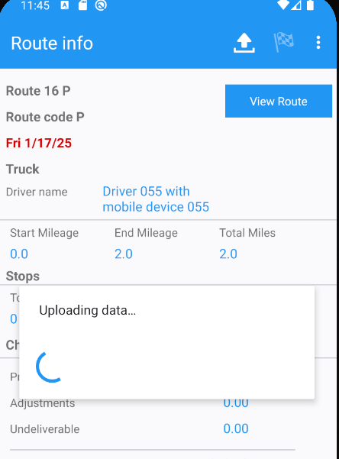
- RA: Finish the route and upload
- WebX: Find the route
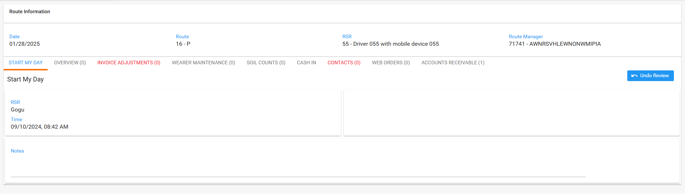
- WebX: Add Adjustment> Select Invoice line corresponding to Work Order Line 2 garment and adjust it by -3
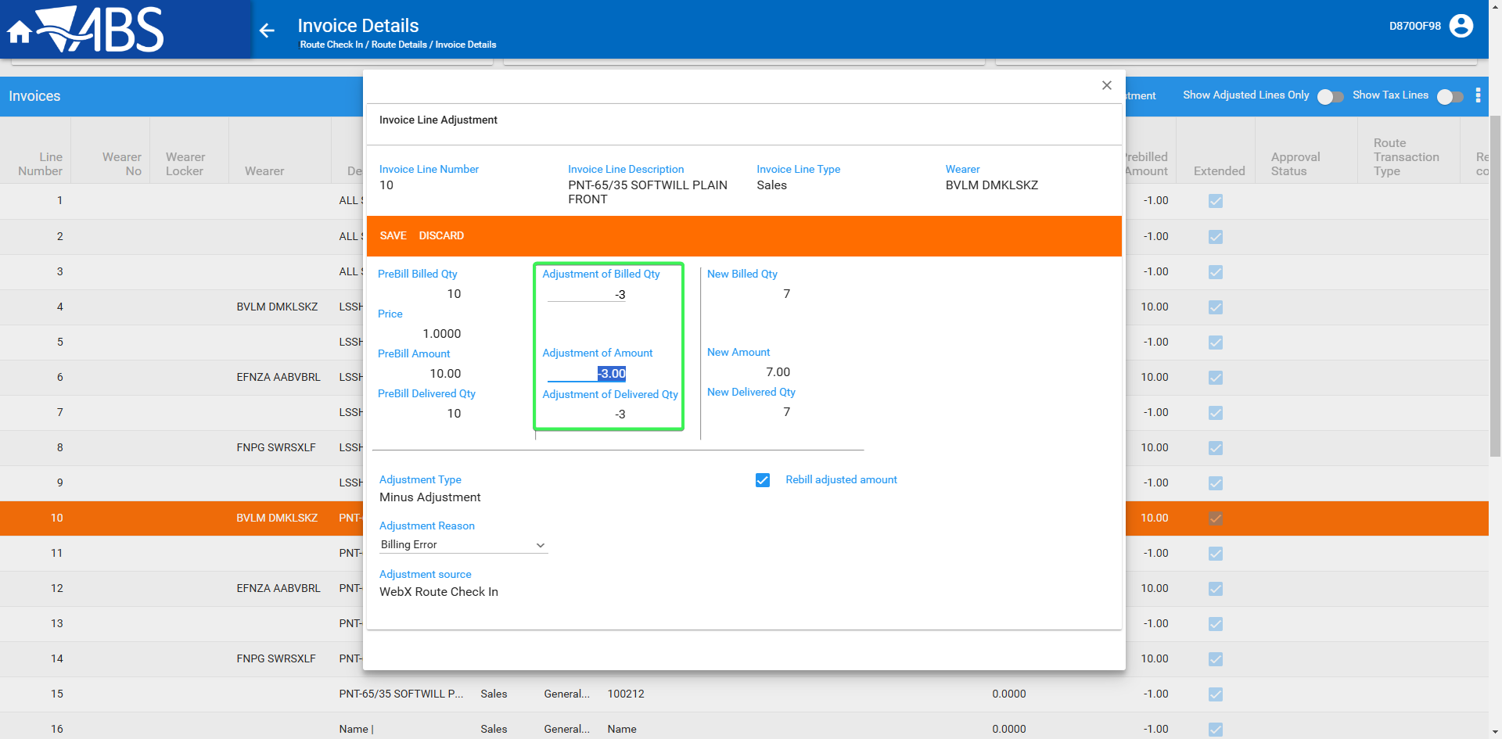
- WebX: Add Adjustment> Select Invoice line corresponding to Work Order Line 2 emblem and adjust it by -3
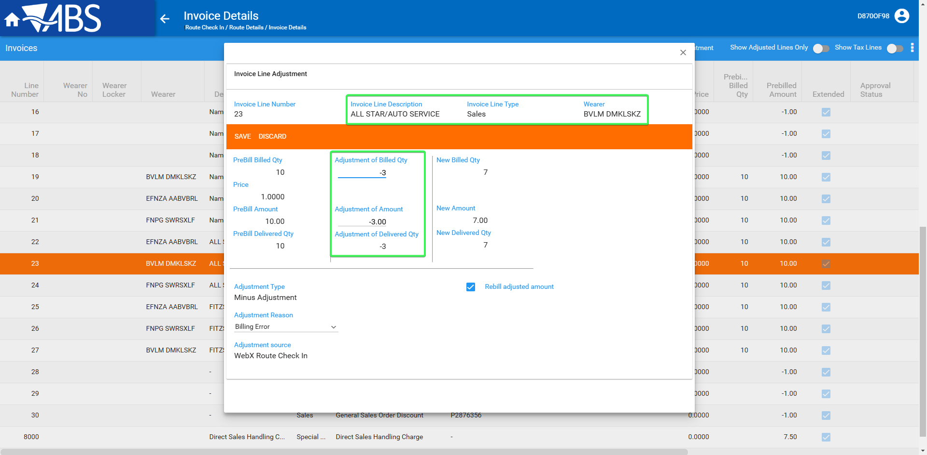
- WebX: Make sure all the transactions have been marked for Rebill
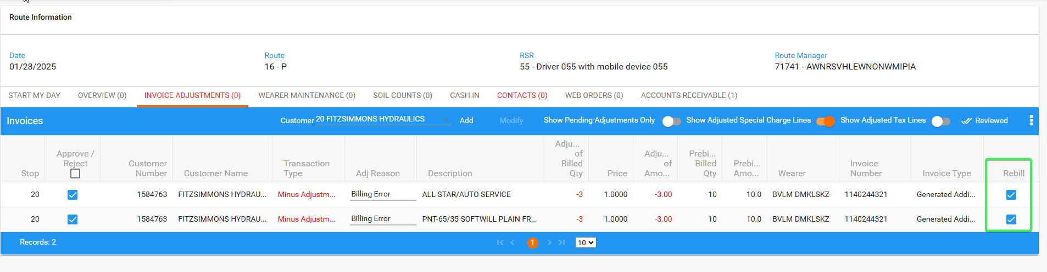
- WebX: Settle the route
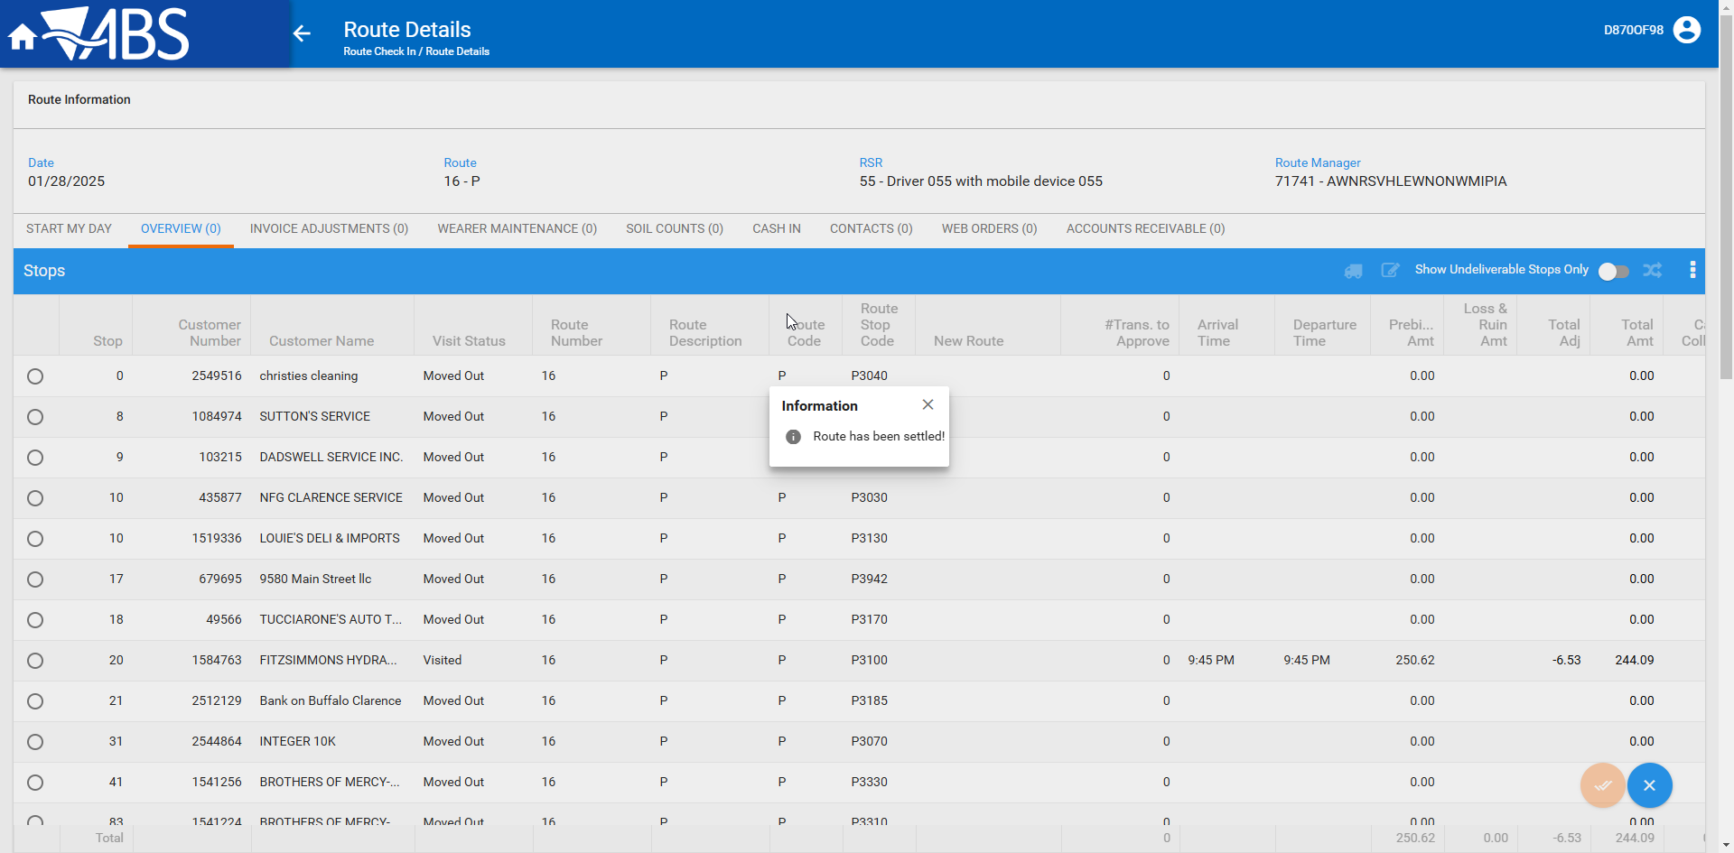
- Check that the settlement process has re-created the delivery note and the GSH records for Rebill
select gsh.quantity, gsh.* from garmentsaleshistory gsh
join packingnoteline pnl on gsh.packingnoteline_id=pnl.packingnoteline_id
join packingnote pn on pn.packingnote_id=pnl.packingnote_id
where pn.notenumber= 1140574325
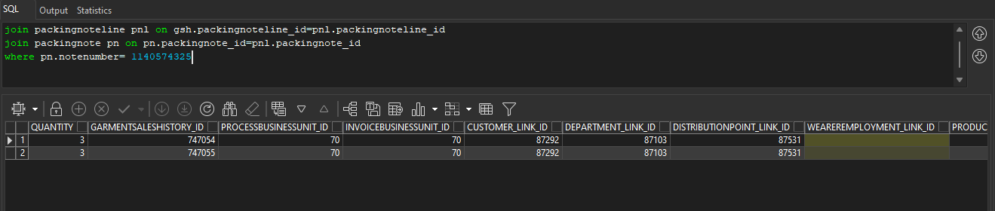
- RSC DLG: Create next week’s route control and make sure the new sales note delivery note is assigned to it
Sales Notes Manually assigned
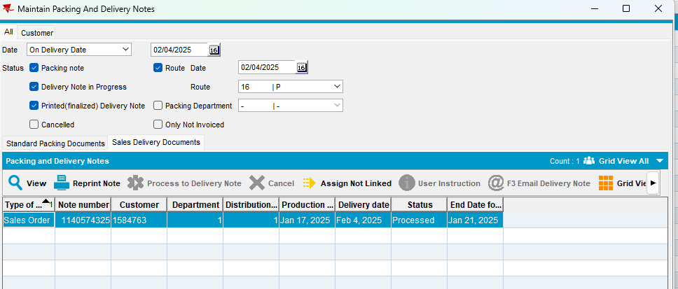
- RSC DLG: Generate the invoices for next week’s route control (Route #3)
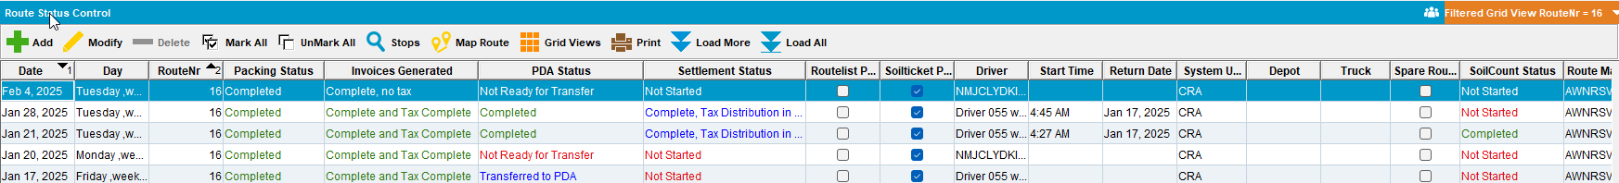
- RSC DLG: Verify that the new GSH records are linked to the new invoiceheader and it’s corresponding invoicelines
select gsh.quantity, gsh.invoiceheader_id,gsh.invoiceline_id, gsh.* from garmentsaleshistory gsh
join packingnoteline pnl on gsh.packingnoteline_id=pnl.packingnoteline_id
join packingnote pn on pn.packingnote_id=pnl.packingnote_id
where pn.notenumber= 1140574325
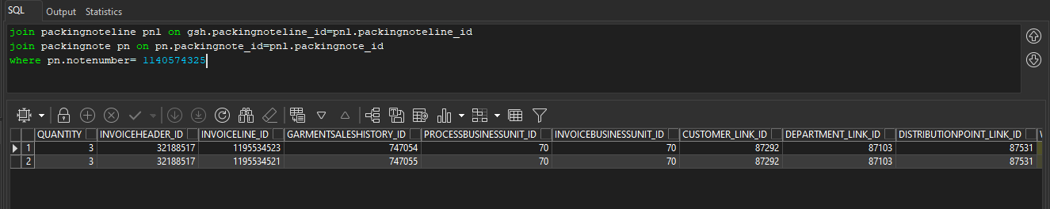
- Verify that on Route#3 you have a generated additional invoice with all the rebill invoice lines from the table.
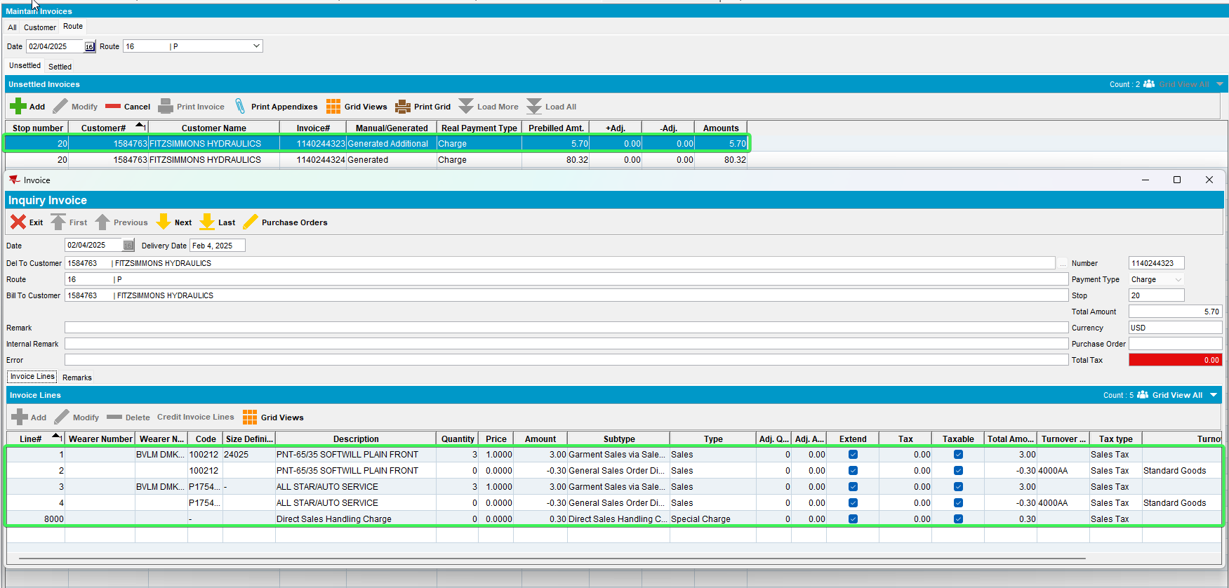
Tested OK

