ABSN-6254 - Discrepancy of handling quit wearer/wearer inventory in Route Assistant 13.07
Environment | Prerequisites
Version: 9.07.00.UNF18 + RouteAssistant_v12.37  DBServerName= abs-srv20.internal.abslbs.com  DBSID=CUST24  DBUser=UNFDEV  DBPassword= UNFDEV  Environment=Test | - Module:  - System setting

Contents
Retest after fix 1
Test Case 1 – Verify items with “QUIT ITEM” flag are able to be scanned in “Scan Return Items” screen (RASA) 1

Retest after fix

Test Case 1 – Verify items with “QUIT ITEM” flag are able to be scanned in “Scan Return Items” screen (RASA)
Expected Behavior: Items with “QUIT ITEM” flag set using “Inactive Wearer” and “Inactive Wearer Inventory” should be able to be scanned in “Scan Return Items” screen (RASA).
“N” value should be set in “tobereturned” table of database for those items with <Multiple> flag
Hash: e4ea4aab85bb
- Wearers DLG: Have a customer with at least 2 wearers which have WI with Unique IDs
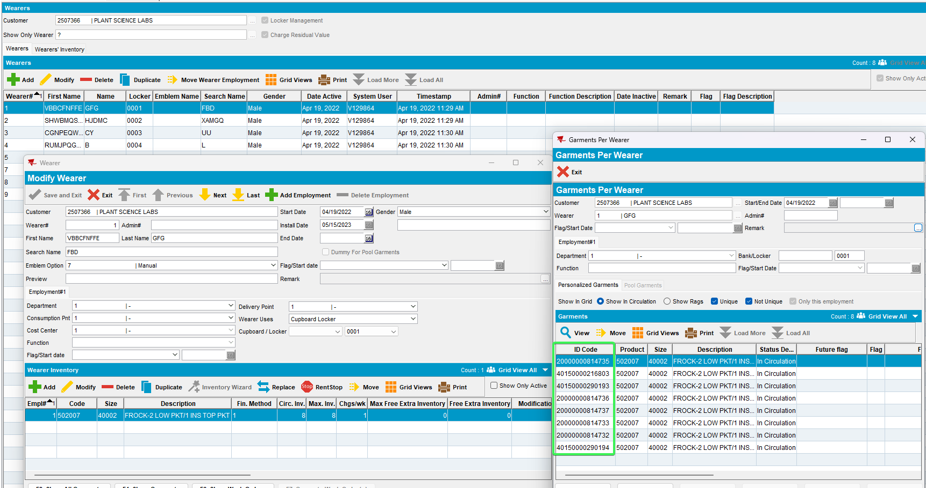
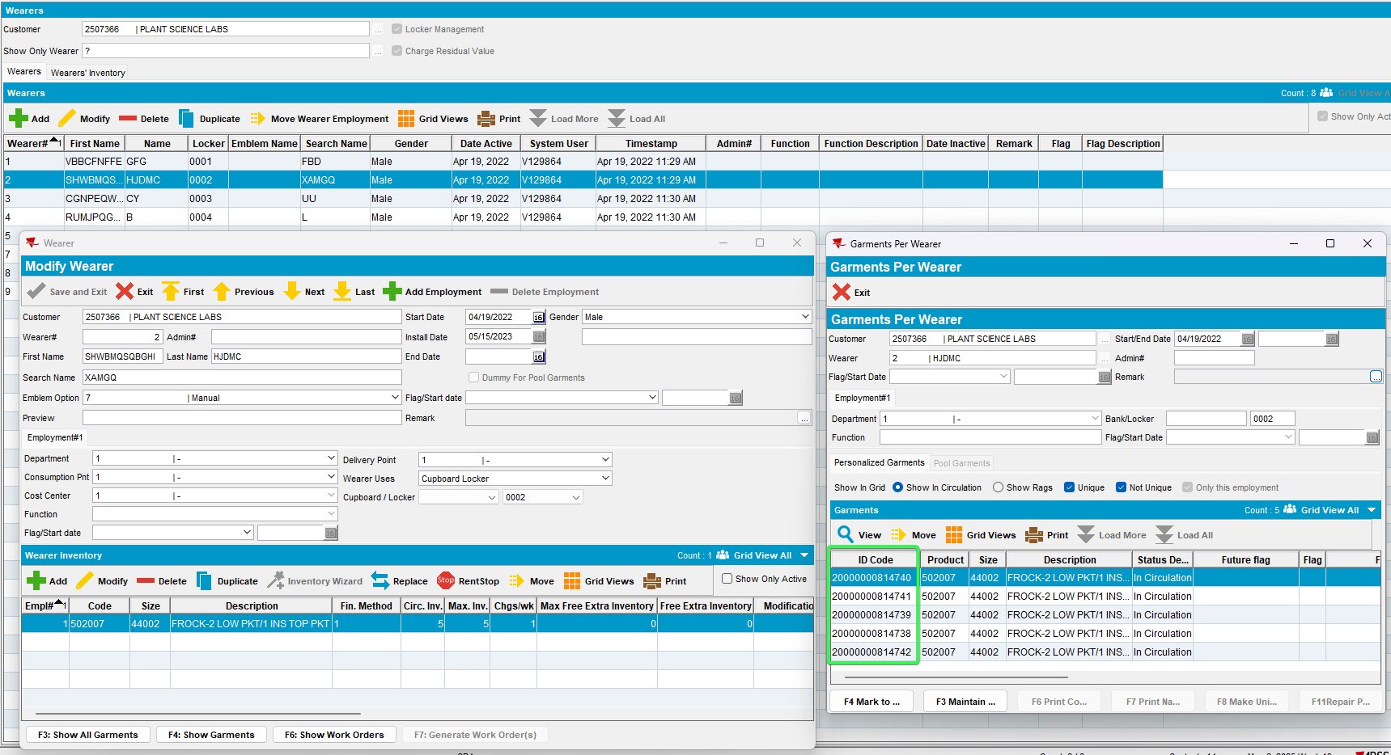
- For wearer 1 > go into his inventory and Mark to Replace one of his UI
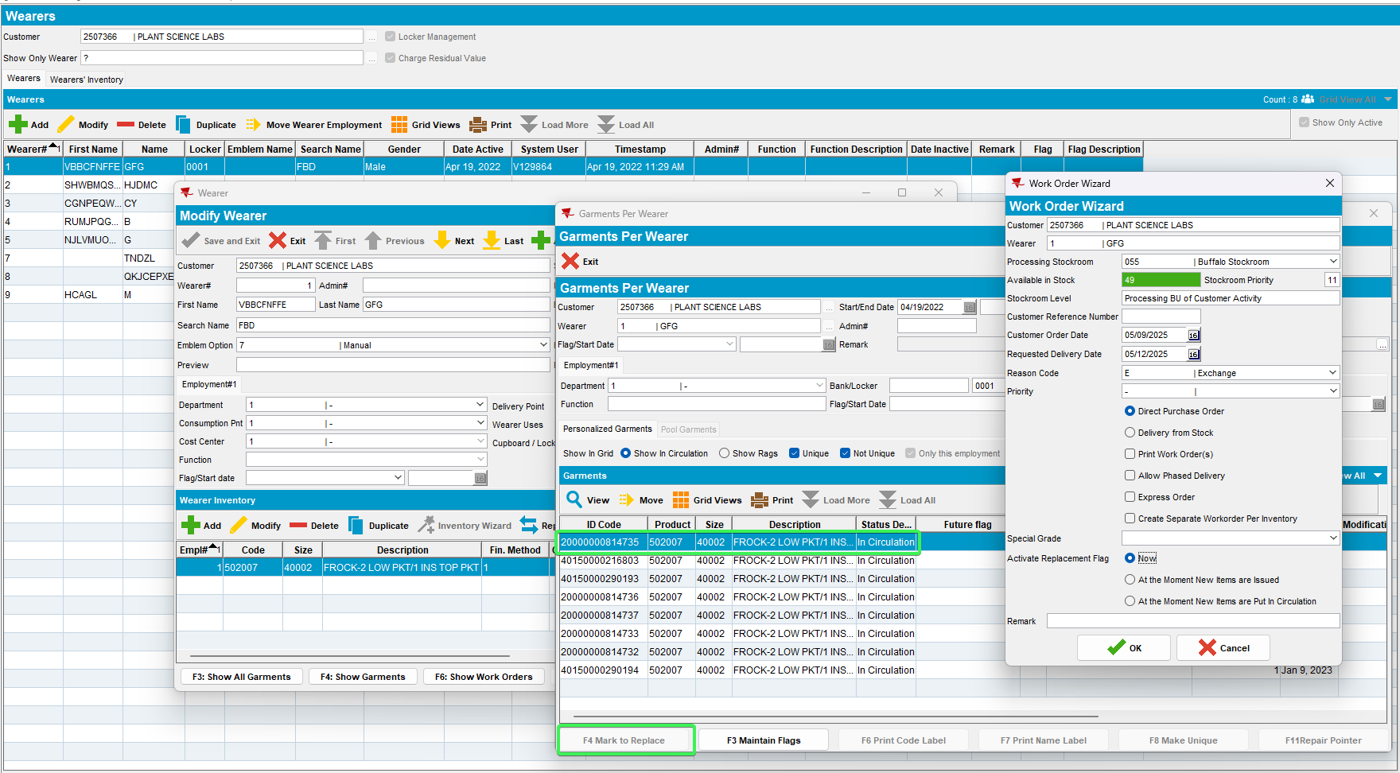
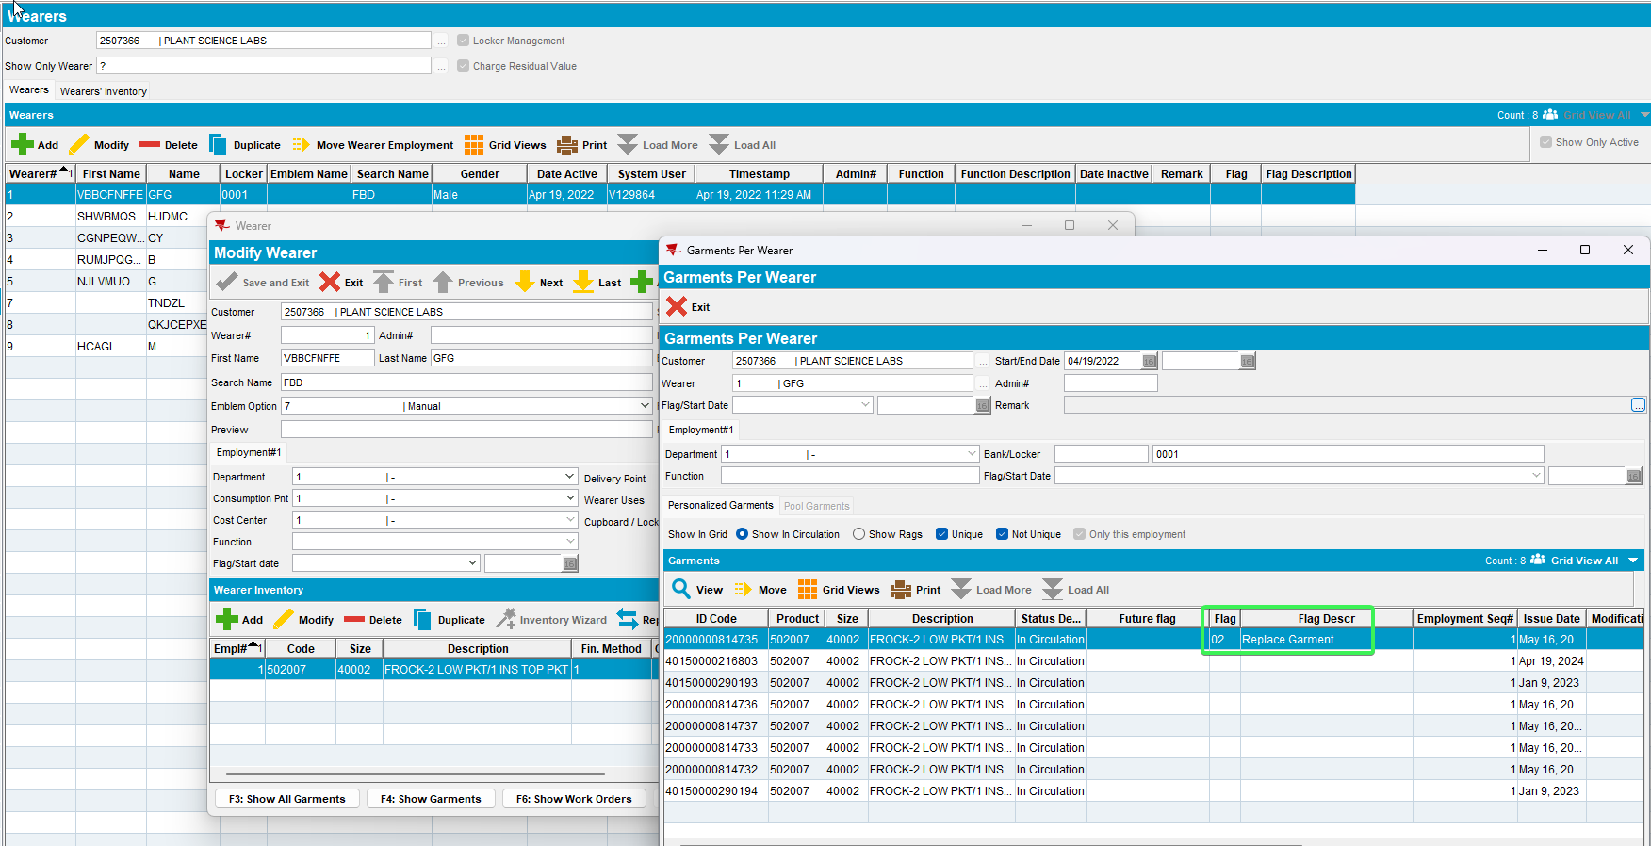
- Issue Work Order DLG: issue the OW for your item
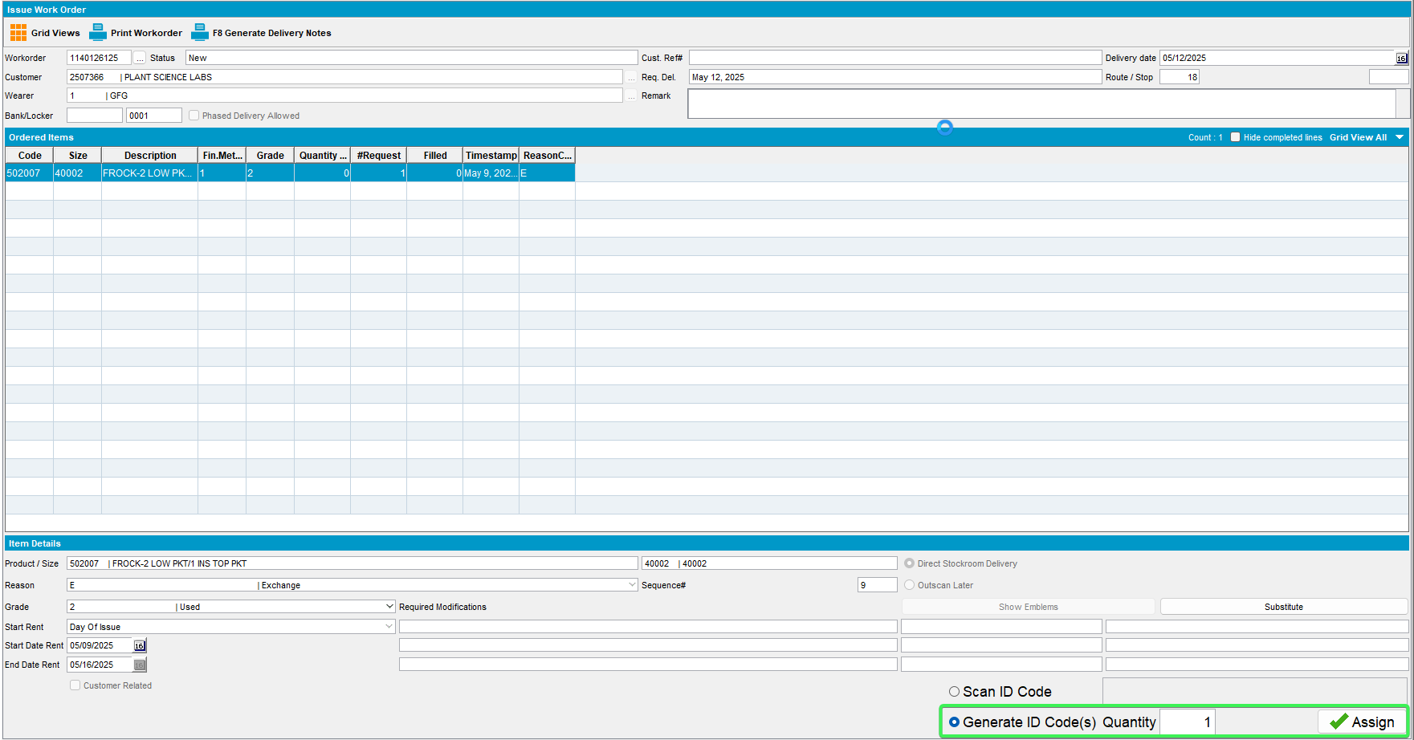
- For the same wearer 1 > Quit wearer End Date = Sysdate
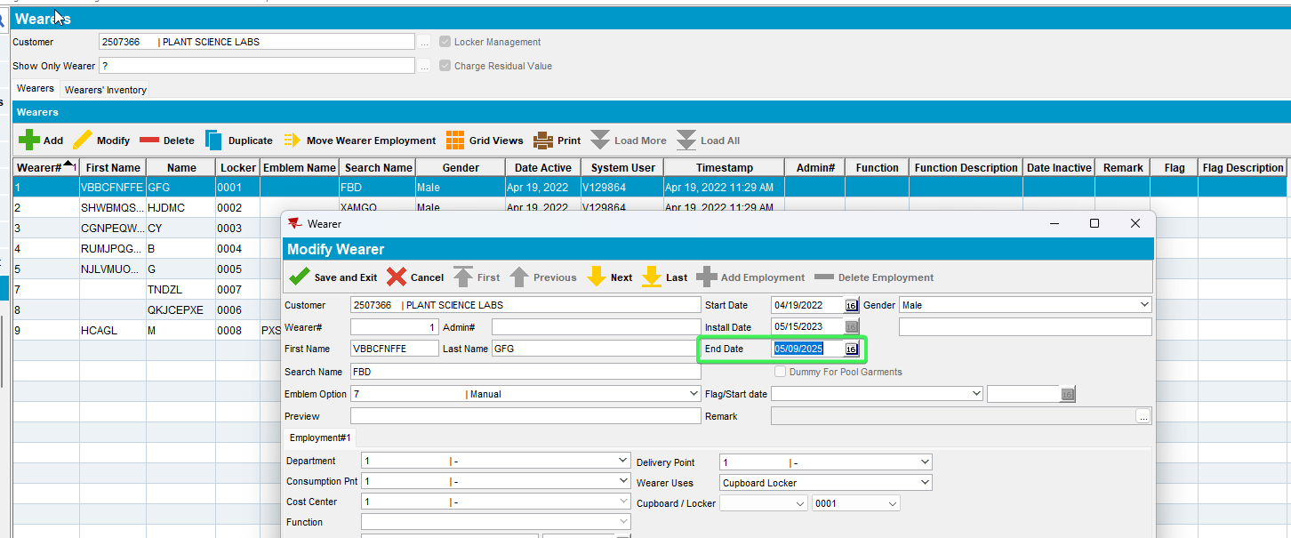
- Open the wearers inventory and see that the item you marked with a replacement flag now has multiple flags set while the others just the Quit Wearer Garment
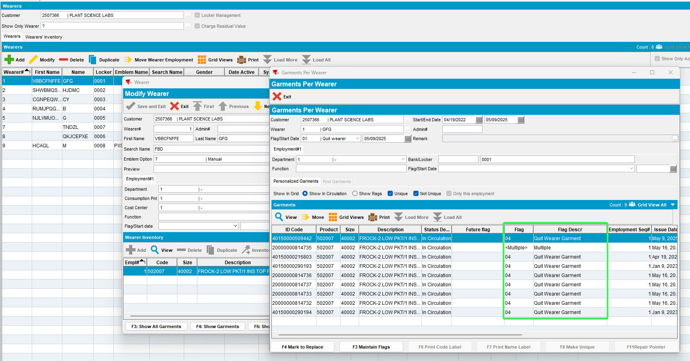
- Wearer 2 > Open the WI and Mark for Replace one of its UI
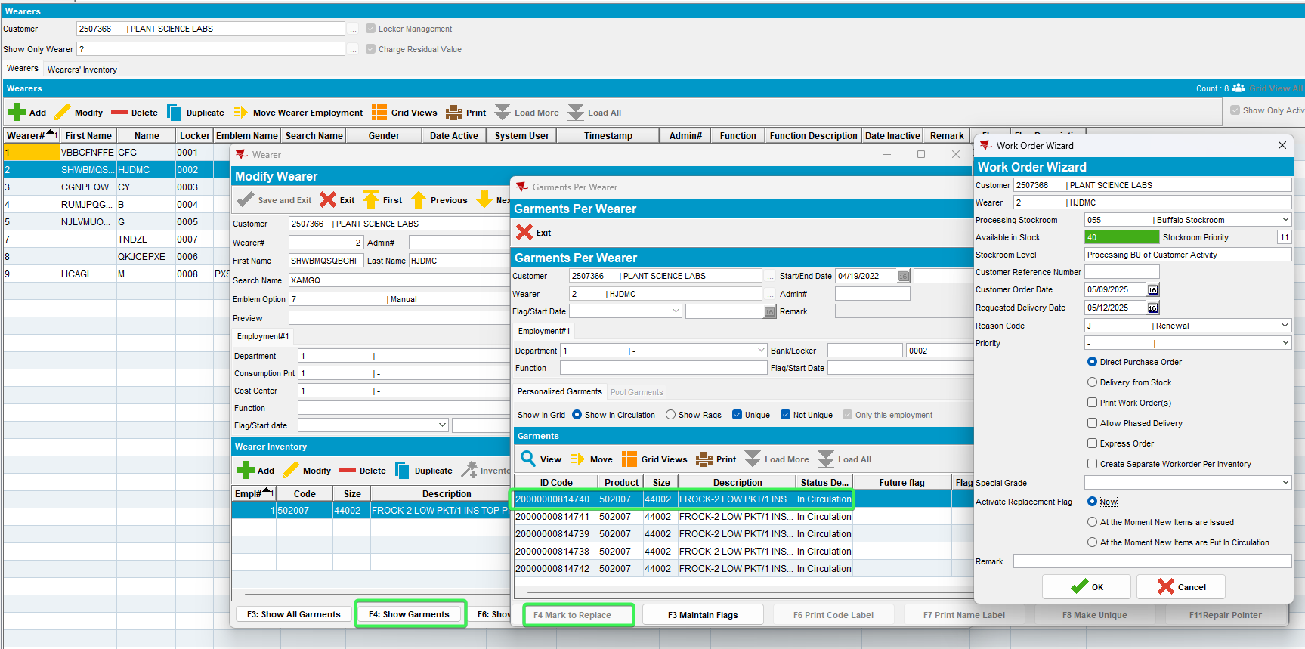
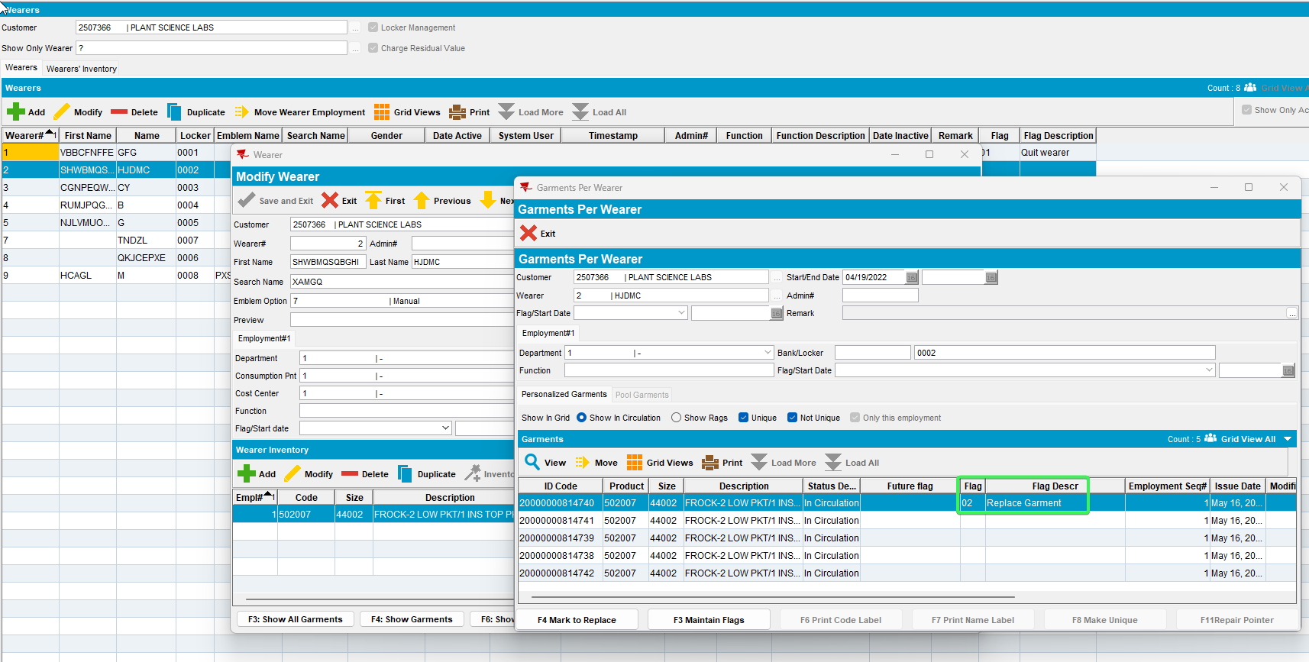
- Issue Work Order DLG: Issue the WO you just created
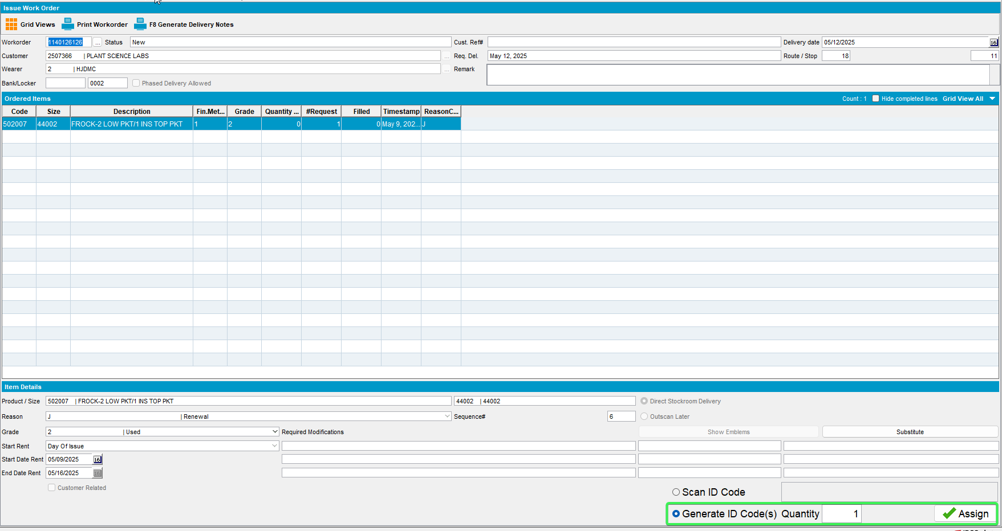
- Quit the Were Inventory of Wearer 2

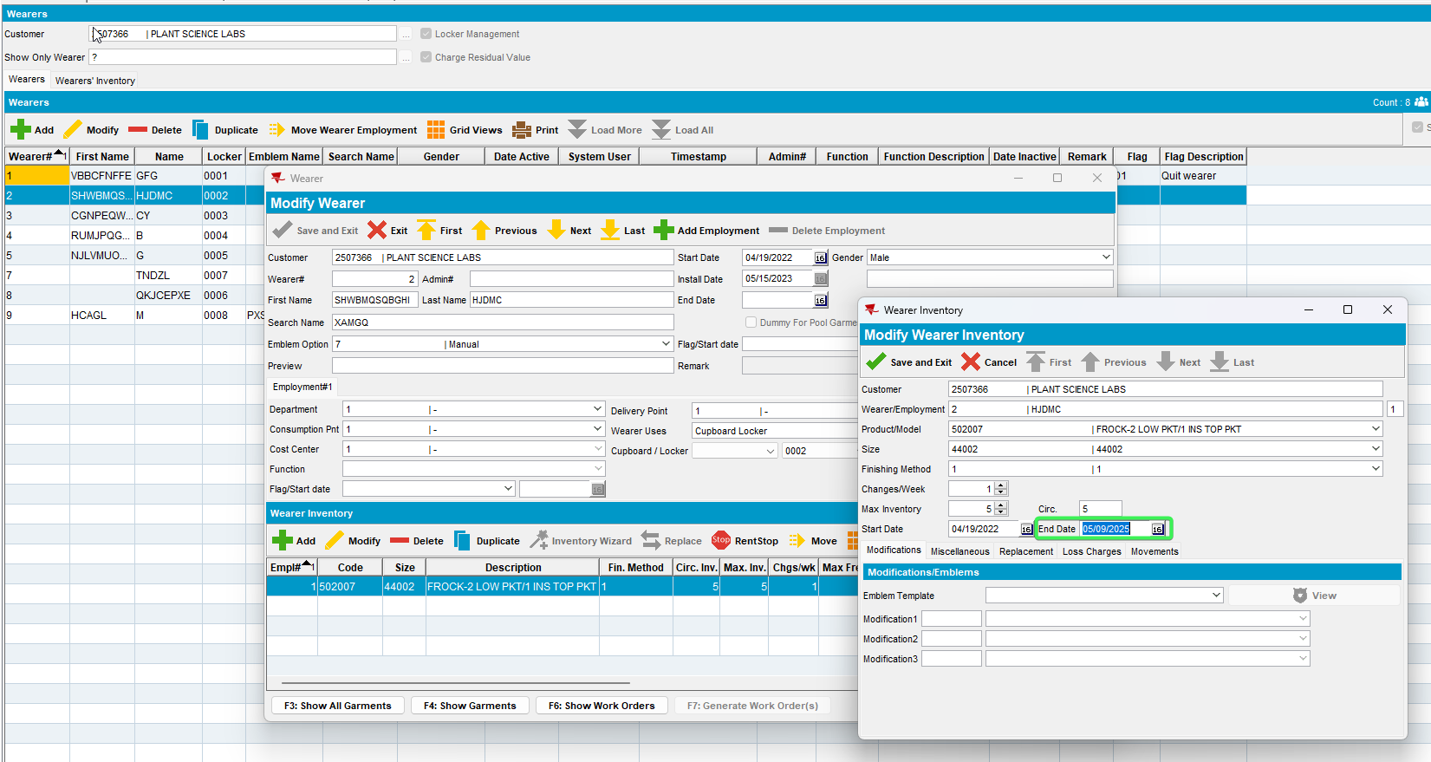
- Open the wearers inventory and see that the item you marked with a replacement flag now has multiple flags set while the others just the Quit Wearer Garment
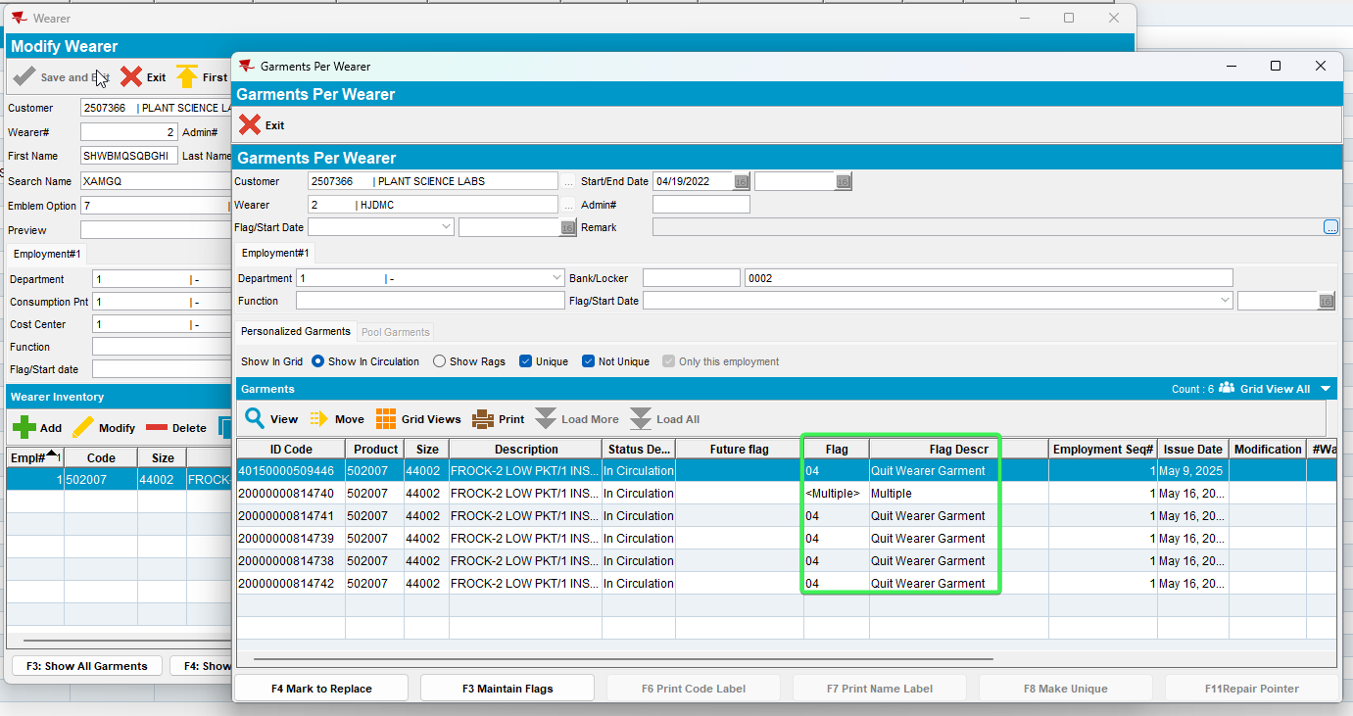
- Route Status Control DLG: Add a new route with your customer on it
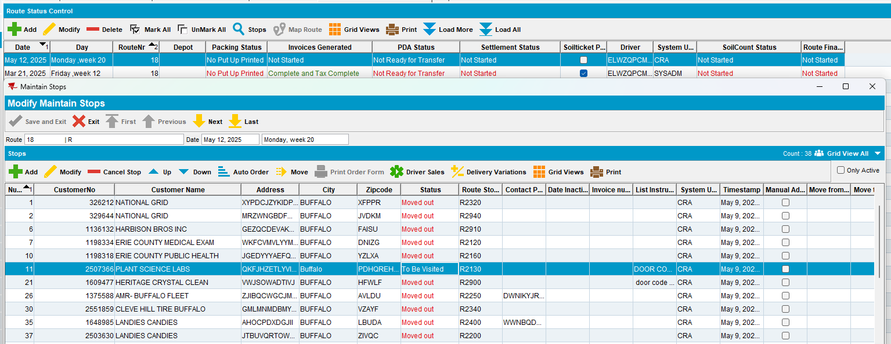
- Generate invoices and send it to RA
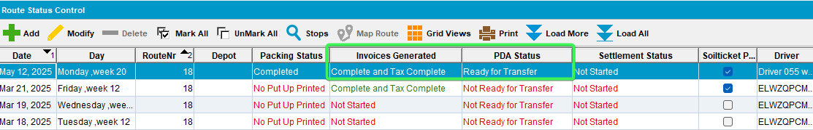
- RA: Arrive at the customer
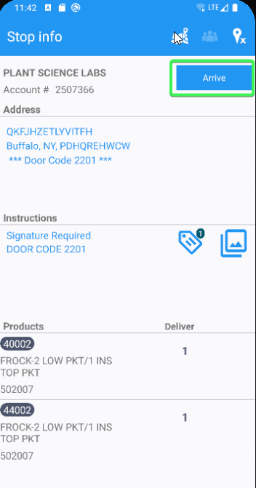
- Return Items menu > Select the Wearer that was quit earlier (Wearer 1) > Tap on the WI> Tap the Scan Returns button
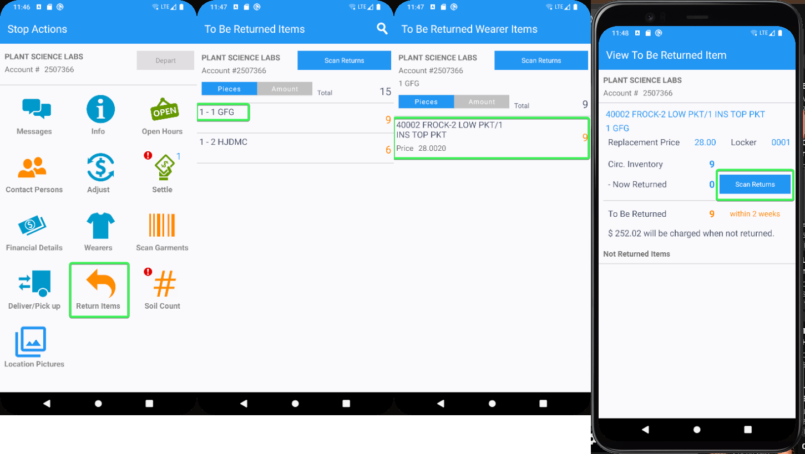
- Scan the UID with Multiple flags on it and see that is scanned “OK”
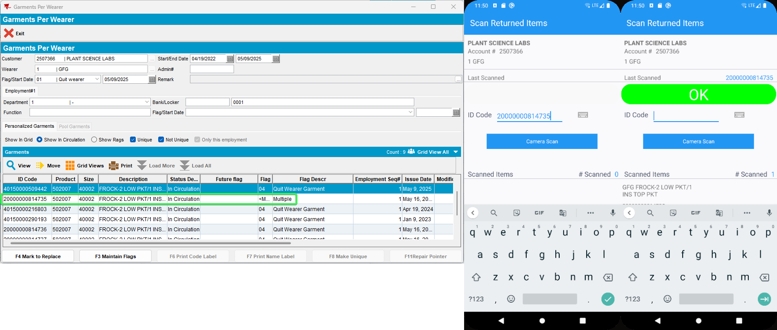
- Scan an UID that has “Quit Wearer Garment” flag on it and see that is scanned “OK”
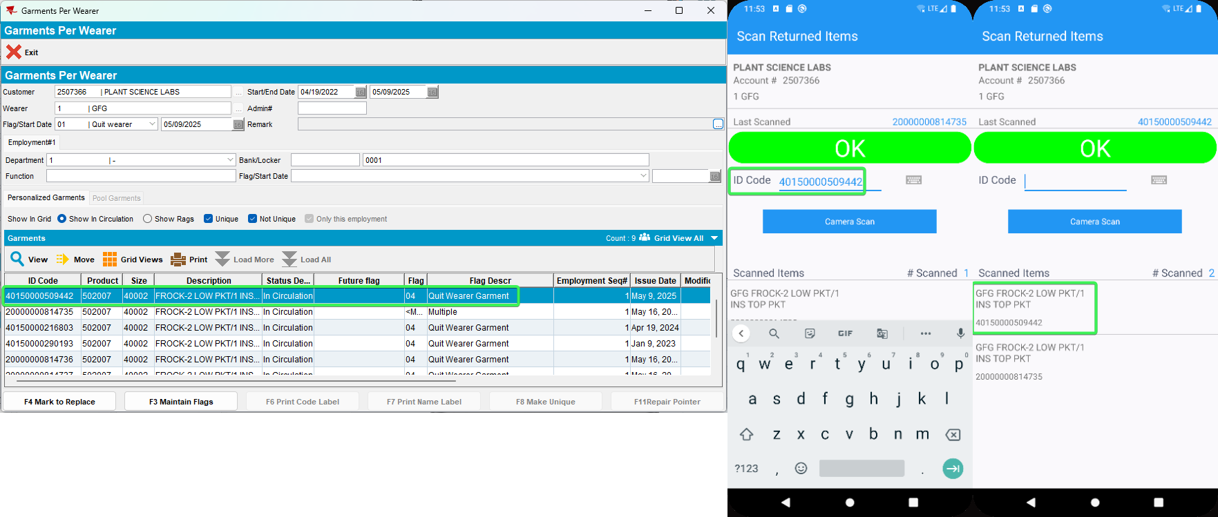
- Select the Wearer for which WI was quit earlier (Wearer 2) > Tap on the WI> Tap the Scan Returns button
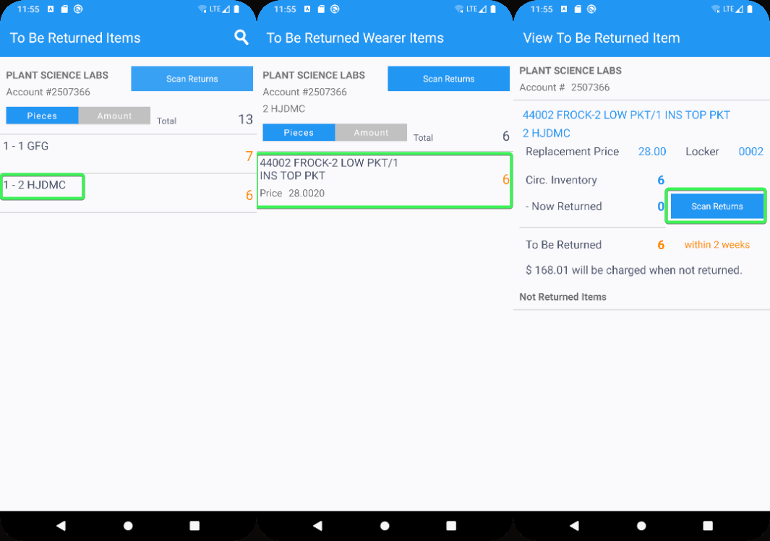
- Scan the UID with Multiple flags on it and see that is scanned “OK”
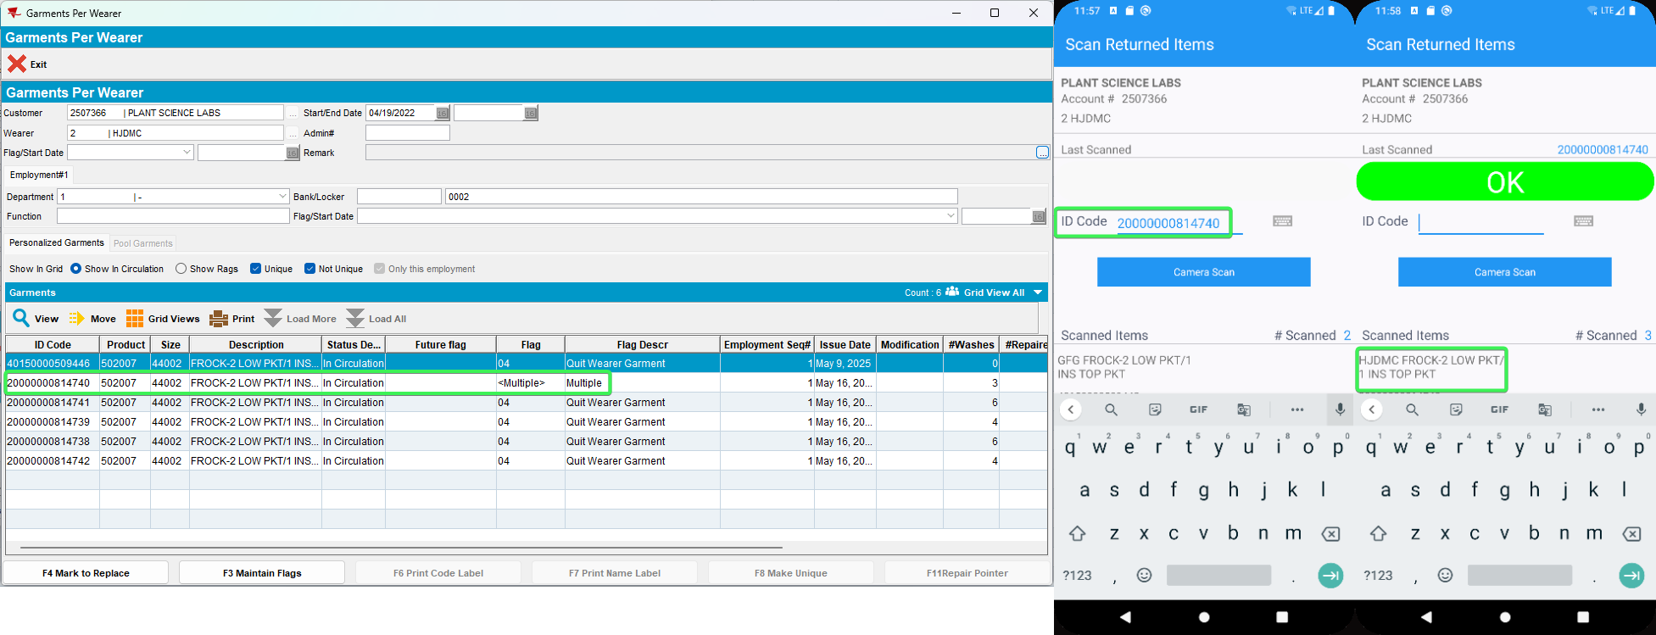
- Scan an UID that has “Quit Wearer Garment” flag on it and see that is scanned “OK”
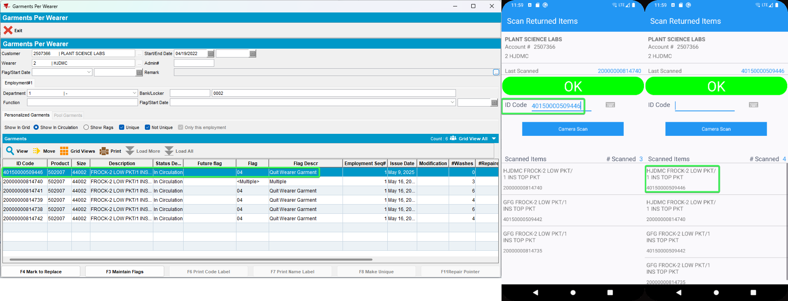
- Open the RA database and open "GarmentIDDTO" table
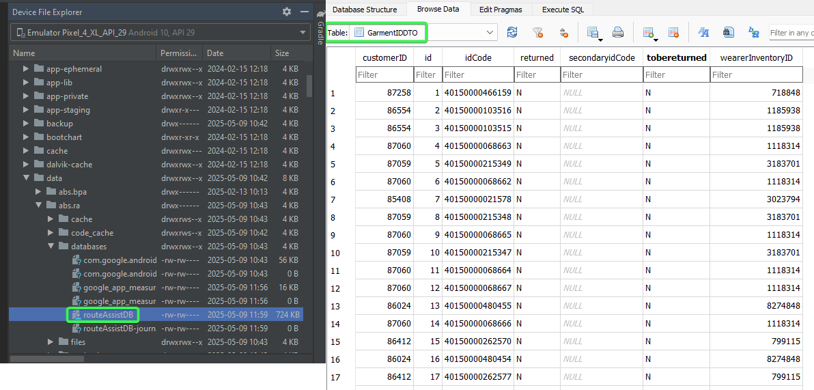
- Find the IDs you scanned for both wearers and see that value of the "tobereturned" field is “N”
Wearer 1 – Quit Wearer Garment flag
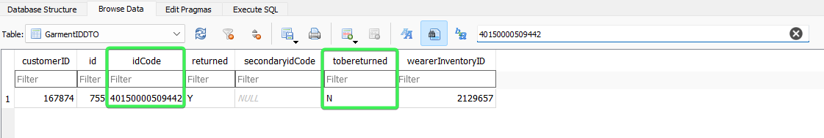
Wearer 1 – <Multiple>
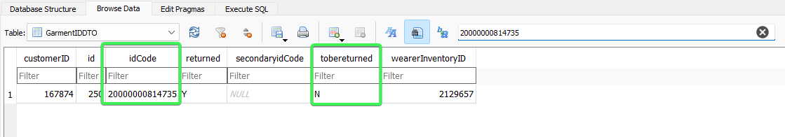
Wearer 2 – Quit Wearer Garment flag
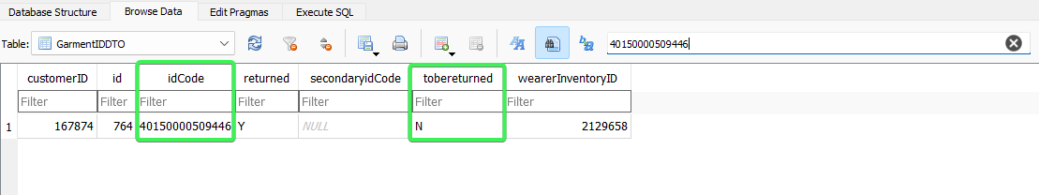
Wearer 2 – <Multiple>
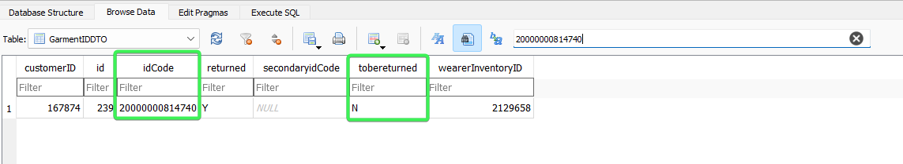
Tested OK

