ABSN-6208 Contact monitor not showing contact name when not a contact person
Environment | Prerequisites
Version:9.07.00  DBServerName= abs-srv16.internal.abslbs.com  DBSID=CUST24  DBUser=UNFDEV  DBPassword=UNFDEV  Environment=PRODUCTION | - Module:  - System setting

Contents
Reproducing before fix 1
Steps to reproduce 1
Current Behavior 2
Expected behavior 2
Retest after fix 2
Steps to reproduce 2

Reproducing before fix

Steps to reproduce

- Contact Monitor dlg: Create a contact with a contact person name without linking a contact person. This was introduced to save creating contact persons for everyone at the customer.
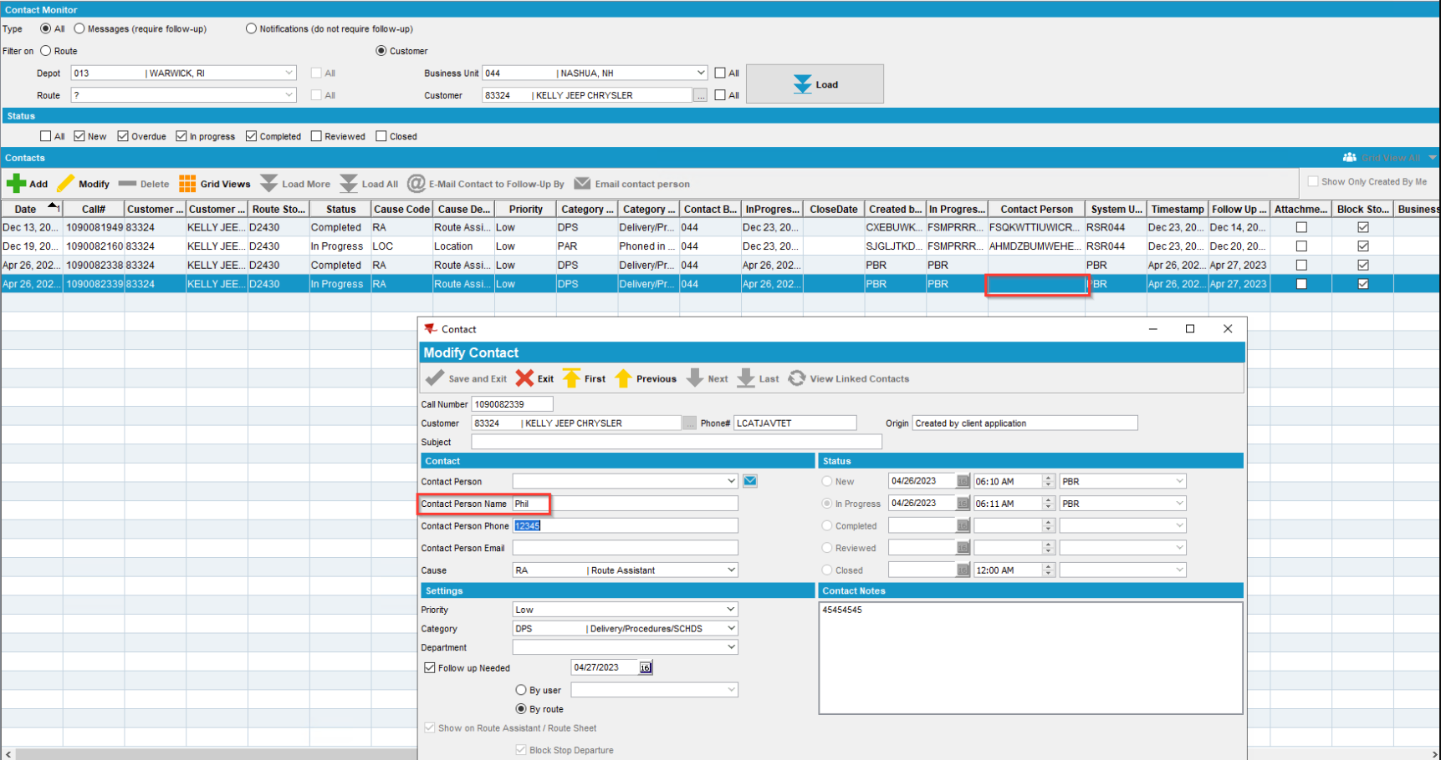
REPRODUCED OK.

Current Behavior
The contact monitor dialog does not show this "free text" person name, only the person name if there is a linked contact person.

Expected behavior
Contact Name should appear in this column.

Retest after fix
9.07.00.UNF18 hash: 0cdbae9716c1
Expected behavior: No error should be displayed. Route should be downloaded.

Steps to reproduce

- Contact Monitor dlg: Add a new contact
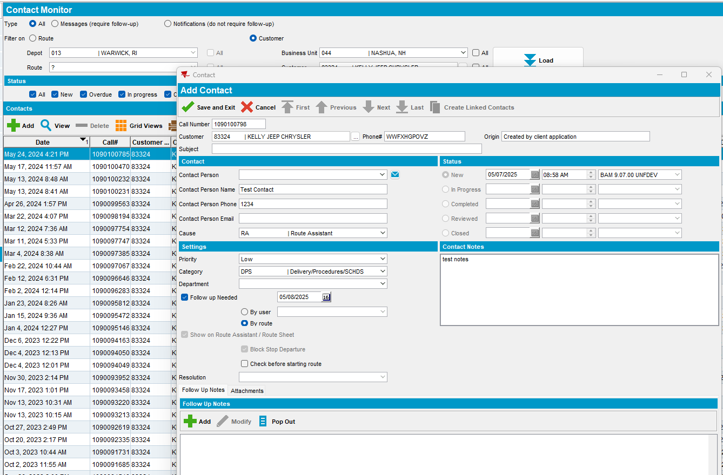
- Check the Contact Person column.
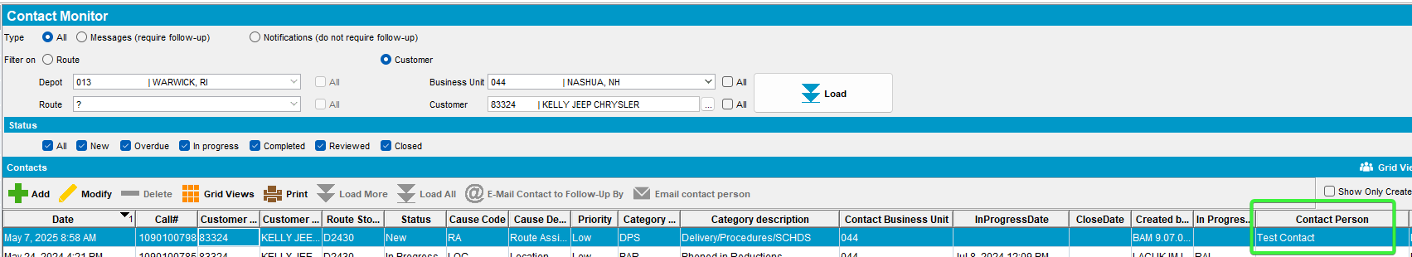
- Contact Monitor dlg: Re-open the contact and add a contact person
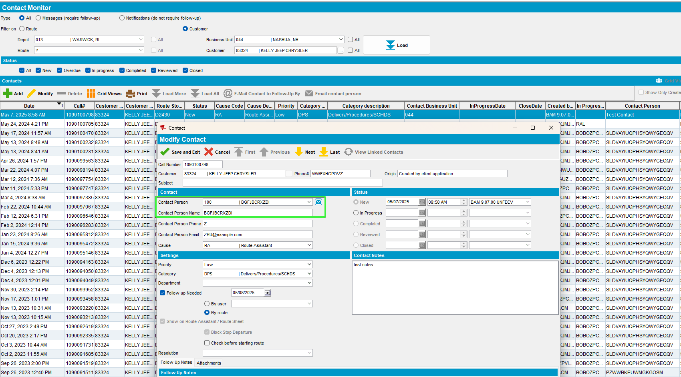
- Contact Monitor dlg: Re-check the contact person column.
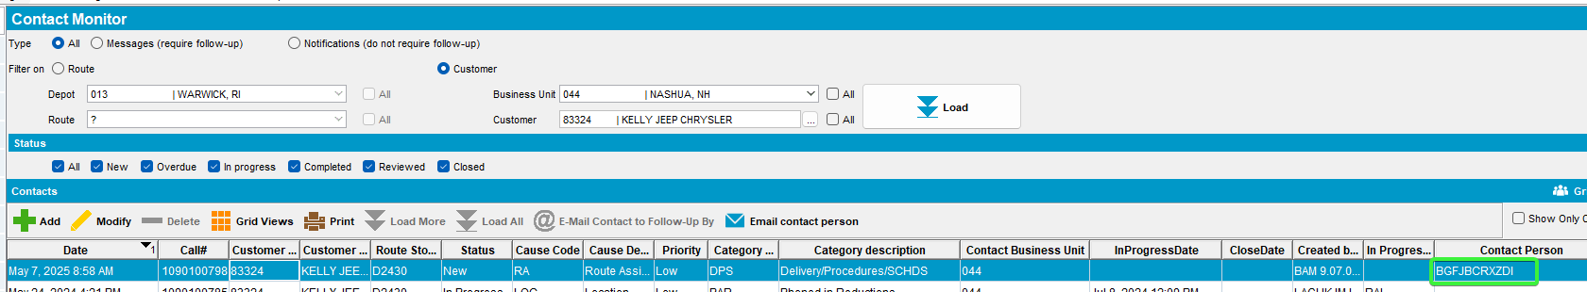

RETEST OK

