ABSN-617 ASD-59982 UNF: D_UBS_2323 Customer first service date being set when invoice value is 0
Environment | Prerequisites
Version:9.07.00  DBServerName=abs-SRV20.internal.abslbs.com  DBSID=CUST24  DBUser=UNFDEV  DBPassword=UNFDEV  Environment=Test | - Module:  - System setting

Contents
Test after fix 1
Test Case 1 – Settle on client and credit with settle later – Tested OK 1
Test Case 2 – Settle on client and credit with settle now – Tested OK 16
Test Case 3 – Settle on WebX and credit with settle later – Tested OK 29
Test Case 4 – Settle on WebX and credit with settle now – Tested OK 45
Test Case 5 – Generate invoice and settle the first 2 routes, credit the invoice for the first route – Tested OK 59

Test after fix

Test Case 1 – Settle on client and credit with settle later – Tested OK
Expected behavior: The updates for the first service log and install date will appear in the log.
Hash: 9a17455
- Add a new customer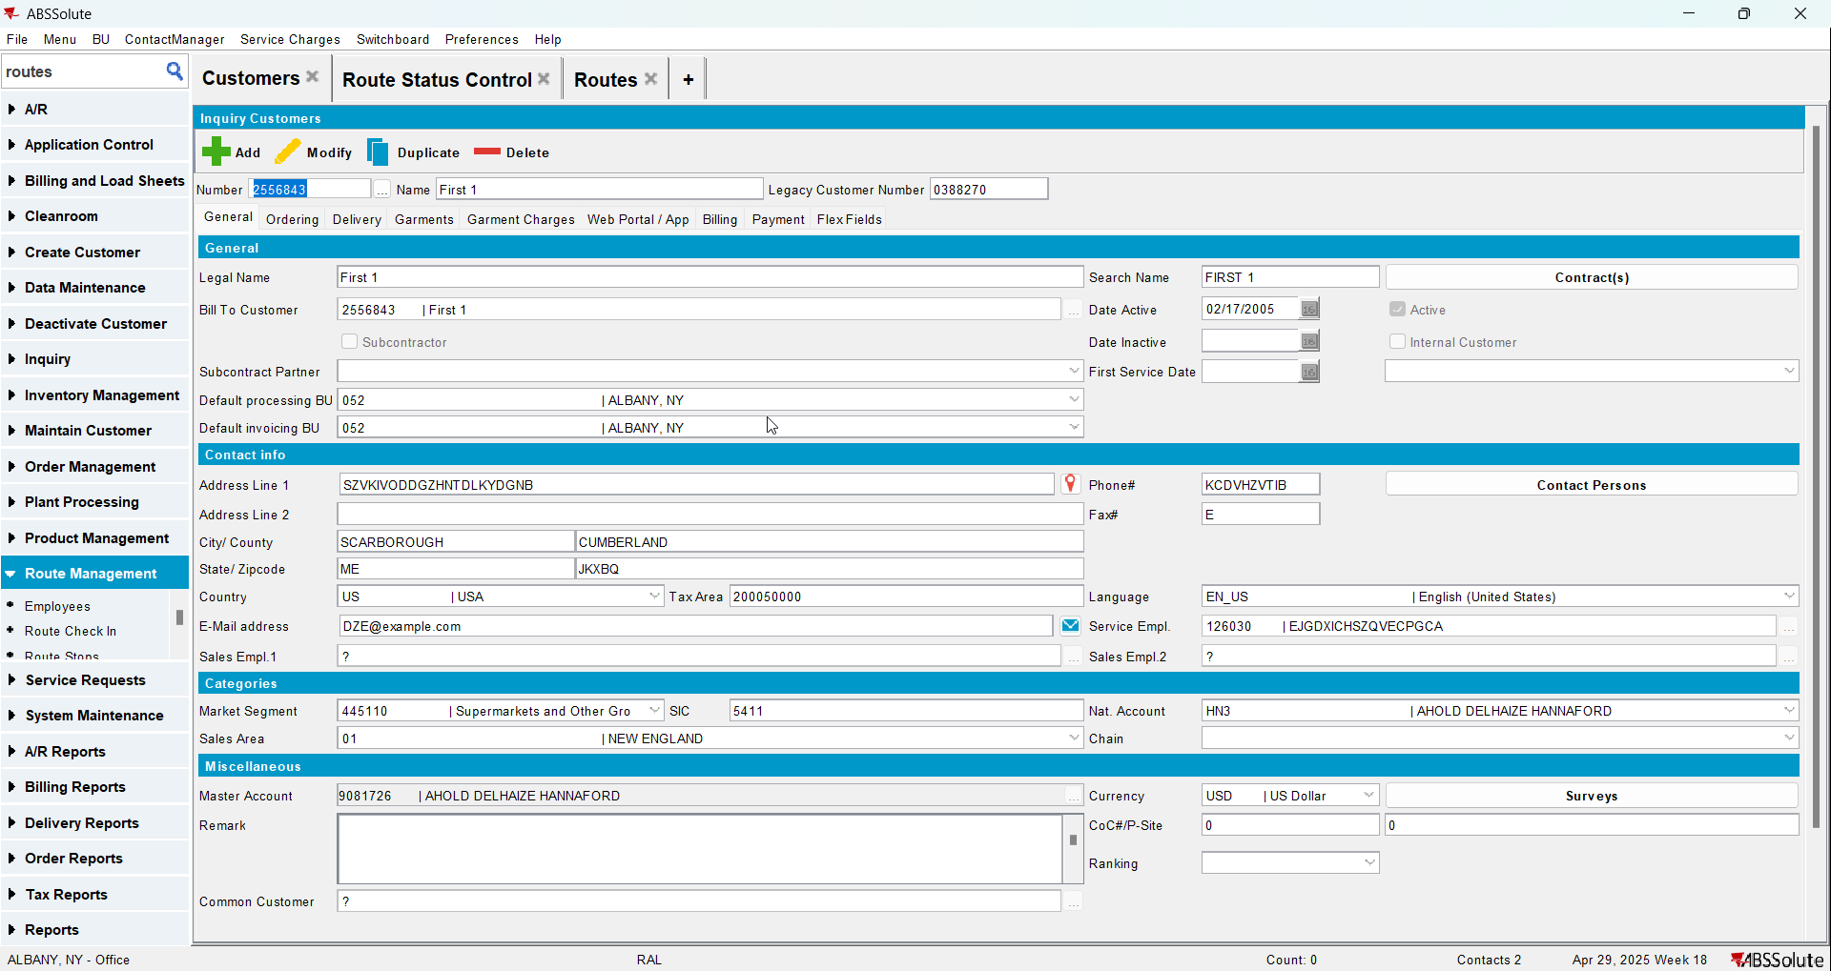
- Add a new contract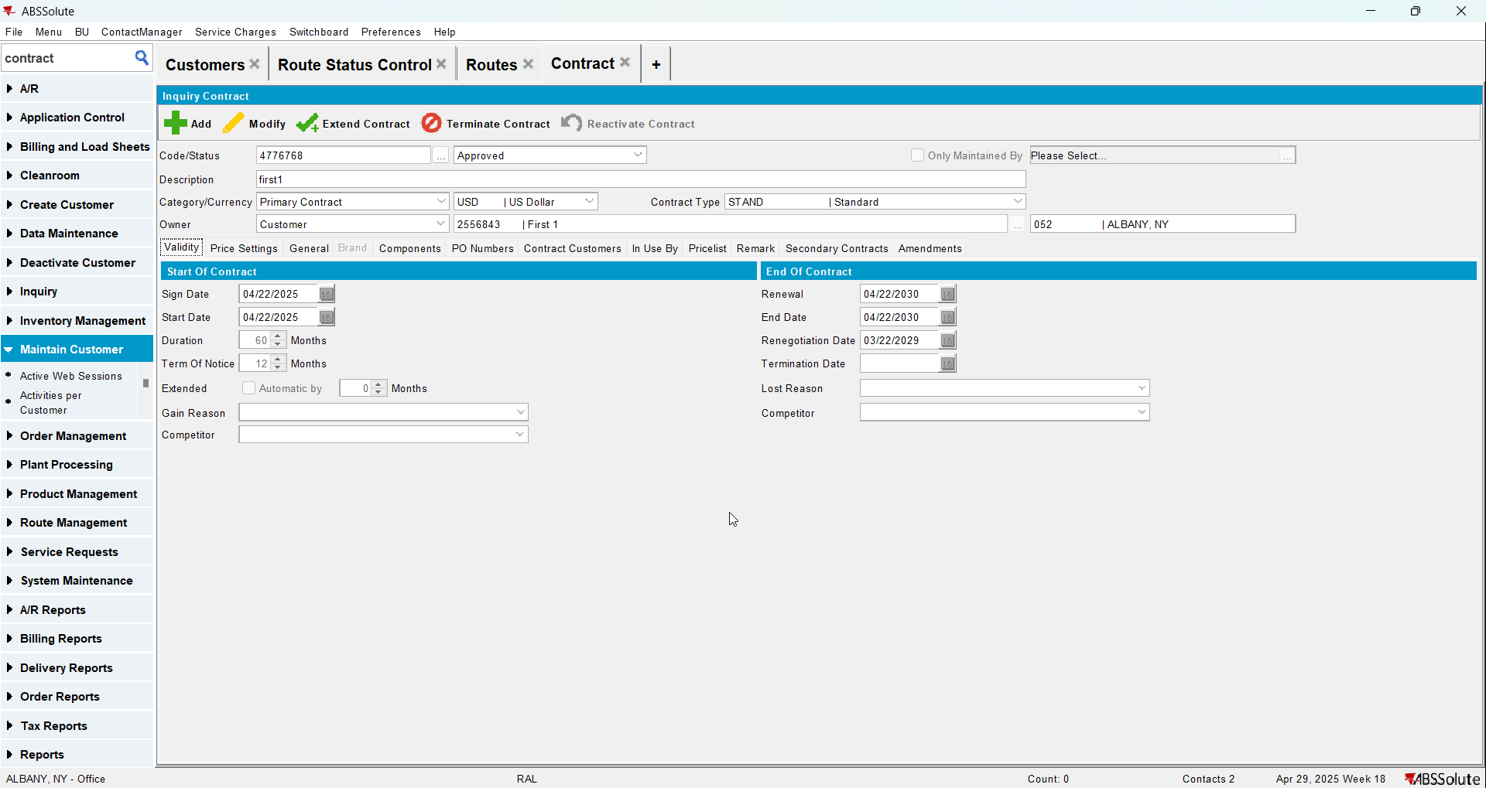
- Add a garment to contract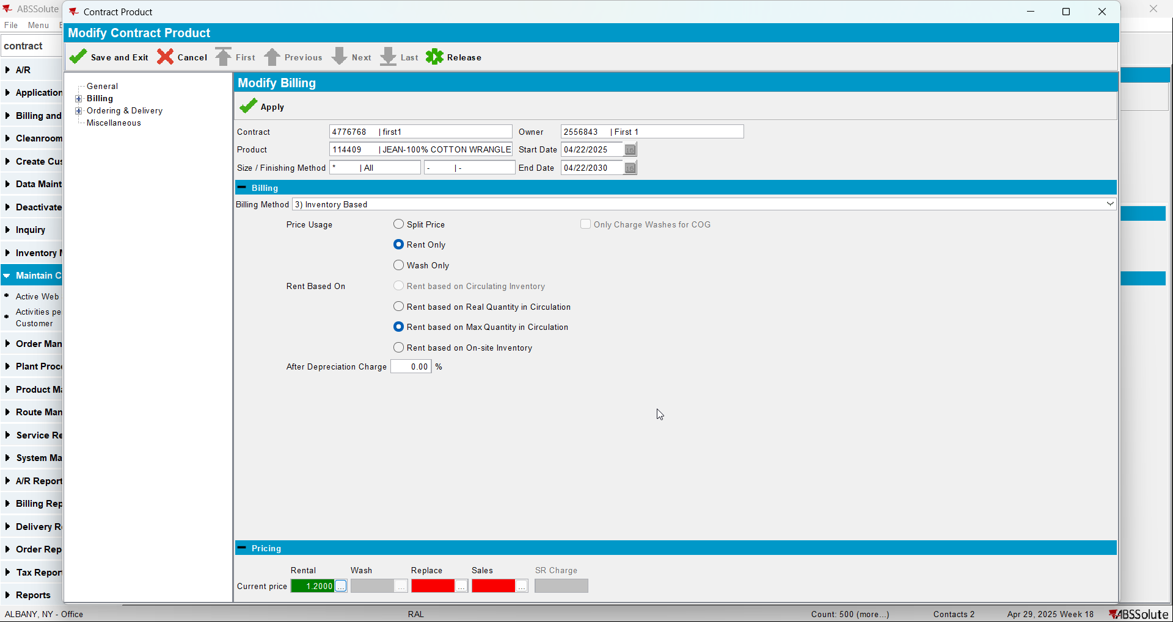
- Add the new customer to contract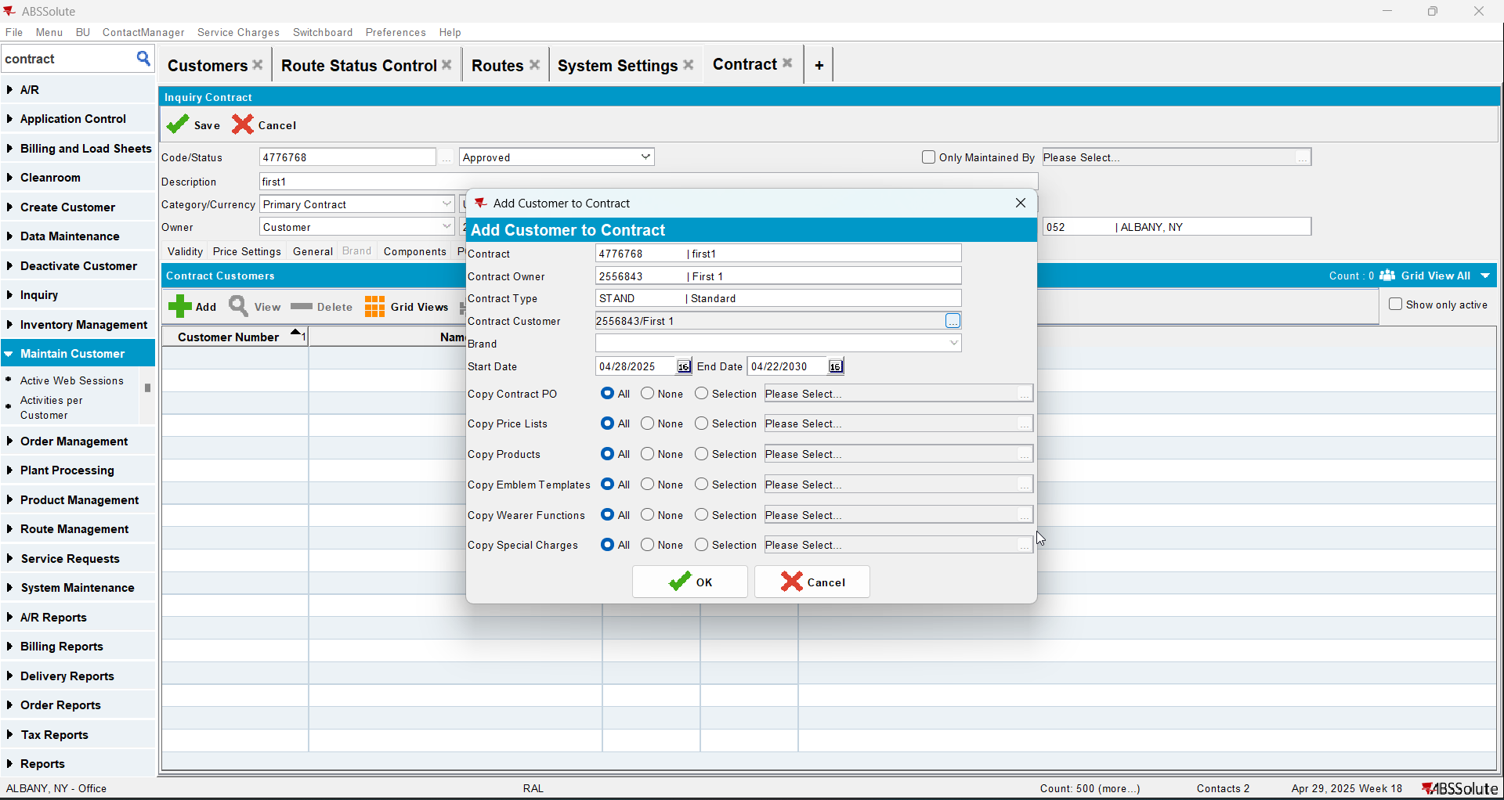
- Add new lockers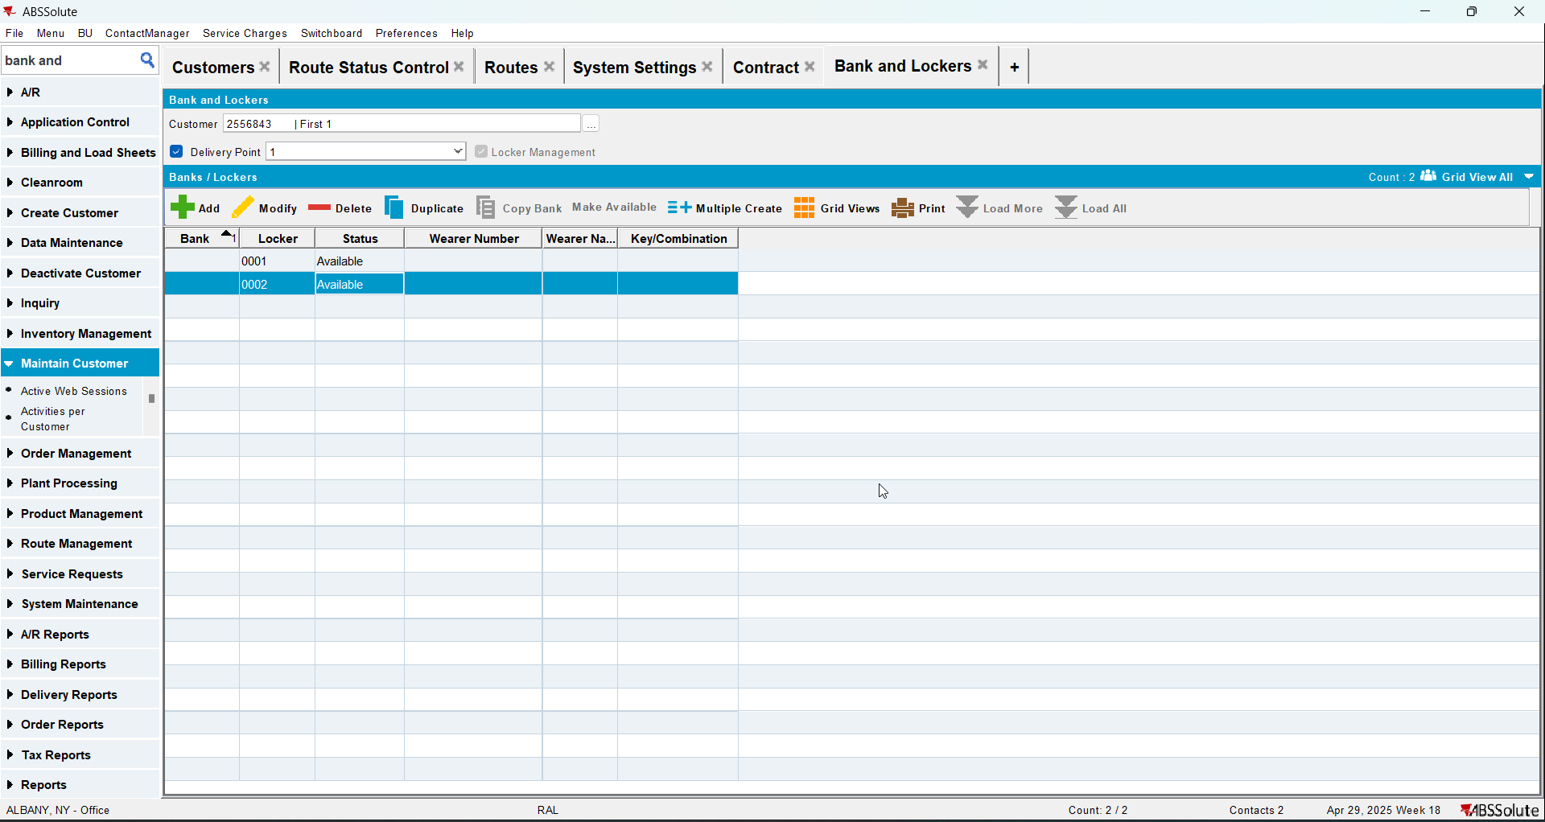
- Add a wearer with a wearer inventory
- Generate work order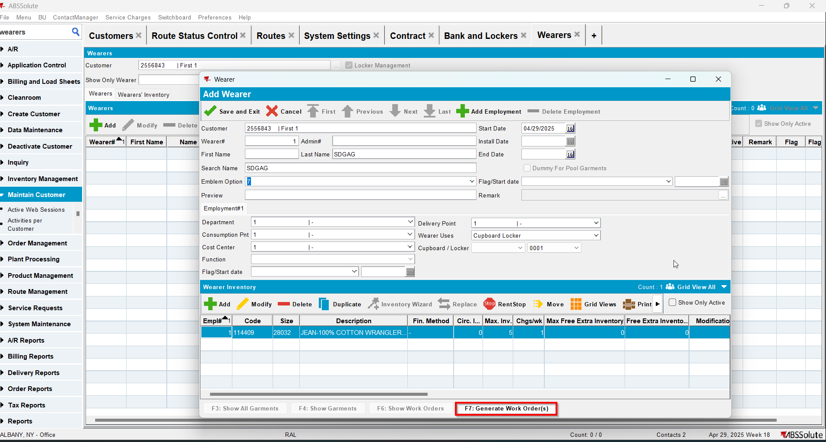
- Issue the work order and generate the delivery note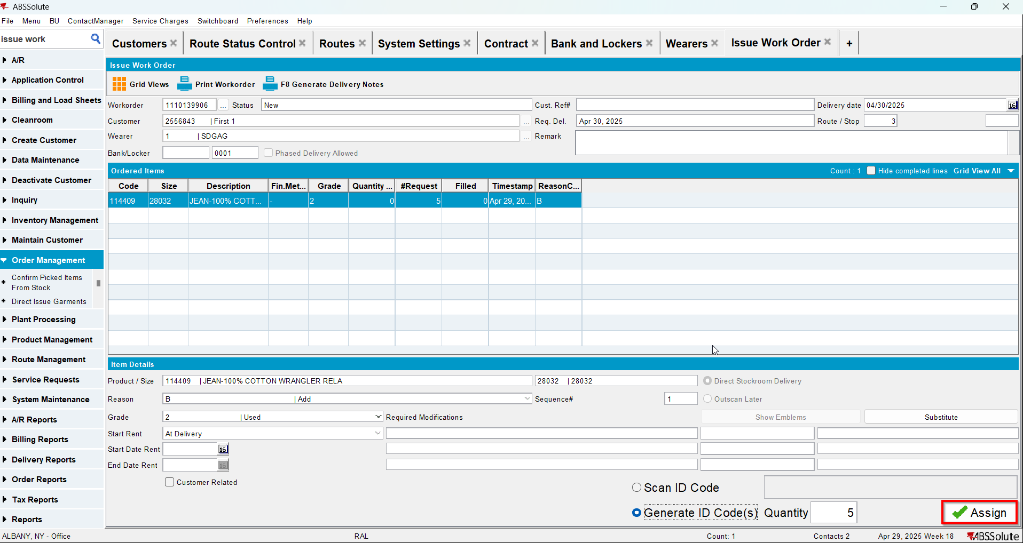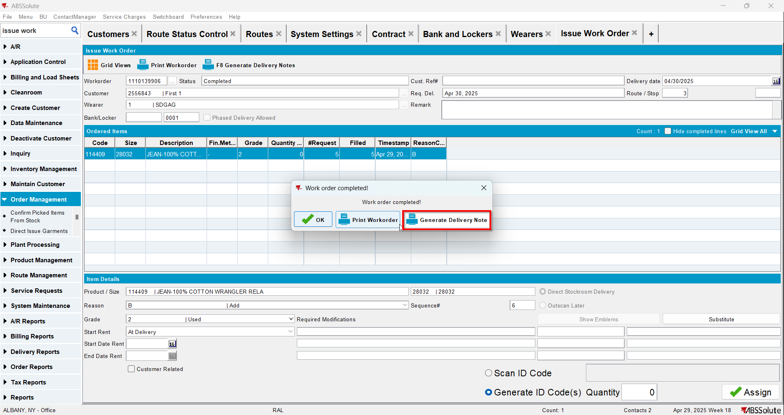
- Add the next route for the customer
- Generate the invoice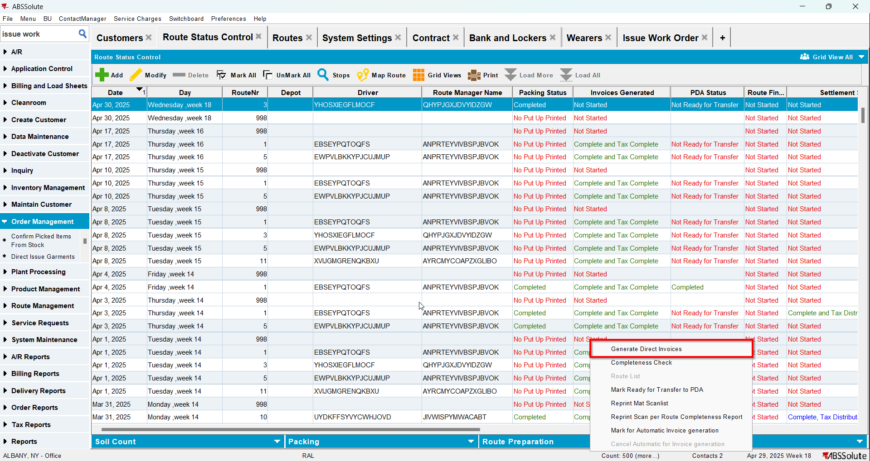
- Tax the invoice
- Settle the invoice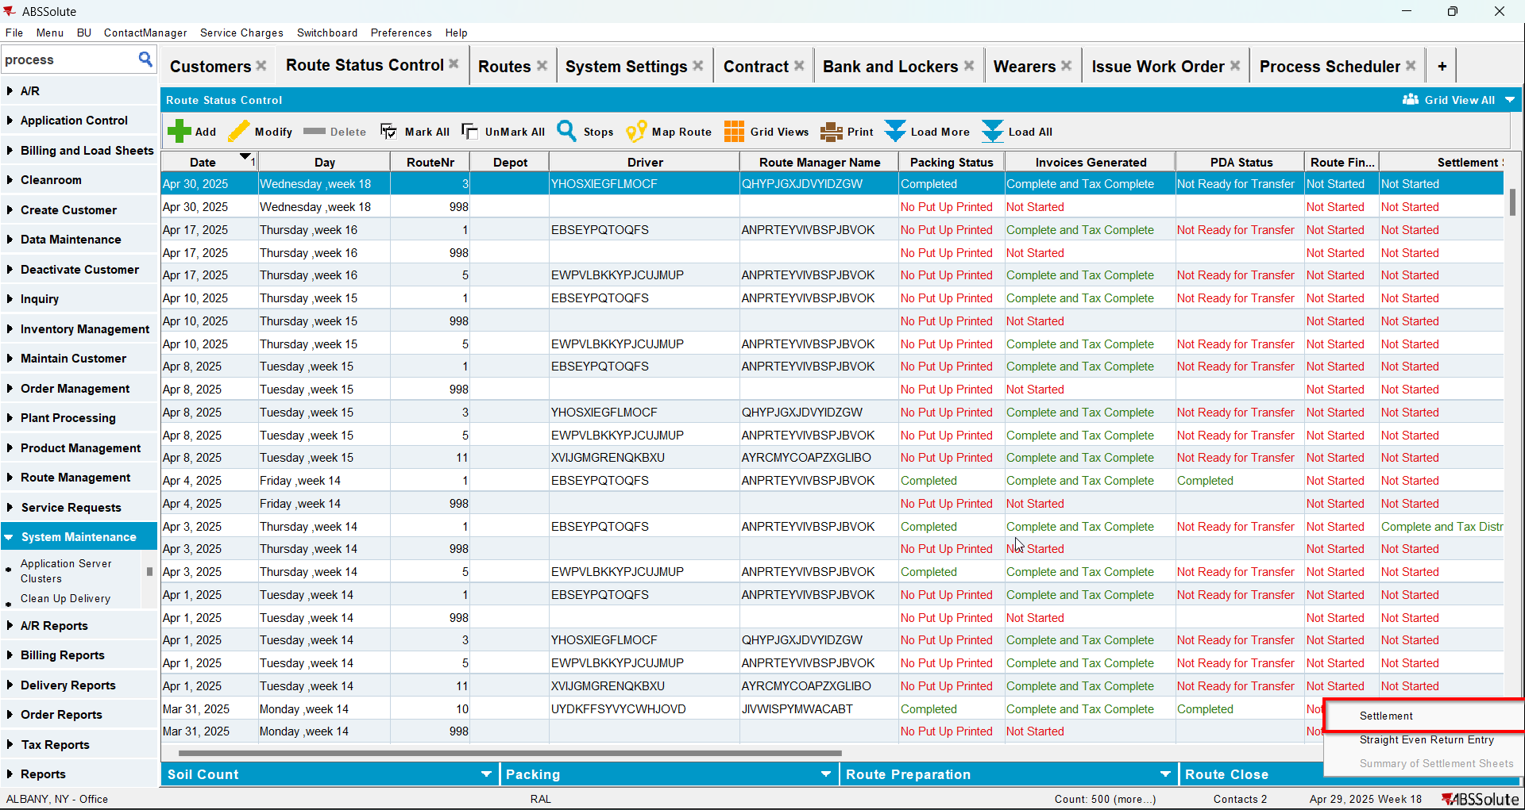
- In View Process Log check the Settlement log for the updates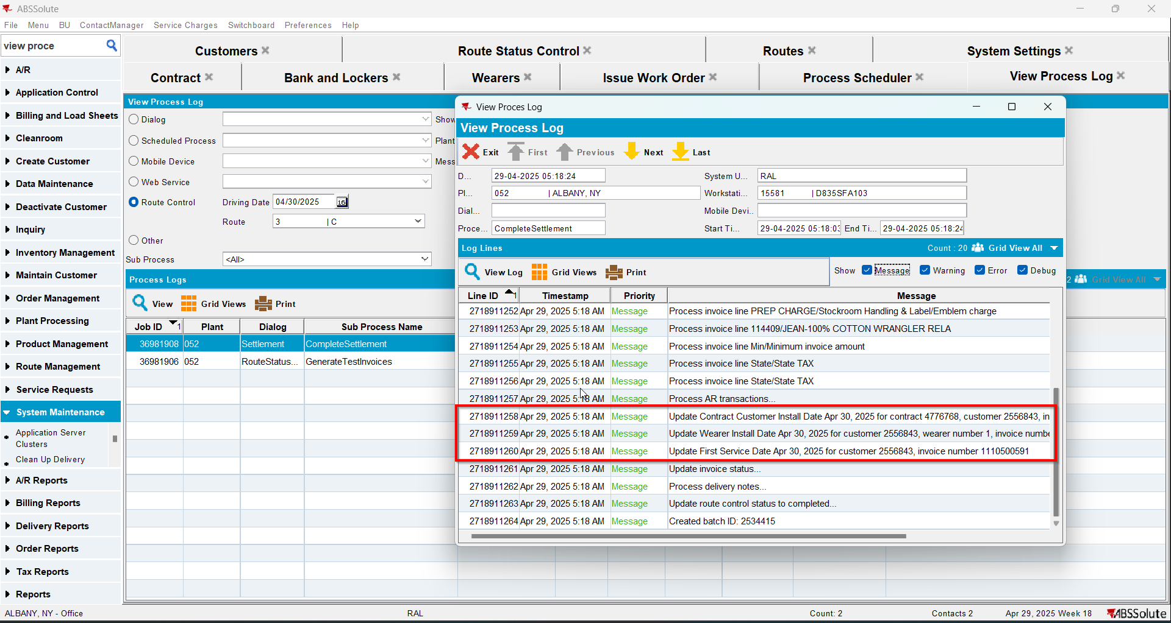
- Check that the Customer - First Service date was updated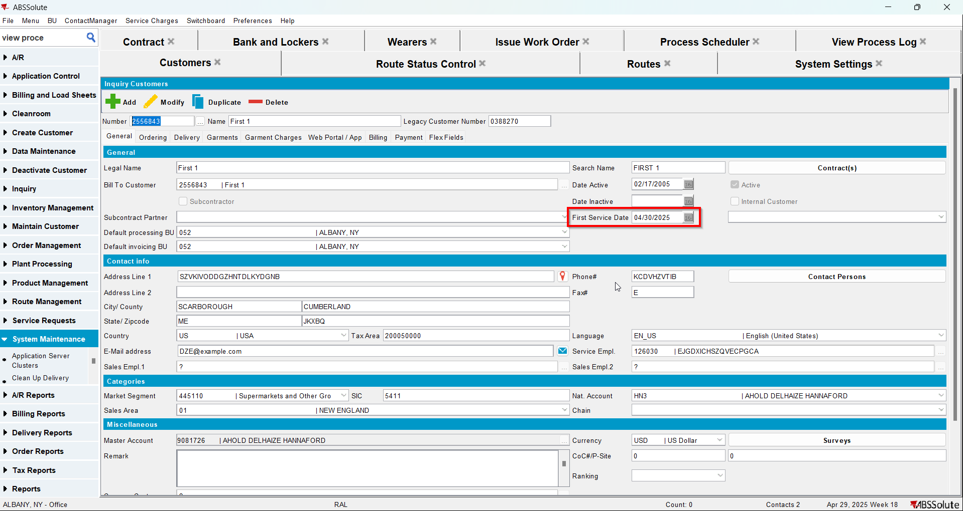
- Check that the Contract - Install date was updated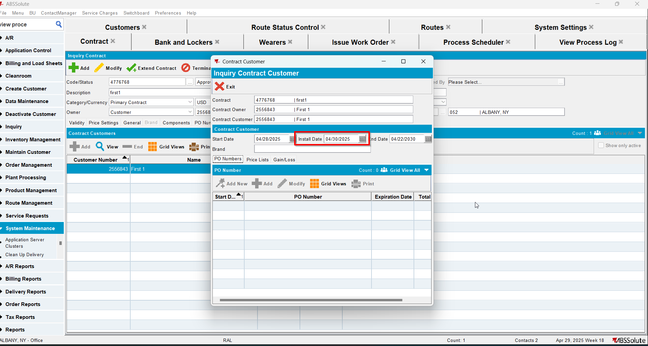
- Check that the Wearer - Install date was updated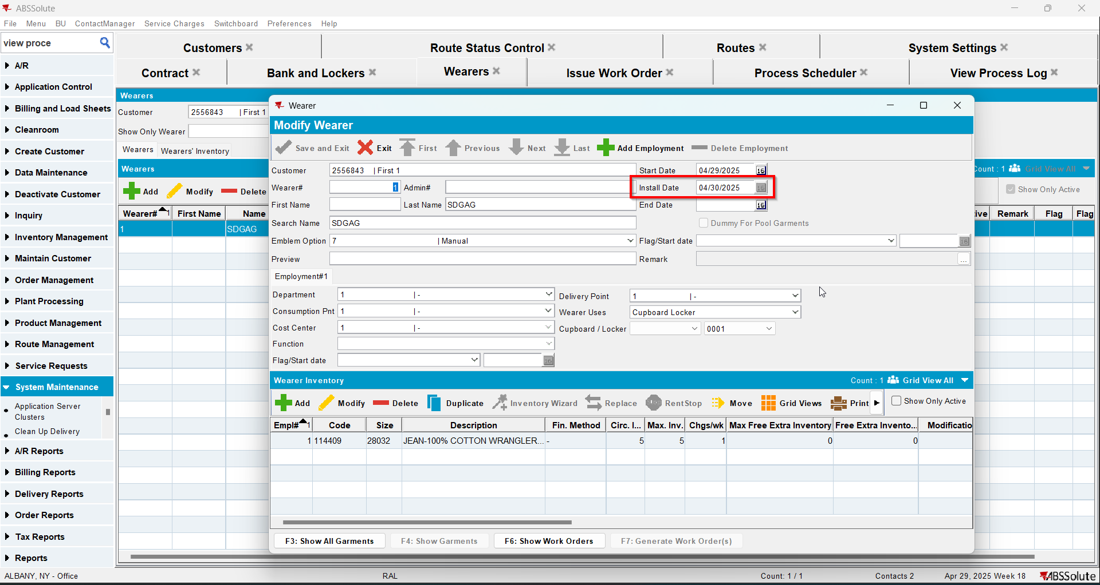
- Script in the Tax distribution data
- Process scheduler: run the process scheduler to distribute the tax
- Maintain Invoices DLG: Find the settled invoice and click on the credit invoice button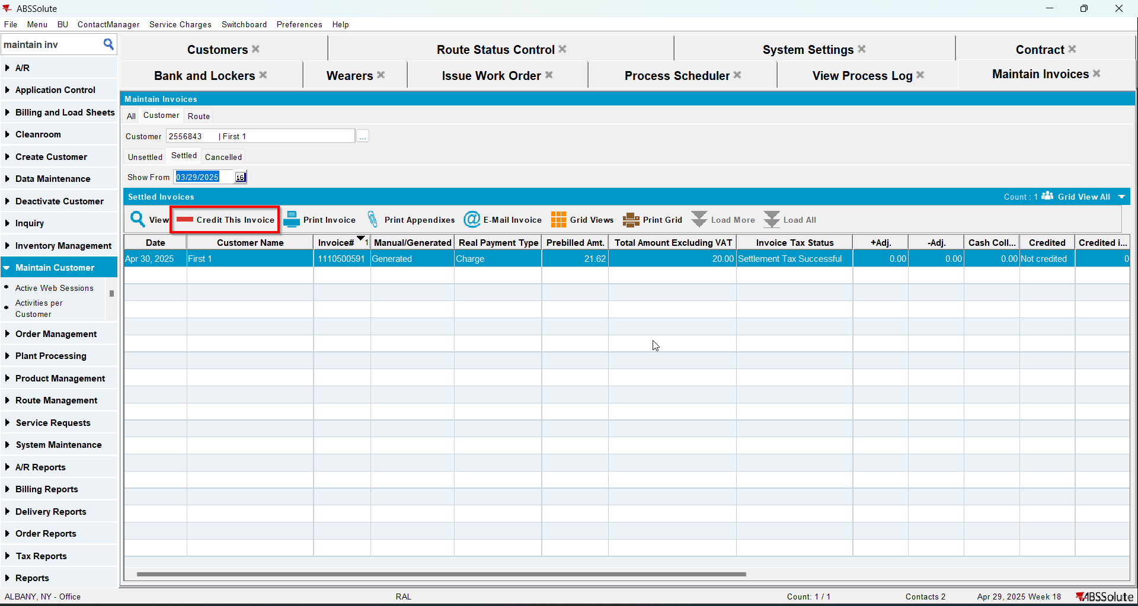
- When Credit Flow pop-up appears uncheck the Assign Invoice to route checkbox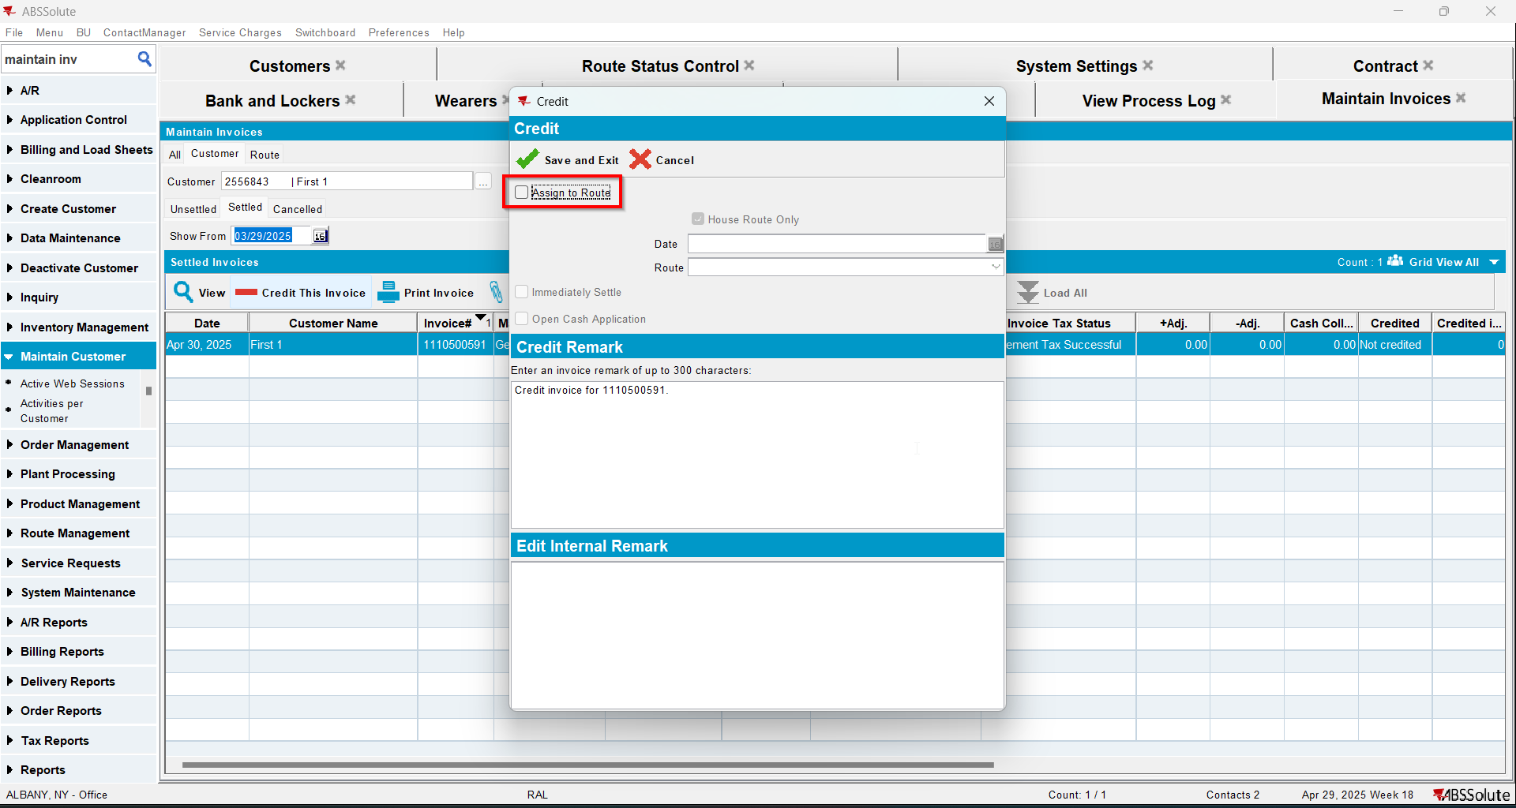
- In View Process Log check the CreditFlowDateUpdates log for the updates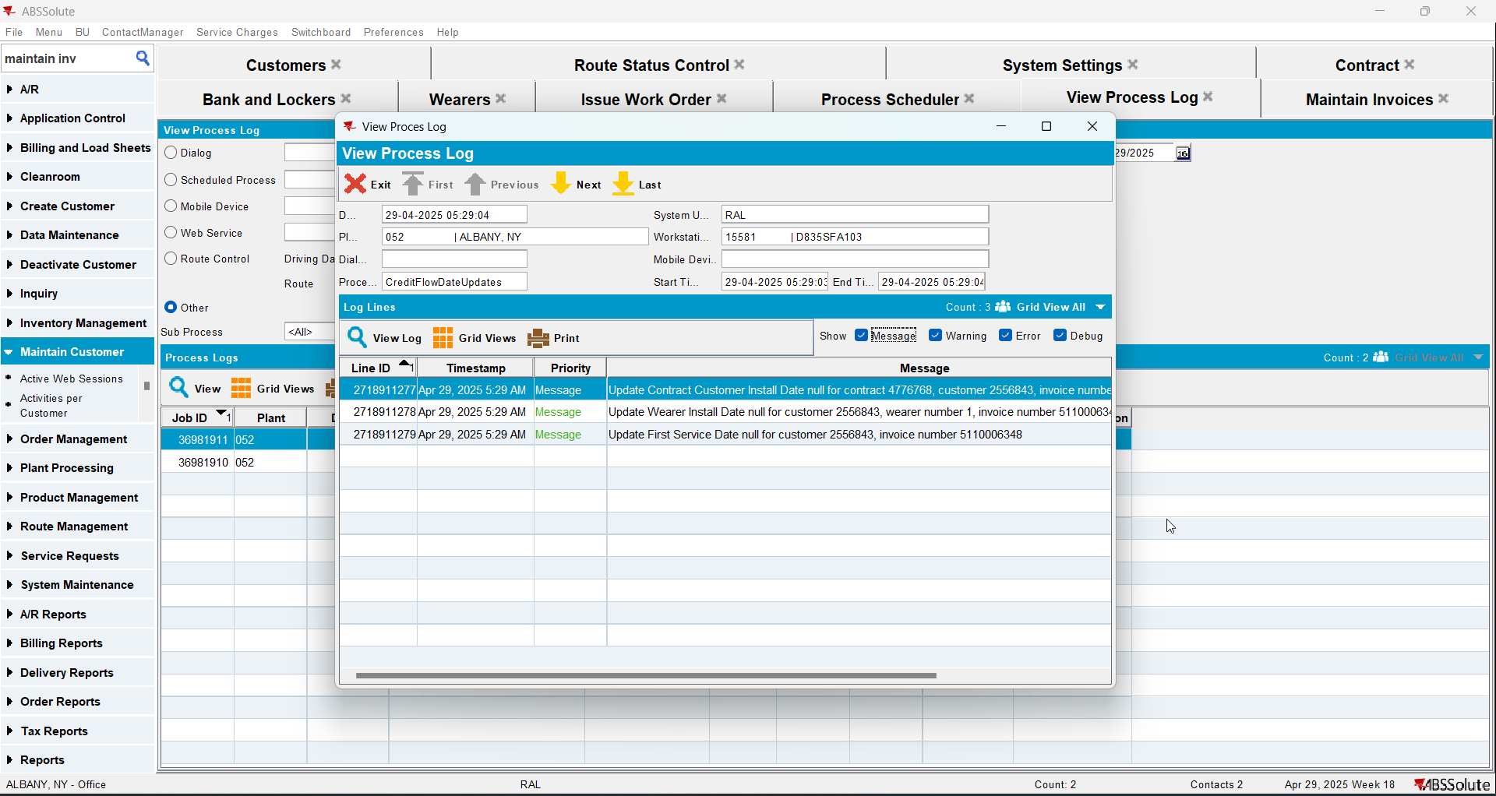
- Check that the Customer - First Service date was deleted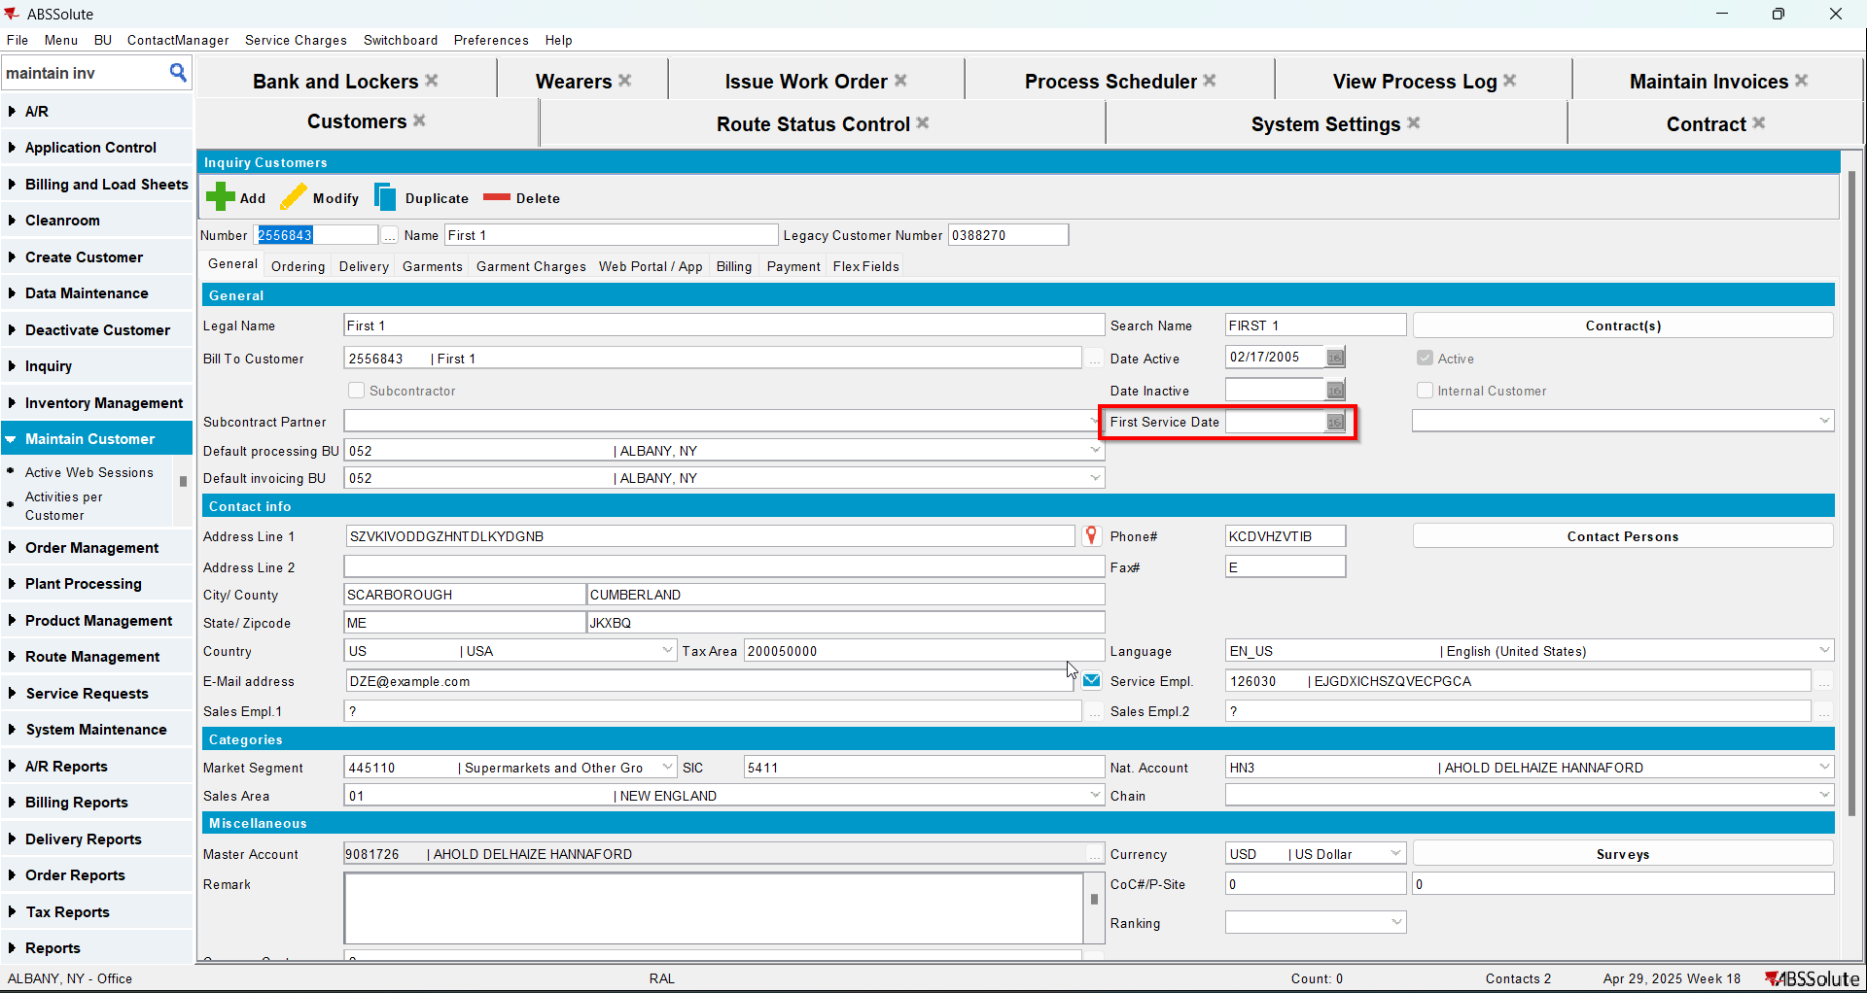
- Check that the Contract - Install date was deleted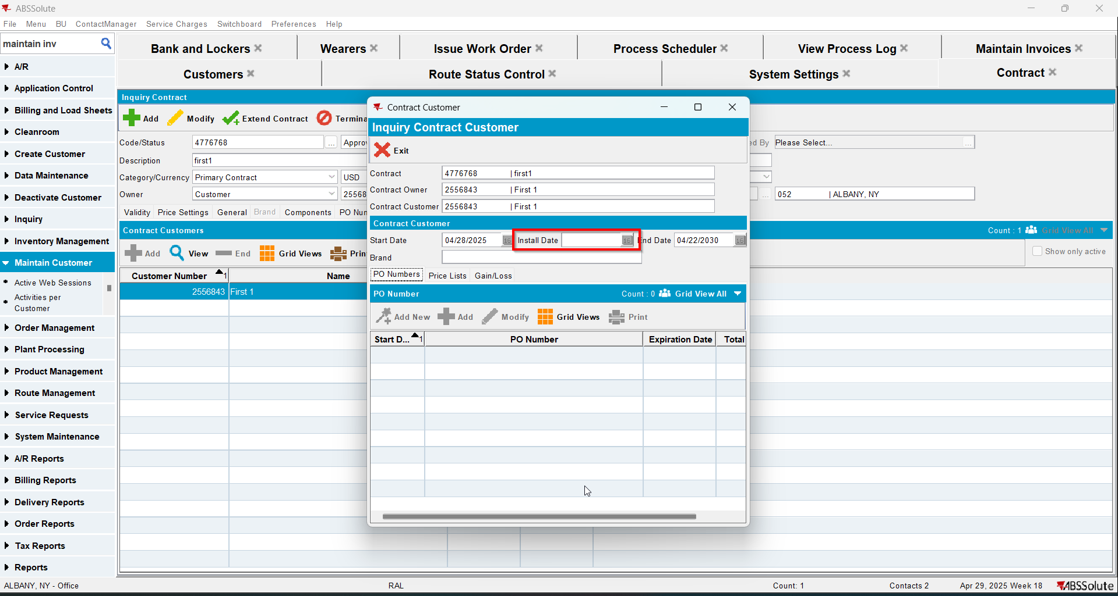
- Check that the Wearer - Install date was deleted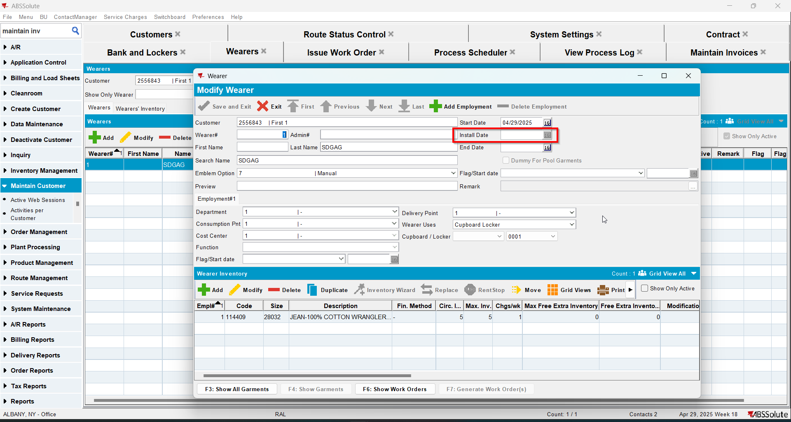
- Maintain Invoices DLG > All Tab > Find the credit invoice and assign it to an empty route (990 + range)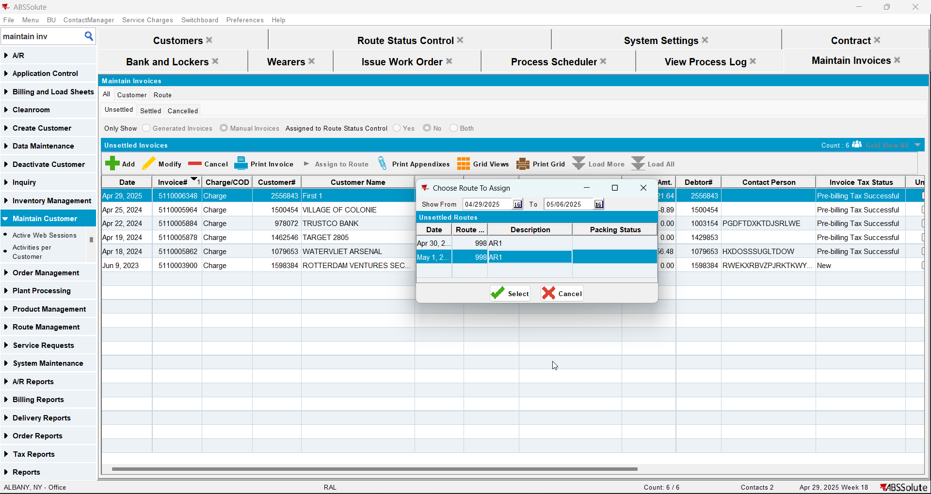
- Route Status Control DLG: Find the route where the credit invoice was assigned and generate invoices for it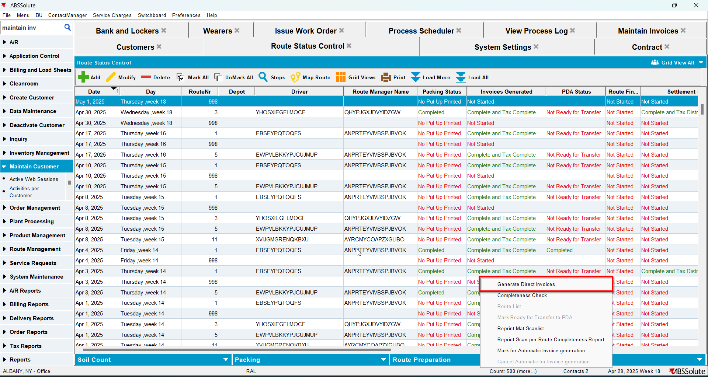
- Route Status Control DLG: For the same route click on settle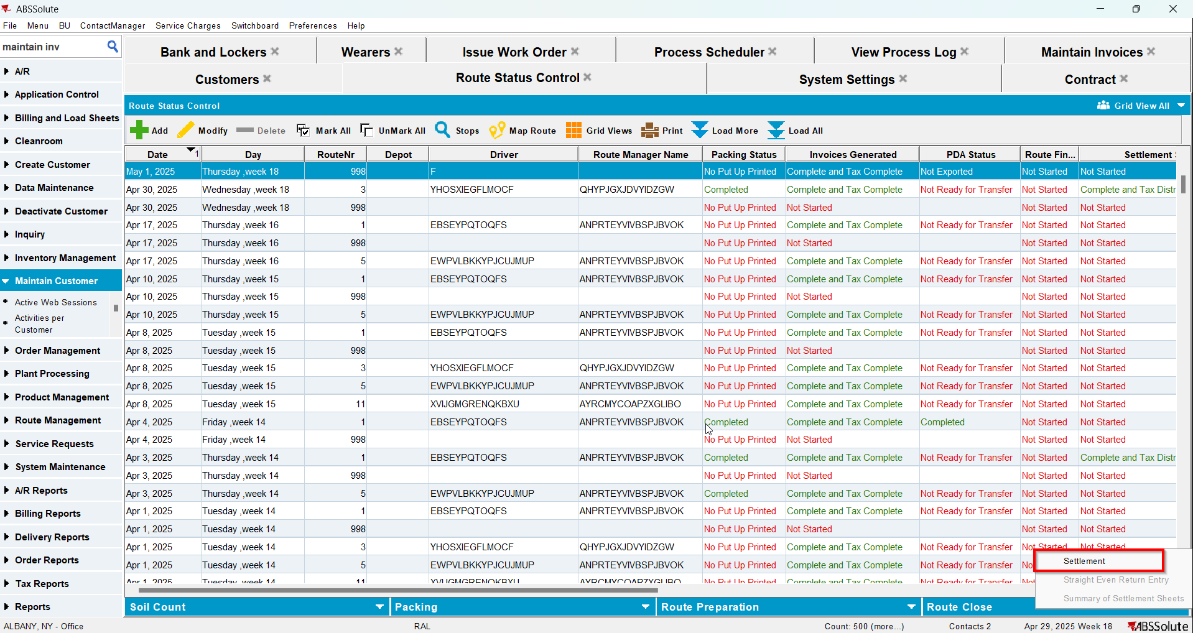
- Route Status Control DLG: Add next week's route
- Generate the invoice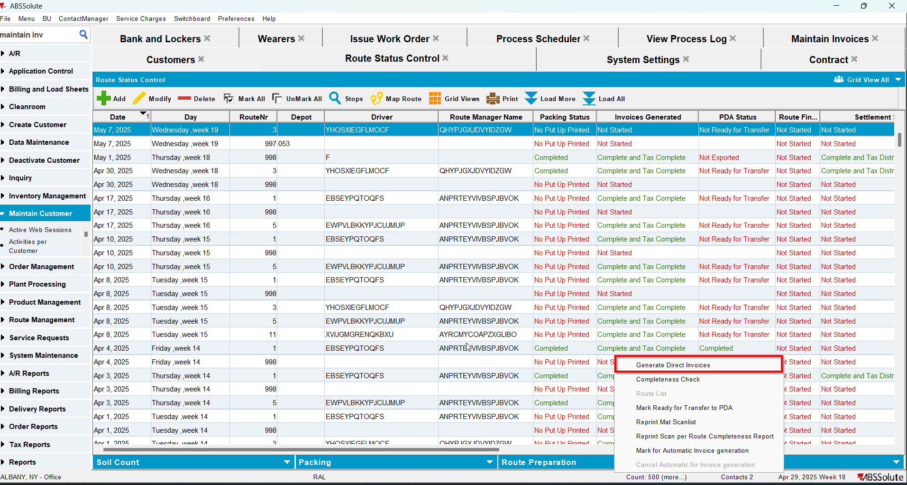
- Tax the invoice
- Settle the invoice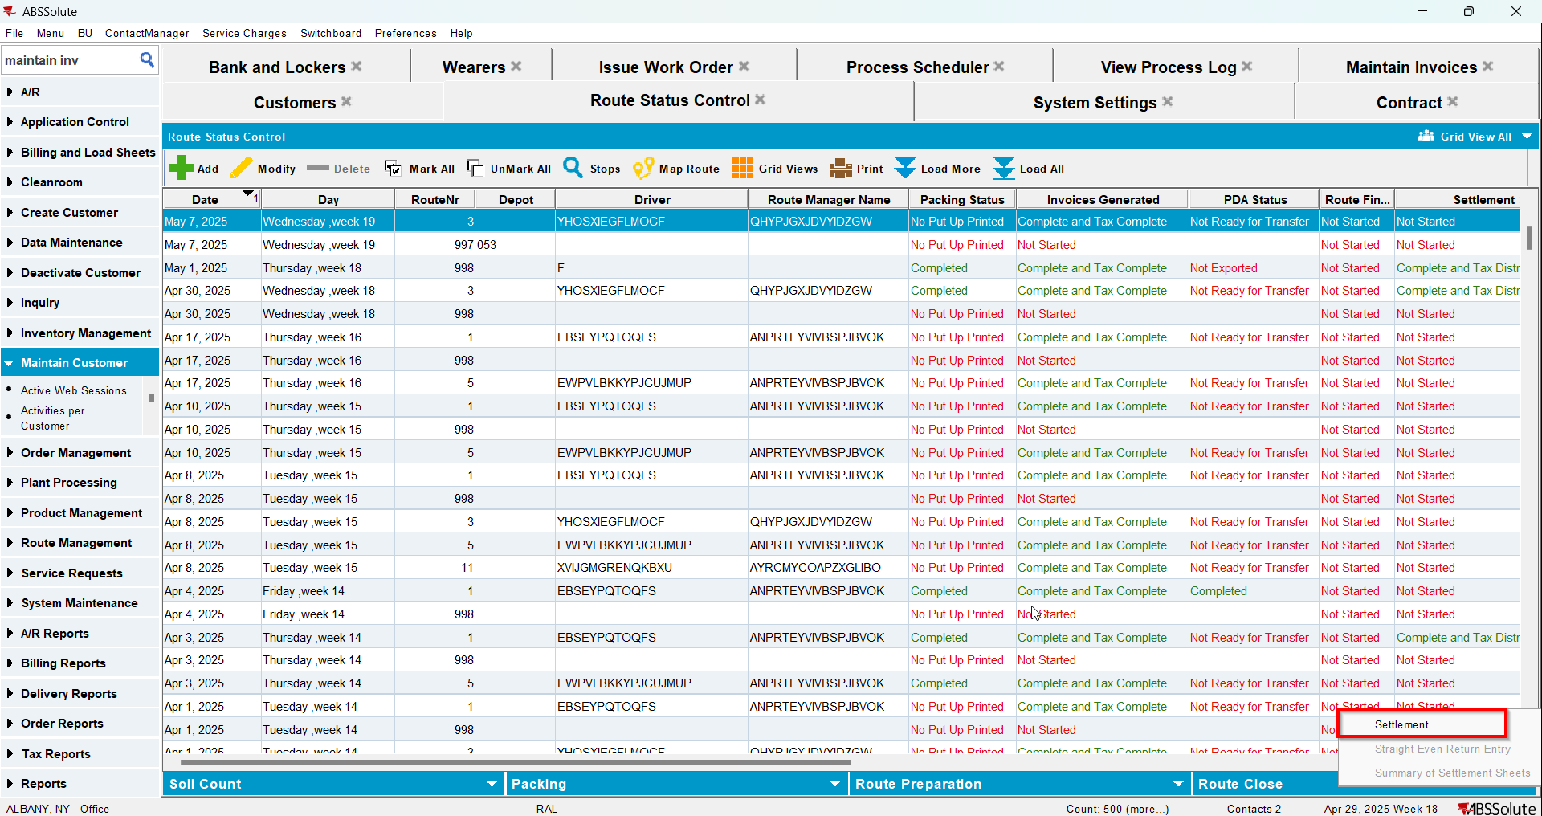
- In View Process Log check the Settlement log for the updates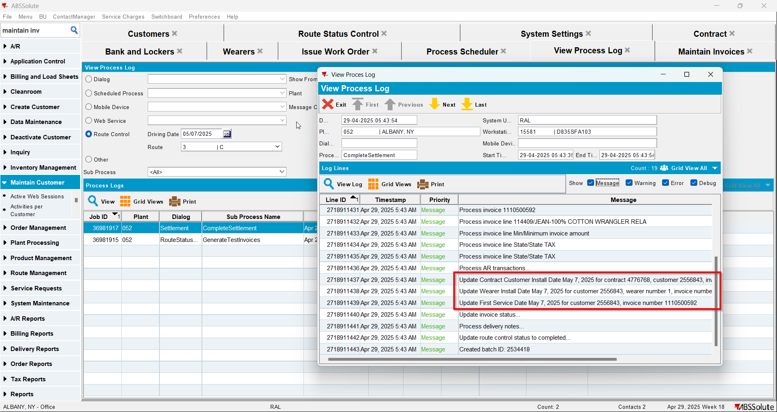
- Check that the Customer - First Service date was updated.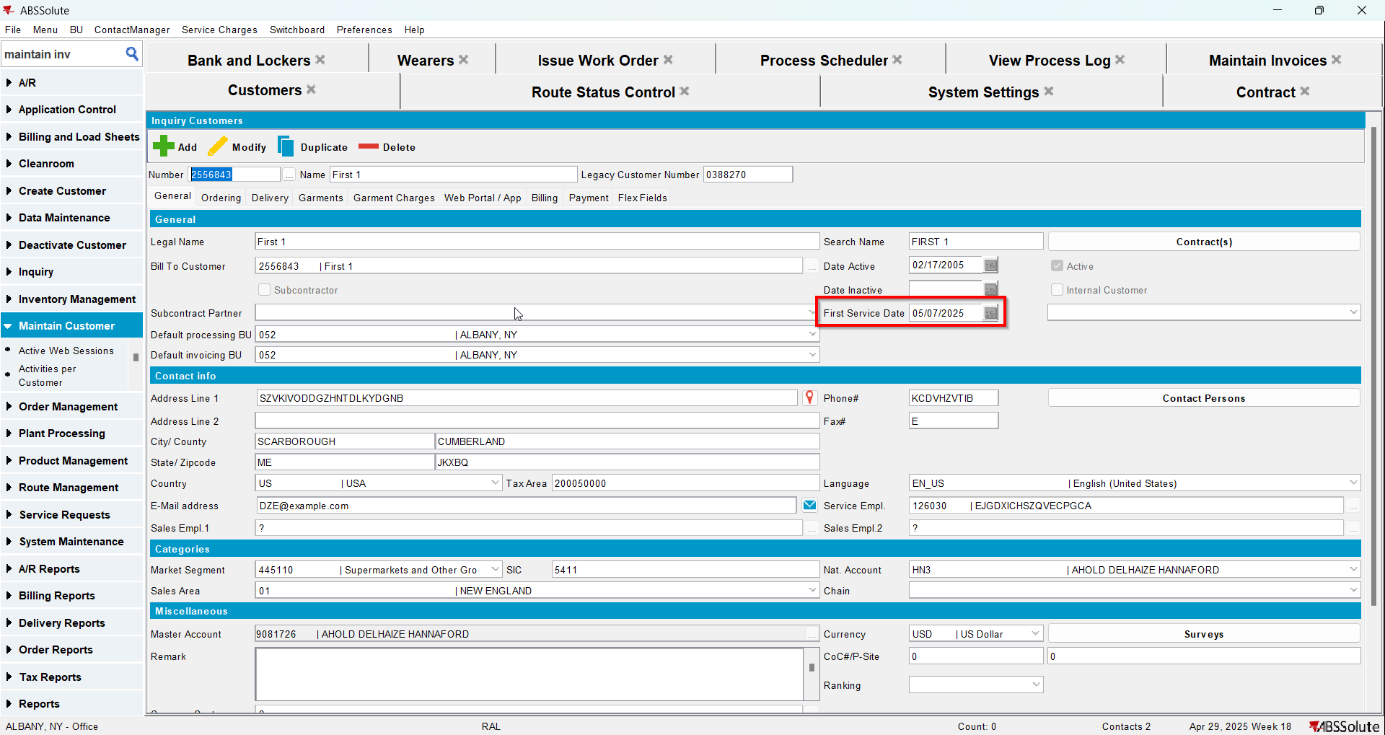
- Check that the Contract - Install date was updated.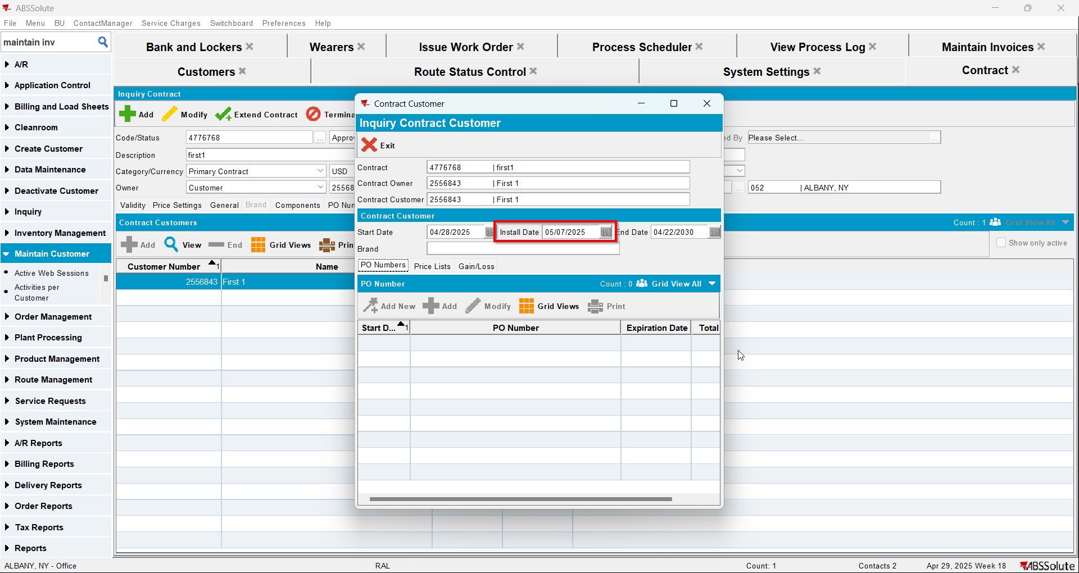
- Check that the Wearer - Install date was updated.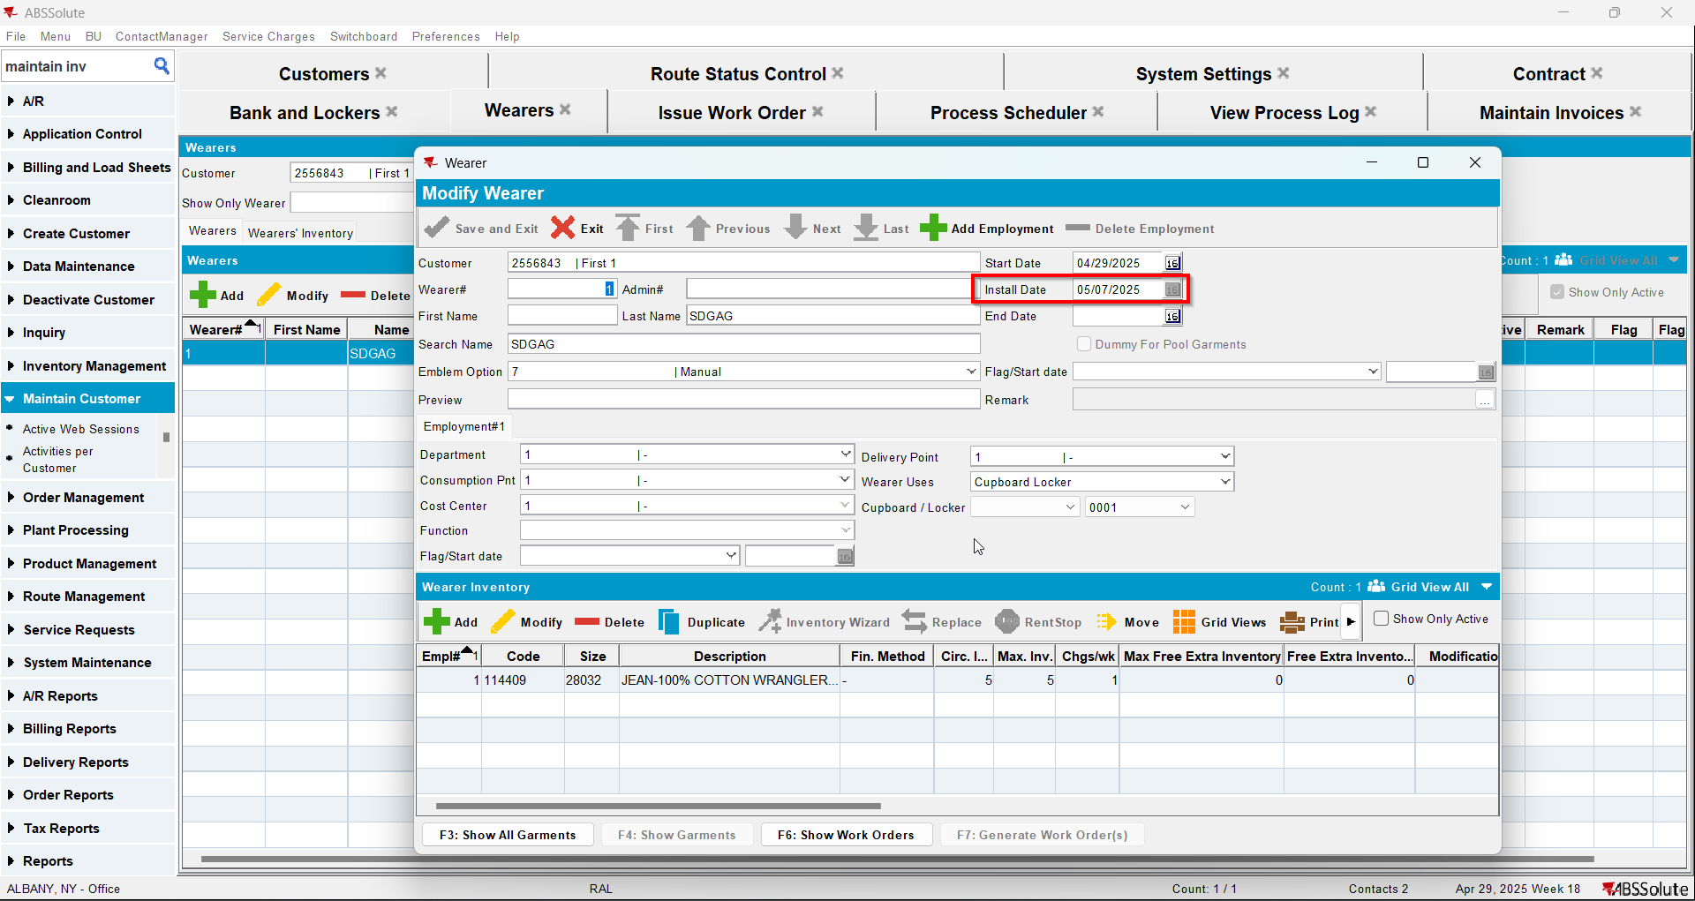

Test Case 2 – Settle on client and credit with settle now – Tested OK
Expected behavior: The updates for the first service log and install date will appear in the log.
Hash: 9a17455
- Add a new customer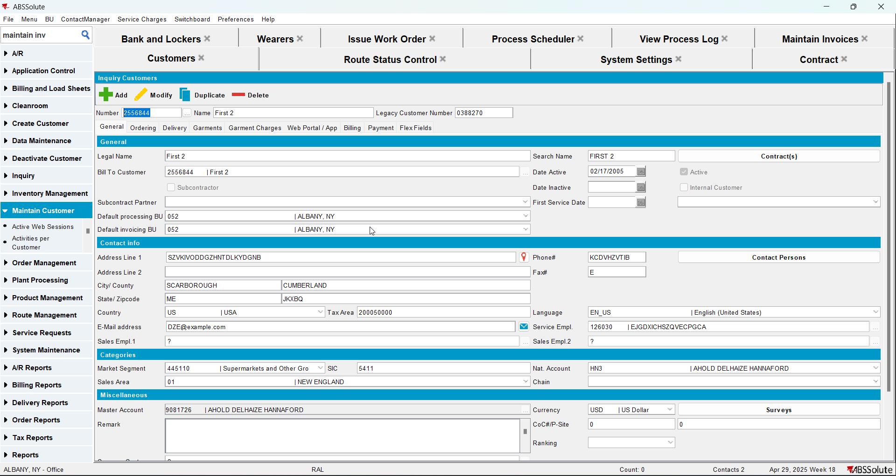
- Add a new contract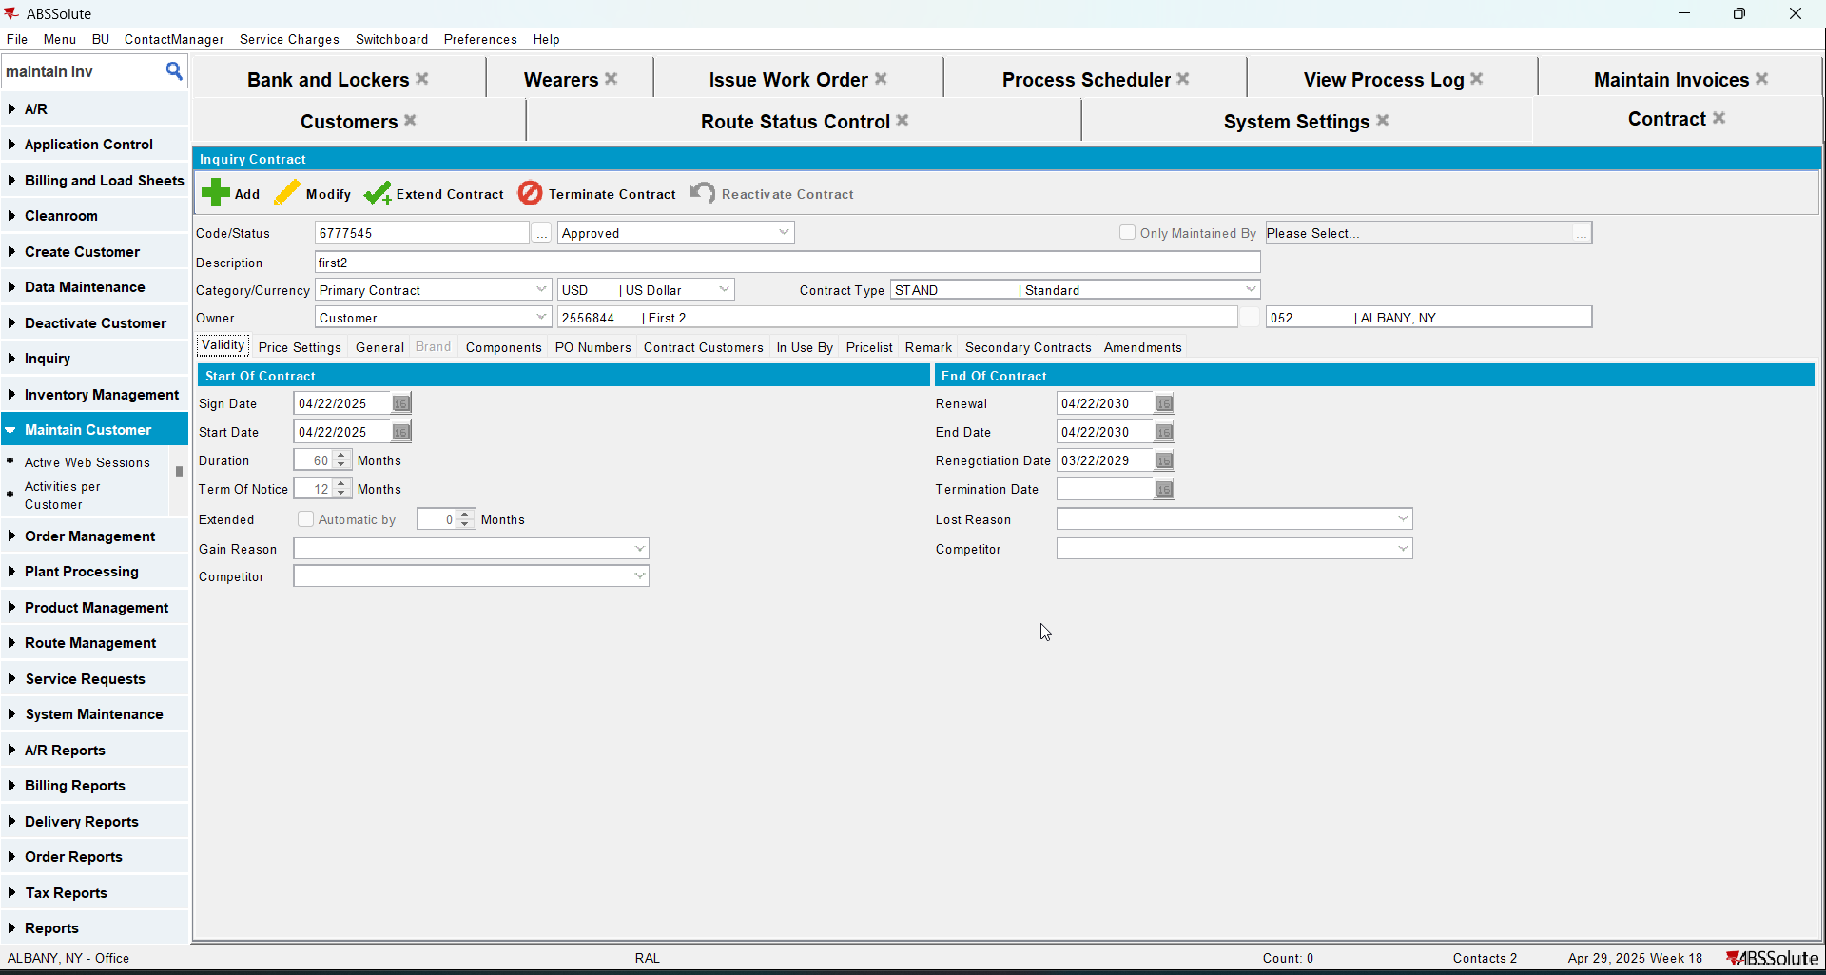
- Add a garment to contract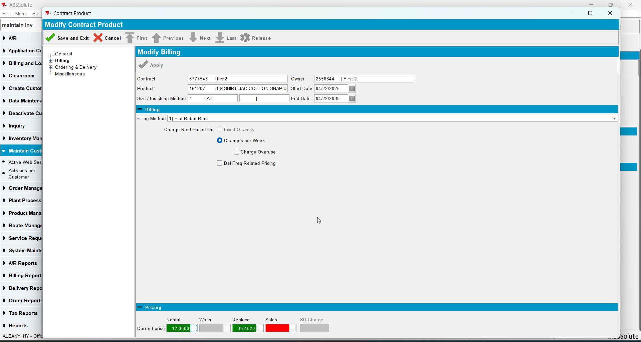
- Add the new customer to contract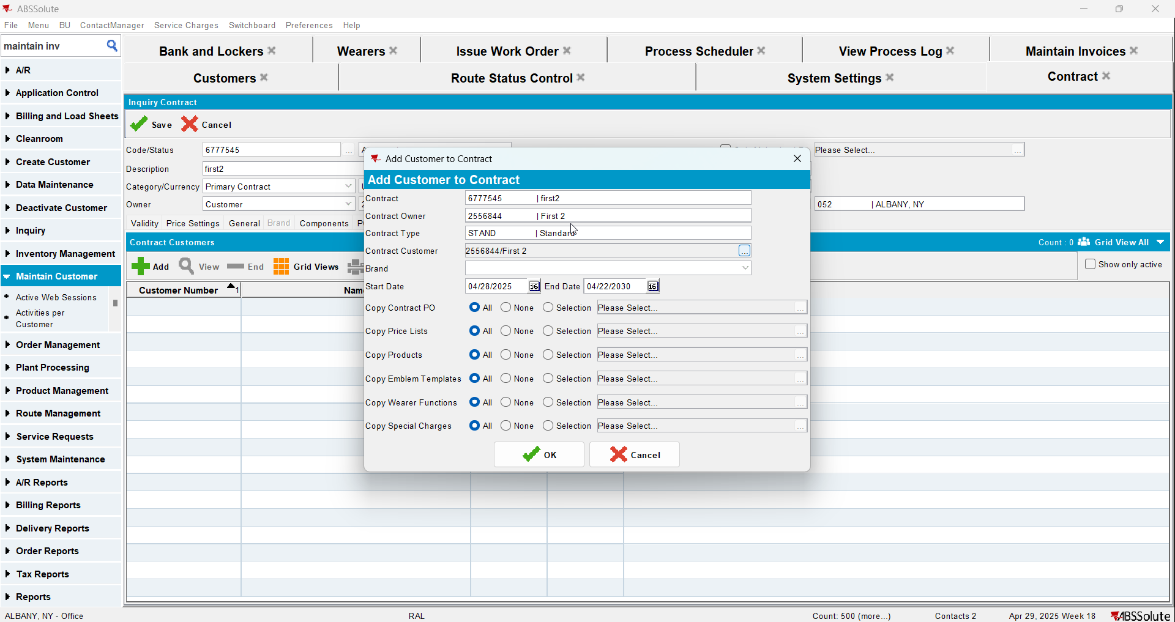
- Add new lockers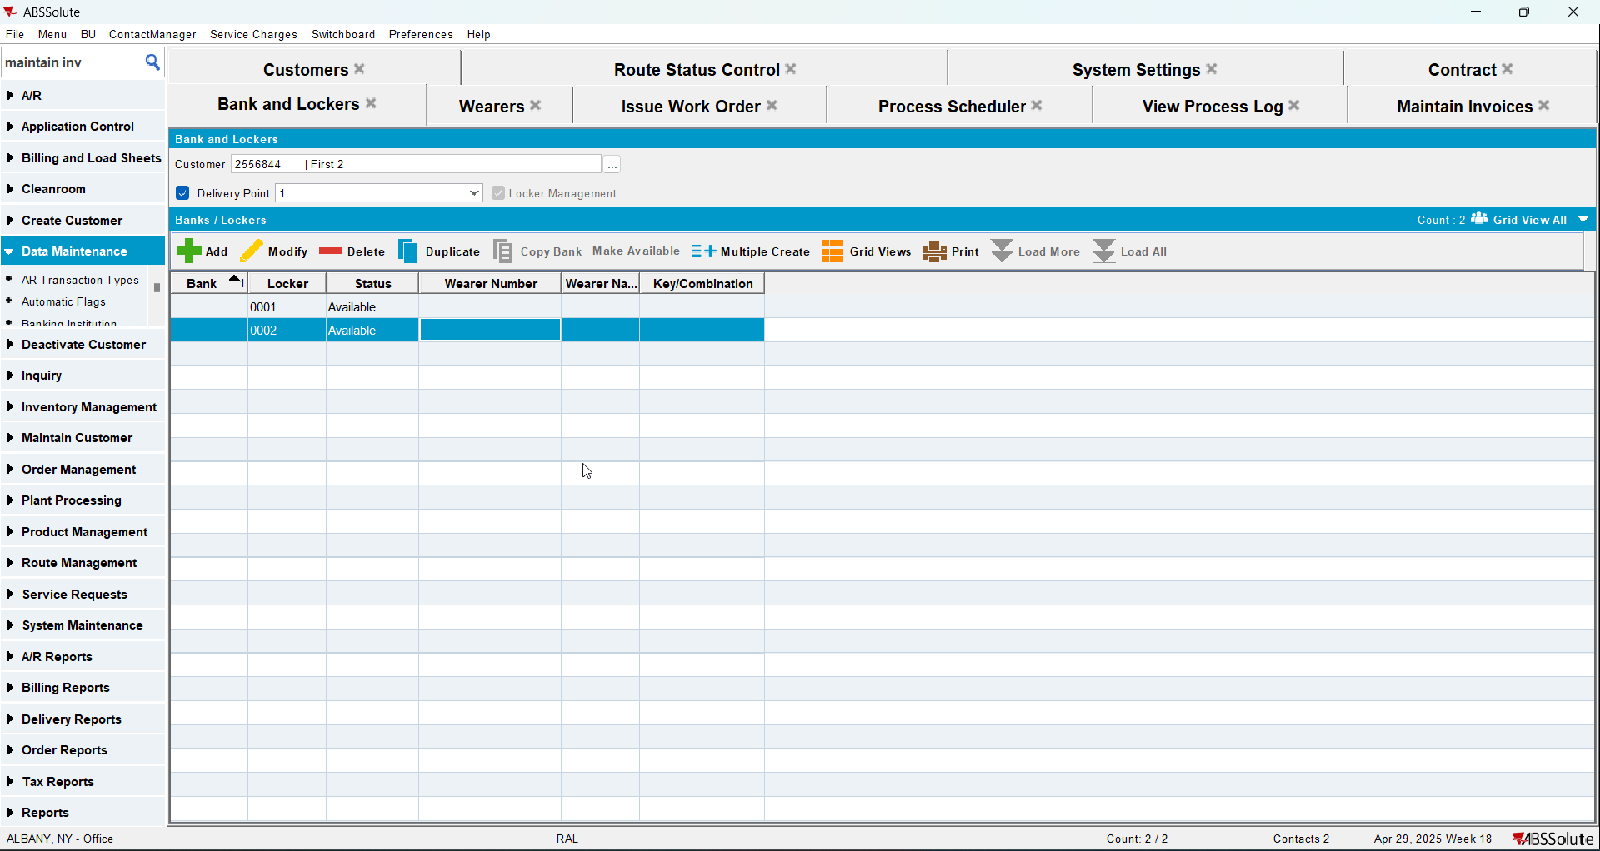
- Add a wearer with a wearer inventory
- Generate work order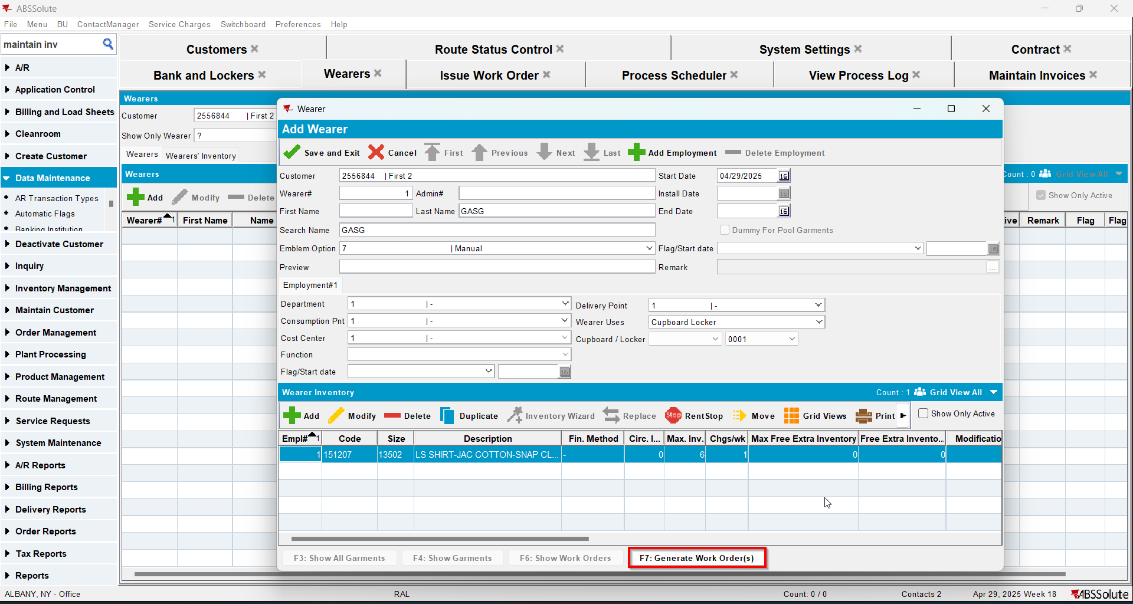
- Issue the work order and generate the delivery note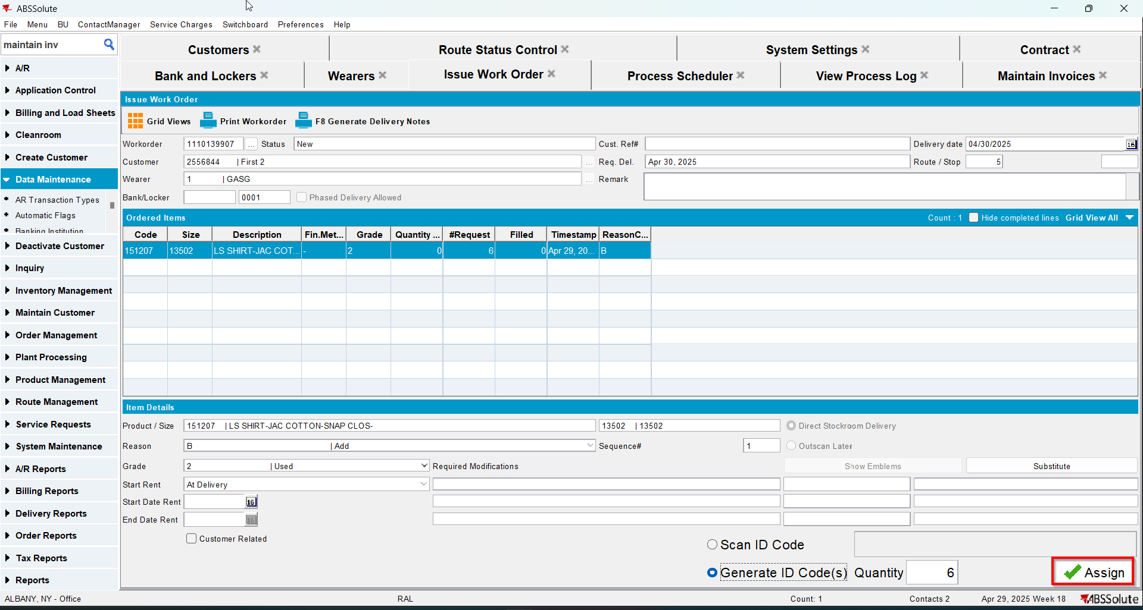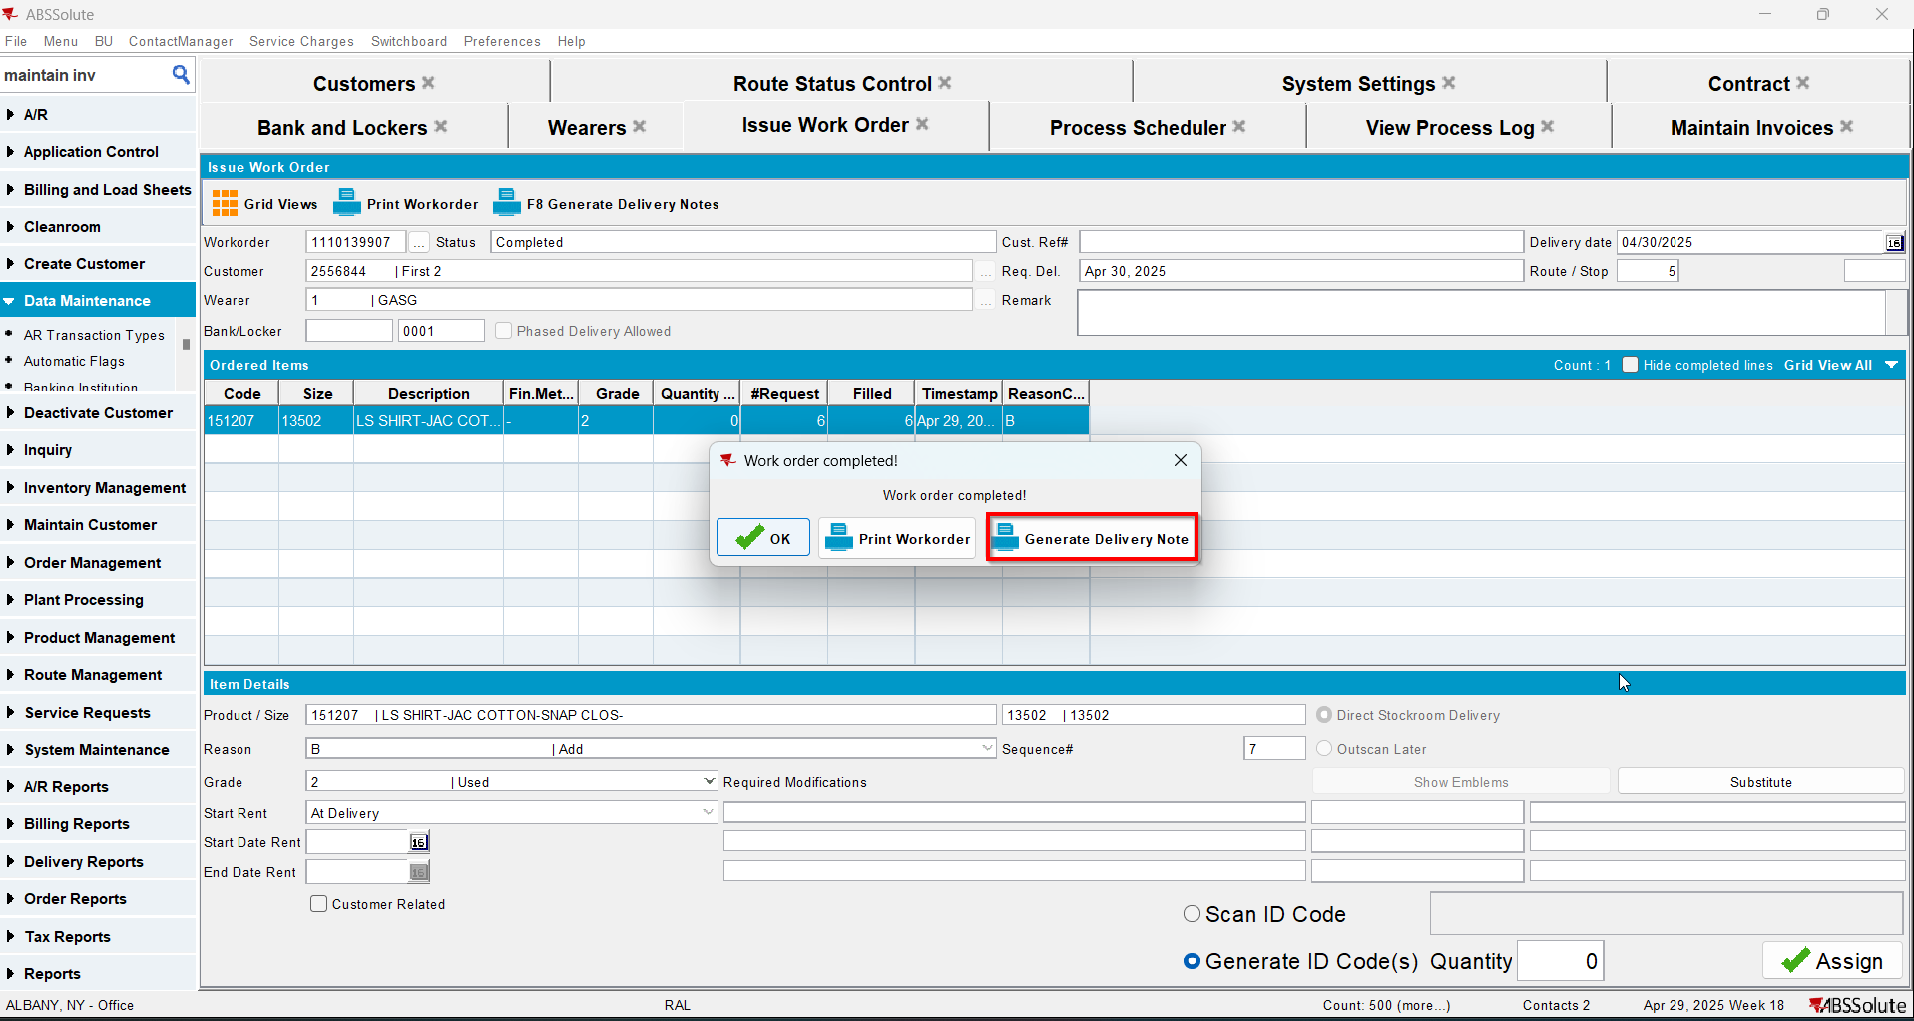
- Add the next route for the customer
- Generate the invoice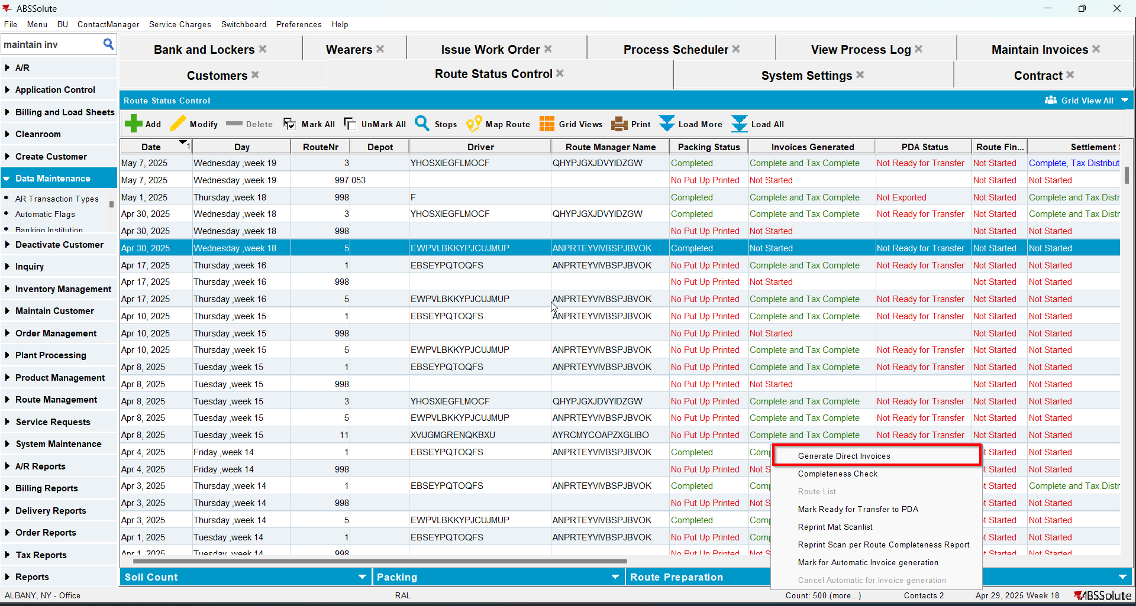
- Tax the invoice
- Settle the invoice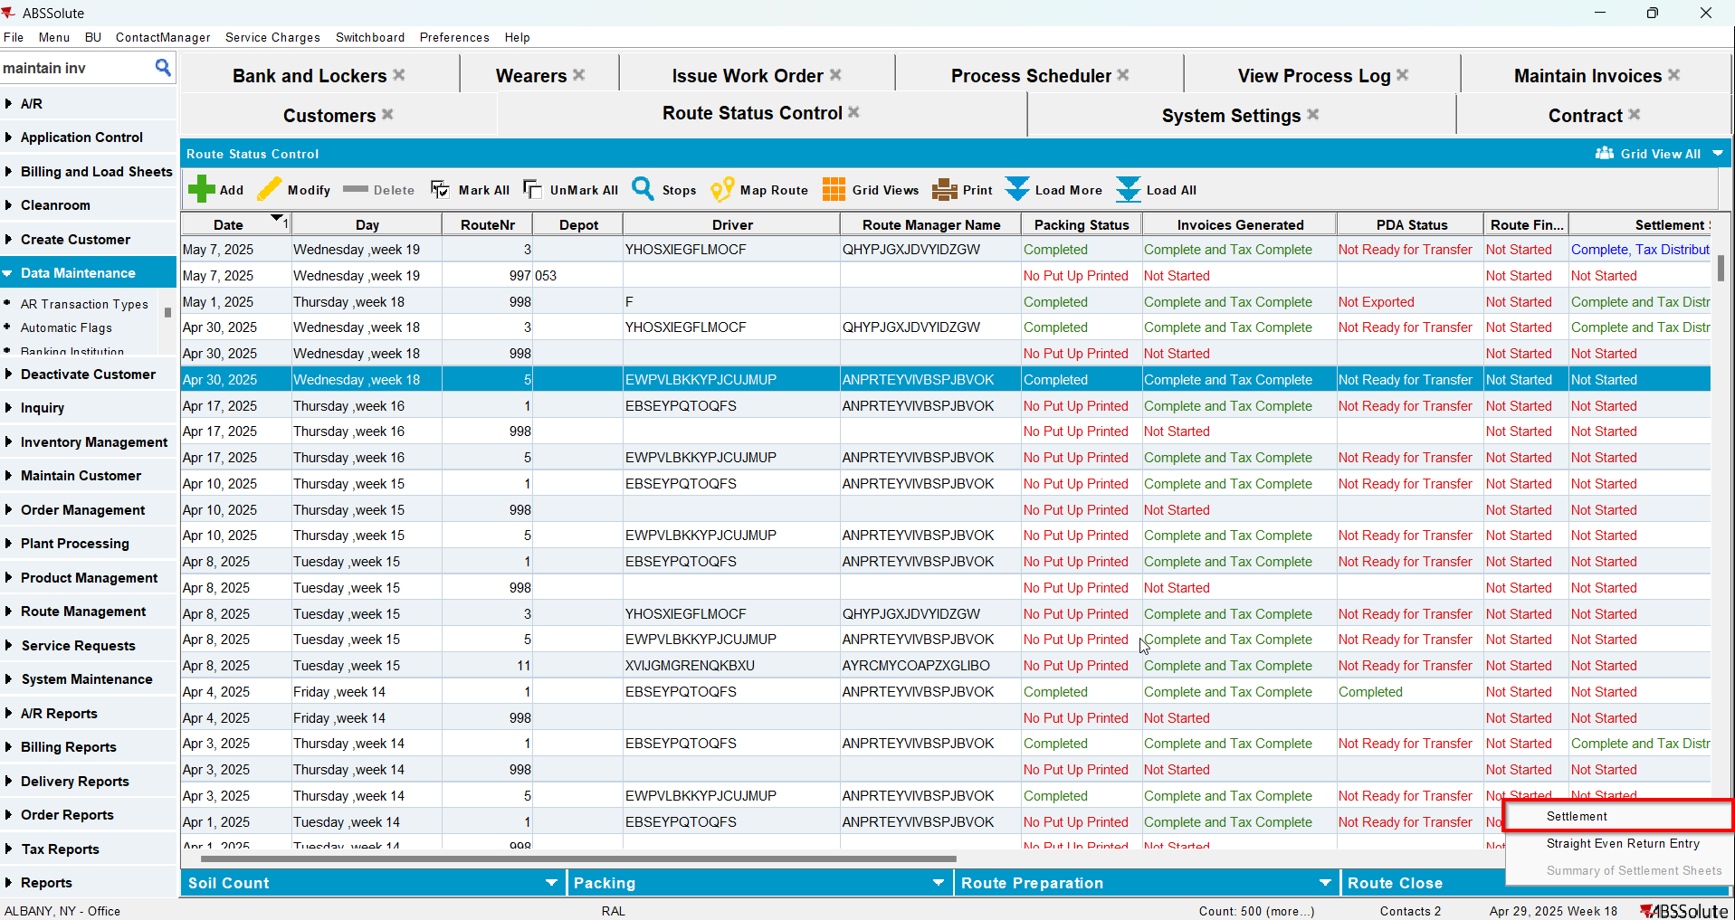
- In View Process Log check the Settlement log for the updates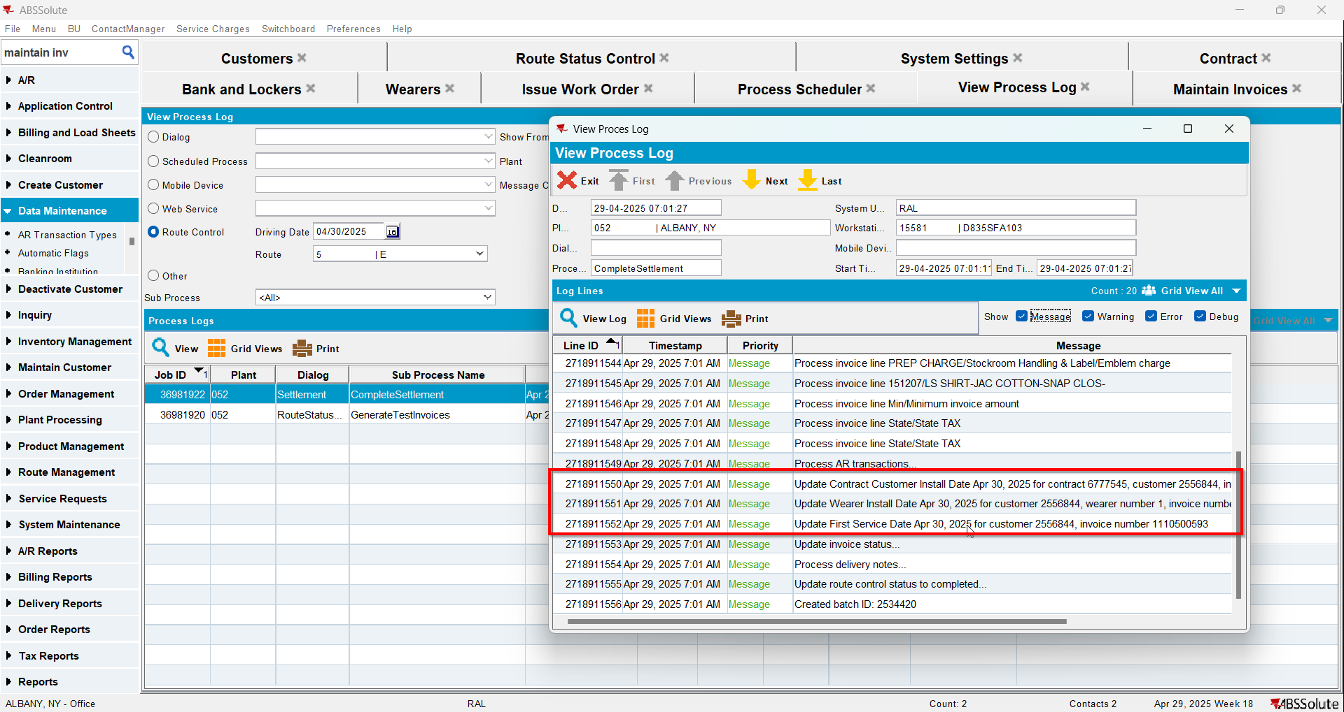
- Check that the Customer - First Service date was updated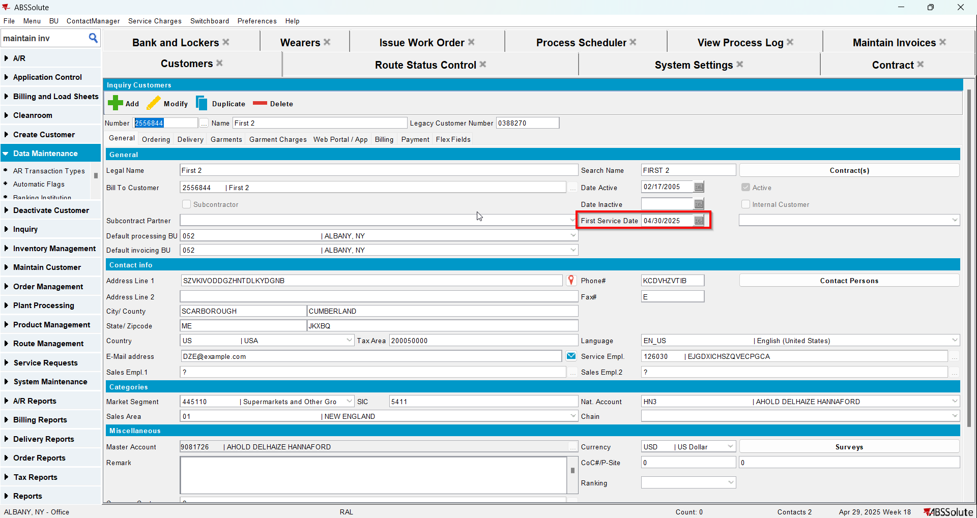
- Check that the Contract - Install date was updated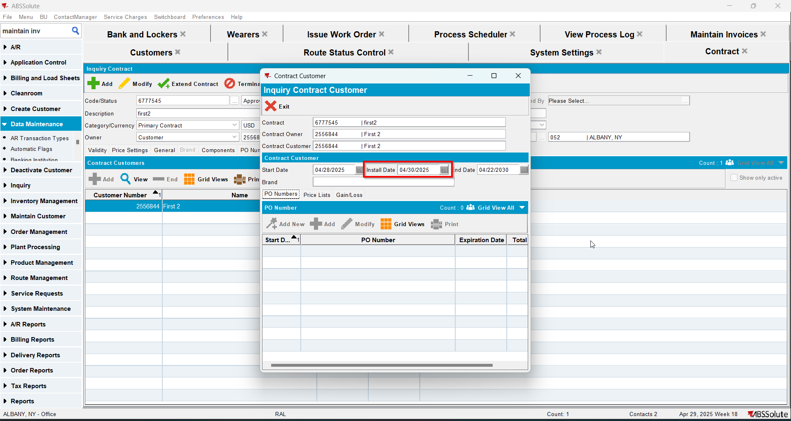
- Check that the Wearer - Install date was updated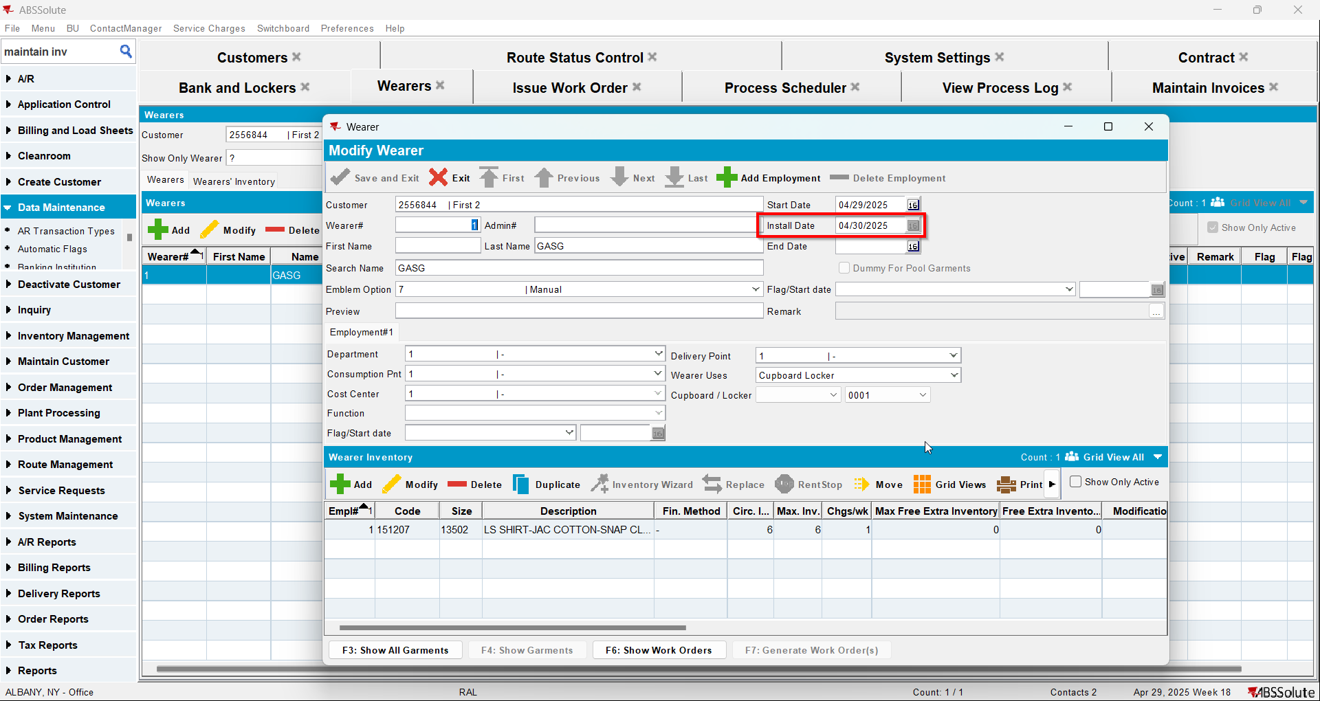
- Script in the Tax distribution data
- Process scheduler: run the process scheduler to distribute the tax
- Maintain Invoices DLG: Find the settled invoice and click on the credit invoice button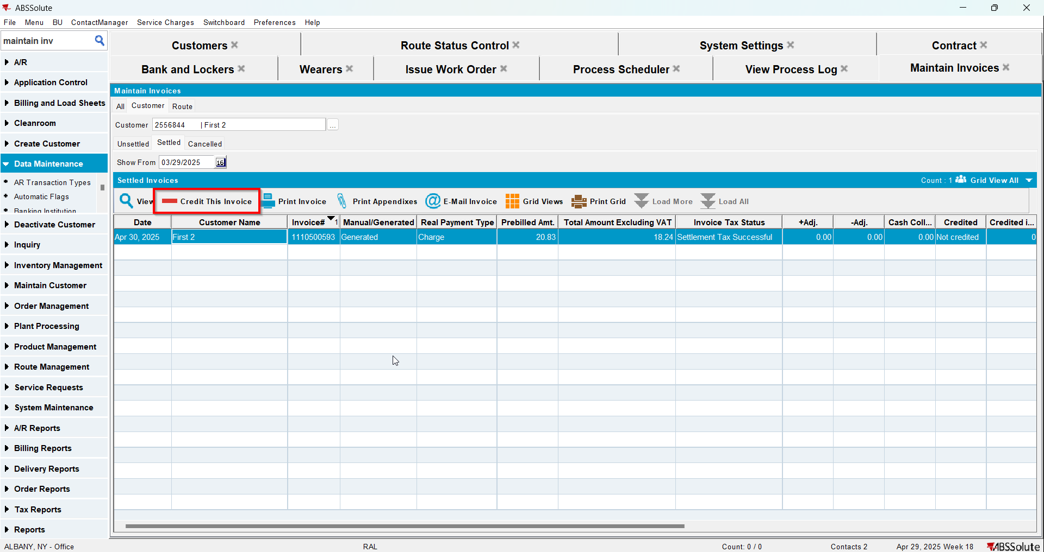
- When Credit Flow pop-up appears check the Assign Invoice to route checkbox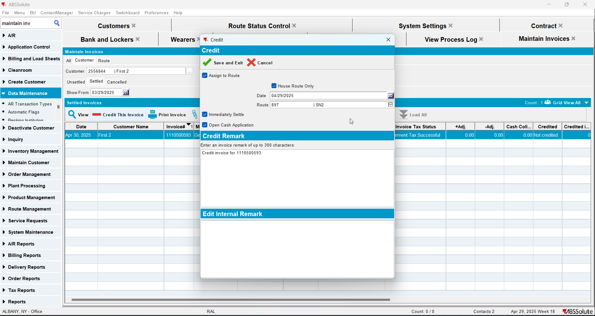
- In View Process Log check the CreditFlowDateUpdates log for the updates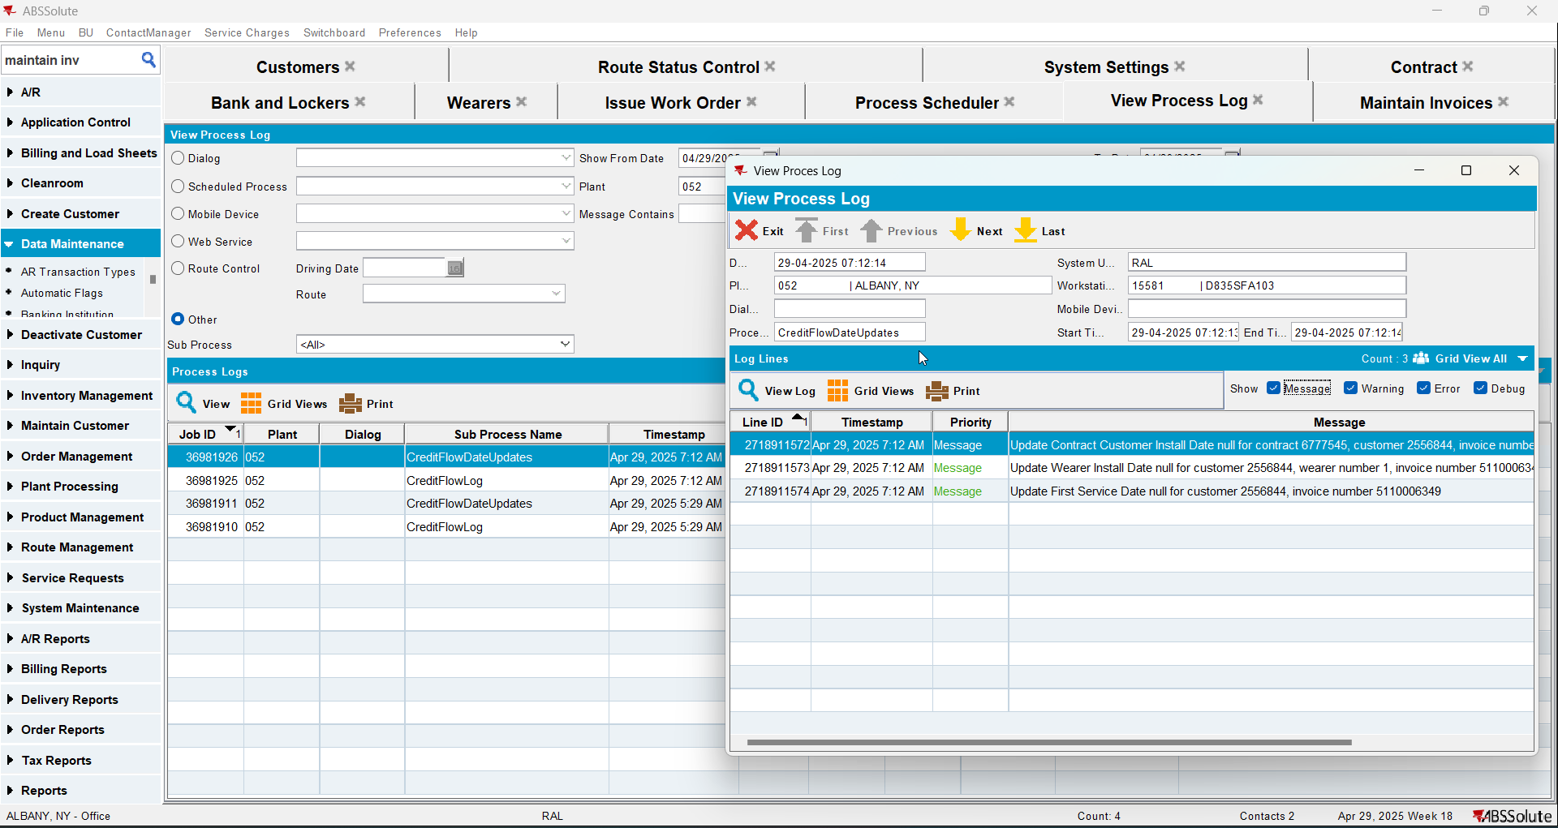
- Check that the Customer - First Service date was deleted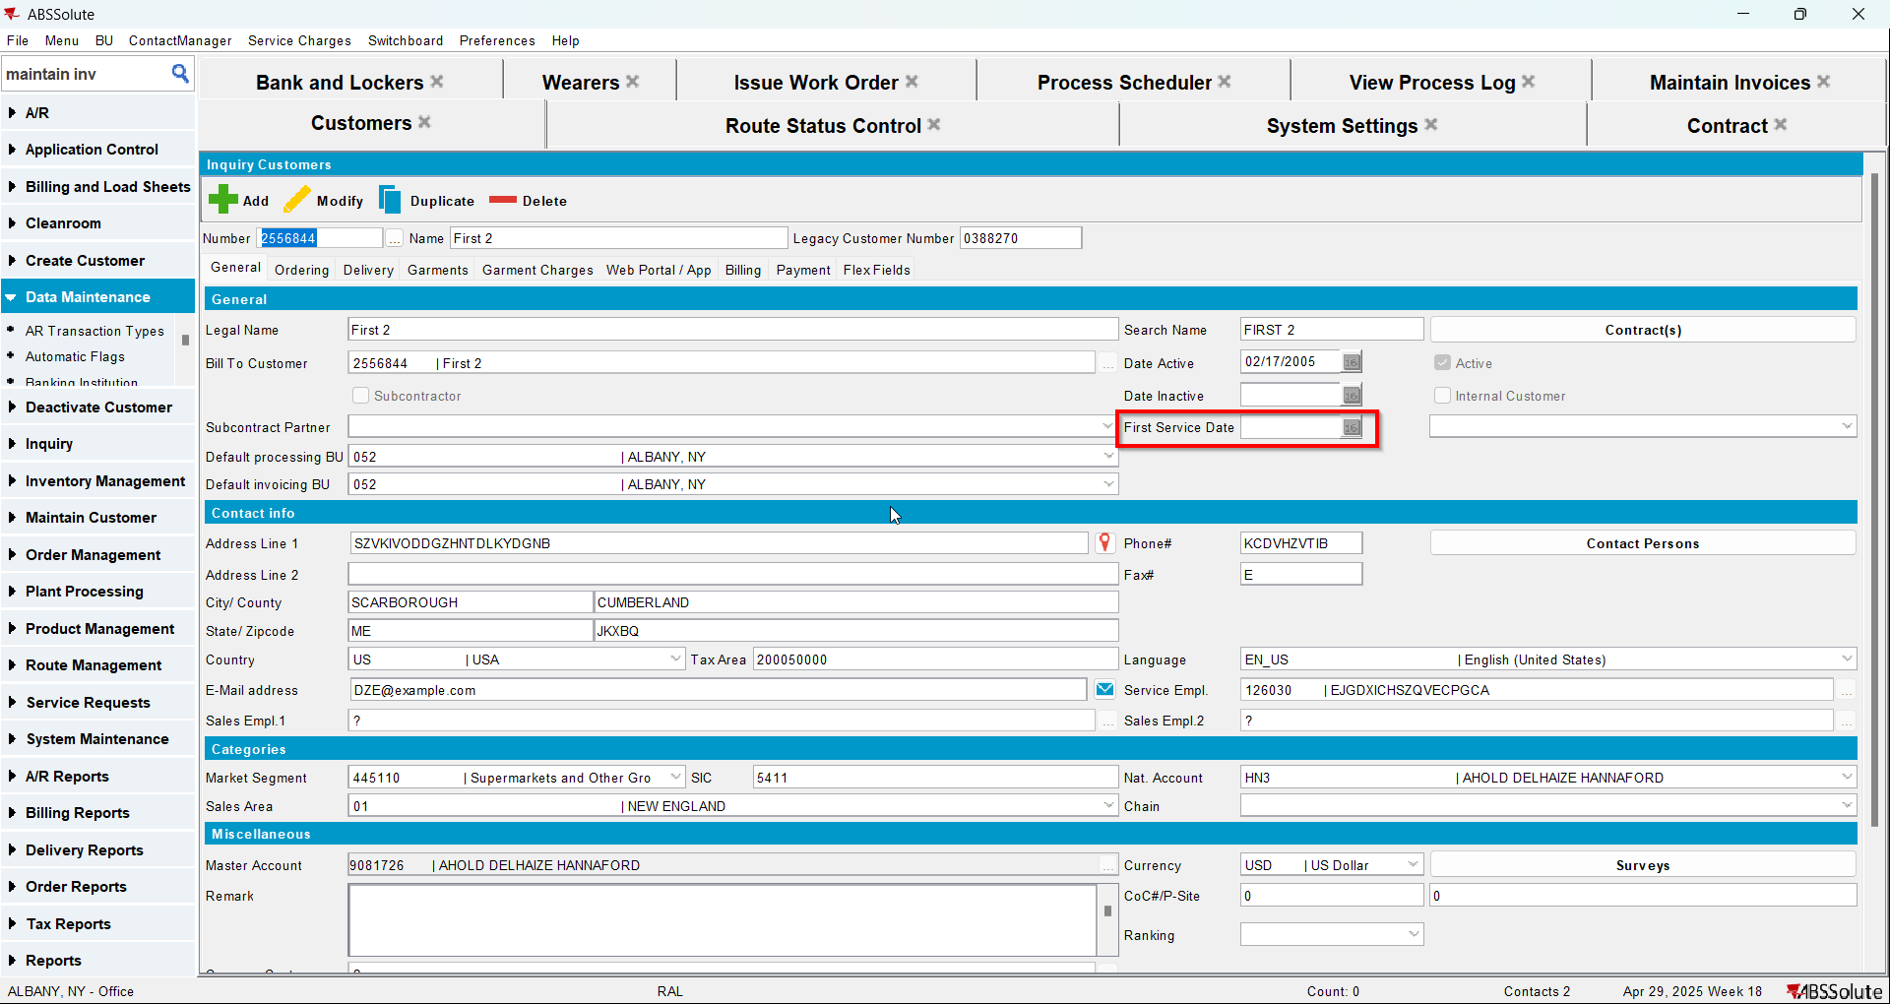
- Check that the Contract - Install date was deleted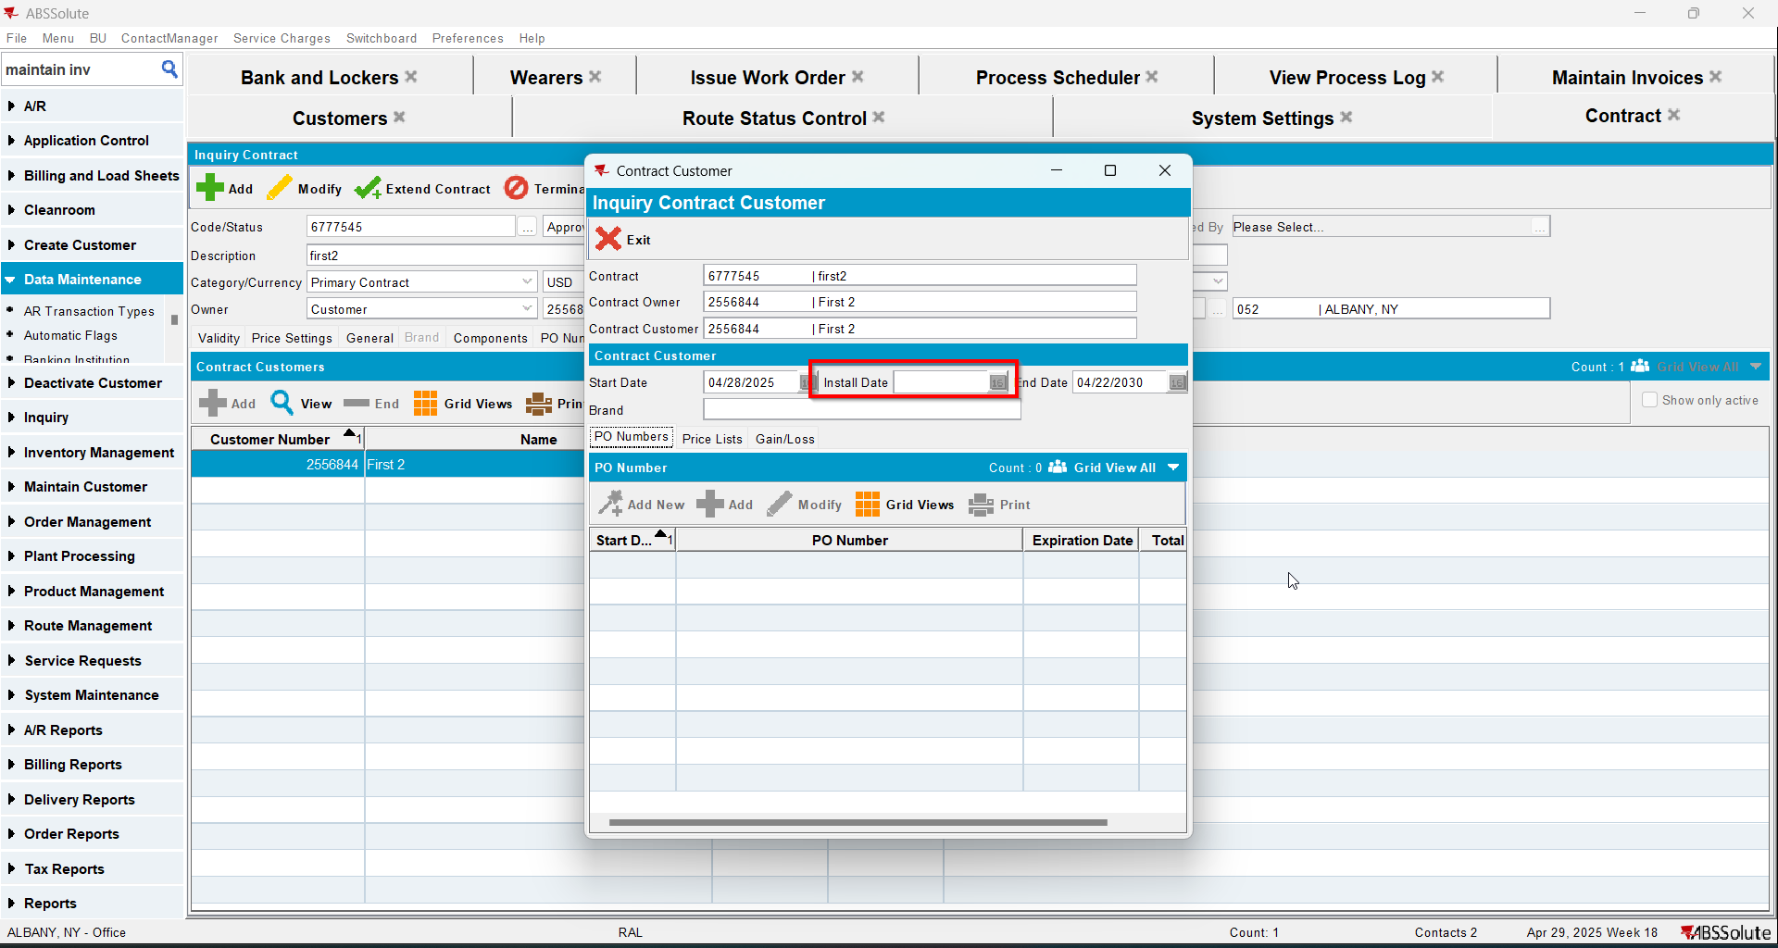
- Check that the Wearer - Install date was deleted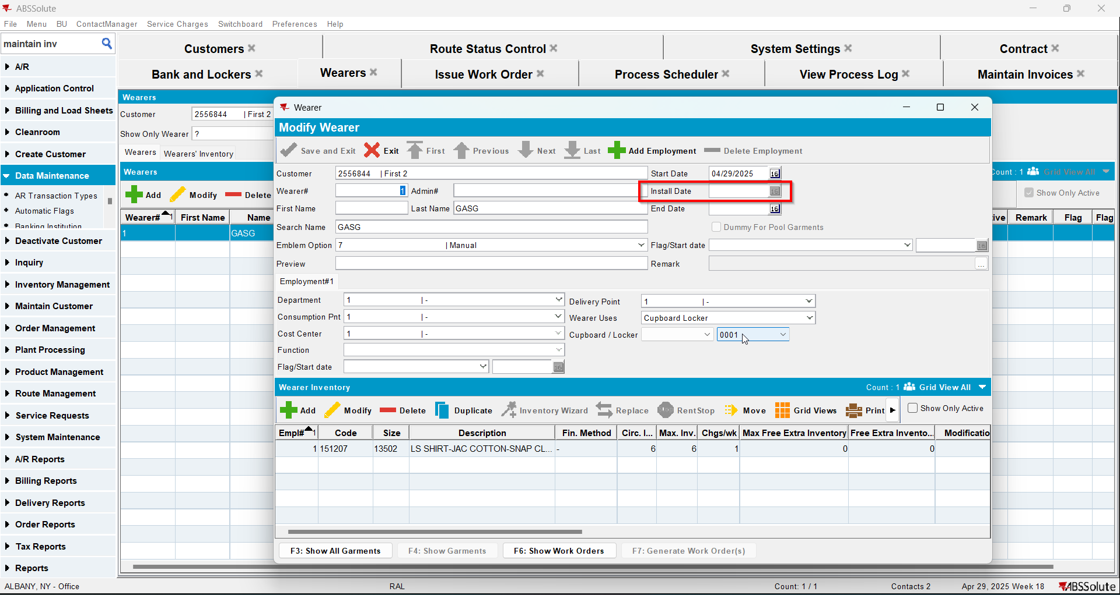
- Route Status Control DLG: Add next week's route
- Generate the invoice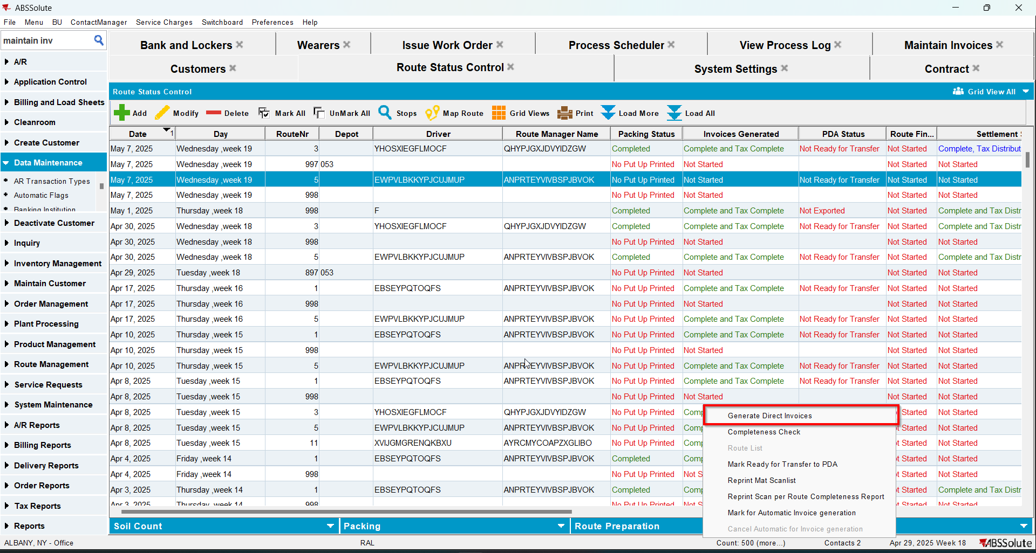
- Tax the invoice
- Settle the invoice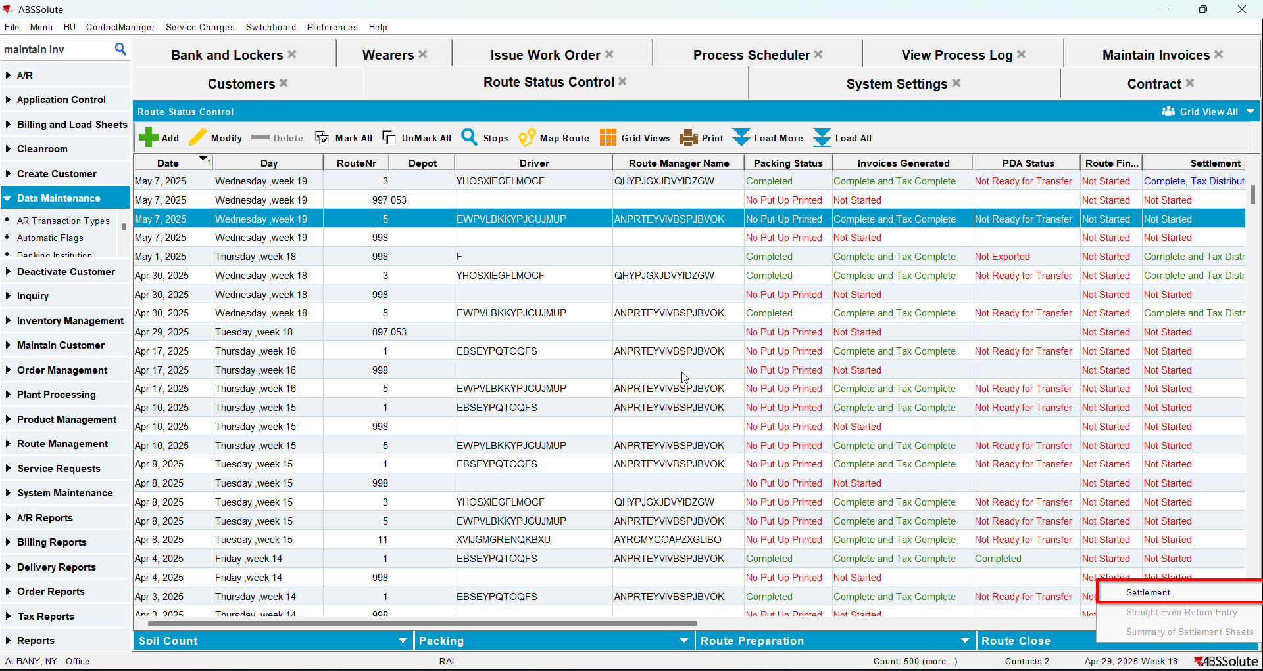
- In View Process Log check the Settlement log for the updates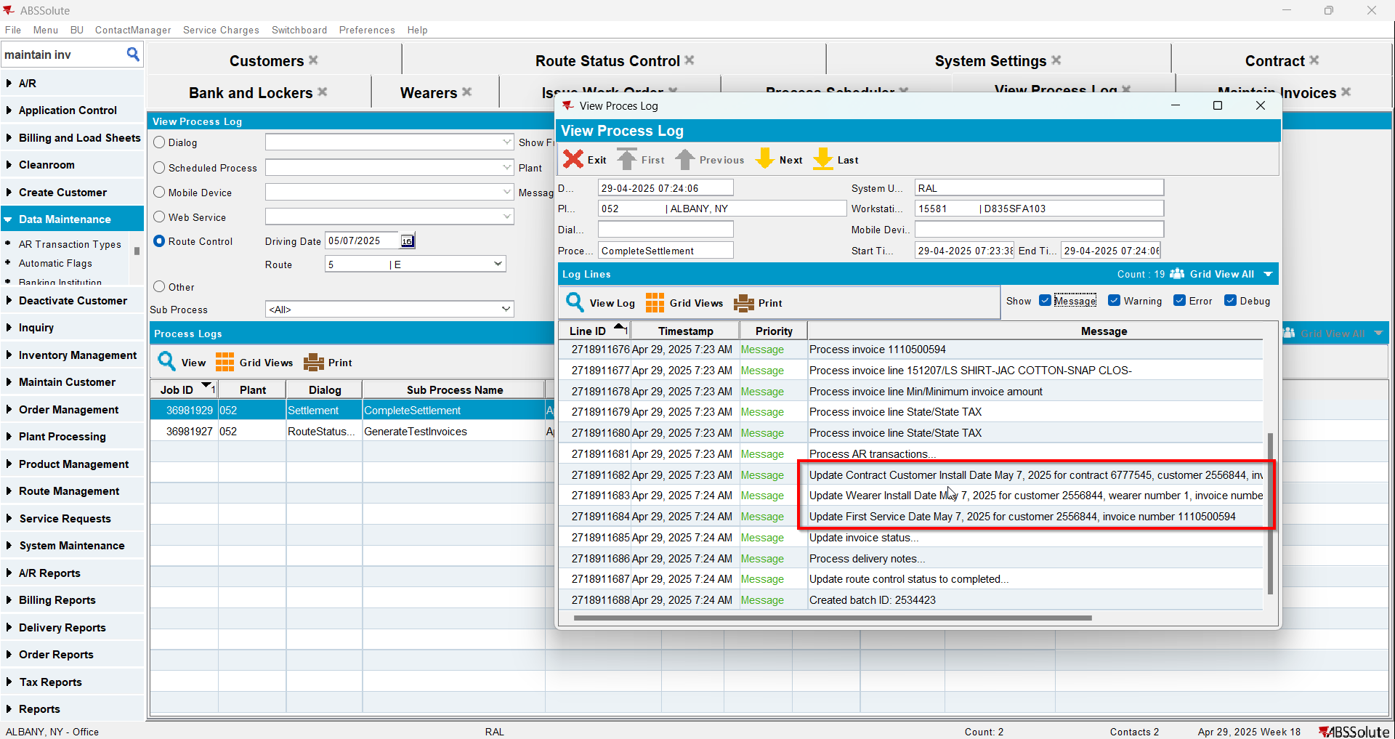
- Check that the Customer - First Service date was updated.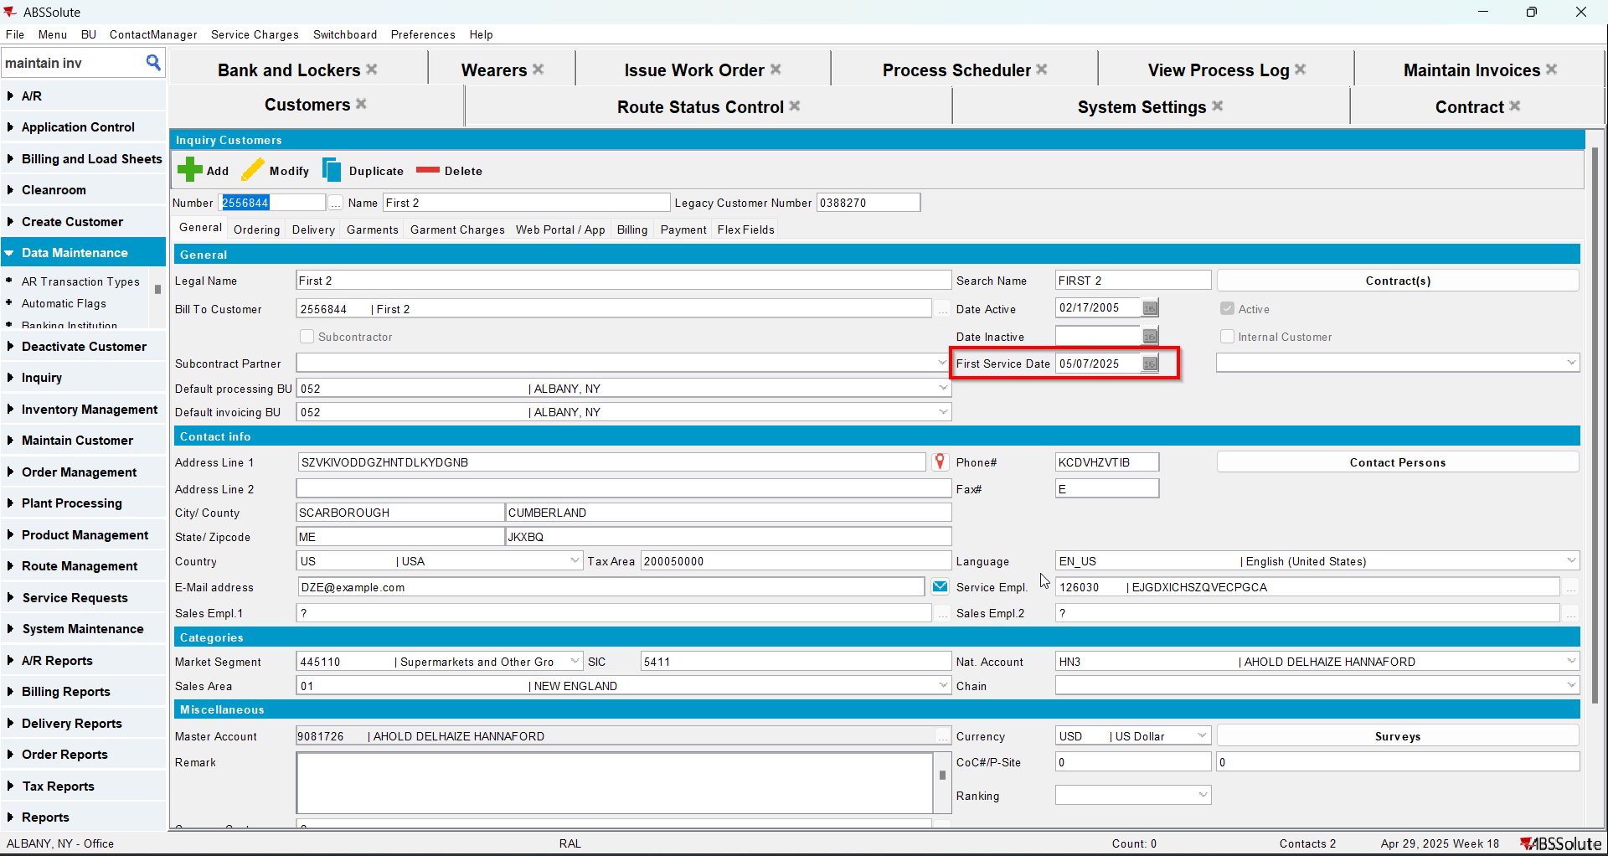
- Check that the Contract - Install date was updated.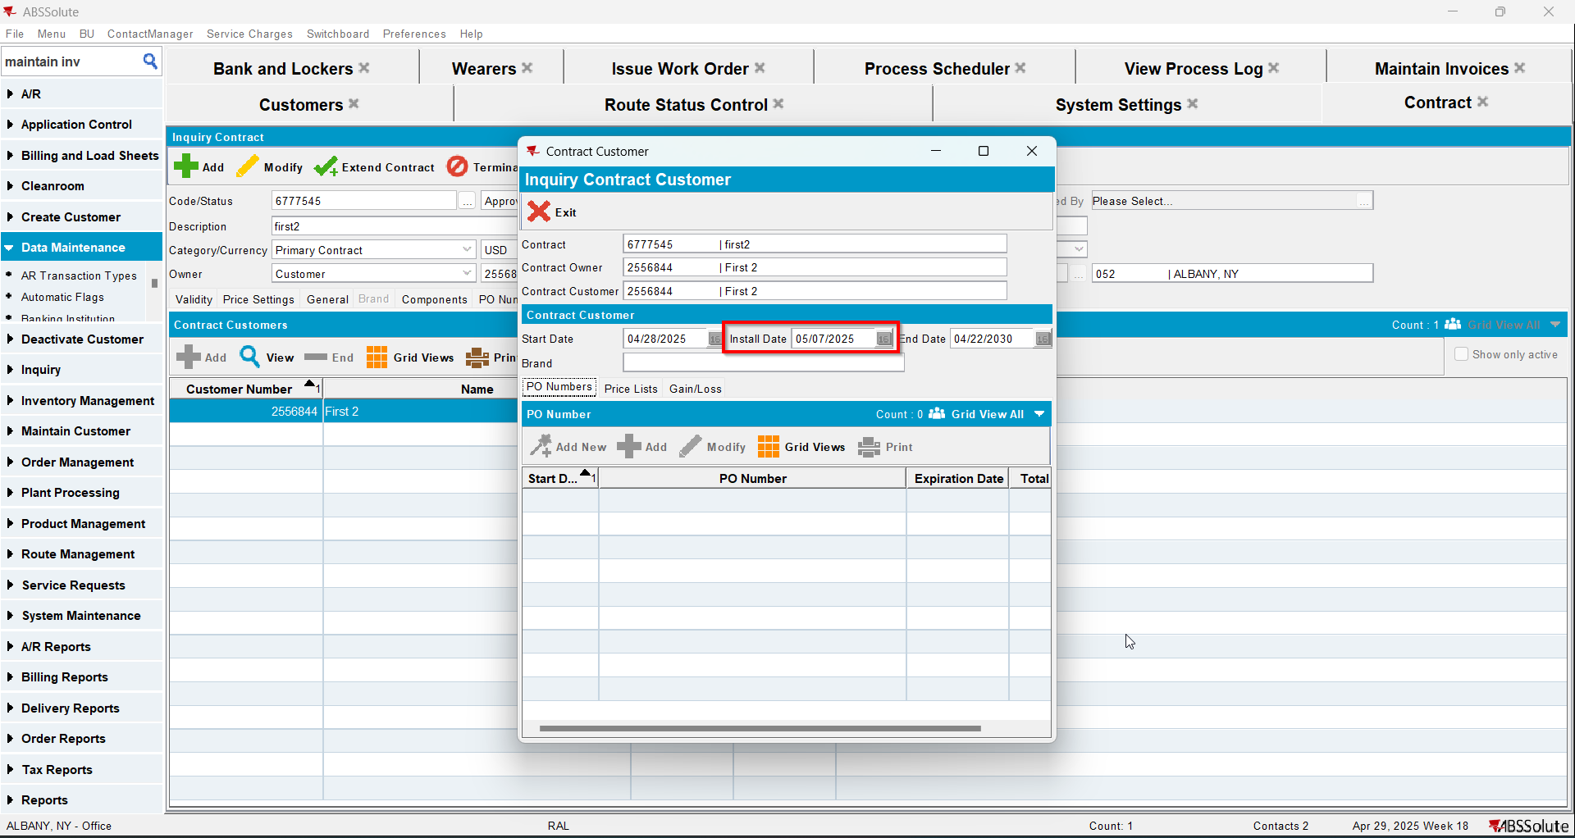
- Check that the Wearer - Install date was updated.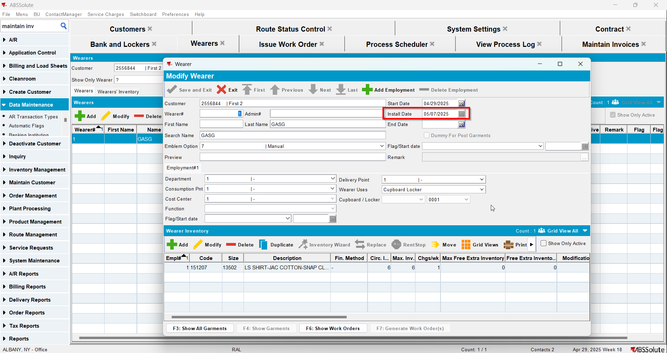

Test Case 3 – Settle on WebX and credit with settle later – Tested OK
Expected behavior: The updates for the first service log and install date will appear in the log.
Hash: 9a17455
- Add a new customer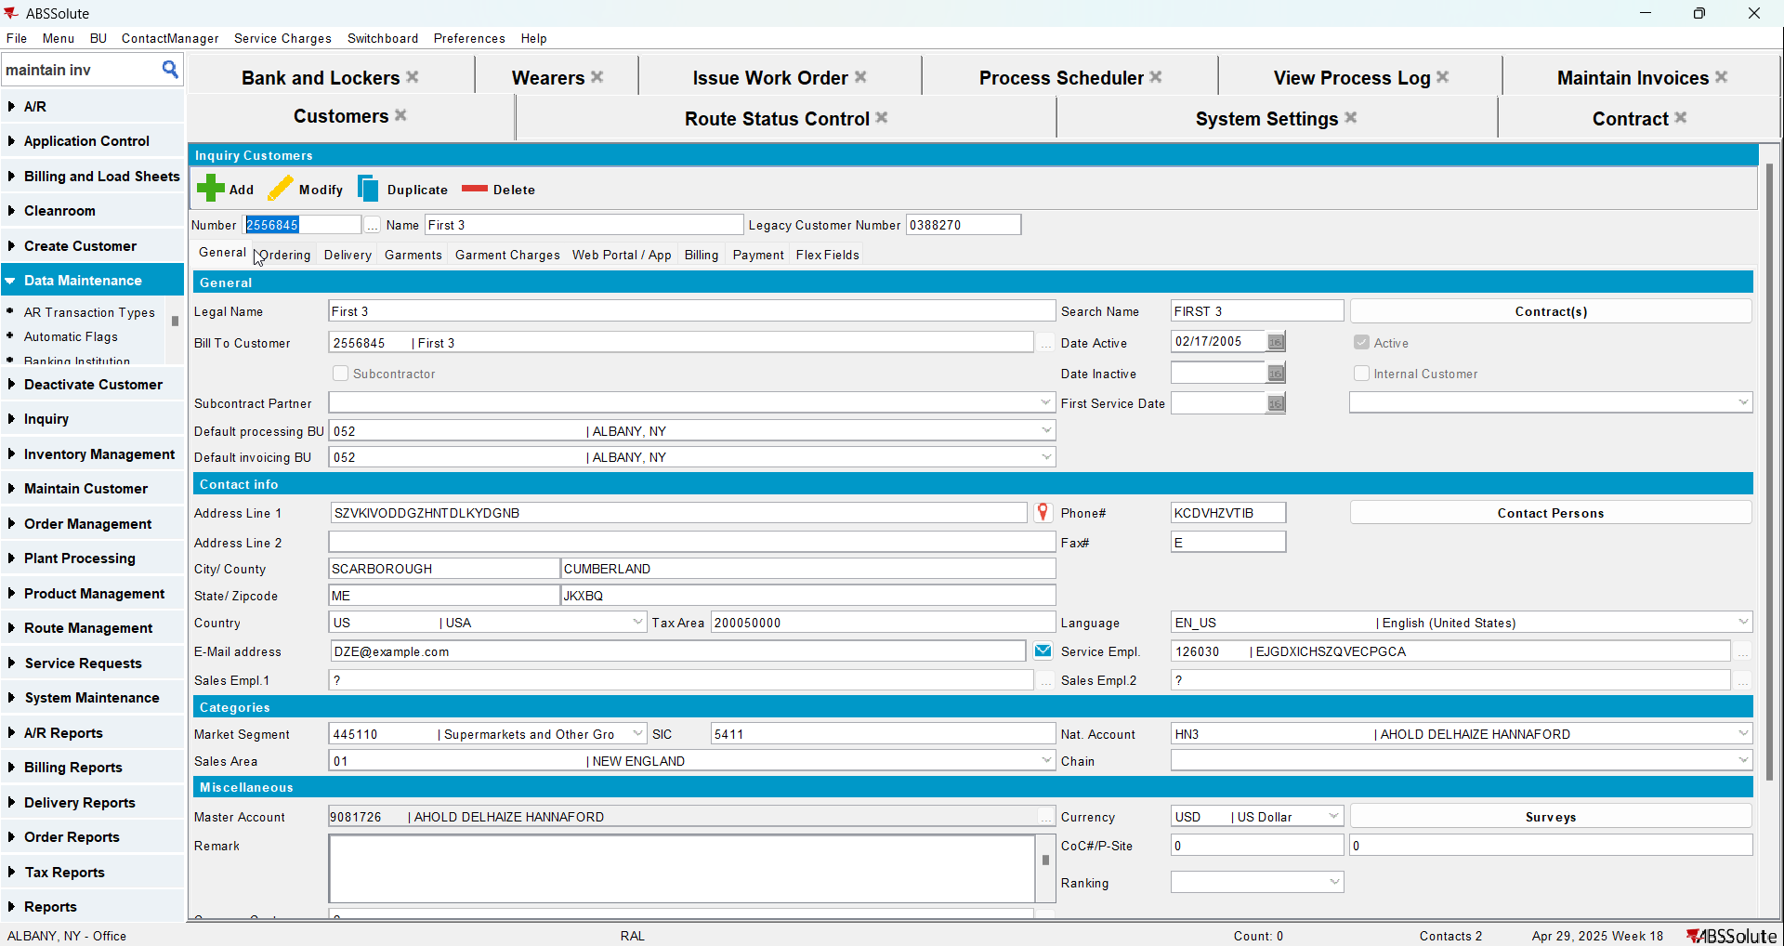
- Add a new contract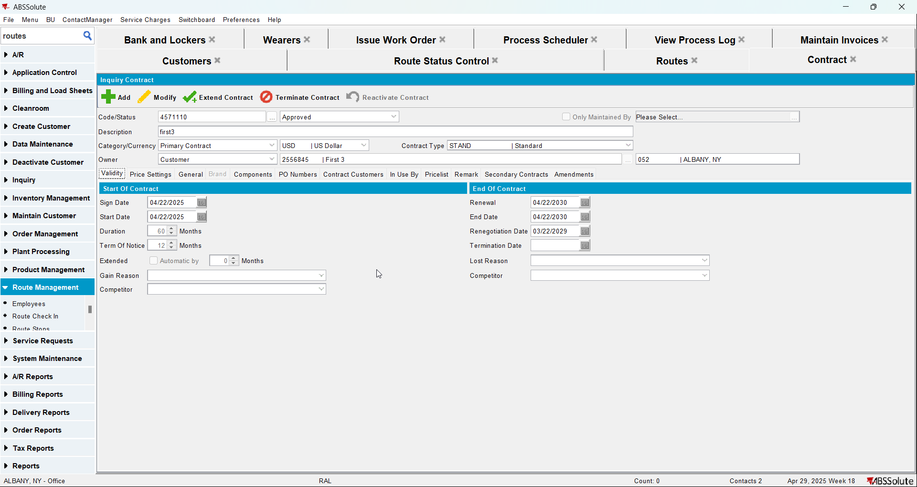
- Add a garment to contract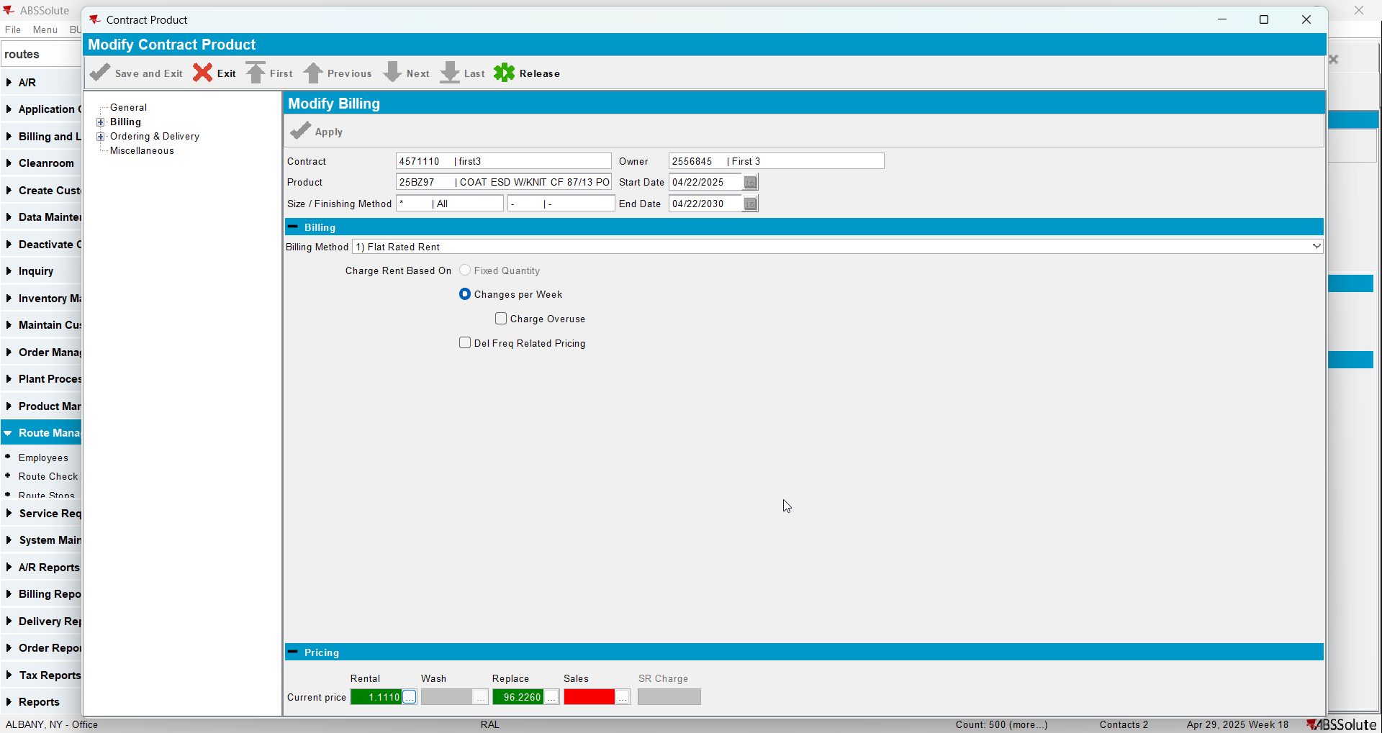
- Add the new customer to contract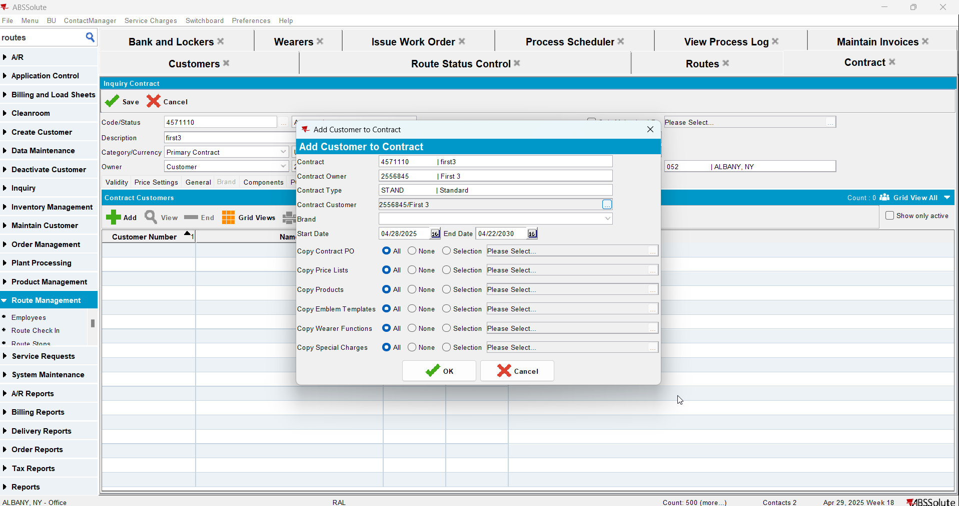
- Add new lockers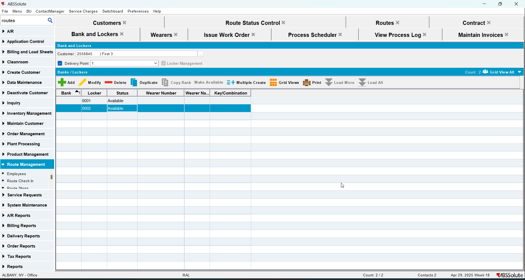
- Add a wearer with a wearer inventory
- Generate work order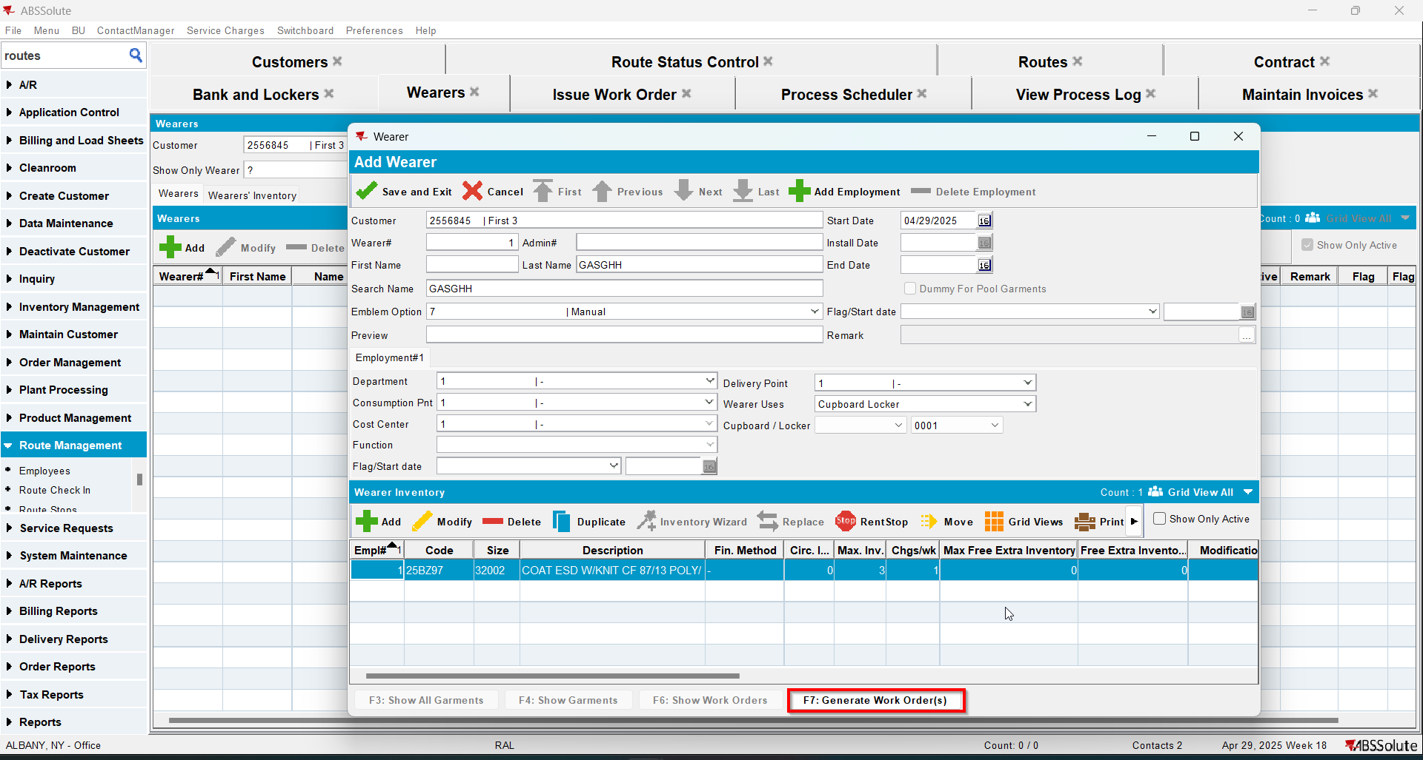
- Issue the work order and generate the delivery note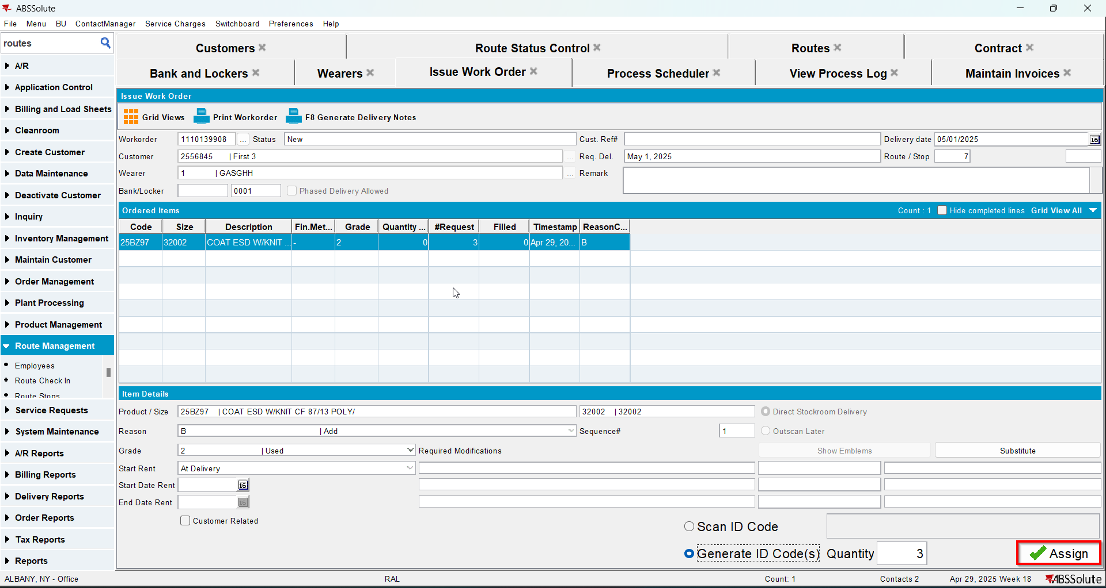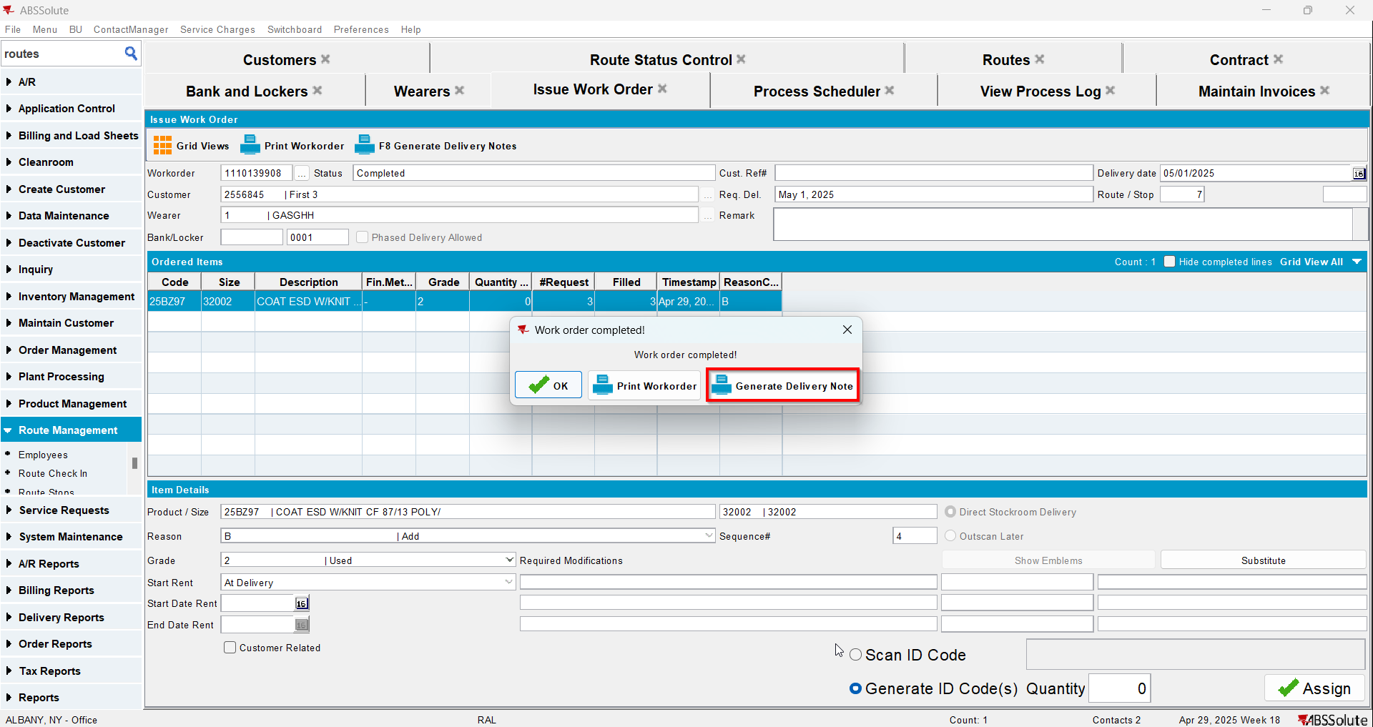
- Add the next route for the customer
- Generate the invoice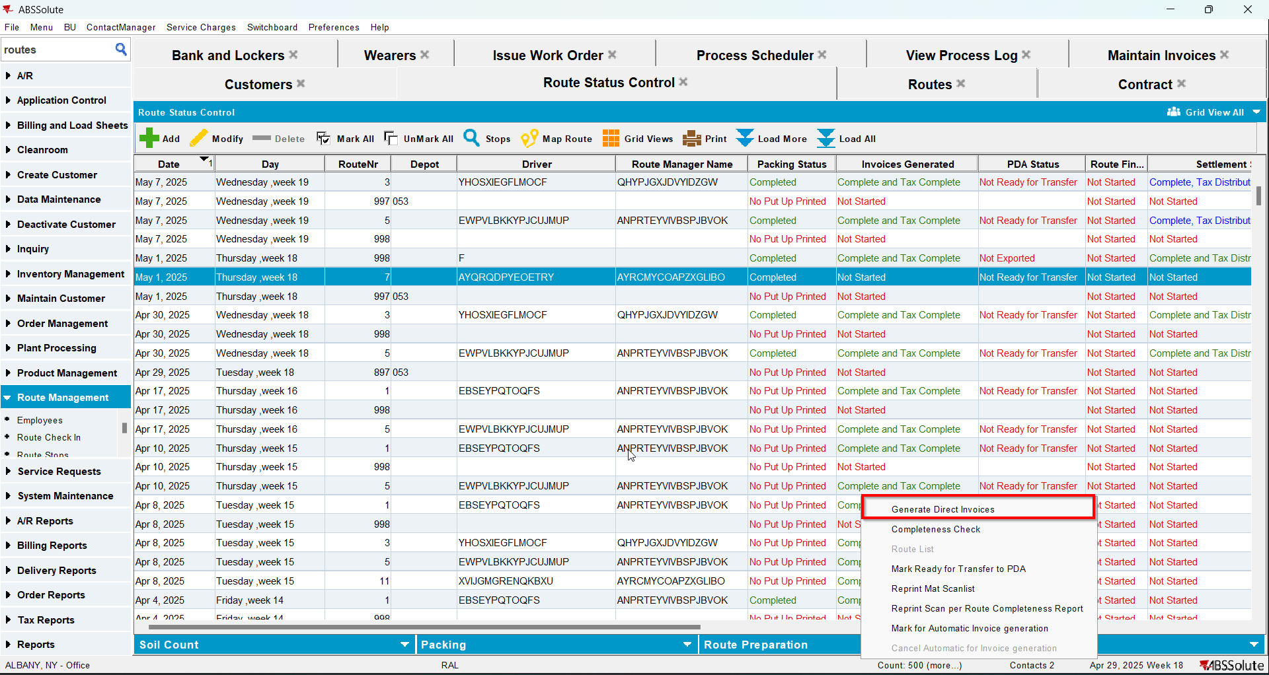
- Tax the invoice
- Send the route to RA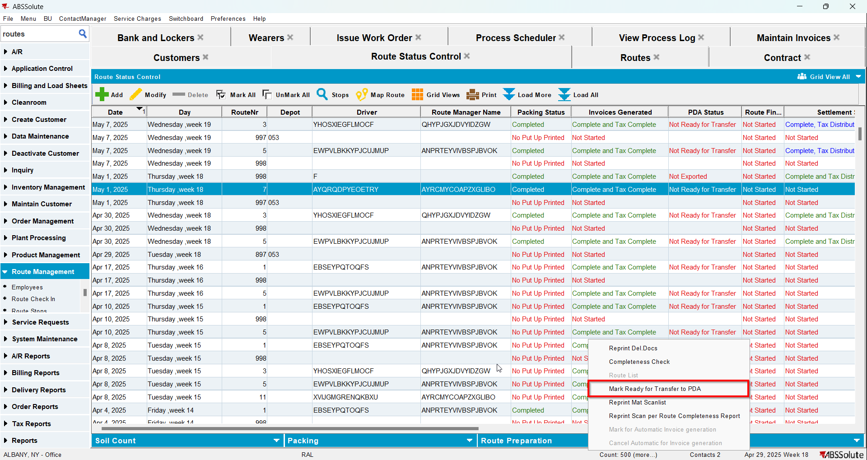
- Finish the route and upload it
- On WebX settle the route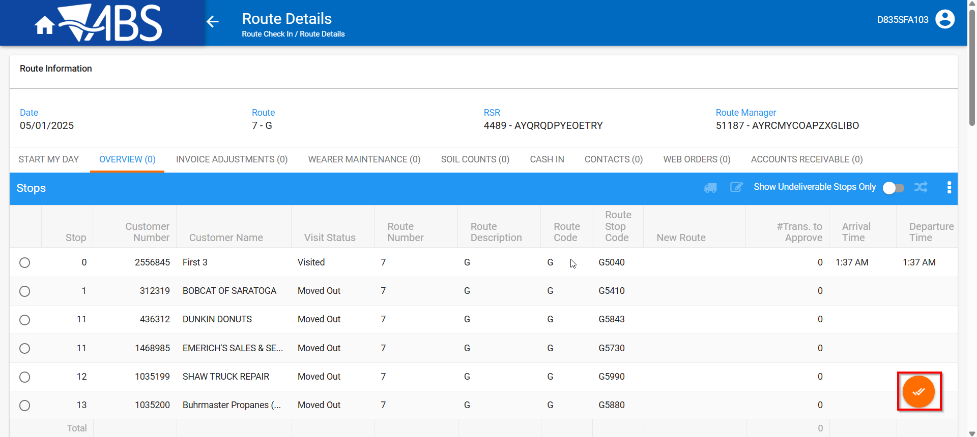
- In View Process Log check the Settlement log for the updates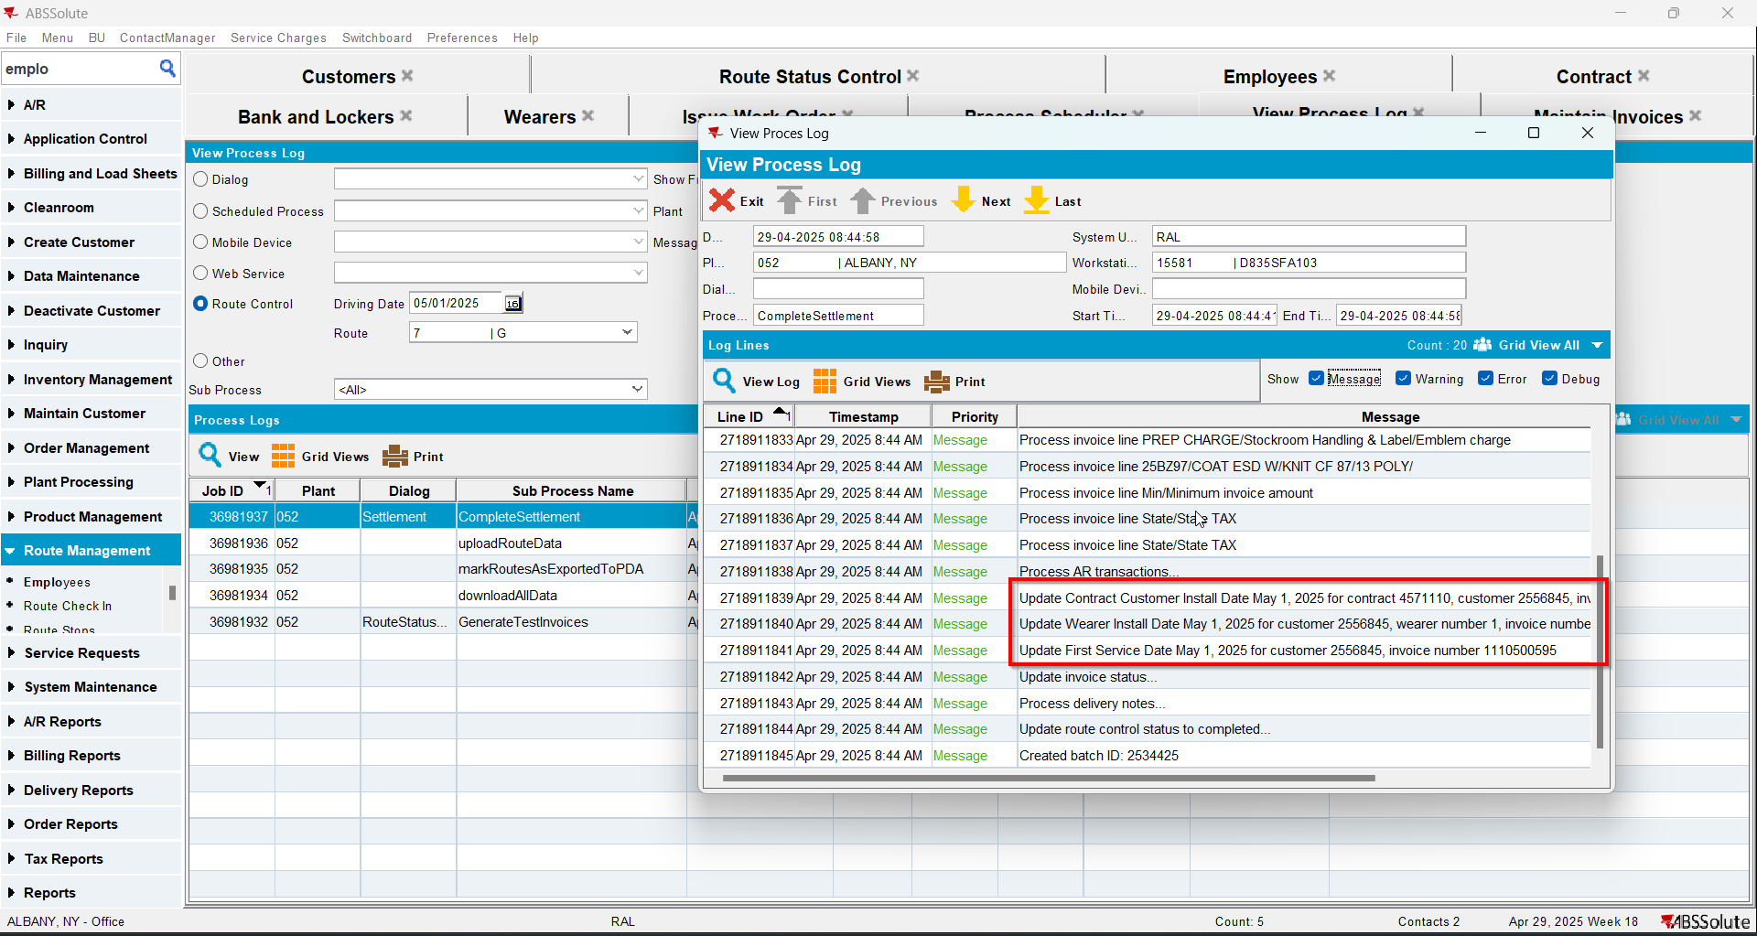
- Check that the Customer - First Service date was updated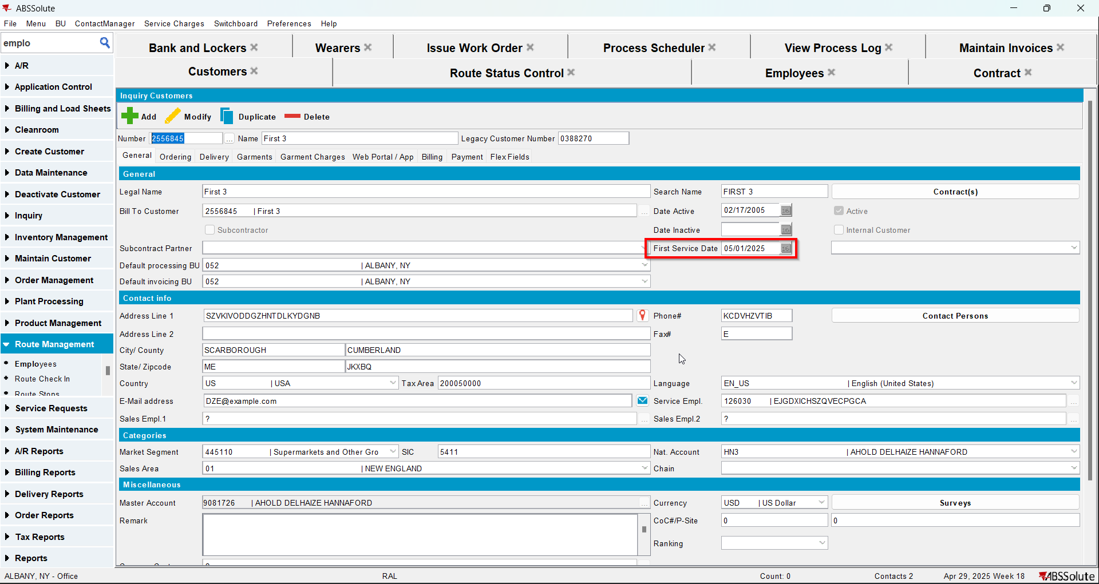
- Check that the Contract - Install date was updated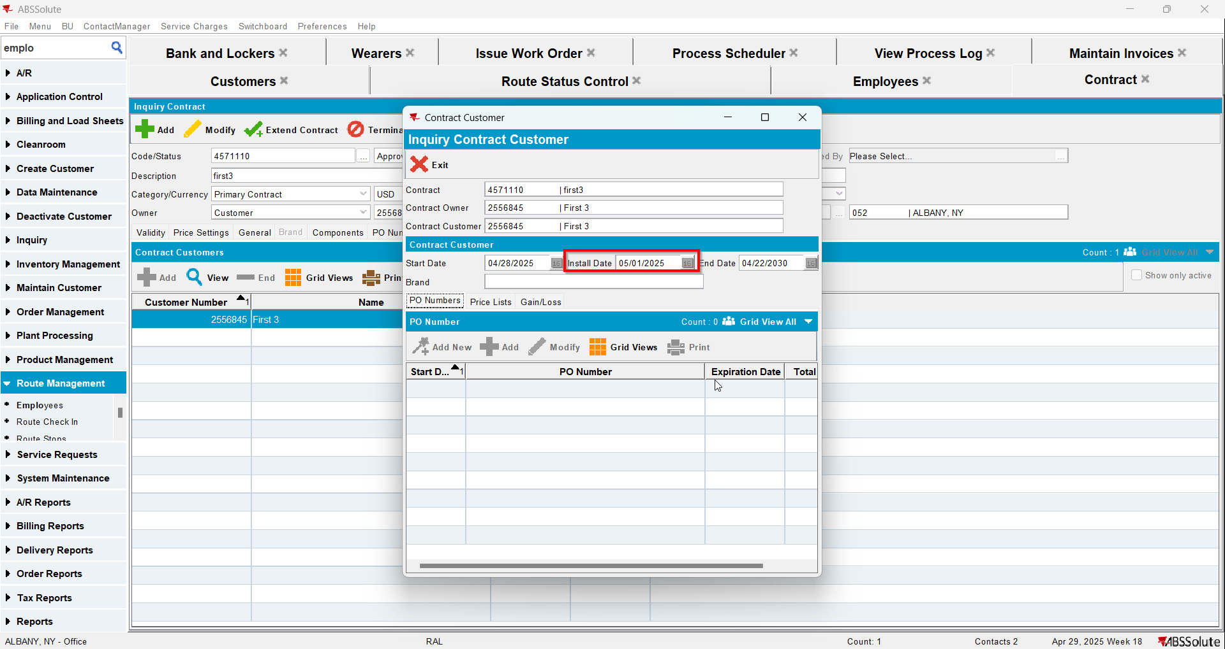
- Check that the Wearer - Install date was updated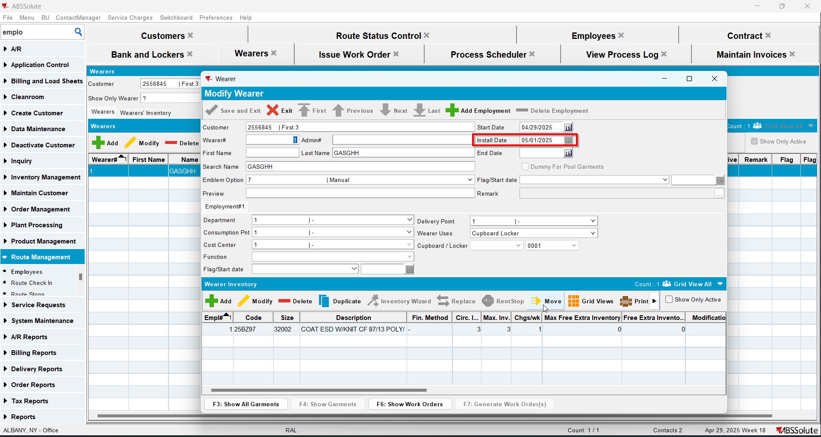
- Script in the Tax distribution data
- Process scheduler: run the process scheduler to distribute the tax
- Maintain Invoices DLG: Find the settled invoice and click on the credit invoice button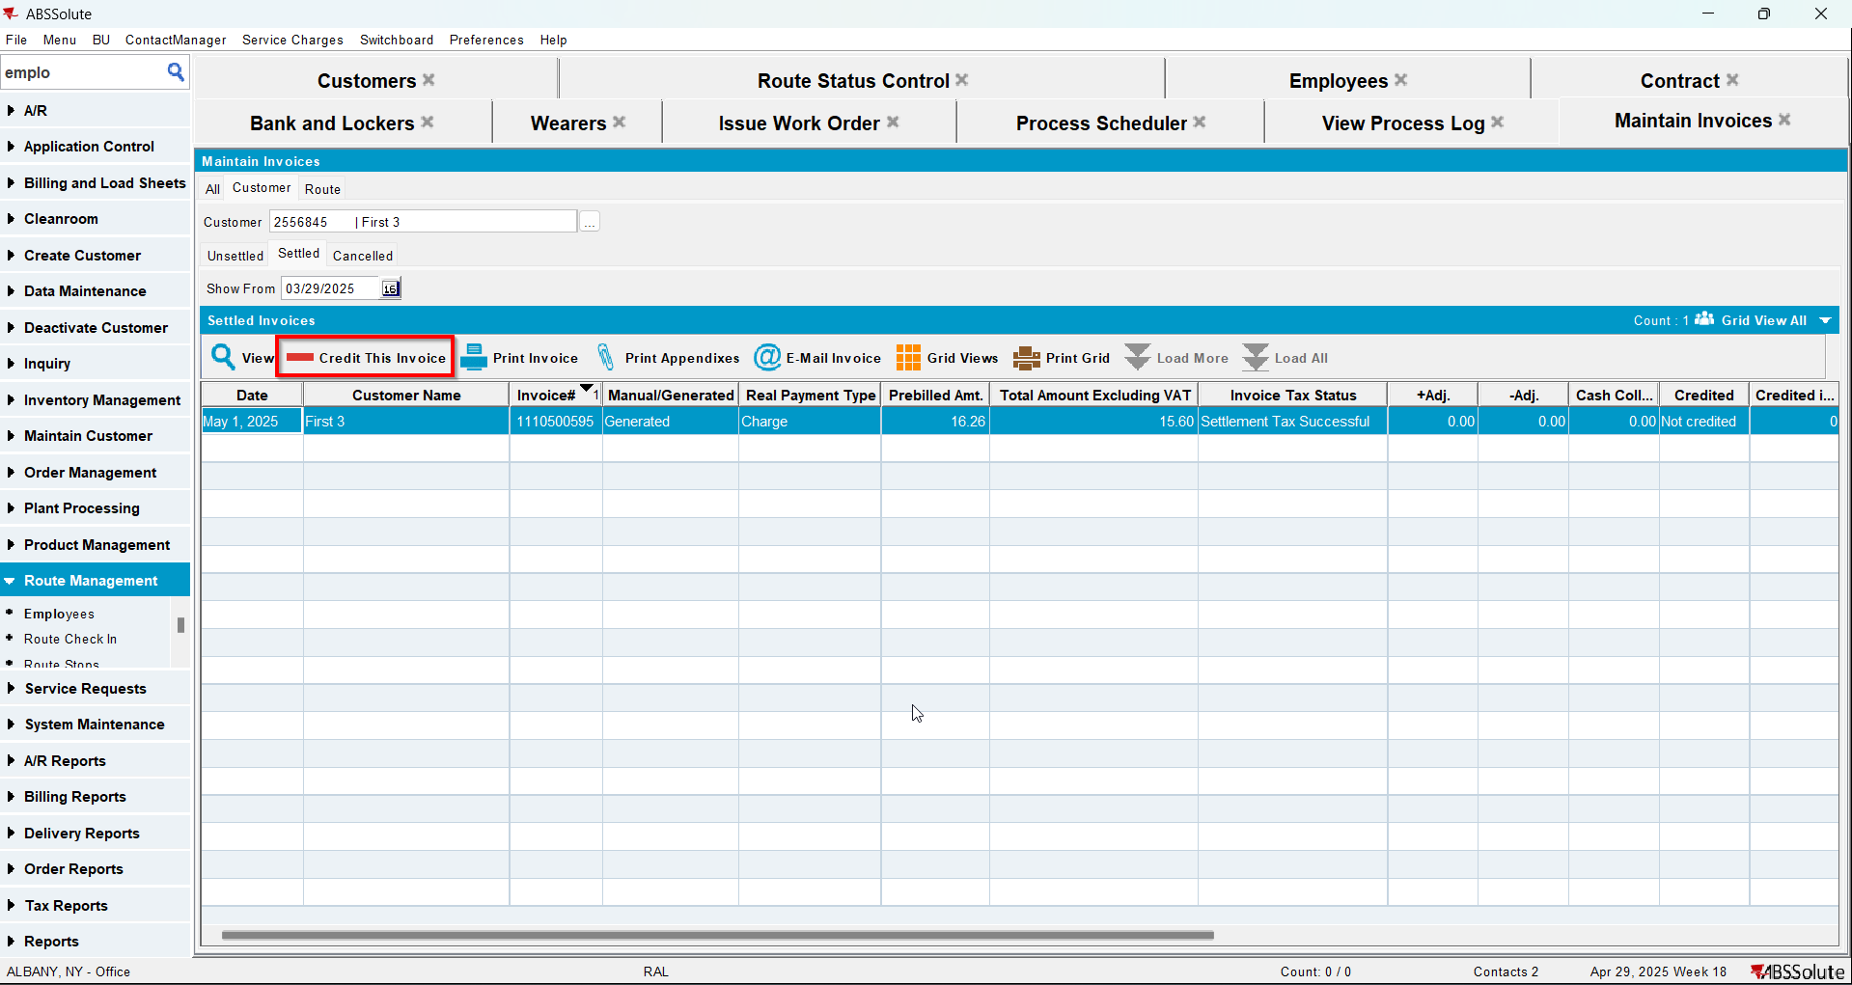
- When Credit Flow pop-up appears uncheck the Assign Invoice to route checkbox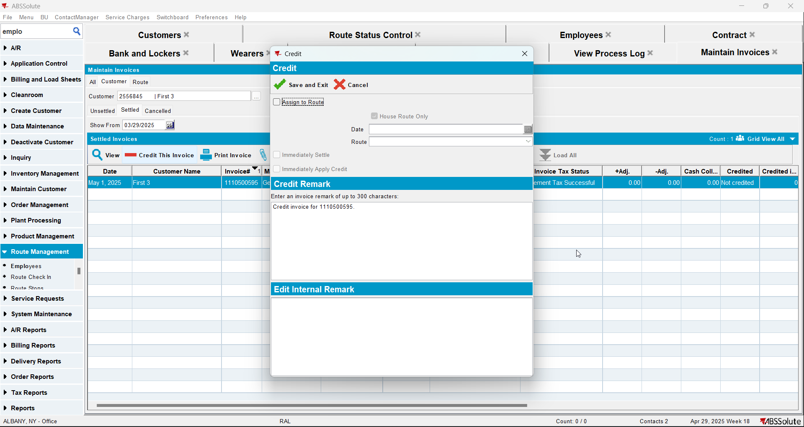
- In View Process Log check the CreditFlowDateUpdates log for the updates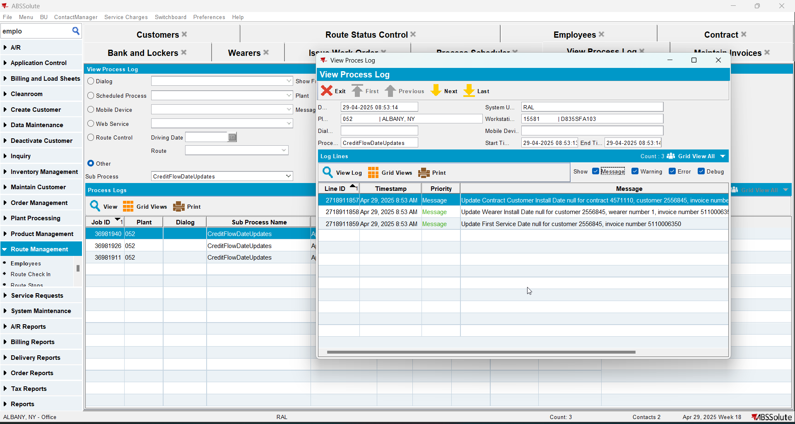
- Check that the Customer - First Service date was deleted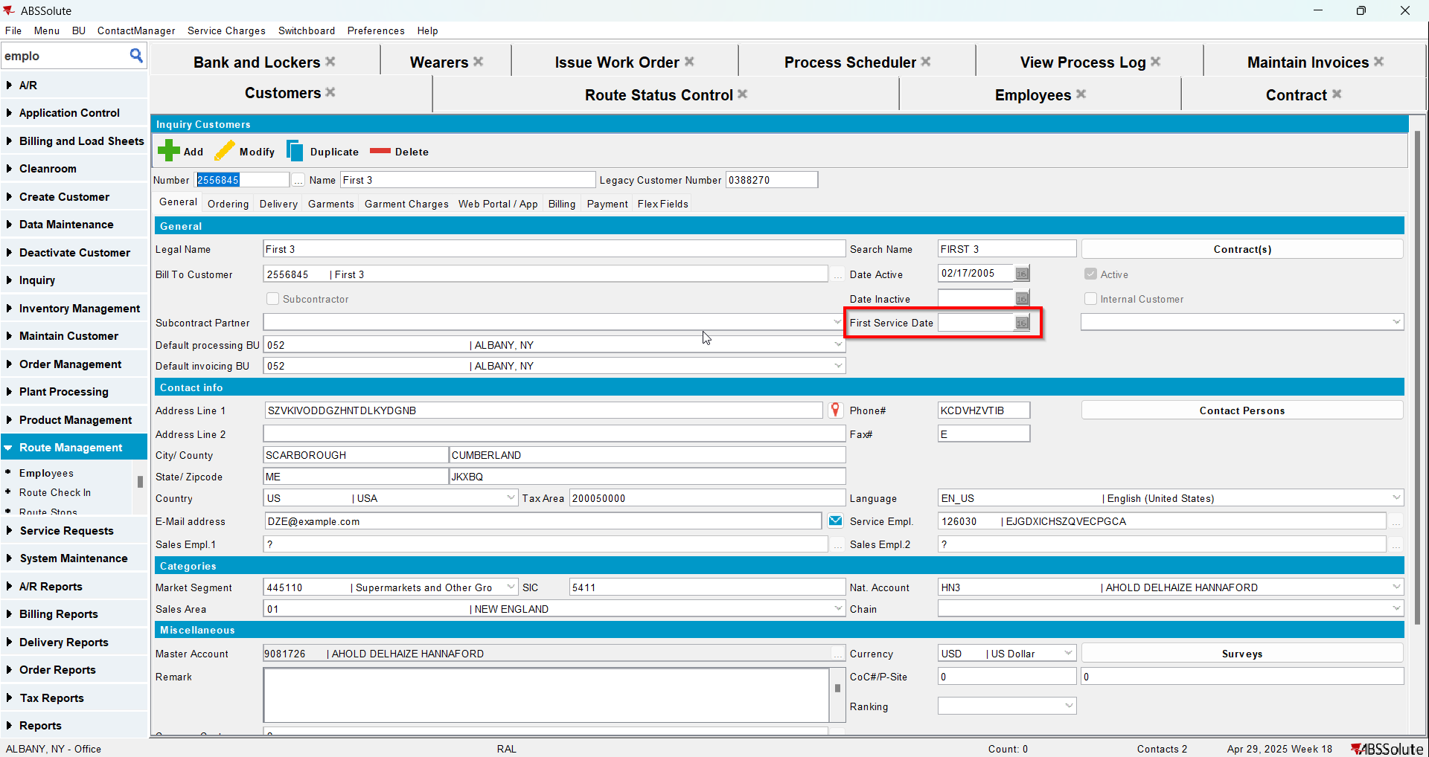
- Check that the Contract - Install date was deleted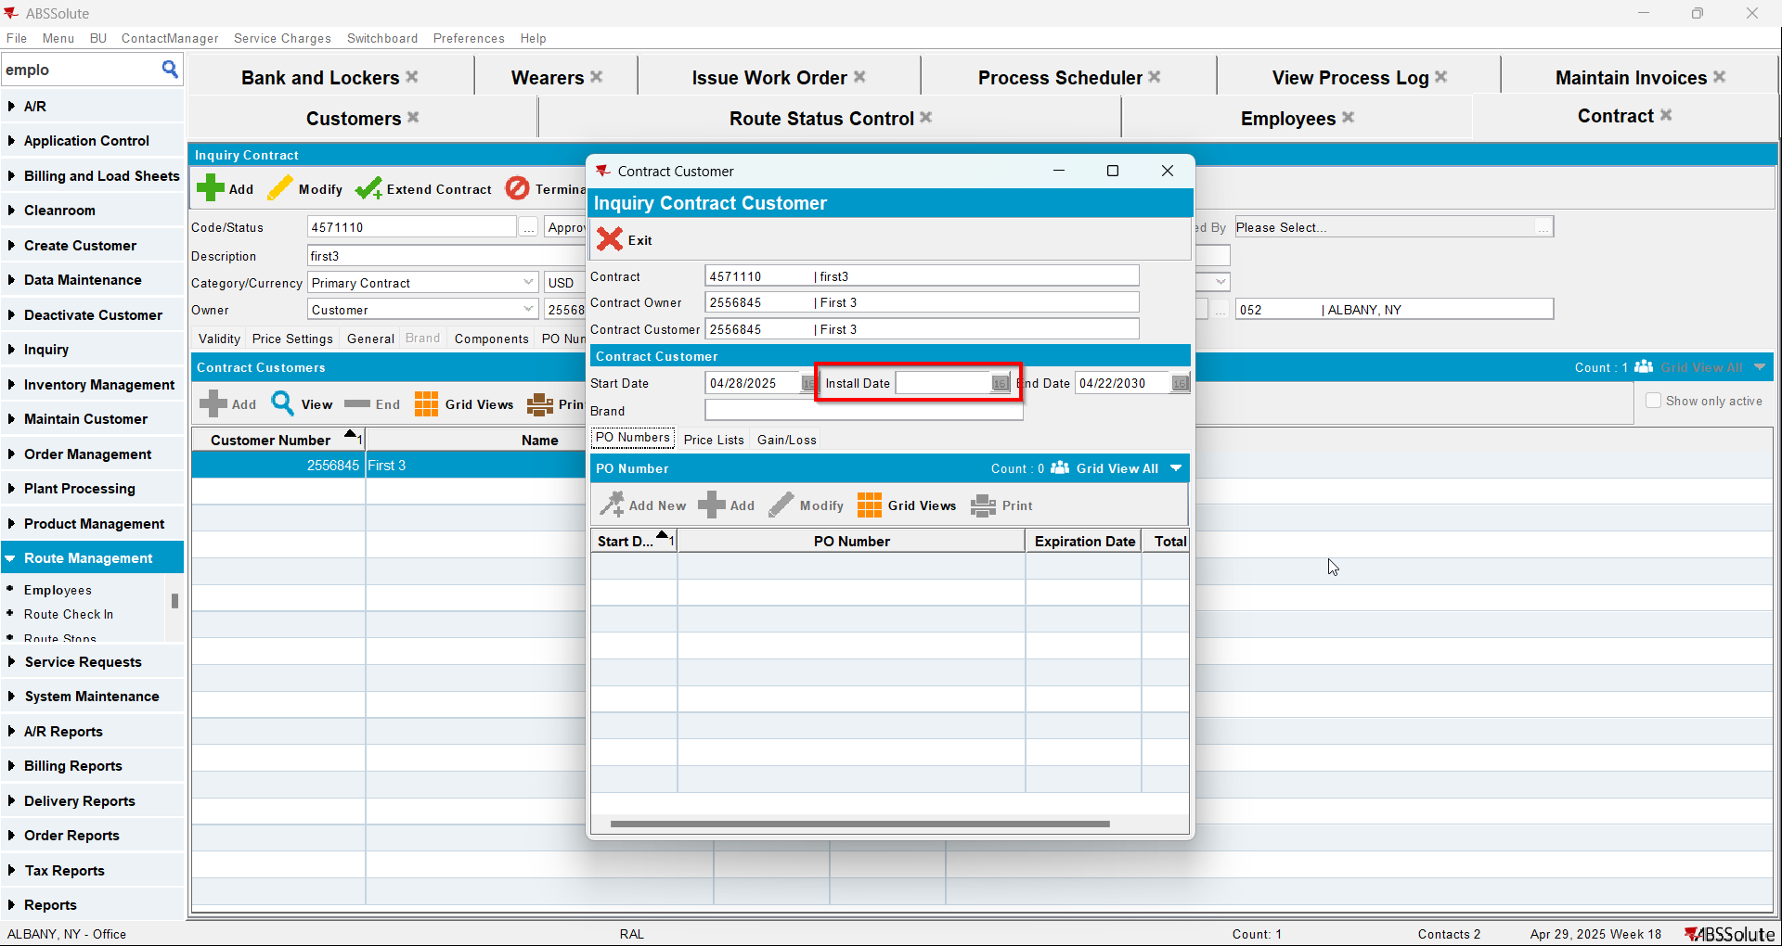
- Check that the Wearer - Install date was deleted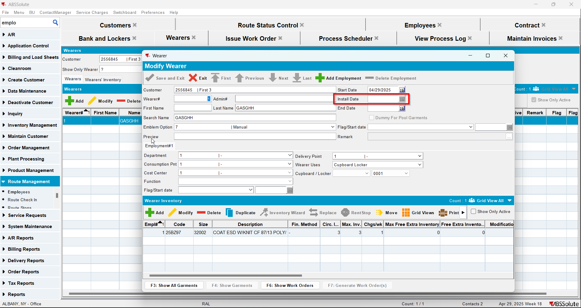
- Maintain Invoices DLG > All Tab > Find the credit invoice and assign it to an empty route (990 + range)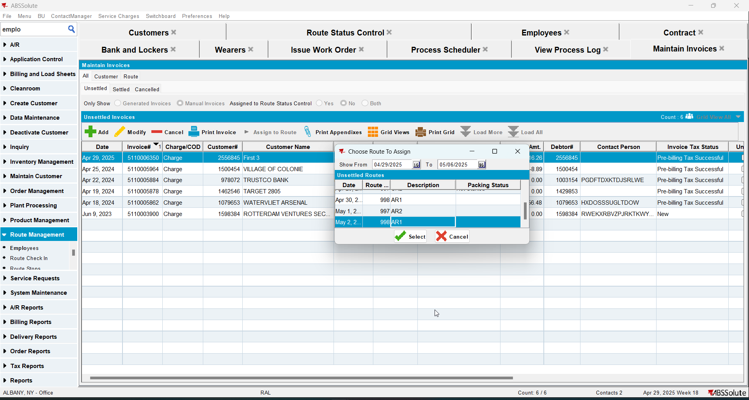
- Route Status Control DLG: Find the route where the credit invoice was assigned and generate invoices for it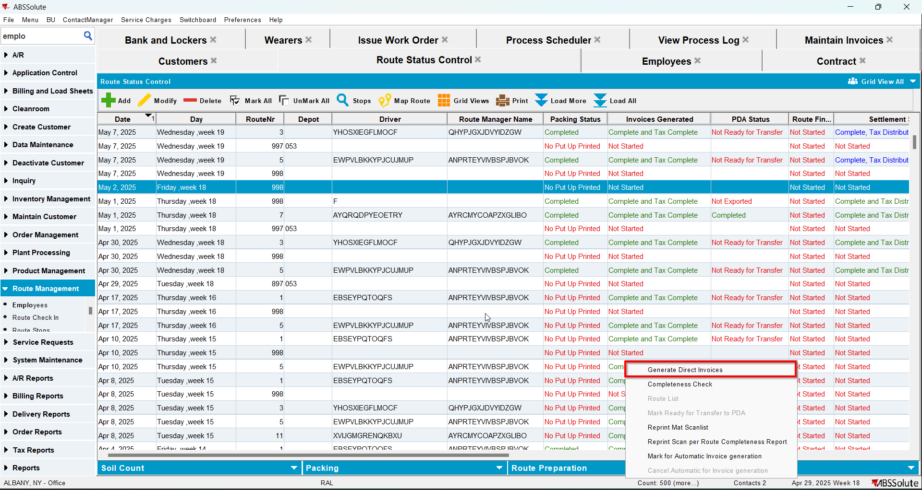
- Route Status Control DLG: For the same route click on settle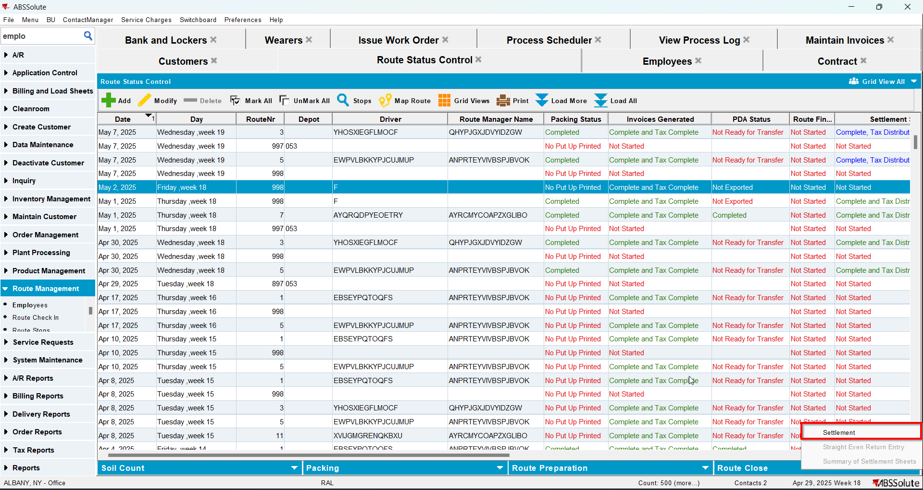
- Route Status Control DLG: Add next week's route
- Generate the invoice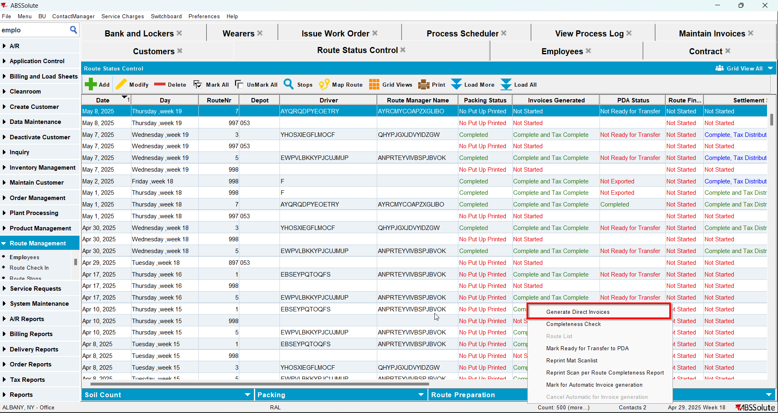
- Tax the invoice
- Send the route to RA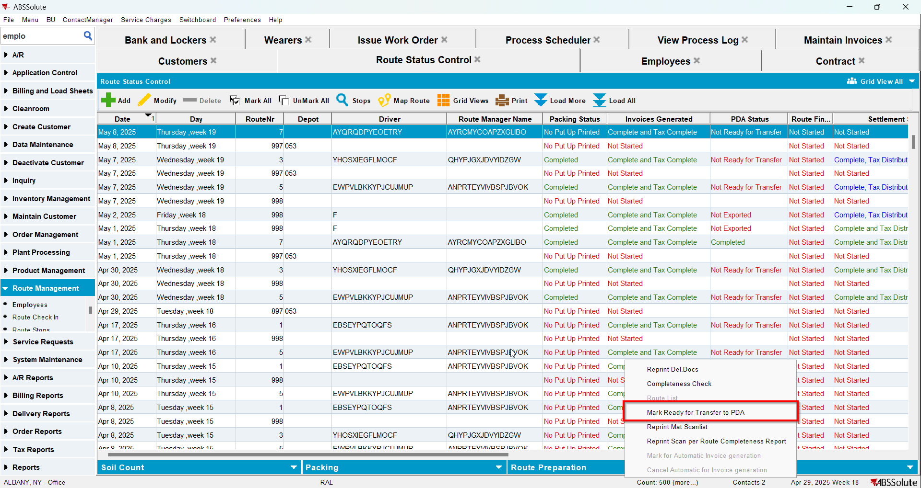
- Finish the route and upload it
- On WebX settle the route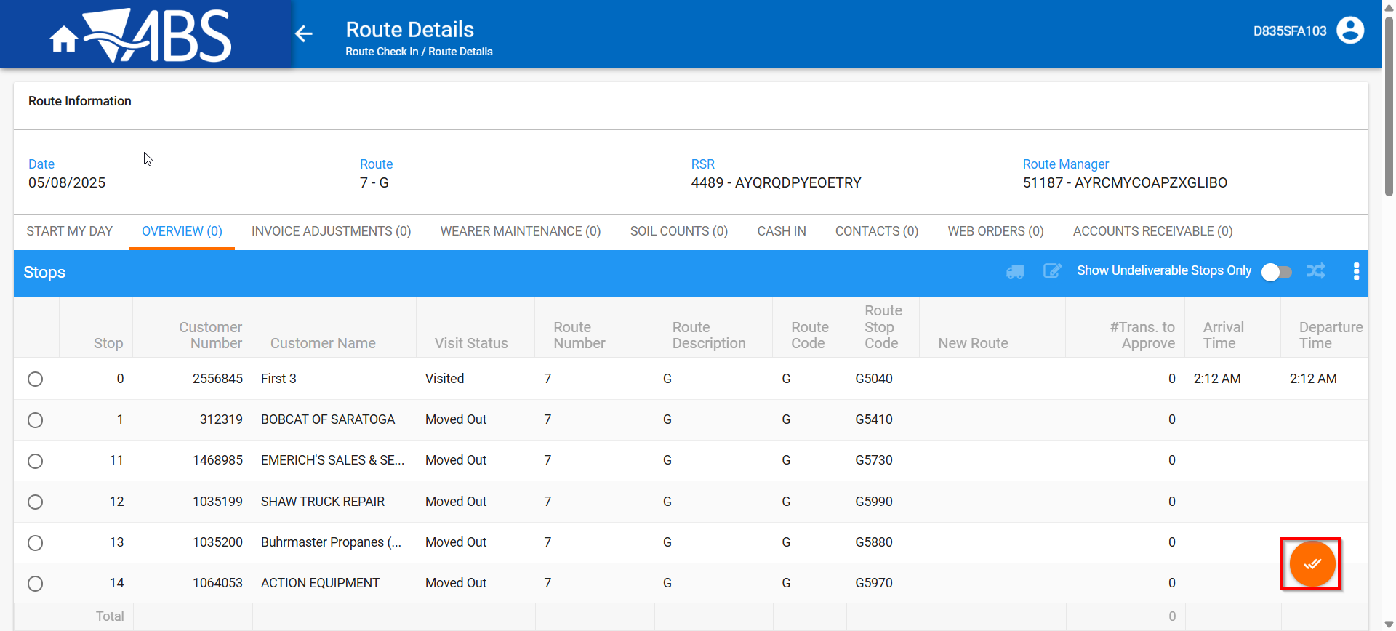
- In View Process Log check the Settlement log for the updates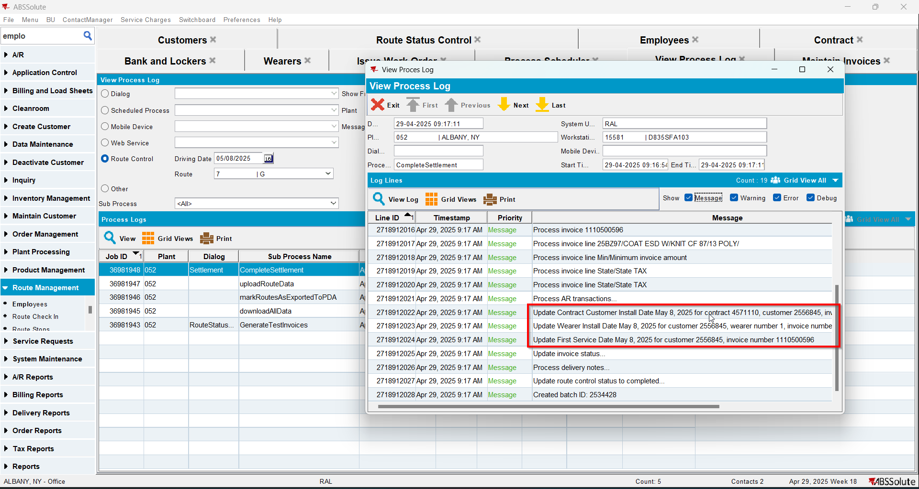
- Check that the Customer - First Service date was updated.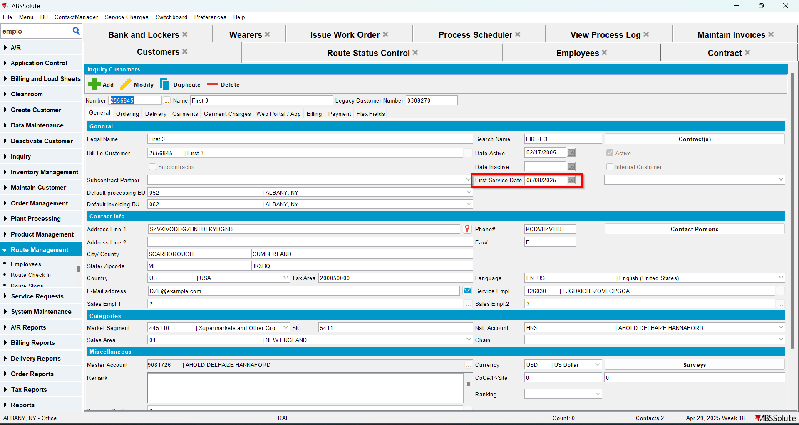
- Check that the Contract - Install date was updated.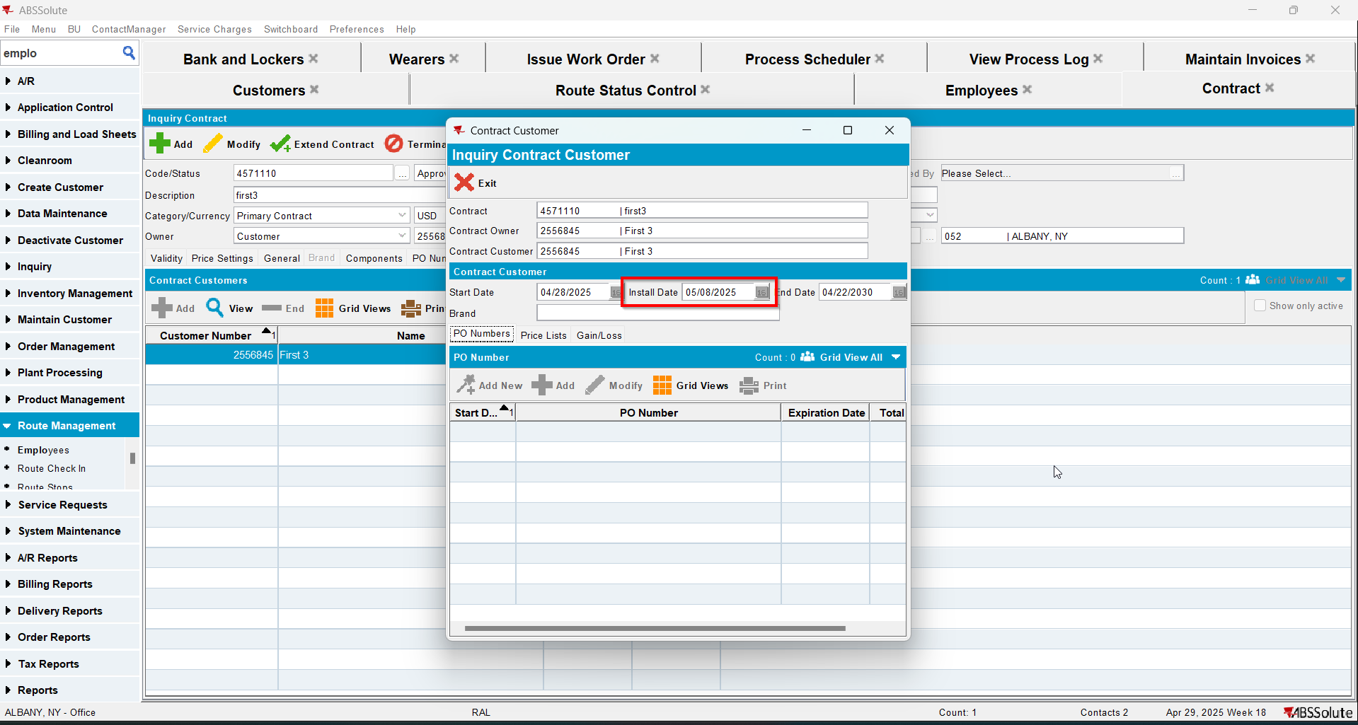
- Check that the Wearer - Install date was updated.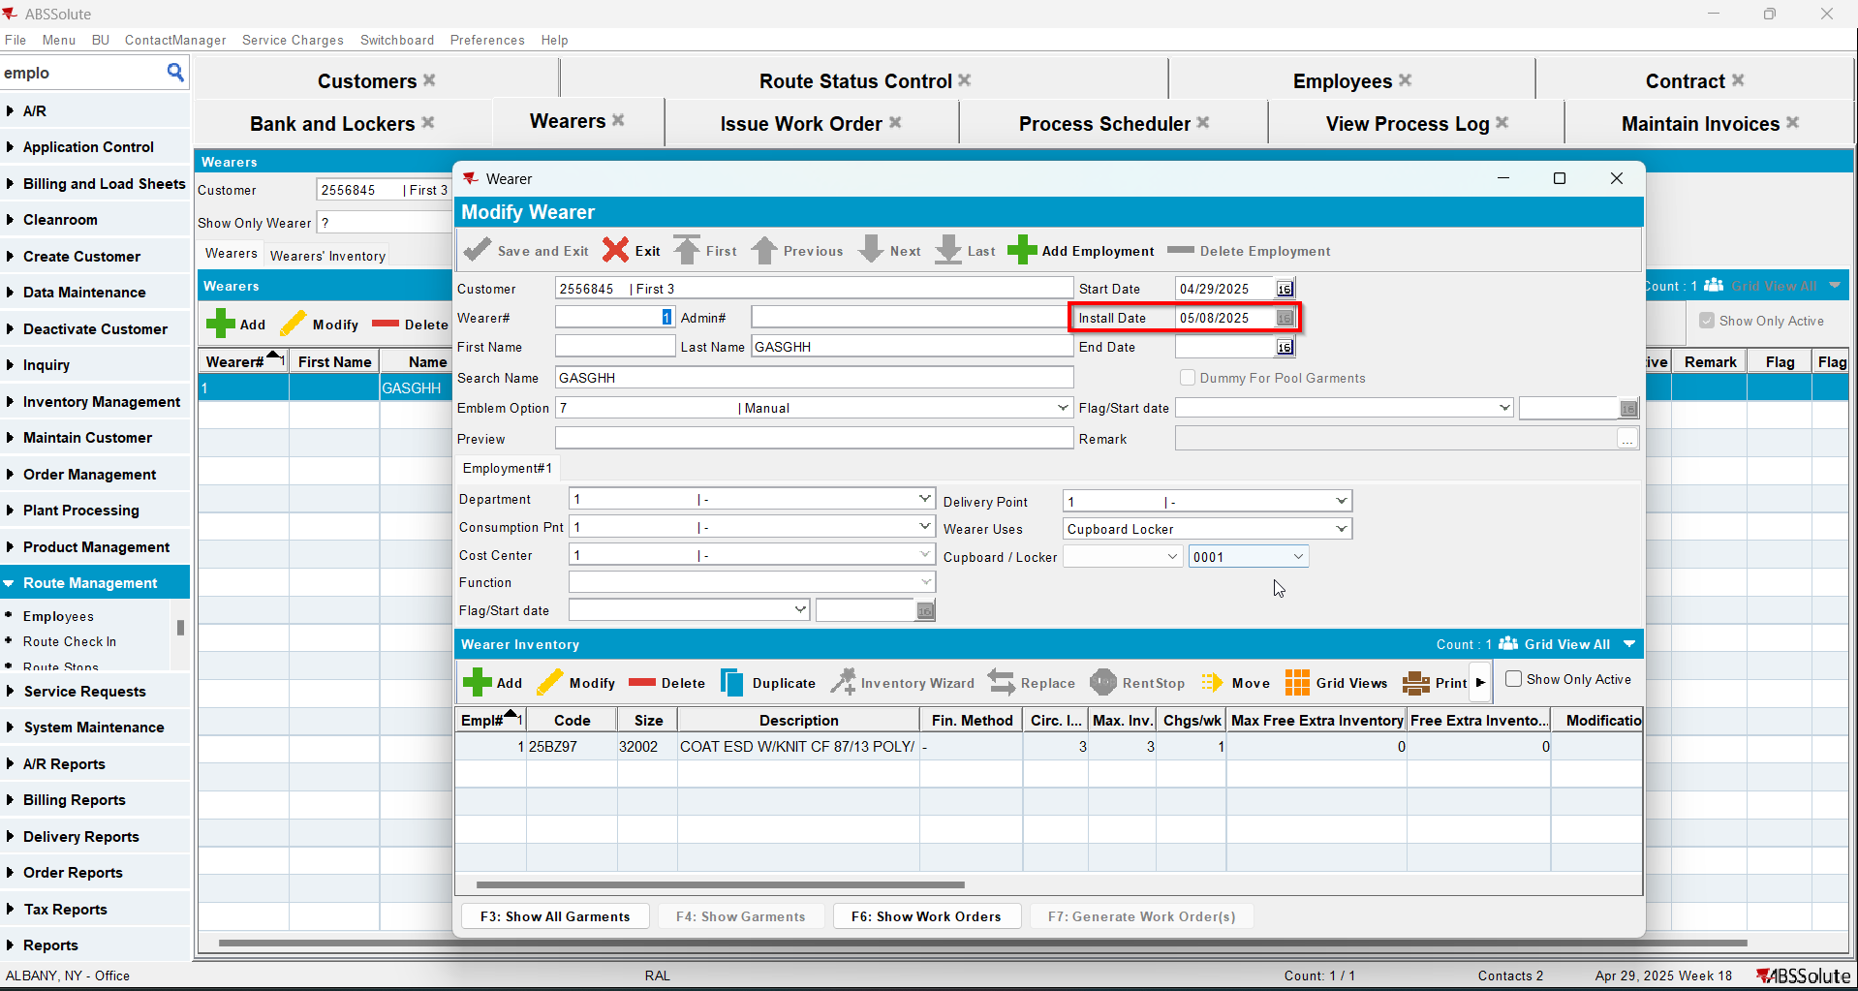

Test Case 4 – Settle on WebX and credit with settle now – Tested OK
Expected behavior: The updates for the first service log and install date will appear in the log.
Hash: 9a17455
- Add a new customer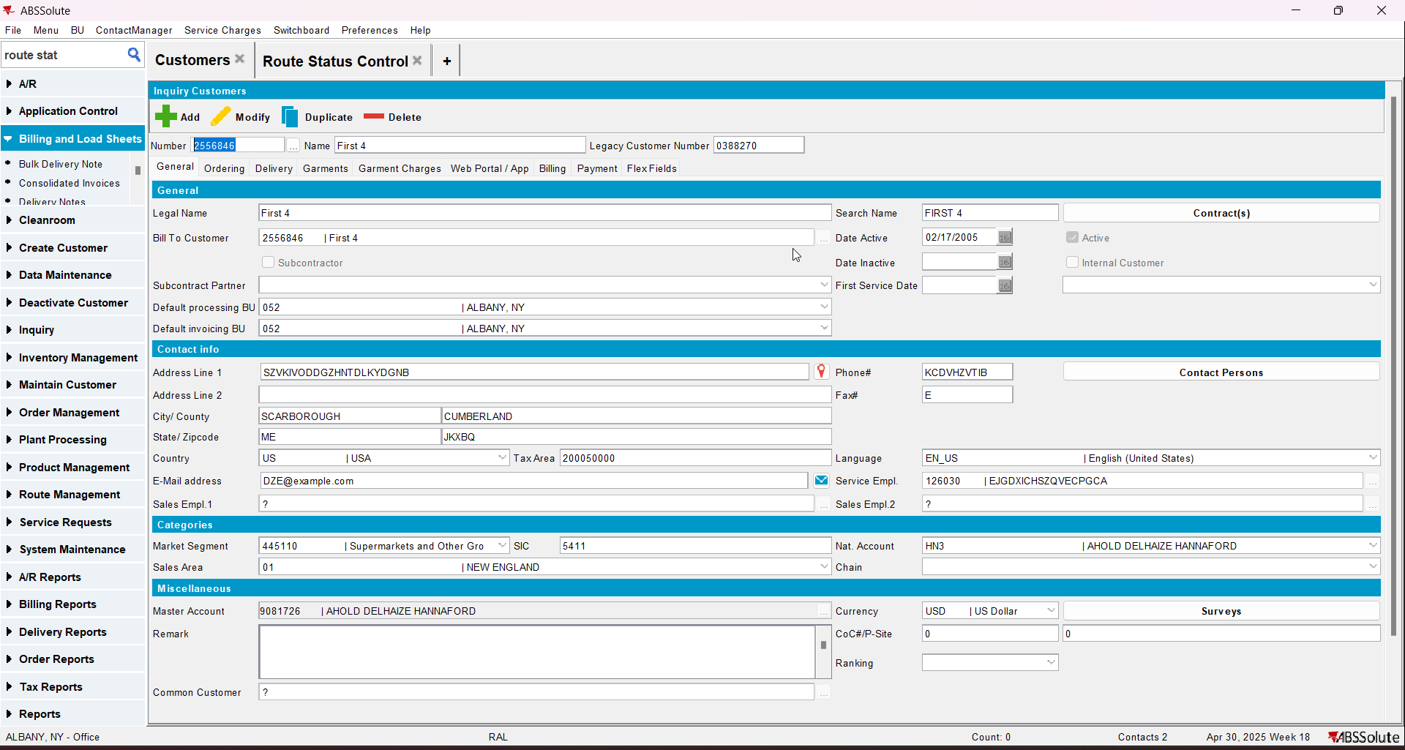
- Add a new contract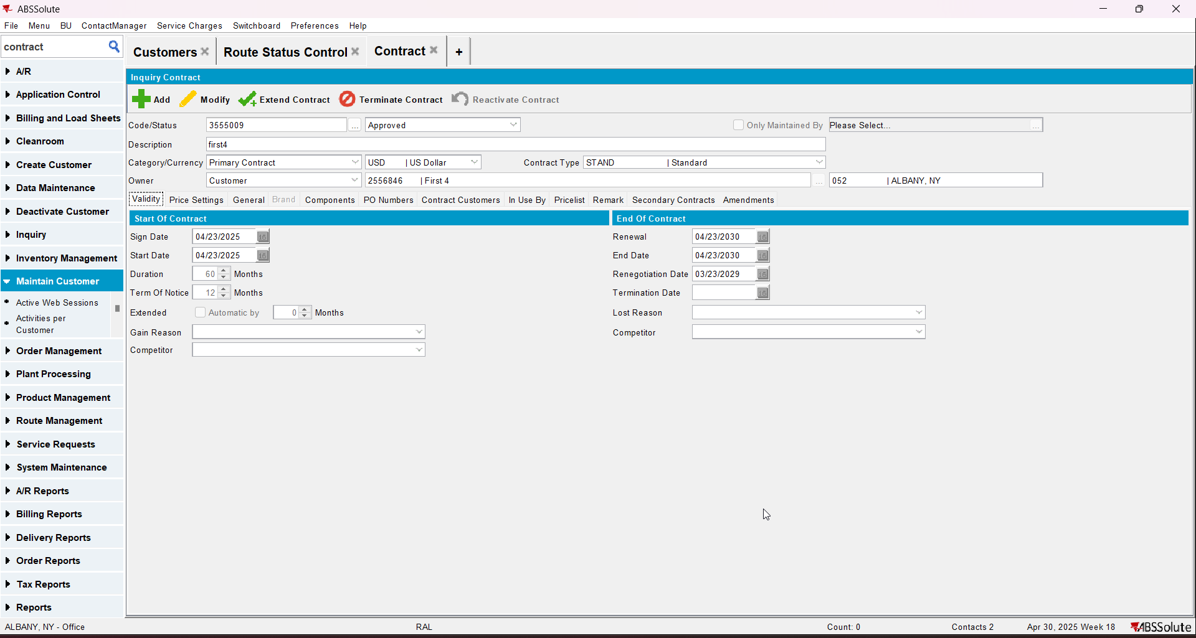
- Add a garment to contract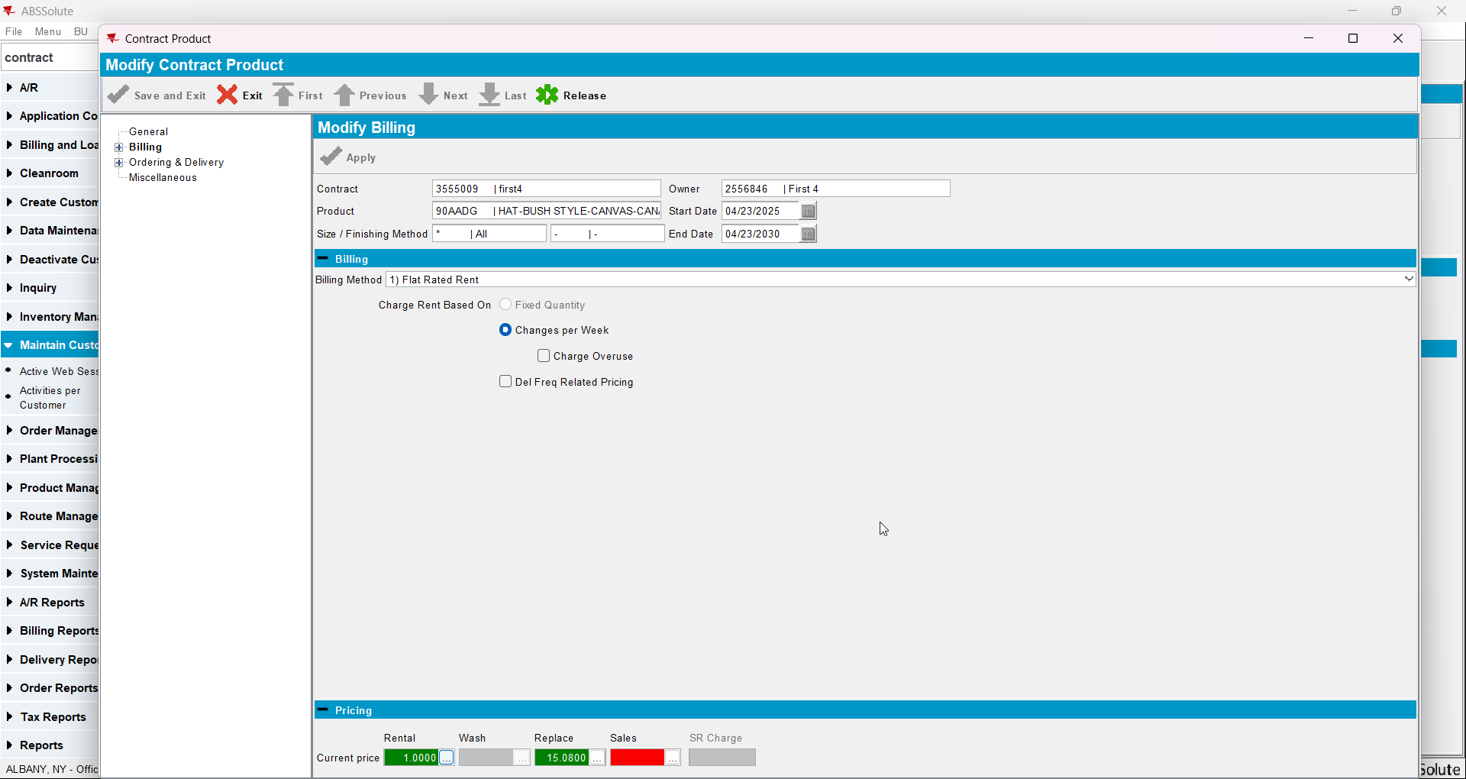
- Add the new customer to contract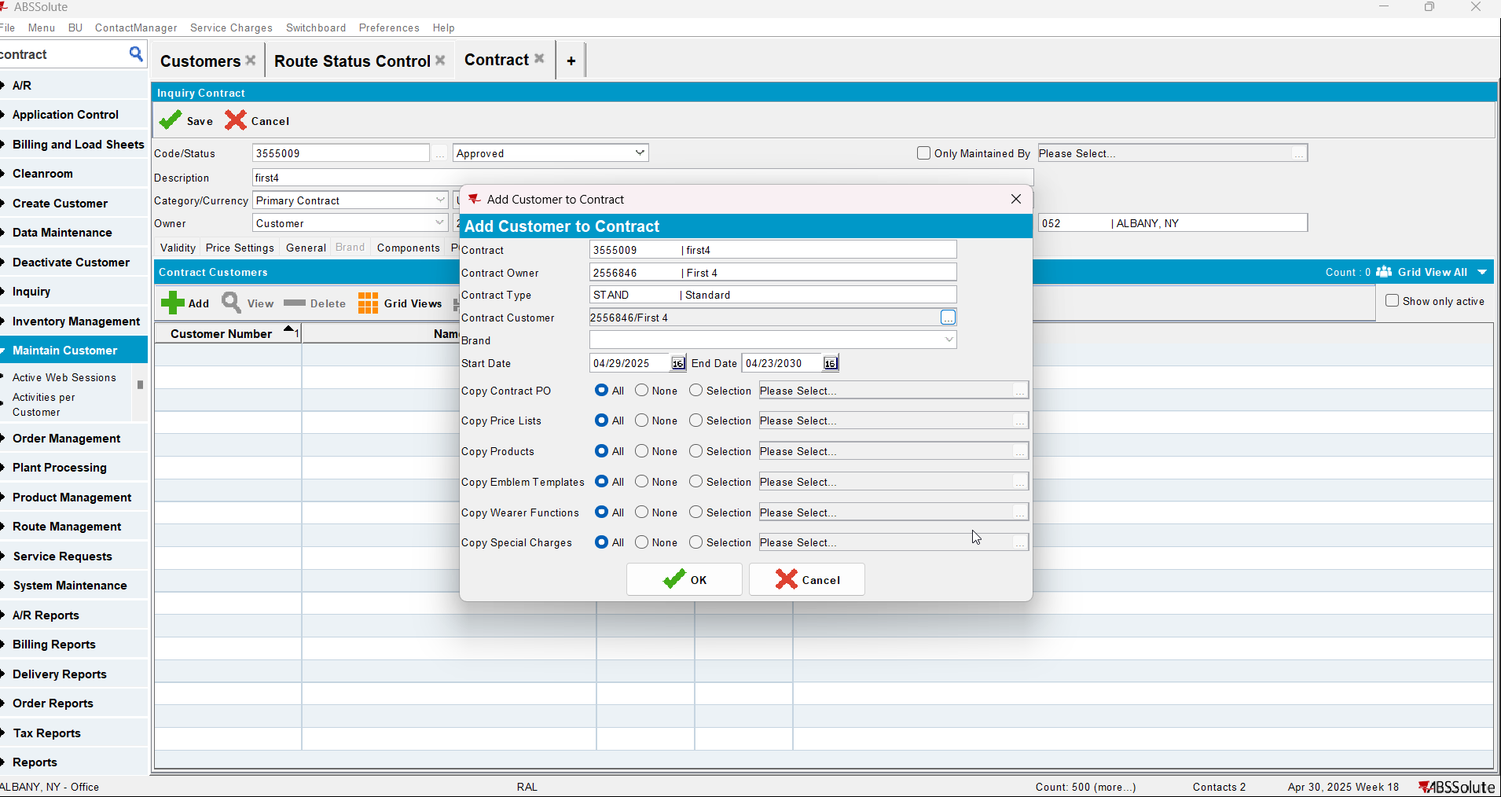
- Add new lockers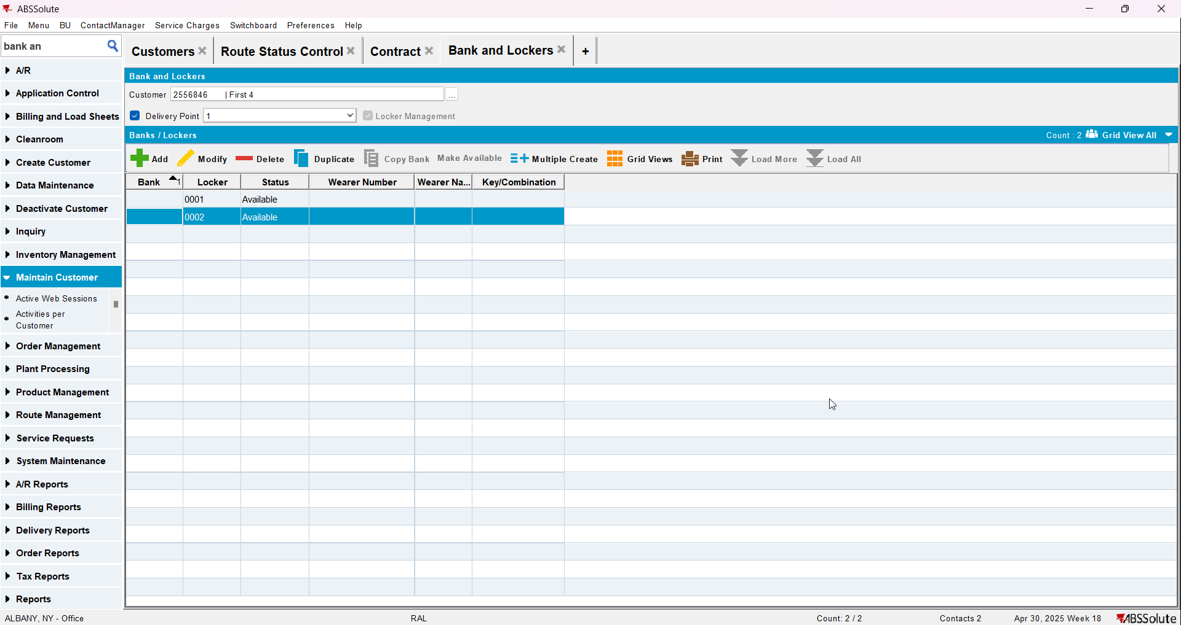
- Add a wearer with a wearer inventory
- Generate work order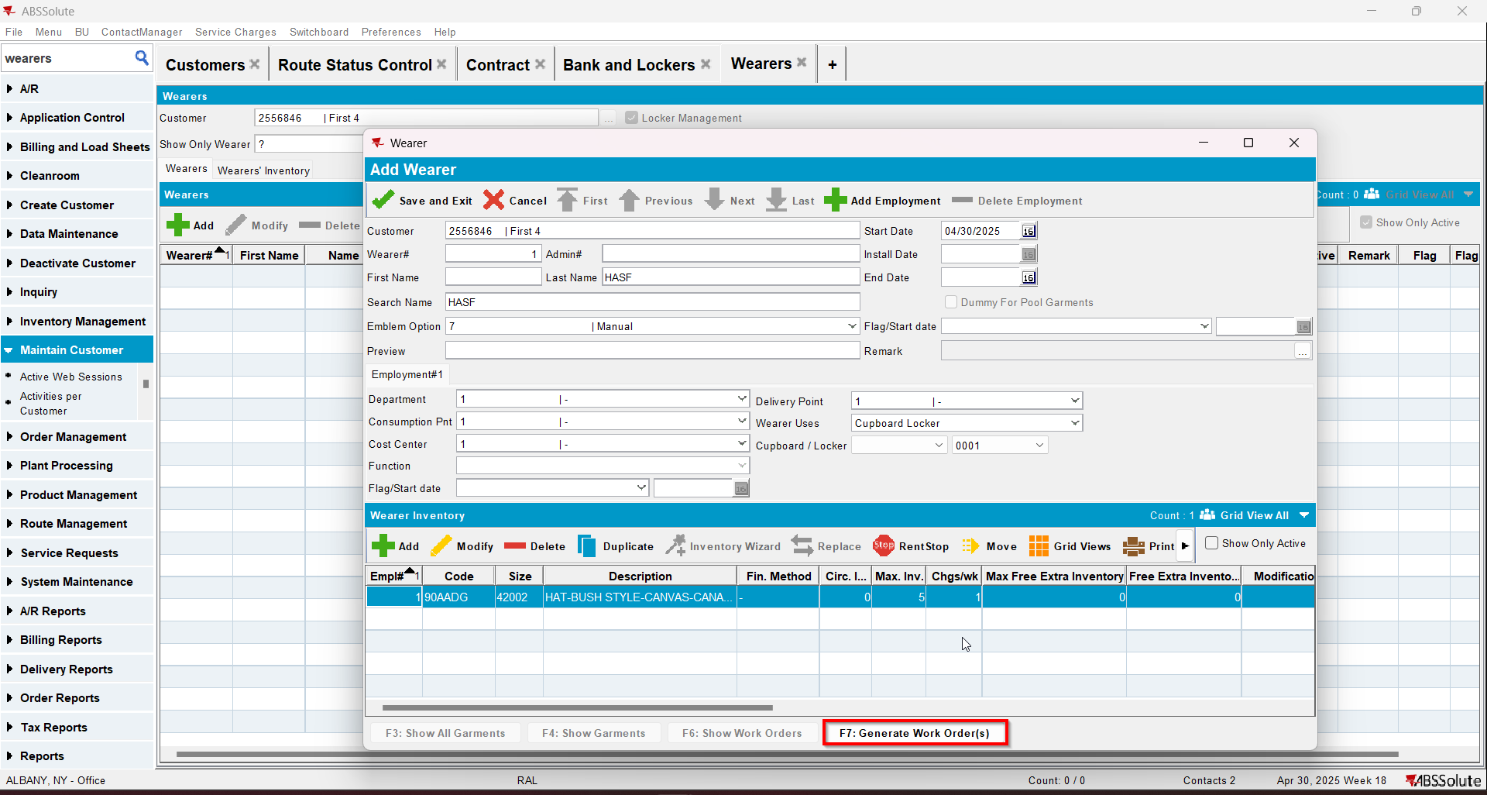
- Issue the work order and generate the delivery note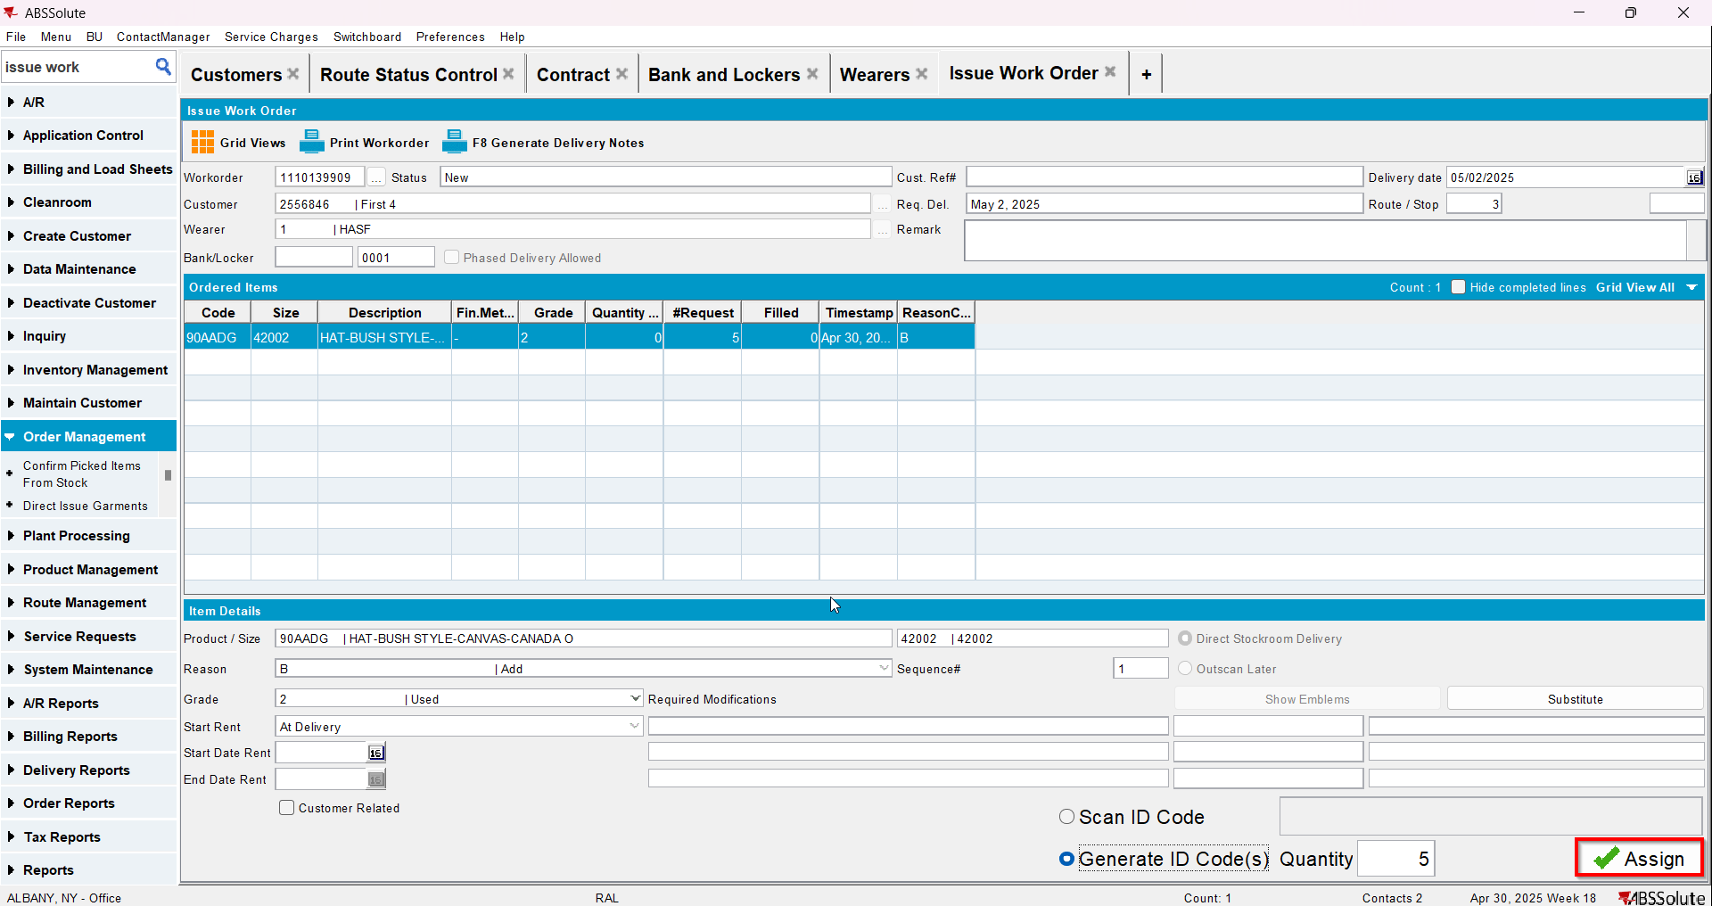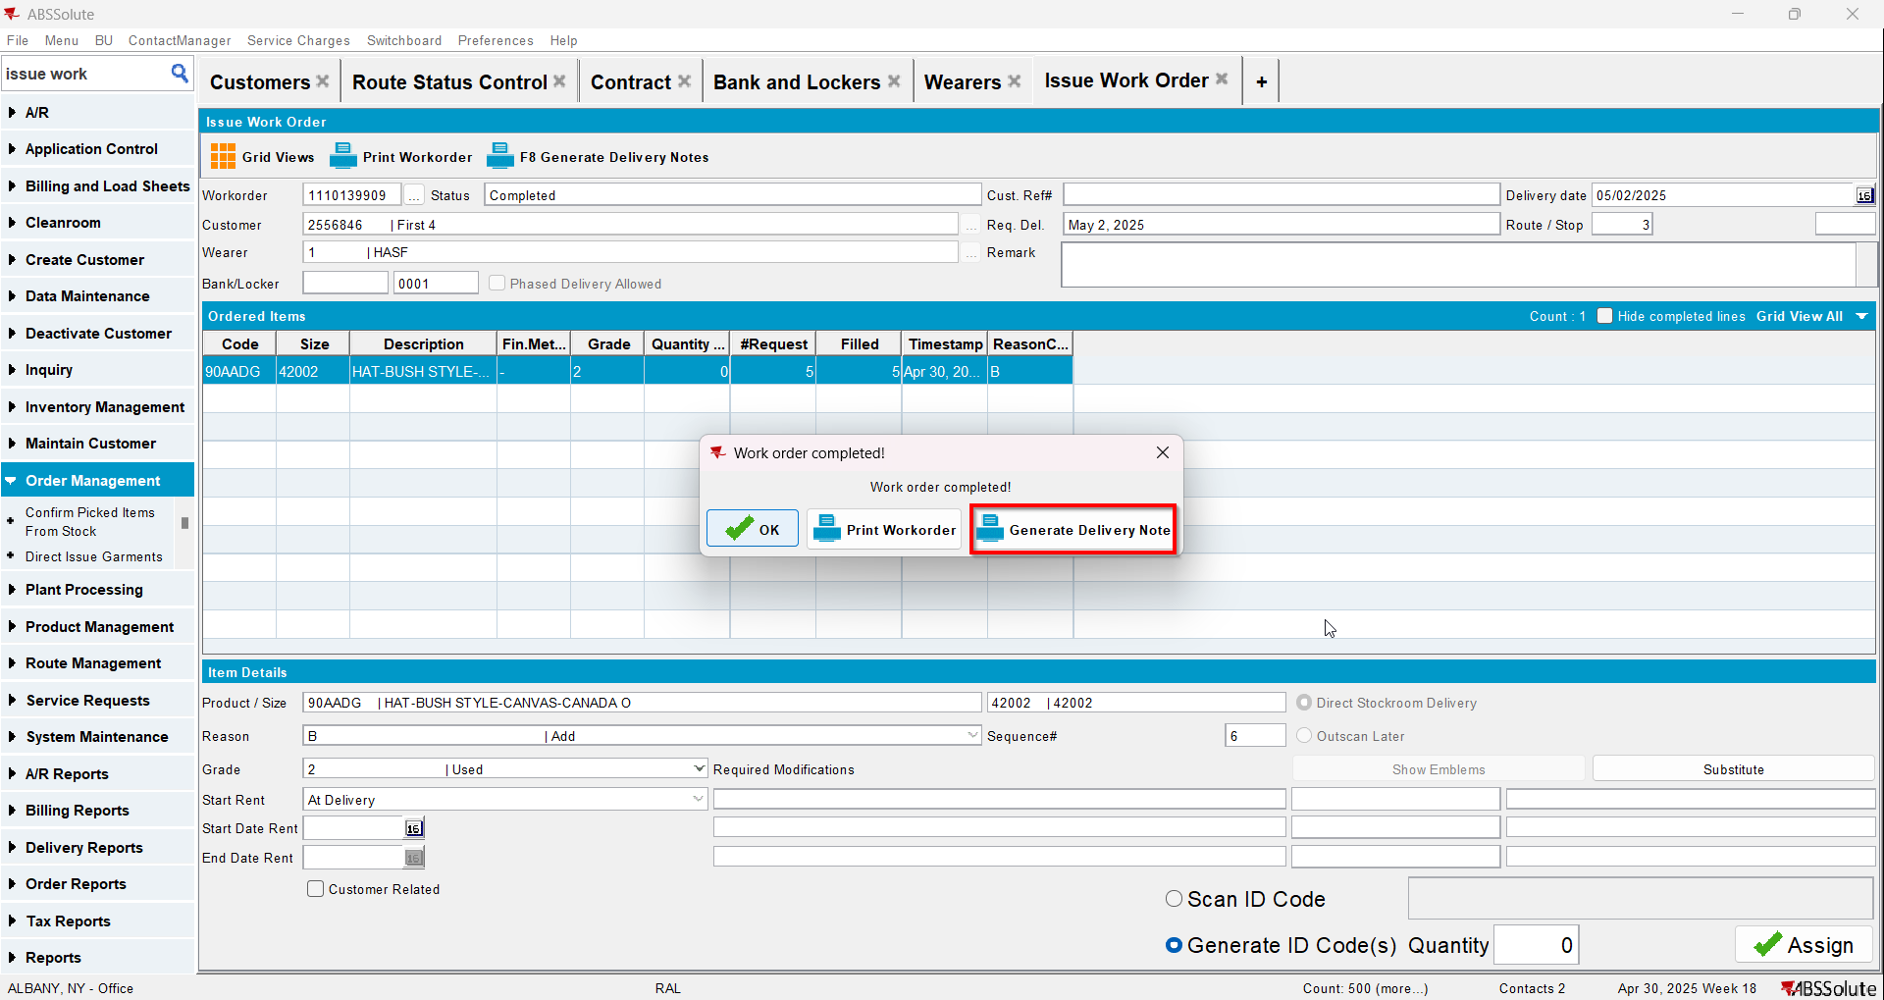
- Add the next route for the customer
- Generate the invoice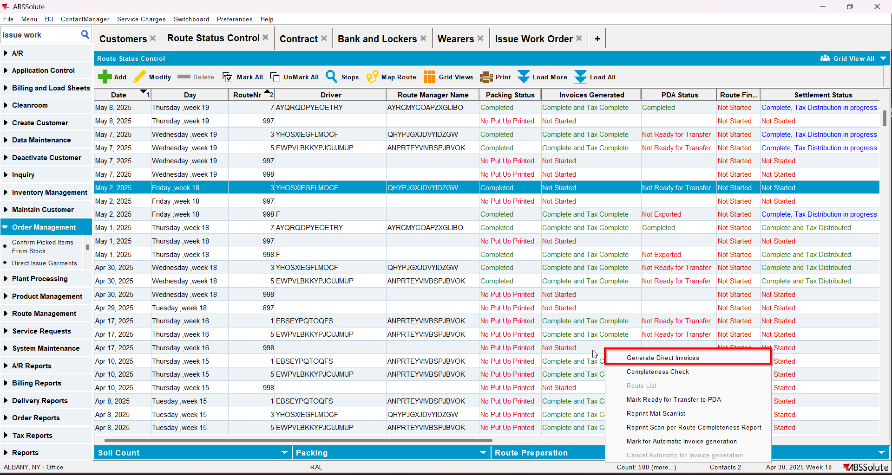
- Tax the invoice
- Send the route to RA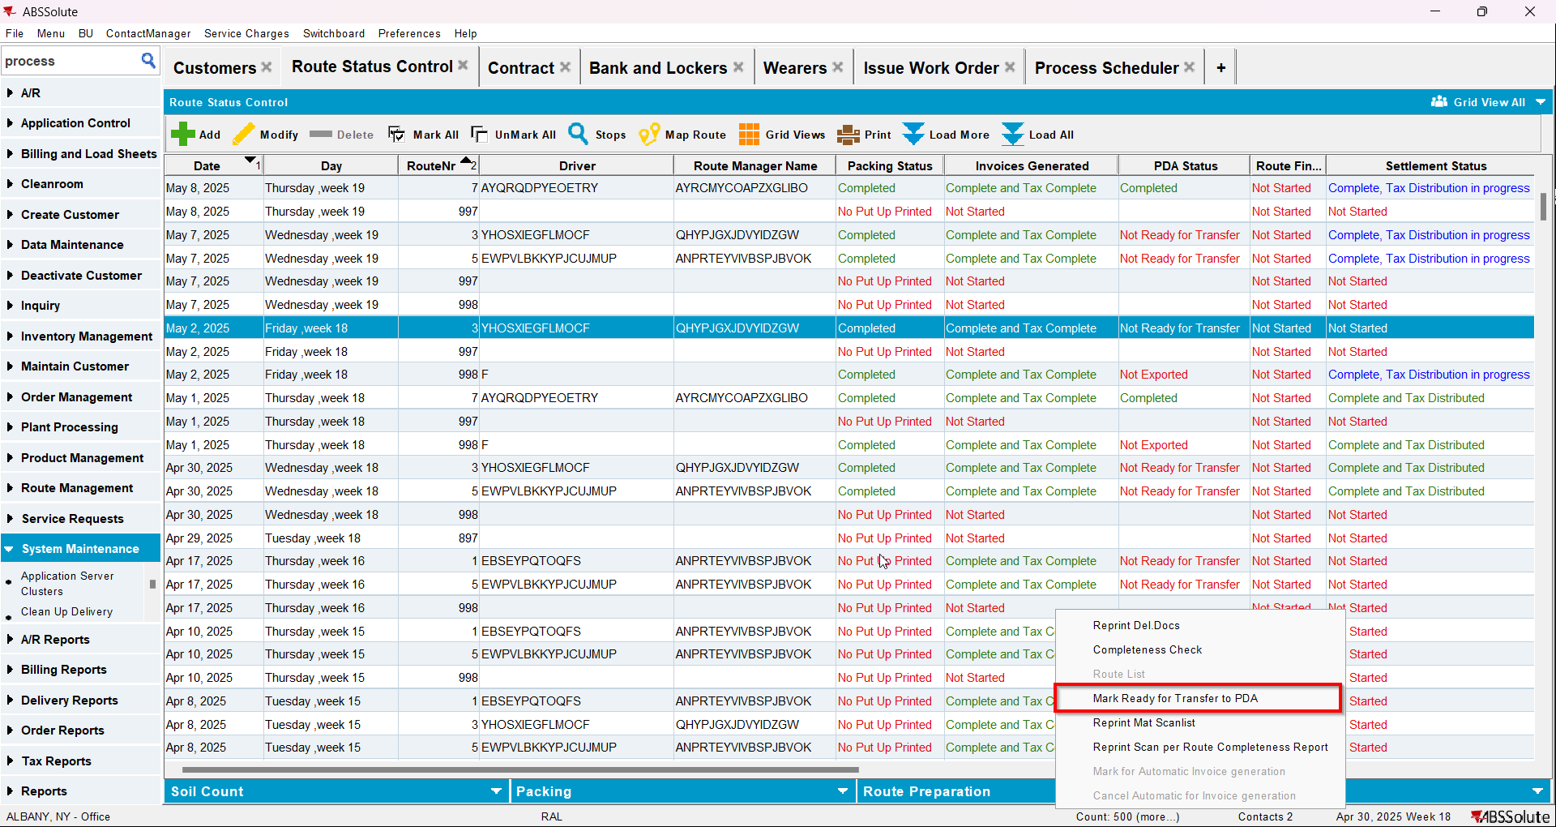
- Finish the route and upload it
- On WebX settle the route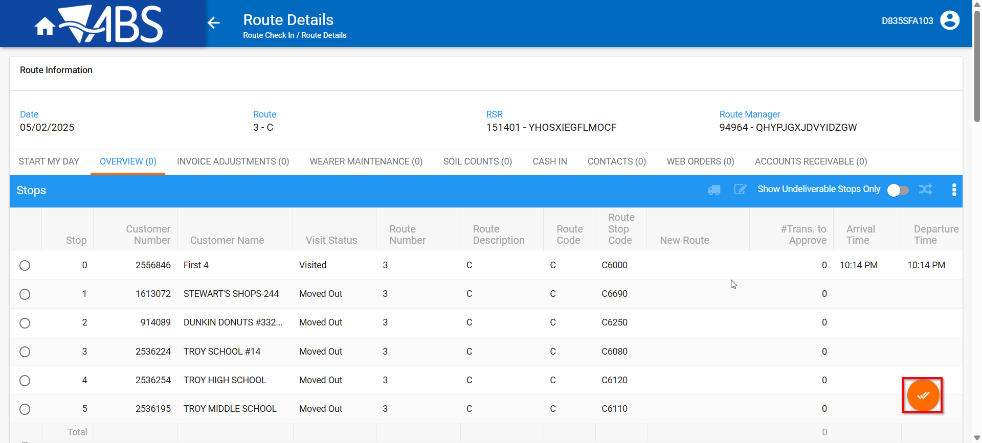
- In View Process Log check the Settlement log for the updates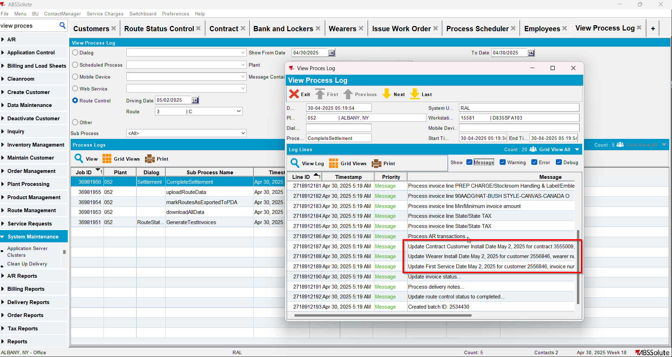
- Check that the Customer - First Service date was updated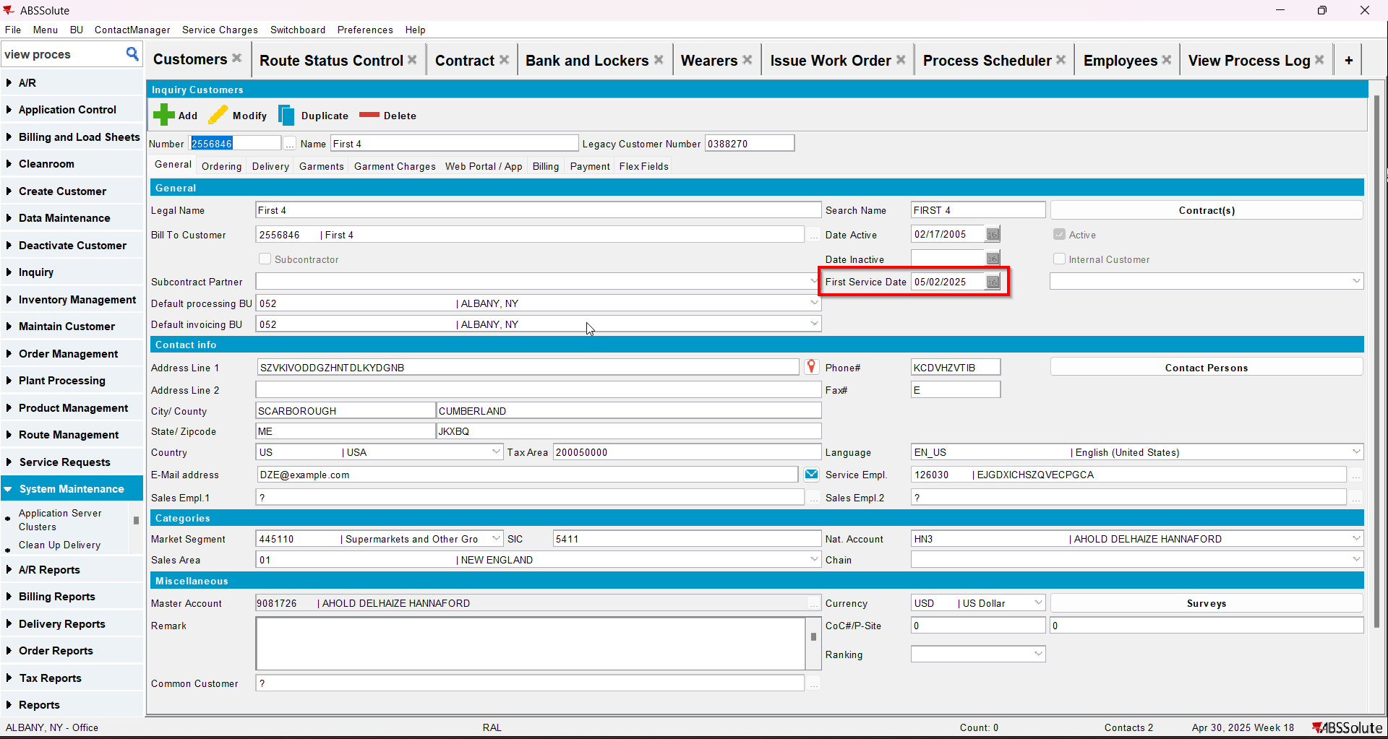
- Check that the Contract - Install date was updated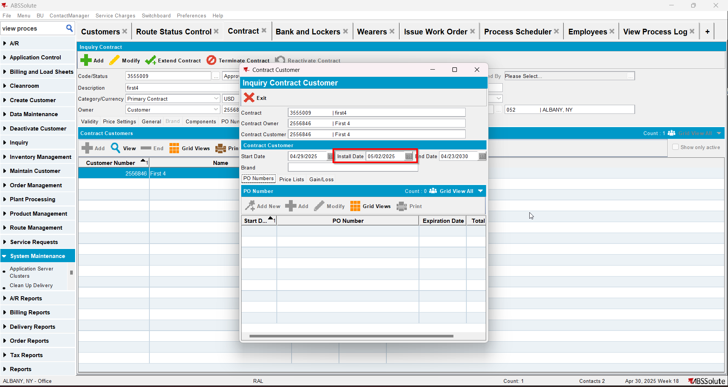
- Check that the Wearer - Install date was updated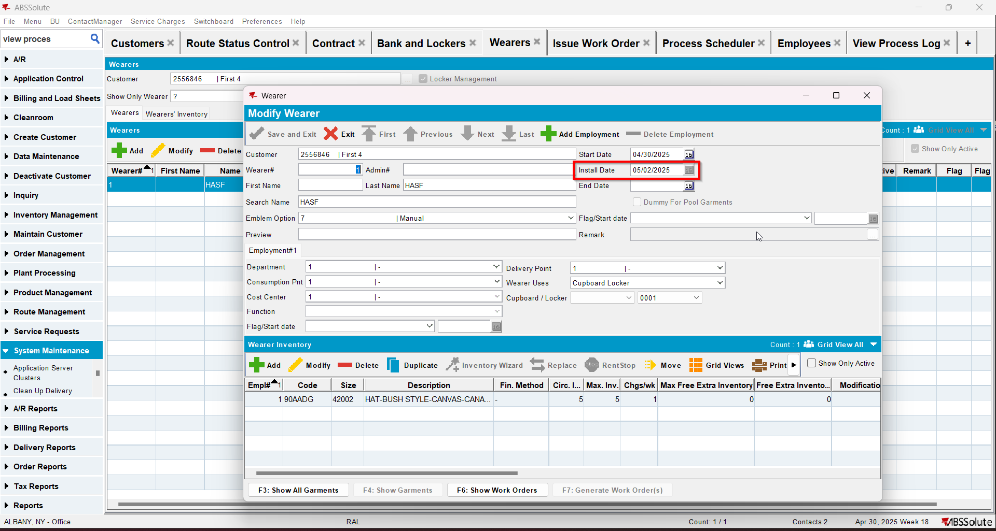
- Script in the Tax distribution data
- Process scheduler: run the process scheduler to distribute the tax
- Maintain Invoices DLG: Find the settled invoice and click on the credit invoice button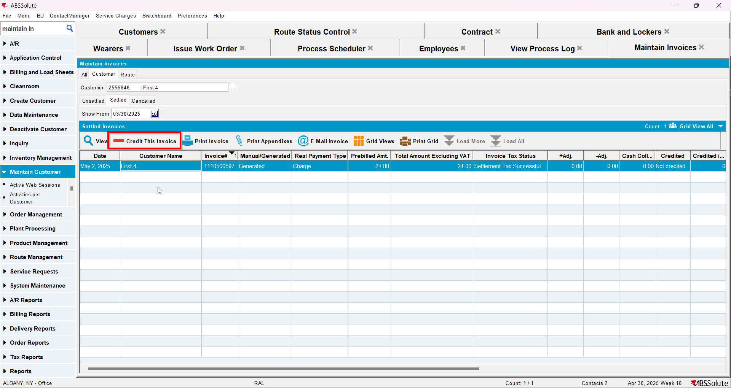
- When Credit Flow pop-up appears check the Assign Invoice to route checkbox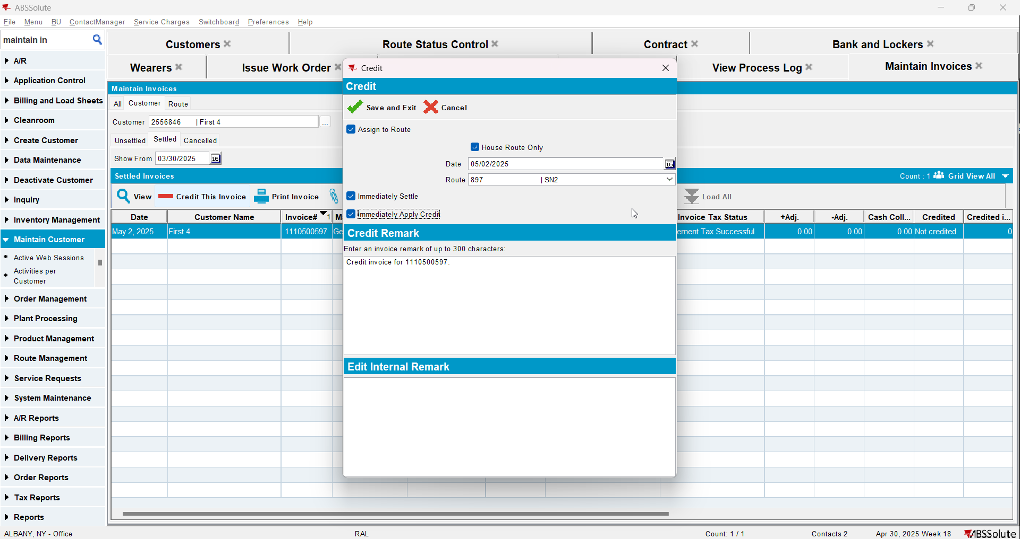
- In View Process Log check the CreditFlowDateUpdates log for the updates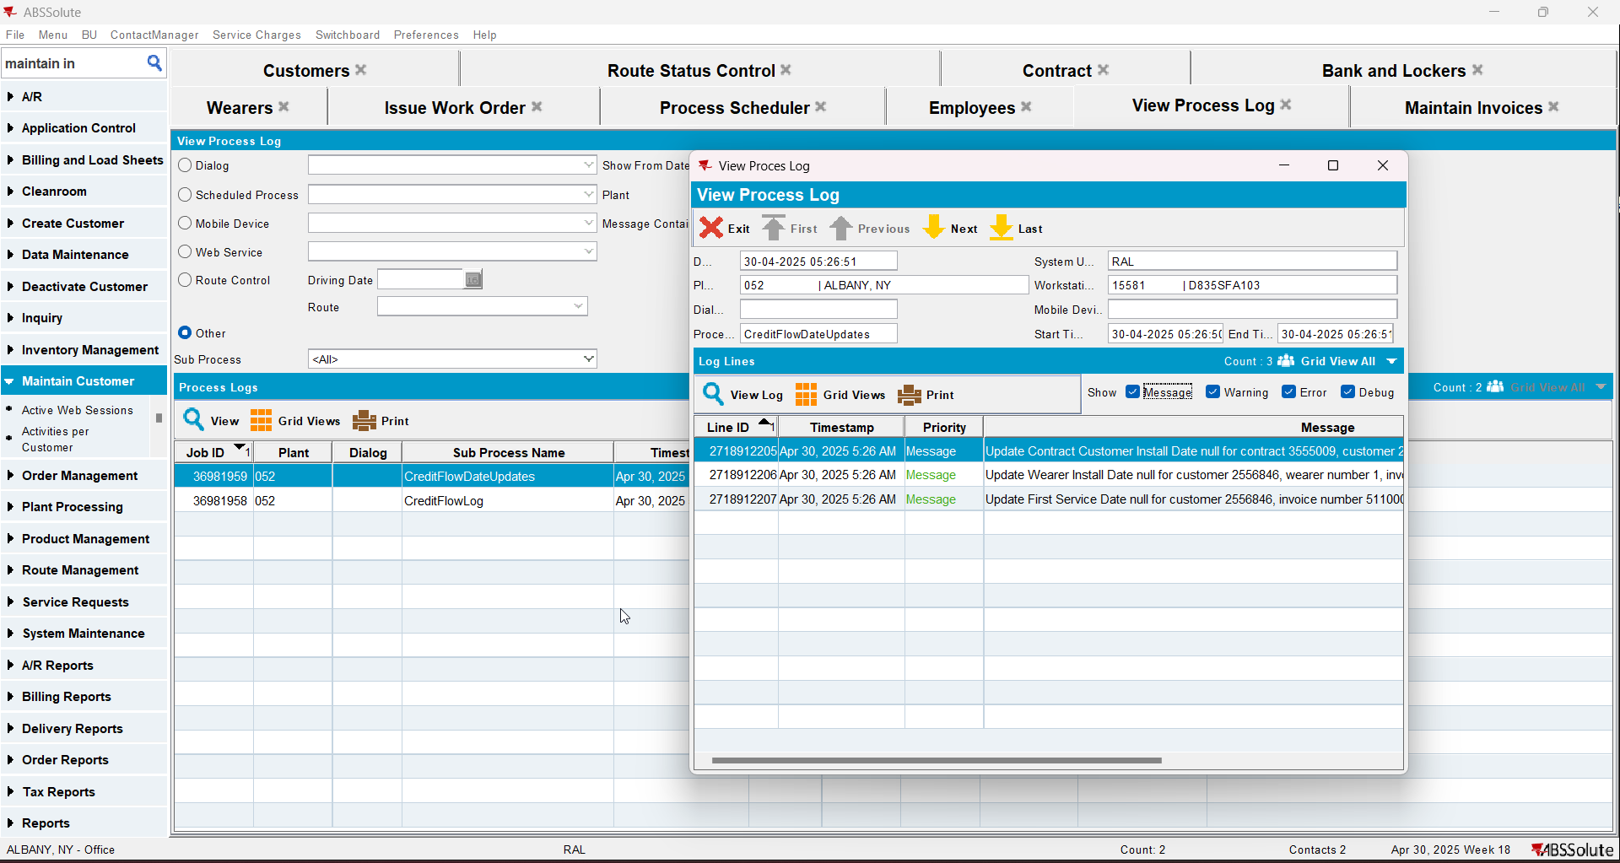
- Check that the Customer - First Service date was deleted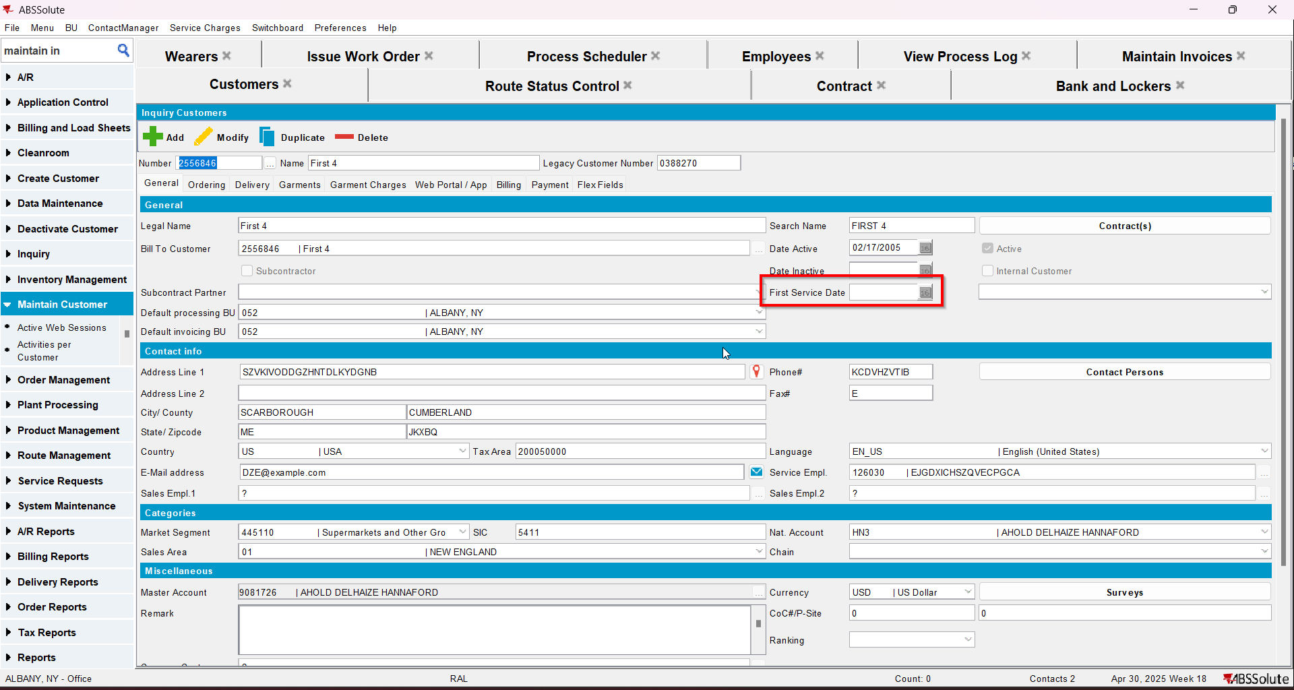
- Check that the Contract - Install date was deleted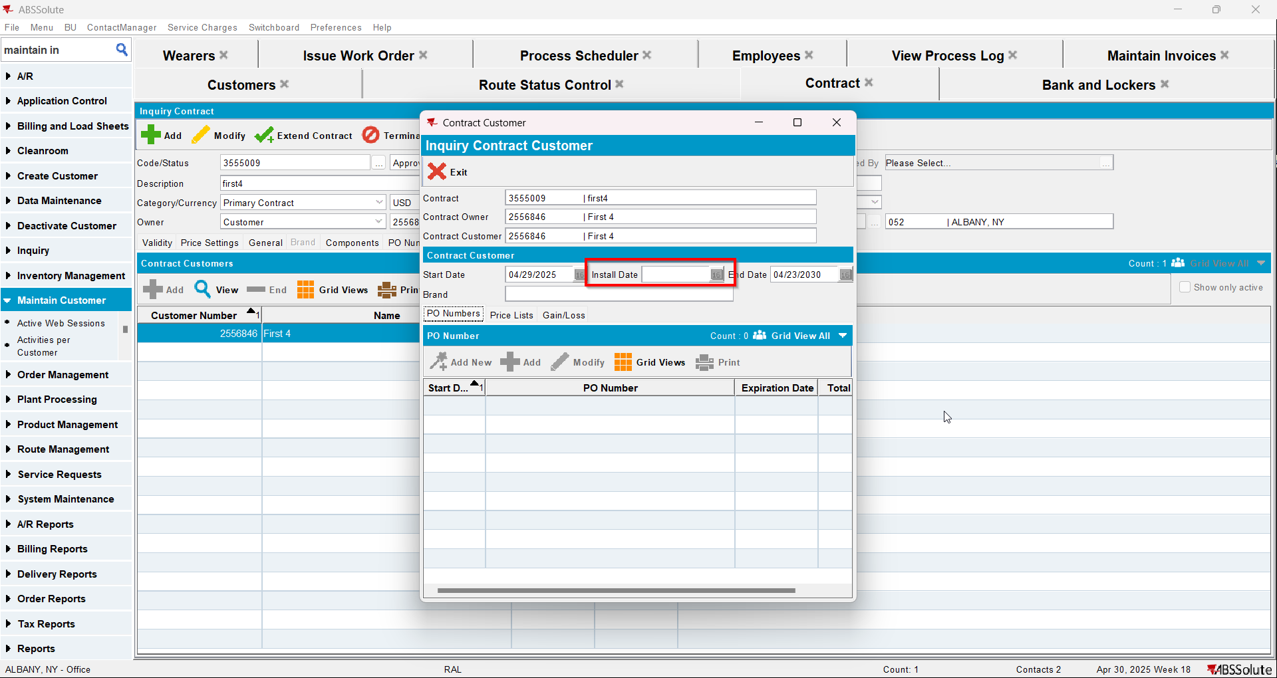
- Check that the Wearer - Install date was deleted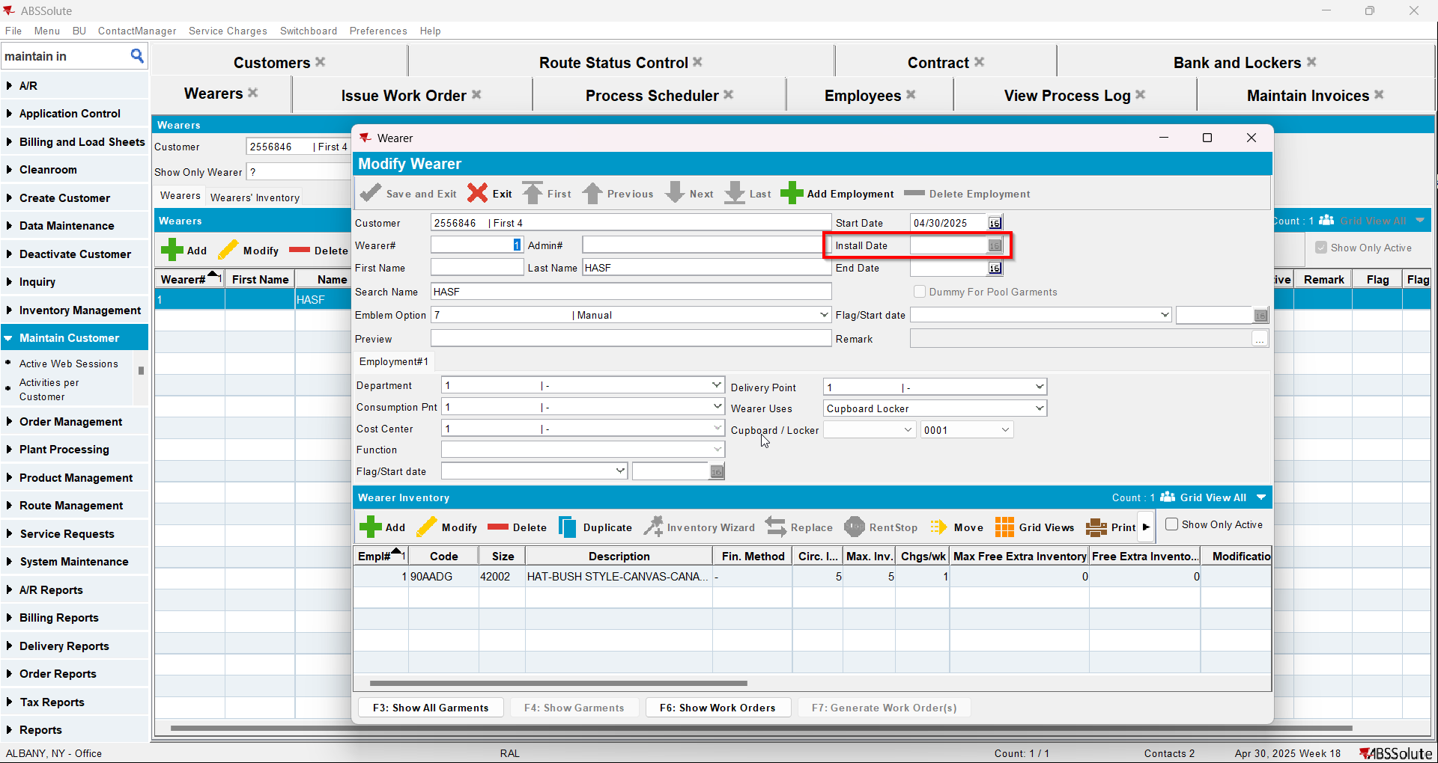
- Route Status Control DLG: Add next week's route
- Generate the invoice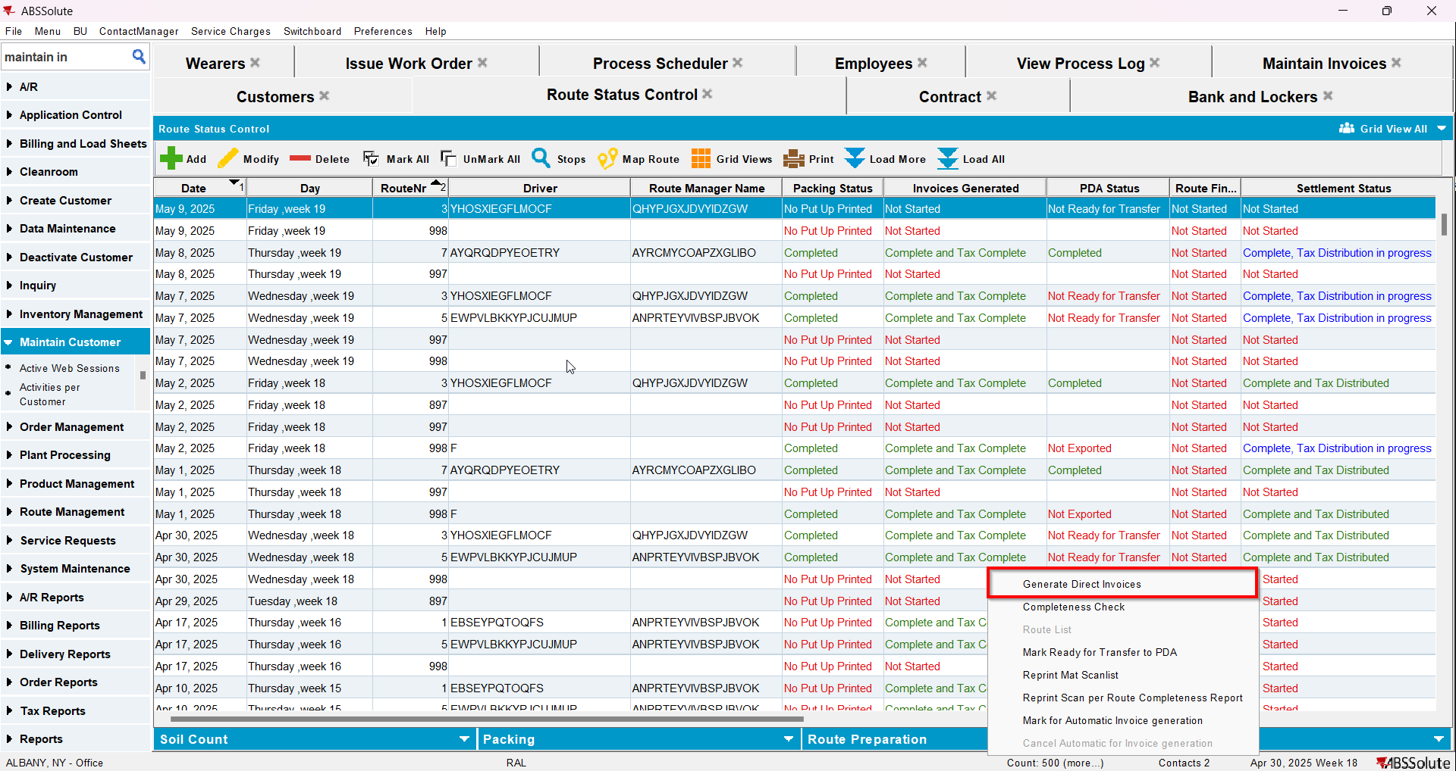
- Tax the invoice
- Send the route to RA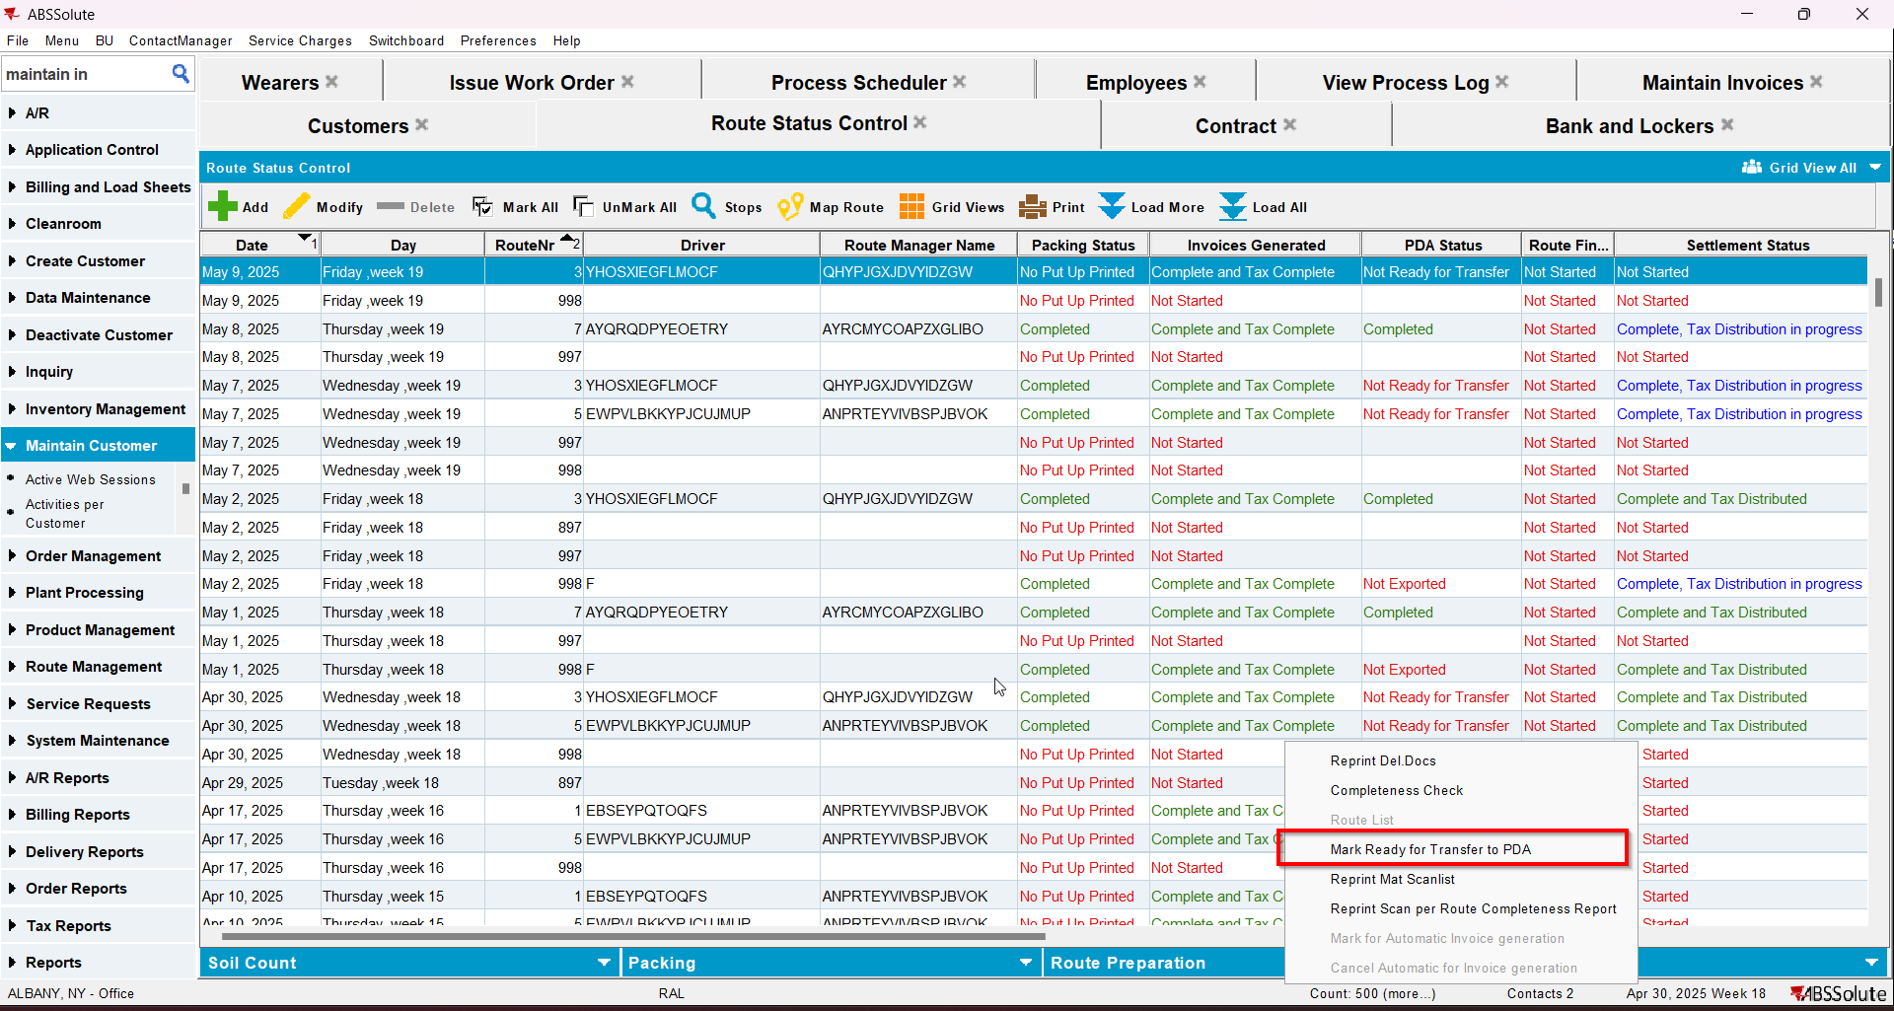
- Finish the route and upload it
- On WebX settle the route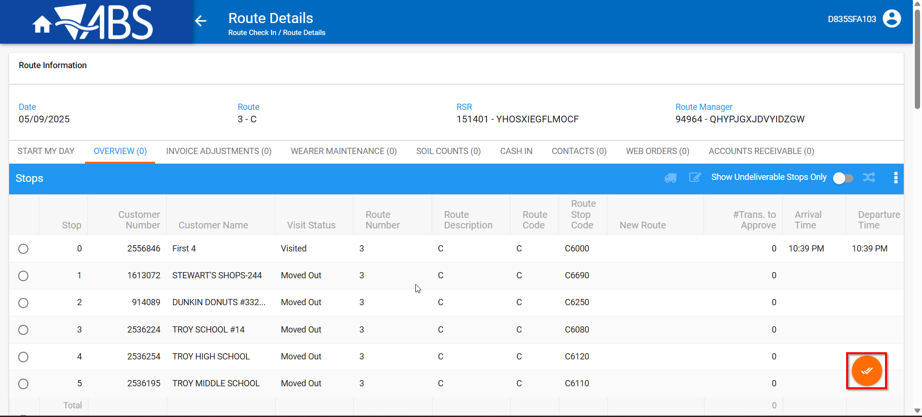
- In View Process Log check the Settlement log for the updates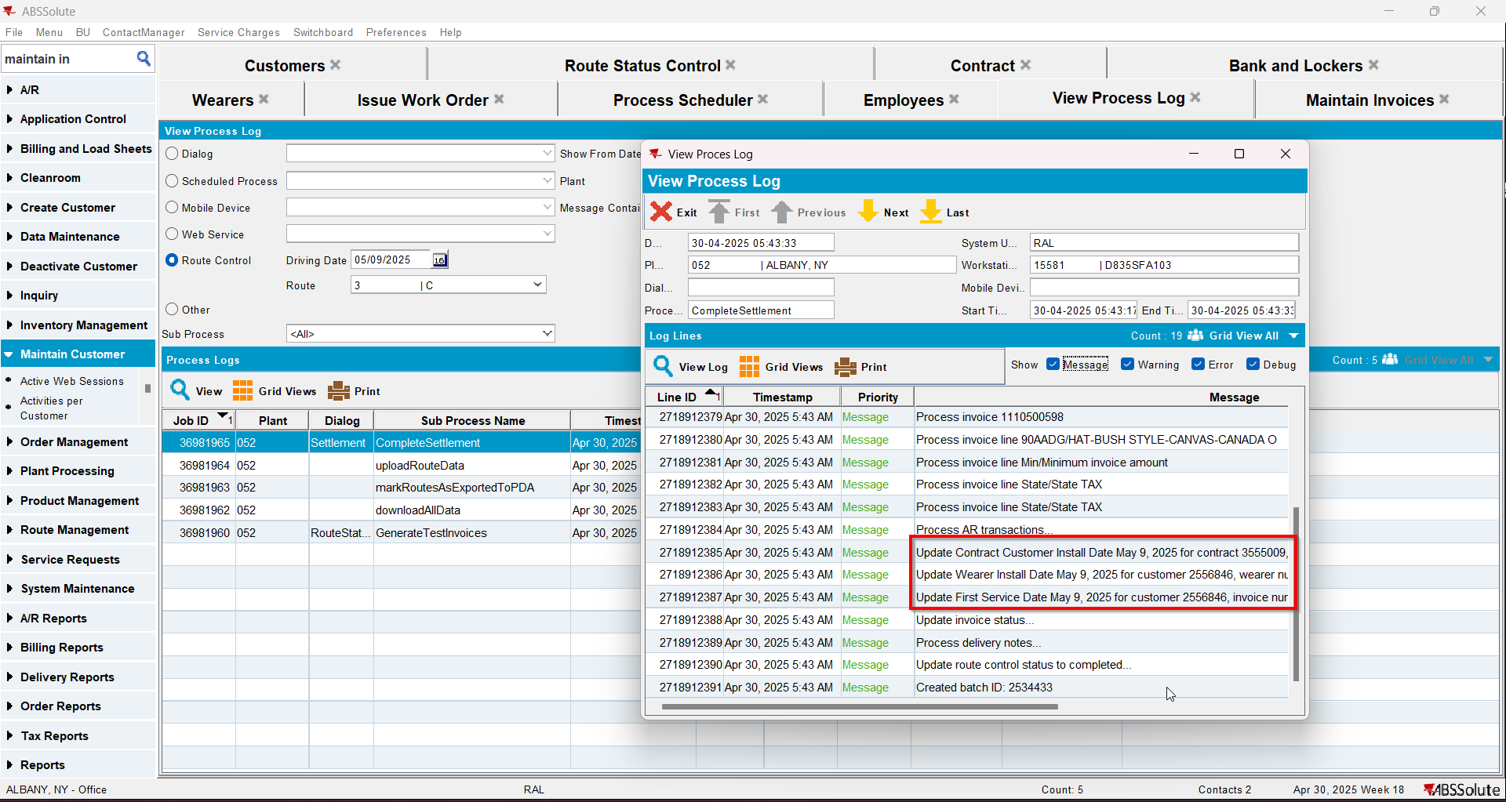
- Check that the Customer - First Service date was updated.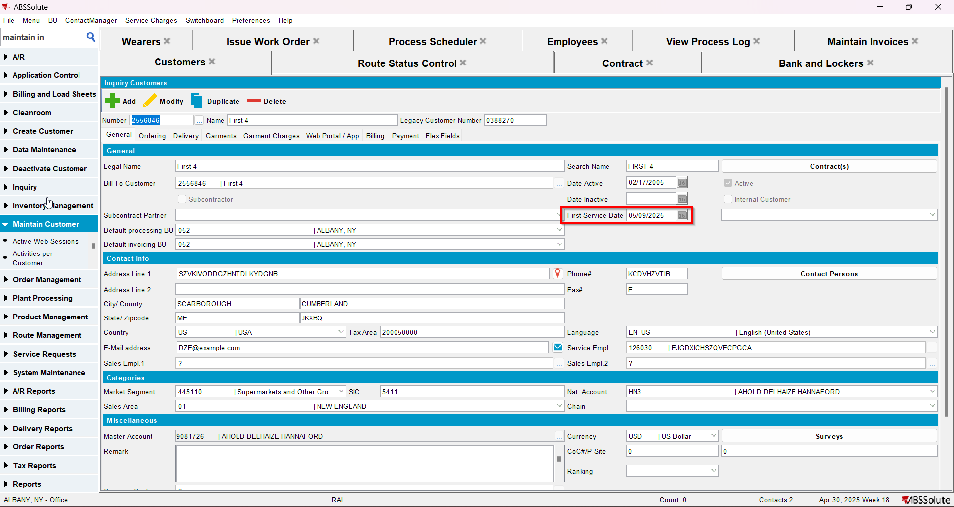
- Check that the Contract - Install date was updated.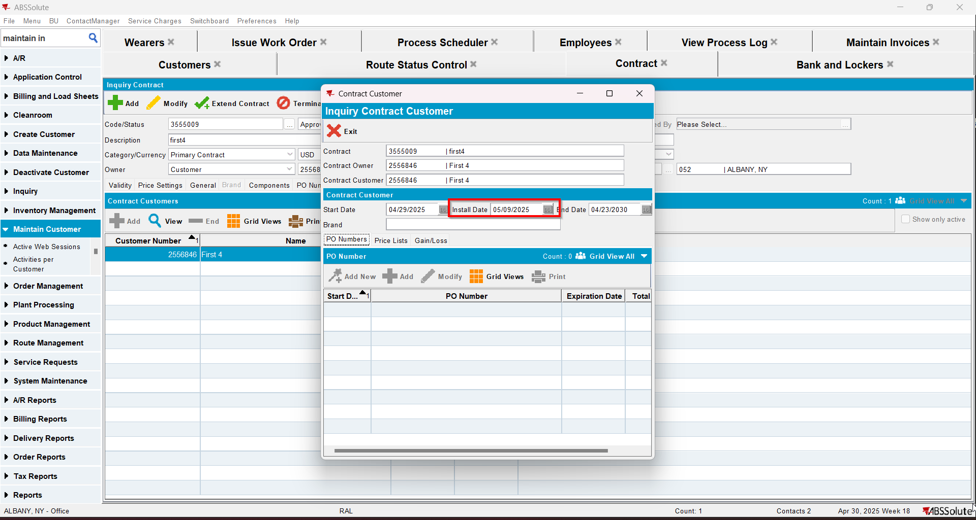
- Check that the Wearer - Install date was updated.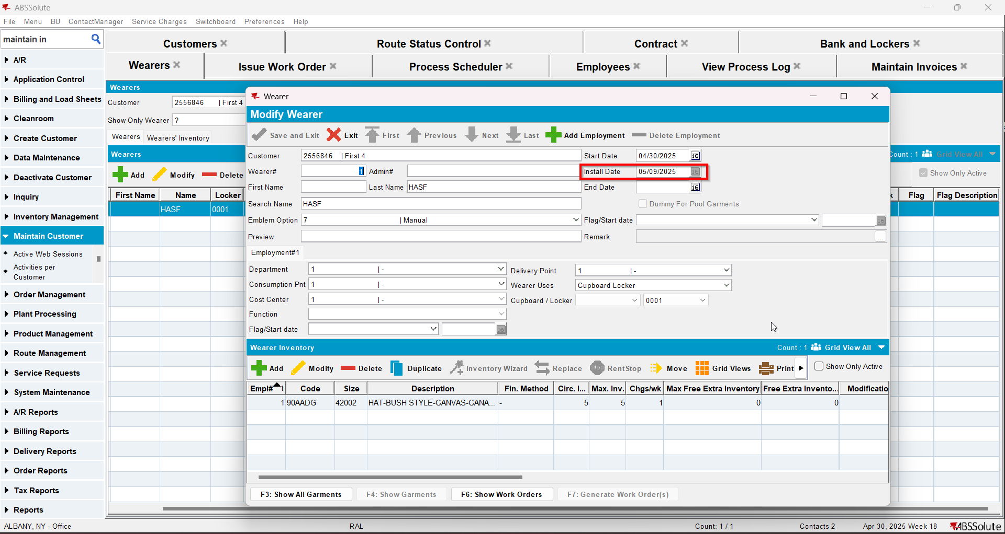

Test Case 5 – Generate invoice and settle the first 2 routes, credit the invoice for the first route – Tested OK
Expected behavior: The updates for the first service log and install date will appear in the log.
Hash: 9a17455
- Add a new customer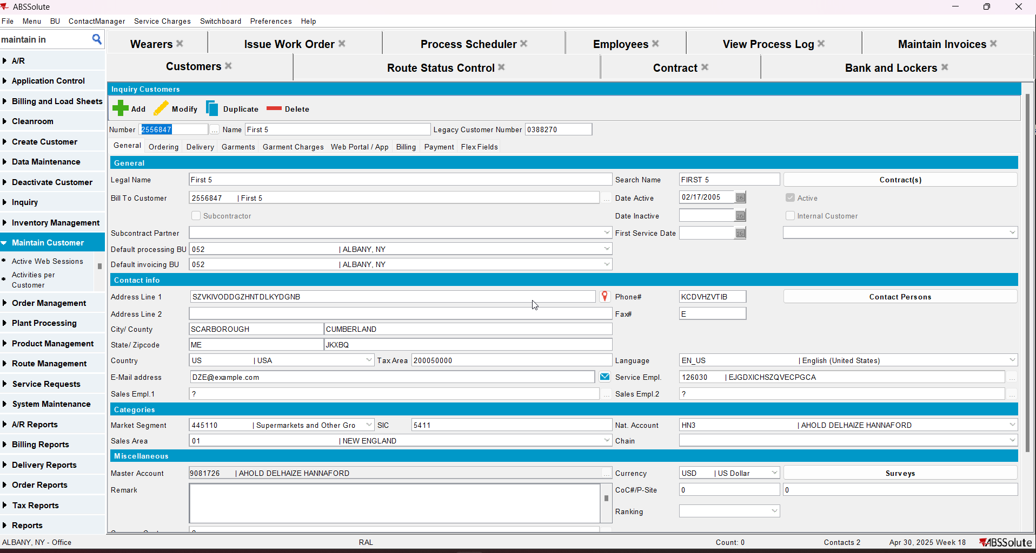
- Add a new contract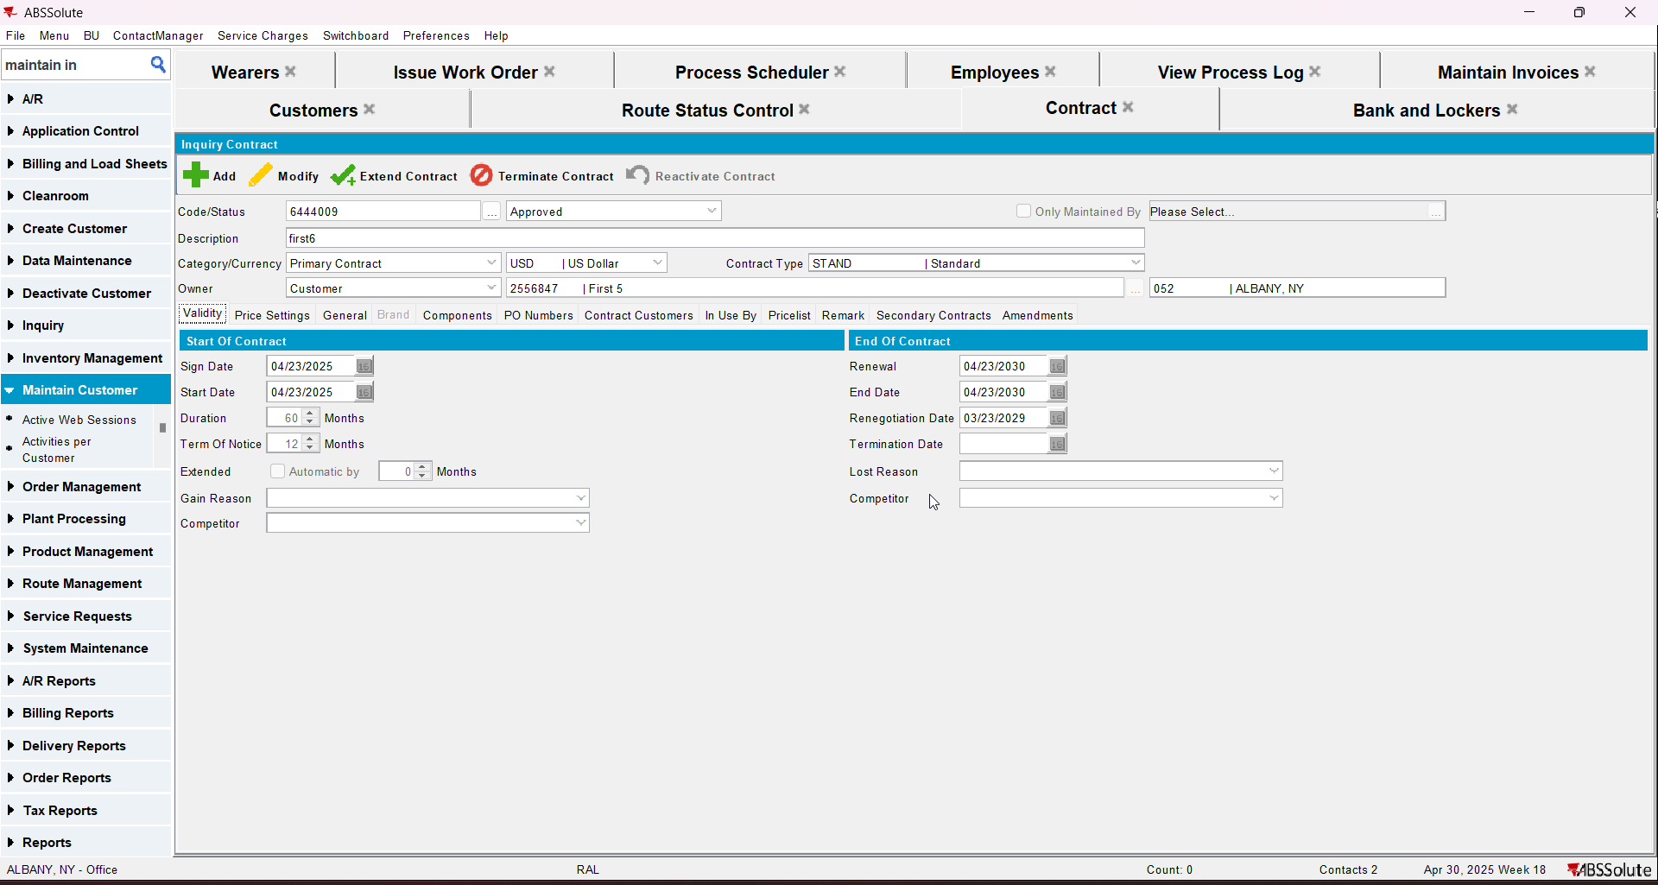
- Add a garment to contract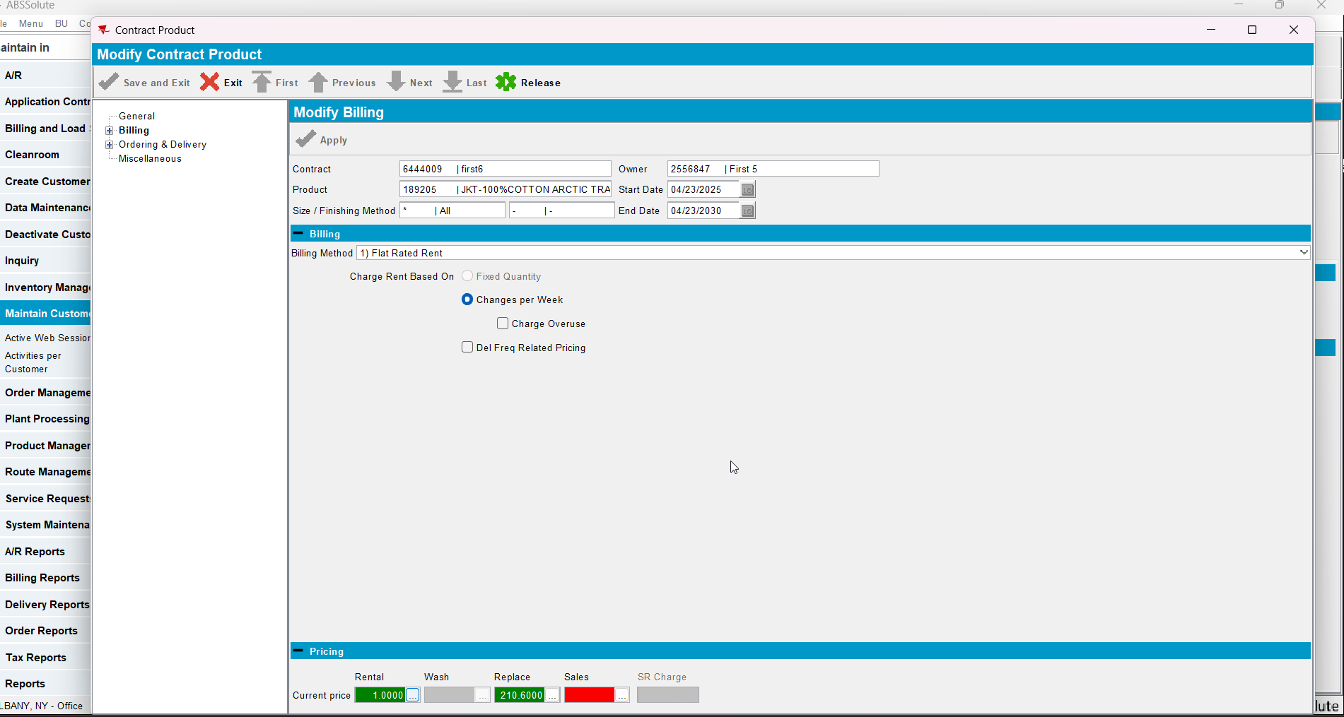
- Add the new customer to contract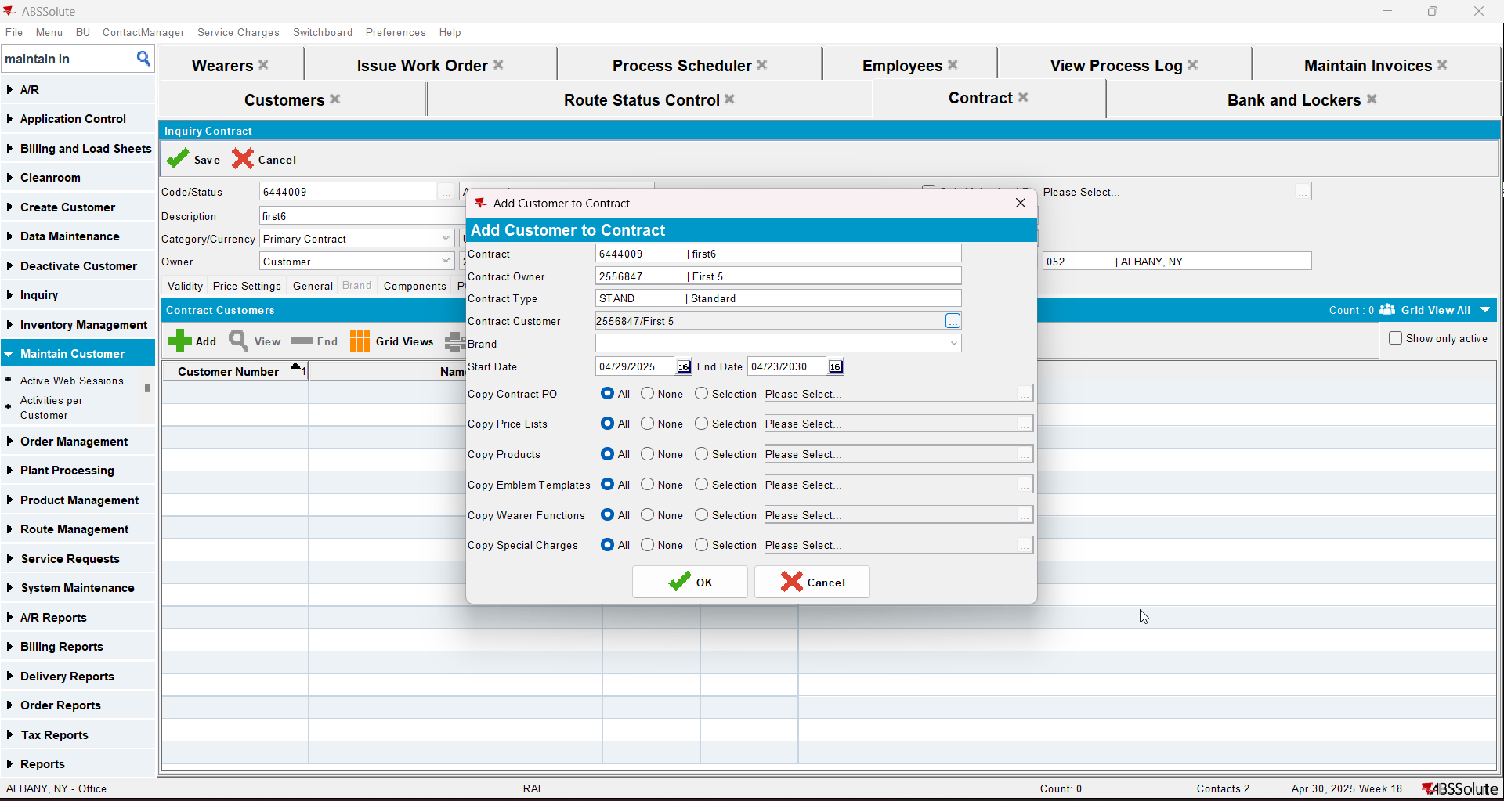
- Add new lockers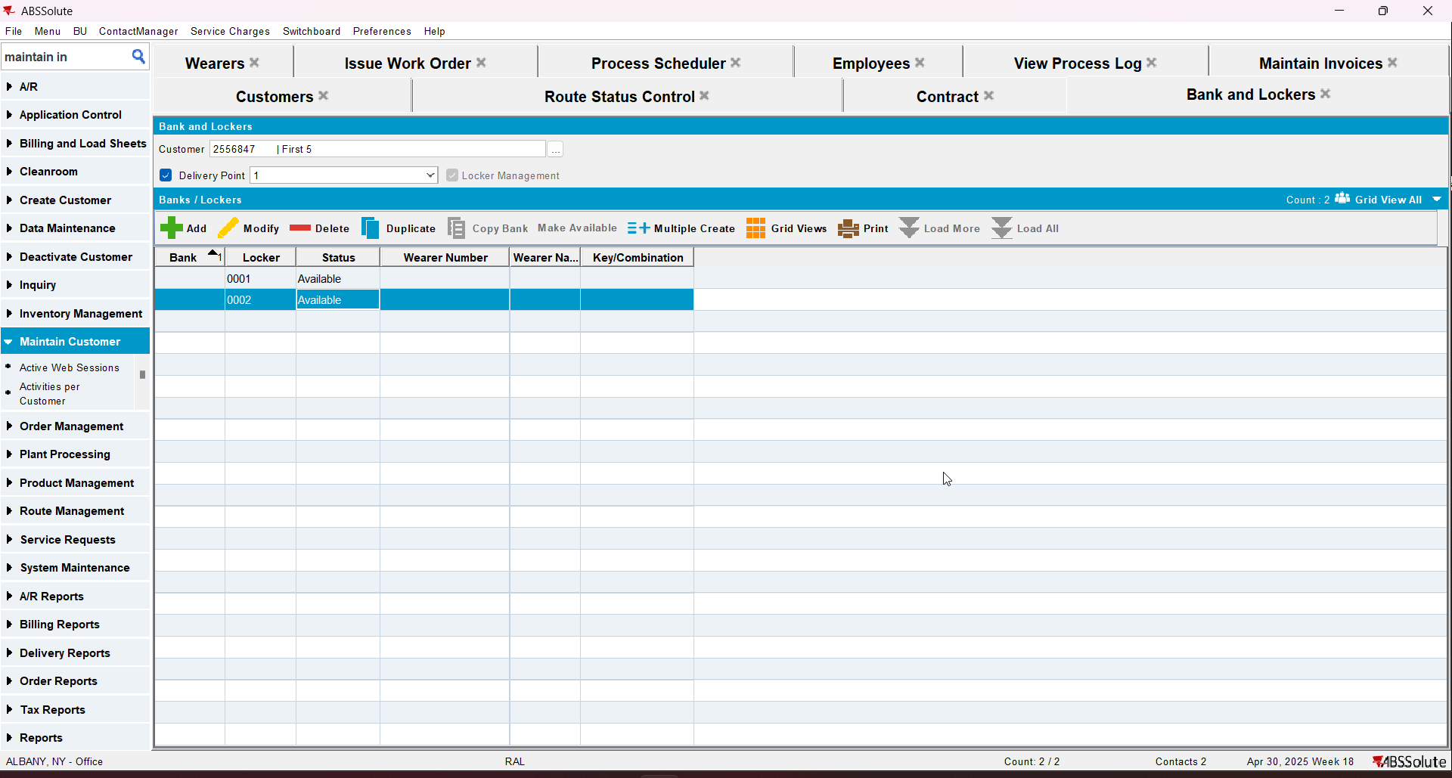
- Add a wearer with a wearer inventory
- Generate work order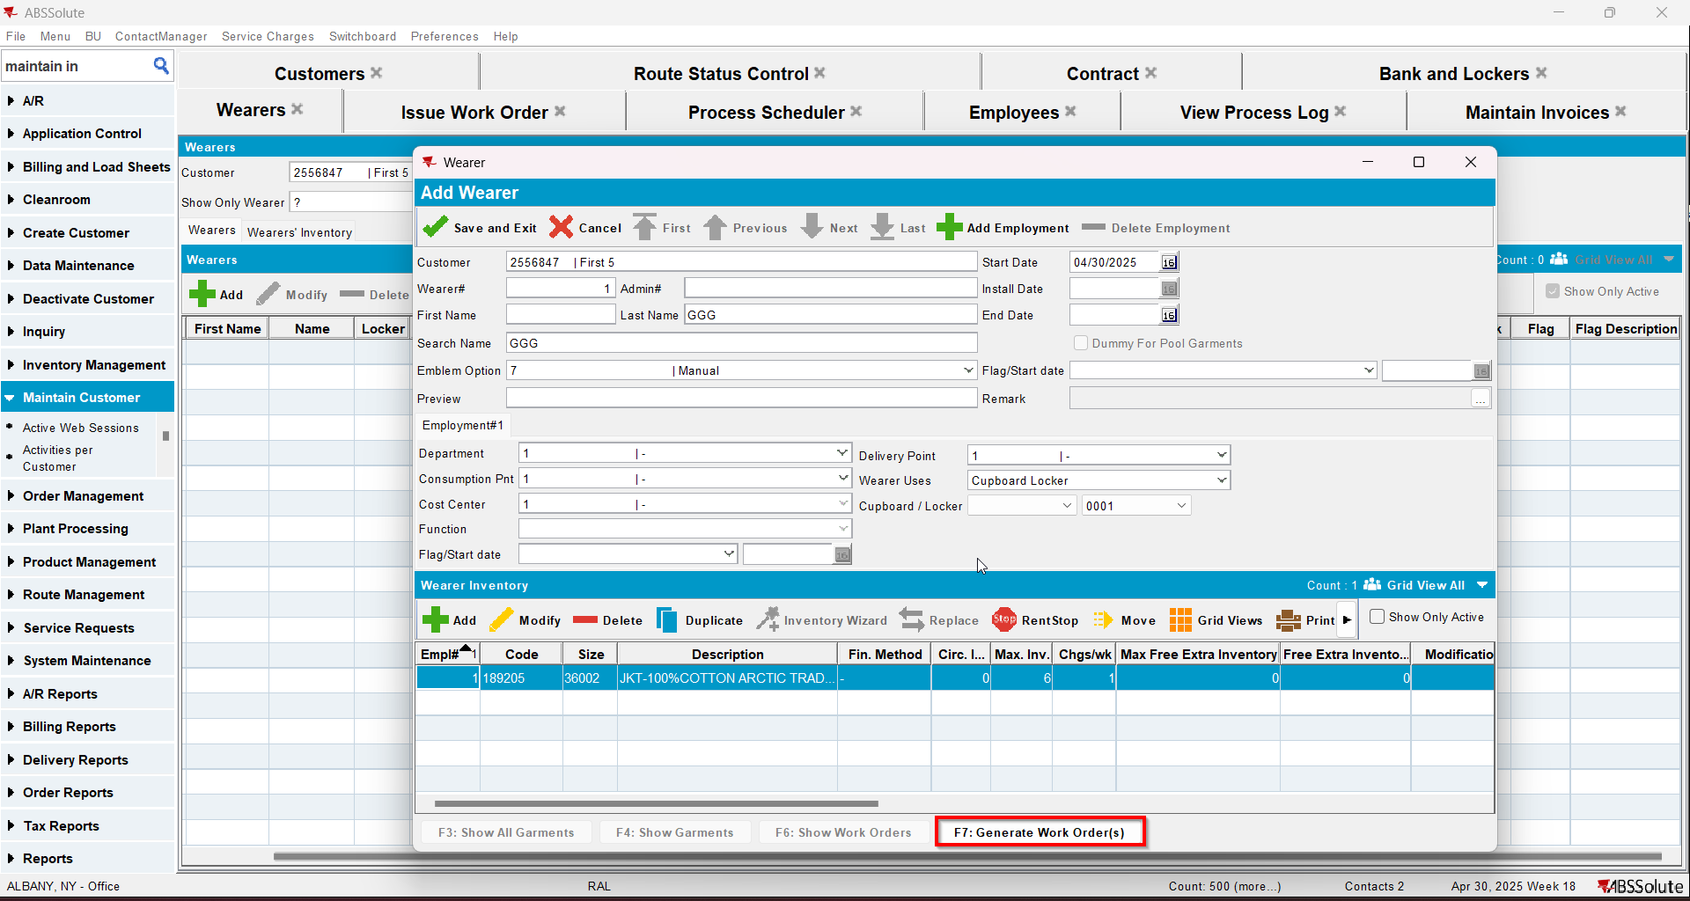
- Issue the work order and generate the delivery note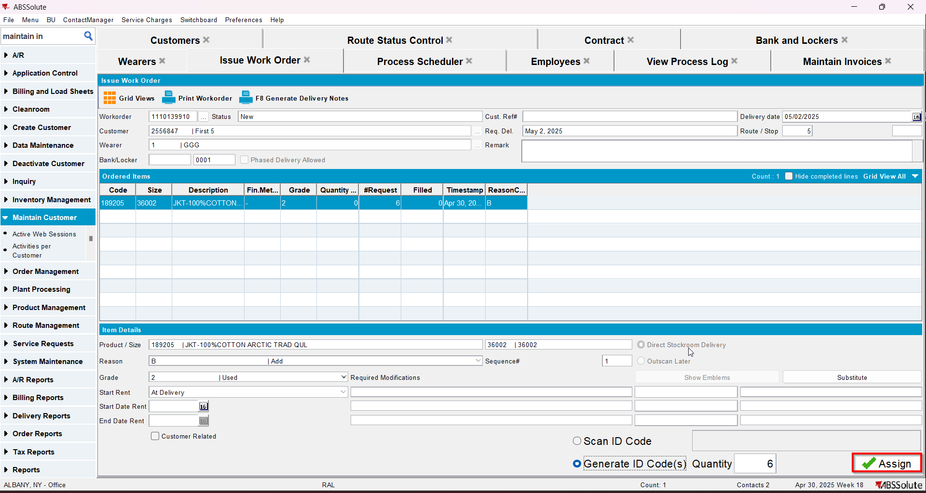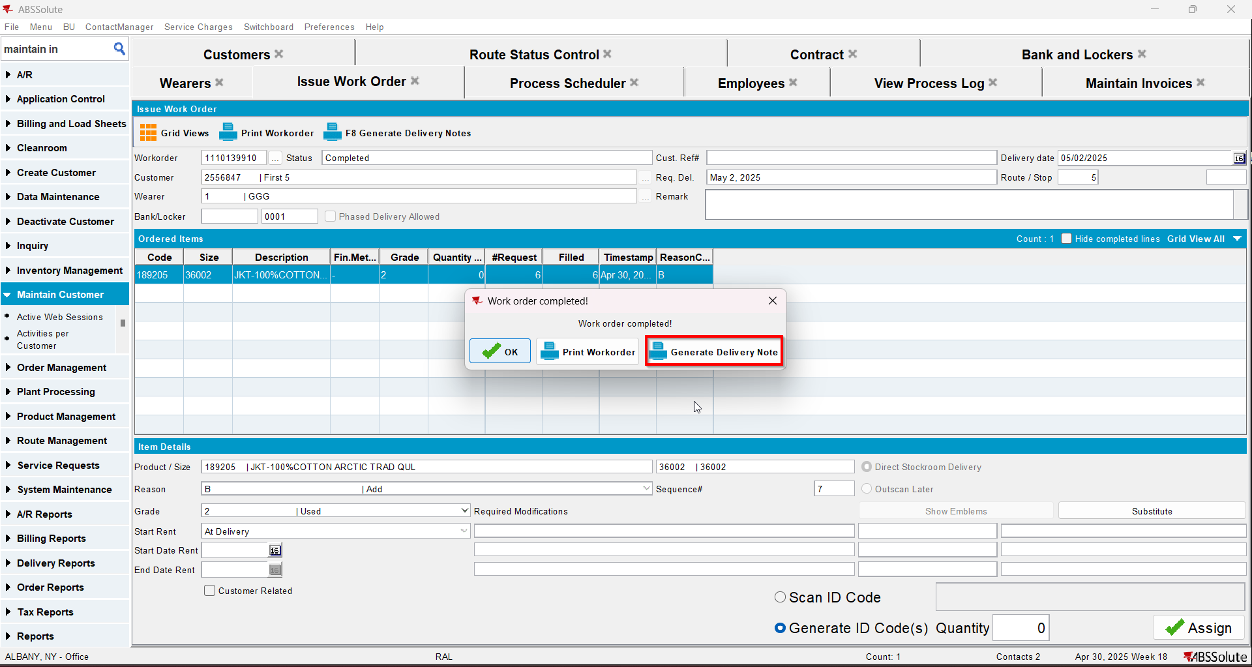
- Add the next route for the customer
- Generate the invoice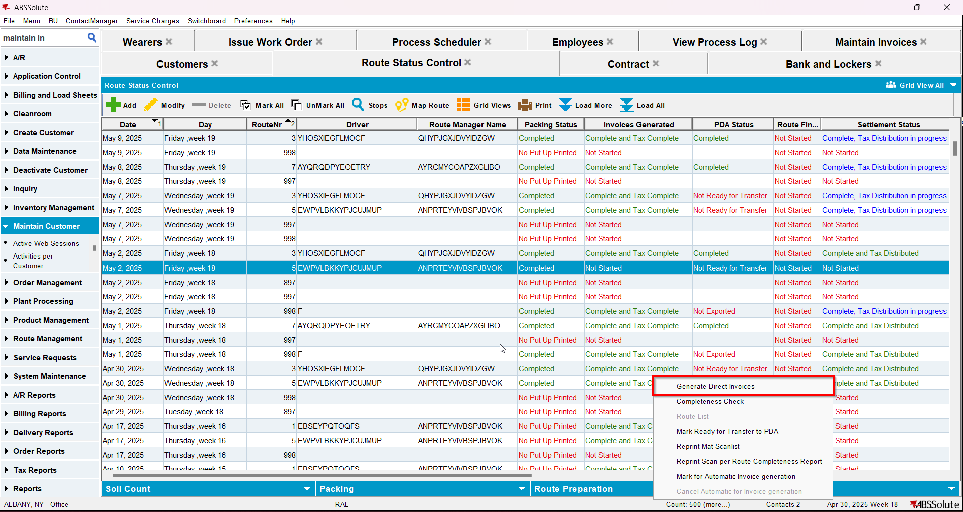
- Tax the invoice
- Settle the invoice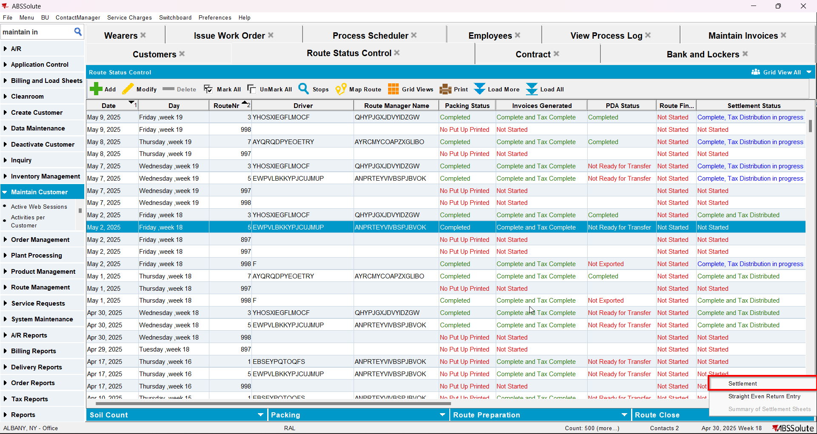
- In View Process Log check the Settlement log for the updates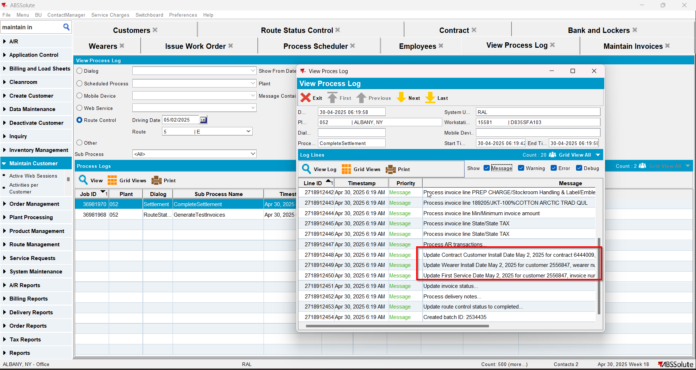
- Check that the Customer - First Service date was updated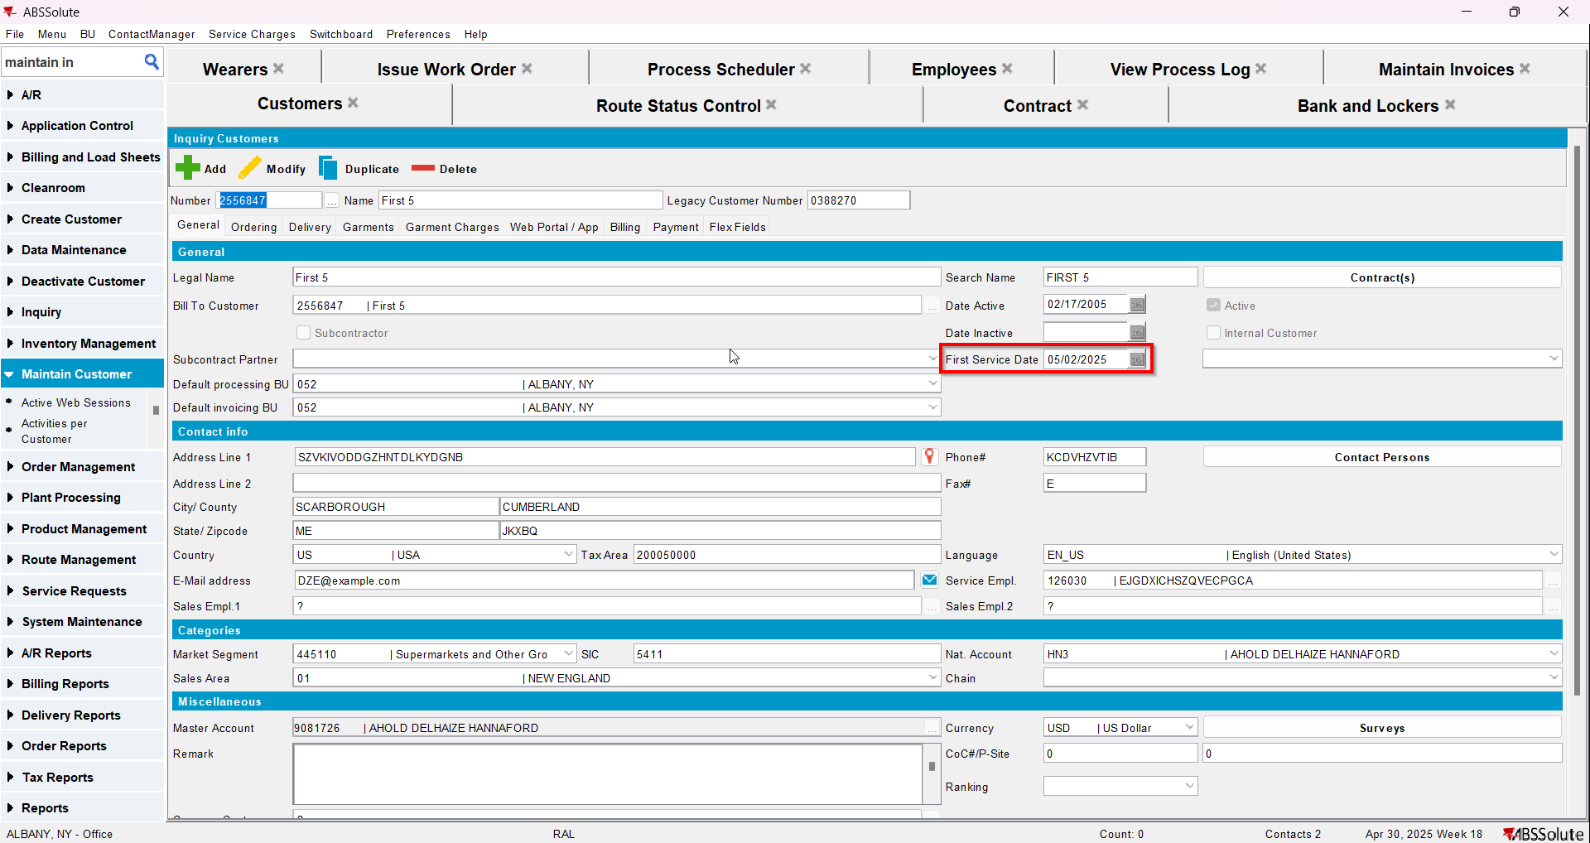
- Check that the Contract - Install date was updated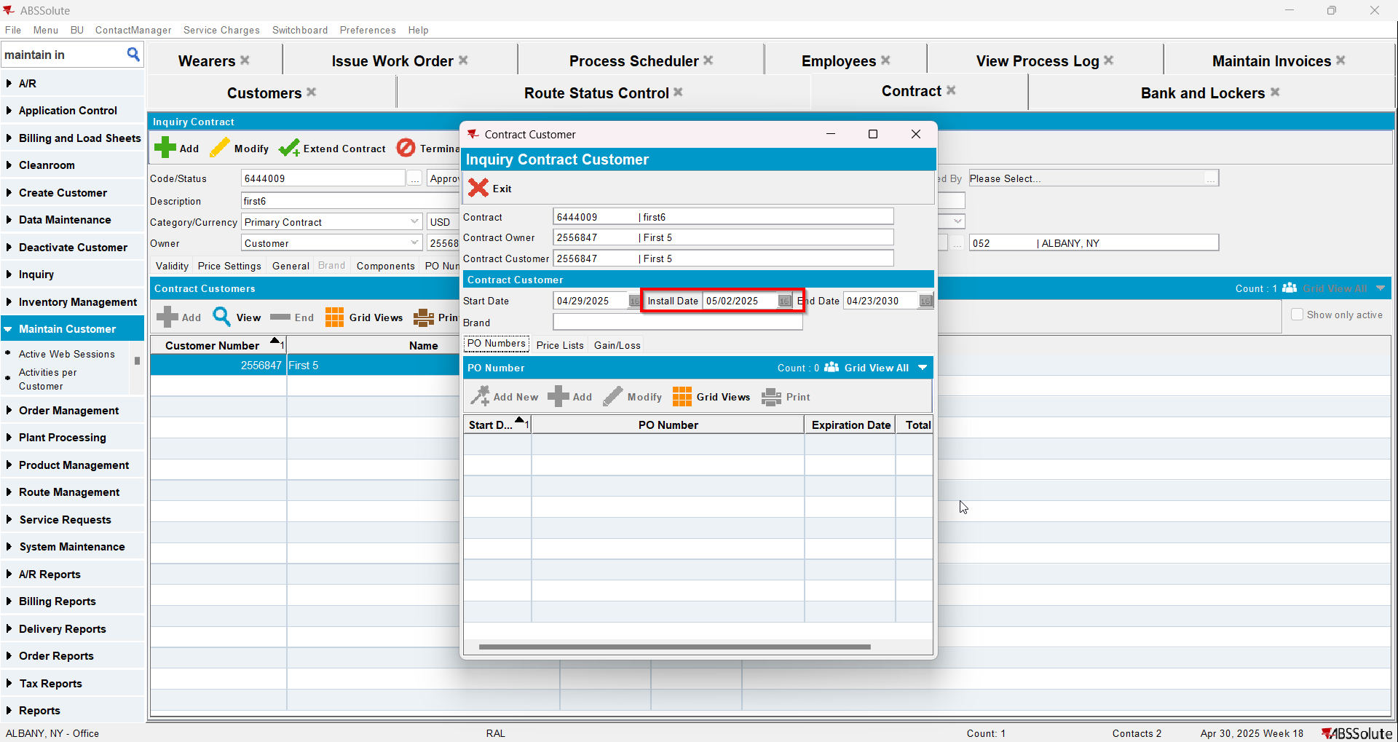
- Check that the Wearer - Install date was updated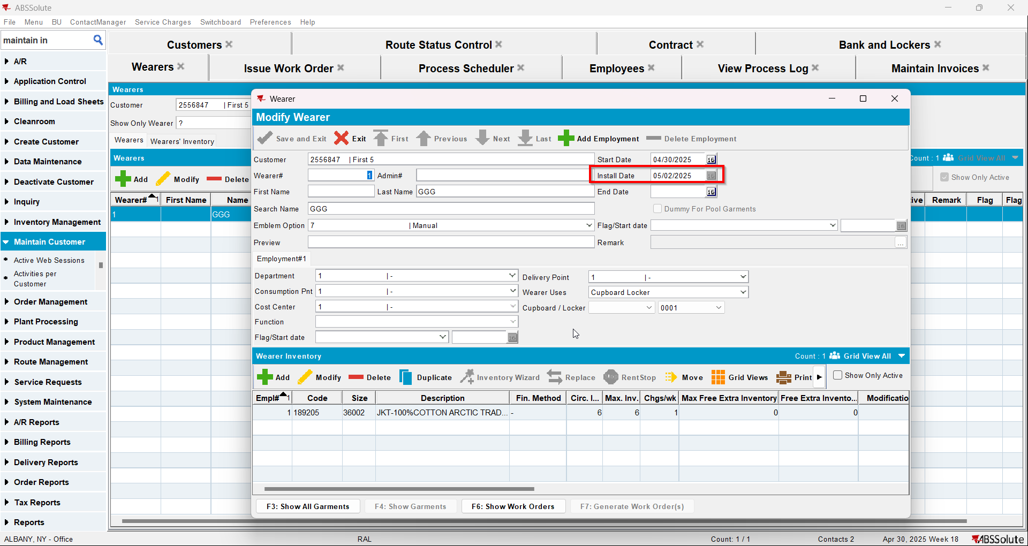
- Script in the Tax distribution data
- Process scheduler: run the process scheduler to distribute the tax
- Add the route for the next week
- Generate invoices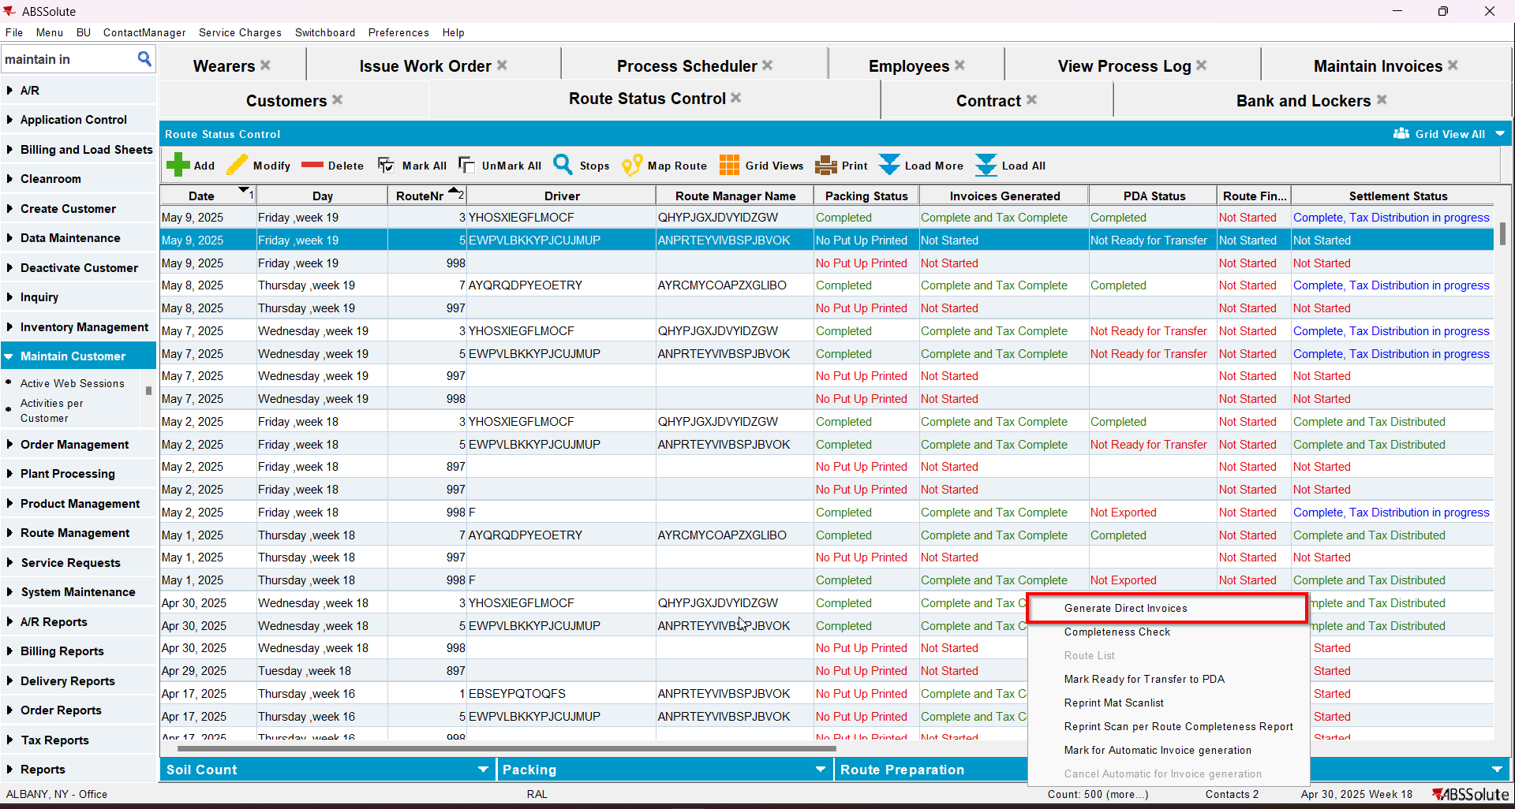
- Tax the invoice
- Settle the invoice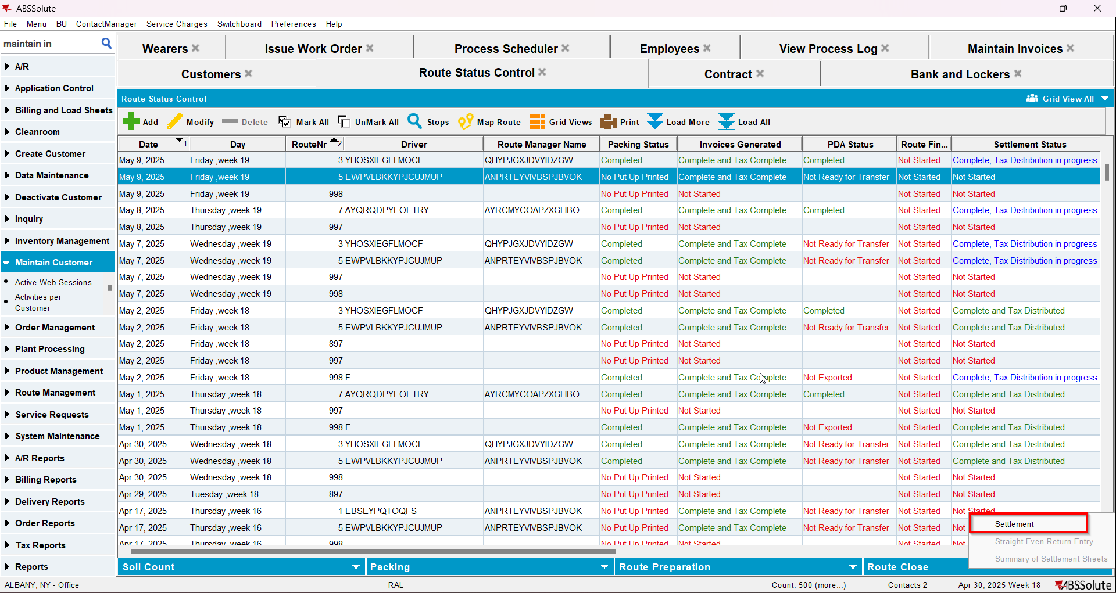
- Script in the Tax distribution data
- Process scheduler: run the process scheduler to distribute the tax
- Check that the dates were not updated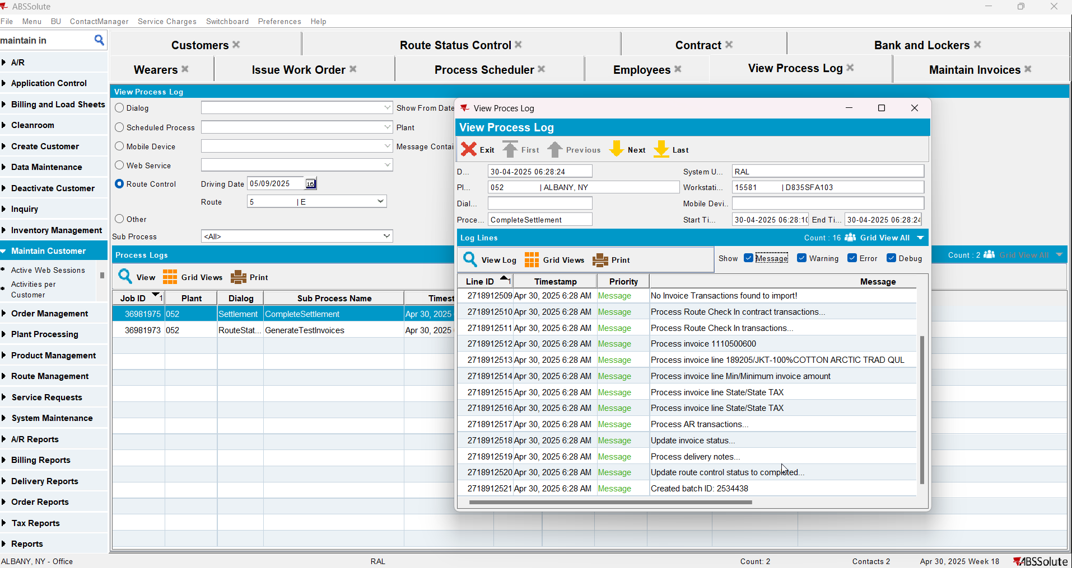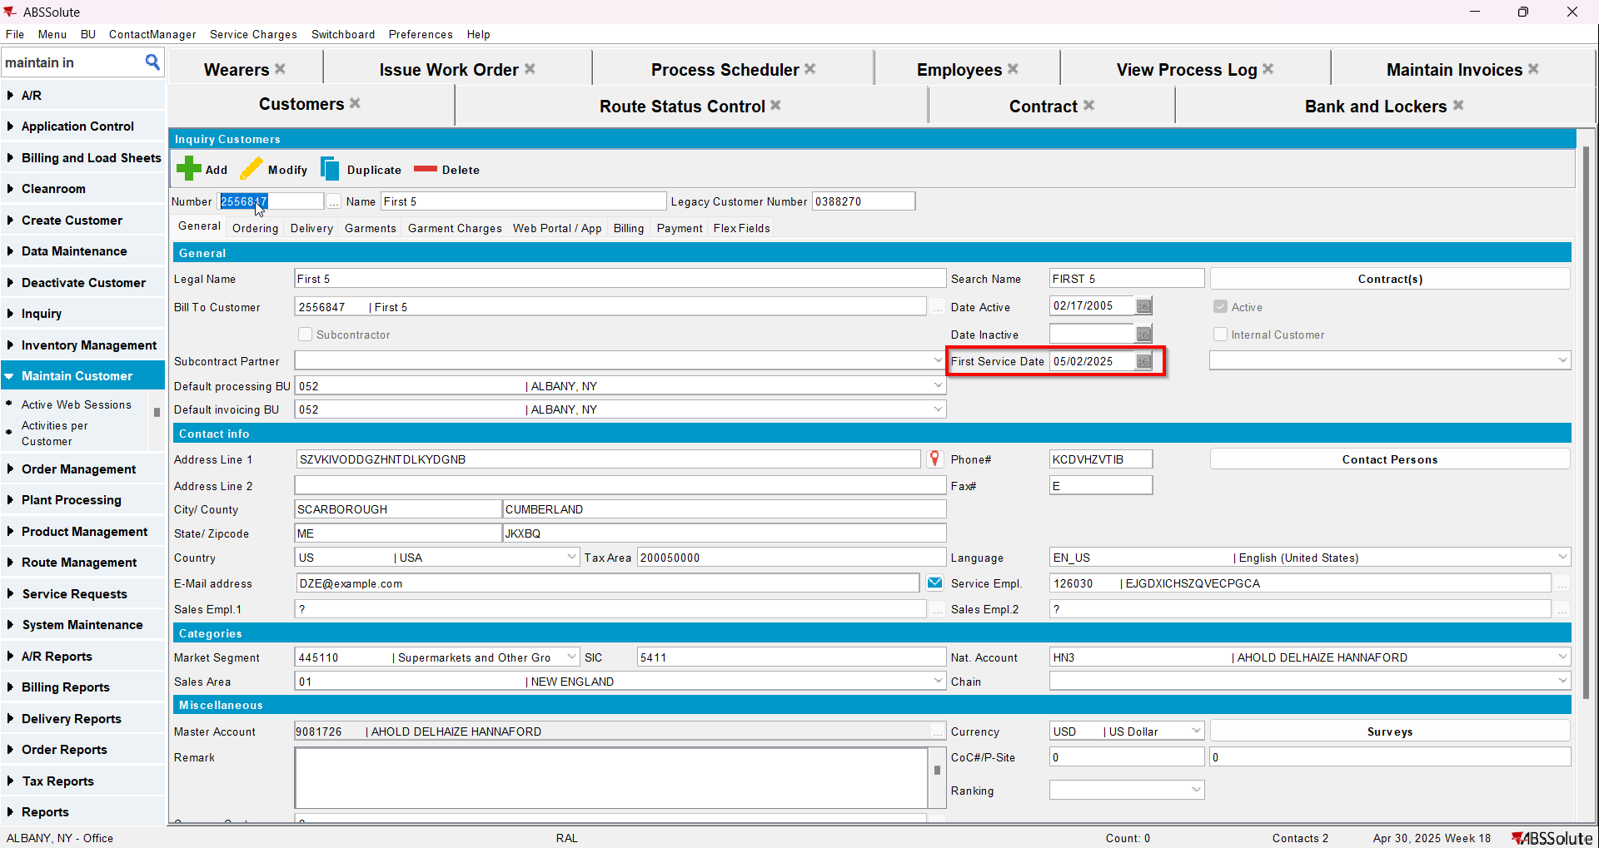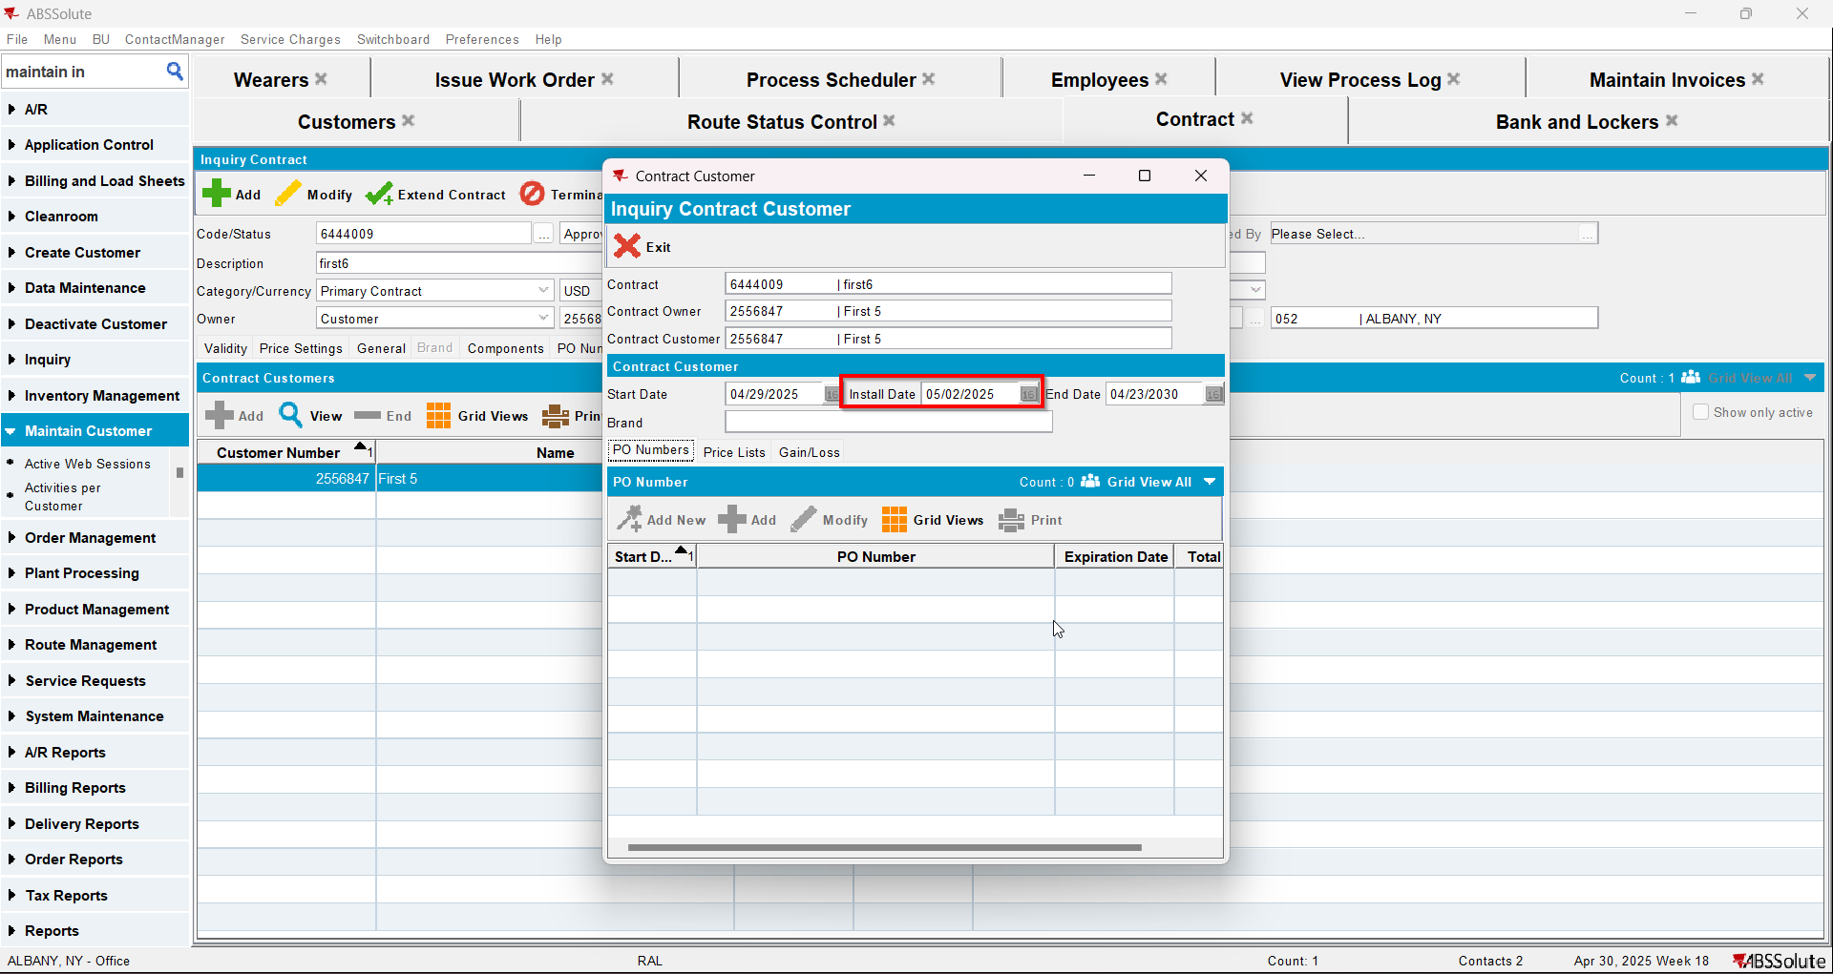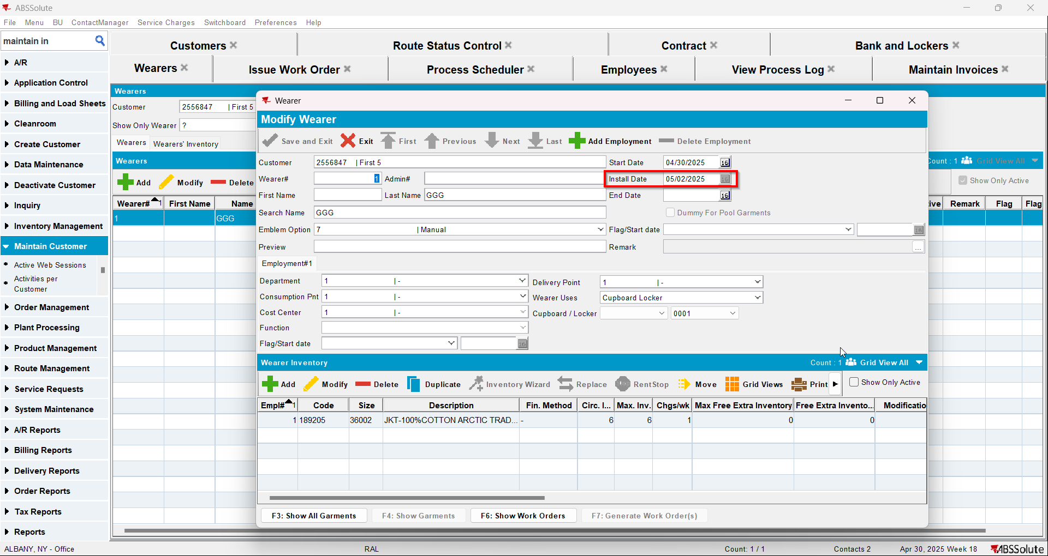
- Maintain Invoices DLG: Find the first settled invoice and click on the credit invoice button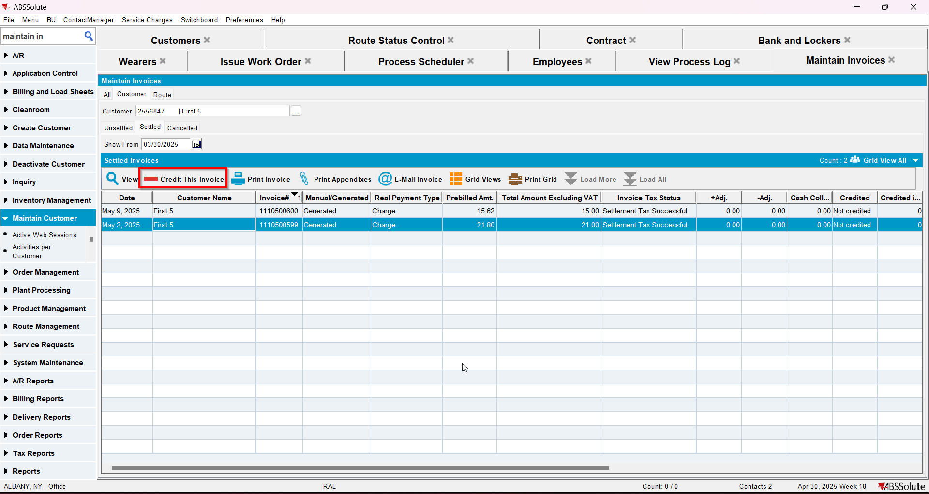
- When Credit Flow pop-up appears check the Assign Invoice to route checkbox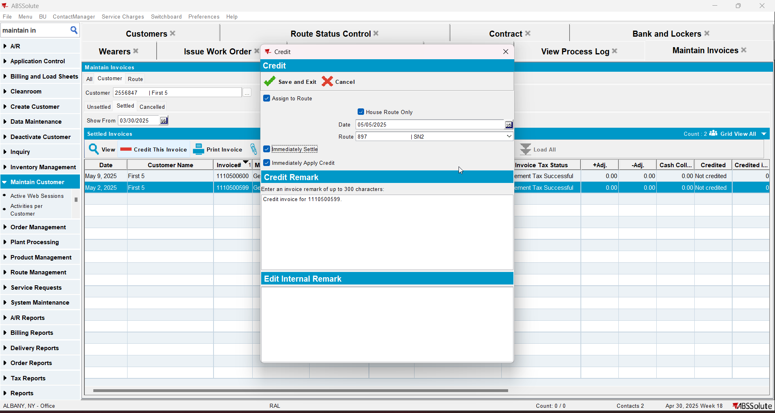
- In View Process Log check the CreditFlowDateUpdates log for the updates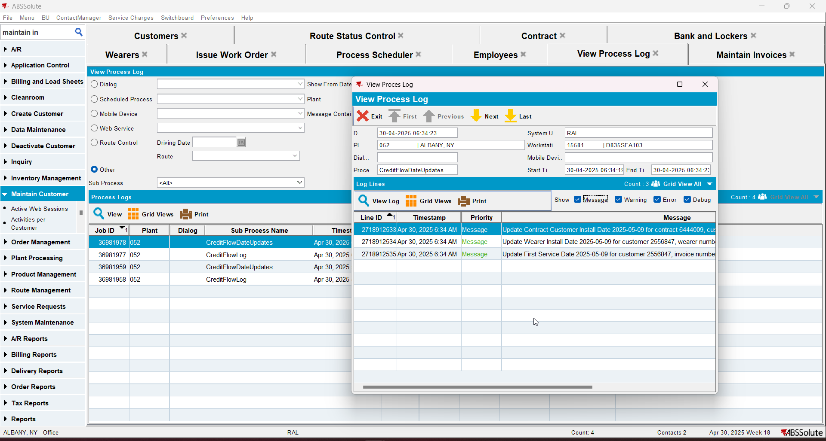
- Check that the Customer - First Service date was updated with the date of the second route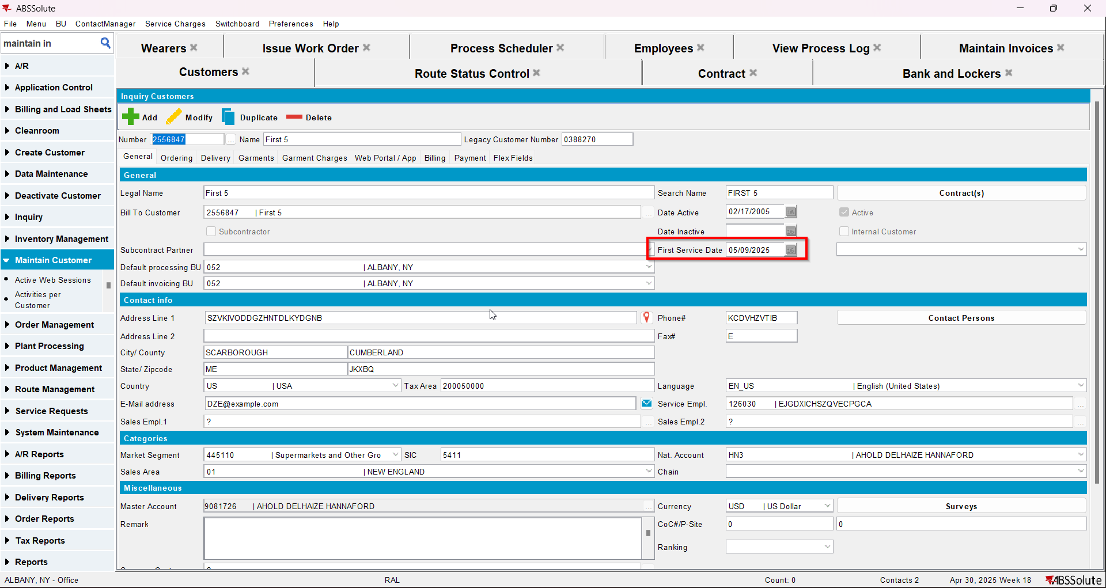
- Check that the Contract - Install date was updated with the date of the second route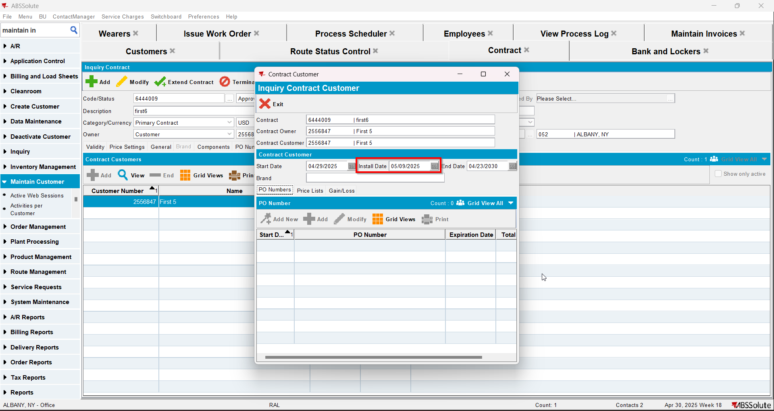
- Check that the Wearer - Install date was updated with the date of the second route