ABSN-6098 - Closed days in week 1 not displayed correctly
Environment | Prerequisites
Version: 9.07.00.UNF19  DBServerName= abs-srv20.internal.abslbs.com  DBSID=CUST24  DBUser= UNFDEV  DBPassword= UNFDEV  Environment= Test | - Module:  - System setting:

Contents
Retest after fix: 1
Test Case 1: Checking if non-business days are displayed correctly for DNs: 1

Retest after fix:

Test Case 1: Checking if non-business days are displayed correctly for DNs:
Hash: 317995a57a14
Step 1) Define as non-business days all days from week 52 and week 1 of 2025:
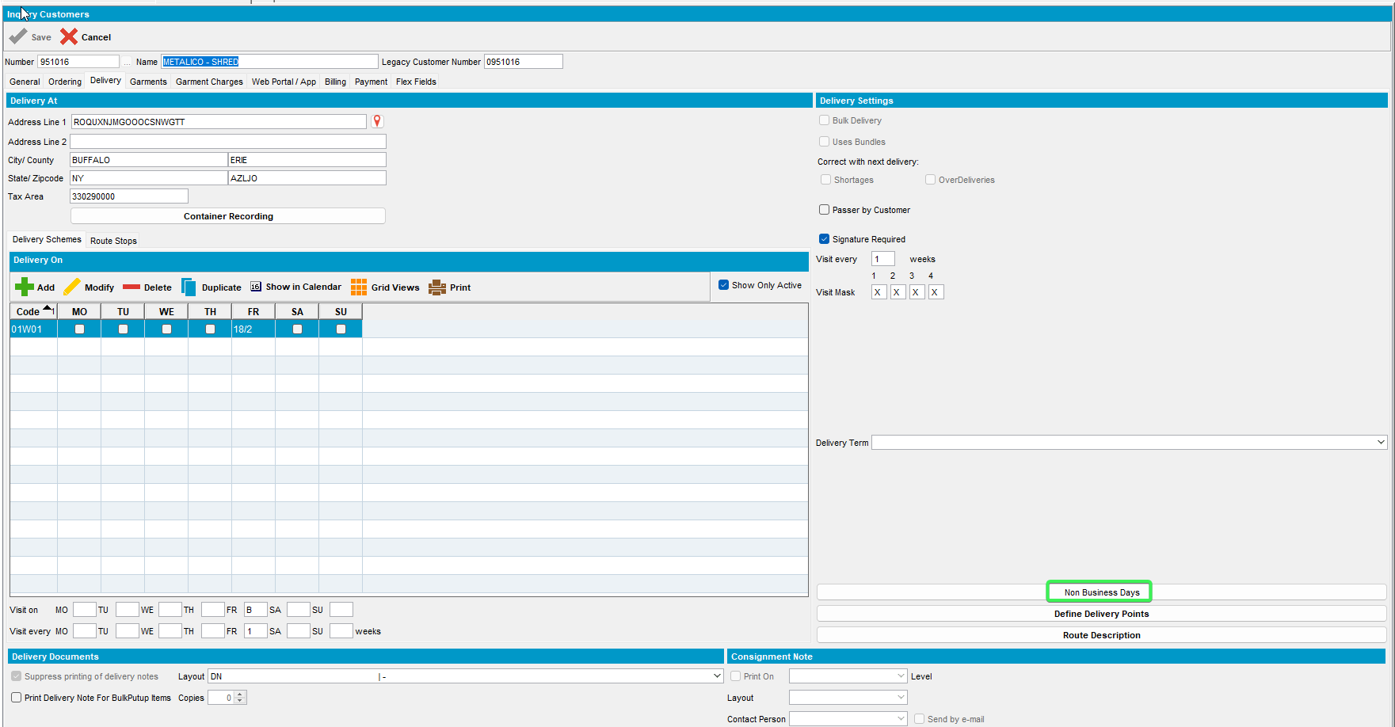
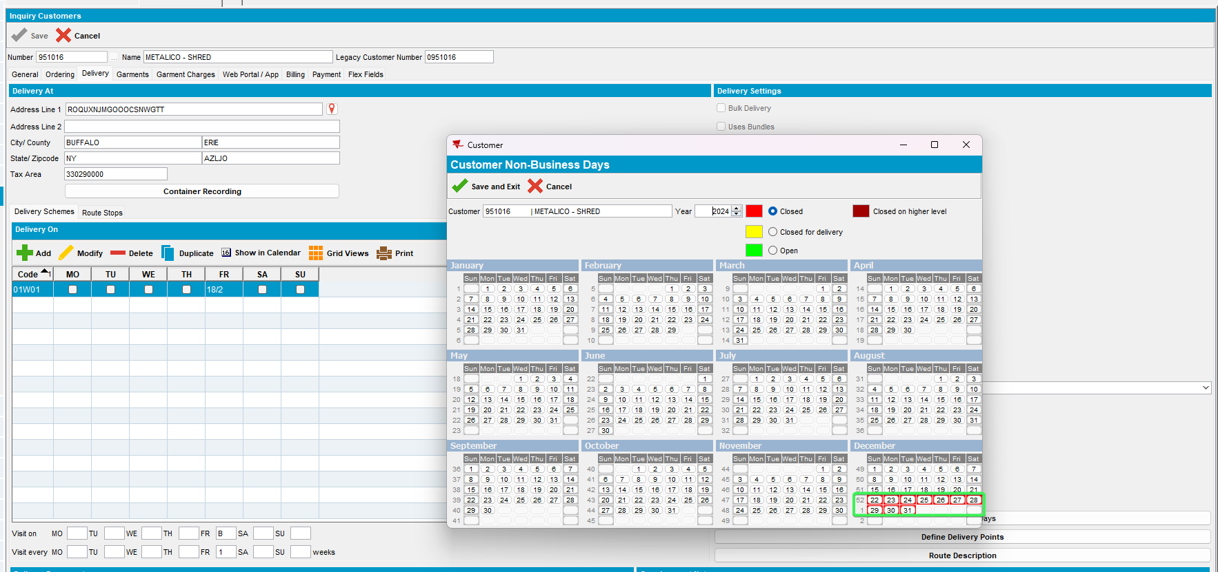
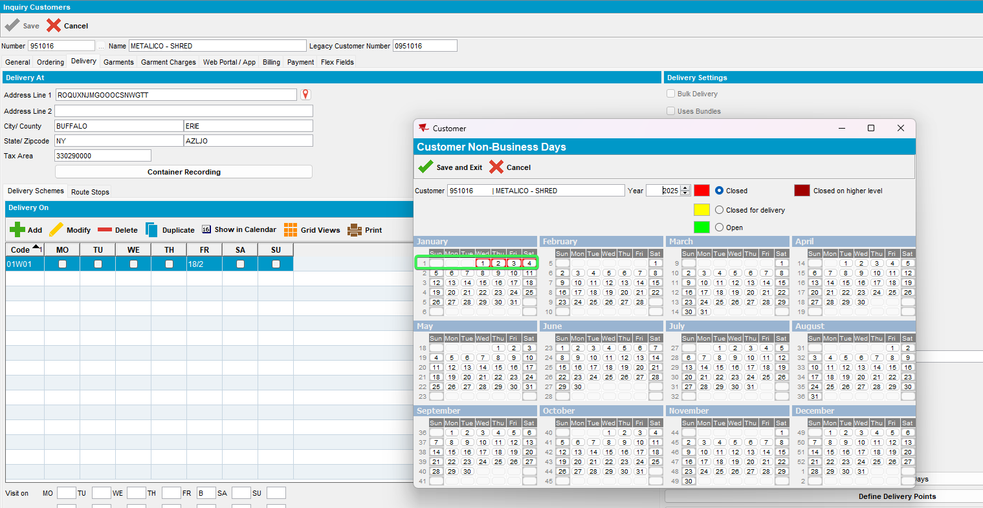

Step 2) Check the delivery date for a DN:
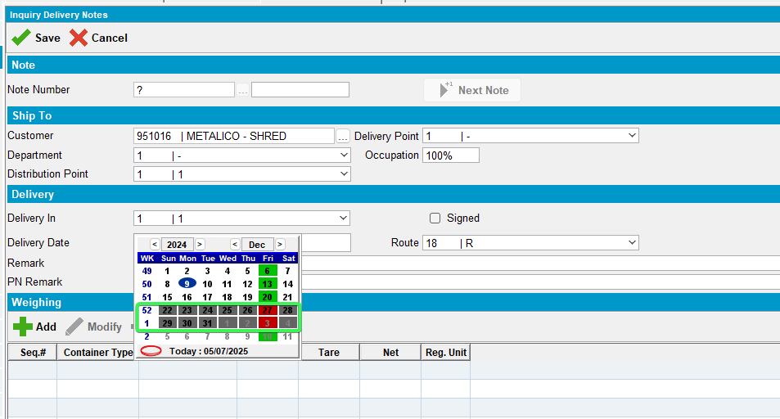
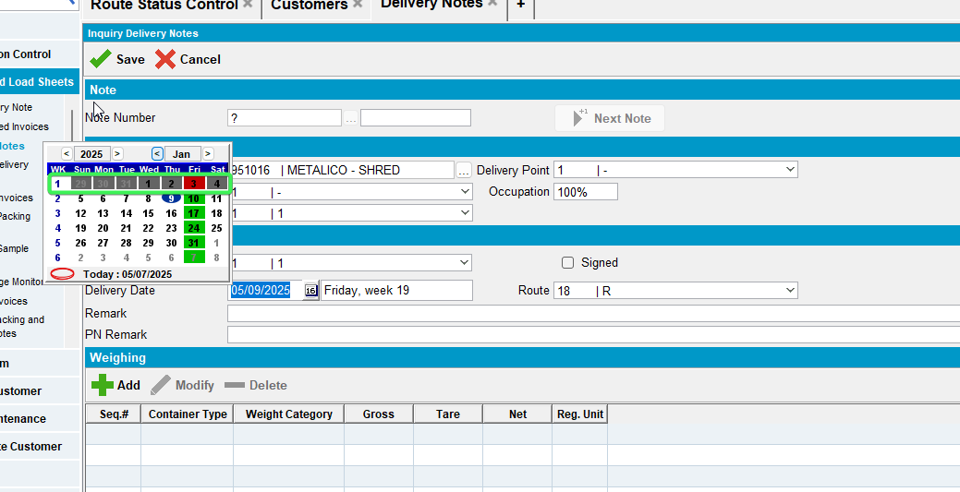
When trying to fill in the <Delivery date> field, the non-business adays previously marked are correctly shown in the calendar.

Step 3) Verify the calendar also in <Customers> dialog, <Delivery tab>:
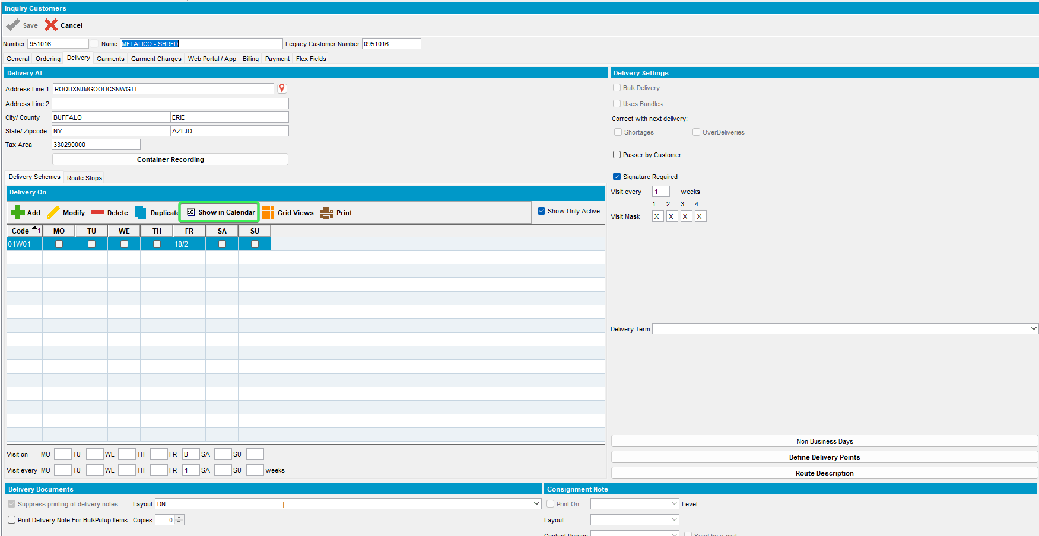
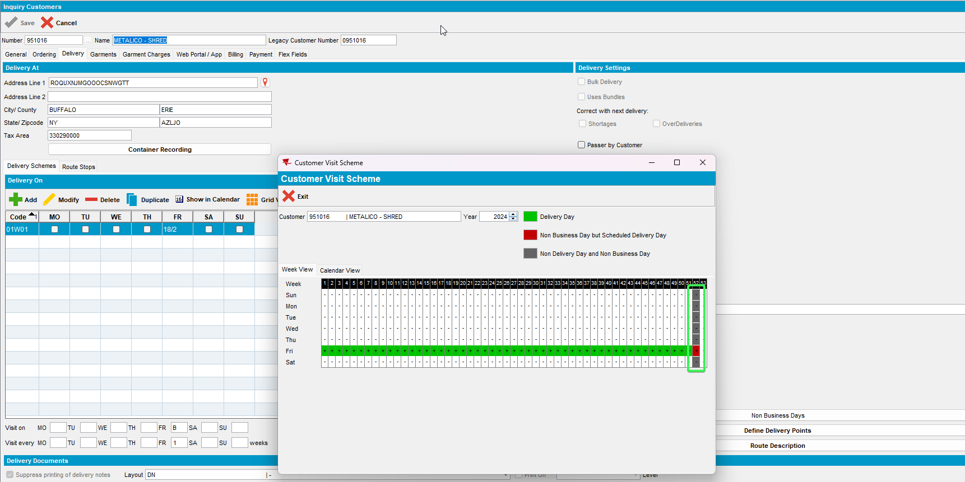
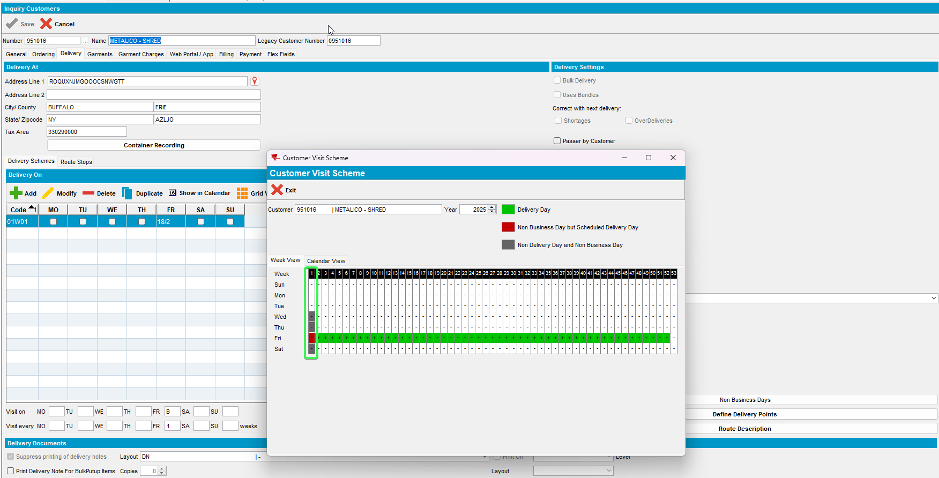
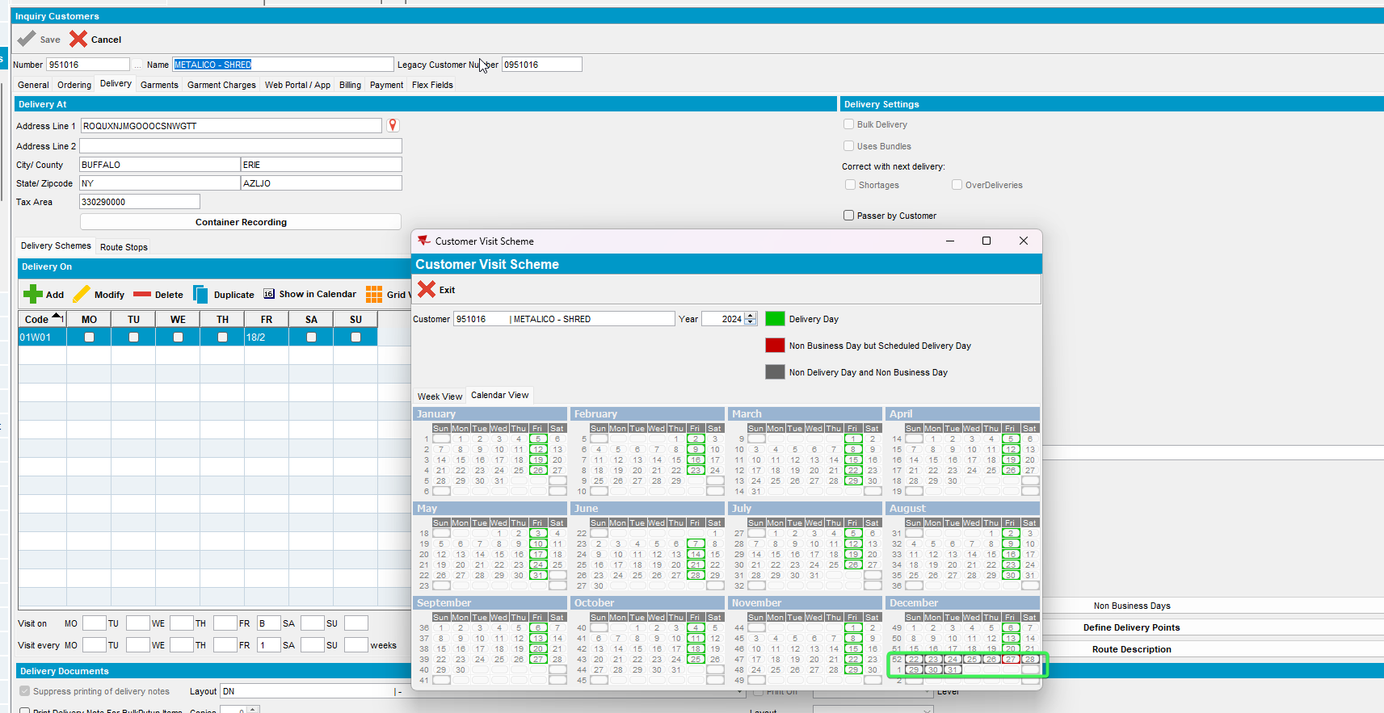
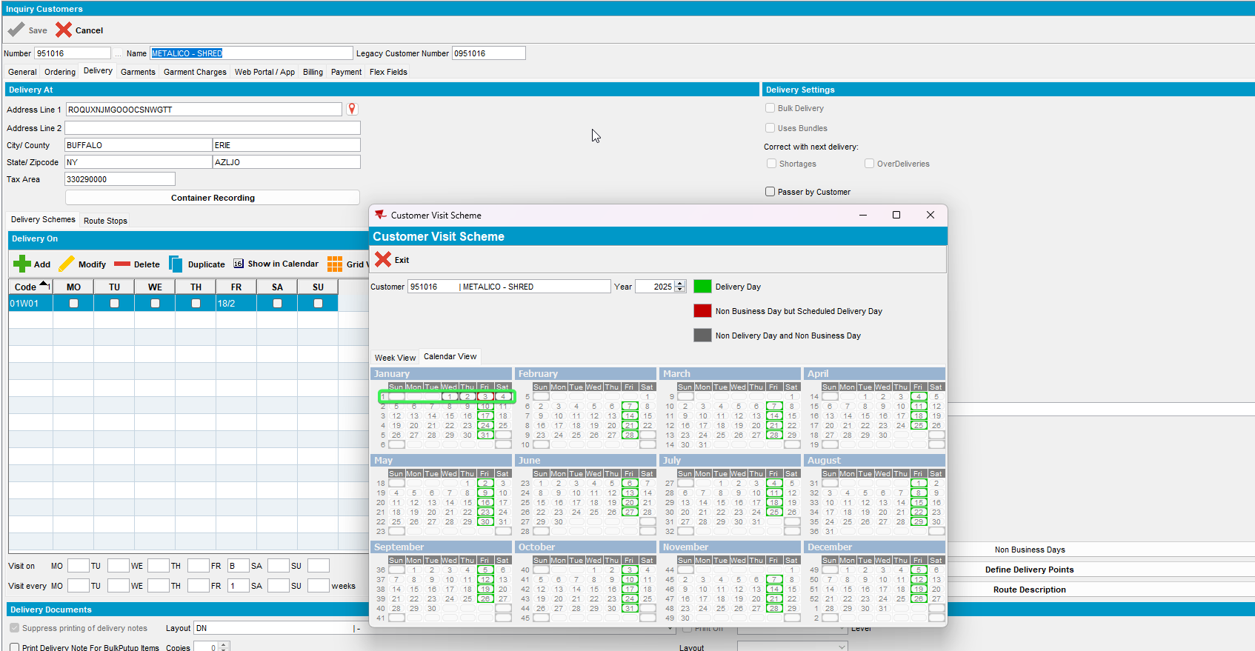
Non-business days are correctly displayed.
Tested OK.

