ABS-171845 WebX - Invoice adjustments, Wearer Maintenance and Contacts tabs are not in red colour when there is nothing to be approved, but the Review button was not done
Environment | Prerequisites
Version:9.07.00.UNF19  DBServerName=abs-SRV20.internal.abslbs.com  DBSID=CUST24  DBUser=UNFDEV  DBPassword=UNFDEV  Environment=Test | - Module:  - System setting

Contents
Retest after fix 1
Test Case 1 – With UNFCUSTOM module – Tested OK 1
Test Case 2 – Without UNFCUSTOM module – Tested OK 5

Retest after fix

Test Case 1 – With UNFCUSTOM module – Tested OK
Expected behavior: Invoice adjustments, Wearer Maintenance and Contacts tab are red
Hash: d8ec4b4056a
- Have UNFCUSTOM module in license
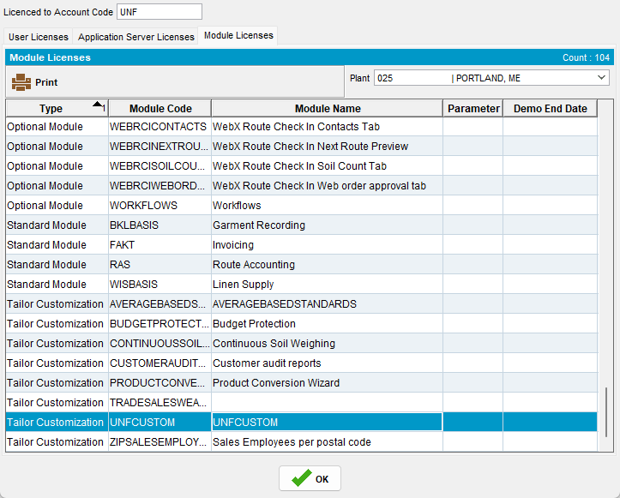
- Generate invoices for a route
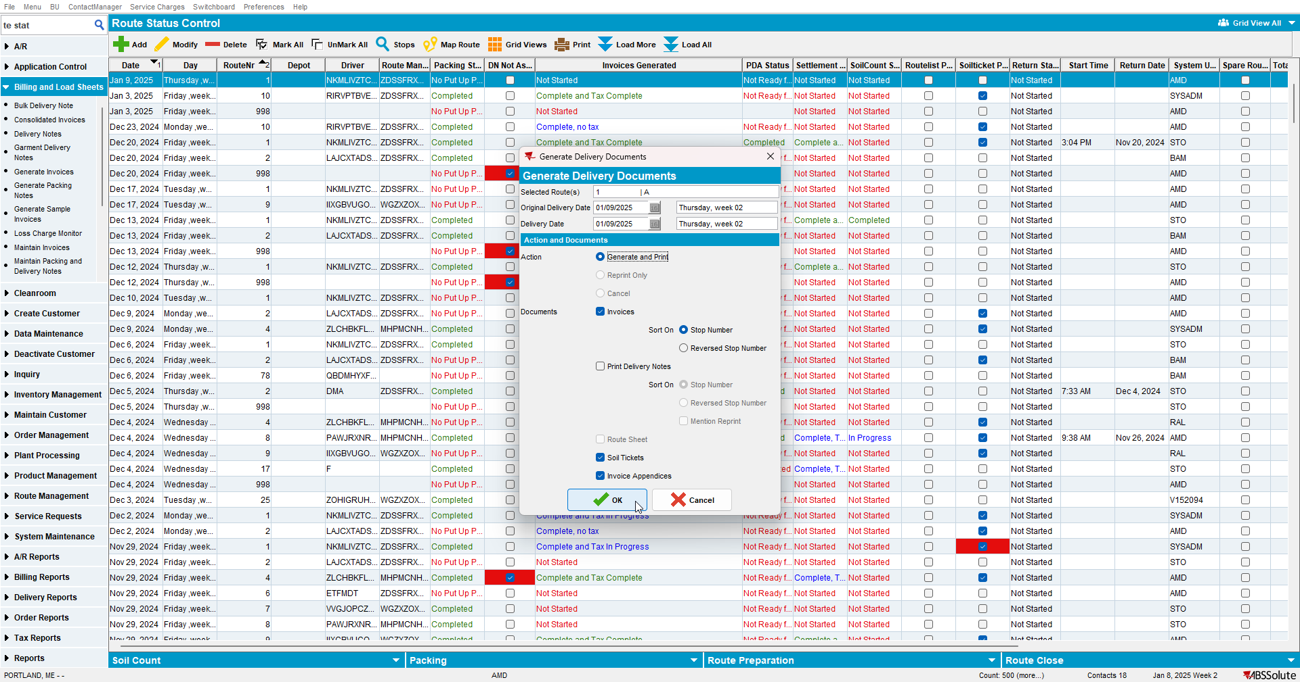
- Mark the route ready for transfer
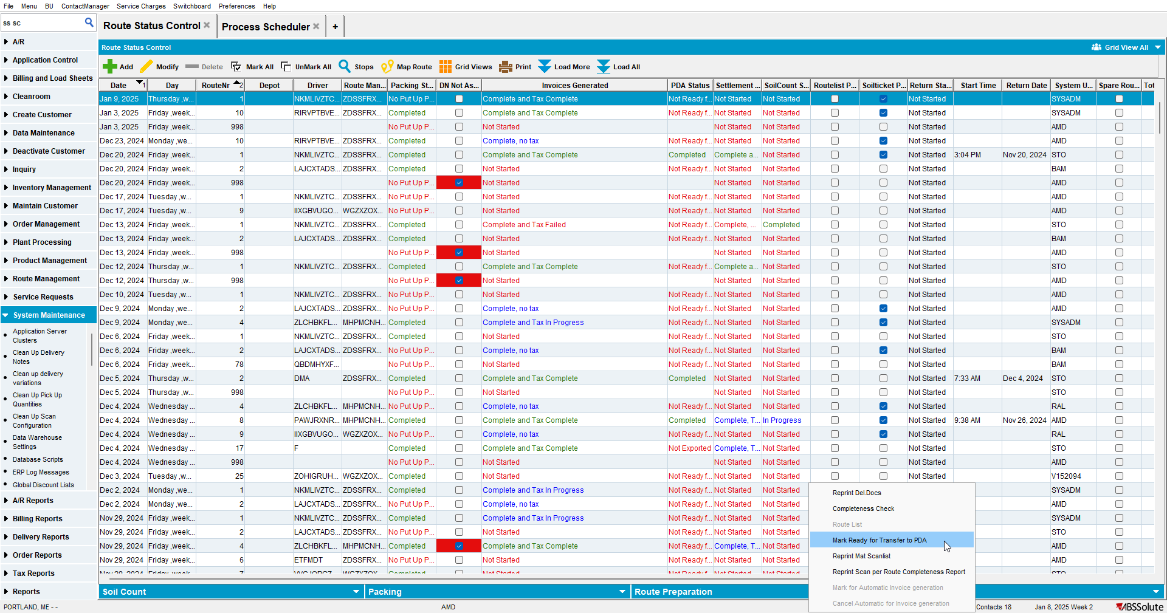
- On RA settle, finish and upload the route
- On WebX check that Invoice adjustments, Wearer Maintenance and Contacts have count 0 and are not reviewed and are written in red.

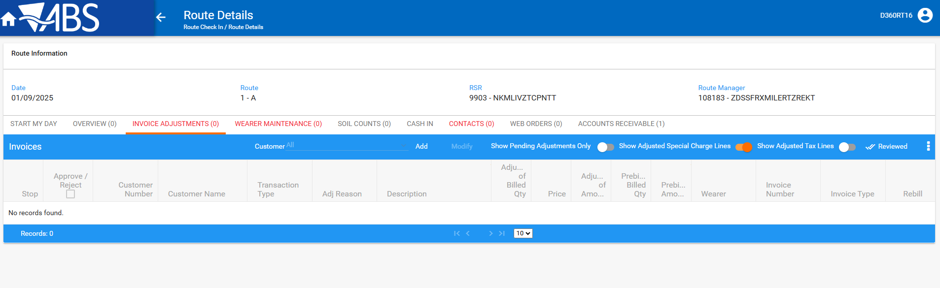
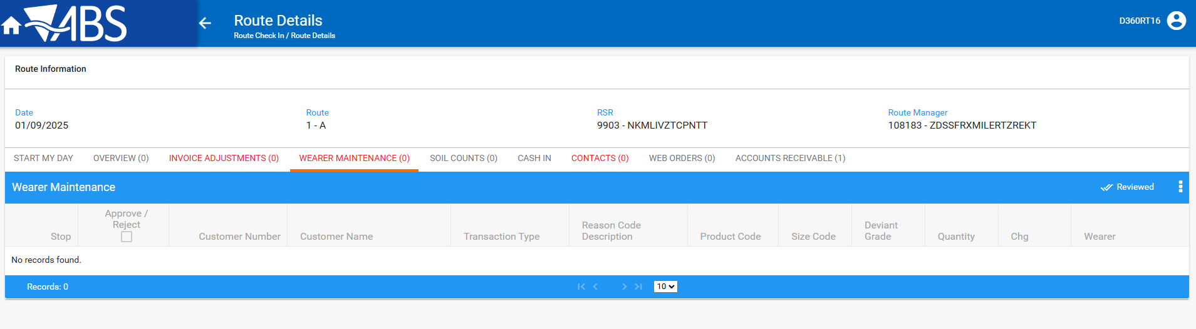
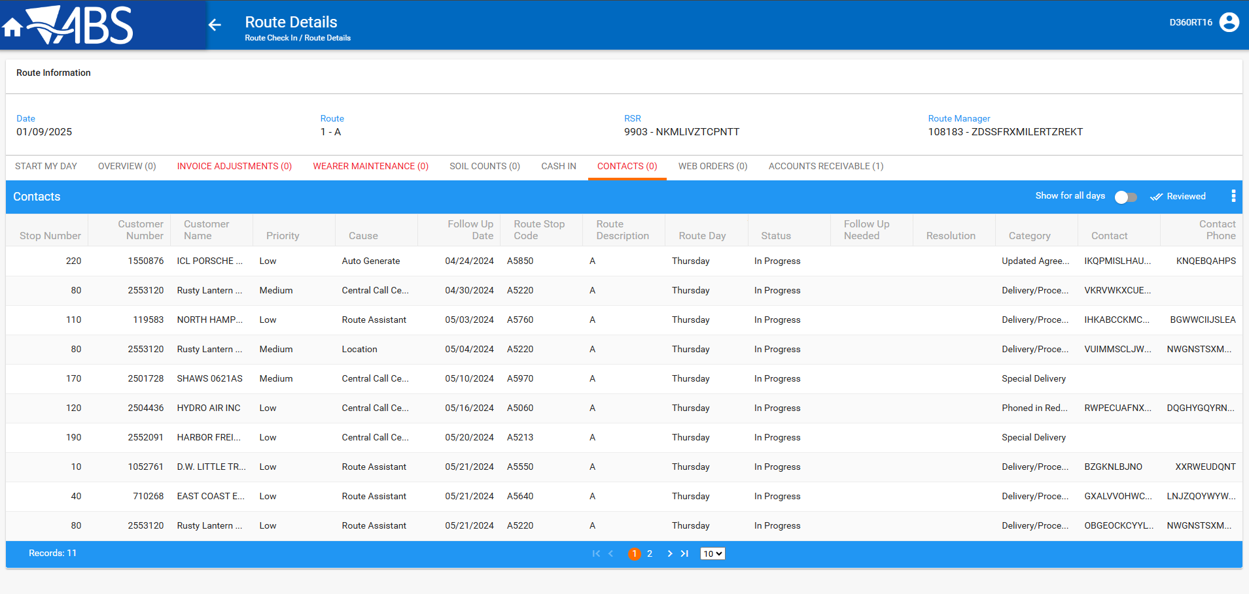

Test Case 2 – Without UNFCUSTOM module – Tested OK
Expected behavior: Invoice adjustments, Wearer Maintenance and Contacts tab are red
Hash: d8ec4b4056a
- Do not have UNFCUSTOM module in license
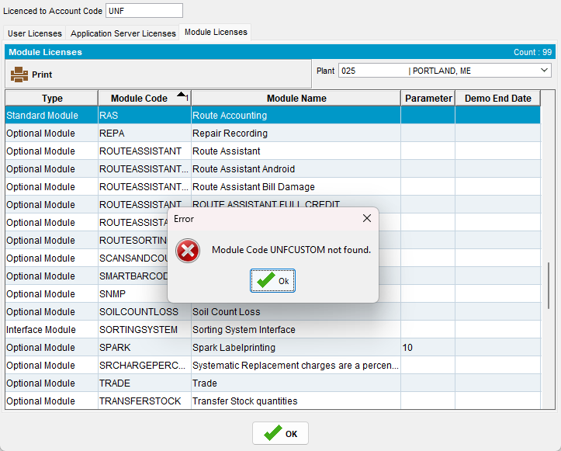
- Generate invoices for a route
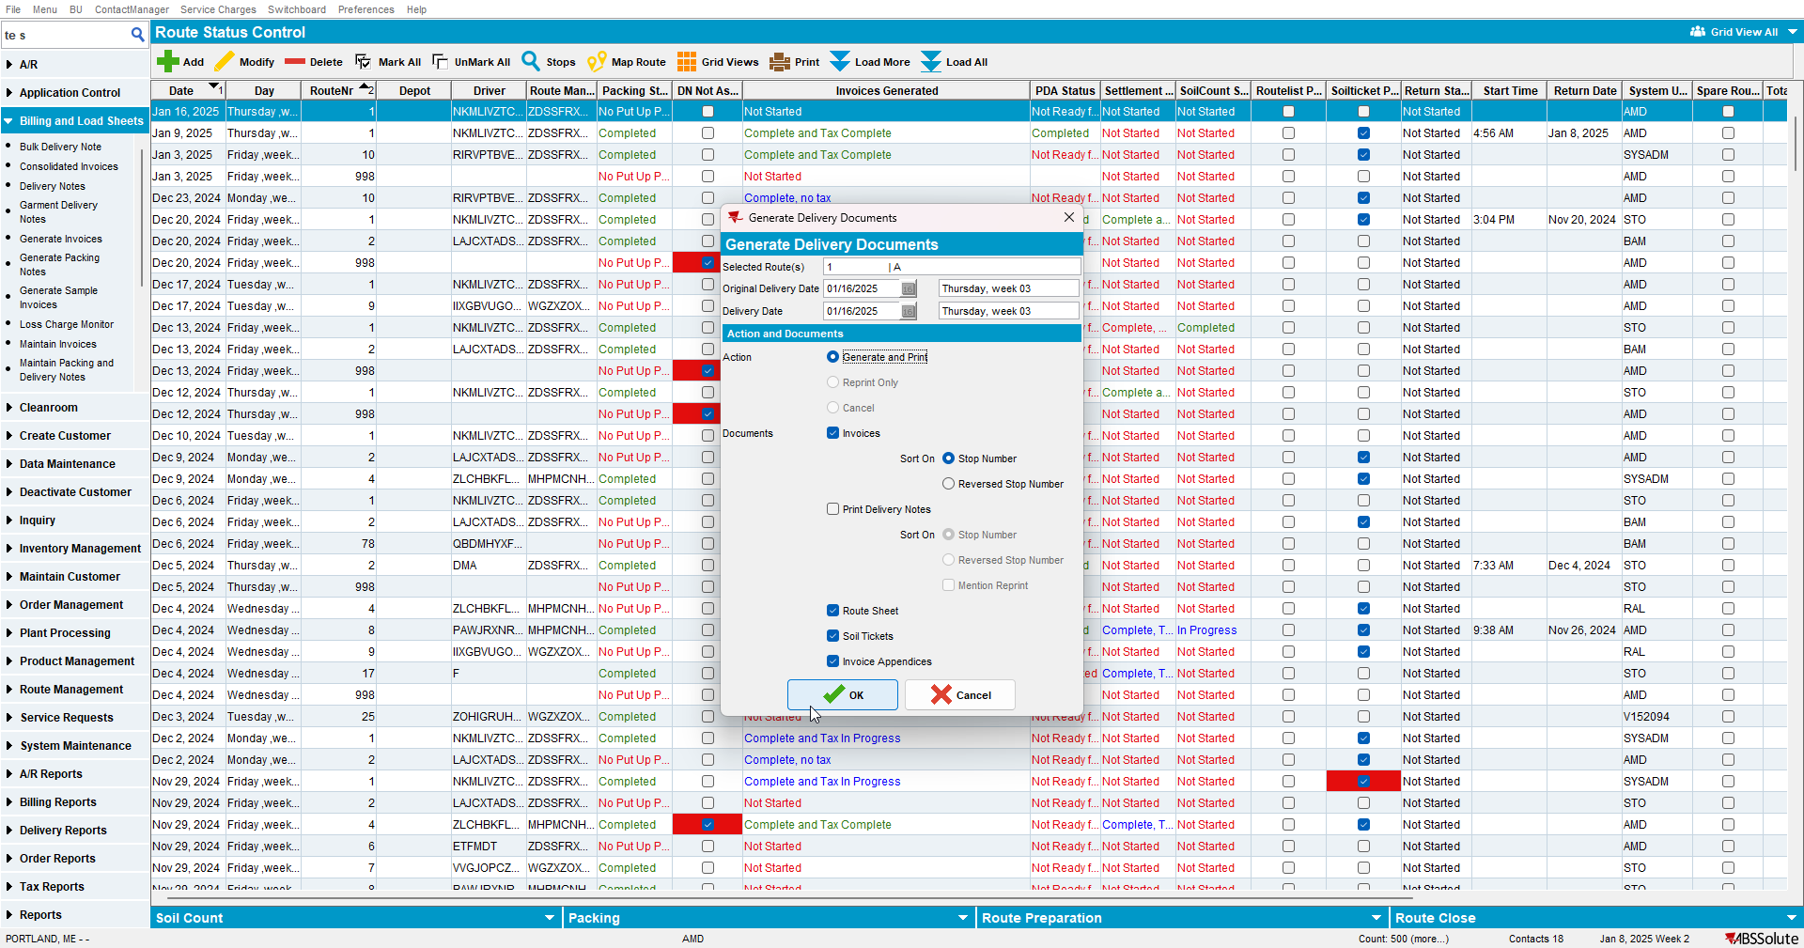

- Mark the route ready for transfer
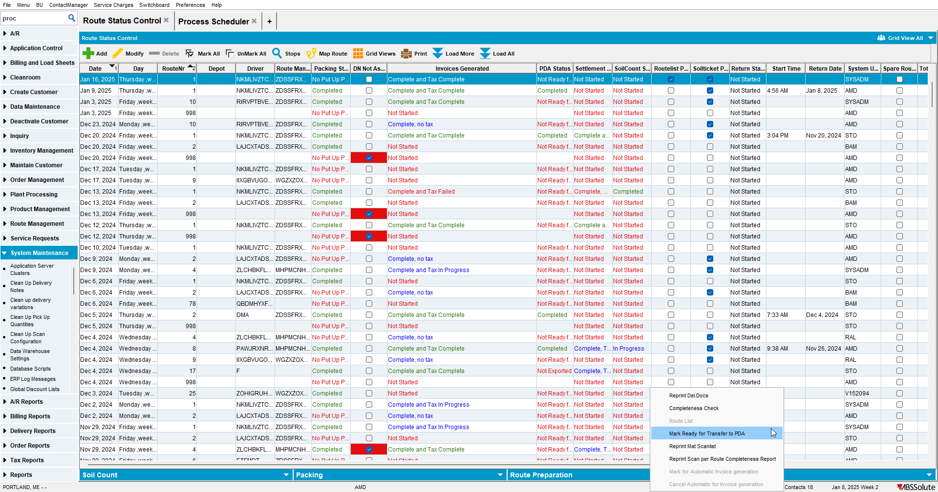
- On RA settle, finish and upload the route
- On WebX check that Invoice adjustments, Wearer Maintenance and Contacts have count 0 and are not written in red
