ABSN-600 Import Vertex BCI Tax Response content log is not visible
Environment | Prerequisites
Version: 9.07.00.UNF19  DBServerName= abs-srv20.internal.abslbs.com  DBSID=CUST24  DBUser=UNFDEV  DBPassword=UNFDEV  Environment=Production | - Module:

Contents
Retest after fix 1

Retest after fix
Hash: 5a06bd8d4ece
- RSC DLG: Create a new routecontrol for a route
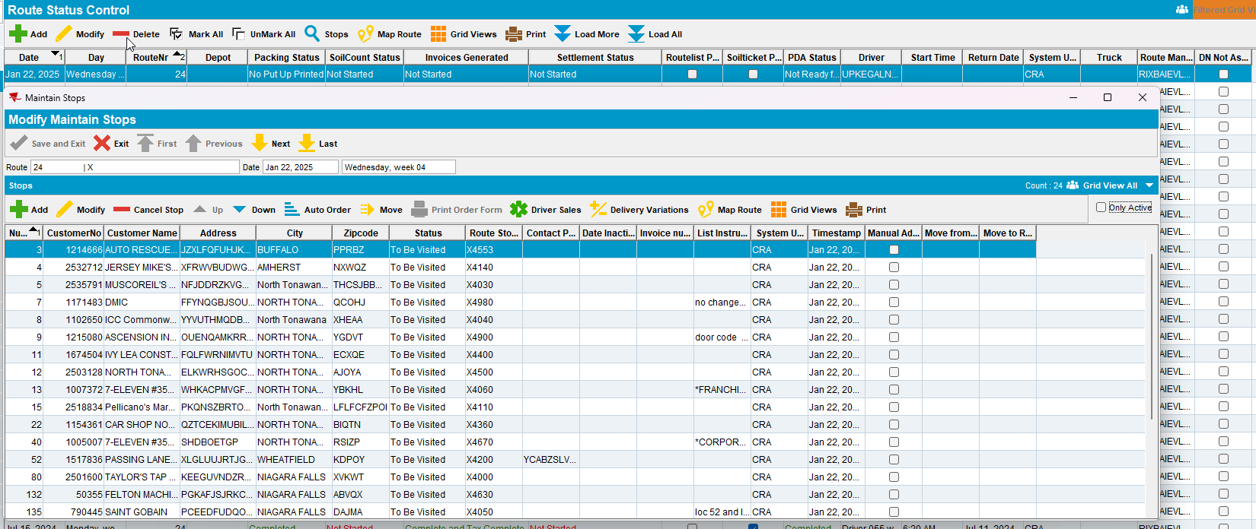
- Generate invoices
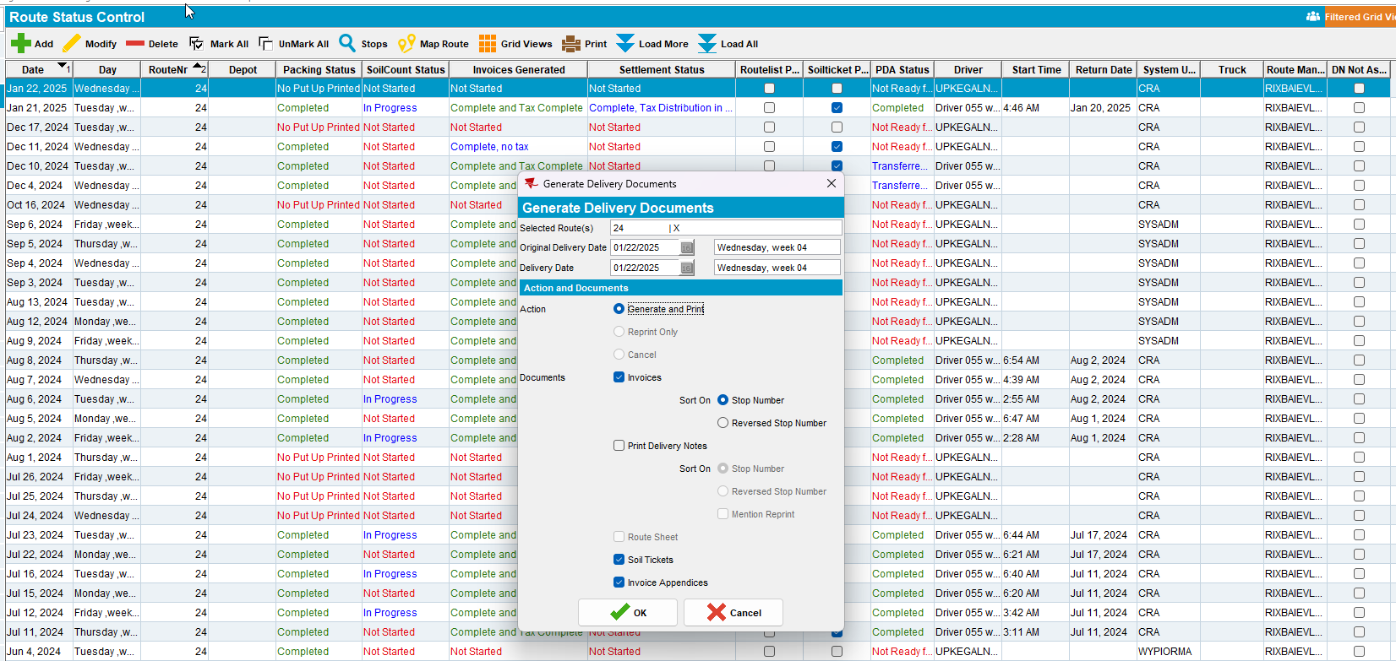
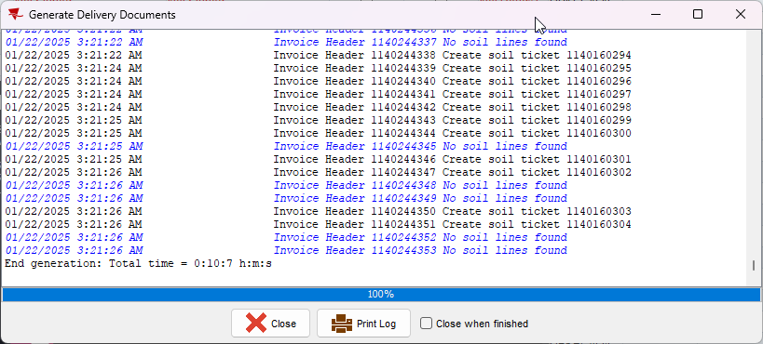
- Script taxes using SQL script
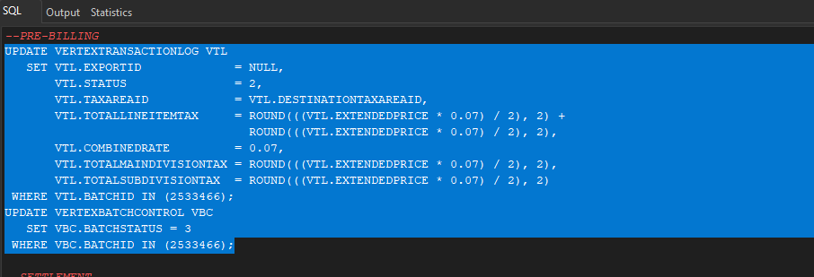
- Process Scheduler DLG: Run Import Vertex BCI Tax Response
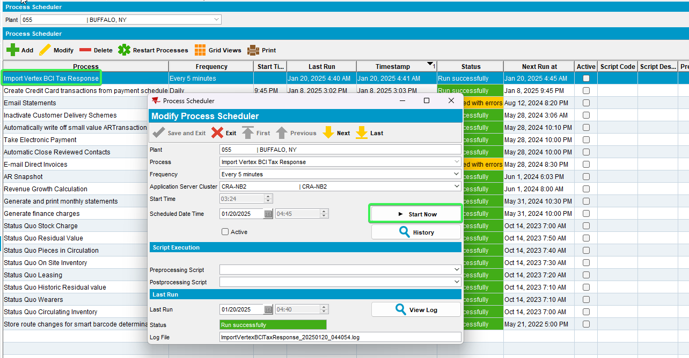
- View Process Log DLG: select Scheduled Process and Import Vertex BCI Tax Response
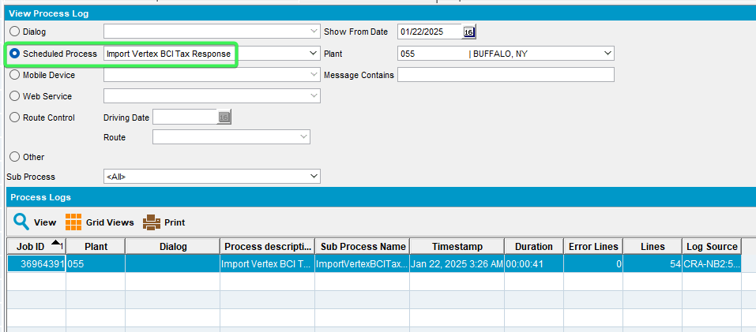
- View Vertex BCI Process Log
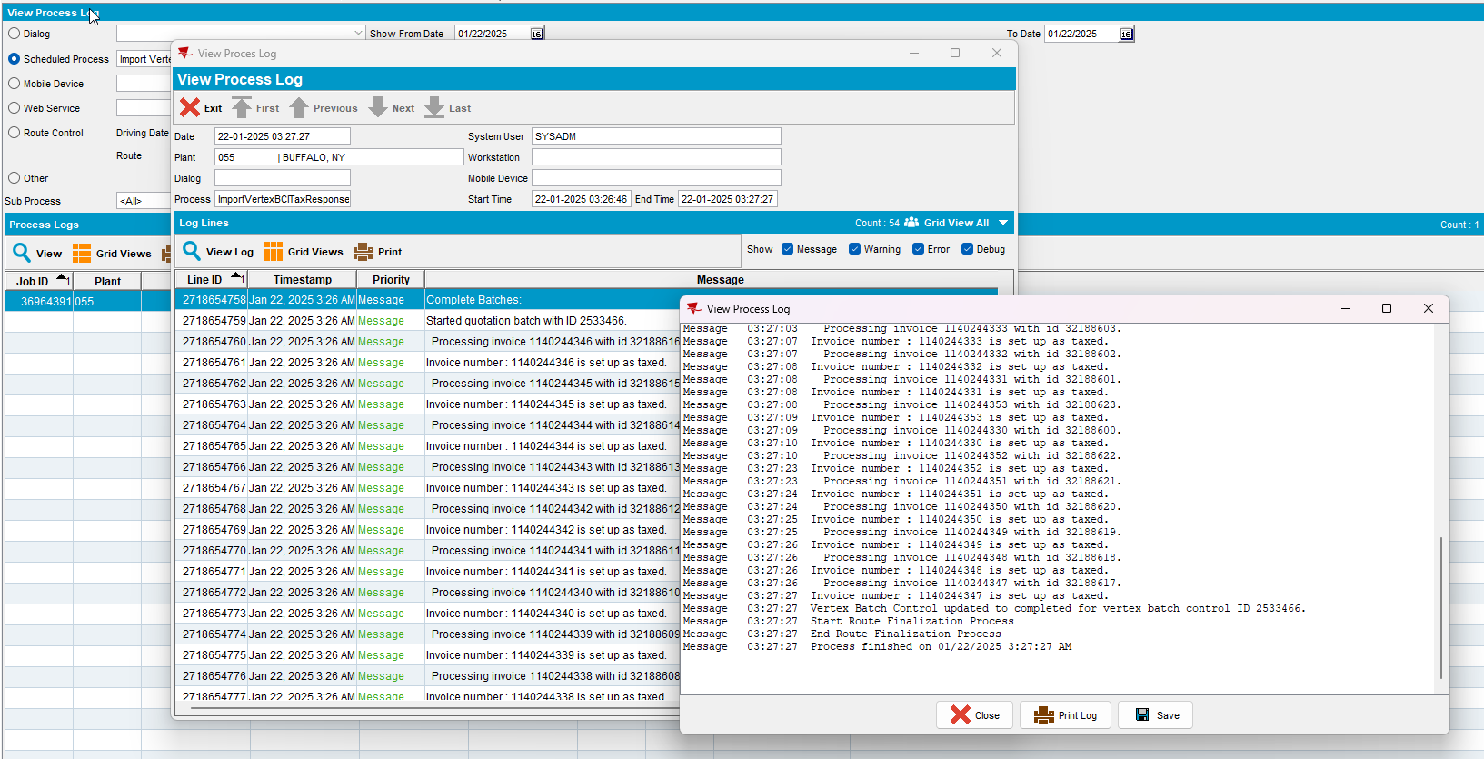
- Process Scheduler DLG: Import Vertex BCI Tax Response > Check the Last Run log
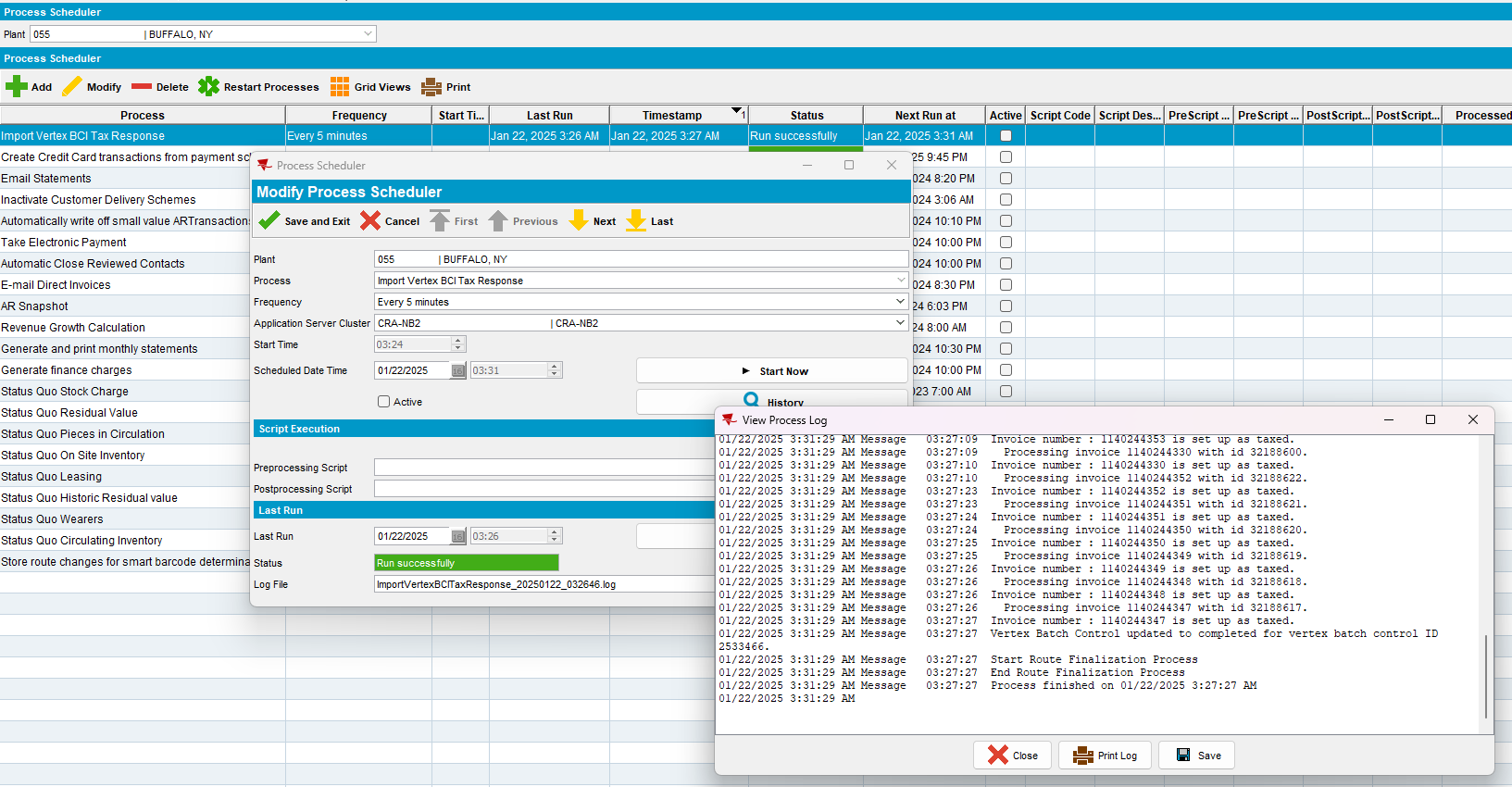
TESTED OK.

