ABSN-598 Error on settlement when a new wearer was added on RA, wearer created without a locker assigned
Environment | Prerequisites
Version:9.07.00.UNF19  DBServerName=abs-SRV20.internal.abslbs.com  DBSID=CUST24  DBUser=UNFDEV  DBPassword=UNFDEV  Environment=Test | - Module:  - System setting

Contents
Reproducing before fix 2
Steps to reproduce 2
Current Behavior 5
Expected behavior 5
Retest after fix 5
Test Case 1 – Add wearer on RA – Tested OK 5

Reproducing before fix

Steps to reproduce
- Generate invoices for a route and mark it ready for transfer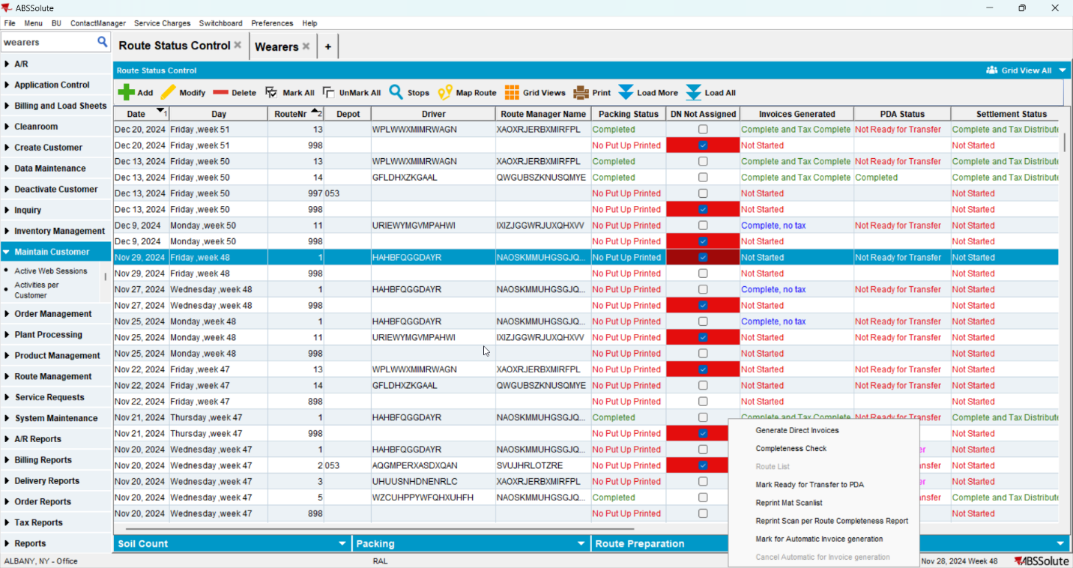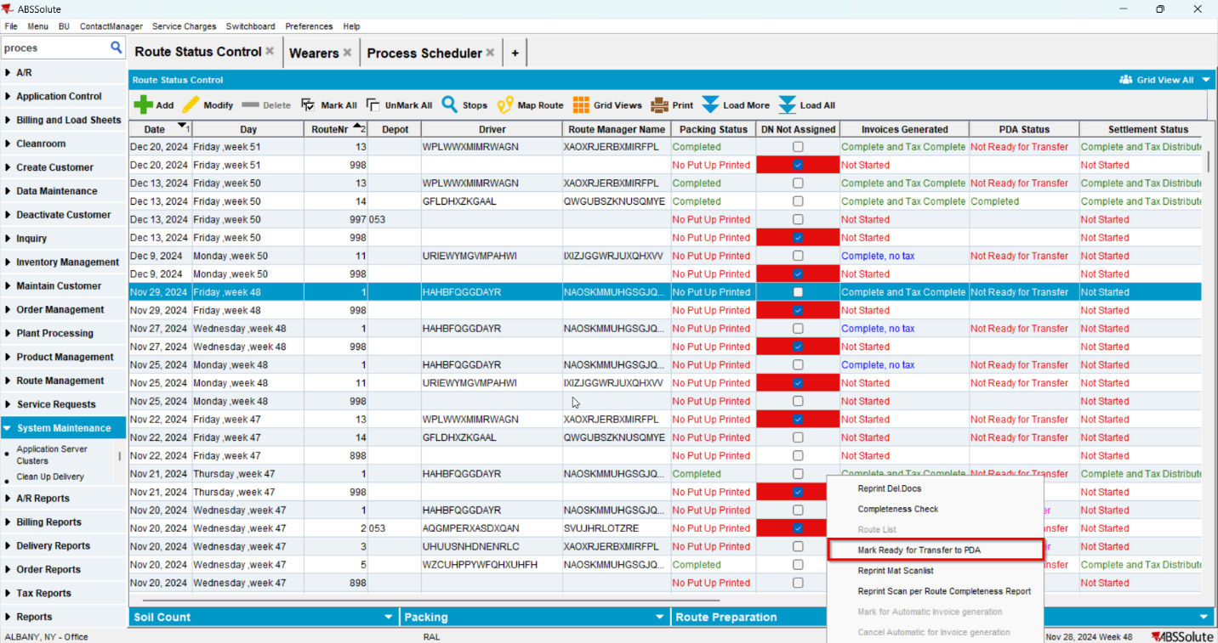
- On RA add a new wearer with a product
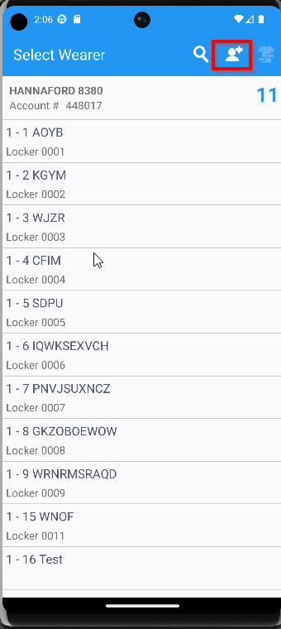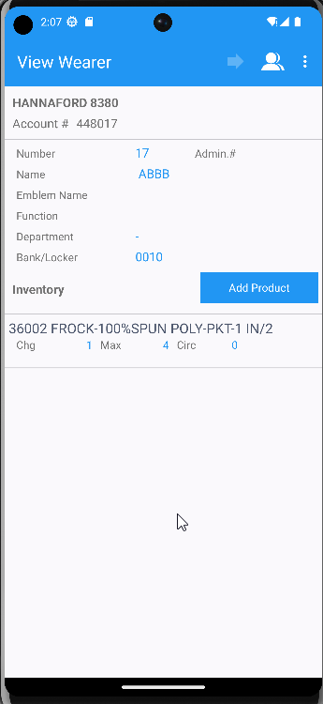
- Finish and settle the route
- On WebX settle the route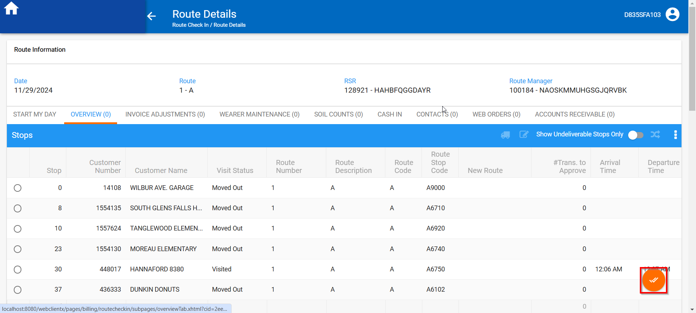
- Go to Wearers dlg and check if the wearer was added with a locker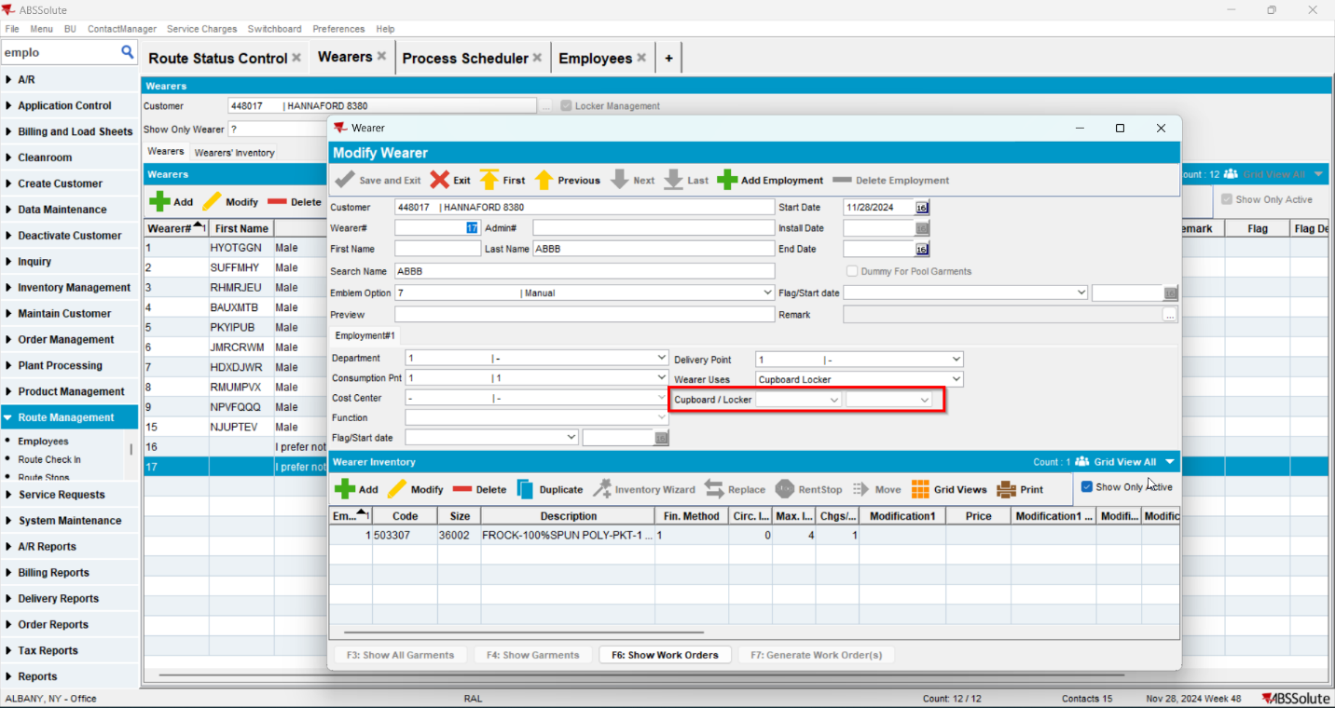
- Go to View Process log and check the log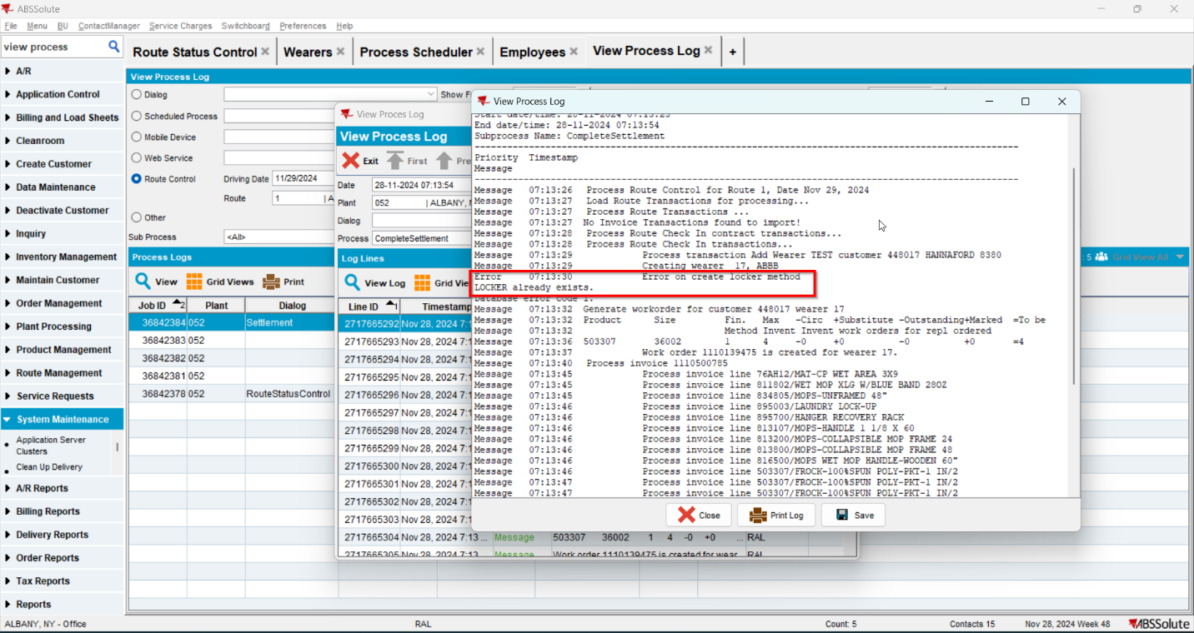

REPRODUCED OK.

Current Behavior
The following error will be displayed
"Error on create locker method LOCKER already exists. Database error code 1. "

Expected behavior
No error should appear, the wearer should be created with the locker

Retest after fix

Test Case 1 – Add wearer on RA – Tested OK
Expected behavior: No error should appear, the wearer should be created with the locker
Hash: 5a06bd8d4ec
- Generate invoices for a route and mark it ready for transfer
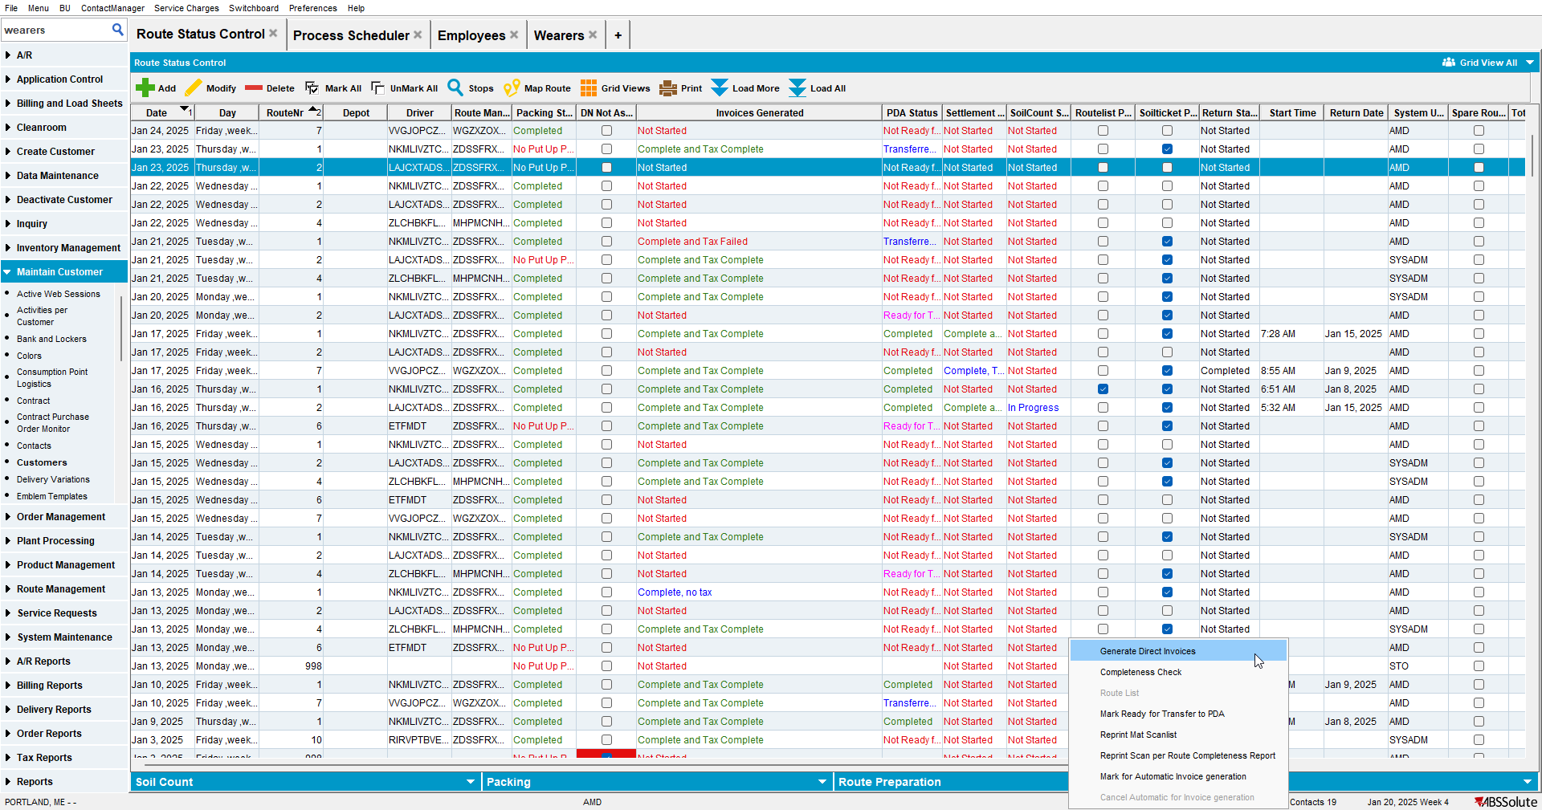
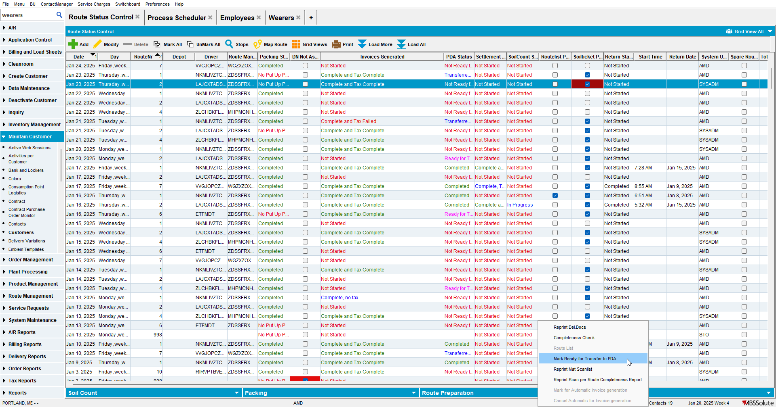

- On RA add a new wearer with a product
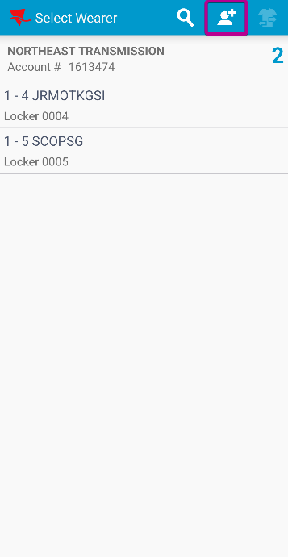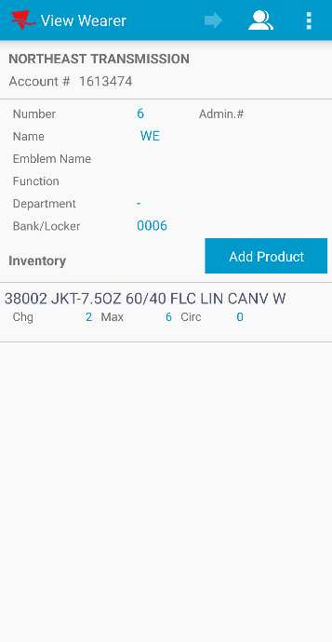

- Finish and settle the route
- On WebX settle the route
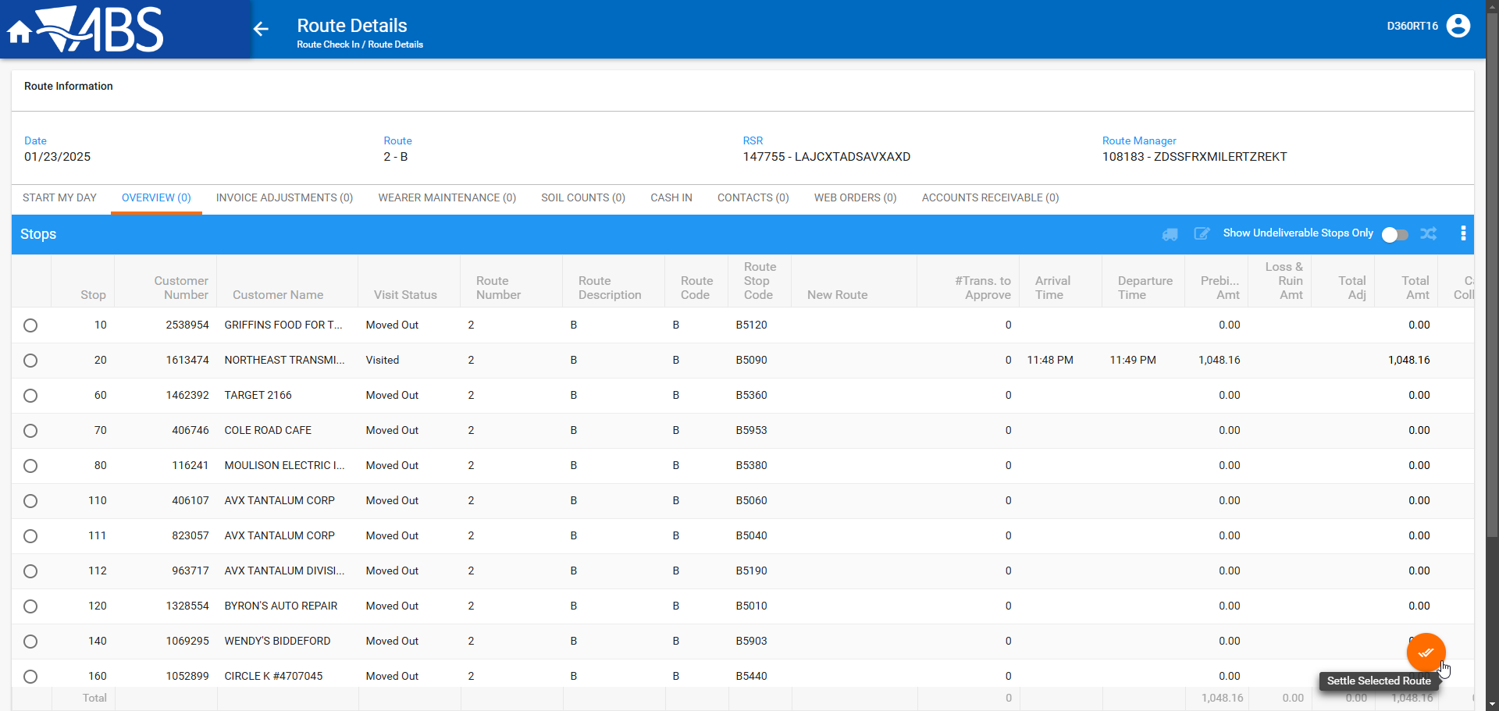

- Go to Wearers dlg and check if the wearer was added with a locker
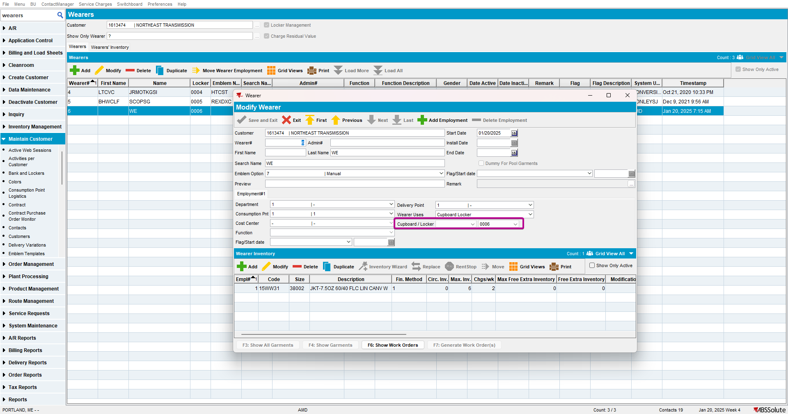

- Go to View Process log and check the log
