ABSN-596 D_UBS_2517 Blank Description column for Tax adjustments in Invoice Adjustment Tab
Environment | Prerequisites
Version: 9.07.00.UNF19  DBServerName= abs-srv20.internal.abslbs.com  DBSID=CUST24  DBUser=UNFDEV  DBPassword=UNFDEV  Environment=Production | - Module:

Contents
Reproducing before fix 1
Retest after fix 1

Reproducing before fix
Hash: 0e4aa78af29

- Create a route, generate the invoices, transfer to PDA, make an adjustment then upload it.
- Web Client X: Find the route and go to Invoice Adjusments.
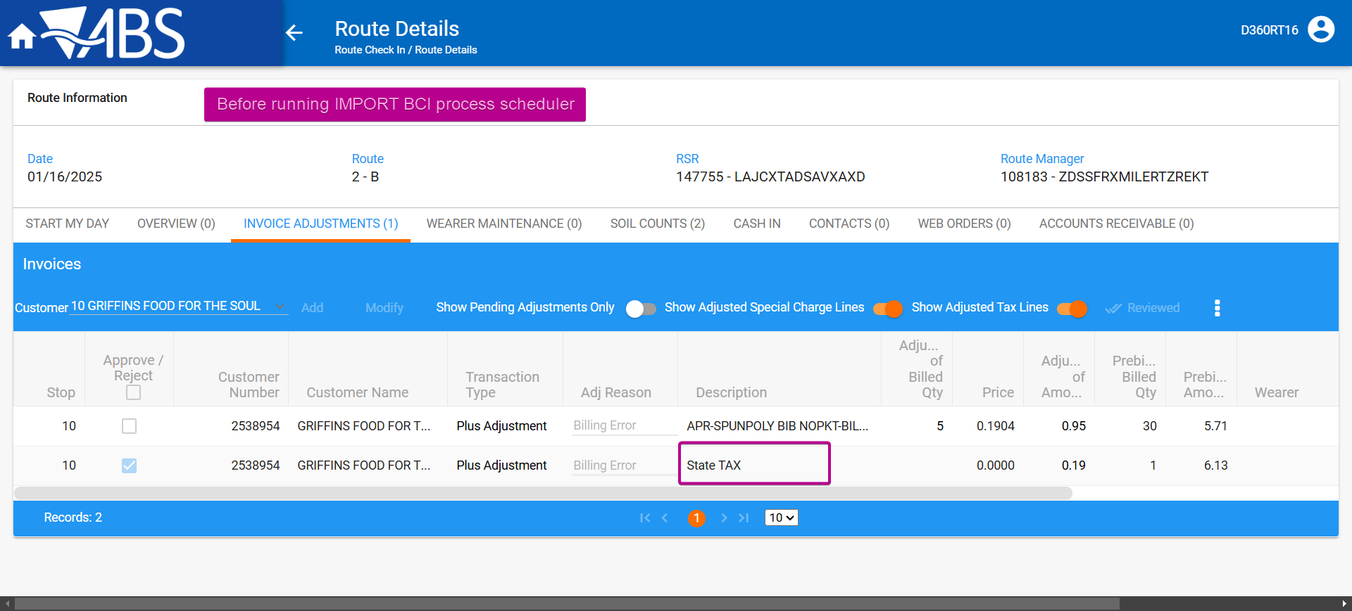

- Run Import BCI process scheduler.
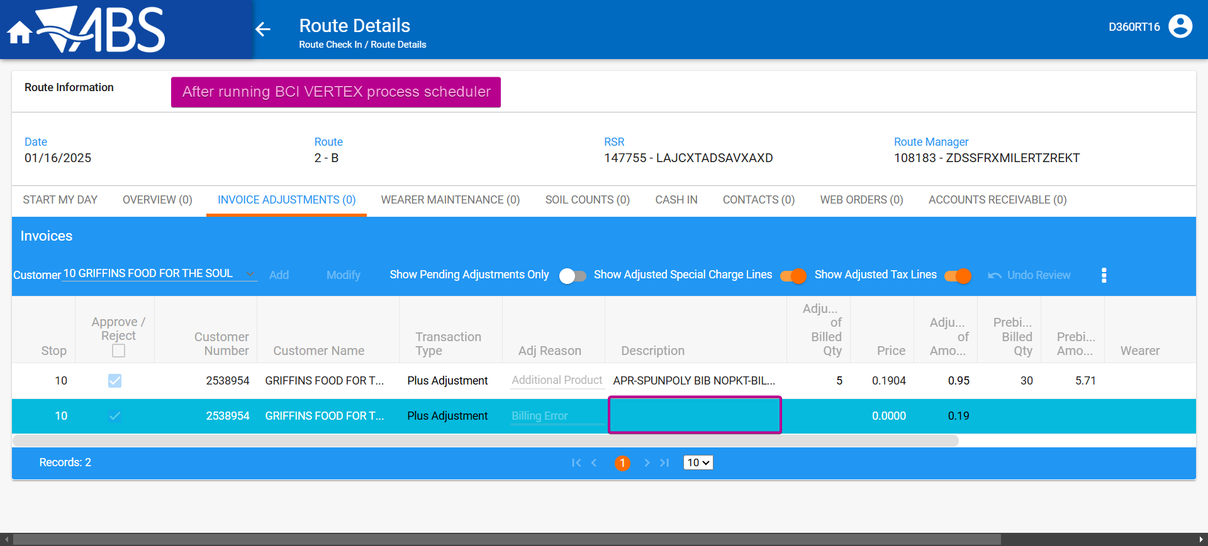

The description is missing.

Retest after fix
Hash: 79b1cfc154c

- Create a route, generate the invoices, transfer to PDA, make an adjustment then upload it.
- Web Client X: Find the route and go to Invoice Adjusments.
- Create a route, generate the invoices, transfer to PDA, make an adjustment then upload it.
- Web Client X: Find the route and go to Invoice Adjusments.
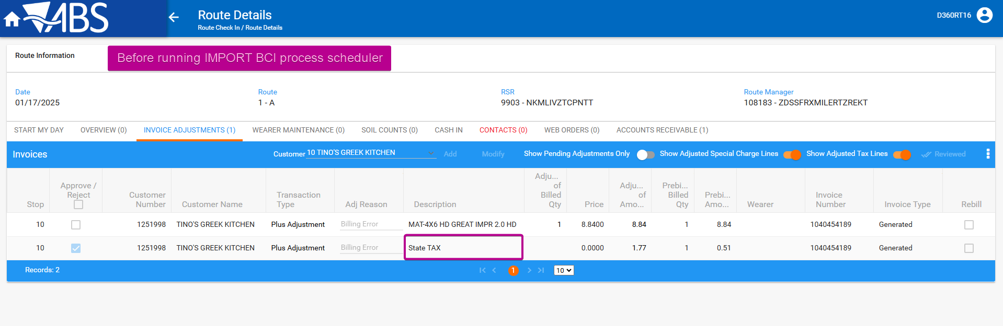

- Run Import BCI process scheduler.
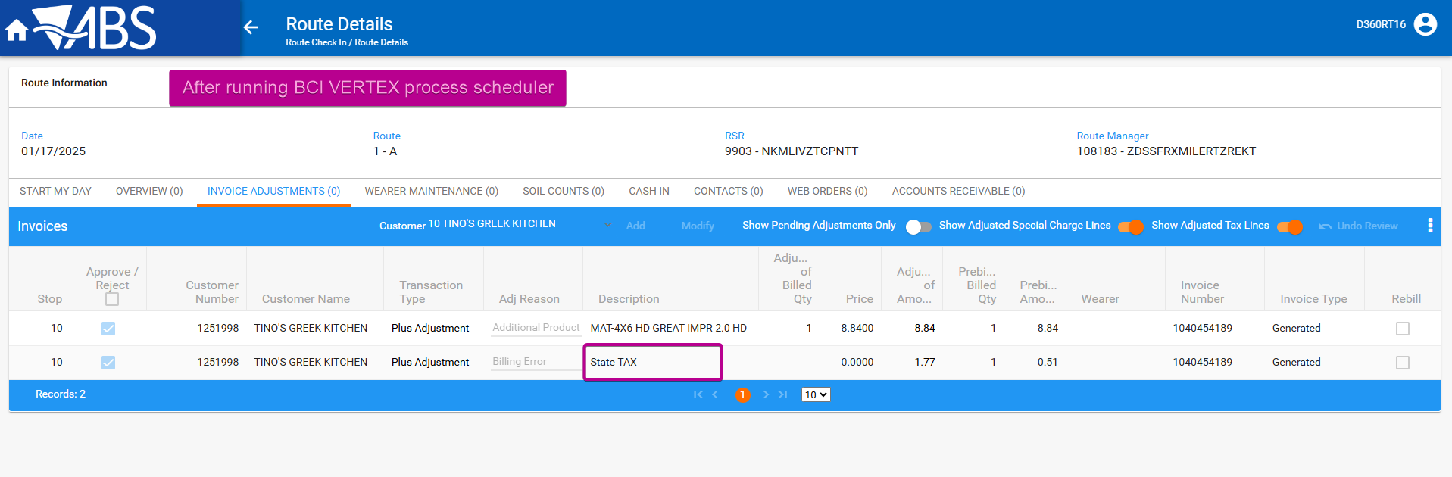

The description is not missing.

TESTED OK.

