ABSN-5955 QF - Error logged upon saving an additional employment
Environment | Prerequisites
Version:9.07.00  DBServerName=abs-SRV20.internal.abslbs.com  DBSID=CUST24  DBUser=UNFDEV  DBPassword=UNFDEV  Environment=Test | - Module:  - System setting

Contents
Reproducing before fix 1
Steps to reproduce 1
Current Behavior 4
Expected behavior 4
Retest after fix 5
Test Case 1 – Add employment – Tested OK 5

Reproducing before fix

Steps to reproduce
- Go to Wearers dlg
- Open an existing wearer
- Add an employment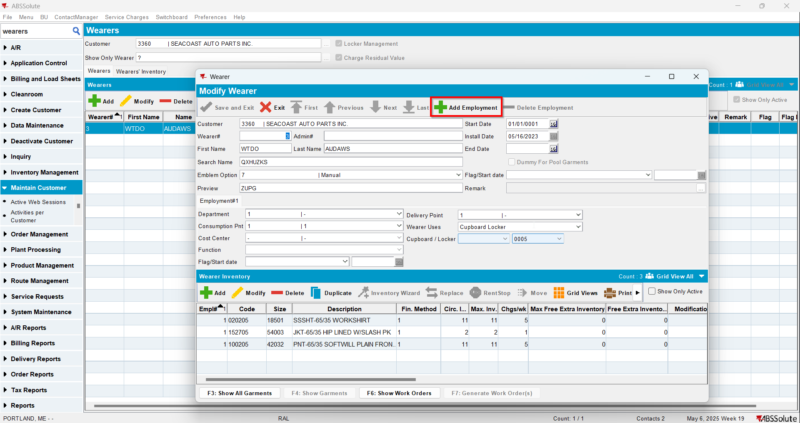
- Add a wearer inventory for that new employment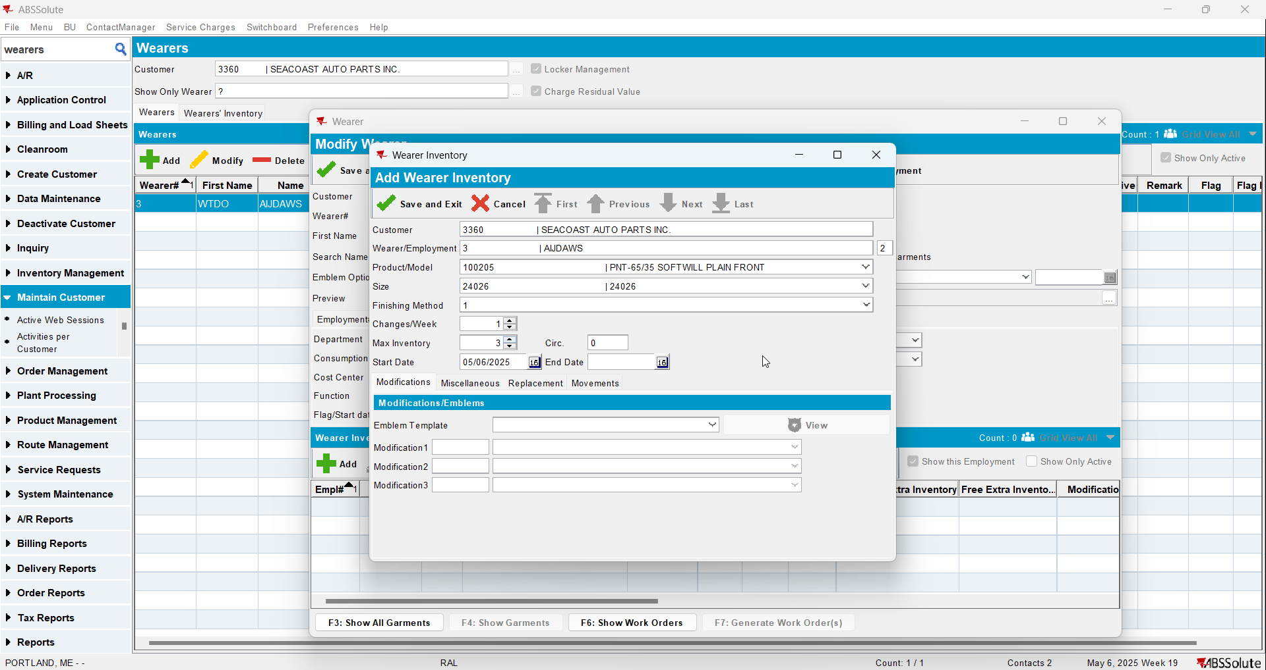
- Save the wearer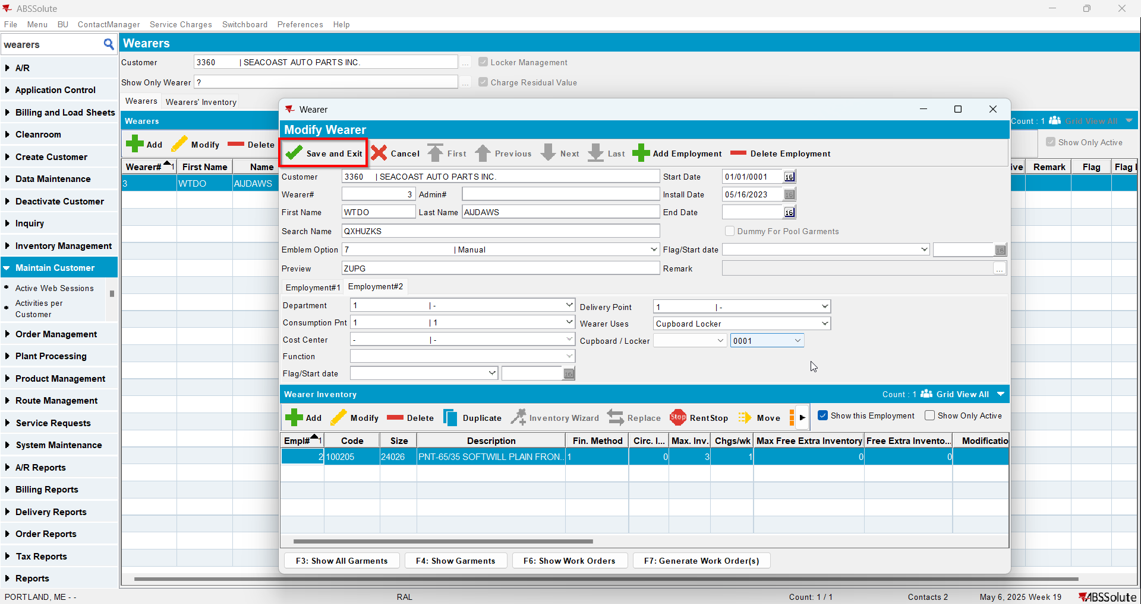
- When the message appears press Yes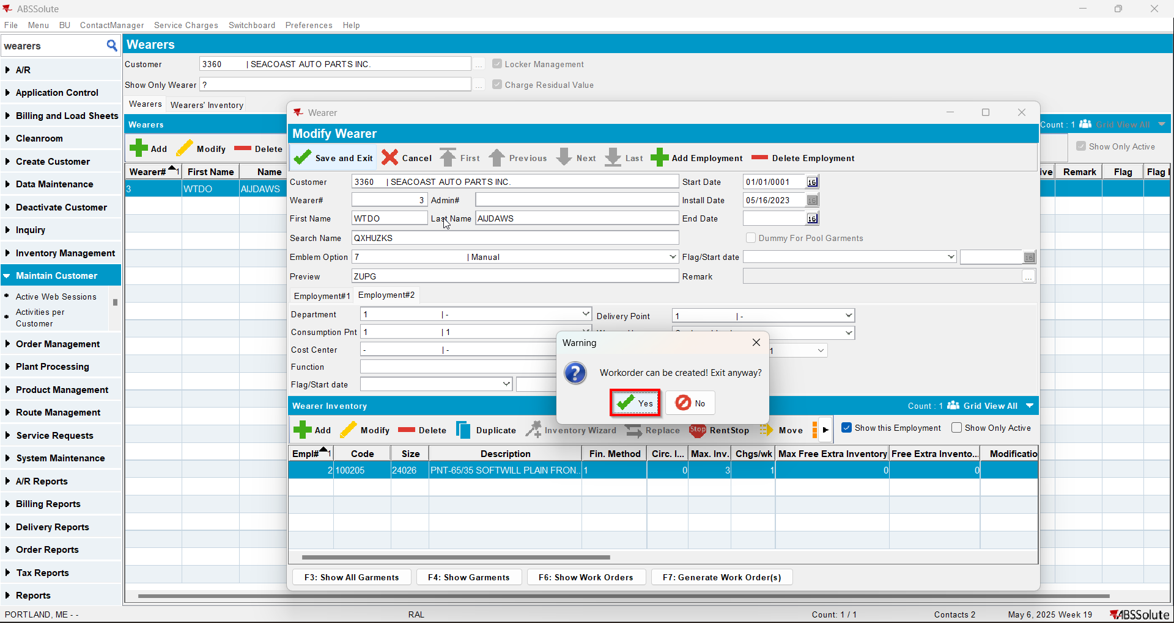
- Check that the wearer saved and also check the client log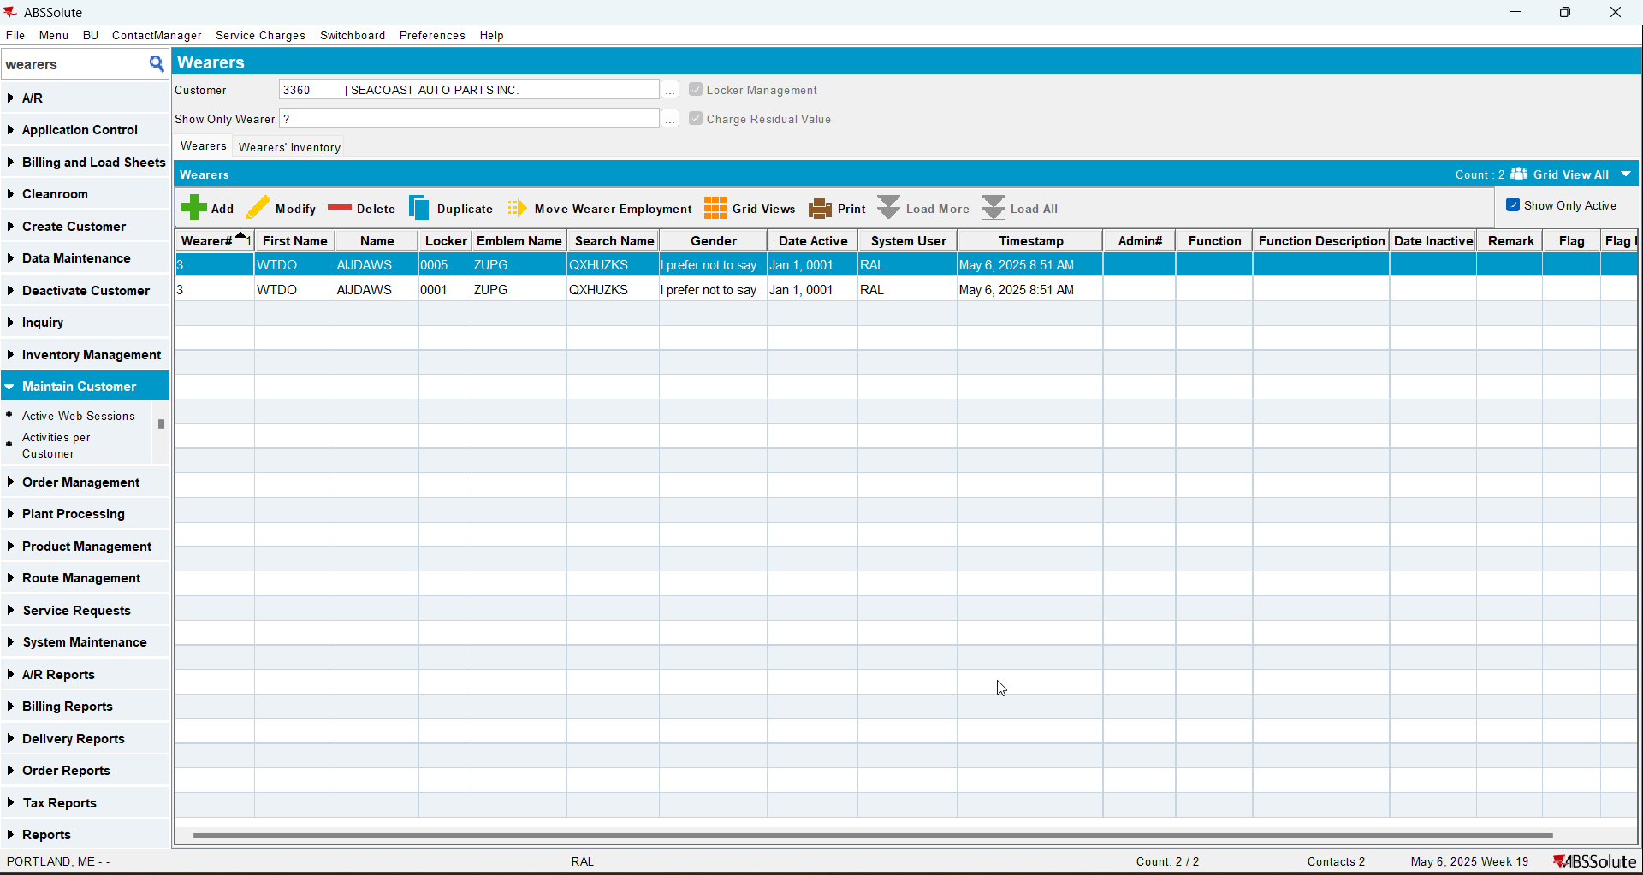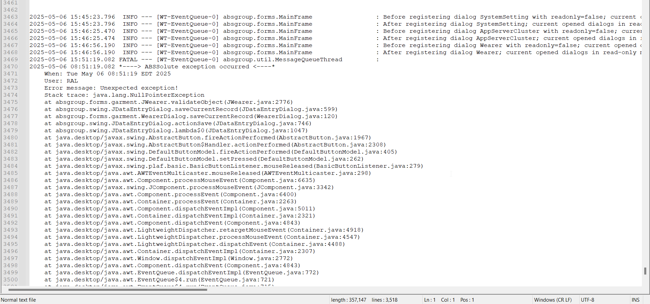

REPRODUCED OK.

Current Behavior
An error appears in the client log

Expected behavior
No error should appear in the client log

Retest after fix

Test Case 1 – Add employment – Tested OK
Expected behavior: The wearer is saved and no error appears in the client log
Hash: bff01e8
- Go to Wearers dlg
- Open an existing wearer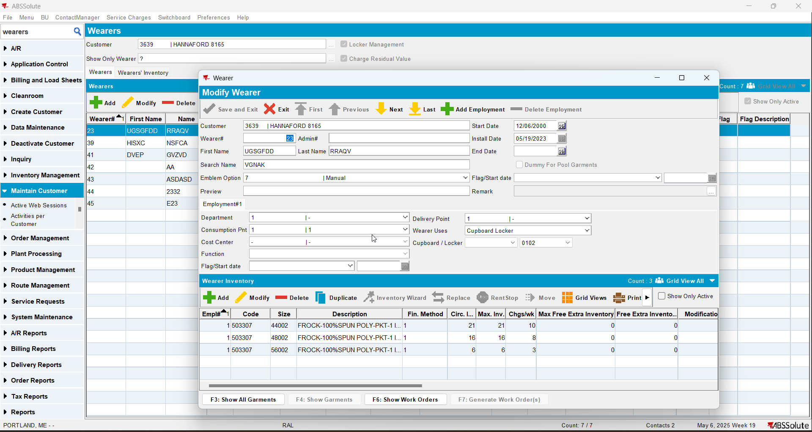
- Add an employment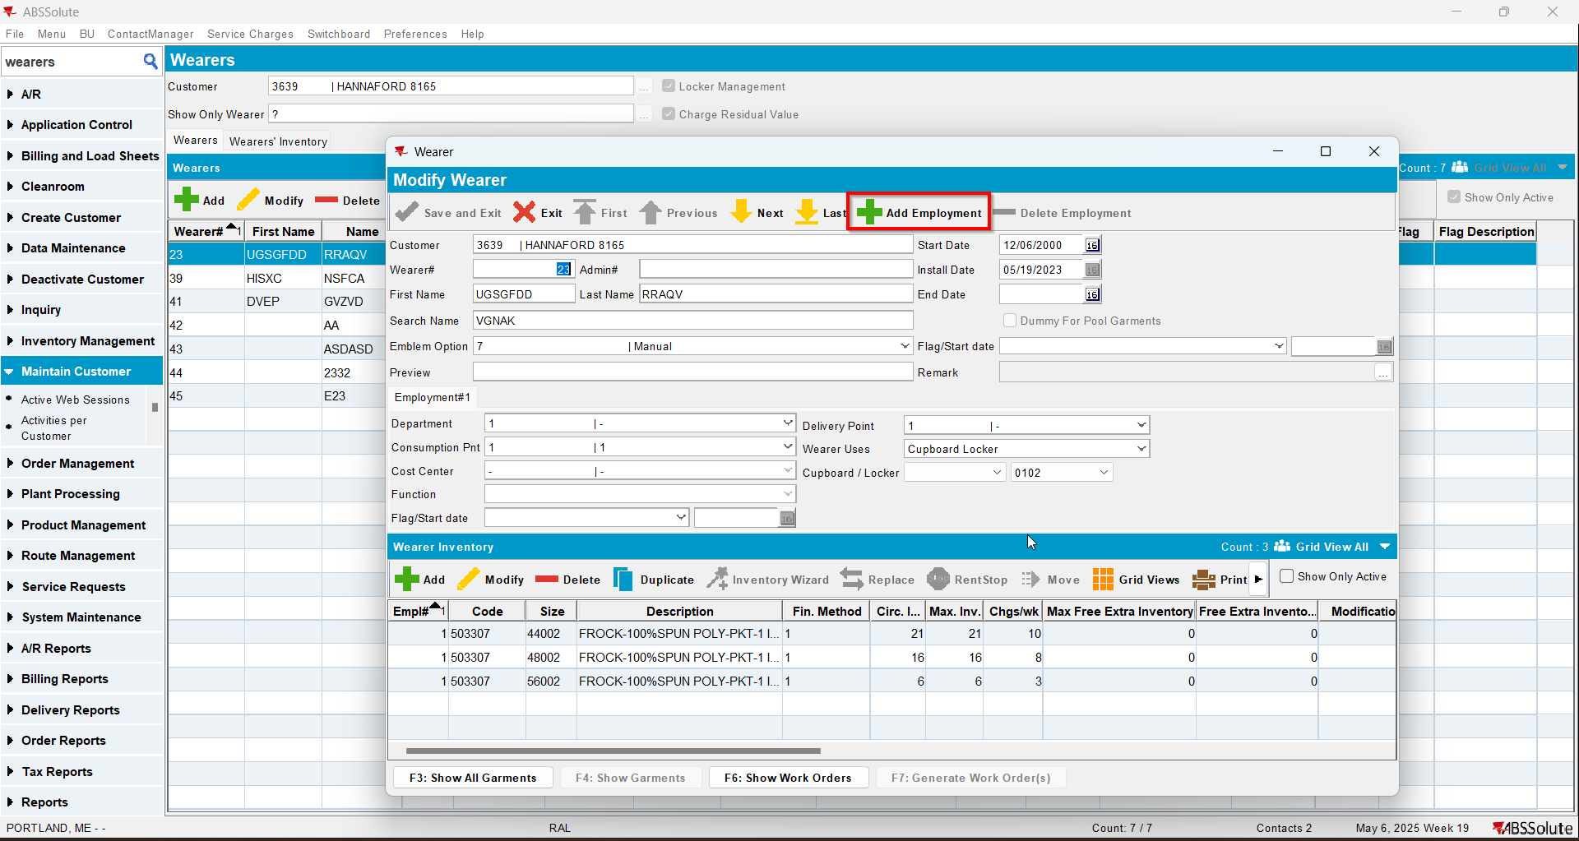
- Add a wearer inventory for that new employment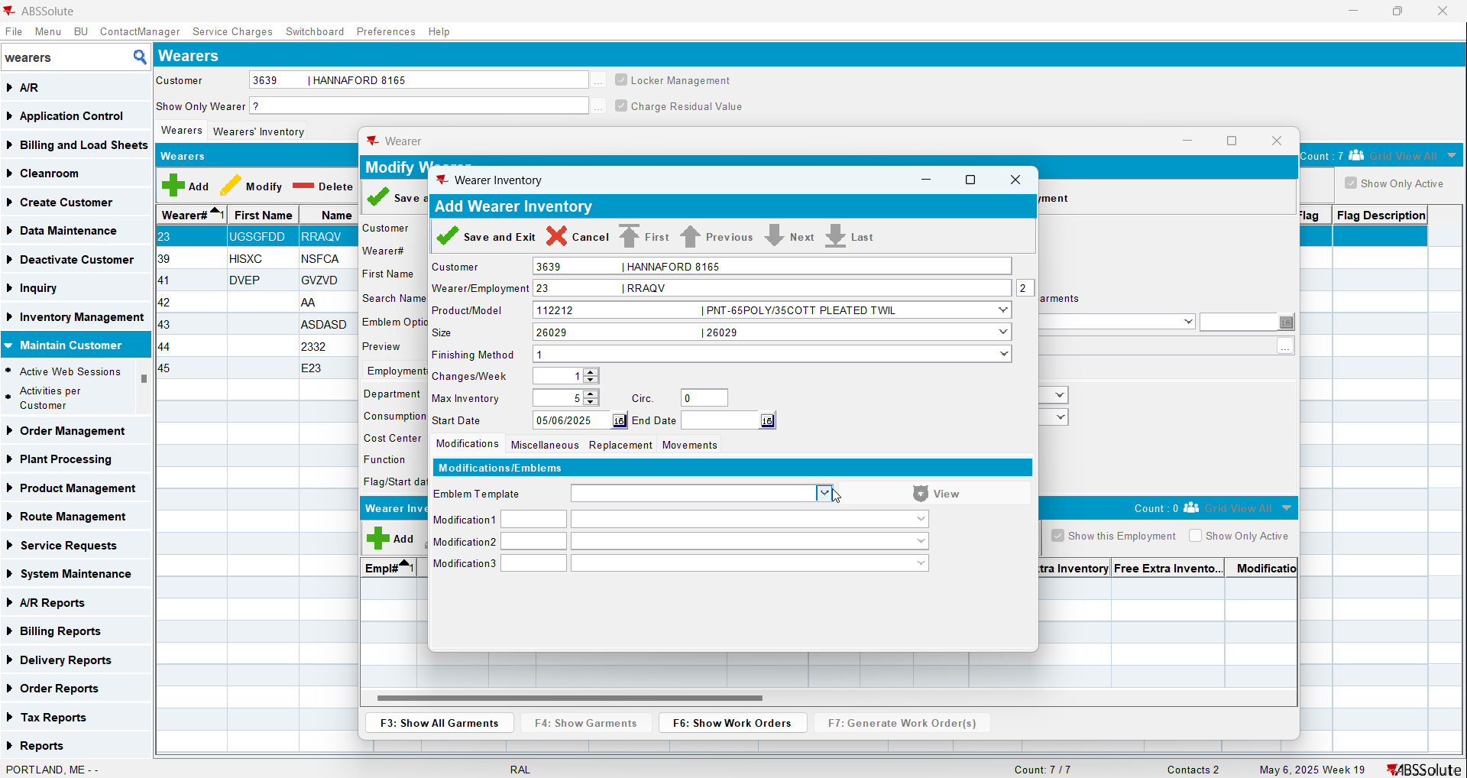
- Save the wearer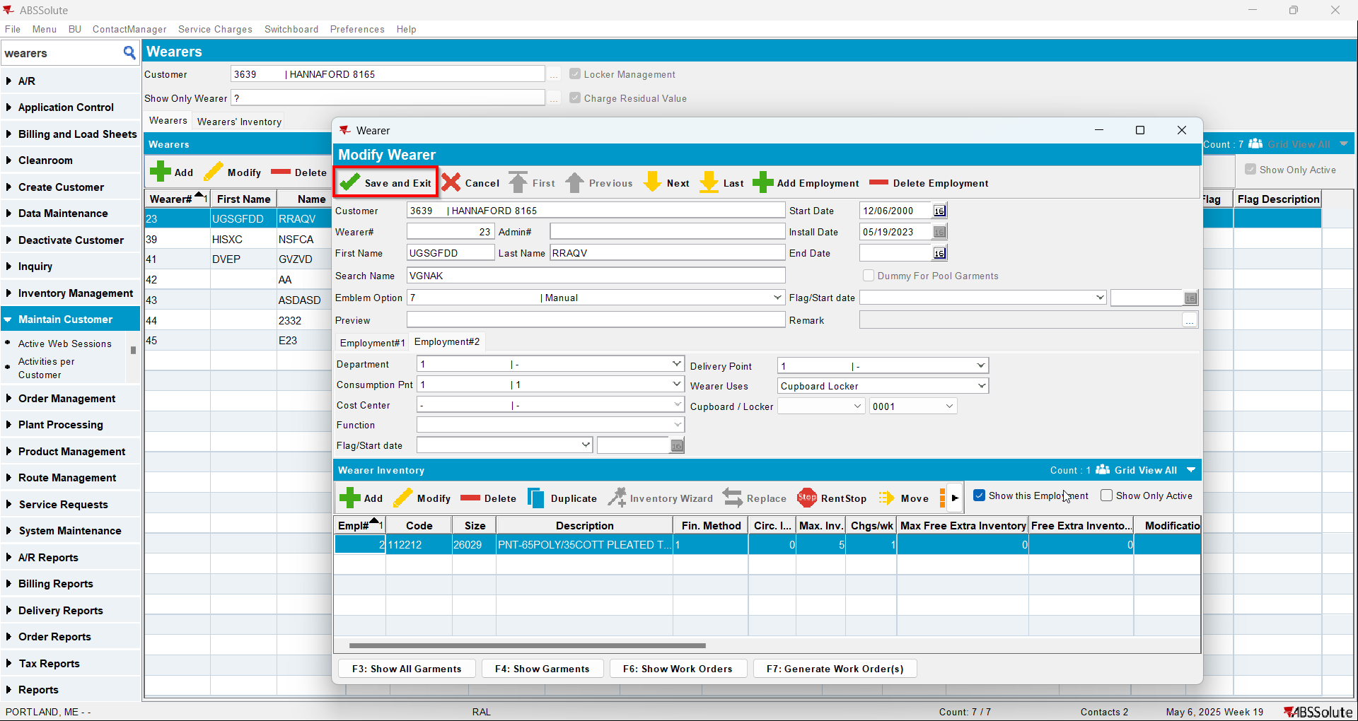
- When the message appears press Yes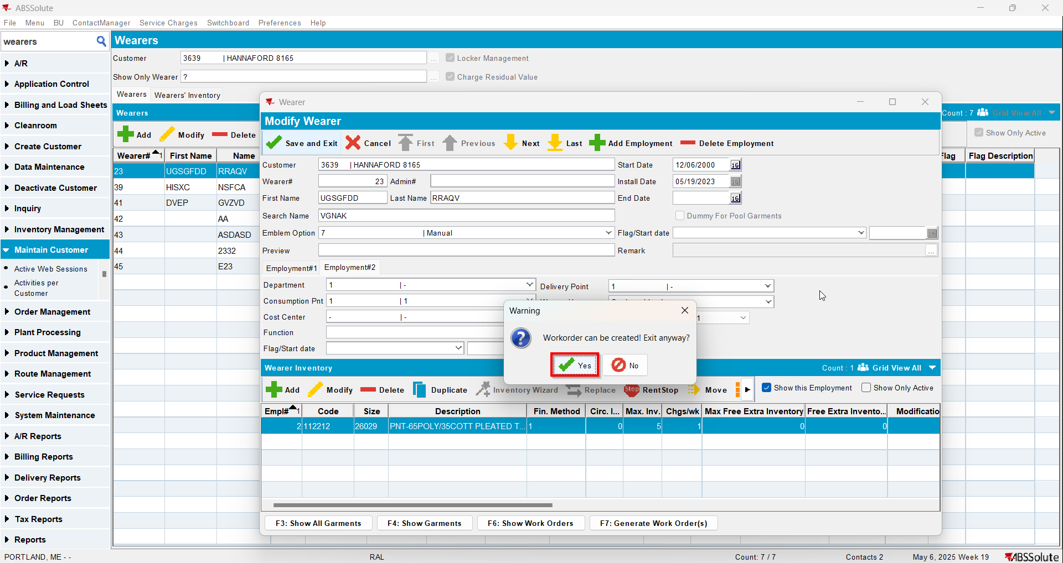
- Check that the wearer saved and there are no errors in the client log