ABSN-591 D_UBS_2481 Loc- 081 -cannot determine customer delivery date Customer 1760904 has no garments visit days
Environment | Prerequisites
Version:9.07.00.UNF19  DBServerName=abs-srv20.internal.abslbs.com  DBSID=CUST24  DBUser=UNFDEV  DBPassword=UNFDEV  Environment=Test | - Module:  - System setting

Contents
Test after fix 1
Test Case 1 – Issue work order for a non-garment for a customer that does not have garment visit days – Tested OK 1

Test after fix

Test Case 1 – Issue work order for a non-garment for a customer that does not have garment visit days – Tested OK
Expected behavior: No error should appear
Hash: 5a06bd8d4ec
- Use the below select to find data
SELECT C.CUSTOMERNUMBER FROM CUSTOMER C
JOIN BUSINESSUNIT BU ON BU.BUSINESSUNIT_ID = C.DEFAULTBUSINESSUNIT_ID
WHERE EXISTS (SELECT 1 from CUSTOMERDELIVERYDAY CDD
WHERE CDD.CUSTOMER_ID = C.CUSTOMER_ID
AND CDD.TYPEOFMERCHADISE = 1)
AND NOT EXISTS (SELECT 1 from CUSTOMERDELIVERYDAY CDD
WHERE CDD.CUSTOMER_ID = C.CUSTOMER_ID
AND CDD.TYPEOFMERCHADISE = 2)
AND BU.CODE = '025'
AND C.DATEINACTIVE > SYSDATE;
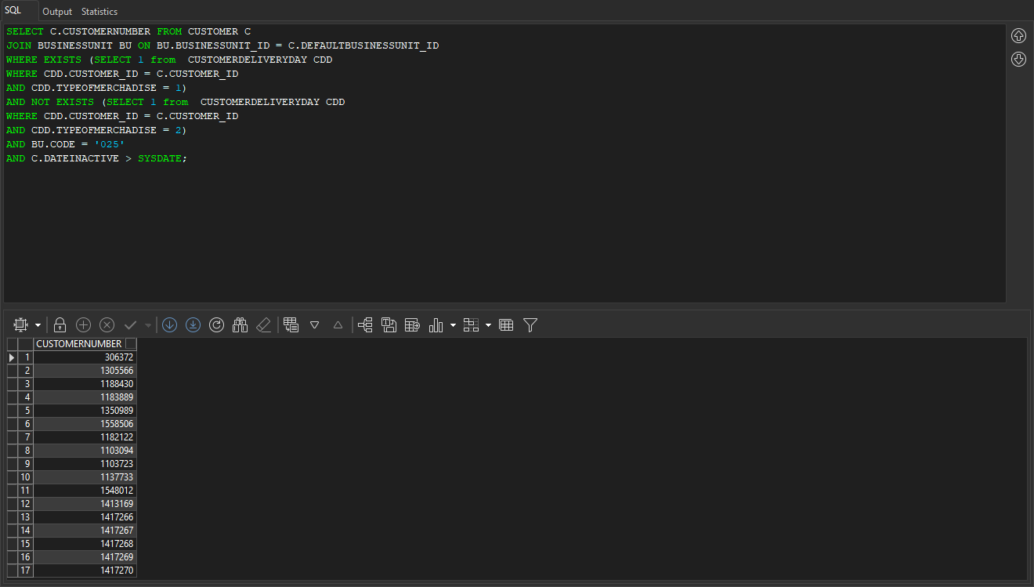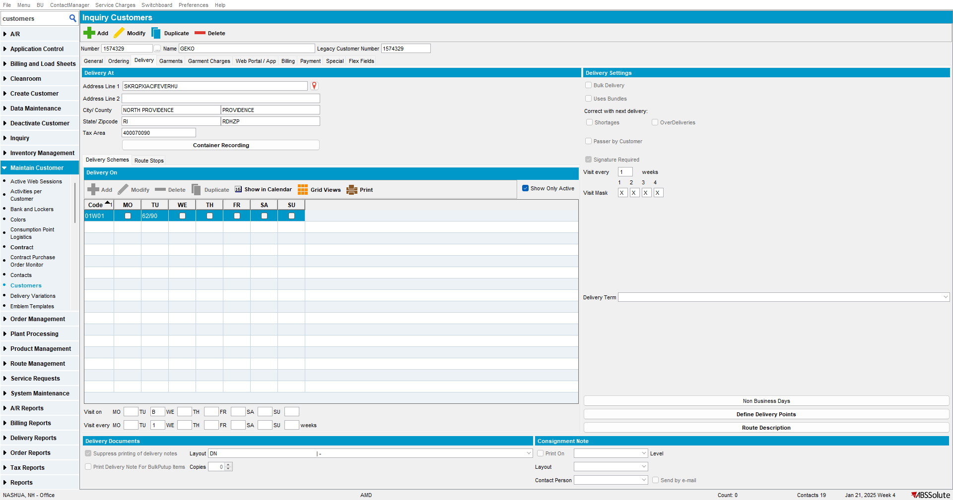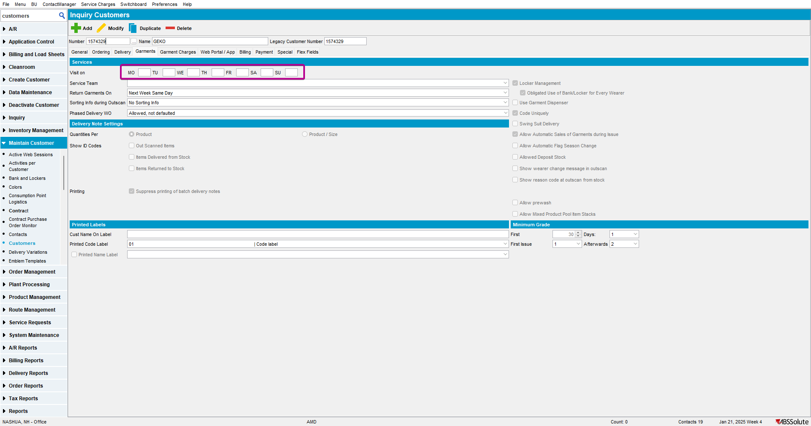

- Create a WO for your customer with a non garment
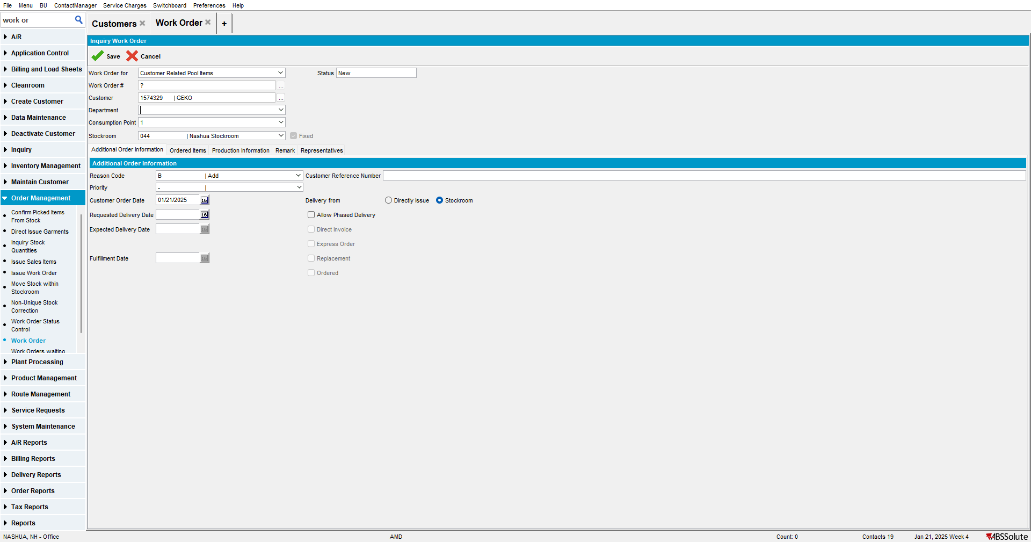
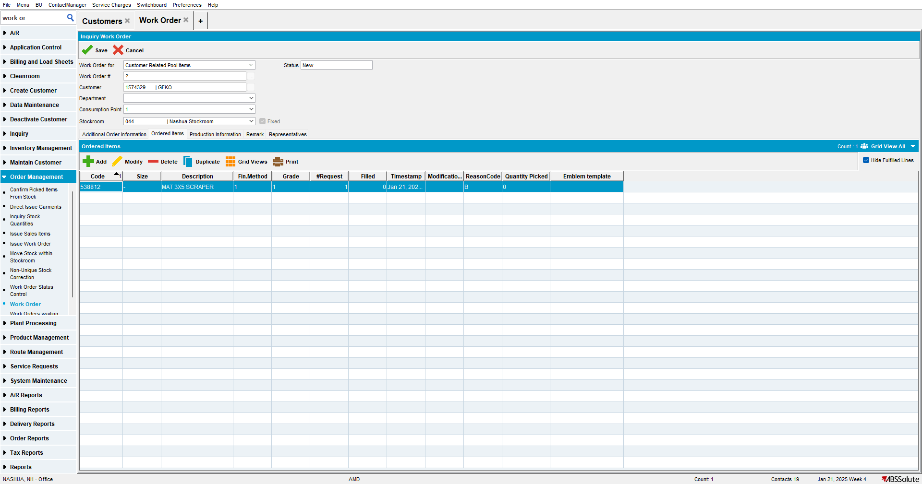

- Issue the WO
