ABSN-590 PLPC - Combo Destination FM from popup Change Finishing Method should be filled only if contractProduct.Released=Y
Environment | Prerequisites
Version:9.07.00.UNF19  DBServerName=abs-SRV20.internal.abslbs.com  DBSID=CUST24  DBUser=UNFDEV  DBPassword=UNFDEV  Environment=Test | - Module:  - System setting

Contents
Test after fix 1
Test Case 1 – Contract management in license – Tested OK 1
Test Case 2 – Contract management not in license – Tested OK 4

Test after fix

Test Case 1 – Contract management in license – Tested OK
Expected behavior: Will appear finishing methods for products on contract that are released
Hash: 5a06bd8d4ec
- Check that you have CONTRACTMANAGEMENT in license
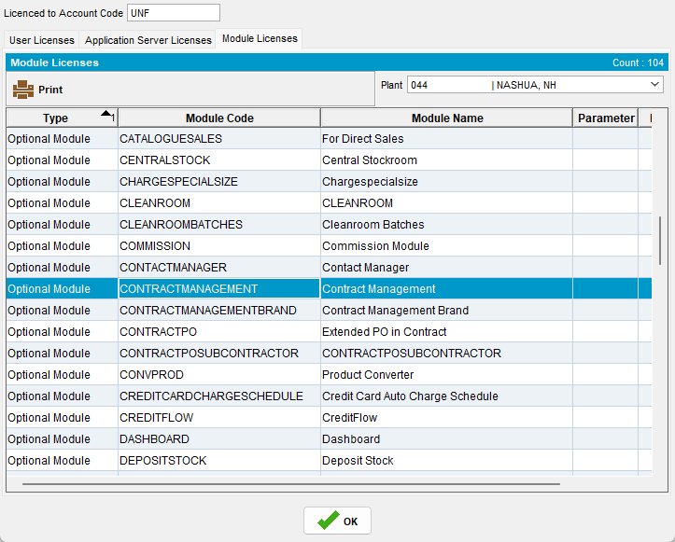
- Go to contract and add another product that is in PLPC but for another finishing method
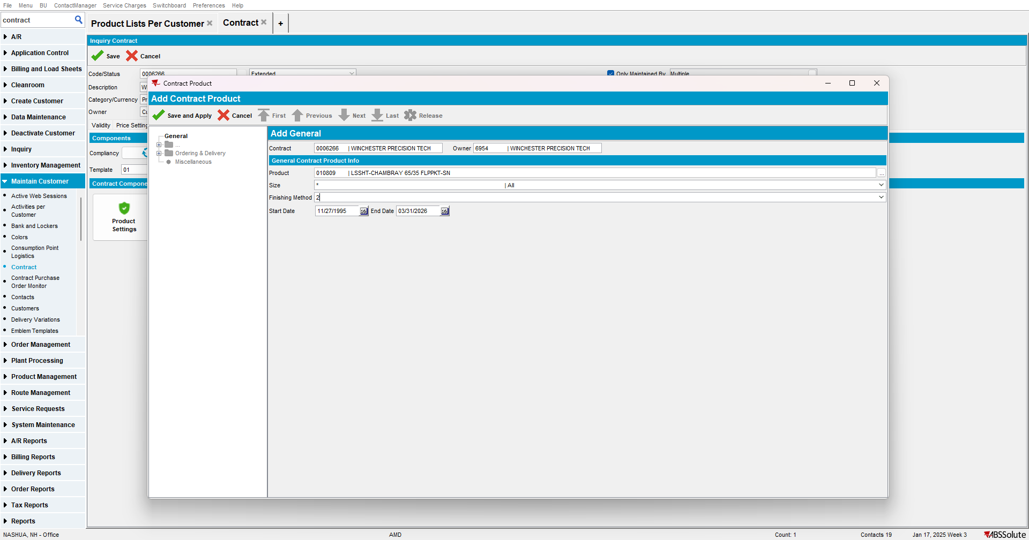

- Release it but do not copy it to customer
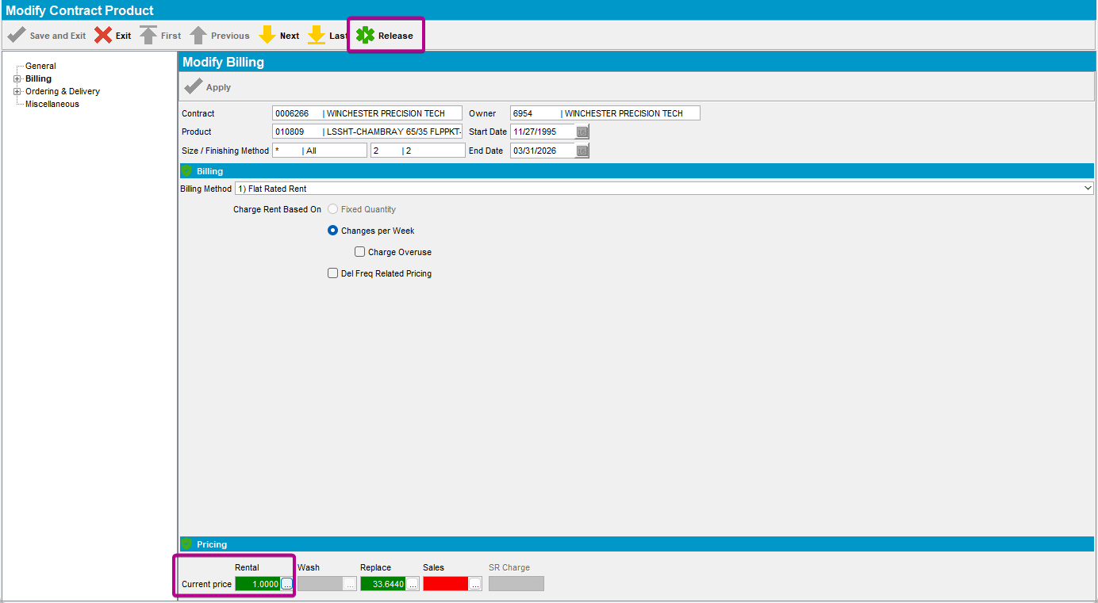
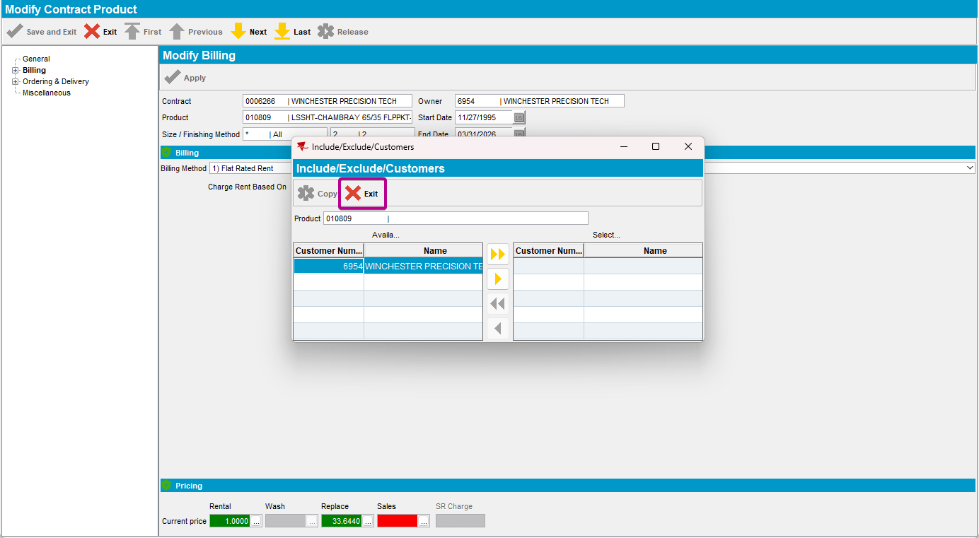

- Go to PLPC and select that product for finishing method 1 and click on Change Finishing Method
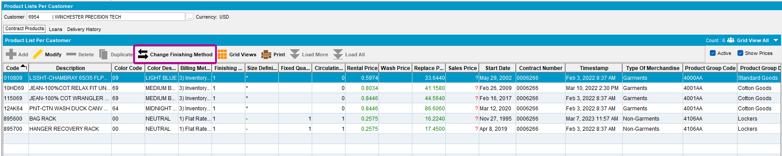

- In the drop down list there will be only the finishing method that you added on the contract
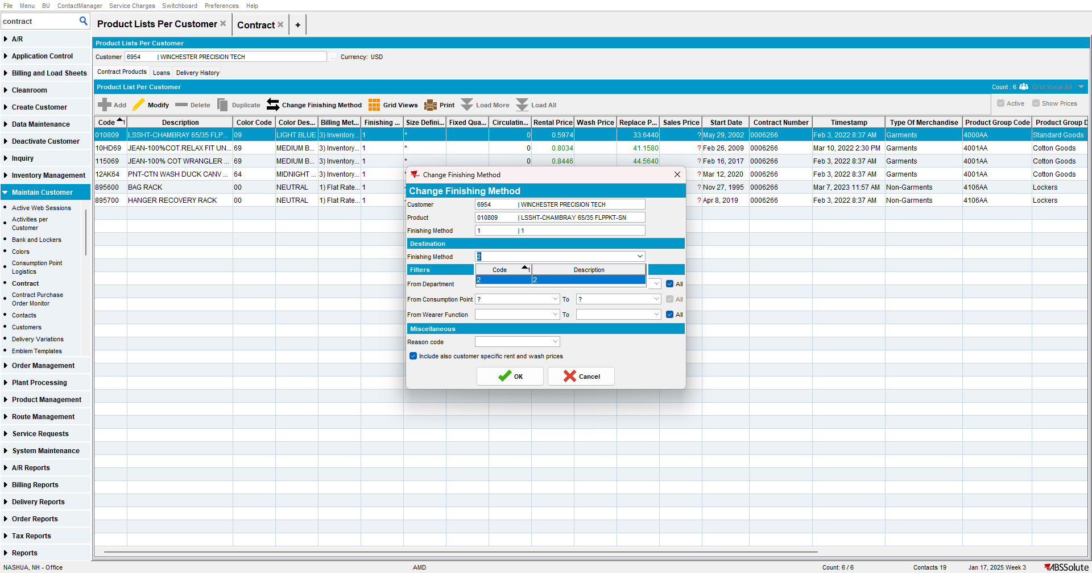

Test Case 2 – Contract management not in license – Tested OK
Expected behavior: Will appear all finishing methods
Hash: 5a06bd8d4ec
- Check that you do not have CONTRACTMANAGEMENT in license
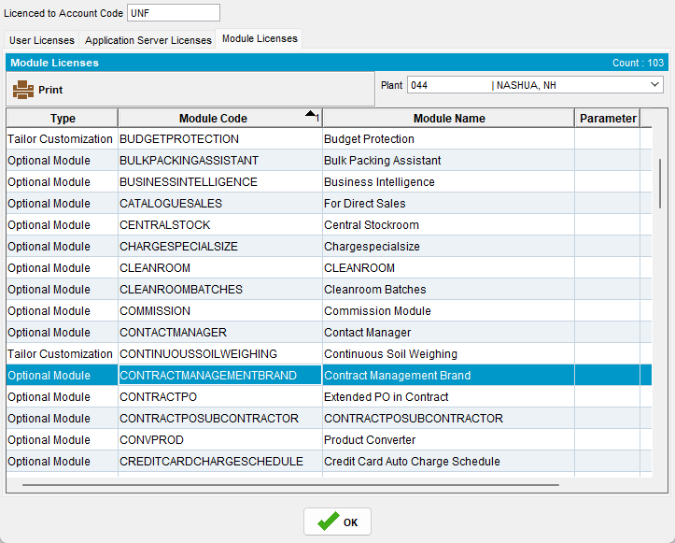
- Go to PLPC and select a product and click on Change Finishing Method

- In the drop down list there will be all finishing methods
