ABSN-586 PLPC - Change Finishing Method does not create the CONTRACTPRODUCTPLPC record for the new PLPC
Environment | Prerequisites
Version:9.07.00.UNF19  DBServerName=abs-SRV20.internal.abslbs.com  DBSID=CUST24  DBUser=UNFDEV  DBPassword=UNFDEV  Environment=Test | - Module:  - System setting

Contents
Test after fix 1
Test Case 1 – CONTRACTMANAGEMENT module in license– Tested OK 1
Test Case 2 – CONTRACTMANAGEMENT module not in license– Tested OK 3

Test after fix

Test Case 1 – CONTRACTMANAGEMENT module in license– Tested OK
Expected behavior: The Change Finishing Method process should also create the link to the contract if CONTRACTMANAGEMENT module is in the license
Hash: 5a06bd8d4ec
- On PLPC find a product
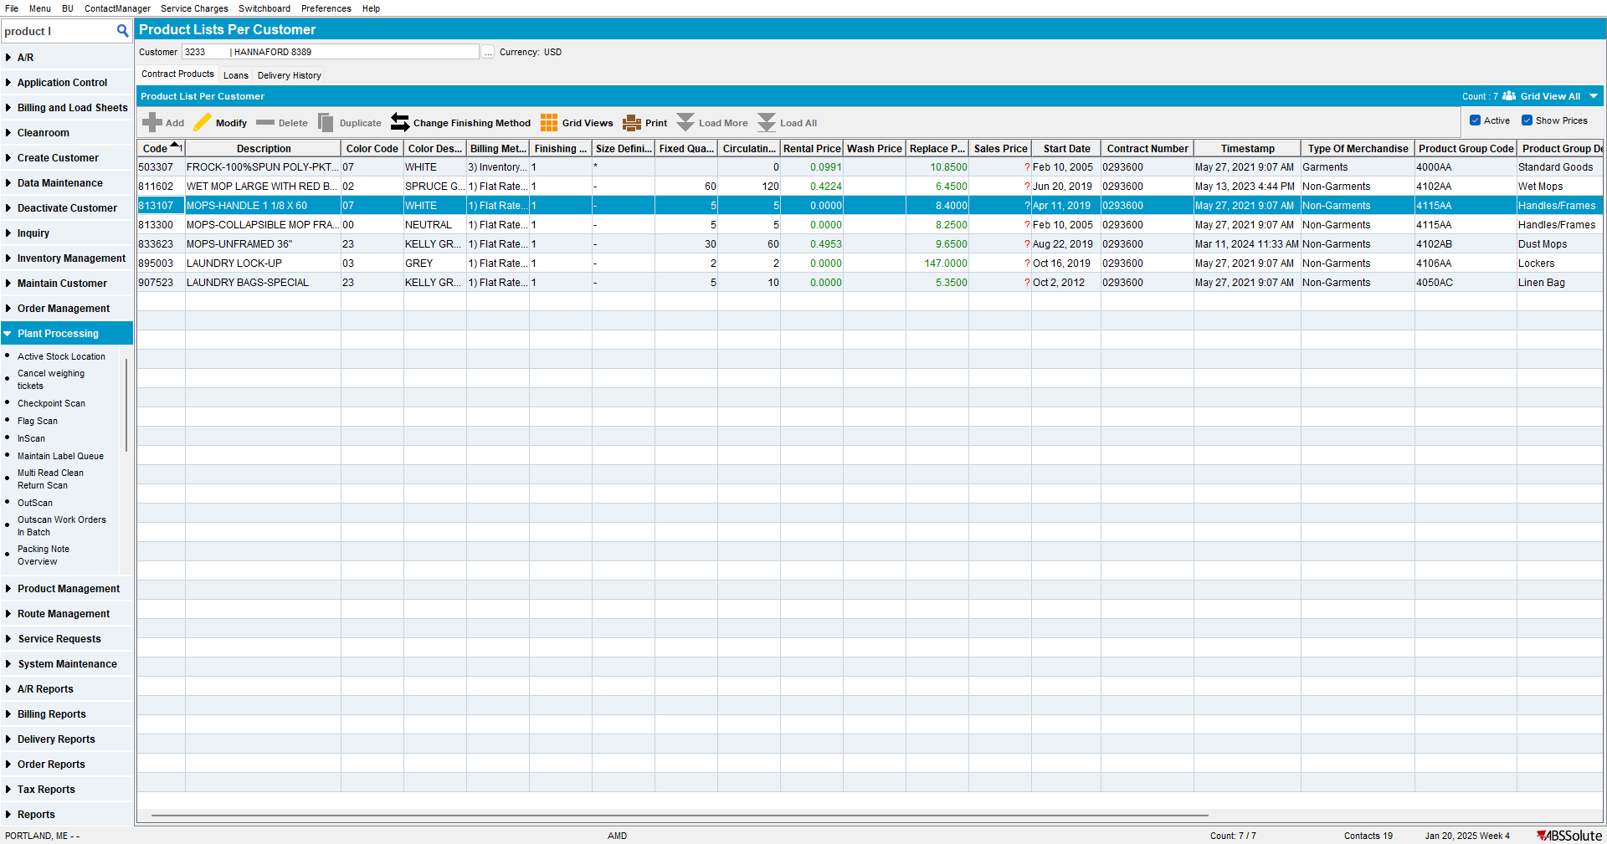
- On contract add more finishing methods for that product, release it but don’t copy it to customer
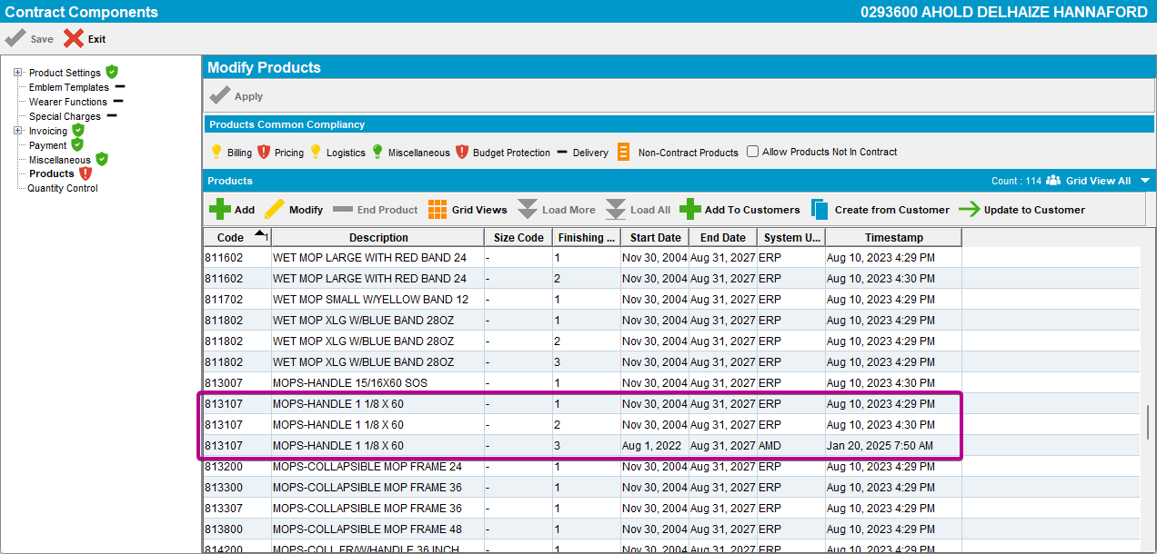

- For the product change the finishing method with a finishing method that is not already in the PLPC
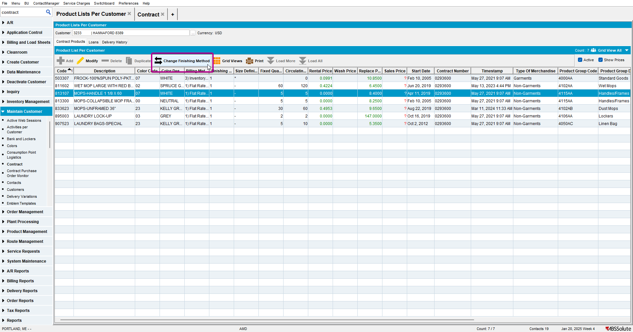
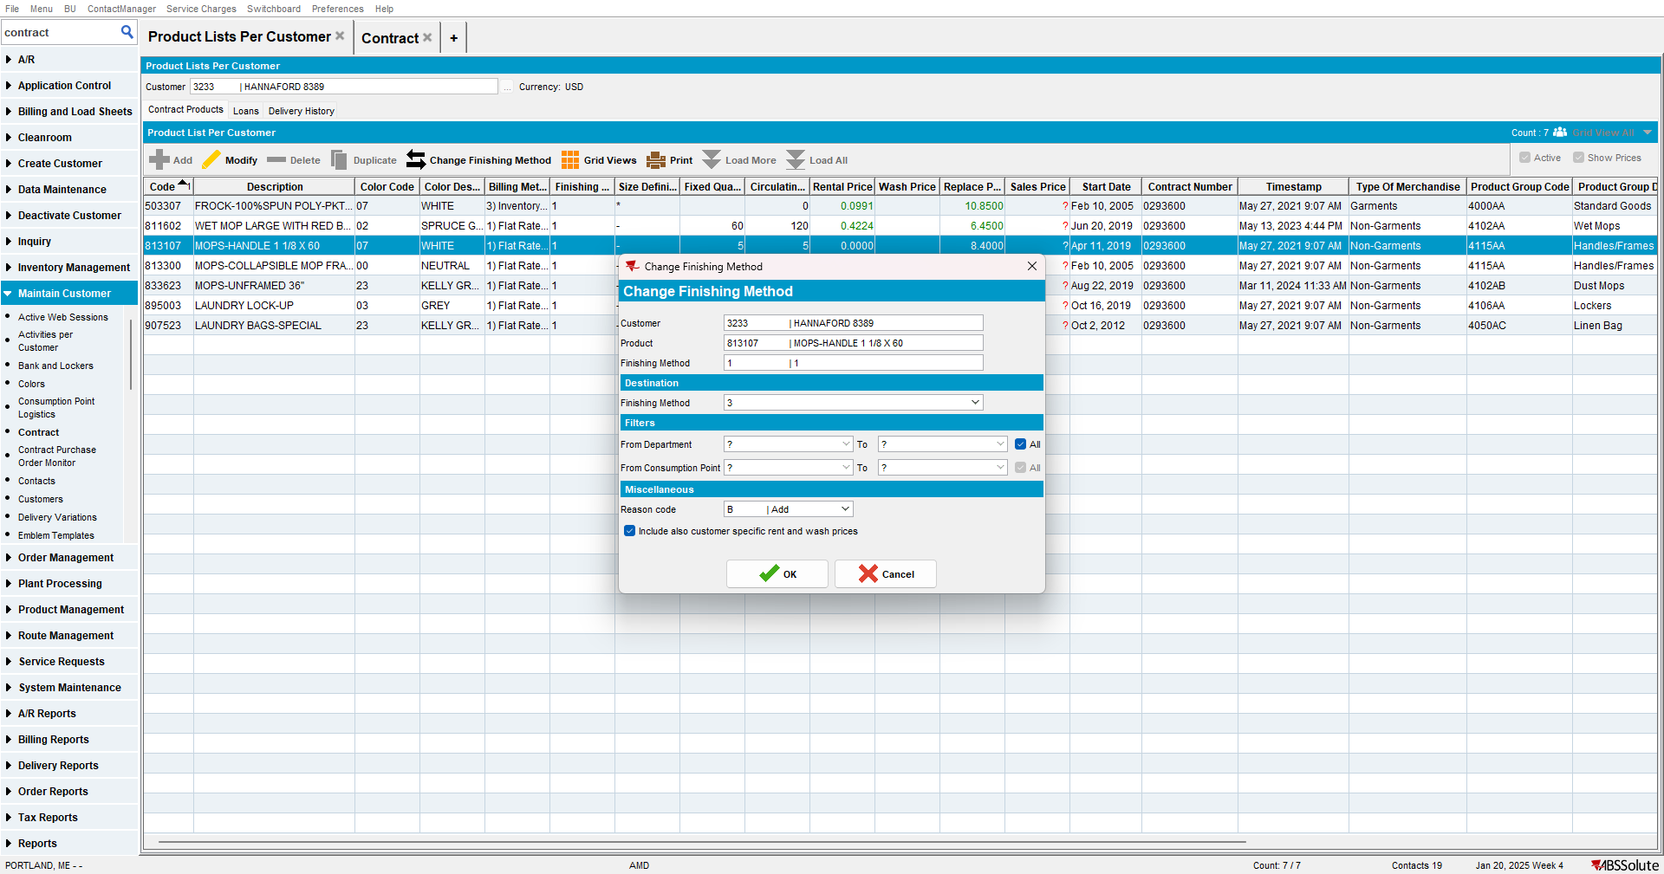

- Check that the product has a link to the contract
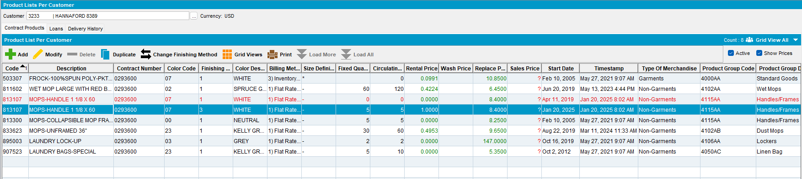

Test Case 2 – CONTRACTMANAGEMENT module not in license– Tested OK
Expected behavior: The Change Finishing Method process should not create a link to the contract
Hash: 5a06bd8d4ec
- For the product change the finishing method with a finishing method that is not already in the PLPC
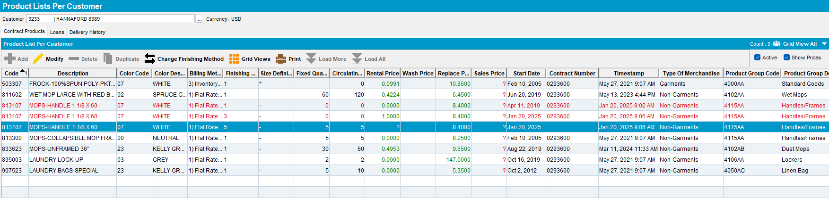

- Check that the product does not have a link to the contract
