ABSN-5848 - Invoice Generation fails for customer using Garment Setup Budget Protection
Environment | Prerequisites
Version: 9.07.00.UNF18  DBServerName= abs-srv20.internal.abslbs.com  DBSID=CUST24  DBUser=UNFDEV  DBPassword= UNFDEV  Environment=Test | - Module:  - System setting

Contents
Reproducing before fix 1
Data preparation 1
Steps to reproduce 1
Current Behavior 2
Expected behavior 2
Retest after fix 2
Test Case 1 – Invoices are generated successfully for customers with GSP garment protection 2

Reproducing before fix

Data preparation
Test data: BU 069, customer 2517582, route 18 from November 28, 2024.

Steps to reproduce
- Customer having Budget Protection with Garment Setup Protection selected:
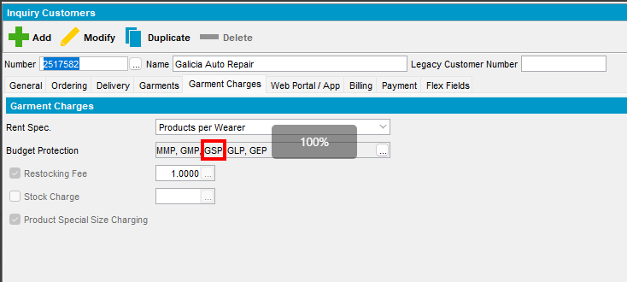
- Generate invoices for this customer on a route
REPRODUCED OK.

Current Behavior
Invoicing fails with an SQL error but Invoices Generated status gets to Completed
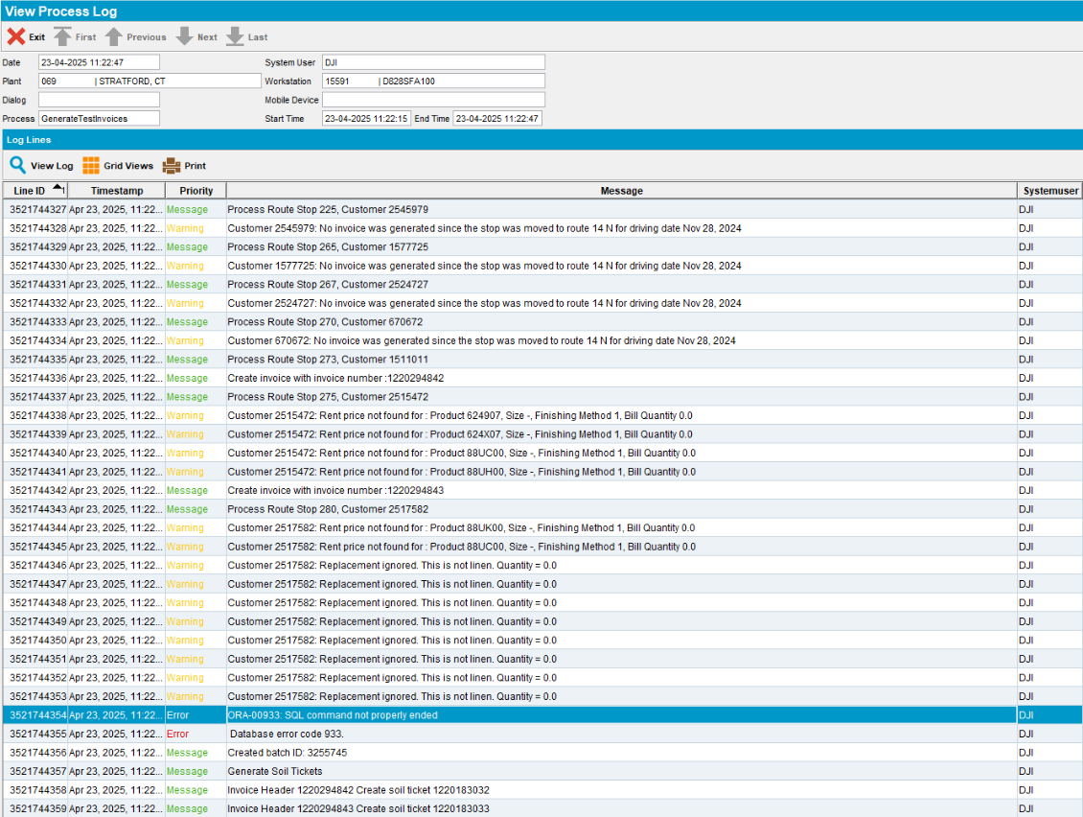

Expected behavior
Invoice generation completes successfully.

Retest after fix

Test Case 1 – Invoices are generated successfully for customers with GSP garment protection
Hash: 9a174557bb58
- Select a customer with garment delivery days
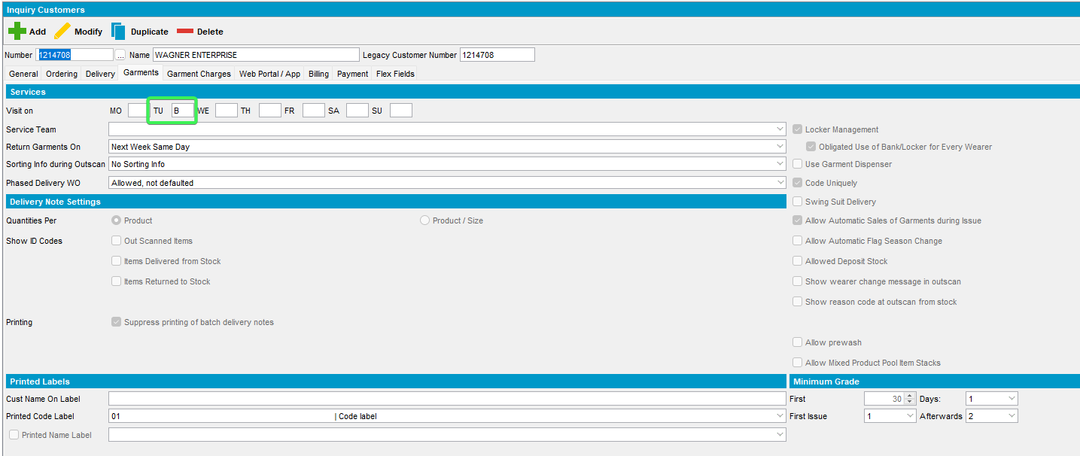
- Contract: Components > Product settings > Charges
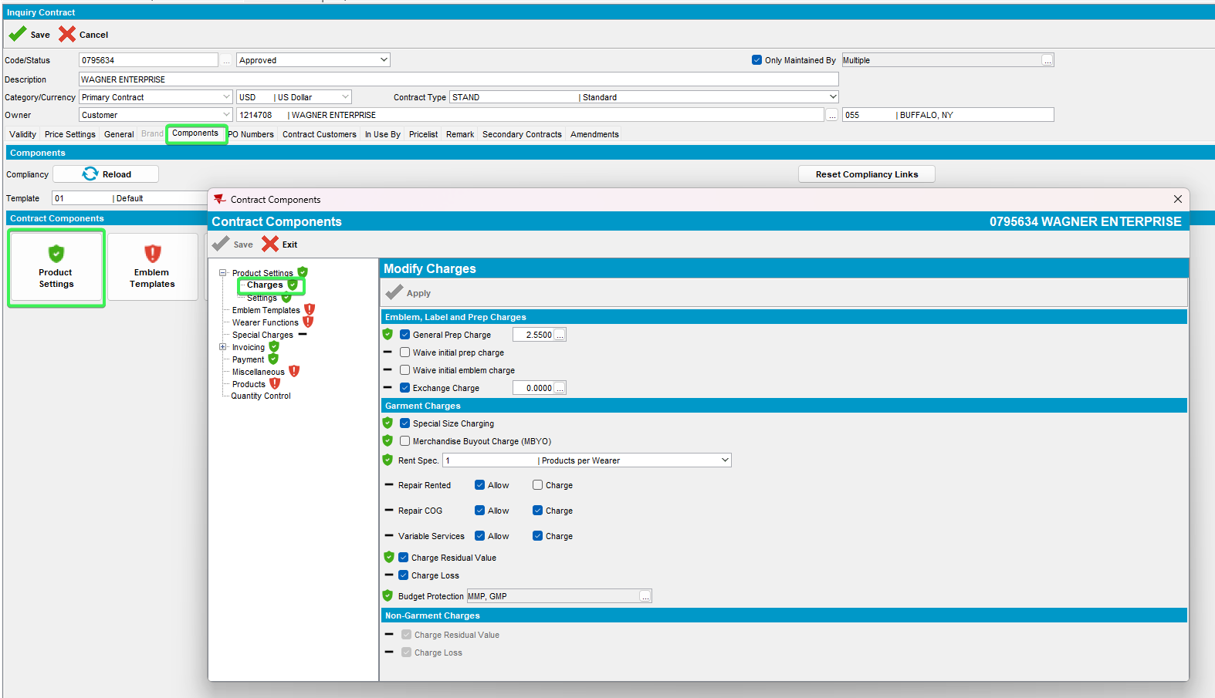
- Add a Garment Setup Protection charge
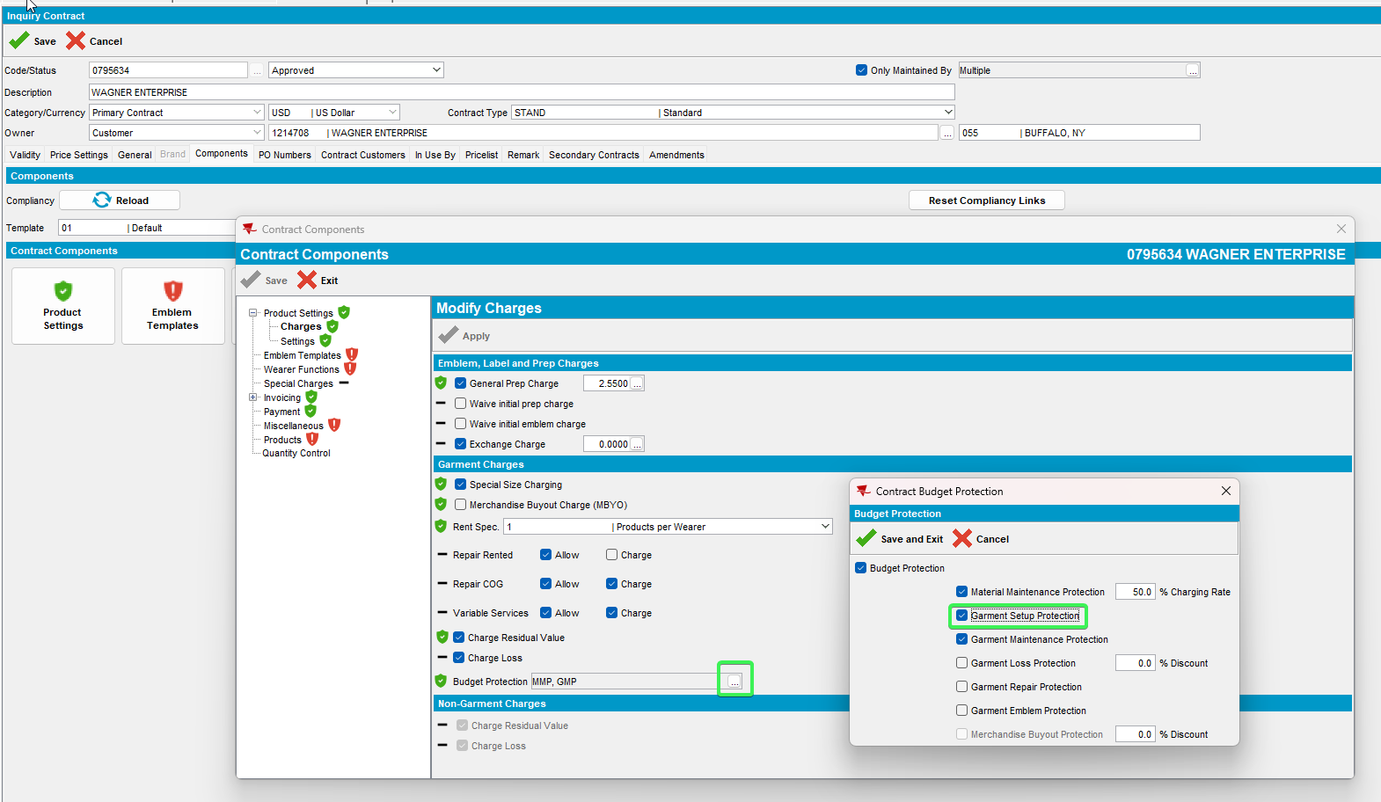
- Update the change to your customer
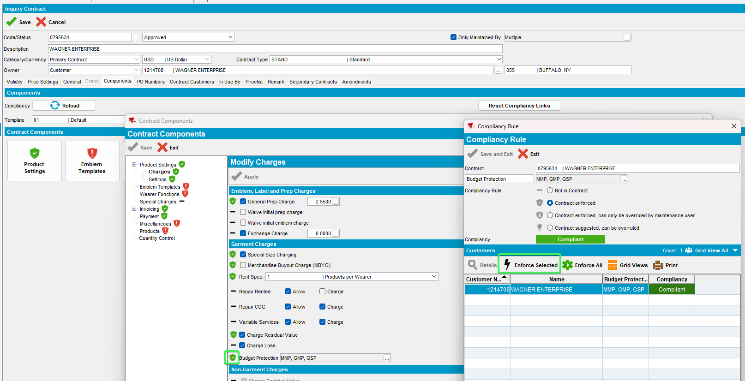
- Customers DLG: Garment Charges > see that Garment Setup Protection has been added to customer
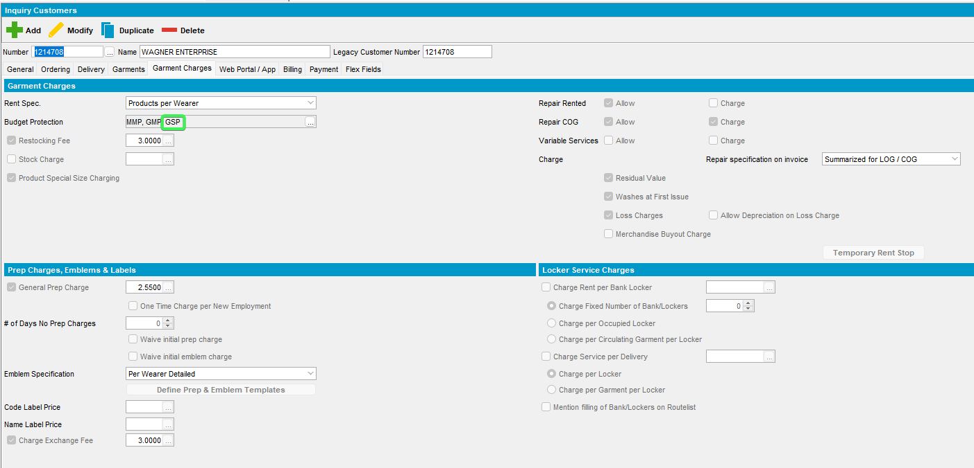
- Route Status Control DLG: Add a new route with your customer on it
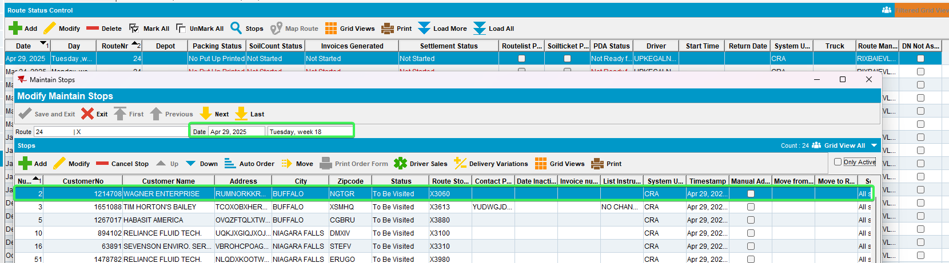
- Generate an invoice for your customer
- See that the invoice is successfully generated
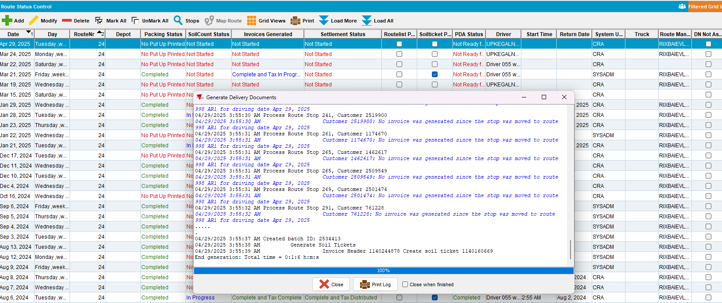
- View Process Log DLG: See that there are no errors present in the log
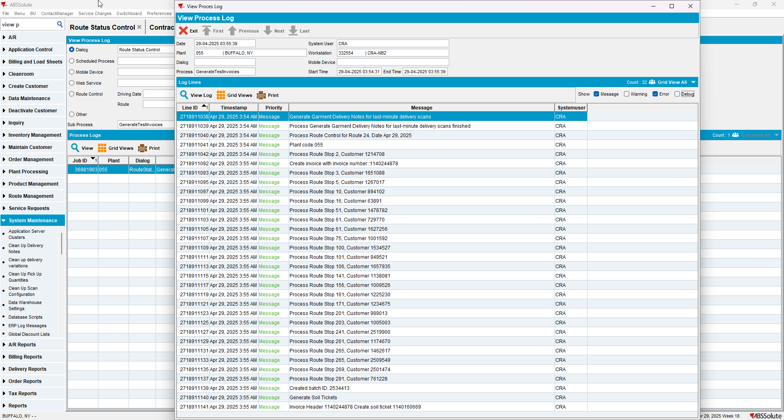
Tested OK

