ABSN-583 - D_UBS_2562 When using the “Change Finishing Method” function in the PLPC on logo mats, only one unique ID moves to the new Finishing Method
Environment | Prerequisites
Version:9.07.00.UNF19  DBServerName= abs-srv20.internal.abslbs.com  DBSID=CUST24  DBUser=UNFDEV  DBPassword=UNFDEV  Environment=Production | - Module:  - System setting

Contents
Test after fix 1
Test Case 1 – Change finishing method for a PLPC with logo mats with stay “Sorted” 1

Test after fix

Test Case 1 – Change finishing method for a PLPC with logo mats with stay “Sorted”
Expected behavior: All mats associated with a PLPC should be moved to the new PLPC after Finishing Method change even the ones that have no distribution point.
Hash: 5a06bd8d4ec
- Find a customer with Customer Logo mats with stay “Sorted”
SELECT BU.CODE, C.CUSTOMERNUMBER, P.CODE AS PRODUCTCODE, FM.CODE AS FMCODE, UI.PRIMARYID, (SELECT S.FACTORYDESCRIPTION FROM STAY S WHERE S.STAY_ID = UI.STAY_ID) AS STAY
FROM CUSTOMER C
JOIN PRODUCTLISTPERCUSTOMER PLPC
ON PLPC.CUSTOMER_ID = C.CUSTOMER_ID
JOIN PLPCEXTRAINFO PLPCE
ON PLPCE.PRODUCTLISTPERCUSTOMER_ID = PLPC.PRODUCTLISTPERCUSTOMER_ID
JOIN PRODUCT P
ON P.PRODUCT_ID = PLPC.PRODUCT_ID
JOIN FINISHINGMETHOD FM
ON FM.FINISHINGMETHOD_ID = PLPC.FINISHINGMETHOD_ID
JOIN UNIQUEITEM UI
ON UI.PRODUCT_ID = PLPC.PRODUCT_ID
AND UI.FINISHINGMETHOD_ID = PLPC.FINISHINGMETHOD_ID
AND UI.SIZEDEFINITION_ID = PLPC.SIZEDEFINITION_ID
AND PLPC.CUSTOMER_ID = UI.RELATEDCUSTOMER_ID
JOIN BUSINESSUNIT BU
ON BU.BUSINESSUNIT_ID = C.DEFAULTBUSINESSUNIT_ID
WHERE UI.DISTRIBUTIONPOINT_ID IS NULL
AND PLPC.DATEINACTIVE > SYSDATE
AND PLPCE.SPECIFICBULKPACKINGTYPE = 1
AND P.TYPEOFMERCHANDISE = 1
AND P.STOREACTIVESTOCKLOCATION = 'Y'
AND P.BULKPACKINGACTIVESTOCKTYPE = 1
AND UI.STATUS_ID IN (27, 29)
AND UI.STAY_ID = 16;

- Go to PLPC and find the product that has these mats associated with.
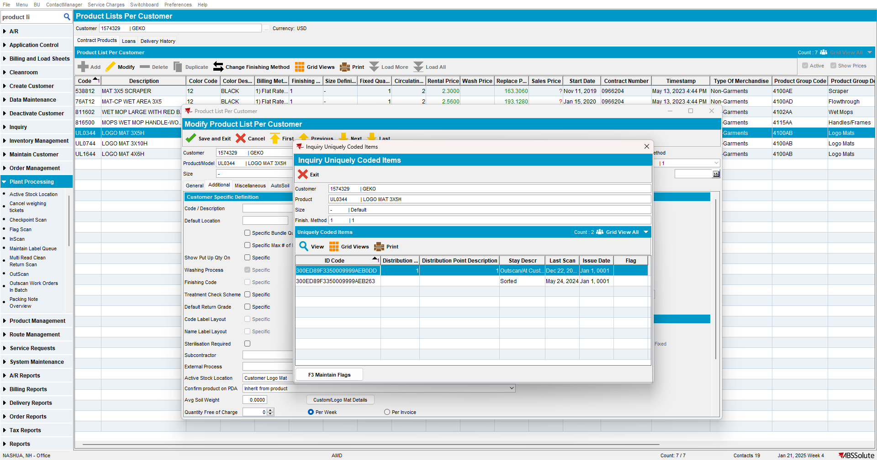

- Contract DLG: Open the contract for your customer and go to Components > Products tab
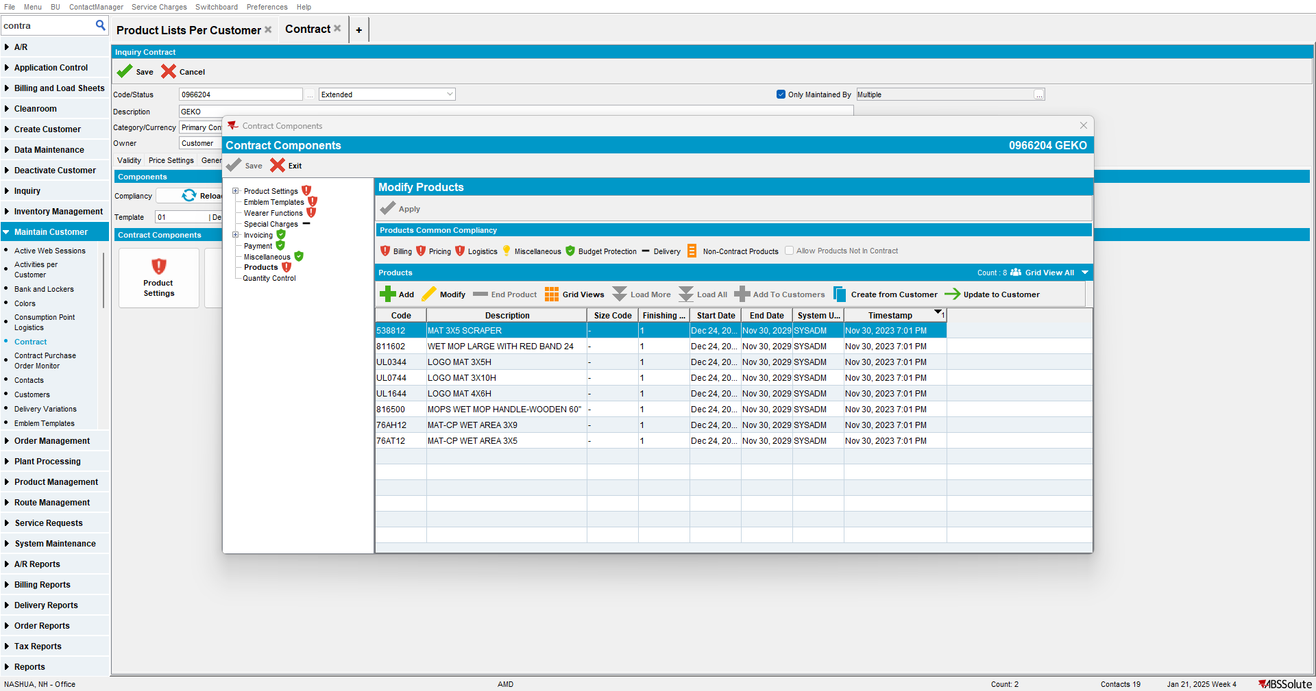

- Contract DLG: Add another entry for product UL0344 with a different finishing method
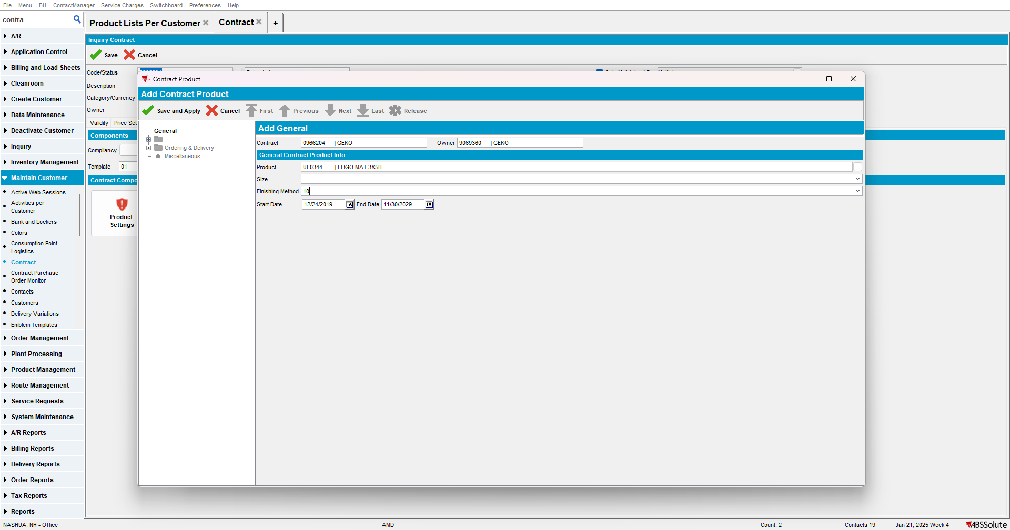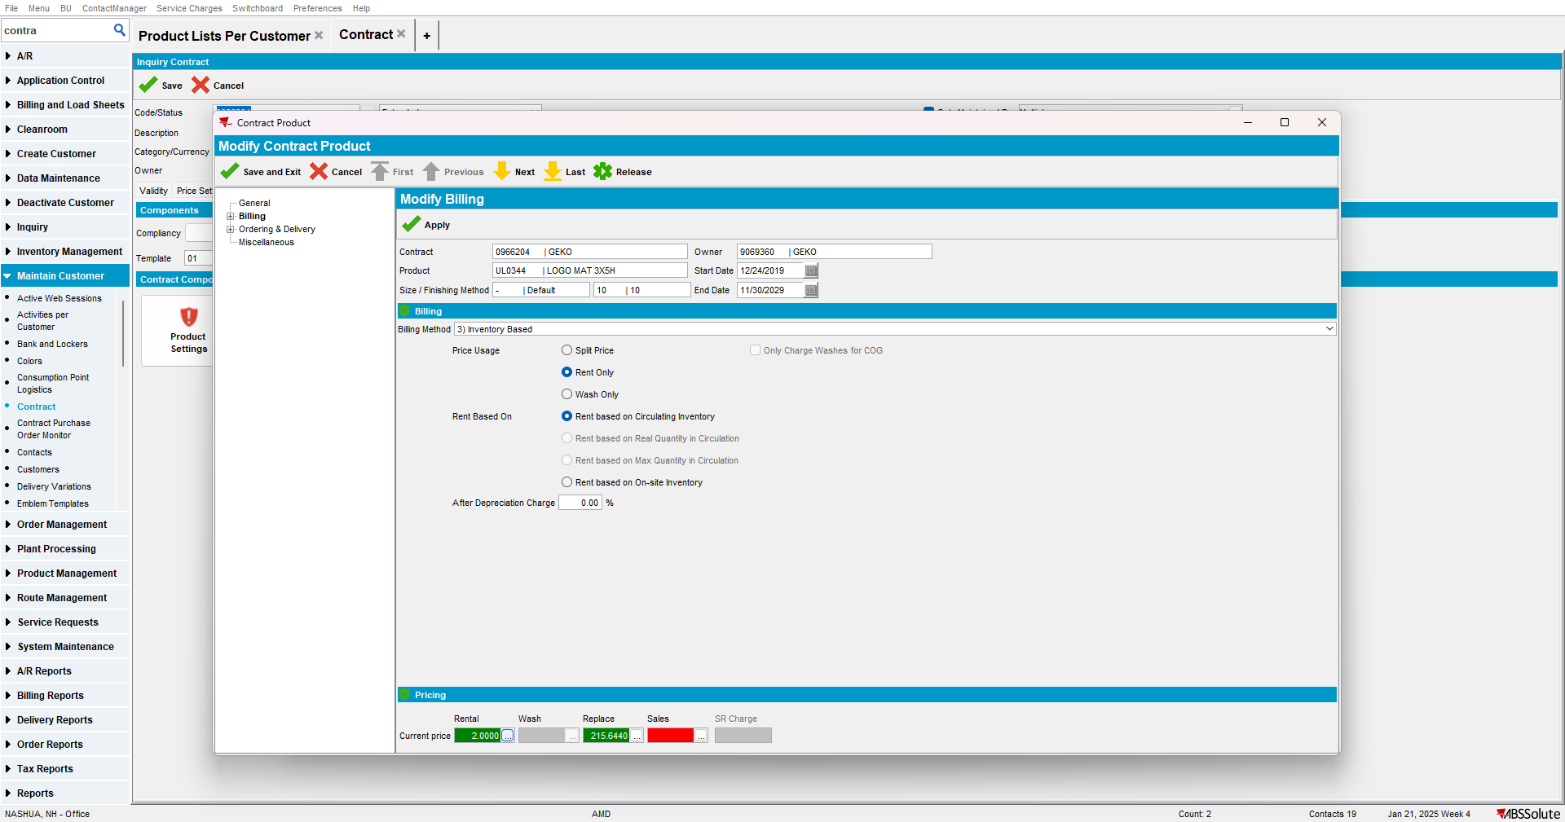

- Contract DLG: Click on Release button but DO NOT add it to any customer, just close the include/exclude pop-up
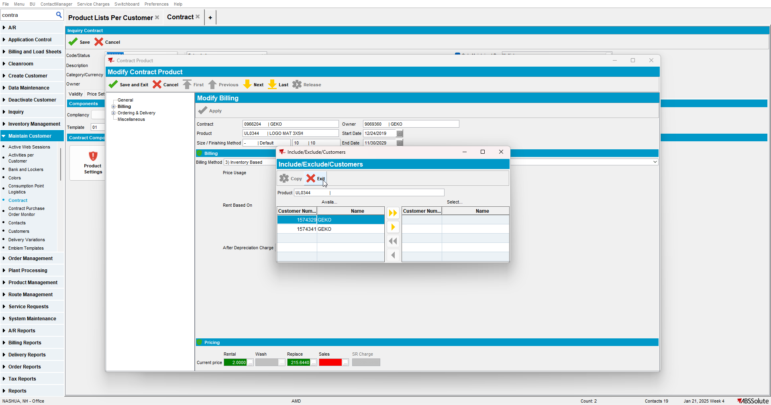

- PLPC DLG: Change the finishing method for your product with the mats from before
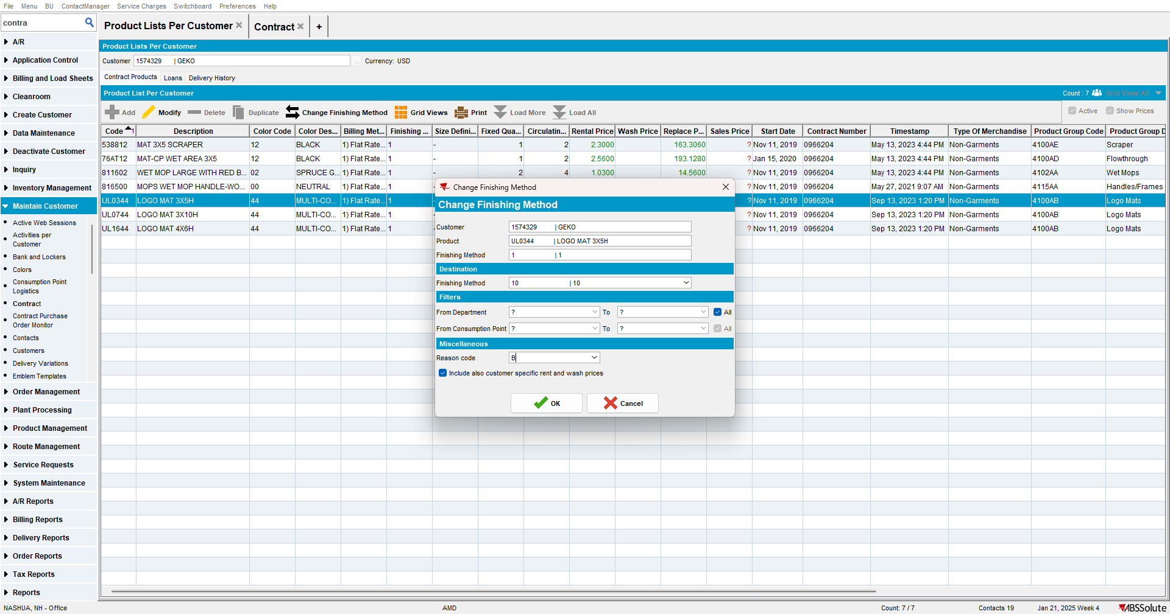
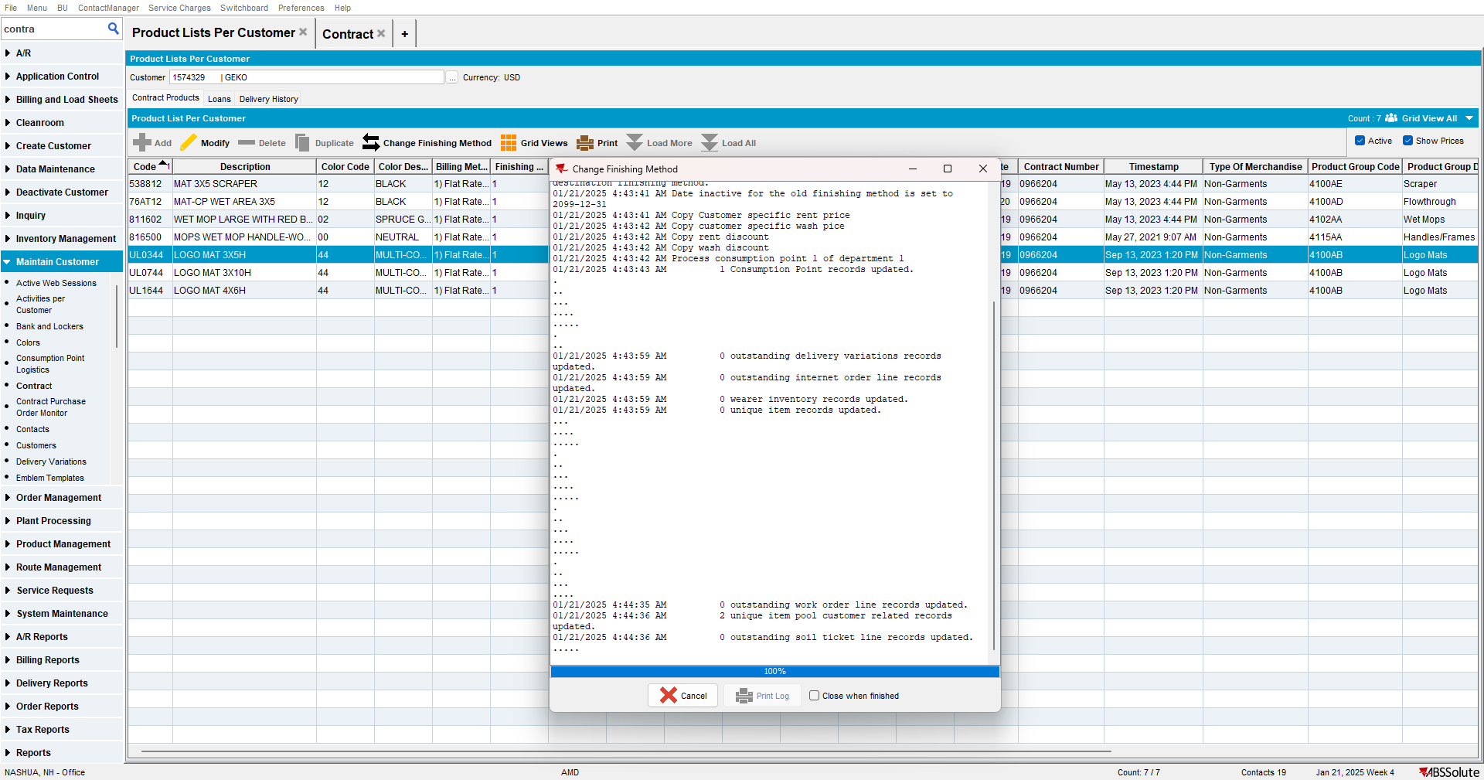

- Open the new PLPC with the new Finishing Method and view the uniquely coded items
