ABSN-582- [WebX] Settlement doesn't complete if another user modifies the data in a different tab on the same browser
Environment | Prerequisites
Version: 9.07.00.UNF19  DBServerName= abs-srv20.internal.abslbs.com  DBSID=CUST24  DBUser=UNFDEV  DBPassword= UNFDEV  Environment=Test | - Module:  - System setting

Contents
Reproducing before fix 1
Steps to reproduce 1
Current Behavior 2
Retest after fix 2
Test Case 1 – Check that when signing in on a second user the first user’s session expires and is signed out after making an action 2
Test Case 2 – Two users on the same browser try to log in with different credentials in different tabs 7
Test Case 3 – Two users on different browsers try to log in with different credentials 9
Test Case 4 – One user tries login in on different browsers 11

Reproducing before fix

Steps to reproduce
- RSC: Create a new route with a customer on it
- RSC: Generate invoices and script taxes
- RSC: Send the route to RA
- On RA add a new wearer, increase the inventory of an existing wearer, quit the inventory of another
- Perform few invoice adjustments
- Settle, depart and upload the data
- WebX: Complete start my day
- With User A(CRA) Review all the tabs
- With User A(CRA) go to Overview tab and stay remain there with the settlement button active
- Open a different tab on the same browser and access WebX page log out from User A(CRA)
- Log in with a different User B (CRA3) and go to Wearer Maintenance on your route
- Unreview and Unapprove some of the transactions
- Go back the tab with User A(CRA) and press the settlement button
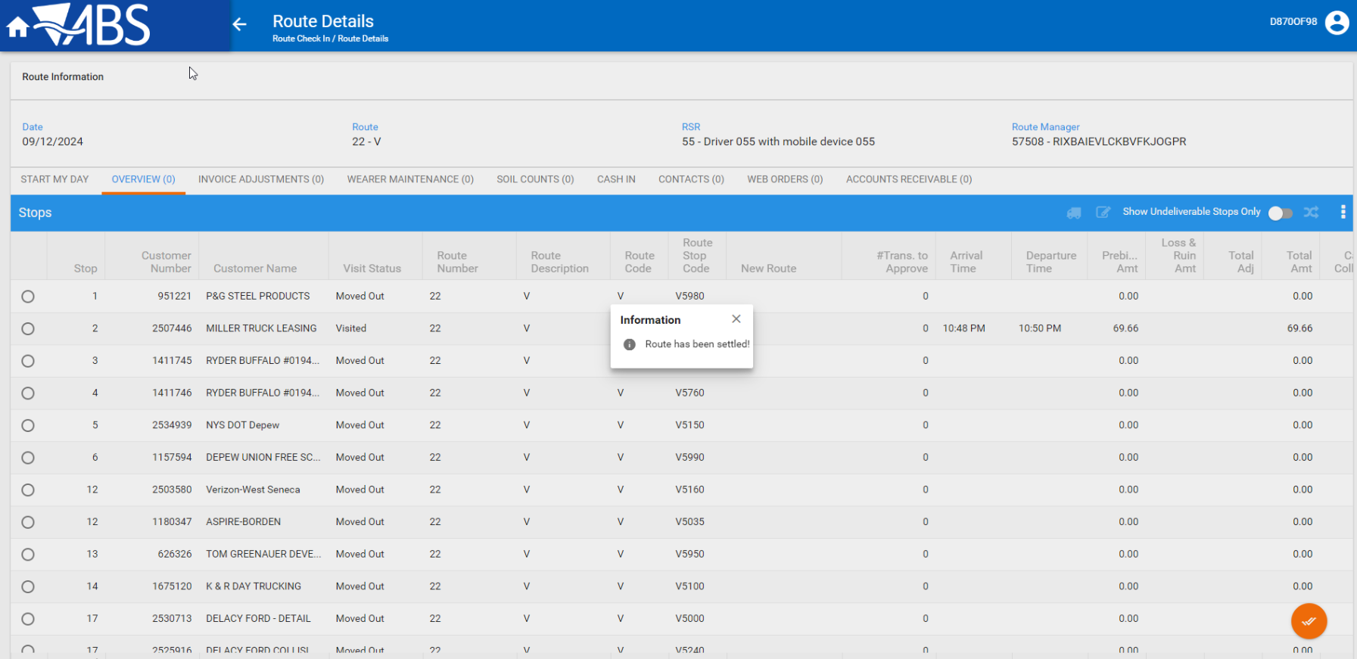

REPRODUCED OK.

Current Behavior
Loggin in with another user has no effect on the current user in a different tab.

Retest after fix

Test Case 1 – Check that when signing in on a second user the first user’s session expires and is signed out after making an action
Hash: 9b746106152e
Expected behavior: The session of the first user (User A) should expire and as soon as he does any action in the tab he should be logged out and brought to log in screen
- RSC: Create a new route with a customer on it
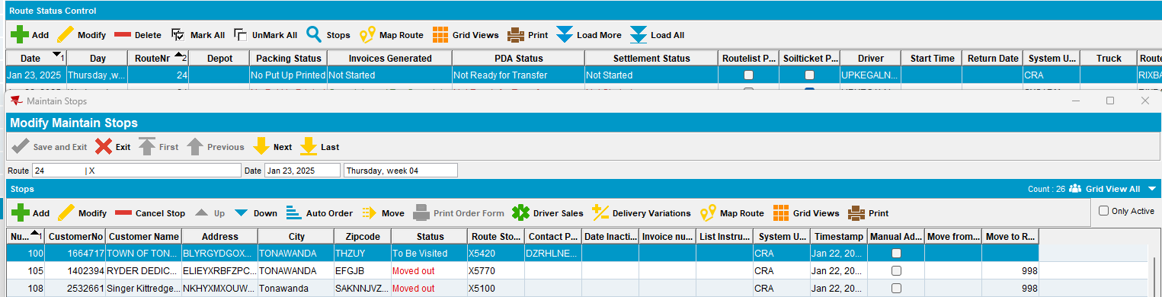
- RSC: Generate invoices and script taxes
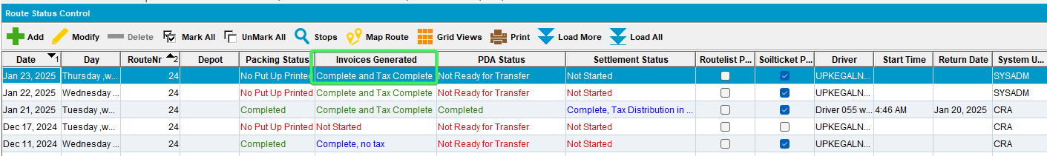
- RSC: Send the route to RA
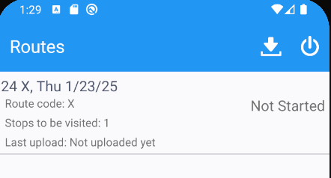
- On RA add a new wearer, increase the inventory of an existing wearer, quit the inventory of another
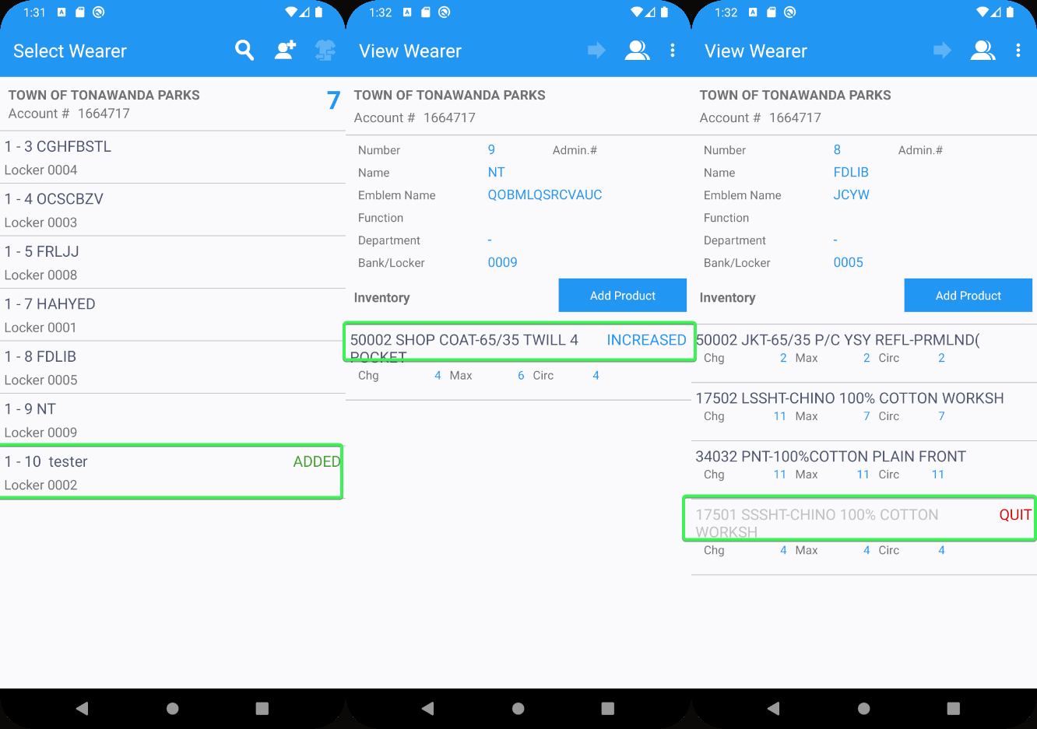
- RA: Perform few invoice adjustments
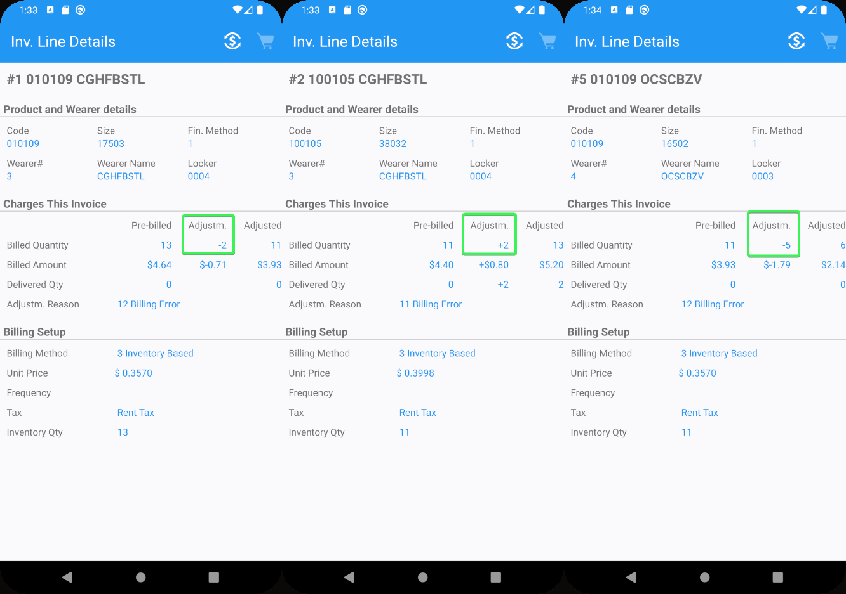
- Settle, depart and upload the data
- WebX: Complete start my day
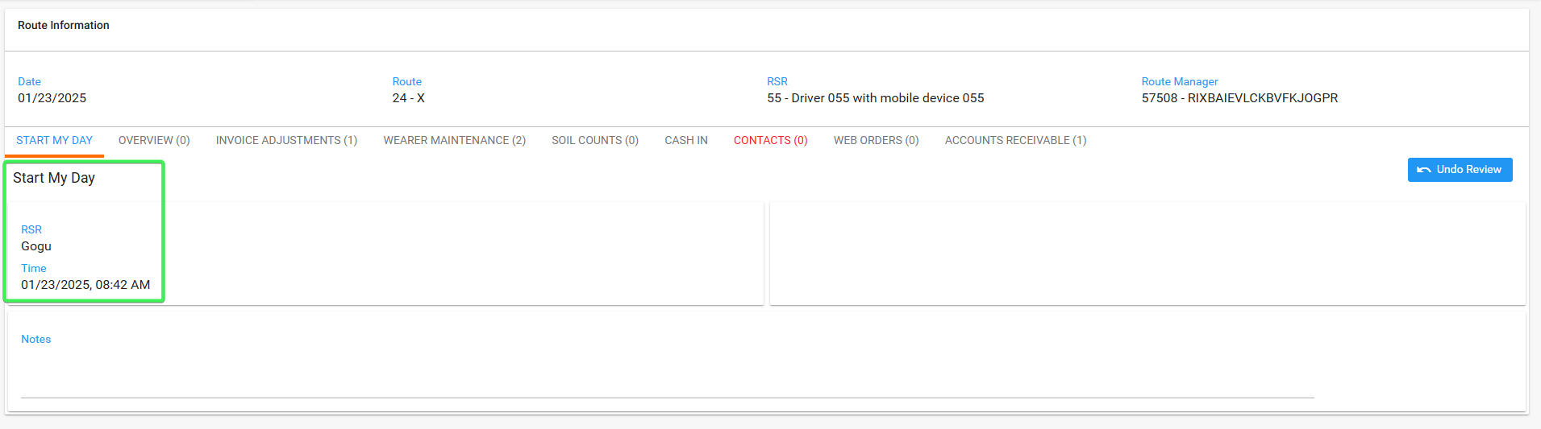
- With User A(CRA) Review all the tabs
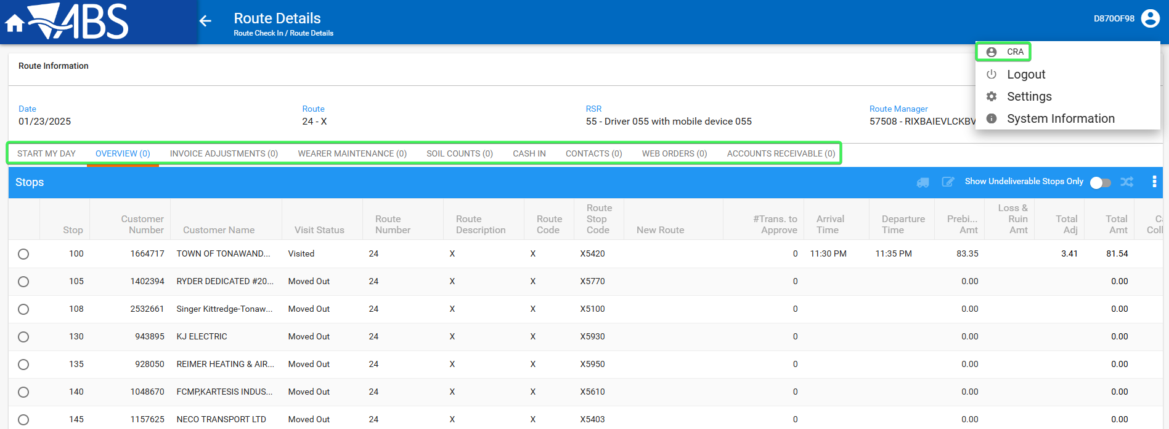
- With User A(CRA) go to Overview tab and remain there with the settlement button active
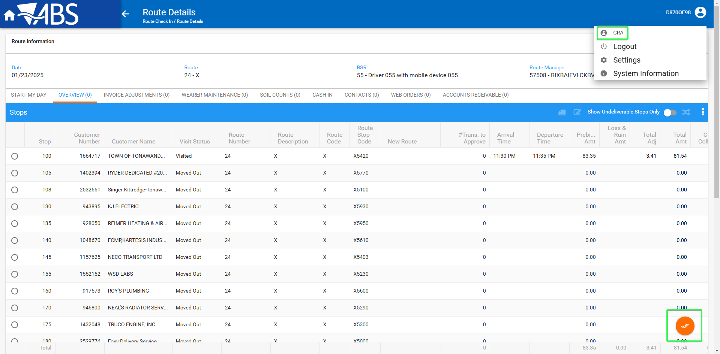
- Open a different tab on the same browser and access WebX page log out from User A(CRA)
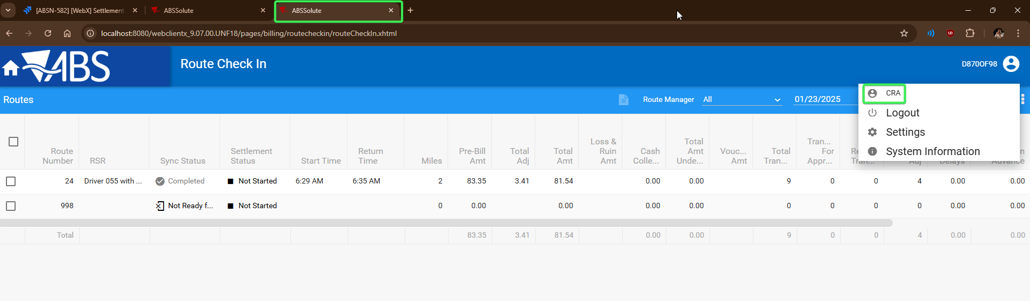
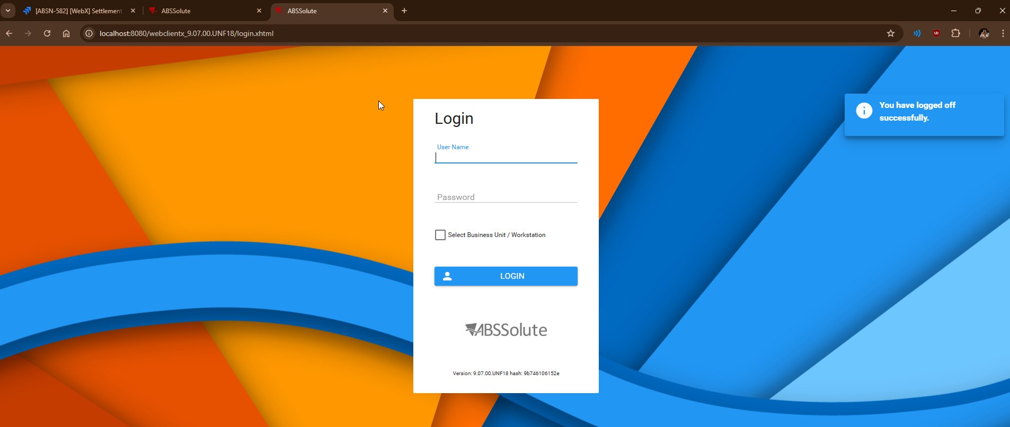
- Log in with a different User B (CRA3) and go to Wearer Maintenance on your route
- Unreview and Unapprove some of the transactions
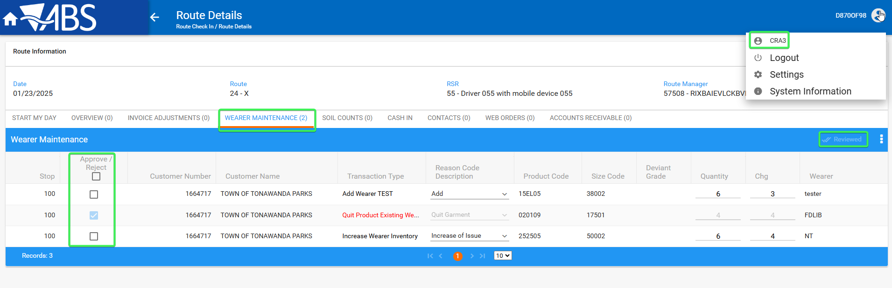
- Go back the tab with User A(CRA) and press the settlement button
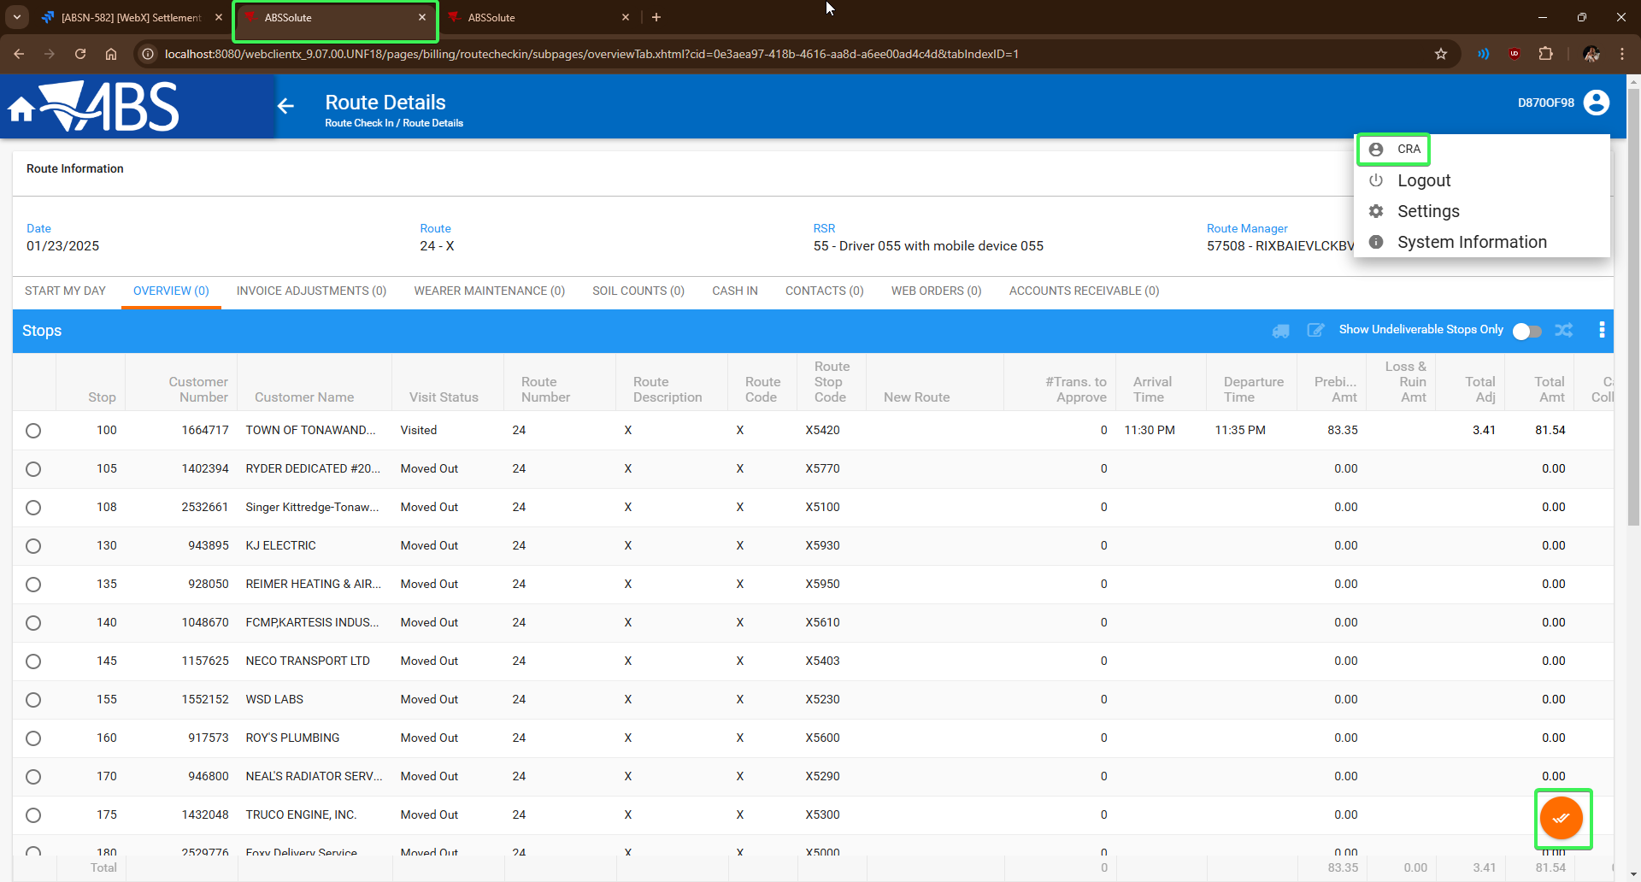
The user is brought back to log in screen and settlement does not take place
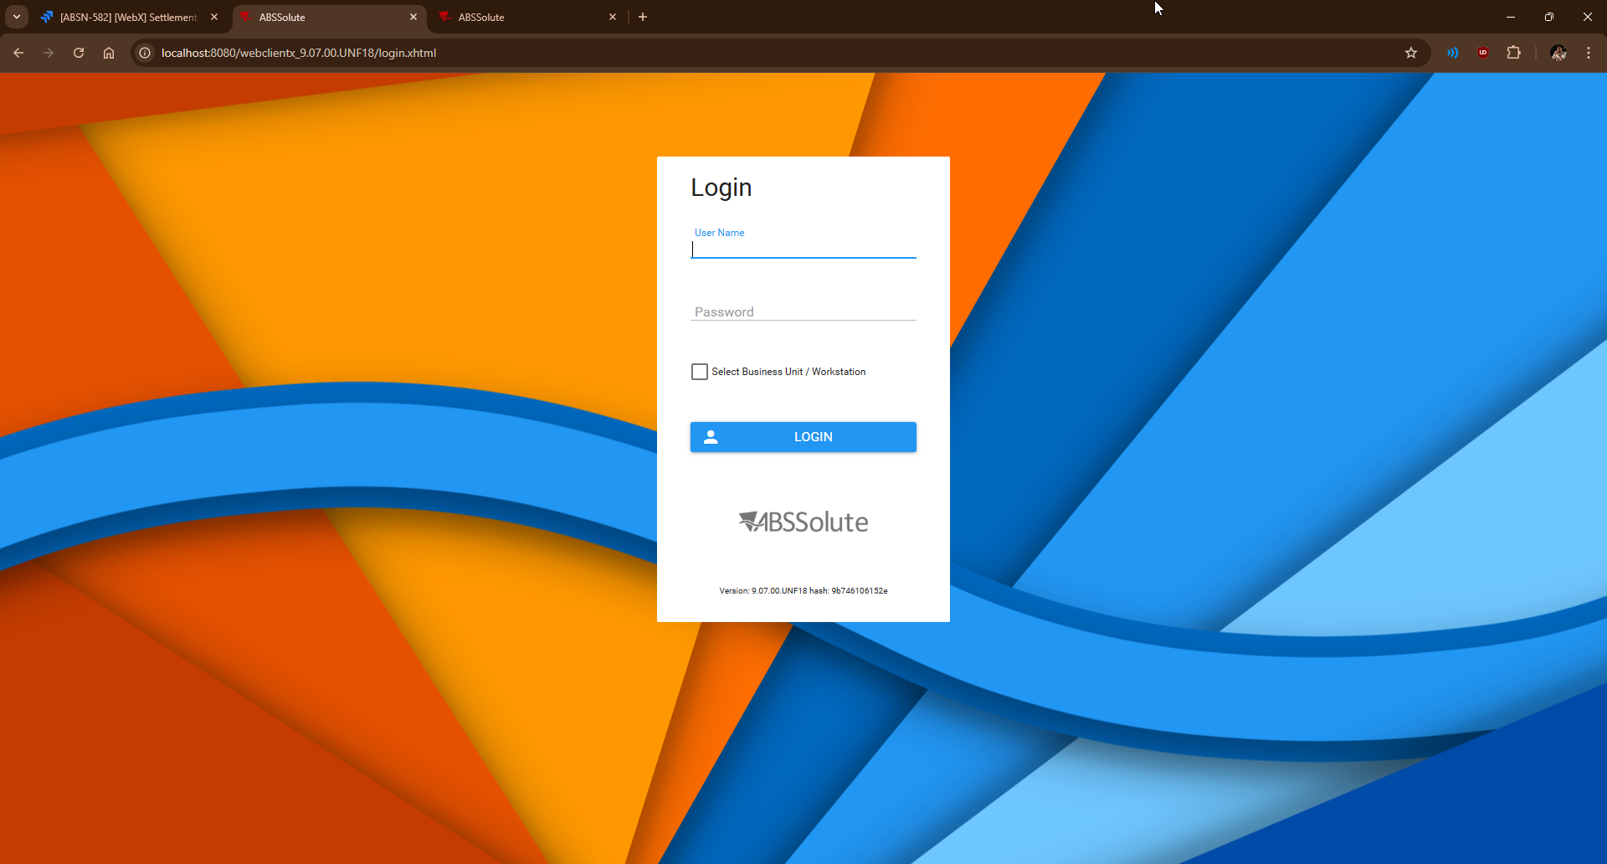
Tested OK

Test Case 2 – Two users on the same browser try to log in with different credentials in different tabs
Hash: 9b746106152e
Expected behavior: The second user should not be permitted to log in, a message should be prompted telling the user to log in on a different browser with a different user.
- In the same browser have 2 users on the log in page (User A and User B) in 2 different tabs
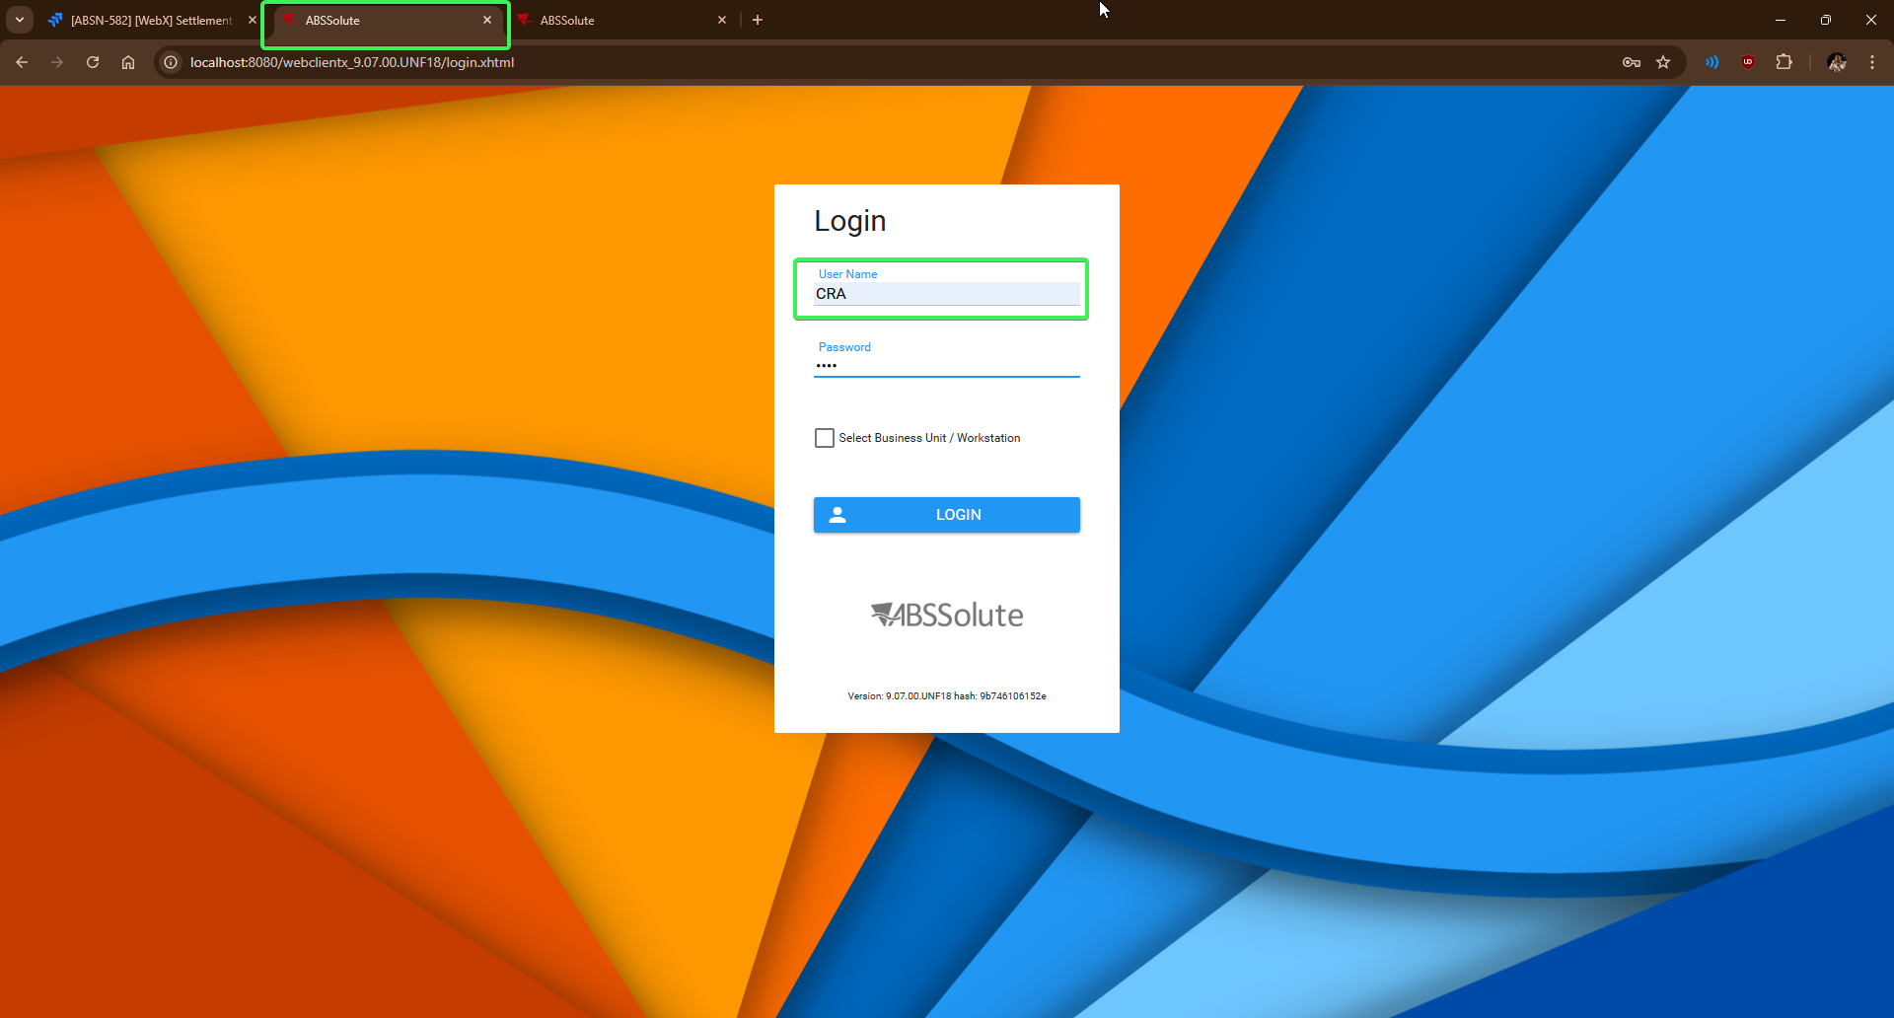
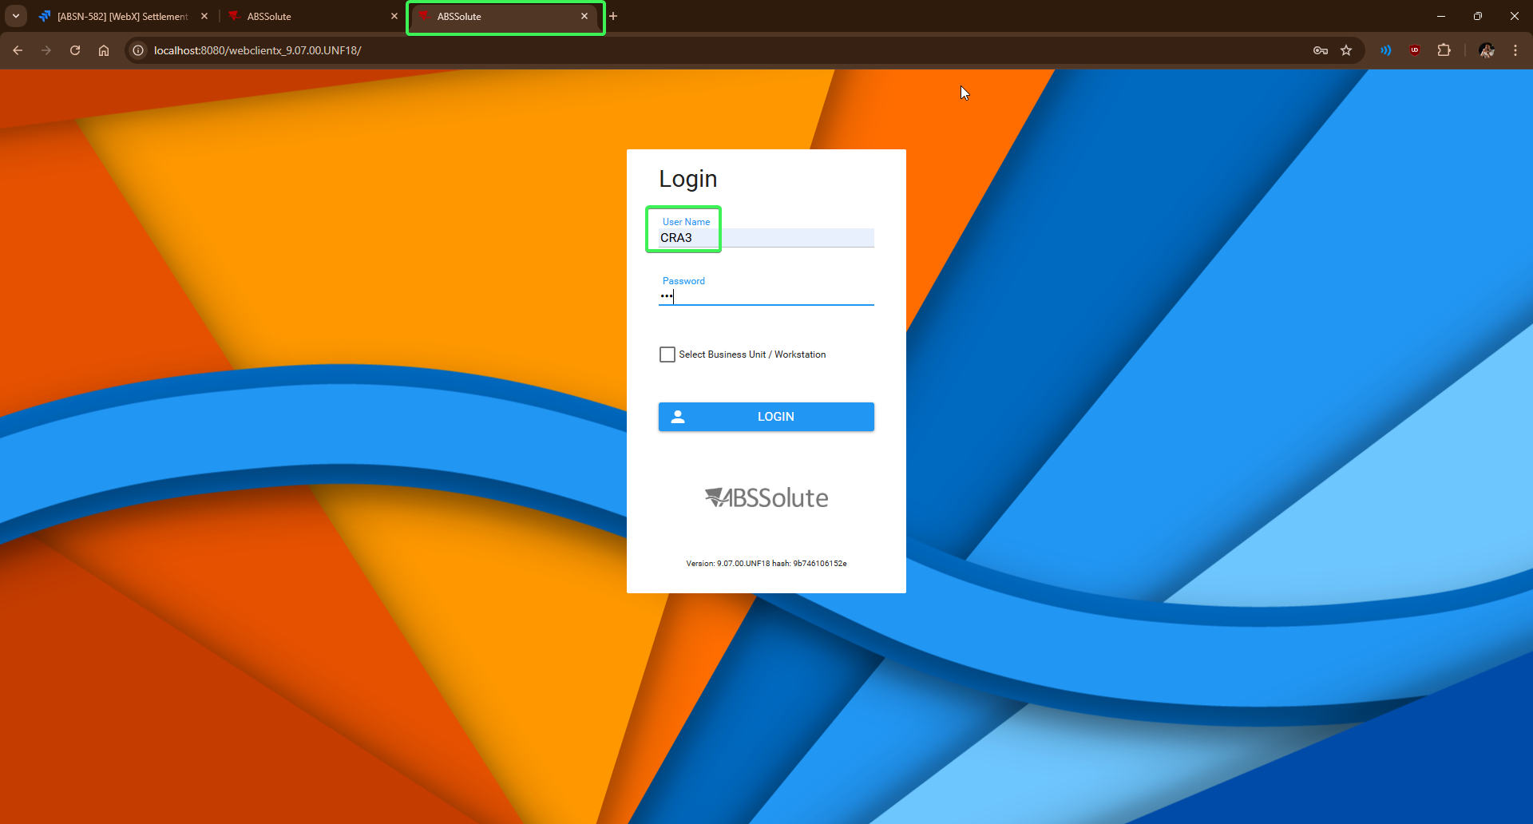
- Input your credentials and log in with User A(CRA) on tab1
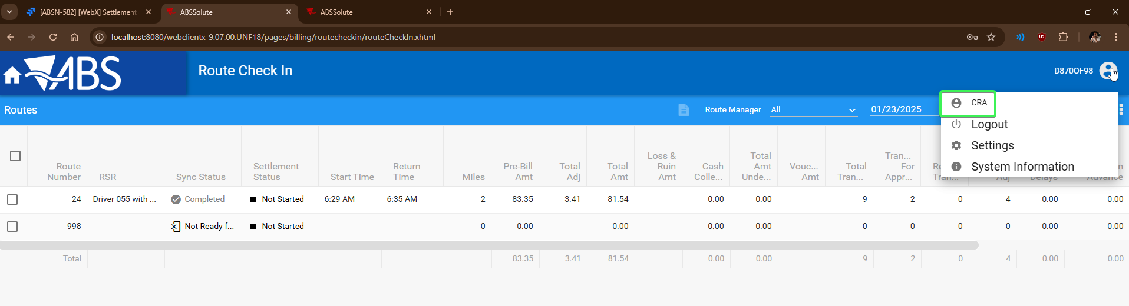
- Input your credentials and log in with User B(CRA3) on tab 2
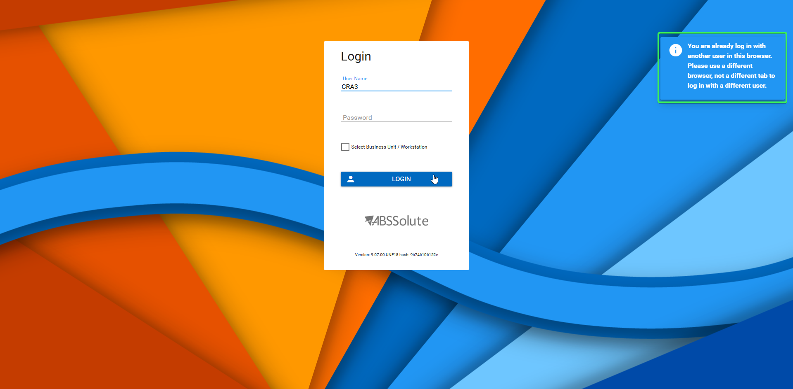
Tested OK

Test Case 3 – Two users on different browsers try to log in with different credentials
Hash: 9b746106152e
Expected behavior: The 2 users should be able to log in with no error message being displayed
- Open WebX log in page on a browser(Chrome) with User A(CRA)
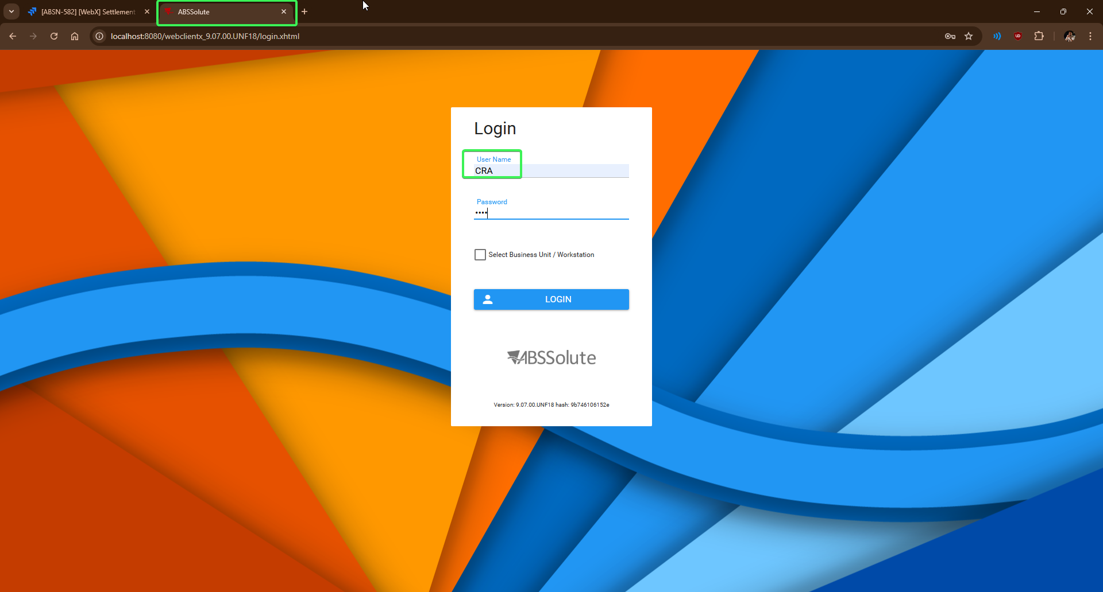
- Open WebX log in page on a different browser(Edge) with User B(CRA3)
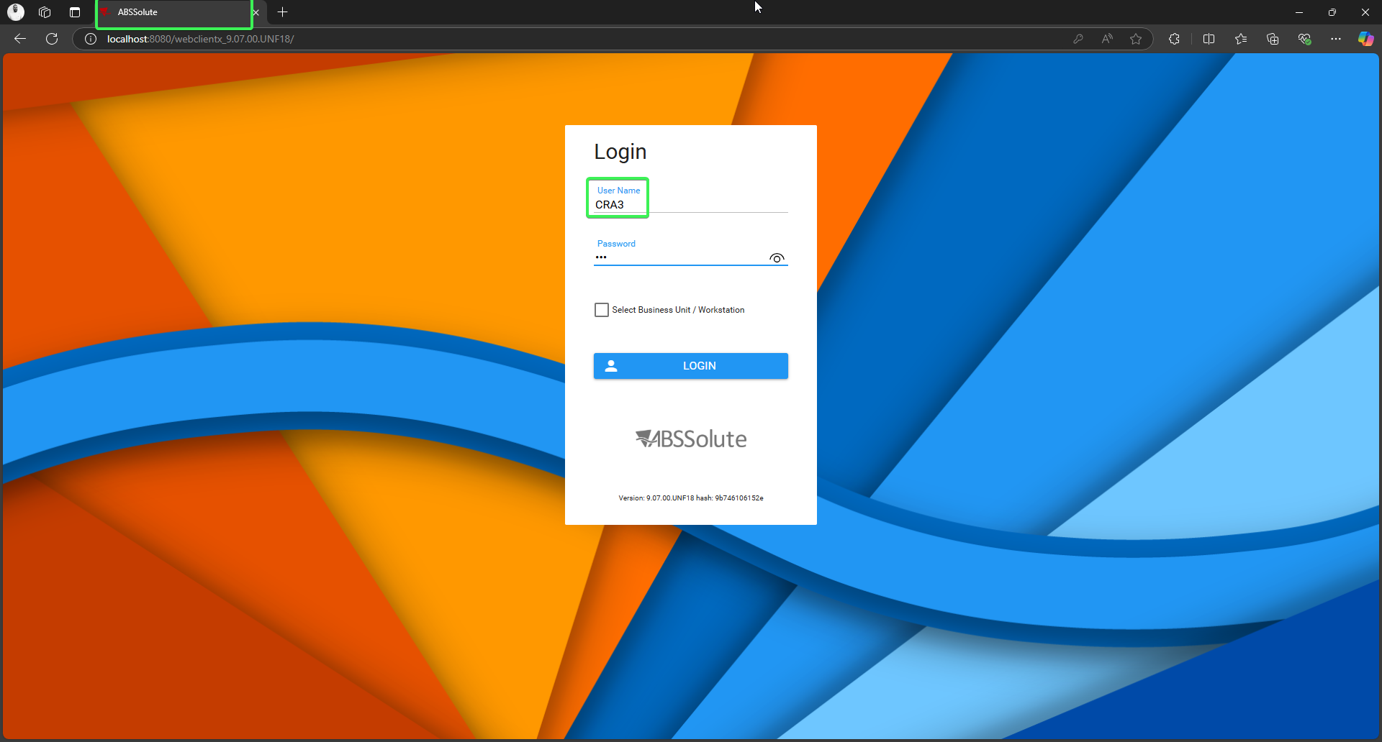
- Log in with User A on Browser 1 (Chrome)
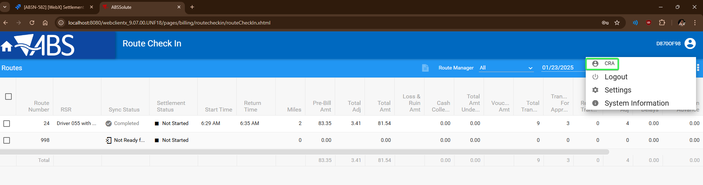
- Log in with User B on Browser 2 (Edge)
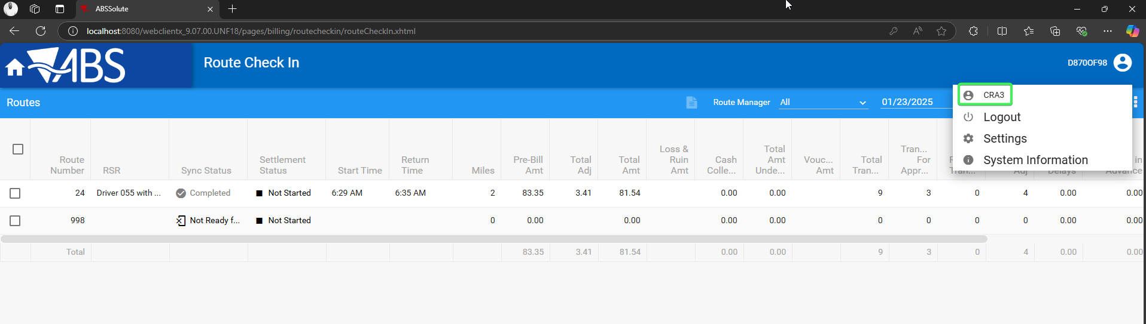
Tested OK

Test Case 4 – One user tries login in on different browsers
Hash: 9b746106152e
Expected behavior: The user should be able to log in on both browsers
- Open WebX log in page on a browser(Chrome) with User A(CRA)
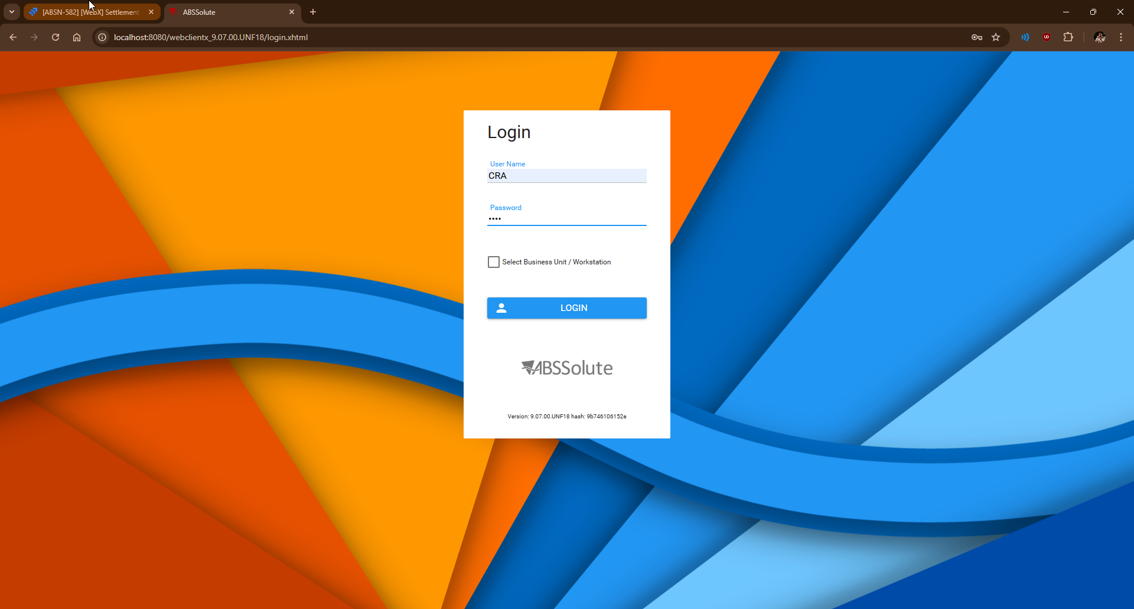
- Open WebX log in page on a different browser(Edge) with the same user (CRA)
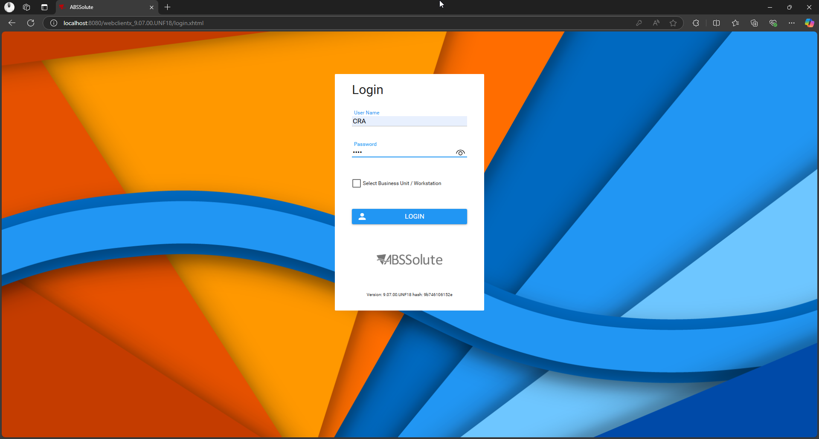
- Log in on browser 1 (Chrome)
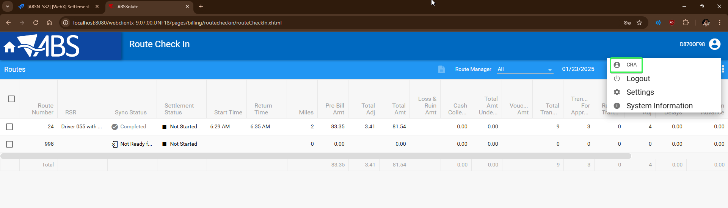
- Log in on browser 2 (Edge)
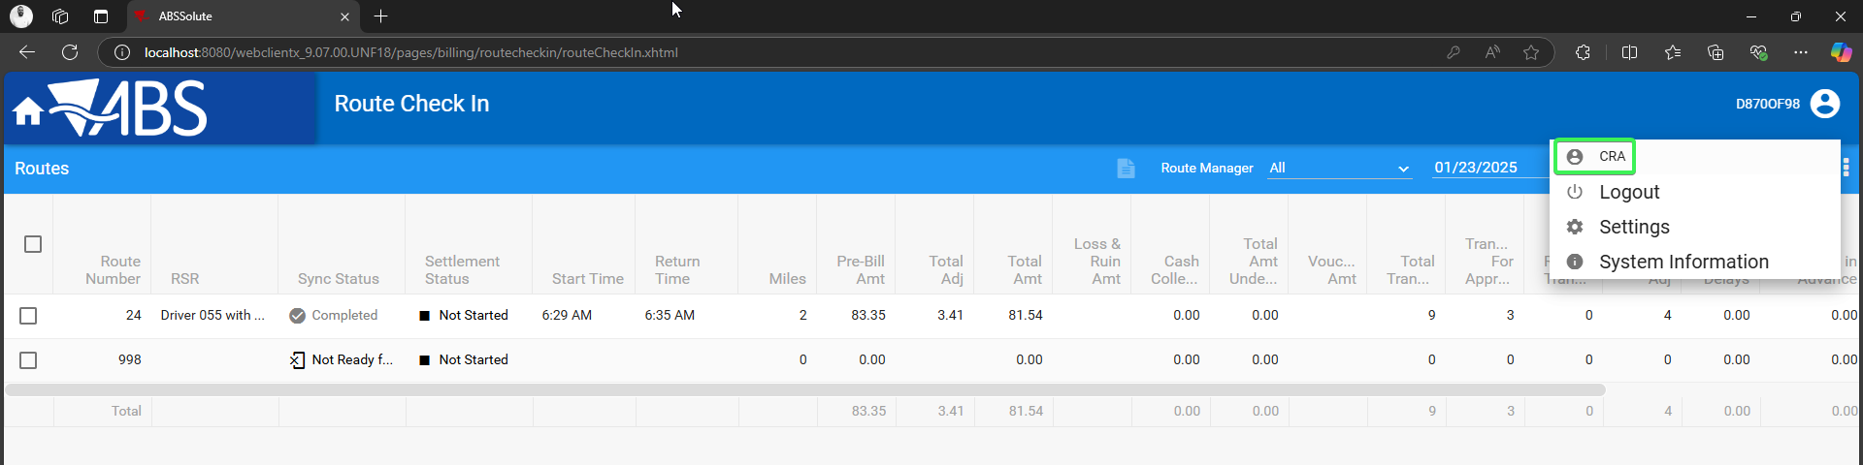
- Perform any action on browser 1 and see that you are not logged off
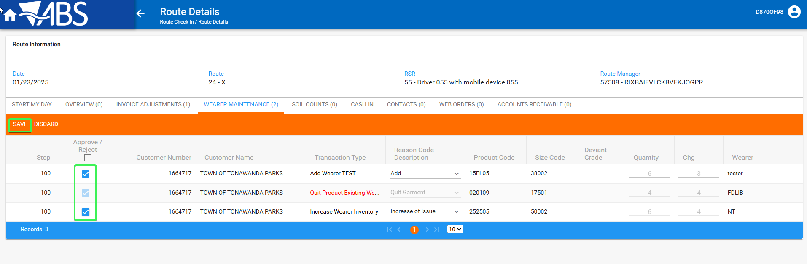
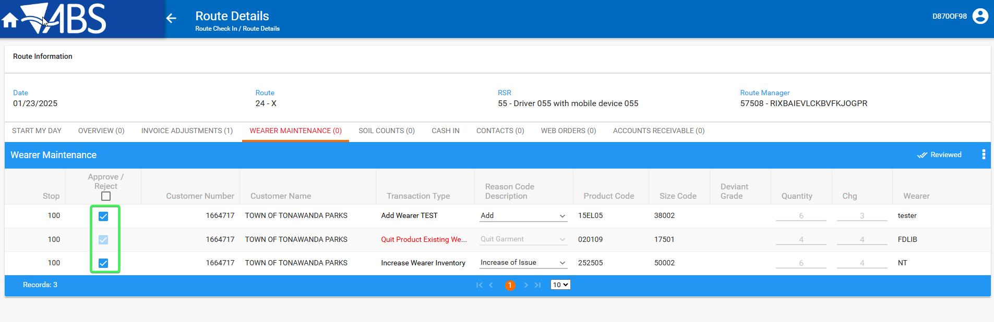
Tested OK

