ABSN-580 Maintain Packing and Delivery Notes: Route combo is empty
Environment | Prerequisites
Version:9.07.00.UNF19  DBServerName=abs-SRV20.internal.abslbs.com  DBSID=CUST24  DBUser=UNFDEV  DBPassword=UNFDEV  Environment=Test | - Module:  - System setting

Contents
Test after fix 1
Test Case 1 – Maintain Packing and Delivery notes dlg, Route dropdown – Tested OK 1

Test after fix

Test Case 1 – Maintain Packing and Delivery notes dlg, Route dropdown – Tested OK
Expected behavior: All the routes appear in the Route dropdown
Hash: 5a06bd8d4ec
- In Route Status Control dlg add routes from 2 BU
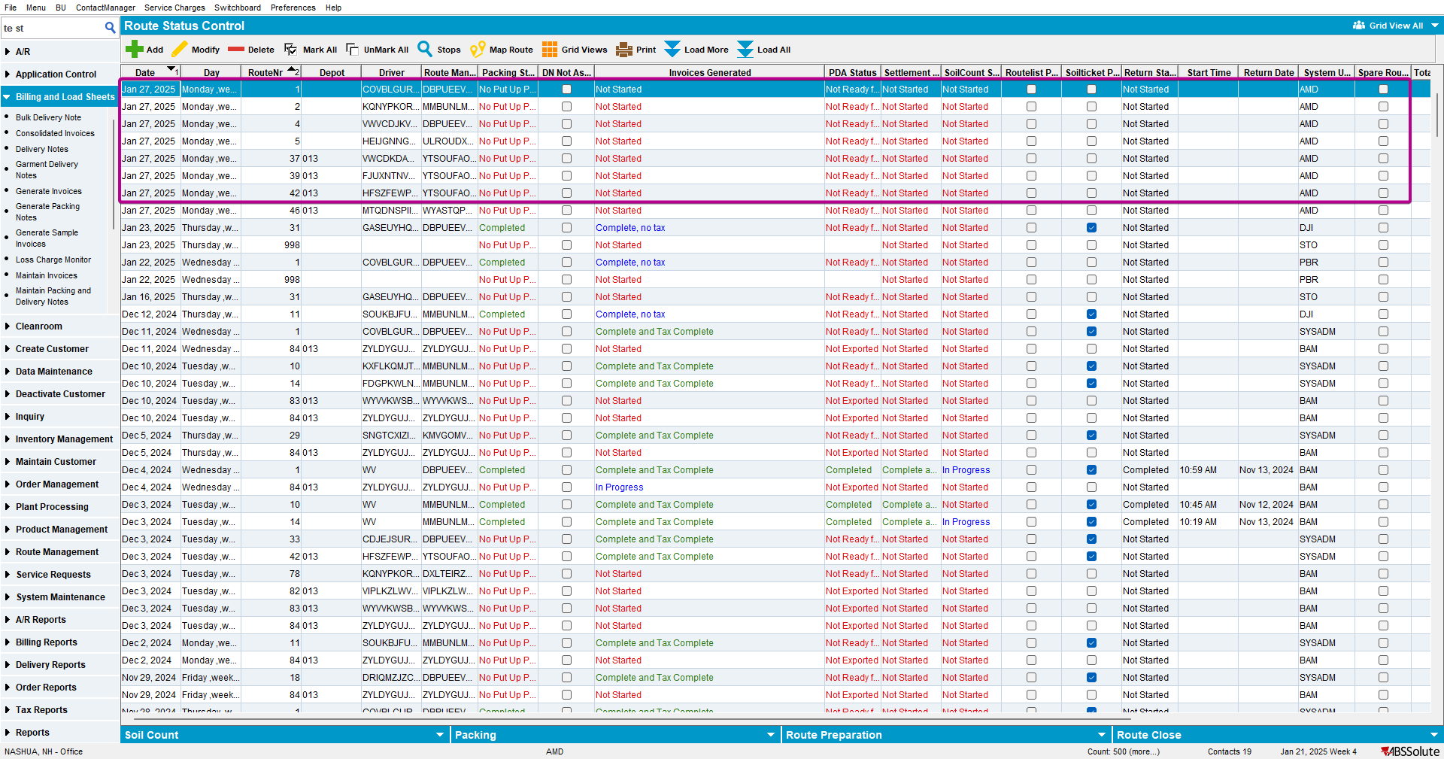

- In Maintain Packing and Delivery notes dlg check that the routes appear in the Route dropdown
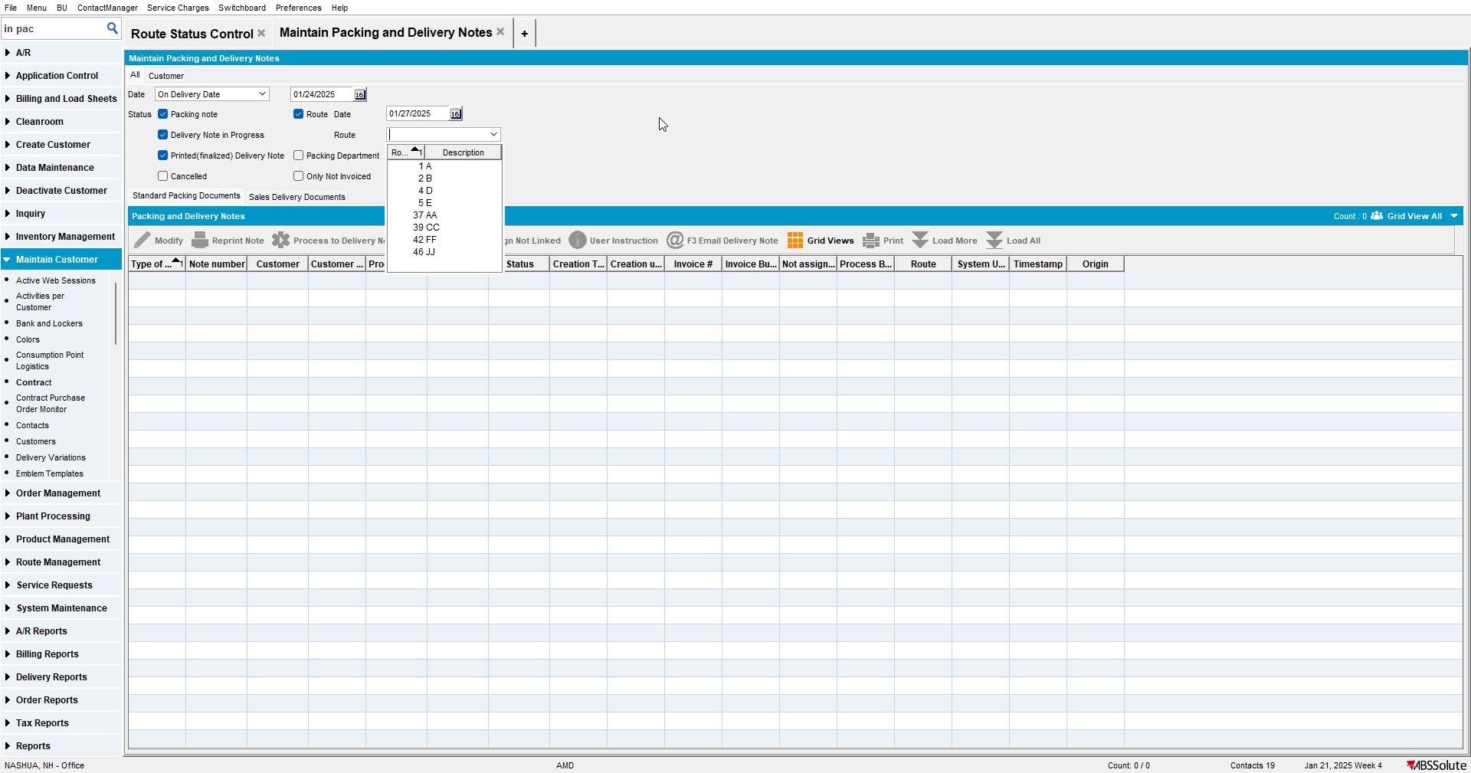

- Generate packing notes for some of the routes
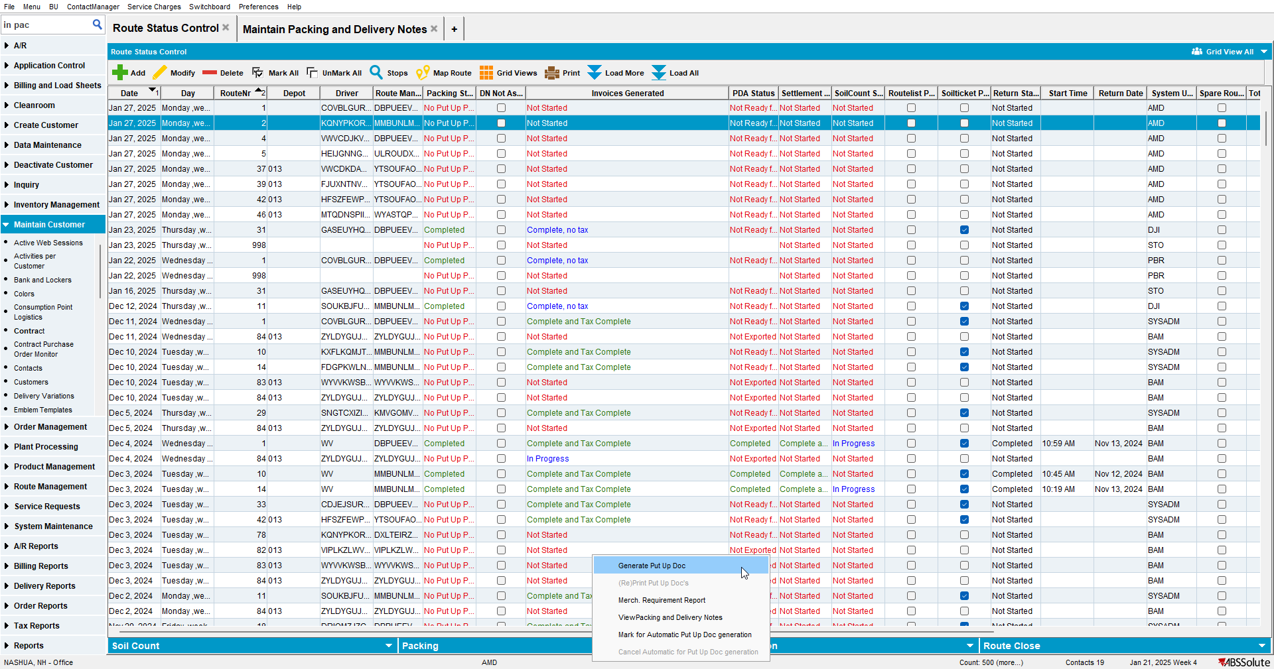
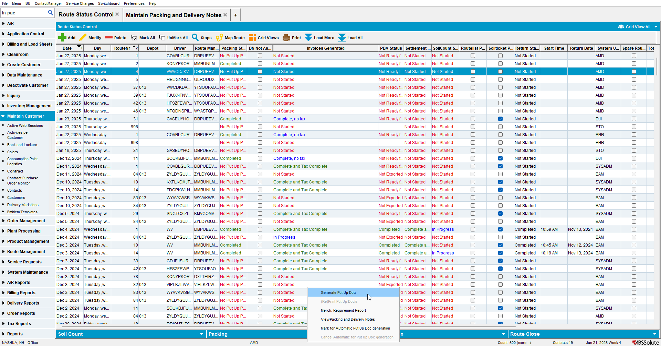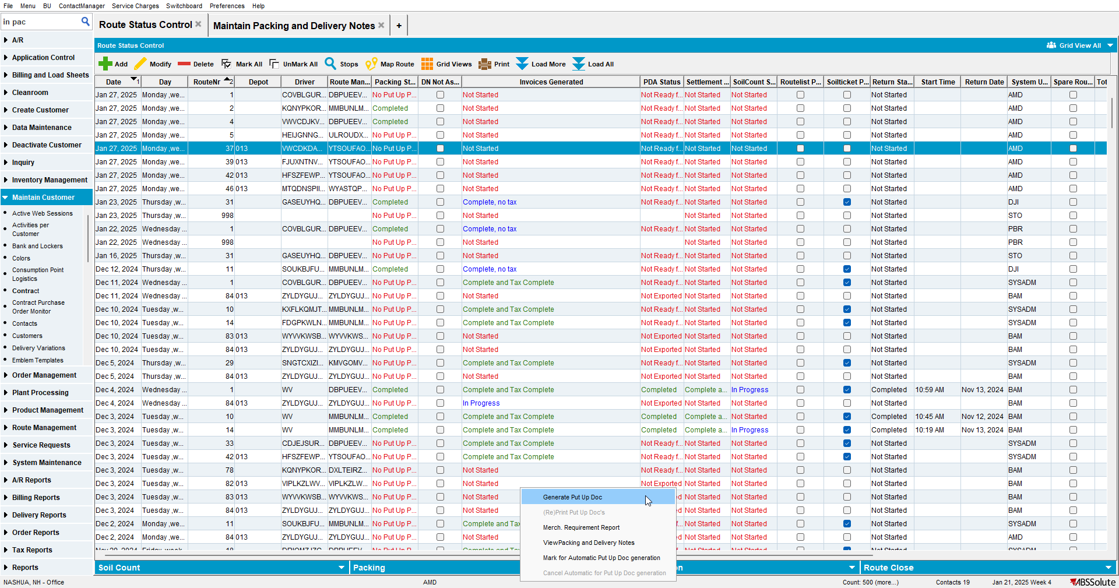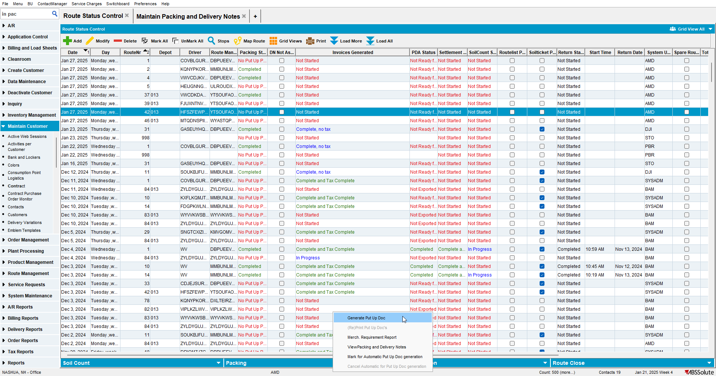

- In Maintain Packing and Delivery notes dlg check that the routes appear in the Route dropdown
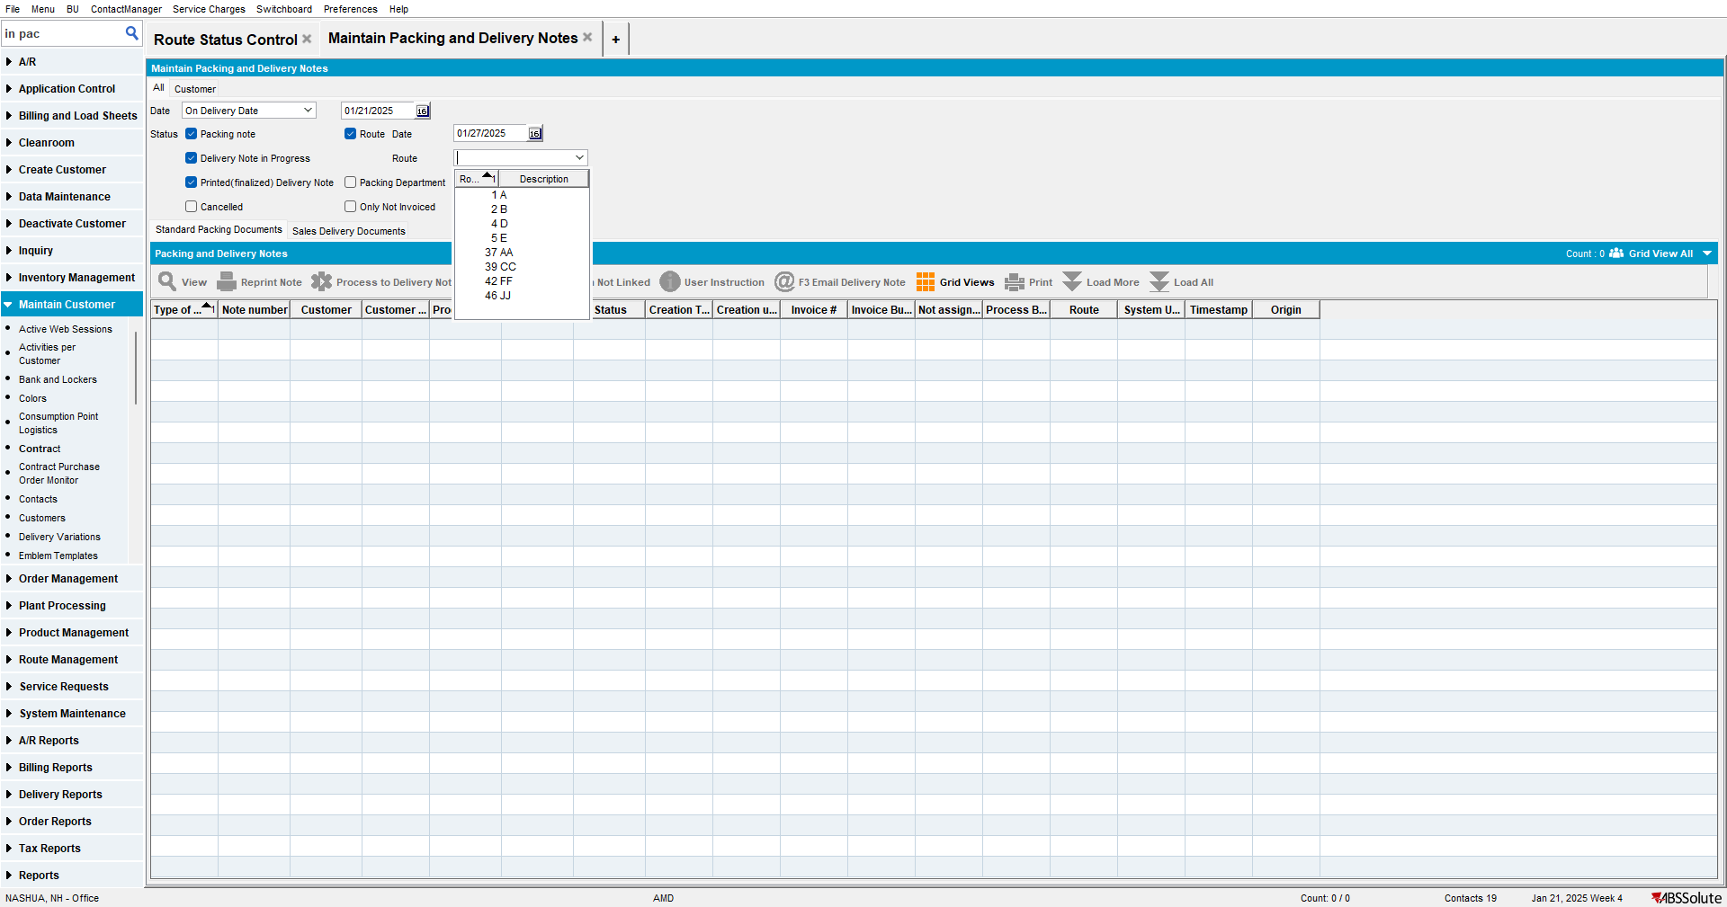
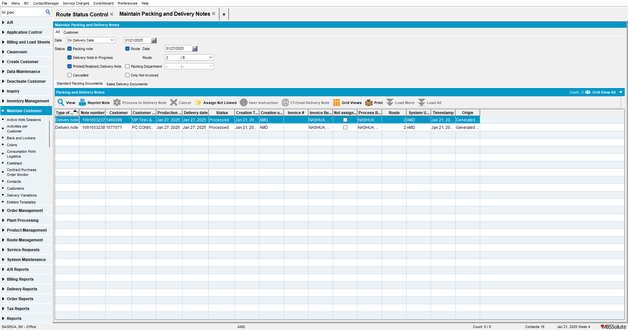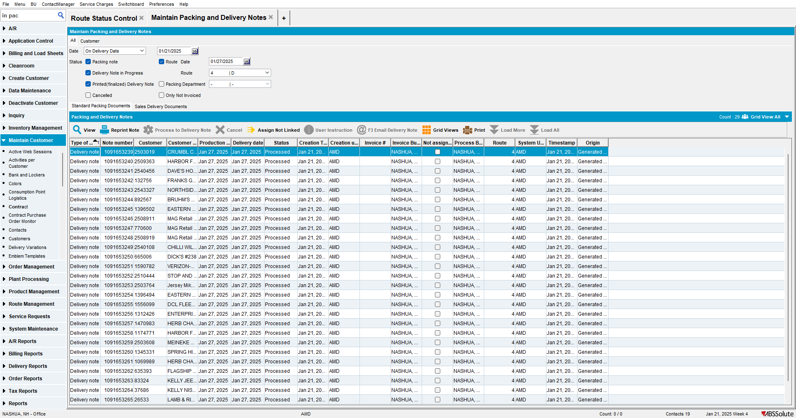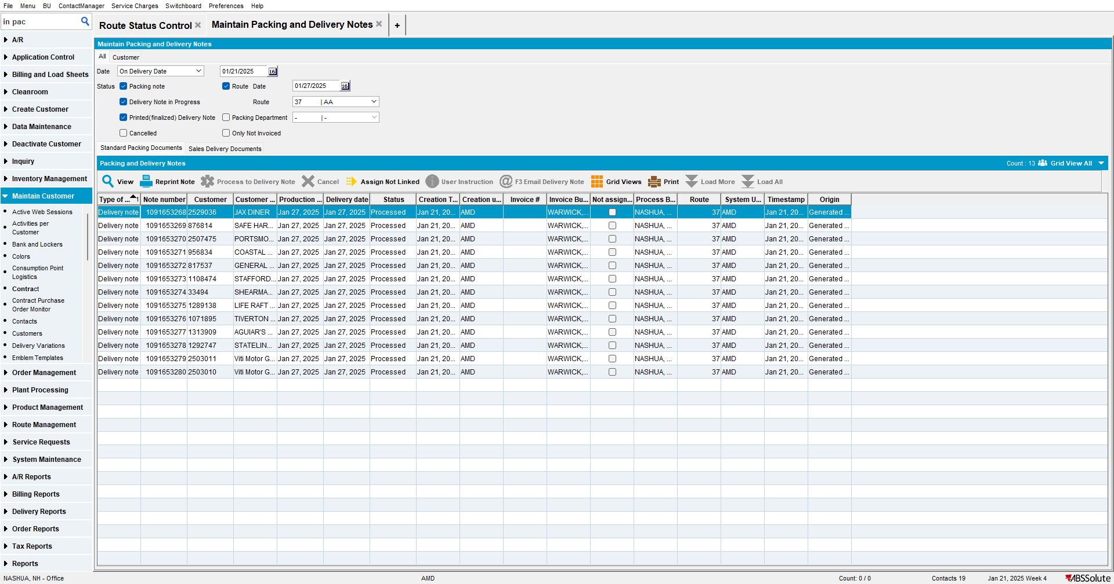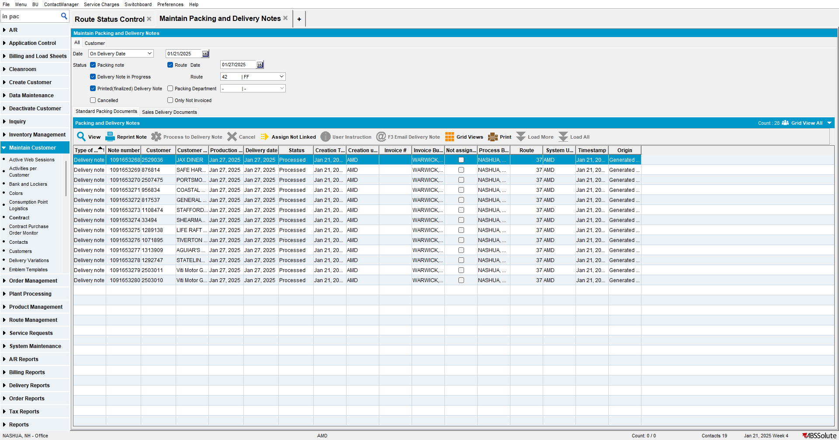

- Generate invoices for some of the routes
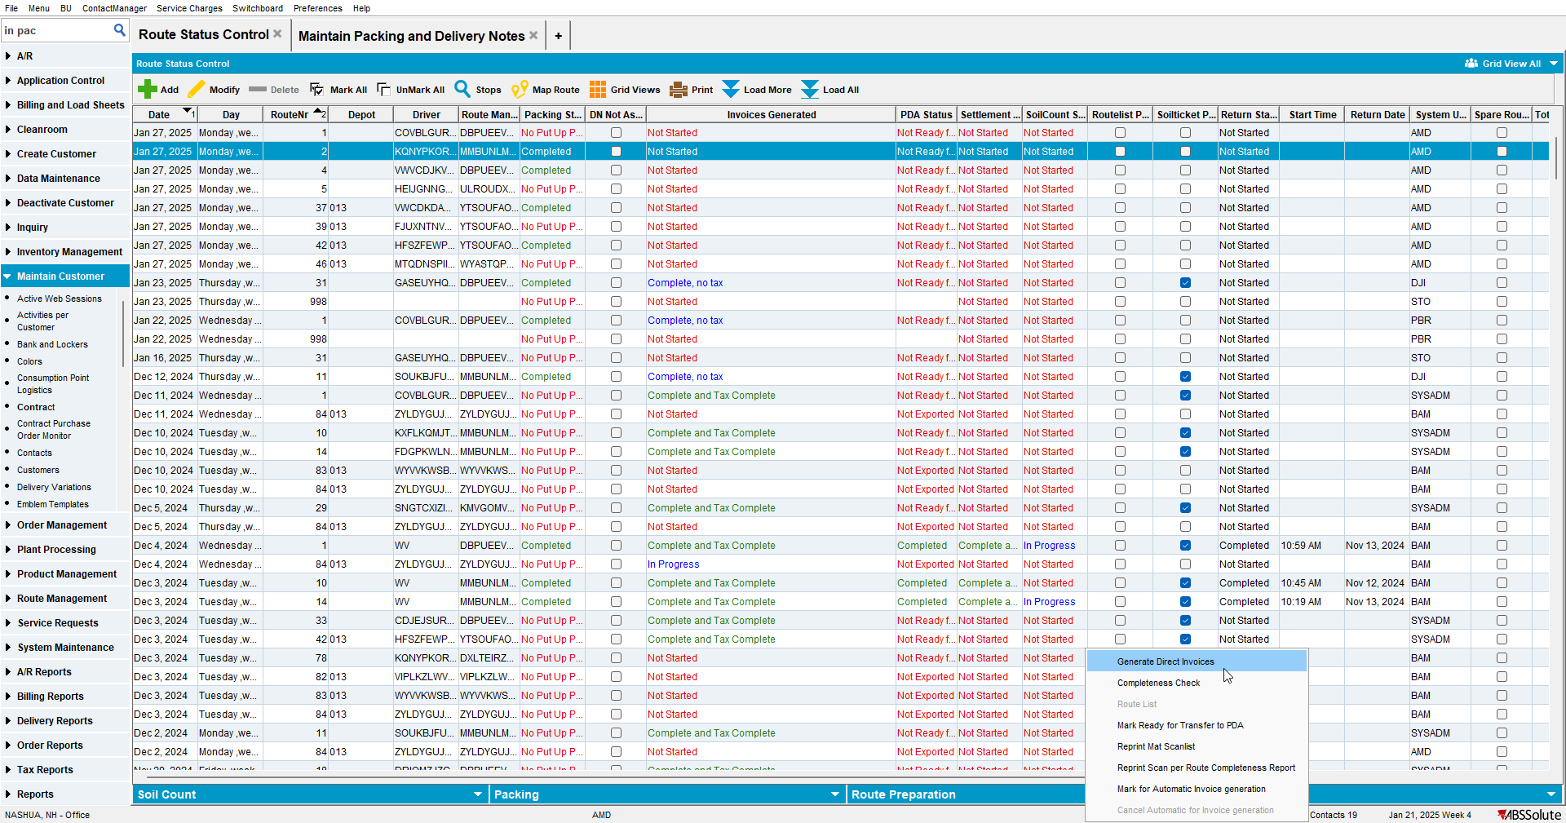
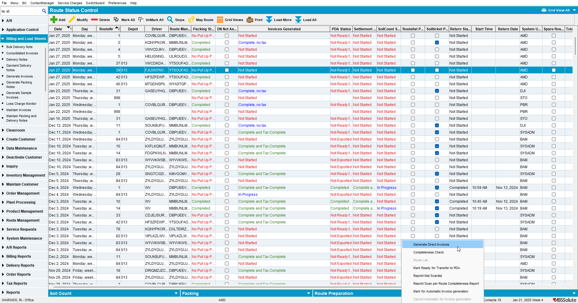
- In Maintain Packing and Delivery notes dlg check that the routes appear in the Route dropdown
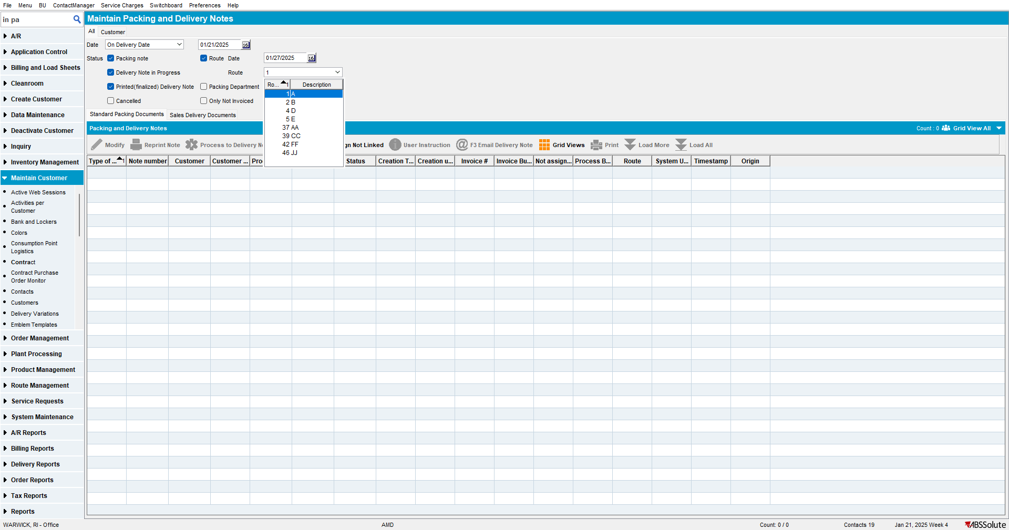

- Settle a route
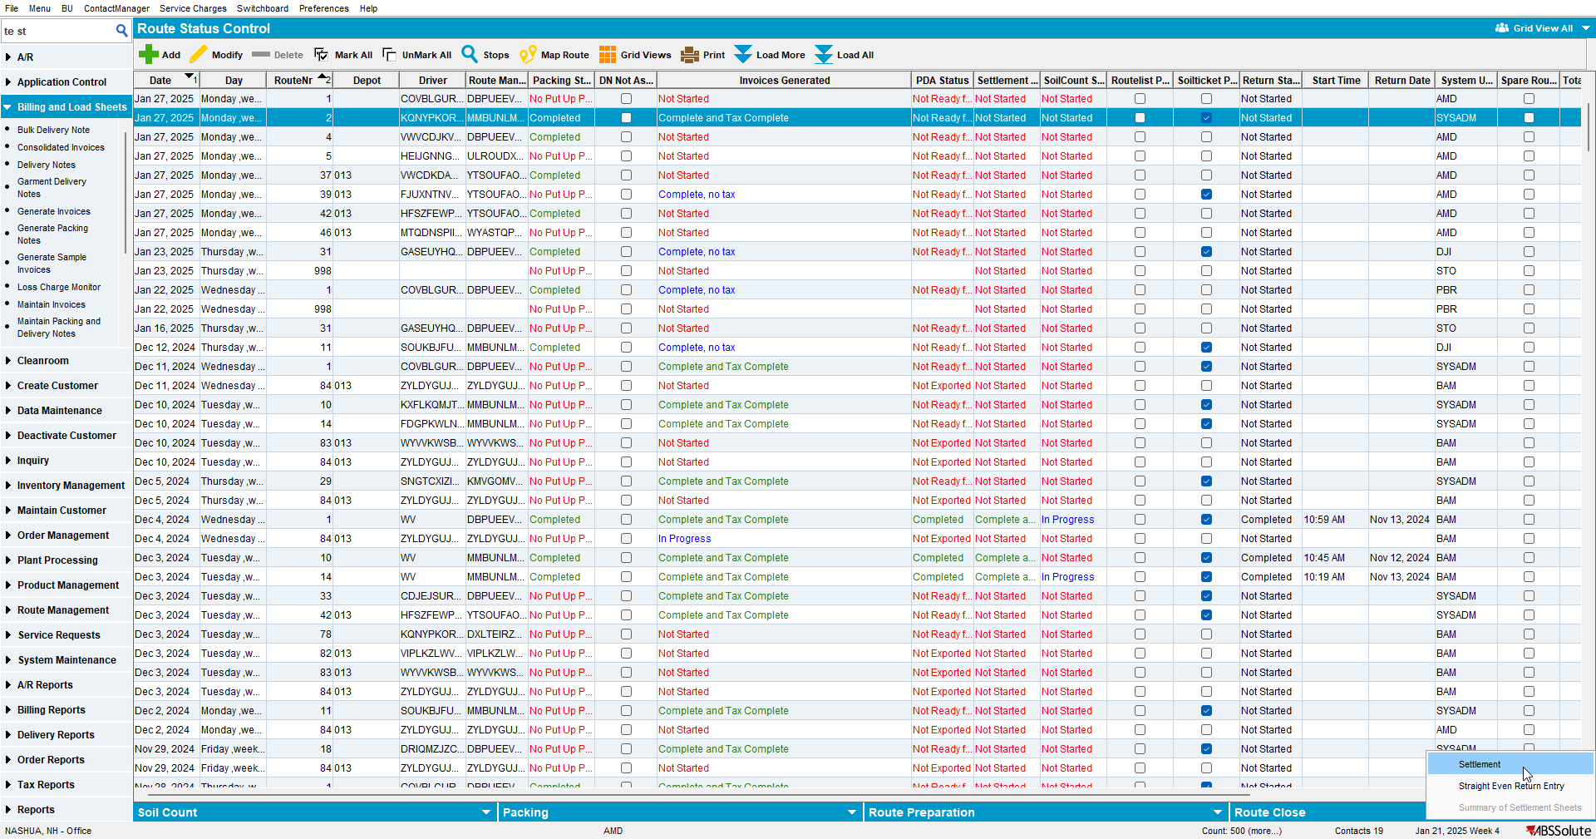

- In Maintain Packing and Delivery notes dlg check that the routes appear in the Route dropdown
