ABSN-5435 Invoices settled for Undeliverable stops
DataBase | Preconditions
Version:9.07.00.UNF19  DBServerName= abs-srv20.internal.abslbs.com  DBSID=CUST24  DBUser=UNFDEV | - Module: ROUTEASSISTANT; ROUTEASSISTANTANDROID; ROUTEASSISTANTGARMENT;
Environment: Production
Contents
Expected Behaviour: 1
Summary: Retest after fix 1

Expected Behaviour:
If the user moves stop on a route (using the auto order/up/down buttons on client application or moves them using the PDA) and marks the stops as undeliverable from PDA, then the invoice should be disconnected when doing settlement.

Summary: Retest after fix
Preconditions: Hash: 9.07.00.UNF19 hash:
Step 1) I will be using customer visited weekly on route 1
Customer 2504118
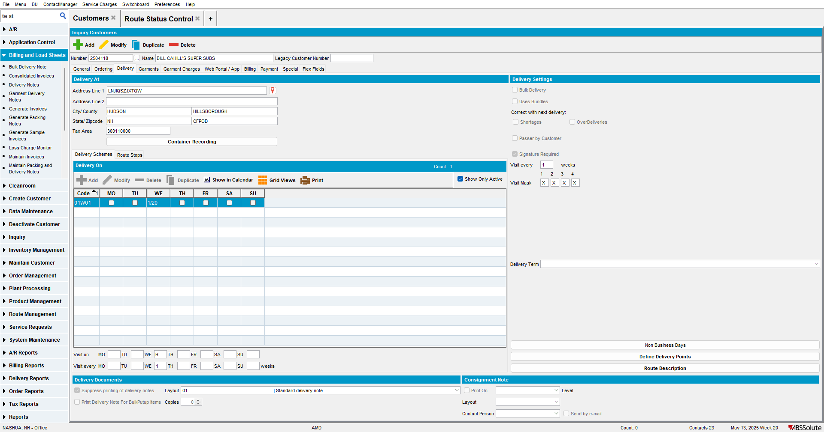
Step 2) Add route in Route Status Control (in a day this customer is not normally visited): I added route 1 for Thursday: notice the customer is not on the route yet. This is correct
Step 3) Add sales note:
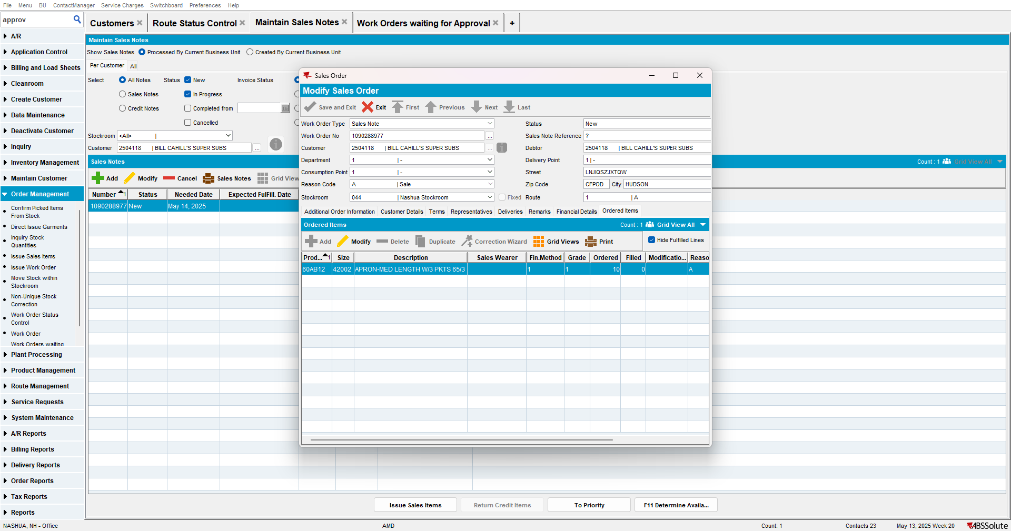

Step 4) Issue Sales Items and Generate Delivery Note:
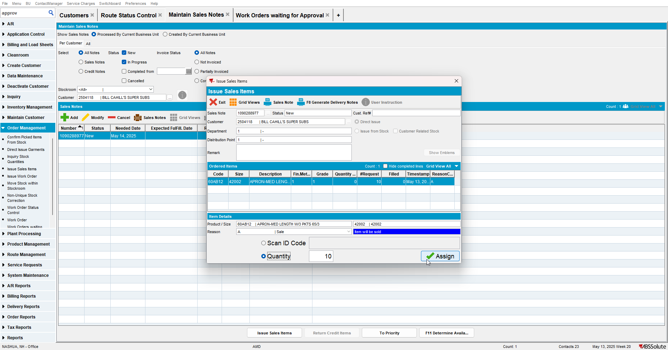

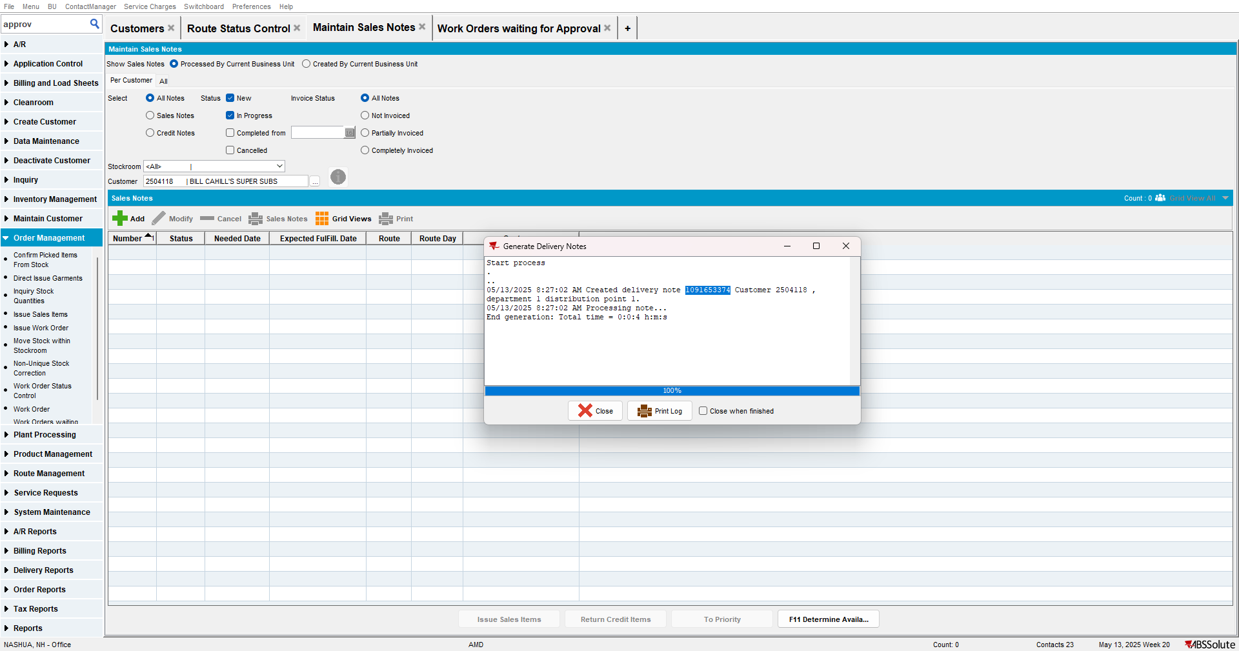
Step 5) Issue Invoice:
Note: make sure customer is set to allow issuing invoice from Sales Ordering, not only from RSC.
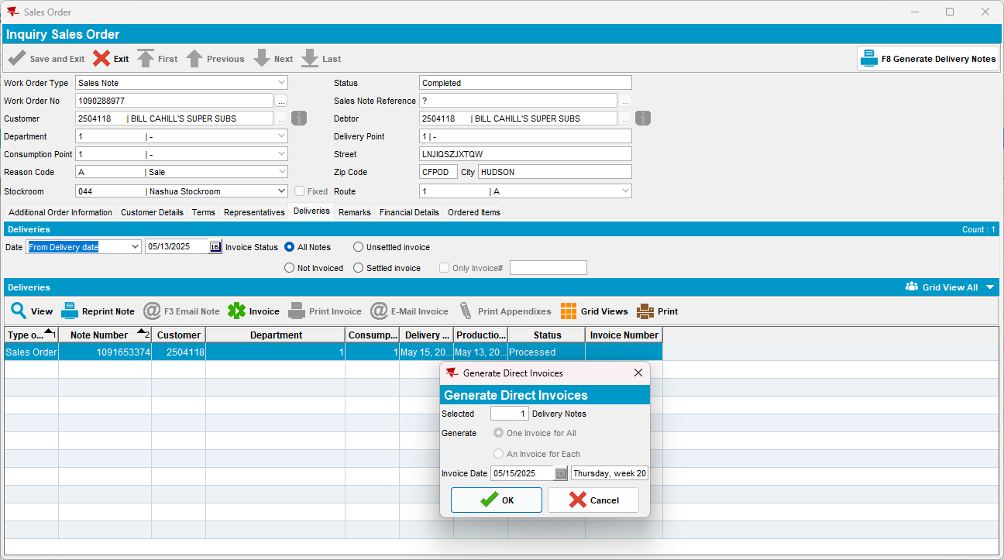

Invoice created:
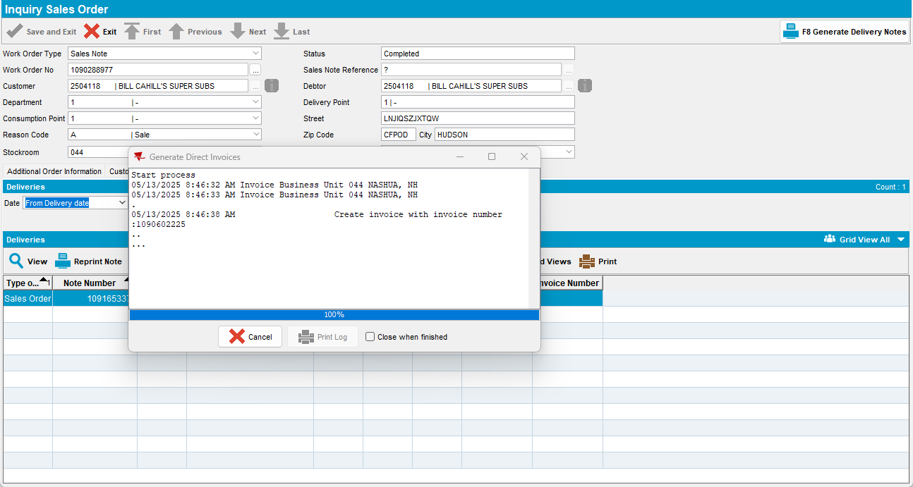

Step 6) Generate put-up docs on the route:
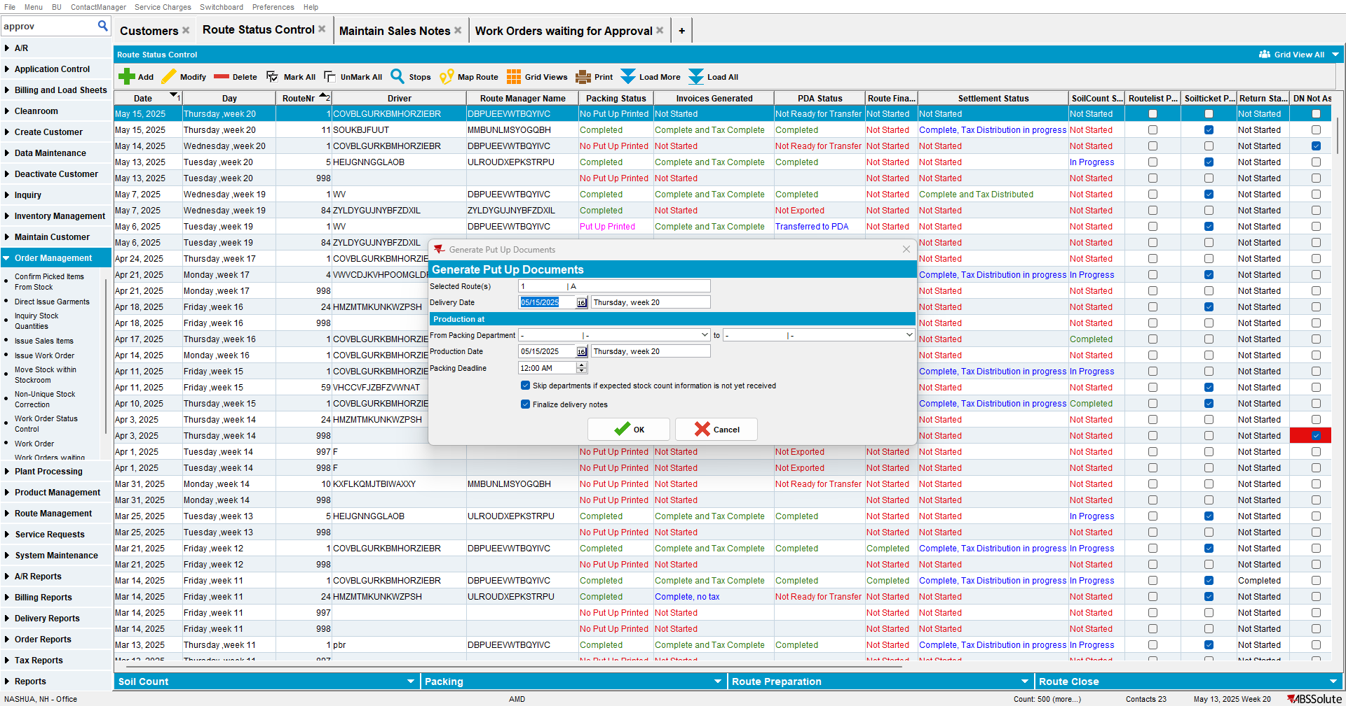

Step 7) From Maintain Invoices dlg, assign the invoice to the route:
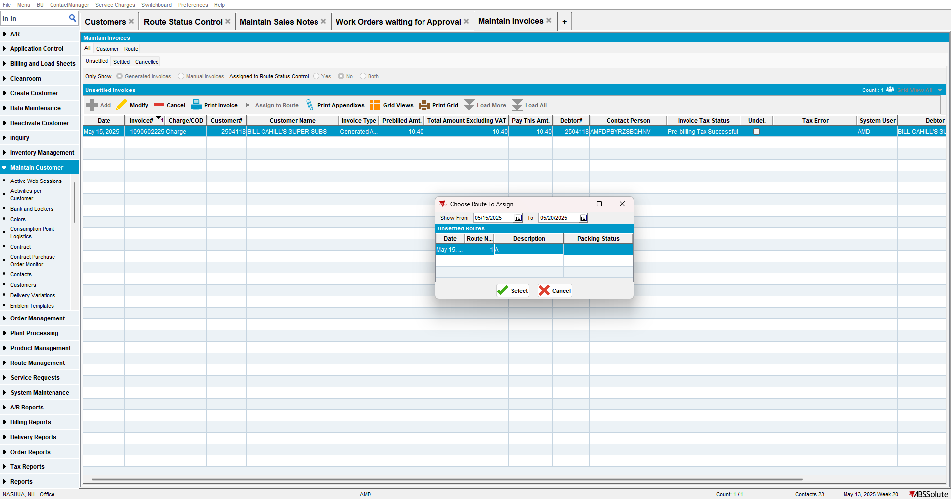
Step 8) Notice the stop is added to the route (stop 0) and invoice is visible:
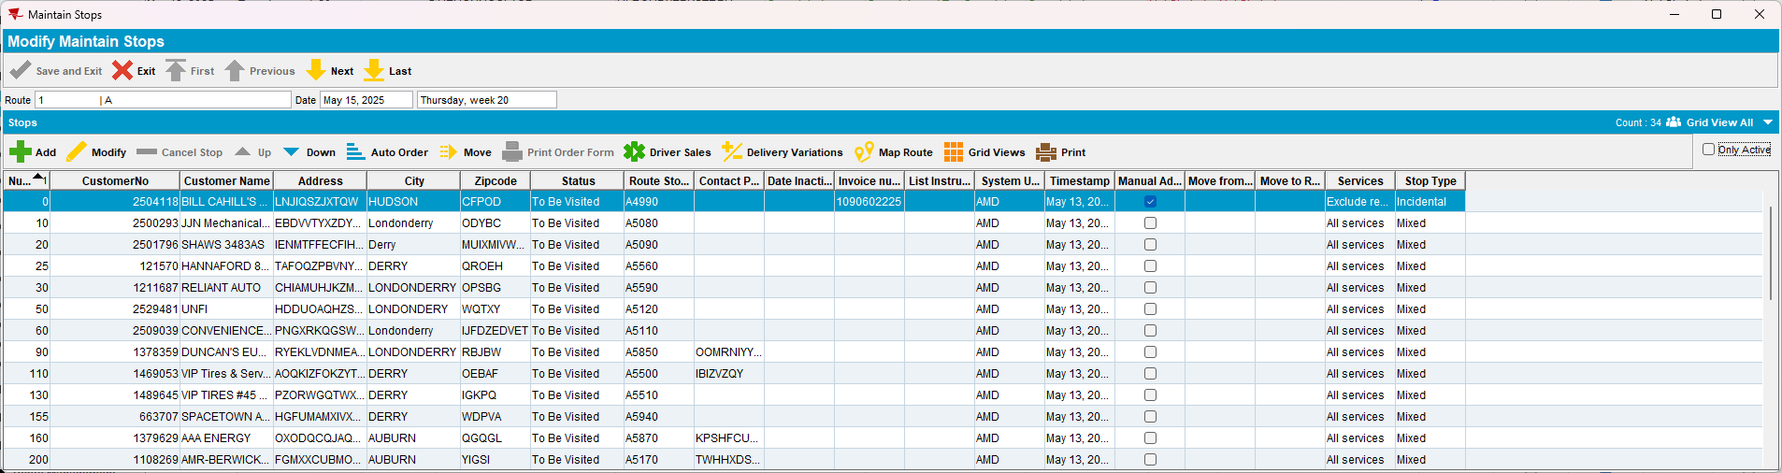
Step 9) Auto order the stops on the route (to have the button enabled, make sure the checkbox “active only” is not checked):
After auto order, the stop has changed from 0 to 1:
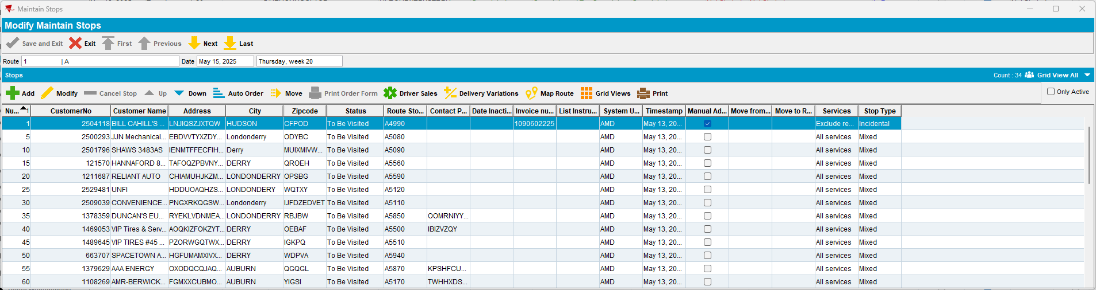

Step 10) Generate Invoices on route:
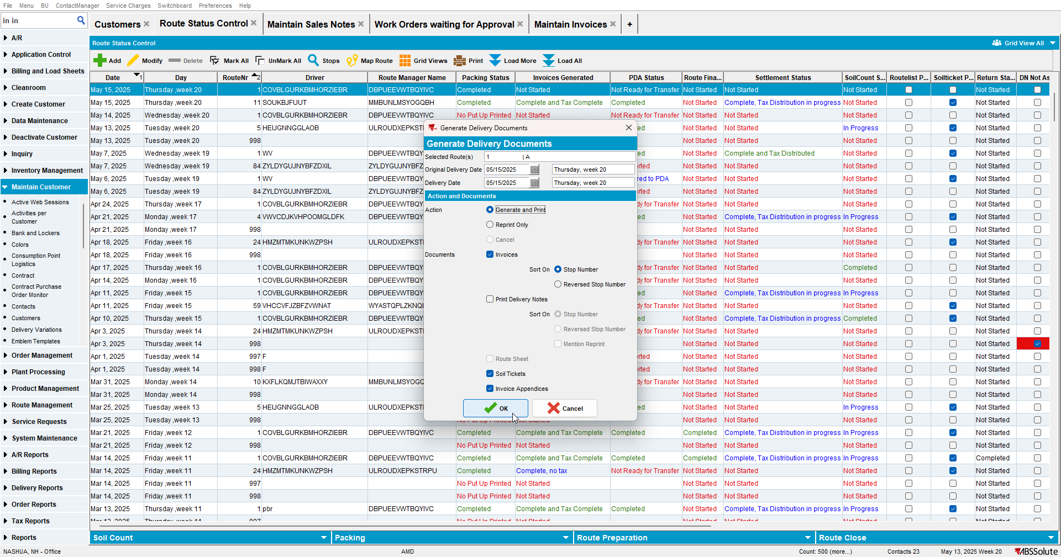
Step 11) Transfer to PDA:
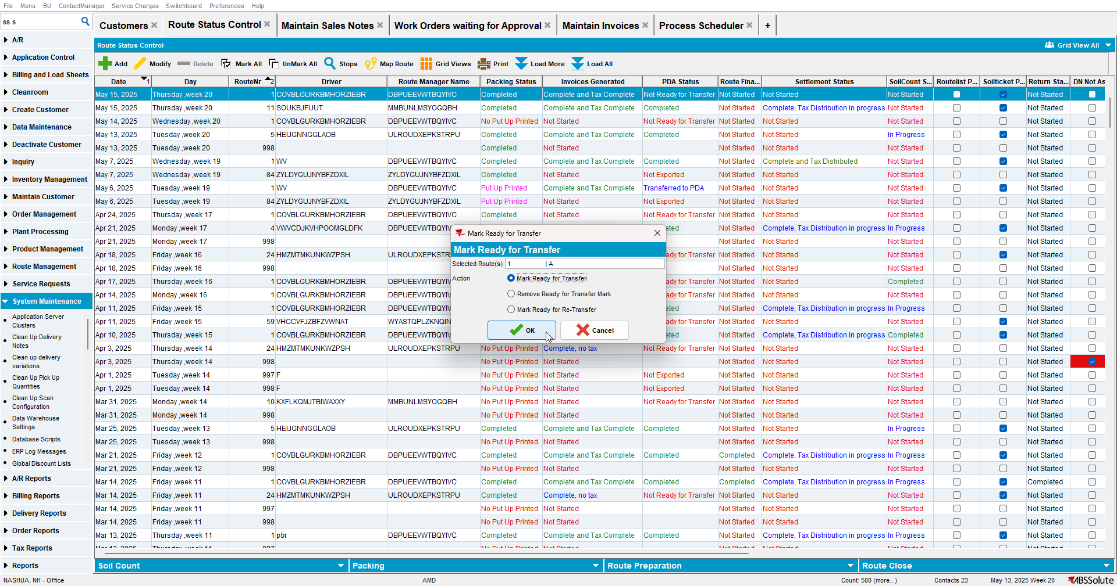

Step 19) Select route -> Start Route -> Select Stop -> Mark stop as undeliverable:
Step 20) Drag and move the other stops as well: (note: moving stops is available under ss STOPORDERCHANGE. Make sure it has value 1 or 2. In my case, it has value 1)
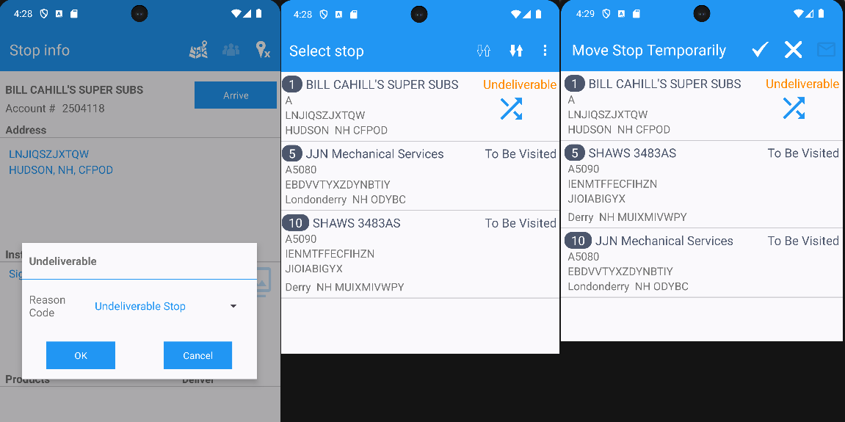
Step 21) I also made one of the recently moved stops, undeliverable as well:
Step 22) Makre sure all the other stops are visited
Step 23) Finish and upload route:
Step 25) We have 2 invoices for 2 stops, marked as undeliverable (also, stop numbers were updated according to how they were moved on PDA):
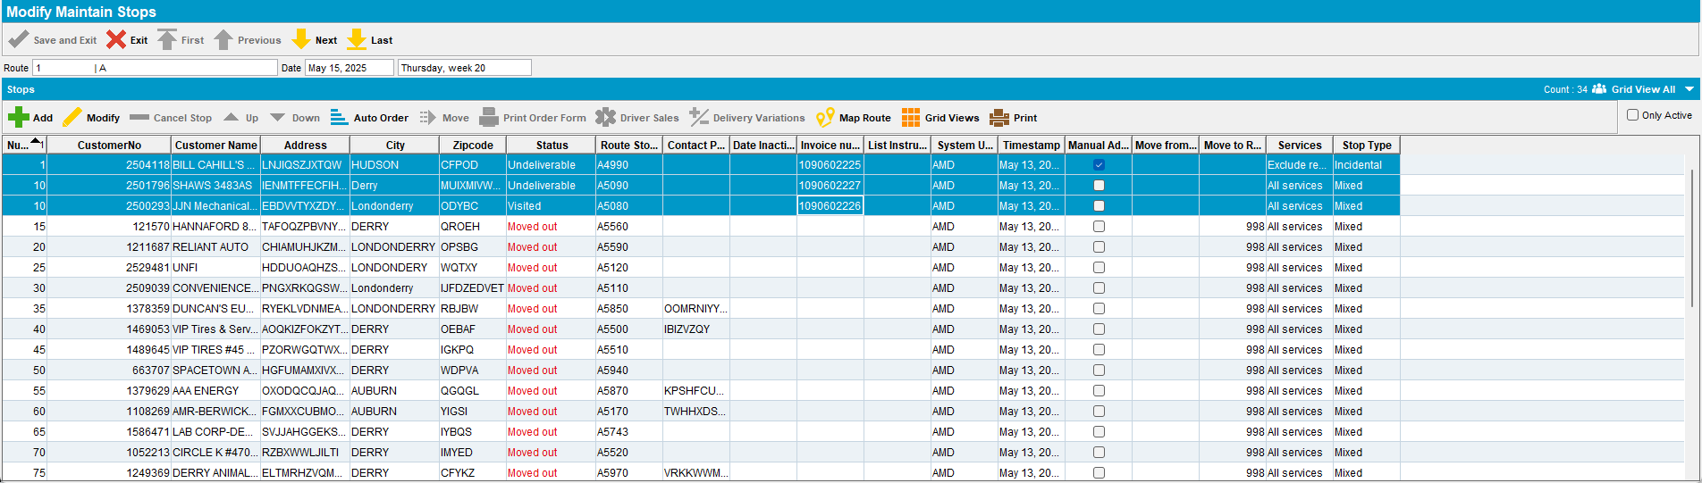

Step 26) Using the Settlement form, check the invoices: notice that they have the undeliverable check on. This is correct:
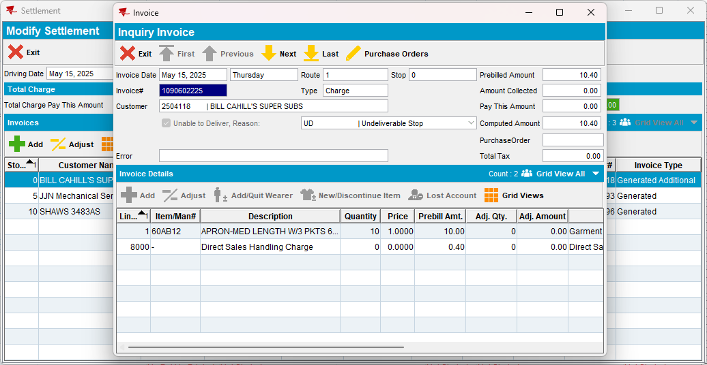
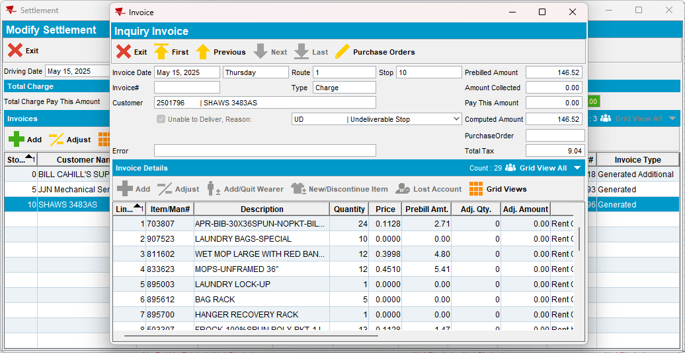

Note: check database as well: notice that for the 2 invoices that were marked as undeliverable, the adjustment reason id is filled:
select ih.status_id, ih.invoiceheader_id, ih.invoicenumber, ih.settlementrejectreason, ih.adjustmentreason_id from invoiceheader ih
where ih.invoicenumber in ('1090602225', '1090602226', '1090602227')
Check is also visible in maintain invoices:
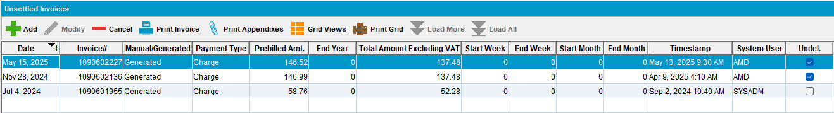
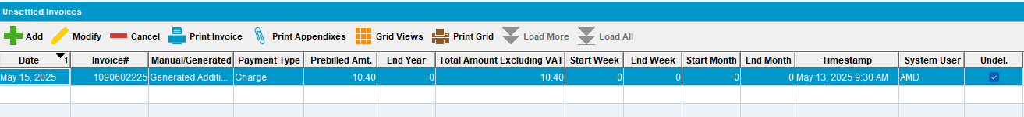
Step 27) Use webclientx to settle the route:
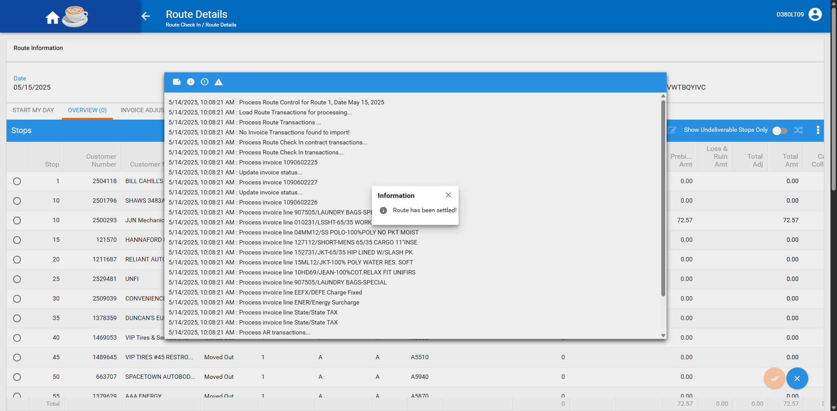
Settlement status is completed:

Step 26) Check stops. The undeliverable stops have their invoices disconnected: this is correct
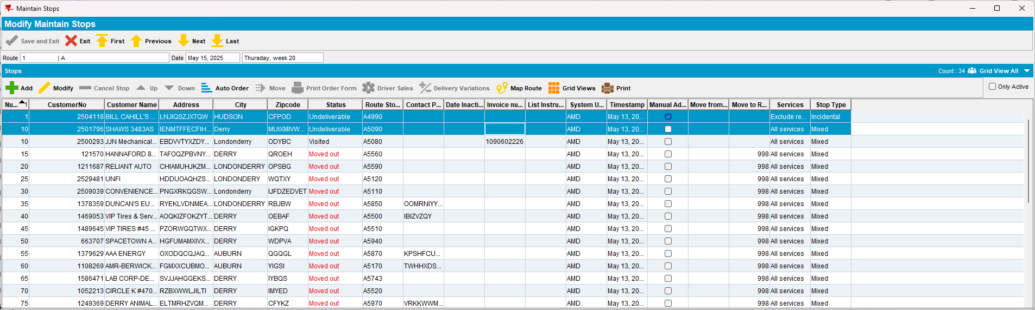
Note: if you check in Maintain Invoices, the invoices were not settled. This is correct, user can connect them to a different route if needed:
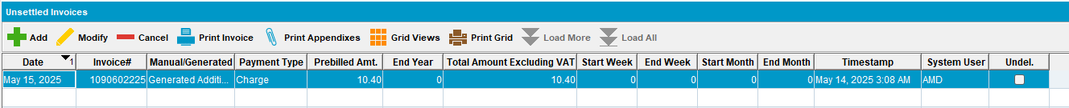
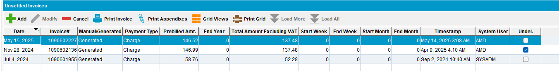
Check database: for the undeliverable invoices, the status_id is 1 (not settled). The other invoice for the stop that was moved and was not marked as undeliverable, it is 2 (settled):
select ih.status_id, ih.invoiceheader_id, ih.invoicenumber, ih.settlementrejectreason, ih.adjustmentreason_id from invoiceheader ih
where ih.invoicenumber in ('1090602225', '1090602226', '1090602227') 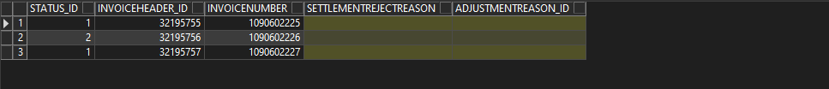
After fix, invoice header is updated using the stop_id (which is unique) and not the stopnumber.
RETEST OK

