ABS-170523 D_UBS_2552 Unsettled invoice on a settled route has an Invoice Tax Status of “Settlement Tax Successful”
Environment | Prerequisites
Version:9.07.00  DBServerName=abs-SRV20.internal.abslbs.com  DBSID=CUST24  DBUser=UNFDEV  DBPassword=UNFDEV  Environment=Test | - Module:  - System setting

Contents
Test after fix 1
Test Case 1 – Move stop from RC2 to RC3 and RC3 is a regular stop for your customer– Tested OK 1
Test Case 2 – Move stop from RC2 to RC3 and RC3 is NOT a regular stop for your customer– Tested OK 7

Test after fix

Test Case 1 – Move stop from RC2 to RC3 and RC3 is a regular stop for your customer– Tested OK
Expected behavior: the invoice is assigned to the "moved in" stop.
Hash: c620897
- For a customer add its route(RC1) in RSC 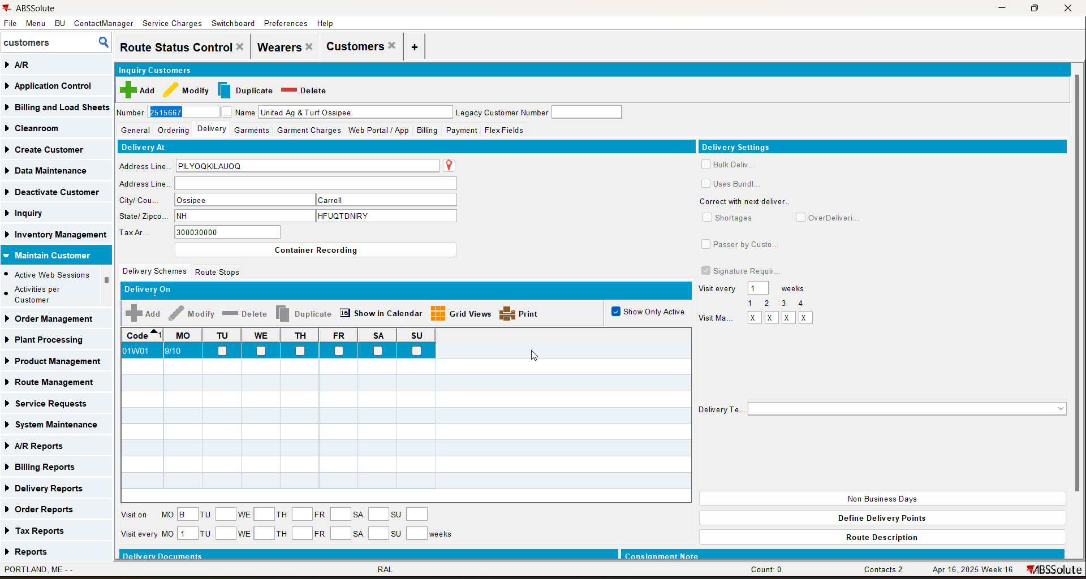
- Generate packing note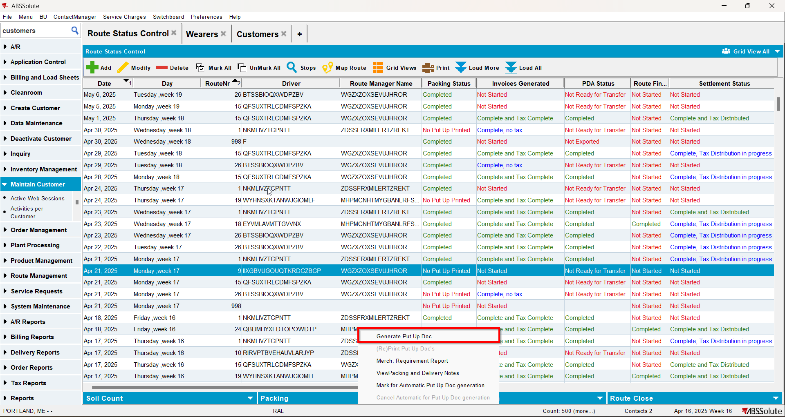
- Generate invoices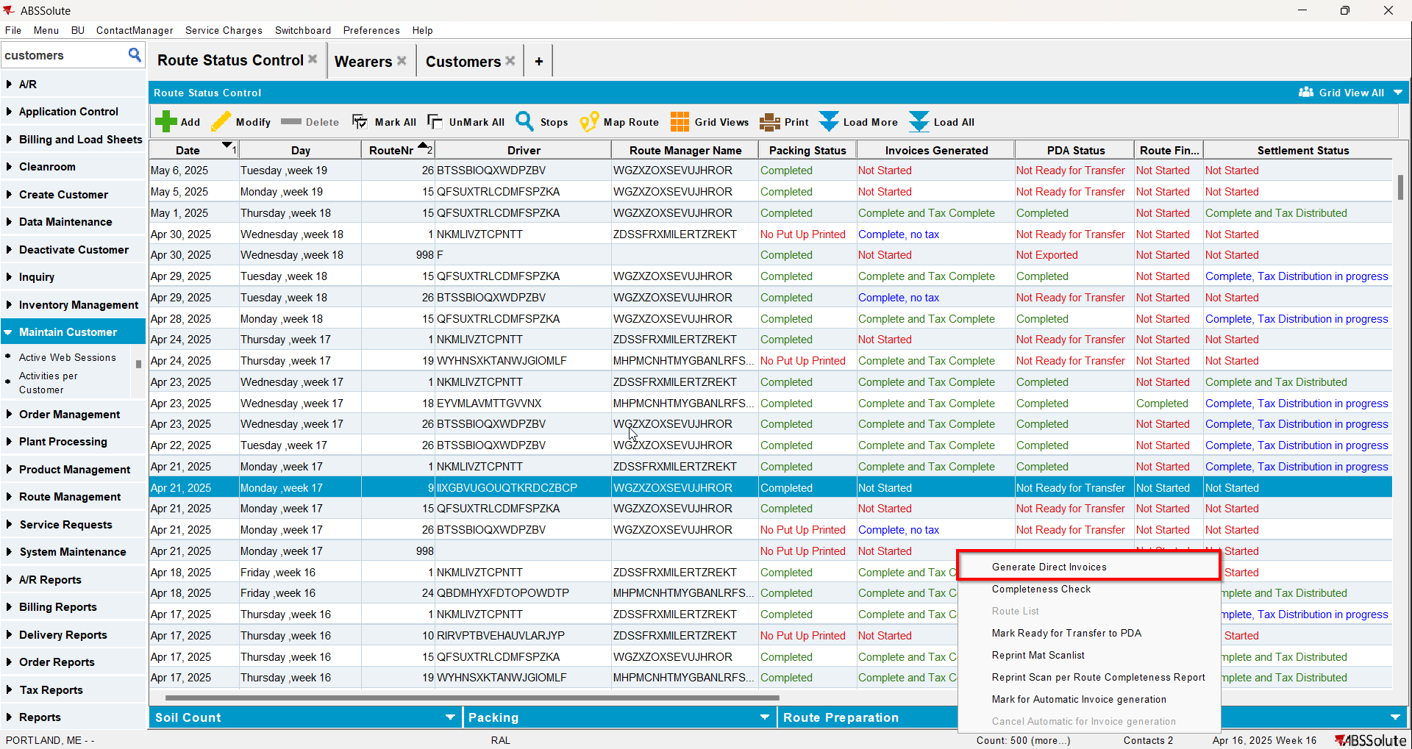
- Mark route ready for transfer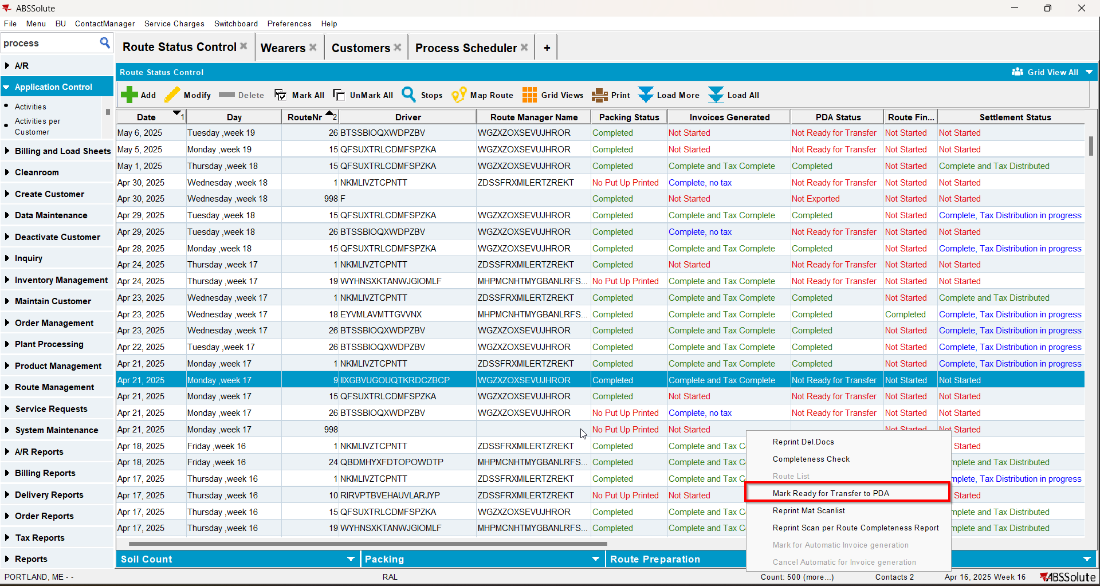
- In RA make the stop undeliverable
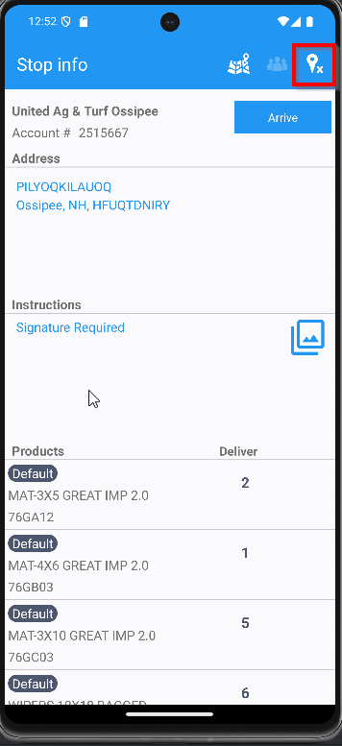
- On WebX move the undeliverable stop to another route(RC2)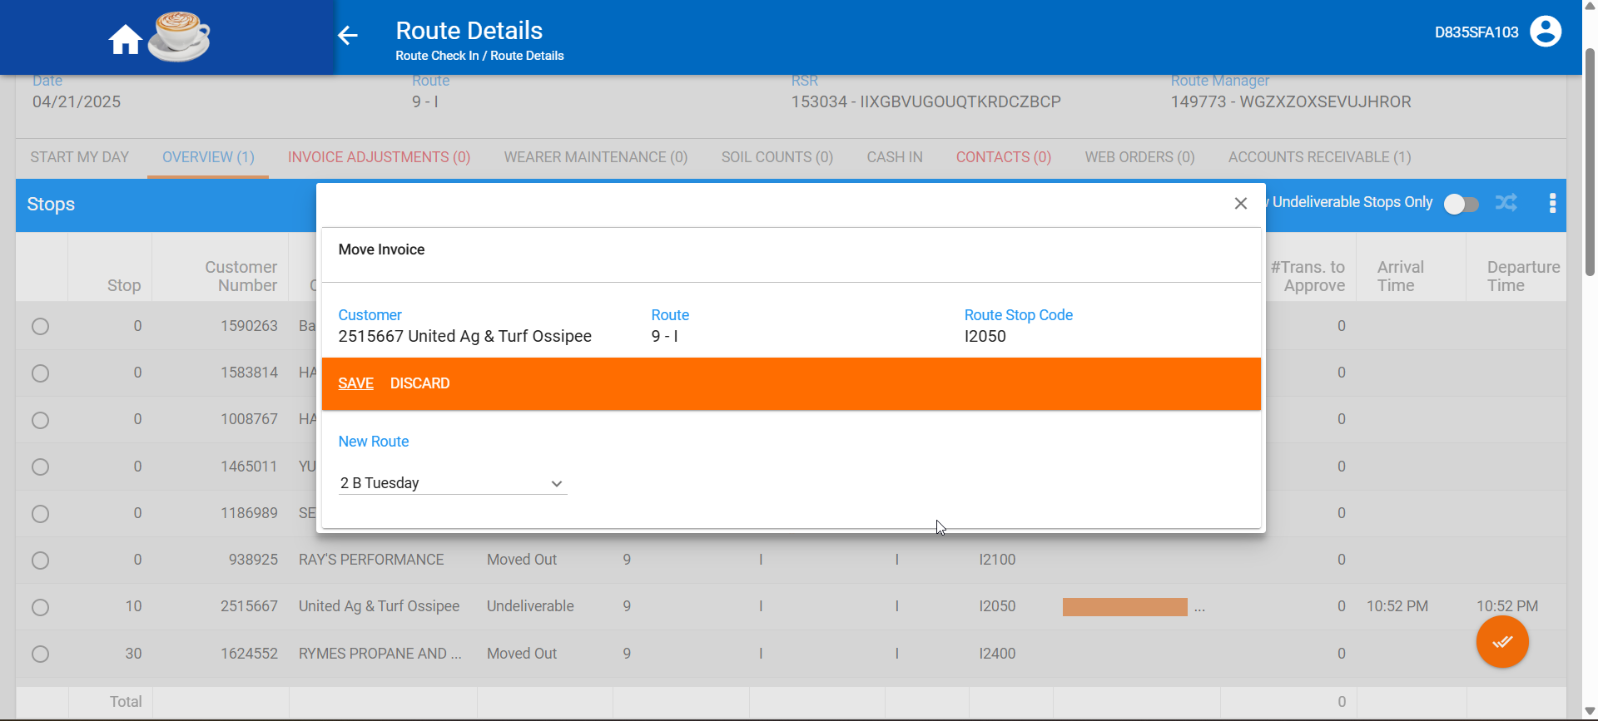
- Settle the route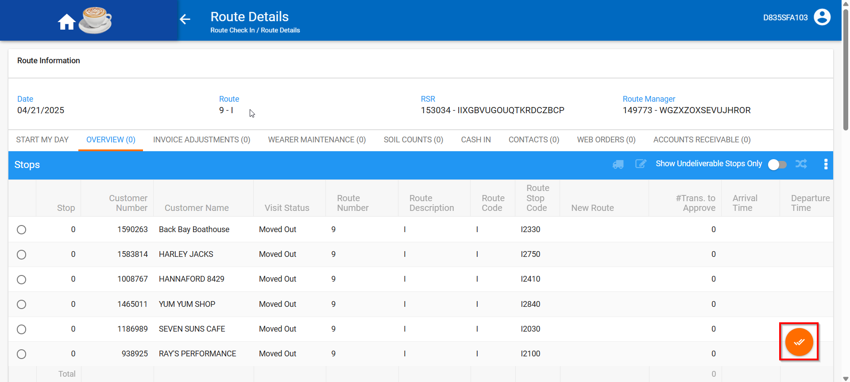
- Move the stop from route RC2 to route RC3 and RC3 is a regular stop for your customer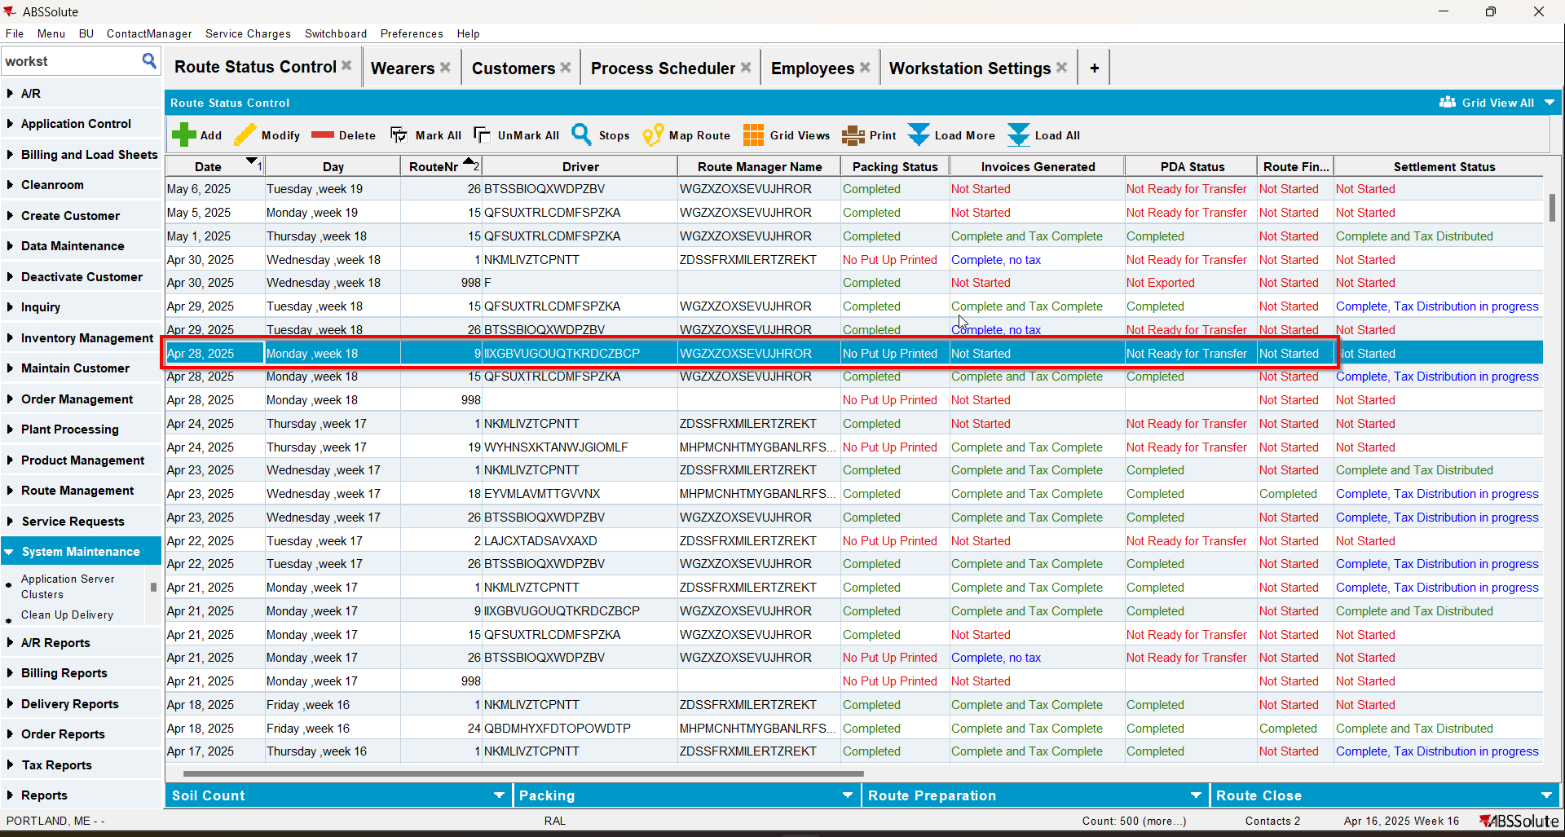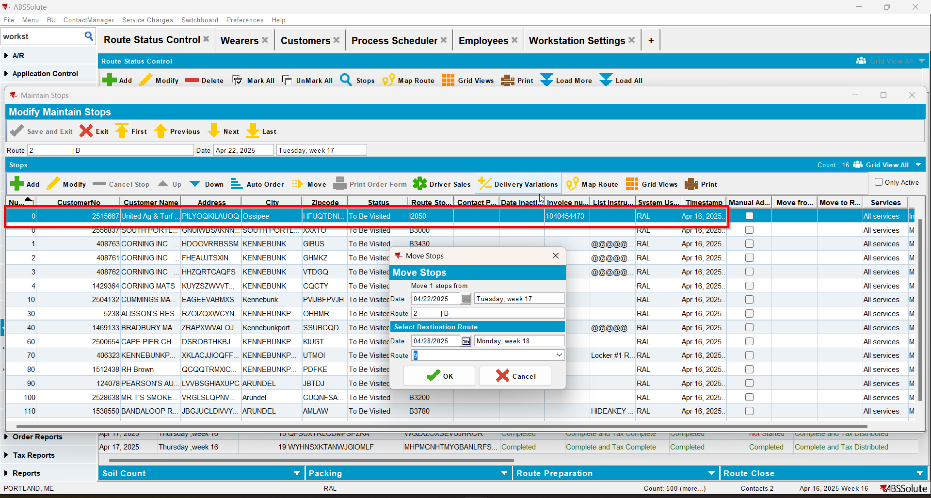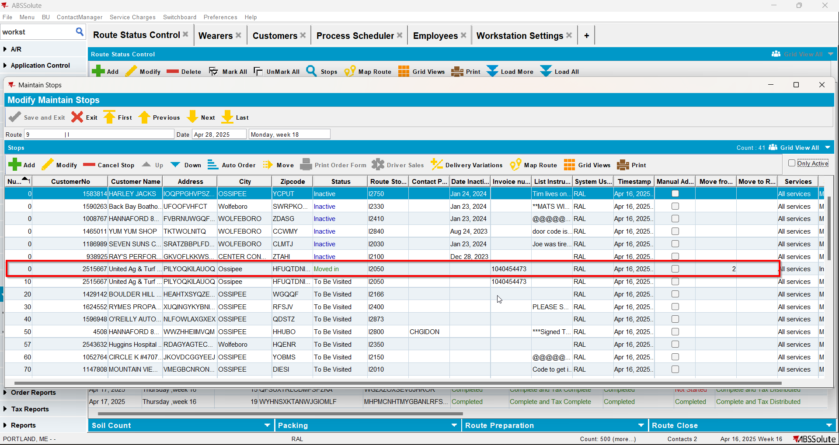

Test Case 2 – Move stop from RC2 to RC3 and RC3 is NOT a regular stop for your customer– Tested OK
Expected behavior: the invoice is assigned to the "moved in" stop.
Hash: c620897
- For a customer add its route(RC1) in RSC 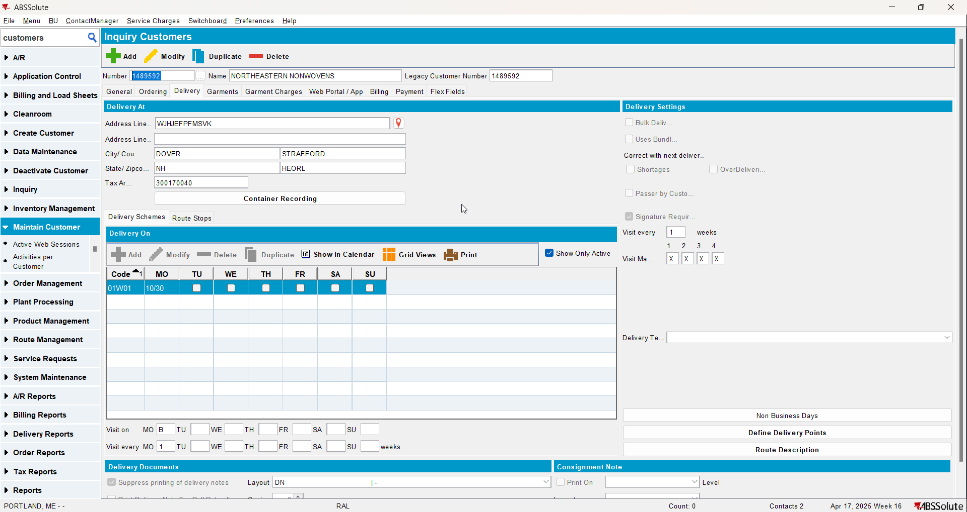
- Generate packing note
- Generate invoices
- Mark route ready for transfer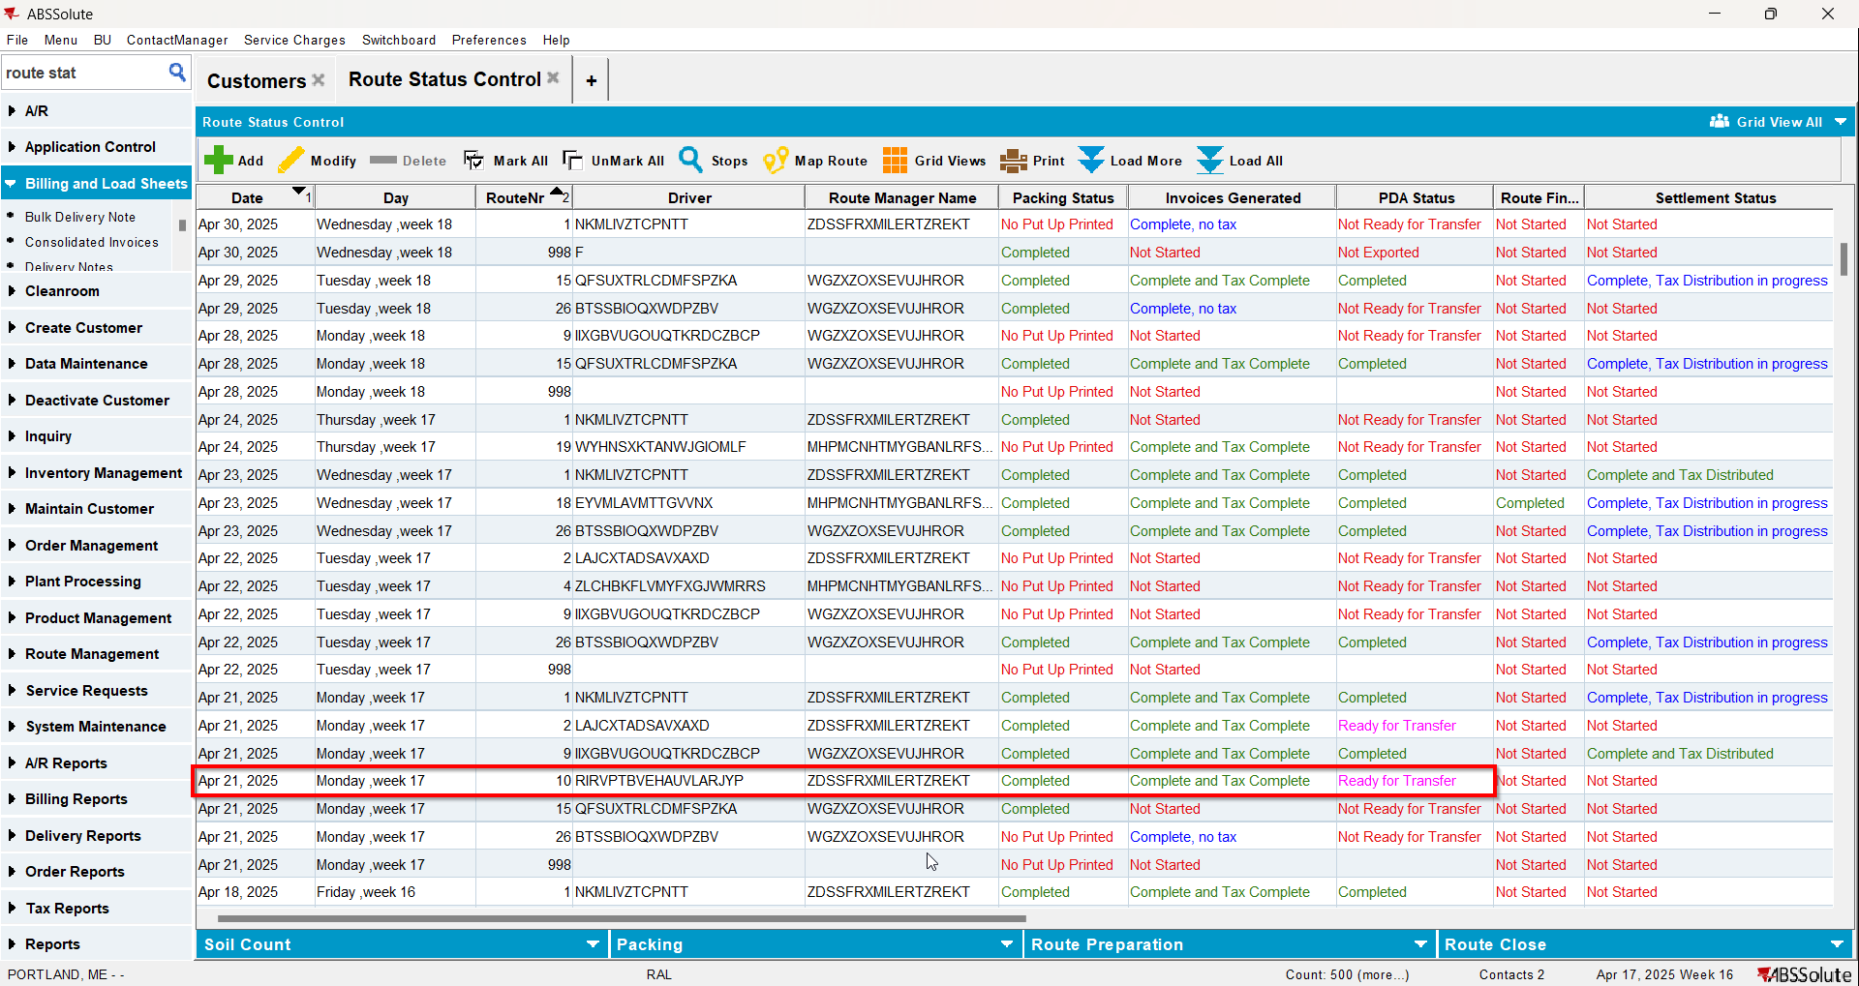
- In RA make the stop undeliverable
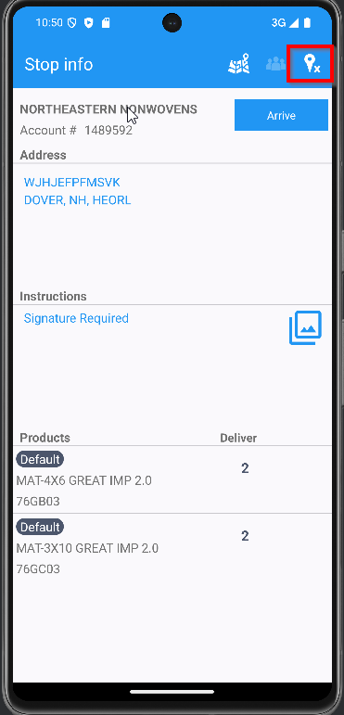
- On WebX move the undeliverable stop to another route(RC2)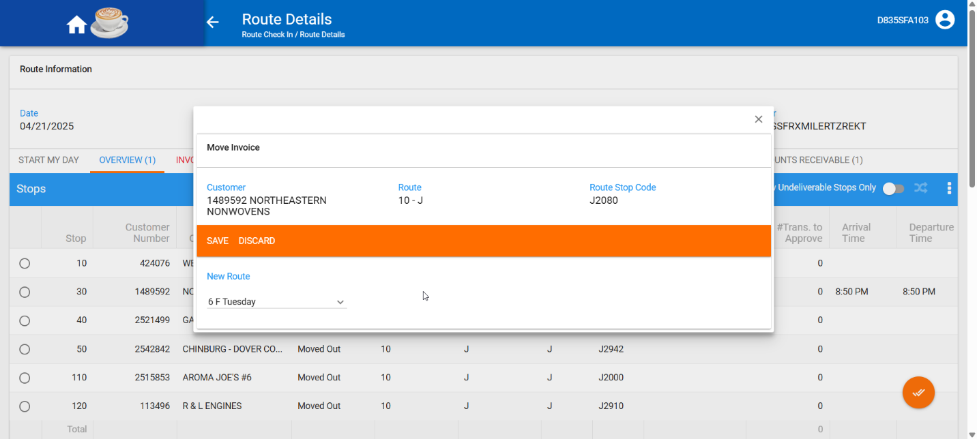
- Settle the route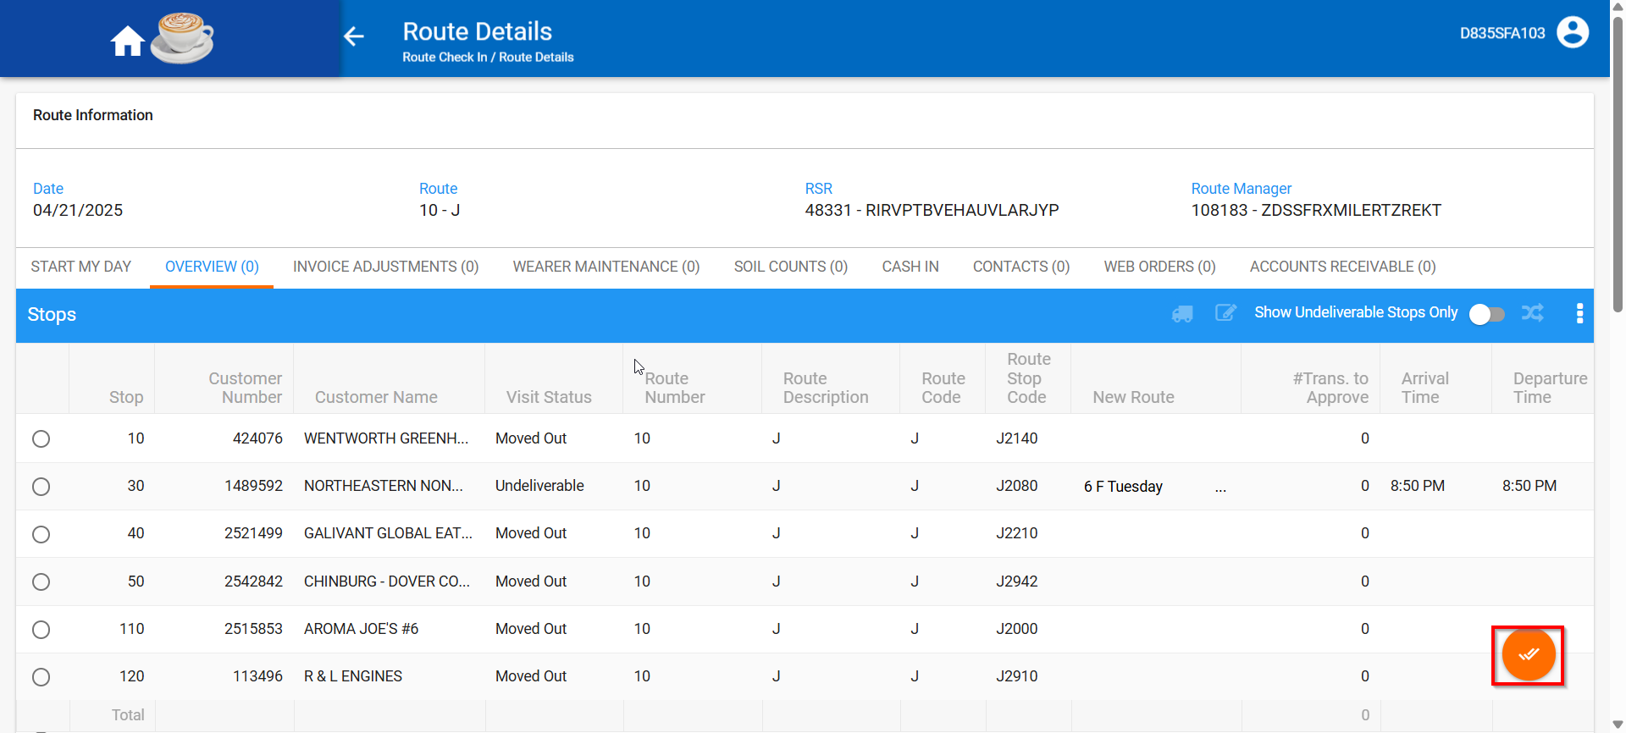
- Move the stop from route RC2 to route RC3 and RC3 is NOT a regular stop for your customer