ABS-170149 D_UBS_2545 Garments not billing for wearer after exchange
Environment | Prerequisites
Version:9.07.00  DBServerName=abs-SRV20.internal.abslbs.com  DBSID=CUST24  DBUser=UNFDEV  DBPassword=UNFDEV  Environment=Test | - Module:  - System setting

Contents
Test after fix 1
Test Case 1 – Cancel replacement order – Tested OK 1

Test after fix

Test Case 1 – Cancel replacement order – Tested OK
Expected behavior: Need to reset REPL_STILLTOBECHARGED to null when the replacement is cancelled and the maximum inventory on wearer inventory A is changed from 0 to the previous value
Hash: c620897
- Have a wearer inventory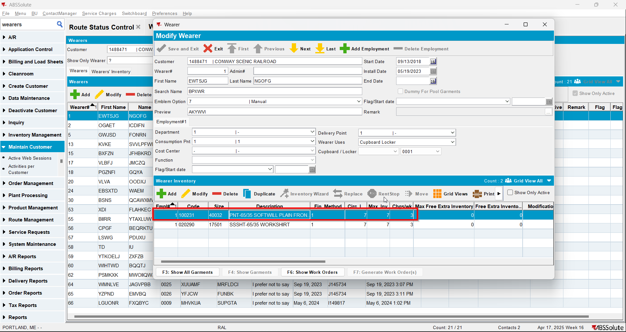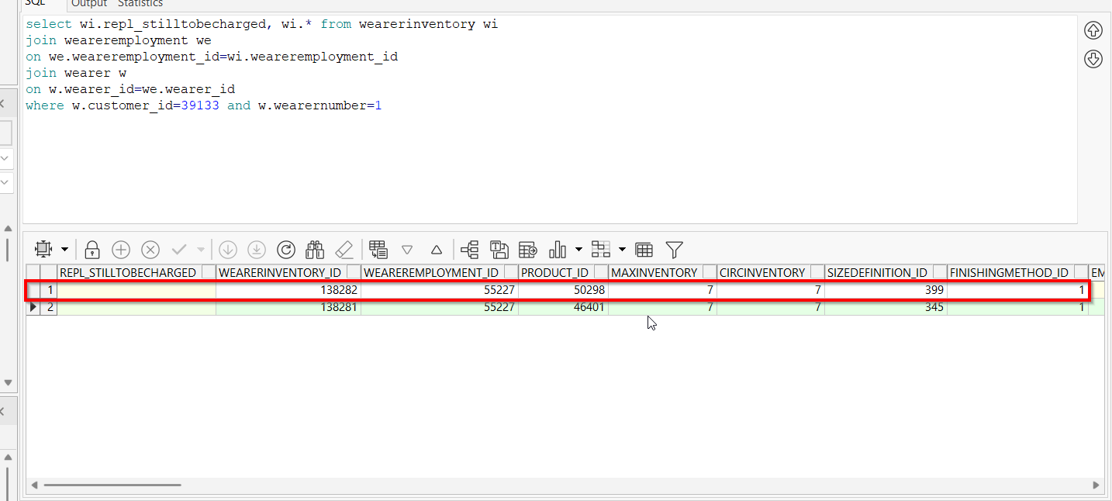
- Replace the wearer inventory with a different product/size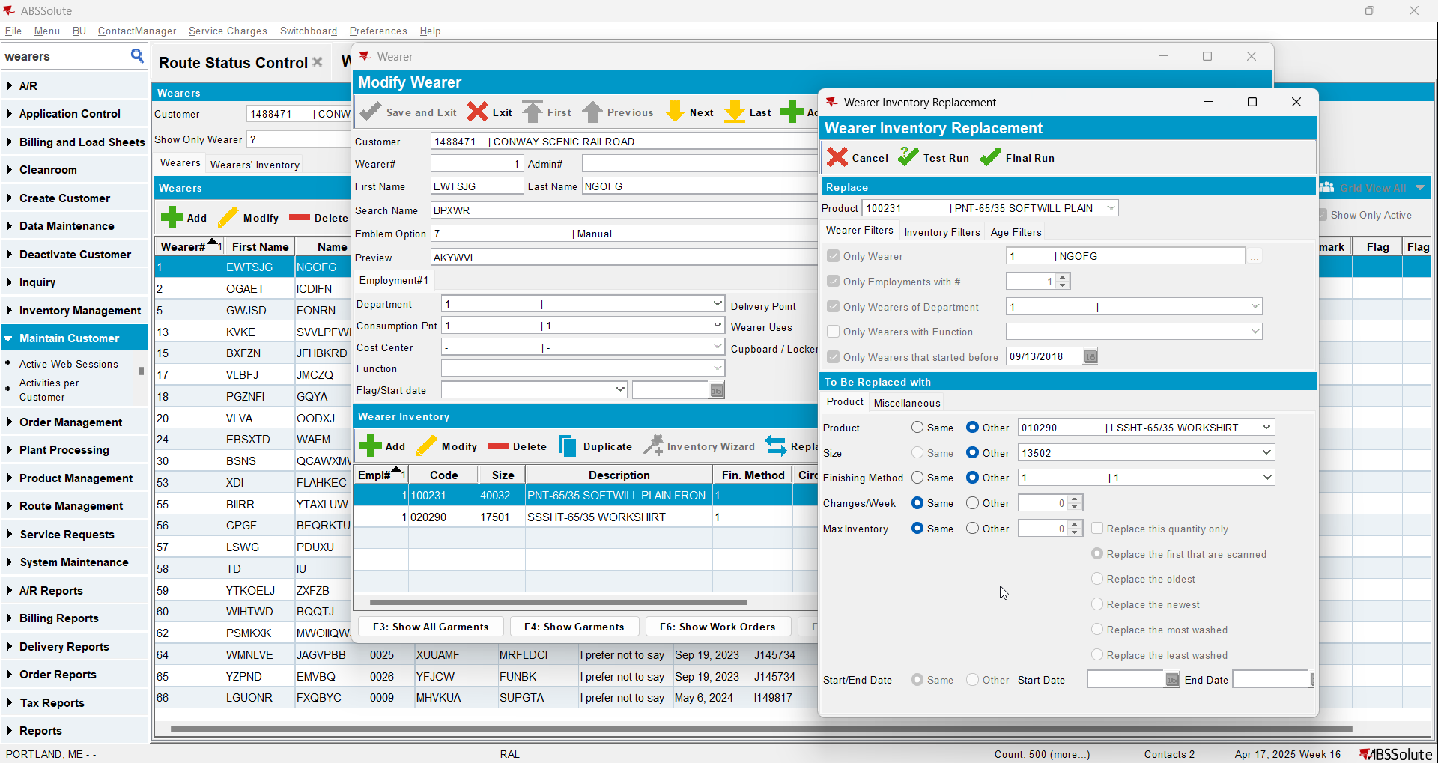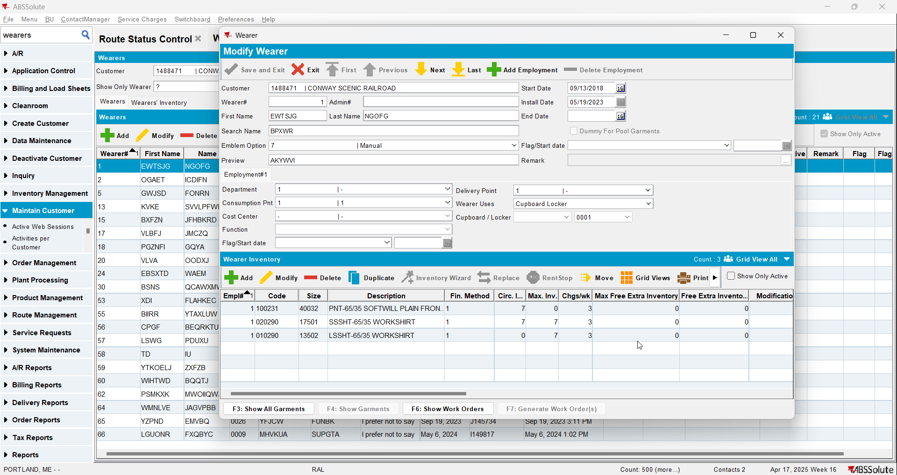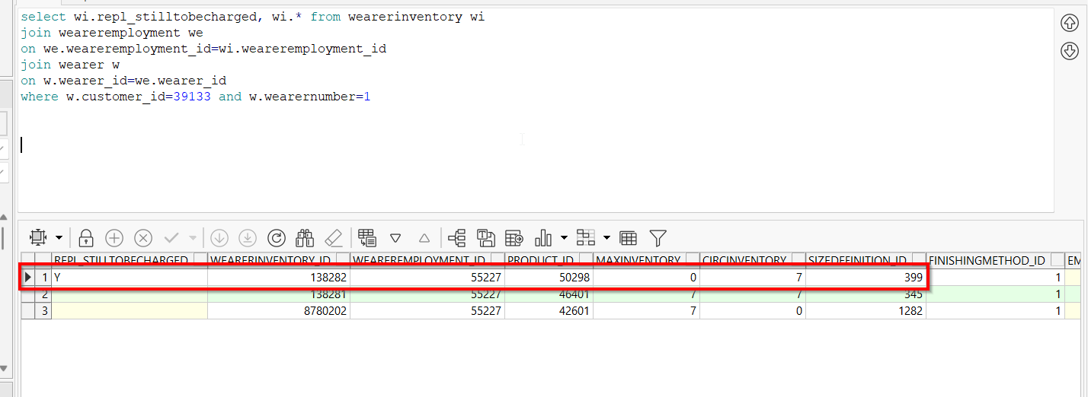
- Cancel replacement order