ABSN-538 - Consolidation of level 3 data for Freedom Pay
Environment | Prerequisites
Version:9.07.00.UNF17  DBServerName=abs-SRV20.internal.abslbs.com  DBSID=CUST24  DBUser= UNFDEV  DBPassword= UNFDEV  Environment=Test | - Module:  - System setting

Contents
Expected behavior: 1
Test Case 1 – Single payment for an Invoice with multiple wearers with the same product with different sizes and budget protection invoice lines 2
Test Steps 2
Test Case 2 – Run Take Electronic Payment process scheduler for multiple invoices for the same bill-to-customer 6
Test Steps 6
Test Case 3 – Process Credit Card Payment for a TRADESALESWEARER Generated Additionally invoice 13
Test Steps 13
Test Case 4 – Process Credit Card Payment for a Manual Invoice 19
Test Steps 19

Expected behavior:
The request has invoice line level XML elements grouped by: productName, productSKU, productCode, productDescription, unitOfMeasure, saleCode, taxIncludedFlag, unitPrice, and commodityCode.
The following XML elements at invoice line level are summed: Quantity, totalAmount, taxAmount, and discountAmount.
section | field | value | Operator
Items.item | productName | InvoiceLine.description - InvoiceLine.invoicelinetype_id.description  truncated to 35 characters | Group by
 | productSKU | InvoiceLine.Code | Group by
 | Quantity | If InvoiceLine.AdjustmentBilledQty >0 then use this else use InvoiceLine.BilledQty | Sum
 | totalAmount | If InvoiceLine.AdjustmentAmount >0 then use this else use invoiceLine.amount | Sum
 | taxAmount | Tax amount for the line from InvoiceLineExtraInfo.TotalTax - only passed if VERTEXTAX module is in the license. | Sum
 | productCode | InvoiceLine.Code | Group by
 | productDescription | InvoiceLine.description - InvoiceLine.invoicelinetype_id.description  truncated to 35 characters (same as productName) | Group by
 | unitOfMeasure | Fixed value of “EA” | Group by
 | saleCode | Fixed value of “S” | Group by
 | taxIncludedFlag | Fixed value of “N” | Group by
 | unitPrice | totalAmount / Quantity (if quantity = 0 then use 1) | Group by
 | discountAmount | 0 | Sum
 | commodityCode | Fixed value of 5137 | Group by

Test Case 1 – Single payment for an Invoice with multiple wearers with the same product with different sizes and budget protection invoice lines
Hash: 9b74610

Test Steps
- Find a customer with at least 2-3 wearers that have rent invoice lines as well as budget protection lines (example: 55755 from BU: 055)
- Make sure your customer has the payment method set as Credit Card and a valid card for the test environment set
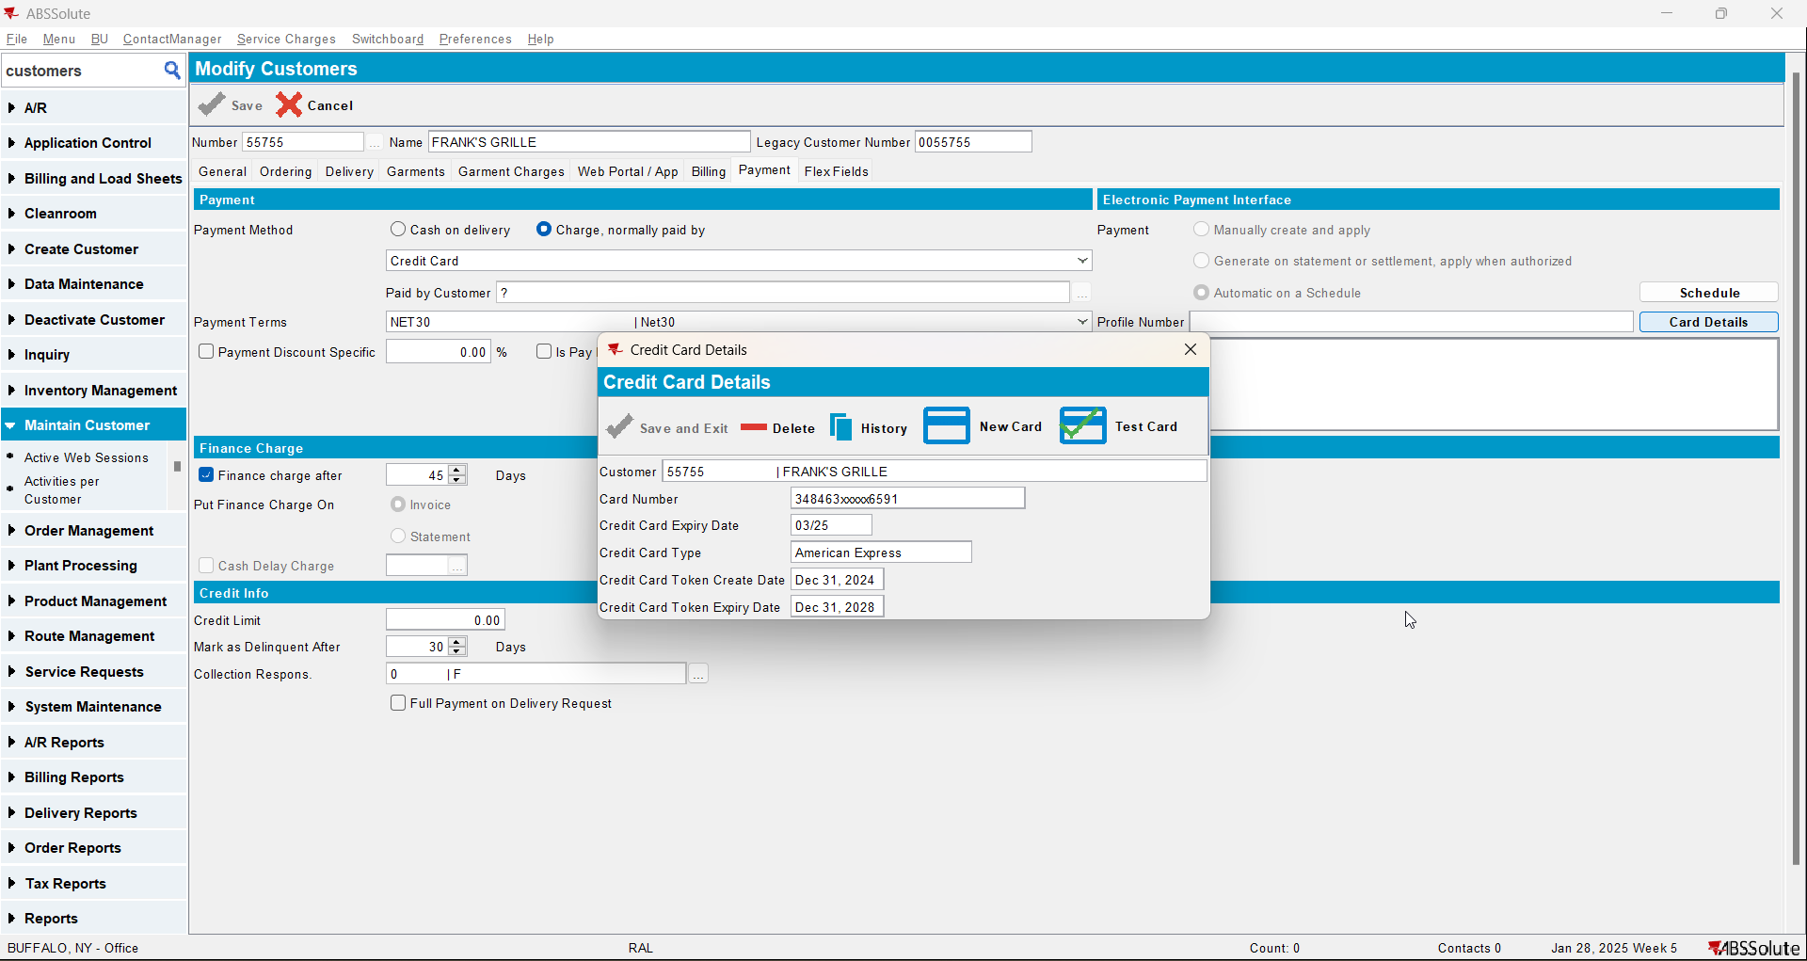
- Generate an invoice that has a past invoice date
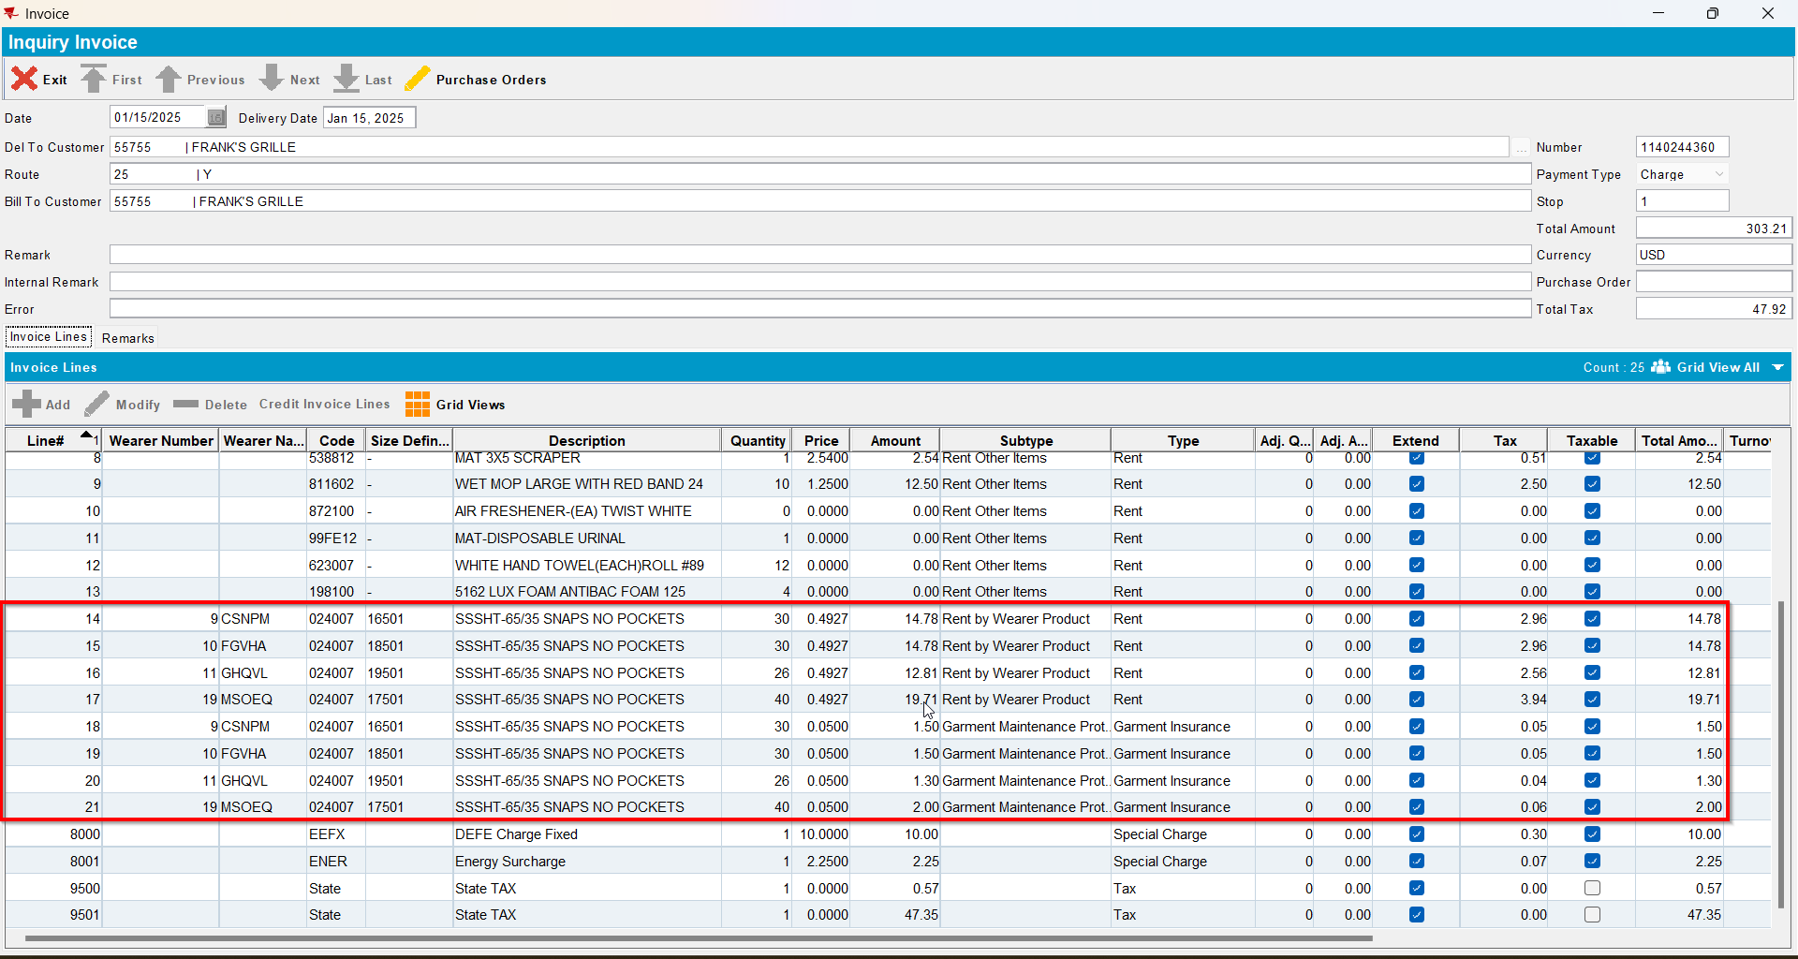
- Settle the route
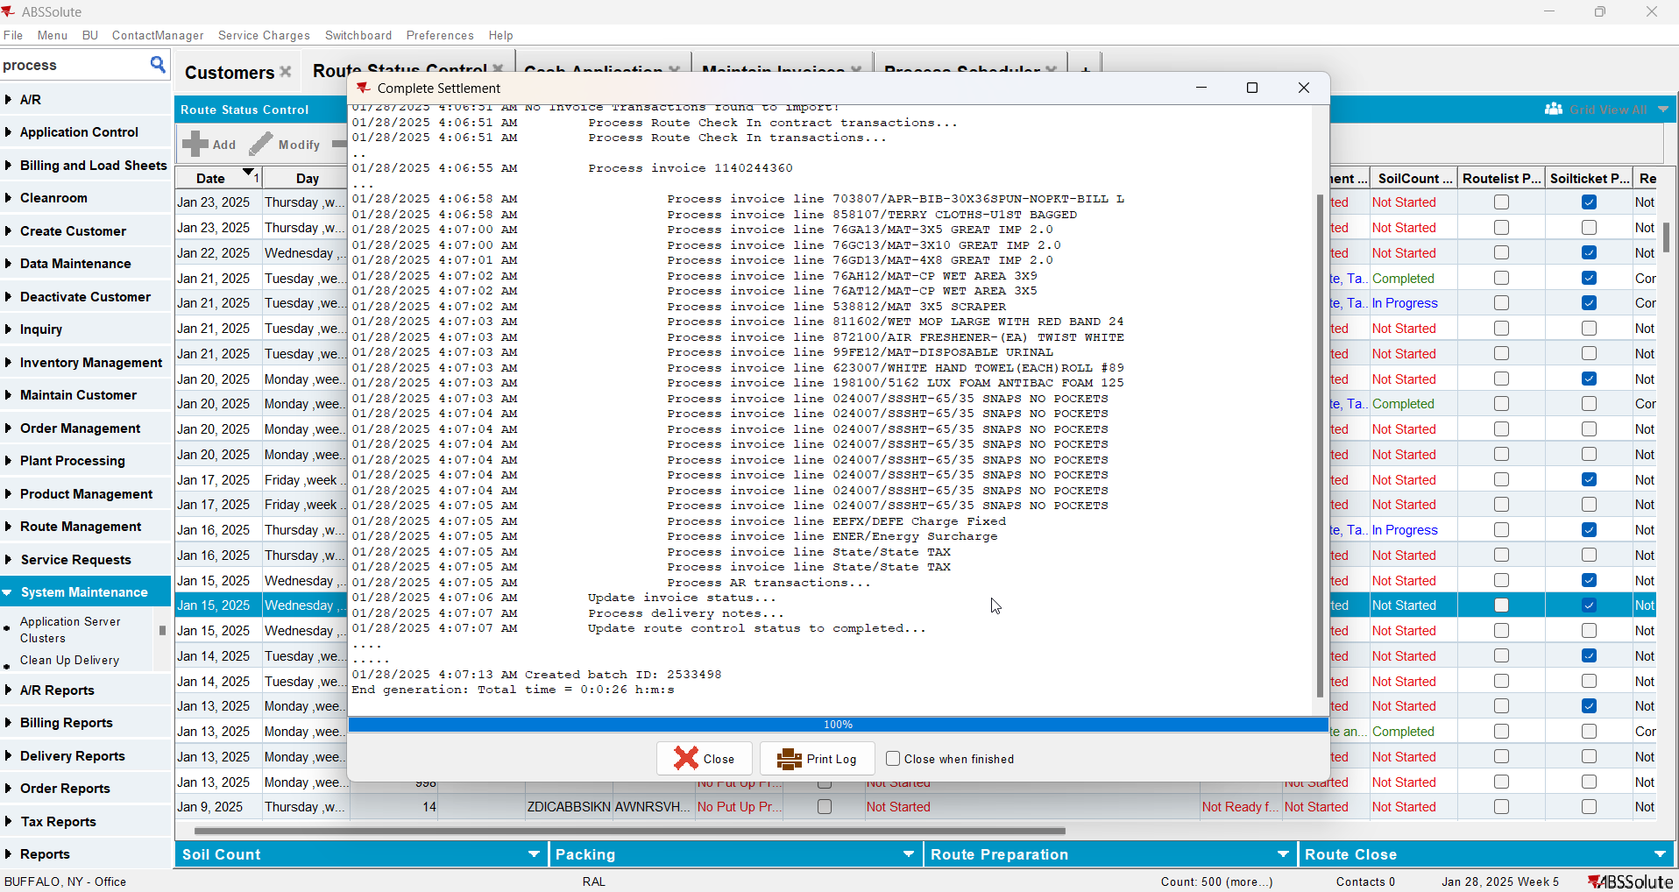
- Script in the BCI data and run the Process Scheduler for Vertex Tax to distribute the tax
- Process Scheduler DLG: Run the “Create Credit Card transactions from payment schedule” process
- Credit Card Transactions DLG: Load Credit Card Transactions and find the credit card transaction for your invoice
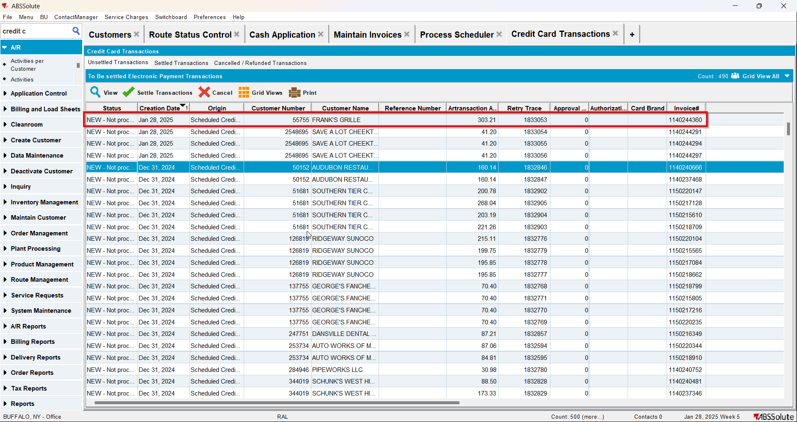
- Credit Card Transactions DLG: Process the payment for this one invoice by pressing the Settle Transaction button
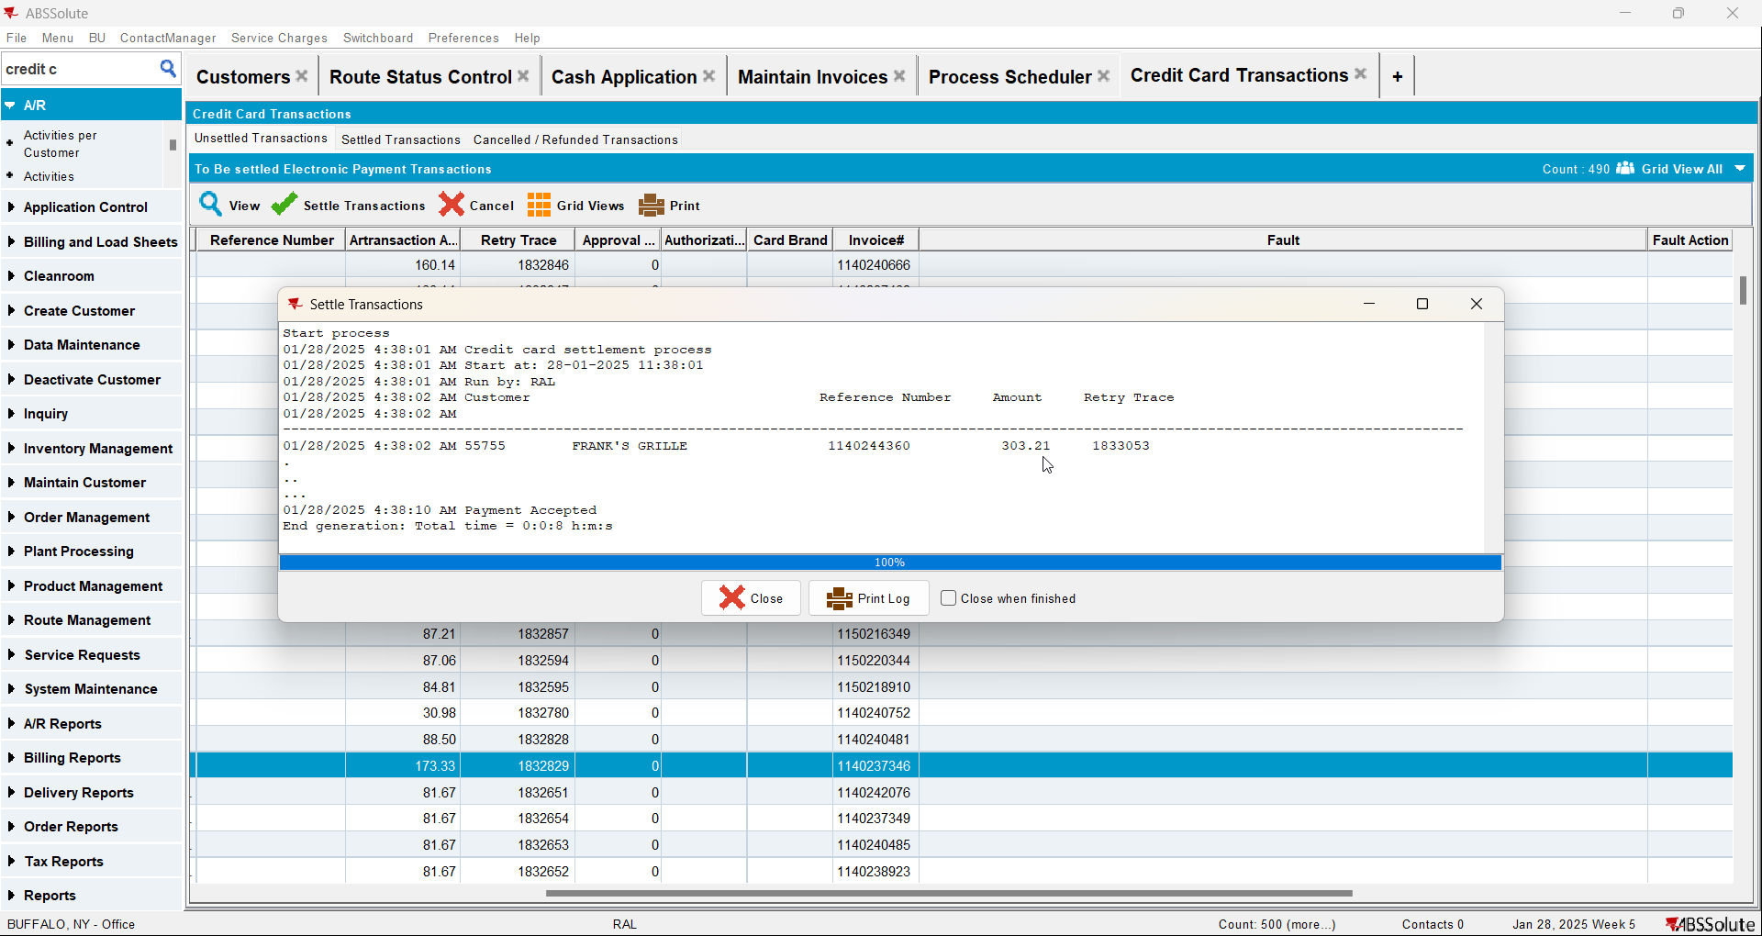
- Find the XML Request body in the WebServiceLog table using this querry:
SELECT *
FROM WEBSERVICELOG WSL
WHERE WSL.MESSAGEID =
(SELECT TO_CHAR(CCT.CREDITCARDTRANSACTION_ID)
FROM CREDITCARDTRANSACTION CCT
JOIN INVOICEHEADER IH
ON IH.INVOICEHEADER_ID = CCT.INVOICEHEADER_ID
WHERE IH.INVOICENUMBER = 1140244360)
AND WSL.APPLICATION = 'SOAP'
AND WSL.TRANSACTIONTYPE = 'REQUEST';
- Compare the results with the select below that sums up the Quantity, totalAmount, taxAmount and calculates the unitprice
SELECT
IH.INVOICENUMBER,
IL.DESCRIPTION || ' - ' || ILT.FACTORYDESCRIPTION AS productName_productDescription,
IL.CODE AS productSKU_productCode,
SUM(CASE
WHEN IL.AdjustmentBilledQty > 0 THEN IL.AdjustmentBilledQty
ELSE IL.BilledQty
END) AS QTY,
SUM(CASE
WHEN IL.AdjustedAmount > 0 THEN IL.AdjustedAmount
ELSE IL.Amount
END) AS TOTALAMOUNT,
SUM(ILEI.TOTALTAX) AS TOTALTAX,
SUM(CASE
WHEN IL.ADJUSTEDAMOUNT > 0 THEN IL.ADJUSTEDAMOUNT
ELSE IL.Amount
END) / CASE
WHEN SUM(IL.BilledQty) = 0 THEN 1
ELSE SUM(IL.BilledQty)
END AS UNITPRICE
FROM
INVOICELINE IL
JOIN
INVOICEHEADER IH ON IH.INVOICEHEADER_ID = IL.INVOICEHEADER_ID
JOIN
INVOICELINEEXTRAINFO ILEI ON ILEI.INVOICELINE_ID = IL.INVOICELINE_ID
JOIN
INVOICELINETYPE ILT ON IL.INVOICELINETYPE_ID = ILT.INVOICELINETYPE_ID
WHERE IH.INVOICENUMBER = 1140244360
GROUP BY
IH.INVOICENUMBER,
IL.DESCRIPTION || ' - ' || ILT.FACTORYDESCRIPTION,
IL.CODE;

PRODUCTNAME_PRODUCTDESCRIPTION | PRODUCTSKU_PRODUCTCODE | QTY |  | TOTALAMOUNT | TOTALTAX | UNITPRICE
MAT-3X10 GREAT IMP 2.0 - Rent | 76GC13 |  | 2.00 | 11.38 | 2.28 | 5.69
MAT-3X5 GREAT IMP 2.0 - Rent | 76GA13 |  | 7.00 | 29.82 | 5.96 | 4.26
SSSHT-65/35 SNAPS NO POCKETS - Rent | 024007 |  | 126.00 | 62.08 | 12.42 | 0.49
5162 LUX FOAM ANTIBAC FOAM 125 - Rent | 198100 |  | 4.00 | 0.00 | 0.00 | 0.00
SSSHT-65/35 SNAPS NO POCKETS - Garment Insurance | 024007 |  | 126.00 | 6.30 | 0.22 | 0.05
Energy Surcharge - Special Charge | ENER |  | 1.00 | 2.25 | 0.08 | 2.25
AIR FRESHENER-(EA) TWIST WHITE - Rent | 872100 |  | 0.00 | 0.00 | 0.00 | 0.00
WET MOP LARGE WITH RED BAND 24 - Rent | 811602 |  | 10.00 | 12.50 | 2.50 | 1.25
WHITE HAND TOWEL(EACH)ROLL #89 - Rent | 623007 |  | 12.00 | 0.00 | 0.00 | 0.00
DEFE Charge Fixed - Special Charge | EEFX |  | 1.00 | 10.00 | 0.30 | 10.00
TERRY CLOTHS-U1ST BAGGED - Rent | 858107 |  | 350.00 | 70.00 | 14.00 | 0.20
MAT-4X8 GREAT IMP 2.0 - Rent | 76GD13 |  | 2.00 | 14.22 | 2.84 | 7.11
MAT-CP WET AREA 3X9 - Rent | 76AH12 |  | 4.00 | 19.36 | 3.88 | 4.84
MAT 3X5 SCRAPER - Rent | 538812 |  | 1.00 | 2.54 | 0.52 | 2.54
APR-BIB-30X36SPUN-NOPKT-BILL L - Rent | 703807 |  | 40.00 | 10.00 | 2.00 | 0.25
MAT-CP WET AREA 3X5 - Rent | 76AT12 |  | 1.00 | 4.84 | 0.98 | 4.84
MAT-DISPOSABLE URINAL - Rent | 99FE12 |  | 1.00 | 0.00 | 0.00 | 0.00

Test Case 2 – Run Take Electronic Payment process scheduler for multiple invoices for the same bill-to-customer
Hash: 9b74610

Test Steps
- Find a customer with at least 4 invoices being paid on a single bill-to.
SELECT BILLTO.CUSTOMERNUMBER, CREDIT_AR.ARTRANSACTION_ID, COUNT(DEBIT_AR.ARTRANSACTION_ID), COUNT(DISTINCT IH.DELTOCUSTOMER_LINK_ID) FROM CREDITCARDTRANSACTION CCT
JOIN ARTRANSACTION CREDIT_AR ON CCT.Artransaction_Id = CREDIT_AR.ARTRANSACTION_ID
JOIN INVOICEHEADER IH ON IH.INVOICEHEADER_ID = CCT.INVOICEHEADER_ID
JOIN ARTRANSACTION DEBIT_AR ON DEBIT_AR.ARTRANSACTION_ID = IH.INVOICEHEADER_ID
JOIN CUSTOMER BILLTO ON BILLTO.CUSTOMER_ID = IH.BILLTOCUSTOMER_LINK_ID
WHERE CCT.STATUS = 2
AND BILLTO.ACTIVE = 'Y'
AND BILLTO.DATEINACTIVE > SYSDATE
AND CREDIT_AR.ARTRANSACTIONDATE > TO_DATE('01/01/2023', 'dd/mm/yyyy')
GROUP BY BILLTO.CUSTOMERNUMBER, CREDIT_AR.ARTRANSACTION_ID
HAVING COUNT(DEBIT_AR.ARTRANSACTION_ID) > 4
ORDER BY COUNT(DISTINCT IH.DELTOCUSTOMER_LINK_ID) DESC;
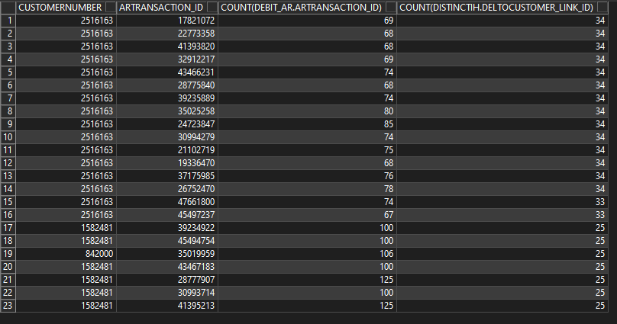
- Find a customer with at least 4 invoices being paid on a single bill-to.
- Set a valid credit card for the customer
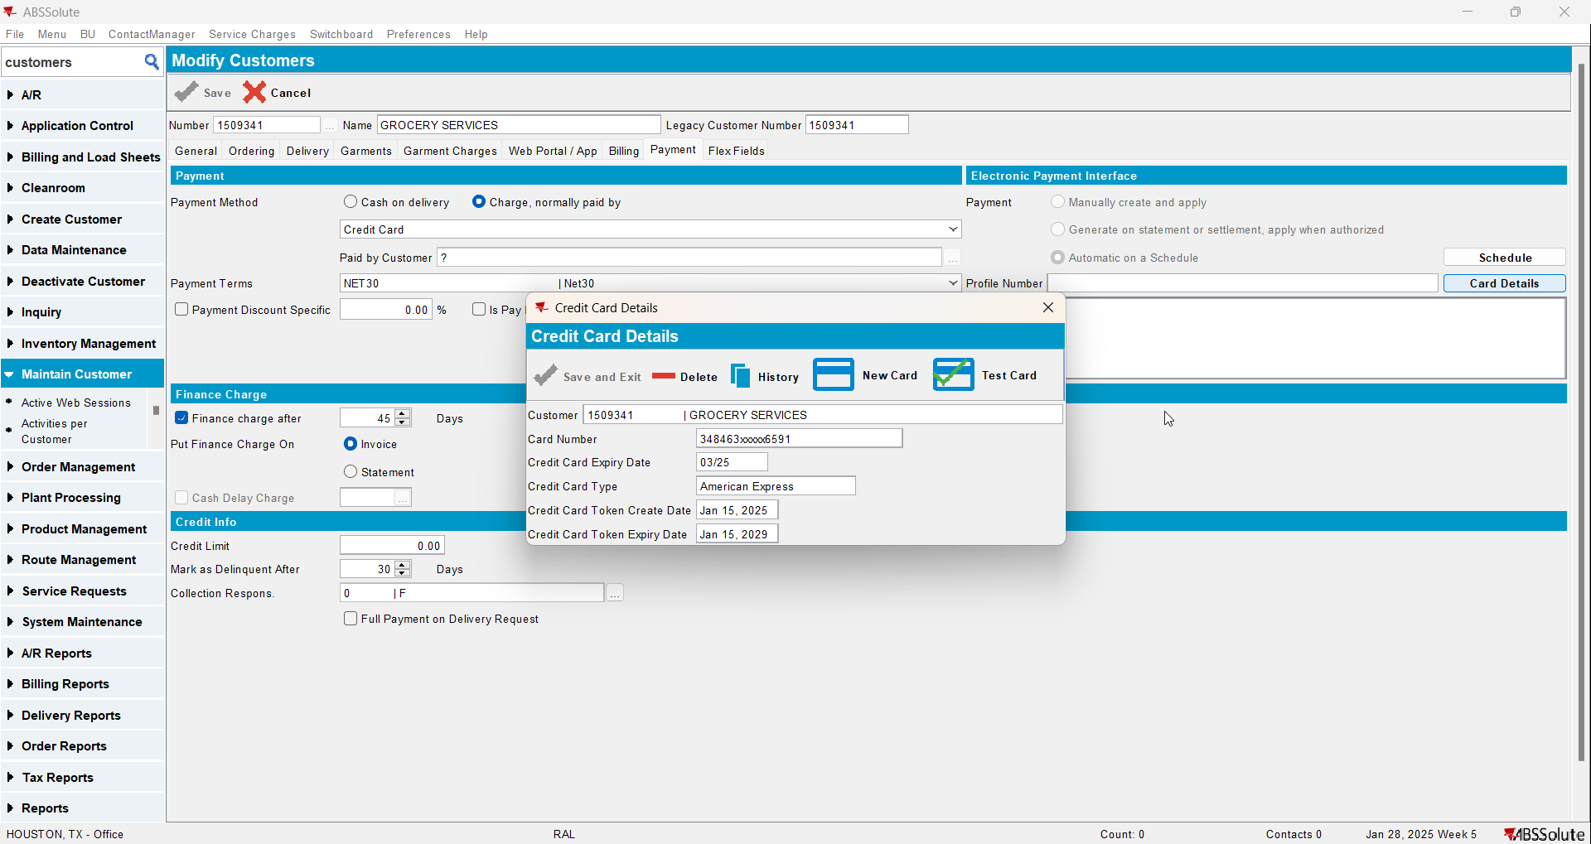
- Cash Application: Load that customer and find one of the payments with a lot of invoices in a single payment
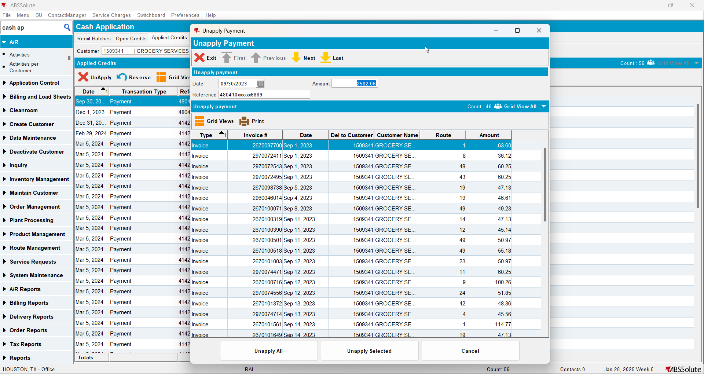
- Cash Application DLG: Un-apply the cash
- Credit Card Transactions DLG: Check for them in the Unsettled Transactions tab
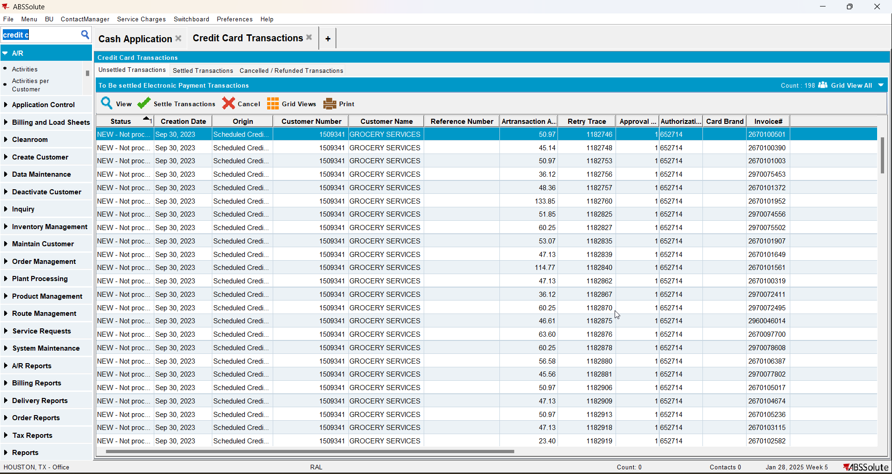
- Get the list of InvoiceNumbers as an expression list like so:
SELECT IH.INVOICENUMBER FROM INVOICEHEADER IH
JOIN ARTRANSACTION AR ON AR.INVOICEHEADER_ID = IH.INVOICEHEADER_ID
JOIN CUSTOMER C ON C.CUSTOMER_ID = IH.BILLTOCUSTOMER_LINK_ID
WHERE C.CUSTOMERNUMBER = 1509341
AND IH.STATUS_ID = 2
AND EXISTS (SELECT 1 FROM CREDITCARDTRANSACTION CCT
WHERE CCT.INVOICEHEADER_ID = IH.INVOICEHEADER_ID
AND CCT.STATUS = 0)
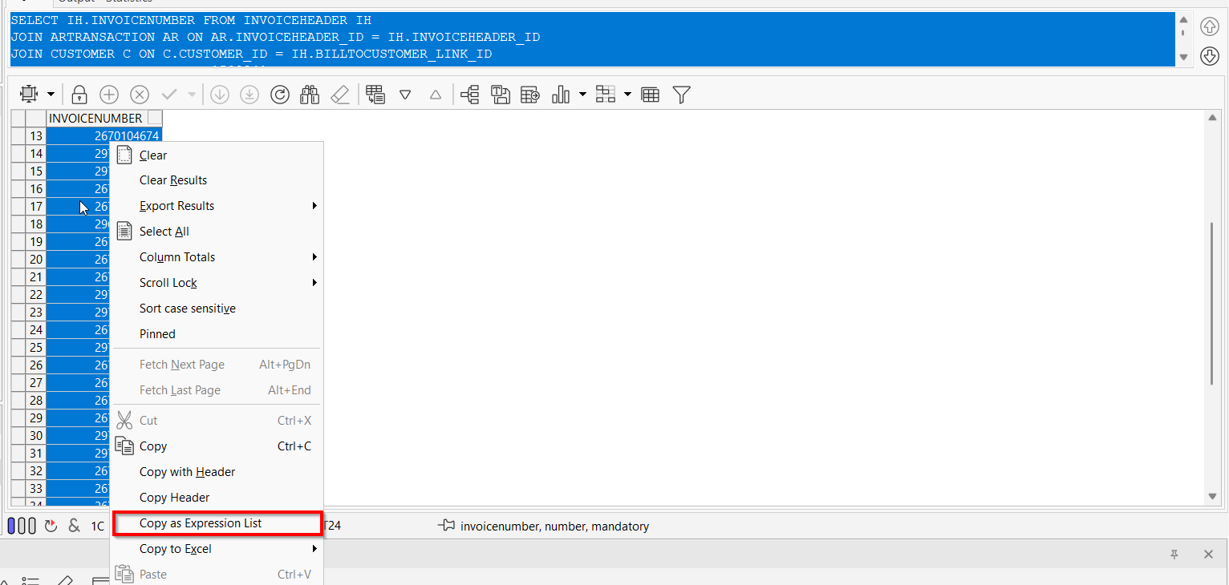
- Use the expression list in the following select to give you the number of elements and the specific quantities we should see in the REQUEST XML
SELECT IH.INVOICENUMBER,
IL.DESCRIPTION || ' - ' || ILT.FACTORYDESCRIPTION AS productName_productDescription,
IL.CODE AS productSKU_productCode,
SUM(CASE
WHEN IL.AdjustmentBilledQty > 0 THEN
IL.AdjustmentBilledQty
ELSE
IL.BilledQty
END) AS QTY,
SUM(CASE
WHEN IL.AdjustedAmount > 0 THEN
IL.AdjustedAmount
ELSE
IL.Amount
END) AS TOTALAMOUNT,
SUM(ILEI.TOTALTAX) AS TOTALTAX,
SUM(CASE
WHEN IL.ADJUSTEDAMOUNT > 0 THEN
IL.ADJUSTEDAMOUNT
ELSE
IL.Amount
END) / CASE
WHEN SUM(IL.BilledQty) = 0 THEN
1
ELSE
SUM(IL.BilledQty)
END AS UNITPRICE
FROM INVOICELINE IL
JOIN INVOICEHEADER IH
ON IH.INVOICEHEADER_ID = IL.INVOICEHEADER_ID
JOIN INVOICELINEEXTRAINFO ILEI
ON ILEI.INVOICELINE_ID = IL.INVOICELINE_ID
JOIN INVOICELINETYPE ILT
ON IL.INVOICELINETYPE_ID = ILT.INVOICELINETYPE_ID
WHERE IH.invoicenumber (2970078584, 2970078389, 2970078608, 2970078680, 2670106387, 2970077802, 2670106070, 2670106138, 2670106187, 2670105296, 2670105017, 2670105034, 2670104674, 2970077543, 2970077620, 2670105236, 2670105922, 2960047985, 2670103115, 2670102582, 2670104411, 2970075453, 2970075502, 2670101003, 2970074471, 2670100071, 2670101372, 2670100716, 2670101952, 2970074556, 2970075569, 2670100501, 2670100518, 2670100390, 2670101907, 2970074714, 2670101649, 2670101561, 2970075283, 2670100319, 2670097700, 2960046014, 2670098738, 2970072543, 2970072411, 2970072495)
GROUP BY IH.INVOICENUMBER,
IL.DESCRIPTION || ' - ' || ILT.FACTORYDESCRIPTION,
IL.CODE;
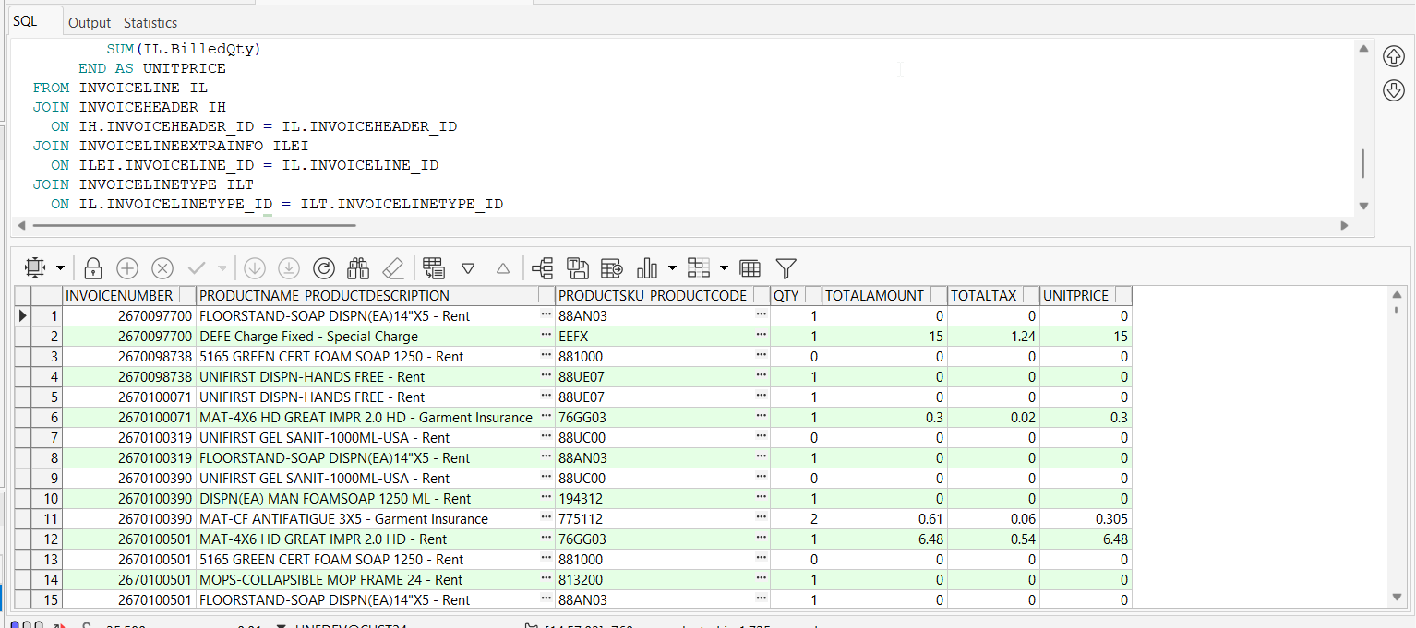
- Run the process scheduler for Take Electronic Payment
- Run the select and export the results
SELECT IH.INVOICENUMBER,
IL.DESCRIPTION || ' - ' || ILT.FACTORYDESCRIPTION AS productName_productDescription,
IL.CODE AS productSKU_productCode,
SUM(CASE
WHEN IL.AdjustmentBilledQty > 0 THEN
IL.AdjustmentBilledQty
ELSE
IL.BilledQty
END) AS QTY,
SUM(CASE
WHEN IL.AdjustedAmount > 0 THEN
IL.AdjustedAmount
ELSE
IL.Amount
END) AS TOTALAMOUNT,
SUM(ILEI.TOTALTAX) AS TOTALTAX,
SUM(CASE
WHEN IL.ADJUSTEDAMOUNT > 0 THEN
IL.ADJUSTEDAMOUNT
ELSE
IL.Amount
END) / CASE
WHEN SUM(IL.BilledQty) = 0 THEN
1
ELSE
SUM(IL.BilledQty)
END AS UNITPRICE
FROM INVOICELINE IL
JOIN INVOICEHEADER IH
ON IH.INVOICEHEADER_ID = IL.INVOICEHEADER_ID
JOIN INVOICELINEEXTRAINFO ILEI
ON ILEI.INVOICELINE_ID = IL.INVOICELINE_ID
JOIN INVOICELINETYPE ILT
ON IL.INVOICELINETYPE_ID = ILT.INVOICELINETYPE_ID
WHERE IH.invoicenumber in (2970078584, 2970078389, 2970078608, 2970078680, 2670106387, 2970077802, 2670106070, 2670106138, 2670106187, 2670105296, 2670105017, 2670105034, 2670104674, 2970077543, 2970077620, 2670105236, 2670105922, 2960047985, 2670103115, 2670102582, 2670104411, 2970075453, 2970075502, 2670101003, 2970074471, 2670100071, 2670101372, 2670100716, 2670101952, 2970074556, 2970075569, 2670100501, 2670100518, 2670100390, 2670101907, 2970074714, 2670101649, 2670101561, 2970075283, 2670100319, 2670097700, 2960046014, 2670098738, 2970072543, 2970072411, 2970072495)
GROUP BY IH.INVOICENUMBER,
IL.DESCRIPTION || ' - ' || ILT.FACTORYDESCRIPTION,
IL.CODE;
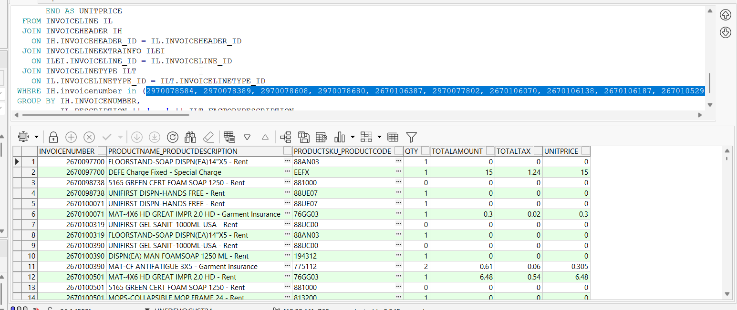
Export the results in an xlsx file attached here:
- Find the REQUEST xml via the following SELECT:
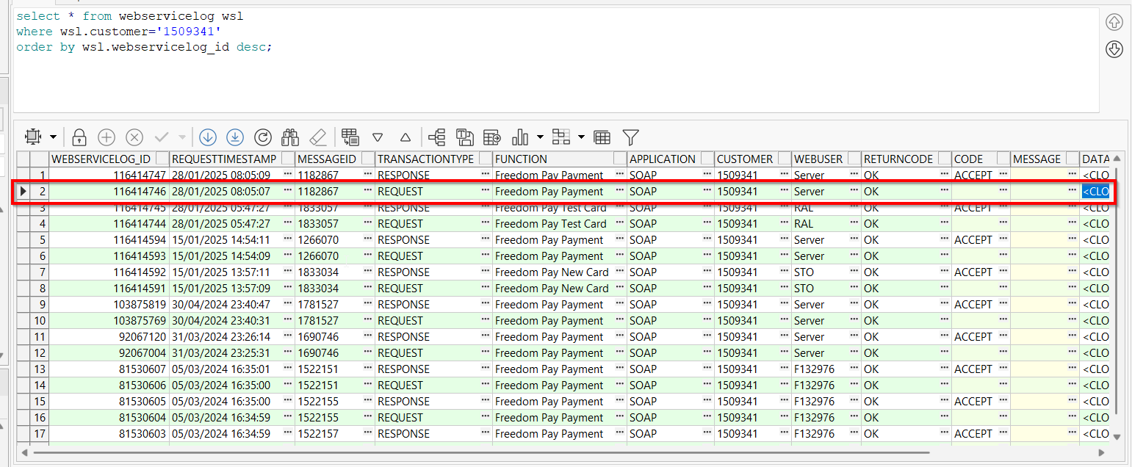
- Process the CLOB saved as an XML into a CSV file by using an AI tool such as the MS Copilot provided by ABS by uploading the xml file and giving the following prompts:

Parse the xml file and output a csv or xls file with all values in the <item> elements, so the columns should be named discountAmount, taxIncludedFlag, productCode, productSKU, productName, productDescription, commodityCode, unitPrice, quantity, totalAmount, taxAmount, unitOfMeasure, saleCode and custom1
- Compare the two excel file results and make sure the values are identical
TESTED OK

Test Case 3 – Process Credit Card Payment for a TRADESALESWEARER Generated Additionally invoice
Hash: 9b74610

Test Steps
- Maintain Sales Notes DLG: Add a sales note with Sales Wearers enabled
- Maintain Sales Notes DLG: Add an ordered item line with emblems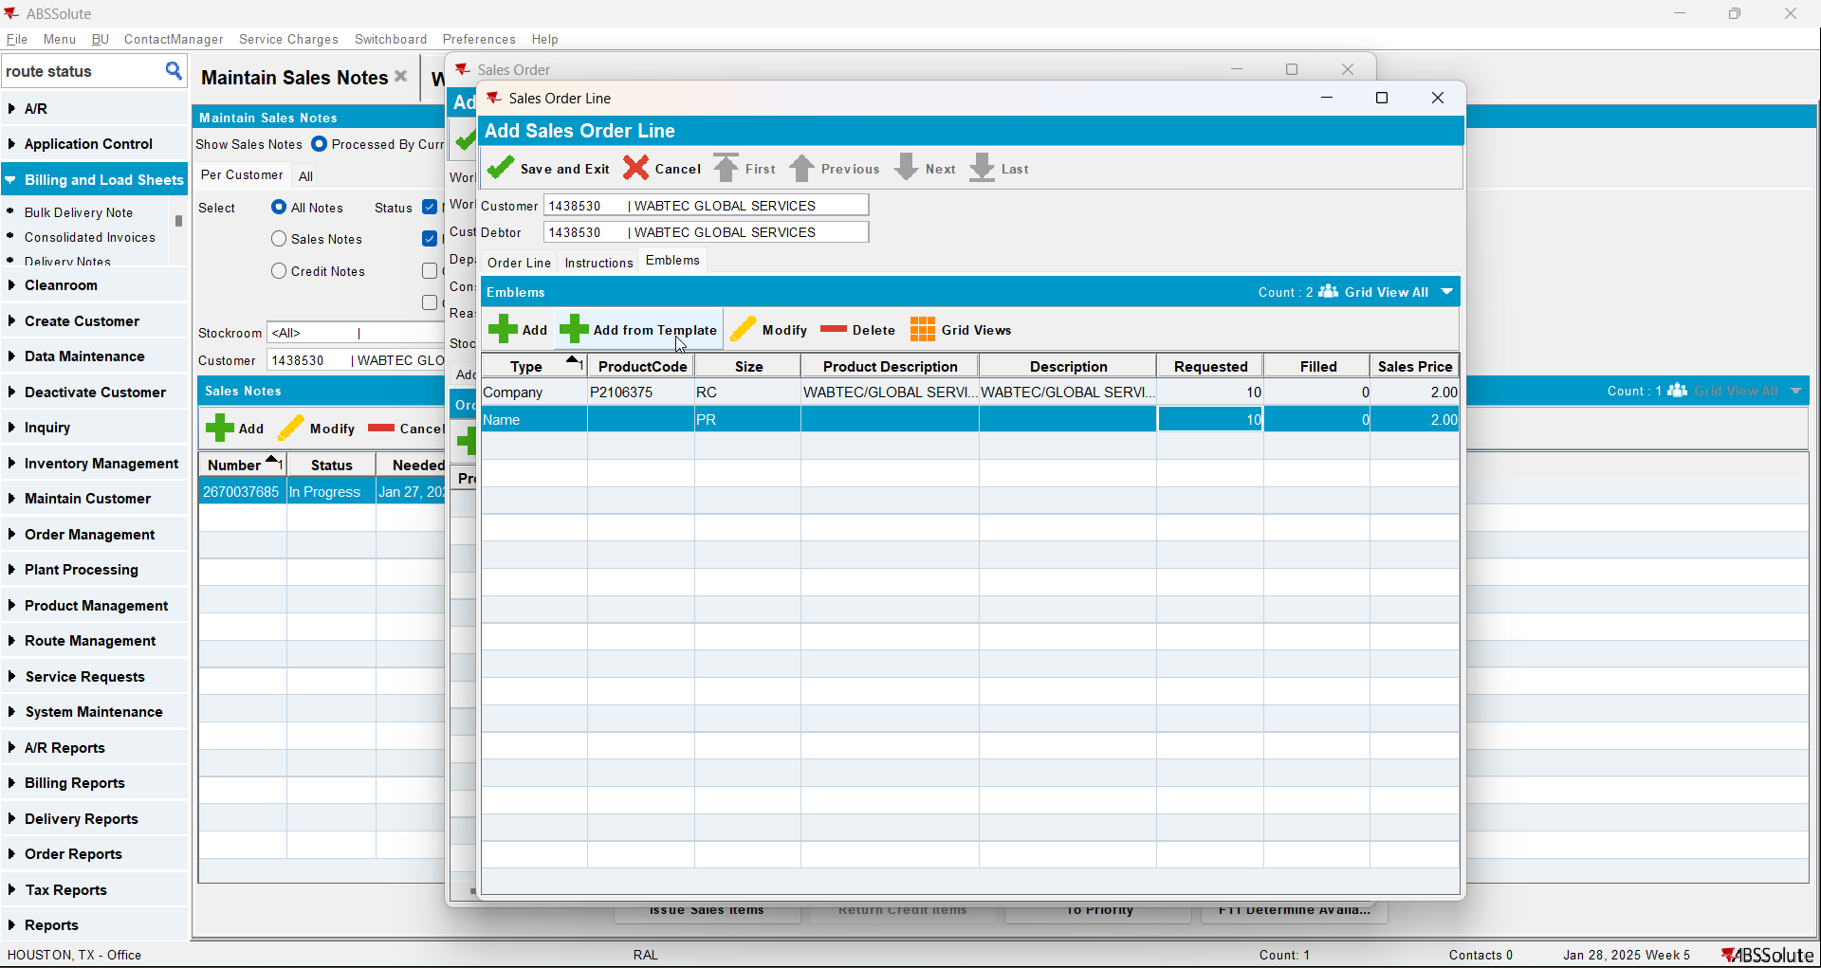
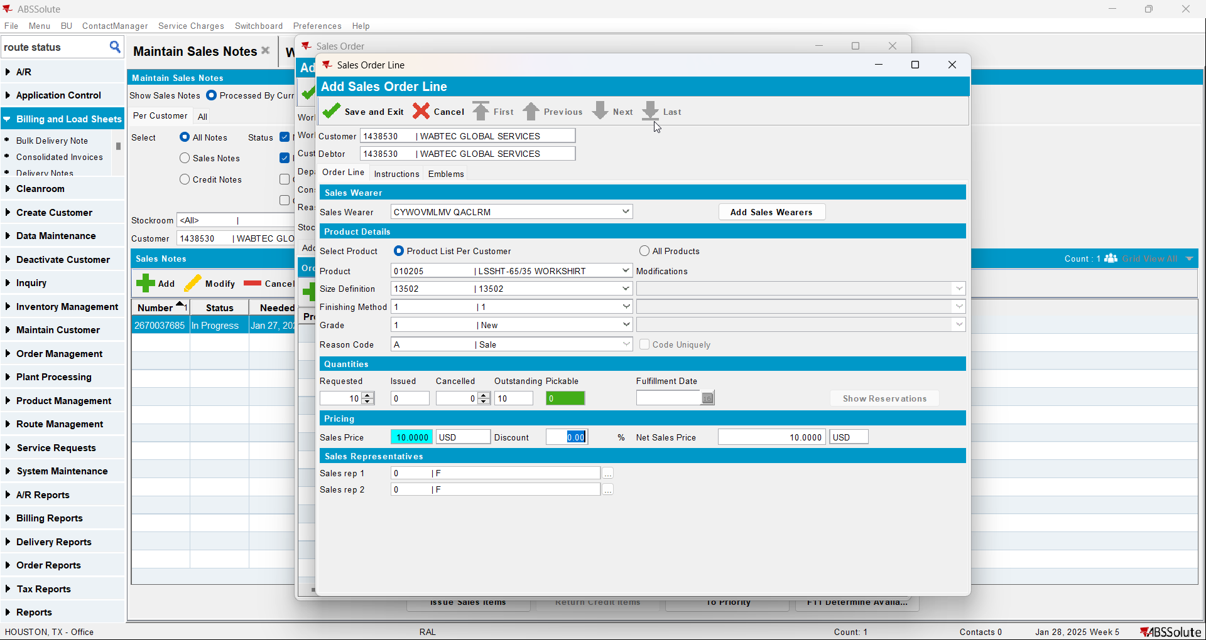

- Duplicate the Work Order line and change the sales wearer, repeat 4 times
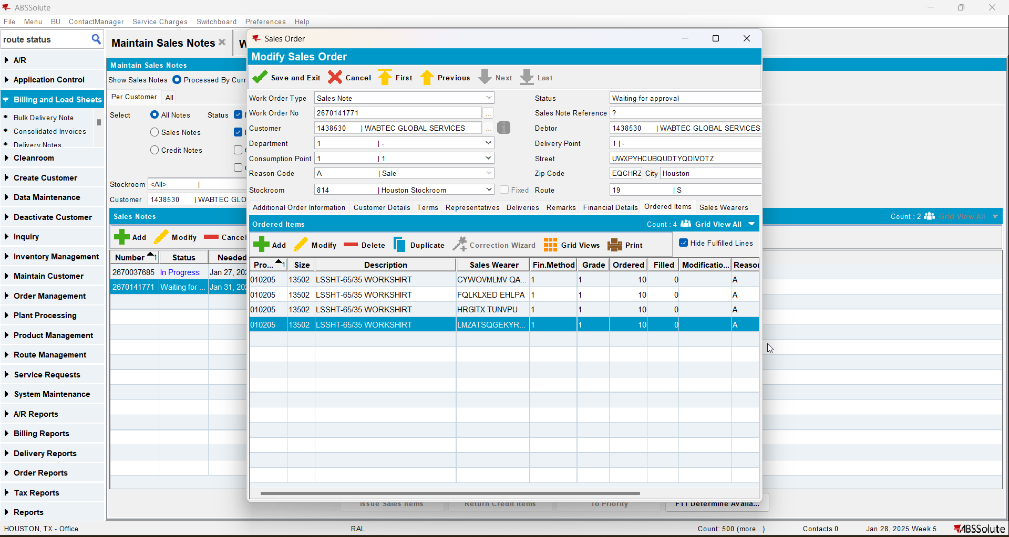
- Work Orders Waiting For Approval DLG: Approve the sales order
- Maintain Sales notes DLG: Issue Sales Items
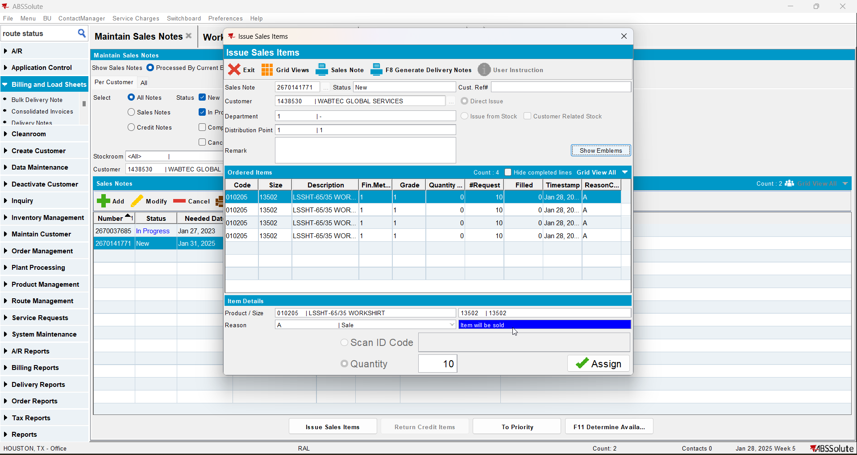
- Generate the Delivery Note
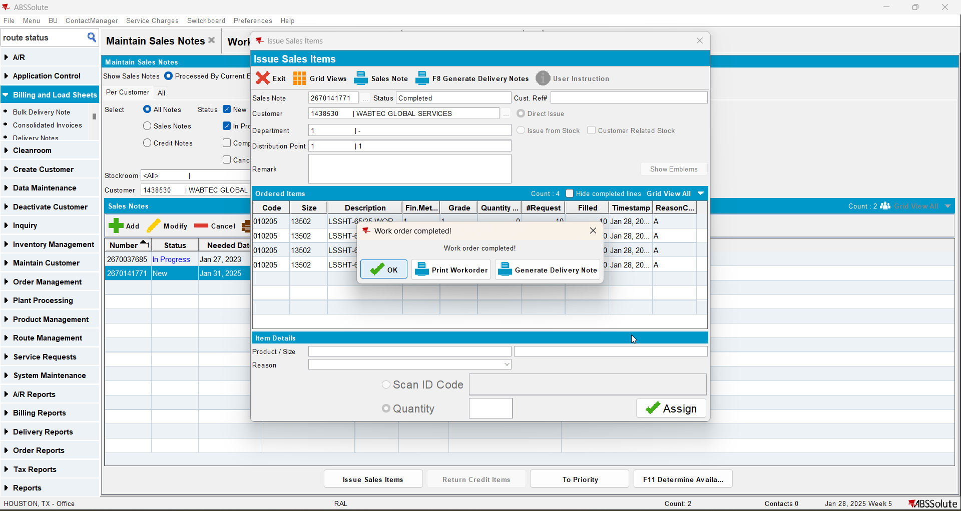
- Select the Delivery date in the past
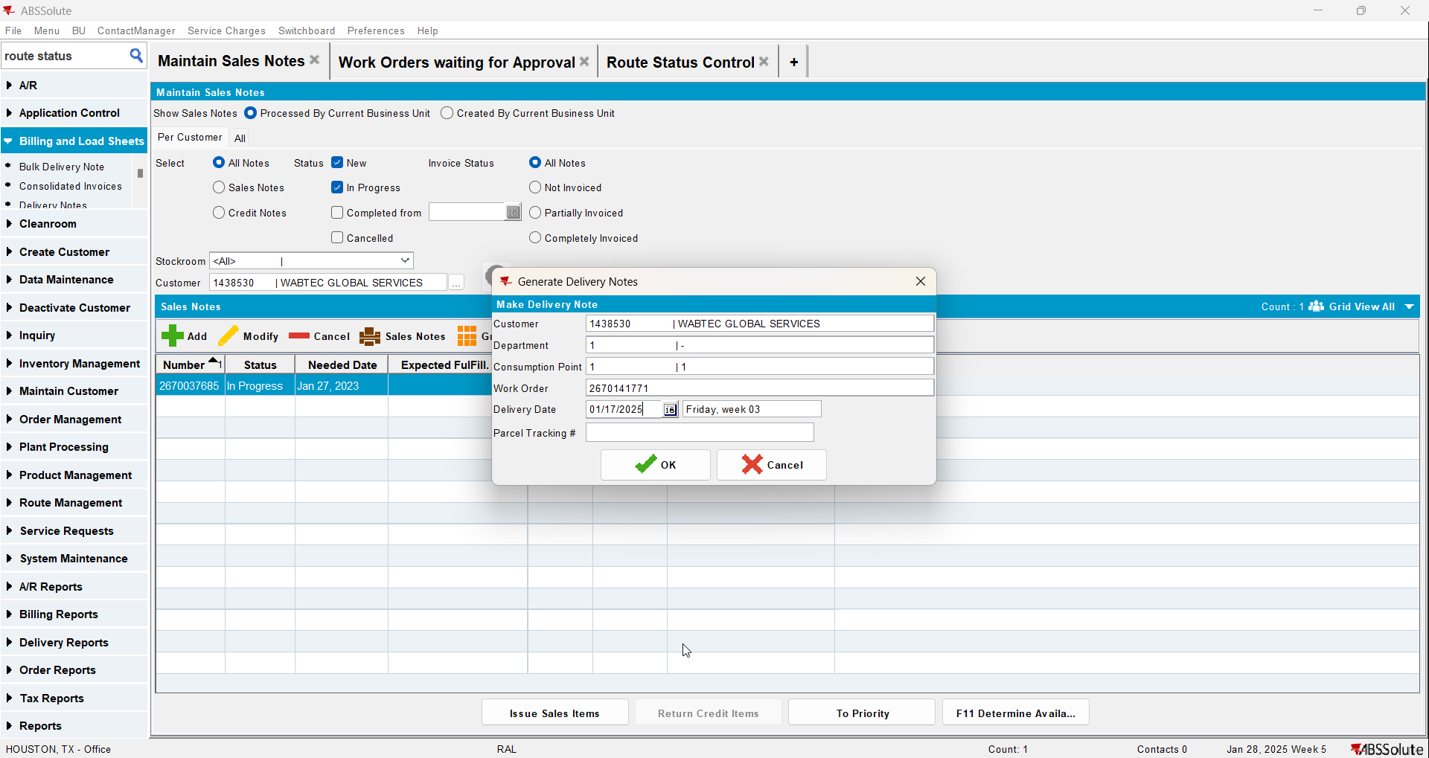
- Route Status Control DLG: Generate invoices for the route where the Delivery Note was attached
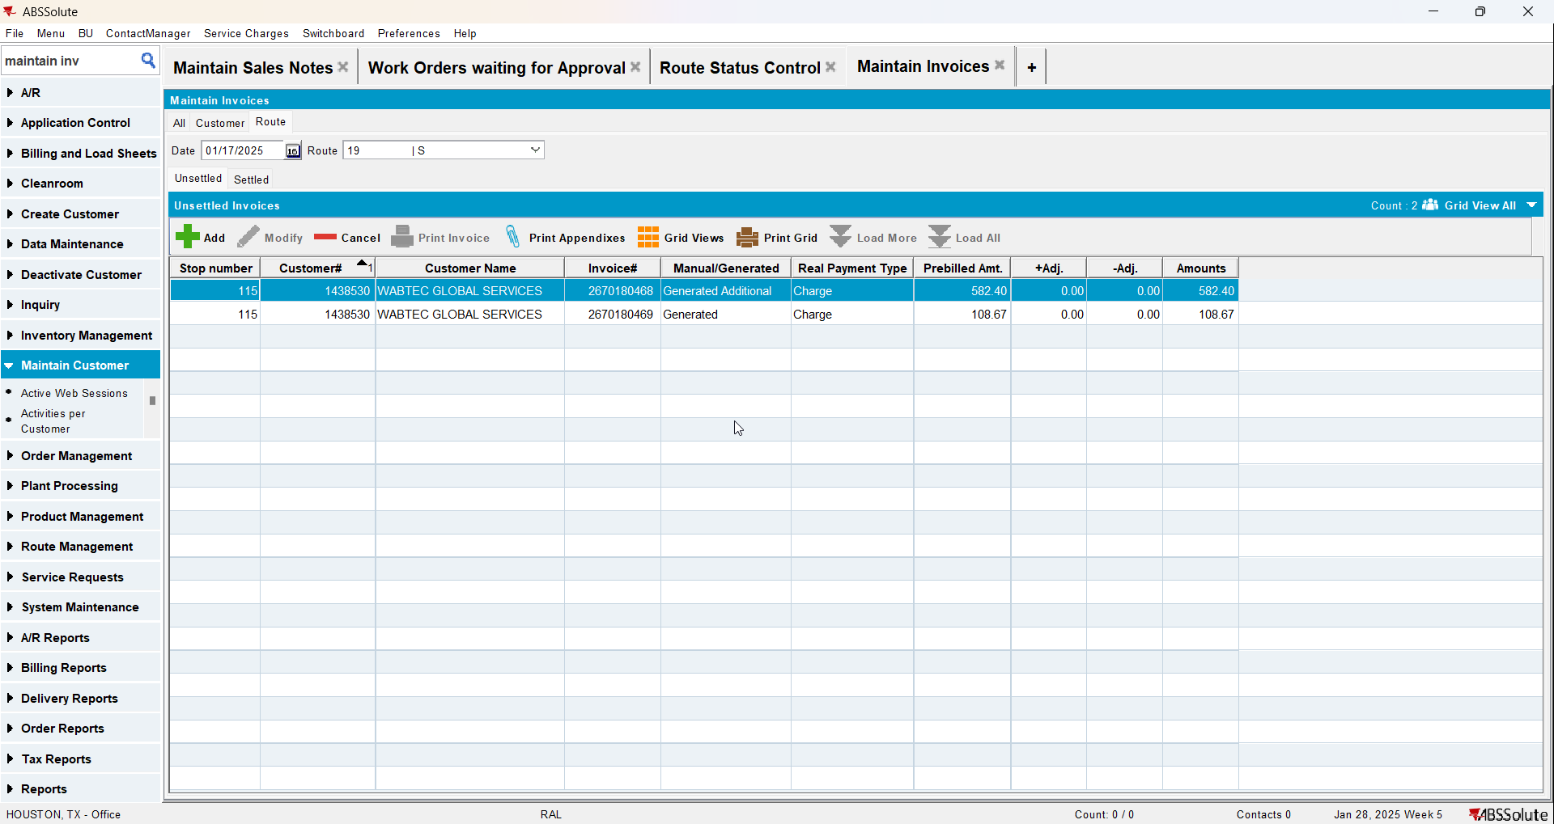
- Settle the route
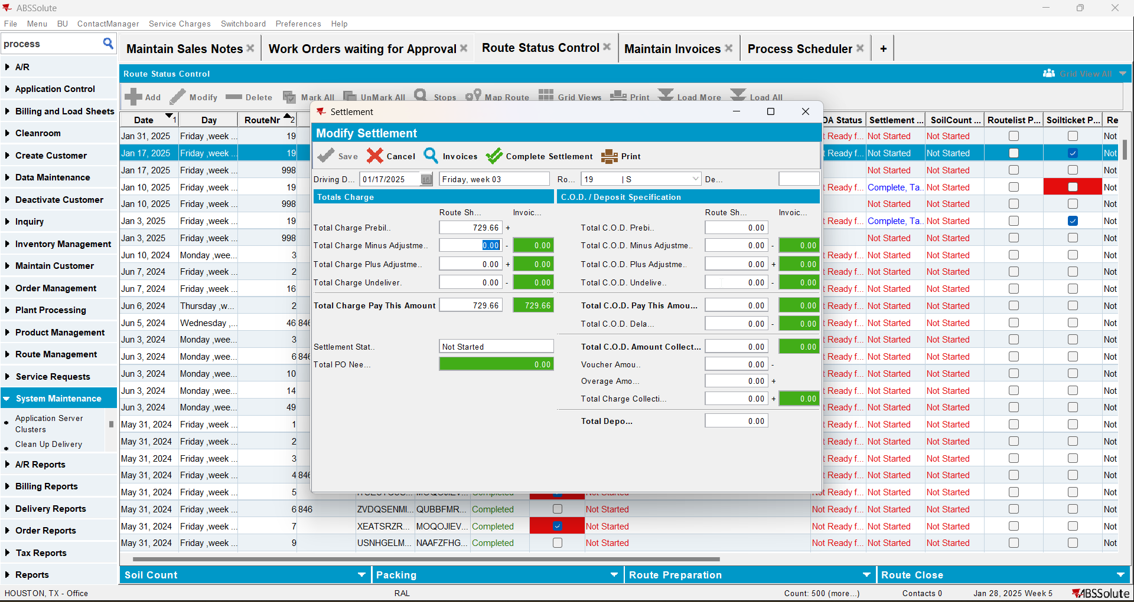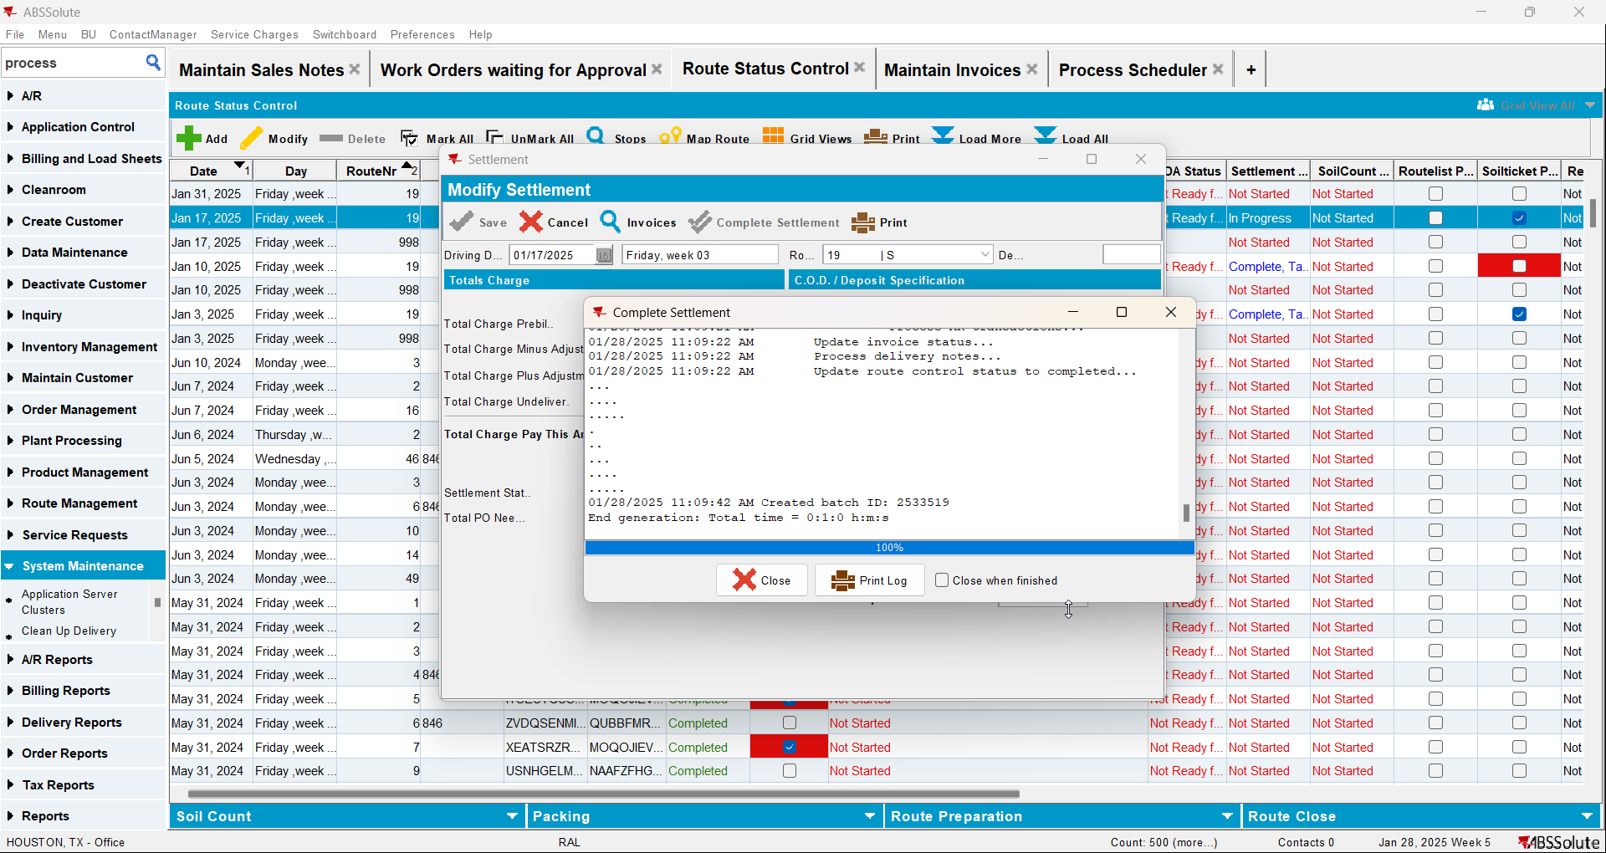

- Run the process scheduler to create the Credit Card Transactions
- Credit Card Transactions DLG: Find the transaction for your sales wearer invoice and settle it
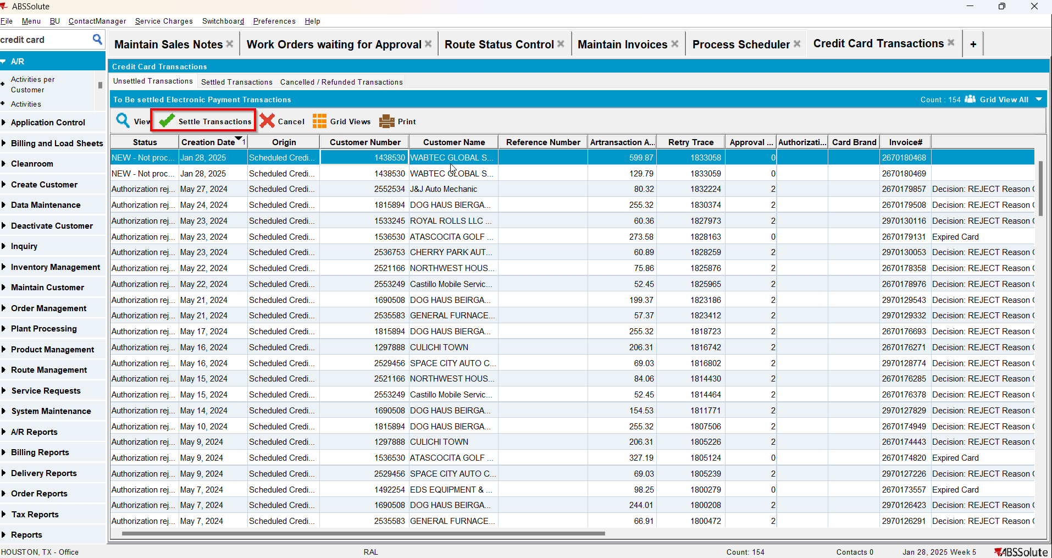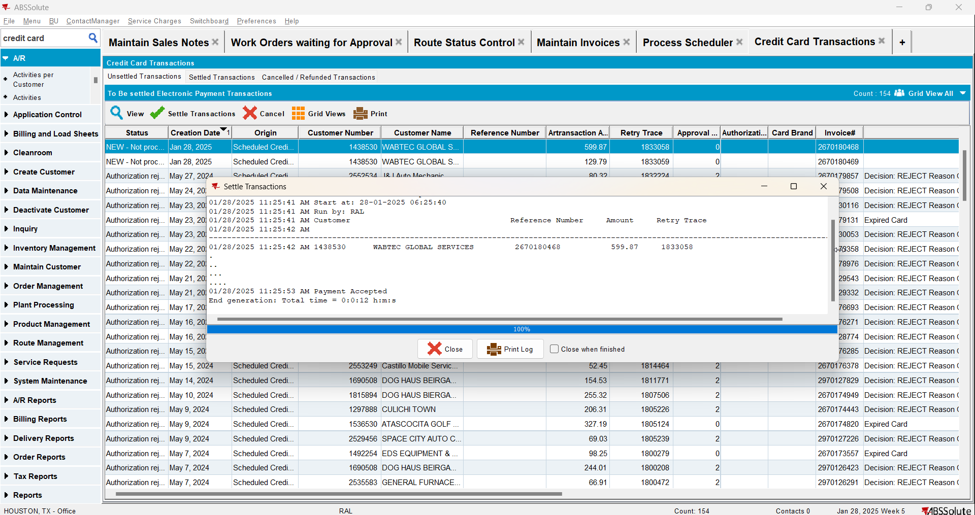

- Get the REQUEST XML with the following select
SELECT *
FROM WEBSERVICELOG WSL
WHERE WSL.customer = '1438530'
ORDER BY WSL.WEBSERVICELOG_ID DESC;
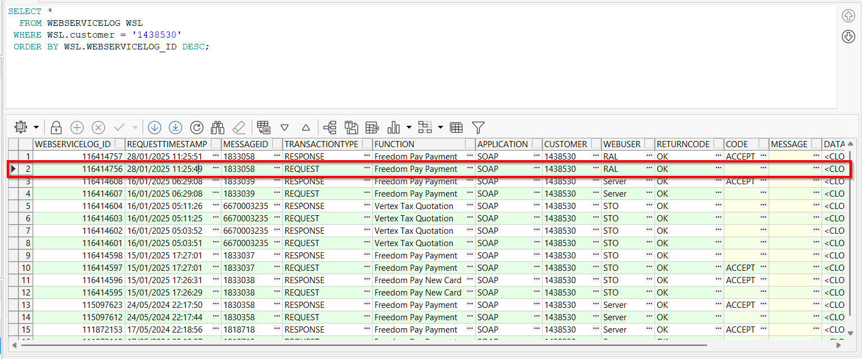
- Compare with the results to the SQL with the values in the XML:
SELECT IH.INVOICENUMBER,
IL.DESCRIPTION || ' - ' || ILT.FACTORYDESCRIPTION AS productName_productDescription,
IL.CODE AS productSKU_productCode,
SUM(CASE
WHEN IL.AdjustmentBilledQty > 0 THEN
IL.AdjustmentBilledQty
ELSE
IL.BilledQty
END) AS QTY,
SUM(CASE
WHEN IL.AdjustedAmount > 0 THEN
IL.AdjustedAmount
ELSE
IL.Amount
END) AS TOTALAMOUNT,
SUM(ILEI.TOTALTAX) AS TOTALTAX,
SUM(CASE
WHEN IL.ADJUSTEDAMOUNT > 0 THEN
IL.ADJUSTEDAMOUNT
ELSE
IL.Amount
END) / CASE
WHEN SUM(IL.BilledQty) = 0 THEN
1
ELSE
SUM(IL.BilledQty)
END AS UNITPRICE
FROM INVOICELINE IL
JOIN INVOICEHEADER IH
ON IH.INVOICEHEADER_ID = IL.INVOICEHEADER_ID
JOIN INVOICELINEEXTRAINFO ILEI
ON ILEI.INVOICELINE_ID = IL.INVOICELINE_ID
JOIN INVOICELINETYPE ILT
ON IL.INVOICELINETYPE_ID = ILT.INVOICELINETYPE_ID
WHERE IH.invoicenumber in (2670180468)
GROUP BY IH.INVOICENUMBER,
IL.DESCRIPTION || ' - ' || ILT.FACTORYDESCRIPTION,
IL.CODE;
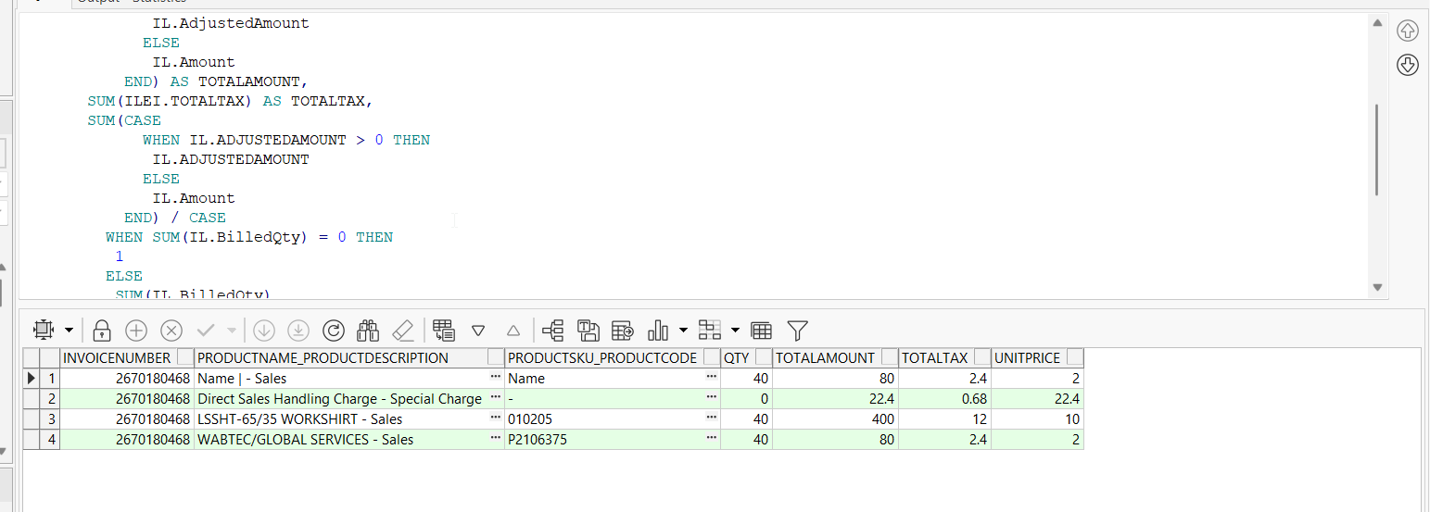
Tested OK

Test Case 4 – Process Credit Card Payment for a Manual Invoice
Hash: 9b74610

Test Steps

- Create a manual invoice where we have duplicate invoice lines from each possible invoice line type with different quantities like so:
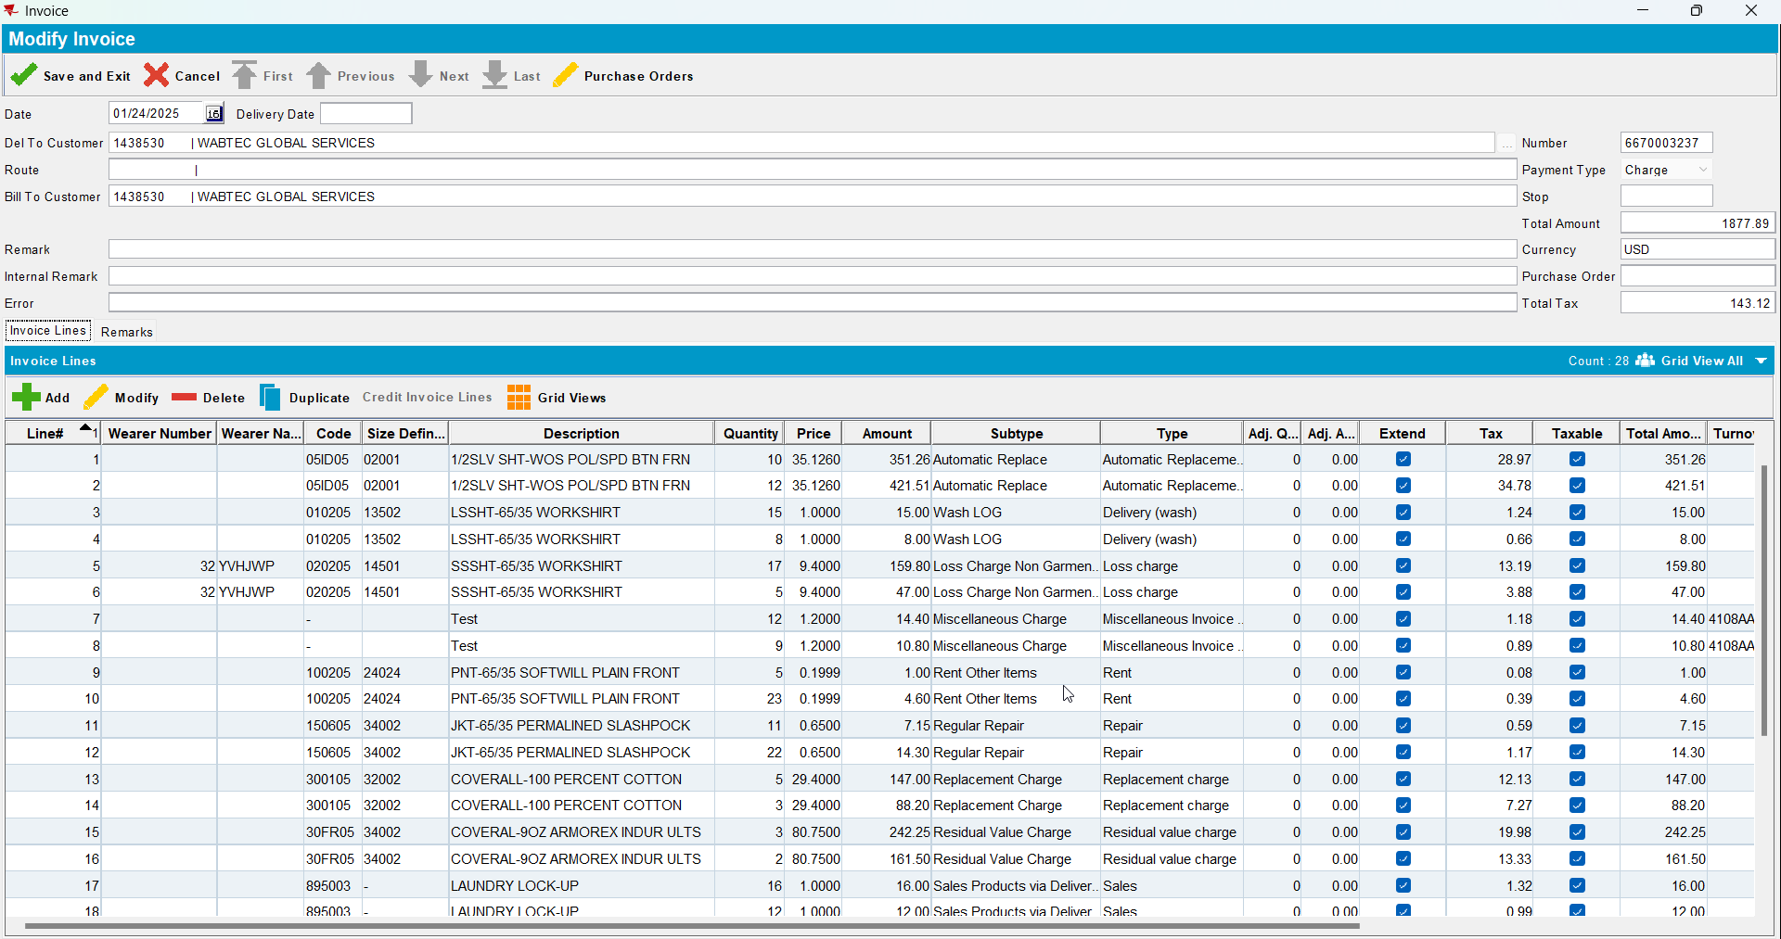
- Make sure your Invoice date is in the past
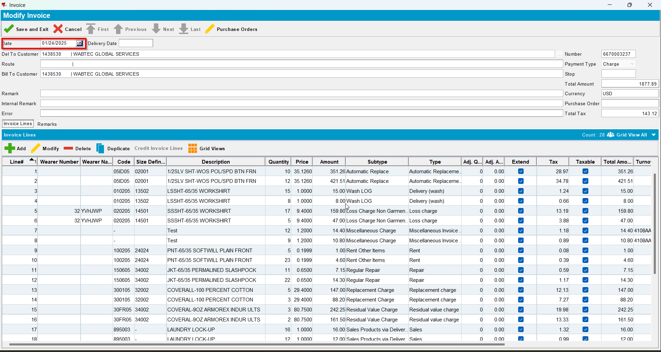
- RSC DLG: Add a route control where this customer has a stop
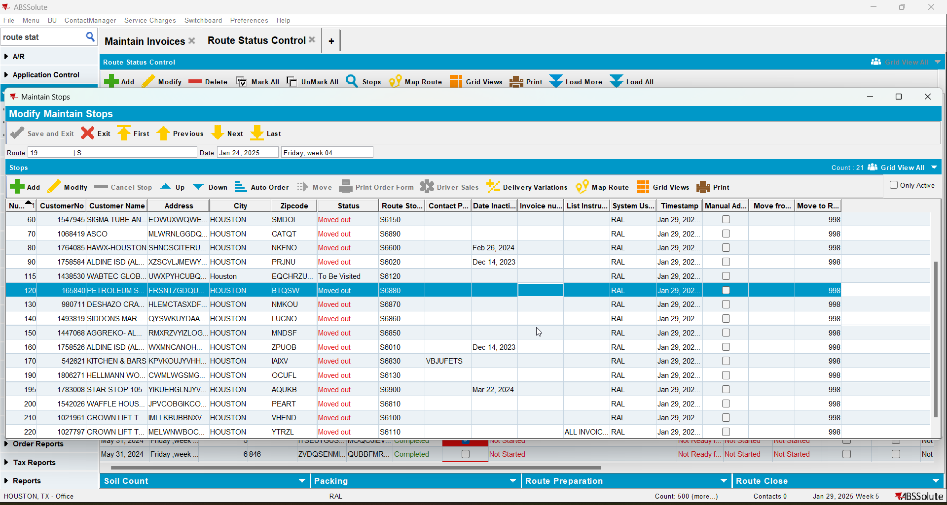
- Go to ALL tab and assign it to the same route control from the previous step (make sure the invoice has Invoice Tax Status: Pre-billing Tax Successful)
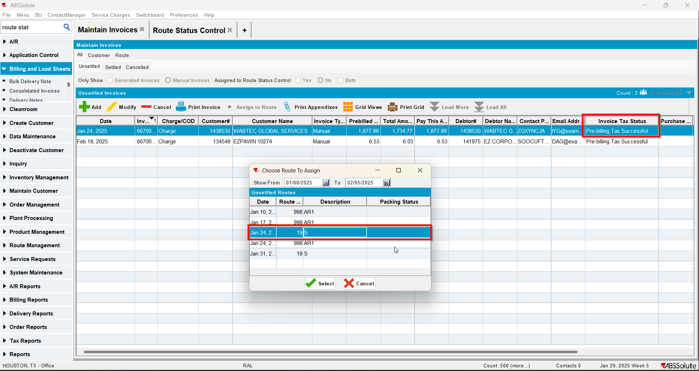
- RSC DLG: Generate the invoices for your route control
- Script in the BCI data and run the Vertex Tax process scheduler
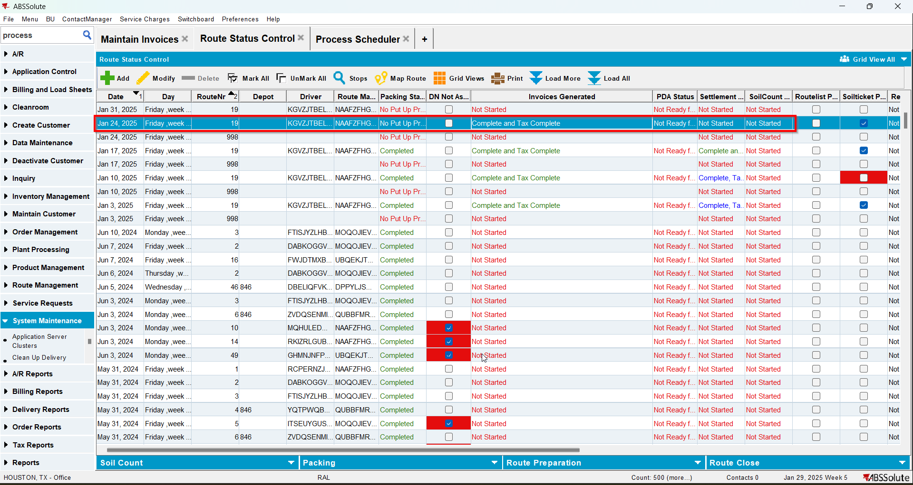
- Settle the route

- Run the Create Credit Card Process scheduler
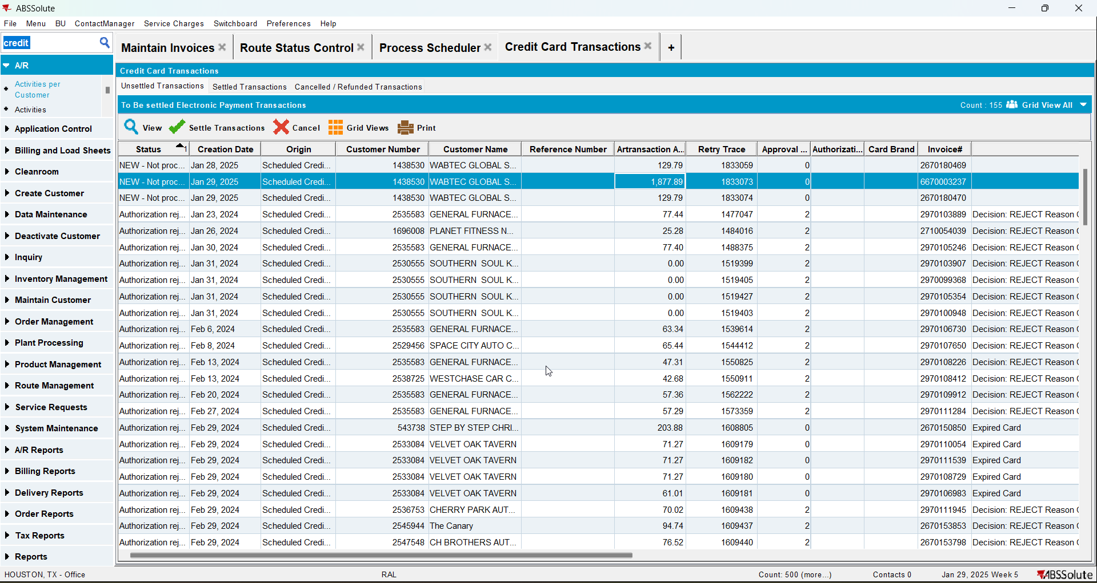
- Run the Take Electronic Payment process scheduler
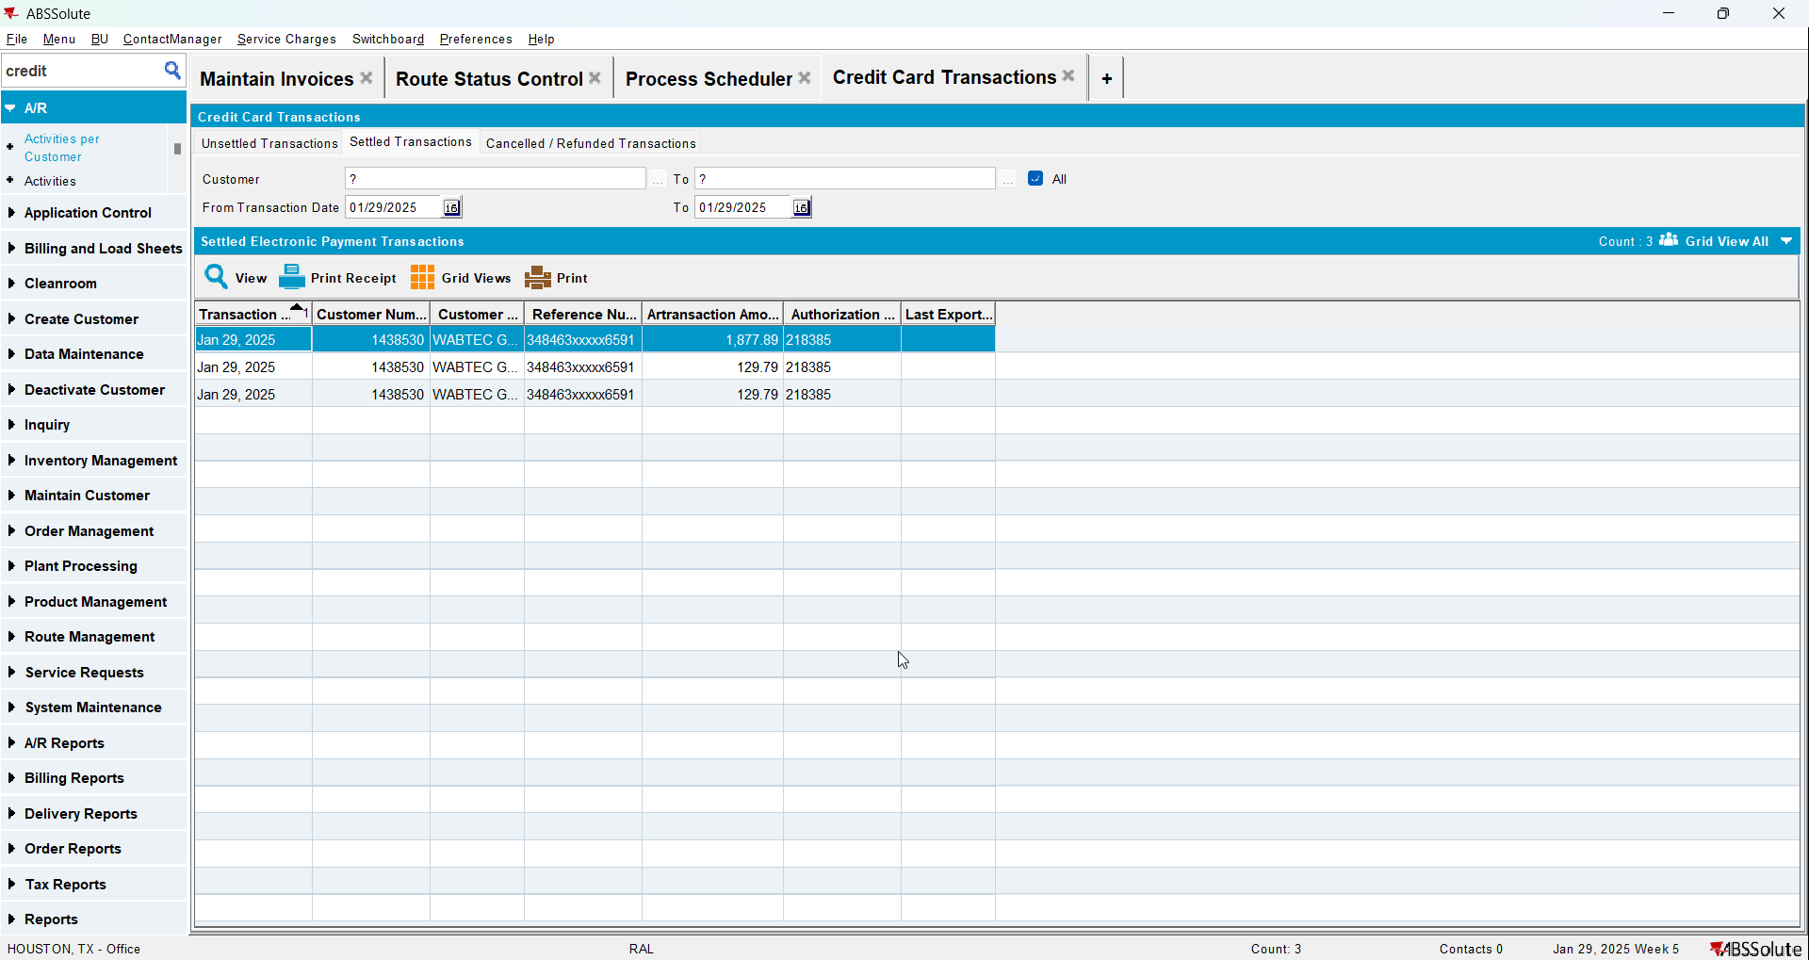
- Get the CLOB data for the REQUEST and format it as XML

- Check all of the ITEM elements in the XML against the following select results to check if the grouping and sum amounts were done properly:
SELECT IH.INVOICENUMBER,
IL.DESCRIPTION || ' - ' || ILT.FACTORYDESCRIPTION AS productName_productDescription,
IL.CODE AS productSKU_productCode,
SUM(CASE
WHEN IL.AdjustmentBilledQty > 0 THEN
IL.AdjustmentBilledQty
ELSE
IL.BilledQty
END) AS QTY,
SUM(CASE
WHEN IL.AdjustedAmount > 0 THEN
IL.AdjustedAmount
ELSE
IL.Amount
END) AS TOTALAMOUNT,
SUM(ILEI.TOTALTAX) AS TOTALTAX,
SUM(CASE
WHEN IL.ADJUSTEDAMOUNT > 0 THEN
IL.ADJUSTEDAMOUNT
ELSE
IL.Amount
END) / CASE
WHEN SUM(IL.BilledQty) = 0 THEN
1
ELSE
SUM(IL.BilledQty)
END AS UNITPRICE
FROM INVOICELINE IL
JOIN INVOICEHEADER IH
ON IH.INVOICEHEADER_ID = IL.INVOICEHEADER_ID
JOIN INVOICELINEEXTRAINFO ILEI
ON ILEI.INVOICELINE_ID = IL.INVOICELINE_ID
JOIN INVOICELINETYPE ILT
ON IL.INVOICELINETYPE_ID = ILT.INVOICELINETYPE_ID
WHERE IH.invoicenumber in (6670003237)
GROUP BY IH.INVOICENUMBER,
IL.DESCRIPTION || ' - ' || ILT.FACTORYDESCRIPTION,
IL.CODE;
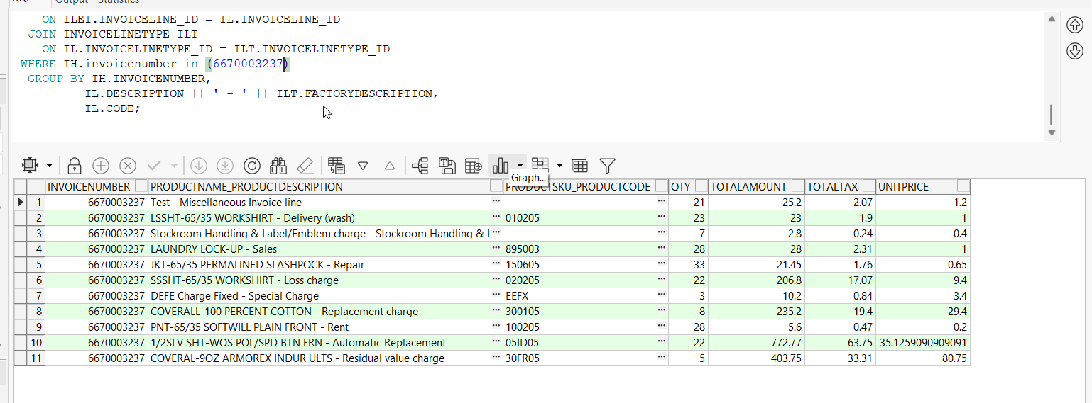
TESTED OK

