ABSN-5265 Web Client X - Error when loading Route Check-In main screen
Environment | Prerequisites
Version:9.07.00  DBServerName=abs-SRV20.internal.abslbs.com  DBSID=CUST24  DBUser=UNFDEV  DBPassword=UNFDEV  Environment=Test | - Module:  - System setting

Contents
Reproducing before fix 1
Steps to reproduce 1
Current Behavior 3
Expected behavior 3
Retest after fix 3
Test Case 1 – Go to Webx, change language and settle the route – Tested OK 3

Reproducing before fix

Steps to reproduce
- Go to WebX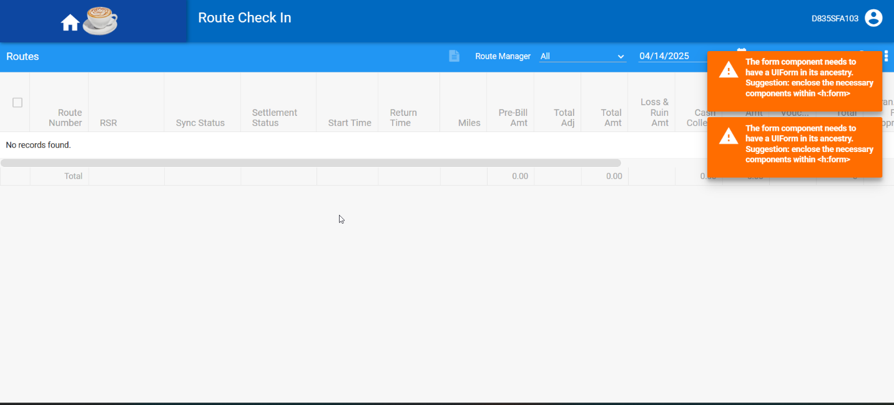
- Go to Change language to French: use Settings option visible when clicking the top right icon and select Francais (France).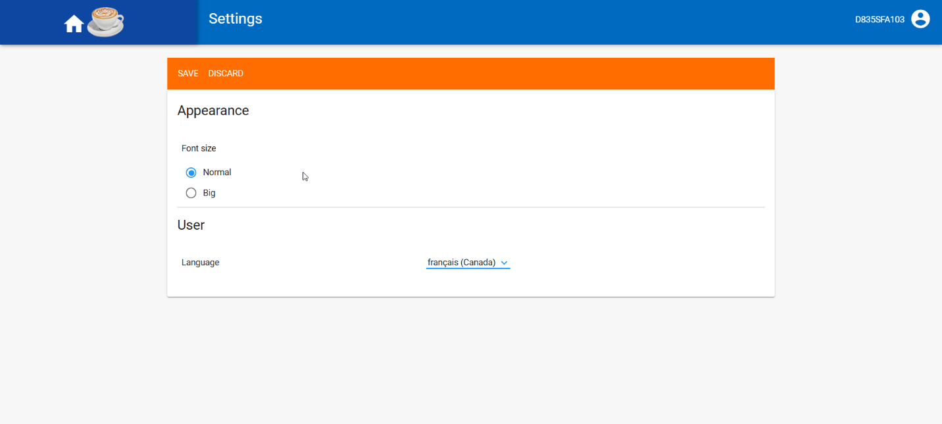
- Press ABS logo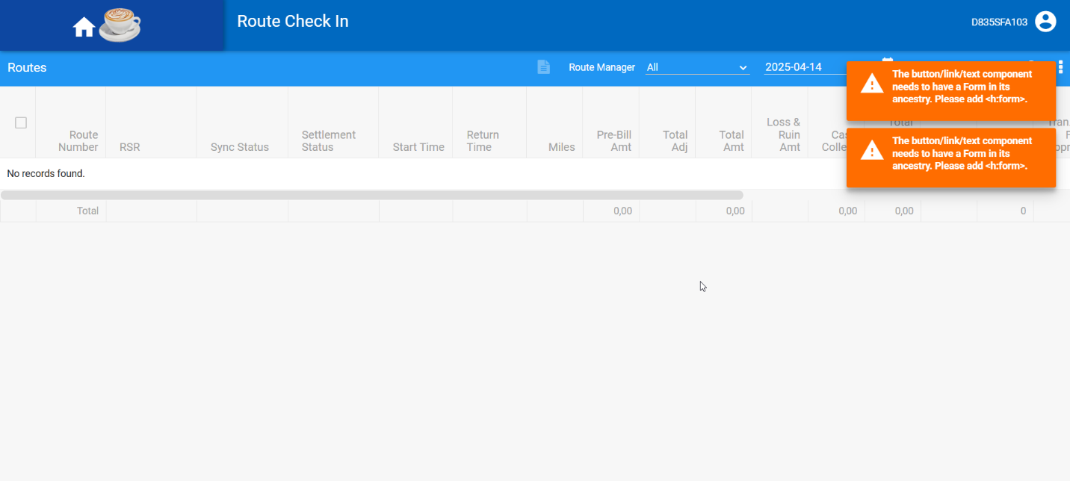
- Change language to English and then press ABS logo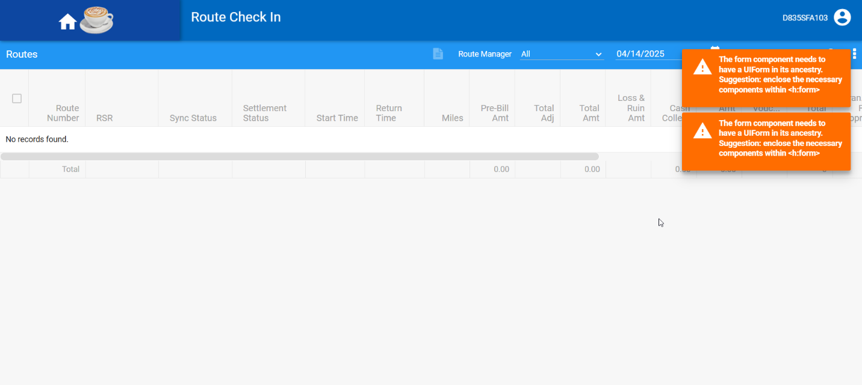
REPRODUCED OK.

Current Behavior
Errors appear in the upper right corner

Expected behavior
No errors should appear

Retest after fix

Test Case 1 – Go to Webx, change language and settle the route – Tested OK
Expected behavior: No erros should appear
Hash: 268c8fa
- Generate invoices for a route with 2 stops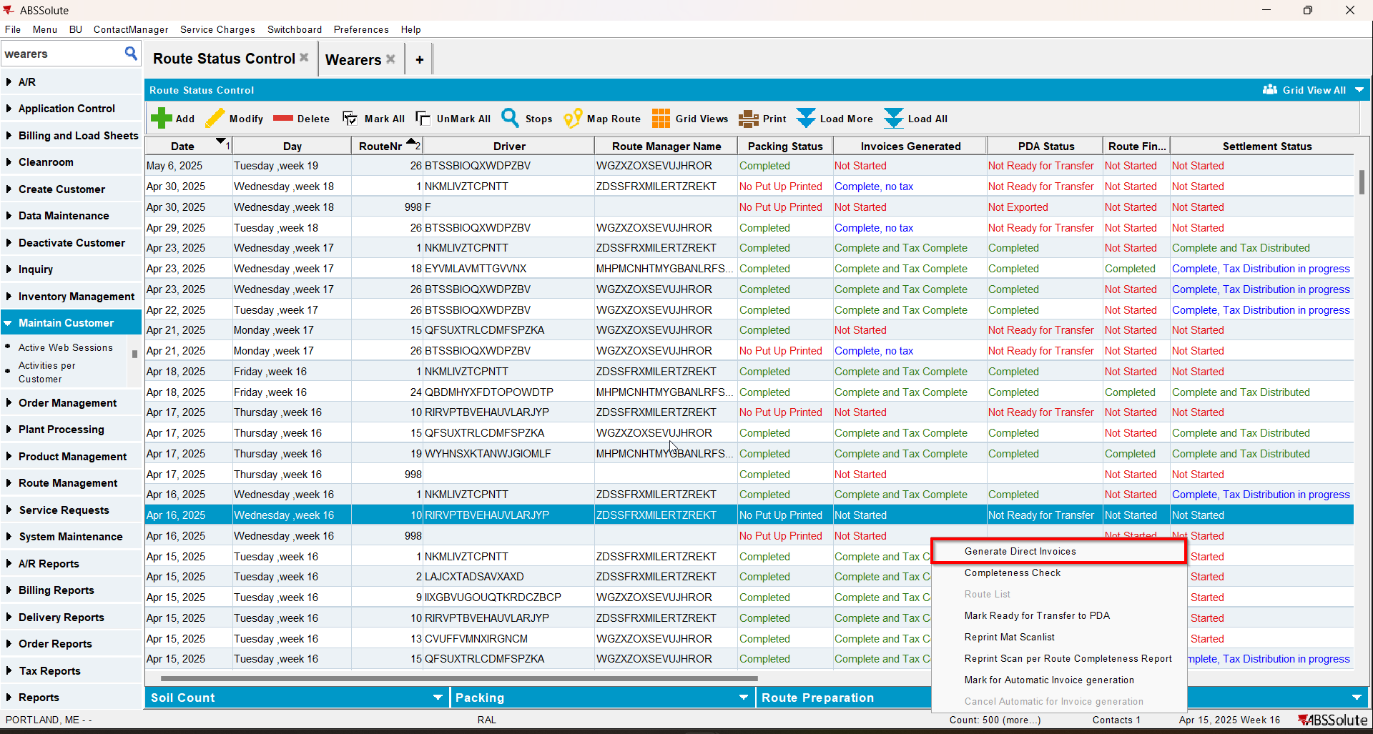
- Send the route to RA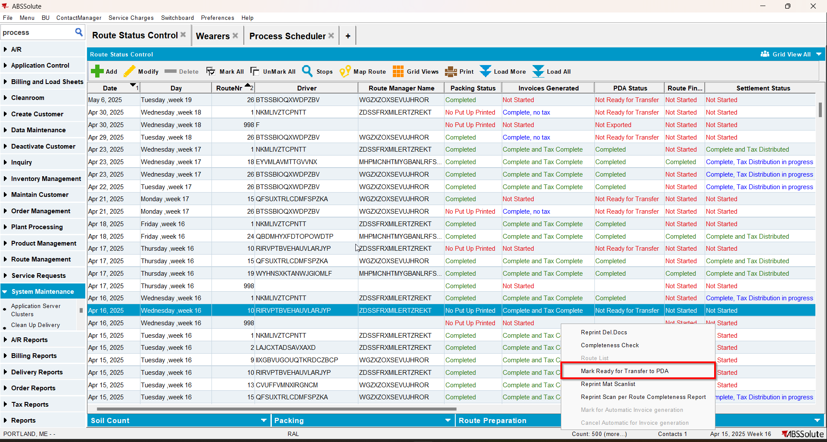
- On RA for a stop do some negative invoice adjustments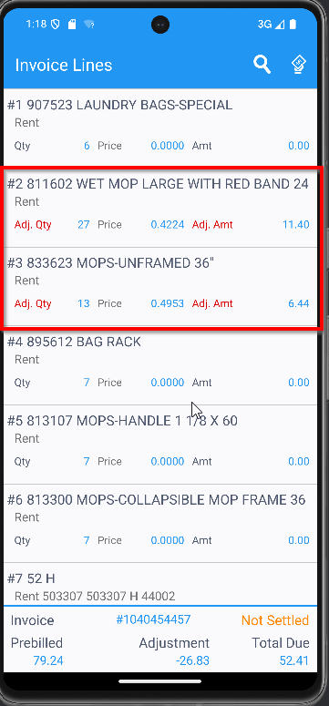
- For the other stop decrease a wearer inventory, quit a wearer inventory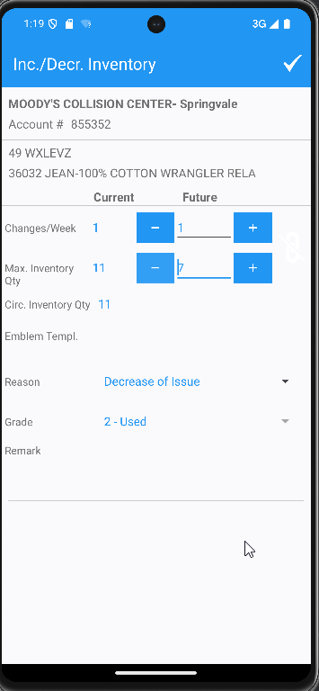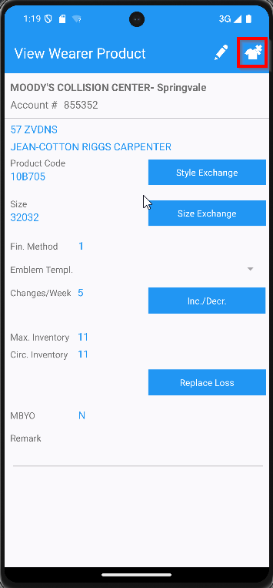
- Finish the route and upload it
- Go to WebX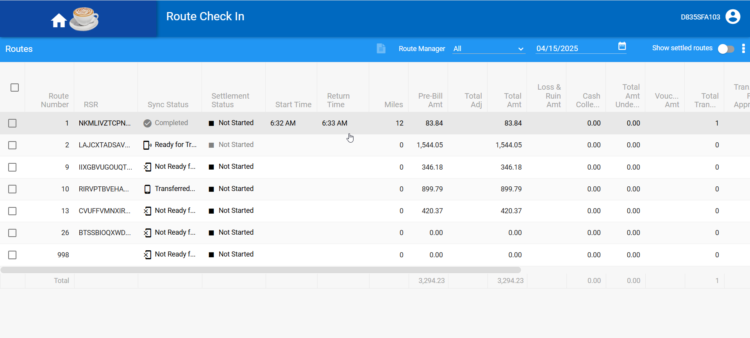
- Change the language to French and click on ABS logo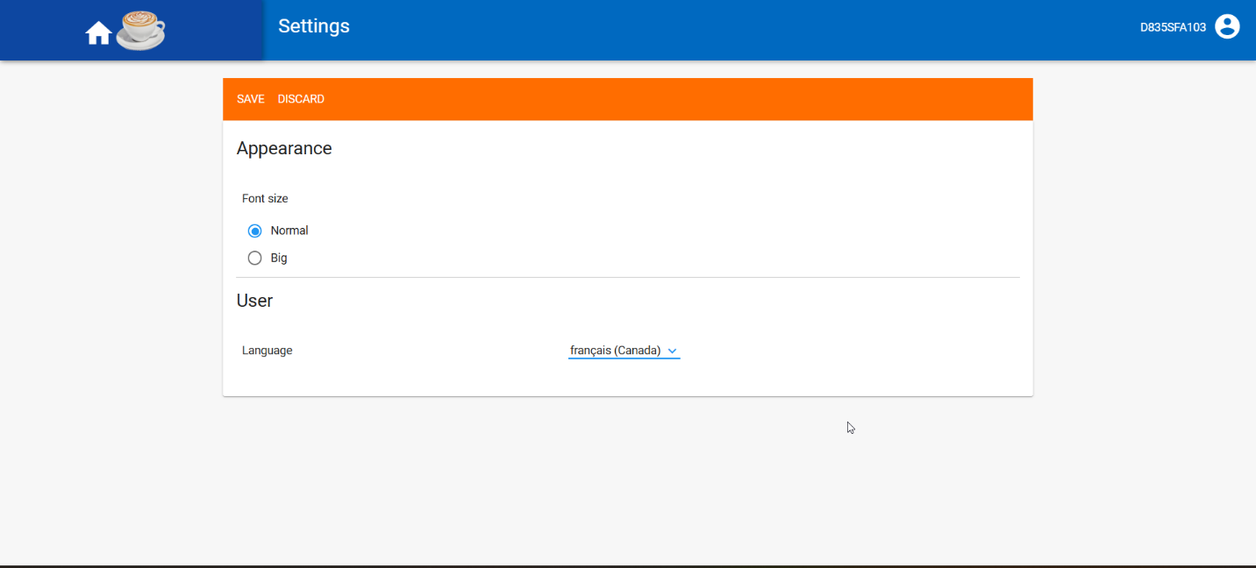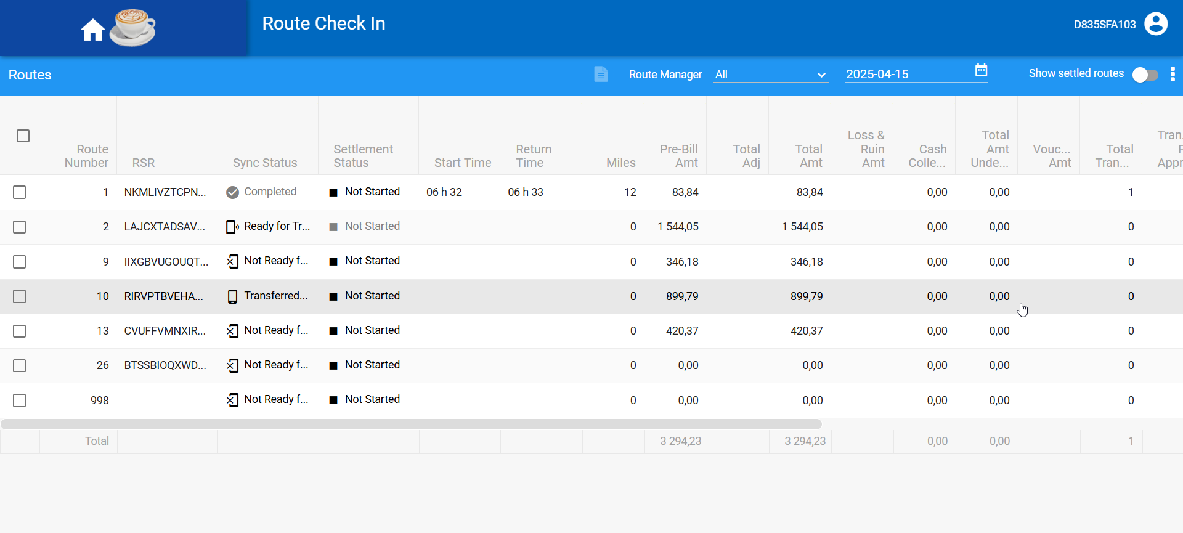
- Change the language back to English and click on ABS logo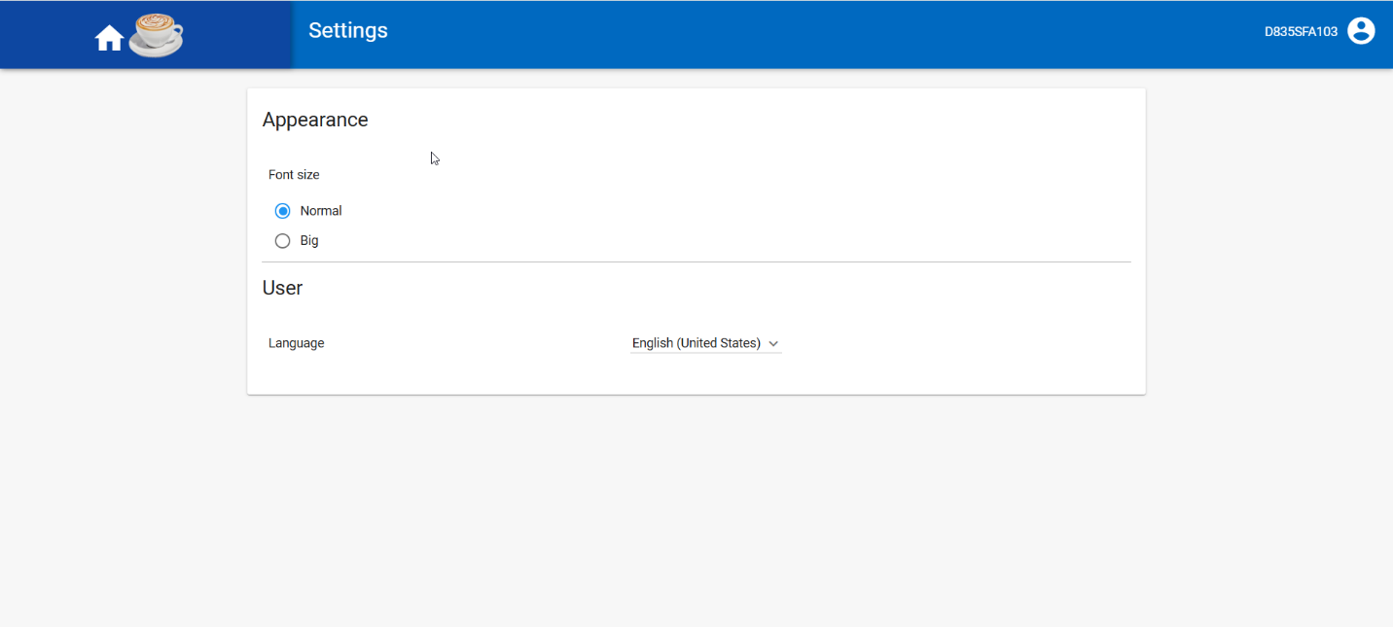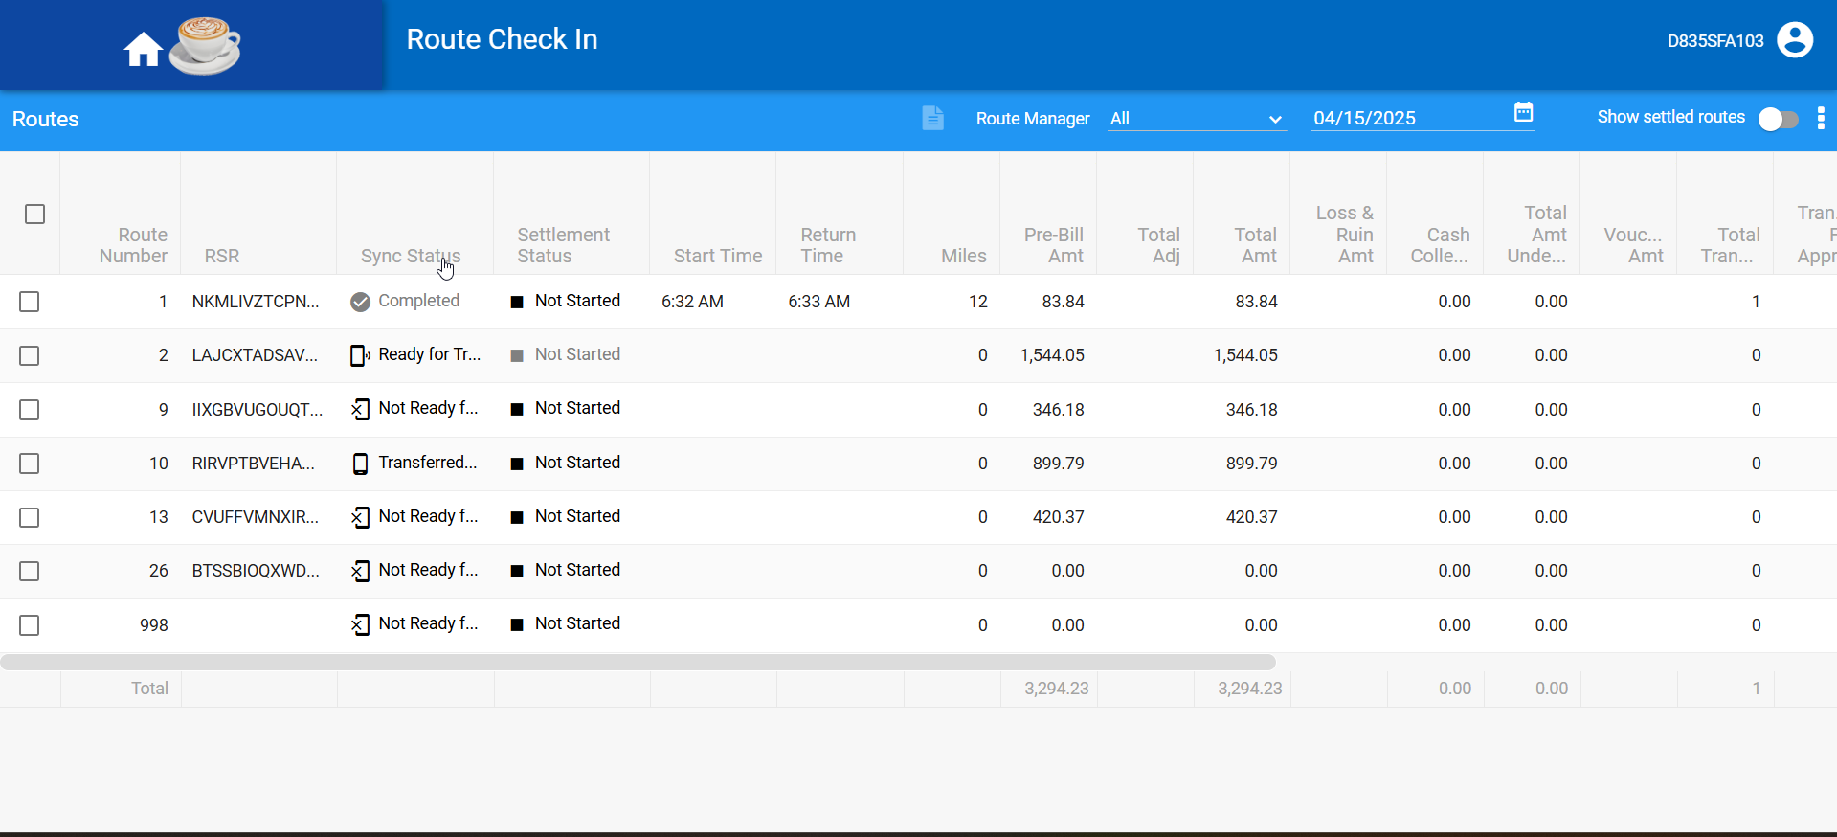
- Settle your route