ABSN-5250 - Contact notes shown in red
Environment | Prerequisites
Version: 9.07.00.UNF19  DBServerName= abs-srv20.internal.abslbs.com  DBSID=CUST24  DBUser=UNFDEV  DBPassword= UNFDEV  Environment=Test | - Module:  - System setting

Contents
Reproducing before fix 1
Steps to reproduce 1
Current Behavior 4
Expected behavior 4
Retest after fix 4
Test Case 1 – Check Contact Notes text box from Contact Monitor 4

Reproducing before fix

Steps to reproduce
- Contact Monitor DLG: Load several Contacts in grid
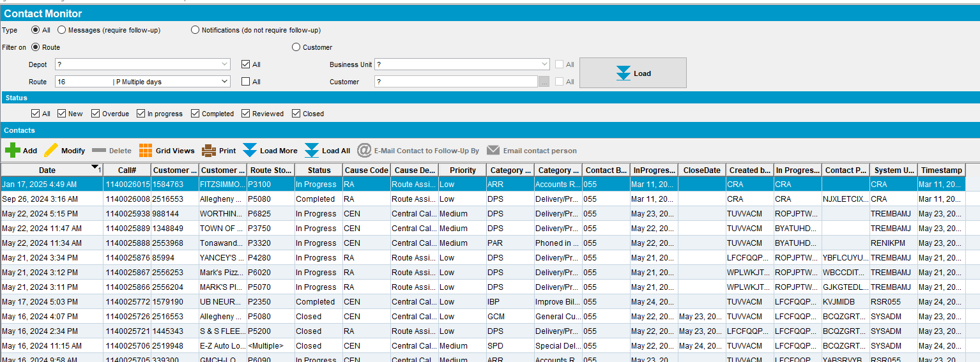
- Press Add button to add a new contact
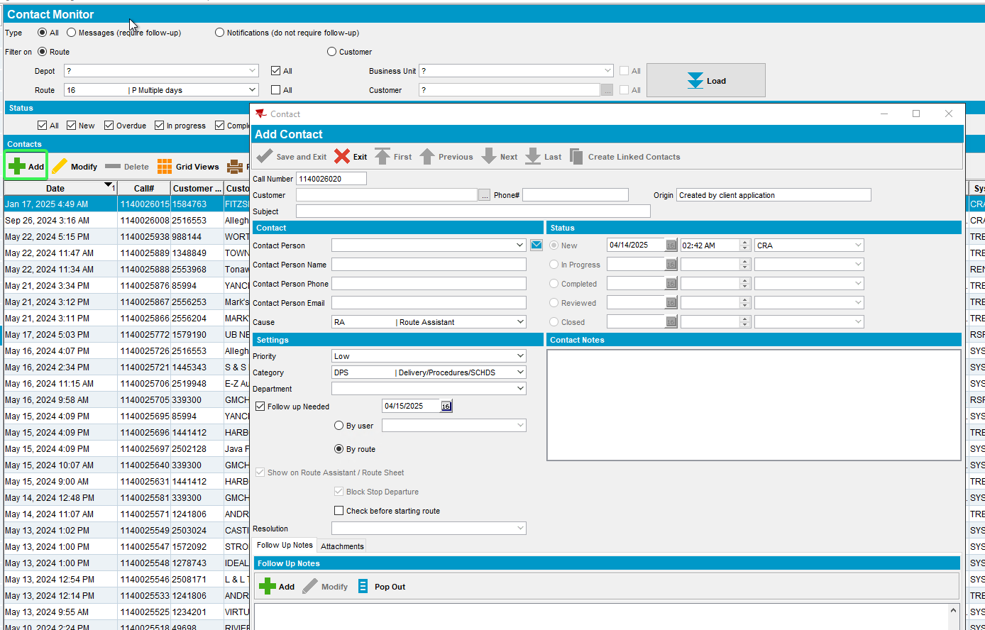
- Go to Contact Notes type box and before writing anything press TAB to switch focus to a different box and have the red question mark appear “?”
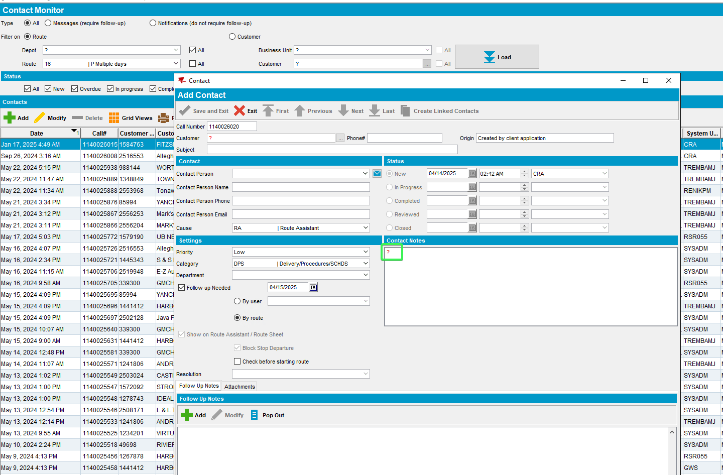
- Press Exit from this “Add Contact” form
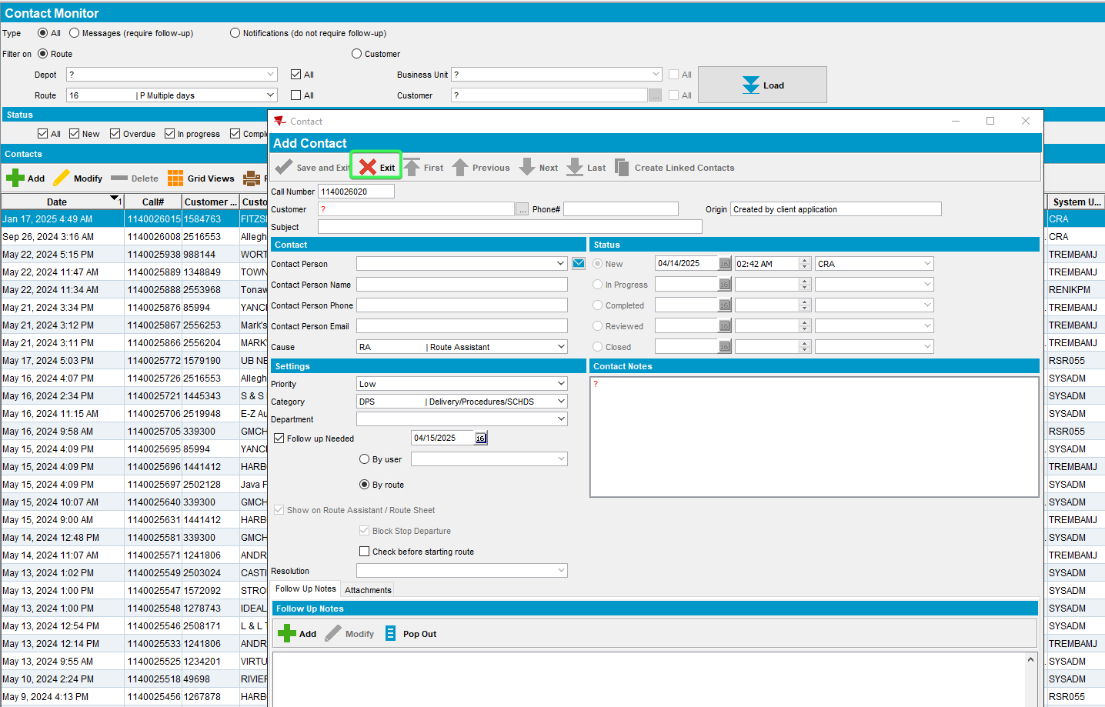
- Open a contact from the grid and see the “Contact Notes” box
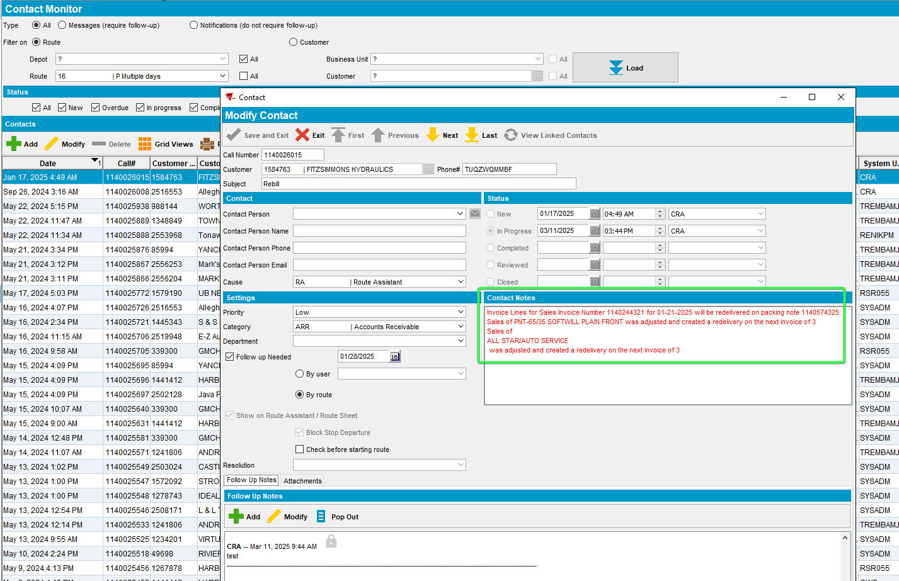
REPRODUCED OK.

Current Behavior
The text in Contact Notes text box is red instead of black

Expected behavior
The text should remain black regardless of previous actions

Retest after fix

Test Case 1 – Check Contact Notes text box from Contact Monitor
Hash: 6dce86a4bdea
- Contact Monitor DLG: Load several Contacts in grid
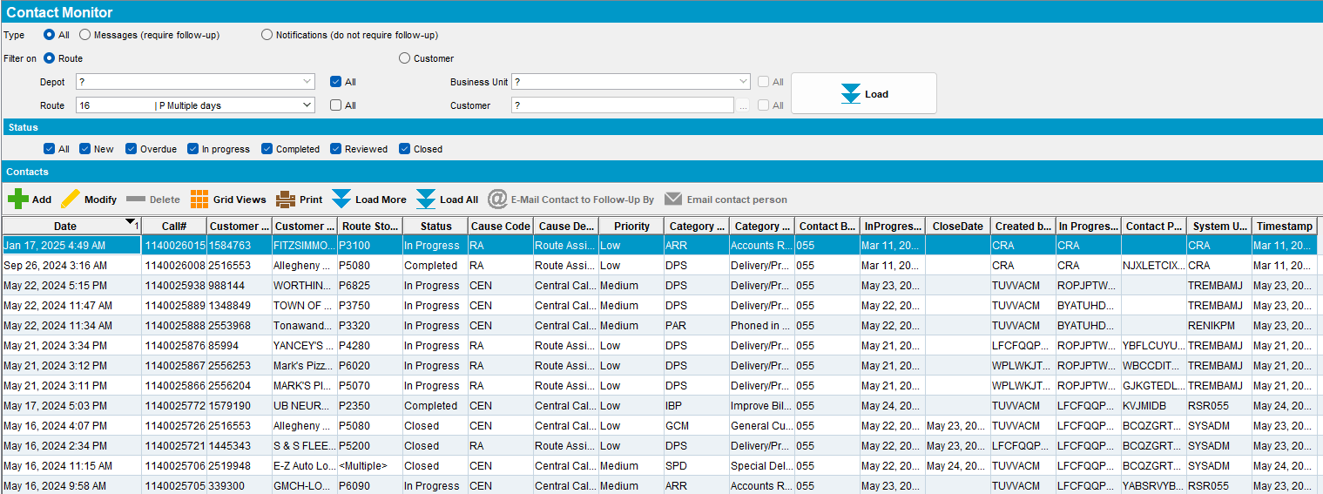
- Press Add button to add a new contact
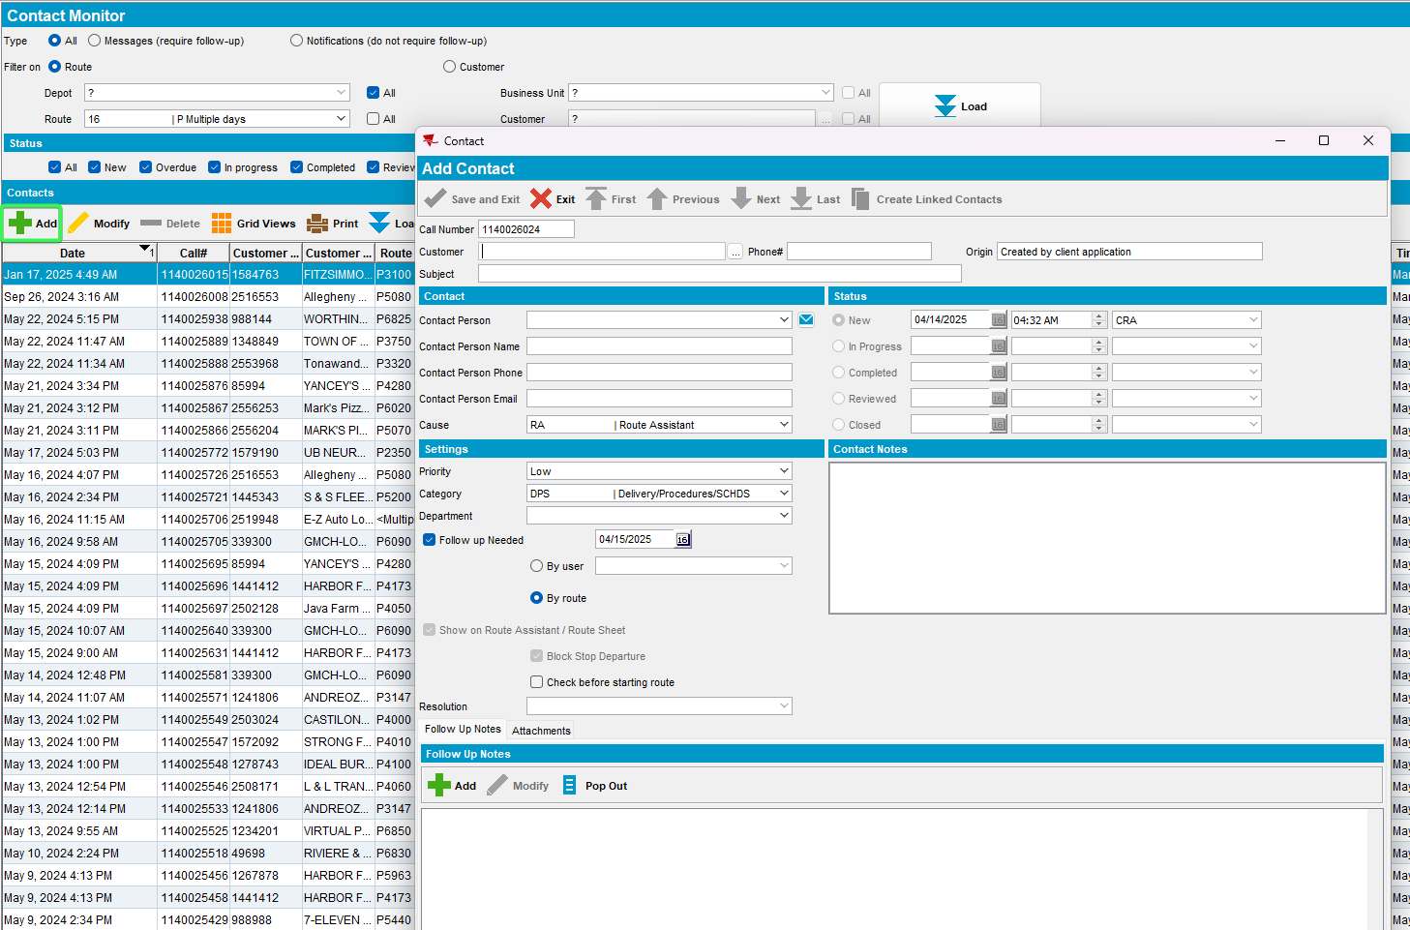
- Go to Contact Notes type box and before writing anything press TAB to switch focus to a different box and have the red question mark appear “?”
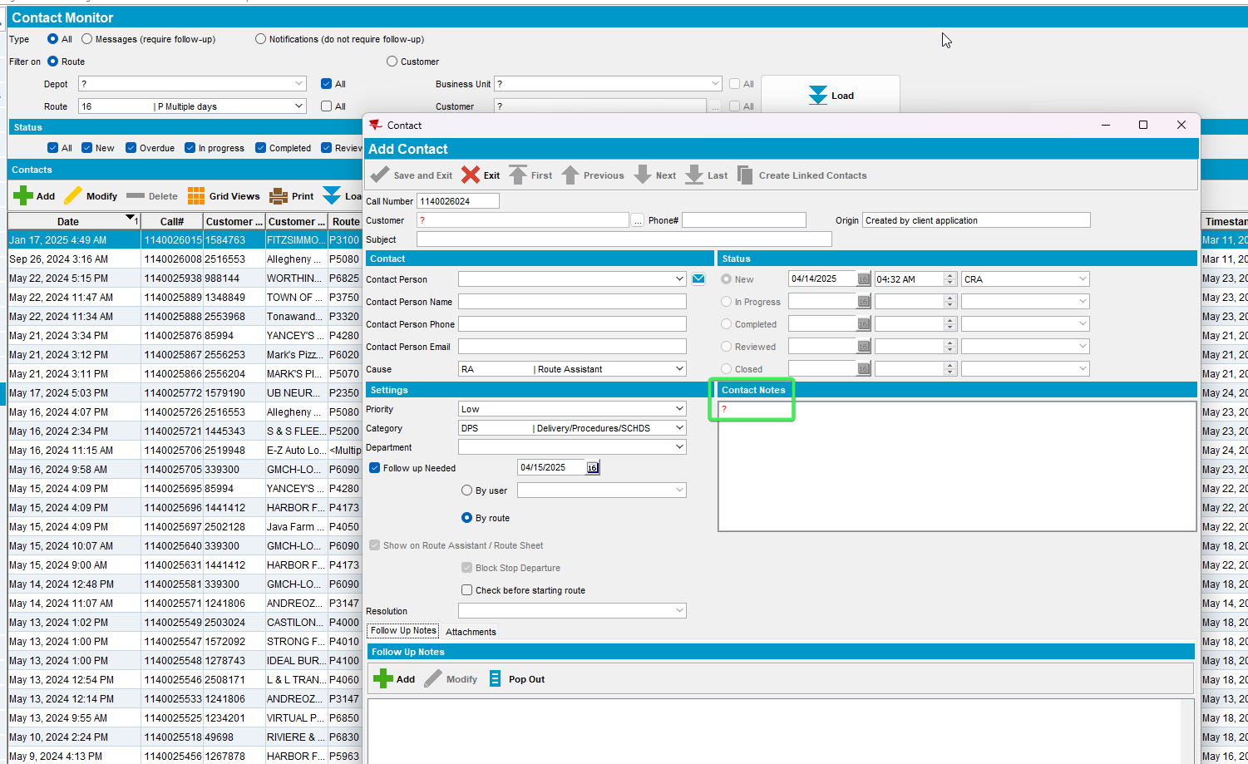
- Press Exit from this “Add Contact” form
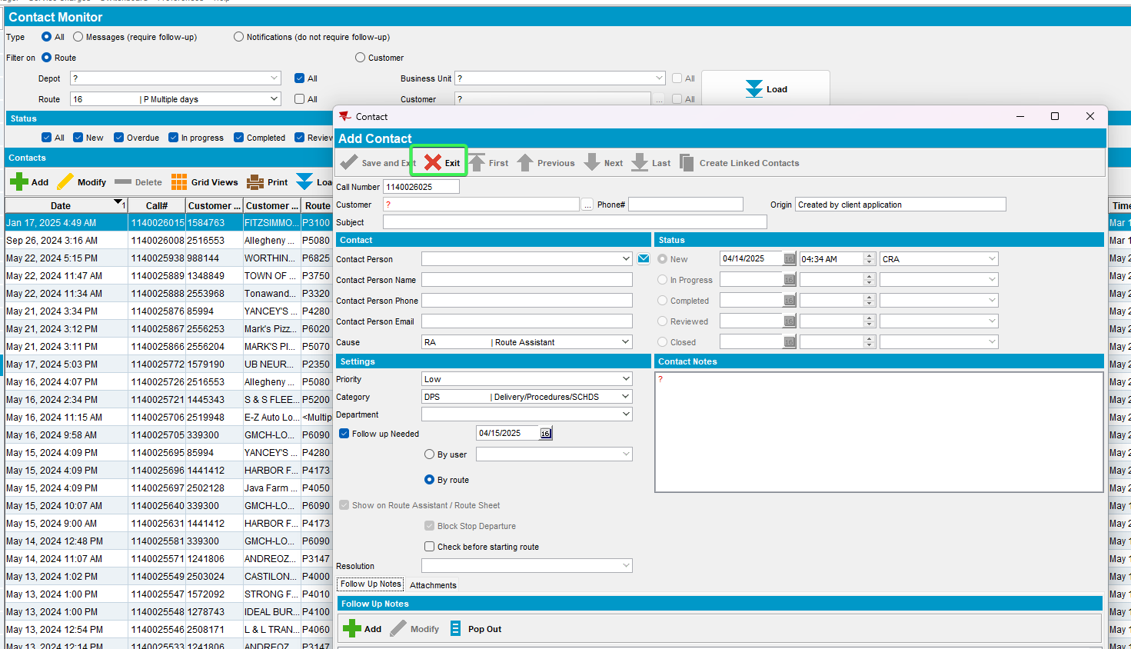
- Open a contact from the grid and see the “Contact Notes” box
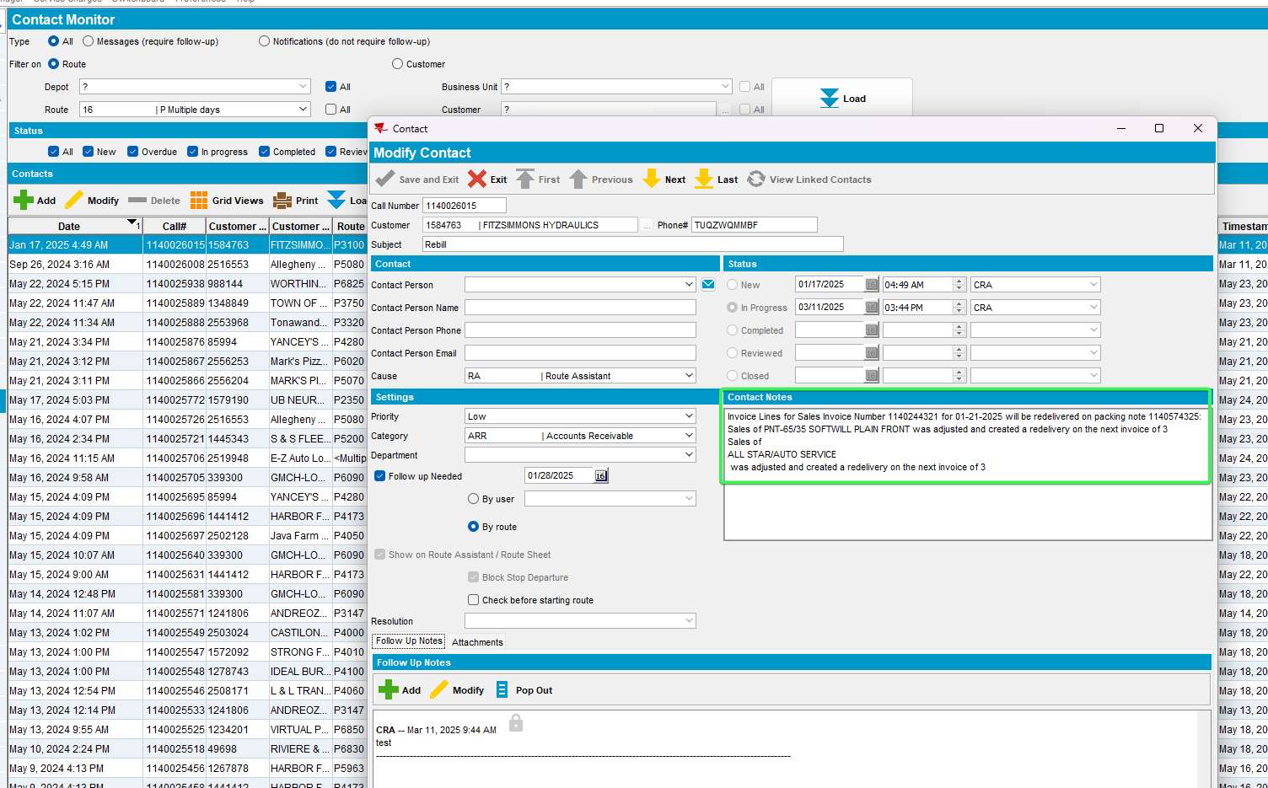
- Repeat 3-5 for Follow Up Notes Box as well
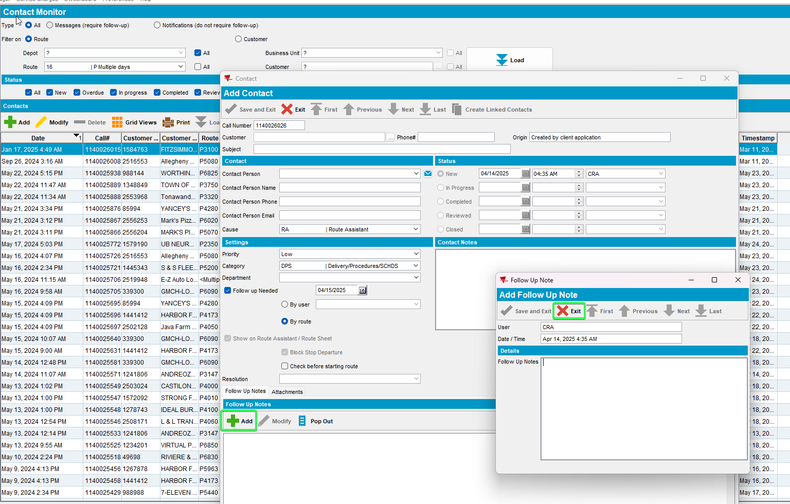
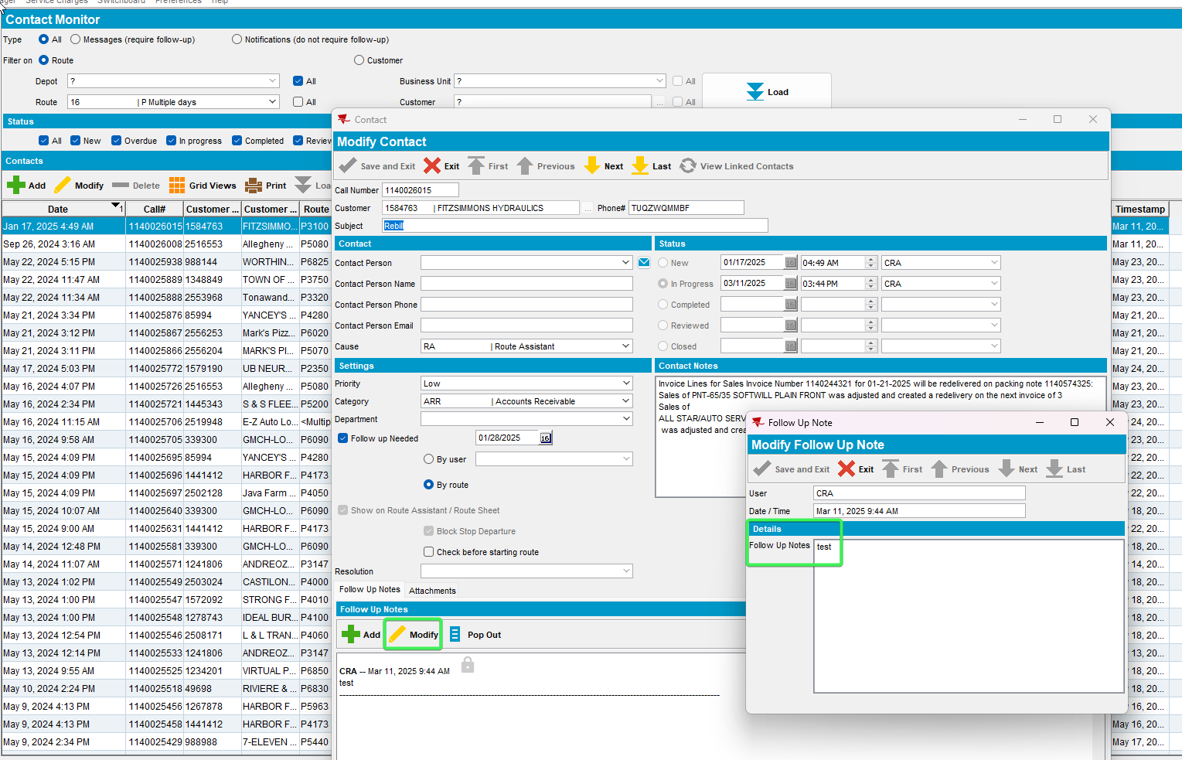
Tested OK

