ABSN-5203 D_UBS_2321 Invoices with $0 prebilled amount not sending by email to customer
Environment | Prerequisites
Version: 9.07.00.UNF19
DBServerName= abs-srv20.internal.abslbs.com
DBSID= CUST24
DBUser= UNFDEV
DBPassword= UNFDEV
Environment=Test

Contents
Retest after fix 1
Version: 9.07.00.UNF17.p06 hash: 9562892671a4 1

Retest after fix

Version: 9.07.00.UNF19 hash: e4ea4aab85bb

- Make an invoice with prebilled amount = 0 and Pay This Amount > 0
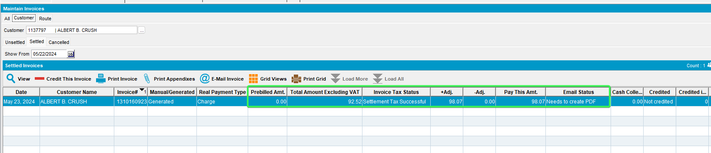
- Run the “E-mail Direct Invoices” process
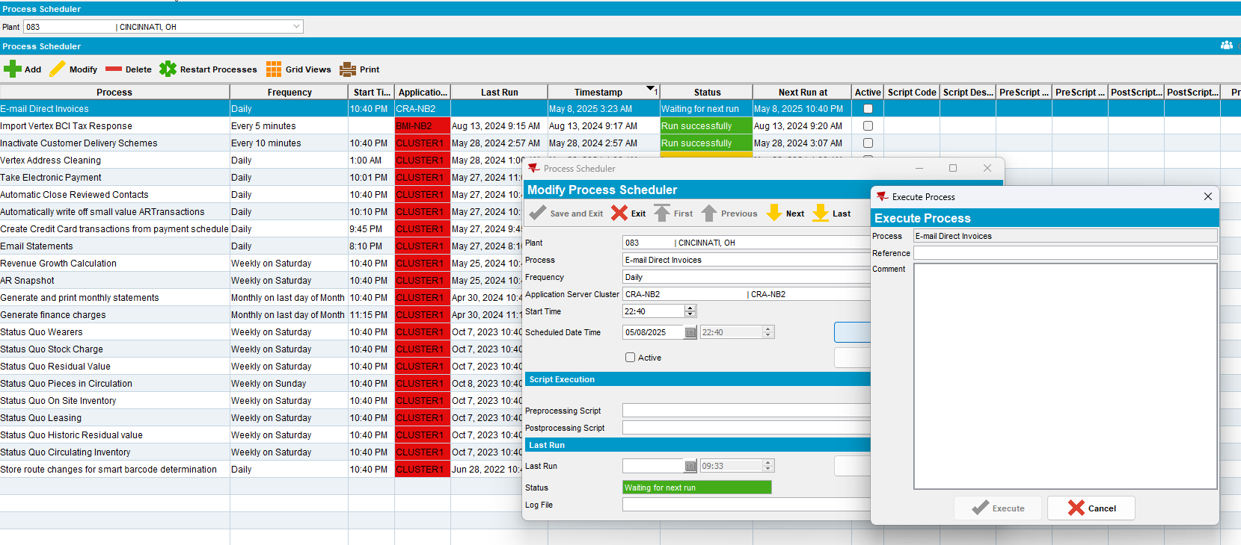

- Check the invoices email status.
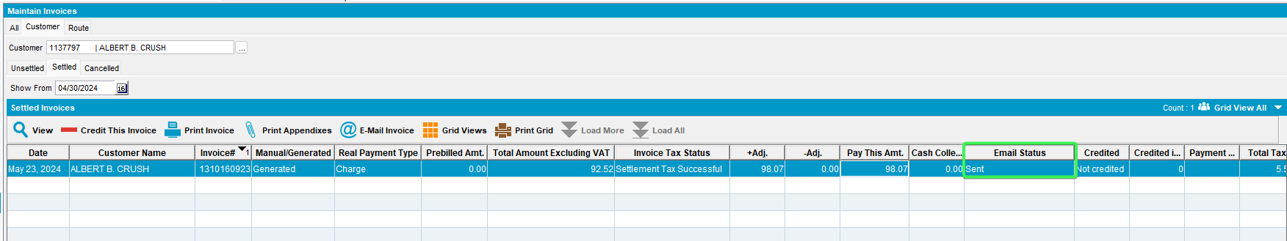
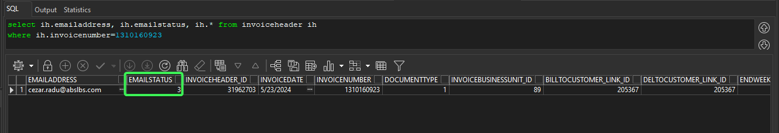
The email status is “Sent”
TESTED OK.

