ABSN-5186 D_UBS_2675 Multiple invoices generated by SYSADM for the exact same customer and delivery date but on different routes
Environment | Prerequisites
Version: 9.07.00.UNF17.p06  DBServerName=abs-SRV20.internal.abslbs.com  DBSID=CUST24  DBUser=UNFDEV  DBPassword=UNFDEV  Environment=Test | - Module:  - System setting

Contents
Retest after fix 1
Test Case 1 – Generate Invoices by Route Status Control 1
Test Case 2 – Generate Invoices by web services 3
Test Case 3 – Generate an Invoice by Web Services and one by Route Status Control 5
Test Case 4 – Generate Invoices by web services with a manual invoice on same date 7
Test Case 5 – Generate Invoices by web services with a credit invoice on same date 10
Test Case 6 – Generate Invoices by web services with a credit invoice on same date 12

Retest after fix
Hash: 41083562ba5d

Test Case 1 – Generate Invoices by Route Status Control

- Add a route in route status control and leave only one customer on the route.
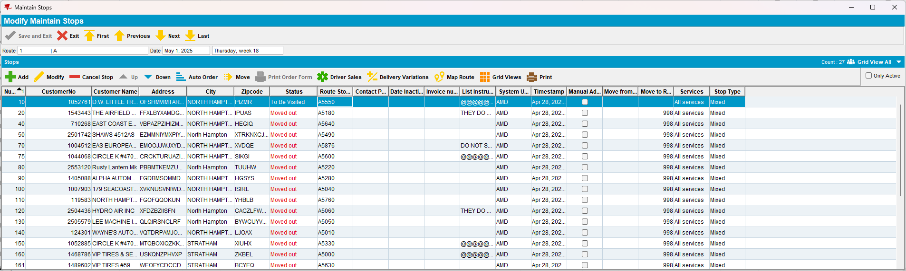

- Add an empty route for the same date.
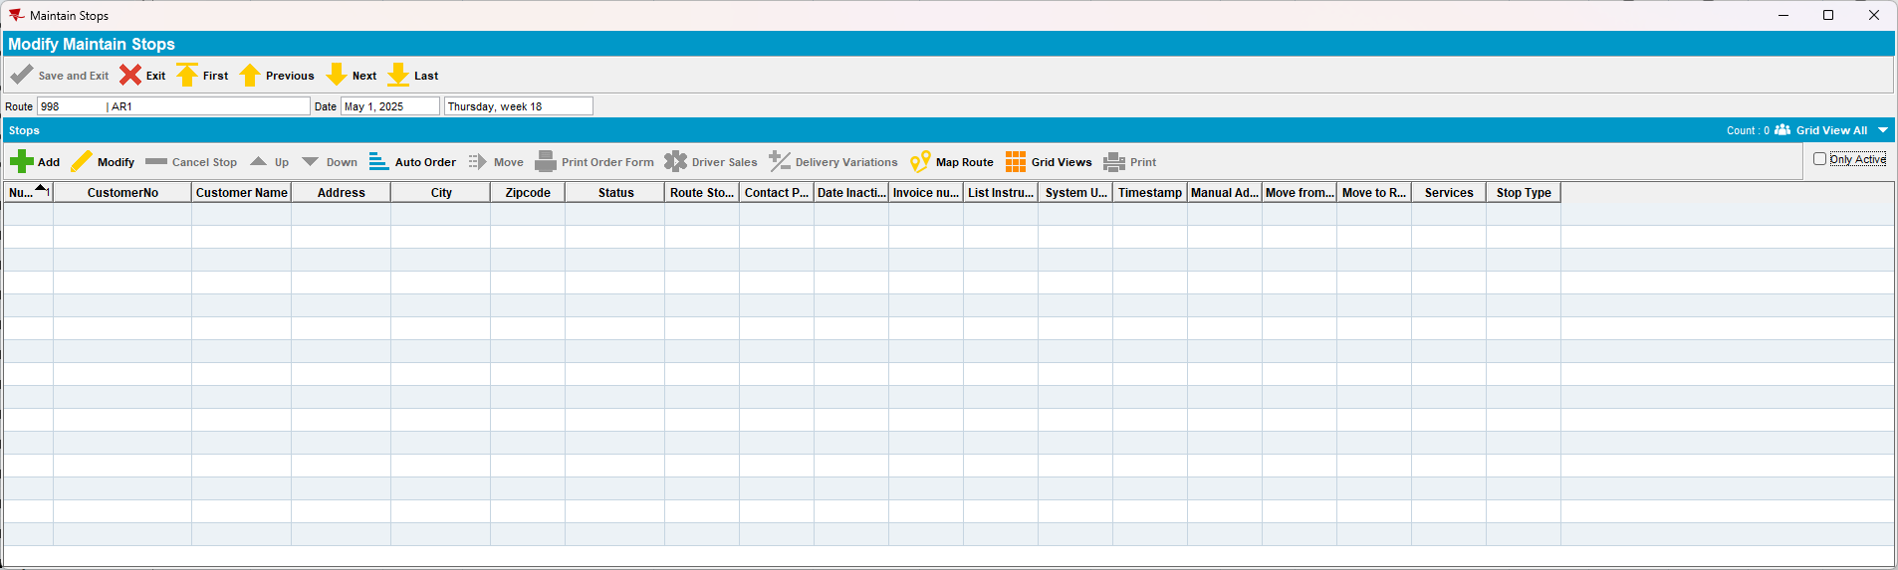

- On the empty route add a manual stop for the customer chosen at step 1.
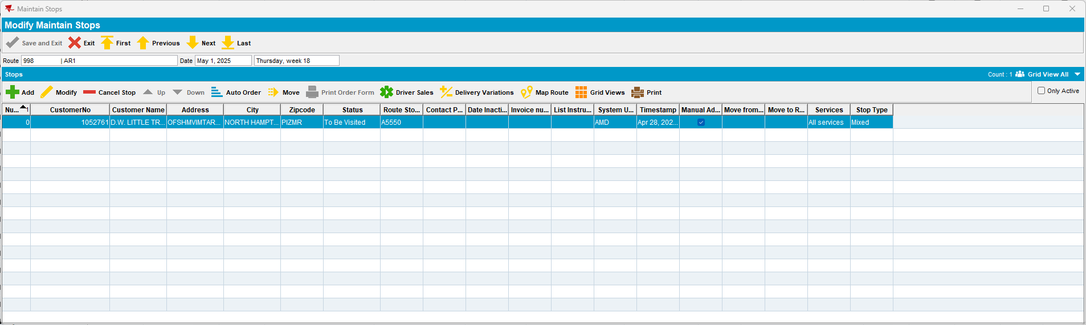

- Generate invoices at the same time for both routes by using route status control.
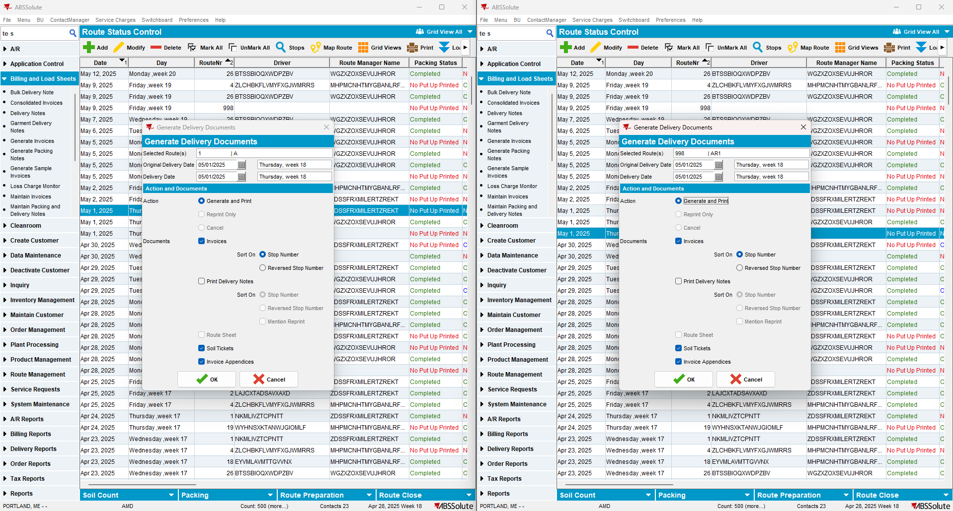
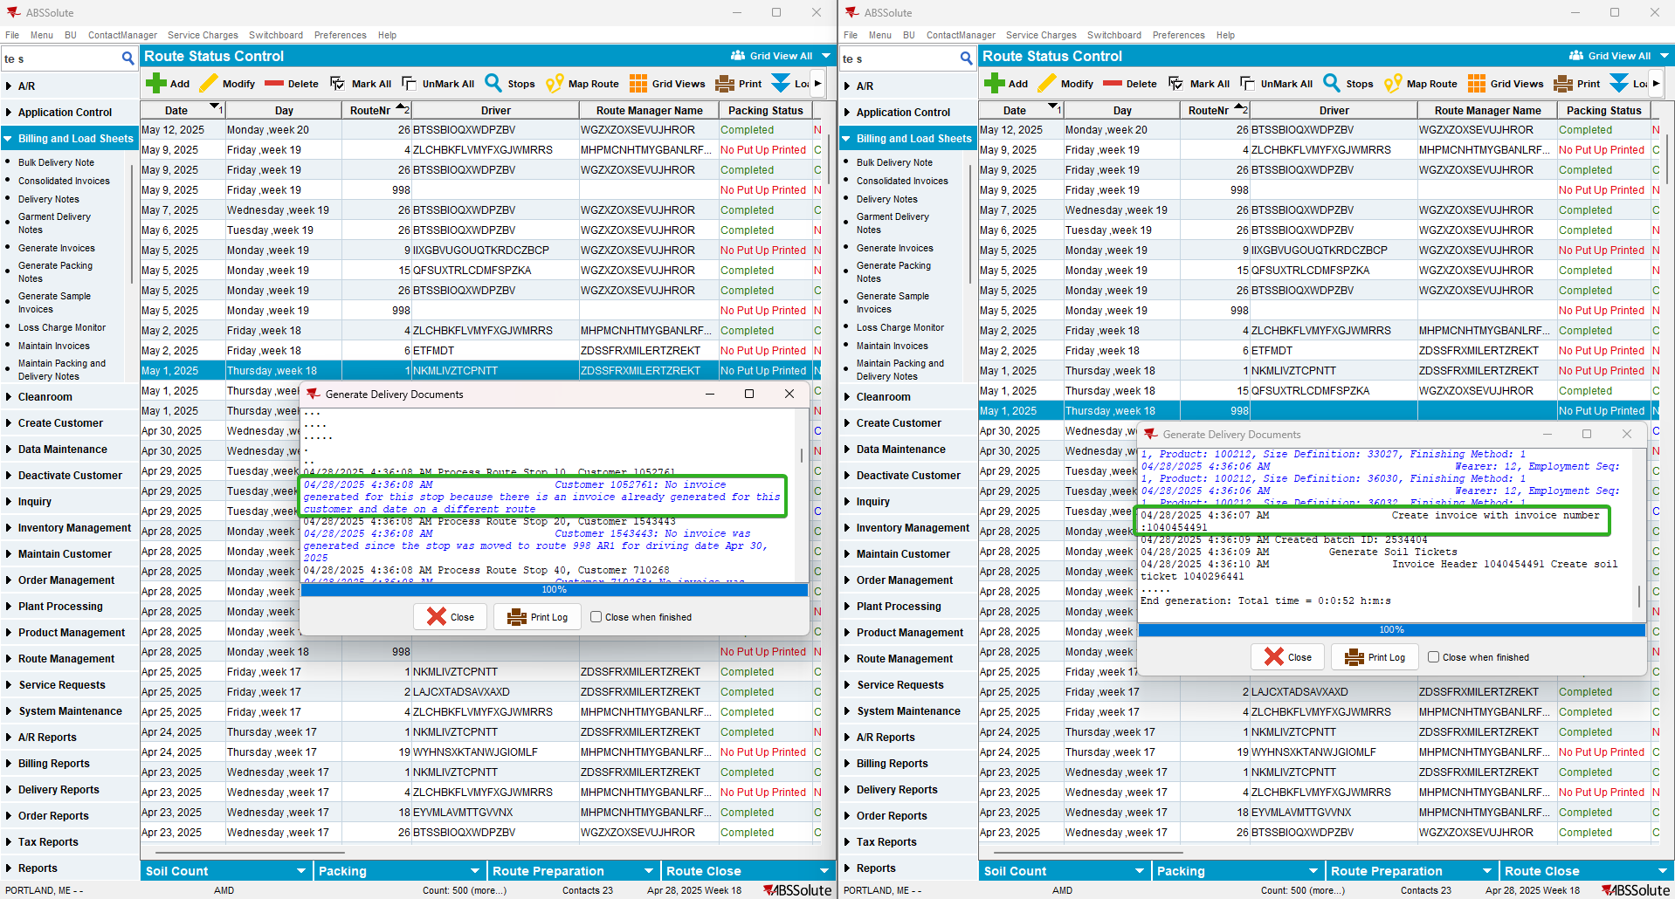

TESTED OK.

Test Case 2 – Generate Invoices by web services

- Add a route in route status control and leave only one customer on the route.

- Add an empty route for the same date.

- On the empty route add a manual stop for the customer chosen at step 1.

- Generate invoices at the same time for both routes by using web services.
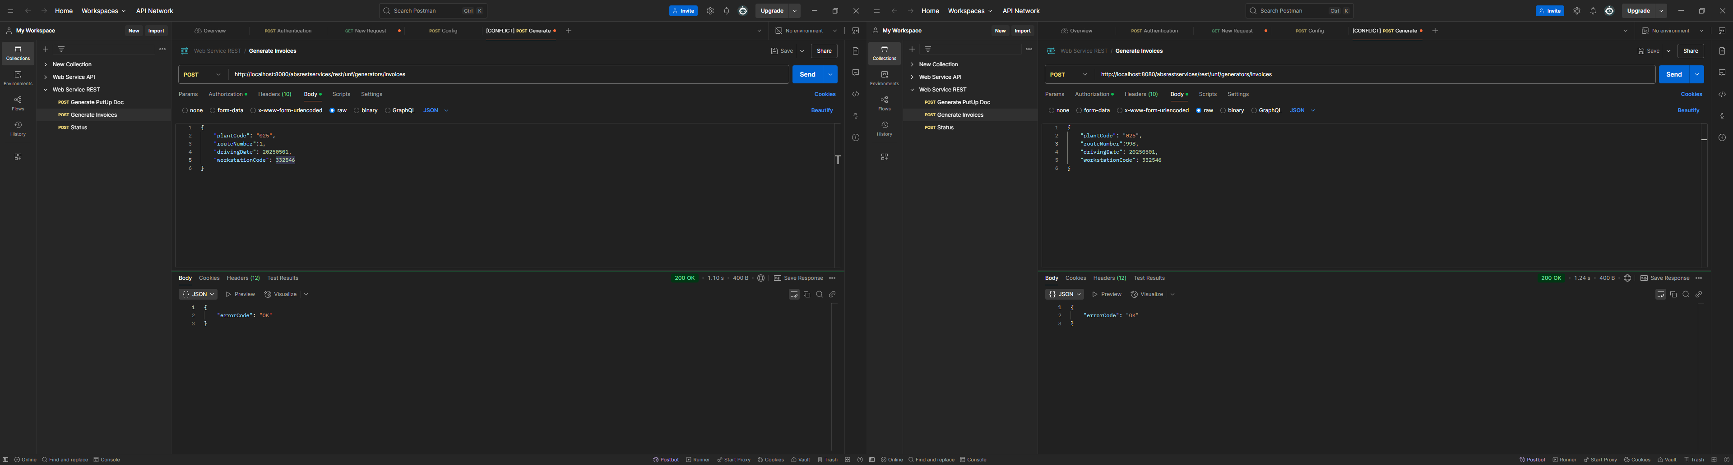

- Check the routes again
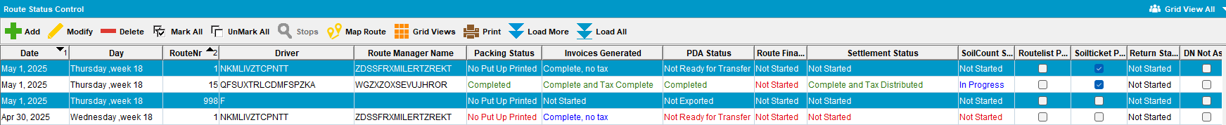

TESTED OK.

Test Case 3 – Generate an Invoice by Web Services and one by Route Status Control

- Add a route in route status control and leave only one customer on the route.

- Add an empty route for the same date.

- On the empty route add a manual stop for the customer chosen at step 1.

- Generate invoices at the same time for both routes by using web services.
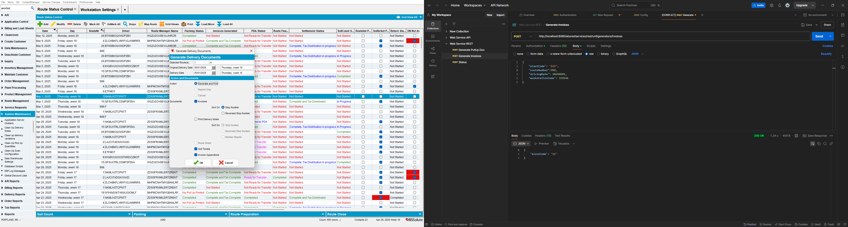
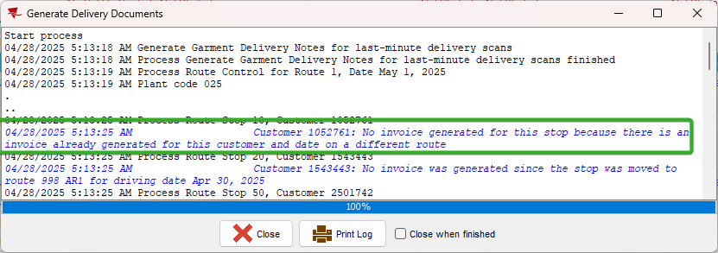

TESTED OK.

Test Case 4 – Generate Invoices by web services with a manual invoice on same date

- Add a route in route status control and leave only one customer on the route.

- Add an empty route for the same date.

- On the empty route add a manual stop for the customer chosen at step 1.

- Add a manual invoice on the same driving date.
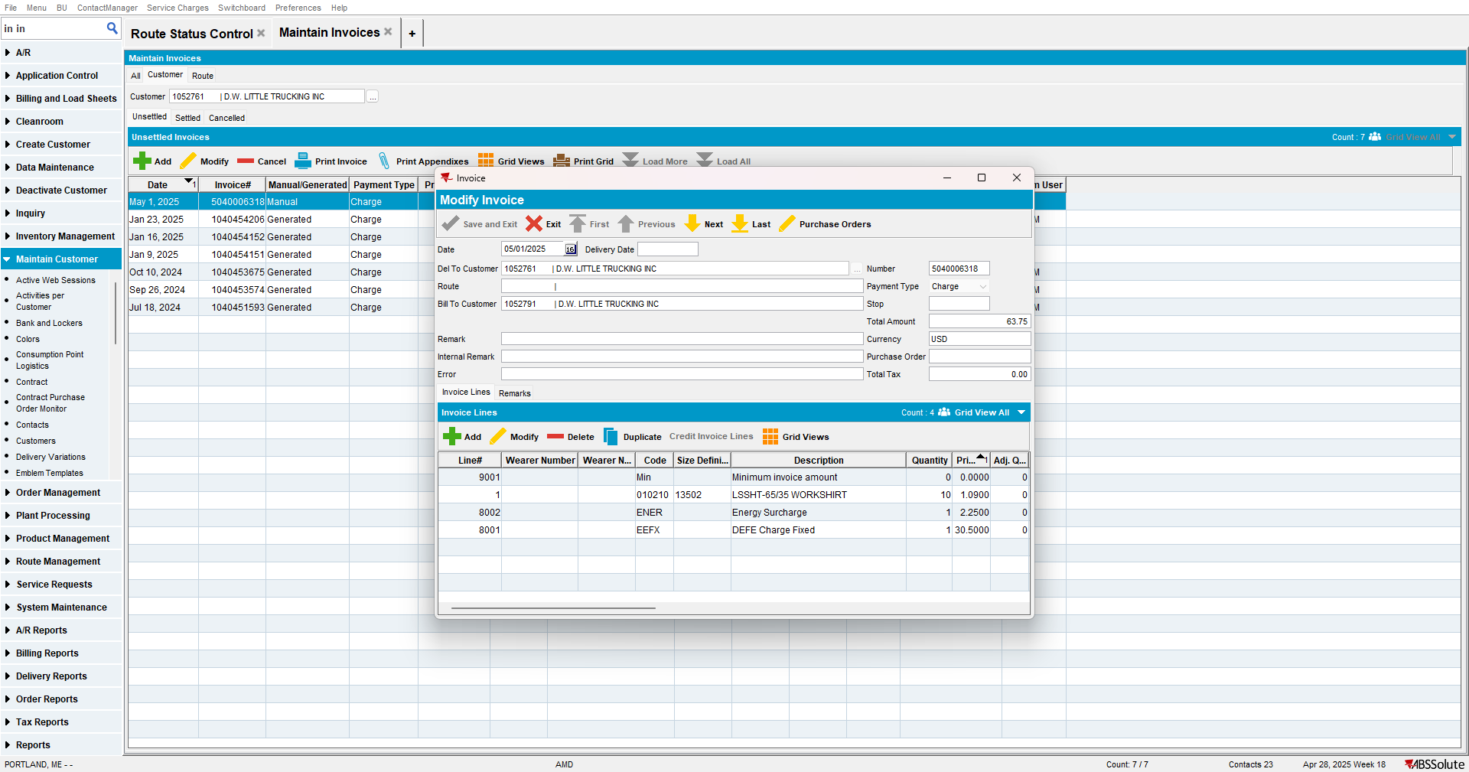

- Generate invoices at the same time for both routes by using web services.

- Check the routes again.
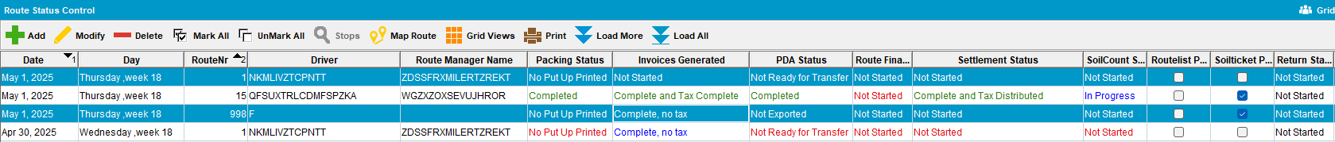
TESTED OK.

Test Case 5 – Generate Invoices by web services with a credit invoice on same date

- Add a route in route status control and leave only one customer on the route.

- Add an empty route for the same date.

- On the empty route add a manual stop for the customer chosen at step 1.

- Add a credit invoice on the same driving date.
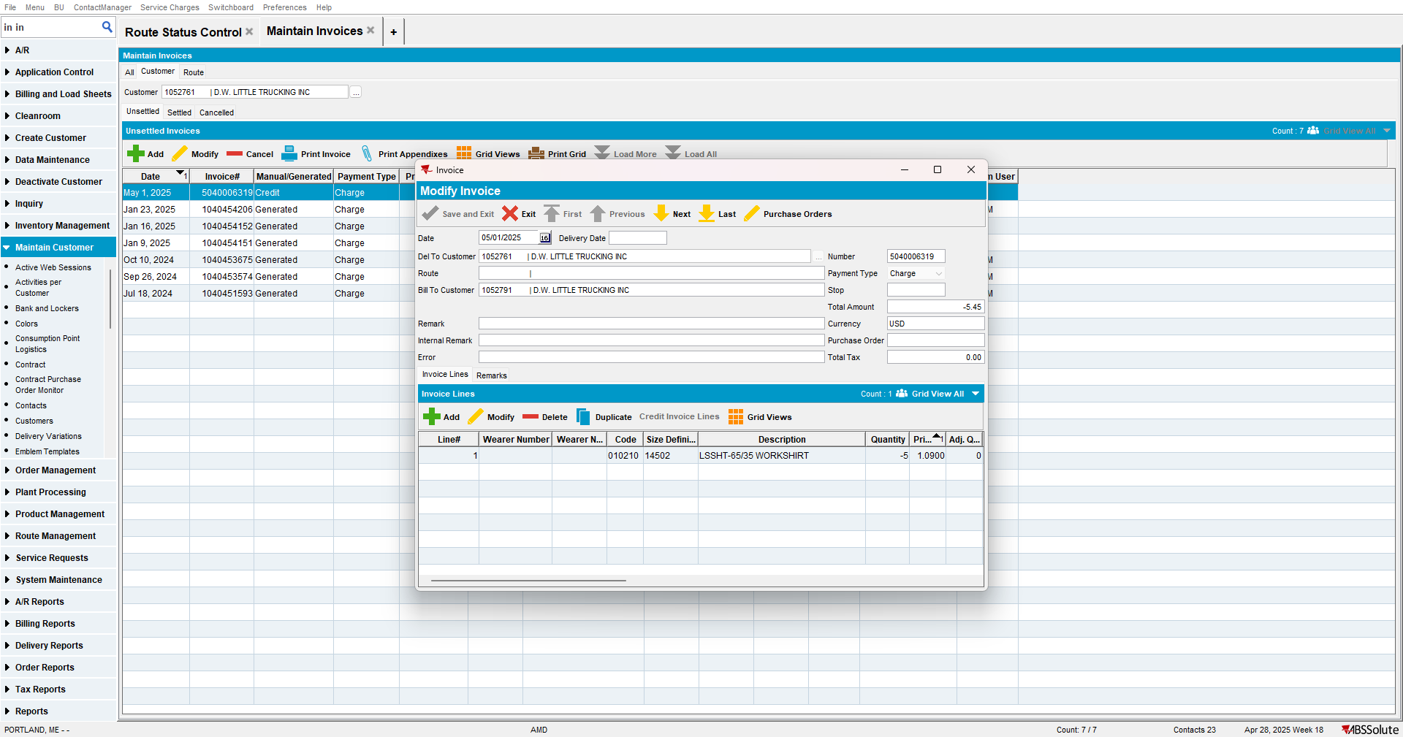

- Generate invoices at the same time for both routes by using web services.
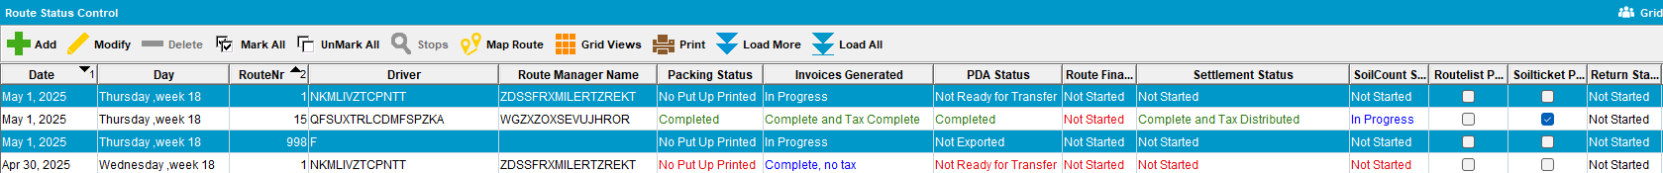

- Check the routes again.
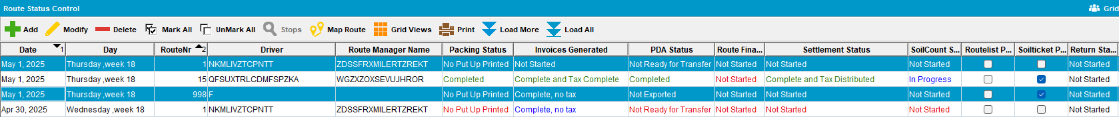TESTED OK.

Test Case 6 – Generate Invoices by web services with a credit invoice on same date

- Add a route in route status control and leave only one customer on the route.
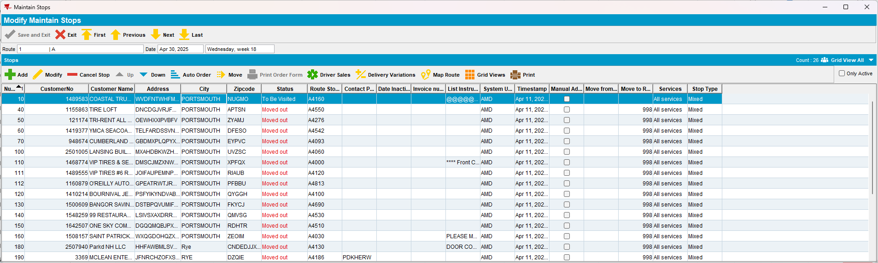

- Add an empty route for the same date.
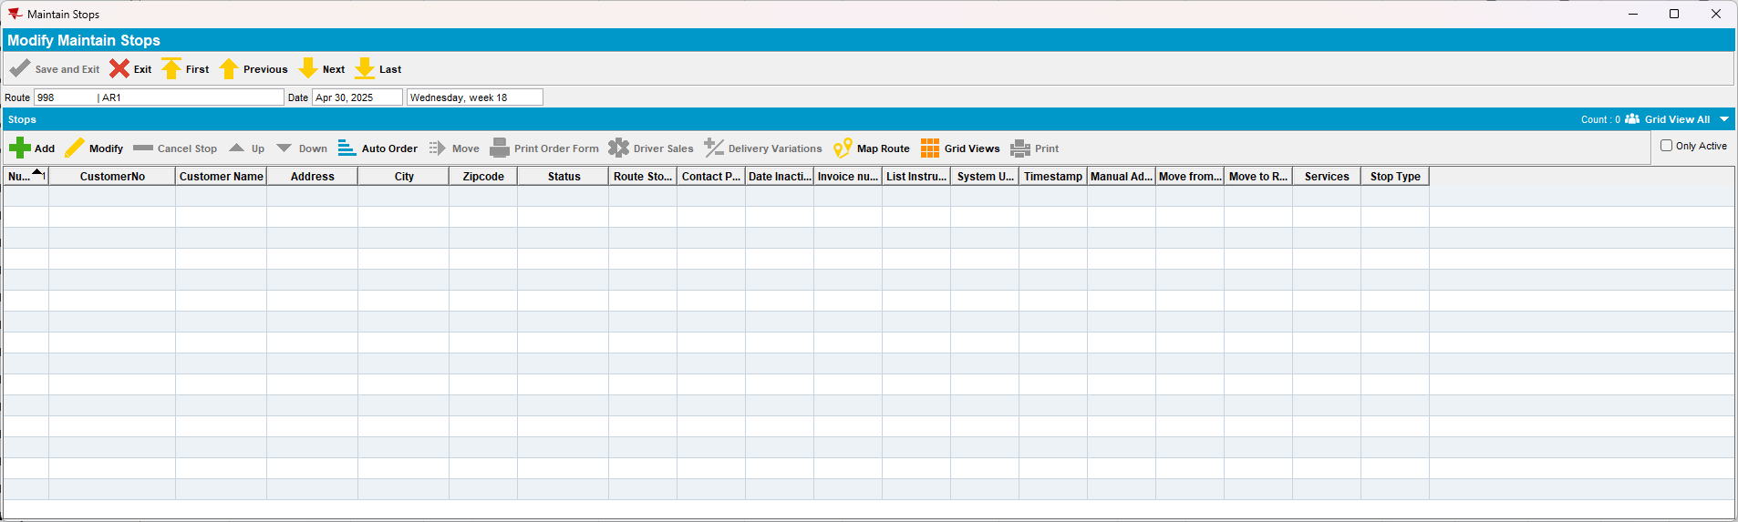

- On the empty route add a manual stop for the customer chosen at step 1.
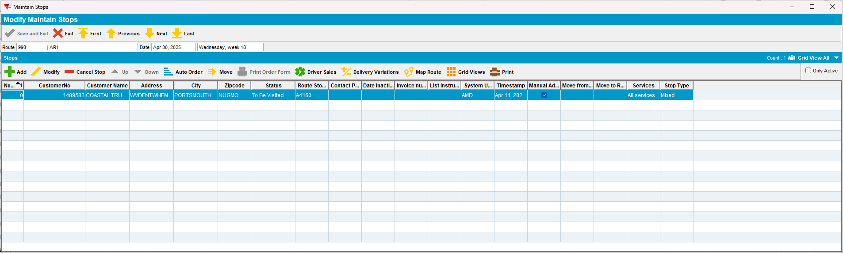

- Add another route for a week earlier and make the stop undeliverable .
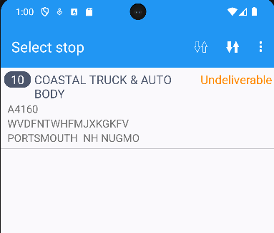

- Move the undeliverable stop to the initial route.
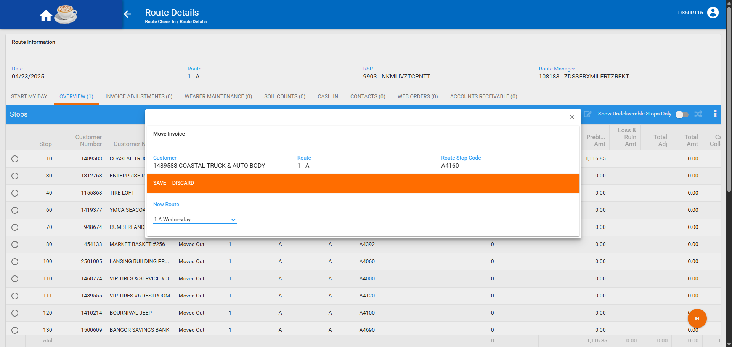
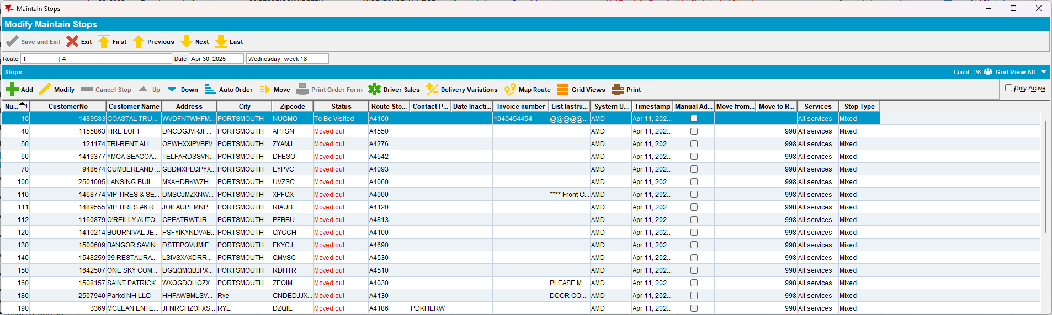
- Generate invoices at the same time for both routes by using web services.
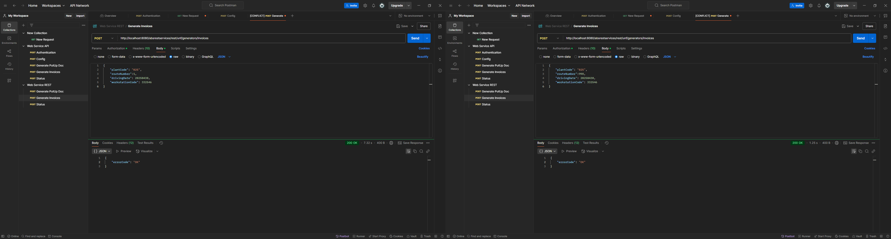
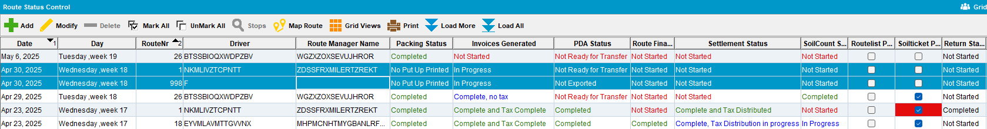

- Check the routes again.
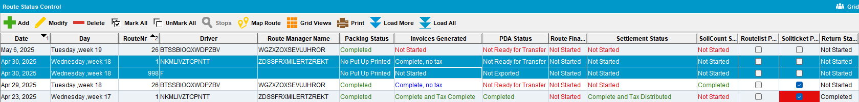
TESTED OK.

