ABSN-508 - WebX Route Checkin, overview tab, show pending invoice adjustment values before settlement
Environment | Prerequisites
Version: 9.07.00.UNF19  DBServerName= abs-srv20.internal.abslbs.com  DBSID=CUST24  DBUser=UNFDEV  DBPassword= UNFDEV  Environment=Test | - Module:  - System setting

Contents
Retest after fix 1
Data Preparation 1
Test Case 1 – INVOICELINEADJAPPROVERULE = 1 check that the columns “Pending Adjustments” and “Pending Total Amount” are present 8
Test Case 2 – INVOICELINEADJAPPROVERULE = 0 check that the columns are not present 13

Retest after fix

Data Preparation
- RSC: Create a new RC with 3 customers on it
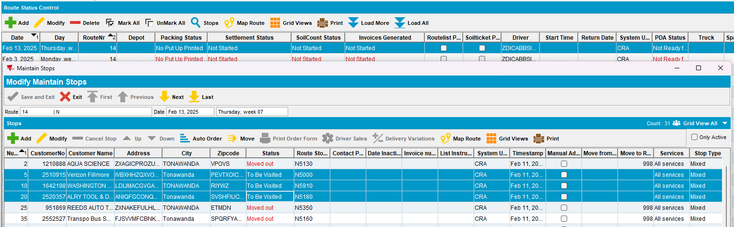
- Maintain Invoices DLG: Create a Manual Invoice for Customer 3 (2520357)
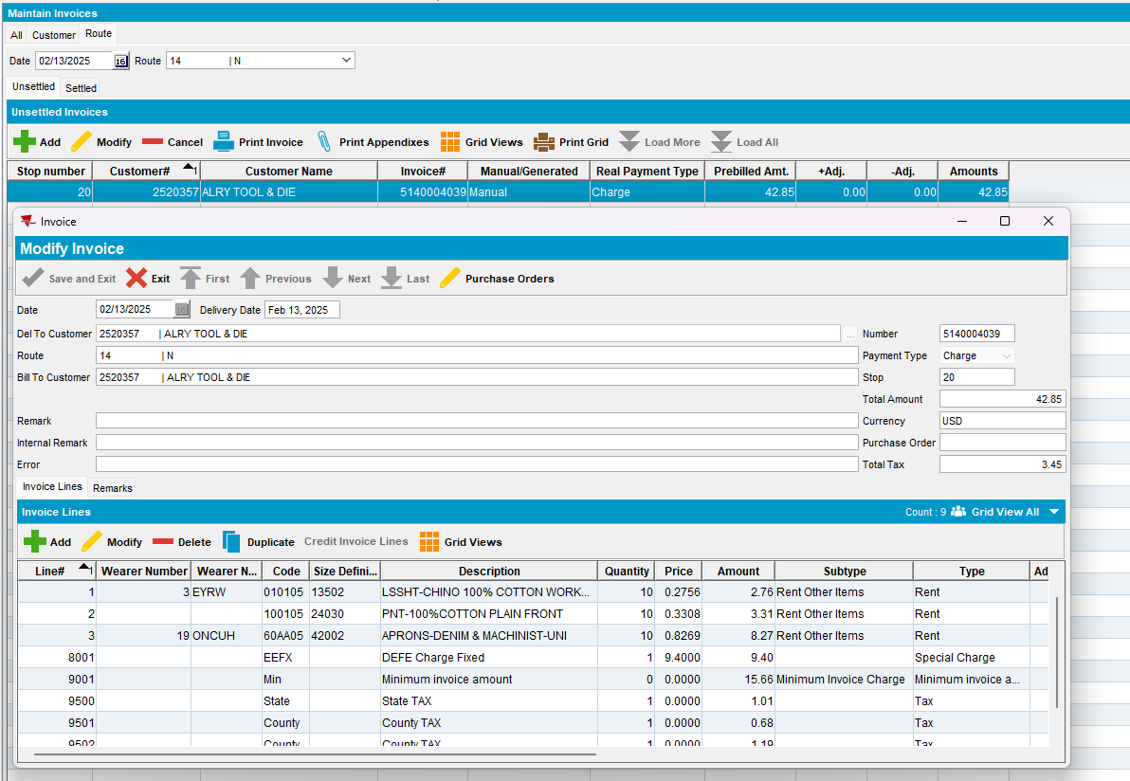
- Generate Invoices and script taxes
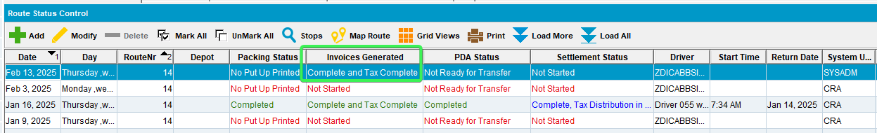
- Send the RC to PDA

- Arrive at Customer 1 and Full credit the Generated invoice
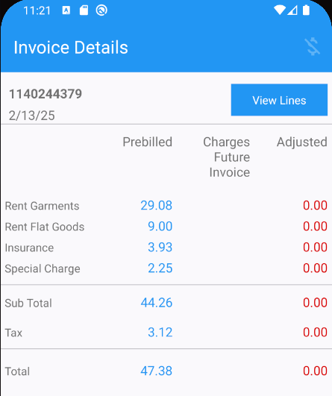
- Arrive the Customer 2 and quit a wearer
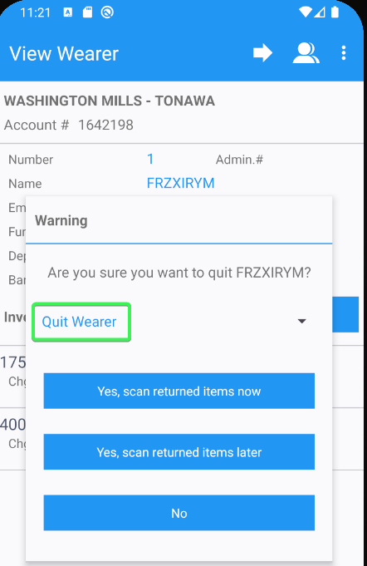
- Returned Items tab > Bill All for Loss now (703)
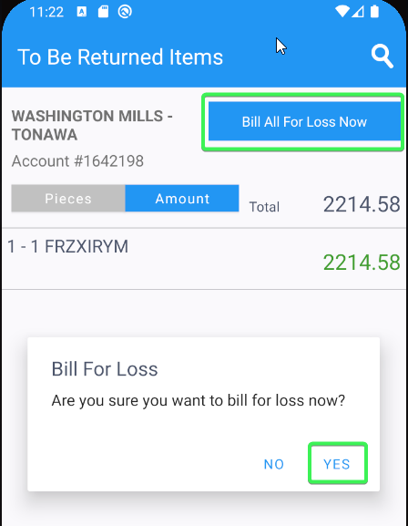
- Arrive at Customer 3 and create Plus (702) and Minus (701) adjustments
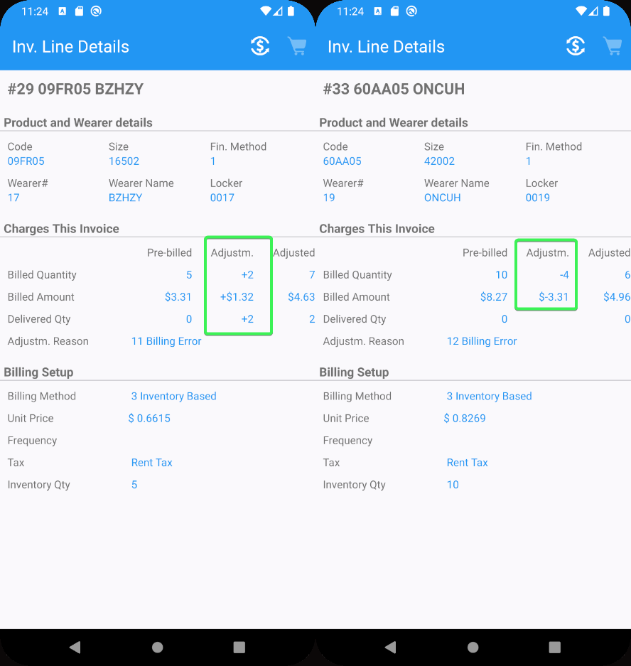
Manual Invoice
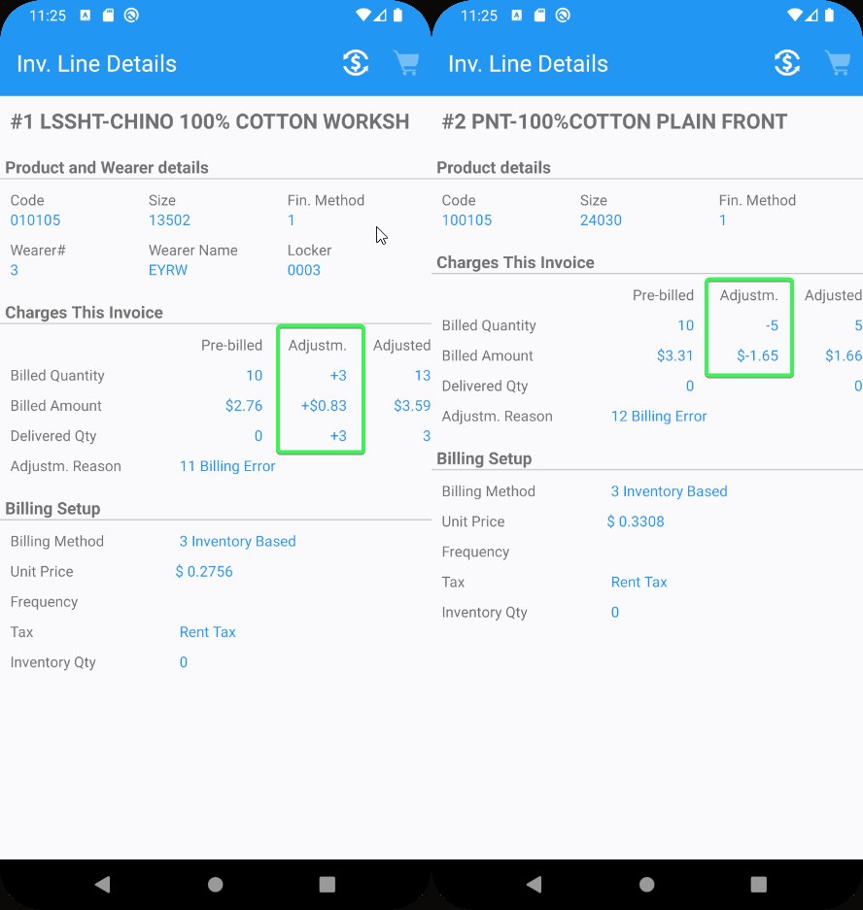
- Settle and upload the data
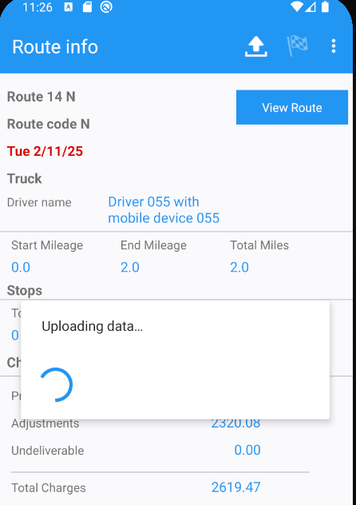

Test Case 1 – INVOICELINEADJAPPROVERULE = 1 check that the columns “Pending Adjustments” and “Pending Total Amount” are present
Hash: e83bb6dbcd30
- System Settings DLG: Have INVOICELINEADJAPPROVERULE = 1
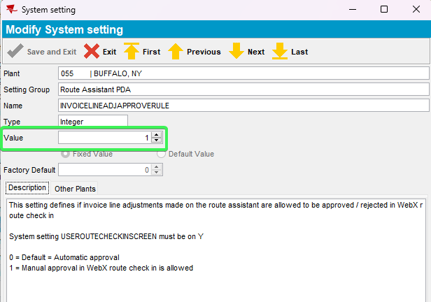
- WebX: Find your route and complete Start my day
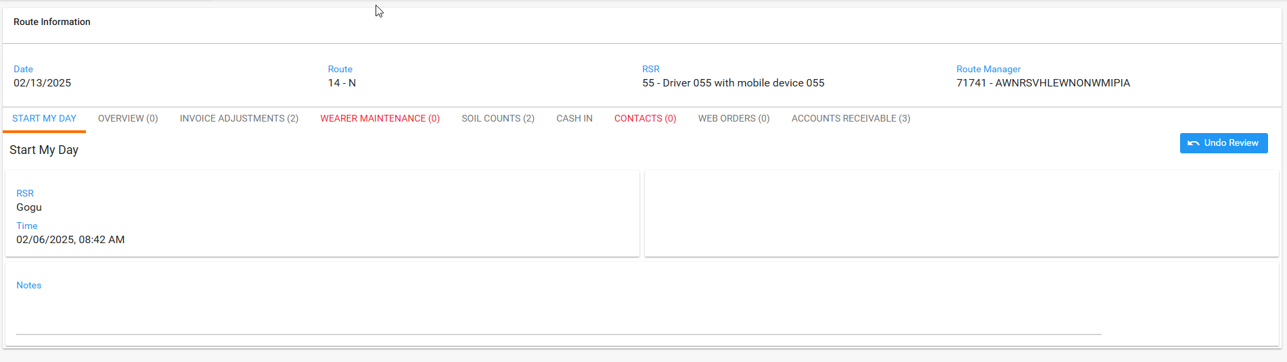
- Overview tab: Check that the 2 columns are not default
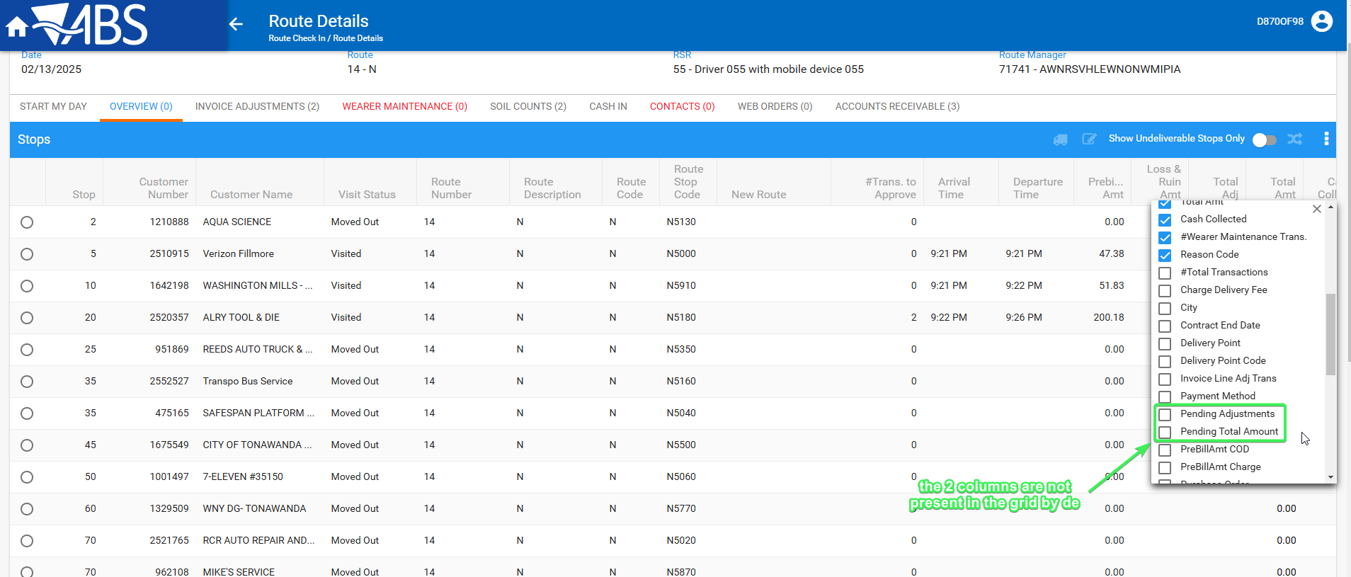
- Check that “Pending Adjustments” and “Pending Total Amount” can be added from Grid settings
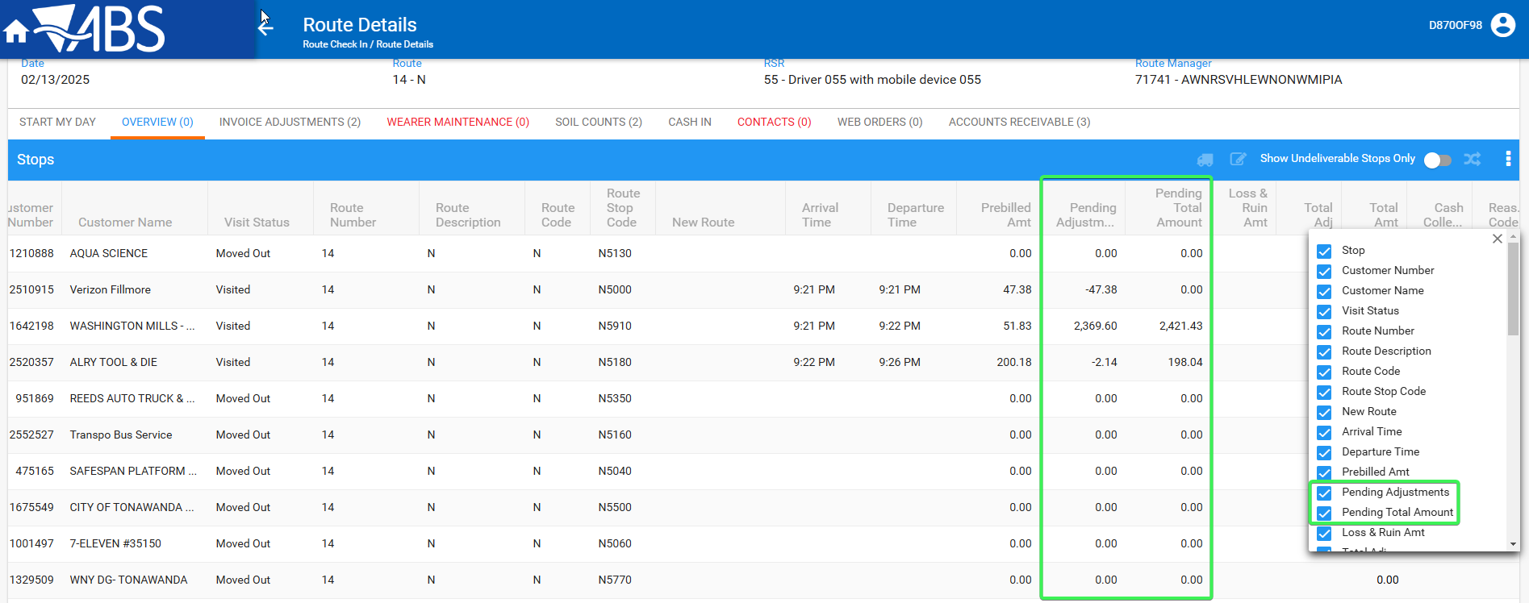

- Check the current values of the “Pending Adjustments” and “Pending Total Amount” columns against the values from the data base using the following select

SELECT SUM(RT.DOUBLEVALUE1) AS PENDING_ADJUSTMENTS, IH.PREBILLAMOUNT, (IH.PREBILLAMOUNT+SUM(RT.DOUBLEVALUE1)) AS PENDING_TOTAL_ADJUSTMENTS, C.CUSTOMERNUMBER FROM ROUTETRANSACTION RT
JOIN STOP S ON S.STOP_ID = RT.STOP_ID
JOIN CUSTOMER C ON C.CUSTOMER_ID = S.CUSTOMER_LINK_ID
JOIN INVOICEHEADER IH ON IH.INVOICEHEADER_ID = RT.INVOICEHEADER_ID
WHERE RT.ROUTECONTROL_ID = (select rc.routecontrol_id
from routecontrol rc
join route r
on r.route_id = rc.route_id
join plant p
on p.plant_id = r.plant_id
where rc.drivingdate = to_date('13/02/2025', 'dd/mm/yyyy')
and r.routenumber = 14
and p.code = '055')
AND RT.ROUTETRANSACTIONTYPE_ID IN (701, 702, 703, 704, 705, 706)
GROUP BY C.CUSTOMERNUMBER, IH.PREBILLAMOUNT;
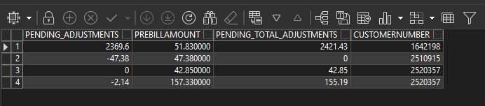
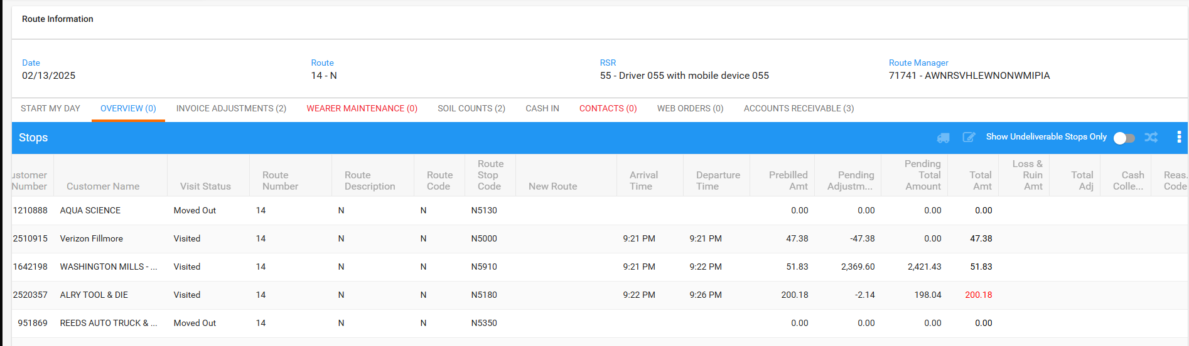
- Invoice Adjustments tab: Add a minus invoice adjustment to Customer 2 (1642198)
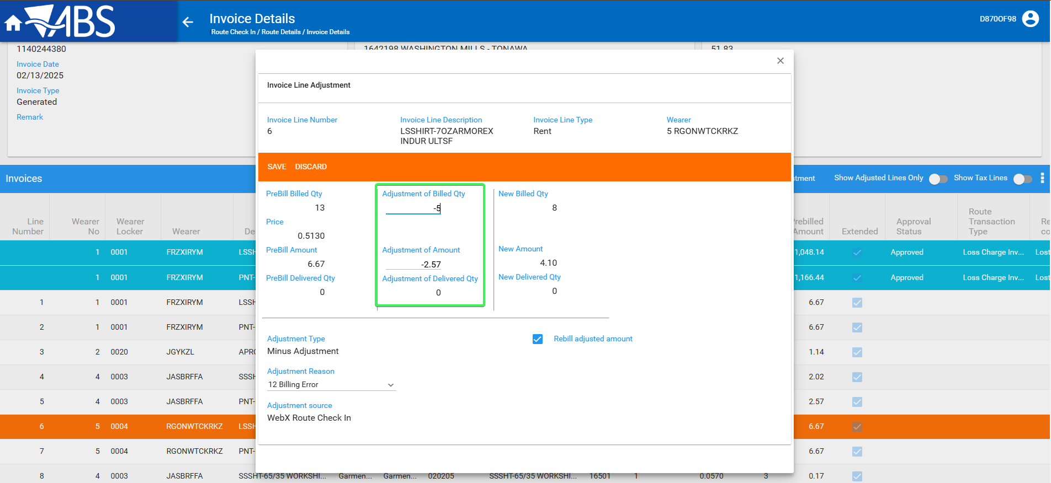
- See that the “Pending Adjustments” and “Pending Total Amount” columns change values
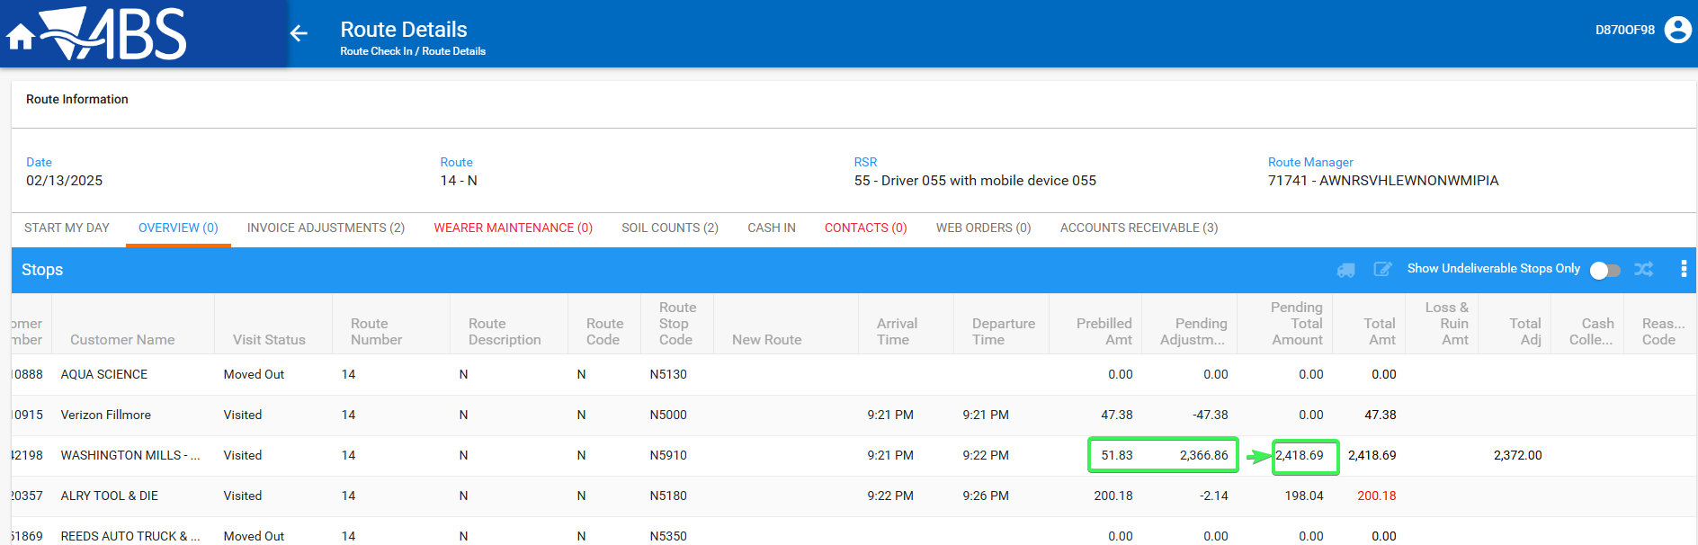
- Review all the tabs
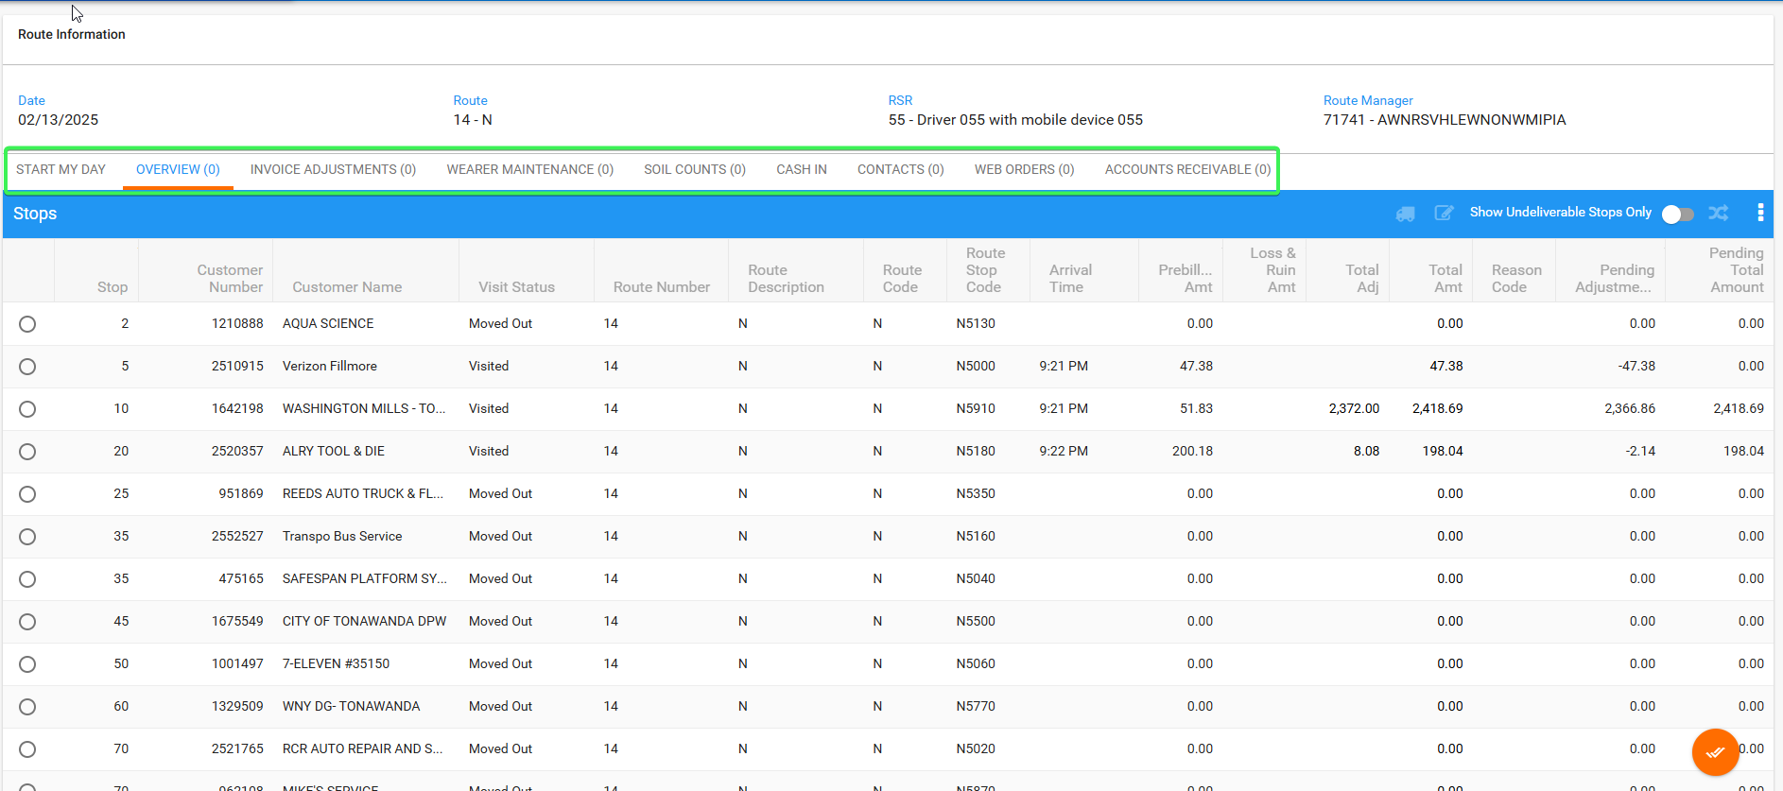
- Settle the route
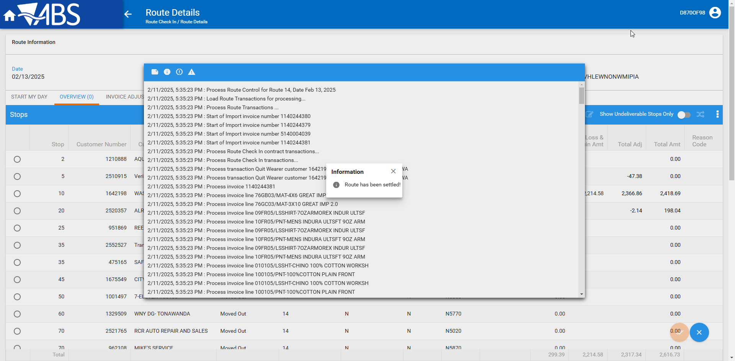
- Check that the values in “Pending Adjustments” and “Pending Total Amount” columns are blank
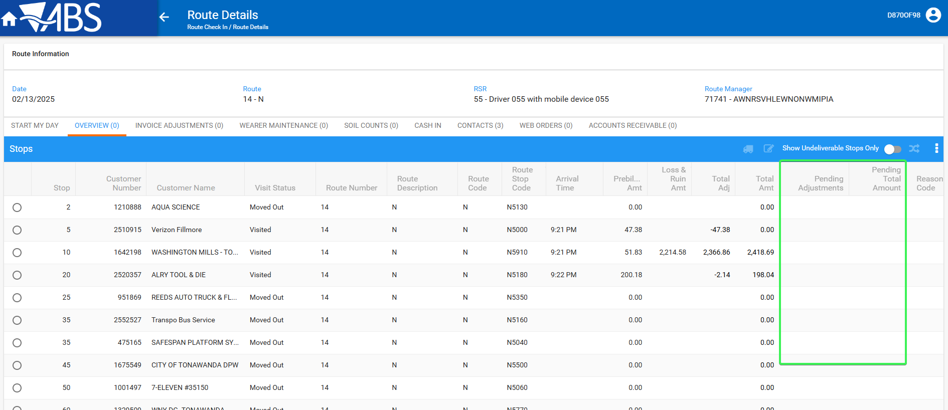
Tested OK

Test Case 2 – INVOICELINEADJAPPROVERULE = 0 check that the columns are not present
Hash: e83bb6dbcd30
- System Settings DLG: Have INVOICELINEADJAPPROVERULE = 0
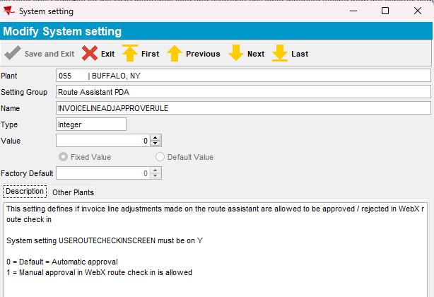
- WebX: Find your route and complete Start my day
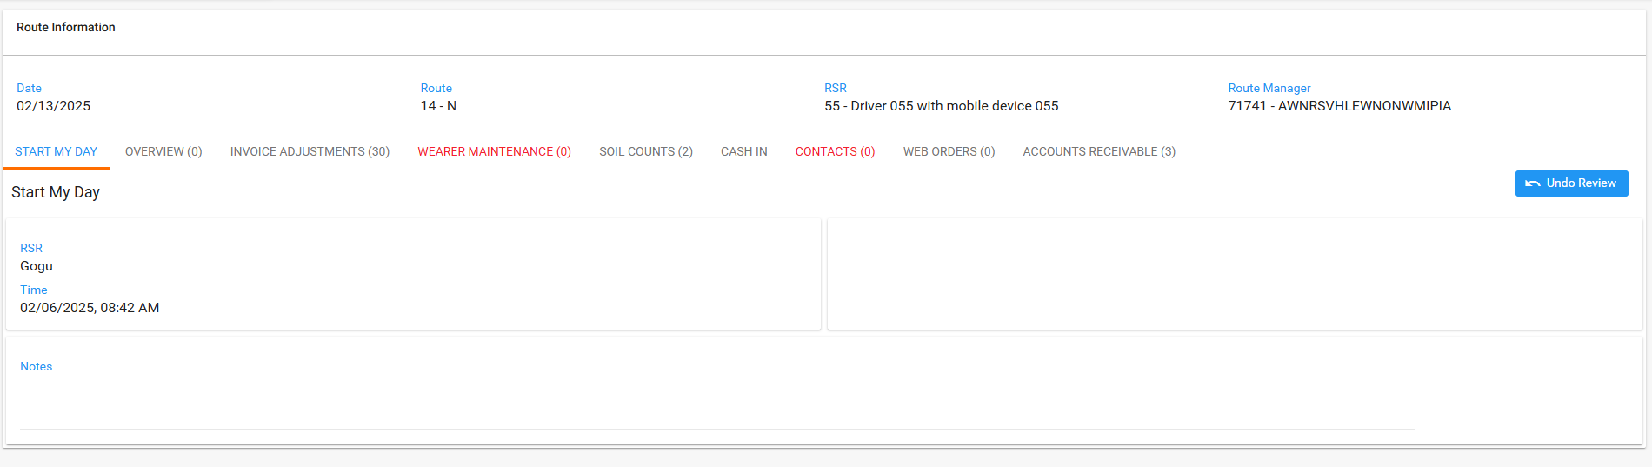
- Overview tab: Check that the 2 columns are not present
“Pending Adjustments” and “Pending Total Amount” columns are not present anymore
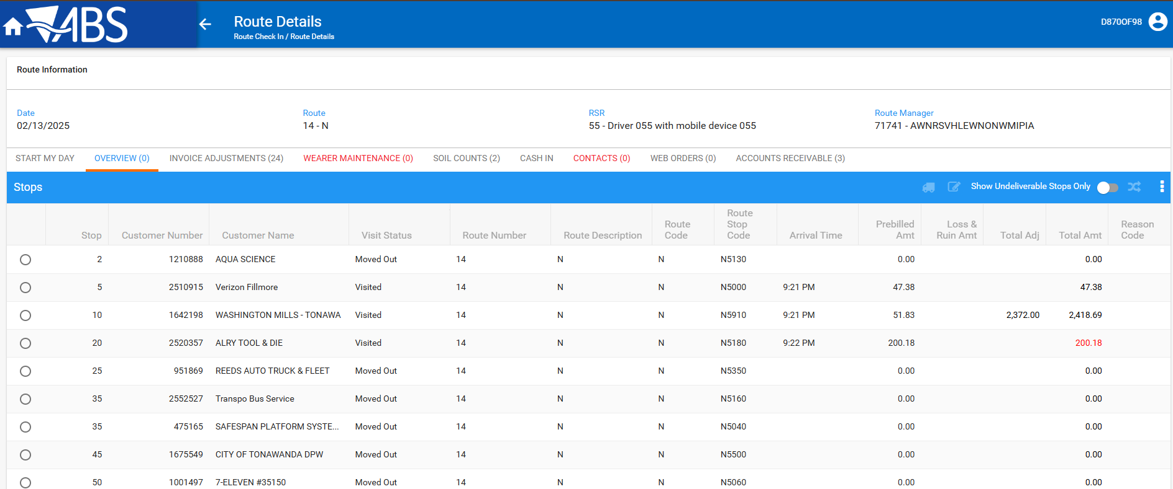
Also, they are not present in the Grid Settings either
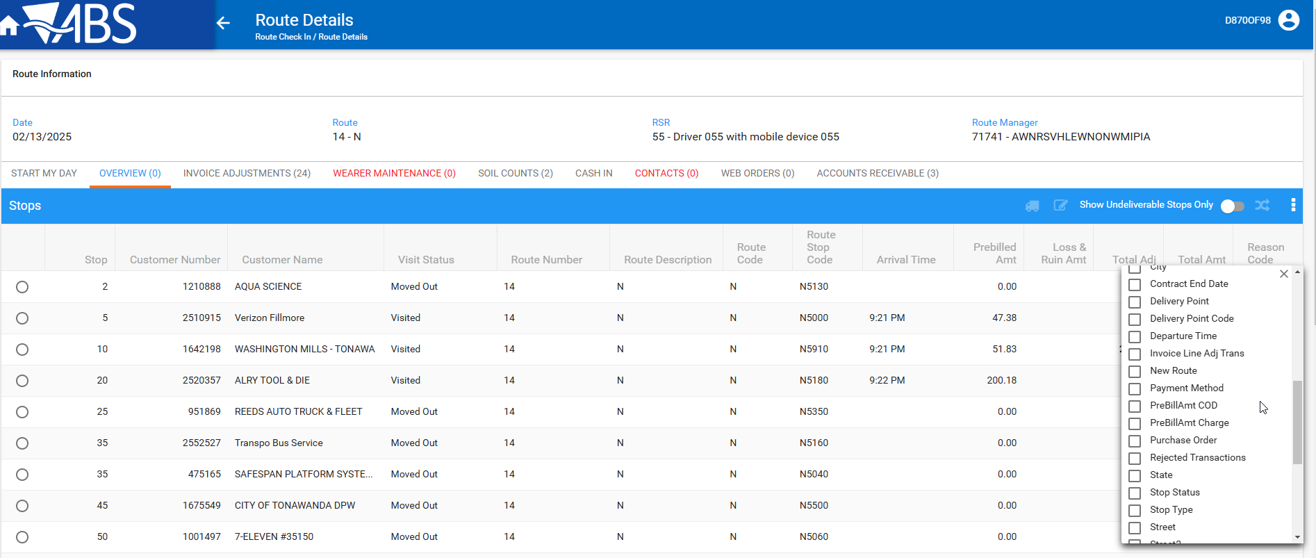
Tested OK

