ABSN-497 Packing Note Generation - With SALESDNONINVOICEDROUTE = 3 and RC.INVOICESGENERATED<>1 PN will be generated unassigned
Environment | Prerequisites
Version:9.07.00  DBServerName=abs-SRV20.internal.abslbs.com  DBSID=CUST24  DBUser=UNFDEV  DBPassword=UNFDEV  Environment=Test | - Module:  - System setting

Contents
Test after fix 1
Test Case 1 – RC.POCKETPCSTATUS = 0– Tested OK 1
Test Case 2 – RC.POCKETPCSTATUS = 3 and (select rca.* from routecontrolradownload rca where rca.routecontrol_id = ?) dose not return a record --> was never downloaded on RA – Tested OK 6
Test Case 3 – RC.POCKETPCSTATUS = 3 and max(select rca.endownloadtimestamp from routecontrolradownload rca where rca.routecontrol_id = ?) is not null – Tested OK 12
Test Case 4 – RC.POCKETPCSTATUS = 3 and max(select rca.endownloadtimestamp from routecontrolradownload rca where rca.routecontrol_id = ?) is null – Tested OK 20
Test Case 5 – RC.POCKETPCSTATUS in (1, 2) – Tested OK 28

Test after fix

Test Case 1 – RC.POCKETPCSTATUS = 0– Tested OK
Expected behavior: the generated PackingNote for the sales note SHOULD be attached to the route control
Hash: 48323c5
- Check that you have module TRADE in license
- Check that SS SALESDNONINVOICEDROUTE is set to 3
- Add a route in RSC
- Generate packing notes and invoices for at least one stop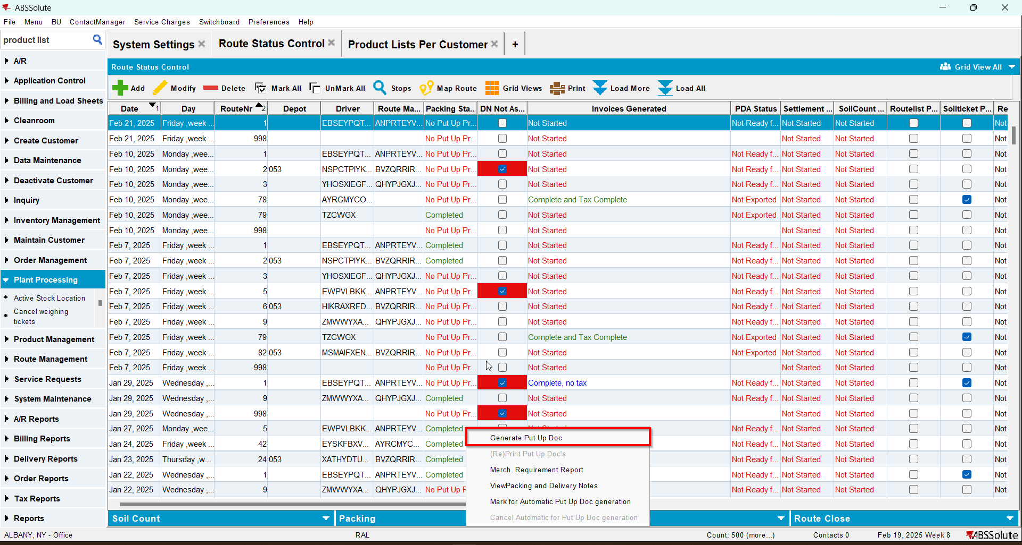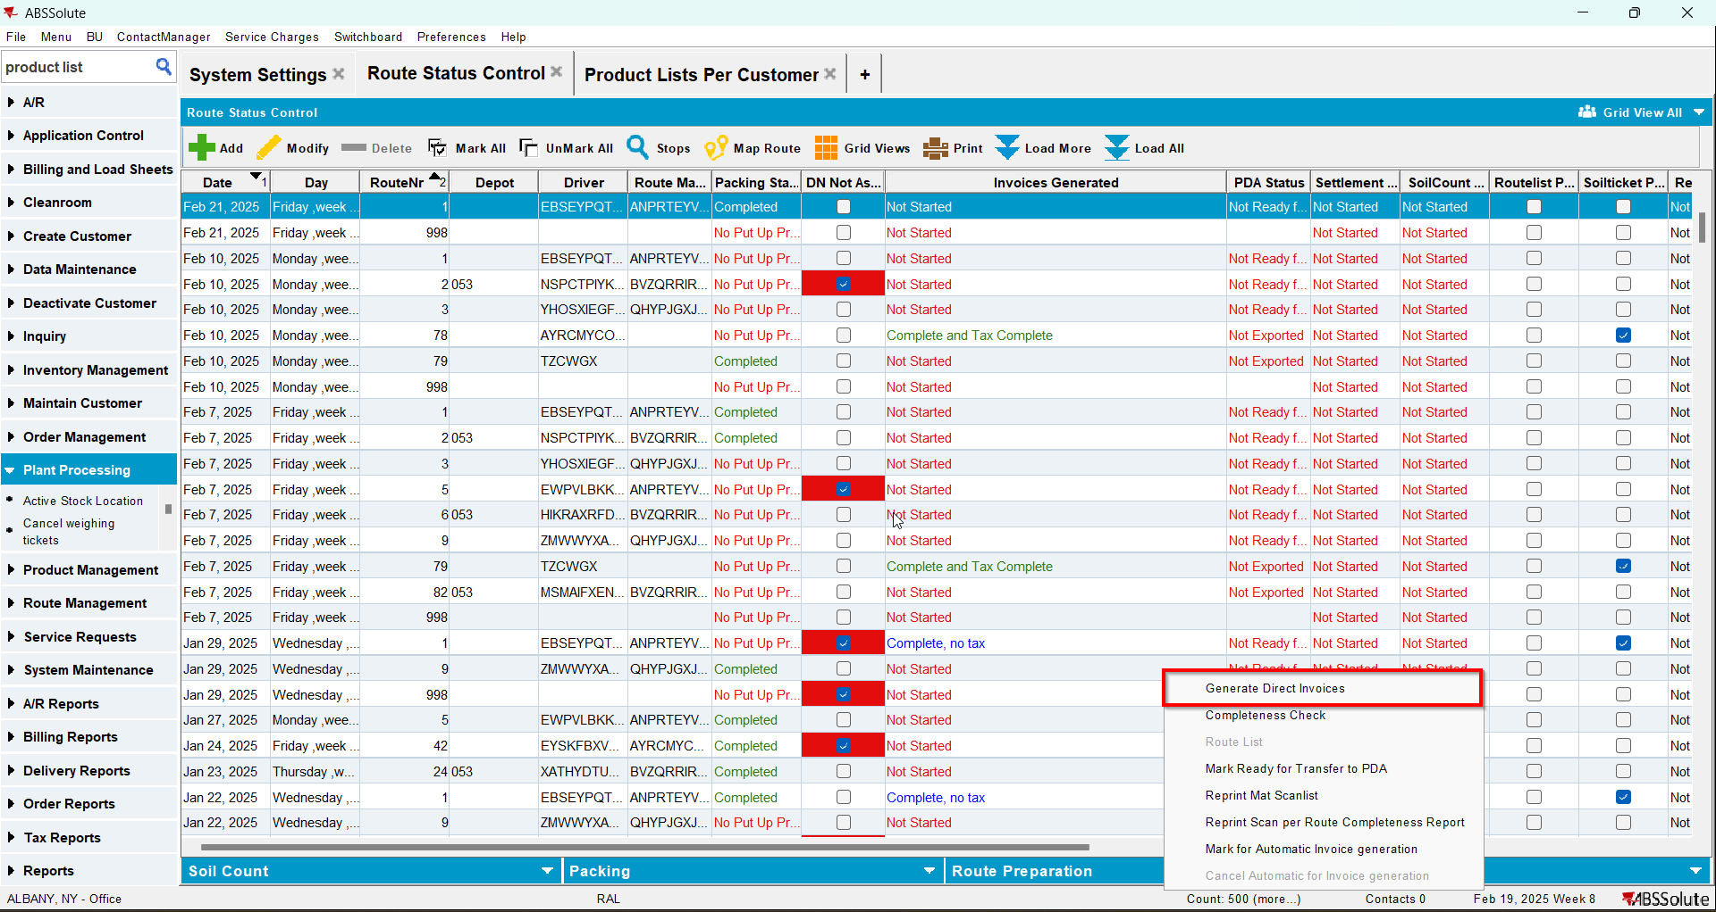
- Maintain Sales Notes DLG: Create a sales note for one of the customers with an active stop on the route from step 1
- Sales Order DLG: Add at least one product to the Ordered Items tab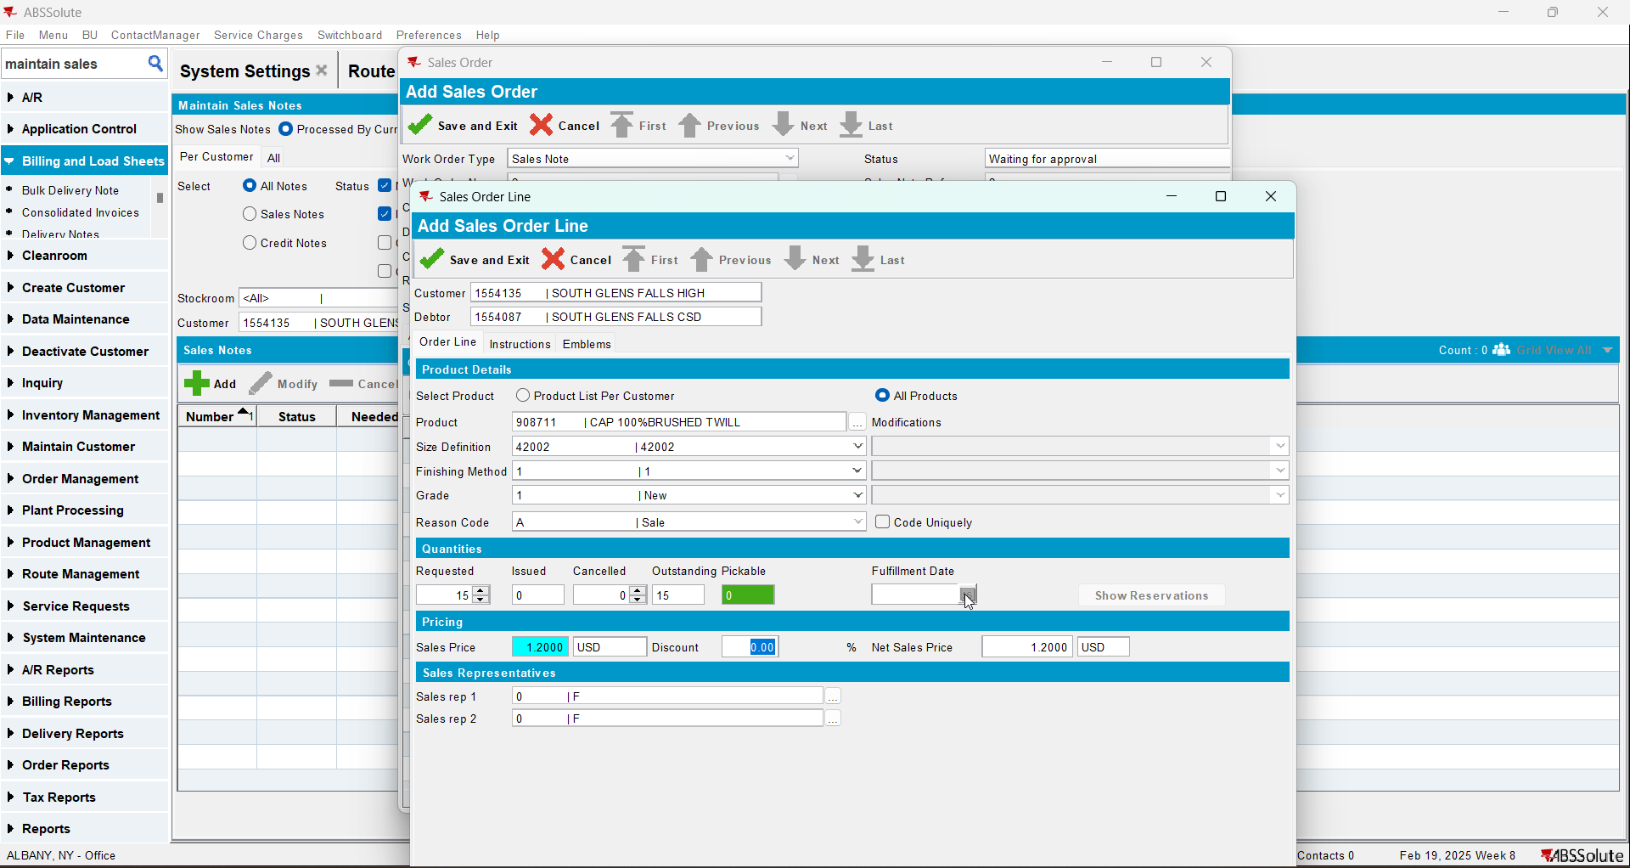
- Save the Sales Order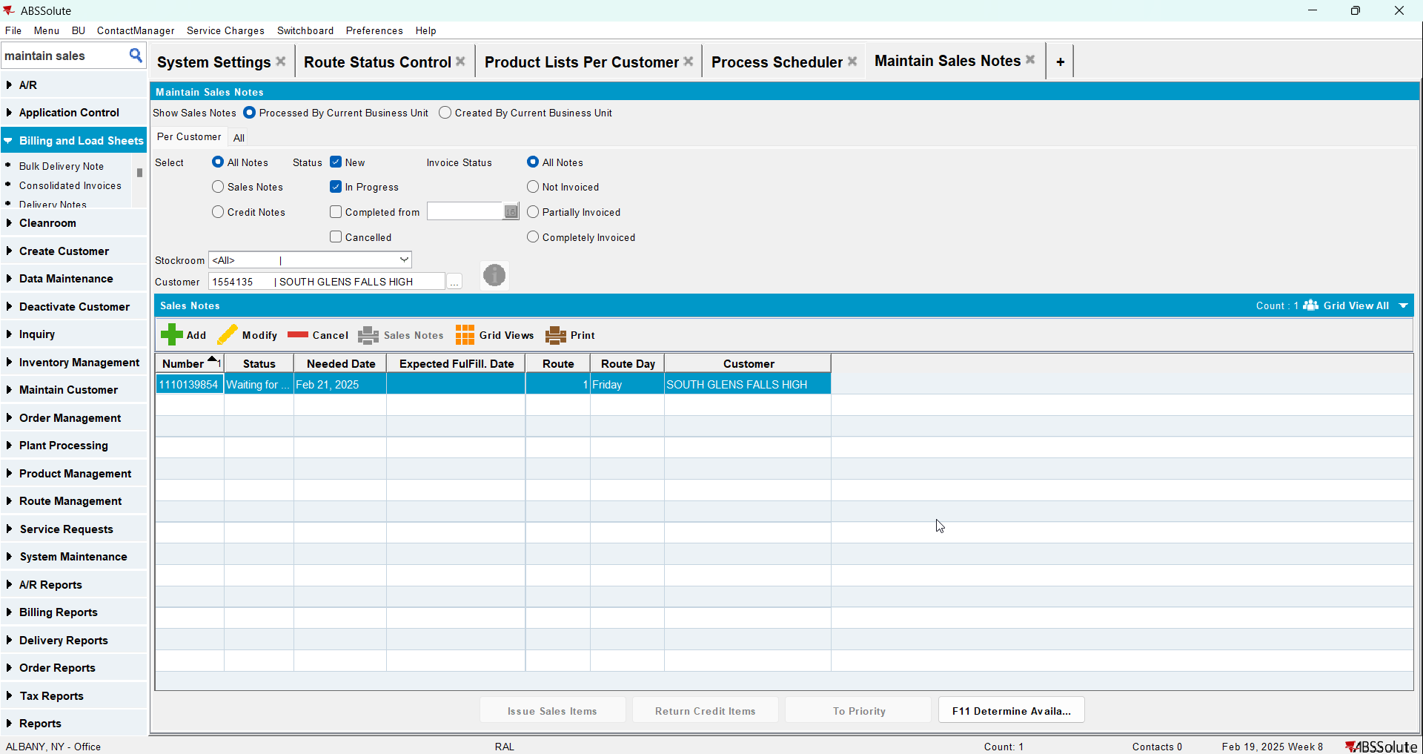
- Work Orders Waiting for Approval DLG: approve the sales note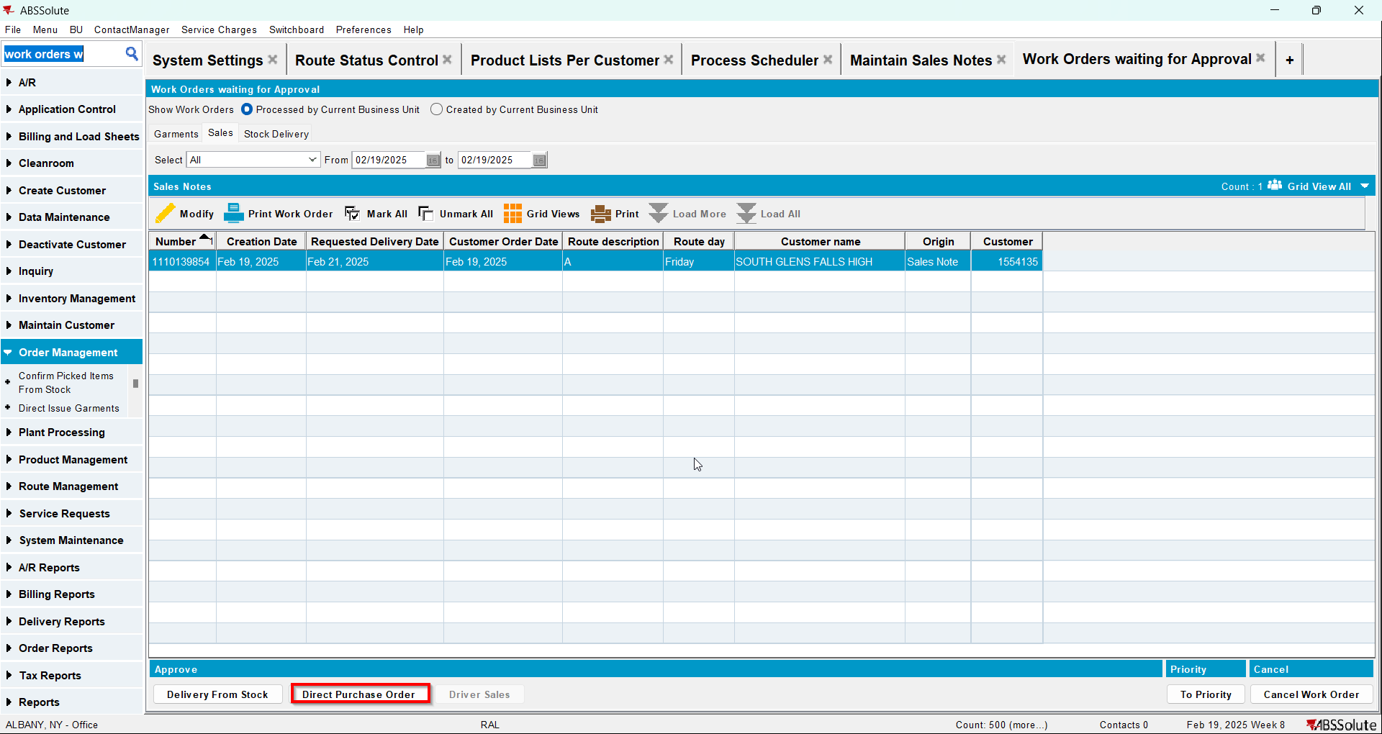
- Maintain Sales Notes DLG: issue the whole quantity and generate the delivery note for the same day as the driving day of the route from step 1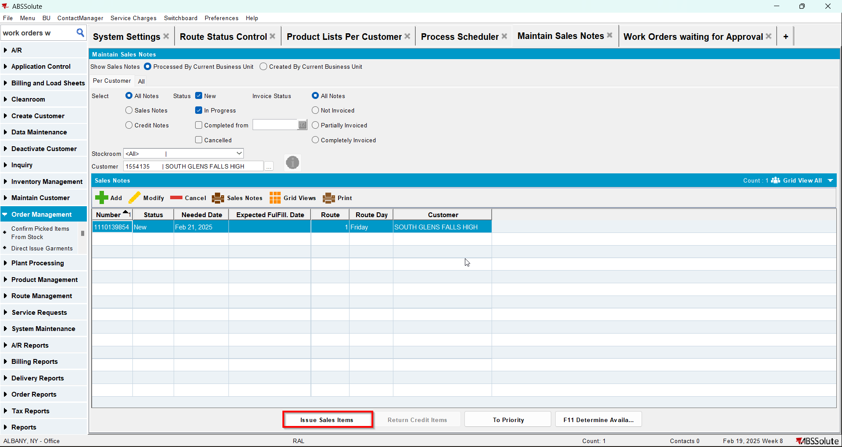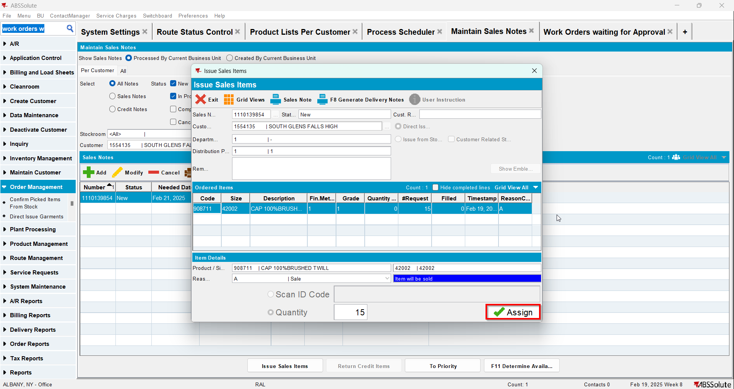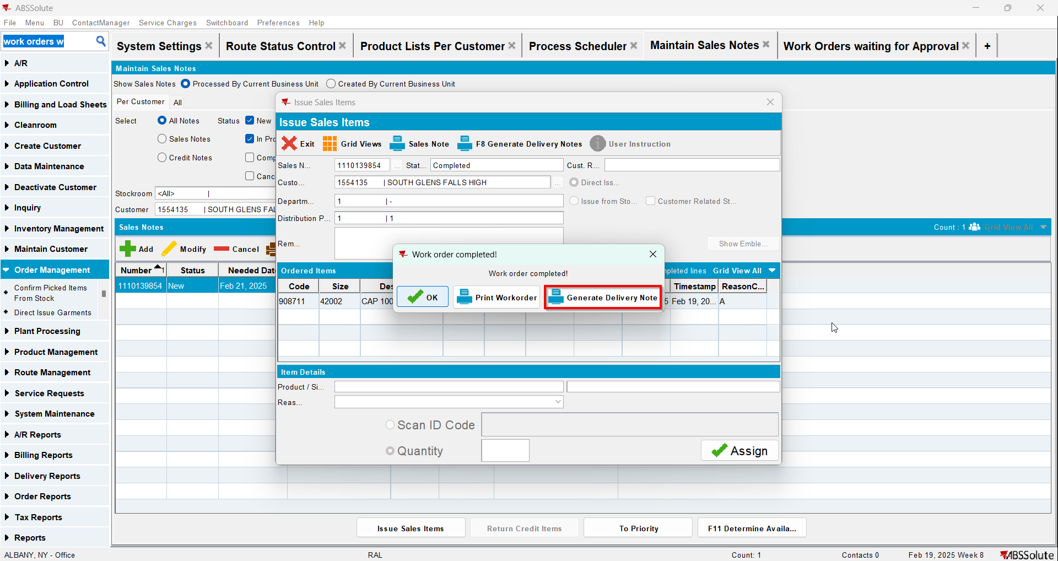
- Route Status Control DLG: Select the same route as the one from step one and click on "View Packing/Delivery notes"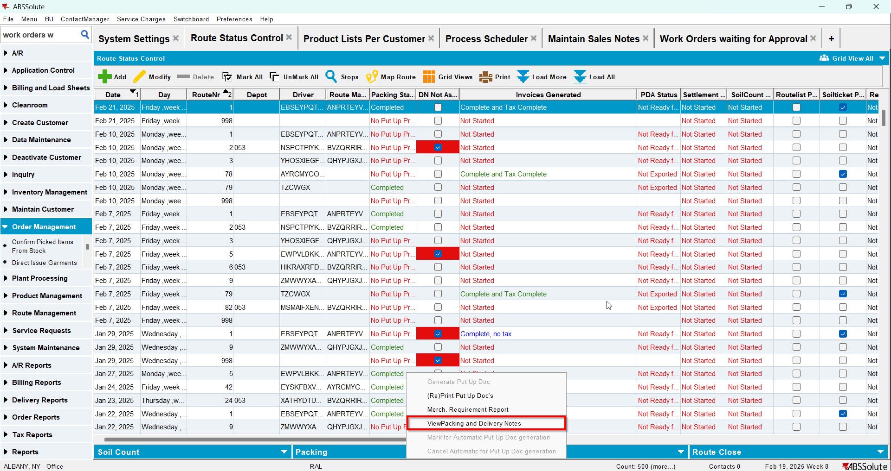
- View Packing/Delivery notes DLG: Click on Sales notes tab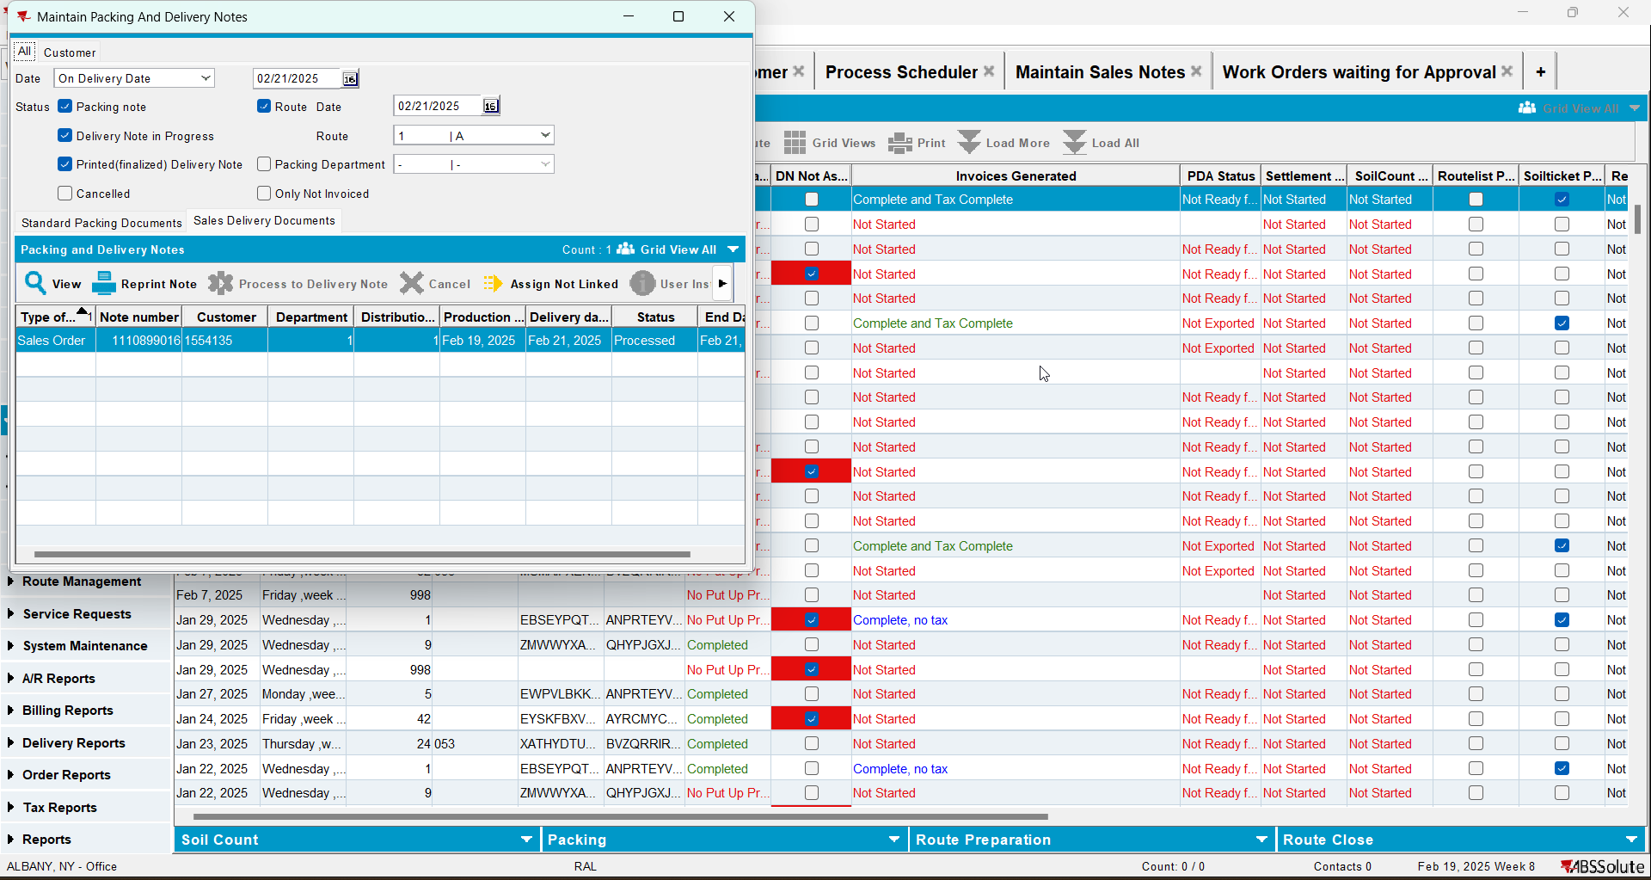

Test Case 2 – RC.POCKETPCSTATUS = 3 and (select rca.* from routecontrolradownload rca where rca.routecontrol_id = ?) dose not return a record --> was never downloaded on RA – Tested OK
Expected behavior: the generated PackingNote for the sales note SHOULD be attached to the route control
Hash: 48323c5
- Check that you have module TRADE in license
- Check that SS SALESDNONINVOICEDROUTE is set to 3
- Add a route in RSC
- Generate packing notes and invoices for at least one stop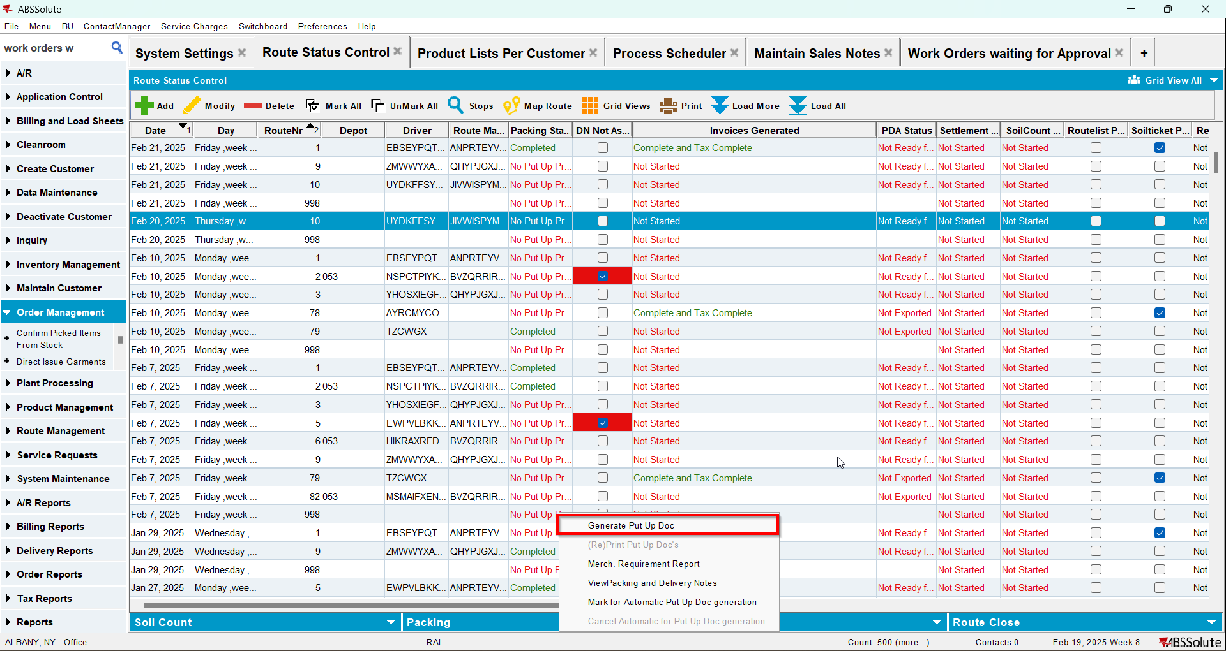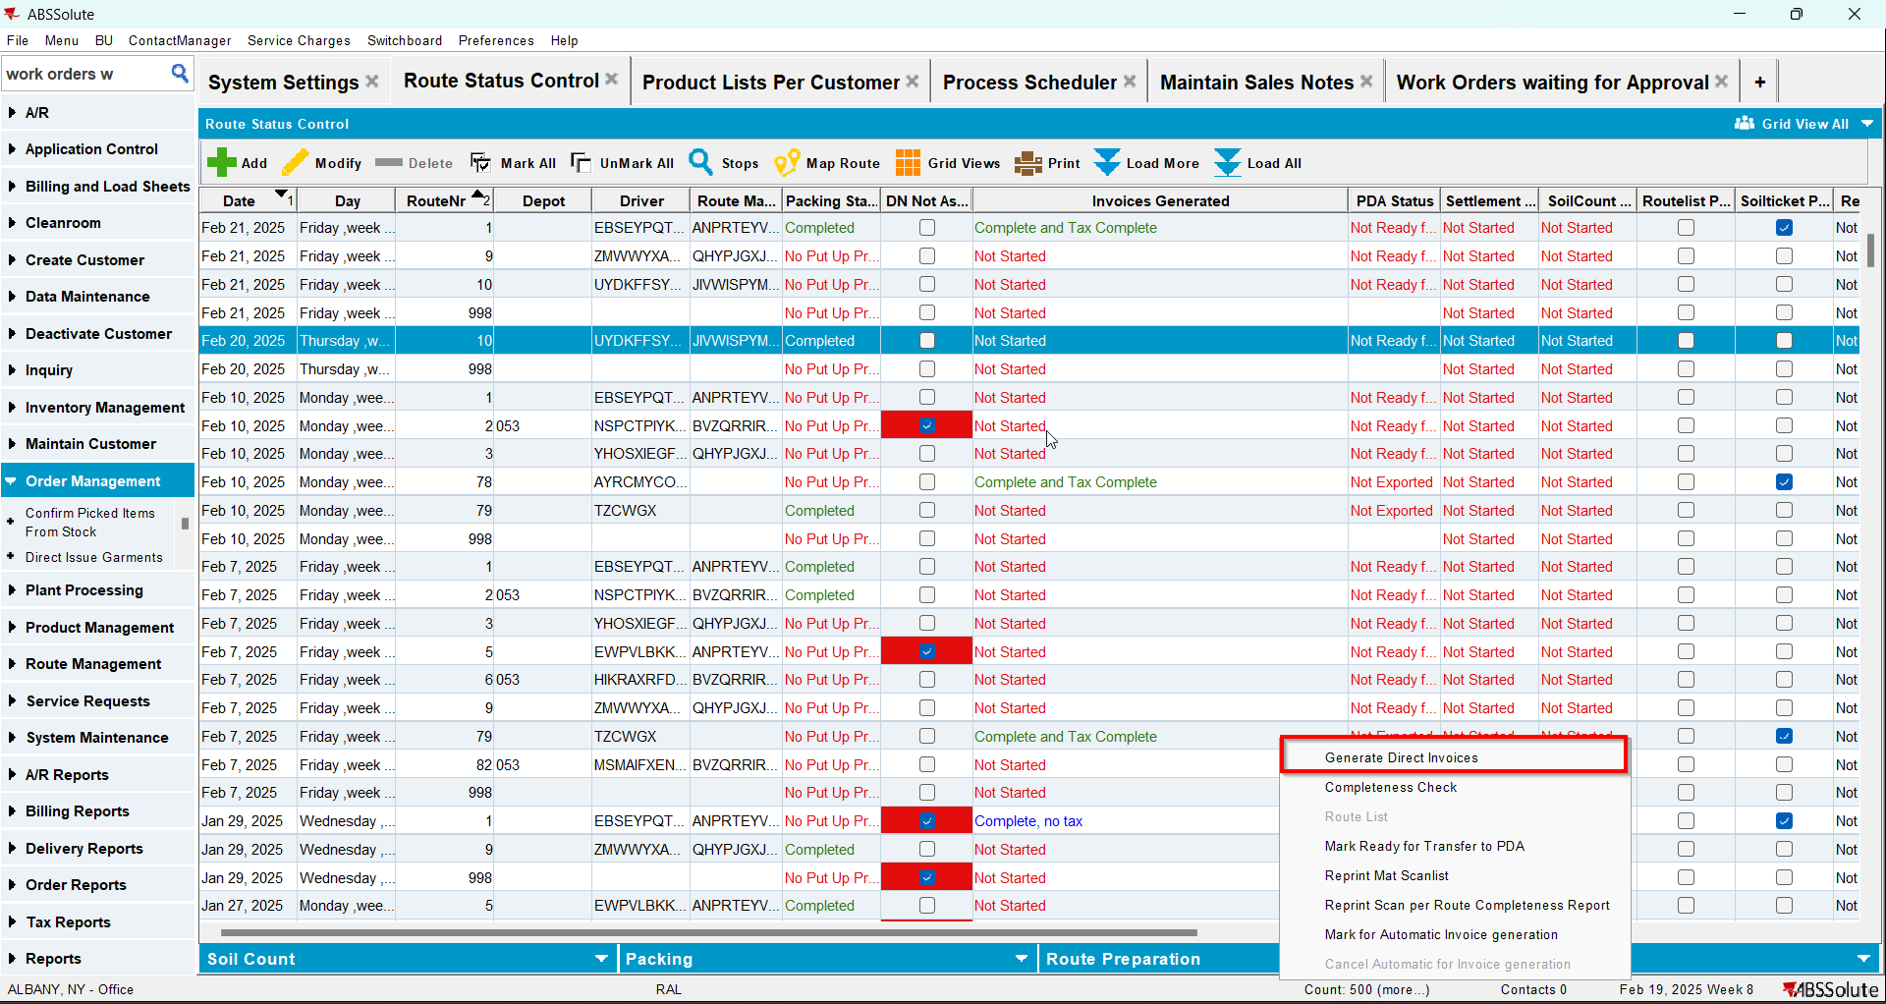
- Mark the route ready for transfer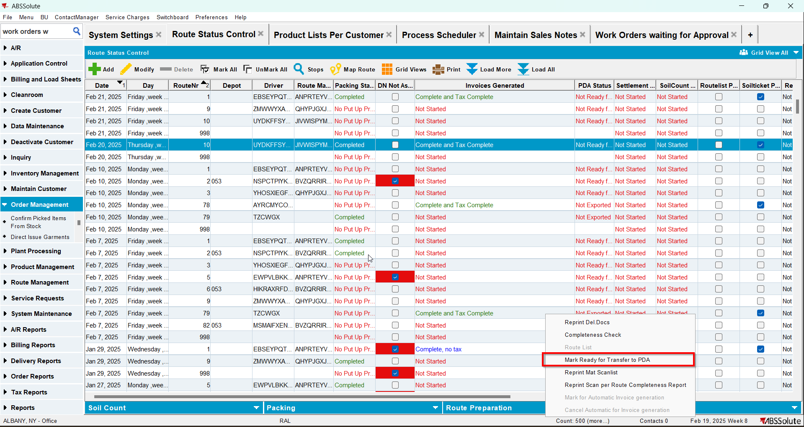
- Maintain Sales Notes DLG: Create a sales note for one of the customers with an active stop on the route from step 1
- Sales Order DLG: Add at least one product to the Ordered Items tab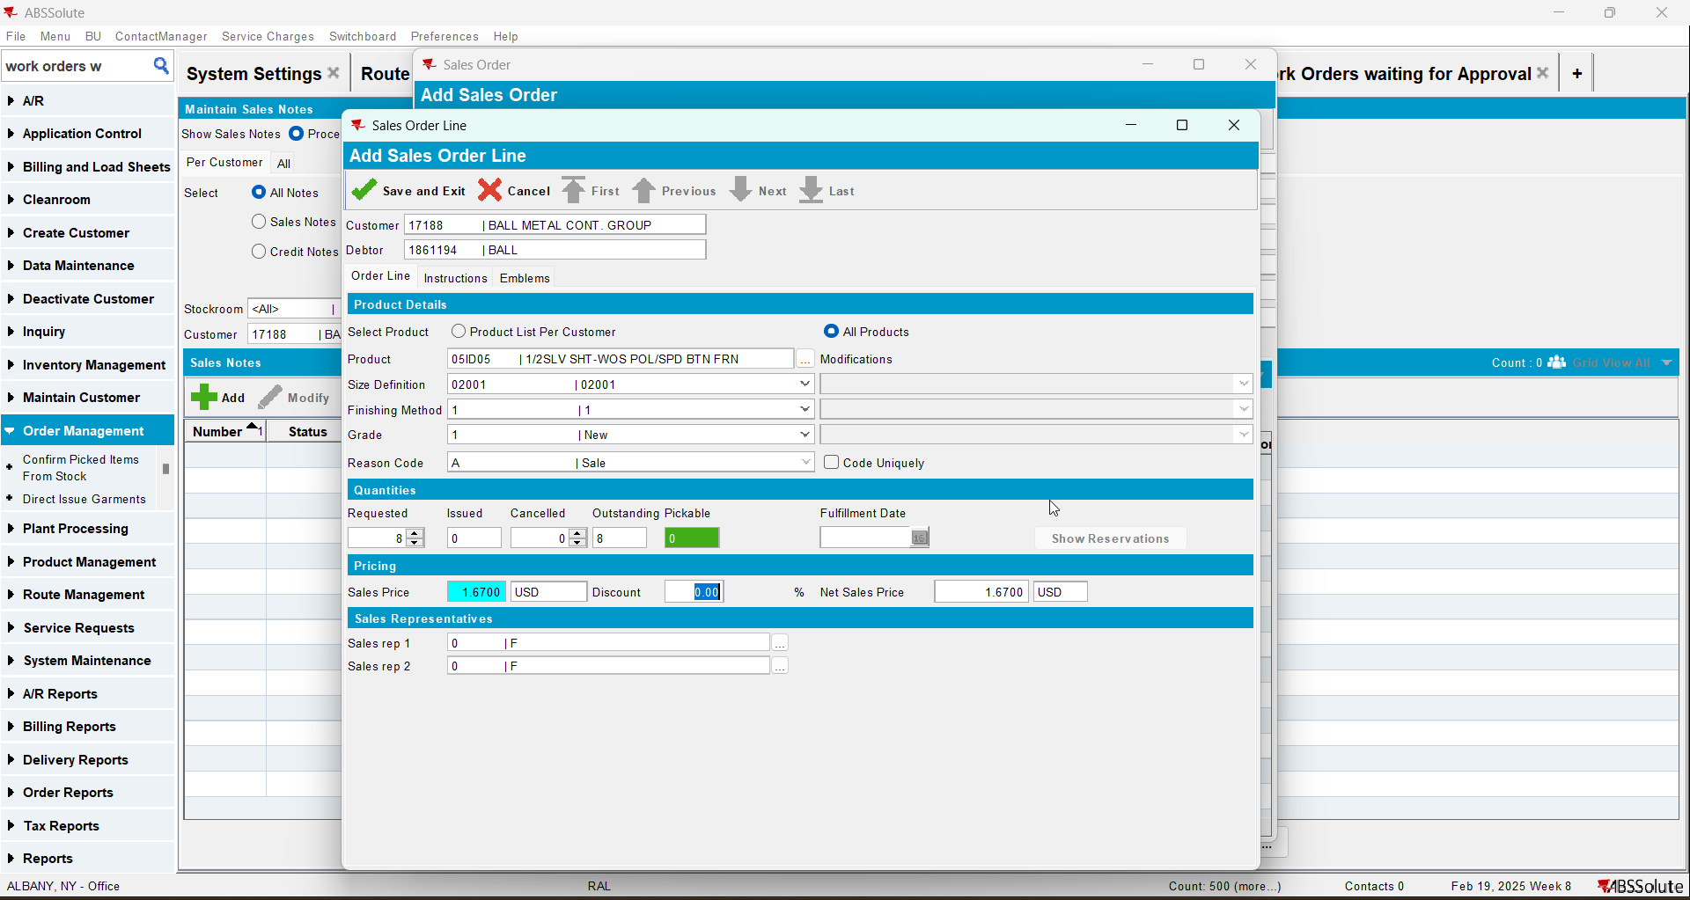
- Save the Sales Order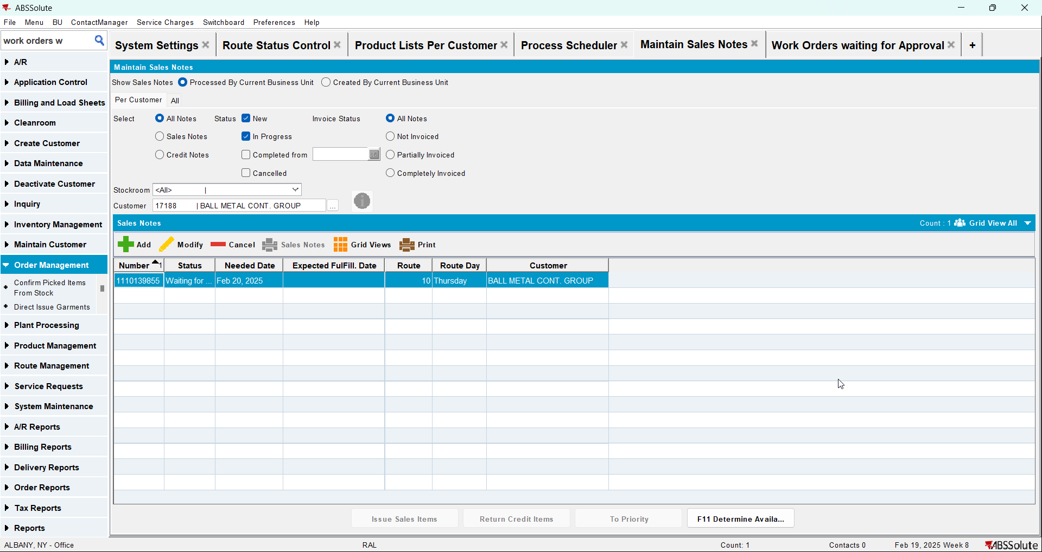
- Work Orders Waiting for Approval DLG: approve the sales note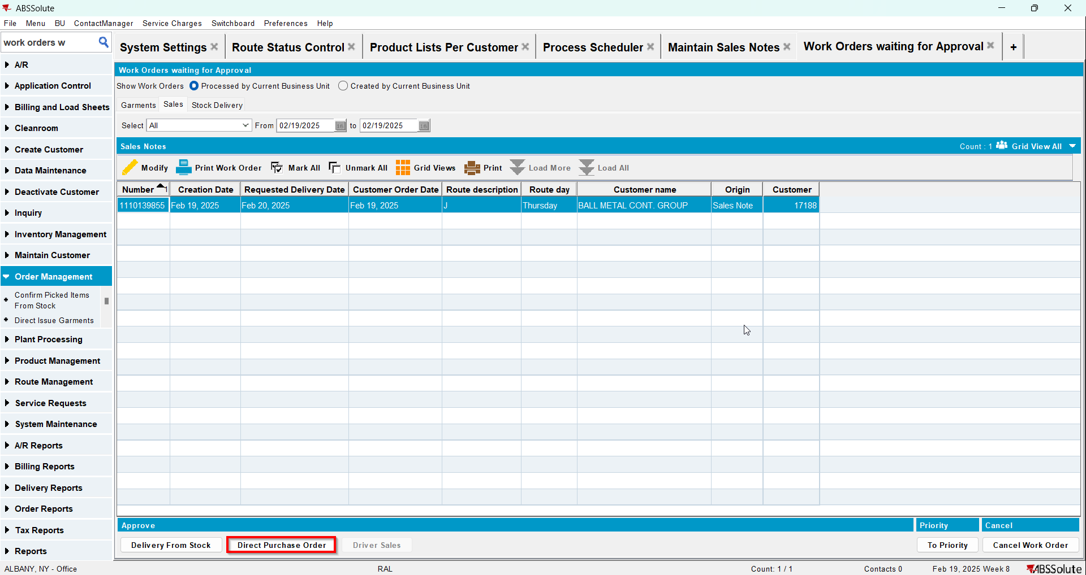
- Maintain Sales Notes DLG: issue the whole quantity and generate the delivery note for the same day as the driving day of the route from step 1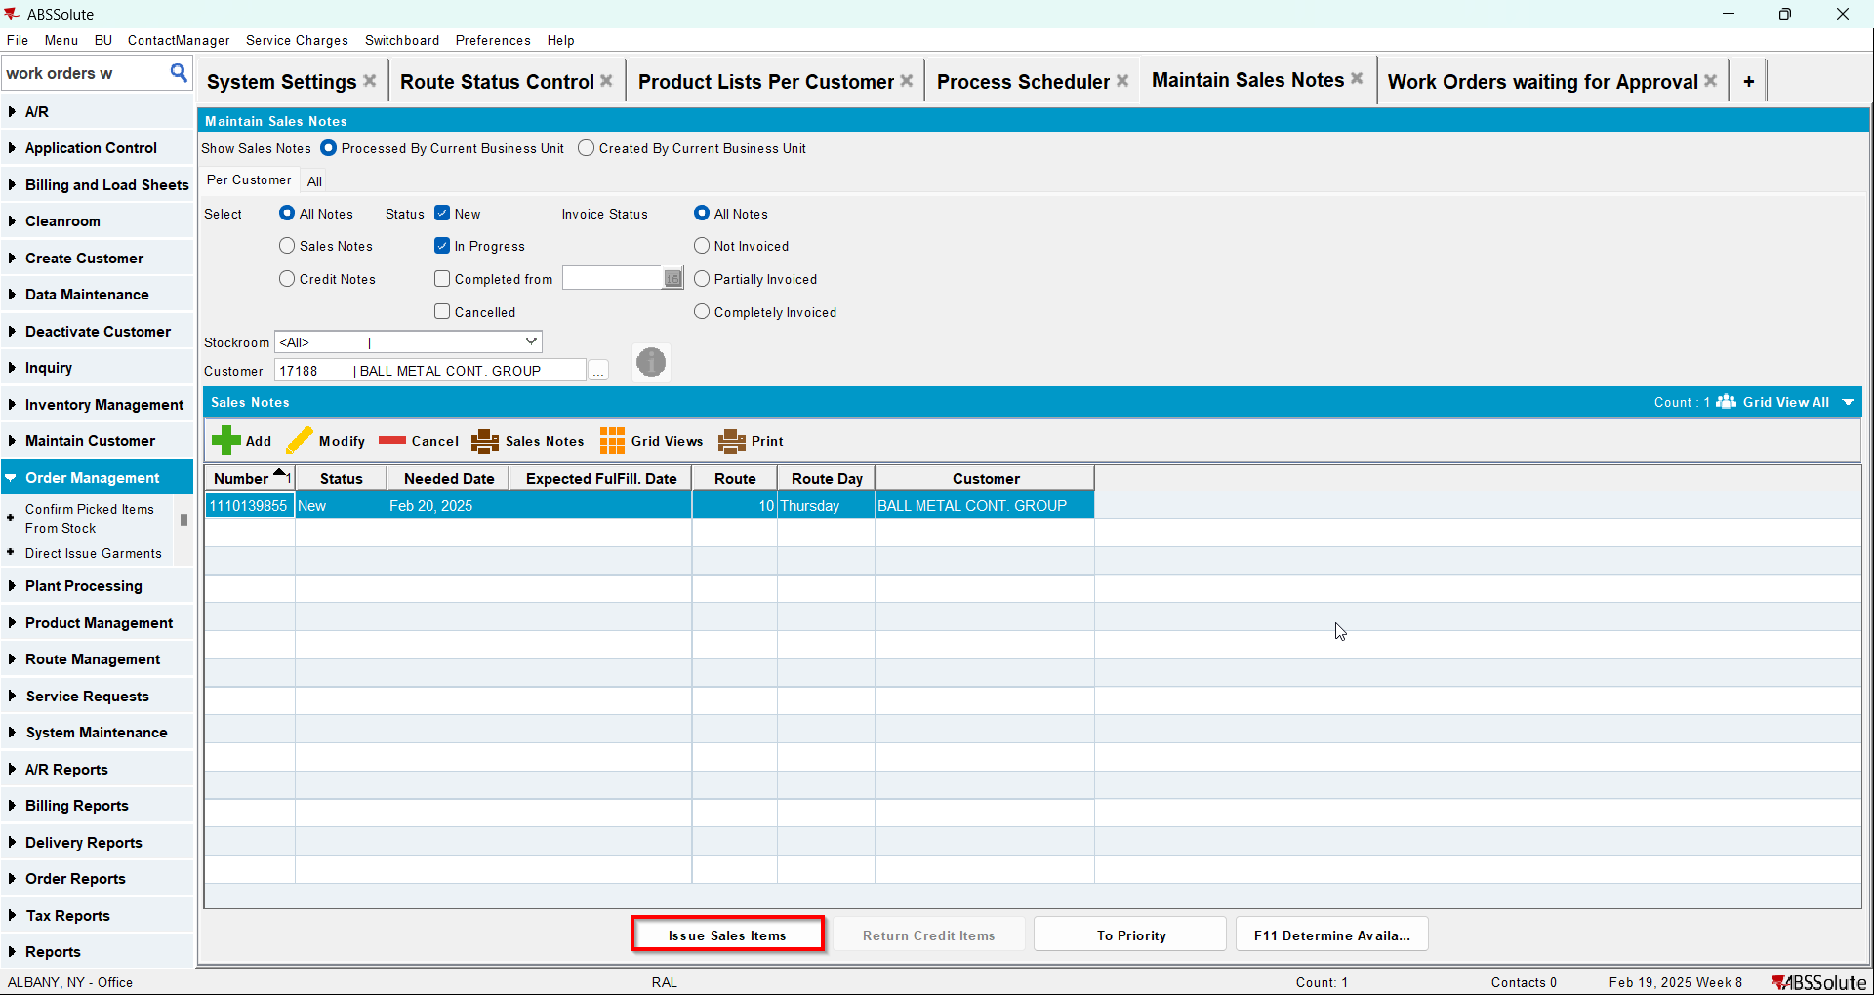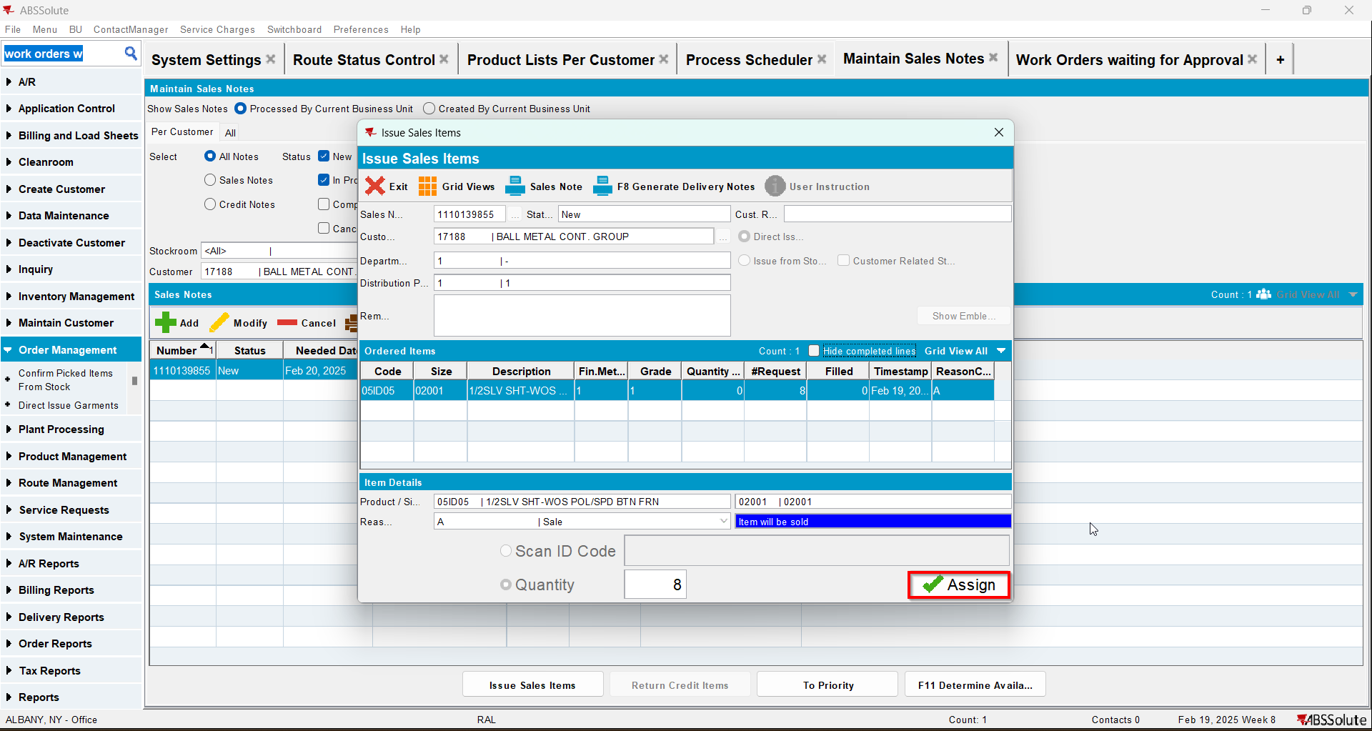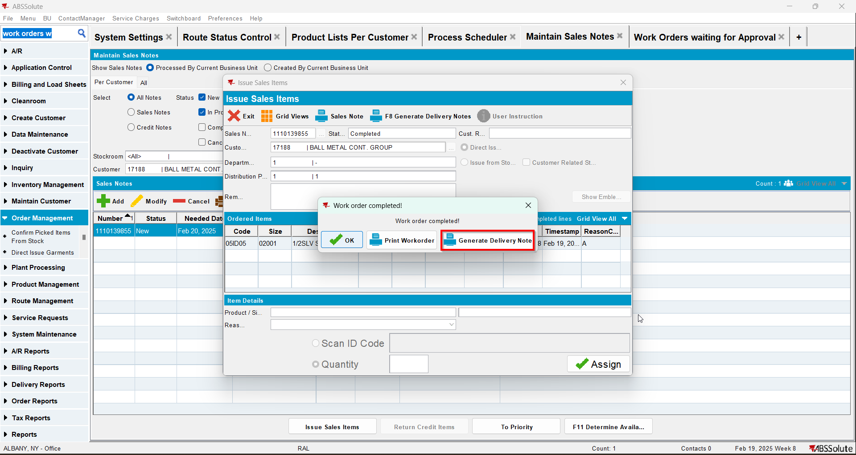
- Route Status Control DLG: Select the same route as the one from step one and click on "View Packing/Delivery notes"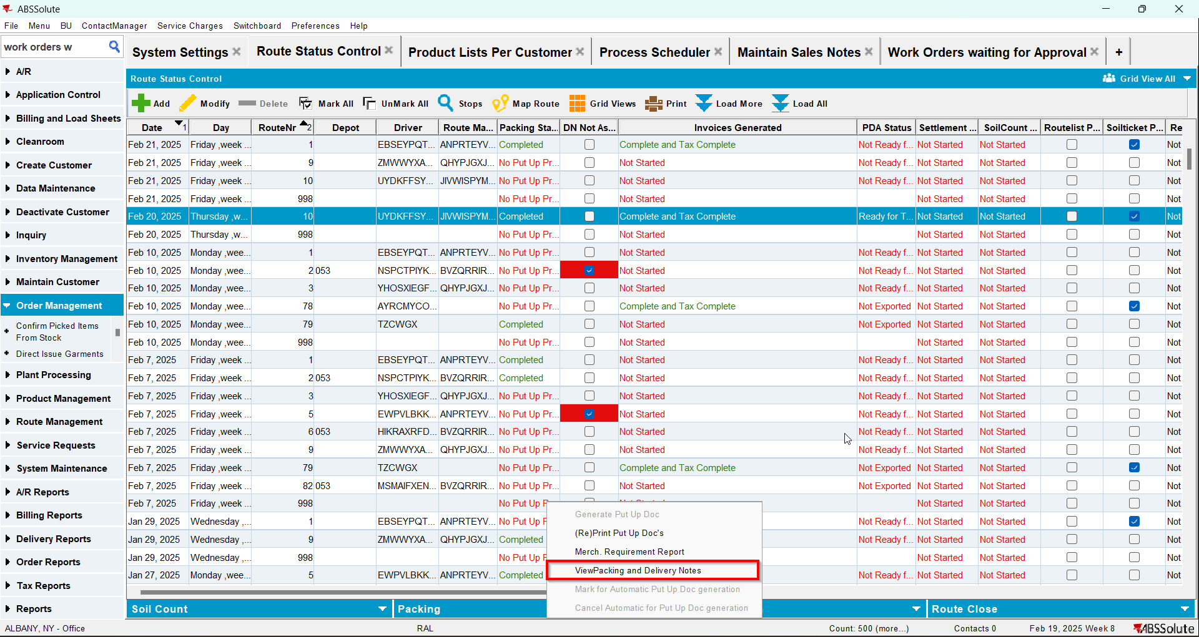
- View Packing/Delivery notes DLG: Click on Sales notes tab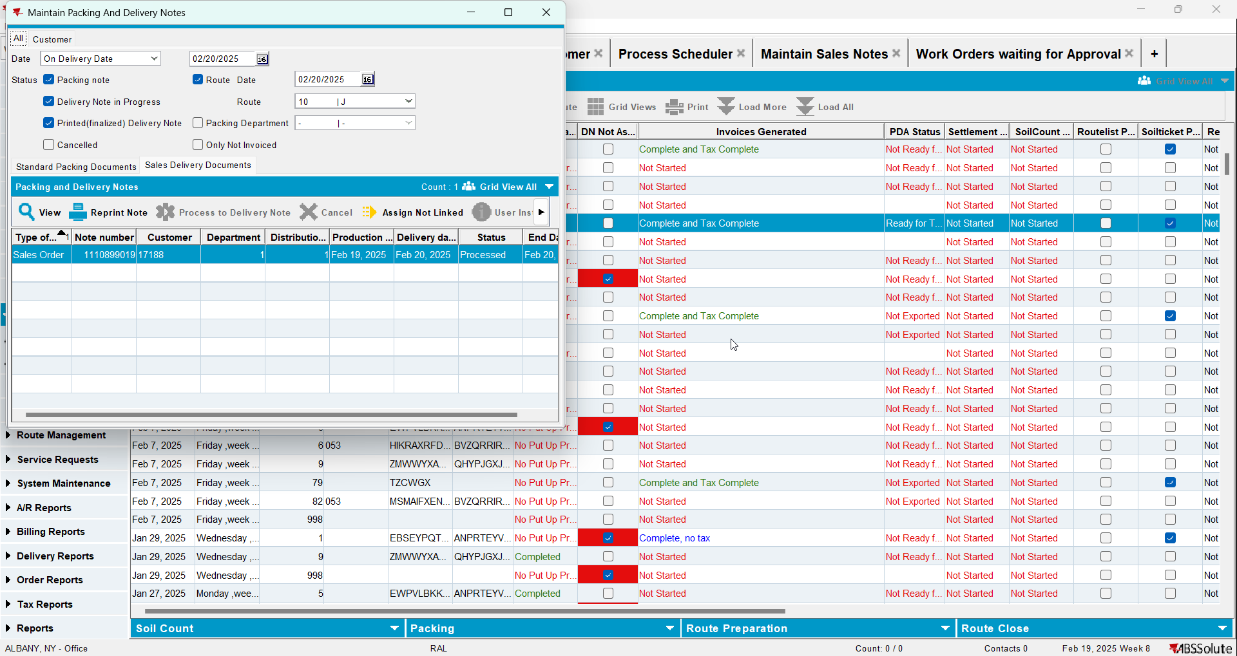

Test Case 3 – RC.POCKETPCSTATUS = 3 and max(select rca.endownloadtimestamp from routecontrolradownload rca where rca.routecontrol_id = ?) is not null – Tested OK
Expected behavior: the generated PackingNote for the sales note SHOULD be attached to the route control
Hash: 48323c5
- Check that you have module TRADE in license
- Check that SS SALESDNONINVOICEDROUTE is set to 3
- Add a route in RSC
- Generate packing notes and invoices for at least one stop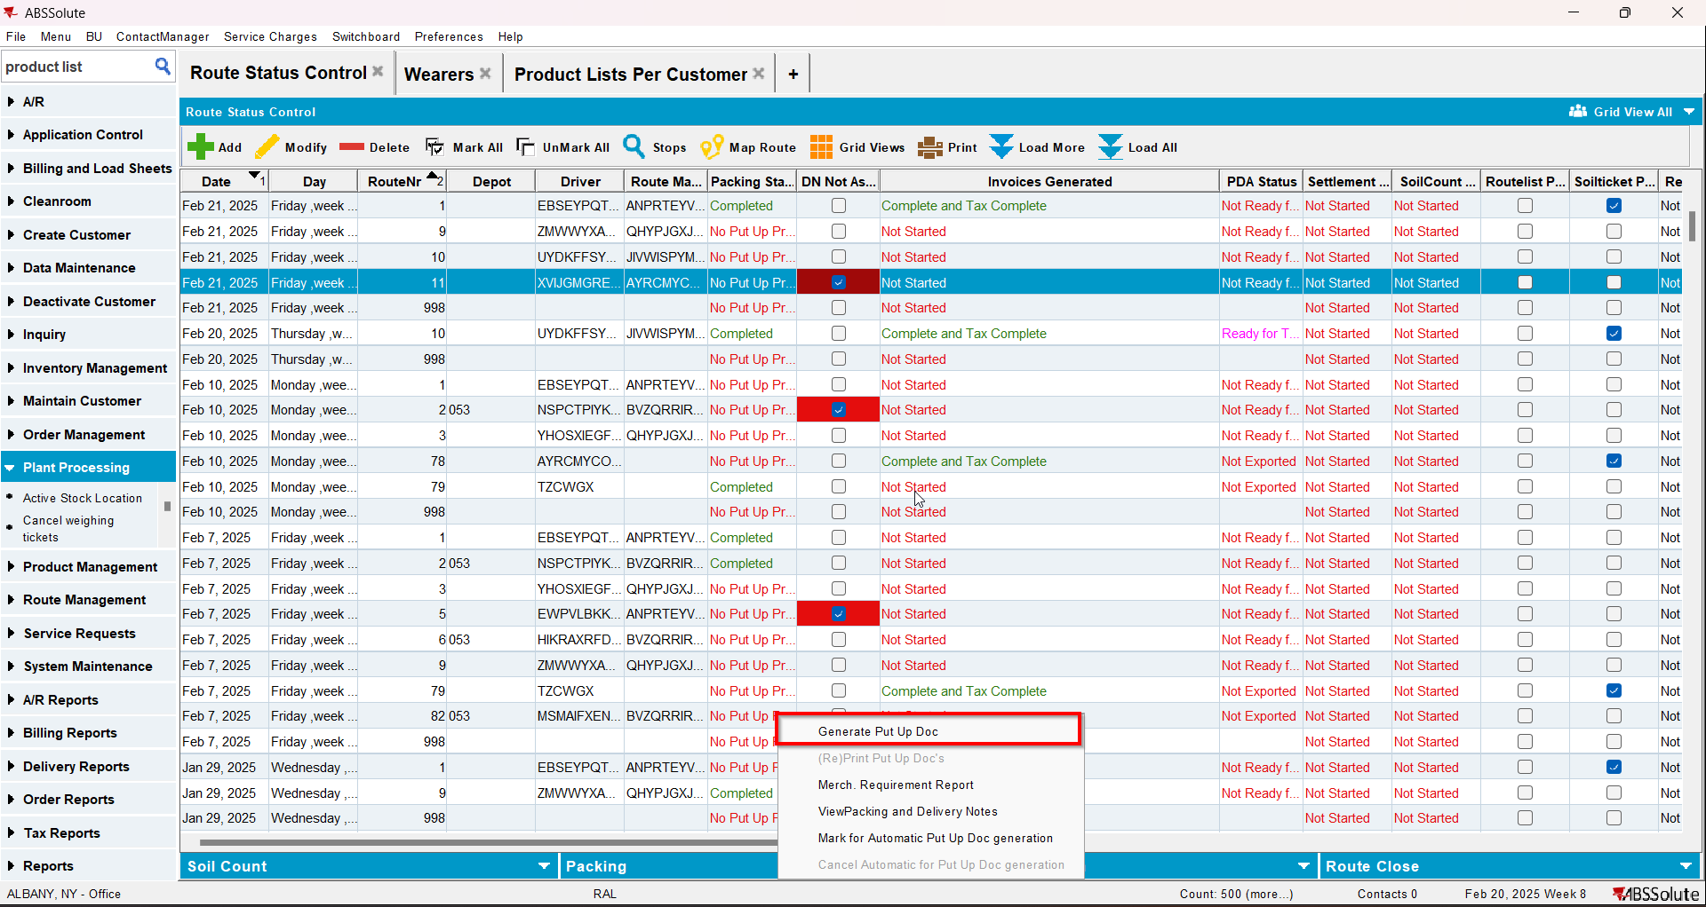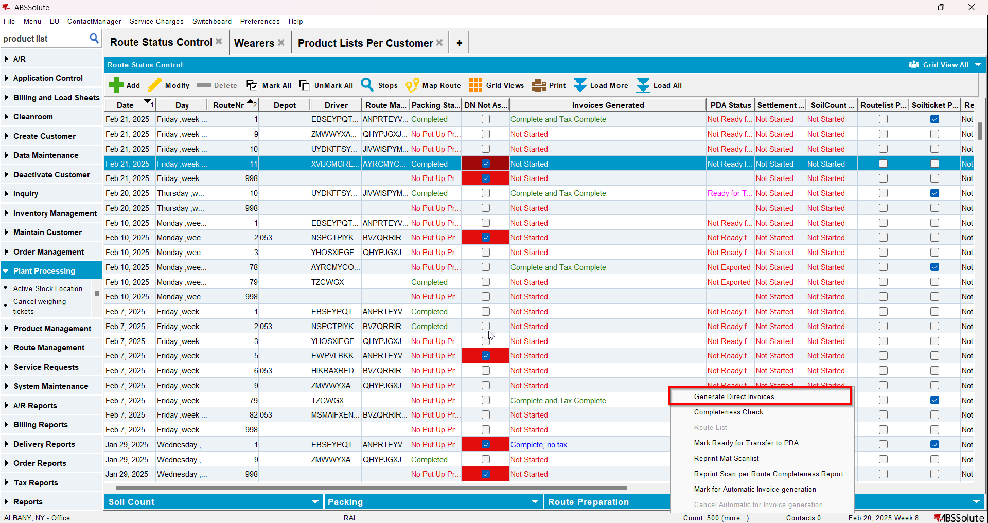
- Mark the route ready for transfer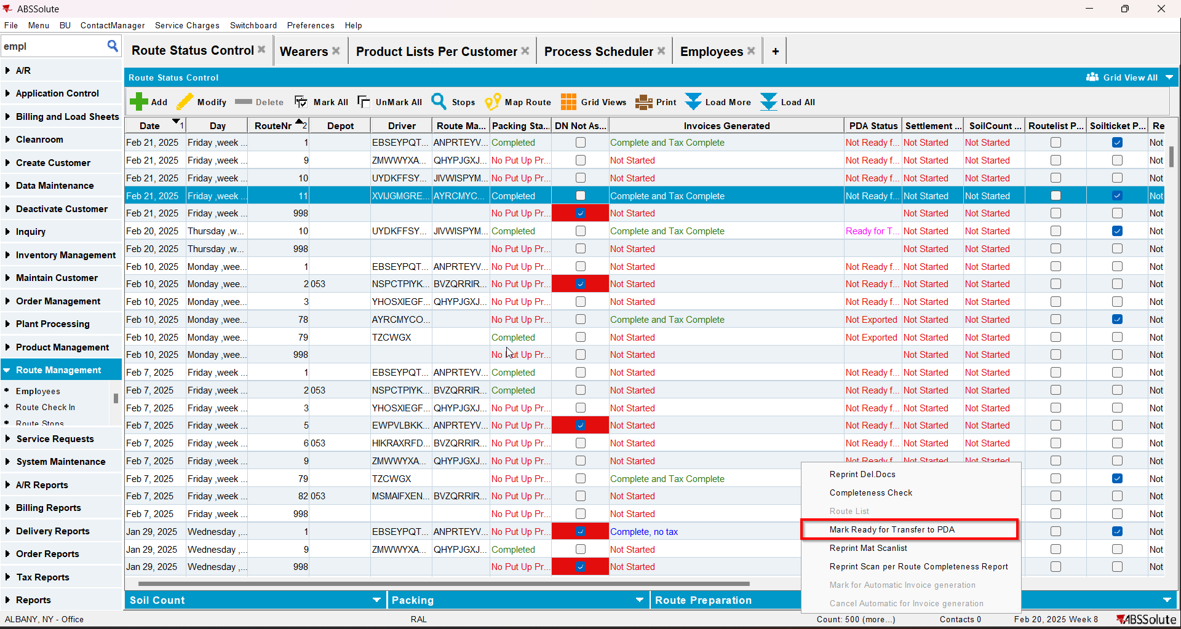
- On RA download the route
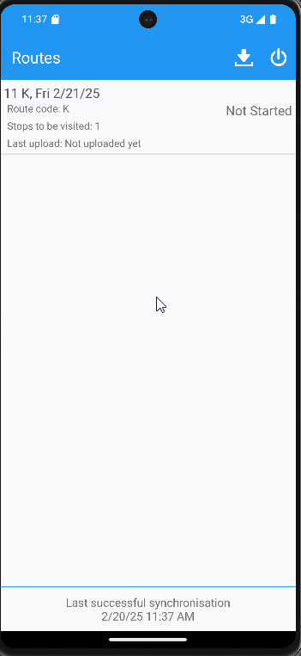
- Mark the route ready for re-transfer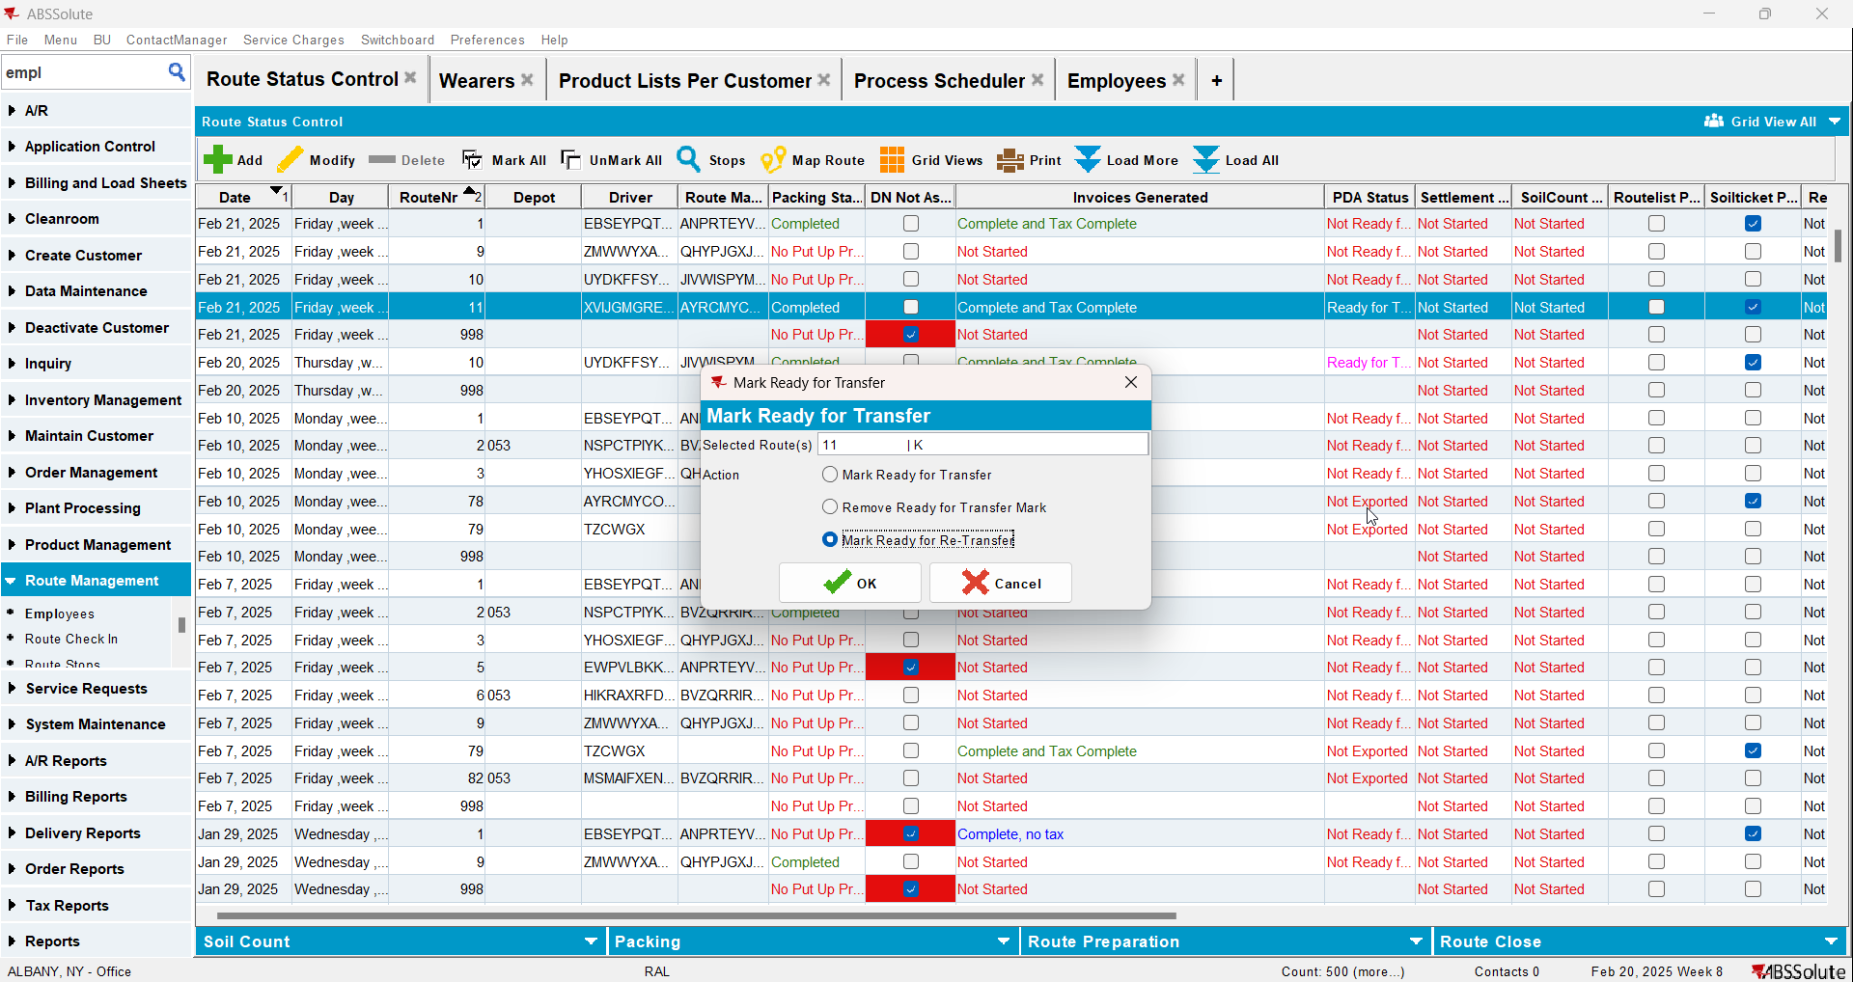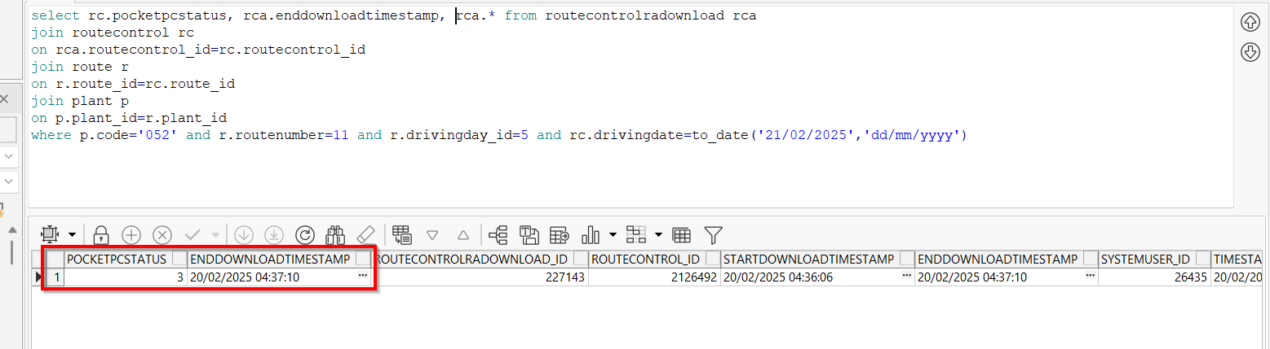
- Maintain Sales Notes DLG: Create a sales note for one of the customers with an active stop on the route from step 1
- Sales Order DLG: Add at least one product to the Ordered Items tab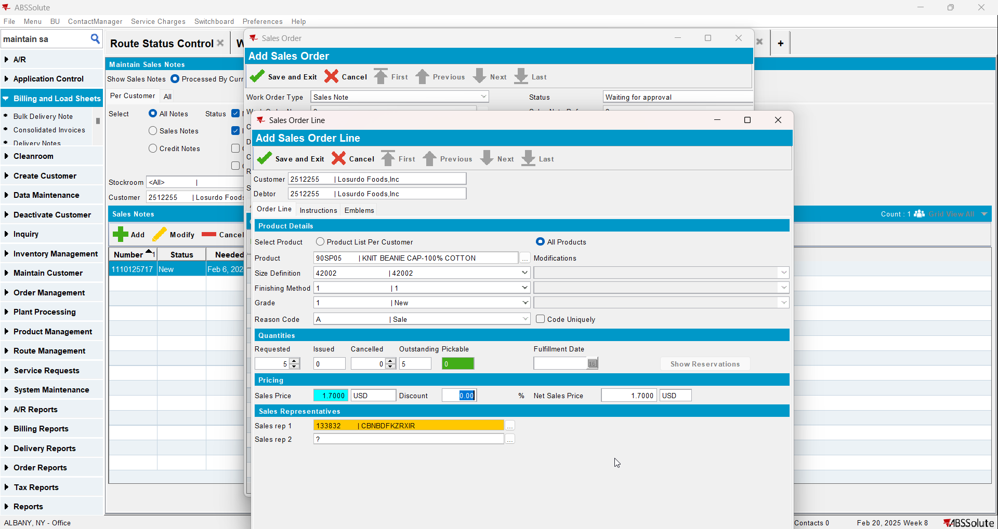
- Save the Sales Order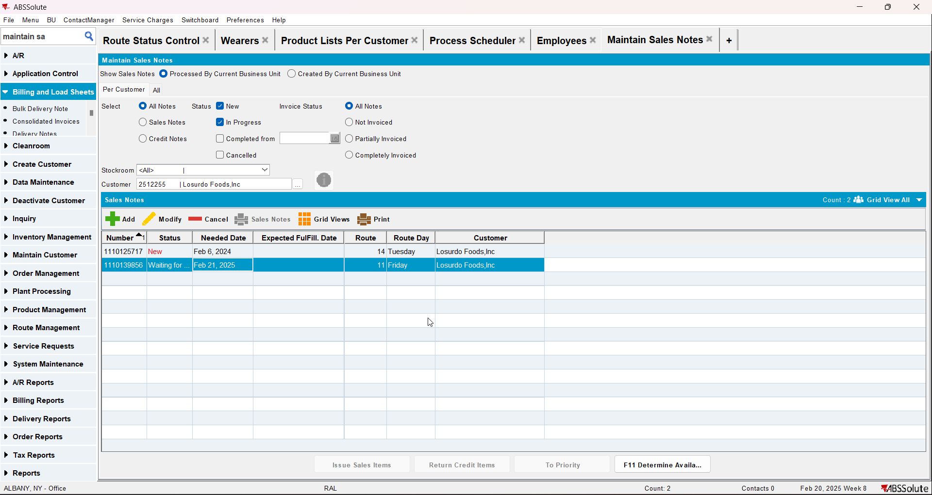
- Work Orders Waiting for Approval DLG: approve the sales note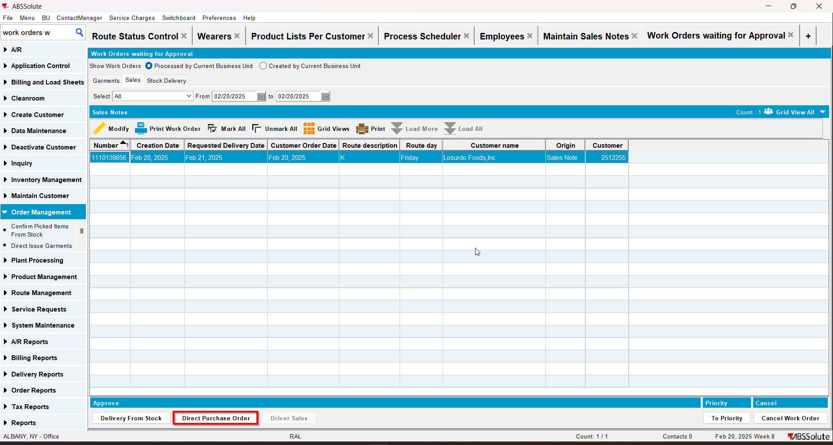
- Maintain Sales Notes DLG: issue the whole quantity and generate the delivery note for the same day as the driving day of the route from step 1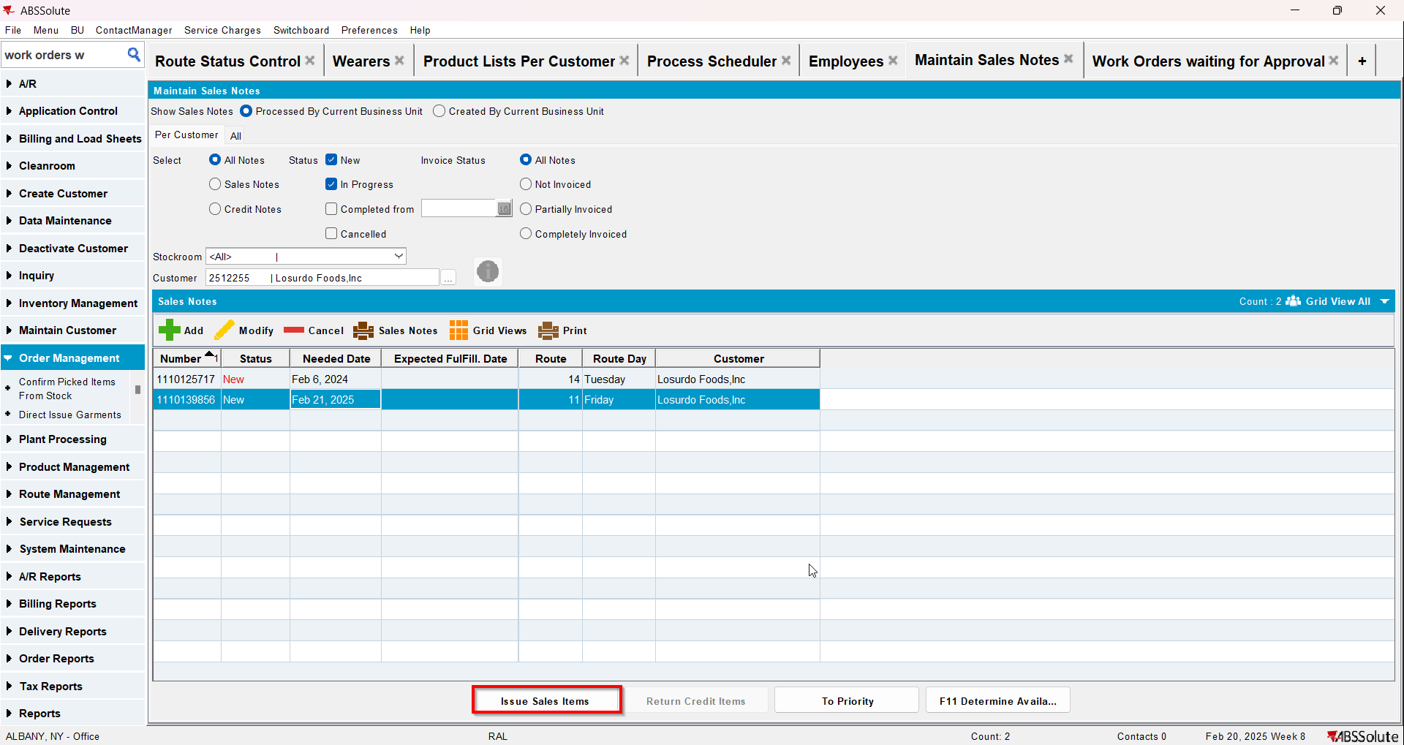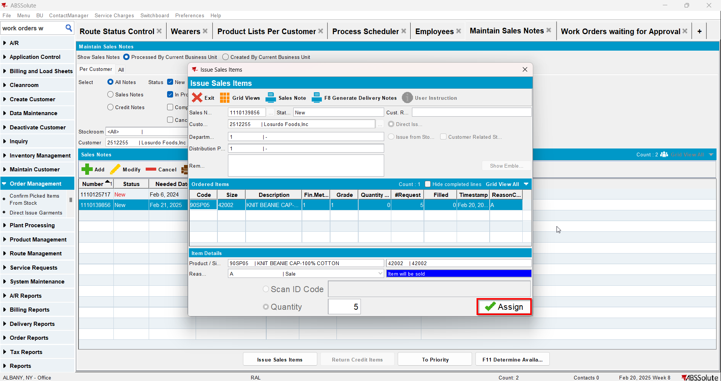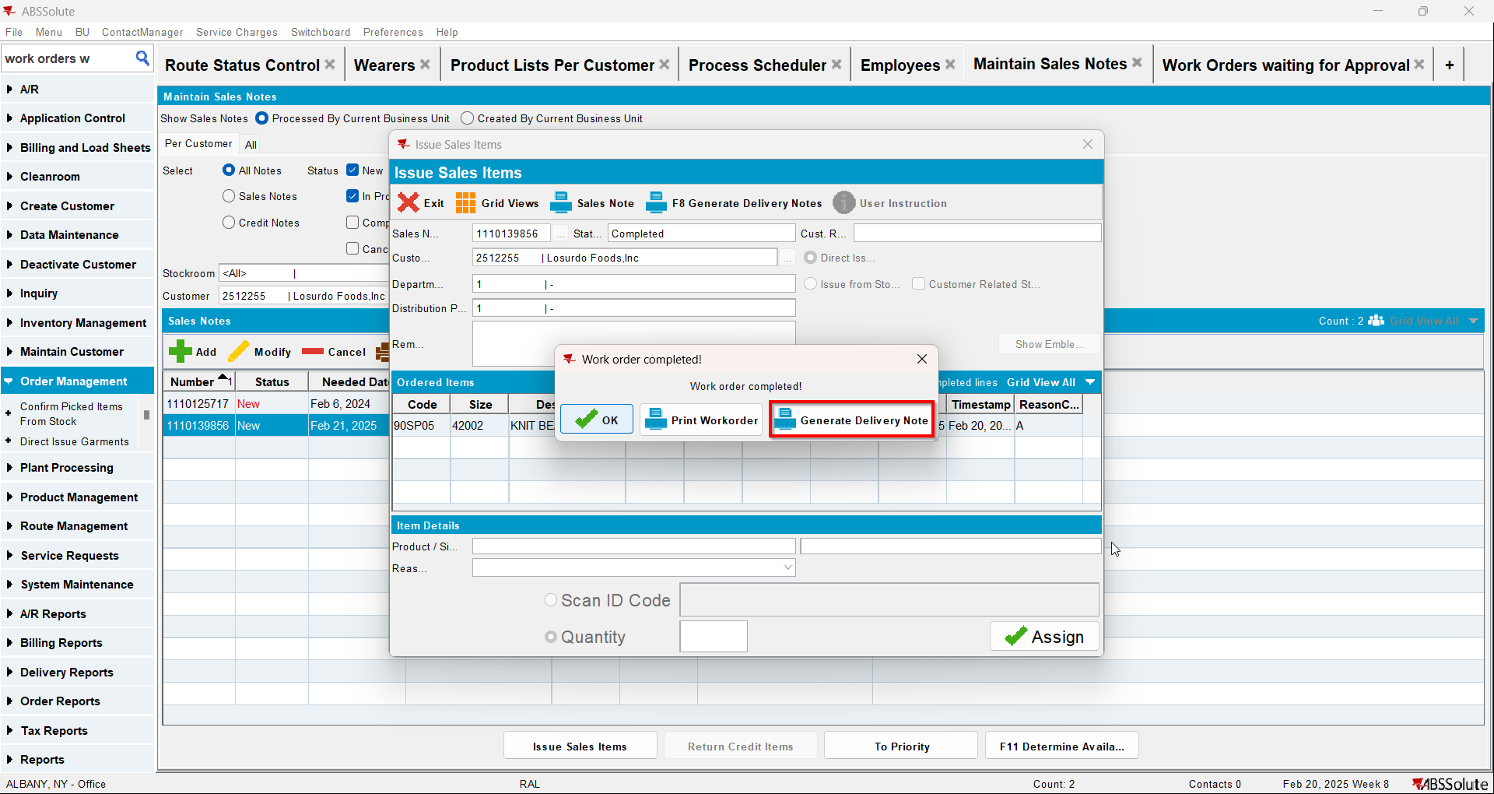
- Route Status Control DLG: Select the same route as the one from step one and click on "View Packing/Delivery notes"
- View Packing/Delivery notes DLG: Click on Sales notes tab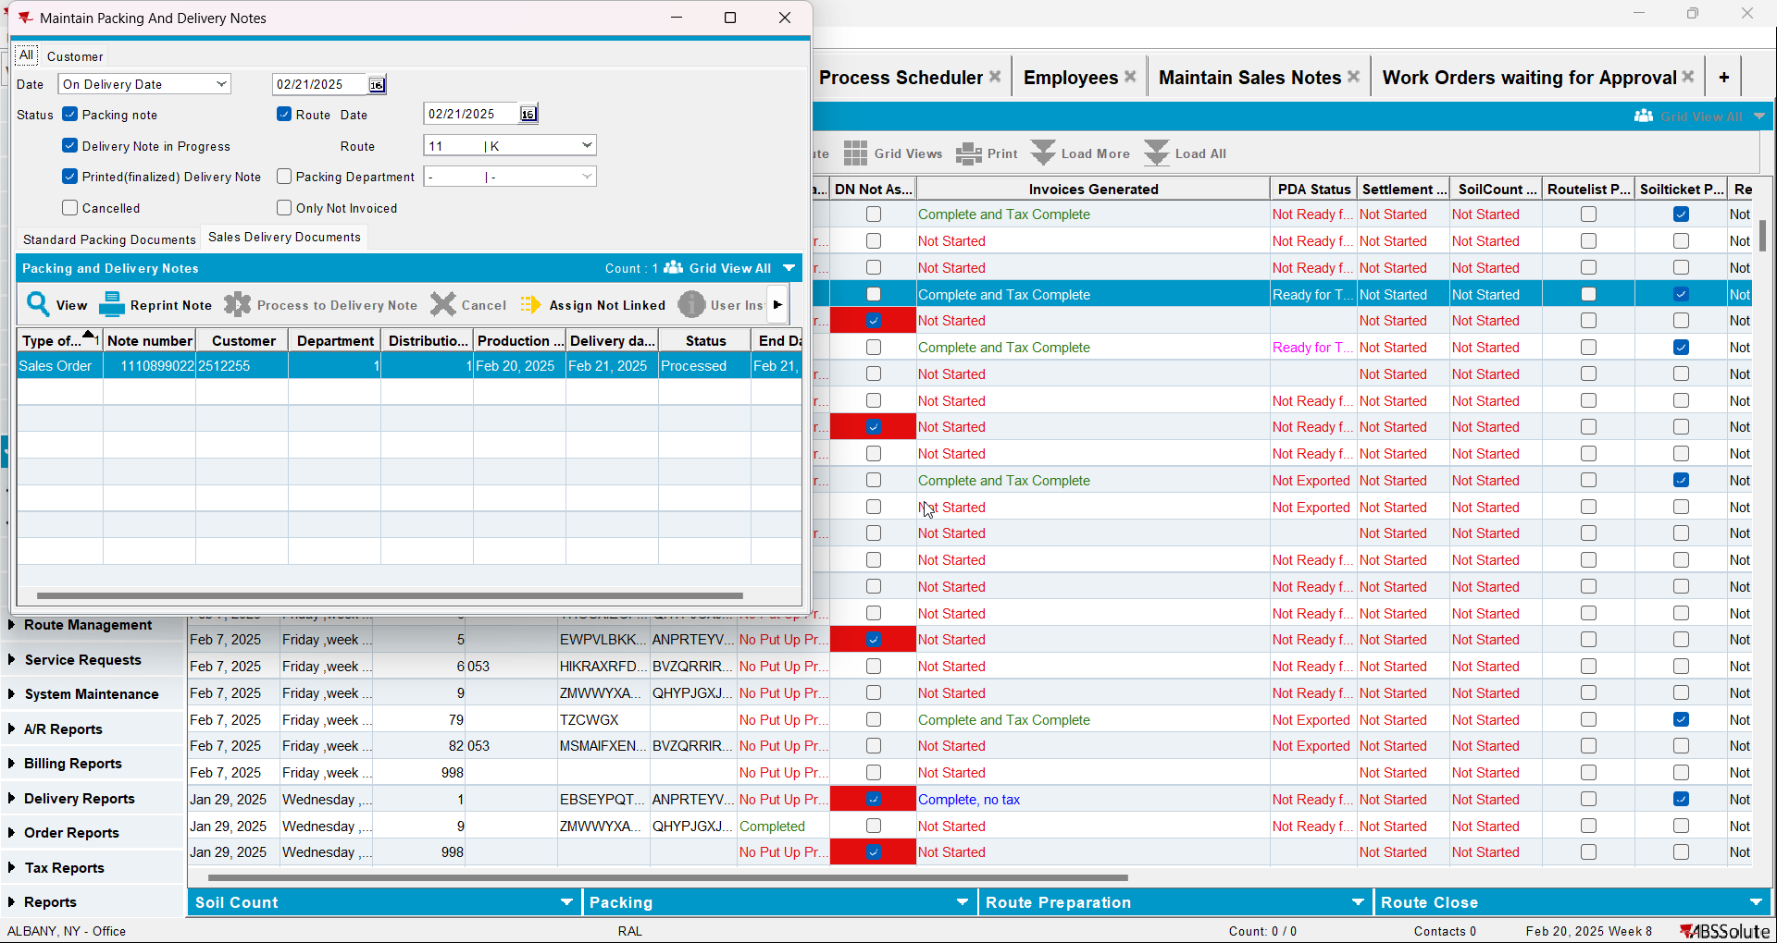

Test Case 4 – RC.POCKETPCSTATUS = 3 and max(select rca.endownloadtimestamp from routecontrolradownload rca where rca.routecontrol_id = ?) is null – Tested OK
Expected behavior: the generated PackingNote for the sales note SHOULD be not attached to the route control. An error will appear
Hash: 48323c5
- Check that you have module TRADE in license
- Check that SS SALESDNONINVOICEDROUTE is set to 3
- Add a route in RSC
- Generate packing notes and invoices for at least one stop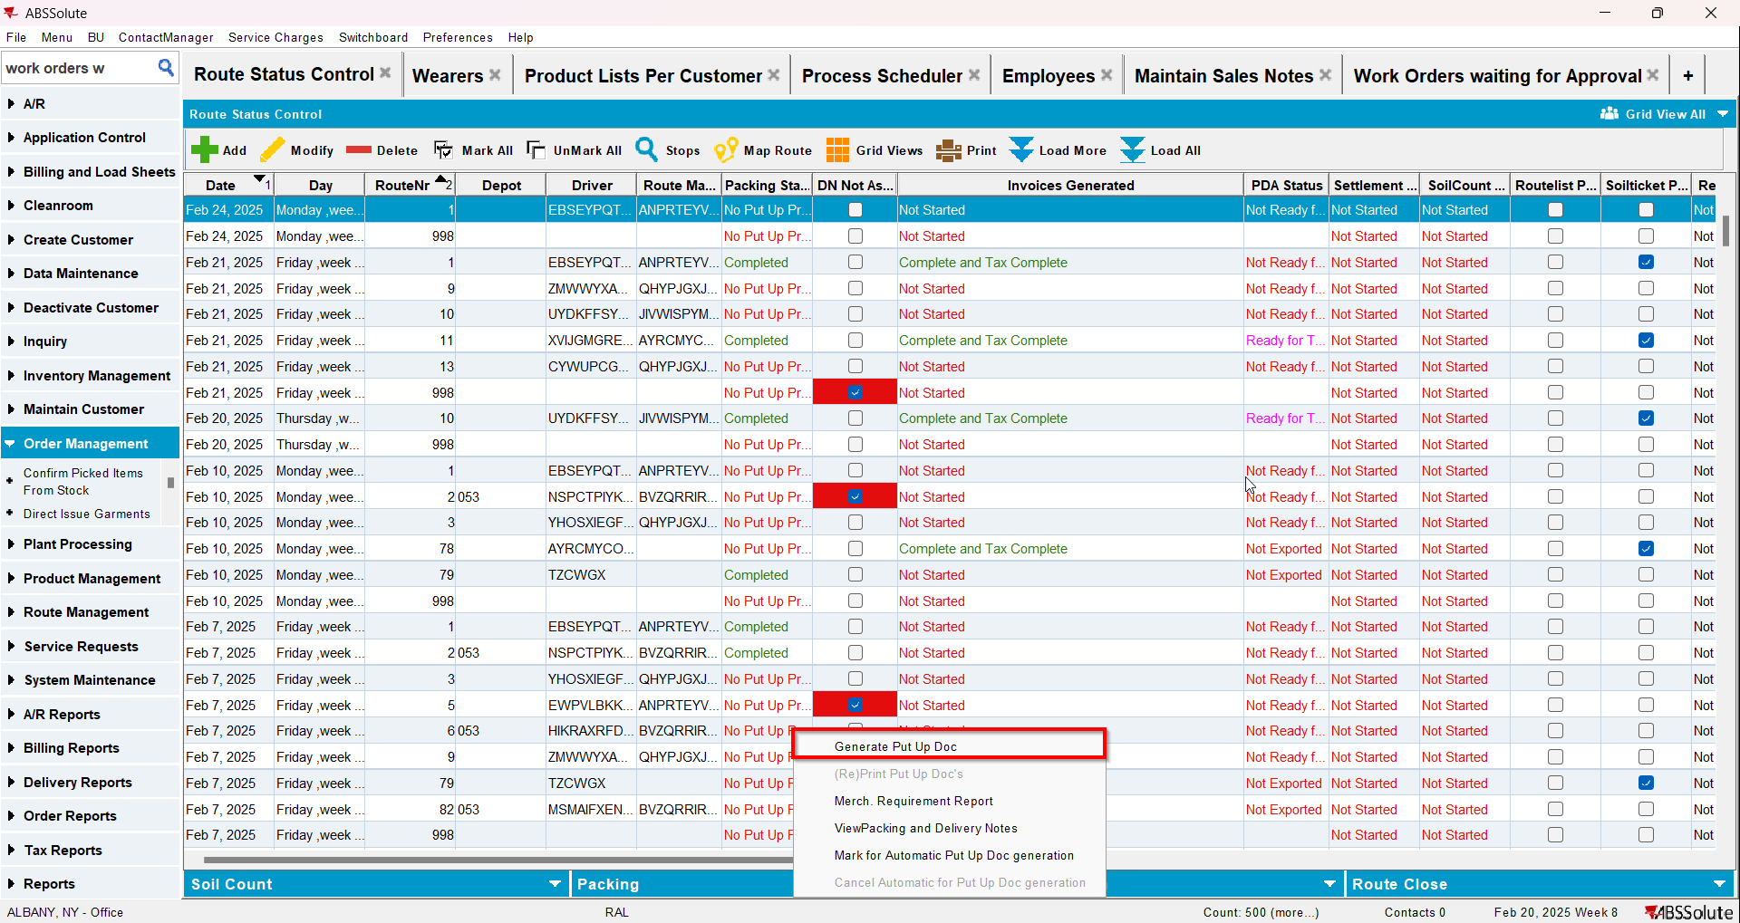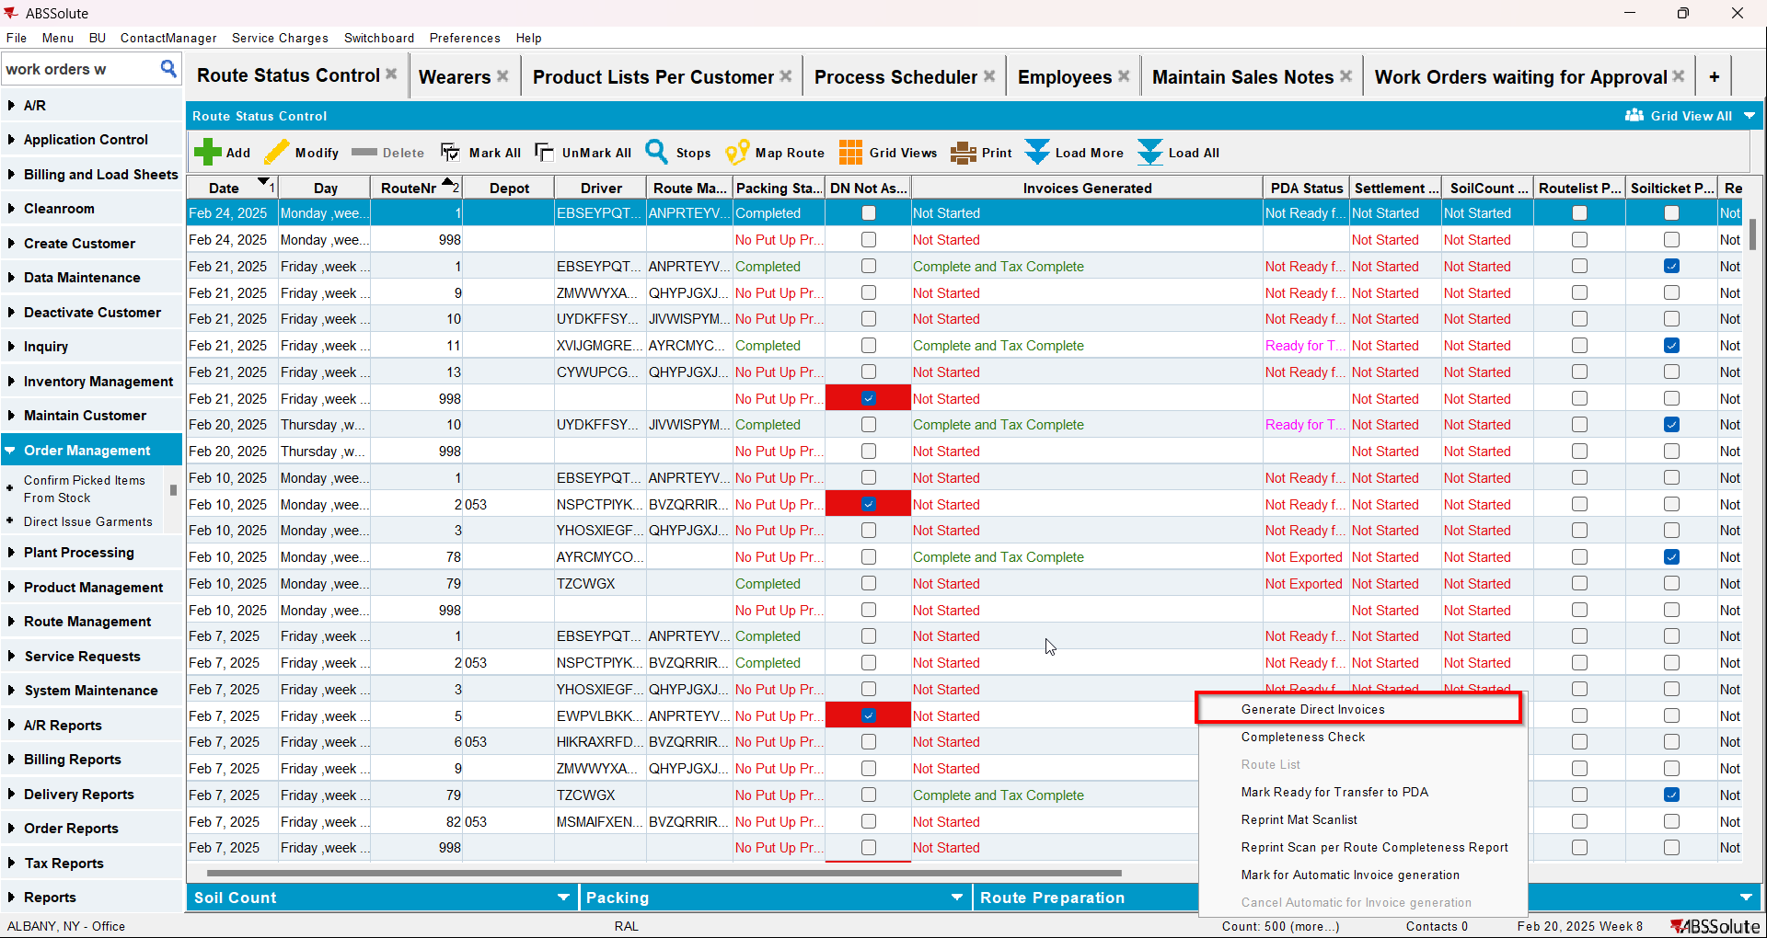
- Mark the route ready for transfer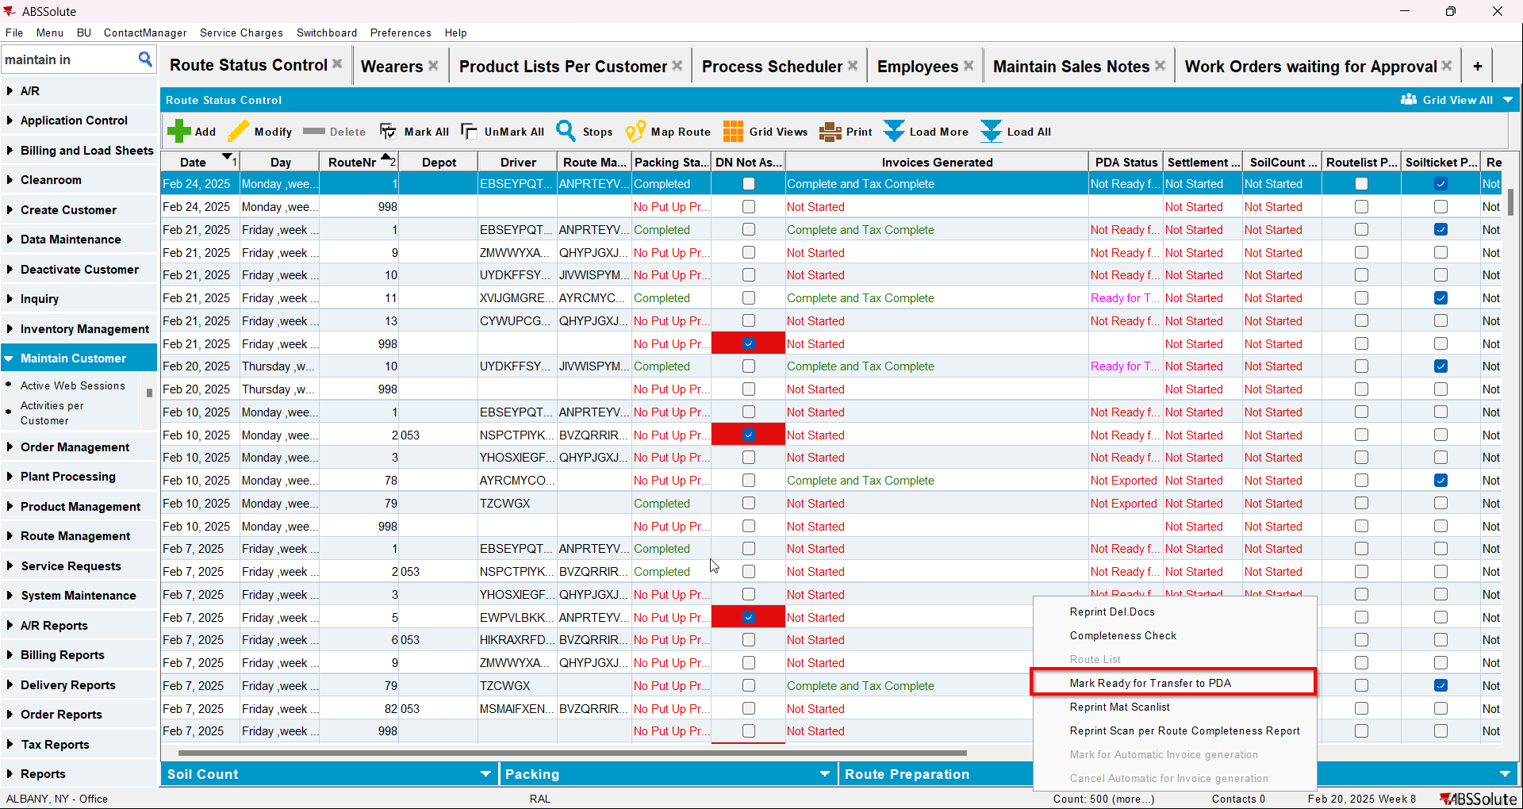
- On RA download the route
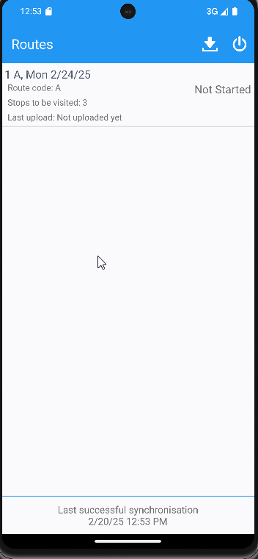
- Mark the route ready for re-transfer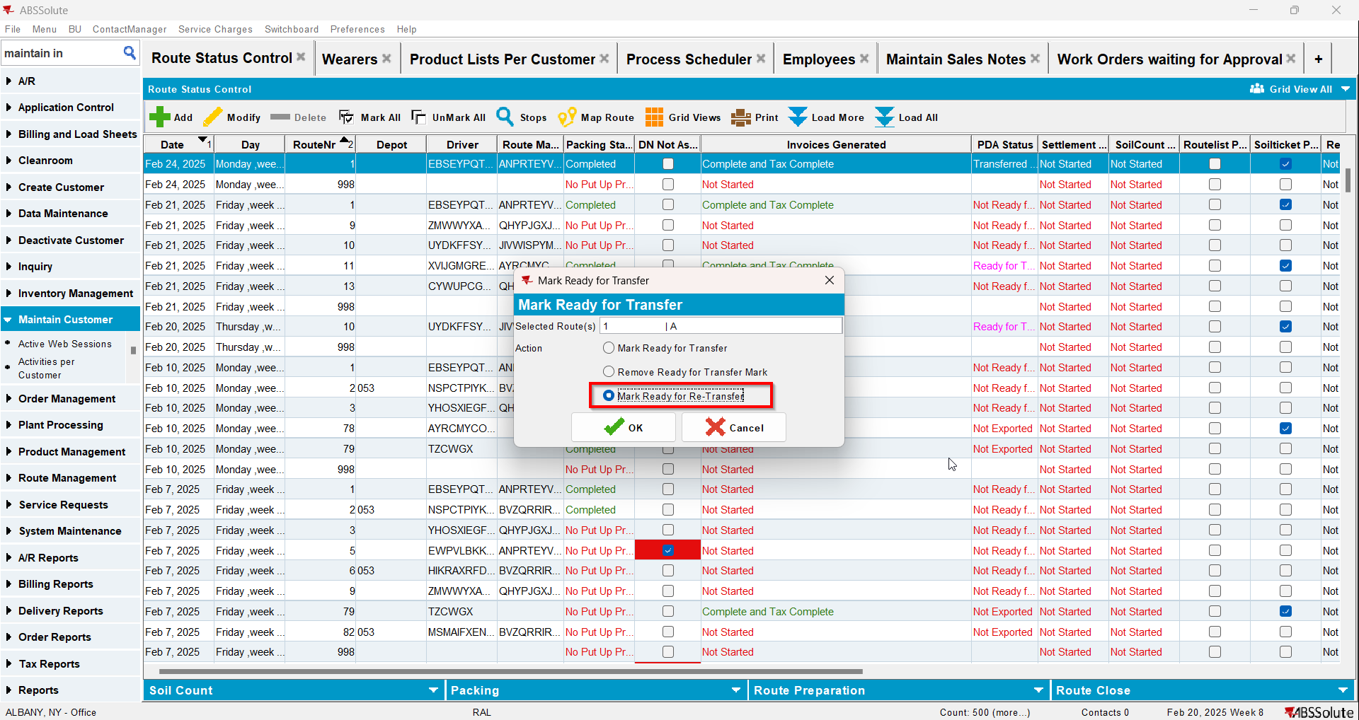
- Delete the enddownloadtimestamp for your route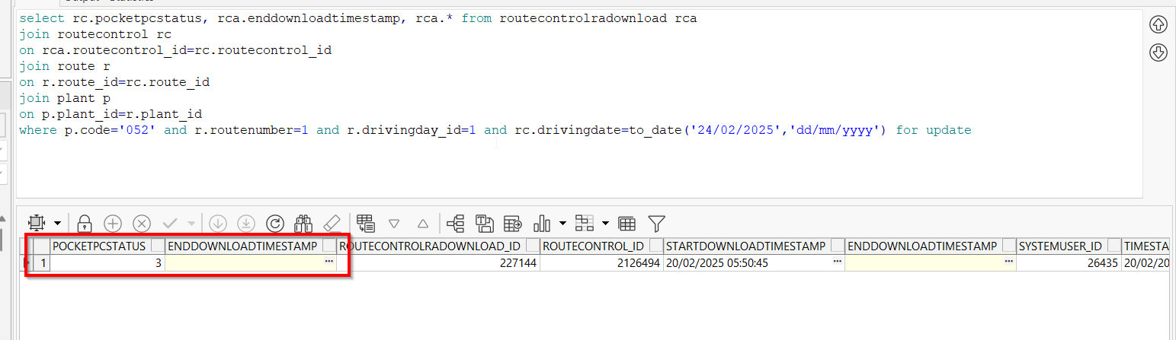
- Maintain Sales Notes DLG: Create a sales note for one of the customers with an active stop on the route from step 1
- Sales Order DLG: Add at least one product to the Ordered Items tab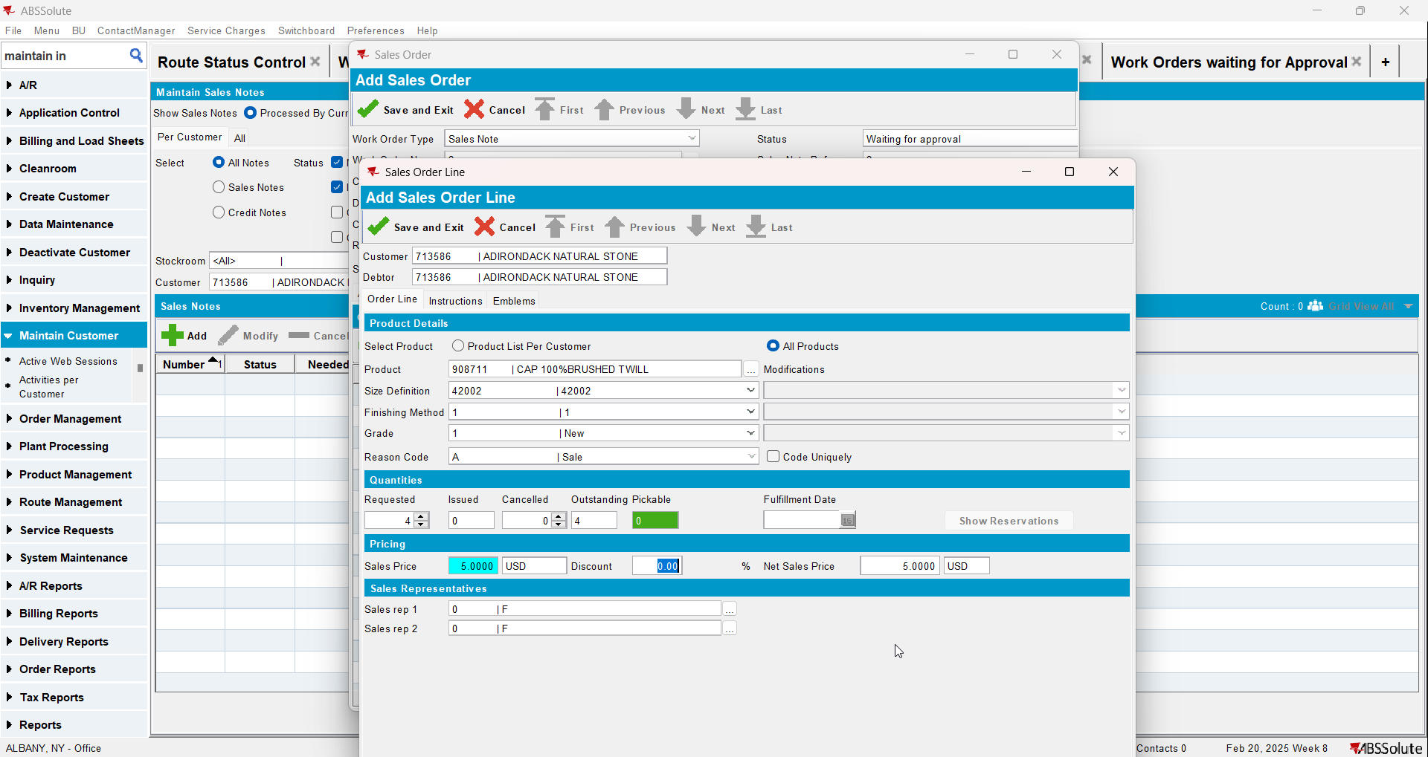
- Save the Sales Order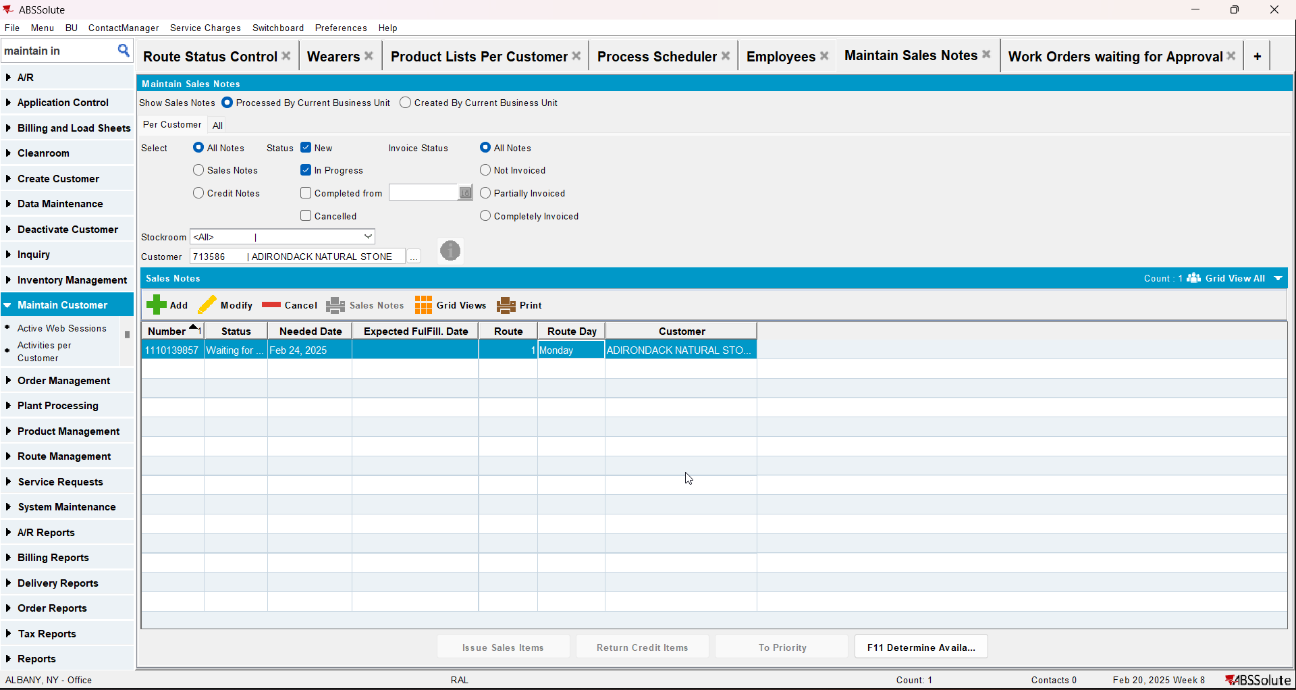
- Work Orders Waiting for Approval DLG: approve the sales note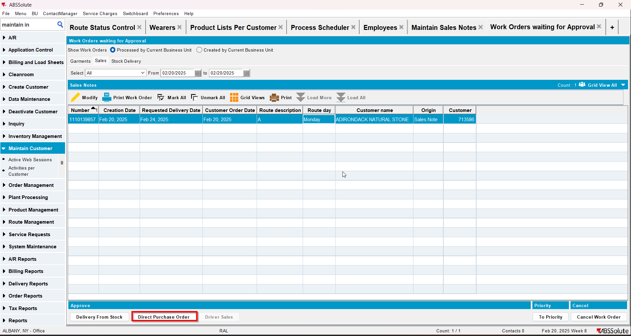
- Maintain Sales Notes DLG: issue the whole quantity and generate the delivery note for the same day as the driving day of the route from step 1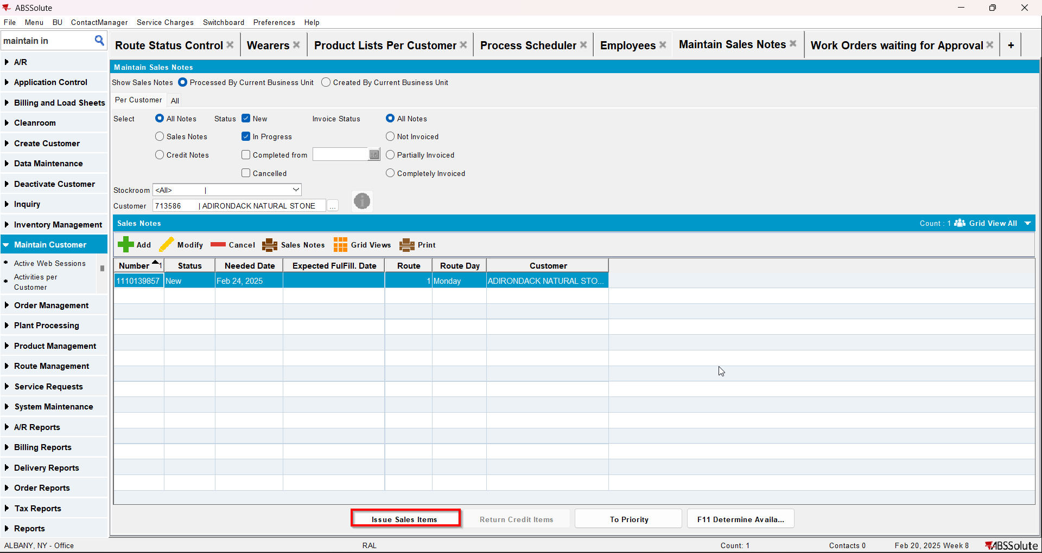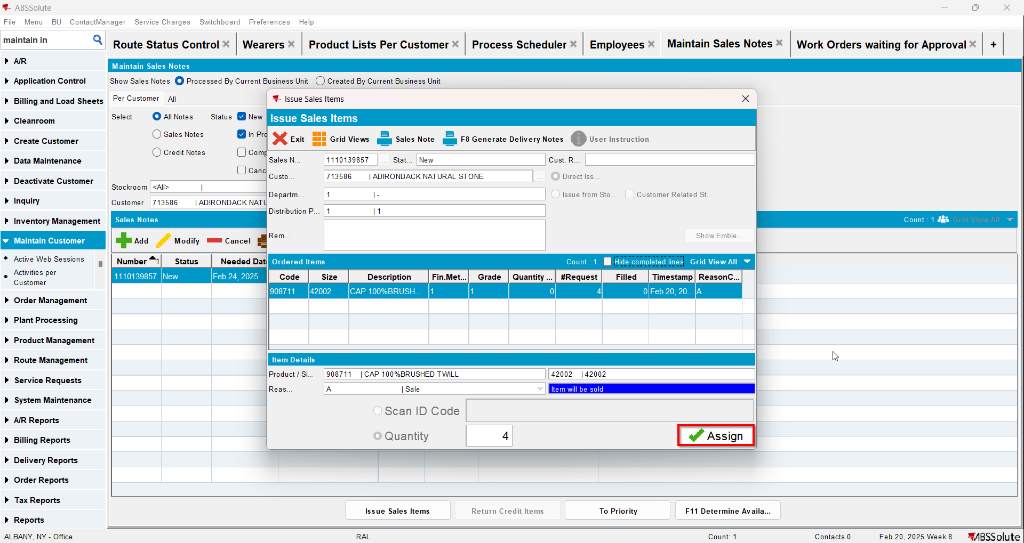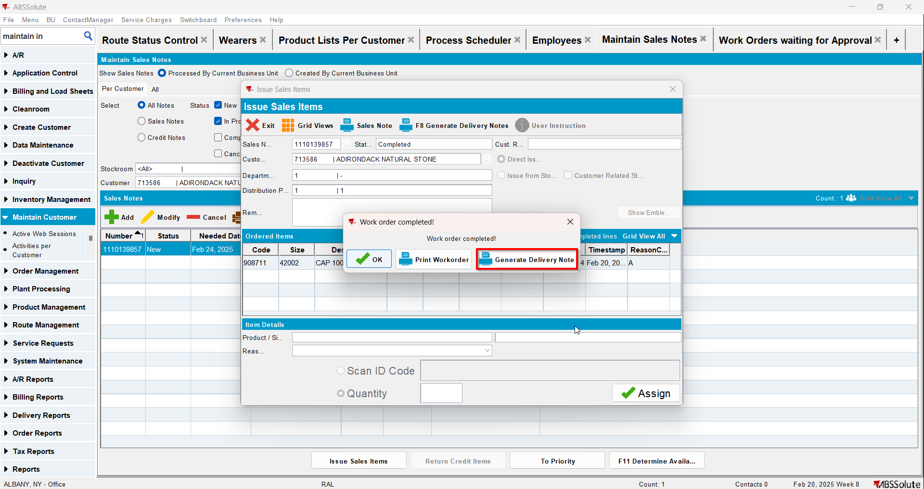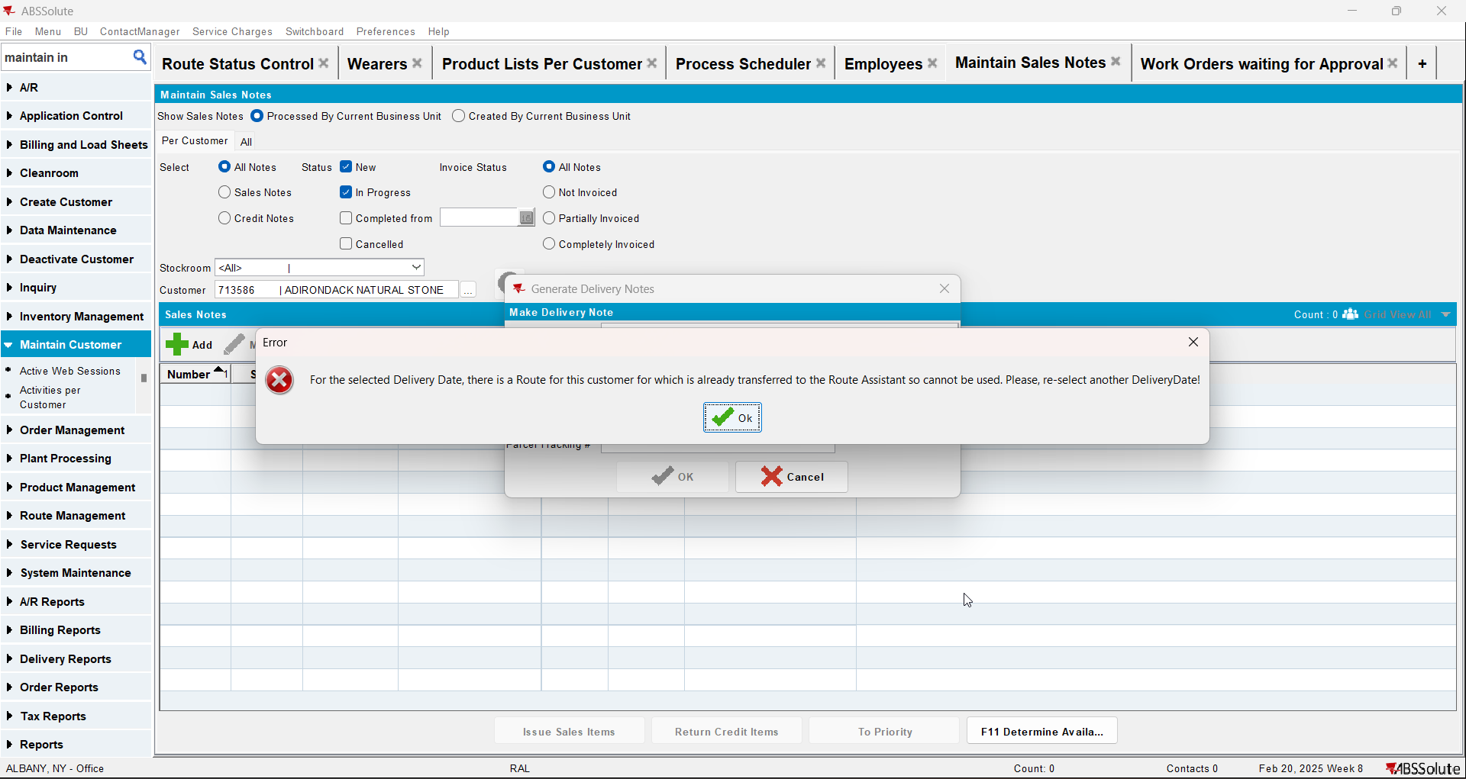

Test Case 5 – RC.POCKETPCSTATUS in (1, 2) – Tested OK
Expected behavior: the generated PackingNote for the sales note SHOULD be not attached to the route control. An error will appear
Hash: 48323c5
- Check that you have module TRADE in license
- Check that SS SALESDNONINVOICEDROUTE is set to 3
- Add a route in RSC
- Generate packing notes and invoices for at least one stop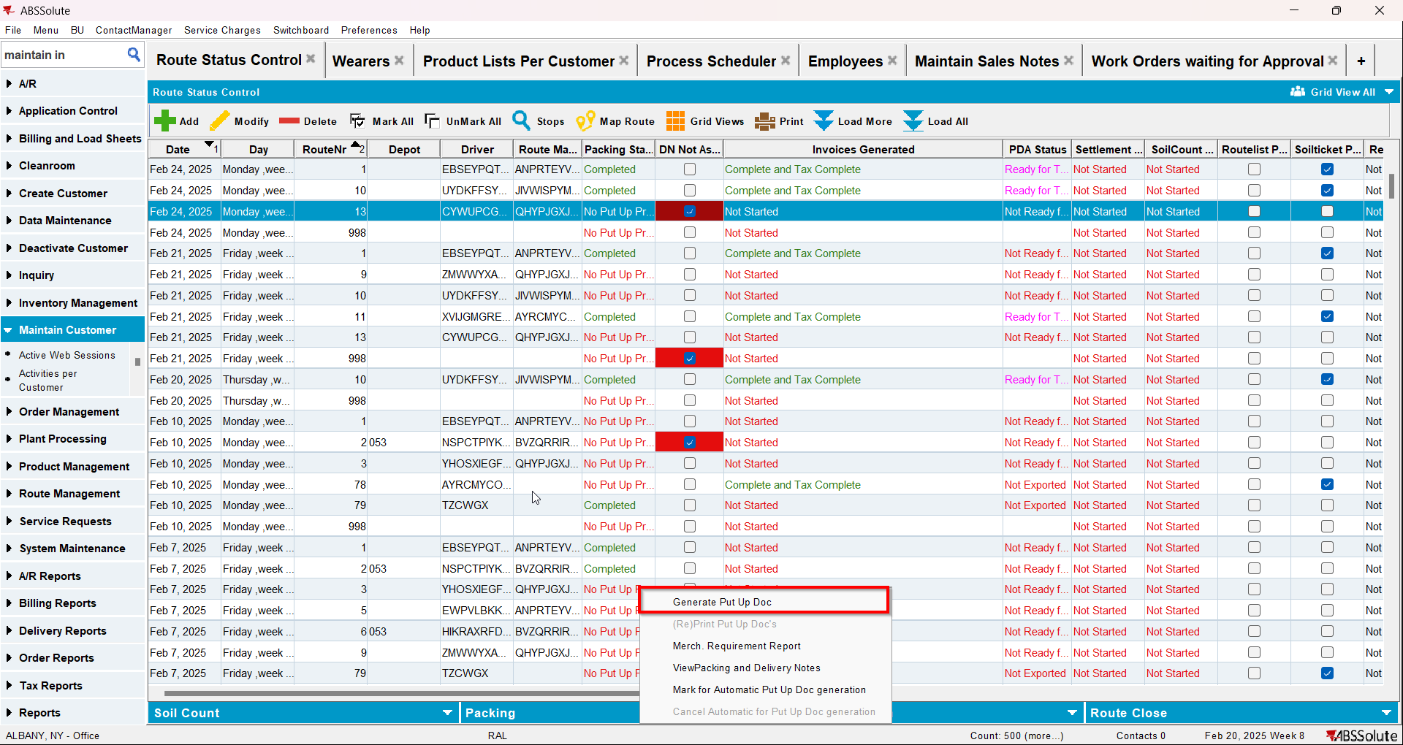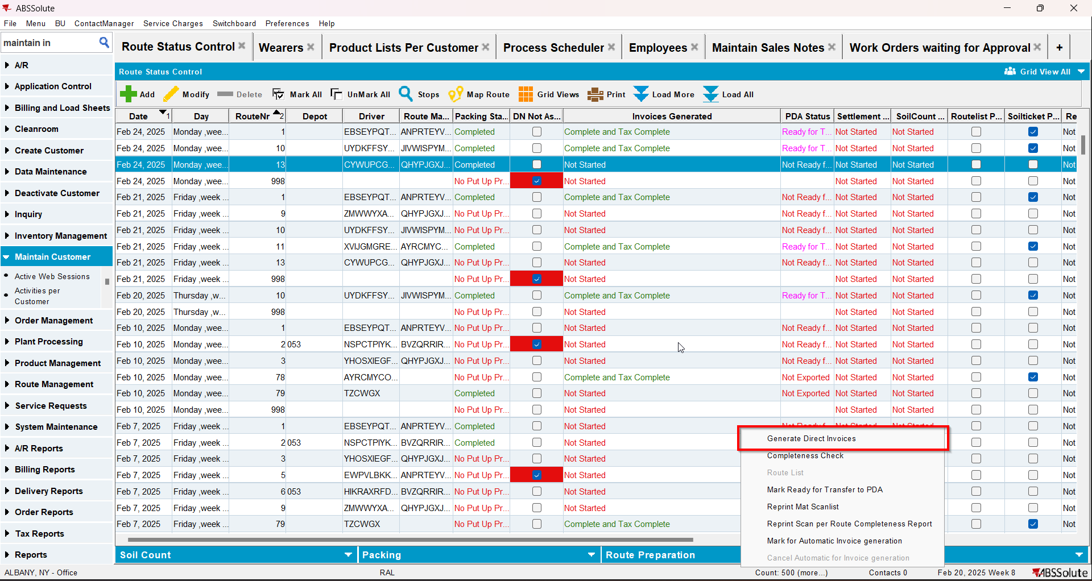
- Mark the route ready for transfer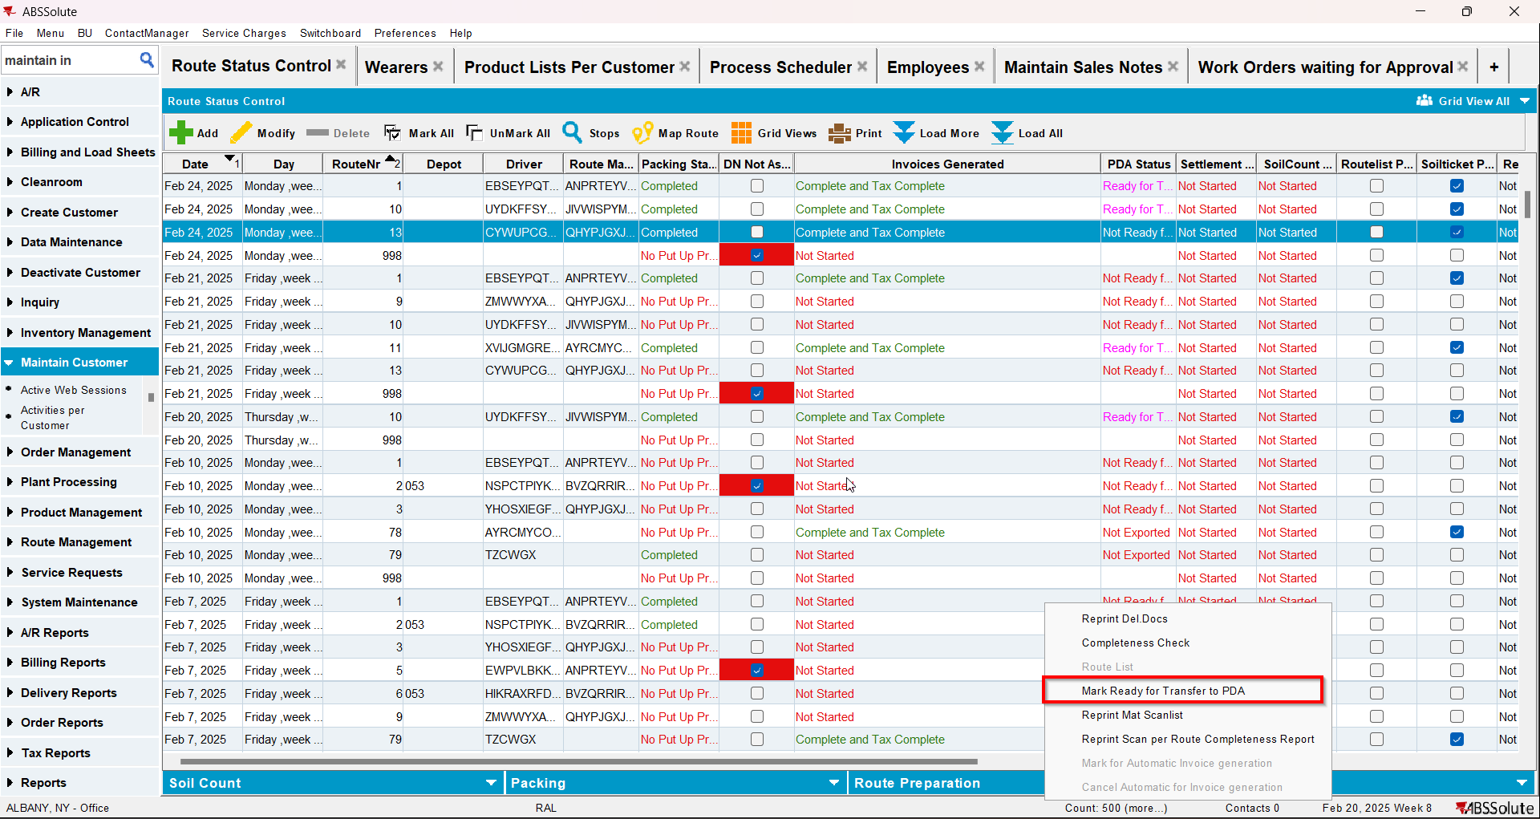
- On RA download the route
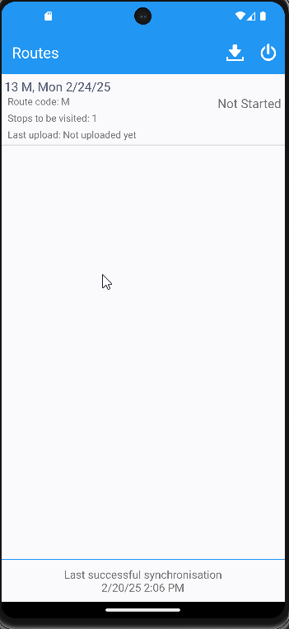
- Maintain Sales Notes DLG: Create a sales note for one of the customers with an active stop on the route from step 1
- Sales Order DLG: Add at least one product to the Ordered Items tab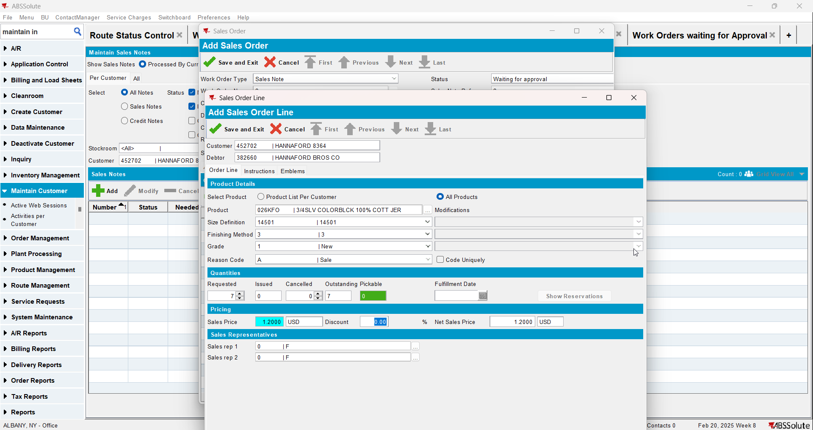
- Save the Sales Order
- Work Orders Waiting for Approval DLG: approve the sales note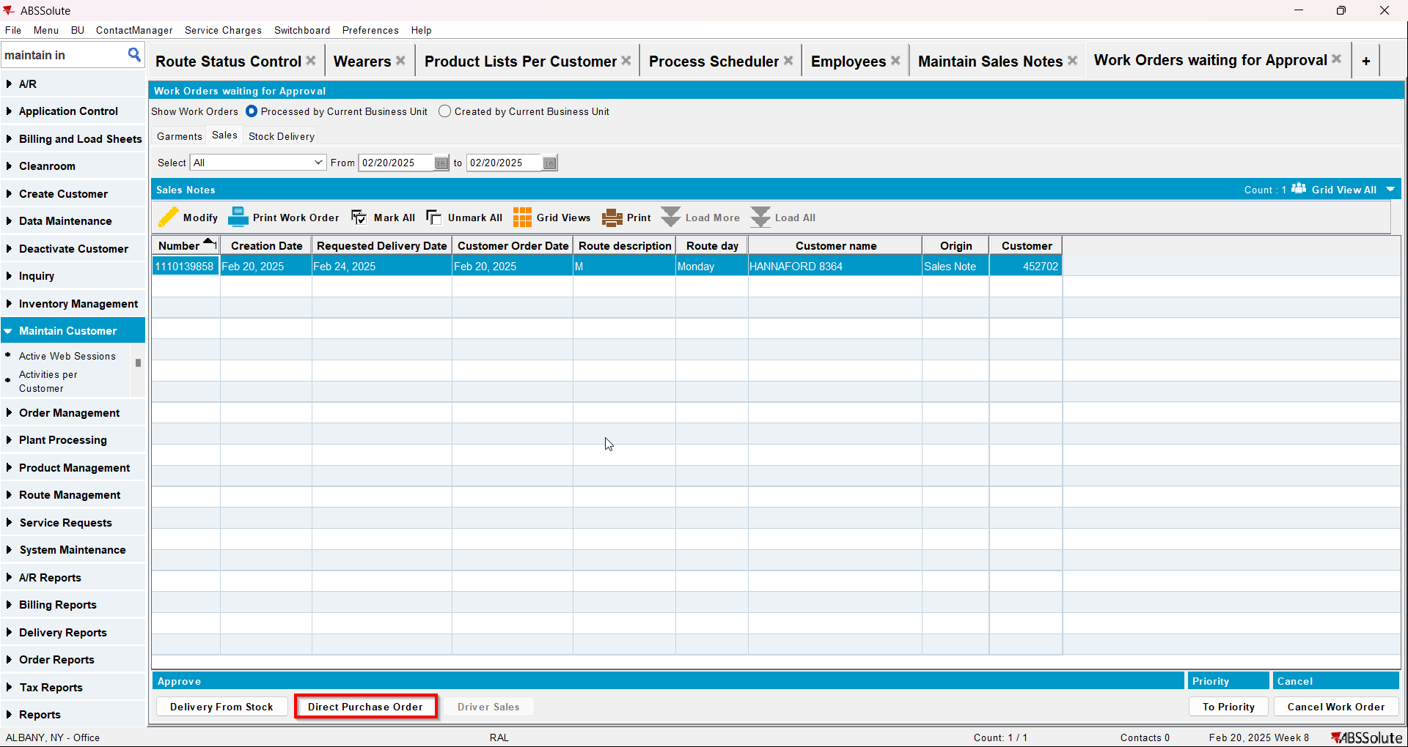
- Maintain Sales Notes DLG: issue the whole quantity and generate the delivery note for the same day as the driving day of the route from step 1