ABSN-4673 Choosing the plant to get system settings when calling Freedom Pay webservices
Environment | Prerequisites
Version: 9.07.00.UNF19  DBServerName= abs-srv20.internal.abslbs.com  DBSID=CUST24  DBUser=UNFDEV  DBPassword=UNFDEV  Environment=Production | - Module:

Contents
Reproducing before fix 1
Retest after fix 3

Reproducing before fix
Hash: c732e20051f4

- Go to an American plant, for example 044 Nashua, NH
- Open a Canadian customer from Switchboard
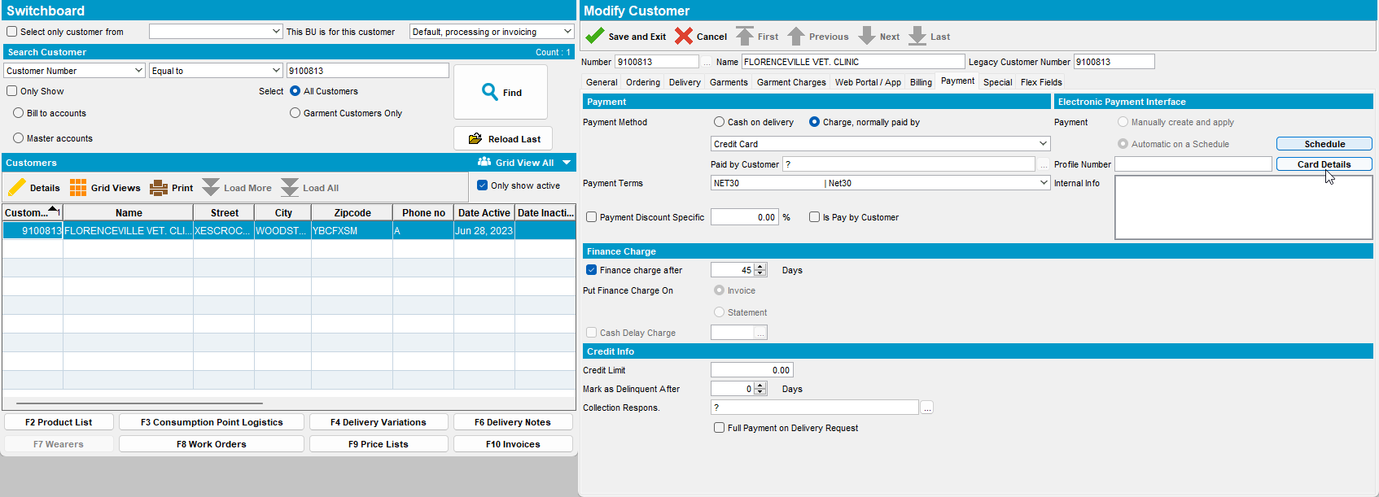

- Try to add a credit card
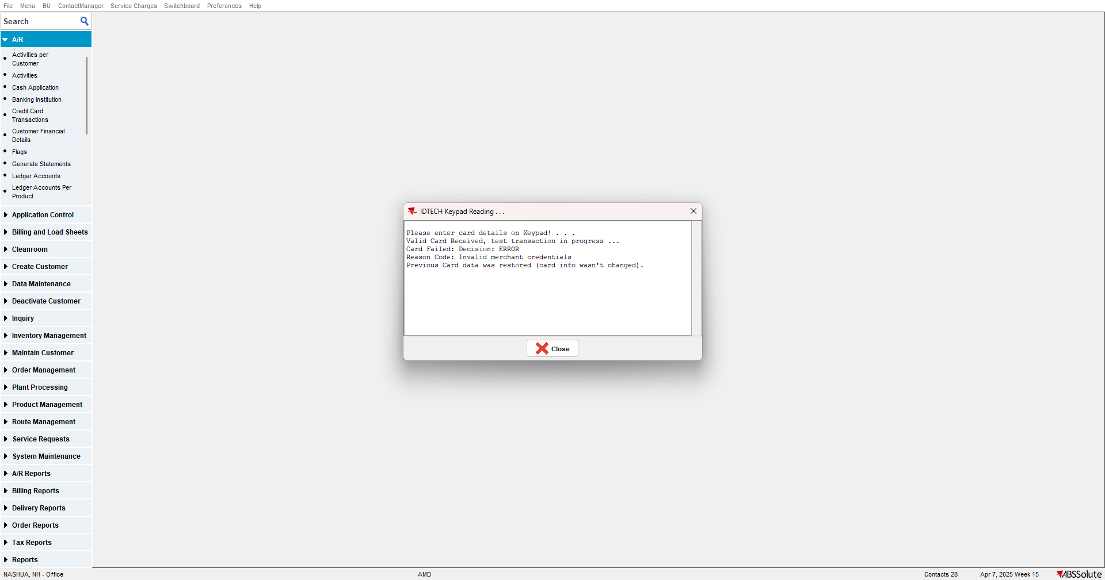

The settings for the plant in Canada are not taken over for the customer in Canada but those of the current plant.

Retest after fix
Hash: 6b968a903456

- Go to an American plant, for example 044 Nashua, NH
- Open a Canadian customer from Switchboard
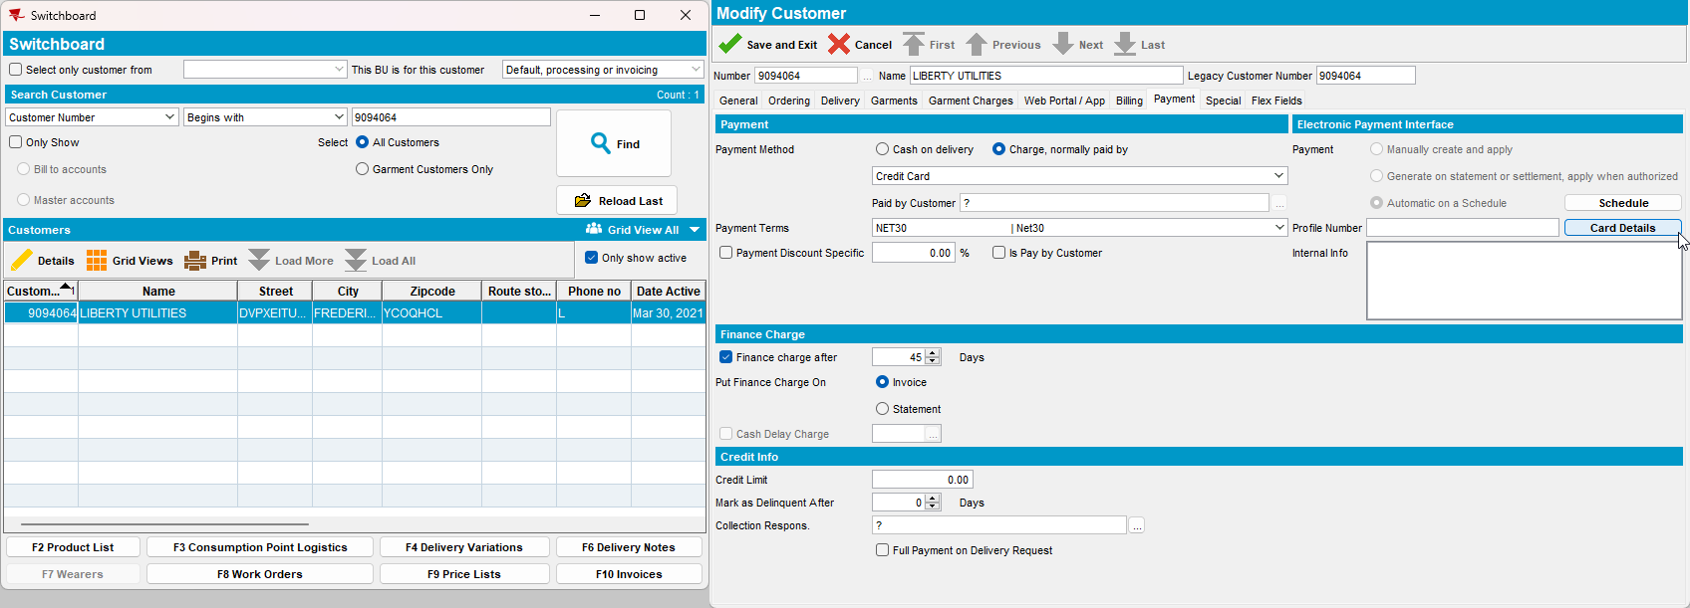

- Try to add a credit card then test it.
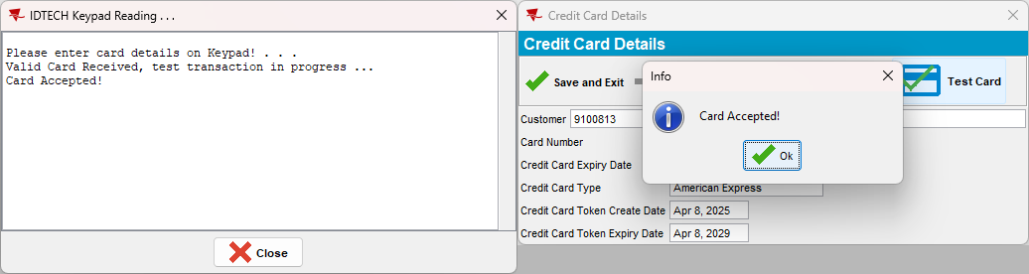

The settings for the plant in Canada are taken into account even if the card is added on another plant.

TESTED OK.

