ABSN-4612 PLPC - contract number to be shown with orange background for inactive contracts
Environment | Prerequisites
Version:9.07.00  DBServerName=abs-SRV20.internal.abslbs.com  DBSID=CUST24  DBUser=UNFDEV  DBPassword=UNFDEV  Environment=Test | - Module:  - System setting

Contents
Test after fix 1
Test Case 1 – CC.ENDDATE < SYSDATE– Tested OK 1
Test Case 2 – CC.STARTDATE > SYSDATE– Tested OK 3
Test Case 3 – COUNT(DISTINCT(CP.CONTRACT_ID)) > 1 – Tested OK 4
Test Case 4 – COUNT(DISTINCT(CP.CONTRACT_ID)) > 1 AND CC.ENDDATE > SYSDATE– Tested OK 7

Test after fix

Test Case 1 – CC.ENDDATE < SYSDATE– Tested OK
Expected behavior: The contract number should appear with an orange background
Hash: 0cdbae9
- Find data using the below select
SELECT CUST.CUSTOMERNUMBER, P.CODE, COUNT(CPLPC.CONTRACTPRODUCT_ID) FROM CONTRACT C
JOIN CONTRACTPRODUCT CP ON CP.CONTRACT_ID = C.CONTRACT_ID
JOIN CONTRACTPRODUCTPLPC CPLPC ON CPLPC.CONTRACTPRODUCT_ID = CP.CONTRACTPRODUCT_ID
JOIN CONTRACTCUSTOMER CC ON CC.CONTRACT_ID = C.CONTRACT_ID
JOIN PRODUCTLISTPERCUSTOMER PLPC ON PLPC.PRODUCTLISTPERCUSTOMER_ID = CPLPC.PRODUCTLISTPERCUSTOMER_ID
JOIN PRODUCT P ON P.PRODUCT_ID = PLPC.PRODUCT_ID
JOIN CUSTOMER CUST ON CUST.CUSTOMER_ID = PLPC.CUSTOMER_ID AND CC.CUSTOMER_LINK_ID = CUST.CUSTOMER_ID
WHERE CC.ENDDATE < SYSDATE
AND CUST.DATEINACTIVE > SYSDATE
GROUP BY CUST.CUSTOMERNUMBER, P.CODE
HAVING COUNT(CPLPC.CONTRACTPRODUCT_ID) = 1;

- Check that the customer is enddated on the contract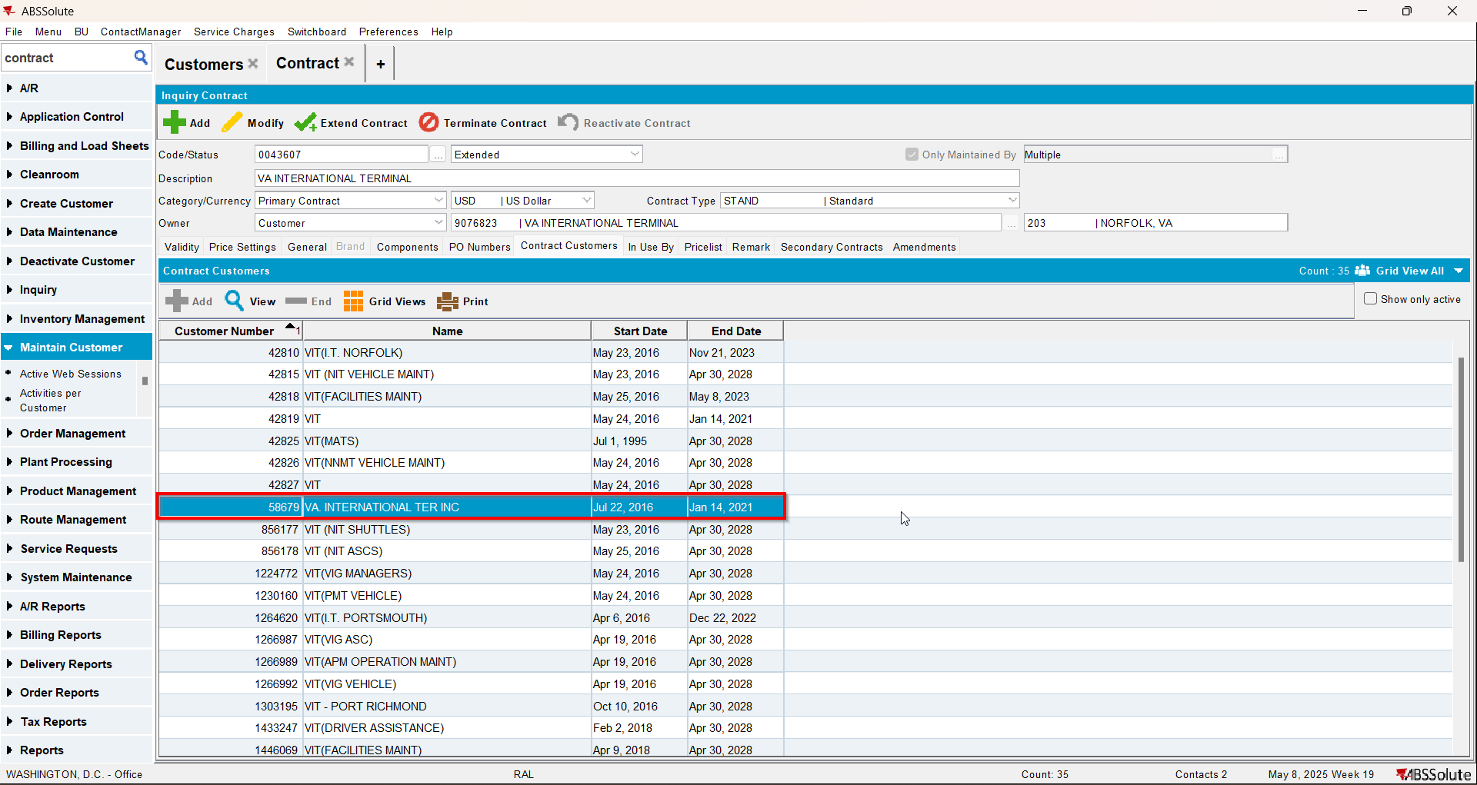
- Check the PLPC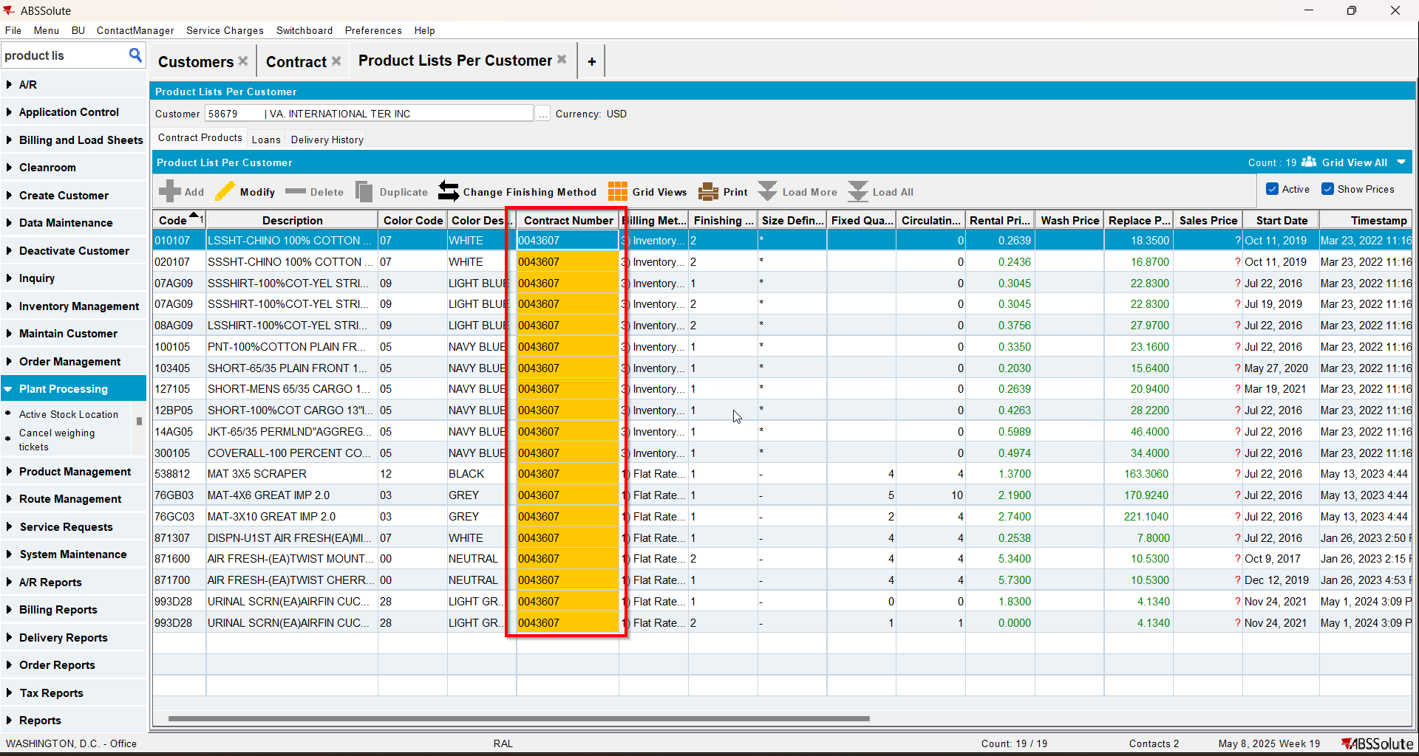

Test Case 2 – CC.STARTDATE > SYSDATE– Tested OK
Expected behavior: All records should be in blue
Hash: 0cdbae9
- Find data using the below select. If you don’t find data you need to create a new customer and add it to a contract with startdate>sysdate
SELECT CUST.CUSTOMERNUMBER, P.CODE, COUNT(CPLPC.CONTRACTPRODUCT_ID) FROM CONTRACT C
JOIN CONTRACTPRODUCT CP ON CP.CONTRACT_ID = C.CONTRACT_ID
JOIN CONTRACTPRODUCTPLPC CPLPC ON CPLPC.CONTRACTPRODUCT_ID = CP.CONTRACTPRODUCT_ID
JOIN CONTRACTCUSTOMER CC ON CC.CONTRACT_ID = C.CONTRACT_ID
JOIN PRODUCTLISTPERCUSTOMER PLPC ON PLPC.PRODUCTLISTPERCUSTOMER_ID = CPLPC.PRODUCTLISTPERCUSTOMER_ID
JOIN PRODUCT P ON P.PRODUCT_ID = PLPC.PRODUCT_ID
JOIN CUSTOMER CUST ON CUST.CUSTOMER_ID = PLPC.CUSTOMER_ID AND CC.CUSTOMER_LINK_ID = CUST.CUSTOMER_ID
WHERE CC.STARTDATE > SYSDATE
AND CUST.DATEINACTIVE > SYSDATE
GROUP BY CUST.CUSTOMERNUMBER, P.CODE
HAVING COUNT(CPLPC.CONTRACTPRODUCT_ID) = 1;

- Check that the customer startdate on the contract is bigger than sysdate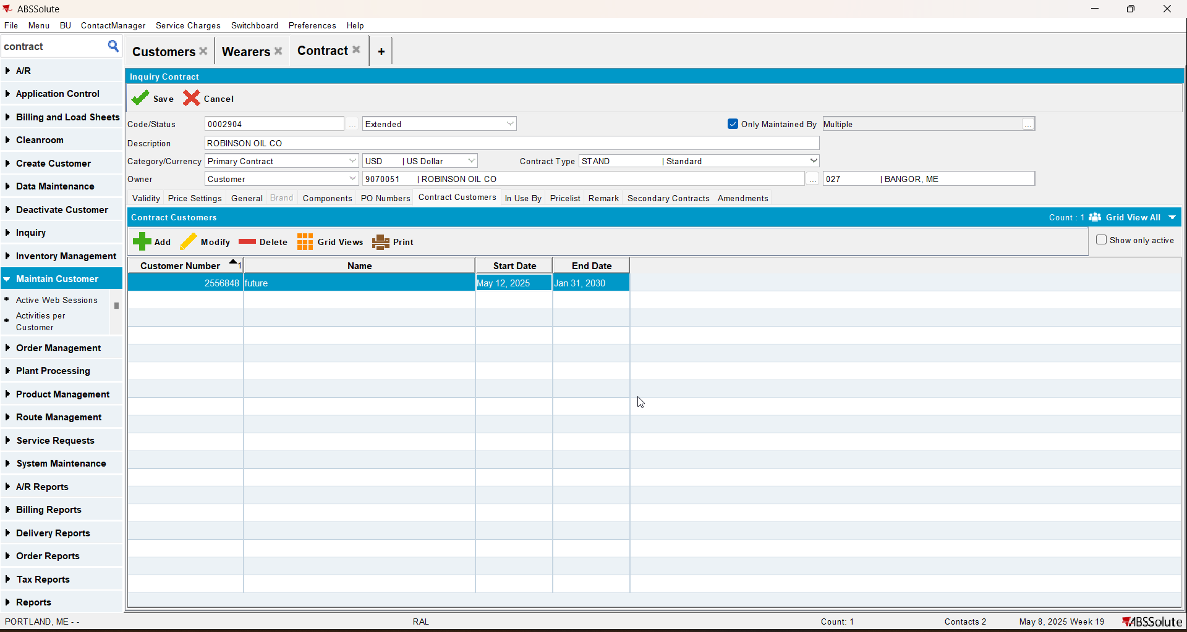
- Check the PLPC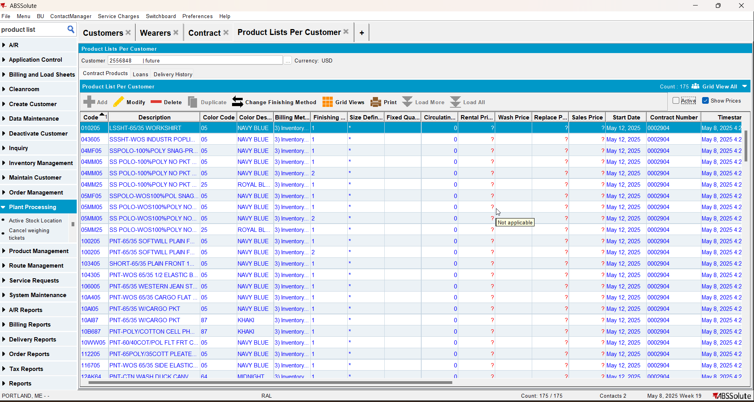

Test Case 3 – COUNT(DISTINCT(CP.CONTRACT_ID)) > 1 – Tested OK
Expected behavior: The number of the active contract will appear
Hash: 0cdbae9
- Find data using the below select
SELECT CUST.CUSTOMERNUMBER, P.CODE, SD.CODE, FM.CODE, PLPC.PRODUCTLISTPERCUSTOMER_ID, COUNT(DISTINCT(CP.CONTRACT_ID)) FROM CONTRACT C
JOIN CONTRACTPRODUCT CP ON CP.CONTRACT_ID = C.CONTRACT_ID
JOIN CONTRACTPRODUCTPLPC CPLPC ON CPLPC.CONTRACTPRODUCT_ID = CP.CONTRACTPRODUCT_ID
JOIN CONTRACTCUSTOMER CC ON CC.CONTRACT_ID = C.CONTRACT_ID
JOIN PRODUCTLISTPERCUSTOMER PLPC ON PLPC.PRODUCTLISTPERCUSTOMER_ID = CPLPC.PRODUCTLISTPERCUSTOMER_ID
JOIN PRODUCT P ON P.PRODUCT_ID = PLPC.PRODUCT_ID
JOIN SIZEDEFINITION SD ON SD.SIZEDEFINITION_ID = PLPC.SIZEDEFINITION_ID
JOIN FINISHINGMETHOD FM ON FM.FINISHINGMETHOD_ID = PLPC.FINISHINGMETHOD_ID
JOIN CUSTOMER CUST ON CUST.CUSTOMER_ID = PLPC.CUSTOMER_ID AND CC.CUSTOMER_LINK_ID = CUST.CUSTOMER_ID
WHERE CUST.DATEINACTIVE > SYSDATE
GROUP BY CUST.CUSTOMERNUMBER, P.CODE, SD.CODE, FM.CODE, PLPC.PRODUCTLISTPERCUSTOMER_ID
HAVING COUNT(DISTINCT(CP.CONTRACT_ID)) > 1;
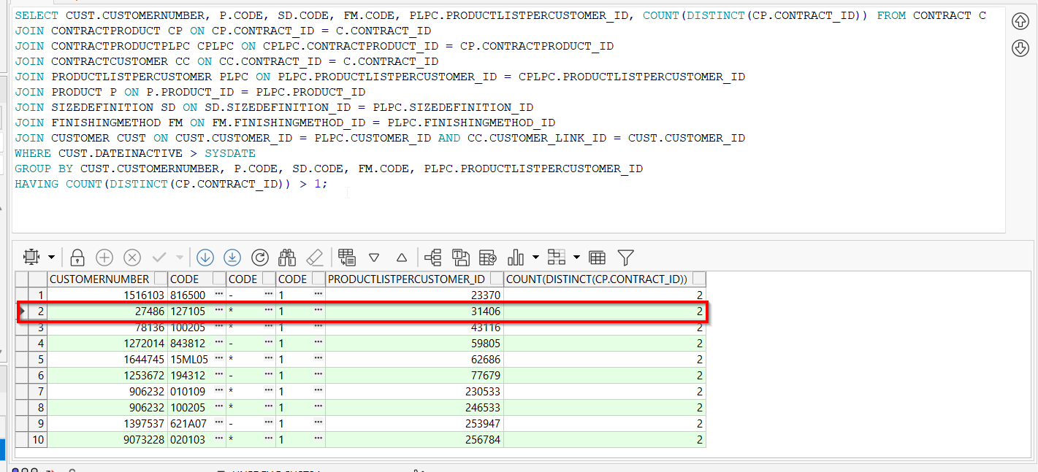
- Check that on a conctart the customer is enddated and on another contract it is still active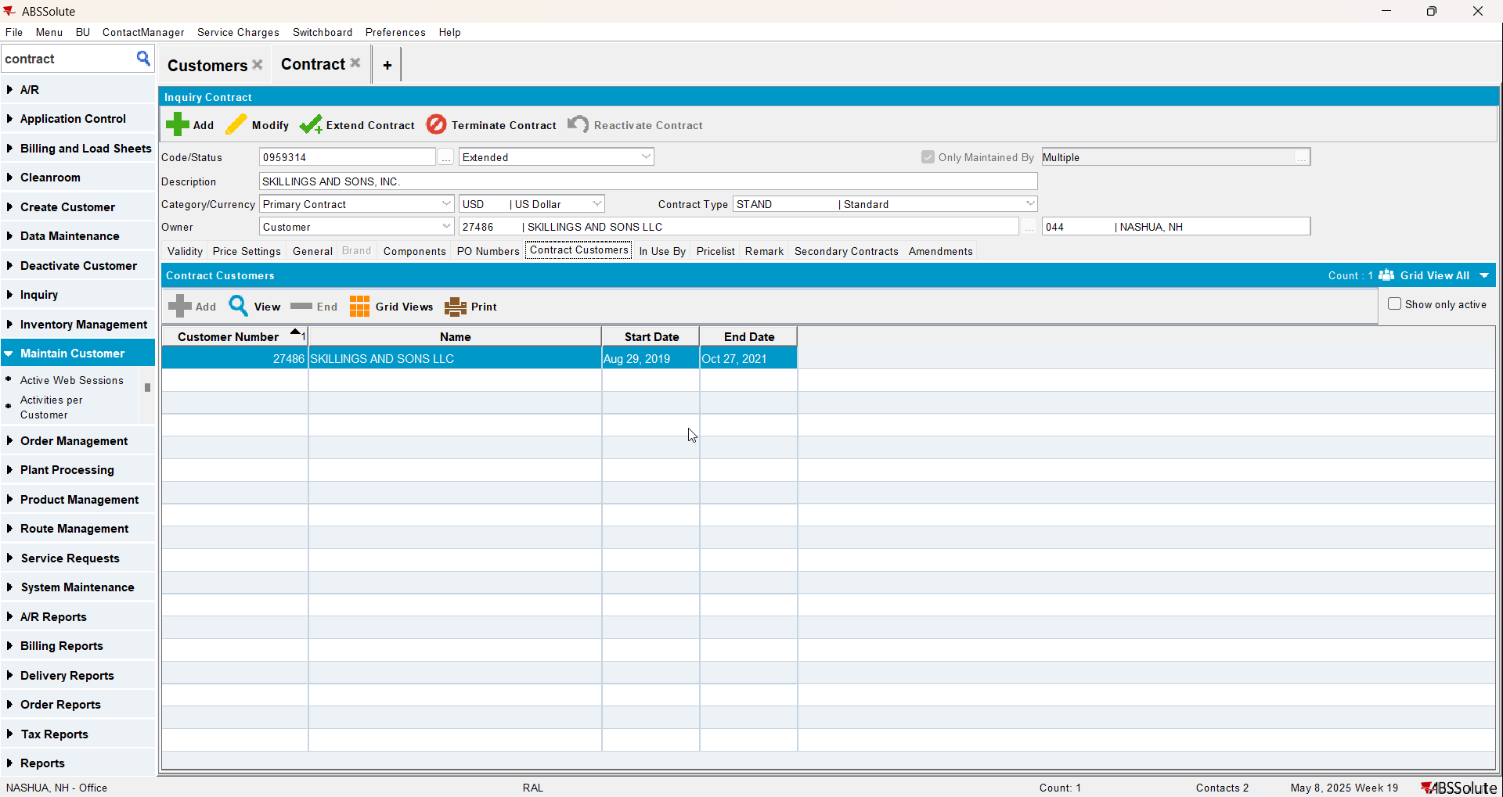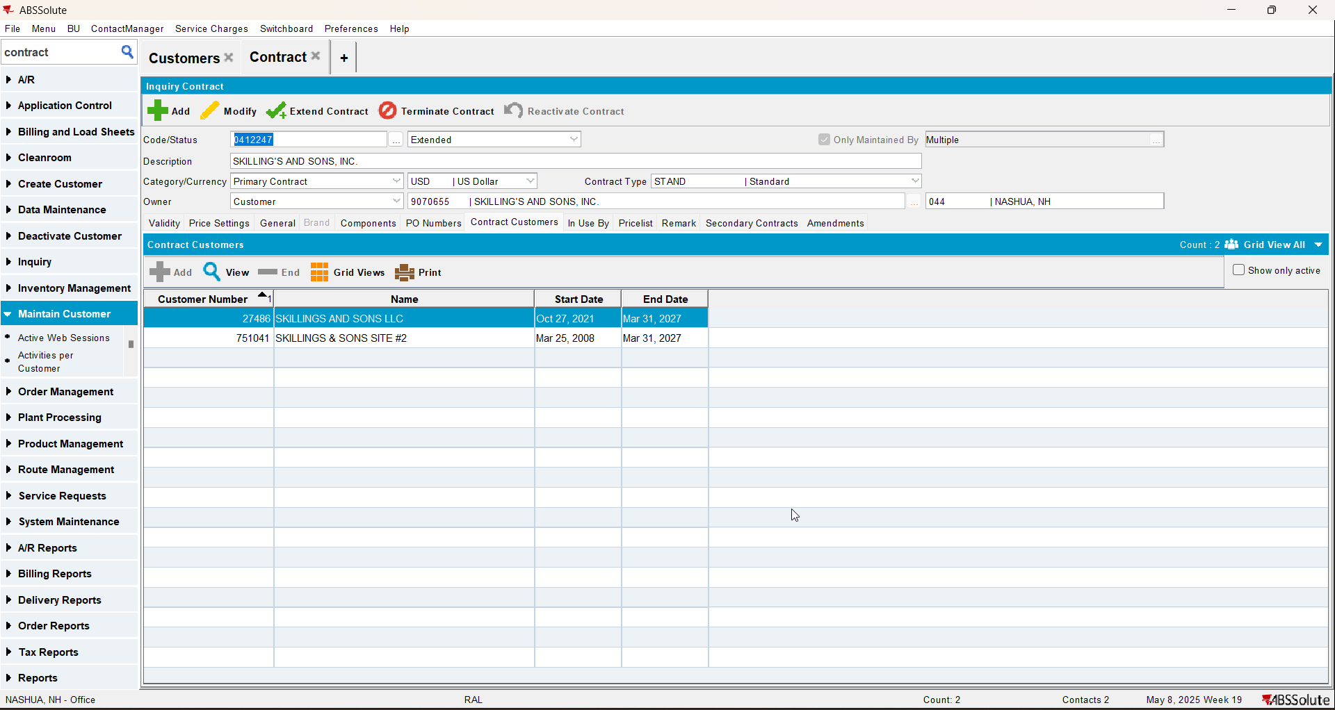
- Check PLPC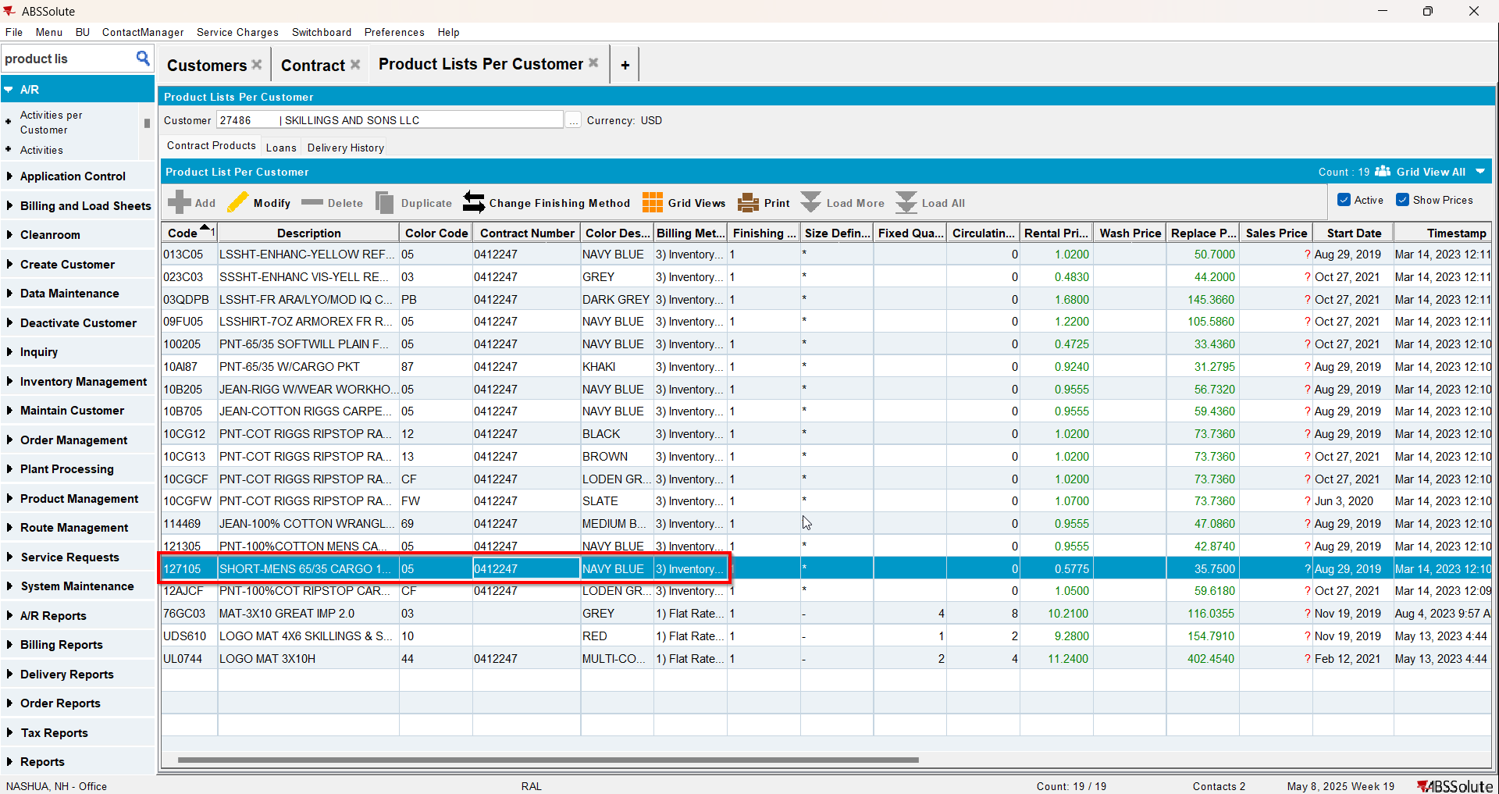

Test Case 4 – COUNT(DISTINCT(CP.CONTRACT_ID)) > 1 AND CC.ENDDATE > SYSDATE– Tested OK
Expected behavior: The number of the active contract where the product startdate is lower will appear. This is not a real life case, we check to be sure nothing crashes
Hash: 0cdbae9
- Find data using the below select
SELECT CUST.CUSTOMERNUMBER, P.CODE, SD.CODE, FM.CODE, PLPC.PRODUCTLISTPERCUSTOMER_ID, COUNT(DISTINCT(CP.CONTRACT_ID)) FROM CONTRACT C
JOIN CONTRACTPRODUCT CP ON CP.CONTRACT_ID = C.CONTRACT_ID
JOIN CONTRACTPRODUCTPLPC CPLPC ON CPLPC.CONTRACTPRODUCT_ID = CP.CONTRACTPRODUCT_ID
JOIN CONTRACTCUSTOMER CC ON CC.CONTRACT_ID = C.CONTRACT_ID
JOIN PRODUCTLISTPERCUSTOMER PLPC ON PLPC.PRODUCTLISTPERCUSTOMER_ID = CPLPC.PRODUCTLISTPERCUSTOMER_ID
JOIN PRODUCT P ON P.PRODUCT_ID = PLPC.PRODUCT_ID
JOIN SIZEDEFINITION SD ON SD.SIZEDEFINITION_ID = PLPC.SIZEDEFINITION_ID
JOIN FINISHINGMETHOD FM ON FM.FINISHINGMETHOD_ID = PLPC.FINISHINGMETHOD_ID
JOIN CUSTOMER CUST ON CUST.CUSTOMER_ID = PLPC.CUSTOMER_ID AND CC.CUSTOMER_LINK_ID = CUST.CUSTOMER_ID
WHERE CUST.DATEINACTIVE > SYSDATE
AND CC.ENDDATE > SYSDATE
GROUP BY CUST.CUSTOMERNUMBER, P.CODE, SD.CODE, FM.CODE, PLPC.PRODUCTLISTPERCUSTOMER_ID
HAVING COUNT(DISTINCT(CP.CONTRACT_ID)) > 1;

- Check that the customer is active on 2 contracts 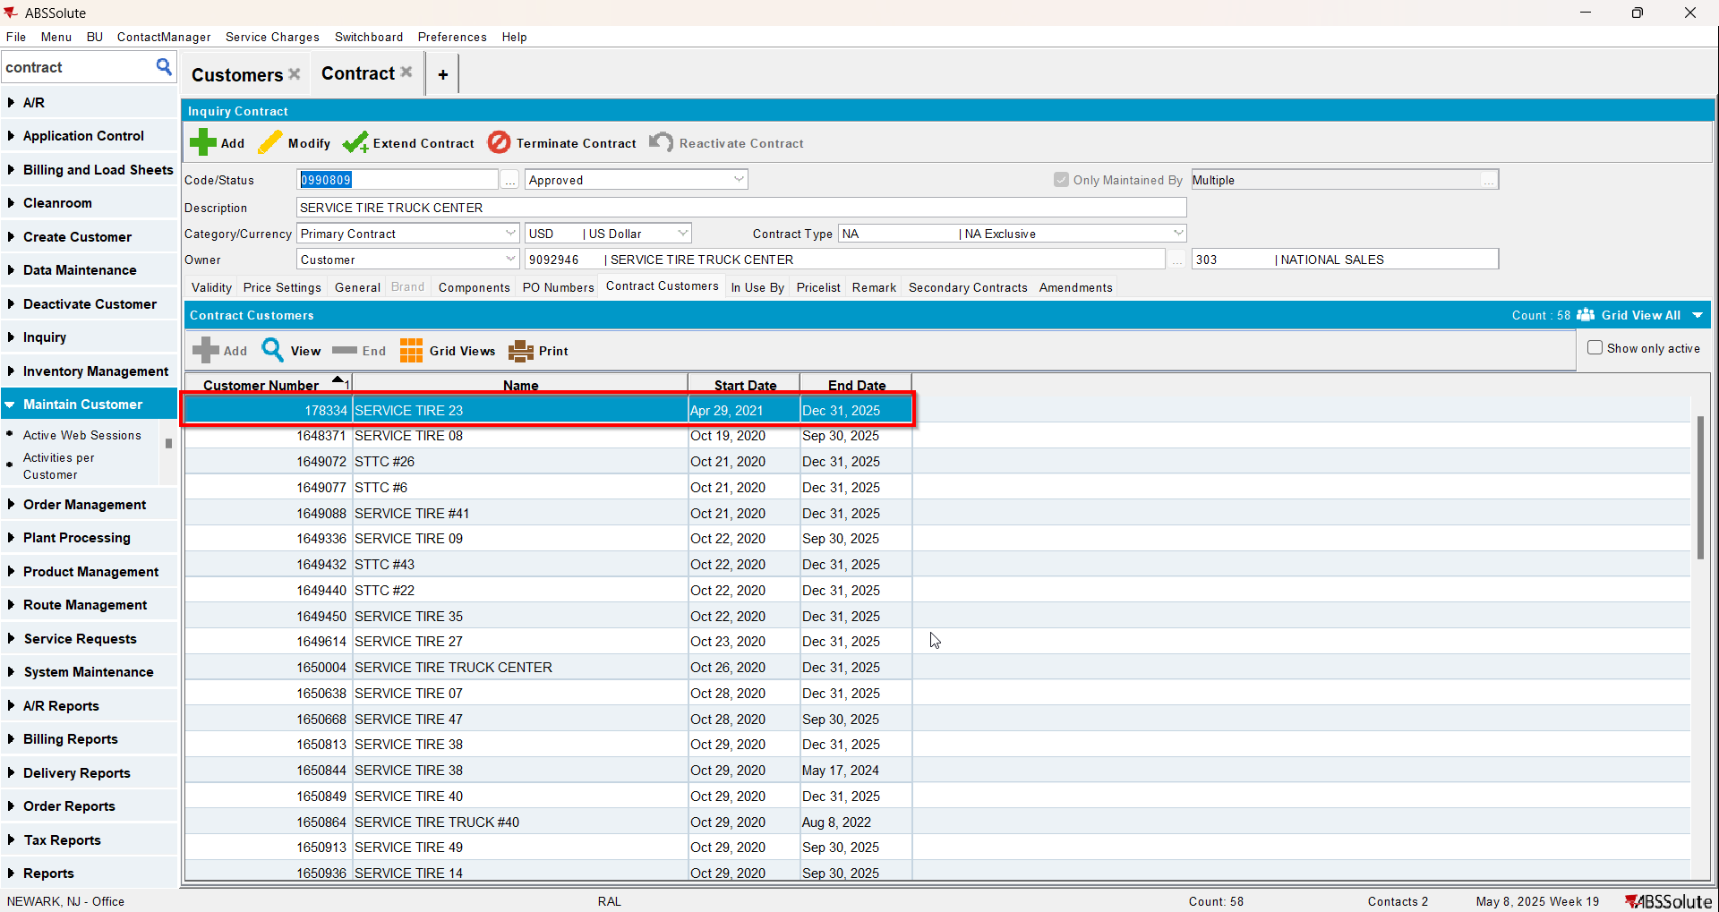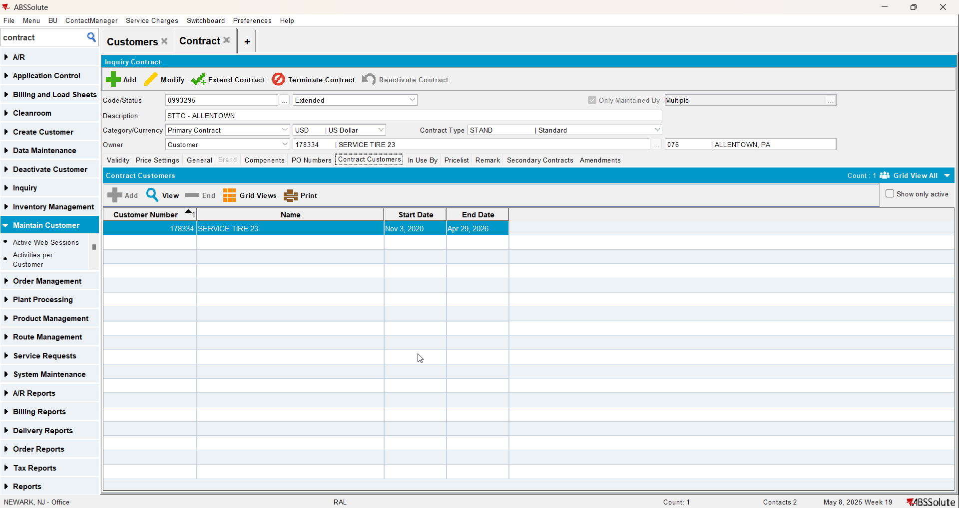
- Check PLPC