ABSN-4489 Sort order of printed invoices through RCS is on delto customer instead of route and stopnumber
Environment | Prerequisites
Version: 9.07.00.UNF19  DBServerName= abs-srv20.internal.abslbs.com  DBSID=CUST24  DBUser=UNFDEV  DBPassword=UNFDEV  Environment=Production | - Module:  - System setting

Contents
Test after fix 1
Test Case 1 - Print invoices from Maintain Invoices> All Tab with UNFCUSTOM in the license 2
Test Case 2 - Print invoices from Customer Financial Details> Invoices/Charges Tab with UNFCUSTOM in the license 5
Test Case 3 - Print invoices from Route Status Control on Canada BU with UNFCUSTOM in the license 6
Test Case 4 – Generate invoices from Maintain Sales Notes 8
Test Case 5 – Print invoices from Switchboard 10
Test Case 6 – Email invoices from Route Assistant 12
Test Case 7 – Run E-mail Direct Invoices process 14

Test after fix
Hash: e4ea4aab85bb

FOR THESE TESTS, I USED THE FOLLOWING REPORT AND THE FOLLOWING VERSIONS OF THE VIEWS:

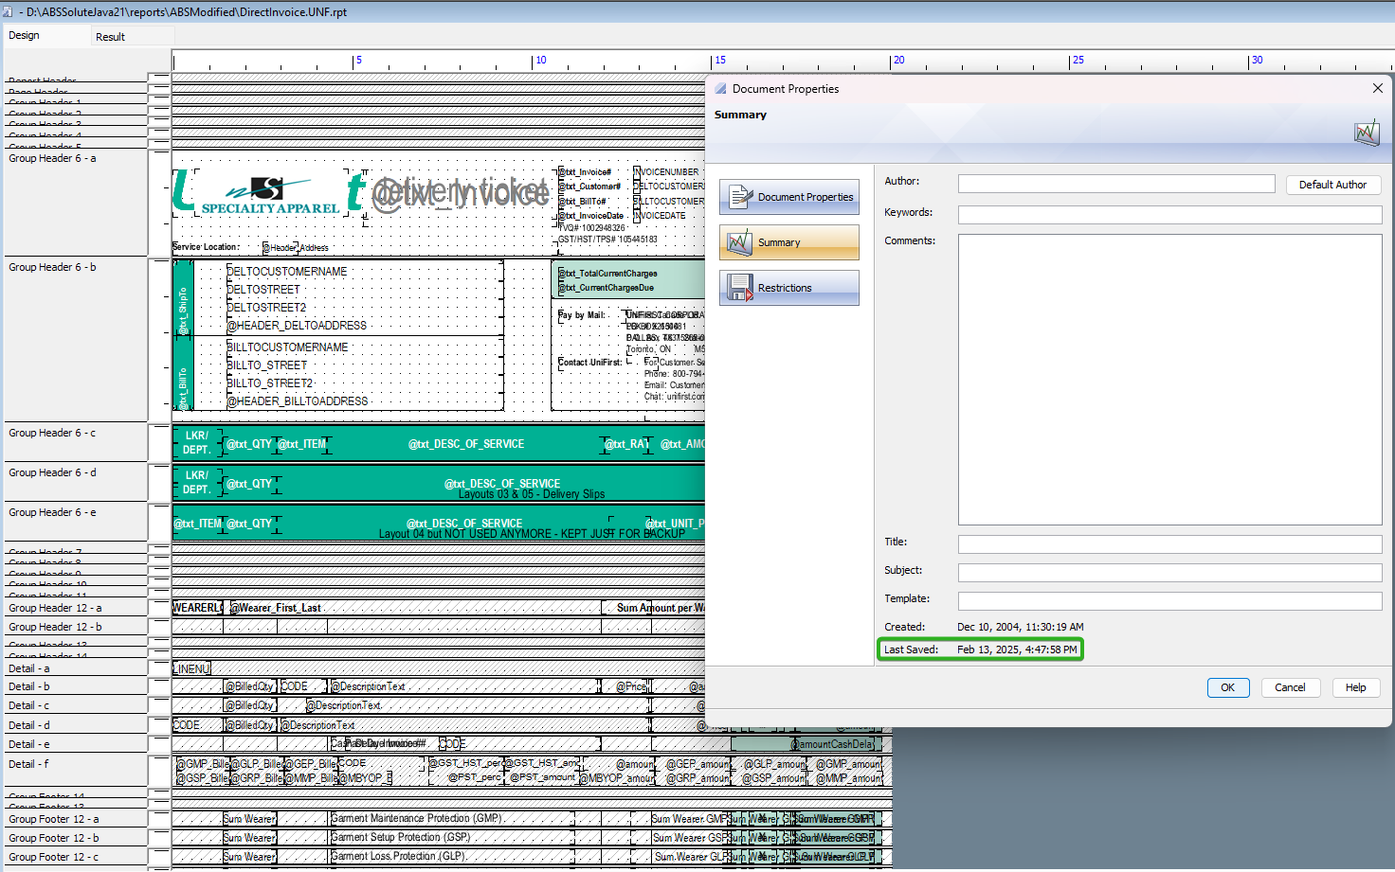

Test Case 1 - Print invoices from Maintain Invoices> All Tab with UNFCUSTOM in the license
Expected behavior:
The order in which invoices are printed is ordered by Route / Stop / Customer / Invoice Number
Test steps:
1. Maintain Invoices DLG>All Tab>Settled subtab
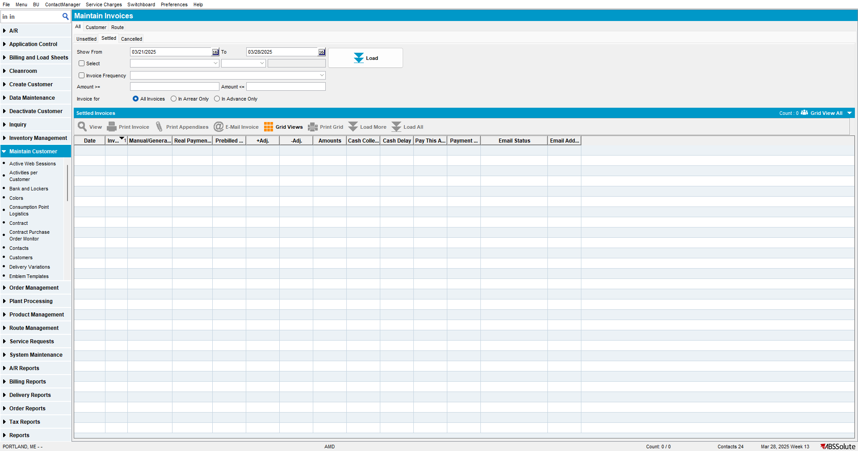
2. Load invoices for a longer period of time
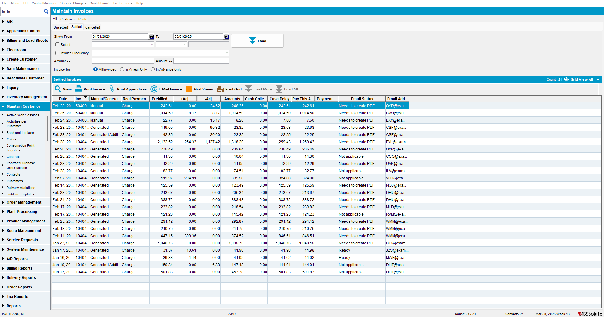

3. Add Route and Stop Number columns
4. Multiselect in the grid invoices from multiple routes
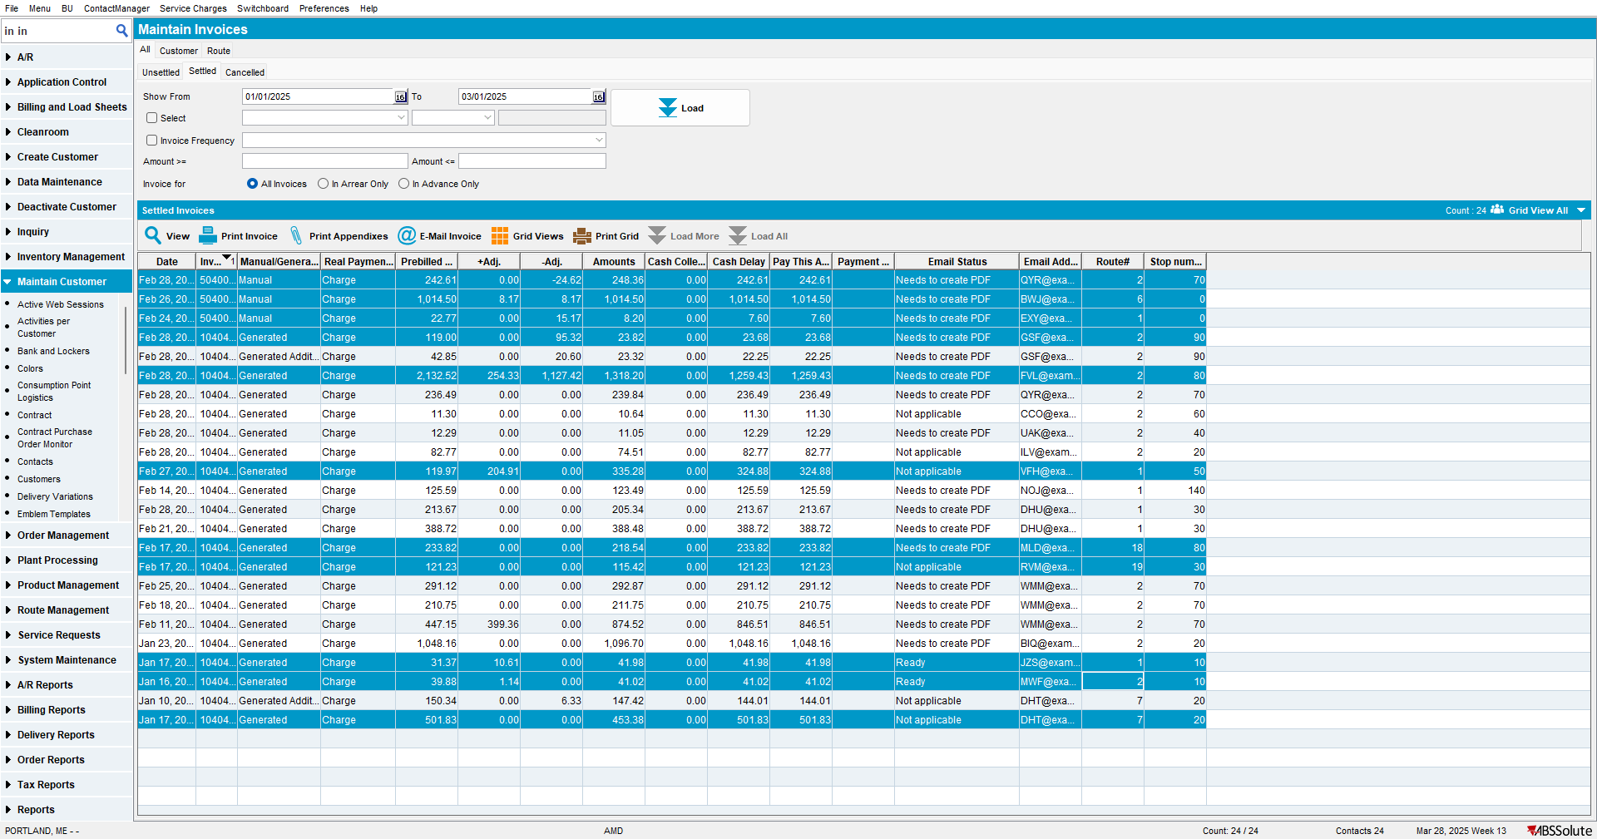
5. Press Print
6. Check to see that invoices are printed in the order of route / stop

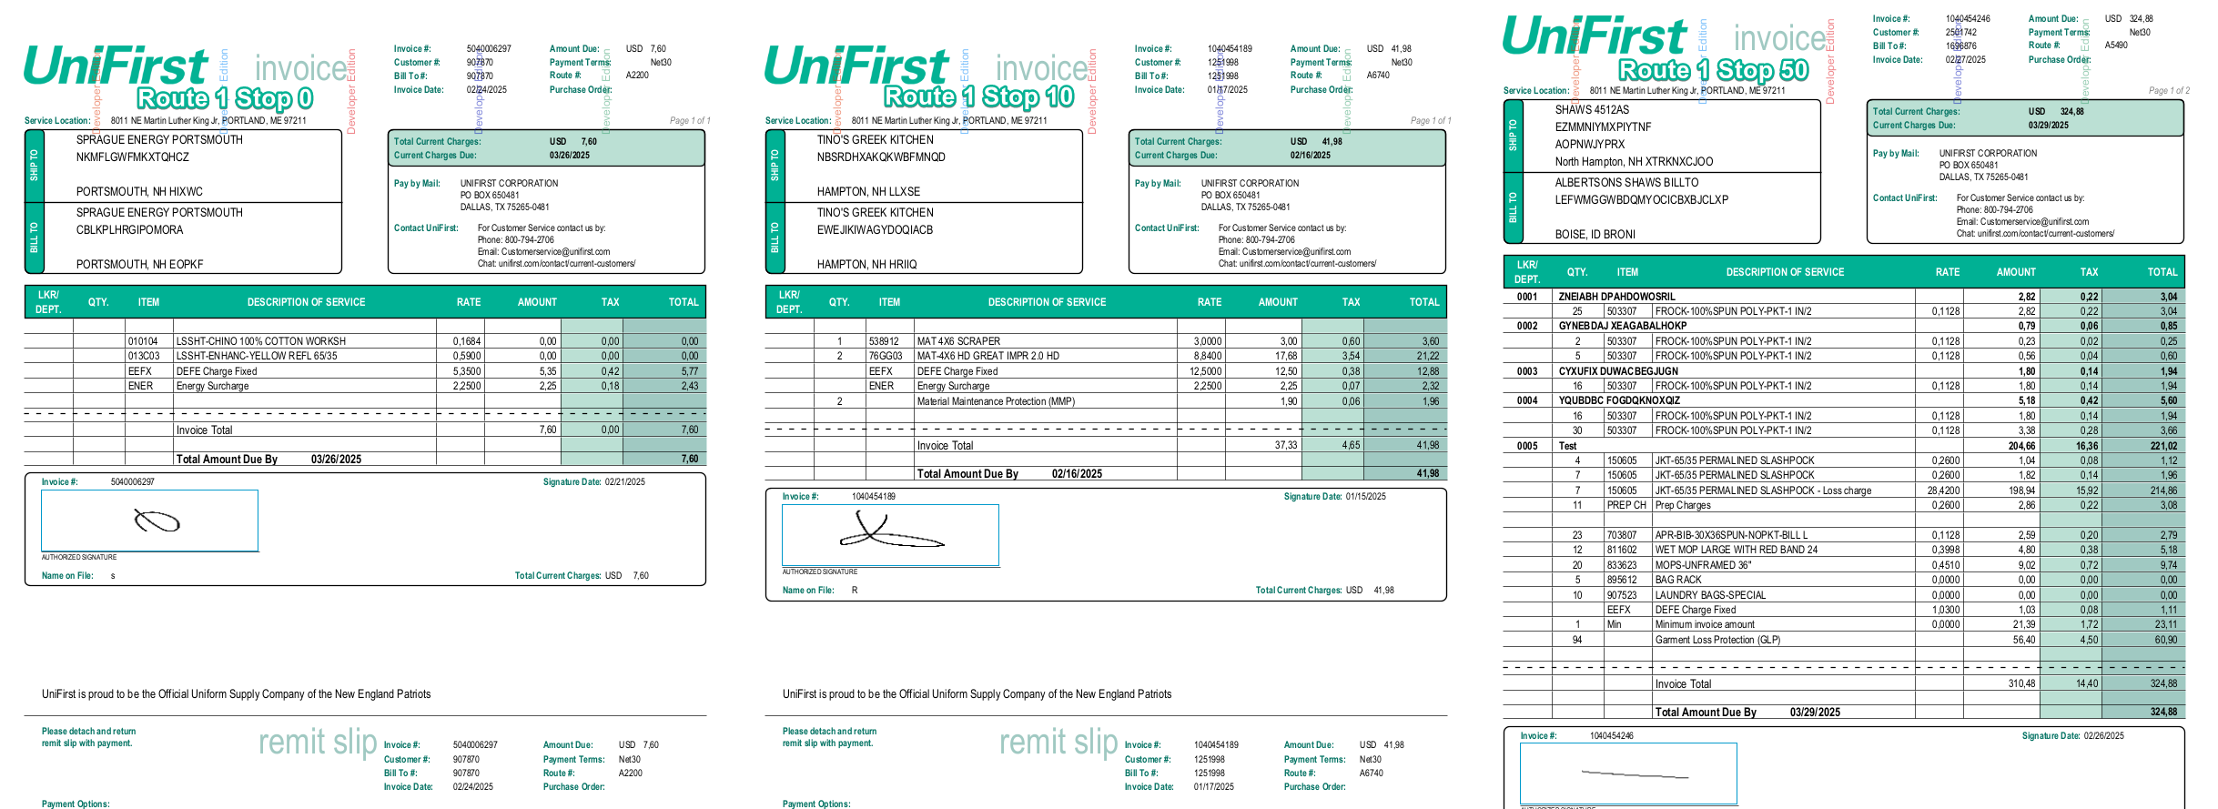
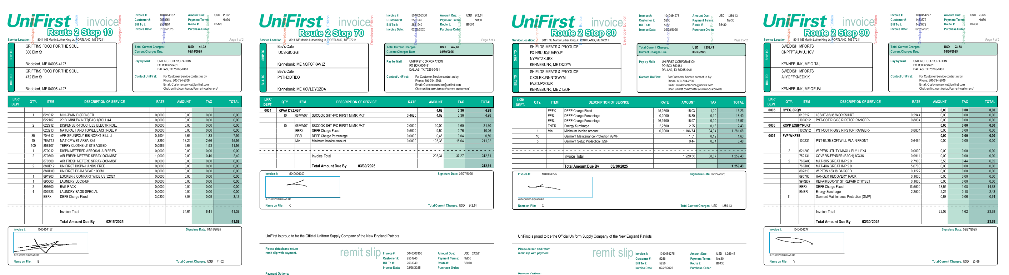
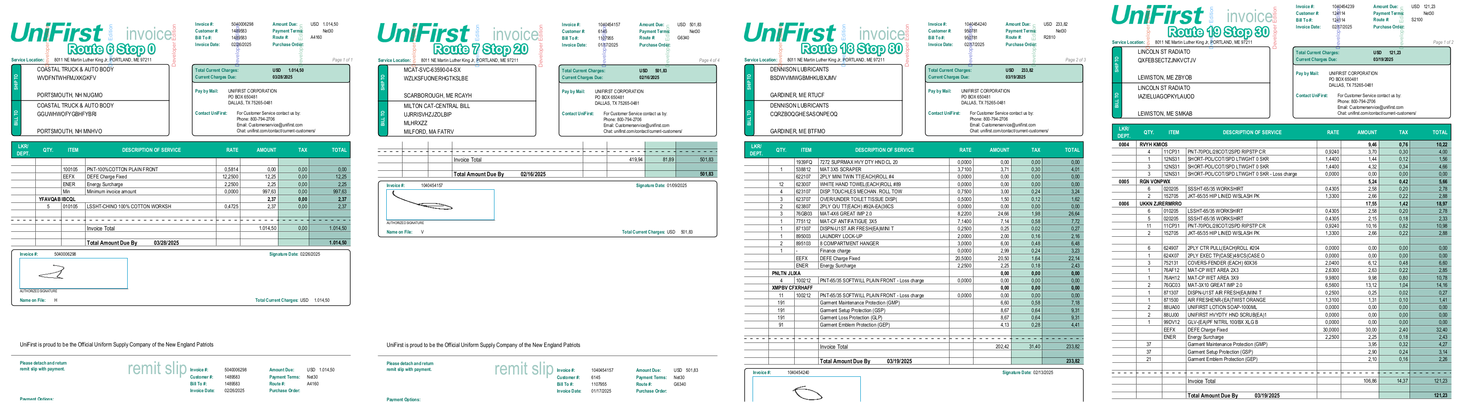

TESTED OK

Test Case 2 - Print invoices from Customer Financial Details> Invoices/Charges Tab with UNFCUSTOM in the license
Expected behavior:
The order in which invoices are printed is ordered by Invoice Date / Customer
Test steps:
1. Customer Financial Details> Invoices/Charges Tab
2. Pick one of the bigger bill-to-customers from BU 011 like 382660
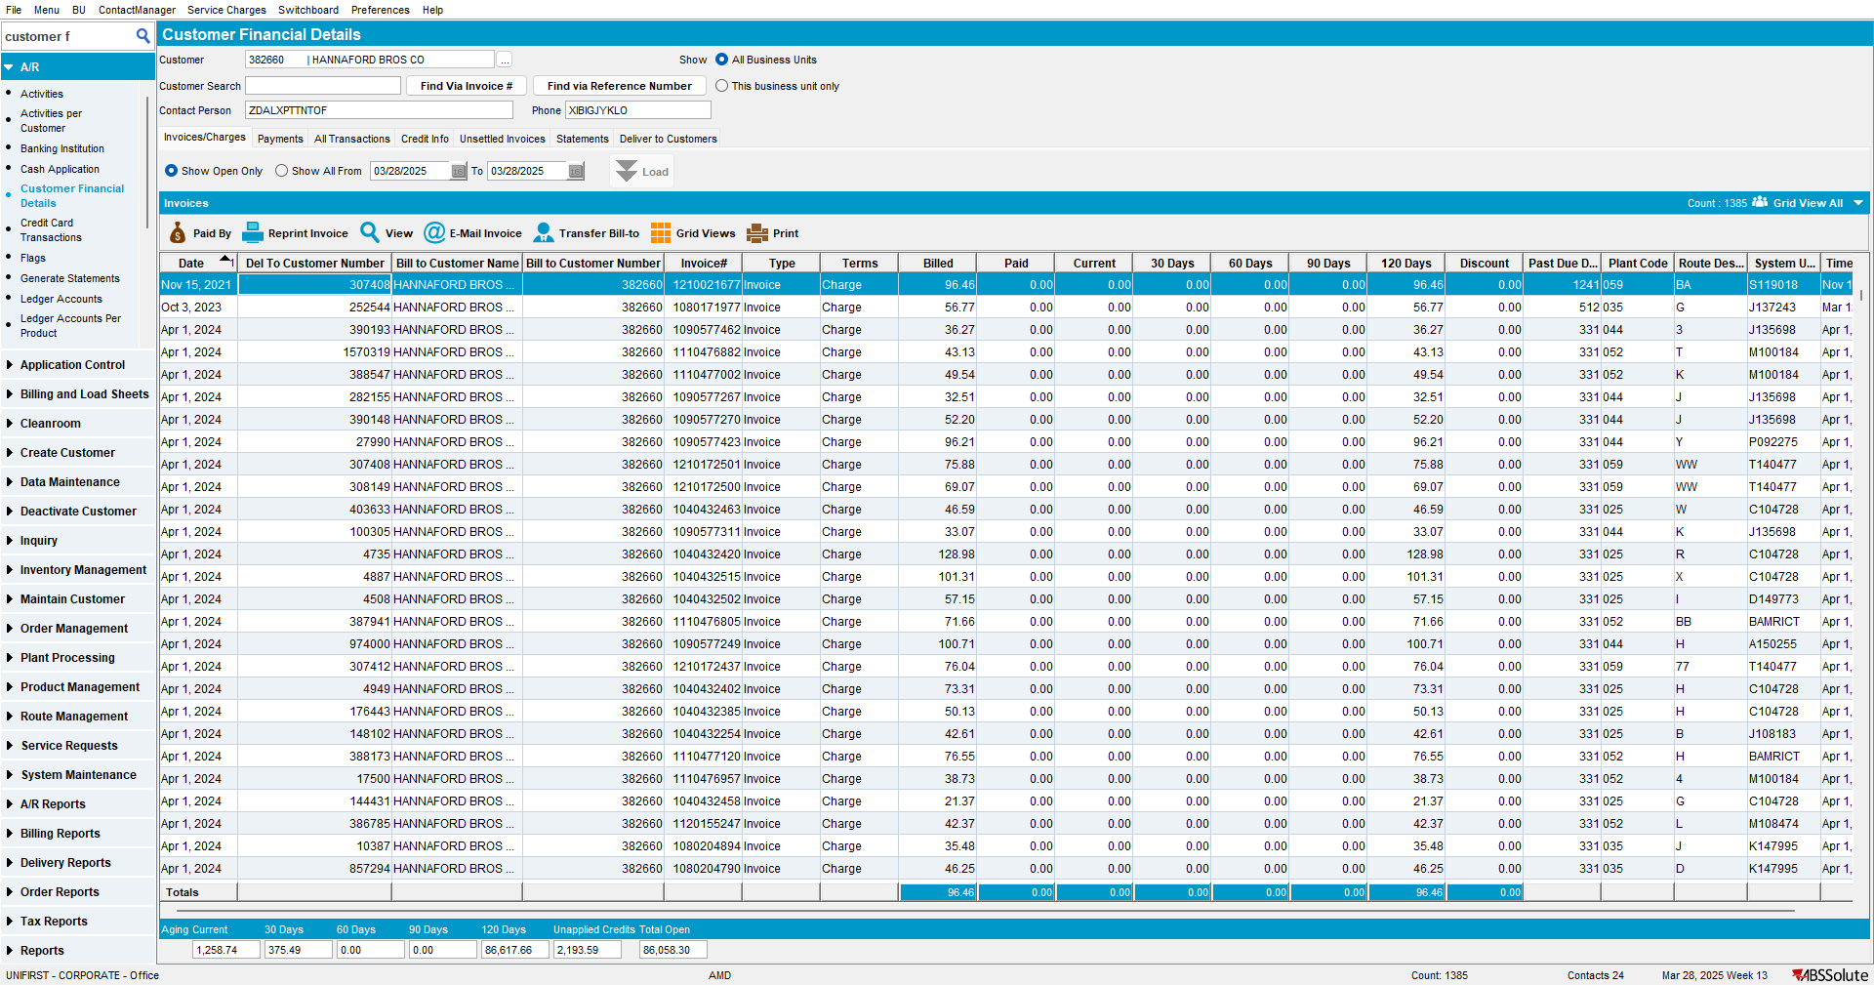

4. Select multiple invoices from different customers and click on Reprint Invoice
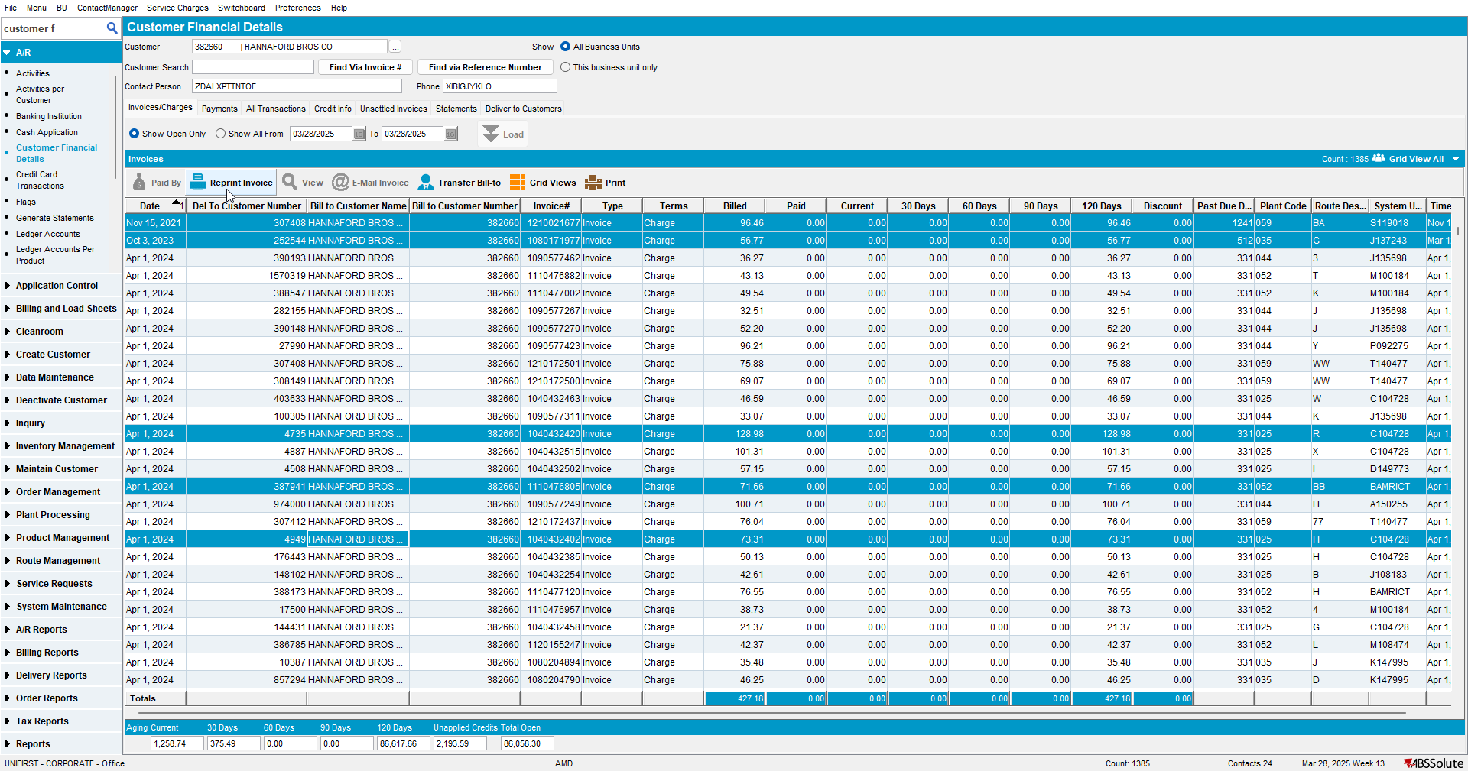
5. Check that the invoices are printed by Invoice Date / Customer.
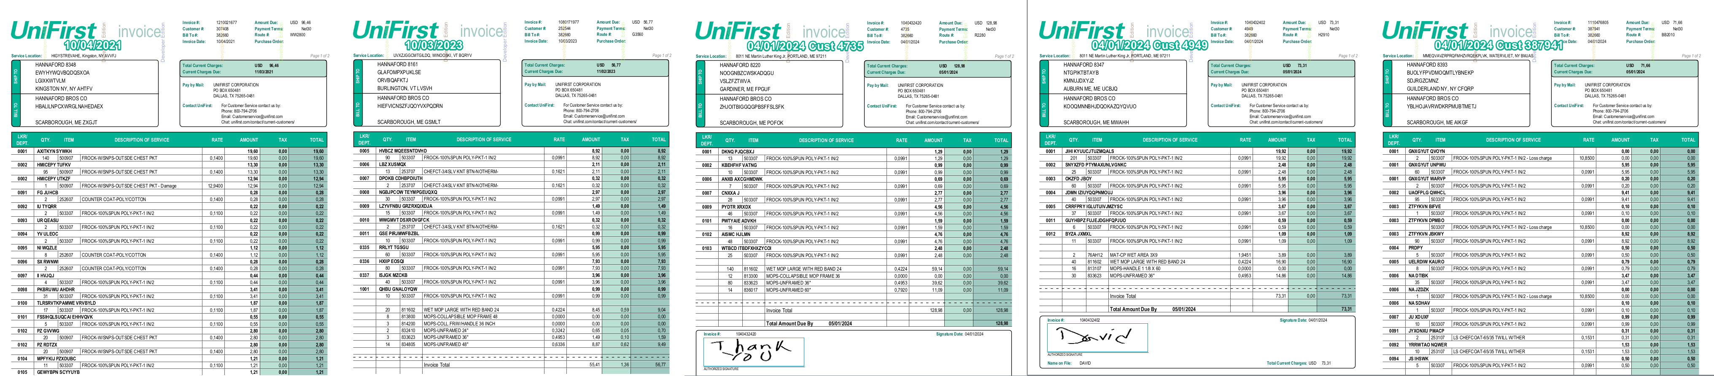

TESTED OK

Test Case 3 - Print invoices from Route Status Control on Canada BU with UNFCUSTOM in the license
Expected behavior:
The order in which invoices are printed is ordered by Route / Stop / Customer / Invoice Number

Test steps:
- Route Status Control
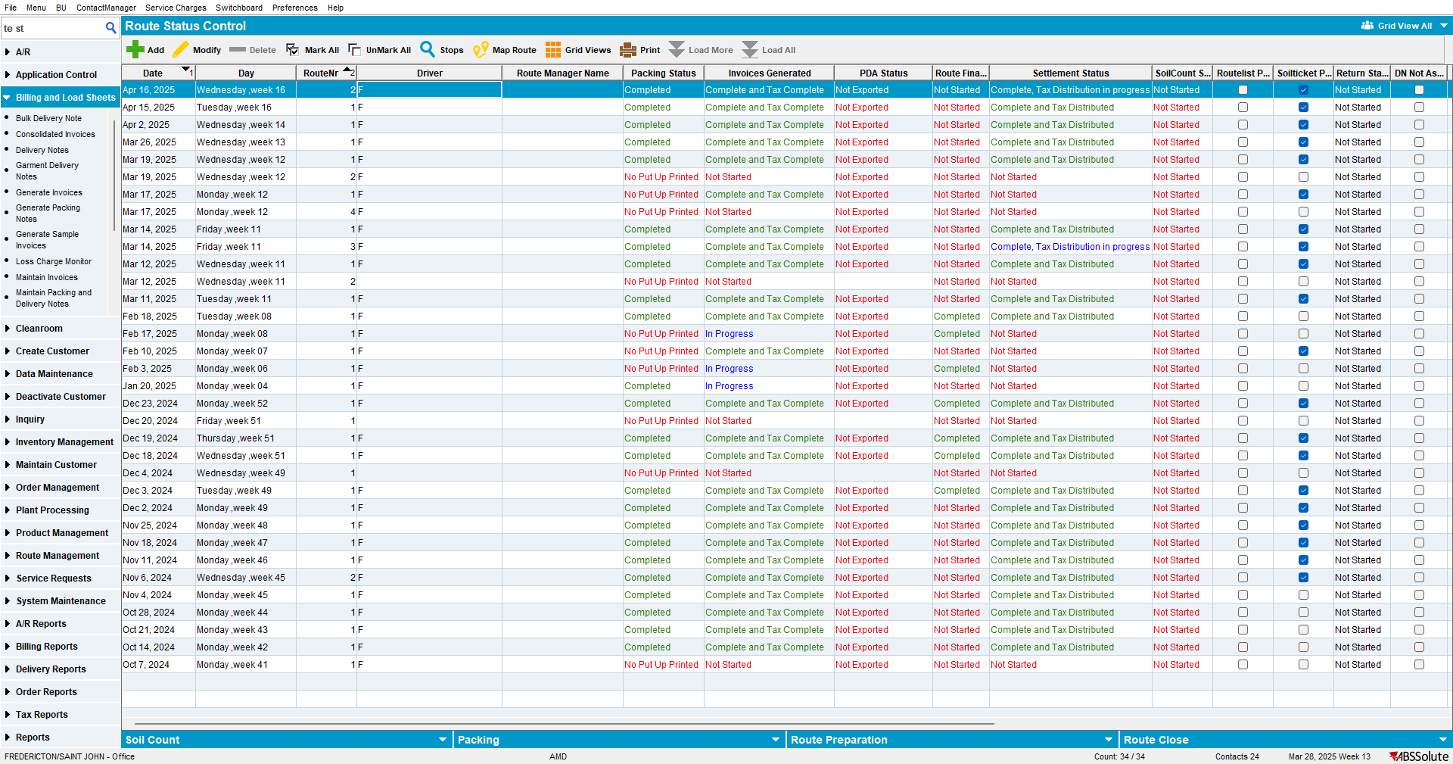

- Multiselect invoices from multiple routes in the grid and reprint the invoices
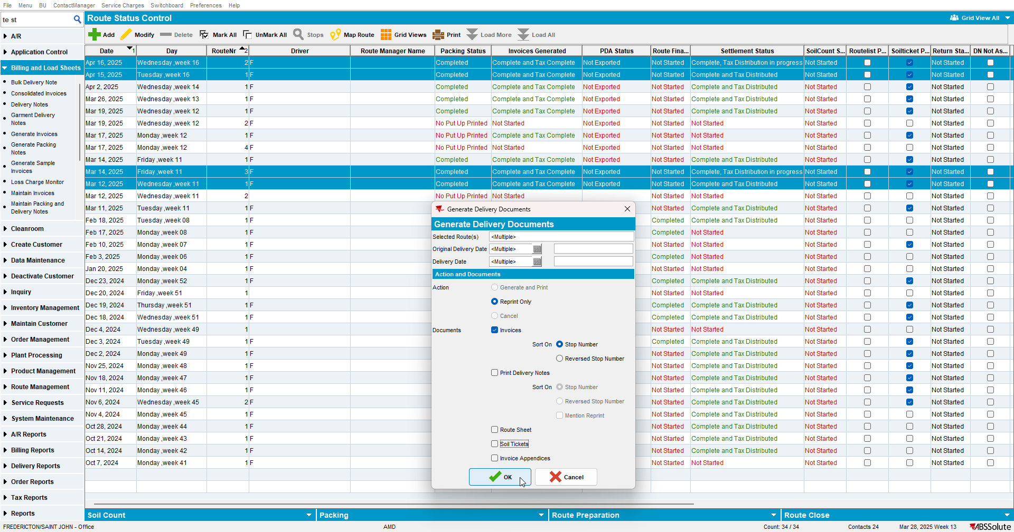

- Check to see that invoices are printed in the order of route / stop / customer / invoice date
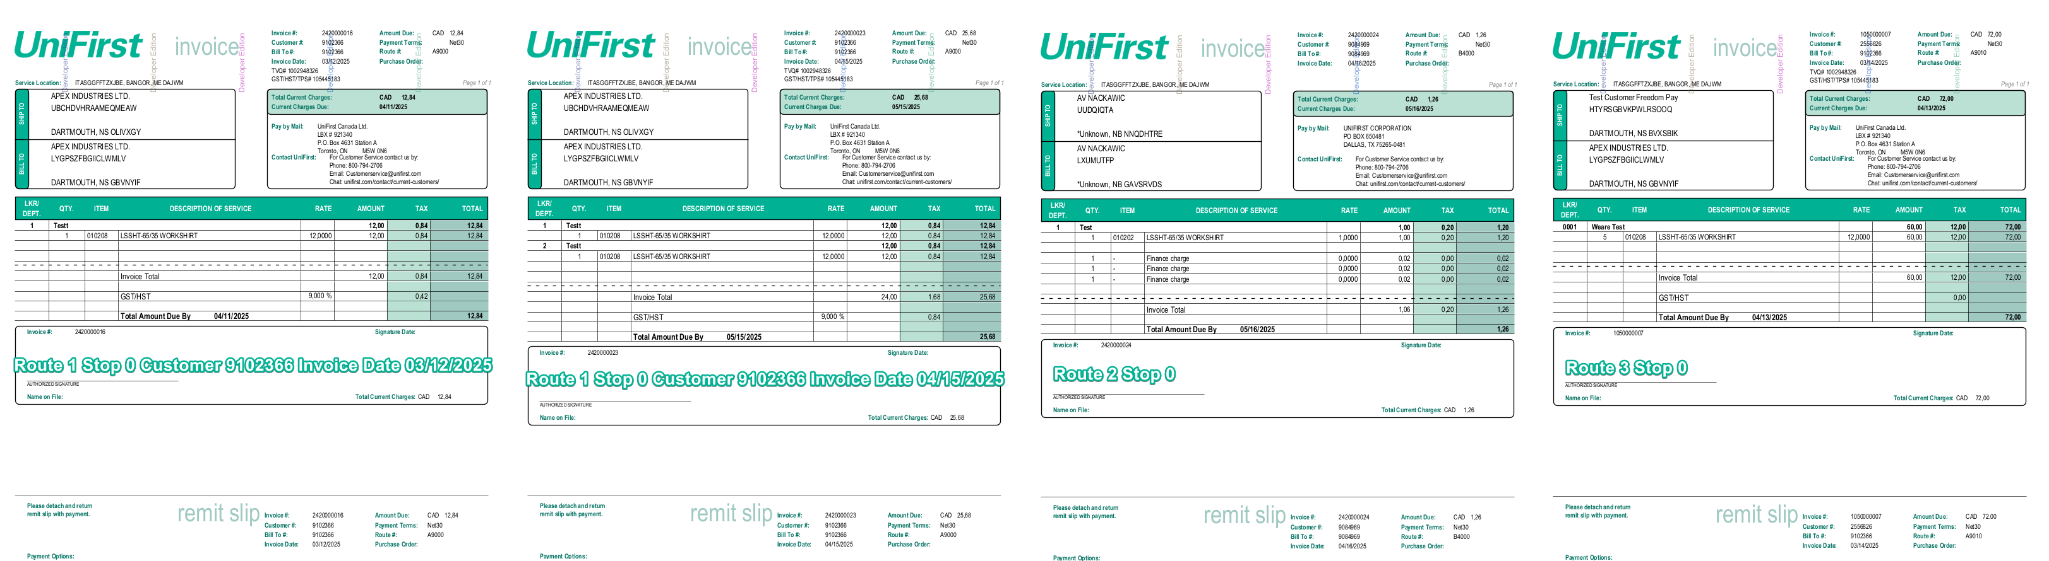

TESTED OK

Test Case 4 – Generate invoices from Maintain Sales Notes
Expected behavior:
There is no error at invoice generation

Test steps:
- Maintain Sales Notes: Create a new sales note
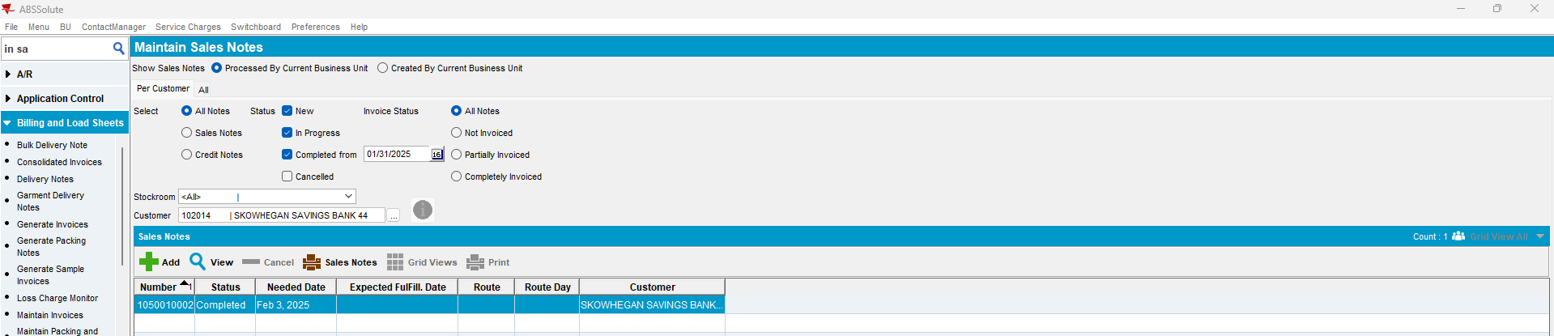

- Go to Deliveries Tab and generate the Invoice
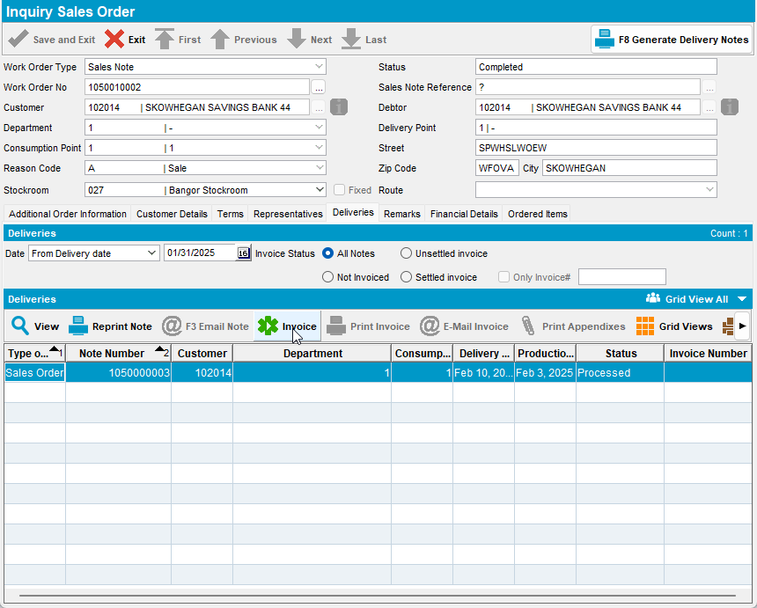

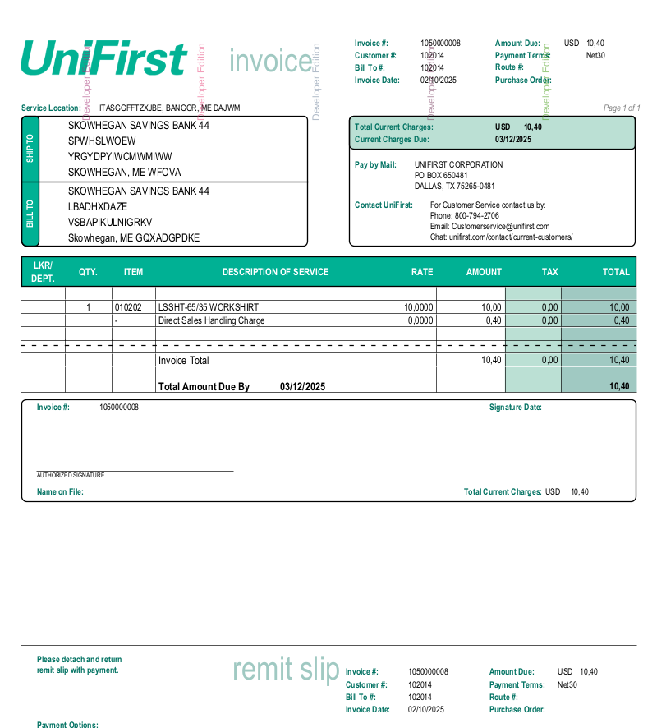

TESTED OK

Test Case 5 – Print invoices from Switchboard
Expected behavior:
There is no error at invoice generation

Test steps:

- Go to Switchboard and select your customer
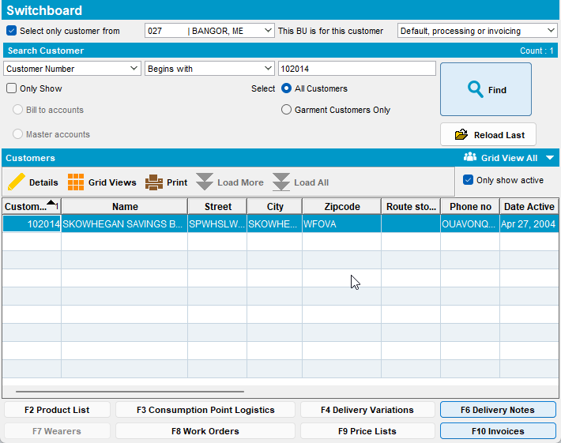

- Press F10 Invoices then press Print Invoice
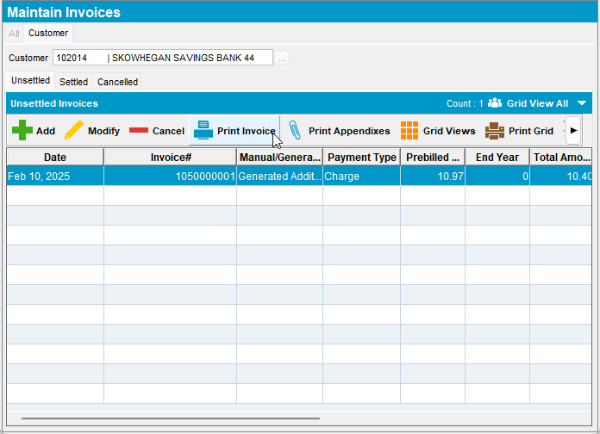
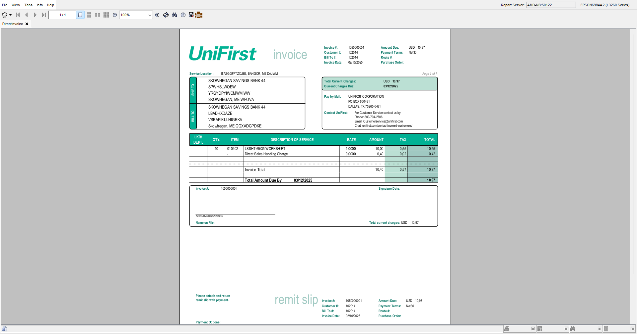

TESTED OK

Test Case 6 – Email invoices from Route Assistant
Expected behavior:
There is no error at emailing invoices

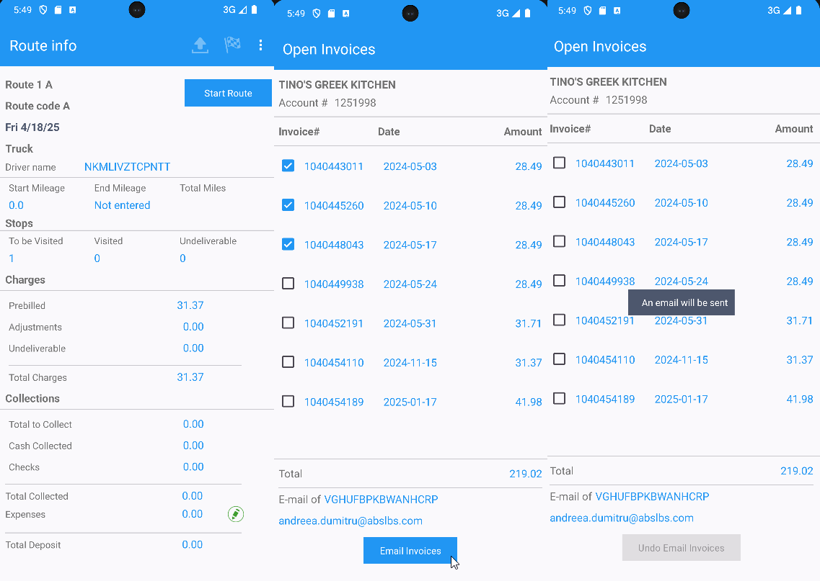
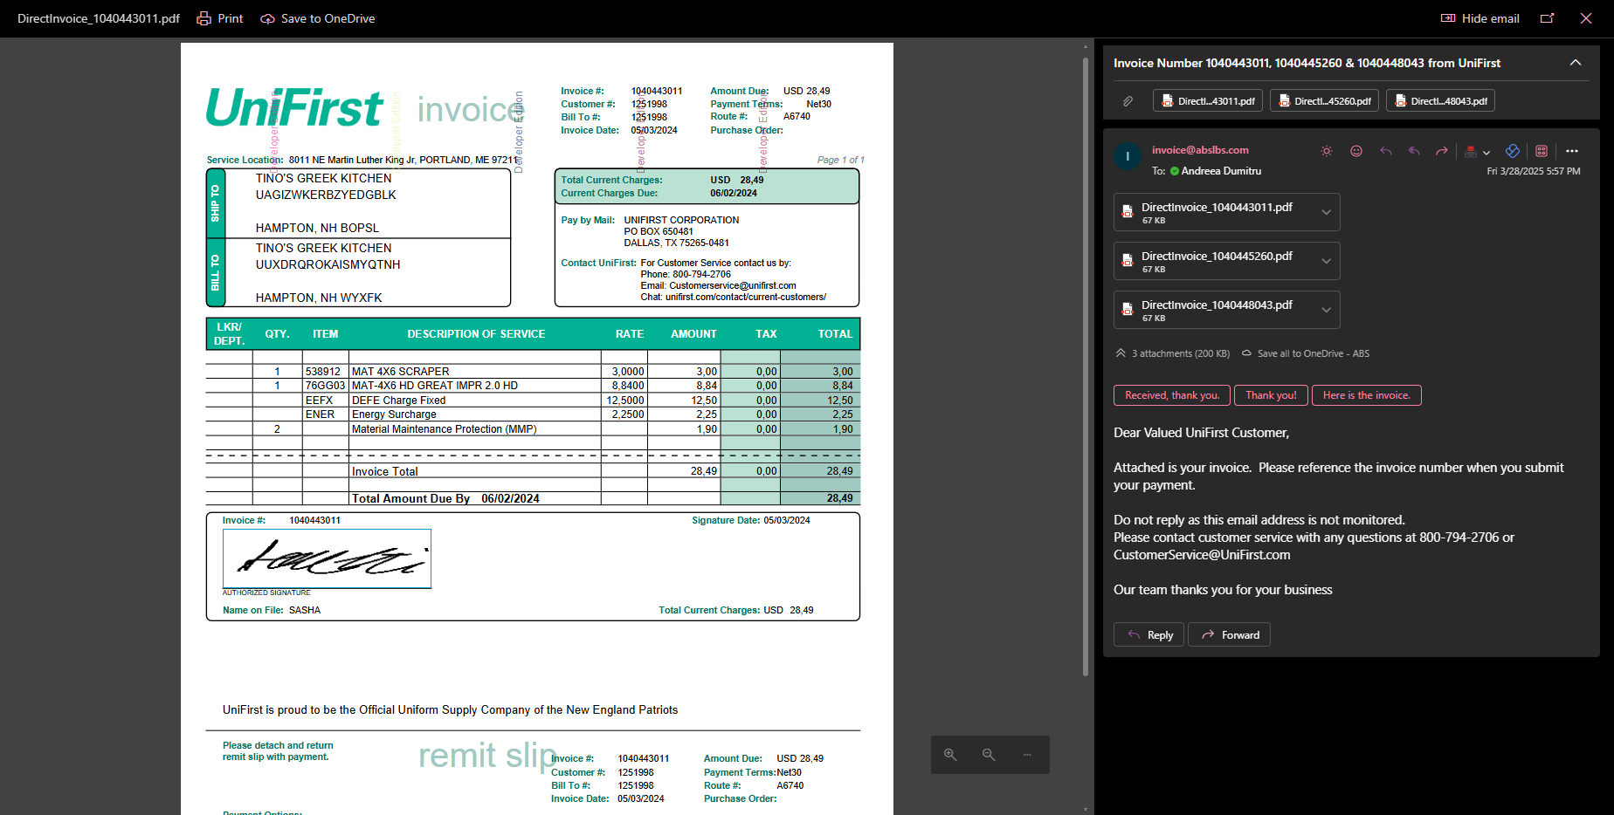

Test Case 7 – Run E-mail Direct Invoices process
Expected behavior:
There is no error at process running

Test steps:

- Process Scheduler: Run E-mail Direct Invoices

- Check the logs
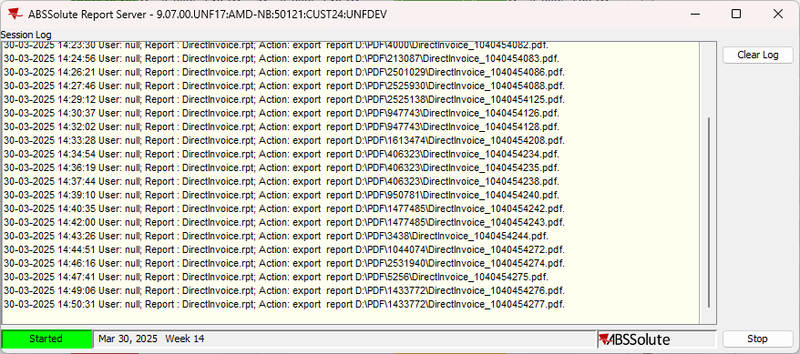

TESTED OK

