ABSN-4274 D_UBS_2068 Positive Adjustments on a $0 invoice don't add tax to invoice total
Environment | Prerequisites
Version:9.07.00  DBServerName=abs-SRV20.internal.abslbs.com  DBSID=CUST24  DBUser=UNFDEV  DBPassword=UNFDEV  Environment=Test | - Module:  - System setting

Contents
Reproducing before fix 2
Steps to reproduce 2
Current Behavior 6
Expected behavior 6
Retest after fix 6
Test Case 1 – Rent and Sales line with 0 price for a customer with US currency – Tested OK 6
Test Case 2 – Rent and Sales line with 0 price for a customer with CA currency – Tested OK 16
Test Case 3 – Bill loss now when there are no tax lines on pre-bill – Tested OK 25
Test Case 4 – Invoice with no 0 amount tax on pre-bill with no bill-loss now 32

Reproducing before fix

Steps to reproduce
- Generate invoices for a route where there are items with Rent price= 0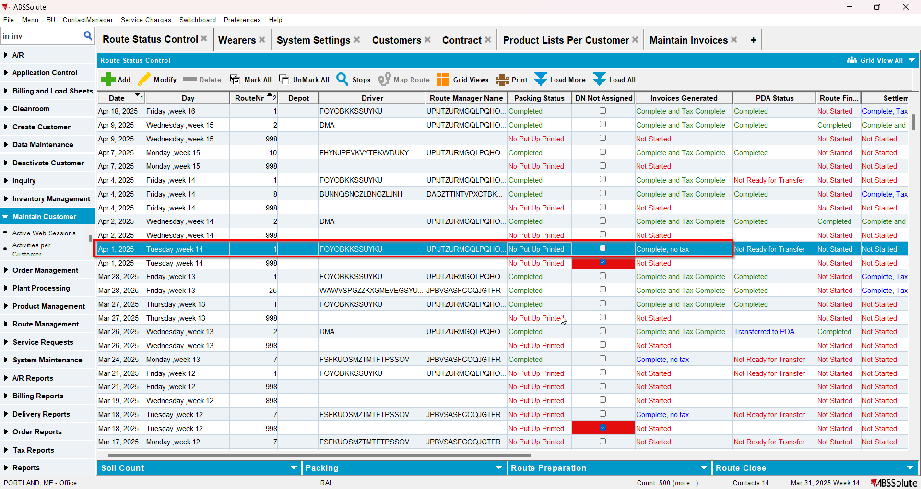
- Check that items have price and amount 0 and there is no tax line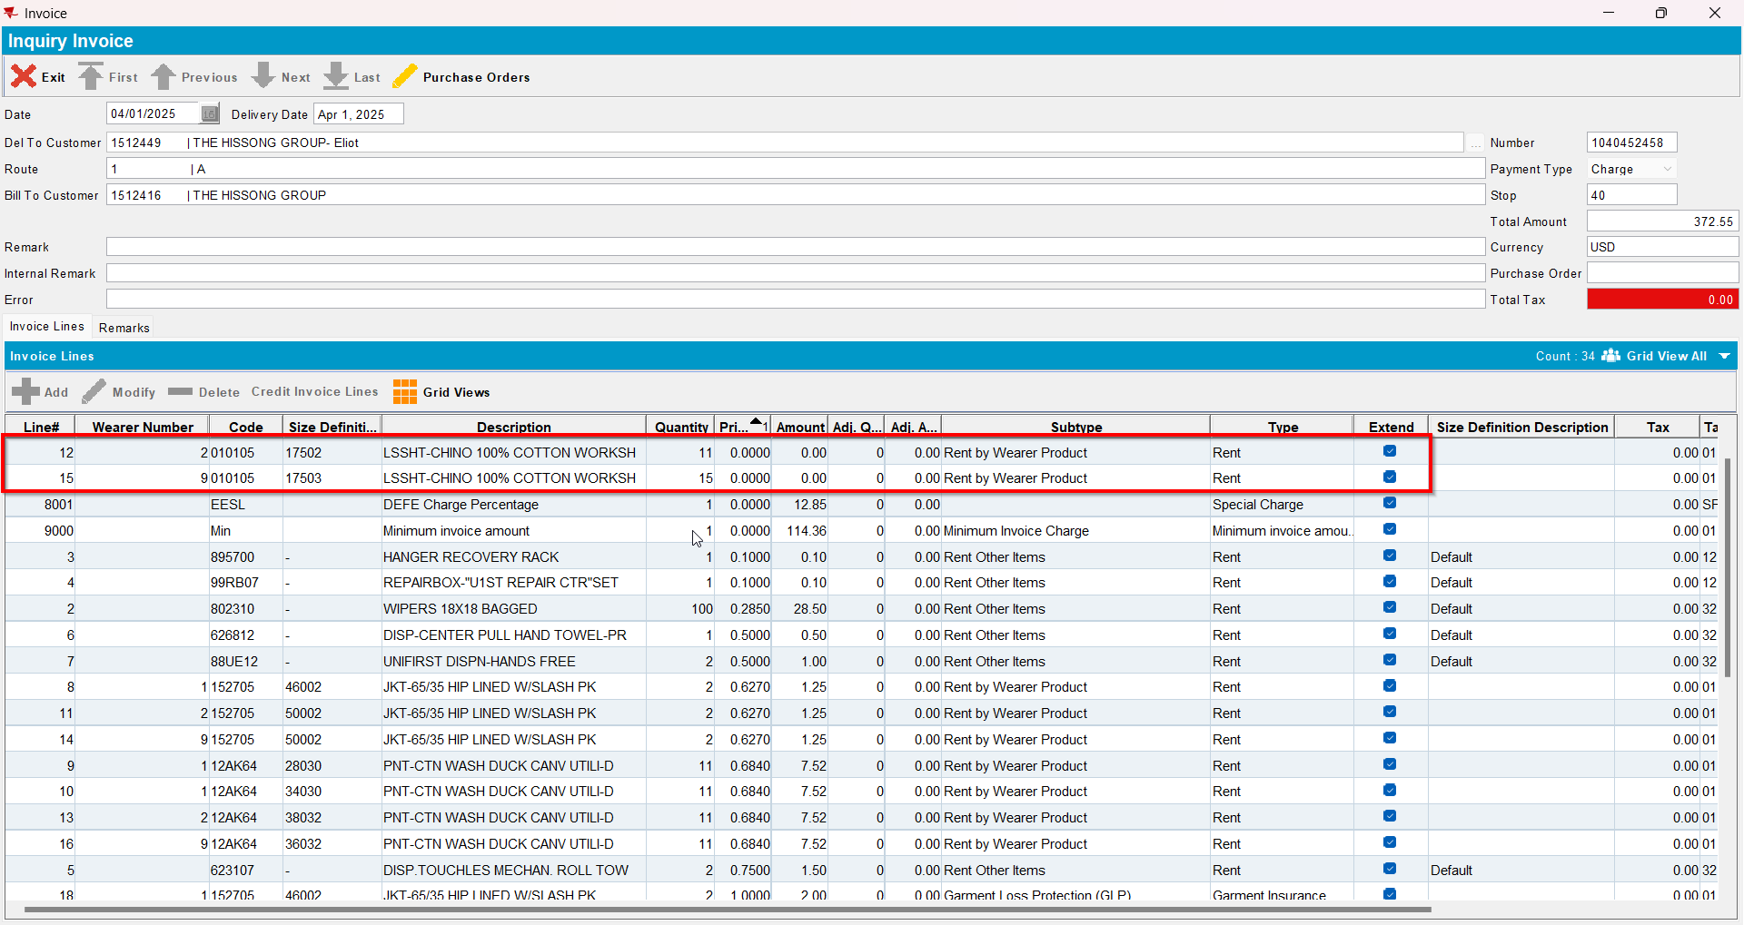
- Script the BCI with the following(for LineItemNumber use the line number of the respective items with price 0):
UPDATE VERTEXTRANSACTIONLOG VTL
SET VTL.EXPORTID = NULL,
VTL.STATUS = 2,
VTL.TAXAREAID = VTL.DESTINATIONTAXAREAID,
VTL.TOTALLINEITEMTAX = 0,
VTL.COMBINEDRATE = 0,
VTL.TOTALMAINDIVISIONTAX = 0
WHERE VTL.BATCHID IN ();
UPDATE VERTEXTRANSACTIONLOG VTL
SET VTL.EXPORTID = NULL,
VTL.STATUS = 2,
VTL.TAXAREAID = VTL.DESTINATIONTAXAREAID,
VTL.TOTALLINEITEMTAX = ROUND((VTL.EXTENDEDPRICE * 0.2), 2),
VTL.COMBINEDRATE = 0.2,
VTL.TOTALMAINDIVISIONTAX = ROUND((VTL.EXTENDEDPRICE * 0.2), 2)
WHERE VTL.BATCHID IN ()
AND VTL.Lineitemnumber in ();
UPDATE VERTEXBATCHCONTROL VBC
SET VBC.BATCHSTATUS = 3
WHERE VBC.BATCHID IN () ;
- Run the BCI process
- Send the route to RA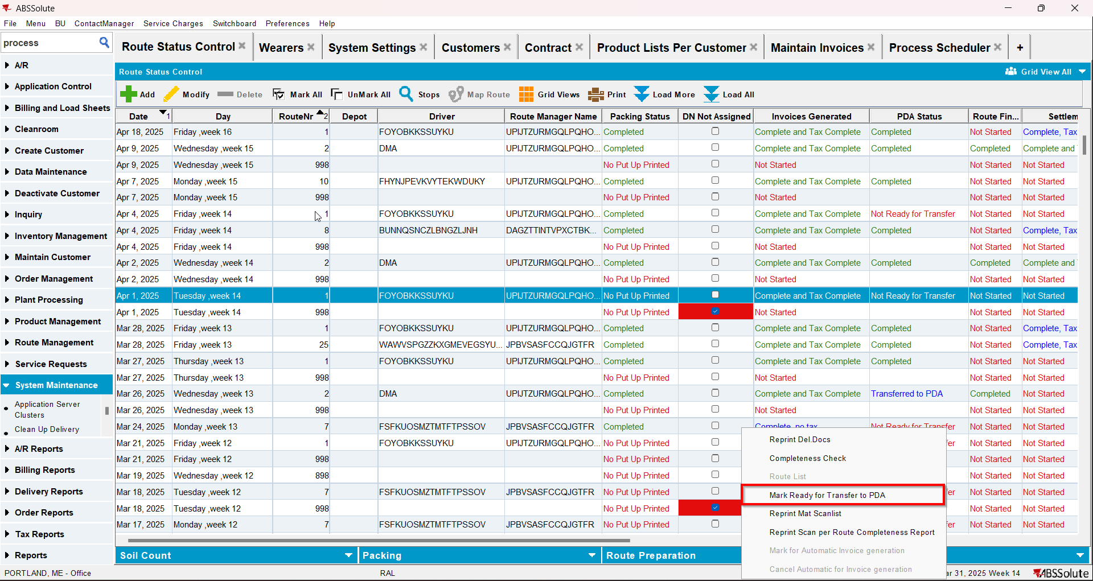
- Do positive adjustments on the items with price 0, increasing amount and qty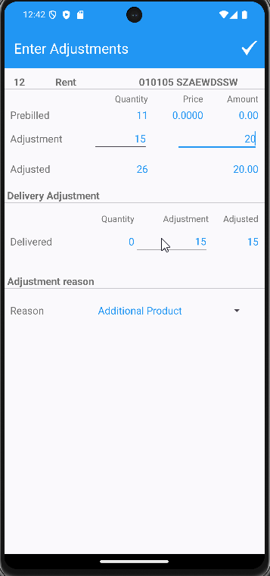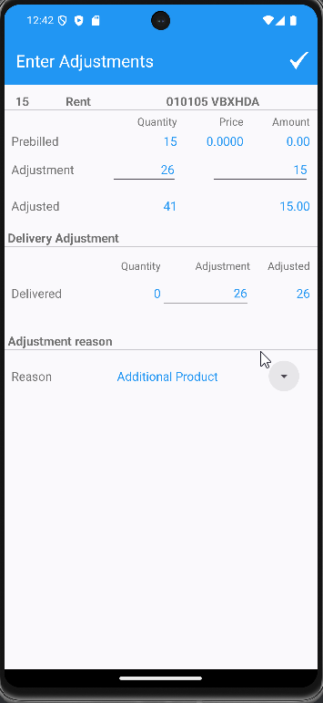
- Finish the route and upload it
- On WebX settle it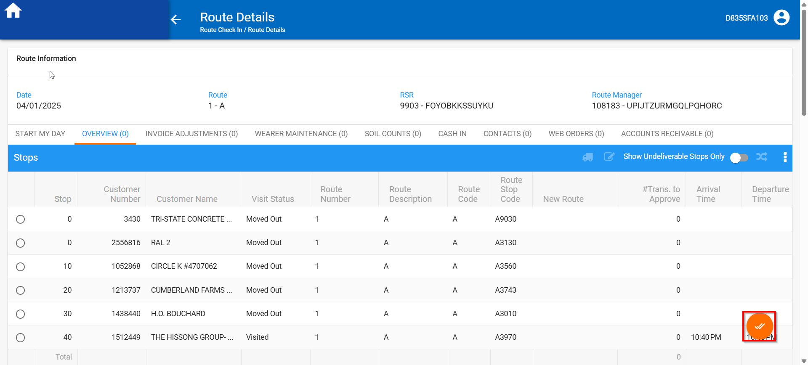
- Script the BCI with the following(for LineItemNumber use the line number of the respective items with price 0):
UPDATE VERTEXTRANSACTIONLOG VTL
SET VTL.EXPORTID = NULL,
VTL.STATUS = 2,
VTL.TAXAREAID = VTL.DESTINATIONTAXAREAID,
VTL.TOTALLINEITEMTAX = ROUND(VTL.INPUTTOTALTAX, 2),
VTL.COMBINEDRATE = 0.00,
VTL.TOTALMAINDIVISIONTAX = ROUND(VTL.INPUTTOTALTAX, 2)
WHERE VTL.BATCHID IN ()
AND VTL.Lineitemnumber NOT IN ();

UPDATE VERTEXTRANSACTIONLOG VTL
SET VTL.EXPORTID = NULL,
VTL.STATUS = 2,
VTL.TAXAREAID = VTL.DESTINATIONTAXAREAID,
VTL.TOTALLINEITEMTAX = ROUND(VTL.INPUTTOTALTAX, 2),
VTL.COMBINEDRATE = 0.2,
VTL.TOTALMAINDIVISIONTAX = ROUND(VTL.INPUTTOTALTAX, 2)
WHERE VTL.BATCHID IN ()
AND VTL.Lineitemnumber in (); ;
UPDATE VERTEXBATCHCONTROL VBC
SET VBC.BATCHSTATUS = 3
WHERE VBC.BATCHID IN ();

- Run the BCI process
- Check the invoice, the Pay This Amount and Total Amount Excluding VAT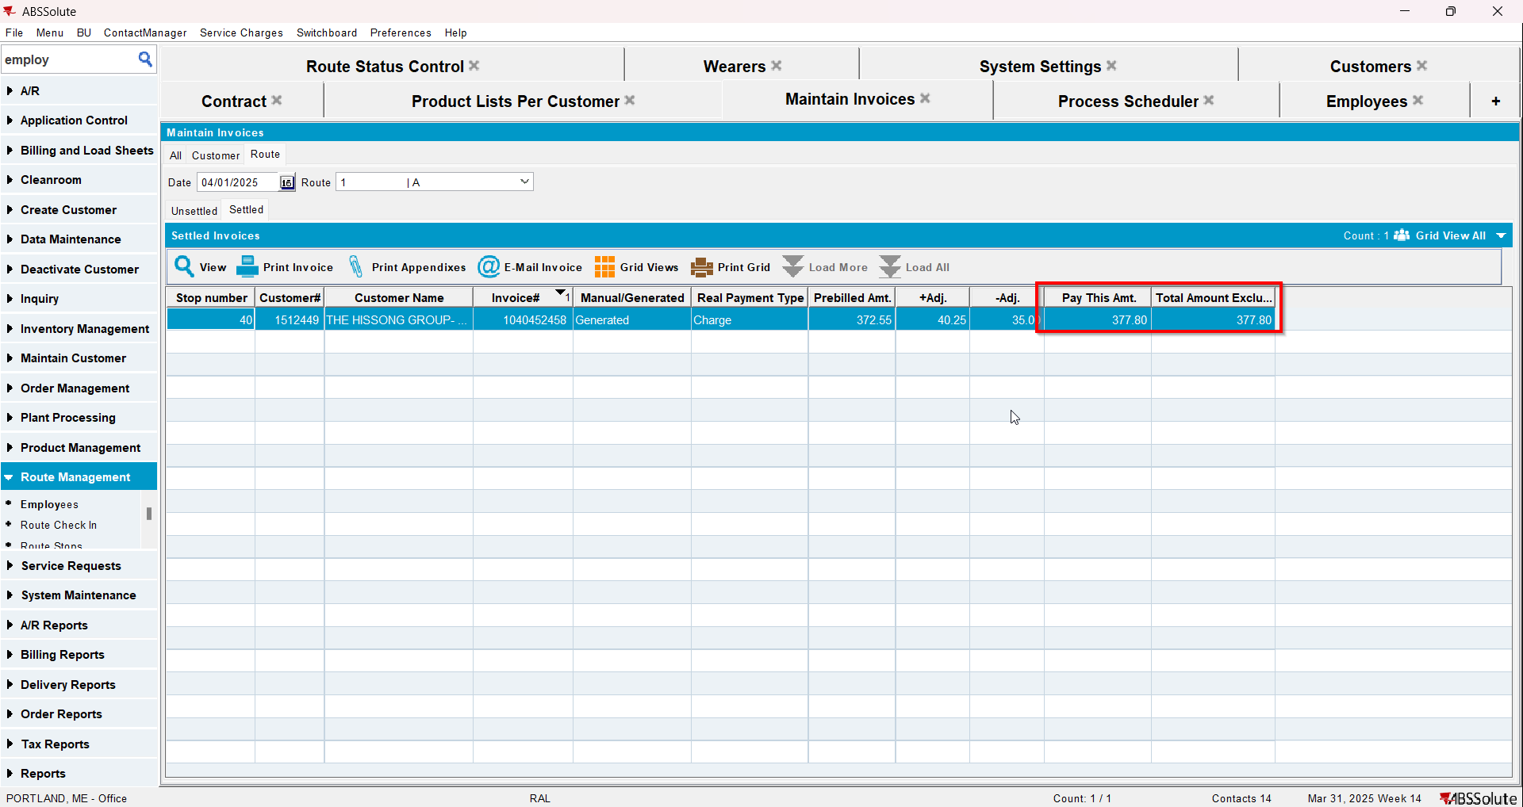
REPRODUCED OK.

Current Behavior
There is no tax line created on the invoice and Pay This Amount=Total Amount Excluding VAT

Expected behavior
There should be tax line for the specific Tax Type created on the invoice and Pay This Amount is not equal to Total Amount Excluding VAT

Retest after fix

Test Case 1 – Rent and Sales line with 0 price for a customer with US currency – Tested OK
Expected behavior: There should be tax line for the specific Tax Type created on the invoice and Pay This Amount is not equal to Total Amount Excluding VAT
Hash: 6d030f8
- Have a customer with US currency and go to its contract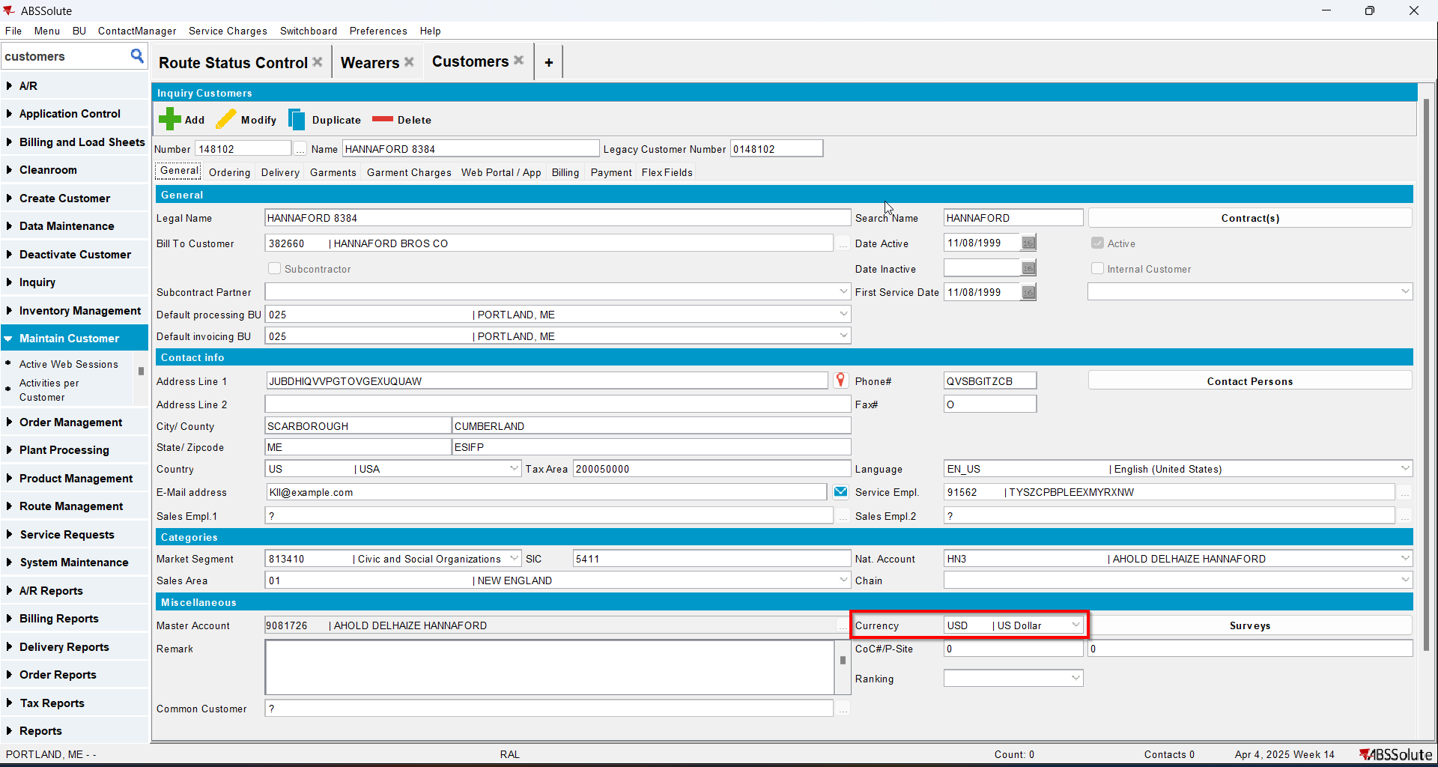
- Add an item with BM3 and Rent Based on Max with Rental Price 0. Add the item to your customer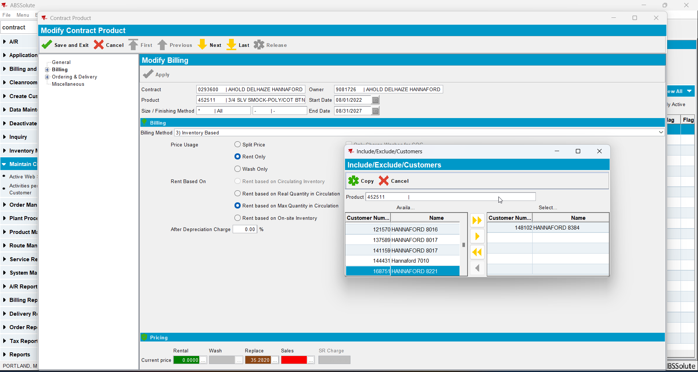
- Add another item with BM4 Sales Only with Sales Price 0. Add the item to your customer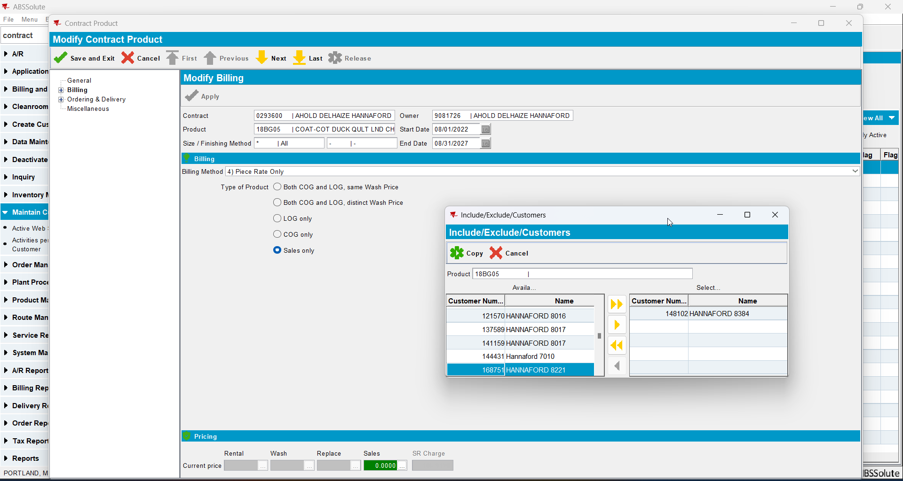
- Create a wearer with 1 wearer inventory for the item with Rental Price 0 and 1 wearer inventory with Sales Price 0. Generate the work orders, issue them and generate delivery notes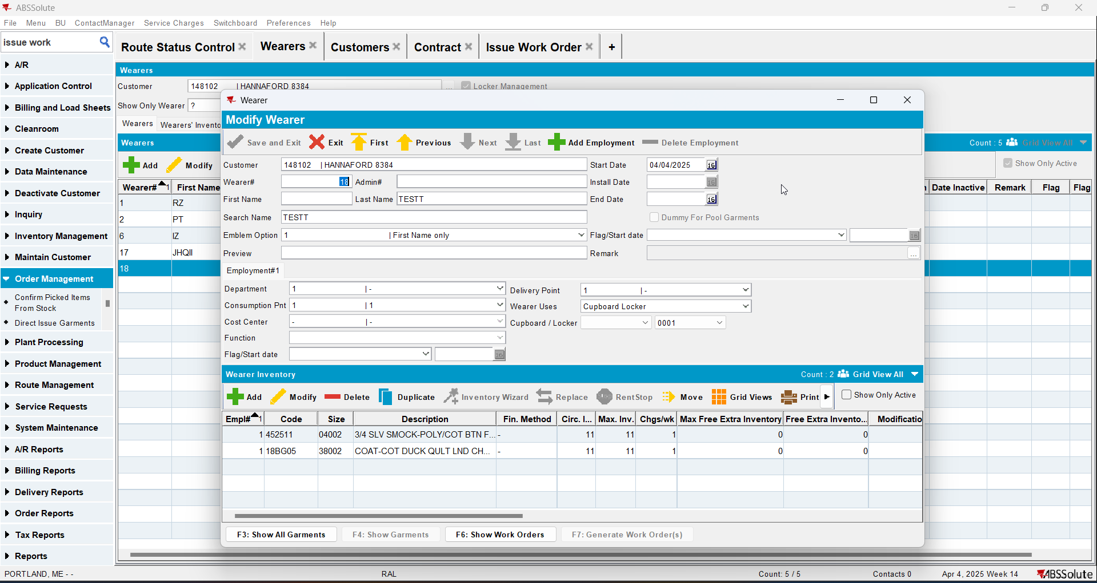
- Generate invoices for the route of your customer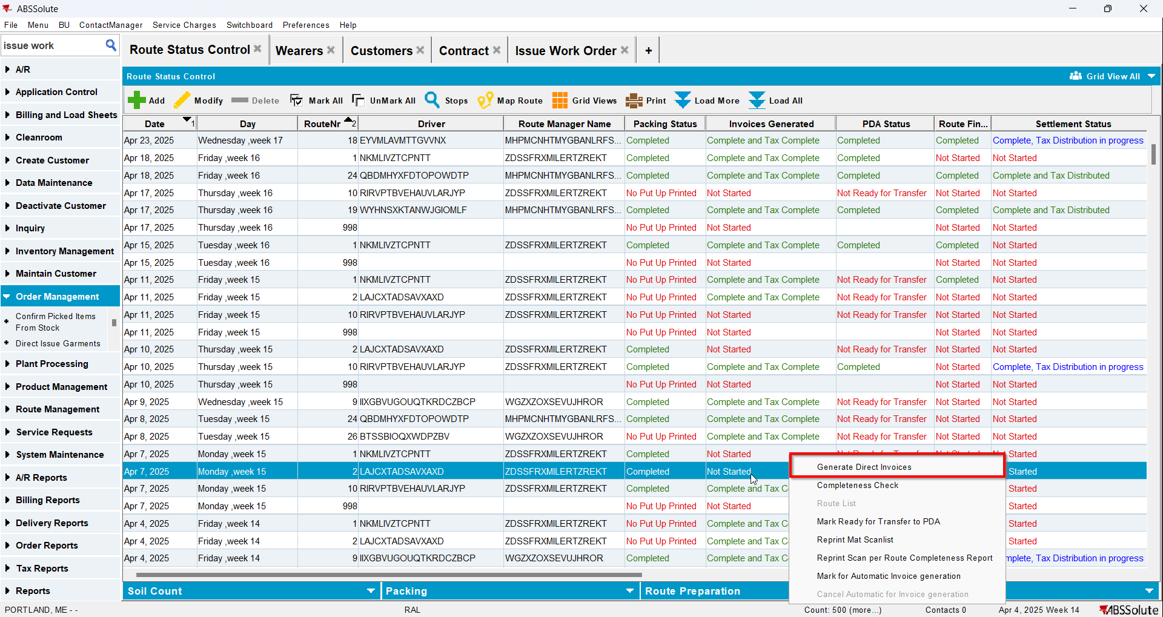
- Check on the invoice that there are 1 invoice line for Rent with price 0 and 1 invoice line for Sales with price 0 for your added items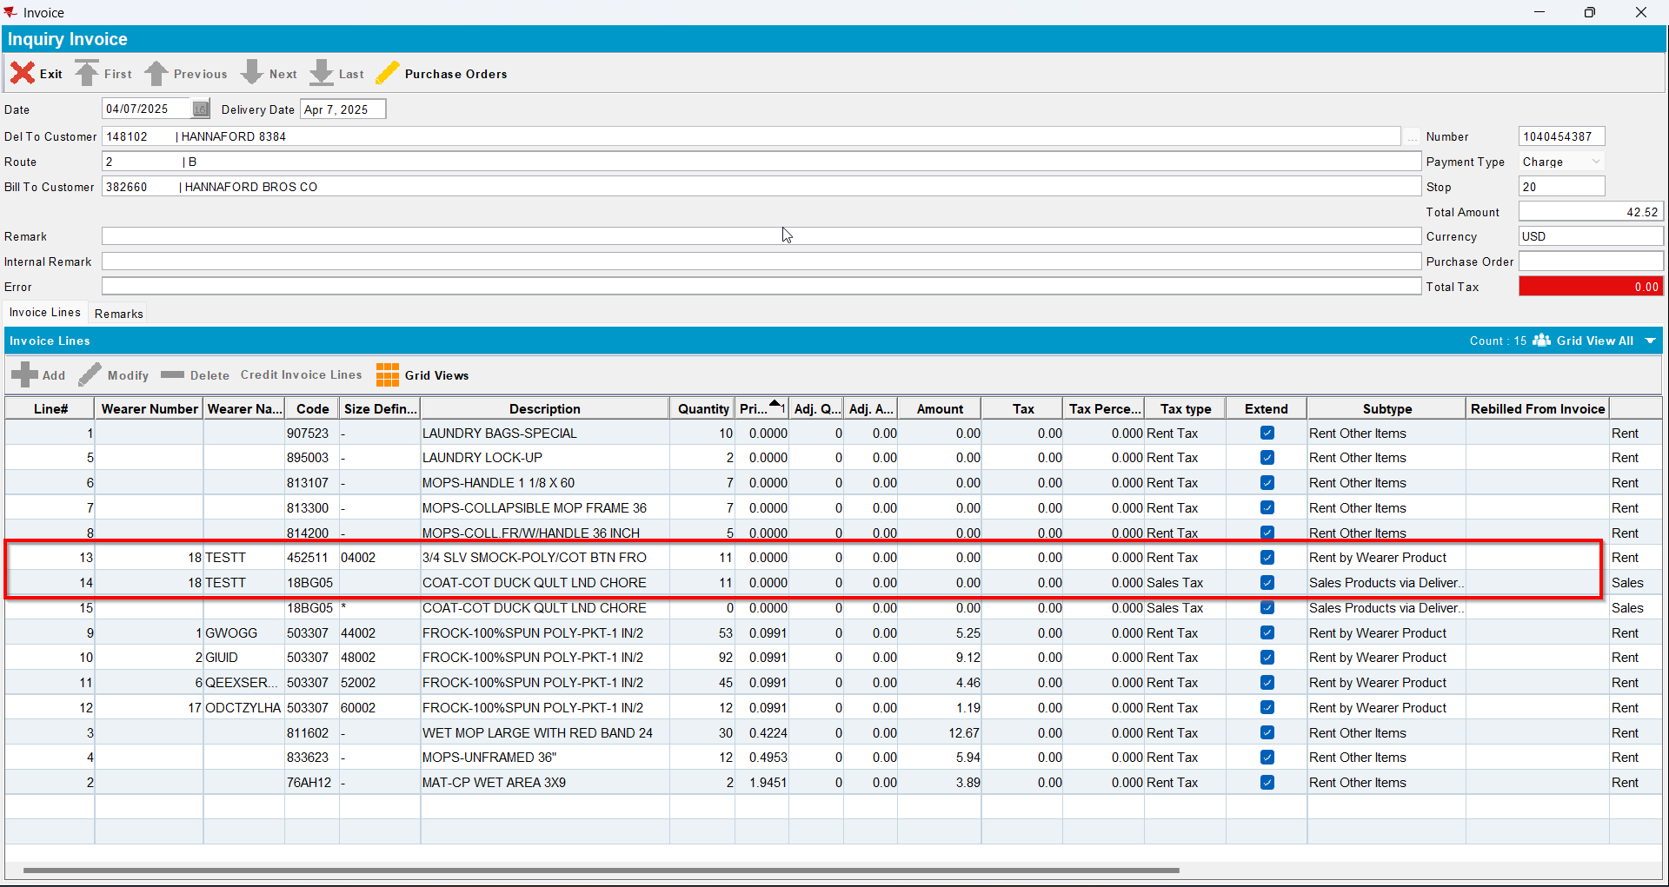
- Script the BCI with the following(for LineItemNumber use the line number of the respective items with price 0):
UPDATE VERTEXTRANSACTIONLOG VTL
SET VTL.EXPORTID = NULL,
VTL.STATUS = 2,
VTL.TAXAREAID = VTL.DESTINATIONTAXAREAID,
VTL.TOTALLINEITEMTAX = 0,
VTL.COMBINEDRATE = 0,
VTL.TOTALMAINDIVISIONTAX = 0
WHERE VTL.BATCHID IN ();
UPDATE VERTEXTRANSACTIONLOG VTL
SET VTL.EXPORTID = NULL,
VTL.STATUS = 2,
VTL.TAXAREAID = VTL.DESTINATIONTAXAREAID,
VTL.TOTALLINEITEMTAX = ROUND((VTL.EXTENDEDPRICE * 0.2), 2),
VTL.COMBINEDRATE = 0.2,
VTL.TOTALMAINDIVISIONTAX = ROUND((VTL.EXTENDEDPRICE * 0.2), 2)
WHERE VTL.BATCHID IN ()
AND VTL.Lineitemnumber in ();
UPDATE VERTEXBATCHCONTROL VBC
SET VBC.BATCHSTATUS = 3
WHERE VBC.BATCHID IN () ;
- Run the BCI process
- Check on the invoice that now those lines have a tax percentage of 20 and there is also a tax line of rent with 0 amount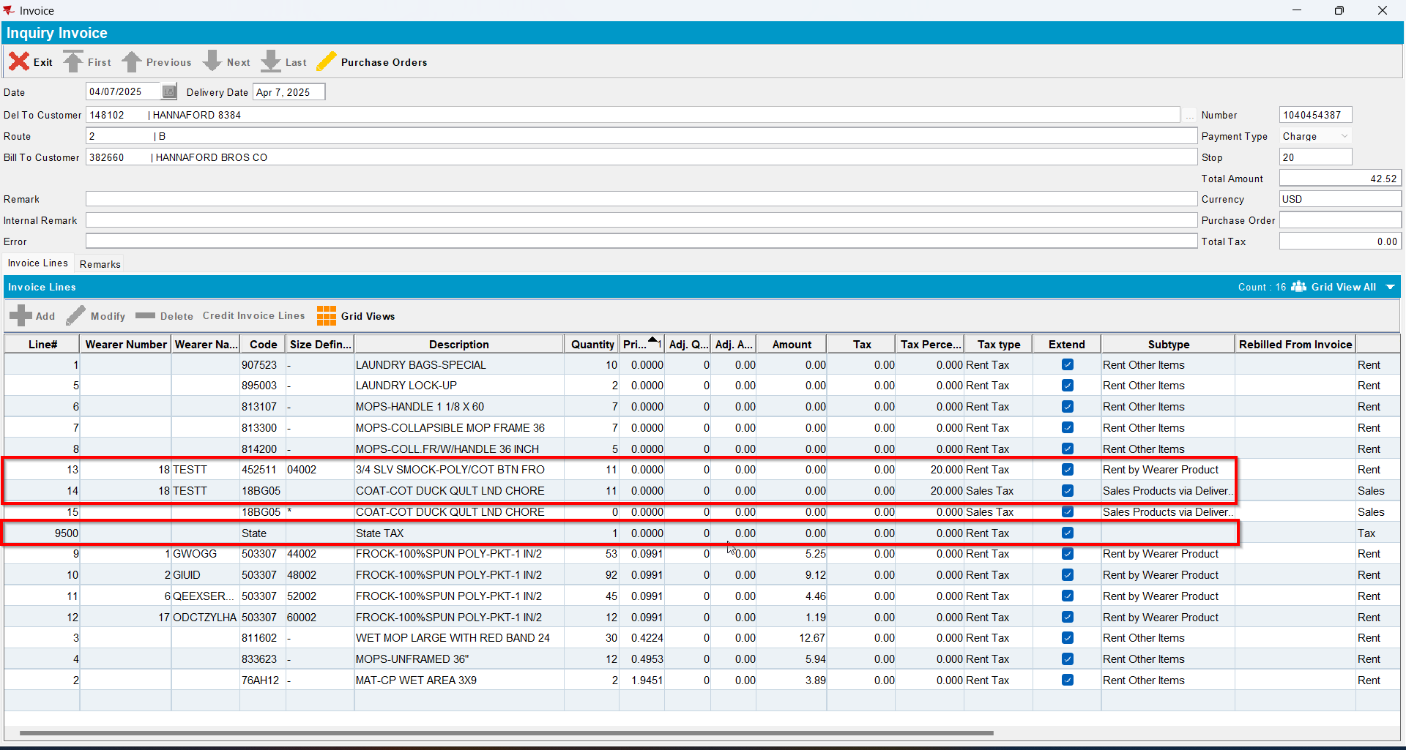
- Send the route to RA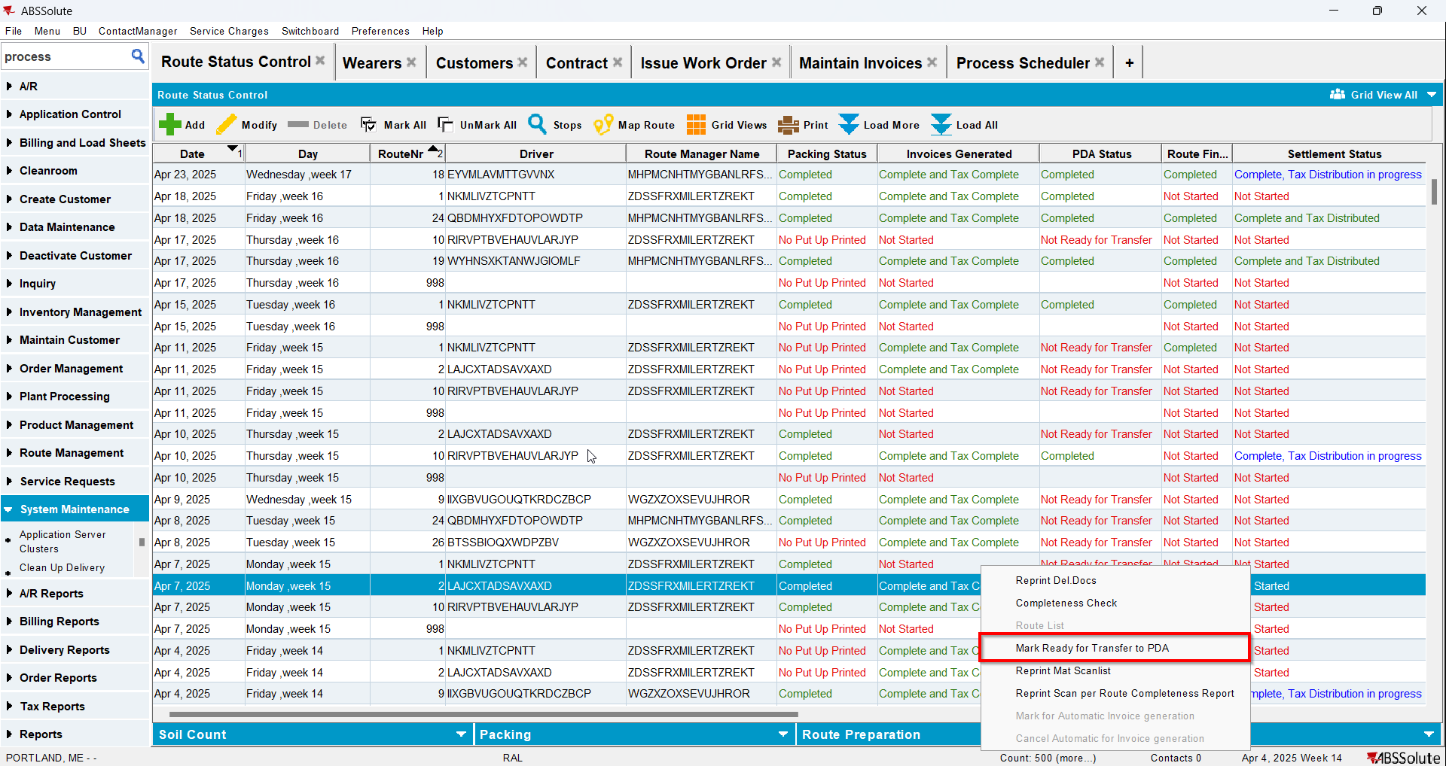
- For your items do positive adjustments increasing qty and amount for both
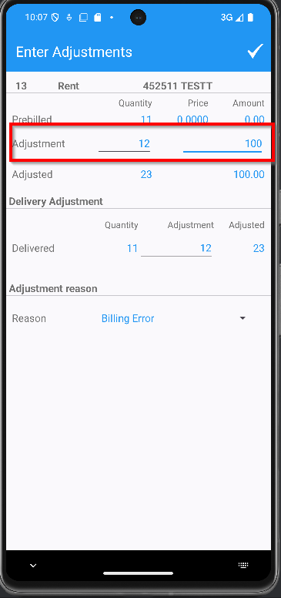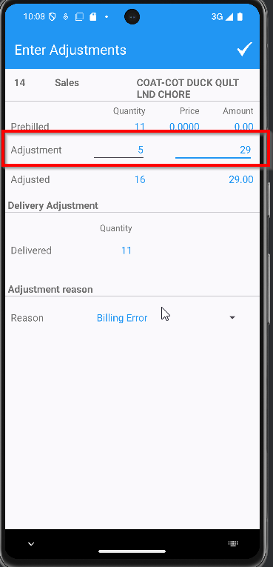
- Finish the route and upload it
- On WebX settle the route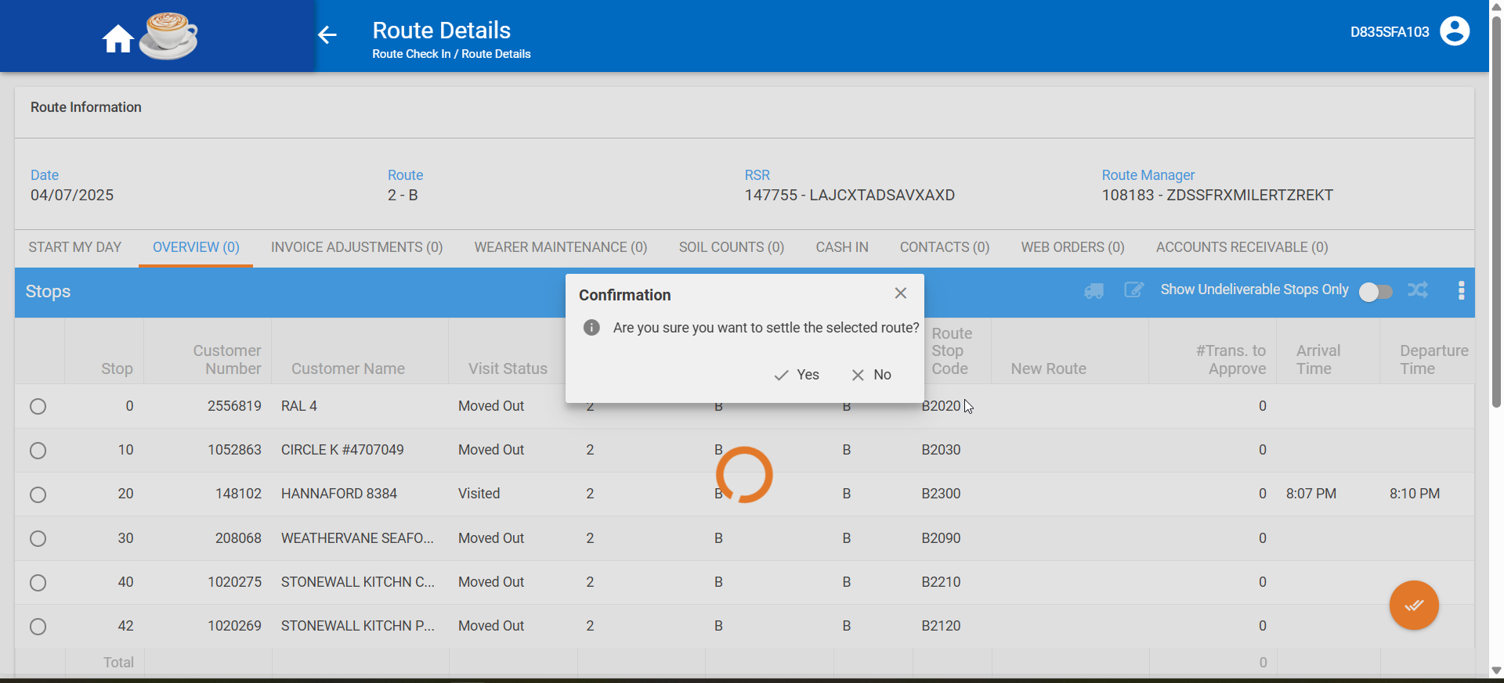
- Check on the invoice that now those line have an adjusted qty, an adjusted amount and a tax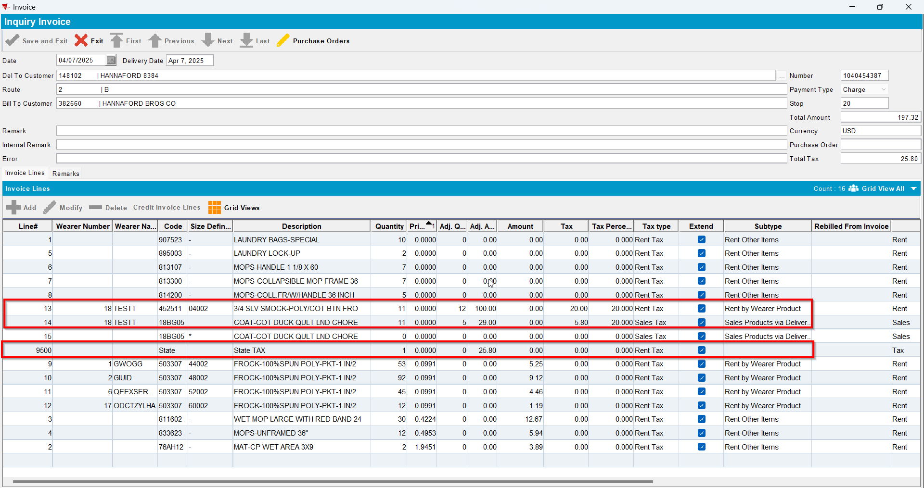
- Script the BCI with the following(for LineItemNumber use the line number of the respective items with price 0):
UPDATE VERTEXTRANSACTIONLOG VTL
SET VTL.EXPORTID = NULL,
VTL.STATUS = 2,
VTL.TAXAREAID = VTL.DESTINATIONTAXAREAID,
VTL.TOTALLINEITEMTAX = ROUND(VTL.INPUTTOTALTAX, 2),
VTL.COMBINEDRATE = 0.00,
VTL.TOTALMAINDIVISIONTAX = ROUND(VTL.INPUTTOTALTAX, 2)
WHERE VTL.BATCHID IN ()
AND VTL.Lineitemnumber NOT IN ();

UPDATE VERTEXTRANSACTIONLOG VTL
SET VTL.EXPORTID = NULL,
VTL.STATUS = 2,
VTL.TAXAREAID = VTL.DESTINATIONTAXAREAID,
VTL.TOTALLINEITEMTAX = ROUND(VTL.INPUTTOTALTAX, 2),
VTL.COMBINEDRATE = 0.2,
VTL.TOTALMAINDIVISIONTAX = ROUND(VTL.INPUTTOTALTAX, 2)
WHERE VTL.BATCHID IN ()
AND VTL.Lineitemnumber in (); ;
UPDATE VERTEXBATCHCONTROL VBC
SET VBC.BATCHSTATUS = 3
WHERE VBC.BATCHID IN ();
- Run the BCI process
- Check on the invoice that now there is a tax rent line and also a tax sales line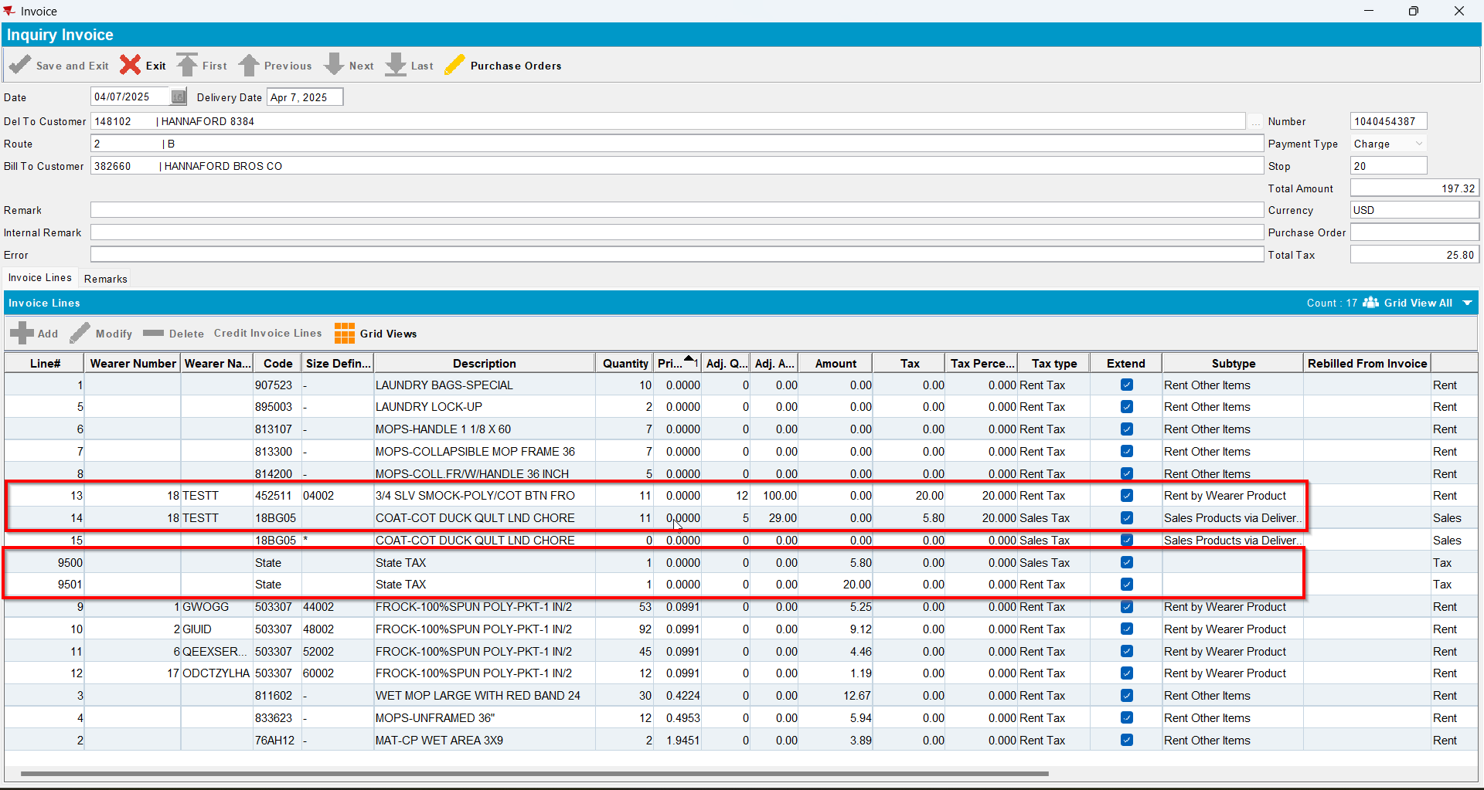
- Check that Pay This Amount is not equal to Total Amount Excluding VAT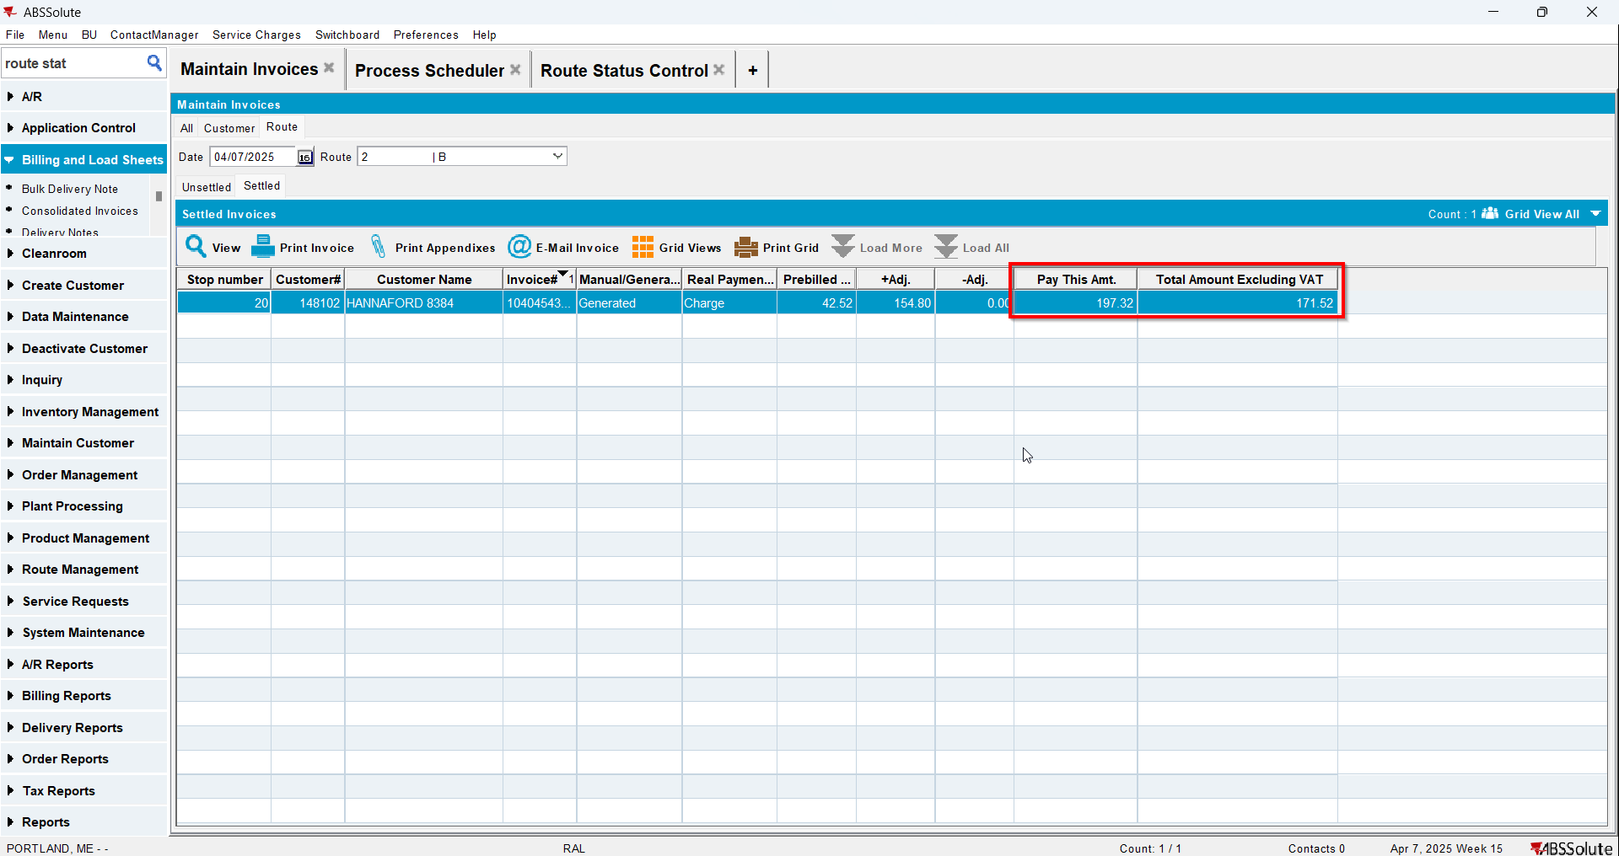

Test Case 2 – Rent and Sales line with 0 price for a customer with CA currency – Tested OK
Expected behavior: There should be tax line for the specific Tax Type created on the invoice and Pay This Amount is not equal to Total Amount Excluding VAT
Hash: 6d030f8
- Have a customer with CA currency and go to its contract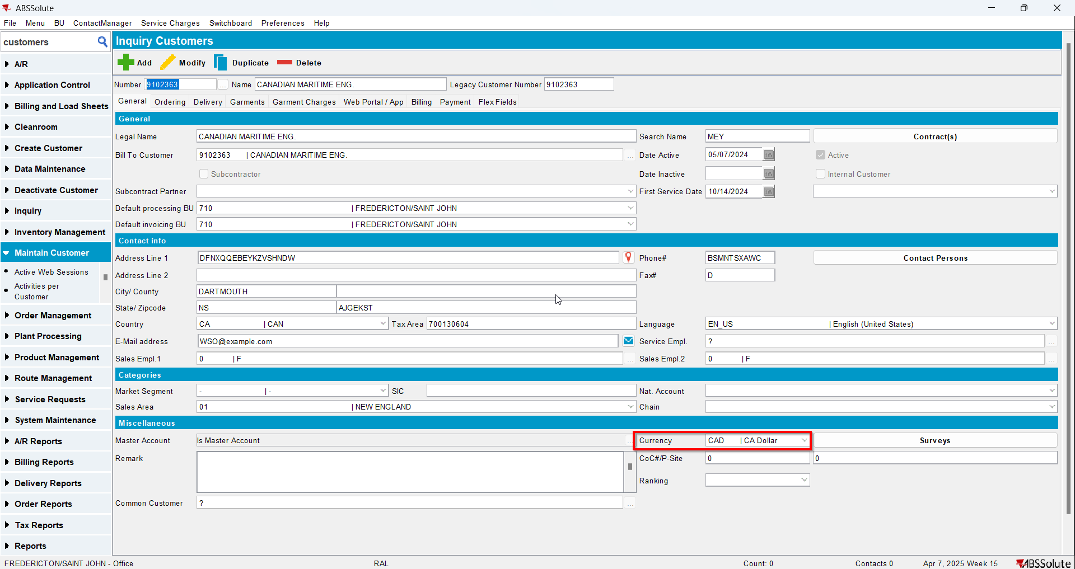
- Add an item with BM3 and Rent Based on Max with Rental Price 0. Add the item to your customer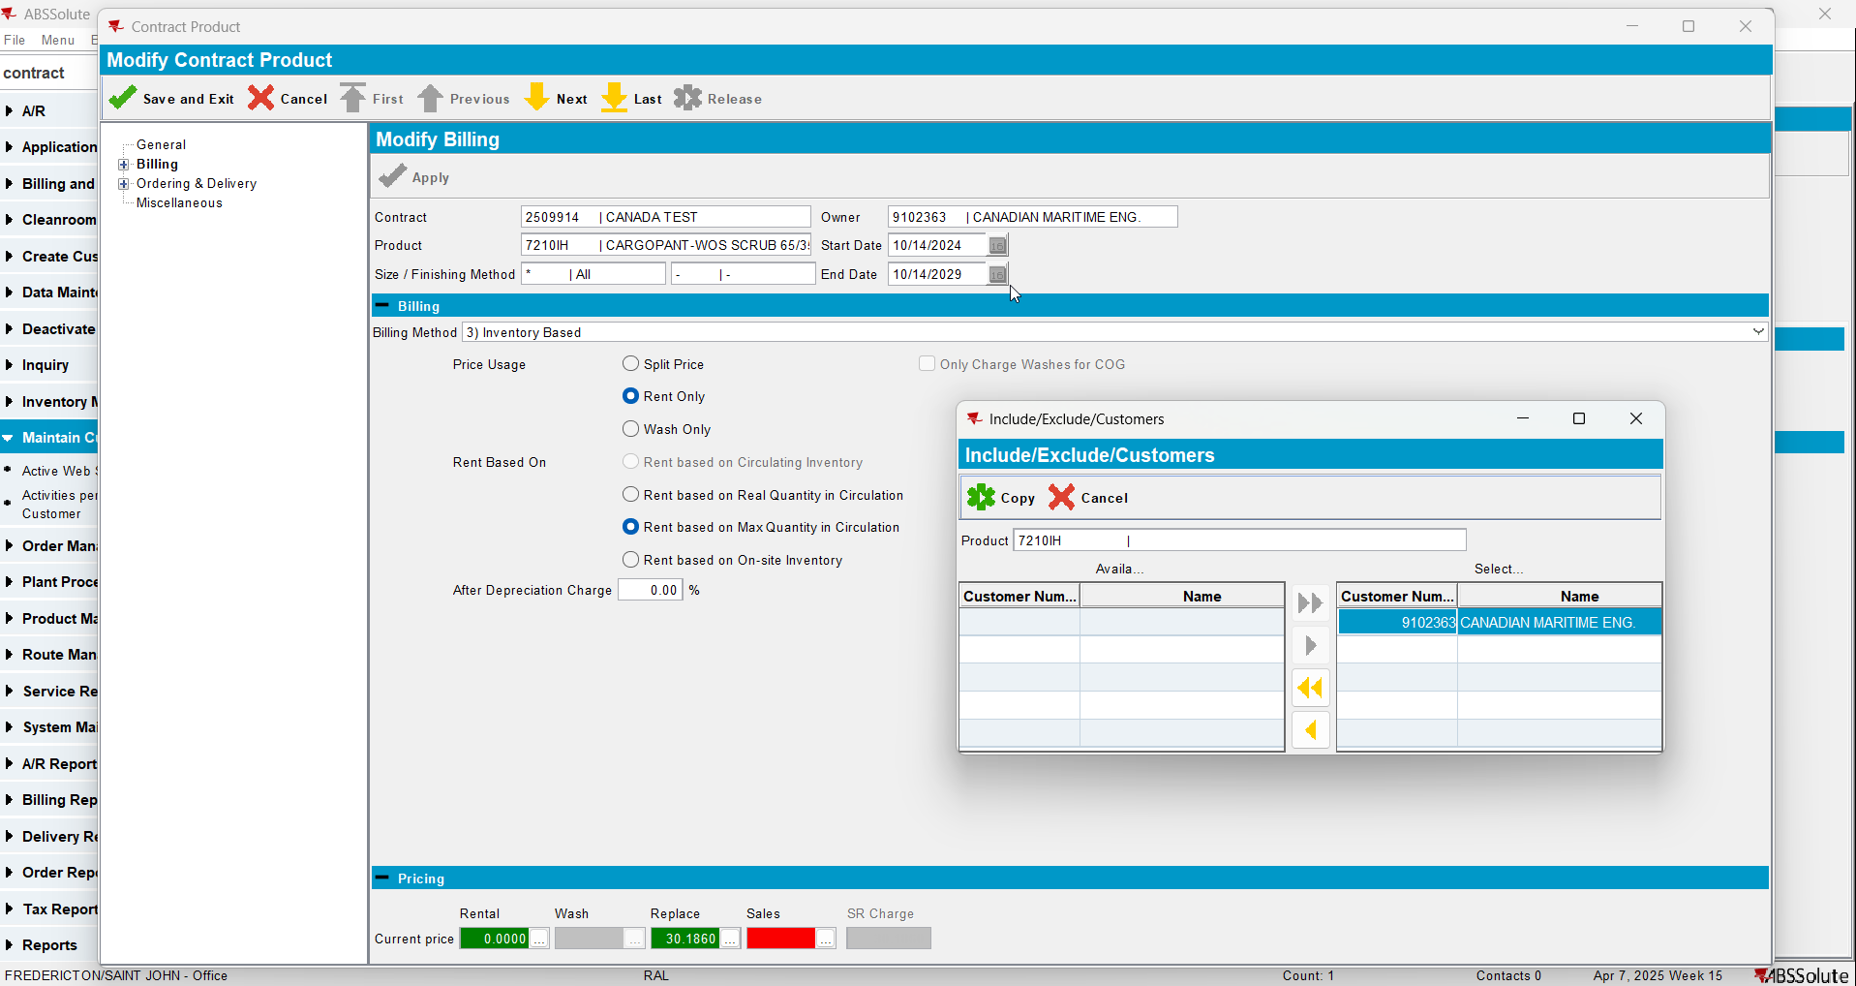
- Add another item with BM4 Sales Only with Sales Price 0. Add the item to your customer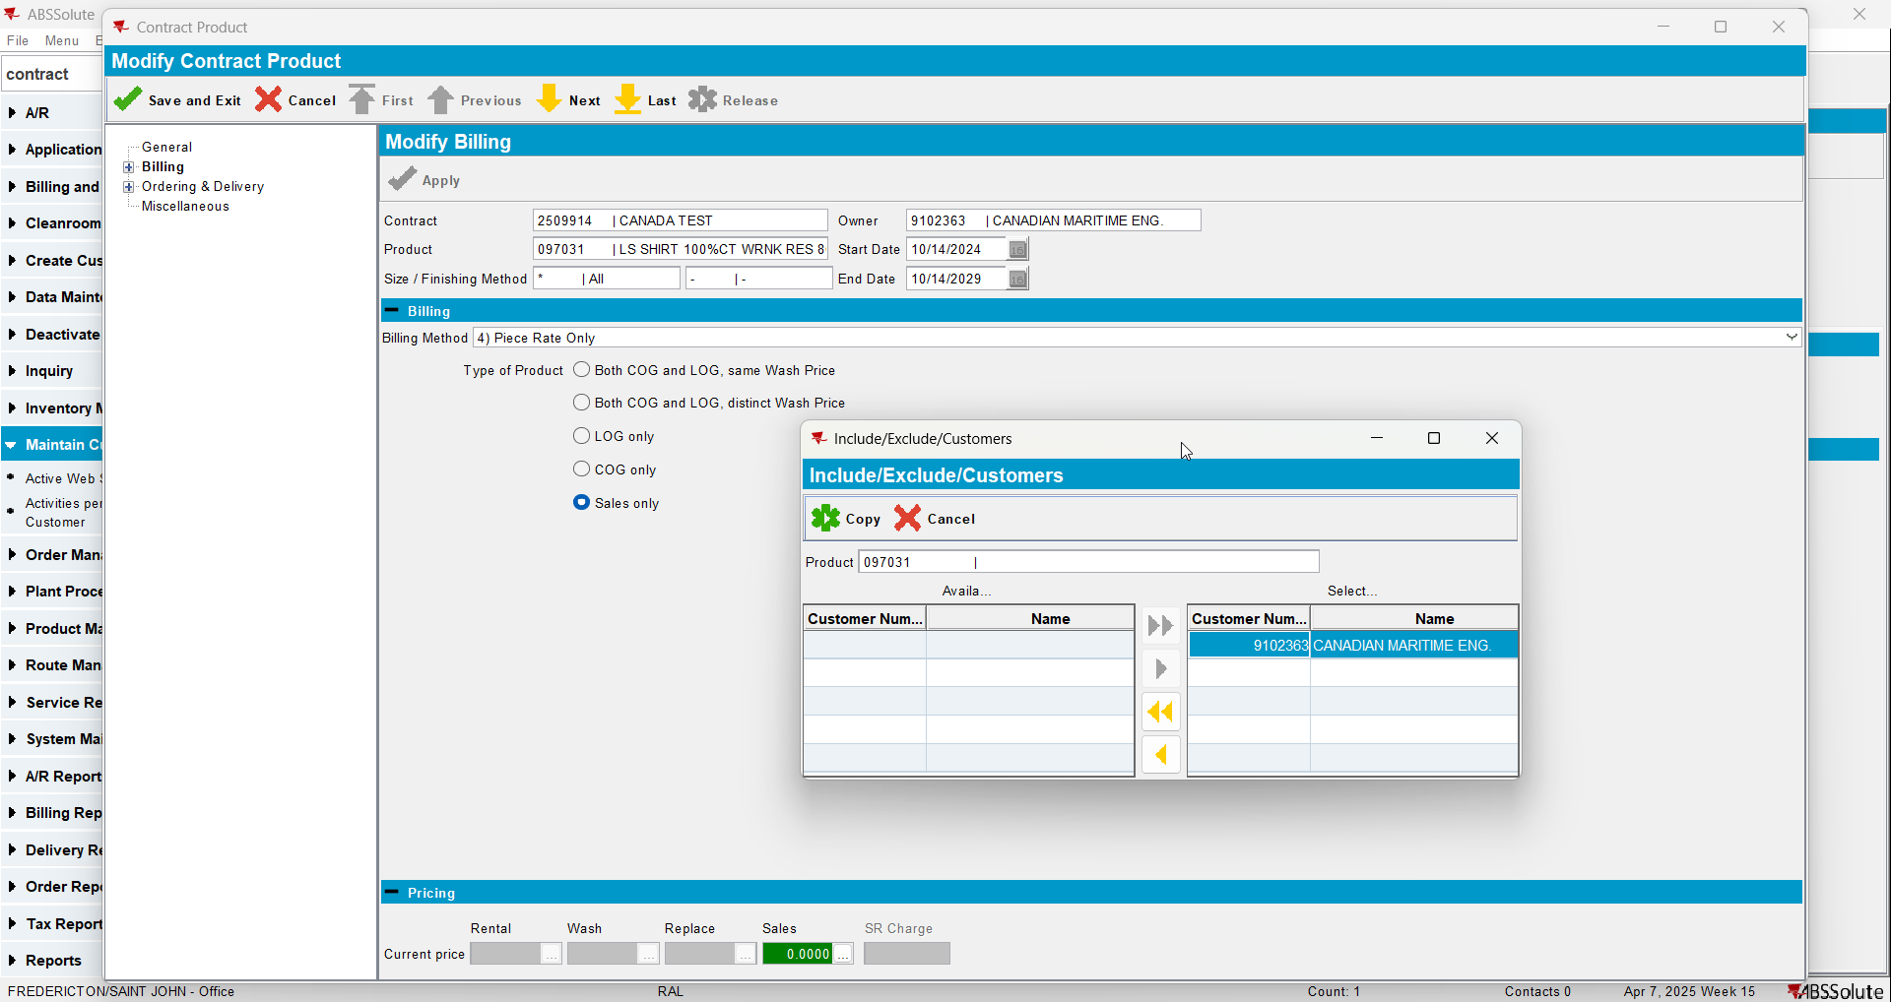
- Create a wearer with 1 wearer inventory for the item with Rental Price 0 and 1 wearer inventory with Sales Price 0. Generate the work orders, issue them and generate delivery notes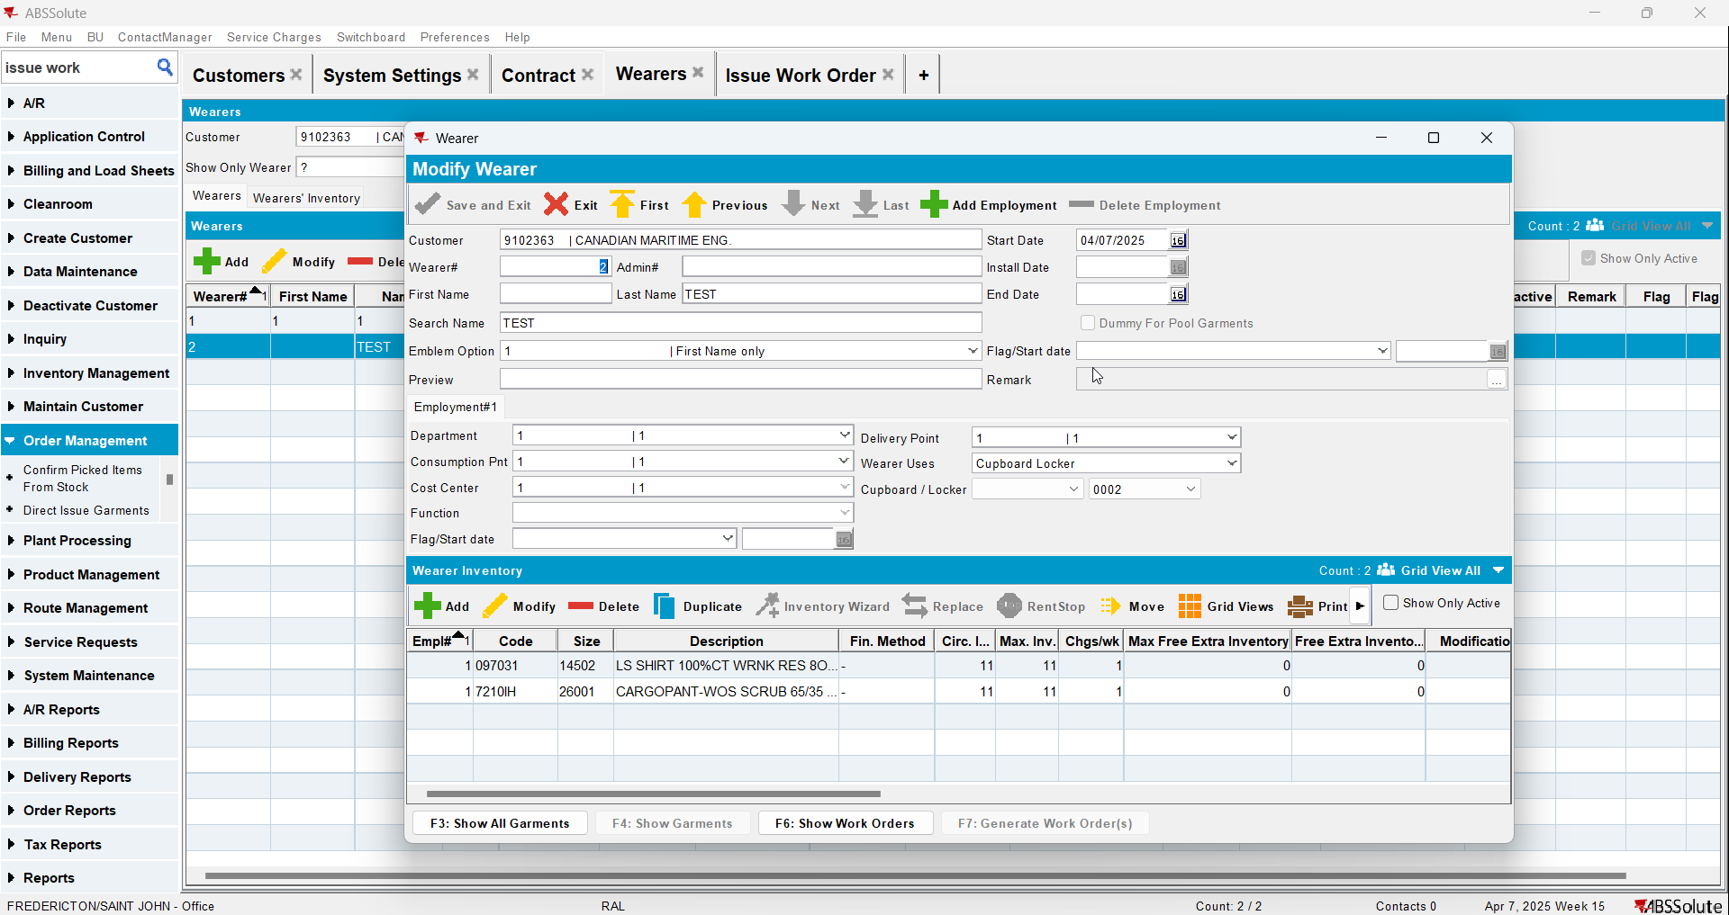
- Generate invoices for the route of your customer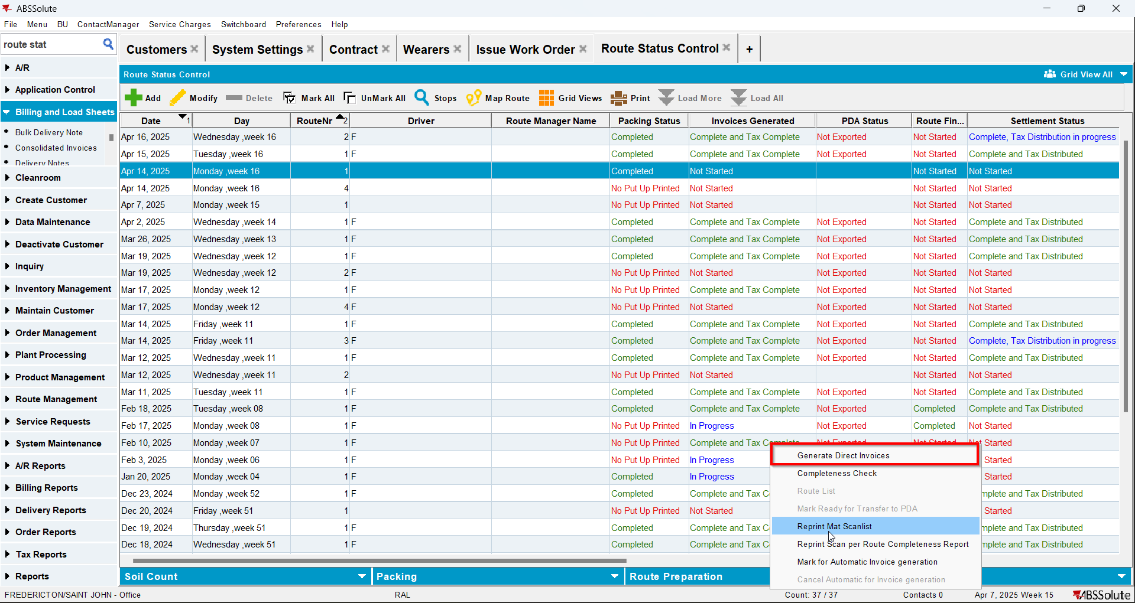
- Check on the invoice that there are 1 invoice line for Rent with price 0 and 1 invoice line for Sales with price 0 for your added items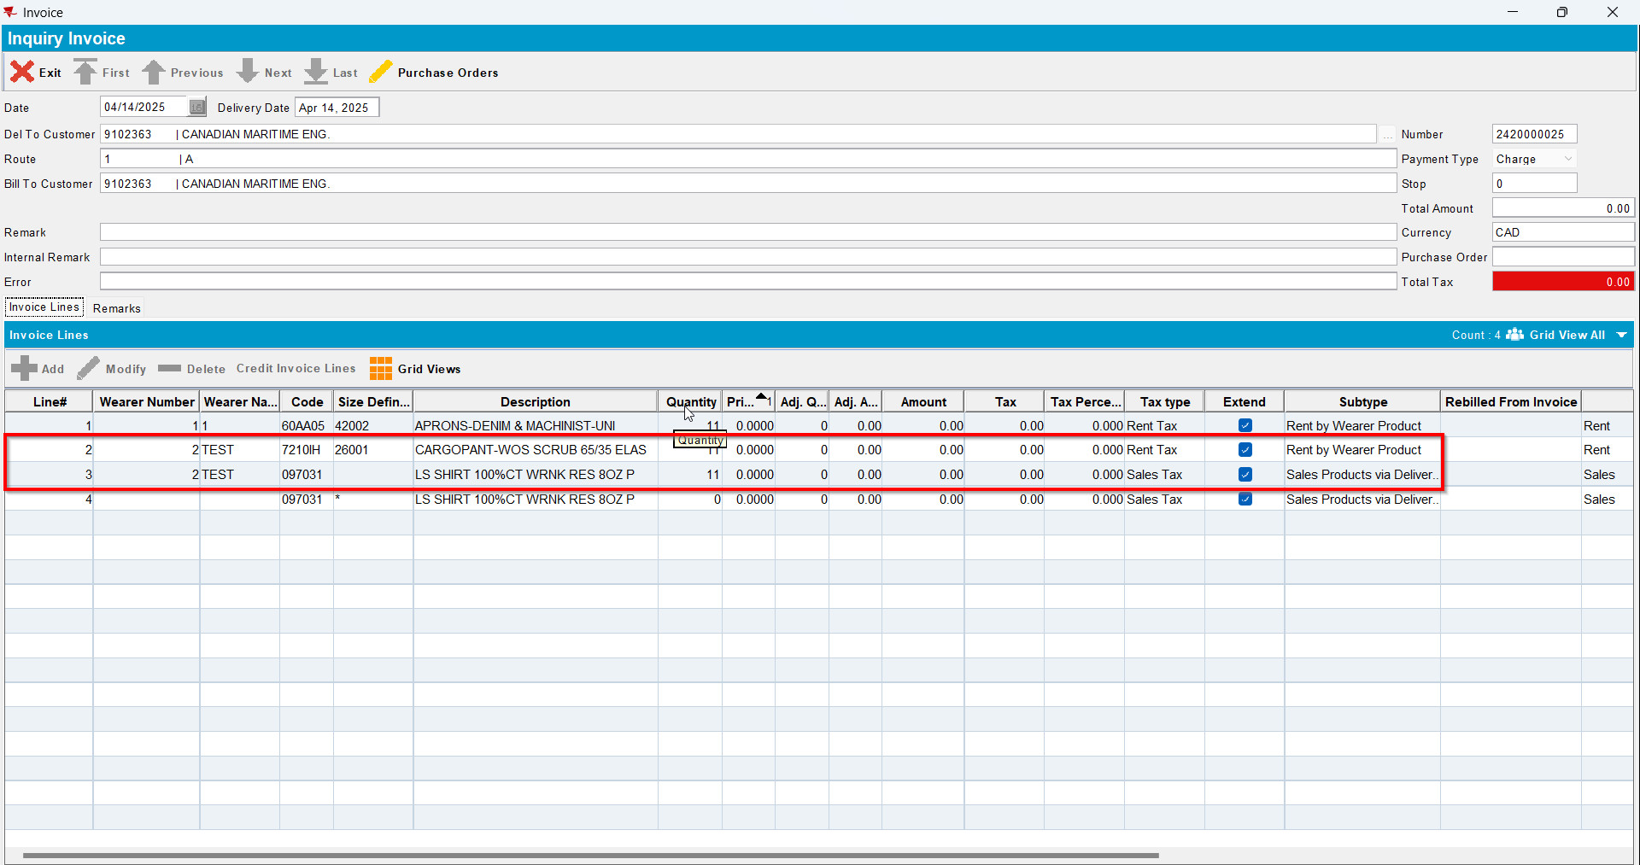
- Script the BCI with the following(for LineItemNumber use the line number of the respective items with price 0):
UPDATE VERTEXTRANSACTIONLOG VTL
SET VTL.EXPORTID = NULL,
VTL.STATUS = 2,
VTL.TAXAREAID = VTL.DESTINATIONTAXAREAID,
VTL.TOTALLINEITEMTAX = 0,
VTL.COMBINEDRATE = 0,
VTL.TOTALMAINDIVISIONTAX = 0
WHERE VTL.BATCHID IN ();
UPDATE VERTEXTRANSACTIONLOG VTL
SET VTL.EXPORTID = NULL,
VTL.STATUS = 2,
VTL.TAXAREAID = VTL.DESTINATIONTAXAREAID,
VTL.TOTALLINEITEMTAX = ROUND((VTL.EXTENDEDPRICE * 0.2), 2),
VTL.COMBINEDRATE = 0.2,
VTL.TOTALMAINDIVISIONTAX = ROUND((VTL.EXTENDEDPRICE * 0.2), 2)
WHERE VTL.BATCHID IN ()
AND VTL.Lineitemnumber in ();
UPDATE VERTEXBATCHCONTROL VBC
SET VBC.BATCHSTATUS = 3
WHERE VBC.BATCHID IN () ;
- Run the BCI process
- Check on the invoice that now those lines have a tax percentage of 20 and there is also a tax line of rent with 0 amount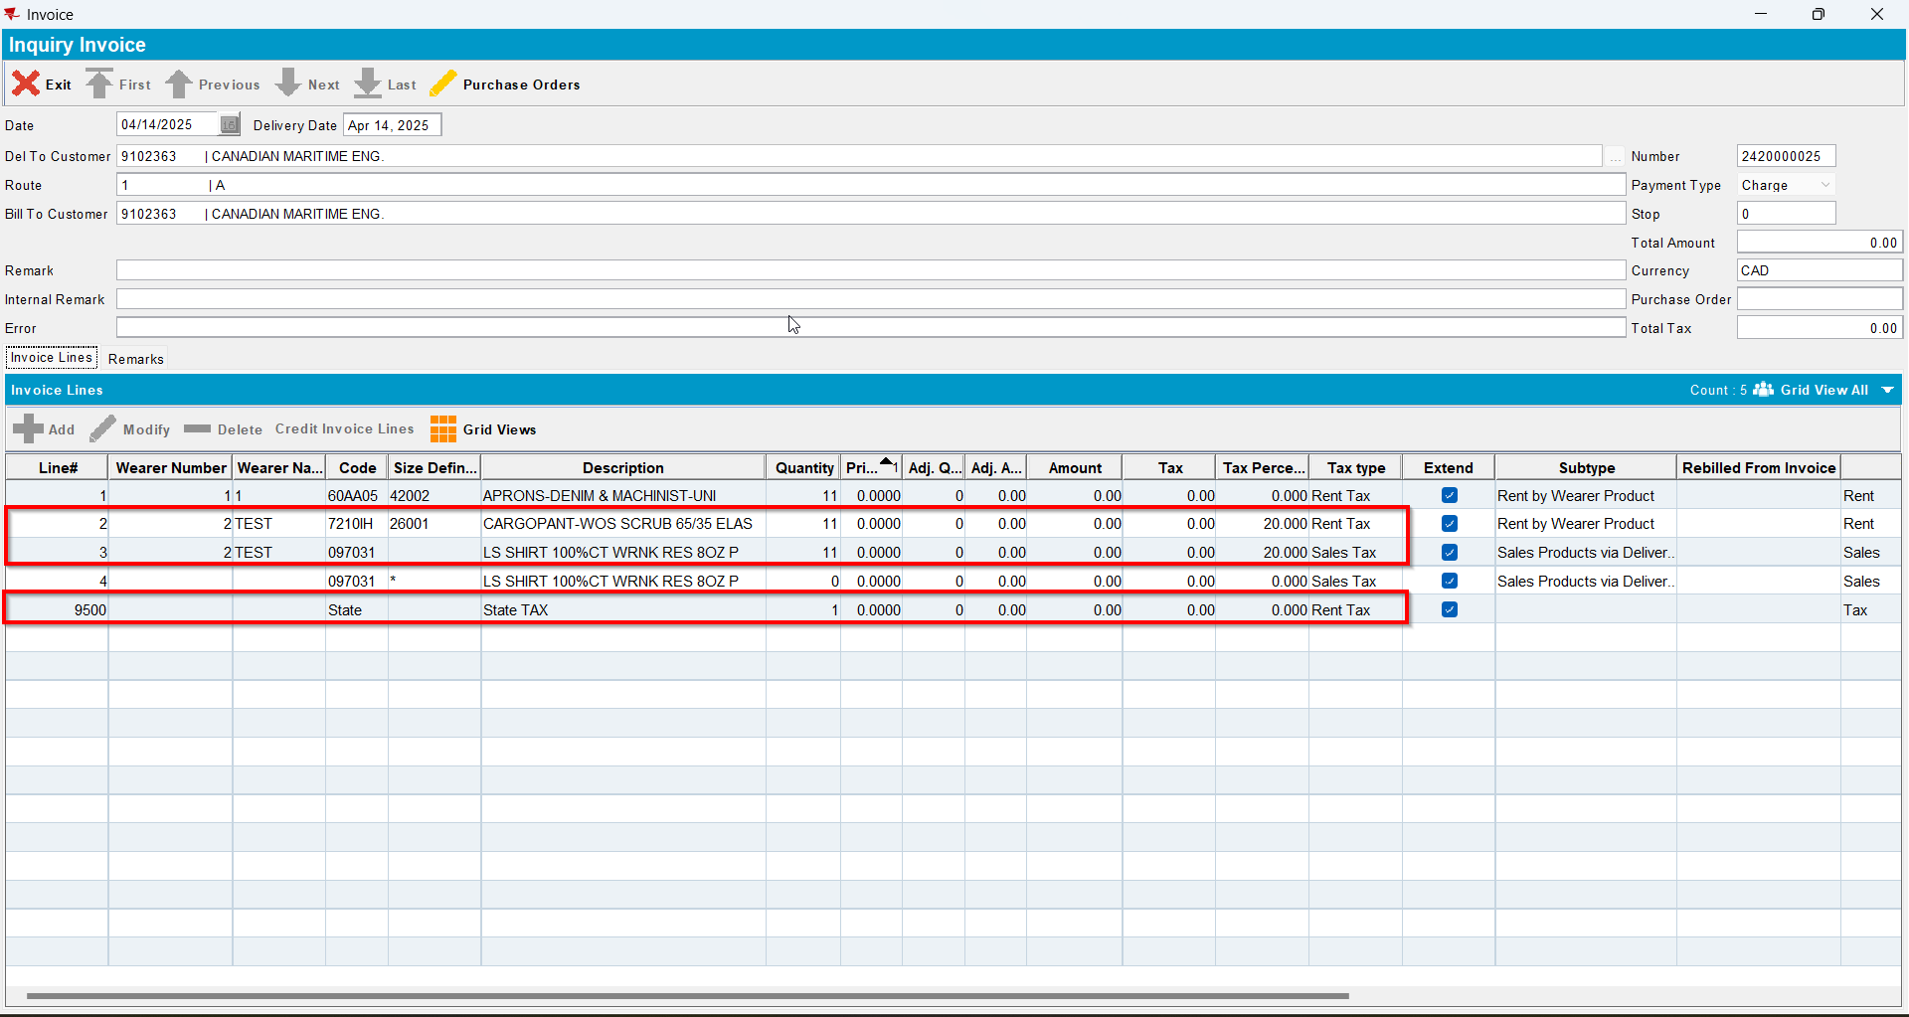
- Send the route to RA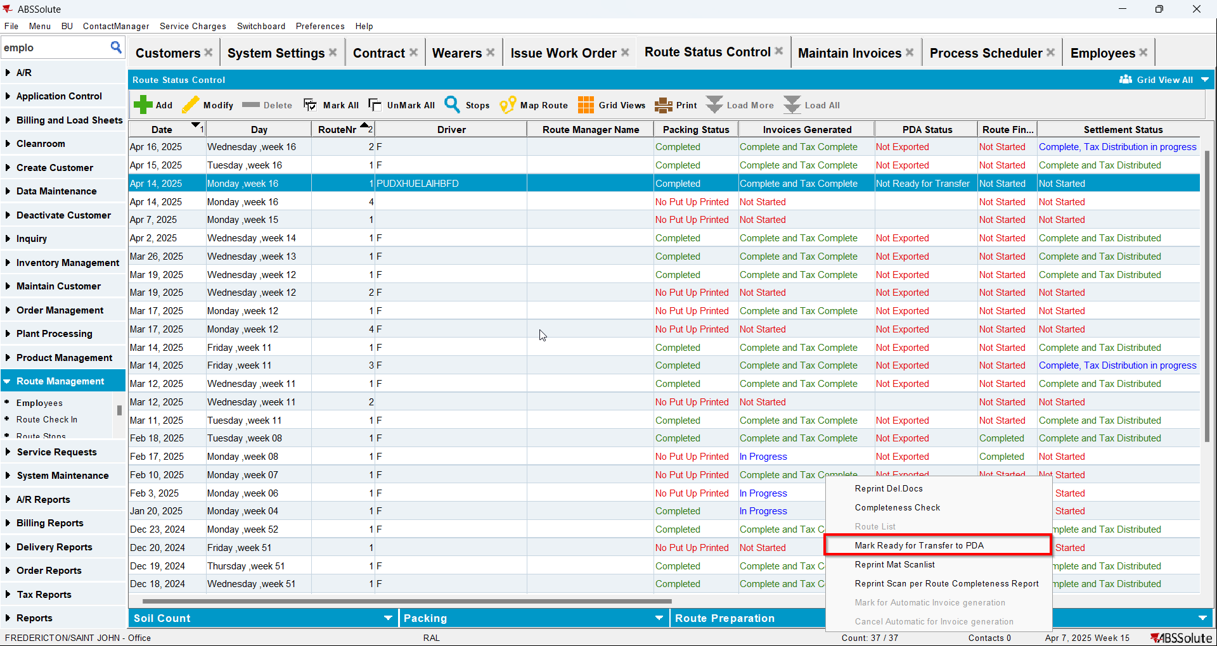
- For your items do positive adjustments increasing qty and amount for both
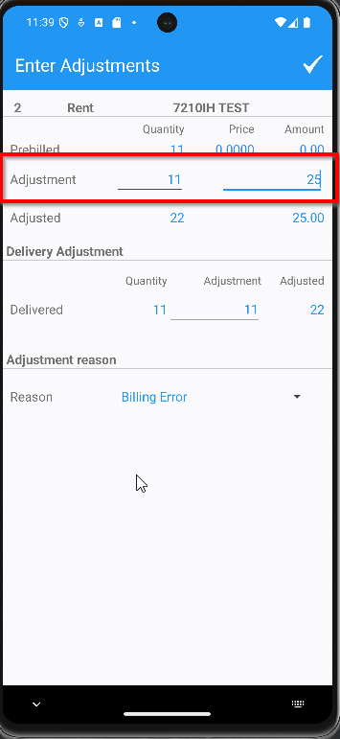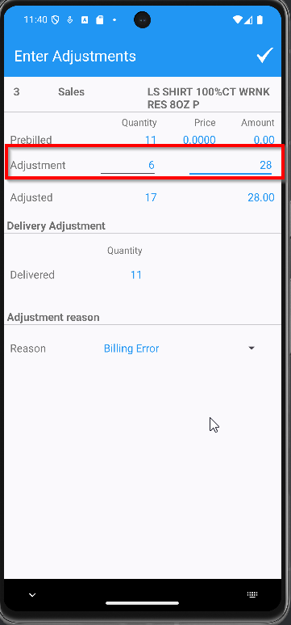
- Finish the route and upload it
- On WebX settle the route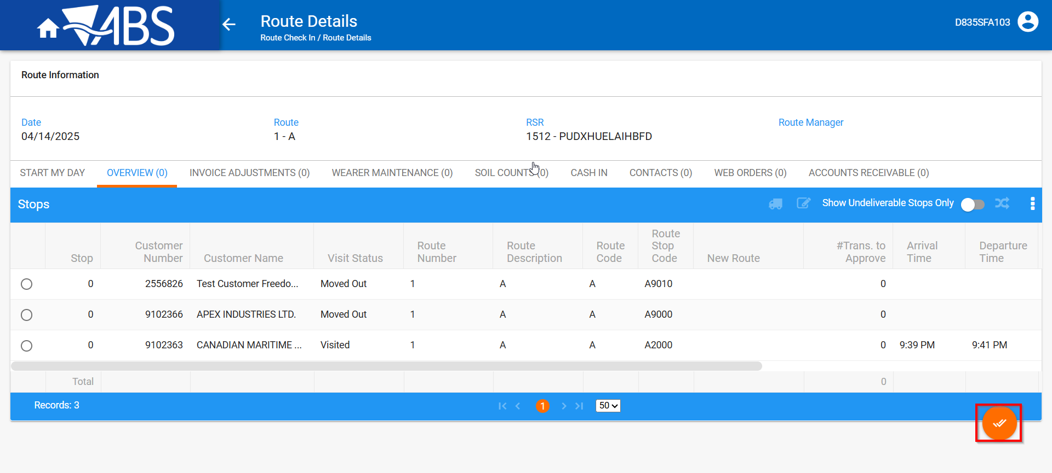
- Check on the invoice that now those line have an adjusted qty, an adjusted amount and a tax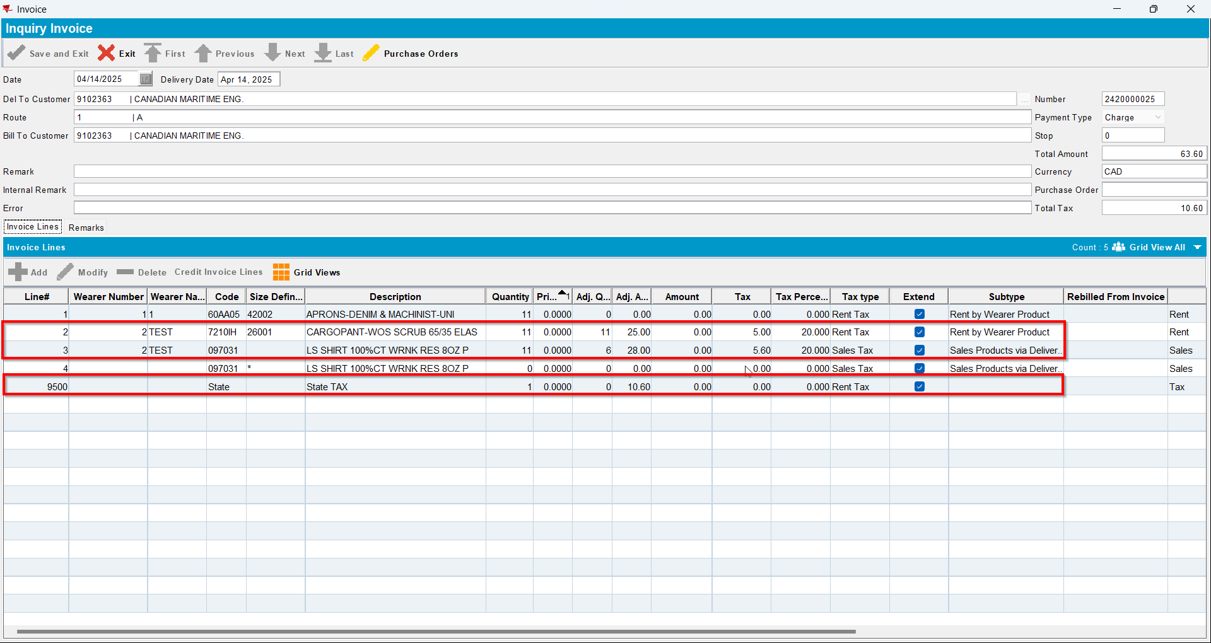
- Script the BCI with the following(for LineItemNumber use the line number of the respective items with price 0):
UPDATE VERTEXTRANSACTIONLOG VTL
SET VTL.EXPORTID = NULL,
VTL.STATUS = 2,
VTL.TAXAREAID = VTL.DESTINATIONTAXAREAID,
VTL.TOTALLINEITEMTAX = ROUND(VTL.INPUTTOTALTAX, 2),
VTL.COMBINEDRATE = 0.00,
VTL.TOTALMAINDIVISIONTAX = ROUND(VTL.INPUTTOTALTAX, 2)
WHERE VTL.BATCHID IN ()
AND VTL.Lineitemnumber NOT IN ();

UPDATE VERTEXTRANSACTIONLOG VTL
SET VTL.EXPORTID = NULL,
VTL.STATUS = 2,
VTL.TAXAREAID = VTL.DESTINATIONTAXAREAID,
VTL.TOTALLINEITEMTAX = ROUND(VTL.INPUTTOTALTAX, 2),
VTL.COMBINEDRATE = 0.2,
VTL.TOTALMAINDIVISIONTAX = ROUND(VTL.INPUTTOTALTAX, 2)
WHERE VTL.BATCHID IN ()
AND VTL.Lineitemnumber in (); ;
UPDATE VERTEXBATCHCONTROL VBC
SET VBC.BATCHSTATUS = 3
WHERE VBC.BATCHID IN ();
- Run the BCI process
- Check on the invoice that now there is a tax rent line and also a tax sales line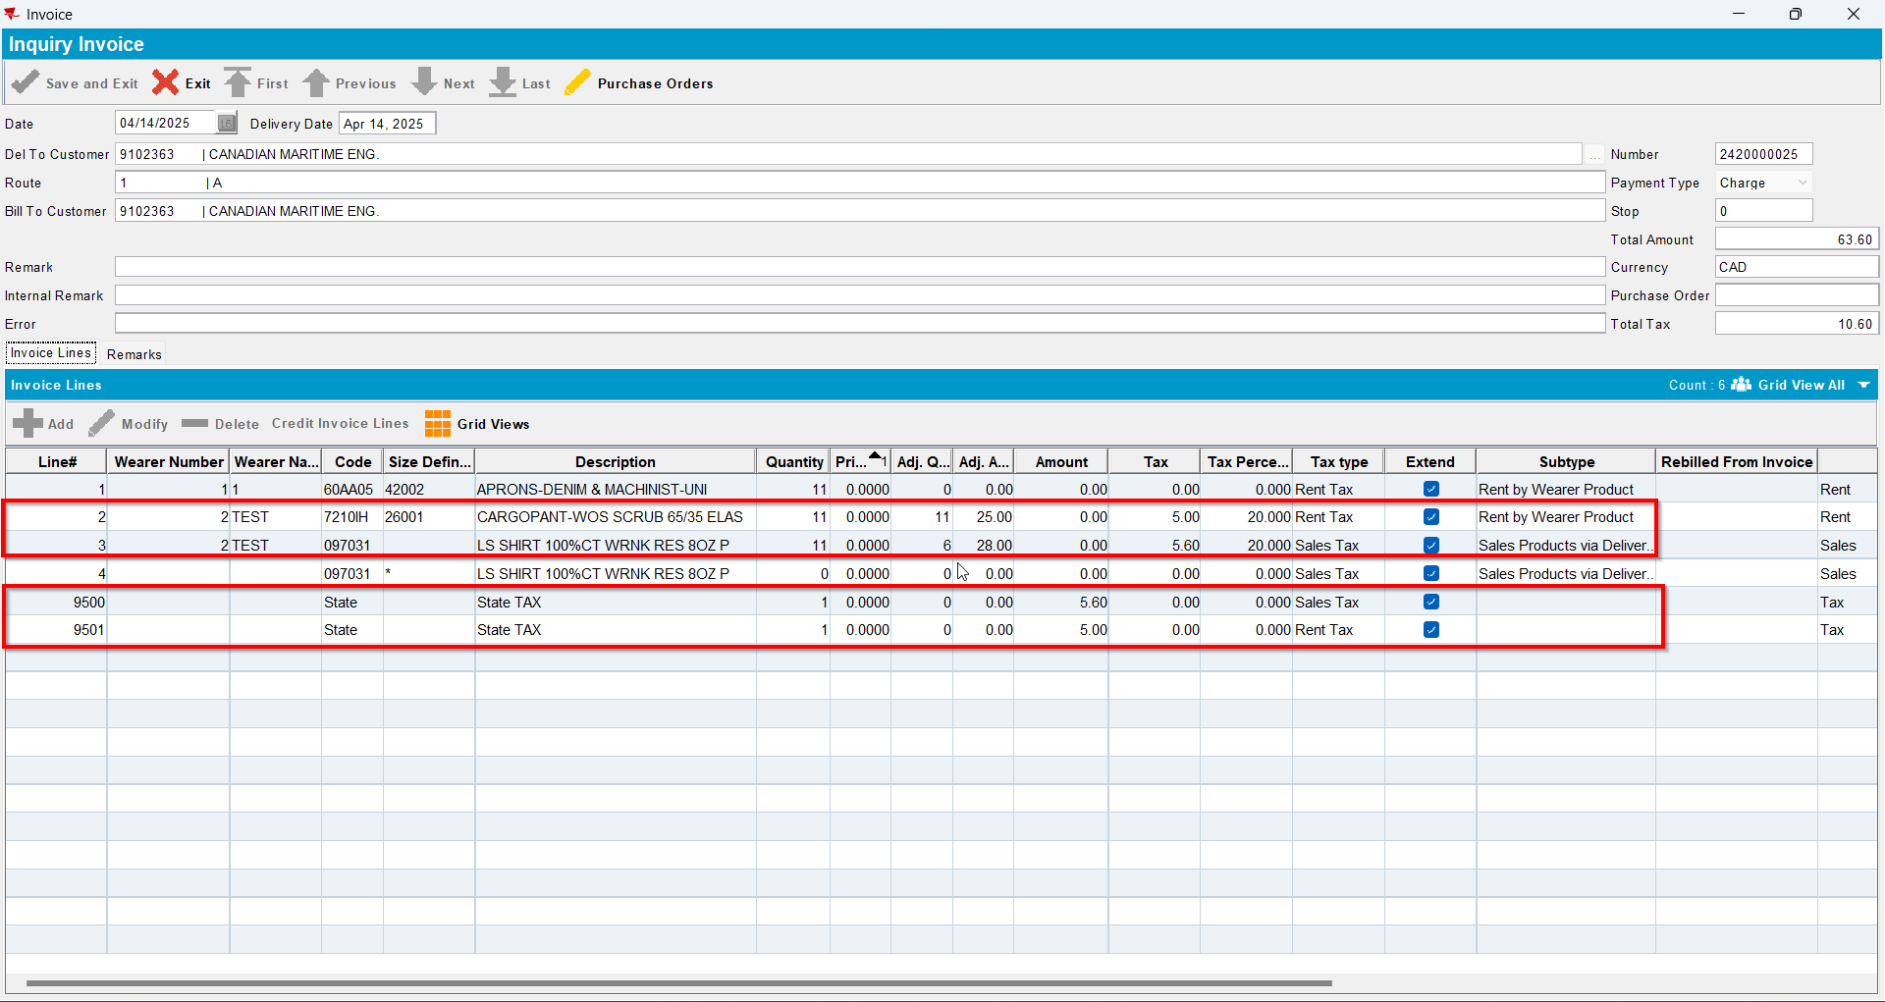
- Check that Pay This Amount is not equal to Total Amount Excluding VAT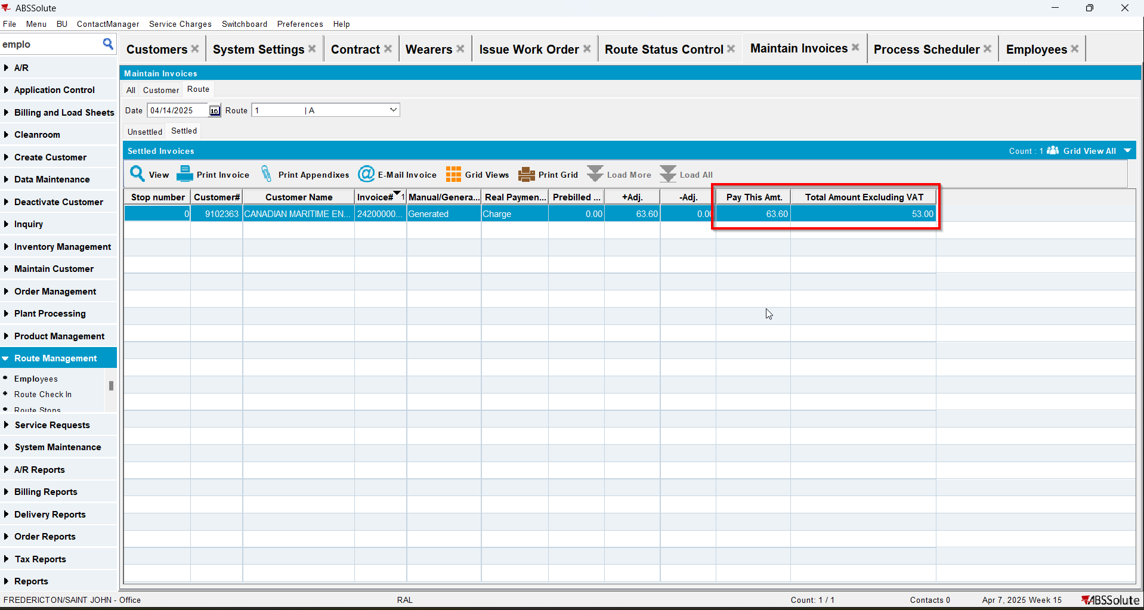

Test Case 3 – Bill loss now when there are no tax lines on pre-bill – Tested OK
Expected behavior: When tax in pre-bill is 0$ but there is a bill-loss now on the RA the additional tax from the RA gets charged to the RA and included in the final paythisamount.
Hash: 6d030f8
- Go to BU 087
- Find customer 1574043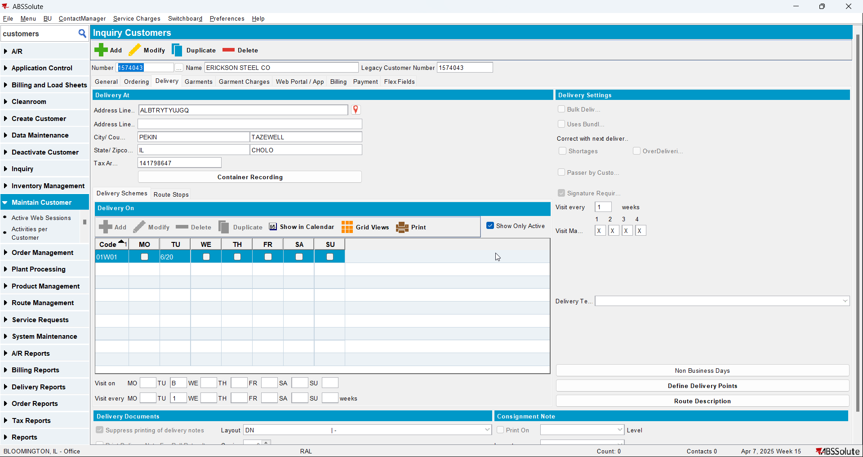
- RSC DLG: Add the next Tuesday’s route 6 and generate invoices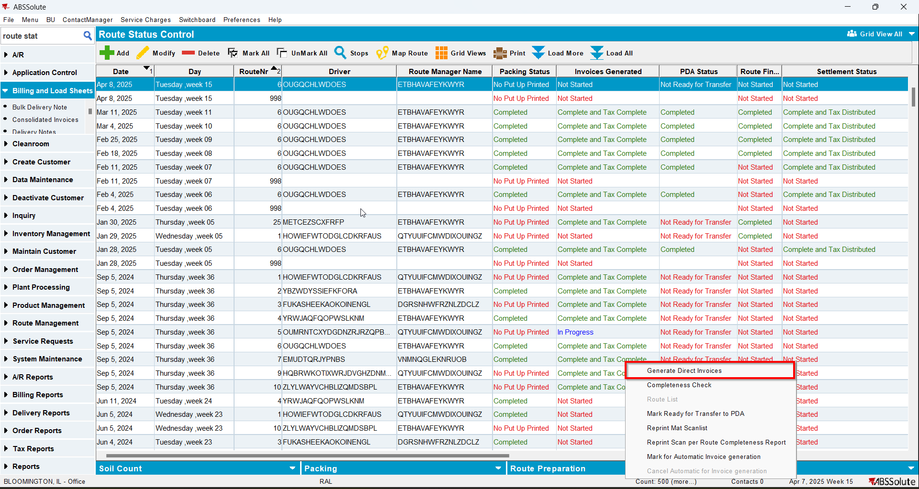
- Script in the BCI data like so:
UPDATE VERTEXTRANSACTIONLOG VTL
SET VTL.EXPORTID = NULL,
VTL.STATUS = 2,
VTL.TAXAREAID = VTL.DESTINATIONTAXAREAID
WHERE VTL.BATCHID IN ()
AND VTL.TRANSACTIONTYPE = 'RENTAL';
UPDATE VERTEXTRANSACTIONLOG VTL
SET VTL.EXPORTID = NULL,
VTL.STATUS = 2,
VTL.TAXAREAID = VTL.DESTINATIONTAXAREAID
WHERE VTL.BATCHID IN ()
AND VTL.TRANSACTIONTYPE = 'SALE';
UPDATE VERTEXTRANSACTIONLOG VTL
SET VTL.EXPORTID = NULL,
VTL.STATUS = 2,
VTL.TAXAREAID = VTL.DESTINATIONTAXAREAID,
VTL.COMBINEDRATE = 0.05
WHERE VTL.BATCHID IN ()
AND VTL.DOCUMENTNUMBER LIKE '%LD';
UPDATE VERTEXBATCHCONTROL VBC
SET VBC.BATCHSTATUS = 3
WHERE VBC.BATCHID IN ();
- Run the process scheduler for Vertex Tax
- Maintain Invoices DLG: Verify that the invoice generated is taxed but has one tax line with 1 qty and 0 amount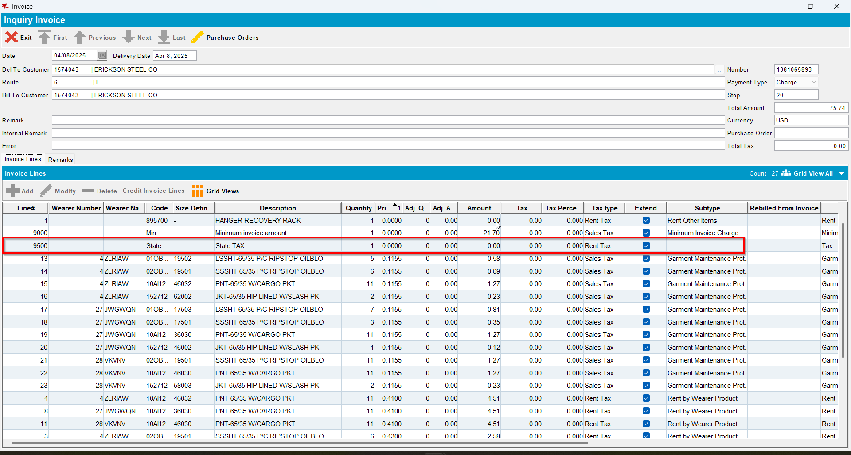

- Send the route to RA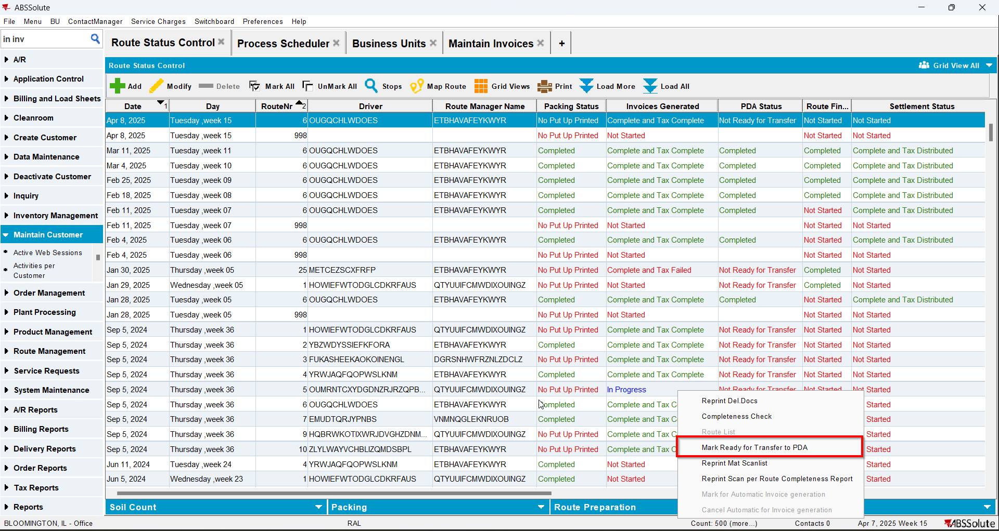

- RA: Quit a wearer and a DOI and bill loss now for both
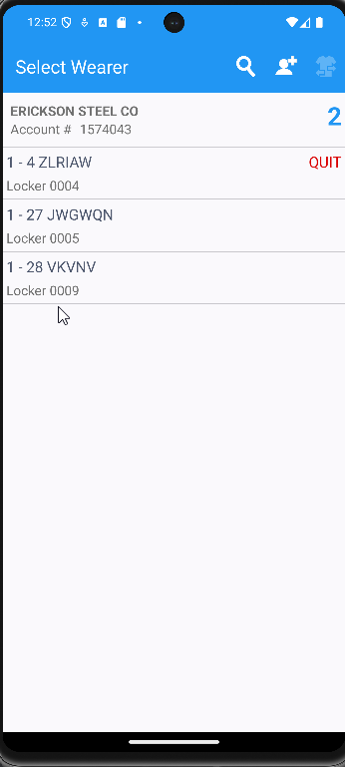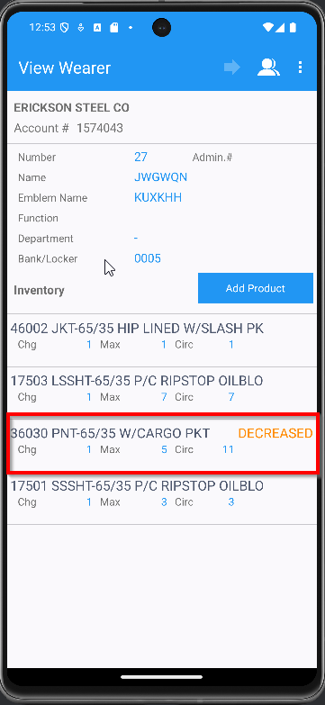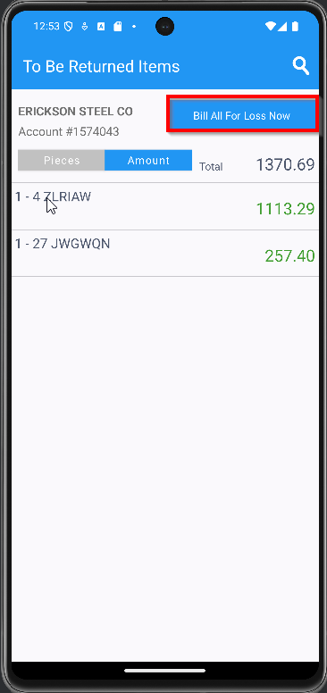
- RA: Finish route and upload
- WebX: Check that you have an adjustment on the tax line
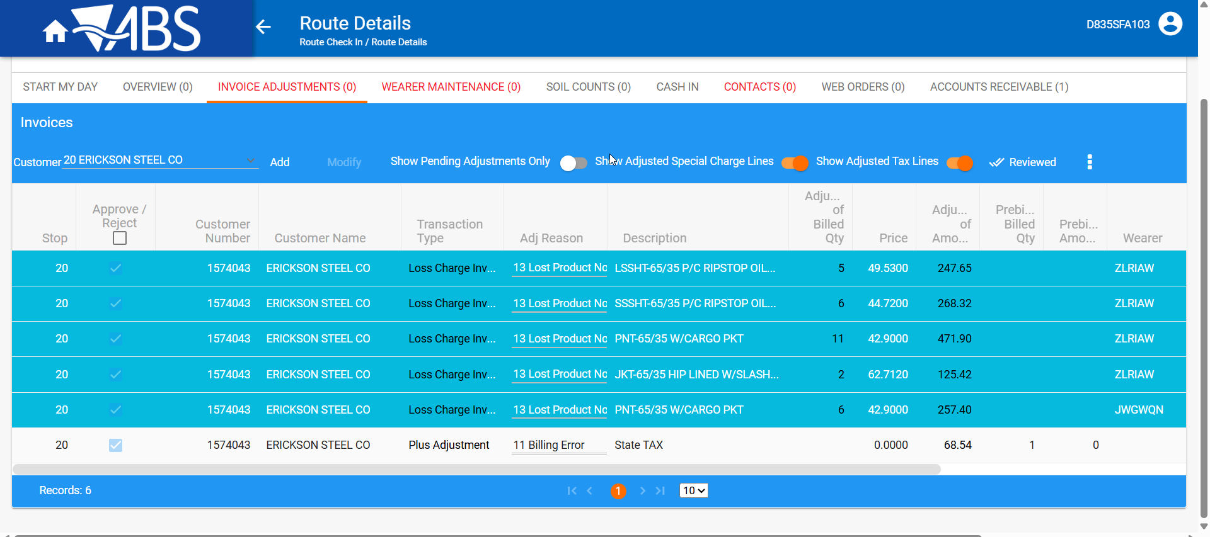
- Review all tabs and settle the route
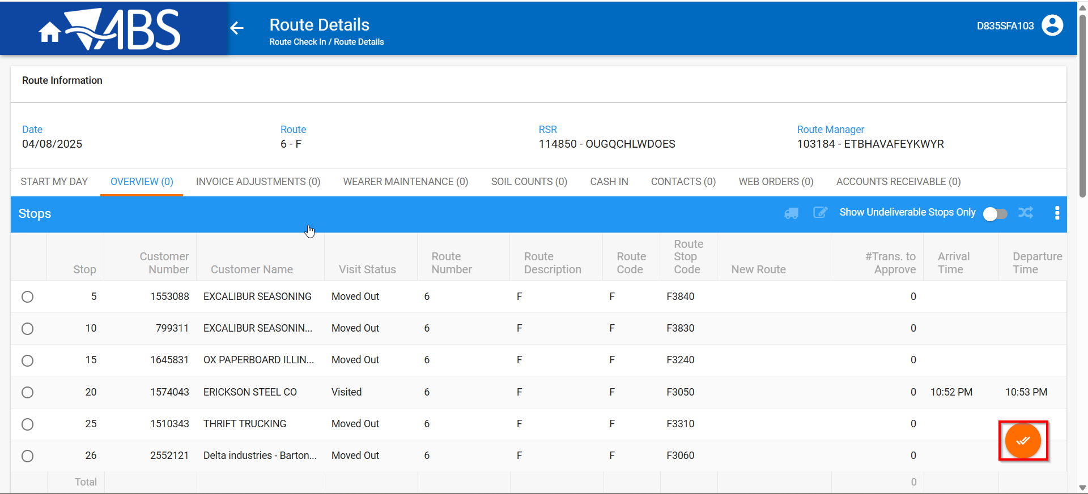
- Run this modified version of the BCI Script on the TaxDistribution batch
--SETTLEMENT
UPDATE VERTEXTRANSACTIONLOG VTL
SET VTL.EXPORTID = NULL,
VTL.STATUS = 2,
VTL.TAXAREAID = VTL.DESTINATIONTAXAREAID,
WHERE VTL.BATCHID IN ()
AND VTL.TRANSACTIONTYPE = 'RENTAL';

UPDATE VERTEXTRANSACTIONLOG VTL
SET VTL.EXPORTID = NULL,
VTL.STATUS = 2,
VTL.TAXAREAID = VTL.DESTINATIONTAXAREAID,
VTL.TOTALLINEITEMTAX = ROUND(VTL.INPUTTOTALTAX, 2),
VTL.COMBINEDRATE = 0.05,
VTL.TOTALMAINDIVISIONTAX = ROUND(VTL.INPUTTOTALTAX, 2)
WHERE VTL.BATCHID IN ()
AND VTL.TRANSACTIONTYPE = 'SALE';

UPDATE VERTEXBATCHCONTROL VBC
SET VBC.BATCHSTATUS = 3
WHERE VBC.BATCHID IN ();
- Run the process scheduler for Vertex Tax
- Maintain Invoices DLG: Check that the IH.PayThisAmount = IH.TotalAmountExclVat + SUM(ILEI.TotalTax)* and that the tax line now contains the tax amount from the loss charge lines
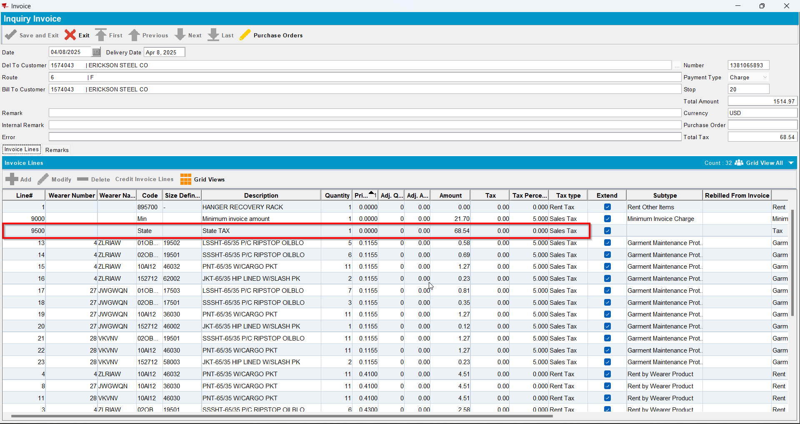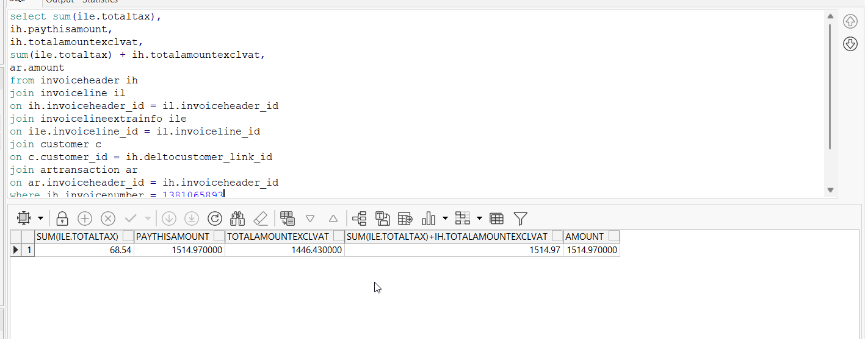
select sum(ile.totaltax),
ih.paythisamount,
ih.totalamountexclvat,
sum(ile.totaltax) + ih.totalamountexclvat,
ar.amount
from invoiceheader ih
join invoiceline il
on ih.invoiceheader_id = il.invoiceheader_id
join invoicelineextrainfo ile
on ile.invoiceline_id = il.invoiceline_id
join customer c
on c.customer_id = ih.deltocustomer_link_id
join artransaction ar
on ar.invoiceheader_id = ih.invoiceheader_id
where ih.invoicenumber =
group by ih.paythisamount,
ih.totalamountexclvat,
ar.amount;

Test Case 4 – Invoice with no 0 amount tax on pre-bill with no bill-loss now
Expected behavior: We get a 0 amount tax line on prebill but when the TAXDISTRIBUTION is processed the 0 amount tax line is removed
Hash: 6d030f8
- Go to BU 087
- Find customer 1574043
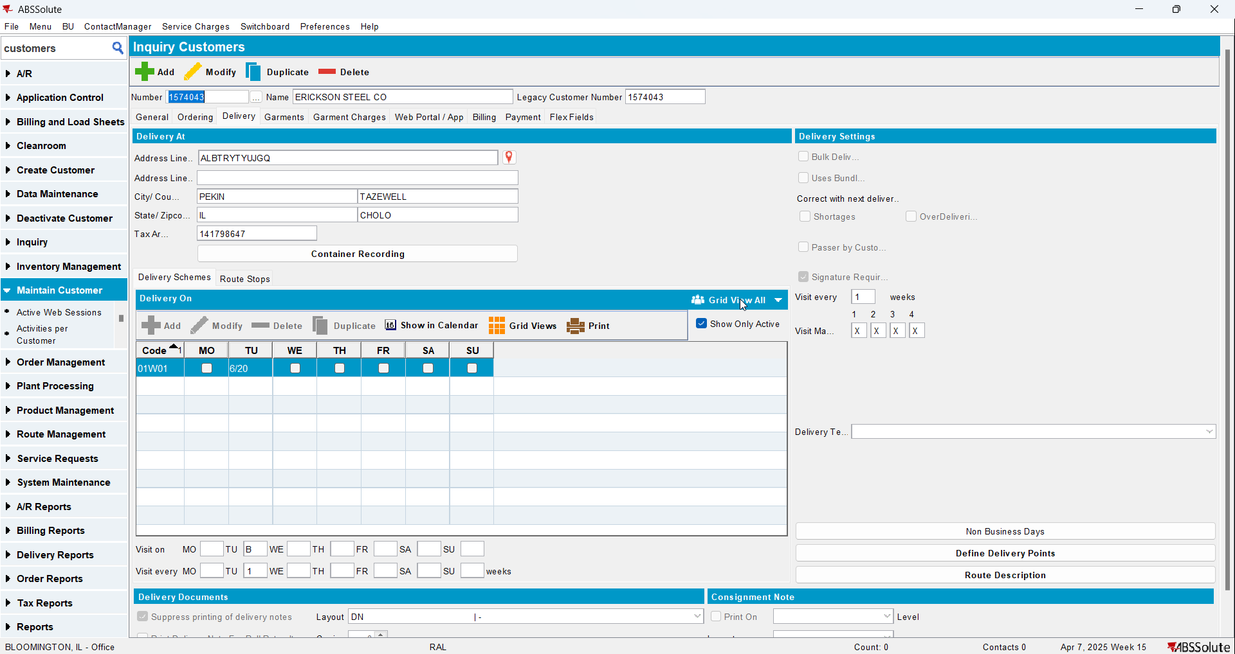
- RSC DLG: Add the next Tuesday’s route 6 and generate invoices
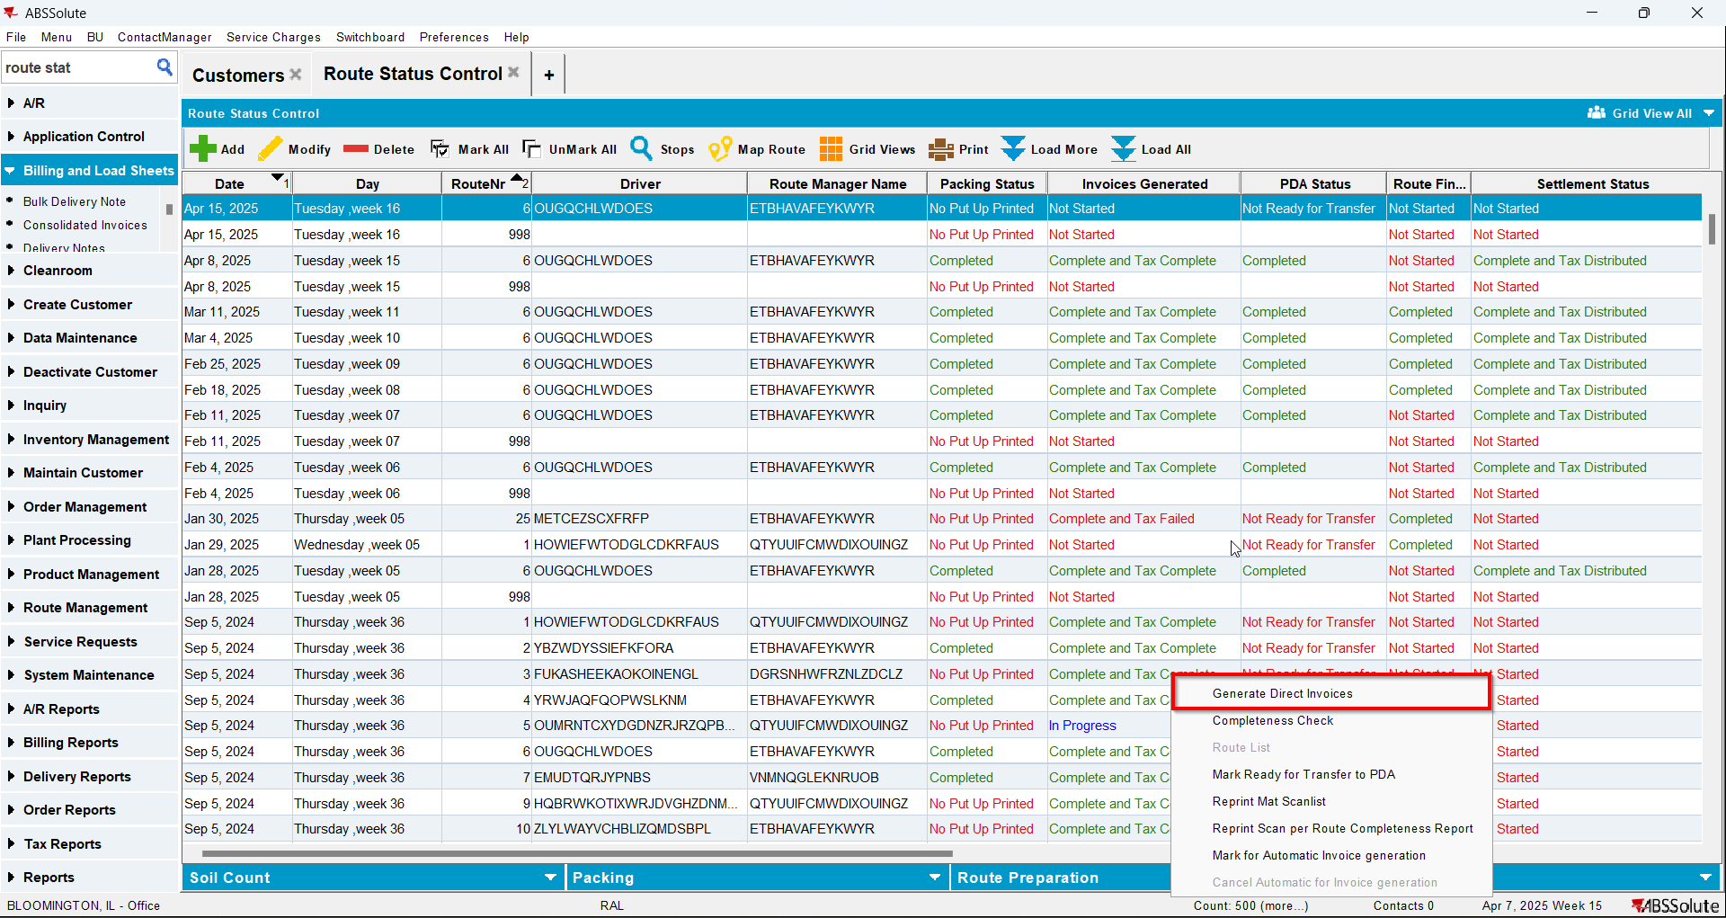
- Script in the BCI data to simulate 0% tax for all lines except the LD lines
UPDATE VERTEXTRANSACTIONLOG VTL
SET VTL.EXPORTID = NULL,
VTL.STATUS = 2,
VTL.TAXAREAID = VTL.DESTINATIONTAXAREAID
WHERE VTL.BATCHID IN ()
AND VTL.TRANSACTIONTYPE = 'RENTAL';
UPDATE VERTEXTRANSACTIONLOG VTL
SET VTL.EXPORTID = NULL,
VTL.STATUS = 2,
VTL.TAXAREAID = VTL.DESTINATIONTAXAREAID
WHERE VTL.BATCHID IN ()
AND VTL.TRANSACTIONTYPE = 'SALE';
UPDATE VERTEXTRANSACTIONLOG VTL
SET VTL.EXPORTID = NULL,
VTL.STATUS = 2,
VTL.TAXAREAID = VTL.DESTINATIONTAXAREAID,
VTL.COMBINEDRATE = 0.05
WHERE VTL.BATCHID IN ()
AND VTL.DOCUMENTNUMBER LIKE '%LD';
UPDATE VERTEXBATCHCONTROL VBC
SET VBC.BATCHSTATUS = 3
WHERE VBC.BATCHID IN ();
- Run the process scheduler for Vertex Tax
- Maintain Invoices DLG: Verify that the invoice generated is taxed but has one tax line with 1 qty and 0 amount
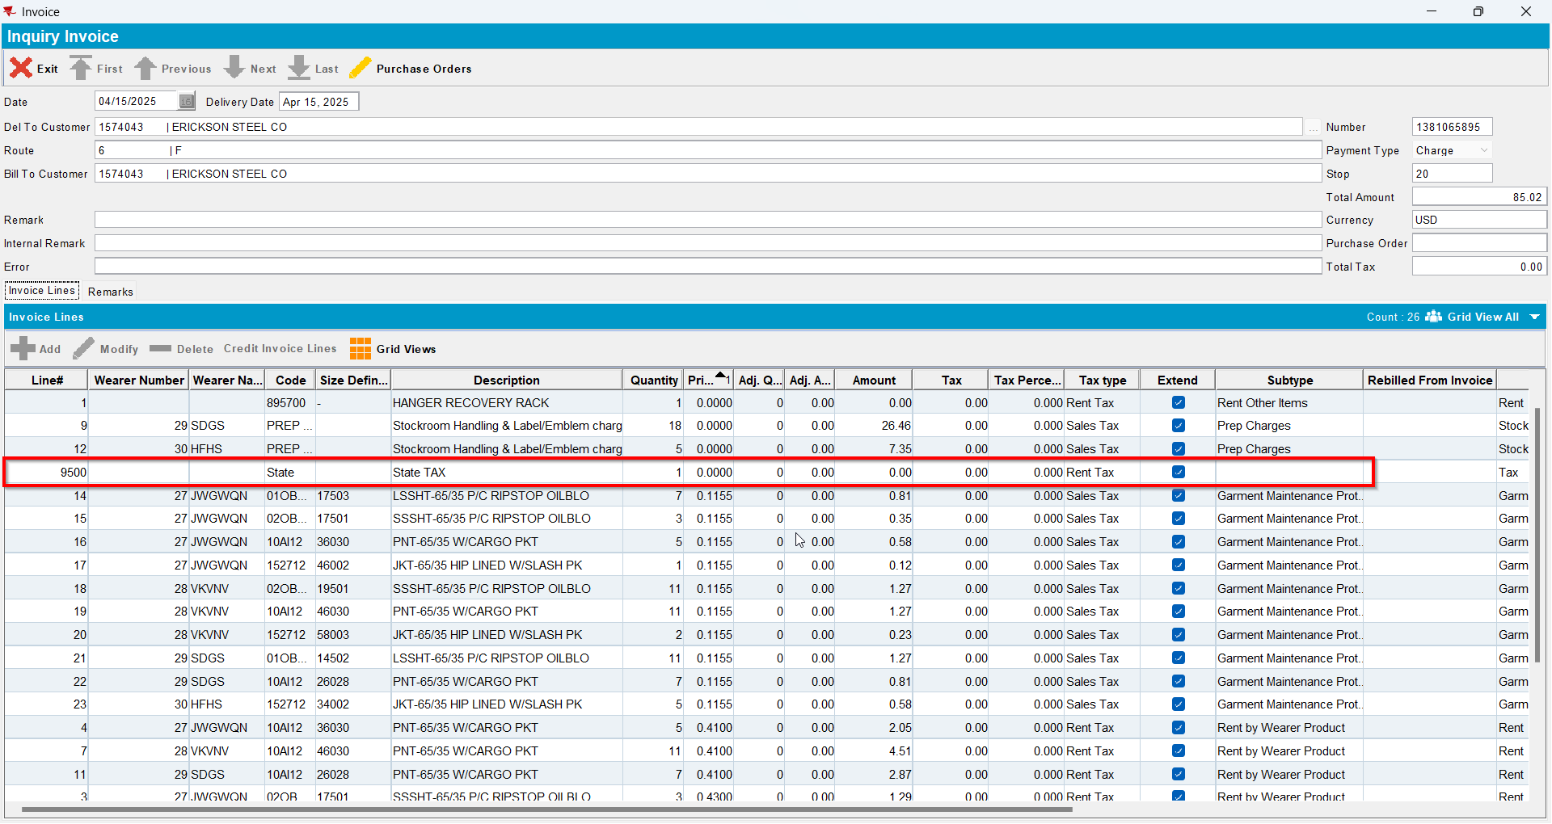
- Send the route to RA
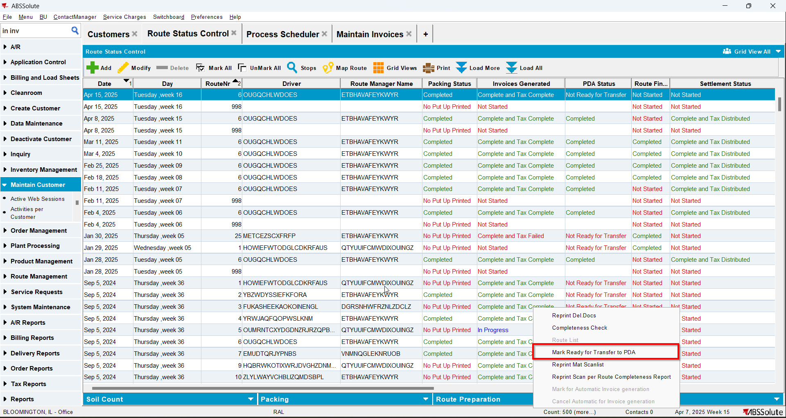
- RA: Adjust two invoice lines
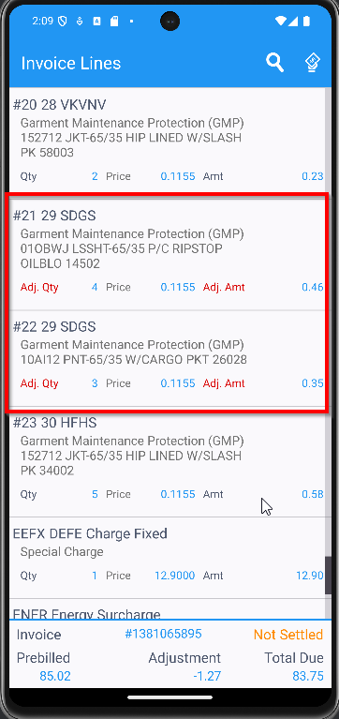
- RA: Finish route and upload
- WebX: Check that you have no adjustment on the tax line
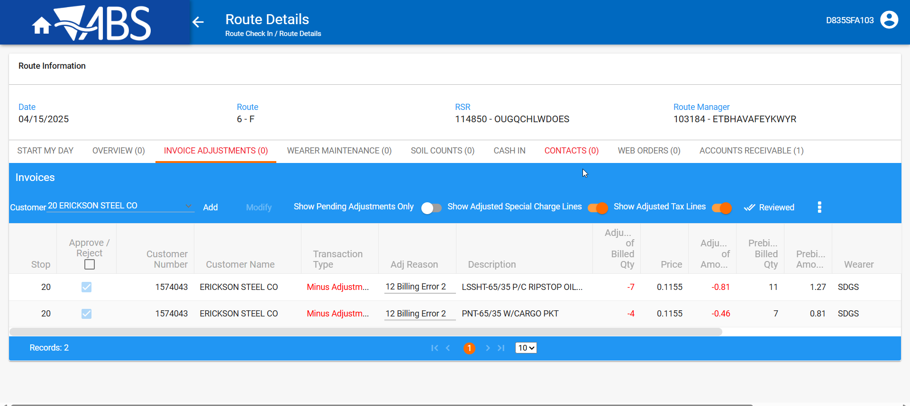
- Review all tabs and settle the route
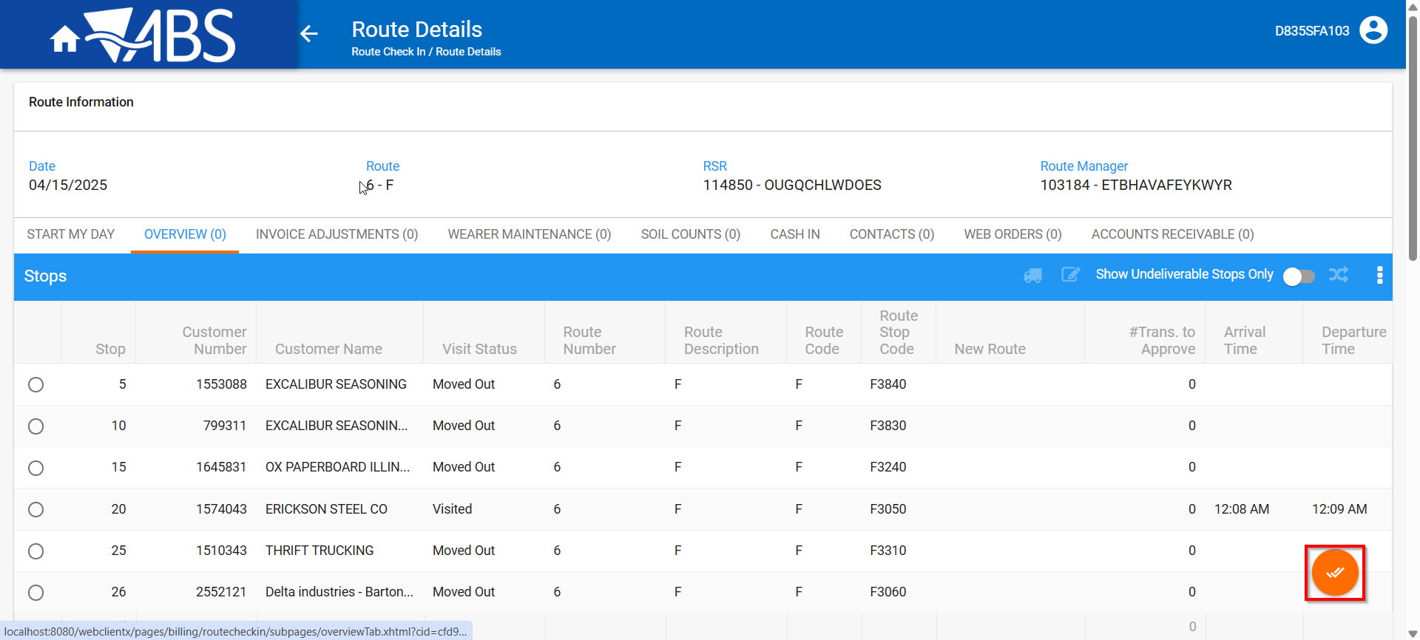
- Run this modified version of the BCI Script on the TaxDistribution batch
--SETTLEMENT
UPDATE VERTEXTRANSACTIONLOG VTL
SET VTL.EXPORTID = NULL,
VTL.STATUS = 2,
VTL.TAXAREAID = VTL.DESTINATIONTAXAREAID,
WHERE VTL.BATCHID IN ()
AND VTL.TRANSACTIONTYPE = 'RENTAL';

UPDATE VERTEXTRANSACTIONLOG VTL
SET VTL.EXPORTID = NULL,
VTL.STATUS = 2,
VTL.TAXAREAID = VTL.DESTINATIONTAXAREAID,
VTL.TOTALLINEITEMTAX = ROUND(VTL.INPUTTOTALTAX, 2),
VTL.COMBINEDRATE = 0.05,
VTL.TOTALMAINDIVISIONTAX = ROUND(VTL.INPUTTOTALTAX, 2)
WHERE VTL.BATCHID IN ()
AND VTL.TRANSACTIONTYPE = 'SALE';

UPDATE VERTEXBATCHCONTROL VBC
SET VBC.BATCHSTATUS = 3
WHERE VBC.BATCHID IN ();

- Run the process scheduler for Vertex Tax
- Maintain Invoices DLG: Check that the IH.PayThisAmount = IH.TotalAmountExclVat + SUM(ILEI.TotalTax)* and that the tax line is not there anymore
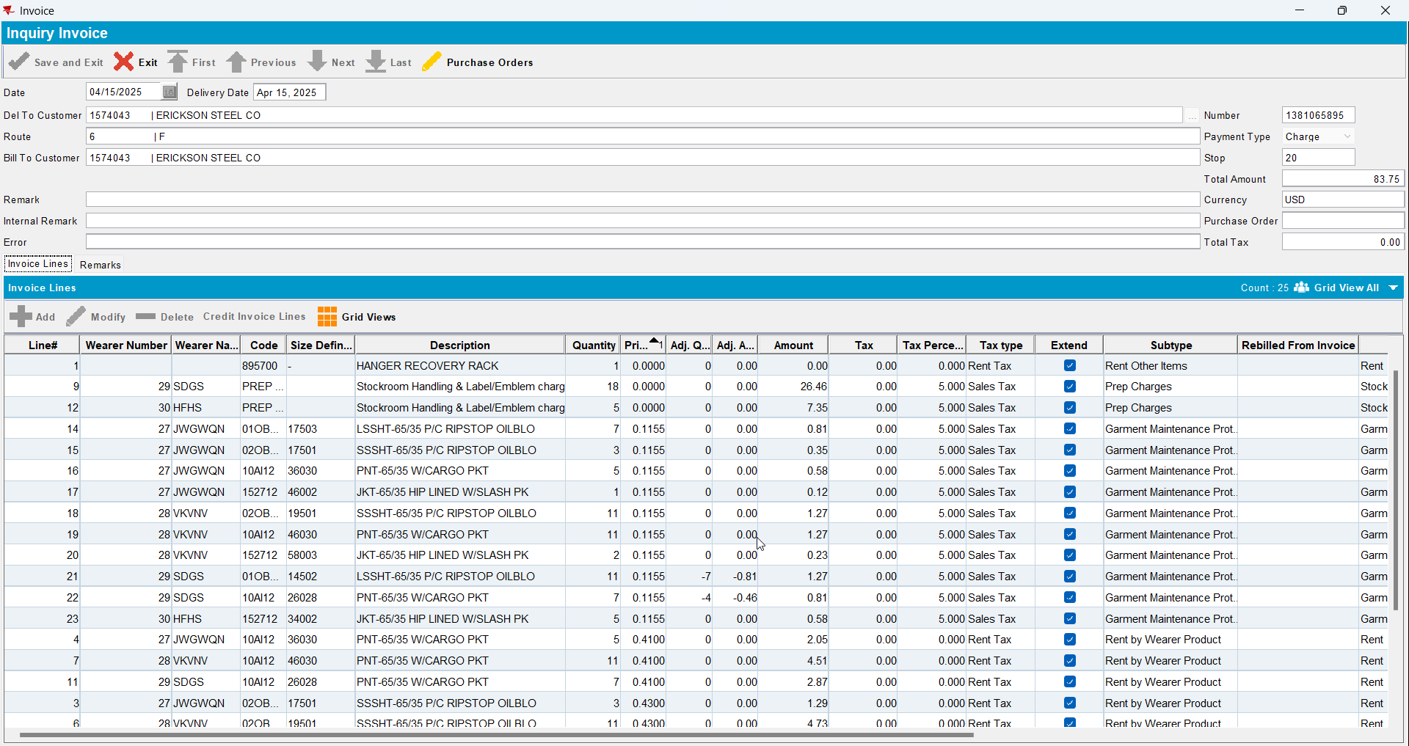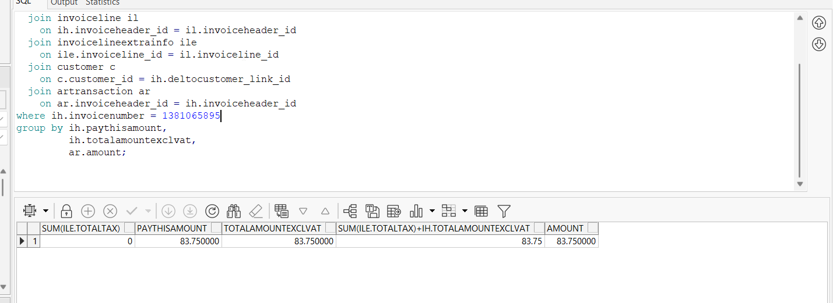
select sum(ile.totaltax),
ih.paythisamount,
ih.totalamountexclvat,
sum(ile.totaltax) + ih.totalamountexclvat,
ar.amount
from invoiceheader ih
join invoiceline il
on ih.invoiceheader_id = il.invoiceheader_id
join invoicelineextrainfo ile
on ile.invoiceline_id = il.invoiceline_id
join customer c
on c.customer_id = ih.deltocustomer_link_id
join artransaction ar
on ar.invoiceheader_id = ih.invoiceheader_id
where ih.invoicenumber =
group by ih.paythisamount,
ih.totalamountexclvat,
ar.amount;

