ABSN-4248 D_UBS_2655 The Home button and ABS logo can no longer be clicked to refresh the Daily Business Meeting application
Environment | Prerequisites
Version: 9.09.01  DBServerName=abs-SRV20.internal.abslbs.com  DBSID=CUST24  DBUser=UNFA  DBPassword=UNFA  Environment=Test | - Module:  - System setting

Contents
Retest after fix 1
Test Case 1 – WebClientX 1
Test Case 2 – Route Returns 3
Test Case 3 – Replace Smart Barcode With Unique Item 4
Test Case 4 – Cleanroom Packing Instructions 5

Retest after fix
Hash: 09447926df9a

Test Case 1 – WebClientX

- Open WebClientX
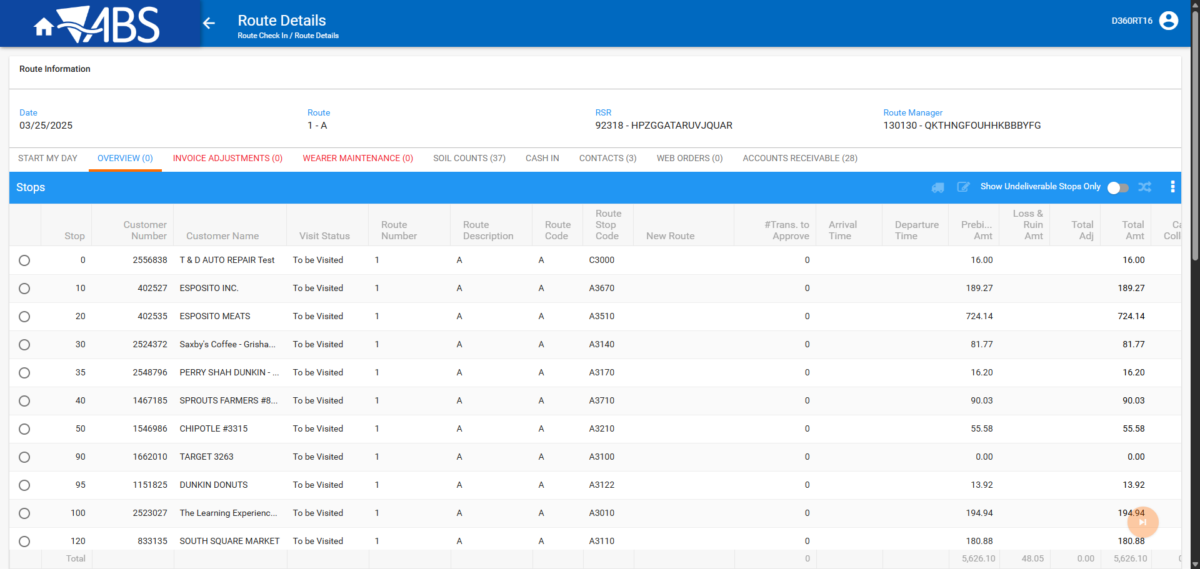
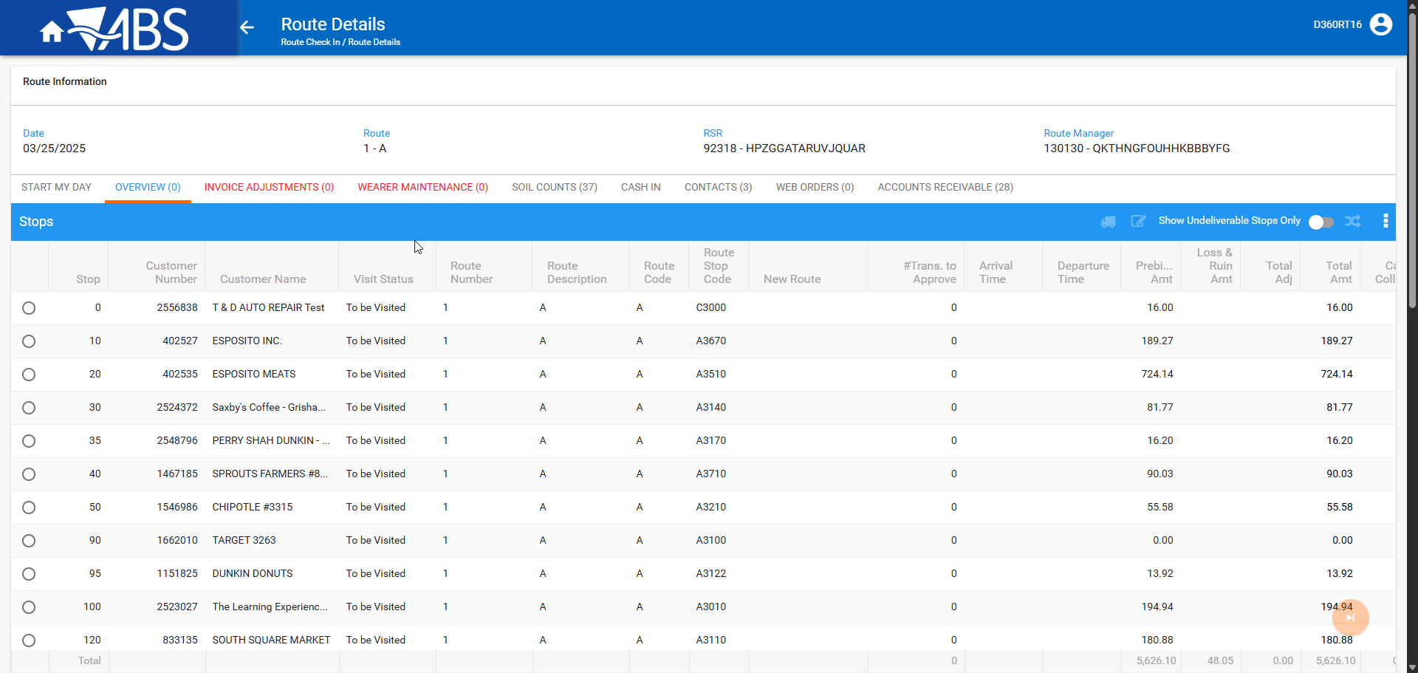

The logo is displayed and it’s clickable.

TESTED OK.

Test Case 2 – Route Returns

- Open Route Returns
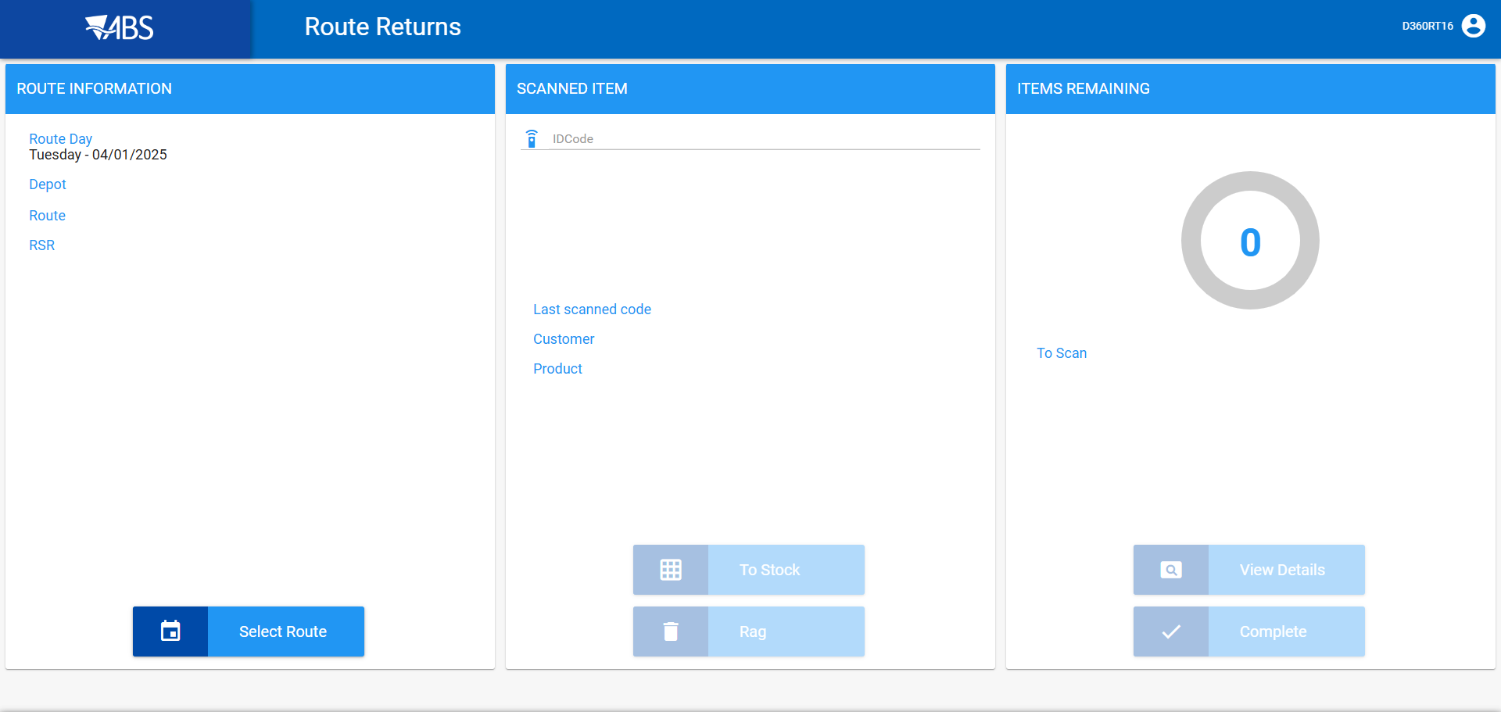
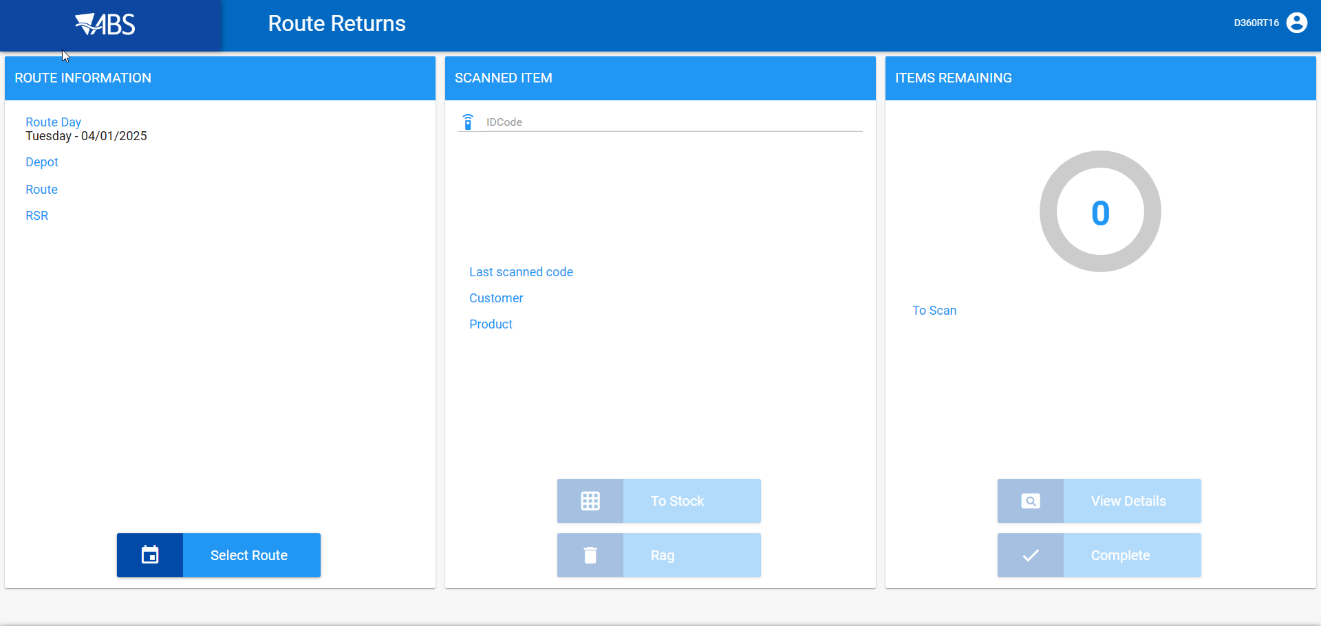

The logo is displayed and it’s clickable.

TESTED OK.

Test Case 3 – Replace Smart Barcode With Unique Item

- Open Replace Smart Barcode With Unique Item
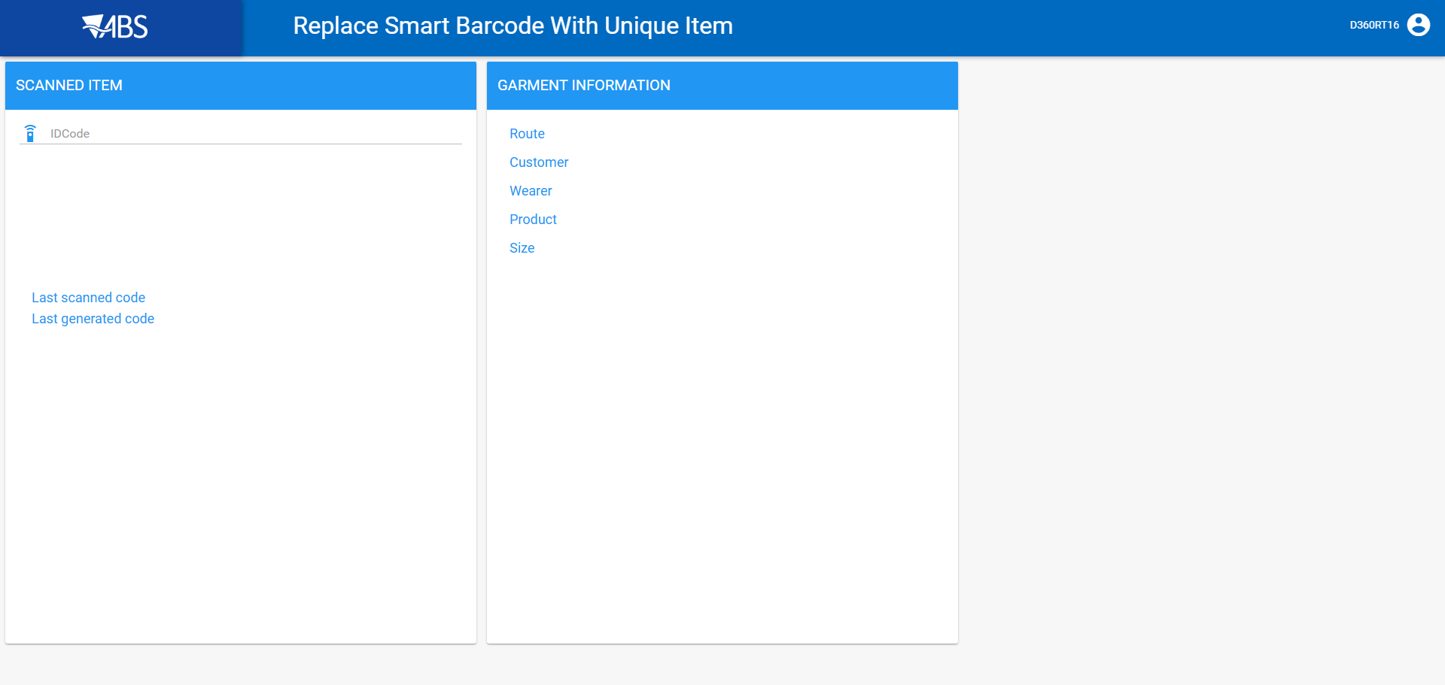
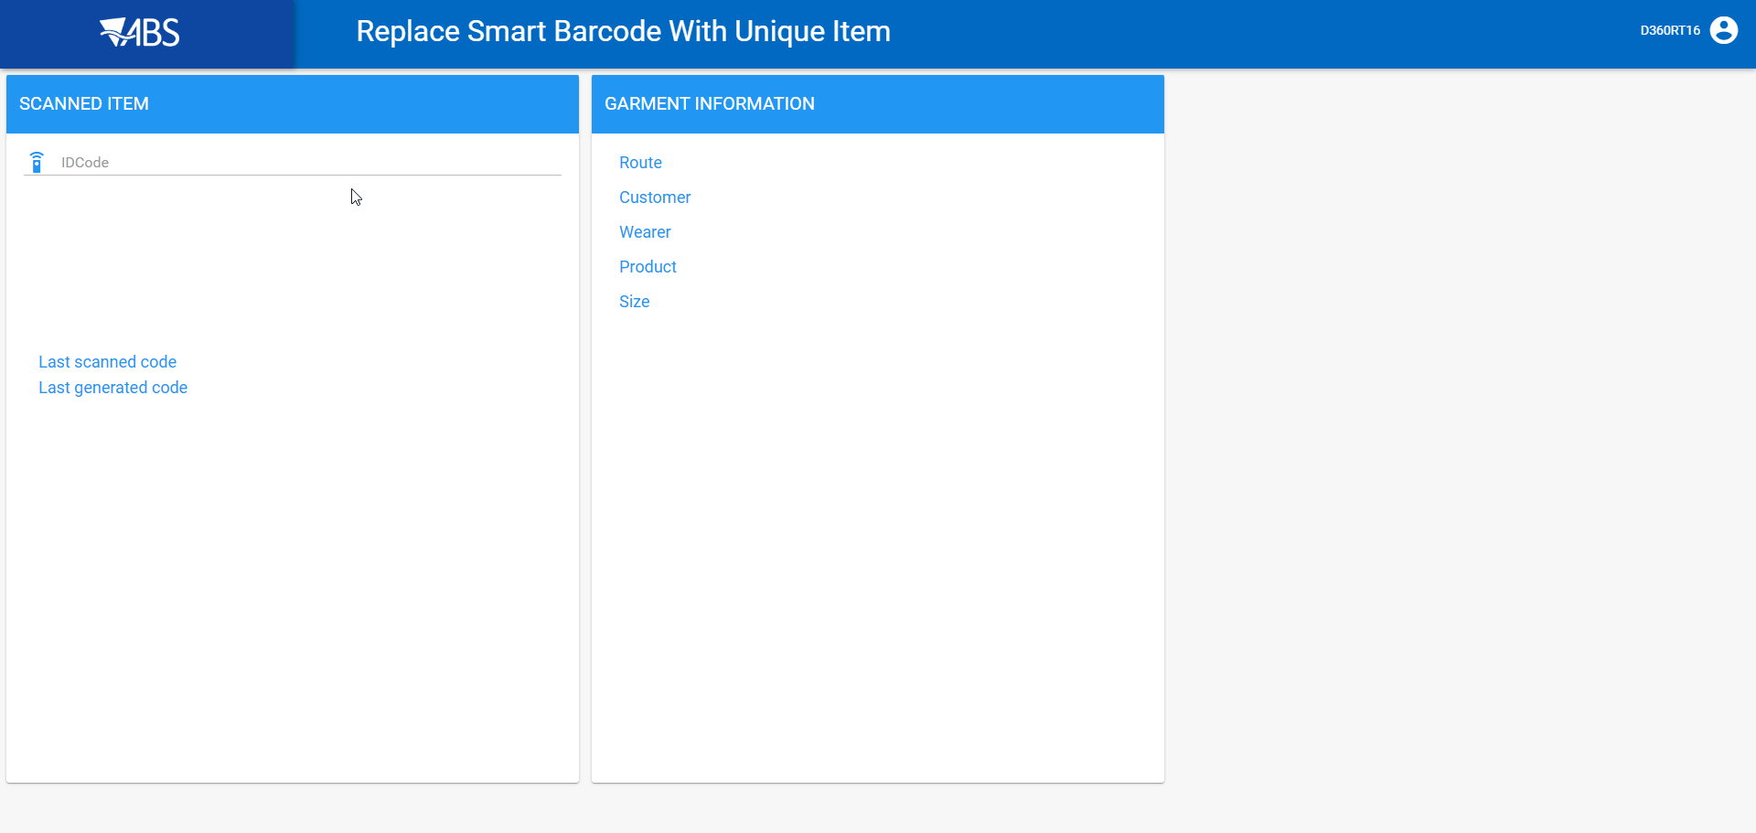

The logo is displayed and it’s clickable.

TESTED OK.

Test Case 4 – Cleanroom Packing Instructions

- Open Cleanroom Packing Instructions
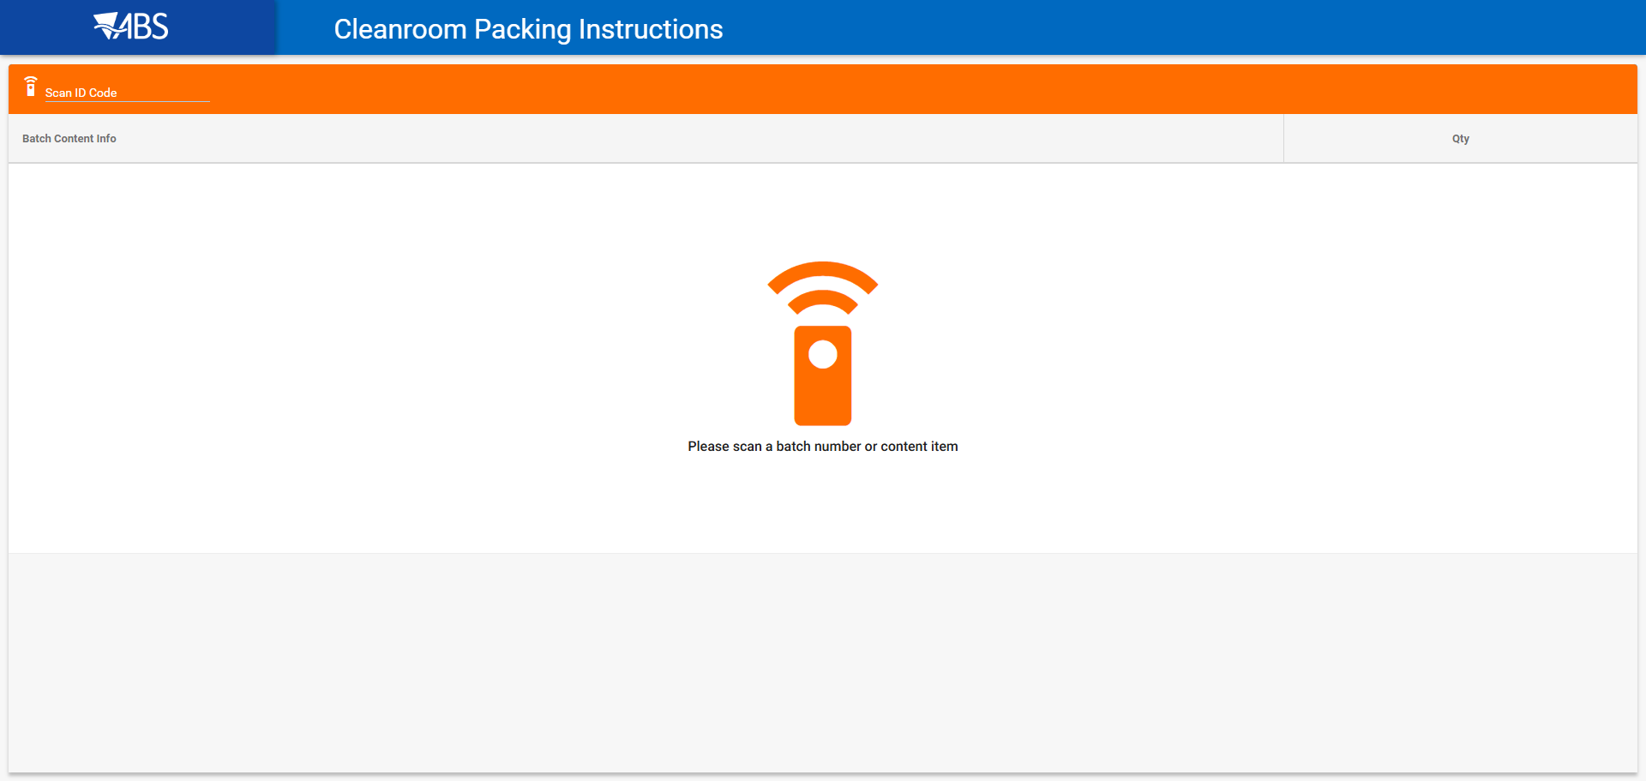
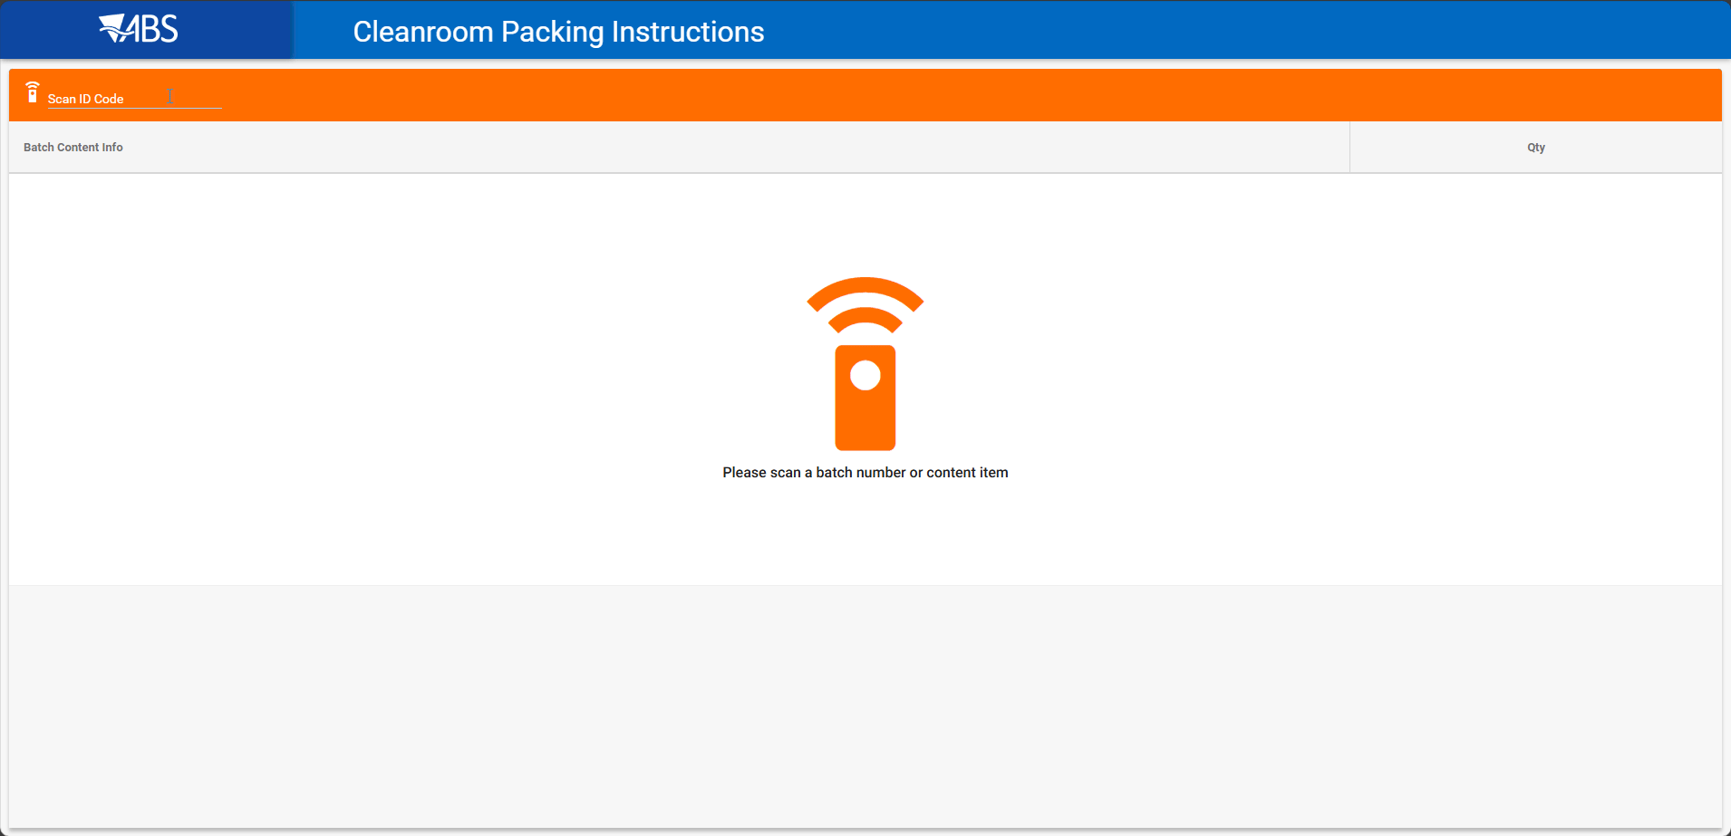

The logo is displayed and it’s clickable.

TESTED OK.

