ABSN-4144 WebX - ORA-01427: single-row subquery returns more than one row - Error on Soil Counts tab when loading the grid
Environment | Prerequisites
Version:9.07.00  DBServerName= abs-srv20.internal.abslbs.com  DBSID=CUST24  DBUser=UNFDEV  DBPassword=UNFDEV  Environment=Test | - Module:  - System setting

Contents
Retest after fix 1
Test Case 1 – Check soil ticket line averages for a Route that has SoilCount Status = In Progress on the same invoicing BU as the WebX BU 1
Test Case 2 – Check soil ticket line averages for a Route that has SoilCount Status = In Progress on the same invoicing BU as the WebX BU 6
Test Case 3 – Duplicate an entry in the SOILREASONABILITY table changing just BU and pickupdate 10
Test Case 4 - Duplicate an entry in the SOILREASONABILITY table changing just day number and pickupdate 14

Retest after fix

Test Case 1 – Check soil ticket line averages for a Route that has SoilCount Status = In Progress on the same invoicing BU as the WebX BU
Expected behavior: The Soil Count average is taken from the SOILREASONABILITY for that product divided by the number of soiltickets for that week day from the past 13 weeks (starting from the day before the current route’s driving day – 1)
Hash: e4ea4aa
- Login on BU 025
- Route Status Control DLG: Generate PN and invoice for your route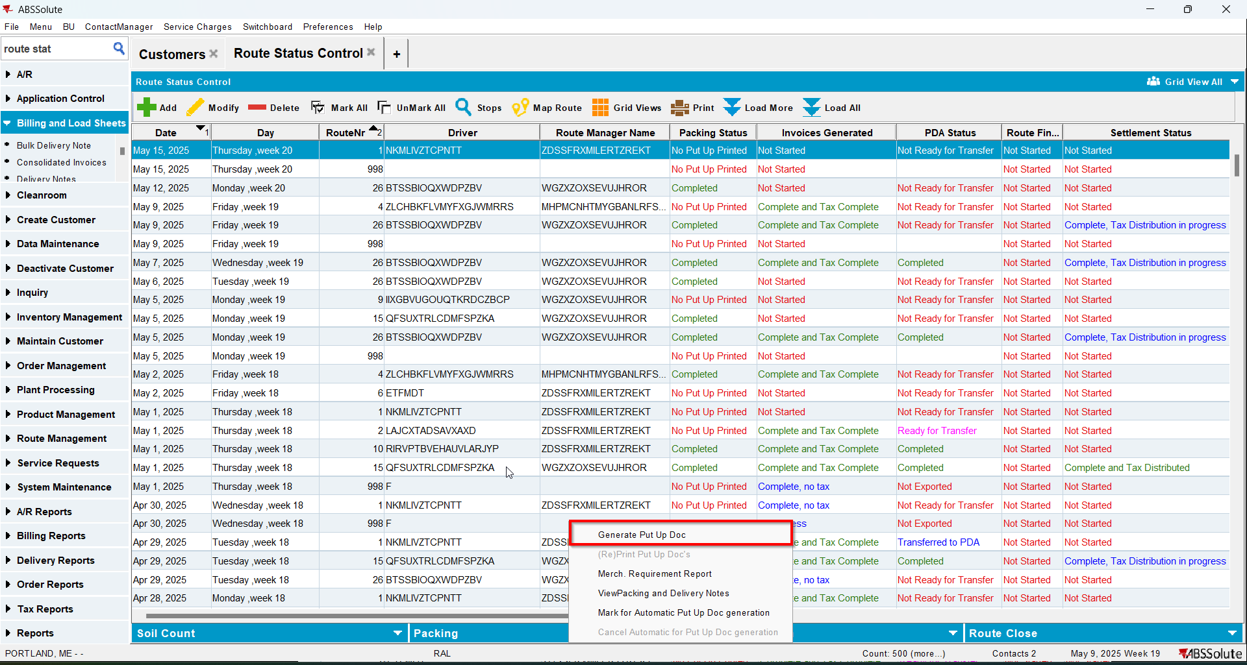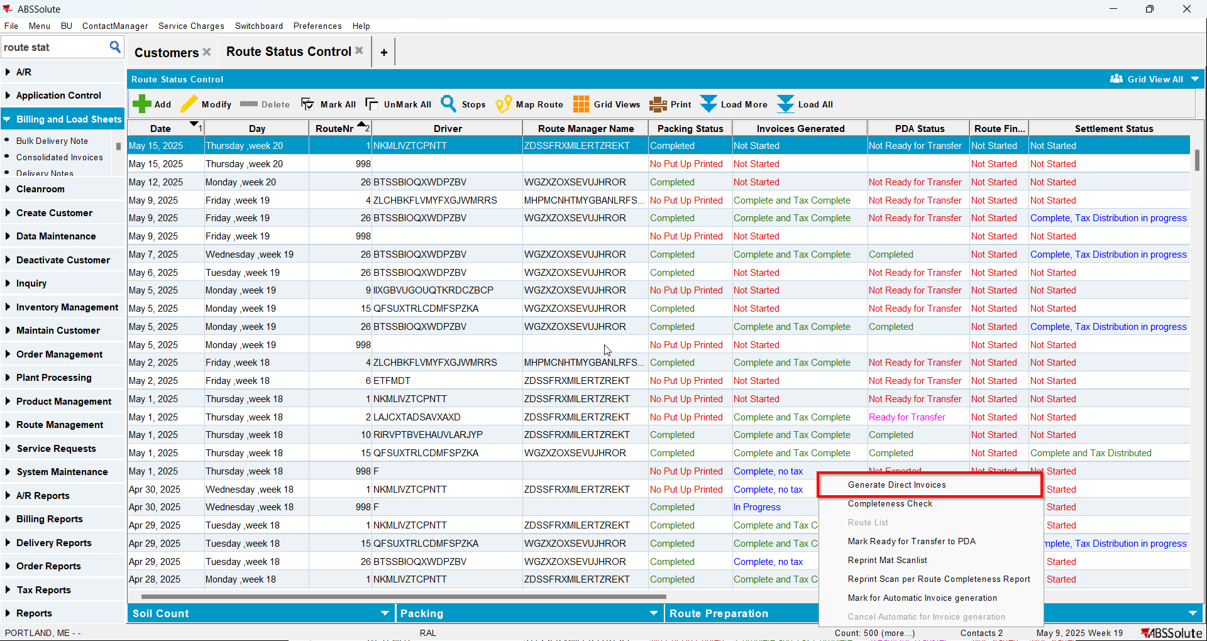
- Send route to RA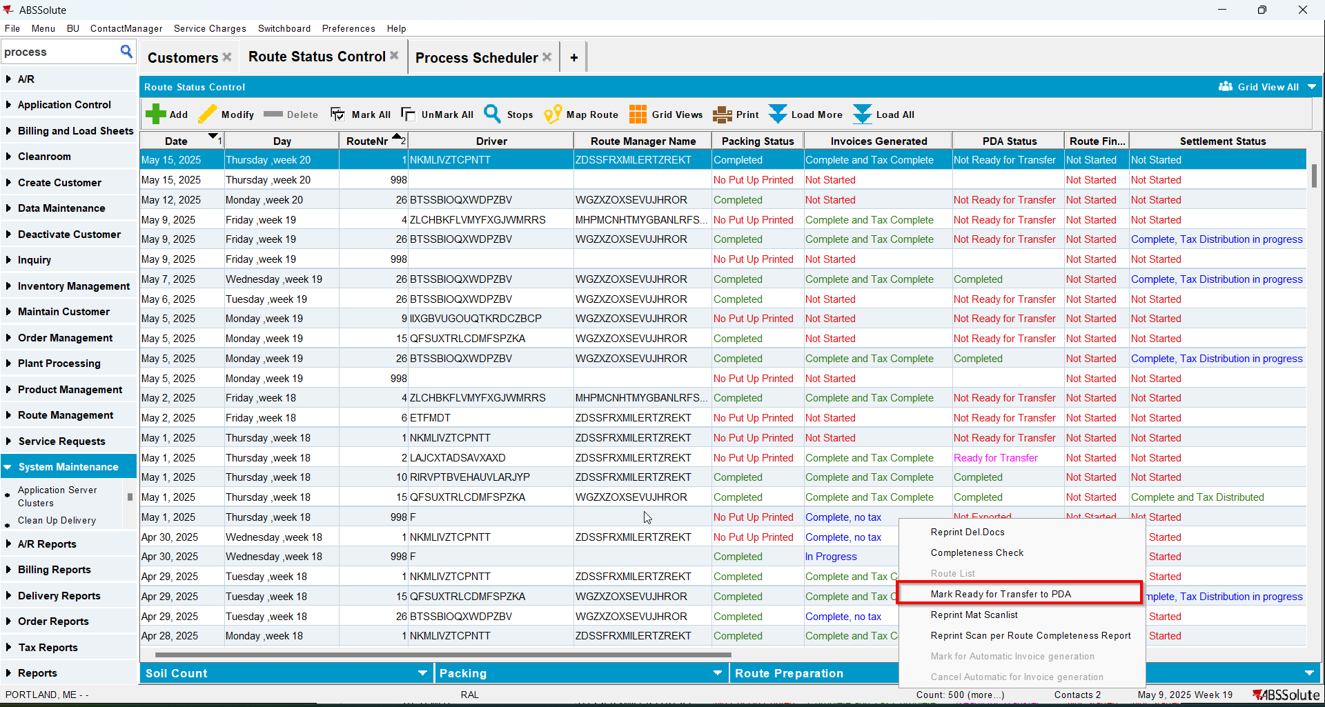
- On RA finish and upload the route
- Check that in SOILREASONABILITY table for your customer you have values in some of the PICKUPQTY columns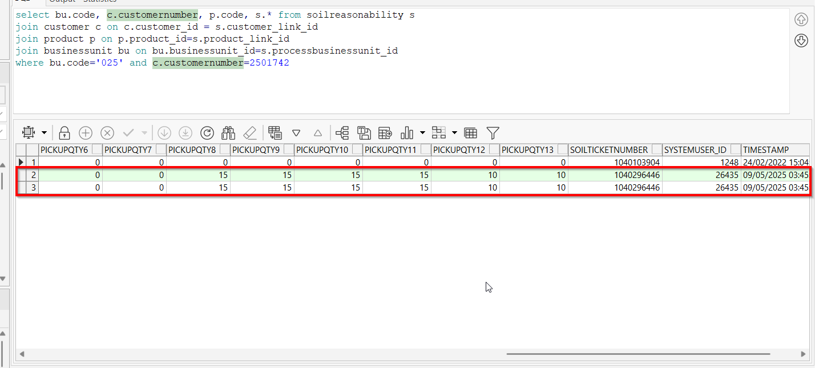
- WebX: login on BU 025
- WebX: Load that route from the same BU as the invoicing BU of the customers on the route
- Go to Soil Counts tab and check the Weekly Ave column value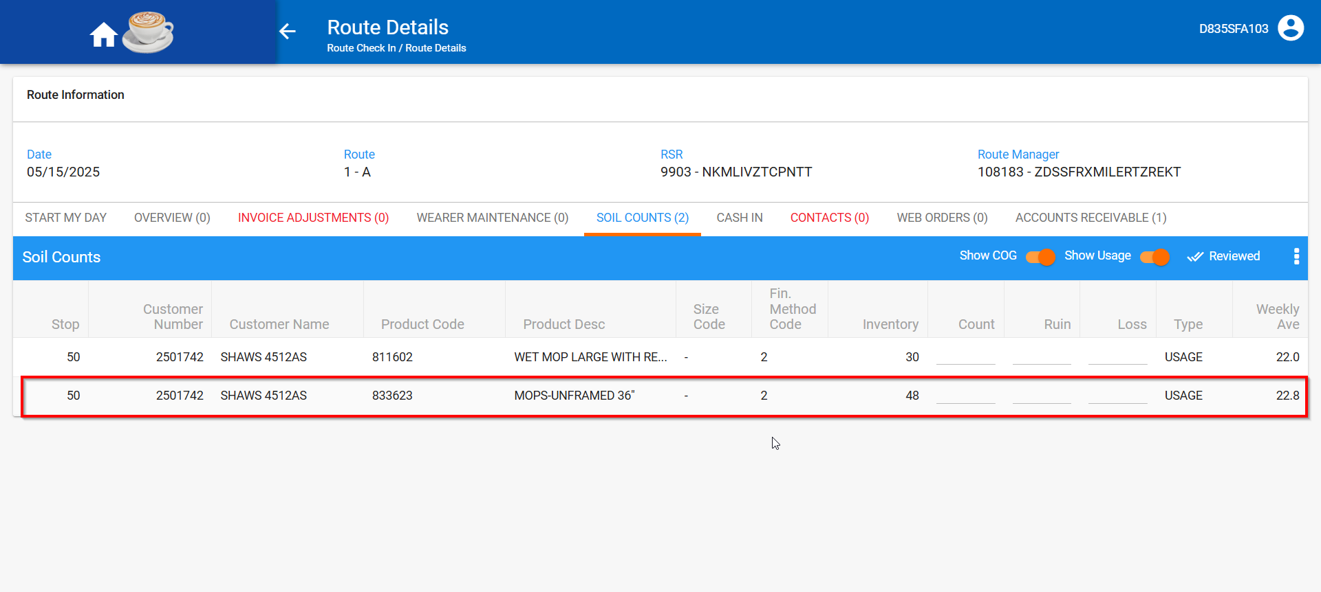
- For each Soil Ticket Line you can check the average by doing the following two selects for X and Y and the calculating ROUND(X/Y).
X is determined by the following select:
SELECT PICKUPQTY1 + PICKUPQTY2 + PICKUPQTY3 + PICKUPQTY4 + PICKUPQTY5 +
PICKUPQTY6 + PICKUPQTY7 + PICKUPQTY8 + PICKUPQTY9 + PICKUPQTY10 +
PICKUPQTY11 + PICKUPQTY12 + PICKUPQTY13
FROM SOILREASONABILITY SR
WHERE SR.CUSTOMER_LINK_ID =
(SELECT C.CUSTOMER_ID FROM CUSTOMER C WHERE C.CUSTOMERNUMBER = 2501742)
AND SR.PRODUCT_LINK_ID =
(SELECT P.PRODUCT_ID FROM PRODUCT P WHERE P.CODE = '833623')
AND SR.SIZEDEFINITION_LINK_ID =
(SELECT SD.SIZEDEFINITION_ID
FROM SIZEDEFINITION SD
WHERE SD.CODE = '-')
AND SR.FINISHINGMETHOD_ID =
(SELECT FM.FINISHINGMETHOD_ID
FROM FINISHINGMETHOD FM
WHERE FM.CODE = '2')
AND SR.PICKUPDATE =
TO_DATE('2025-05-15 00:00:00', 'YYYY-MM-DD HH24:MI:SS')
AND SR.ROUTE_ID =
(SELECT R.ROUTE_ID
FROM ROUTECONTROL RC
JOIN ROUTE R
ON R.ROUTE_ID = RC.ROUTE_ID
JOIN PLANT P
ON P.PLANT_ID = R.PLANT_ID
WHERE RC.DRIVINGDATE = TO_DATE('15/05/2025', 'dd/mm/yyyy')
AND R.ROUTENUMBER = 1
AND P.CODE = '025');
Y is determined by the following select:
SELECT COUNT(SL.SOILTICKETLINE_ID)
FROM SOILTICKET S
JOIN SOILTICKETLINE SL
ON SL.SOILTICKET_ID = S.SOILTICKET_ID
JOIN STOP ST
ON S.STOP_ID = ST.STOP_ID
JOIN ROUTECONTROL RC
ON RC.ROUTECONTROL_ID = S.ROUTECONTROL_ID
JOIN ROUTE R
ON R.ROUTE_ID = RC.ROUTE_ID
JOIN DAY D
ON D.DAY_ID = R.DRIVINGDAY_ID
WHERE S.CUSTOMER_ID =
(SELECT C.CUSTOMER_ID FROM CUSTOMER C WHERE C.CUSTOMERNUMBER = 2501742)
AND SL.PRODUCT_ID =
(SELECT P.PRODUCT_ID FROM PRODUCT P WHERE P.CODE = '833623')
AND SL.SIZEDEFINITION_ID = (SELECT SD.SIZEDEFINITION_ID
FROM SIZEDEFINITION SD
WHERE SD.CODE = '-')
AND SL.FINISHINGMETHOD_ID =
(SELECT FM.FINISHINGMETHOD_ID
FROM FINISHINGMETHOD FM
WHERE FM.CODE = '2')
AND S.COUNTDATE BETWEEN
TO_DATE('2025-02-13 00:00:00', 'YYYY-MM-DD HH24:MI:SS') AND
TO_DATE('2025-05-15 00:00:00', 'YYYY-MM-DD HH24:MI:SS')
AND ST.STATUS = 0
AND D.DAYNUMBER =
(SELECT SR.DAYNUMBER
FROM SOILREASONABILITY SR
WHERE SR.CUSTOMER_LINK_ID =
(SELECT C.CUSTOMER_ID
FROM CUSTOMER C
WHERE C.CUSTOMERNUMBER = 2501742)
AND SR.PRODUCT_LINK_ID =
(SELECT P.PRODUCT_ID FROM PRODUCT P WHERE P.CODE = '833623')
AND SR.SIZEDEFINITION_LINK_ID =
(SELECT SD.SIZEDEFINITION_ID
FROM SIZEDEFINITION SD
WHERE SD.CODE = '-')
AND SR.FINISHINGMETHOD_ID =
(SELECT FM.FINISHINGMETHOD_ID
FROM FINISHINGMETHOD FM
WHERE FM.CODE = '2')
AND SR.ROUTE_ID =
(SELECT R.ROUTE_ID
FROM ROUTECONTROL RC
JOIN ROUTE R
ON R.ROUTE_ID = RC.ROUTE_ID
JOIN PLANT P
ON P.PLANT_ID = R.PLANT_ID
WHERE RC.DRIVINGDATE = TO_DATE('15/05/2025', 'dd/mm/yyyy')
AND R.ROUTENUMBER = 1
AND P.CODE = '025'));
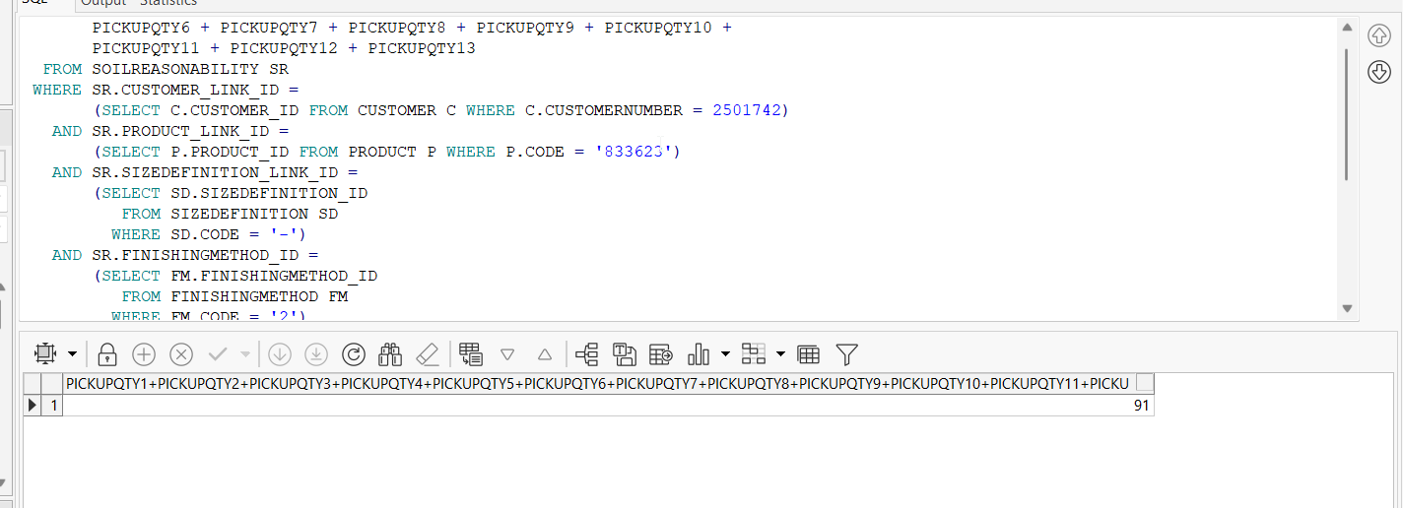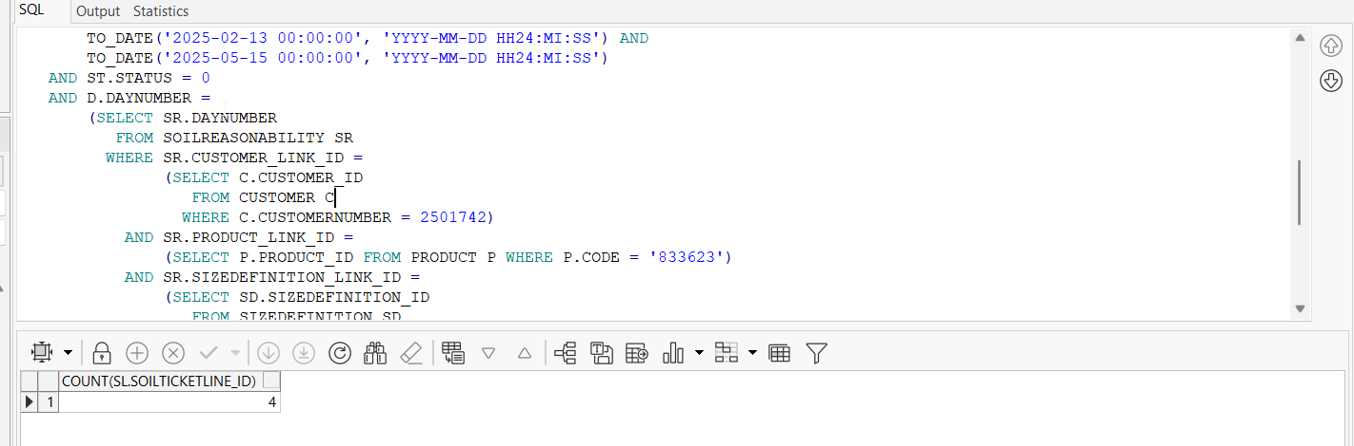

Test Case 2 – Check soil ticket line averages for a Route that has SoilCount Status = In Progress on the same invoicing BU as the WebX BU
Expected behavior: When opening the same route from a different BU belonging to the same plant you get the same results in the Weekly Ave column in the Soil Counts tab
Hash: e4ea4aa
- Go to BU 044

- Generate PN and invoices for a route
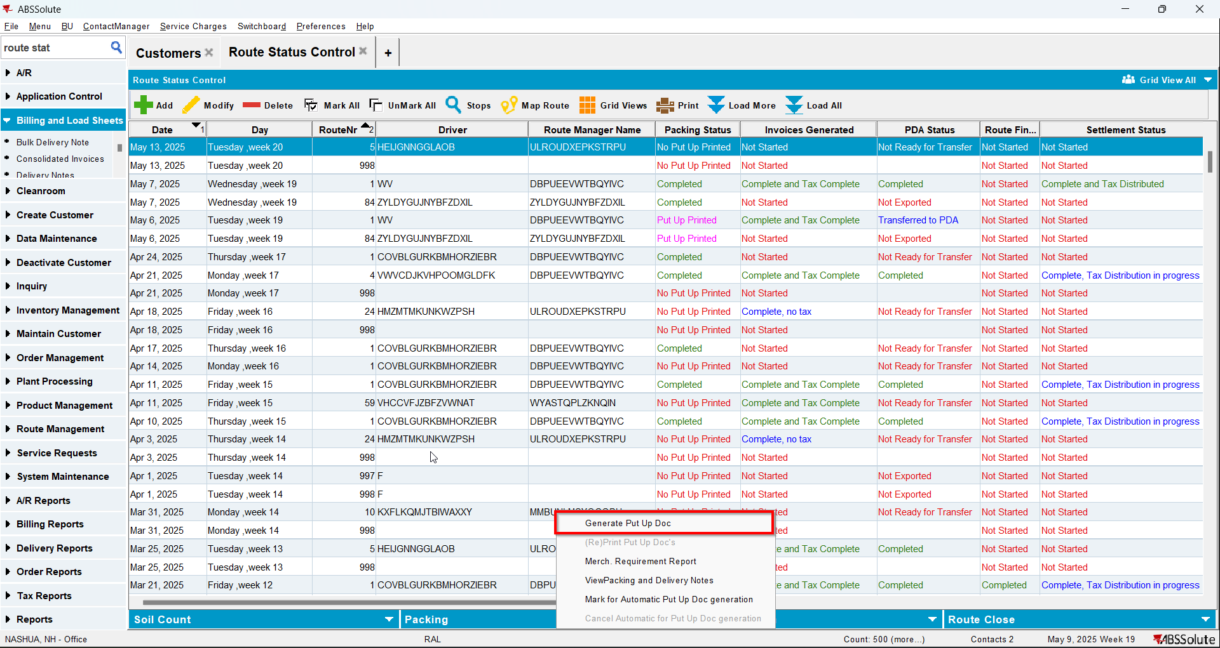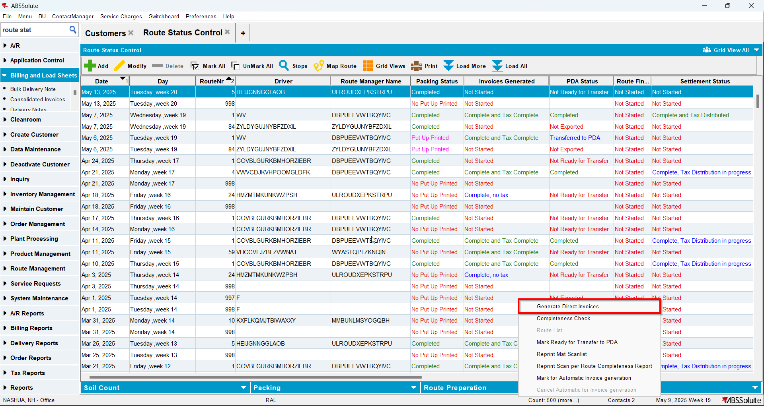
- Send the route to RA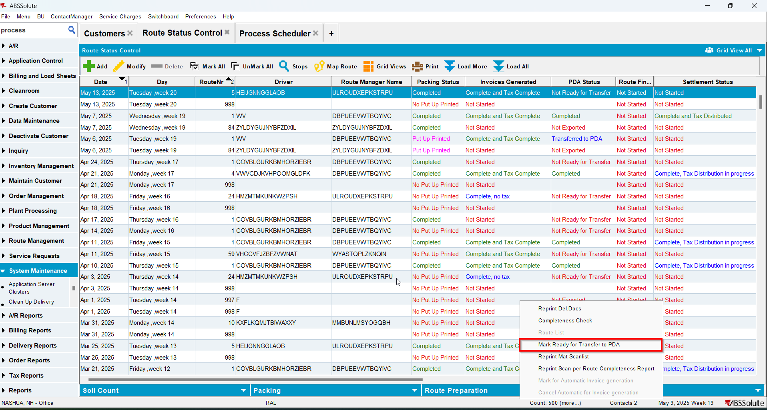
- On RA finish the route and upload it
- Check that in SOILREASONABILITY table for your customer you have values in some of the PICKUPQTY columns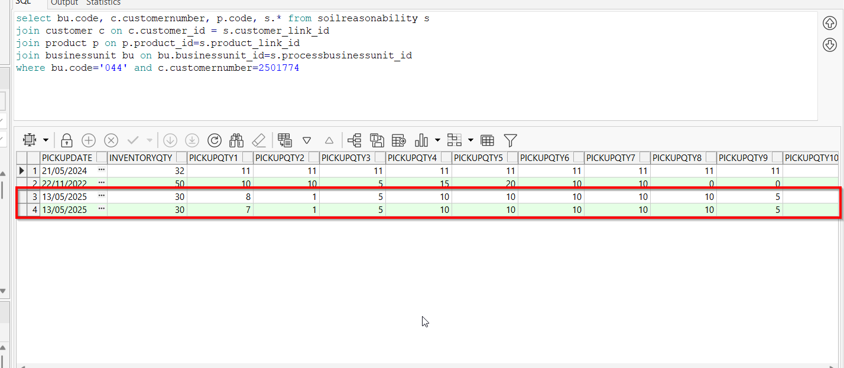
- On WebX log in to BU 044 and check the value of Weekly Ave column from Soil Counts tab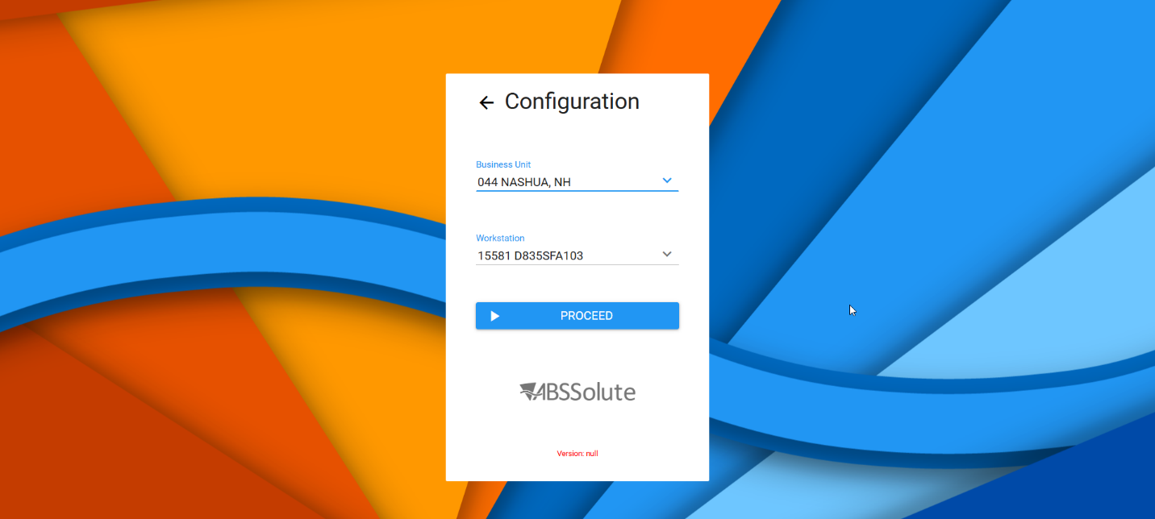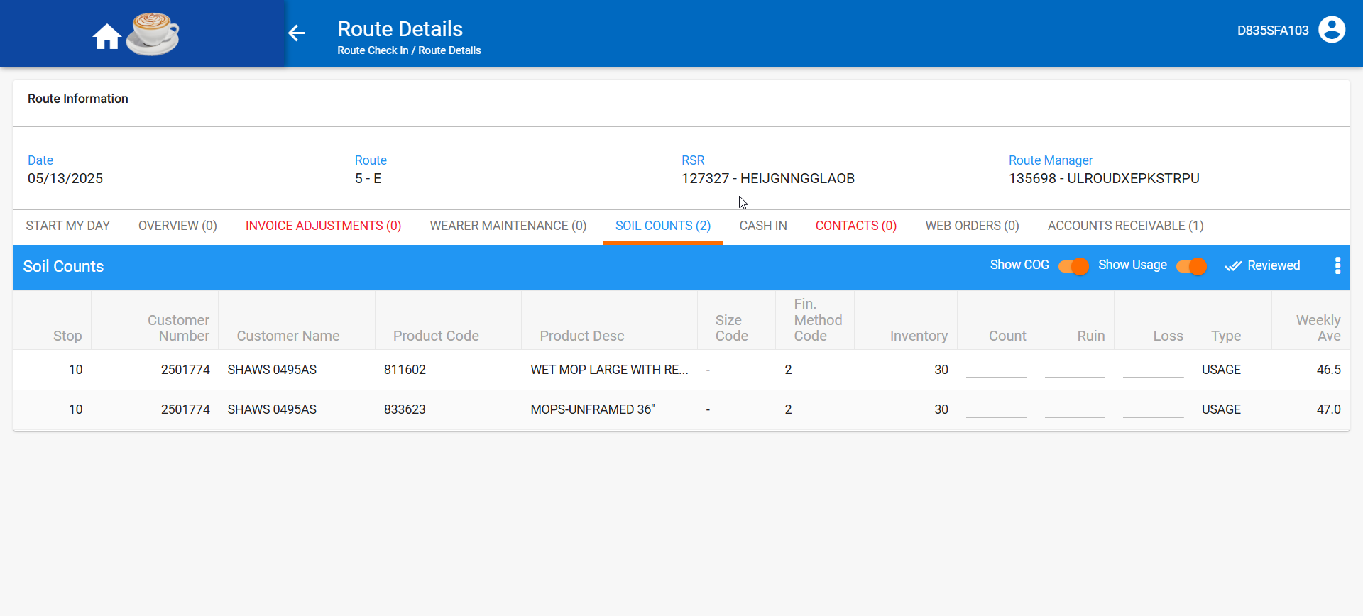
- Log out and login on BU 013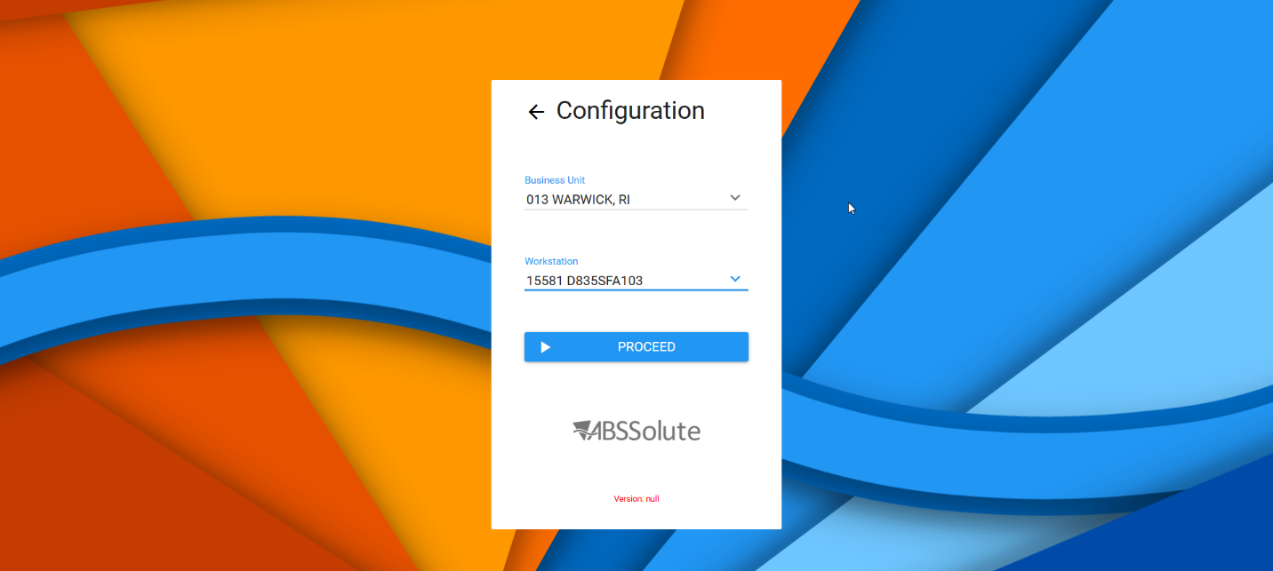
- Find the same route and verify that the averages are the same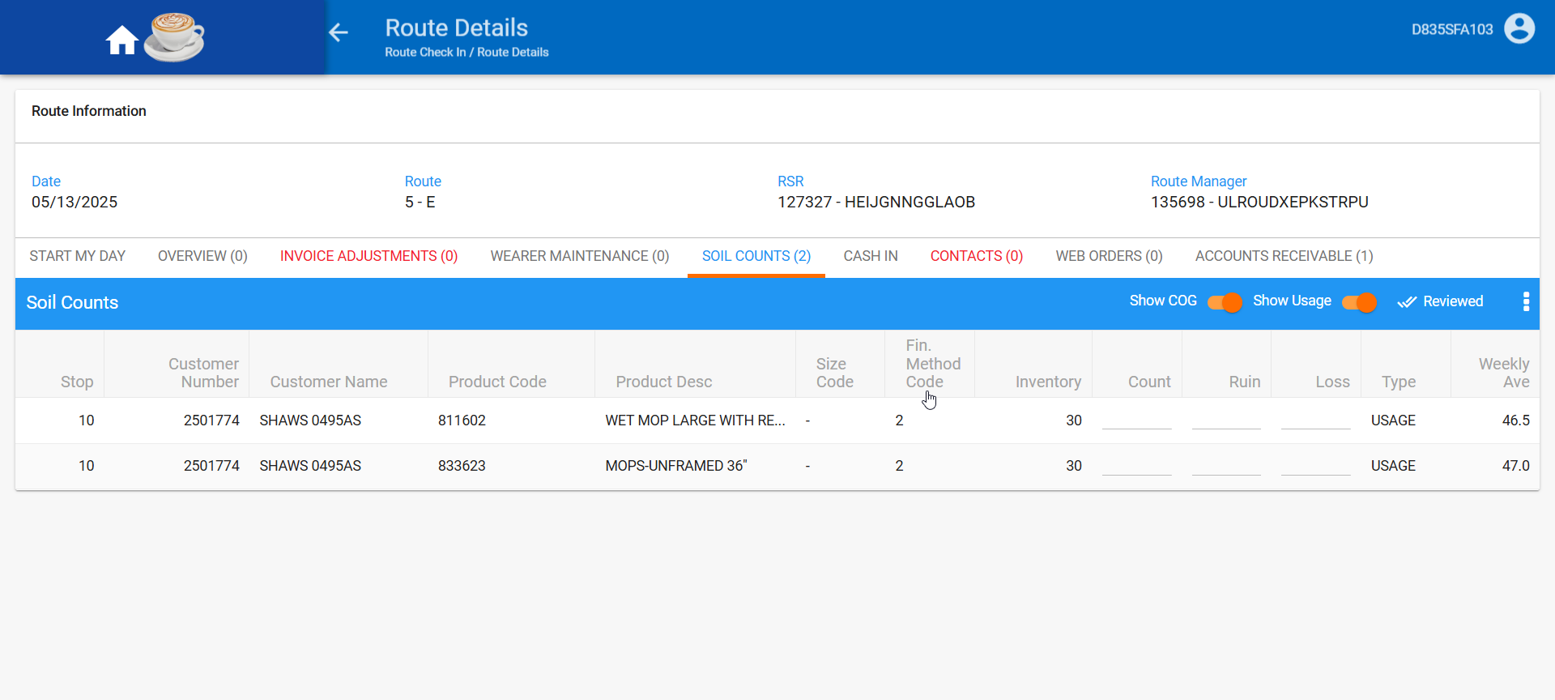

Test Case 3 – Duplicate an entry in the SOILREASONABILITY table changing just BU and pickupdate
Expected behavior: No error should appear when refreshing the page on WebX
Hash: e4ea4aa
- Go to BU 025
- Generate PN and invoices for a route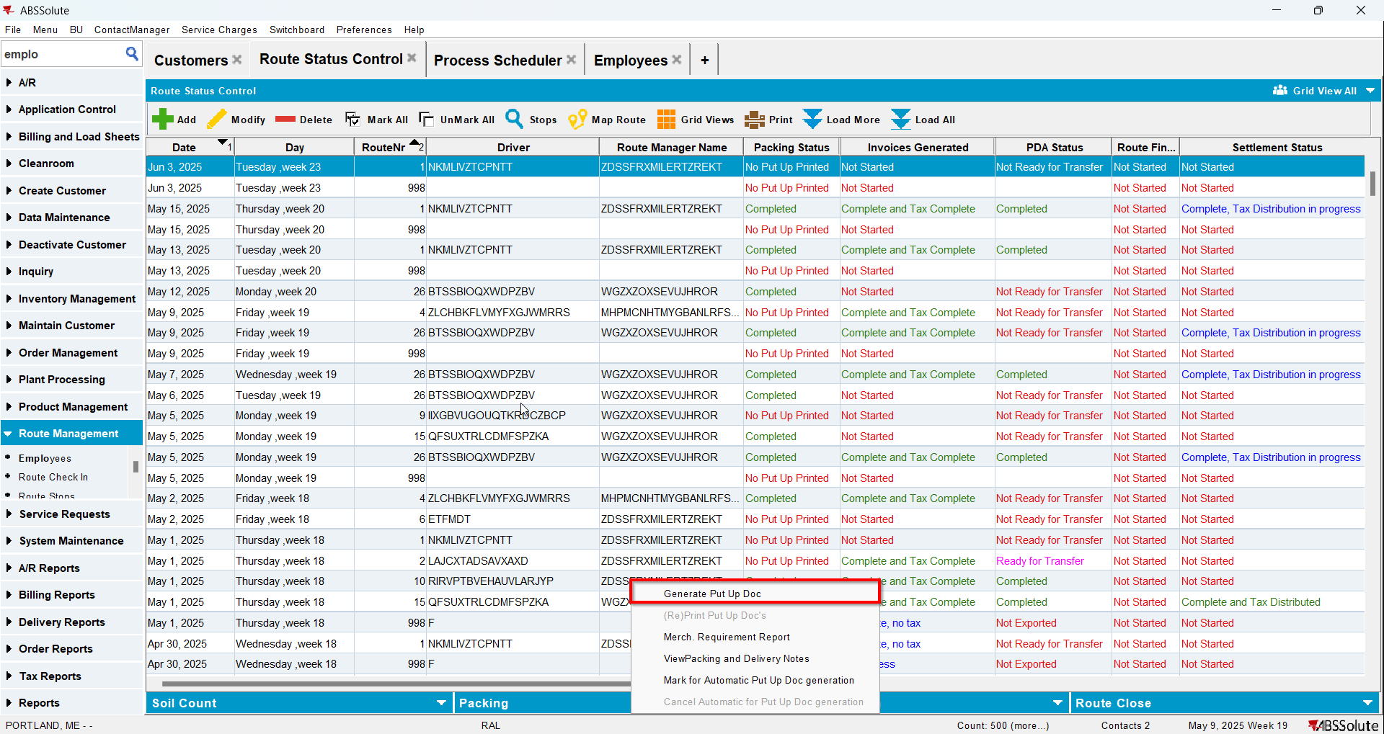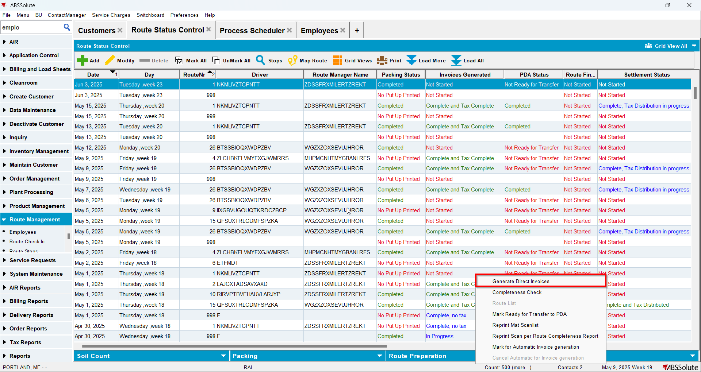
- Send the route to RA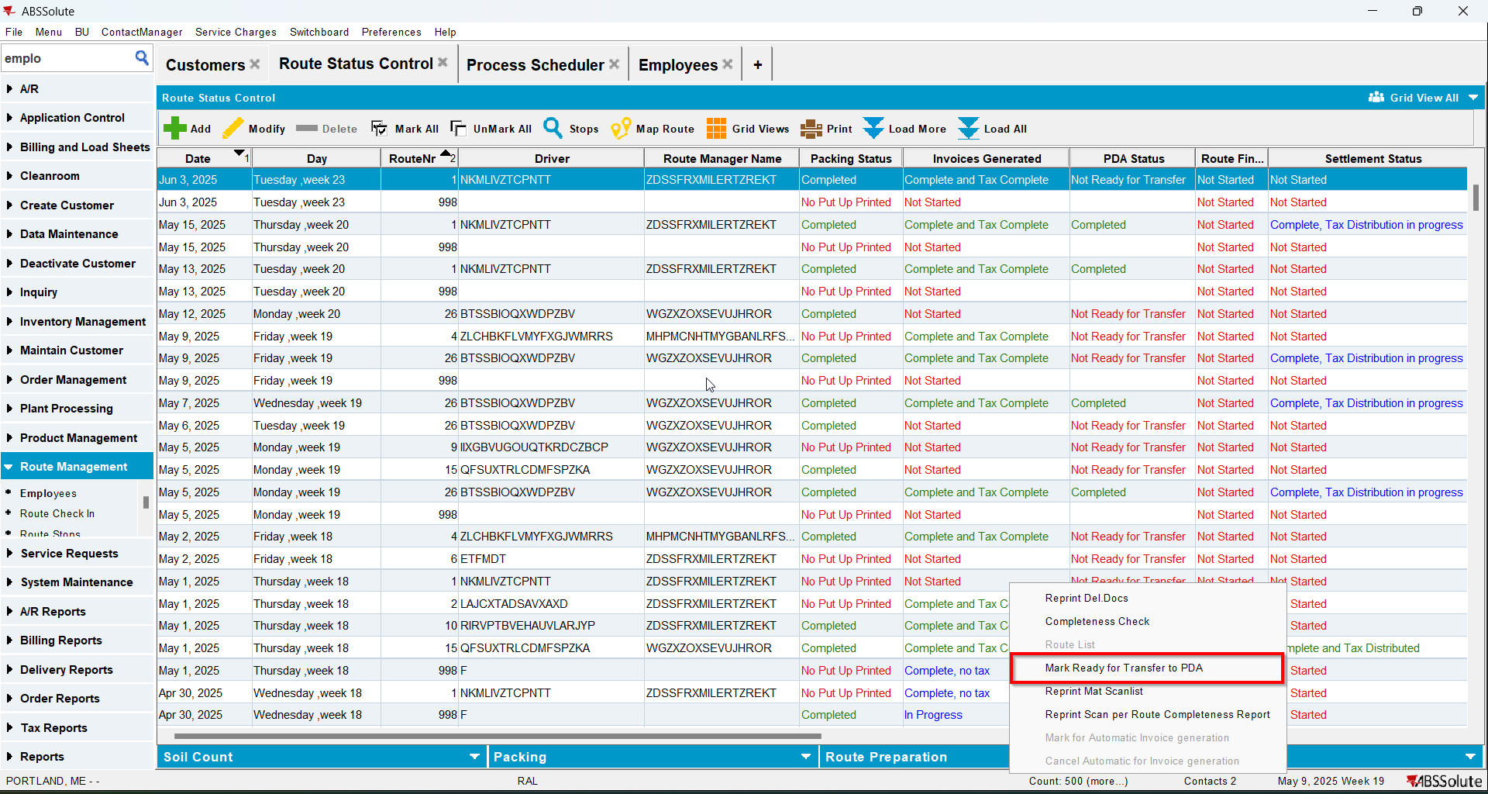
- On RA finish the route and upload it
- Check that in SOILREASONABILITY table for your customer you have values in some of the PICKUPQTY columns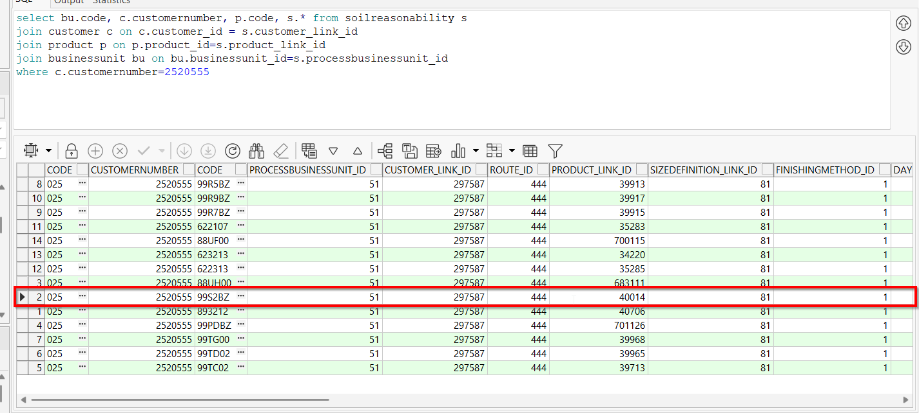
- On WebX go to your route to Soil Counts tab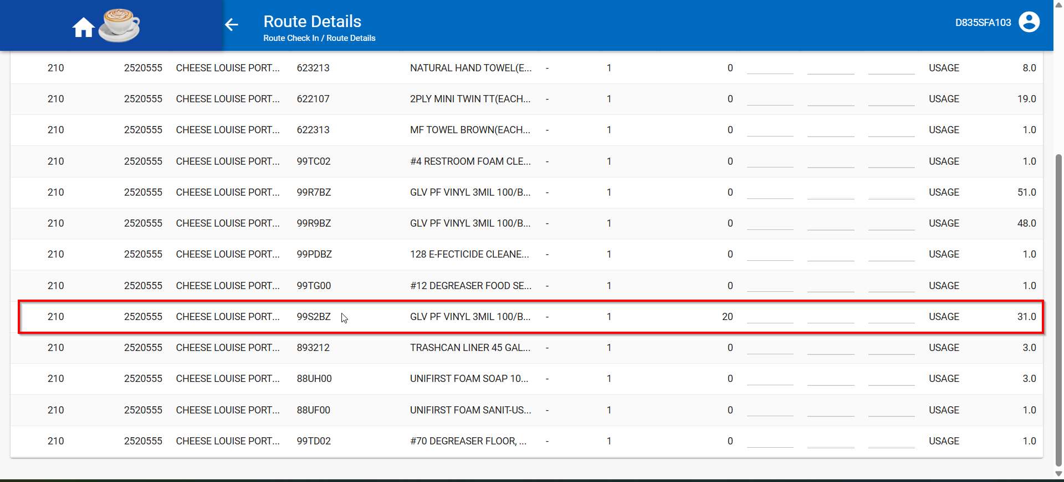
- Duplicate your entry in the SOILREASONABILITY table changing just the BU and PICKUPDATE= original PICKUPDATE-7 days(make sure trigger trg_soilreasonability_duplicatedate is disabled)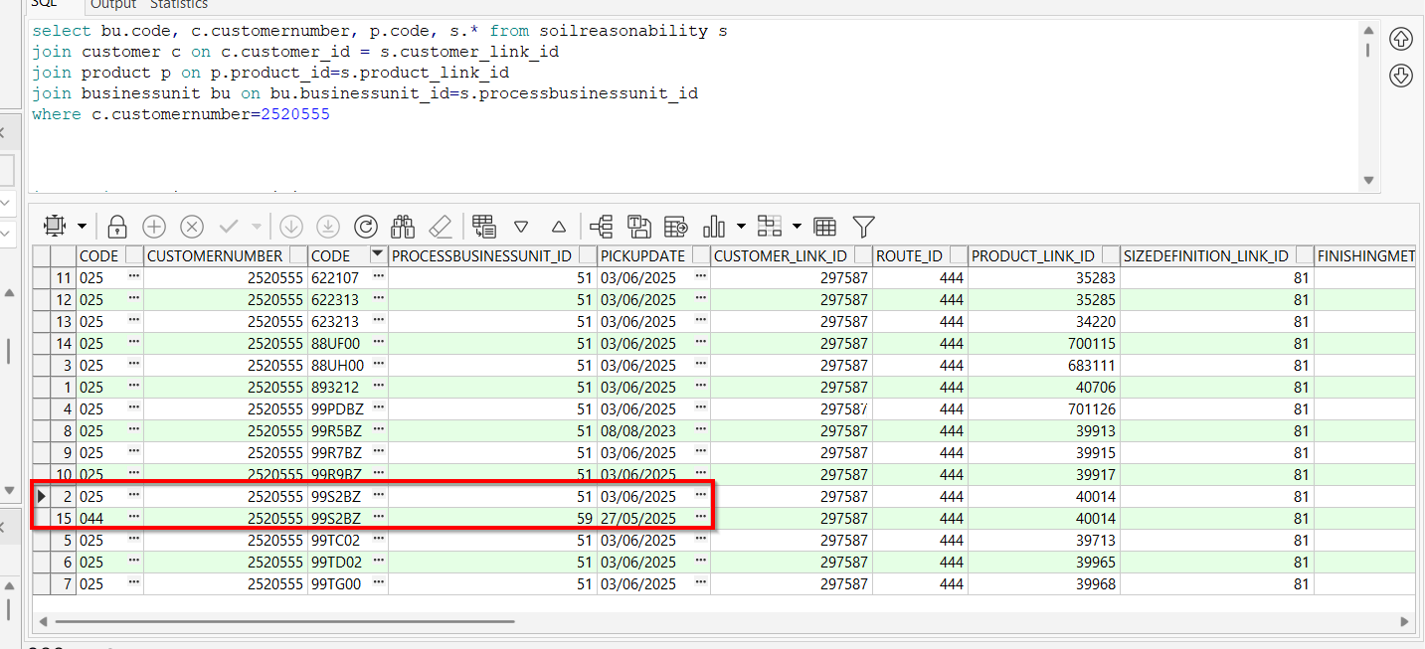
- Go to WebX and refresh the page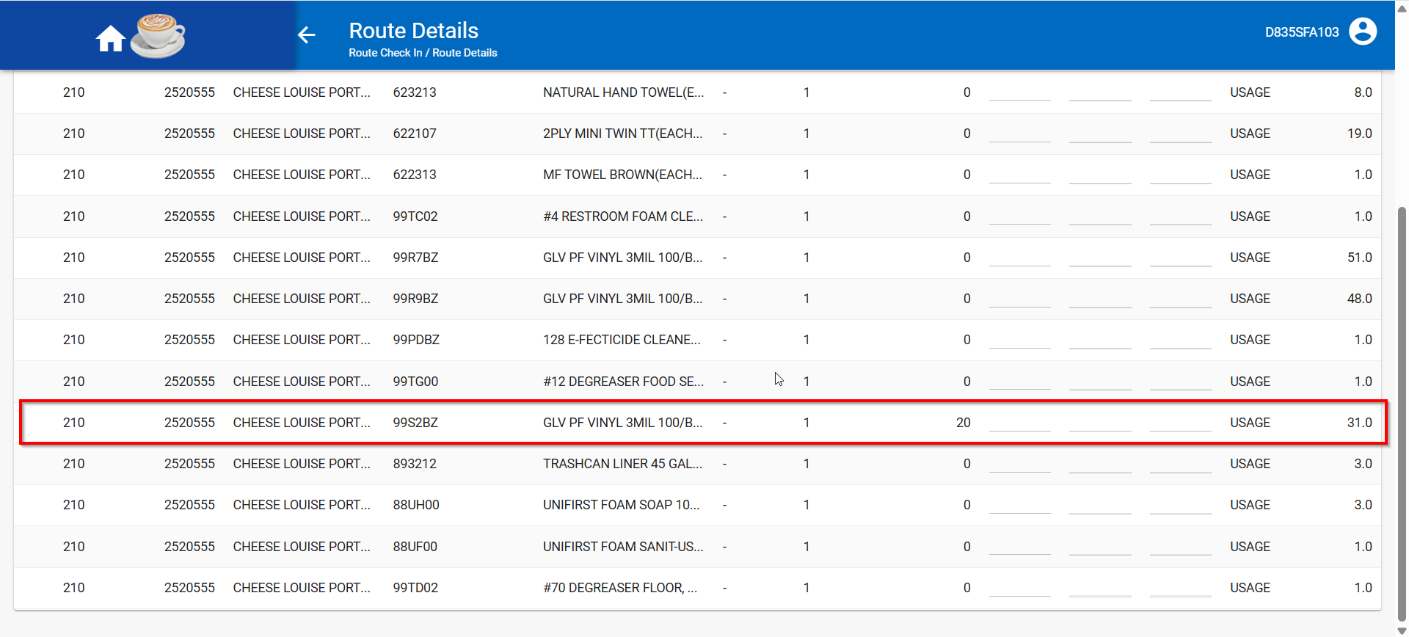

Test Case 4 - Duplicate an entry in the SOILREASONABILITY table changing just day number and pickupdate
Expected behavior: No error should appear when refreshing the page on WebX
Hash: e4ea4aa
- Generate PN and invoices for a route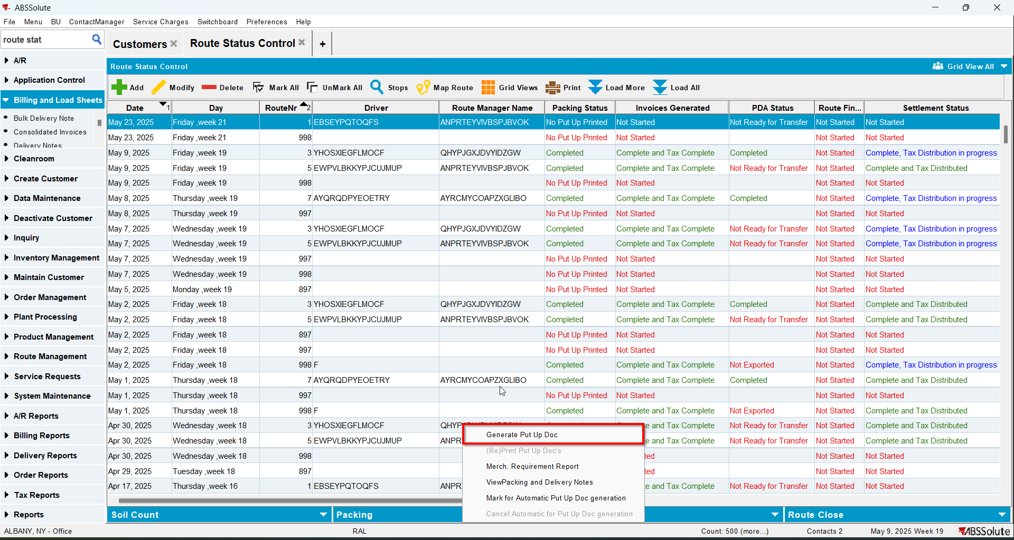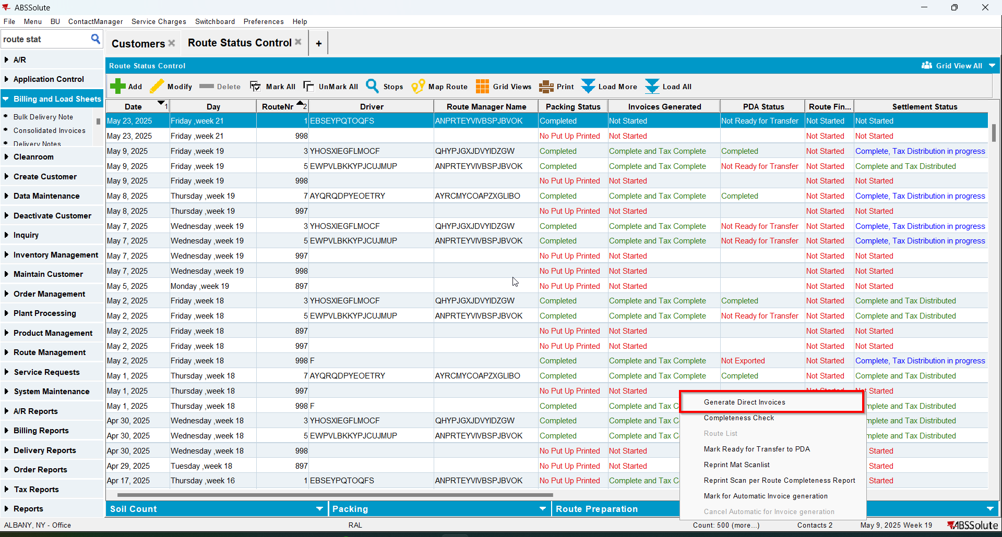
- Send the route to RA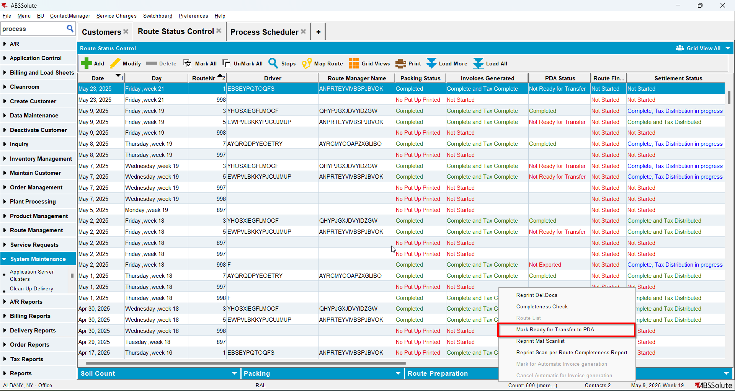
- On RA finish the route and upload it
- Check that in SOILREASONABILITY table for your customer you have values in some of the PICKUPQTY columns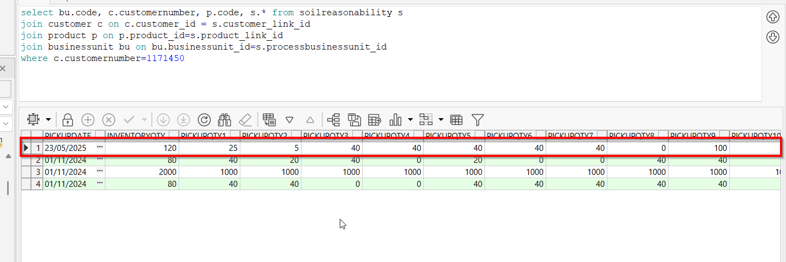
- On WebX go to your route to Soil Counts tab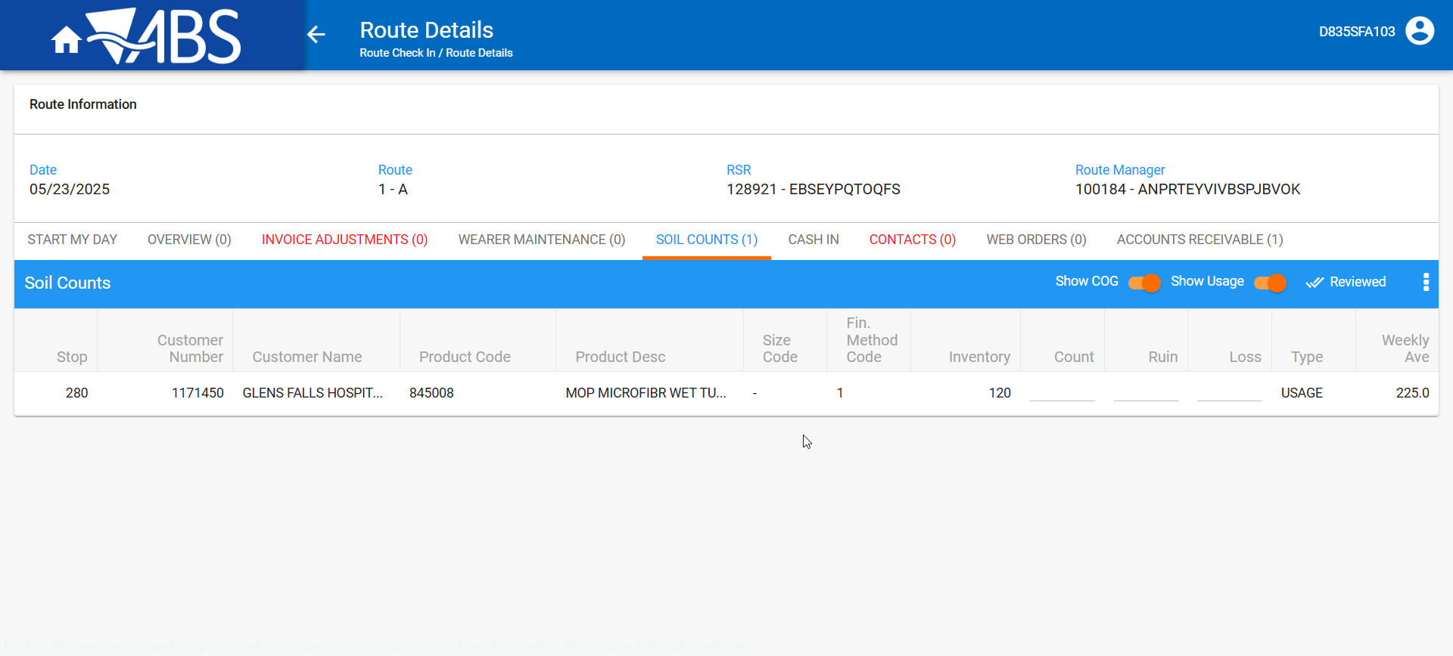
- Duplicate your entry in the SOILREASONABILITY table changing just the DAYNUMBER and PICKUPDATE= original PICKUPDATE-7 days (make sure trigger trg_soilreasonability_duplicatedate is disabled)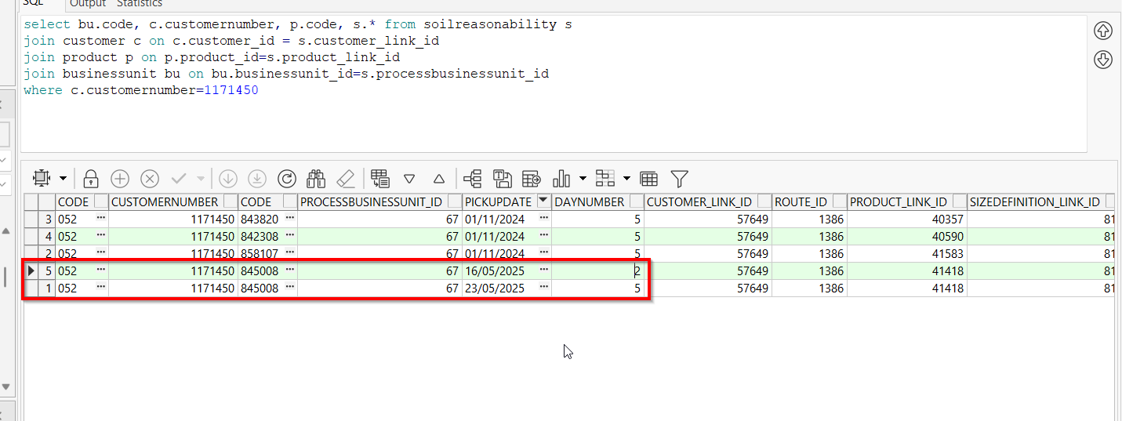
- Go to WebX and refresh the page