ABSN-4143 Settlement - ORA-01476: divisor is equal to zero - when trying to calculate NOTCHARGEDINVOICELINE value
Environment | Prerequisites
Version: 9.07.00.UNF19  DBServerName=abs-SRV20.internal.abslbs.com  DBSID=CUST24  DBUser=UNFDEV  DBPassword=UNFDEV  Environment=Test | - Module:  - System setting

Contents
Retest after fix 1
Test Case 1 – Transaction type 703 loss charge line with extend = N 1
Test Case 2 – Transaction type 701 & 702 loss charge line with extend = Y 7

Retest after fix
Hash: e4ea4aab85bb
FOR THESE TESTS I DISABLED THE TRG_NOTCHARGEDINVOICELINE TRIGGER.

Test Case 1 – Transaction type 703 loss charge line with extend = N

- Find a customer that has wearers and active wearer inventories

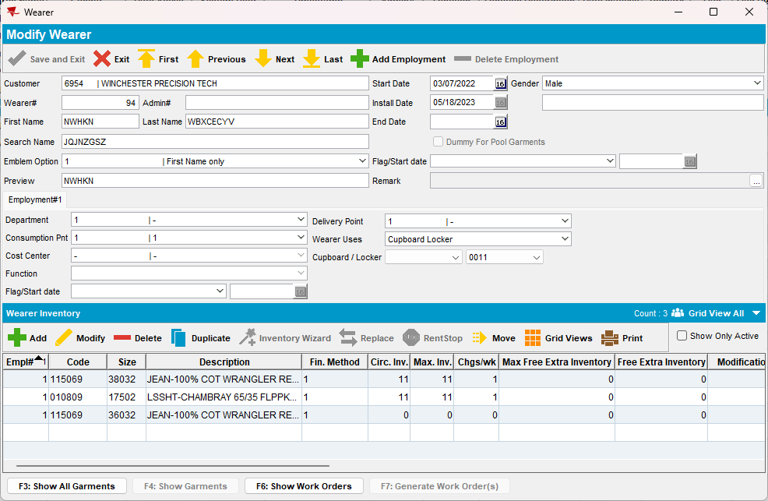

- PLPC DLG: Make sure you have GLP with 100% on your used garments:
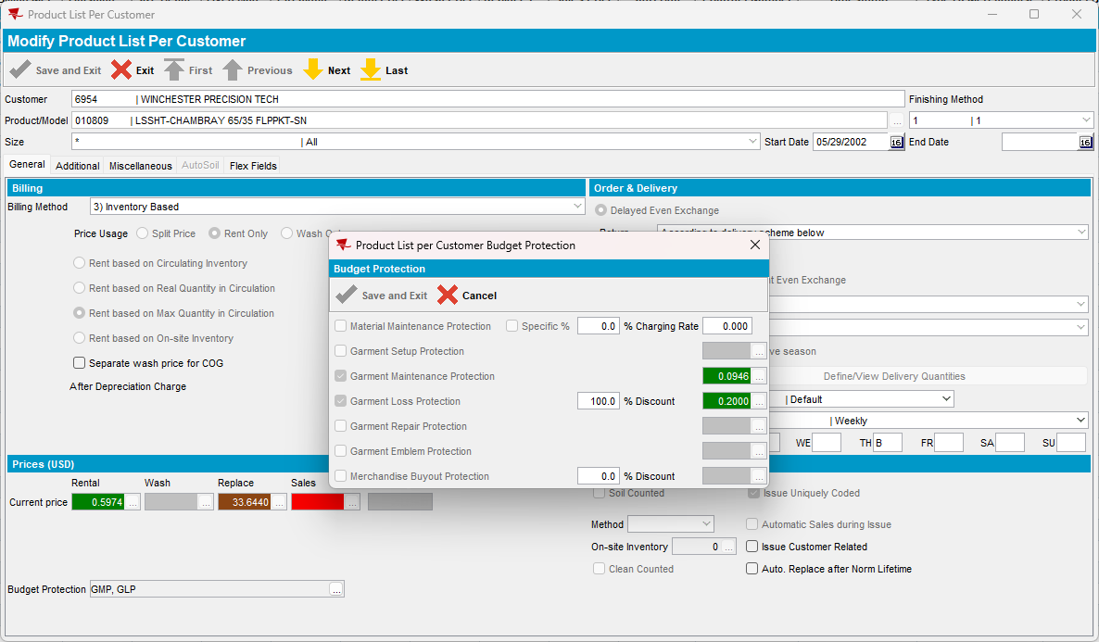
- Wearers DLG: Quit a wearer that has at least one wearer inventory with GLP on the corresponding PLPC
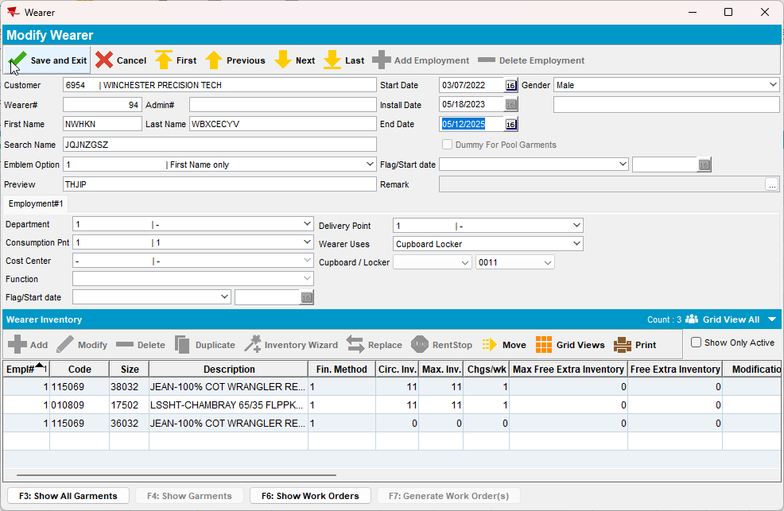

- RSC DLG: Add a route control for our customer in the next two weeks
- RSC DLG: Generate invoices for this route and tax them, there should be a loss charge with Extend = ‘N’
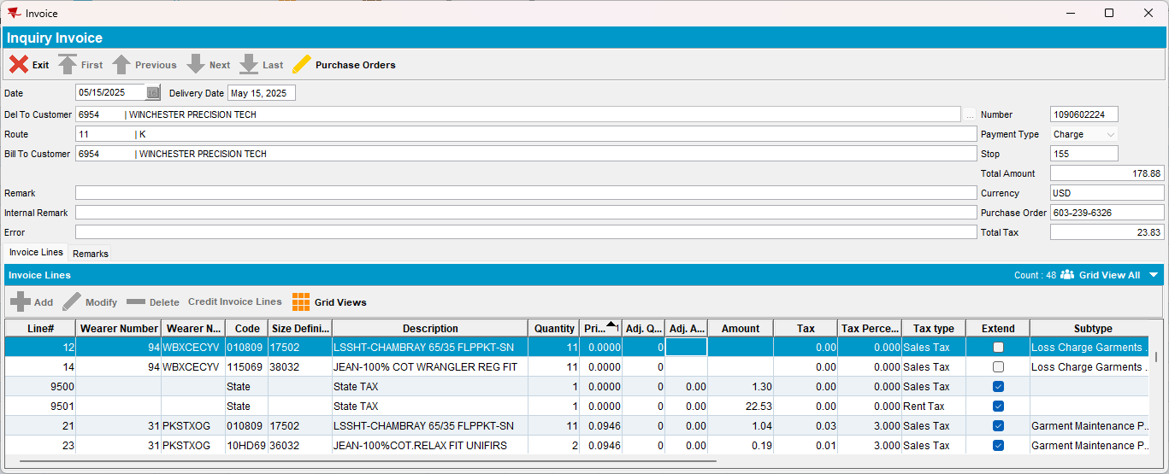

- Check that the NOTCHARGEDINVOICELINE record for the product and loss line
select * from NOTCHARGEDINVOICELINE N
where n.invoiceheader_id = (select ih.invoiceheader_id from invoiceheader ih where ih.invoicenumber = 1090602224)
and n.product_link_id = (select p.product_id from product p where p.code = '010809')
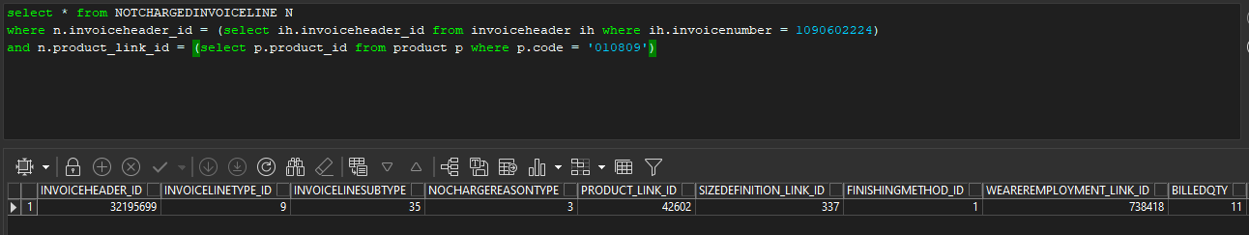
- Download the route on RA
- RA: Download the route
- RA: Scan return all of the garments for the wearer inventory you just quit

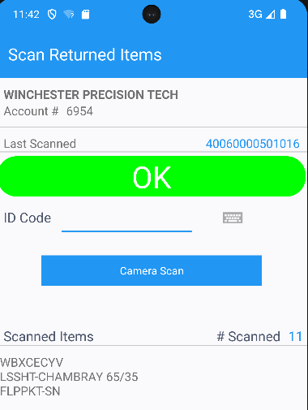

- RA: Return Items: Bill loss now all the loss charge
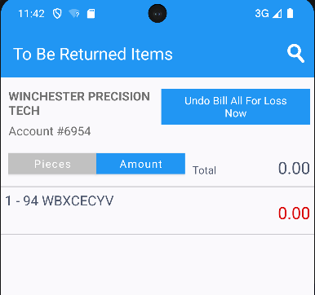
- RA: Settle and depart
- RA: Finish and upload
- Check that the following select returns one record
select il.linenumber, ih.invoicenumber, ih.deltocustomernumber, rt.*
from routetransaction rt
join invoiceheader ih
on rt.invoiceheader_id = ih.invoiceheader_id
join invoiceline il
on il.invoiceline_id = rt.invoiceline_id
where rt.routecontrol_id =
(select rc.routecontrol_id
from routecontrol rc
join route r
on r.route_id = rc.route_id
join plant p
on p.plant_id = r.plant_id
where rc.drivingdate = to_date('15/04\5/2025', 'dd/mm/yyyy')
and r.routenumber = 11
and p.code = '044')
and rt.routetransactiontype_id = 703
and rt.numbervalue1 = 0;

- WebX: Settle the route
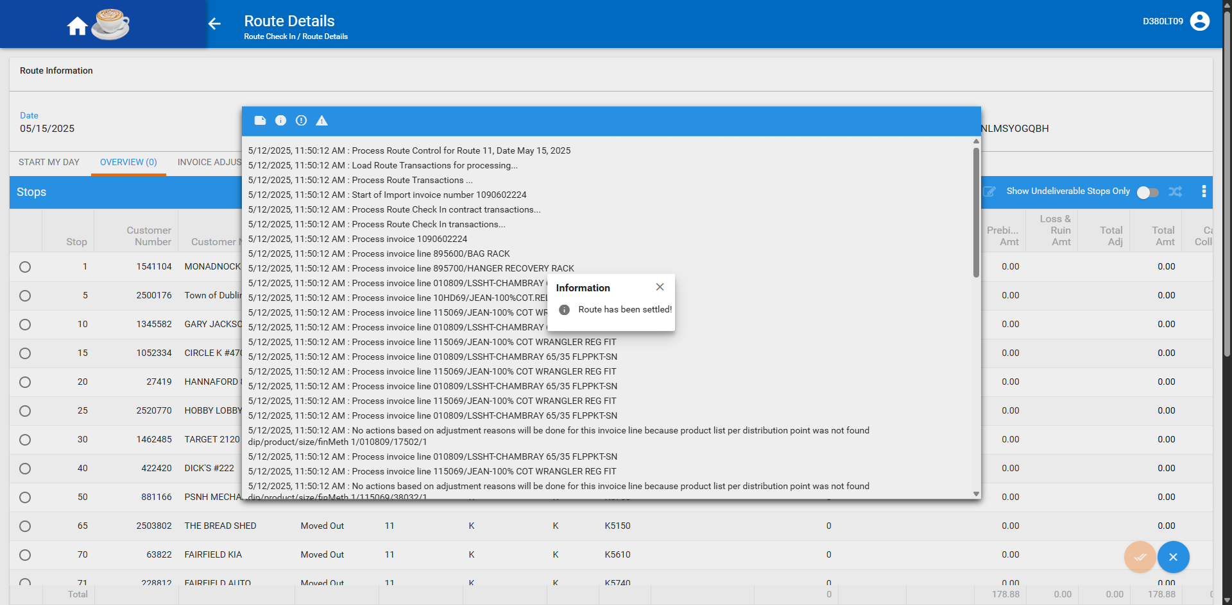
Current behavior
703 (bill loss now) route transactions are not processed as updates in NOTCHARGEDINVOICELINE and the settlement succeeds.
Expected behavior
We should not be processing 703 (bill loss now) route transactions as updates to records in NOTCHARGEDINVOICELINE.
TESTED OK.

Test Case 2 – Transaction type 701 & 702 loss charge line with extend = Y

- Find a customer that has wearers and active wearer inventories
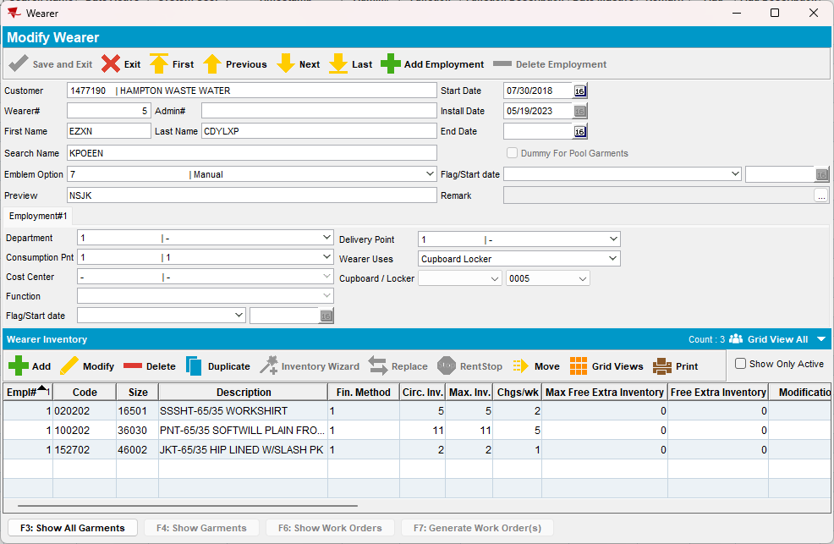
- PLPC DLG: Make sure you have GLP with 100% on your used garments:
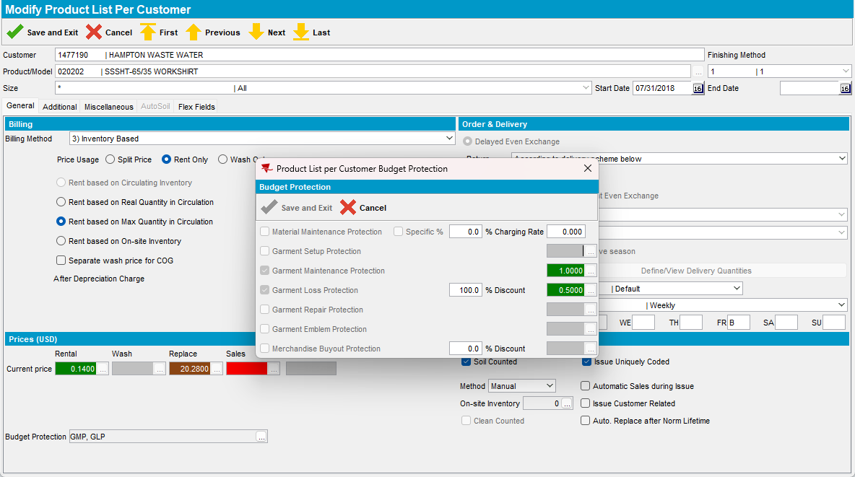
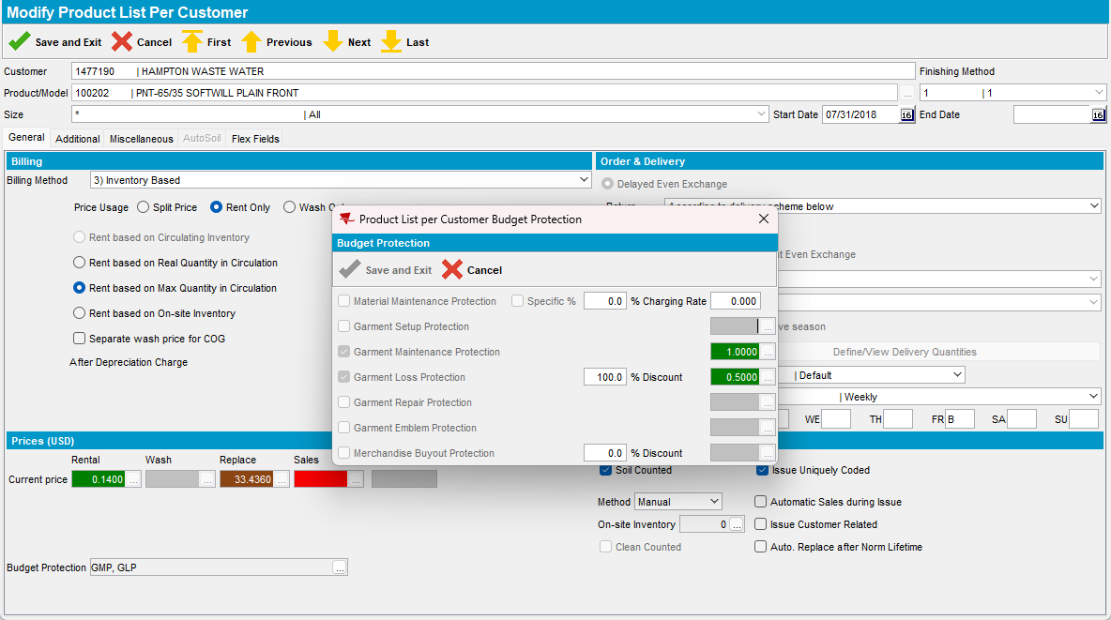

- Wearers DLG: Quit a wearer that has at least one wearer inventory with GLP on the corresponding PLPC
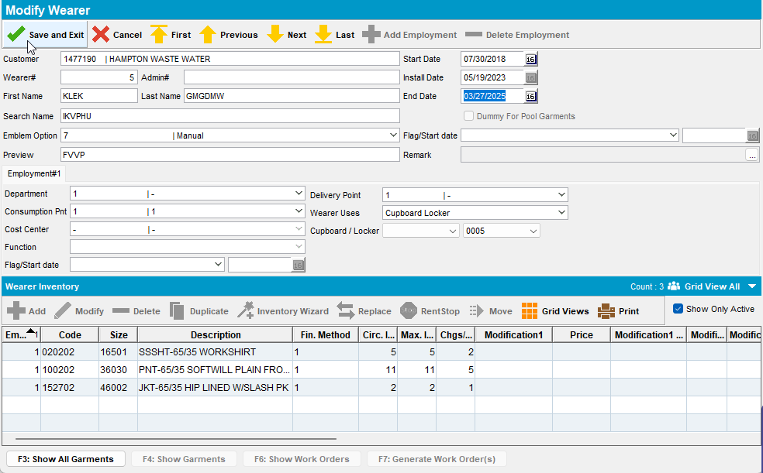

- RSC DLG: Add a route control for our customer
- RSC DLG: Generate invoices for this route and tax them, there should be a loss charge with Extend = ‘Y’
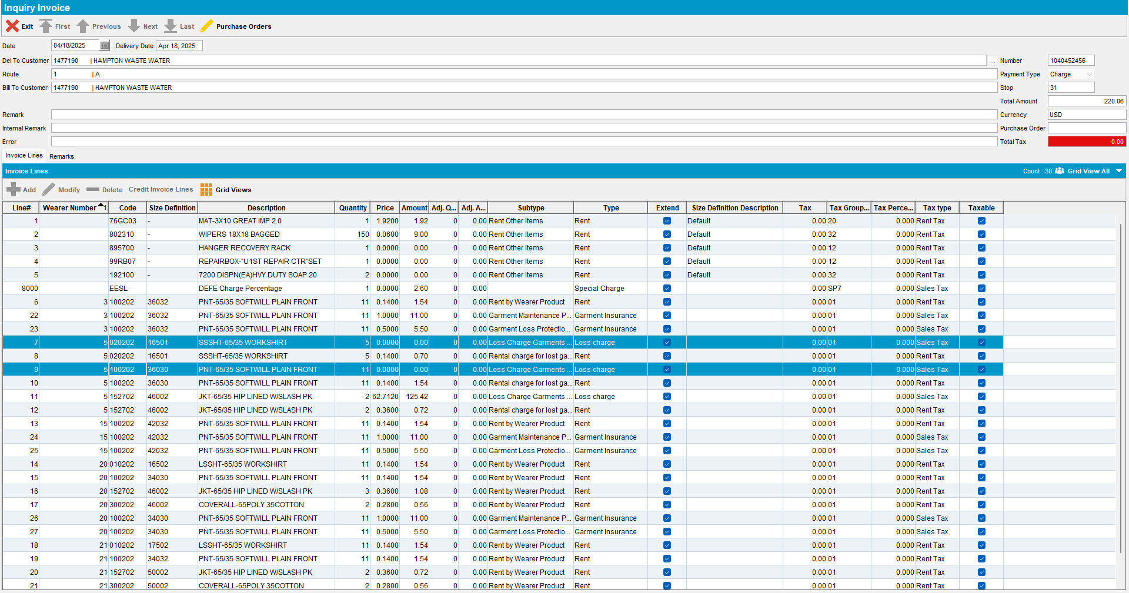
- Check the NOTCHARGEDINVOICELINE records for the product and loss line
select * from NOTCHARGEDINVOICELINE N
where n.invoiceheader_id = (select ih.invoiceheader_id
from invoiceheader ih
where ih.invoicenumber = 1040452456)
and n.product_link_id IN (select p.product_id
from product p
where p.code IN ('020202', '100202'))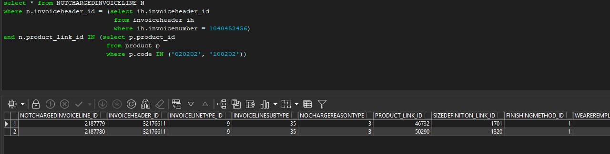
- Download the route on RA
- RA: Download the route
- RA: Do a positive adjustment for the first product and a negative one for the second product.
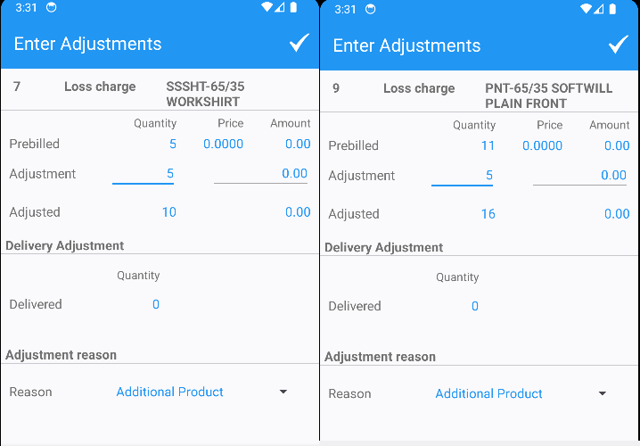

- RA: Settle and depart
- RA: Finish and upload
- Check the transactions
select il.linenumber, ih.invoicenumber, ih.deltocustomernumber, rt.*
from routetransaction rt
join invoiceheader ih
on rt.invoiceheader_id = ih.invoiceheader_id
join invoiceline il
on il.invoiceline_id = rt.invoiceline_id
where rt.routecontrol_id =
(select rc.routecontrol_id
from routecontrol rc
join route r
on r.route_id = rc.route_id
join plant p
on p.plant_id = r.plant_id
where rc.drivingdate = to_date('18/04/2025', 'dd/mm/yyyy')
and r.routenumber = 1
and p.code = '025')
and rt.routetransactiontype_id IN (701, 702)

- WebX: Settle the route
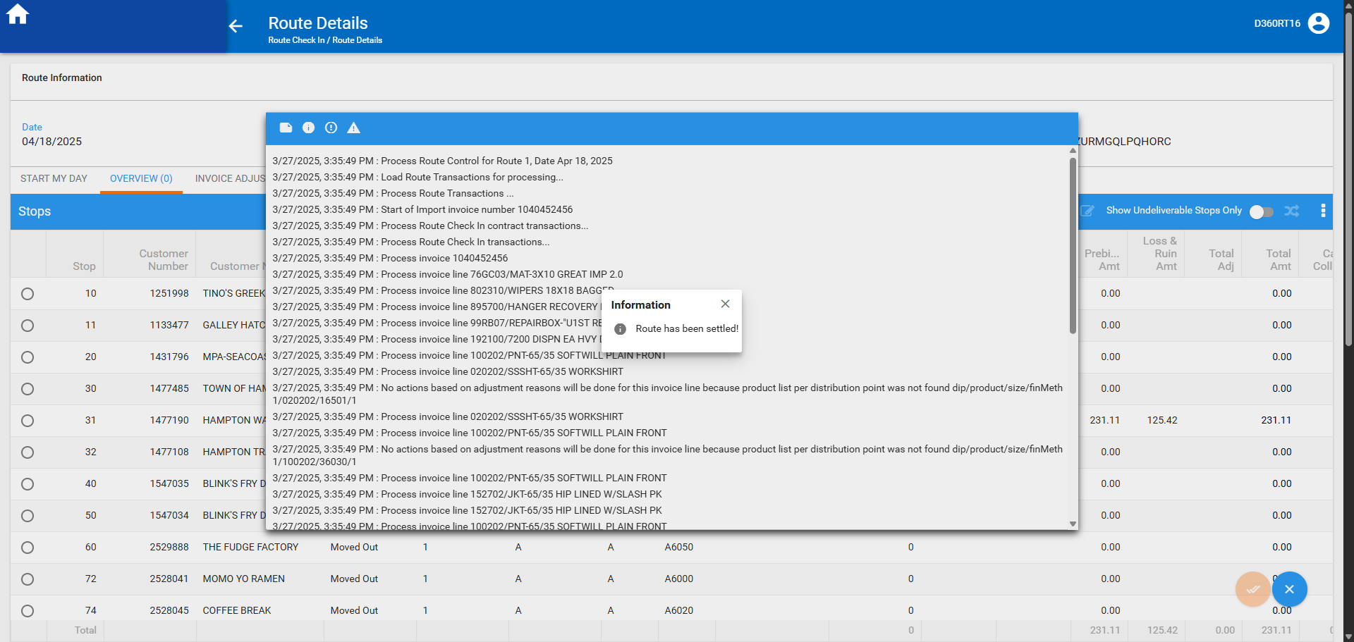

- Check the quantities in the NORCHARGEDINVOICELINE
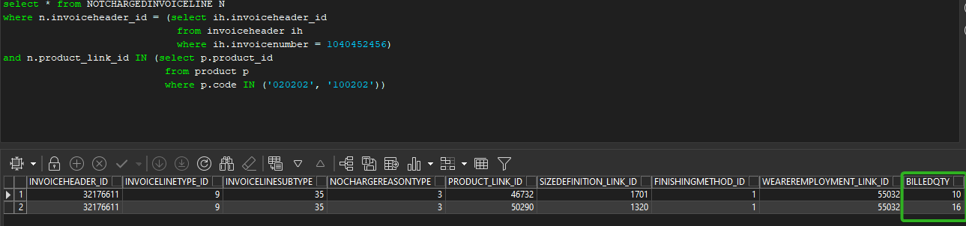

Current behavior
701 & 702 route transactions are processed as updates in NOTCHARGEDINVOICELINE.
Expected behavior
701 & 702 route transactions are processed as updates in NOTCHARGEDINVOICELINE.
TESTED OK.

