ABSN-4129 - WebX - The select new route (ellipsis button) is hidden if the Start My Day tab isn't reviewed
Environment | Prerequisites
Version: 9.07.00.UNF19  DBServerName= abs-srv20.internal.abslbs.com  DBSID=CUST24  DBUser=UNFDEV  DBPassword= UNFDEV  Environment=Test | - Module:  - System setting

Contents
Reproducing before fix 1
Steps to reproduce 1
Current Behavior 2
Retest after fix 2
Test Case 1 – Review button status in unreviewed and the current system user is the driver 2
Test Case 2 – Review button status in reviewed and the current system user is the driver 3
Test Case 3 – Review button status in unreviewed and the current system user is NOT the driver 5
Test Case 4 – Review button status in reviewed and the current system user is NOT the driver 6

Reproducing before fix

Steps to reproduce
- Find a routecontrol where there is at least one "Undeliverable" stop and that was not settled and the undeliverable stop was not assigned to another routecontrol.
select p.code, rc.drivingdate, r.routenumber, rc.routecontrol_id from routecontrol rc
join route r on r.route_id = rc.route_id
join plant p on p.plant_id = rc.plant_id
where rc.settlementstatus <>3
and exists (select 1 from routetransaction rt
where rt.routetransactiontype_id = 202
and rt.routecontrol_id = rc.routecontrol_id
and rt.numbervalue3 is null)
and rc.drivingdate > sysdate - 365;
- Script in the start my day data but have the review status set to not reviewed
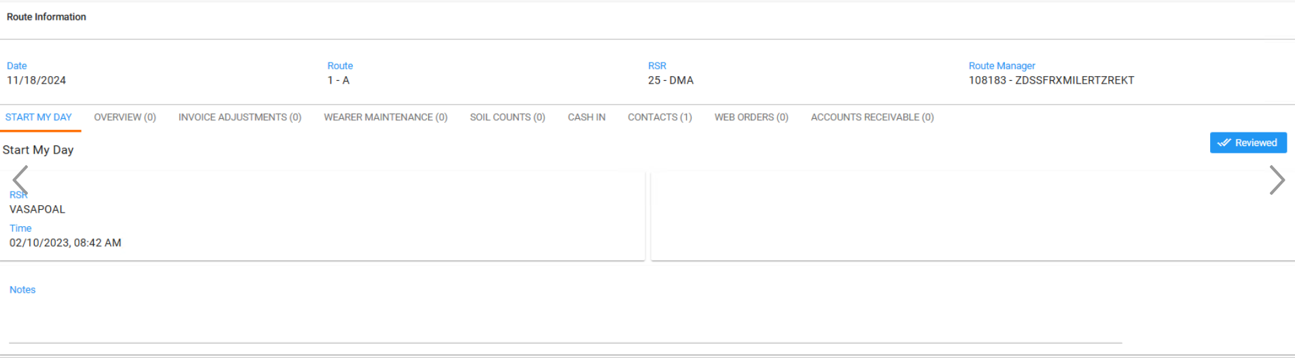
- Go to Overview tab and observe the ellipsis button
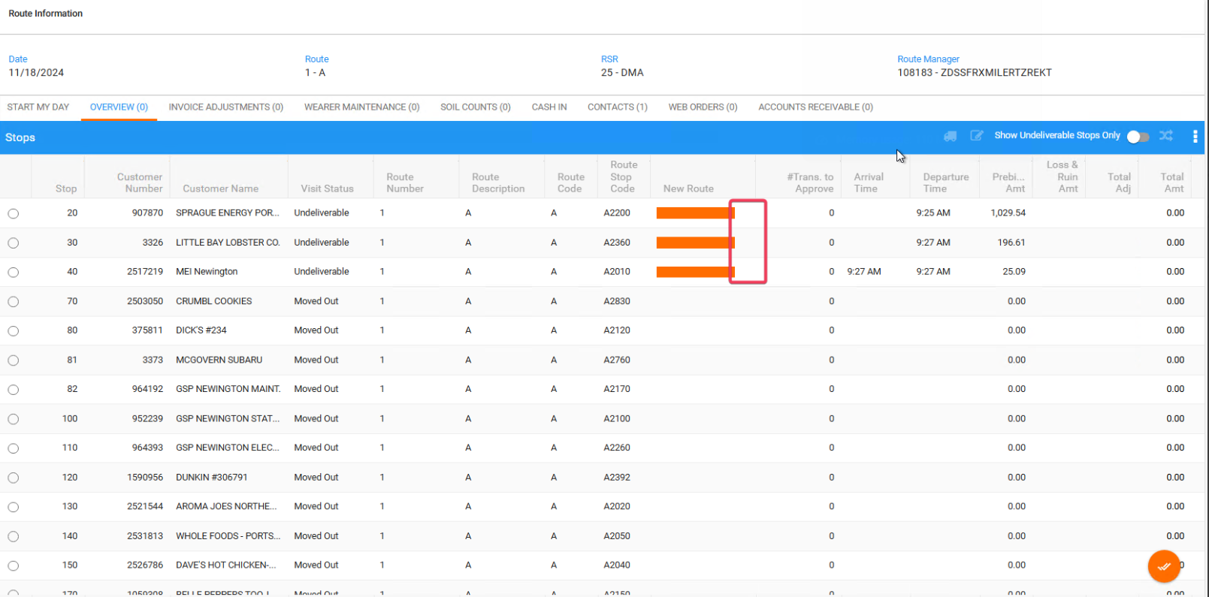
REPRODUCED OK.

Current Behavior
There are currently two problems:
Ellipsis button for selecting a new route for undeliverables availability depends on Start My Day is NOT REVIEWED but the RouteCountrolAD.AD_UserName is different than the current user's SystemUser.DomainName.

Retest after fix

Test Case 1 – Review button status in unreviewed and the current system user is the driver
Hash: 40b446868415
Expected Behavior: Ellipsis buttons are NOT visible.
- Find a routecontrol where there is at least one "Undeliverable" stop and that was not settled and the undeliverable stop was not assigned to another routecontrol.
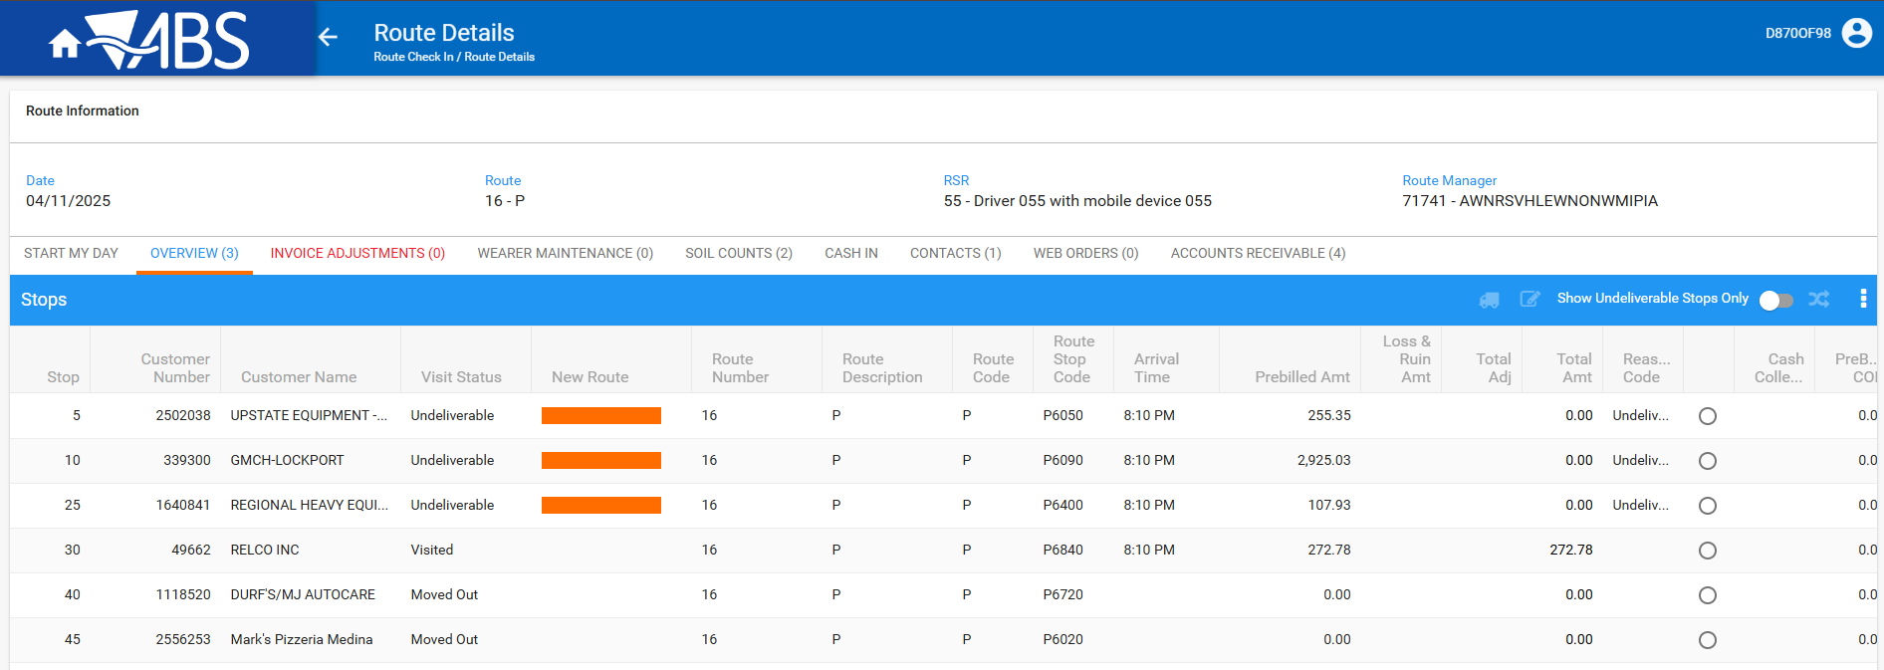
- Have the User completing Start my day be the same as the current Domain User

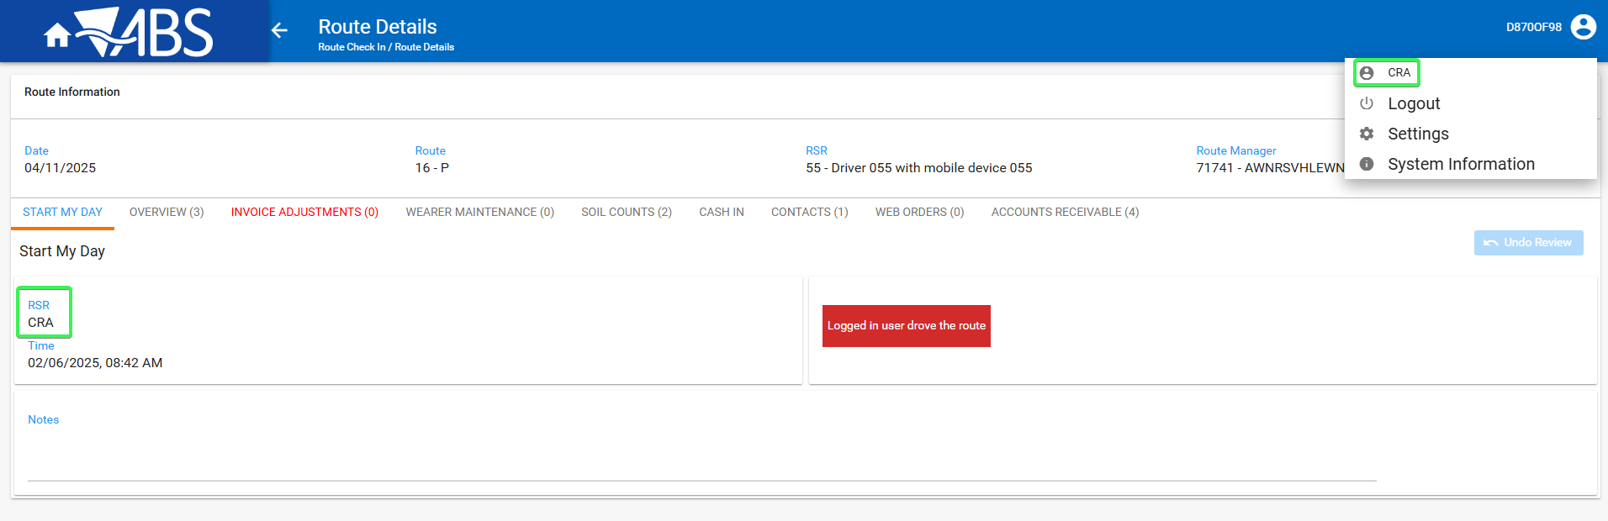
- Start My day Review button is in “Unreviewed” status (button is set as Reviewed)
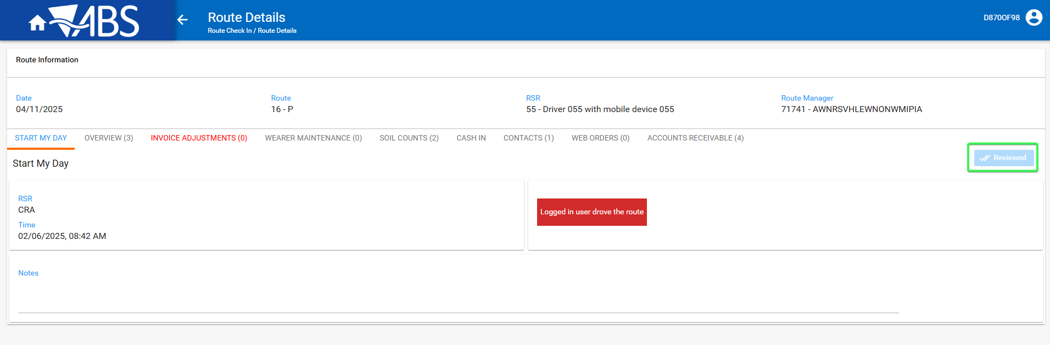
- Overview tab: See that the Ellipsis buttons are NOT visible
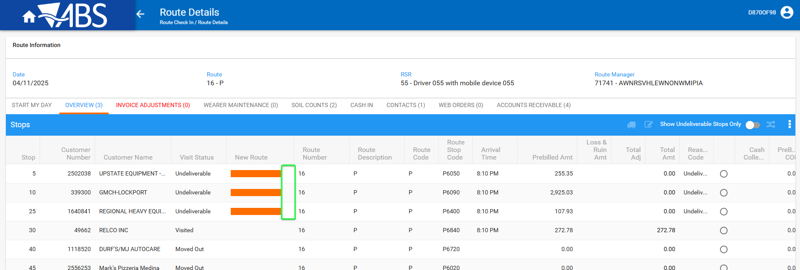
Tested OK

Test Case 2 – Review button status in reviewed and the current system user is the driver
Hash: 40b446868415
Expected Behavior: Ellipsis buttons are NOT visible.
- Find a routecontrol where there is at least one "Undeliverable" stop and that was not settled and the undeliverable stop was not assigned to another routecontrol.
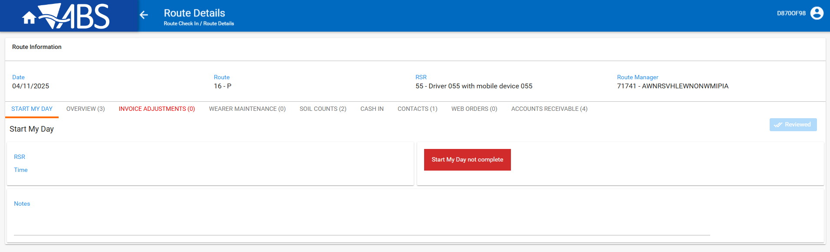
- Have the User completing Start my day be the same as the current Domain User
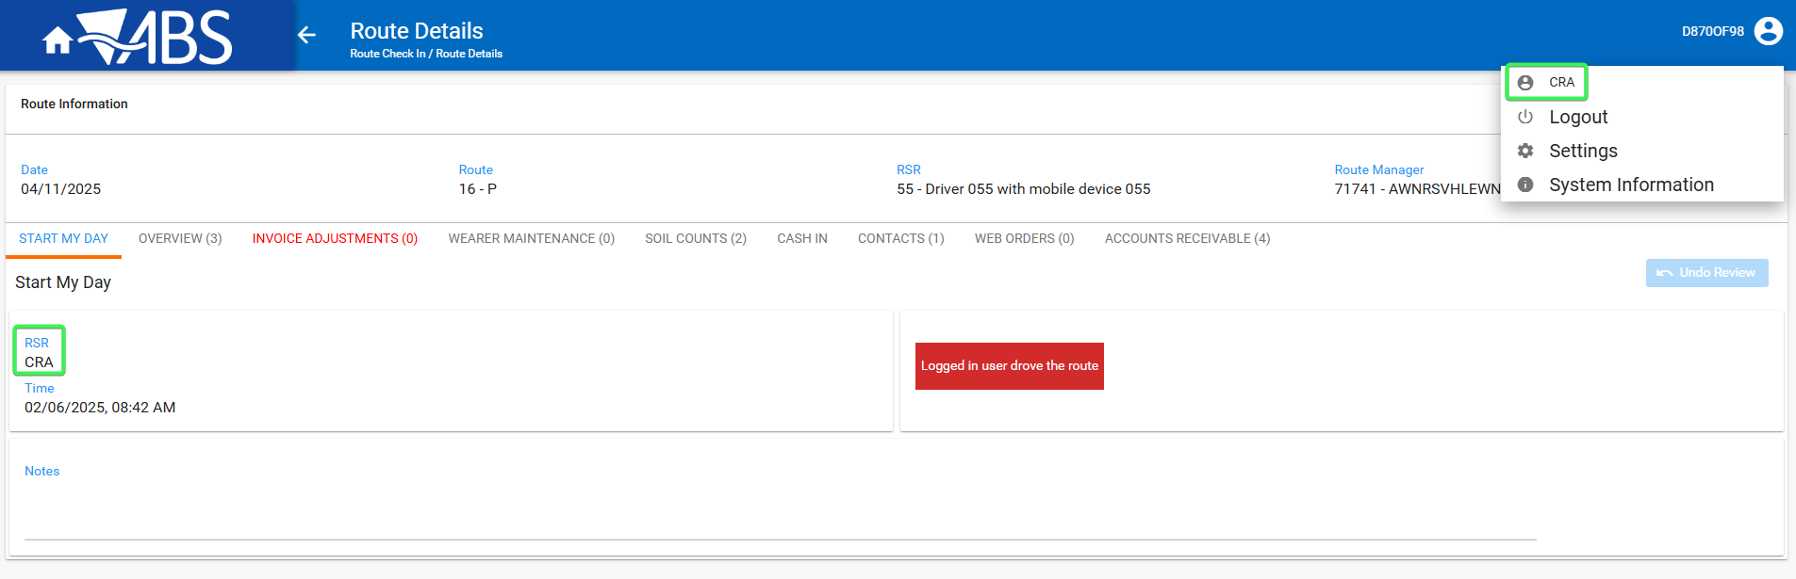
- Start My day Review button is in Reviewed status (Undo review)
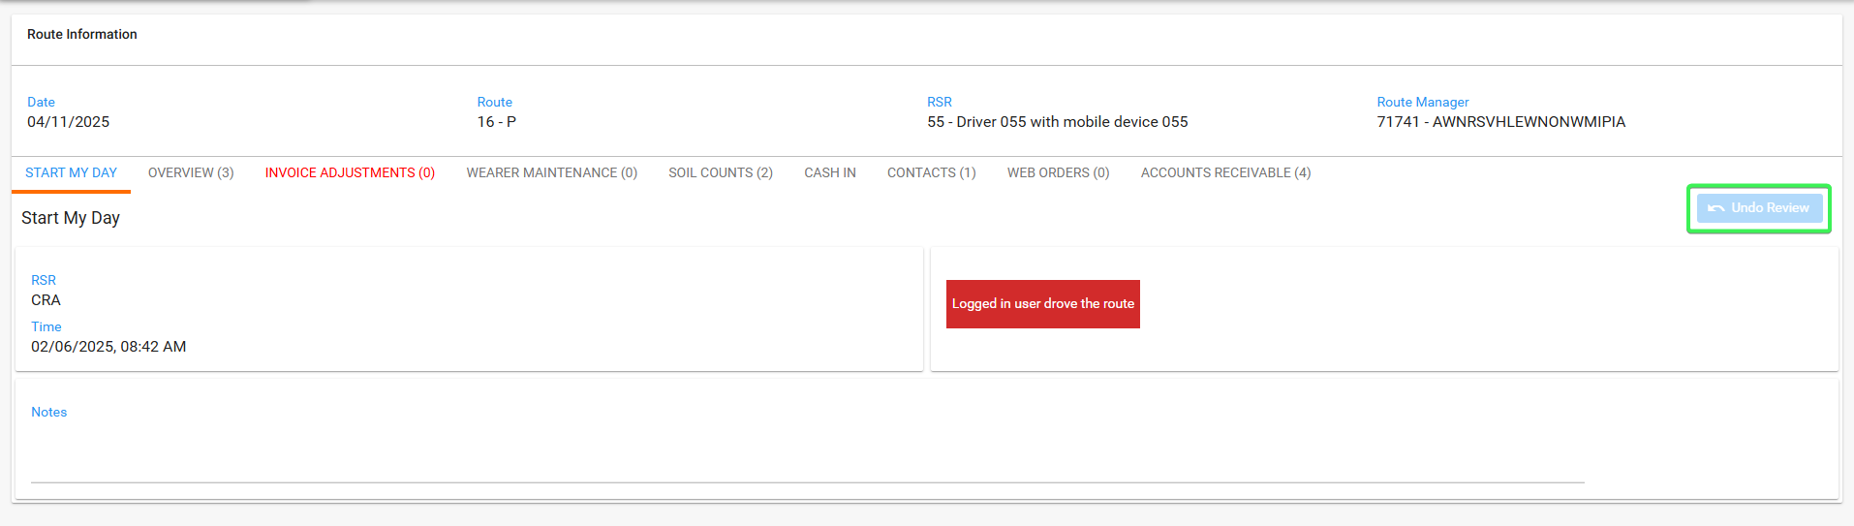
- Overview tab: Check that ellipsis buttons from the Undeliverable routes are Not Visible
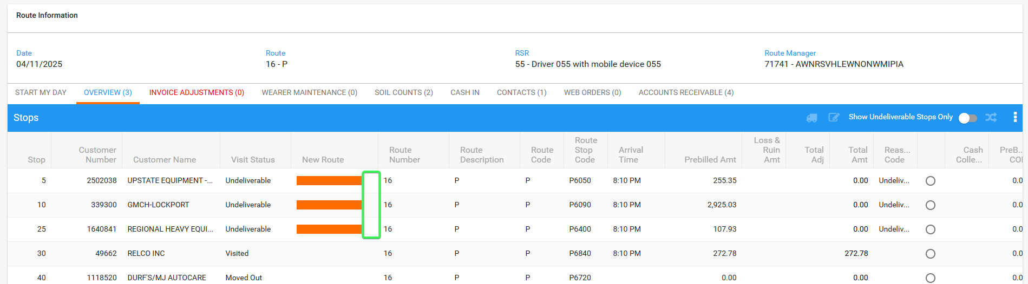
Tested OK

Test Case 3 – Review button status in unreviewed and the current system user is NOT the driver
Hash: 40b446868415
Expected Behavior: Ellipsis buttons are visible and enabled
- Find a routecontrol where there is at least one "Undeliverable" stop and that was not settled and the undeliverable stop was not assigned to another routecontrol.
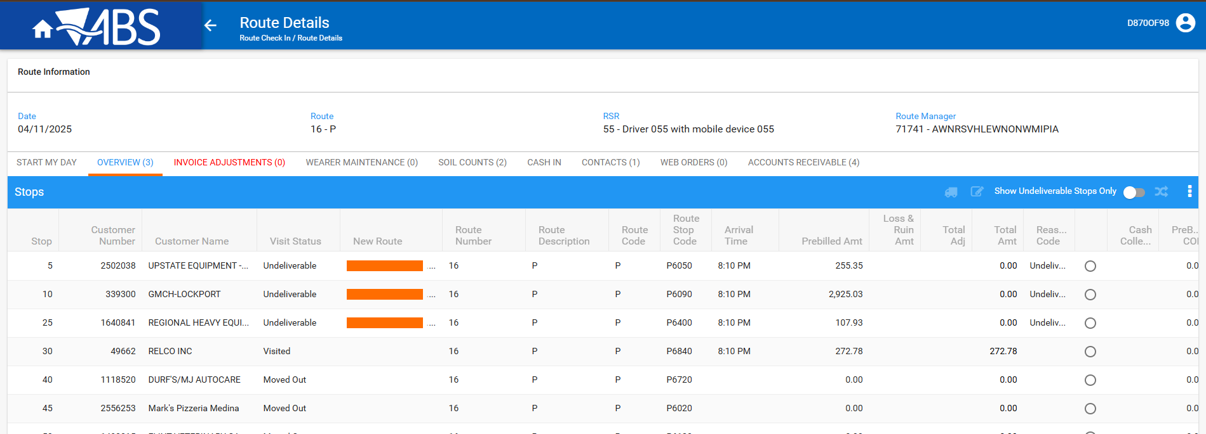
- The User that completed Start my day is different than the current system user
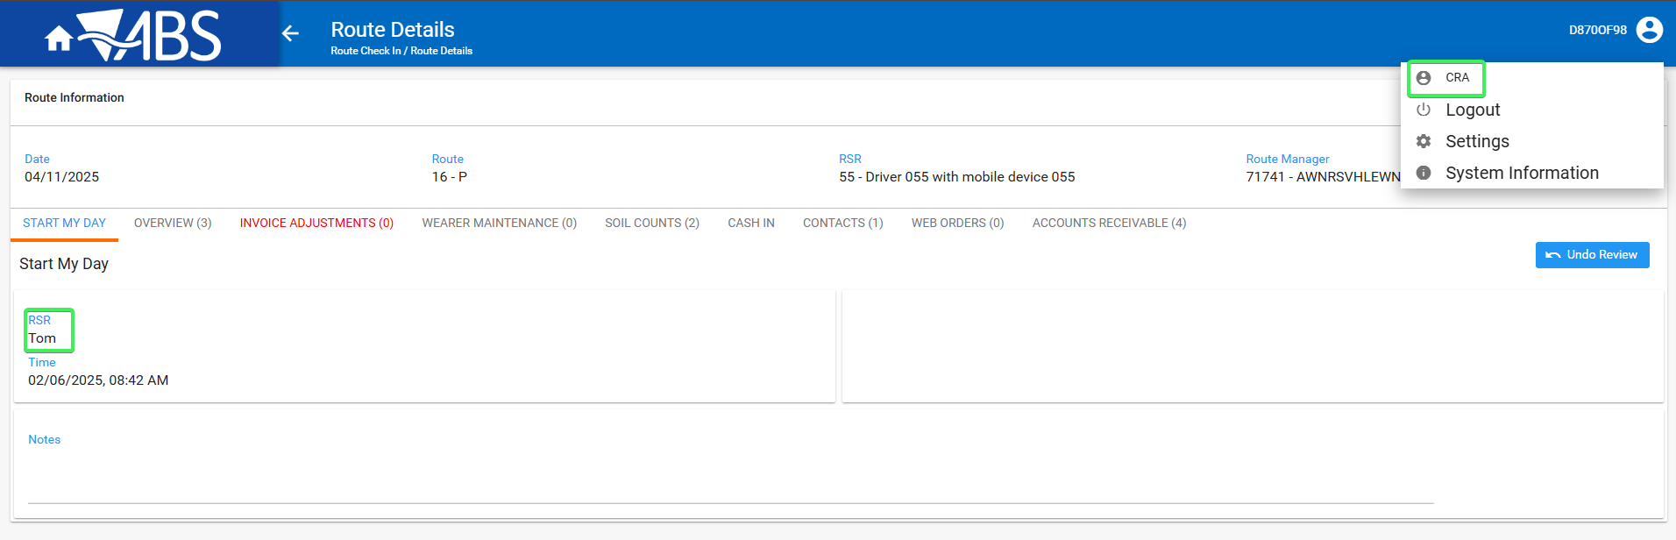
- Start my day is in Unreviewed Status (button is set as Reviewed)
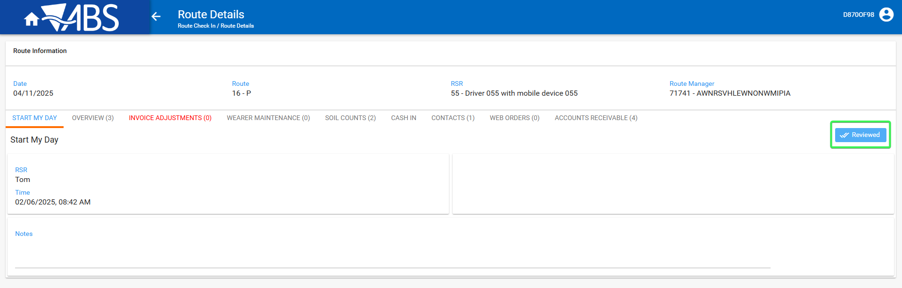
- Overview tab: Check that ellipsis buttons from the Undeliverable routes are visible and enabled
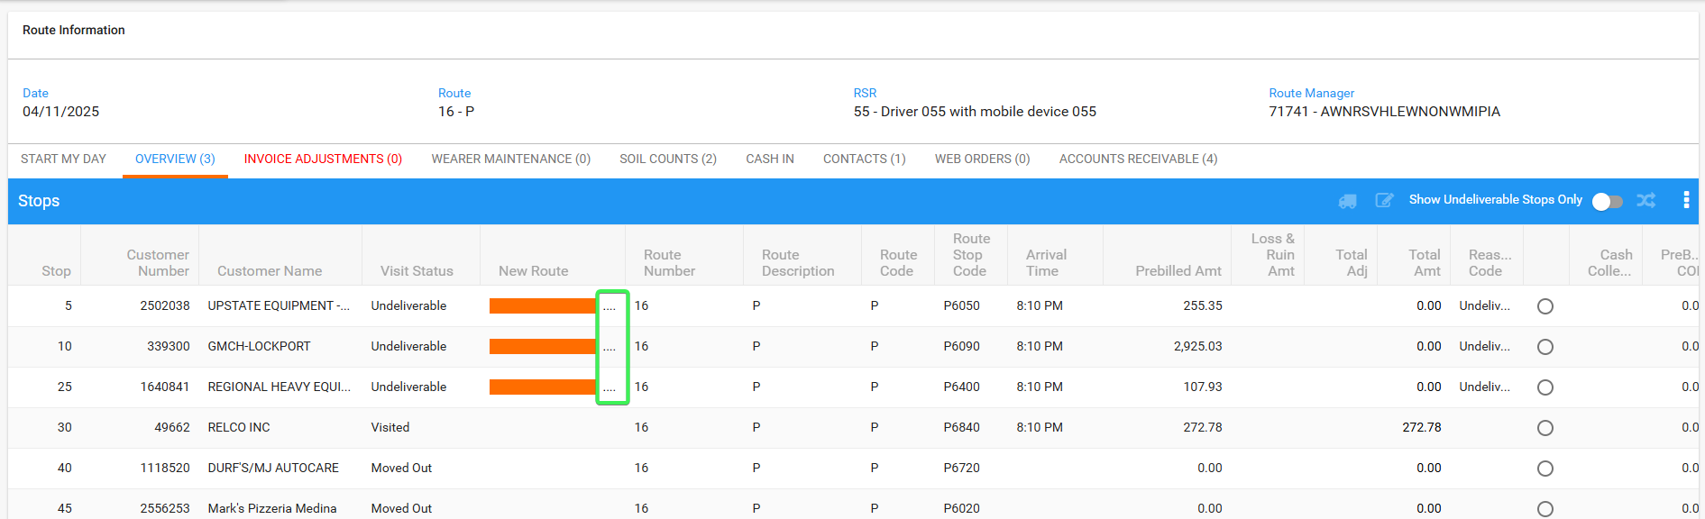
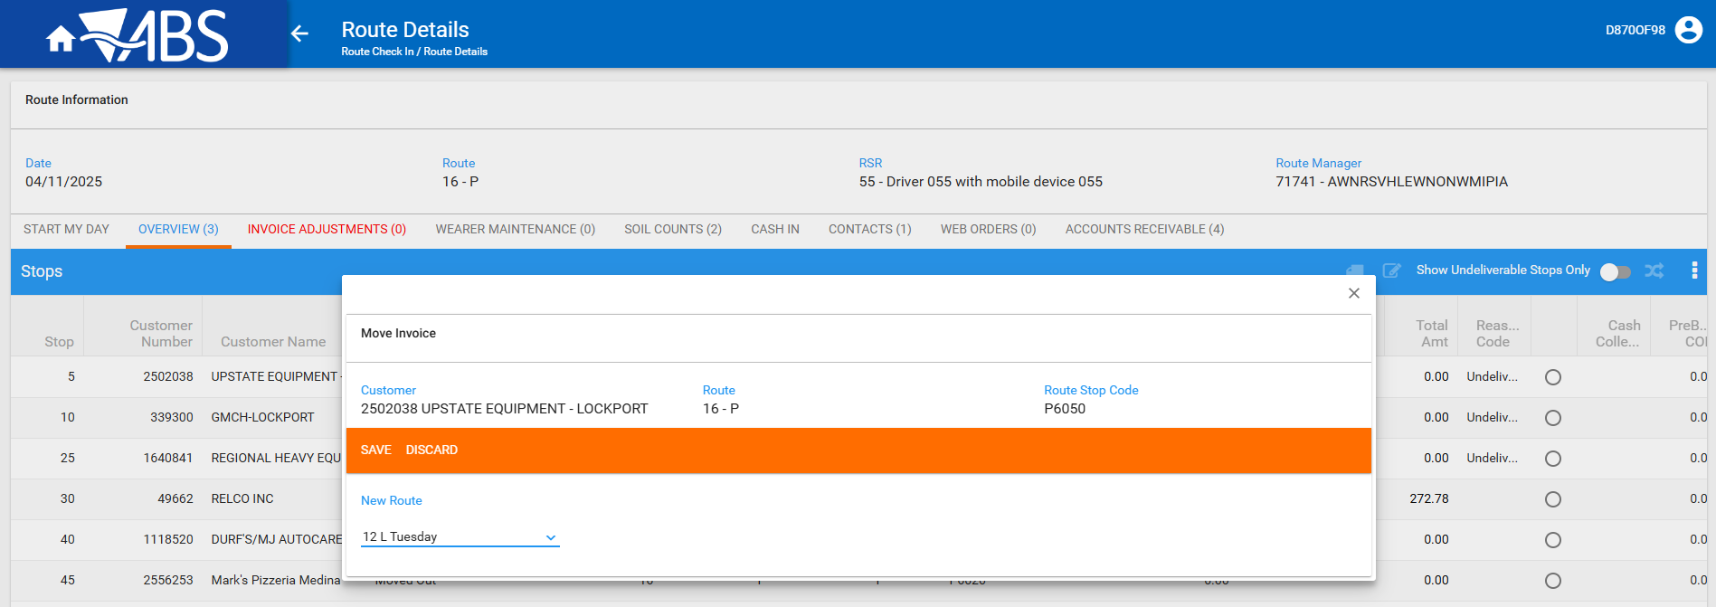
Tested OK

Test Case 4 – Review button status in reviewed and the current system user is NOT the driver
Hash: 40b446868415
Expected Behavior: Ellipsis buttons are visible and enabled
- Find a routecontrol where there is at least one "Undeliverable" stop and that was not settled and the undeliverable stop was not assigned to another routecontrol.
- The User that completed Start my day is different than the current system user
- Start my day is in Reviewed Status (button is set as Undo review)
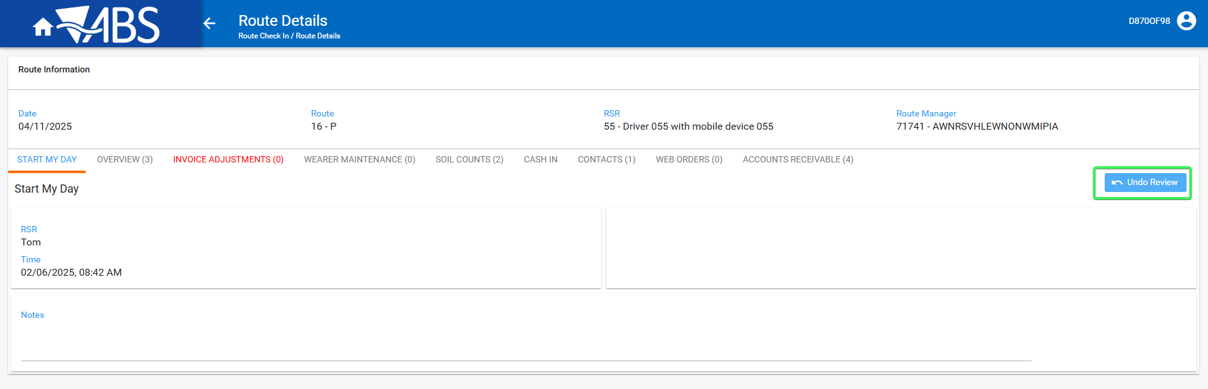
- Overview tab: Check that the ellipsis button is visible and enabled
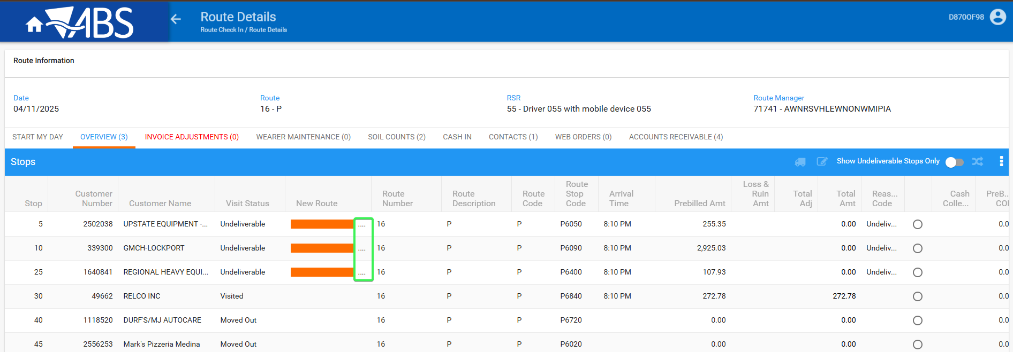
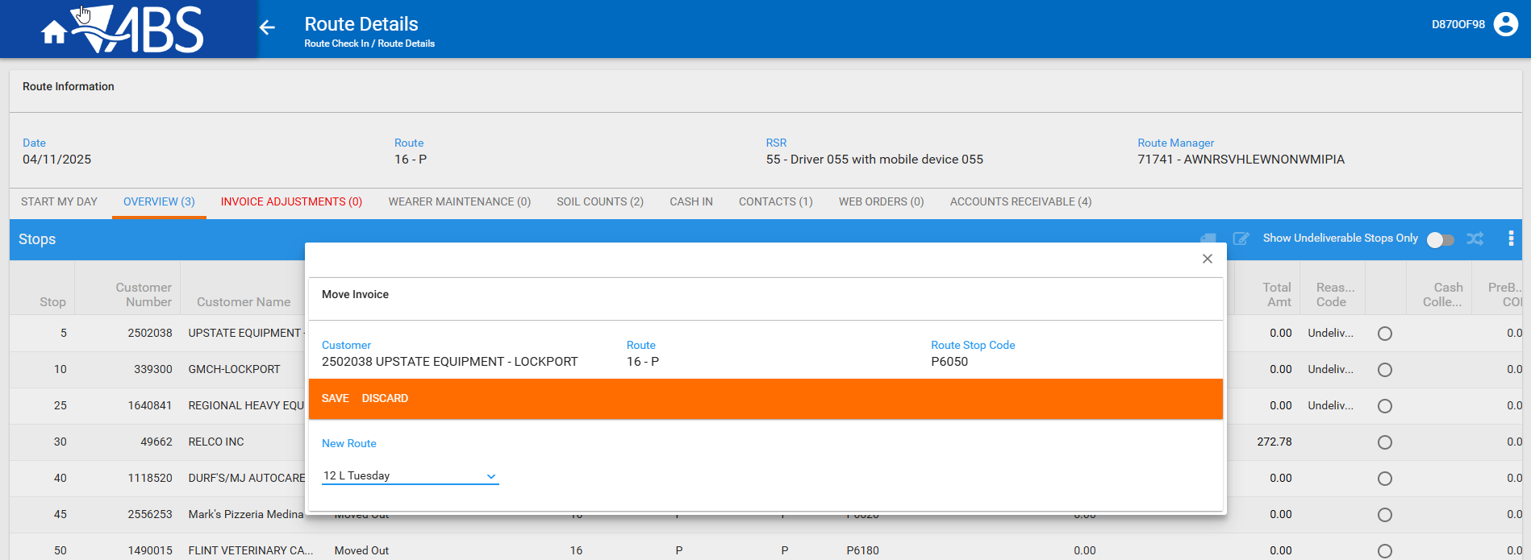
Tested OK

